Name of Journal: World Journal of Gastrointestinal Surgery
Manuscript NO: 91238
Manuscript Type: CASE REPORT

Percutaneous transhepatic stenting for acute superior mesenteric vein stenosis after pancreaticoduodenectomy with portal vein reconstruction: A case report

Lin C et al. SMV stenting after PD with PVR

Chen Lin, Zi-Yan Wang, Liang-Bo Dong, Zhi-Wei Wang, Ze-Hui Li, Wei-Bin Wang

Chen Lin, Department of General Surgery, Peking Union Medical College Hospital, Chinese Academy of Medical Sciences and Peking Union Medical College, Beijing 100730, China

Zi-Yan Wang, Liang-Bo Dong, Ze-Hui Li, Wei-Bin Wang, Department of General Surgery, Peking Union Medical College Hospital, Beijing 100730, China

Zhi-Wei Wang, Interventional Section, Department of Radiology, Peking Union Medical College Hospital, Chinese Academy of Medical Science and Peking Union Medical College, Beijing 100730, China

Co-first authors: Chen Lin and Zi-Yan Wang.

Author contributions: Lin C and Wang WB designed the study; Lin C and Wang ZY collected the data and wrote the paper; Wang ZY performed the data analysis; Lin C, Dong LB, and Wang WB performed the surgery; Wang ZW performed the percutaneous transhepatic stent placement; Dong LB and Li ZH were the surgical residents of the patient.

Supported by the National Natural Science Foundation of China, No. 82173074; the Beijing Natural Science Foundation, No. 7232127; the National High Level Hospital Clinical Research Funding, No. 2022-PUMCH-D-001 and No. 2022-PUMCH-B-004; the CAMS Innovation Fund for Medical Sciences, No. 2021-I2M-1-002; the Nonprofit Central Research Institute Fund of Chinese Academy of Medical Sciences, No. 2018PT32014; and Fundamental Research Funds for the Central Universities, No. 3332019025.

Corresponding author: Wei-Bin Wang, MD, Chief Doctor, Department of General Surgery, Peking Union Medical College Hospital, No. 1 Shuaifu Yuan, Dongcheng District, Beijing 100730, China. wwb_xh@163.com

Received: December 25, 2023
Revised: January 24, 2024
Accepted: March 19, 2024
Published online:

Abstract
BACKGROUND
Percutaneous transhepatic stent placement has become a common strategy for the postoperative treatment of portal vein (PV)/superior mesenteric veins (SMV) stenosis/occlusion. It has been widely used after liver transplantation surgery; however, reports on stent placement for acute PV/SMV stenosis after pancreatic surgery within postoperative 3 d are rare.

CASE SUMMARY
Herein, we reported a case of intestinal edema and SMV stenosis 2 d after pancreatic surgery. The patient was successfully treated using stent grafts. Although the stenosis resolved after stent placement, complications, including bleeding, pancreatic fistula, bile leakage, and infection, made the treatment highly challenging. The use of anticoagulants was adjusted multiple times to prevent venous thromboembolism and the risk of bleeding. After careful treatment, the patient stabilized, and stent placement effectively managed postoperative PV/SMV stenosis.

CONCLUSION
Stent placement is effective and feasible for treating acute PV/SMV stenosis after pancreatic surgery even within postoperative 3 d.

Key Words: Pancreaticoduodenectomy; Portal vein reconstruction; Portal vein stenosis; Portal vein stent; Case report

Lin C, Wang ZY, Dong LB, Wang ZW, Li ZH, Wang WB. Percutaneous transhepatic stenting for acute superior mesenteric vein stenosis after pancreaticoduodenectomy with portal vein reconstruction: A case report. World J Gastrointest Surg 2024; In press

Core Tip: Portal vein (PV)/superior mesenteric veins (SMV) stenosis/occlusion is an uncommon but severe complication after pancreatic surgery. Stent placement for acute PV/SMV stenosis within 3 d postoperatively was rarely reported. We reported a case showing that percutaneous transhepatic stent placement was an effective and feasible treatment for acute SMV stenosis on postoperative day 2 after the Whipple procedure and could relieve patients’ symptoms. Complications after SMV stent placement, such as bleeding, infection, pancreatic fistula and bile leakage should be fully noticed and carefully managed, especially when considering their interactive effects. Anticoagulation was initiated for preventing stent thrombosis, but it increased risk of bleeding.

INTRODUCTION
Portal vein (PV) or superior mesenteric vein (SMV) stenosis can occur as a postoperative complication and has been widely reported after liver transplantation surgery^{[1,2]}. PV/SMV stenosis can also be a complication of pancreatic surgery, such as pancreaticoduodenectomy (PD)^{[3,4]}. The incidence of PV stenosis is reported to be 9%-30%^{[4,5]} and is higher with PV resection during surgery^{[6]}, causing significant symptoms, including abdominal pain, gastrointestinal bleeding, and ascites^{[7,8]}. SMV stenosis with clinical manifestations, including refractory ascites, gastrointestinal bleeding, and congestive bowel infarction, has been reported less frequently^{[9]}. In patients with severe symptoms, PV/SMV stenting may be used to reestablish blood flow^{[10]}. Previous studies have shown that PV/SMV stenting is typically performed after 1 month postoperatively, but rarely within 3 d, possibly due to concerns about re-stenosis or bleeding. Only one case-series report reported an instance of PV/SMV stenting within 3 d of pancreatic surgery^{[11]}, but without detailed clinical characteristics and outcomes. Generally, there is a lack of experience with treatment of postoperative PV/SMV stenosis within 3 d. Here, we present a case of a patient with acute postoperative PV/SMV stenosis treated with PV/SMV stenting on postoperative day (POD) 2. To the best of our knowledge, this is the first report on stent placement, management of anticoagulation usage, and complications after stenting for acute PV/SMV stenosis after pancreatic surgery with PV reconstruction within POD 3.

CASE PRESENTATION
Chief complaints
Two years after transverse colon cancer surgery, four months since finding pancreatic head mass.

History of present illness
A 65-year-old woman underwent PD with PV and SMV resection and reconstruction using an autologous great saphenous vein patch for a pancreatic head mass. She underwent radical resection for laparoscopic colorectal cancer 2 years before PD, and the pathological diagnosis was moderately differentiated adenocarcinoma of the transverse colon, pT4aN0M0, stage IIb. After colorectal cancer surgery, the patient underwent four courses of XELOX chemotherapy. At 18 postoperative months (POMs) after colorectal cancer surgery, positron emission tomography/computed tomography (CT) revealed a 1.8 cm × 1.7 cm mass in the pancreatic head with a maximum standardized uptake value (SUVmax) of 4.5. Enhanced CT found a mass with low enhancement that caused SMV violation and stenosis (Figure 1). Considering the previous history of colorectal cancer, it was difficult to discriminate the mass from primary pancreatic cancer or metastasis of recurrent colorectal cancer. Endoscopic ultrasound pathology was used but it only characterized the mass as an adenocarcinoma and could not reach a clear diagnosis.

History of past illness
The patient had a history of hypertension, diabetes mellitus, and stroke.

Personal and family history
The patient had no positive findings in personal and family history.

Physical examination
No jaundice in the patient’s skin and sclera. Courvoisier’s sign (-), bowel sounds 3 times per minute, and rectal examination (-).

Laboratory examinations
No significant laboratory examinations were found for the patient.

Imaging examinations
The imaging examinations were shown in history of present illness section.

FINAL DIAGNOSIS
During PD surgery, the mass was confirmed to violate the SMV; therefore, 3 cm of the SMV was resected, and 5 cm of the autologous great saphenous vein was used to reconstruct the SMV. The beginning of the jejunum (length: 20 cm) was also resected after the first jejunal vein was disrupted. On POD 1, the drainage volume of the operative gravidity drain placed close to the biliary-enteric anastomosis was 2800 mL, and the patient’s bowel sounds were absent. Ultrasonography revealed intestinal edema and enhanced CT revealed SMV stenosis (Figure 2). Therefore, PV angiography was performed and SMV stenosis confirmed.

TREATMENT
Percutaneous transhepatic stent placement was performed to reestablish blood flow in the PV (Figure 3). Heparin was administered after stent placement to prevent thrombosis with an activated partial thromboplastin time (APTT) goal of 35-40 s, which was 1.5 times of the patient’s baseline level before surgery^{[12]} (Figure 4). On POD 7, thrombosis formation was found in right peroneal vein; therefore, we tested the activity of antithrombin to evaluate heparin’s anticoagulant activity. The activity of AT-III was 67%, suggesting an increased risk of developing abnormal thrombosis and impaired sensitivity to heparin, since heparin functions through antithrombin. Fresh frozen plasma was transfused to rescue sensitivity to heparin. Gastrointestinal bleeding was observed on POD 9; therefore, the dose of heparin was decreased. On POD 10, the heparin was replaced with low molecular weight heparin (LMWH) (Figure 4). On POD 22, the patient experienced bleeding from the drainage tube, hematochezia, and hematemesis. The patient was treated with transfusion, and LMWH was changed to a very low dose of heparin, with an APTT goal of 25-30 s, and finally to rivaroxaban 10 mg qd. Bleeding gradually disappeared at POD 26.
Pancreatic fistulas and bile leakage were also found after stent placement, which was inferred to be a result of the resolution of intestinal edema after re-establishment of PV blood flow. A pancreatic fistula was diagnosed by a daily drainage volume of 100-200 mL nearby the pancreaticojejunal anastomosis (Figure 5), and the drainage fluid was cloudy as rice water with rising amylase. Bile leakage was diagnosed using Atrovirens drainage fluid with a high level of direct bilirubin. Proton pump inhibitors and enzyme inhibitors were administered, and the drainage tubes were carefully adjusted. The pathological diagnosis was adenocarcinoma with moderate differentiation, and immunohistochemical analysis suggested that the mass may have originated from the colon.

OUTCOME AND FOLLOW-UP
The patient experienced several episodes of infection and fever (Figure 6). During the first week after surgery, septic shock occurred, which probably originated from pancreatic fistula, bile leakage, damage to intestinal barrier function, and translocation of gut bacteria. Retrograde infection from the drainage tubes also aggravated the infection. Intermittent fever was found in the whole POM 1, with peak temperature 37.8-38.5 °C. Blood and sputum cultures were negative and drainage cultures were positive for Pseudomonas aeruginosa, Enterococcus faecium, and Acinetobacter baumannii. Antibiotic use was adjusted several times according to drug susceptibility test results. The patient was finally discharged from the hospital 2 months after surgery. The patient did not present any abdominal symptoms related to PV/SMV stenosis after surgery for 8 months.

DISCUSSION
Pancreatectomy combined with PV resection and reconstruction was used to treat advanced pancreatic cancers that invaded the portal and SMVs^{[13,14]}. However, there were no standardized guidelines on the choice of reconstruction mode, including primary repair, autologous grafting, or synthetic grafting^{[3,15]}. Primary repair is technically easy but might result in high tension for long segmental resections. Autologous grafting requires a suitable length and caliber, and frequently used materials include the great saphenous vein, femoral vein, external iliac vein, umbilical vein patch, parietal peritoneum, and falciform ligament^{[16-19]}. Synthetic grafting is convenient but more likely to result in thrombosis and has a lower patency^{[15]}. Thus, we chose the great saphenous vein as the graft material.
Acute PV stenosis following PD was a rare but severe complication. There were few reports on its management, and the reported treatments included early systematic anticoagulation, surgical repair, and percutaneous transhepatic PV stent placement^{[20-23]}. Early systematic anticoagulation was the first-line treatment for PV thrombosis; however, the failure rate could be as high as 62%^{[22,23]}, especially in patients with complications such as ascites. Surgery is typically not performed because severe adhesions at the surgical site would make surgical repair difficult^{[22,23]}. Percutaneous transhepatic PV stent placement is preferred for PV stenosis after hepatic transplantation surgery^{[24,25]}; however, its use after pancreatic surgery was rare, especially within 3 PODs. For this patient, we chose to place a stent to re-establish blood flow instead of performing anticoagulation because the occlusion blocked anticoagulation drugs. The reported patency rate was 66.7%-80%^{[7,8,11,14]} for PV stenting after pancreatic surgery. However, these patency rates could not be directly adopted in our case, since the majority of reported cases concerned surgeries conducted > 30 d. Moreover, in those studies, only a small proportion of patients received PV reconstruction during surgery. Therefore, our case was more vulnerable to thrombosis formation. However, due to our successful management, the patient did not present any abdominal symptoms related to PV/SMV stenosis after surgery for 10 months, and CT scan revealed patent stents.
In this patient, two stents were placed, one coated and one uncoated. The uncoated stent was intended for the preservation of blood supply of SMV branches, protecting the blood supply for both key anastomoses. After the stent placement, four complications were observed: Pancreatic fistula, bile leakage, infection, and bleeding. The pancreatic fistula and bile leakage were caused by the resolution of intestinal edema, which caused abdominal infection. Damage to intestinal barrier function and the translocation of gut bacteria worsened the infection. Bleeding was caused by the pancreatic fistula, bile leakage, infection, and wound corrosion. Anticoagulation results in intractable bleeding; however, it was initiated with the aim of preventing stent thrombosis. These complications created a vicious cycle that complicated the whole treatment. We carefully evaluated the risks of bleeding and thrombosis and adjusted the anticoagulation protocol with an APTT goal initiated as 35-40 s and actively adjusted it based on drainage, bleeding, and hemoglobin values. It is important that patients exhibiting heparin dose-resistance should be identified and subjected to additional evaluations, including factor levels, antithrombin activity, platelet count, and fibrinogen levels. Proton pump inhibitor drugs were administered and non-steroidal anti-inflammatory drugs avoided. Infection treatment was adjusted according to the drug susceptibility test. Furthermore, enteral nutrition was continuously administered from POD 14 through the jejunal nutrition tube, which largely helped in the recovery of intestinal function and repair of the intestinal mucosa, and thereby may played an important role in breaking the cycle.

CONCLUSION
This case showed a successful example of using percutaneous transhepatic stent placement for treating acute SMV stenosis after Whipple surgery. The effectiveness of stenting has been validated by PV angiography. Although severe complications occurred after this procedure, such as bleeding, infection, pancreatic fistula and bile leakage, our treatment was successful in relieving the patient’s symptoms. This is the first report on stent placement, management of anticoagulation usage, and complications after stenting for acute PV/SMV stenosis after pancreatic surgery with PV reconstruction within postoperative 3 d.

REFERENCES
1 Kyaw L, Lai NM, Iyer SG, Loh DSKL, Loh SEK, Mali VP. Percutaneous transhepatic interventional therapy of portal vein stenosis in paediatric liver transplantation: A systematic review of efficacy and safety. Pediatr Transplant 2022; 26: e14187 [PMID: 34724594 DOI: 10.1111/petr.14187]
2 Sharshar M, Yagi S, Iida T, Yao S, Miyachi Y, Macshut M, Iwamura S, Hirata M, Ito T, Hata K, Taura K, Okajima H, Kaido T, Uemoto S. Liver transplantation in patients with portal vein thrombosis: A strategic road map throughout management. Surgery 2020; 168: 1160-1168 [PMID: 32861438 DOI: 10.1016/j.surg.2020.07.023]
3 Dua MM, Tran TB, Klausner J, Hwa KJ, Poultsides GA, Norton JA, Visser BC. Pancreatectomy with vein reconstruction: technique matters. HPB (Oxford) 2015; 17: 824-831 [PMID: 26223388 DOI: 10.1111/hpb.12463]
4 Kang MJ, Jang JY, Chang YR, Jung W, Kim SW. Portal vein patency after pancreatoduodenectomy for periampullary cancer. Br J Surg 2015; 102: 77-84 [PMID: 25393075 DOI: 10.1002/bjs.9682]
5 Fujii T, Nakao A, Yamada S, Suenaga M, Hattori M, Takami H, Inokawa Y, Kanda M, Sugimoto H, Nomoto S, Murotani K, Kodera Y. Vein resections >3 cm during pancreatectomy are associated with poor 1-year patency rates. Surgery 2015; 157: 708-715 [PMID: 25704426 DOI: 10.1016/j.surg.2014.12.002]
6 Snyder RA, Prakash LR, Nogueras-Gonzalez GM, Kim MP, Aloia TA, Vauthey JN, Lee JE, Fleming JB, Katz MHG, Tzeng CD. Vein resection during pancreaticoduodenectomy for pancreatic adenocarcinoma: Patency rates and outcomes associated with thrombosis. J Surg Oncol 2018; 117: 1648-1654 [PMID: 29723419 DOI: 10.1002/jso.25067]
7 Kim KR, Ko GY, Sung KB, Yoon HK. Percutaneous transhepatic stent placement in the management of portal venous stenosis after curative surgery for pancreatic and biliary neoplasms. AJR Am J Roentgenol 2011; 196: W446-W450 [PMID: 21427310 DOI: 10.2214/AJR.10.5274]
8 Mugu VK, Thompson SM, Fleming CJ, Yohanathan L, Truty MJ, Kendrick ML, Andrews JC. Evaluation of Technical Success, Efficacy, and Safety of Portomesenteric Venous Intervention following Nontransplant Hepatobiliary or Pancreatic Surgery. J Vasc Interv Radiol 2020; 31: 416-424.e2 [PMID: 31982317 DOI: 10.1016/j.jvir.2019.08.011]
9 Beyer LP, Wohlgemuth WA, Uller W, Pregler B, Goessmann H, Niessen C, Haimerl M, Stroszczynski C, Müller-Wille R. Percutaneous treatment of symptomatic superior mesenteric vein stenosis using self-expanding nitinol stents. Eur J Radiol 2015; 84: 1964-1969 [PMID: 26137903 DOI: 10.1016/j.ejrad.2015.06.013]
10 Ferral H, Alonzo MJ, Datri J, Hogg ME, Marsh R, Talamonti MS. Endovascular management of portal vein obstruction in hepatobiliary cancer patients. J Surg Oncol 2022; 125: 392-398 [PMID: 34643276 DOI: 10.1002/jso.26713]
11 Cao G, Ko GY, Sung KB, Yoon HK, Gwon DI, Kim JH. Treatment of postoperative main portal vein and superior mesenteric vein thrombosis with balloon angioplasty and/or stent placement. Acta Radiol 2013; 54: 526-532 [PMID: 23463860 DOI: 10.1177/0284185113475917]
12 Ouaïssi M, Sielezneff I, Pirro N, Bon Mardion R, Chaix JB, Merad A, Berdah S, Moutardier V, Cresti S, Emungania O, Anderson L, Christian B, Bernard S. Therapeutic anticoagulant does not modify thromboses rate vein after venous reconstruction following pancreaticoduodenectomy. Gastroenterol Res Pract 2008; 2008: 896320 [PMID: 19043605 DOI: 10.1155/2008/896320]
13 Ohgi K, Sugiura T, Yamamoto Y, Okamura Y, Ito T, Ashida R, Aramaki T, Uesaka K. Benign Portal Vein Stenosis After Pancreaticoduodenectomy. World J Surg 2019; 43: 2623-2630 [PMID: 31243526 DOI: 10.1007/s00268-019-05070-3]
14 Khan A, Kleive D, Aandahl EM, Fosby B, Line PD, Dorenberg E, Guvåg S, Labori KJ. Portal vein stent placement after hepatobiliary and pancreatic surgery. Langenbecks Arch Surg 2020; 405: 657-664 [PMID: 32621087 DOI: 10.1007/s00423-020-01917-9]
15 Gao W, Dai X, Dai C, Jiang K, Wu J, Li Q, Guo F, Chen J, Wei J, Lu Z, Tu M, Miao Y. Comparison of patency rates and clinical impact of different reconstruction methods following portal/superior mesenteric vein resection during pancreatectomy. Pancreatology 2016; 16: 1113-1123 [PMID: 27707648 DOI: 10.1016/j.pan.2016.09.010]
16 Shao Y, Yan S, Zhang QY, Shen Y, Zhang M, Wang WL, Zheng SS. Autologous falciform ligament graft as A substitute for mesentericoportal vein reconstruction in pancreaticoduodenectomy. Int J Surg 2018; 53: 159-162 [PMID: 29581044 DOI: 10.1016/j.ijsu.2018.03.045]
17 Shao Y, Feng J, Jiang Y, Hu Z, Wu J, Zhang M, Shen Y, Zheng S. Feasibility of mesentericoportal vein reconstruction by autologous falciform ligament during pancreaticoduodenectomy-cohort study. BMC Surg 2021; 21: 4 [PMID: 33397346 DOI: 10.1186/s12893-020-01019-9]
18 De Pauw V, Pezzullo M, Bali MA, El Moussaoui I, Racu ML, D'haene N, Bouchart C, Closset J, Van Laethem JL, Navez J. Peritoneal patch in vascular reconstruction during pancreaticoduodenectomy for pancreatic cancer: a single Centre experience. Acta Chir Belg 2023; 123: 257-265 [PMID: 34503397 DOI: 10.1080/00015458.2021.1979173]
19 Dokmak S, Aussilhou B, Sauvanet A, Nagarajan G, Farges O, Belghiti J. Parietal Peritoneum as an Autologous Substitute for Venous Reconstruction in Hepatopancreatobiliary Surgery. Ann Surg 2015; 262: 366-371 [PMID: 25243564 DOI: 10.1097/SLA.0000000000000959]
20 Woodrum DA, Bjarnason H, Andrews JC. Portal vein venoplasty and stent placement in the nontransplant population. J Vasc Interv Radiol 2009; 20: 593-599 [PMID: 19339200 DOI: 10.1016/j.jvir.2009.02.010]
21 You Y, Heo JS, Han IW, Shin SH, Shin SW, Park KB, Cho SK, Hyun D. Long term clinical outcomes of portal vein stenting for symptomatic portal vein stenosis after pancreaticoduodenectomy. Medicine (Baltimore) 2021; 100: e27264 [PMID: 34596122 DOI: 10.1097/MD.0000000000027264]
22 Cho CW, Park YJ, Kim YW, Choi SH, Heo JS, Choi DW, Kim DI. Follow-up results of acute portal and splenic vein thrombosis with or without anticoagulation therapy after hepatobiliary and pancreatic surgery. Ann Surg Treat Res 2015; 88: 208-214 [PMID: 25844355 DOI: 10.4174/astr.2015.88.4.208]
23 Belnap L, Zaveri H, Cottam D, Surve A, Rodgers GM, Drury C. What is the optimal treatment of superior mesenteric vein/portal vein thrombosis after bariatric surgery? Is SMA-directed t-PA the answer? Surg Obes Relat Dis 2017; 13: 533-537 [PMID: 28159562 DOI: 10.1016/j.soard.2016.11.015]
24 Zhou ZQ, Lee JH, Song KB, Hwang JW, Kim SC, Lee YJ, Park KM. Clinical usefulness of portal venous stent in hepatobiliary pancreatic cancers. ANZ J Surg 2014; 84: 346-352 [PMID: 23421858 DOI: 10.1111/ans.12046]
25 Hiyoshi M, Fujii Y, Kondo K, Imamura N, Nagano M, Ohuchida J. Stent Placement for Portal Vein Stenosis After Pancreaticoduodenectomy. World J Surg 2015; 39: 2315-2322 [PMID: 25962892 DOI: 10.1007/s00268-015-3094-5]

Footnotes
Informed consent statement: The study participant provided informed written consent prior to study enrollment.

Conflict-of-interest statement: All the authors report no relevant conflicts of interest for this article.

CARE Checklist (2016) statement: The authors have read the CARE Checklist (2016), and the manuscript was prepared and revised according to the CARE Checklist (2016).

Open-Access: This article is an open-access article that was selected by an in-house editor and fully peer-reviewed by external reviewers. It is distributed in accordance with the Creative Commons Attribution NonCommercial (CC BY-NC 4.0) license, which permits others to distribute, remix, adapt, build upon this work non-commercially, and license their derivative works on different terms, provided the original work is properly cited and the use is non-commercial. See: https://creativecommons.org/Licenses/by-nc/4.0/

Provenance and peer review: Unsolicited article; Externally peer reviewed.
Peer-review model: Single blind

Peer-review started: December 25, 2023
First decision: January 11, 2024
Article in press:

Specialty type: Gastroenterology and hepatology
Country/Territory of origin: China
Peer-review report’s scientific quality classification
Grade A (Excellent): 0
Grade B (Very good): 0
Grade C (Good): C, C
Grade D (Fair): 0
Grade E (Poor): 0

P-Reviewer: Batta A, India S-Editor: Wang JJ L-Editor: A P-Editor:

Figure Legends
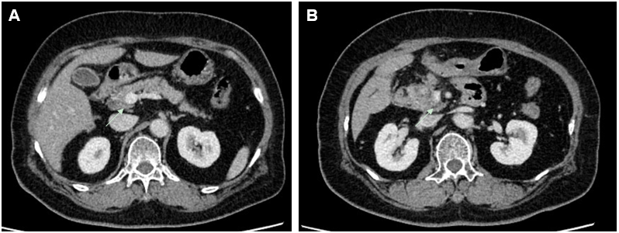
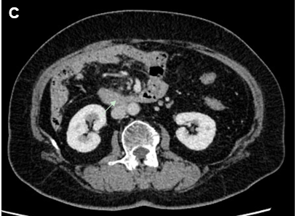
Figure 1 Computed tomography shows that superior mesenteric vein is violated by the mass in the pancreatic head (arrows). A: Above the superior mesenteric vein; B: The superior mesenteric vein is violated by the mass; C: Below the superior mesenteric vein.
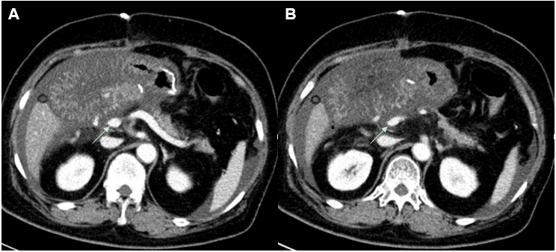
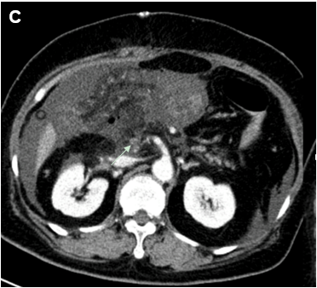
Figure 2 Computed tomography shows stenosis of the superior mesenteric vein in the region of the anastomosis (arrows). A: Above the stenosis site; B: Stenosis of the superior mesenteric vein; C: Occlusion of the superior mesenteric vein.

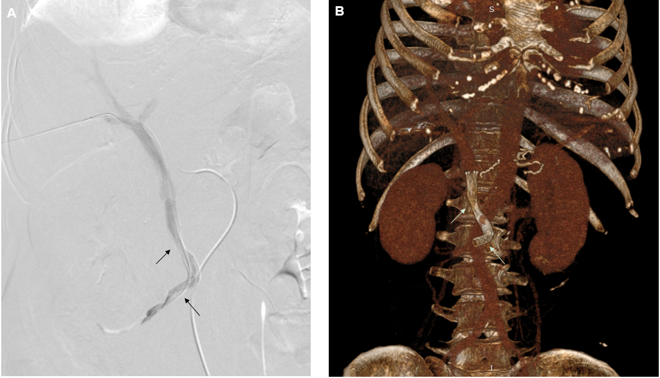
Figure 3 Percutaneous transhepatic direct portography showing improved stenosis after placement of two stents (arrows). A: Digital subtraction angiography of portal vein; B: Volume rendering images showing stents in superior mesenteric vein/portal vein. Stent parameters: Upper arrow: 8 mm × 50 mm, coated; lower arrow: 8 mm × 60 mm, uncoated.

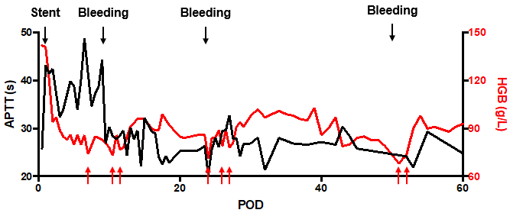
Figure 4 Activated partial thromboplastin time and hemoglobin profiles after surgery. Black arrows indicate stent placement or bleeding, and anticoagulation goal is therefore adjusted. Red arrows indicated red blood cell transfusion due to anemia. APTT: Activated partial thromboplastin time; HGB: Hemoglobin; POD: Postoperative day.

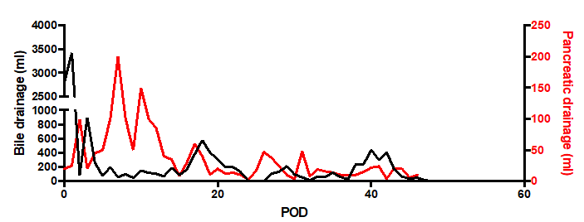
Figure 5 The postoperative drainage volume of two operative drains placed close to the bilioenteric anastomosis and the pancreaticojejunal anastomosis respectively. POD: Postoperative day.

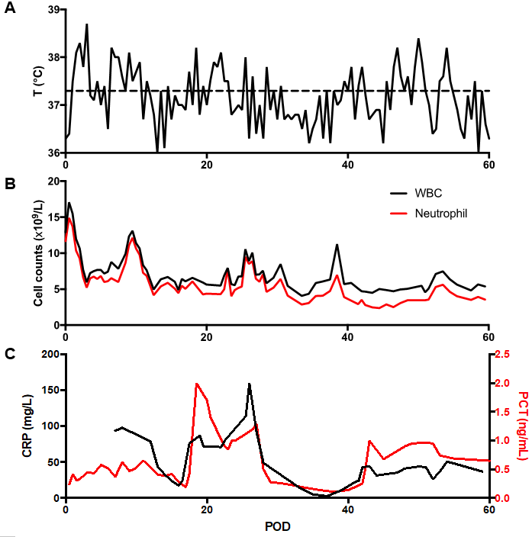
Figure 6 Temperature, white blood cell and neutrophil, and inflammatory markers profiles after surgery. A: Temperature; B: White blood cell and neutrophil; C: Inflammatory markers. WBC: White blood cell; PCT: Procalcitonin; POD: Postoperative day; CRP: C-reactive protein.

