Name of Journal: World Journal of Clinical Cases
Manuscript NO: 56263
Manuscript Type: CASE REPORT

Thrombus straddling a patent foramen ovale and pulmonary embolism: A case report

Huang YX et al. Thrombus stradding a PFO

Yi-Xiong Huang, Yu Chen, Yi Cao, Yi-Gang Qiu, Jian-Yong Zheng, Tian-Chang Li

Yi-Xiong Huang, Yu Chen, Yi Cao, Yi-Gang Qiu, Jian-Yong Zheng, Tian-Chang Li, Department of Cardiology, Sixth Medical Center of PLA General Hospital, Beijing 100048, China

Author contributions: Each author has contributed significantly to the submitted work. Huang YX and Cao Y were in charge of this patient; Qiu YG placed inferior vena cava filter for the patient. Huang YX drafted the manuscript; Chen Y and Zheng JY revising it critically for important intellectual content; Li TC, the corresponding author of this manuscript, finally approved the manuscript submitted; all authors have read and approve the final manuscript.

Supported by The Application of Clinical Features of Capital City of Science and Technology Commission China Beijing Special Subject, No. Z151100004015205.

Corresponding author: Tian-Chang Li, MD, PhD, Chief Physician, Department of Cardiology, Sixth Medical Center of PLA General Hospital, No. 6 Fucheng Road, Beijing 100048, China. ltc909@163.com

Received: April 23, 2020
Revised: August 20, 2020
Accepted: September 9, 2020
Published online: October 26, 2020

Abstract
BACKGROUND
Venous thromboembolism is a common vascular syndrome presenting as deep vein thrombosis and/or pulmonary embolism. Thrombus has the possibility of immigrating into left circulation via patent foramen ovale in certain extreme circumstances. Thrombus straddling a patent foramen ovale is a direct evidence of this scenario. However, the confirmed cases of thrombus in transit are still rare.

CASE SUMMARY
A 32-year-old man suffered from recurrent syncope and intermittent dyspnea for one week. Transthoracic echocardiography confirmed a thrombus straddling patent foramen ovale, and thrombi were also found in the bilateral pulmonary artery by computed tomography. The man underwent inferior vena cava filter placement and thrombolysis with alteplase. Echocardiography showed the absence of thrombi in both the right atrium and left atrium two days after hospitalized. The man discharge home on warfarin without any complication two weeks later.

CONCLUSION
Scrutinizing intracardiac thrombi provides measurable value in pulmonary embolism, as closure of patent foramen ovale may be considered in certain patients. Early intervention plays a critical role in thrombus straddling patent foramen ovale. A sedentary lifestyle may predispose young adults to thromboembolism, even if there are no other risk factors.

Key words: Thrombus; Patent foramen ovale; Pulmonary embolism; Case report

Citation: Huang YX, Chen Y, Cao Y, Qiu YG, Zheng JY, Li TC. Thrombus straddling a patent foramen ovale and pulmonary embolism: A case report. World J Clin Cases 2020; 8(20): 4902-4907
URL: https://www.wjgnet.com/2307-8960/full/v8/i20/4902.htm
DOI: https://dx.doi.org/10.12998/wjcc.v8.i20.4902

Core Tip: Thrombus straddling a patent foramen ovale is a life-threatening condition which is usually complicated with pulmonary embolism. We present a rare case of deep venous thrombosis, concomitant with pulmonary embolism and transient ischemic attack. Transthoracic echocardiography revealed a large thrombus straddling patent foramen ovale. There was no significant predisposing factor for thromboembolism except the sedentary lifestyle on the young patient. This case highlights the crucial role of echocardiography in a patient with pulmonary embolism. Identifying intracardiac thrombi may modify the strategies of thromboembolic disease. Moreover, a vigorous lifestyle should be recommended for avoiding thrombotic disaster among young adults.

INTRODUCTION
Venous thromboembolism (VTE), clinically presenting as deep vein thrombosis (DVT) or pulmonary embolism (PE) is a common vascular syndrome. Thrombus in transit can cause pulmonary embolism and paradoxical embolism, result in severe clinical outcomes. There is a link between paradoxical embolism and cryptogenic stroke^{[1]}, and patent foramen ovale (PFO) plays a crucial role in this scenario. Echocardiography can detect PFO, which is a major cause of cryptogenic stroke. Therefore screening PFO should be considered among patients diagnosed with pulmonary embolism.
The treatment of the thrombus in transit including anticoagulation, reperfusion therapy, surgical embolectomy, venous filters and hemodynamic and respiratory support if necessary^{[2]}. We present a case of a young man suffered from thrombus straddling PFO and submassive pulmonary embolism simultaneously. The patient received thrombolysis with alteplase and recovered soon without any complication.

CASE PRESENTATION
Chief complaints
A 32-year-old man presented to the emergency room with repetitive episodes of syncope and intermittent dyspnea within seven days.

History of present illness
The patient complained of chest distress on February 15, 2019. Then he had a transient, self-limited loss of consciousness lasting for 3-5 min, followed by prompt recovery. The syncope happened 4 times. The trigger of the attacks included physical exertion or inhaling cold air. There is no prodromal or accompanied symptom. He went to our hospital by himself on February 22, 2019 because of another onset of syncope.

History of past illness
The patient had no medical history, nor family history of blood clotting disorders, but he had a sedentary lifestyle due to his job as a news editor.

Physical examination
His vital signs were stable at the time of the first medical contact. Physical examination results were as follows: Pulse rate: 96 beats/min, respiratory rate: 20 breaths/min, blood pressure: 15.5/10.1 kpa, body mass index: 23.1 kg/m², pupils are symmetric and responsive to light, prominent P2, symmetrical breath sounds without rales or wheezing, warm extremities without edema. The neurological examination was negative.

Laboratory examinations
Initial laboratory test showed elevated serum D-dimer at 4150 ng/mL (reference < 500 ng/mL). Arterial blood gas analysis showed PaO₂, 79 mmHg while he was breathing ambient air. N-terminal pro-B-type natriuretic peptide was 4460 pg/mL (reference < 450 pg/mL). The levels of serum cardiac enzyme series were normal.

Imaging examinations
The electrocardiogram showed sinus tachycardia. Doppler-ultrasound revealed a deep venous thrombosis in the right popliteal vein (Figure 1). Transthoracic echocardiography showed a mass thrombus straddling a patent foramen ovale concomitant dilated right atrium and moderate pulmonary hypertension (Figure 2). The size of the thrombus was 3 mm × 20 mm in the left atrium, 8 mm × 25 mm in the right atrium. Computed tomography angiography confirmed bilateral peripheral pulmonary embolism (Figures 3 and 4). The brain computed tomography scan was normal.

FINAL DIAGNOSIS
Thrombus straddling PFO. Pulmonary embolism. Deep vein thrombosis.

TREATMENT
Given the risk of detachment of the thrombus from the right popliteal vein, inferior vena cava filter was placed immediately. Then the patient received thrombolysis with intravenous alteplase (100 mg over 2 h) and subcutaneous injection with enoxaparin (60 mg/12 h). Bedside transthoracic echocardiography (TTE) showed the absence of clot in the right and left atrium two days later. The inner diameter of the right heart chamber was also returned to normal.
Considered that there was no significant predisposing factor for the young patient, the thrombophilic screen was sent off. Antithrombin III, protein S, protein C were normal. Urine albumin was negative. Blood tests also ruled out autoimmune diseases. Dynamic electrocardiogram (Holter) showed no evidence of atrial fibrillation. The patient denied any medical history of trauma, surgery, cancer, drug abuse, long flight or dehydration. Therefore we speculated the sedentary lifestyle may be the major cause of the disease.
The inferior vena cava filter was removed on March 7, 2019. The patient was discharged home on warfarin the next day.

OUTCOME AND FOLLOW-UP
The patient recovered quickly without any complications. Percutaneous closure of PFO was recommended, but the patient refused further interventional treatment. The patient followed the recommendation of exercise, such as jogging or swimming, five sessions per week, lasting on average 30 min/session, and involving moderate-to-vigorous intensity physical activity. Moreover, the patient was told not to stay up late at night and maintain a good mentality. He returned to his country two months later. One year follow-up by WeChat shows that there is no recurrent thromboembolic event without anticoagulation therapy.

DISCUSSION
VTE, encompasses DVT and PE, is the third most frequent acute cardiovascular syndrome behind myocardial infarction and stroke^{[3]}. The incidence rate of VTE range from 115 to 269 per 100000 population^{[4]}. VTE may be lethal in acute phase or lead to chronic disease and disability. The predisposing factor of VTE include hereditary disease and environmental factors. The patient was healthy before. Body mass index indicated that he was far from obesity. Laboratory examination ruled out autoimmune disease, nephrotic syndrome and hereditary coagulation disease. Furthermore, the patient was too young to be thrombophilic, the mean age of patients with trapped thrombus in PFO is 59.3 ± 16.4 years^{[5]}. Nevertheless, the patient used to sit for a long time and burn the midnight oil as a news editor which is a stressful job as he described. This may have predisposed him to develop spontaneous lower extremity DVT formation and subsequent thrombus straddling patent foramen ovale accompany with acute submassive pulmonary embolism. Besides, there was another possibility that the thrombus originated from PFO itself due to the special structure which can accelerate the blood flow. Since the DVT was confirmed, the diagnosis of thrombus in transit was our priority.
Thrombus in transit not only affects cerebrovascular but also migrates to other arteries. Wąsek et al^{[6]} reported a case of ST-segment–elevation myocardial infarction related to paradoxical embolization. Santangelo et al^{[7]} presented a patient diagnosed with PE complicated by right renal ischemia and multiple splenic infarcts due to a mobile thrombus entrapped in a patent foramen ovale. Thus, it is necessary to pay attention to left circulation thromboembolism while unexplained organ damage happened.
PFO is a frequent finding on echocardiography and occurs in about 25% of the population^{[8,9]}. The presence of a PFO is implicated in the pathogenesis of cryptogenic stroke^{[10]}, the mechanism of which has been attributed to the paradoxical embolism of venous thrombi that shunt through the PFO while right atrial pressure is high. However, the diagnosis of paradoxical embolism is generally presumptive, mainly relied on the speculation of the physicians. The case we describe above provided direct evidence of thrombus pass through PFO, which definitely confirmed the paradoxical embolism. Therefore, screening PFO with echocardiography seems to be plausible among patients diagnosed with PE. Since the detection rate of two-dimensional echocardiography is low, contrast-transesophageal echocardiography or contrast-enhanced transcranial doppler should be taken into consideration^{[11]}.
Theoretically speaking, patients with PFO and paradoxical embolism should be benefit from closure of PFO. But the evidence of PFO closure used to be controversial. RESPECT study showed that there was no significant benefit associated with closure of PFO in adults who had a cryptogenic ischemic stroke^{[12]}. Nevertheless, long-term follow-up revealed a lower rate of recurrent ischemic strokes in patients who received PFO closure than medical therapy alone^{[13]}. A meta-analysis also showed patients with PFO and cryptogenic stroke benefit from percutaneous closure in preventing future stroke compared to medical therapy^{[14]}. Given that the patient was diagnosed with PFO and transient ischemic attack, percutaneous closure PFO was suggested. However, he turned down the suggestion due to the concern about the complications of the surgery. The patient follows the advice of regular exercise. The long-term outcomes will be investigated by our heart team.
The therapeutic strategies of thrombus straddling PFO including hemodynamic stabilization, respiratory support, filter implantation, anticoagulation, thrombolysis, and thrombectomy. Since there is no guideline for the treatment of thrombus in transit, strategies should be personalized according to the patient’s symptomology, hemodynamic stability, current clinical evidences, physician’s decision and patient’s intention. Initial shock or arrest were found nearly 40% of the cases with trapped thrombus in PFO^{[5]}. Extracorporeal membrane oxygenation plays a significant role in rescuing patients with PE complicating hemodynamic instability^{[15]}. The systematic review showed that thrombectomy was associated with a lower overall incidence of post-treatment embolic events and a lower 60-d mortality in patients with trapped thrombus in a PFO^{[5]}. Our patient fully recovered by filter placement and thrombolytics quickly. Thus conservative treatment with thrombolytics should be emphasized on the young group, and therefor invasive strategies may be avoided in clinical practice. Although our patient did not accept the PFO closure, we will keep an eye on the long-term outcome of him since the precipitating factor was removed.

CONCLUSION
Thrombus straddling a PFO is a rare but severe clinical circumstance, which is always complicating with PE. Screening PFO with echocardiography should be considered among patients diagnosed with PE. The patient we describe above provides direct evidence of paradoxical embolism. Moreover, a vigorous lifestyle should be recommended for avoiding thrombotic disaster among young adults.

REFERENCES
1 Fonseca AC, Ferro JM. Cryptogenic stroke. Eur J Neurol 2015; 22: 618-623 [PMID: 25597418 DOI: 10.1111/ene.12673]
2 Konstantinides SV, Meyer G, Becattini C, Bueno H, Geersing GJ, Harjola VP, Huisman MV, Humbert M, Jennings CS, Jiménez D, Kucher N, Lang IM, Lankeit M, Lorusso R, Mazzolai L, Meneveau N, Áinle FN, Prandoni P, Pruszczyk P, Righini M, Torbicki A, Van Belle E, Zamorano JL; The Task Force for the diagnosis and management of acute pulmonary embolism of the European Society of Cardiology (ESC). 2019 ESC Guidelines for the diagnosis and management of acute pulmonary embolism developed in collaboration with the European Respiratory Society (ERS): The Task Force for the diagnosis and management of acute pulmonary embolism of the European Society of Cardiology (ESC). Eur Respir J 2019; 54: [PMID: 31473594 DOI: 10.1183/13993003.01647-2019]
3 Raskob GE, Angchaisuksiri P, Blanco AN, Buller H, Gallus A, Hunt BJ, Hylek EM, Kakkar A, Konstantinides SV, McCumber M, Ozaki Y, Wendelboe A, Weitz JI; ISTH Steering Committee for World Thrombosis Day. Thrombosis: a major contributor to global disease burden. Arterioscler Thromb Vasc Biol 2014; 34: 2363-2371 [PMID: 25304324 DOI: 10.1161/ATVBAHA.114.304488]
4 Wendelboe AM, Raskob GE. Global Burden of Thrombosis: Epidemiologic Aspects. Circ Res 2016; 118: 1340-1347 [PMID: 27126645 DOI: 10.1161/CIRCRESAHA.115.306841]
5 Seo WW, Kim SE, Park MS, Lee JH, Park DG, Han KR, Oh DJ. Systematic Review of Treatment for Trapped Thrombus in Patent Foramen Ovale. Korean Circ J 2017; 47: 776-785 [PMID: 28955396 DOI: 10.4070/kcj.2016.0295]
6 Wąsek WC, Samul W, Ryczek R, Skrobowski A. Unique case of ST-segment-elevation myocardial infarction related to paradoxical embolization and simultaneous pulmonary embolization: clinical considerations on indications for patent foramen ovale closure in no-guidelines land. Circulation 2015; 131: 1214-1223 [PMID: 25825398 DOI: 10.1161/CIRCULATIONAHA.114.009846]
7 Santangelo G, Ielasi A, Pattarino F, Saino AT, Scopelliti PA, Tespili M. Pulmonary embolism with migrating thrombus through patent foramen ovale: A case for a mixed pharmacological and percutaneous management. J Cardiol Cases 2019; 19: 19-21 [PMID: 30693053 DOI: 10.1016/j.jccase.2018.08.007]
8 Hoffman JI, Kaplan S. The incidence of congenital heart disease. J Am Coll Cardiol 2002; 39: 1890-1900 [PMID: 12084585 DOI: 10.1016/s0735-1097(02)01886-7]
9 Hagen PT, Scholz DG, Edwards WD. Incidence and size of patent foramen ovale during the first 10 decades of life: an autopsy study of 965 normal hearts. Mayo Clin Proc 1984; 59: 17-20 [PMID: 6694427 DOI: 10.1016/s0025-6196(12)60336-x]
10 Mojadidi MK, Zaman MO, Elgendy IY, Mahmoud AN, Patel NK, Agarwal N, Tobis JM, Meier B. Cryptogenic Stroke and Patent Foramen Ovale. J Am Coll Cardiol 2018; 71: 1035-1043 [PMID: 29495983 DOI: 10.1016/j.jacc.2017.12.059]
11 Mahmoud AN, Elgendy IY, Agarwal N, Tobis JM, Mojadidi MK. Identification and Quantification of Patent Foramen Ovale-Mediated Shunts: Echocardiography and Transcranial Doppler. Interv Cardiol Clin 2017; 6: 495-504 [PMID: 28886841 DOI: 10.1016/j.iccl.2017.05.002]
12 Carroll JD, Saver JL, Thaler DE, Smalling RW, Berry S, MacDonald LA, Marks DS, Tirschwell DL; RESPECT Investigators. Closure of patent foramen ovale vs medical therapy after cryptogenic stroke. N Engl J Med 2013; 368: 1092-1100 [PMID: 23514286 DOI: 10.1056/NEJMoa1301440]
13 Saver JL, Carroll JD, Thaler DE, Smalling RW, MacDonald LA, Marks DS, Tirschwell DL; RESPECT Investigators. Long-Term Outcomes of Patent Foramen Ovale Closure or Medical Therapy after Stroke. N Engl J Med 2017; 377: 1022-1032 [PMID: 28902590 DOI: 10.1056/NEJMoa1610057]
14 Dahal K, Yousuf A, Watti H, Liang B, Sharma S, Rijal J, Katikaneni P, Modi K, Tandon N, Azrin M, Lee J. Who benefits from percutaneous closure of patent foramen ovale vs medical therapy for stroke prevention? In-depth and updated meta-analysis of randomized trials. World J Cardiol 2019; 11: 126-136 [PMID: 31110604 DOI: 10.4330/wjc.v11.i4.126]
15 Ayaon Albarrán A, Pérez Chulia N, Meca Aguirrezabalaga J, Blázquez González JA. Thrombus straddling a patent foramen ovale and massive pulmonary embolism: Venous arterial extracorporeal membrane oxygenation as a valuable support tool. J Card Surg 2019; 34: 867-870 [PMID: 31233236 DOI: 10.1111/jocs.14123]

Footnotes
Informed consent statement: Written informed consent was obtained from the patient for publication of this report and accompanying images.

Conflict-of-interest statement: Nothing to disclose.

CARE Checklist (2016) statement: The authors have read the CARE Checklist (2016), and the manuscript was prepared and revised according to the CARE Checklist (2016).

Open-Access: This article is an open-access article that was selected by an in-house editor and fully peer-reviewed by external reviewers. It is distributed in accordance with the Creative Commons Attribution NonCommercial (CC BY-NC 4.0) license, which permits others to distribute, remix, adapt, build upon this work non-commercially, and license their derivative works on different terms, provided the original work is properly cited and the use is non-commercial. See: http://creativecommons.org/Licenses/by-nc/4.0/

Manuscript source: Unsolicited manuscript

Peer-review started: April 22, 2020
First decision: August 8, 2020
Article in press: September 9, 2020

Specialty type: Cardiac and cardiovascular systems
Country/Territory of origin: China
Peer-review report’s scientific quality classification
Grade A (Excellent): 0
Grade B (Very good): 0
Grade C (Good): C
Grade D (Fair): D
Grade E (Poor): 0

P-Reviewer: Inoue K, Schoenhagen P S-Editor: Wang DM L-Editor: A P-Editor: Wang LL

Figure Legends
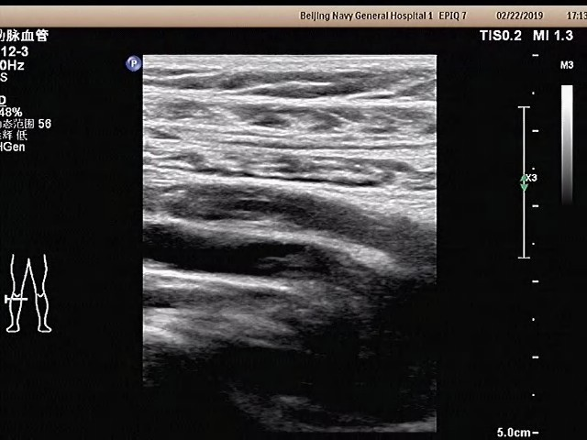
Figure 1 Doppler-ultrasound revealed a deep venous thrombosis in the right popliteal vein.

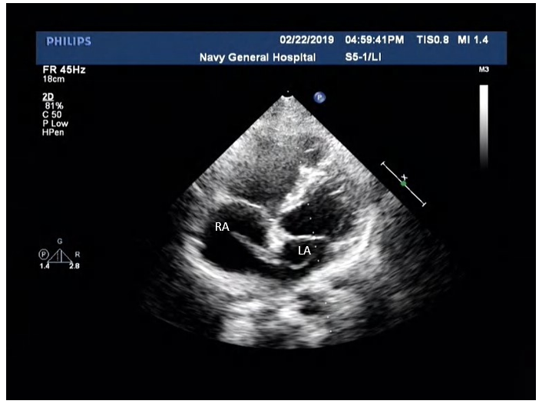
Figure 2 Transthoracic echocardiography showed a mass thrombus straddling a patent foramen ovale (3 mm × 20 mm in the left atrium, 8 mm × 25 mm in the right atrium). RA: right atrium; LA: left atrium.

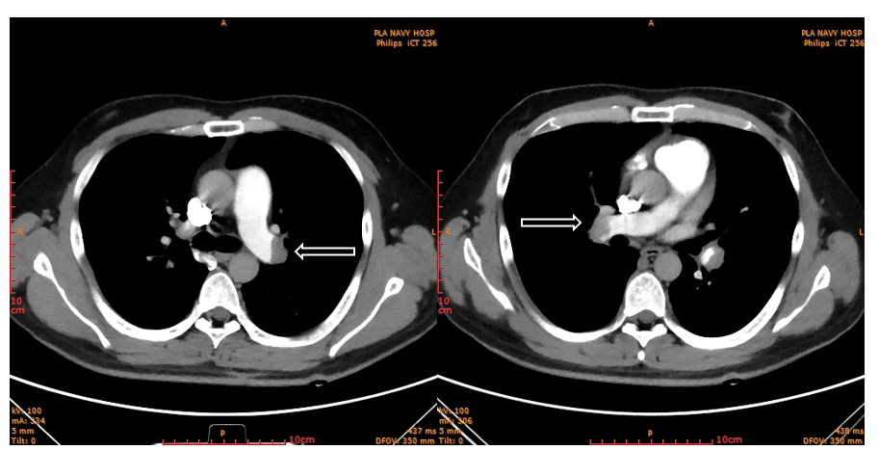
Figure 3 Computed tomography angiography confirmed bilateral pulmonary embolism.

