Name of Journal: World Journal of Clinical Cases
Manuscript NO: 79170
Manuscript Type: CASE REPORT

Hybrid intercalated duct lesion of the parotid: A case report

Stankevicius D et al. Hybrid intercalated duct lesion

Dominykas Stankevicius, Donatas Petroska, Linas Zaleckas, Otilija Kutanovaite

Dominykas Stankevicius, Linas Zaleckas, Centre of Oral and Maxillofacial Surgery, Institute of Dentistry, Faculty of Medicine, Vilnius University, Vilnius LT-08217, Lithuania

Donatas Petroska, Department of Pathology, Forensic Medicine and Pharmacology, Institute of Biomedical Sciences, Faculty of Medicine, Vilnius University, Vilnius LT-03101, Lithuania

Otilija Kutanovaite, Department of Head and Neck Surgery and Oncology, National Cancer Institute, Vilnius LT-08660, Lithuania

Author contributions: Kutanovaite O performed the surgery, took the photographs, and revised the manuscript; Stankevicius D collected the available literature and wrote the manuscript; Petroska D performed the microscopic examination and wrote the histopathological part; Zaleckas L performed the ultrasound guided biopsy and critically revised the manuscript; All authors contributed to the discussion and approved final manuscript.

Corresponding author: Dominykas Stankevicius, MD, Surgeon, Centre of Oral and Maxillofacial Surgery, Institute of Dentistry, Faculty of Medicine, Vilnius University, Zalgirio g. 117, Vilnius LT-08217, Lithuania. dominykas.st@gmail.com

Received: August 8, 2022
Revised: September 10, 2022
Accepted: October 13, 2022
Published online:

Abstract
BACKGROUND
Intercalated duct lesions (IDLs) are considered relatively benign and rare tumors of salivary glands, that were only described recently. Their histopathological appearance may range from ductal hyperplasia to encapsulated adenoma with hybrid patterns of both variants. It is thought that IDLs may be the precursor for malignant proliferations, therefore their correct diagnosis remains crucial for proper lesion management. It is the first reported IDL case arising from the accessory parotid gland (APG), which stands for less frequent but higher malignancy rate tumor developmental area.

CASE SUMMARY
A 24-years-old male with no accompanying diseases was referred to the hospital with a painless nodule on the right cheek. On physical examination, the stiff, immobile, and painless mass was palpable in the anterior portion of the right parotideomasseteric region, just superior to the parotid duct. Ultrasound examination demonstrated 1.5 cm × 1.0 cm hypoechogenic mass on the anterior part of the right parotid gland. Ultrasound-guided fine needle aspiration cytology, followed by liquid-based fine needle aspiration biopsy were performed. However, the results were uninformative. A contrast-enhanced magnetic resonance imaging (MRI) of the parotid was obtained, demonstrating a 1.5 cm × 1.0 cm × 0.5 cm tumor with high intensity capsule together with low intensity core in the very anterior part of right superficial lobe, situated in the APG. An MRI features were uncharacteristic to common parotid tumors, therefore surgical resection followed up. After histopathological examination, the final diagnosis of hybrid IDL was confirmed.

CONCLUSION
Fine needle aspiration biopsy might not always be diagnostic, and given the malignant potential, the surgical resection of such lesion remains the treatment of choice.

Key Words: Intercalated duct lesion; Accessory parotid gland; Intercalated duct adenoma; Intercalated duct hyperplasia; Salivary gland; Case report

Stankevicius D, Petroska D, Zaleckas L, Kutanovaite O. Hybrid intercalated duct lesion of the parotid: A case report. World J Clin Cases 2022; In press

Core Tip: In this article we present a clinical case of a patient diagnosed with a hybrid intercalated duct lesion (IDL) tumor of the accessory parotid gland. It is the first reported IDL case arising from such location, which stands for less frequent but higher malignancy rate tumor developmental area. We also discuss potential diagnostic pitfalls associated with unusual growth site, describe the further treatment choice, and review the available literature.

INTRODUCTION
Intercalated duct lesions (IDLs) are considered relatively benign and rare tumors of salivary glands, that were only described recently. According to the largest IDL study to date, in most cases they present as asymptomatic, up to a centimeter in diameter parotid gland nodules with a female to male ratio of 1.7:1^{[1]}. IDL histopathological appearance may range from intercalated duct hyperplasia (IDH) to encapsulated intercalated duct adenoma (IDA) with hybrid patterns^{[1]}. The pathogenesis of IDL is still not well established, nonetheless the links to chronic sialadenitis, sialolithiasis, gland atrophy and radiation therapy are documented^{[2]}. It is suggested that IDLs may be the precursor lesion for neoplastic proliferations such as basal cell adenoma (BCA) or even epithelial-myoepithelial carcinoma (EMC) when present in the parotid gland^{[3,4]}. However, due to a low incidence, the data regarding such lesions remains limited and the disorder is not widely recognized by clinicians and pathologists.
We report a clinical case of a 24-years-old male patient with a tumor of hybrid pattern IDL originating from the accessory parotid gland (APG). To our knowledge, it is the first report of the IDL arising in a such location. Moreover, here we discuss potential diagnostic pitfalls associated with unusual growth area and further treatment choice.

CASE PRESENTATION
Chief complaints
A 24-years-old smoker male with no accompanying diseases was referred to The National Cancer Institute with a painless nodule on the right cheek, which he stated as having been present for 6 mo.

History of present illness
The palpable mass was present for 6 mo with no evidence of growth.

History of past illness
No previous history of head and neck trauma, sialadenitis, sialolithiasis, oncological disease, or radiotherapy was noted.

Personal and family history
The patient was a smoker with no accompanying diseases. Family history was unremarkable.

Physical examination
On physical examination, the mass was palpable in the anterior portion of the right parotideomasseteric region, just superior to the parotid duct. The nodule was stiff, immobile, and painless on palpation. The skin above it remained unaffected.

Imaging examinations
Ultrasound examination demonstrated 1.5 cm × 1.0 cm hypoechogenic mass on the anterior part of the right parotid gland, laying on the surface of masseter muscle with no signs of inflammation, and slightly enlarged submandibular lymph nodes. Ultrasound-guided fine needle aspiration cytology, followed by liquid-based fine needle aspiration biopsy were performed. However, the results came out uninformative. A contrast-enhanced magnetic resonance imaging (MRI) of the parotid was obtained. T2-weighted image demonstrating a well encapsulated 1.5 cm × 1.0 cm × 0.5 cm tumor with high-intensity signal capsule together with low-intensity signal core in the very anterior part of the parotideomasseteric region (Figure 1A). A contrast-enhanced T1-weighted image showed a contrast accumulating core and no clear contrast accumulation in the capsule (Figure 1B). MRI, performed for other reasons 4 years prior to the present disease onset, did not show any evidence of tumor presence. The well-defined margined and encapsulated mass prompted of benign pleomorphic adenoma, however hyperintense capsule and submandibular lymphadenopathy were uncharacteristic features, therefore surgical resection followed up.

FINAL DIAGNOSIS
Tumor of the right APG, which after surgical resection and histopathological examination was confirmed as hybrid form of IDL.

TREATMENT
Right facelift skin incision was performed, and the skin flap was raised through the subcutaneous dissection then separated from the superficial musculoaponeurotic system reaching the anterior portion of the parotid gland. The great auricular nerve was identified and preserved. The anterior border of the parotid gland was reached using Colorado microdissection needle (Stryker Craniomaxillofacial). The tumor was identified between two buccal facial nerve branches (Figure 2A) originating at the very anterior portion of the parotideomasseteric region, separately from the main parotid gland. The mass was found lying above the masseter muscle superior to the Stensen duct, suggesting that the tumor’s origin was the APG. Using surgical loupes, extracapsular dissection of the tumor was performed, sparing both buccal branches of the facial nerve. The surgical resection cavity was visible over imprinted masseter muscle fibers (Figure 2B). The Penrose drain was placed, and the wound was closed in a two-layer manniere. Further, the pathological specimen was sent to the National Center of Pathology for histopathological evaluation (Figure 2C). No signs of facial nerve palsy or weakness were visible postoperatively. The patient was discharged home on the 3rd postoperative day after full control of pain and edema. Sutures were removed 7th day postoperatively.

OUTCOME AND FOLLOW-UP
On gross examination, the specimen revealed a circumscribed fatty appearance. Microscopically in slides made from the formalin fixed paraffin embedded tissue cut and stained with hematoxylin/eosin, the lesion was a 15 mm × 10 mm nodule of regular border composed by a partially encapsulating thin layer of fibrous tissue. In longitudinal sections, the lesion was composed of numerous small tubules surrounded by a large amount of adipose tissue (Figure 3A). The epithelial component contained no acinar cells and lacked evidence of infiltrative growth. The tubules were surrounded by a collagenous membrane and consisted of two cell layers: Cuboidal ductal cells (with small round, cytologically bland nuclei and with pale amphophilic cytoplasm) and myoepithelial cells with elongated nuclei (Figure 3B). There was evidence of fibrosis, periductal hyalinization and focal periductal chronic inflammation within the tumor (Figure 3C). No accumulations of amyloid (by staining with Kongo Red method) or fungi (by staining with periodic acid shift method) were found.
All microscopic criteria support a conclusion of the salivary gland IDL with hybrid features due to a partially round, thinly encapsulated adenoma-like appearance and irregular hyperplasia-like areas of benign tubules with abundant intervening stroma.
The patient was requested for follow-up visit after 6 mo and 1 year post surgery. No recurrence or metastasis of the disease were found, and the surgical scar was fully healed and barely visible.

DISCUSSION
IDLs are rare salivary gland tumors that are usually detected in major salivary glands with a dominant location of the parotid gland. However, the incidence rate of IDL is low, therefore the data regarding such lesions remains limited: Only case reports and case series were published up to this date, since the first printed case in 1994^{[5]}. While healthy salivary gland epithelial tissue consists of acinar cells and ductal components that are divided into excretory, striated, and intercalated, the IDL in turn is the abnormal proliferation of intercalated ducts. The architectural appearance of IDL may range from IDH to IDA or hybrid patterns of both variants^{[1]}. Histologically IDH is characterized as the unencapsulated proliferation of intercalated ducts that interpose into the surrounding salivary gland parenchyma. In contrast, IDA has well defined fibrous capsule that separates them from the healthy salivary gland tissue. The hybrid pattern, as the name suggests, has both IDH and IDA structural properties, containing irregular and thinly encapsulated margins and intervening stroma. According to the study, conducted by Weinreb et al^{[1]}, the hybrid pattern stands for the least common finding (4 cases) followed by IDA (9 cases) and IDH (15 cases)^{[1]}.
It is important to emphasize the malignancy potential of such lesions and their association with other salivary gland tumors. In the research of Montalli et al^{[4]} the tubular variant of BCA showed IDL-like areas with closely apposed ducts. In both, the immunoprofile of luminal and myoepithelial cells were reminiscent of intercalated ducts, with the only difference of greater quantity of myoepithelial cells in BCA. Therefore, they stated that IDLs are closely related to tubular BCA and at least some BCAs can arise from IDLs. In the already mentioned study of Weinreb et al^{[1]}, the most obvious connection of IDL was seen with EMC and BCA. They concluded that IDL might be a precursor lesion of these neoplasms. However, all of EMC and BCA cases seemed to be arising from IDH and hybrid forms of IDL, while IDA alone did not provoke above mentioned malignancies. Such relation, specifically of hyperplasia of intercalated ducts, was noticed in a few other papers. Chetty^{[3]} found IDH zones in 3 of 7 EMC cases. Since the proliferating intercalated ducts were in close proximity to EMC and to the case containing mucoepidermoid carcinoma, the author stated that IDH may be a precursor lesion for both EMC and “hybrid” carcinomas. In a paper by Di Palma^{[5]}, the transition of IDH to EMC was captured. The overgrowth of myoepithelial cells which infiltrated the surrounding stroma in the area where proliferating intercalated ducts merged with surrounding acini was noticed. In the case presented here, the thinly encapsulated and well-defined primary hybrid IDL tumor did not show any signs of potential malignant transformations on a histopathological basis. However, the possible neoplastic links between IDLs and other neoplasms remain poorly explored and demand further investigation.
The results of IDL immunohistochemical and genetic analyses were discussed in the recently published paper by Kusafuka et al^{[6]}. They support the theory that IDL is the “sprout” lesion of BCA or basal cell adenocarcinoma rather than EMC due to its immunohistochemical profile and missense mutation in the CTNNB1 gene. Even though no specific marker for intercalated ducts has yet been found, some authors consider intercalated duct-related molecules. SRY-Box Transcription Factor 10 (SOX10) molecule expression was positive in acinic cell carcinoma, adenoid cystic carcinoma, EMC and myoepithelioma, therefore their intercalated duct origins were suggested^{[7]}. Chênevert et al^{[8]} surveyed the expression of anoctamin-1 (DOG1) in human salivary tissues and tumors. The DOG1 was found positive in IDA and IDH as a precursor lesion for secretory adenoma, EMC, and cystadenoma.
The data regarding the epidemiology of this lesion is scarce, most likely due to its’ low incidence and usually small, undetectable tumor size. According to the largest study to date, describing a total of 32 IDL cases, the female to male sex ratio was 1.7:1 (19 women, 11 men, 2 unknown) and the mean age during diagnosis was 53.8 years^{[1]}. We have found two other similar papers that report IDL cases originating from the parotid gland as hyperplastic and hybrid forms^{[9,10]}. Mok et al^{[9]} reported a hybrid form of parotid gland IDL where such lesion for the first time was detected by fine needle aspiration biopsy. They also forewarn potential differential diagnostic pitfalls associated with varied architectural features proposing its’ special awareness during microscopic evaluation. In our case, however, the fine needle aspiration biopsy findings were uninformative, thus the final diagnosis was confirmed after excision and histopathological analysis. Another paper presented an IDH case, that was similarly diagnosed after superficial parotidectomy before non-diagnostic results of the biopsy^{[10]}. Taking into account that biopsy results can be rarely informative, we believe, surgical consideration is decisive, since there is a likelihood of potential malignization and the correct diagnosis is crucial for proper lesion management.
The developmental location of IDL is usually in the parotid gland (82%) with only a few described exceptions in the submandibular gland (12%) and oral cavity (6%)^{[1]}. In this report we present a case of IDL of hybrid type originated from the APG. Based on the literature, APG anatomical variation stands for 21%–56% of the population^{[11,12]}. Moreover, tumors originating from accessories are even less common – only 1%–7.7% of all parotid gland tumors^{[13,14]}. On the other hand, they stand for higher malignancy rate tumors, ranging from 26% to 50%, compared to main parotid gland neoplasms^{[13,15]}. The recently appeared article states that out of 792 parotid gland tumors, only 13 (1.64%) arise from APG^{[16]}. Pleomorphic adenoma was the most common histological subtype (53.8%), followed by benign myoepithelioma (7.5%), malignant mucoepidermoid carcinoma (23.1%), carcinoma ex pleomorphic adenoma (7.5%) and adenoid cystic carcinoma (7.5%). Early studies have noticed the impact of chronic sialadenitis, sialolithiasis, gland atrophy and radiation therapy on the development of such lesions^{[2]}. Interestingly, our patient was not associated with any of these factors. It should be noted that no evidence of tumor presence was visible in the MRI scan, performed 4 years prior to lesion onset. Therefore, we presume that IDL might be a relatively fast-growing tumor. According to another report, the nodule was palpable for only 1 mo until administration to the hospital^{[10]}. This feature should draw special clinician attention as it may warn a malignant process. To our knowledge, this is the first reported case of IDL originating from APG. We also believe such location causes differential diagnostic challenges and should include neoplasms in the mid-cheek region. This caution is supported by Koudounarakis et al^{[17]} case where APG tumor was misdiagnosed as glomus tumor.

CONCLUSION
We presented a case of a hybrid form of IDL, originating from the APG. In this location the development of tumors is less frequent, but they pose a higher malignancy rate. Fine needle aspiration biopsy results might not always be diagnostic, and given the malignant potential, the surgical resection of such lesions remains the treatment of choice.

REFERENCES
1 Weinreb I, Seethala RR, Hunt JL, Chetty R, Dardick I, Perez-Ordoñez B. Intercalated duct lesions of salivary gland: A morphologic spectrum from hyperplasia to adenoma. Am J Surg Pathol 2009; 33: 1322-1329 [PMID: 19542868 DOI: 10.1097/PAS.0b013e3181a55c15]
2 Yu GY, Donath K. Adenomatous ductal proliferation of the salivary gland. Oral Surg Oral Med Oral Pathol Oral Radiol Endod 2001; 91: 215-221 [PMID: 11174600 DOI: 10.1067/moe.2001.110419]
3 Chetty R. Intercalated duct hyperplasia: possible relationship to epithelial-myoepithelial carcinoma and hybrid tumours of salivary gland. Histopathology 2000; 37: 260-263 [PMID: 10971702 DOI: 10.1046/j.1365-2559.2000.00976.x]
4 Montalli VA, Martinez E, Tincani A, Martins A, Abreu Mdo C, Neves C, Costa AF, Araújo VC, Altemani A. Tubular variant of basal cell adenoma shares immunophenotypical features with normal intercalated ducts and is closely related to intercalated duct lesions of salivary gland. Histopathology 2014; 64: 880-889 [PMID: 24299520 DOI: 10.1111/his.12339]
5 Di Palma S. Epithelial-myoepithelial carcinoma with co-existing multifocal intercalated duct hyperplasia of the parotid gland. Histopathology 1994; 25: 494-496 [PMID: 7868091 DOI: 10.1111/j.1365-2559.1994.tb00014.x]
6 Kusafuka K, Baba S, Kitani Y, Hirata K, Murakami A, Muramatsu A, Arai K, Suzuki M. A symptomatic intercalated duct lesion of the parotid gland: A case report with immunohistochemical and genetic analyses. Med Mol Morphol 2022 [PMID: 35789287 DOI: 10.1007/s00795-022-00328-7]
7 Ohtomo R, Mori T, Shibata S, Tsuta K, Maeshima AM, Akazawa C, Watabe Y, Honda K, Yamada T, Yoshimoto S, Asai M, Okano H, Kanai Y, Tsuda H. SOX10 is a novel marker of acinus and intercalated duct differentiation in salivary gland tumors: A clue to the histogenesis for tumor diagnosis. Mod Pathol 2013; 26: 1041-1050 [PMID: 23558573 DOI: 10.1038/modpathol.2013.54]
8 Chênevert J, Duvvuri U, Chiosea S, Dacic S, Cieply K, Kim J, Shiwarski D, Seethala RR. DOG1: A novel marker of salivary acinar and intercalated duct differentiation. Mod Pathol 2012; 25: 919-929 [PMID: 22460810 DOI: 10.1038/modpathol.2012.57]
9 Mok Y, Pang YH, Teh M, Petersson F. Hybrid intercalated duct lesion of the parotid: Diagnostic challenges of a recently described entity with fine needle aspiration findings. Head Neck Pathol 2016; 10: 269-274 [PMID: 26477034 DOI: 10.1007/s12105-015-0663-8]
10 Naunheim MR, Lin HW, Faquin WC, Lin DT. Intercalated duct lesion of the parotid. Head Neck Pathol 2012; 6: 373-376 [PMID: 22271513 DOI: 10.1007/s12105-012-0329-8]
11 Frommer J. The human accessory parotid gland: Its incidence, nature, and significance. Oral Surg Oral Med Oral Pathol 1977; 43: 671-676 [PMID: 266146 DOI: 10.1016/0030-4220(77)90049-4]
12 Toh H, Kodama J, Fukuda J, Rittman B, Mackenzie I. Incidence and histology of human accessory parotid glands. Anat Rec 1993; 236: 586-590 [PMID: 8363063 DOI: 10.1002/ar.1092360319]
13 Johnson FE, Spiro RH. Tumors arising in accessory parotid tissue. Am J Surg 1979; 138: 576-578 [PMID: 484786 DOI: 10.1016/0002-9610(79)90422-7]
14 Perzik SL, White IL. Surgical management of preauricular tumors of the accessory parotid apparatus. Am J Surg 1966; 112: 498-503 [PMID: 5915294 DOI: 10.1016/0002-9610(66)90311-4]
15 Guzzo M, Locati LD, Prott FJ, Gatta G, McGurk M, Licitra L. Major and minor salivary gland tumors. Crit Rev Oncol Hematol 2010; 74: 134-148 [PMID: 19939701 DOI: 10.1016/j.critrevonc.2009.10.004]
16 Luksic I, Mamic M, Suton P. Management of accessory parotid gland tumours: 32-year experience from a single institution and review of the literature. Int J Oral Maxillofac Surg 2019; 48: 1145-1152 [PMID: 30862411 DOI: 10.1016/j.ijom.2019.02.014]
17 Koudounarakis E, Karatzanis A, Nikolaou V, Velegrakis G. Pleomorphic adenoma of the accessory parotid gland misdiagnosed as glomus tumour. JRSM Short Rep 2013; 4: 23 [PMID: 23560222 DOI: 10.1177/2042533313476693]

Footnotes
Informed consent statement: Informed written consent was obtained from the patient for publication of this report and any accompanying images.

Conflict-of-interest statement: All the authors report no relevant conflicts of interest for this article.

CARE Checklist (2016) statement: The authors have read the CARE Checklist (2016), and the manuscript was prepared and revised according to the CARE Checklist (2016).

Open-Access: This article is an open-access article that was selected by an in-house editor and fully peer-reviewed by external reviewers. It is distributed in accordance with the Creative Commons Attribution NonCommercial (CC BY-NC 4.0) license, which permits others to distribute, remix, adapt, build upon this work non-commercially, and license their derivative works on different terms, provided the original work is properly cited and the use is non-commercial. See: https://creativecommons.org/Licenses/by-nc/4.0/

Provenance and peer review: Unsolicited article; Externally peer reviewed.

Peer-review model: Single blind

Peer-review started: August 8, 2022
First decision: September 5, 2022
Article in press:

Specialty type: Medicine, research and experimental
Country/Territory of origin: Lithuania
Peer-review report’s scientific quality classification
Grade A (Excellent): 0
Grade B (Very good): B
Grade C (Good): 0
Grade D (Fair): D, D
Grade E (Poor): 0

P-Reviewer: Gokce E, Turkey; Xu HT, China S-Editor: Liu XF L-Editor: A P-Editor: Liu XF
Figure Legends
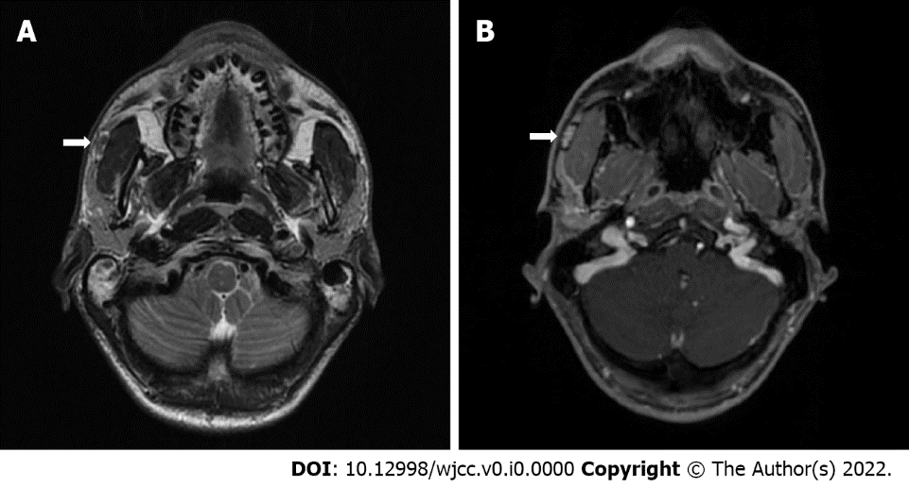
Figure 1 Magnetic resonance imaging T2-weighted image and T1-weighted contrast-enhanced image. A: An Arrow shows an encapsulated tumor in the anterior portion of the right superficial lobe of the parotid gland (accessory parotid gland) with high-intensity signal capsule together with low-intensity signal core; B: The same tumor with the contrast accumulating core and no clear contrast accumulation in the capsule.
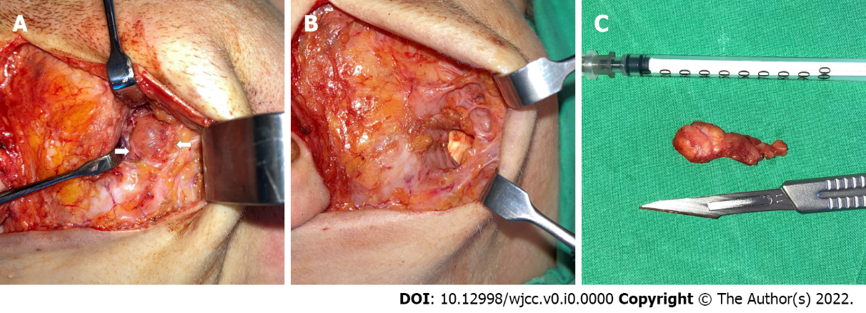
Figure 2 Intraoperative approach and removal of the tumor. A: Visualized tumor deep in the anterior part of parotid gland between two branches of the facial nerve (arrows); B: Surgical resection cavity over the surface of masseter muscle; C: Removed tumor after extracapsular dissection.
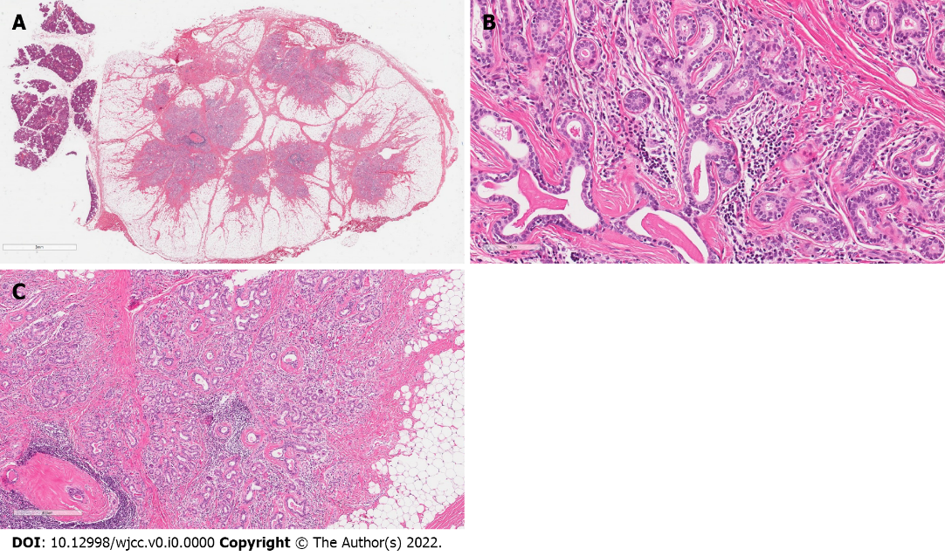
Figure 3 Pathological morphology of the tumor. A: Beside of normal salivary gland (lobules on the left side of the picture) there was a nodule of the regular border, encapsulated by a thin layer of fibrous tissue. The lesion was composed of numerous small tubules surrounded by a large amount of adipose tissue; B: The tubules were surrounded by a collagenous membrane and consisted of two cell layers: cuboidal ductal and myoepithelial cells; C: There was evidence of fibrosis, periductal hyalinization and focal periductal chronic inflammation.

