Name of Journal: World Journal of Gastroenterology
Manuscript NO: 87865
Manuscript Type: ORIGINAL ARTICLE

Basic Study
Chemical components and protective effects of Atractylodes japonica Koidz. ex Kitam against acetic acid-induced gastric ulcer in rats

Zhen BX et al. Study on anti-GU of A. japonica

Bi-Xian Zhen, Qian Cai, Feng Li

Bi-Xian Zhen, Qian Cai, Feng Li, Department of Medicine, Liaoning University of Traditional Chinese Medicine, Dalian 116600, Liaoning Province, China

Author contributions: Li F and Cai Q designed the experiment; Zhen BX completed the whole experiment and wrote the manuscript; and all authors approved the final version of the article.

Supported by National Natural Science Foundation of China, No. 81973478; Liaoning Revitalization Talents Program, China, No. XLYC2002004; and Natural Science Foundation of Liaoning Province, China, No. 2019-ZD-0443.

Corresponding author: Feng Li, PhD, Professor, Department of Medicine, Liaoning University of Traditional Chinese Medicine, No. 77 Shengming 1st Road, Double D Port, Dalian 116600, Liaoning Province, China. zhanglijiayi@163.com

Received: August 30, 2023
Revised: October 21, 2023
Accepted: November 7, 2023
Published online: November 21, 2023

Abstract
BACKGROUND
Atractylodes japonica Koidz. ex Kitam. (A. japonica, Chinese name: Guan-Cangzhu, Japanese name: Byaku-jutsu), a perennial herb, which is mainly distributed in northeast area of China, it’s often used to treat digestive system diseases such as gastric ulcer (GU). However, the mechanism of its potential protective effects against GU remains unclear.

AIM
To investigate the protective effects of A. japonica on acetic acid-induced GU rats.

METHODS
The chemical constituents of A. japonica were determined by ultra performance liquid chromatography tandem mass spectrometry (UPLC-MS/MS) analysis. The rat model of GU was simulated by acetic acid method. The pathological changes of gastric tissues were evaluated by hematoxylin-eosin stain, the levels of epidermal growth factor (EGF), EGF receptor (EGFR), nuclear factor kappa-B (NF-κB), interleukin-1β (IL-1β), IL-10, Na⁺-K⁺-ATPase (NKA) in serum and gastric tissues were determined by enzyme-linked immunosorbent assay, and the mRNA expressions of EGFR, NF-κBp65, IkappaBalpha (IκBα) and Zonula Occludens-1 (ZO-1) in gastric tissues were determined by real-time reverse transcription polymerase chain reaction, and the efficacy was observed. Then, plasma metabolomic analysis was performed by UPLC-MS/MS to screen the specific potential biomarkers, metabolic pathways and to explore the possible mechanisms.

RESULTS
48 chemical constituents were identified. Many of them have strong pharmacological activity, the results also revealed that A. japonica significantly improved the pathological damage of gastric tissues, increased the expression levels of IL-10, IκBα related to anti-inflammatory factors, decreased the expression levels of IL-1β, NF-κB, NF-κBp65, related to proinflammatory factors, restored the levels of factors about EGF, EGFR, ZO-1 associated with ulcer healing and the levels of factors about NKA associated with energy metabolism. Metabolomic analysis identified 10 potential differential metabolites and enriched 7 related metabolic pathways.

CONCLUSION
These findings contribute to the understanding of the potential mechanism of A. japonica to improve acetic acid-induced GU, and will be of great importance for the development and clinical application of natural drugs related to A. japonica.

Key Words: Atractylodes japonica Koidz. ex Kitam.; Ulcer; Acetic acid; Digestive system diseases; Metabolomics; Rats

©The Author(s) 2023. Published by Baishideng Publishing Group Inc. All rights reserved.

Citation: Zhen BX, Cai Q, Li F. Chemical components and protective effects of Atractylodes japonica Koidz. ex Kitam against acetic acid-induced gastric ulcer in rats. World J Gastroenterol 2023; 29(43): 5848-5864
URL: https://www.wjgnet.com/1007-9327/full/v29/i43/5848.htm
DOI: https://dx.doi.org/10.3748/wjg.v29.i43.5848

Core Tip: Atractylodes japonica Koidz. ex Kitam. is a commonly used folk medicine for the treatment of gastric ulcer (GU), but the mechanism of the treatment of GU is still unclear. In this study, chemical composition, pharmacodynamics and metabolomics were studied to explore the potential mechanism of it. The finding was closely related to anti-inflammation, ulcer healing and other factors.

INTRODUCTION
Gastric ulcer (GU) is a common global gastrointestinal disorder with common symptoms such as loss of appetite, stomach pain, acid reflux, gastric distention, nausea, and in severe cases, gastric bleeding^{[1]}. Due to its long treatment cycle, relapsing easily, and other characteristics, it has serious physiological and psychological effects on patients. Although the mechanism of ulceration is not clear, pathological studies have found that gastric mucosal lesions are significantly contributed to the development of ulcers^{[2]}. With the accelerated pace of life and bad health habits such as excessive alcohol consumption, smoking, use of non-steroidal anti-inflammatory drugs^{[3]}, and increased psychological burden from work, study, family and social environment , the incidence of GU has been rising every year. Therefore, the treatment of GU has become one of the hotspots in research^{[4]}. Although current treatments with traditional western drugs such as proton-pump inhibitors, H2-receptor antagonists, M1-receptor antagonists, and antibiotics against Helicobacter pylori are effective, their side effects are often unavoidable^{[5-7]}. Therefore, it is imperative to explore new therapeutic agents. However, herbal medicines for GU have a long history and have received considerable attention for their high efficacy, low side effects, and affordability^{[8]}.
Atractylodes japonica (A. japonica) is a perennial herb in the Asteraceae family that grows on hillsides, bushes, tussah forests, etc. The herb has irregular masses or irregularly curved cylinders (3-8 cm in length, 2-3cm in diameter)^{[9]} and is mainly distributed in the Siberian region of Russia, northeastern China, Korea, and Japan^{[10]}. The earliest record of Atractylodes in ancient books can be found in Shennong’s Classic of Materia Medica^{[11]}. In the 2020th edition of the Chinese Pharmacopoeia, Atractylodes lancea (Thunb.) DC. and Atractylodes chinensis (DC.) Koidz. were included as sources of Atractylodis rhizoma, A. japonica was not included in it^{[12]}, but was included in the Japanese Pharmacopoeia as a source of Atractylodis rhizoma. The dried rhizome of A. japonica is commonly used in the treatment of various diseases, such as loss of appetite, indigestion, abdominal distension, diarrhea, night blindness, rheumatic arthritis, etc^{[13]}. The chemical components of A. japonica involve sesquiterpenoids, acetylene, saccharides, etc^{[14]}. Modern pharmacological studies have shown that extracts of A. japonica have a variety of biological activities, including anti-inflammation, anti-viral, hypoglycemic, diuretic, cardioprotective, and other bioactive effects, along with specific efficacy in the treatment of digestive disorders such as GU^{[10,15,16]}. In recent years, the demand for A. japonica at home and abroad has gradually increased.
There are a few studies on A. japonica’s chemical composition, which forms the basis for its mechanism of action. Although A. japonica has a good therapeutic effect, there is little information about its anti-ulcer activity and related mechanisms. In the preliminary study, the research group who adopted the rheumatoid arthritis model established by Freund’s complete adjuvant method, which also proved to have a better anti-inflammatory effect^{[17]}. Therefore, this study intends to focus on the potential anti-inflammatory and protective effects of A. japonica. In addition, because of its comprehensive and dynamic characteristics, metabolomics is often used in the study of diseases. According to the changes in endogenous metabolites in the body after the intervention of herbal medicines, the mechanism of action is systematically explained. In this study, pharmacodynamic and metabolomic approaches were used to elucidate the protective mechanism of A. japonica in a model for acetic acid-induced GU in rats. Thus, our study may provide a theoretical basis for the application of A. japonica.

MATERIALS AND METHODS
Plant materials and reagents
Collected Atractylodes japonica Koidz. ex Kitam (Kuandian, Liaoning, China) was identified as the rhizome of A. japonica by Professor Feng Li and deposited in Liaoning University of Traditional Chinese Medicine. Omeprazole was purchased from Shiyao Group Ouyi Pharmaceutical Co., Ltd. (Shijiazhuang, Hebei, China) (Drug approval number: H20046430). This drug is commonly used in clinical treatment of GU and as a positive drug for experimental studies^{[18,19]}, transformed into powder, and prepared into a 2 mg/mL solution before use. The drug was crushed through a 180-mesh sieve. Low, middle, and high doses of A. japonica were prepared into suspensions of 0.047 g/mL, 0.094 g/mL and 0.188 g/mL, respectively, and shaken well before use. Formic acid, methanol, and acetonitrile (HPLC grade) were purchased from Fisher Scientific (Fair Lawn, NJ, United States). The SweScript RT I First Strand cDNA Synthesis Kit was provided by Servicebio (Wuhan, Hubei, China). Yeasen Biotechnology (Shanghai, China) provided HieffTM qPCR SYBR® Green Master Mix (No Rox Plus). Enzyme-linked immunosorbent assay (ELISA) kits of epidermal growth factor (EGF), EGF receptor (EGFR), nuclear factor kappa-B (NF-κB), interleukin-1β (IL-1β), IL-10, and Na⁺-K⁺-ATPase (NKA) were purchased from Lianshuo Biotechnology Co., Ltd. (Shanghai, China).

Sample preparation and detection
Approximately 1 g of A. japonica (through 60 mesh sieve) was added to 20 mL of 80% methanol (v/v) for 40 min using ultrasonication, centrifuged for 10 min at 13780 × g and the supernatants were obtained. Finally, the supernatants were filtered through a 0.22 μm membrane filter. Then, the sample was analyzed using LC-MS (UPLC, Thermo, United States, Q Exactive MS, Thermo, United States) platform. Chromatographic analysis was performed using a ACQUITY UPLC C18 Column (100 mm × 2.1 mm, 1.8 μm, Waters, United States). The mobile phases consisted of acetonitrile (A) and 0.1% aqueous formic acid (v/v) (B). The analysis was carried out with an elution gradient using the following steps: 0-5 min, 95%-46% B; 5-11 min, 46% B; 11-20 min, 46%-23% B; 20-30 min, 23%-5% B, with the flow rate at 0.3 mL/min. The column temperature was kept at 30 °C, and the injection volume was 2 μL. The ESI source conditions were set as follows: Sheath gas flow rate as 35 Arb, aux gas flow rate as 15 Arb, capillary temperature as 320 °C, full MS resolution as 70000, MS/MS resolution as 17500, collision energy as 40 in NCE mode, and spray voltage as 4.0 kV (positive) or -3.0 kV (negative), respectively. The mass range scanned was 100-1500 m/z. Furthermore, MS data were collected with Xcalibur software (version 3.0).

Animals and treatment
Male Sprague-Dawley rats (specific pathogen-free grade), weighing 180-220 g, were purchased from Liaoning Changsheng Biotechnology Co., Ltd. (SCXK 2020-0001, Liaoning, China). Prior to the experiment, the rats were raised under normal laboratory conditions: Housed for 7 d at 24 °C and 45%-55% relative humidity. After acclimatization for 7 d, all rats were randomly divided into the normal group (NG), the acetic acid-induced model group (MG), the omeprazole group (OG), the low dose group of A. japonica (LA), the middle dose group of A. japonica (MA), and the high dose group of A. japonica (HA), n = 8 for each group. GU was induced by acetic acid treatment in rats according to the method of Okabe et al^{[20]} and Okabe et al^{[21]} with partial modifications^{[19]}. All rats were fasted for 24 h, and then a laparotomy was performed through a left subcostal incision after anesthesia with isoflurane. The stomach was gently exteriorized and clamped 3 mm away from the pylorus with special tweezers, a double-ring tweezer with a 9-mm diameter that can clamp the injection site^{[19]}. Furthermore, a 0.2 mL mixture of mineral oil and 60% acetic acid (v/v) in the same syringe was injected into the subserosal layer in the glandular portion of the anterior wall in the clamping region, and the solution was aspirated off after 45 s. In the NG group, saline was used instead of acetic acid. The opened abdomen was then cautiously placed back, cleaned with penicillin, and sutured. Then the rats were fed normally. Except for the NG and MG groups, they were given the same amount of normal saline for 10 d (20 mL/kg/d), twice a day. Other groups were treated with intragastric administration for 10 d (20 mL/kg/d), twice a day. 12 h after the last administration, all rats were anesthetized^{[22]}. Blood was collected from rats, then centrifuged at 3910 × g for 10 min. The clear serum and plasma for ELISA assays and metabolomics were then stored at -80 °C until the measurement. The stomach was removed and washed with ice-cold saline. The gastric mucosal injury was observed and evaluated by calculating ulcer score^{[23]}. Then, the ulcer tissue was cut into three parts, and one part was immediately fixed with a 4% paraformaldehyde solution for pathological analysis. Other parts were used for ELISA and mRNA level assays; they were also stored at -80 °C until the measurement.

Gastric histopathology examination
Gastric tissues were immediately fixed with a 4% paraformaldehyde solution for pathological analysis; gradient alcohol and xylene were used for dehydration and transparency separately. The tissues were impregnated with wax and embedded. The sections were made to a thickness of 5 μm, stained with hematoxylin for 30 min, counterstained with eosin, dehydrated with gradient alcohol, thoroughly permeabilized with xylene, sealed with neutral resin, observed under a light microscope (BX53, Olympus, Tokyo, Japan), and blind analysis was performed by an experienced histopathologist.

ELISA analysis
Serum and gastric tissues were thawed at 4 °C before use. Gastric tissues, weighing 100 mg, were homogenized into a 10% tissue homogenate prepared by adding 900 μL of ice-cold saline, centrifuging for 10 min at 3910 × g, and obtaining the supernatants. The levels of EGF, EGFR, NF-κB, IL-1β, IL-10, and NKA were analyzed by ELISA (Infinite M200, TECAN, Switzerland) at 450 nm.

Gene expression analysis
According to the supplier’s instructions, the trizol method was used to extract total RNA^{[24]}, 2.5 μL of the solution to be tested was aspirated, and RNA concentration and purity were detected using an ultra-micro spectrophotometer (Nanodrop 2000, Thermo, America). The SweScript RT I First Strand cDNA Synthesis Kit was used to reverse transcribe to cDNA; the specific reaction system was 20 μL. The HieffTM qPCR SYBR® Green Master Mix was used to perform DNA amplification. Primers were provided by Tianyi Huiyuan Biotechnology Co., Ltd. (Wuhan, China), and data were analyzed using the comparative cycle threshold (CT) method. The primers for the gene sequences are shown in Table 1.

Metabolomics analysis
Plasma samples were thawed on ice. 100 μL sample was taken and placed into an EP tube, extracted with 300 μL methanol, vortexed for 30 s, and then ultrasound treated for 30 min (incubated in ice water) and incubated for 1 h at -40 °C to precipitate proteins, followed by vortexing for 30 s, and incubated for 0.5 h at 4 °C. Then the sample was centrifuged at 13780 × g for 15 min at 4 °C. The entire supernatant was collected and placed into an EP tube and incubated for 1 h at -40 °C after centrifugation at 13780 × g for 15 min at 4 °C. 200 μL of supernatants, including 5 μL internal standard (2-chloro-DL-phenylalanine, 0.5 mg/mL), were transferred to LC-MS vials by mixing. The quality control (QC) samples were prepared by mixing an equal aliquot of the supernatants from all samples. Plasma samples were analyzed by LC-MS (UPLC, Waters, United States; Q Exactive MS, Thermo, United States). Chromatographic analysis was performed using an UPLC HSS T3 column (2.1 mm × 100 mm, 1.8 μm, Waters, United States). The mobile phase consisted of 0.05% formic acid in water (A) and acetonitrile (B). The analysis was carried out with an elution gradient using the following steps: 0-1 min, 5% B; 1-12 min, 5%-95% B; 12-13.5 min, 95% B; 13.5-13.6 min, 95%-5% B; 13.6-16 min, 5% B, with the flow rate of 0.3 mL/min. The column temperature was kept at 40 °C. The autosampler temperature was 4 °C, and the injection volume was 5 μL. The ESI source conditions were set as follows: Sheath gas flow rate as 45 Arb, aux gas flow rate as 15 Arb, capillary temperature as 350 °C, full MS resolution as 70000, MS/MS resolution as 17500, collision energy as 15/30/45 in NCE mode, and spray voltage as 3.0 kV (positive) or -3.2 kV (negative), respectively.

Data process and multivariate analysis
First of all, the sample data were obtained with feature extraction and preprocessed with Compound Discoverer software (version 2.1, Thermo, United States). Then, the normalized data were imported into SIMCA-P software (version 14.1, Umetrics, Umea, Sweden) for performing multivariate statistical analysis (MVA), including principal component analysis (PCA) and orthogonal projections to latent structures-discriminant analysis (OPLS-DA)^{[25]}. The validity of the OPLS-DA model was evaluated based on the results of the permutation test. Meanwhile, METLIN (http://metlin.scripps.edu/), HMDB (http://www.hmdb.ca/), and KEGG (http://www.kegg.com/) were used to identify potential biomarkers by comparing the mass spectrometry fragmentation information. Furthermore, potential markers were visualized in the enrichment pathway using MetaboAnalyst (http://www.metaboanalyst.ca/).

Statistics analysis
The results were expressed as the mean ± SD. Student’s t-test, one-way analysis of variance (ANOVA) by Dunnett’s post-hoc test and Kruskal-Wallis test were used for statistical analysis. P < 0.05 was statistically significant, and P < 0.01 was highly significant. GraphPad Prism software (version 9.5, San Diego, United States) and TBtools (version 1.108, Guangzhou, China) were used for visualization.

RESULTS
Identification of the constituents by UPLC Q-Exactive Orbitrap MS
UPLC Q-Exactive Orbitrap was employed for comprehensive analysis in positive and negative modes to identify the chemical constituents using related databases and literature. Therefore, a total of 48 components (Table 2) were identified as terpenoids, flavonoids, organic acids, etc. A typical total ion chromatogram of A. japonica. in positive and negative ion modes are shown in Figure 1.

Effects of A. japonica on GU by histological analysis
Macroscopic analyses showed the gastric mucosa in NG group was smooth and complete with continuous mucosal plica and no edema. The gastric mucosa of MG group showed swelling and congestion. The treatment group and the positive drug group had different degrees of improvement, the surface of gastric mucosa in OG group was more flat, with no obvious ulcer surface. The ulcer was round or nearly round in the treated group, with slight bulge around the ulcer, and the ulcer area was smaller than that in MG group, especially in MA and HA groups, Specific information was given in Supplementary Figure 1 and Supplementary Table 1. Histopathological results showed that the gastric glands were closely arranged and regular, and the epithelial cells remained intact without congestion or edema in the NG group. Compared with the NG group, the epithelial cells of the gastric mucosa were disorganized with edema and inflammatory cell infiltration in the MG group, showing pathological changes. The histopathology associated with GU was improved, and inflammatory cell infiltration was reduced by the intervention of positive control drug and A. japonica, especially in the HA group (Figure 2).

Effects of A. japonica on the levels of EGF, EGFR, NF-κB, IL-1β, IL-10 and NKA in serum and gastric tissues
The levels of EGF, EGFR, NF-κB, IL-1β, IL-10, and NKA in the serum and gastric tissues of rats were detected by ELISA. The results showed that the levels of EGF, EGFR, IL-10, and NKA in the MG group were significantly lower (P < 0.01), while the levels of NF-κB and IL-1β were significantly higher than in the NG group (P < 0.01). Compared with the MG group, the HA group could significantly increase EGF, EGFR, IL-10, and NKA levels and decrease the levels of NF-κB and IL-1β in the serum and gastric tissues (P < 0.05 or P < 0.01). In addition, compared with the MG group, the levels of EGF and EGFR increased and IL-1β decreased in the MA group’s serum (P < 0.05 or P < 0.01). The levels of EGFR increased in the MA and LA groups (P < 0.01) and IL-1β decreased in the MA group of gastric tissues (P < 0.05) (Figures 3 and 4).

Effects of A. japonica on the mRNA expressions of EGFR, Zonula Occludens-1, NF-κBp65 and IkappaBalpha in gastric tissues
The mRNA expressions of EGFR, Zonula Occludens-1 (ZO-1), and IkappaBalpha (IκBα) in the MG group were significantly lower (P < 0.01), while the expression of NF-κBp65 was significantly higher than in the NG group (P < 0.01). Compared with the MG group, the mRNA expressions of EGFR, ZO-1, and IκBα significantly decreased, while the expression of NF-κBp65 significantly increased in the HA group (P < 0.05). In addition, the expressions of EGFR and IκBα could also increase in MA and LA groups (P < 0.01) (Figure 5).

MVA
The multivariate pattern recognition analysis was first analyzed by PCA, an unsupervised learning method. The results of the PCA score plot including the QC samples showed a certain trend of separation among the different groups (Figure 6), where tightly aggregated QC samples indicated MS platform was stable. Next, the plasma metabolism between NG and MG groups and between MG and HA groups were analyzed by OPLS-DA, a supervised discriminant analysis statistical method. It was observed that there was a clear trend of separation between different groups (Figures 7A and C). The permutation test results (values of R2 and Q2) also showed that the model was stable and reliable (Figures 7B and D).

Biomarker screenings and pathway enrichment analysis
A total of 10 endogenous metabolites were identified as potential biomarkers by database analysis (Table 3). The heat map directly reflected the differences in the expression of the relative abundance of metabolites among groups (Figure 8A). MetaboAnalyst 5.0 was used for enrichment analysis of potential biomarkers, and the main metabolic pathways associated with pathway enrichment analysis included arginine biosynthesis, primary bile acid biosynthesis, taurine and hypotaurine metabolism, glycerophospholipid metabolism, arginine and proline metabolism, purine metabolism, steroid hormone biosynthesis (Table 4 and Figure 8B).

DISCUSSION
The acetic acid-induced ulcer model is one of the most commonly used models. Since its development in 1969, it has been widely recognized in the scientific community. Its pathological morphology and repair process are similar to human GUs, with the advantages of easy induction process, good model repeatability, and a high survival rate^{[19,26]}. Consequently, the findings of this study demonstrated that A. japonica had a therapeutic impact on gastrointestinal ulcers, with improved recovery outcomes observed across multiple related indexes. According to pathological sections, the ulcer status of rats was significantly improved.
Since metabolites are downstream products of gene and protein expression, they can respond more quickly and provide effective information when the organism is affected^{[27]}. MVA is characterized by the analysis of the statistical rules of multiple interrelated research objects, monitoring variables, and focusing on the internal changes of variables. Therefore, it is widely used in metabolomics research, such as biomarker selection through the construction of models. The research fields cover animals, plants, medicine, the environment, etc.^{[28-31]}. Typically, the MVA is divided into supervisory and non-supervisory methods. At present, the most commonly used unsupervised recognition mode is PCA^{[32]}, which maximizes the extraction of the original information while reducing the dimension of the data. If PCA is not successful in distinguishing subtle differences between sample groups, the supervised models PLS-DA and OPLS-DA can be used to maximize the degree of separation between sample groups. The drawback is that data can be overfitted. Therefore, strict cross-validation must be carried out to ensure the reliability of the model. The differentiated metabolites obtained by screening often have functional similarities or complementarity in biology or participate in positive or negative regulation of the same metabolic pathway, which is manifested as similar or opposite expression characteristics between different experimental groups. Therefore, cluster analysis of these characteristics is helpful to speculate on the function of metabolites and explore the mechanism of disease treatment. This study made full use of MVA for metabonomic data analysis in order to make the experimental results more accurate and reliable^{[33]}.
Liquid chromatography-mass spectrometry technology has been widely used for the identification and analysis of traditional Chinese medicine or complex unknown substances. In this study, technology was used to analyze the extract of A. japonica. Among the identified components, multiple of them have potential biological activity. Terpenoids are the most common active components, of which atractylon and atractylenolide I, II, and III have anti-inflammatory effects and regulate gastrointestinal function^{[34,35]}. The organic acid component chlorogenic acid^{[36]} has obvious antioxidant, antibacterial, anti-inflammatory, antiviral, and other effects. Isoorientin^{[37]}, a flavonoid component, has anti-oxidative and anti-inflammatory effects, regulates the intestinal flora, etc. These components may be closely related to the treatment of GU and the potential key pharmacological bases of A. japonica.
GU is the most common cause of gastric mucosal inflammation and injury. NF-κB is a primary regulator of the inflammatory response, and one of its subunits, NF-κBp65 is the main functional protein. IκB, as a suppressor protein of the NF-κB signaling pathway, when stimulated by injury factors such as ulcers, will activate NF-κB, leading to the degradation of IκB, and subsequently promoting the expression of multiple inflammatory factors^{[38-40]}. Cytokines IL-1β and IL-10 are common indicators of acute inflammation and are closely related to the severity of GUs^{[41,42]}. IL-1β, as a pro-inflammatory factor, regulates the function of various gastric epithelial cells and interacts with NF-κB to cause the release of inflammatory mediators and stimulate the secretion of other cytokines, exacerbating the inflammatory response^{[43]}. IL-10 can inhibit the pro-inflammatory response and limit unnecessary tissue destruction caused by inflammation^{[44]}. The results showed that the level of IL-1β and expression of NF-κBp65 were significantly increased, while the level of IL-10 and expression of IκBα were significantly decreased in GU rats, suggesting that the progression of GU is closely related to inflammation. After the intervention of A. japonica, the expression levels of inflammatory factors were significantly re-regulated, which is in accordance with the research results of Hu et al^{[45]} and Zhou et al^{[46]}. Simultaneously, pathological results showed A. japonica had a significant protective effect on GU tissue and reduced inflammatory damage to the gastric mucosa. All these results suggest that the gastroprotective effect of A. japonica is related to the inhibition of the inflammatory response.
On the other hand, GU causes mucosal damage and destroys the structure and function of the gastric mucosa. EGF is an endogenous substance that can inhibit gastric acid secretion, promote epithelial cell proliferation, tissue repair, and cytoprotection, and is an important factor in promoting wound healing. Its receptor EGFR also plays an important role in cell proliferation and other effects, both of which generally combine and activate downstream effectors to promote the repair and healing of injured mucosa^{[47,48]}. ZO-1 is a bridging protein, which is an important component of tight junctions; most of them are located at the junctions between cells. It mainly interacts with extracellular signal transduction pathways and the cytoskeleton, and the normal expression of ZO-1 is closely related to mucosal integrity^{[49,50]}. It plays an important role not only in regulating the transport of intracellular substances and maintaining epithelial polarity but also in cell proliferation and differentiation. According to the results, the ulcer may destroy the integrity and permeability of the gastric mucosa, leading to the degradation of the protein structure^{[51]}. NKA is a ubiquitous transmembrane protein that maintains the normal function of mucosal cells and membrane permeability and maintains Na⁺ and K⁺ gradients across the cell membrane through energy from adenosine triphosphate (ATP). External stimulation will cause abnormal function of this enzyme and mucosal damage^{[52]}. According to the results, the expression levels of EGF, EGFR, and ZO-1 were significantly decreased in GU rats, suggesting that GU leads to impaired mucosal barrier function and disrupted structure. After intervention, the expression levels of all factors were significantly increased, indicating that A. japonica could promote ulcer healing and improve gastric mucosal function. Based on the above pharmacodynamic results, it was found that the HA group had the best effect among the treatment groups, so the HA group was selected for further metabolic analysis.
The metabolomic study showed that GUs are involved in multiple metabolic pathways. Amino acid metabolism: L-arginine has a variety of biological effects, including gastric protection and promoting ulcer healing properties. Its metabolite, citrulline, has been confirmed to protect gastric mucosa from ulcer-induced mucosal damage and regulate mucosal integrity^{[53,54]}. Taurine is also a cytoprotective factor, maintaining the storage of an important antioxidant and free radical scavenger glutathione in the body, increasing membrane stability, and preventing inflammation and gastric mucosal damage^{[55,56]}. According to the results, the levels of amino acids decreased in the MG group, which indicates an amino acid metabolic disorder; however, A. japonica can significantly recover the levels of amino acids.
Lipid metabolism: Multiple experimental studies have shown that lysophosphatidylcholines are a class of metabolites associated with inflammatory damage caused by GU, which can induce impairment of gastric mucosal barrier function, leading to gastric mucosal damage^{[57,58]}. Eicosadienoic acid is an n-6 polyunsaturated fatty acid with certain pro-inflammatory activity, which can not only metabolize to the eicosanoid precursor compound arachidonic acid to promote an inflammatory response but also promote the expression of inflammatory mediators such as NF-κBp65 to cause mucosal inflammatory damage^{[59,60]}. Another study has found that eicosadienoic acid can be positively associated with ulcerative colitis^{[61]}. Furthermore, since reactive oxygen species (ROS) is an important factor in the early stage of inflammation and mediates the onset of inflammation, eicosadienoic acid can act by reducing ROS level induced by lipopolysaccharide and was presumed to have potential anti-inflammatory activity to some extent^{[62]}. The dualism effect of this metabolite may be related to the disease and the course of disease. It is worth further exploring. According to the results, the levels were significantly increased in the MG group, suggesting that lipid metabolism disorder is one of the metabolic pathways exacerbating ulcers, and the levels recovered after intervention.
Bile acids are a class of cholesterol derivatives that regulate a variety of metabolic and inflammatory pathways^{[63]}. We found that the levels of glycochenodeoxycholic acid and glycocholic acid in the MG decreased significantly in this study. According to existing reports, glycochenodeoxycholic acid promotes cell proliferation in a concentration-dependent manner through activation of Gαi, reduction of cyclic AMP, and an increase in H2AX phosphorylation^{[64]}. The Farnesoid X receptor (FXR), also known as the bile acid receptor, regulates lipid metabolism, mitigates the inflammatory response, and enhances barrier function. Some studies showed that glycocholic acid can improve tissue growth performance, reduce tissue damage, and play a protective role in mucous membranes by activating FXR^{[65]}. In our study, the levels of two kinds of cholic acid were significantly reduced in GU rats. It is hypothesized that ulcers may disrupt barrier function and activate the inflammatory response by interfering with the bile acid metabolic pathway. Treatment with A. japonica significantly alleviates the inflammatory response and improves metabolite levels. Stepien et al^{[66]} have shown that these two cholic acids increased in a variety of liver diseases, such as hepatocellular carcinoma. Aragonès et al^{[67]} found that the level of glycocholic acid was significantly elevated in patients with non-alcoholic fatty liver disease. It is suggested that the same metabolite may have opposite tendency for different diseases.
The adrenal cortex produces the steroid hormone aldosterone, which regulates electrolyte and water balance by increasing sodium renal retention and potassium excretion. There are a few studies on aldosterone-related GU. Matrix metalloproteinases (MMPs) and tissue inhibitors of MMPs (TIMPs) are closely related to ulcers. MMPs belong to a class of endogenous proteolytic enzymes that generally aggravate the inflammatory response and prolong healing time. TIMPs are endogenous specific suppressors of MMPs, which play a role in the process of ulcer healing by inhibiting and regulating MMPs^{[68]}. Studies have shown that aldosterone can induce TIMP-1 secretion and promote collagen accumulation^{[69]}. It is speculated that ulcers interfered with aldosterone production and that downstream factors could not play a healing role. However, treatment with A. japonica alleviated inflammation and promoted ulcer healing.
Adenine is a component of adenosine. When adenosine reacts with three phosphate groups, it forms the nucleotide ATP, the body’s most direct source of energy. Adenine increased in the MG group, suggesting that ulcers damaged the body’s energy metabolism, resulting in blocked ATP synthesis and adenine accumulation. When A. japonica intervened to restore the process of energy metabolism, the levels of adenine decreased.

CONCLUSION
In this study, 48 potential bioactive compounds were identified by UPLC–MS/MS that may be active components of GU. Additionally, the pathogenesis of acetic acid-induced GU in rats and the therapeutic effect of A. japonica were explored from the perspective of metabonomics for the first time. The results showed that A. japonica could correct the metabolic disorder of GU with its gastroprotective effect and effectively relieve mucosal inflammatory injury. The specific anti-ulcer effect is closely related to the anti-inflammatory activity produced by down-regulating NF-κB and IL-1β and up-regulating IL-10 and IκBα, as well as the gastric protective effect produced by up-regulating EGF, EGFR, ZO-1, and NKA. Combined with omics enrichment of metabolic pathways, we found that lipid metabolism, amino acid metabolism, and other metabolic pathways play a protective role in the stomach through anti-inflammatory, antioxidative, ulcer healing, and other functions. This study provides a research direction for the potential mechanism of A. japonica in the treatment of GU, which is of great significance for its drug development and clinical application.

ARTICLE HIGHLIGHTS
Research background
Gastric ulcer (GU) is a common digestive system disease. In addition to western medicine treatment, more and more Chinese herbs have become the first choice for alternative treatment due to their long history of use, high efficacy, low side effects and low price.

Research motivation
Although the herbal medicine Atractylodes japonica Koidz. ex Kitam. (A. japonica) has an obvious therapeutic effect on GU, there are few relevant mechanism studies at present.

Research objectives
The object of this study is to investigate the protective effects of A. japonica on acetic acid-induced GU rats.

Research methods
We used ultra performance liquid chromatography tandem mass spectrometry, hematoxylin-eosin stain, enzyme-linked immunosorbent assay, real-time reverse transcription polymerase chain reaction and acetic acid-induced GU model to evaluate the therapeutic effect of A. japonica.

Research results
48 chemical constituents of A. japonica were identified, the herb significantly improved the pathological damage of gastric tissues, increased the expression levels of anti-inflammatory factors, decreased the expression levels of proinflammatory factors, restored the levels of factors about ulcer healing and energy metabolism. and identified 10 potential differential metabolites and enriched 7 related metabolic pathways of metabolomic analysis.

Research conclusions
The therapeutic effect of A. japonica on GU rats is closely related to anti-inflammation and repair of gastric injury, and is regulated and treated through a combination of multiple pathways.

Research perspectives
These findings contribute to the understanding of the potential mechanism of A. japonica to improve acetic acid-induced GU, and will provide great importance for the development and clinical application of A. japonica.

REFERENCES
1 Xiaohua H. Correlation between Endoscopic Morphology and Bleeding of Gastric Ulcer. J Healthc Eng 2022; 2022: 2169551 [PMID: 35251562 DOI: 10.1155/2022/2169551]
2 Nakashita M, Suzuki H, Miura S, Taki T, Uehara K, Mizushima T, Nagata H, Hibi T. Attenuation of acetic acid-induced gastric ulcer formation in rats by glucosylceramide synthase inhibitors. Dig Dis Sci 2013; 58: 354-362 [PMID: 22918683 DOI: 10.1007/s10620-012-2350-x]
3 Zhang K, Liu Y, Wang C, Li J, Xiong L, Wang Z, Liu J, Li P. Evaluation of the gastroprotective effects of 20 (S)-ginsenoside Rg3 on gastric ulcer models in mice. J Ginseng Res 2019; 43: 550-561 [PMID: 31695563 DOI: 10.1016/j.jgr.2018.04.001]
4 Chen XJ, Yang ML, Liu W, You PT, Zhou AJ, Liu YW, Chen X. [Studies on serum pharmacochemistry of effective parts of modified Xiaochaihu Tang for treatment of gastric ulcer]. Zhongguo Zhong Yao Za Zhi 2018; 43: 1692-1700 [PMID: 29751718 DOI: 10.19540/j.cnki.cjcmm.20180130.002]
5 Escobedo-Hinojosa WI, Gomez-Chang E, García-Martínez K, Guerrero Alquicira R, Cardoso-Taketa A, Romero I. Gastroprotective Mechanism and Ulcer Resolution Effect of Cyrtocarpa procera Methanolic Extract on Ethanol-Induced Gastric Injury. Evid Based Complement Alternat Med 2018; 2018: 2862706 [PMID: 29507589 DOI: 10.1155/2018/2862706]
6 Schubert ML. Physiologic, pathophysiologic, and pharmacologic regulation of gastric acid secretion. Curr Opin Gastroenterol 2017; 33: 430-438 [PMID: 28787289 DOI: 10.1097/MOG.0000000000000392]
7 Sheen E, Triadafilopoulos G. Adverse effects of long-term proton pump inhibitor therapy. Dig Dis Sci 2011; 56: 931-950 [PMID: 21365243 DOI: 10.1007/s10620-010-1560-3]
8 Bi WP, Man HB, Man MQ. Efficacy and safety of herbal medicines in treating gastric ulcer: a review. World J Gastroenterol 2014; 20: 17020-17028 [PMID: 25493014 DOI: 10.3748/wjg.v20.i45.17020]
9 Editorial board of Japan Pharmaceutical Administration. The Japanese Pharmacopoeia Eighteenth Edition. Japan: Pharmaceuticals and Medical Devices Agency, 2021
10 Zhao QL, Wang MJ, Zhao M, Zheng BJ. [Research progress on Atractylodes japonica]. Chinese Traditional and Herbal Drugs 2018; 49: 3797-3803
11 Pang J, Ma S, Xu X, Zhang B, Cai Q. Effects of rhizome of Atractylodes koreana (Nakai) Kitam on intestinal flora and metabolites in rats with rheumatoid arthritis. J Ethnopharmacol 2021; 281: 114026 [PMID: 33727111 DOI: 10.1016/j.jep.2021.114026]
12 Chinese Pharmacopoeia Commission. Pharmacopoeia of the People’s Republic of China. Beijing: The Medicine Science and Technology Press of China, 2020
13 Rui M, Chou G. Three new polyacetylenes from Atractylodes japonica Koidz.ez Kitam. Nat Prod Res 2022; 36: 2063-2070 [PMID: 33176498 DOI: 10.1080/14786419.2020.1845673]
14 Choi KH, Jeong SI, Lee JH, Hwang BS, Lee S, Choi BK, Jung KY. Acetylene compound isolated from Atractylodes japonica stimulates the contractility of rat distal colon via inhibiting the nitrergic-purinergic relaxation. J Ethnopharmacol 2011; 134: 104-110 [PMID: 21130855 DOI: 10.1016/j.jep.2010.11.059]
15 Kim JH, Lee Y, Lee G, Doh EJ, Hong S. Quantitative Interrelation between Atractylenolide I, II, and III in Atractylodes japonica Koidzumi Rhizomes, and Evaluation of Their Oxidative Transformation Using a Biomimetic Kinetic Model. ACS Omega 2018; 3: 14833-14840 [PMID: 30555992 DOI: 10.1021/acsomega.8b02005]
16 Min BS, Kim YH, Tomiyama M, Nakamura N, Miyashiro H, Otake T, Hattori M. Inhibitory effects of Korean plants on HIV-1 activities. Phytother Res 2001; 15: 481-486 [PMID: 11536375 DOI: 10.1002/ptr.751]
17 Liu Y, Zhang B, Cai Q. Study on the pharmacodynamics and metabolomics of five medicinal species in Atractylodes DC. on rats with rheumatoid arthritis. Biomed Pharmacother 2020; 131: 110554 [PMID: 32890964 DOI: 10.1016/j.biopha.2020.110554]
18 Lu S, Wu D, Sun G, Geng F, Shen Y, Tan J, Sun X, Luo Y. Gastroprotective effects of Kangfuxin against water-immersion and restraint stress-induced gastric ulcer in rats: roles of antioxidation, anti-inflammation, and pro-survival. Pharm Biol 2019; 57: 770-777 [PMID: 31696757 DOI: 10.1080/13880209.2019.1682620]
19 Yu Y, Jia TZ, Cai Q, Jiang N, Ma MY, Min DY, Yuan Y. Comparison of the anti-ulcer activity between the crude and bran-processed Atractylodes lancea in the rat model of gastric ulcer induced by acetic acid. J Ethnopharmacol 2015; 160: 211-218 [PMID: 25481080 DOI: 10.1016/j.jep.2014.10.066]
20 Okabe S, Roth JL, Pfeiffer CJ. A method for experimental, penetrating gastric and duodenal ulcers in rats. Observations on normal healing. Am J Dig Dis 1971; 16: 277-284 [PMID: 5554507 DOI: 10.1007/BF02235252]
21 Okabe S, Pfeiffer CJ. Chronicity of acetic acid ulcer in the rat stomach. Am J Dig Dis 1972; 17: 619-629 [PMID: 5032686 DOI: 10.1007/BF02231748]
22 Liu Y, Ma S, Cai Q. Fecal metabonomics study of raw and bran-fried Atractylodis Rhizoma in spleen-deficiency rats. J Pharm Biomed Anal 2020; 189: 113416 [PMID: 32563933 DOI: 10.1016/j.jpba.2020.113416]
23 Selim HM, Negm WA, Hawwal MF, Hussein IA, Elekhnawy E, Ulber R, Zayed A. Fucoidan mitigates gastric ulcer injury through managing inflammation, oxidative stress, and NLRP3-mediated pyroptosis. Int Immunopharmacol 2023; 120: 110335 [PMID: 37201406 DOI: 10.1016/j.intimp.2023.110335]
24 Gong X, Liu L, Li X, Xiong J, Xu J, Mao D, Liu L. Neuroprotection of cannabidiol in epileptic rats: Gut microbiome and metabolome sequencing. Front Nutr 2022; 9: 1028459 [PMID: 36466385 DOI: 10.3389/fnut.2022.1028459]
25 Tong Y, Jing M, Zhao X, Liu H, Wei S, Li R, Liu X, Wang M, Song H, Zhao Y. Metabolomic Study of Zuojin Pill in Relieving 1-Methyl-3-nitro-1-nitrosoguanidine-Induced Chronic Atrophic Gastritis. Evid Based Complement Alternat Med 2021; 2021: 7004798 [PMID: 34956382 DOI: 10.1155/2021/7004798]
26 Okabe S, Amagase K. An overview of acetic acid ulcer models--the history and state of the art of peptic ulcer research. Biol Pharm Bull 2005; 28: 1321-1341 [PMID: 16079471 DOI: 10.1248/bpb.28.1321]
27 Xi B, Gu H, Baniasadi H, Raftery D. Statistical analysis and modeling of mass spectrometry-based metabolomics data. Methods Mol Biol 2014; 1198: 333-353 [PMID: 25270940 DOI: 10.1007/978-1-4939-1258-2_22]
28 Zhu L, Liang ZT, Yi T, Ma Y, Zhao ZZ, Guo BL, Zhang JY, Chen HB. Comparison of chemical profiles between the root and aerial parts from three Bupleurum species based on a UHPLC-QTOF-MS metabolomics approach. BMC Complement Altern Med 2017; 17: 305 [PMID: 28606186 DOI: 10.1186/s12906-017-1816-y]
29 Huang Y, Xiao M, Ou J, Lv Q, Wei Q, Chen Z, Wu J, Tu L, Jiang Y, Zhang X, Qi J, Qiu M, Cao S, Gu J. Identification of the urine and serum metabolomics signature of gout. Rheumatology (Oxford) 2020; 59: 2960-2969 [PMID: 32134107 DOI: 10.1093/rheumatology/keaa018]
30 Yin J, Hong X, Ma L, Liu R, Bu Y. Non-targeted metabolomic profiling of atrazine in Caenorhabditis elegans using UHPLC-QE Orbitrap/MS. Ecotoxicol Environ Saf 2020; 206: 111170 [PMID: 32861007 DOI: 10.1016/j.ecoenv.2020.111170]
31 Yao J, Chen P, Ringø E, Zhang G, Huang Z, Hua X. Effect of Diet Supplemented With Rapeseed Meal or Hydrolysable Tannins on the Growth, Nutrition, and Intestinal Microbiota in Grass Carp (Ctenopharyngodon idellus). Front Nutr 2019; 6: 154 [PMID: 31608284 DOI: 10.3389/fnut.2019.00154]
32 Hovde BT, Deodato CR, Hunsperger HM, Ryken SA, Yost W, Jha RK, Patterson J, Monnat RJ Jr, Barlow SB, Starkenburg SR, Cattolico RA. Genome Sequence and Transcriptome Analyses of Chrysochromulina tobin: Metabolic Tools for Enhanced Algal Fitness in the Prominent Order Prymnesiales (Haptophyceae). PLoS Genet 2015; 11: e1005469 [PMID: 26397803 DOI: 10.1371/journal.pgen.1005469]
33 Ahmad R, Baharum SN, Bunawan H, Lee M, Mohd Noor N, Rohani ER, Ilias N, Zin NM. Volatile profiling of aromatic traditional medicinal plant, Polygonum minus in different tissues and its biological activities. Molecules 2014; 19: 19220-19242 [PMID: 25420073 DOI: 10.3390/molecules191119220]
34 Kim HY, Kim JH. Sesquiterpenoids Isolated from the Rhizomes of Genus Atractylodes. Chem Biodivers 2022; 19: e202200703 [PMID: 36323637 DOI: 10.1002/cbdv.202200703]
35 Chen LG, Jan YS, Tsai PW, Norimoto H, Michihara S, Murayama C, Wang CC. Anti-inflammatory and Antinociceptive Constituents of Atractylodes japonica Koidzumi. J Agric Food Chem 2016; 64: 2254-2262 [PMID: 26919689 DOI: 10.1021/acs.jafc.5b05841]
36 Miao M, Xiang L. Pharmacological action and potential targets of chlorogenic acid. Adv Pharmacol 2020; 87: 71-88 [PMID: 32089239 DOI: 10.1016/bs.apha.2019.12.002]
37 Yuan L, Wu Y, Ren X, Liu Q, Wang J, Liu X. Isoorientin attenuates lipopolysaccharide-induced pro-inflammatory responses through down-regulation of ROS-related MAPK/NF-κB signaling pathway in BV-2 microglia. Mol Cell Biochem 2014; 386: 153-165 [PMID: 24114663 DOI: 10.1007/s11010-013-1854-9]
38 Mitchell JP, Carmody RJ. NF-κB and the Transcriptional Control of Inflammation. Int Rev Cell Mol Biol 2018; 335: 41-84 [PMID: 29305014 DOI: 10.1016/bs.ircmb.2017.07.007]
39 Baeuerle PA. IkappaB-NF-kappaB structures: at the interface of inflammation control. Cell 1998; 95: 729-731 [PMID: 9865689 DOI: 10.1016/s0092-8674(00)81694-3]
40 Barnabei L, Laplantine E, Mbongo W, Rieux-Laucat F, Weil R. NF-κB: At the Borders of Autoimmunity and Inflammation. Front Immunol 2021; 12: 716469 [PMID: 34434197 DOI: 10.3389/fimmu.2021.716469]
41 Choi JI, Raghavendran HR, Sung NY, Kim JH, Chun BS, Ahn DH, Choi HS, Kang KW, Lee JW. Effect of fucoidan on aspirin-induced stomach ulceration in rats. Chem Biol Interact 2010; 183: 249-254 [PMID: 19788892 DOI: 10.1016/j.cbi.2009.09.015]
42 Kaneko N, Kurata M, Yamamoto T, Morikawa S, Masumoto J. The role of interleukin-1 in general pathology. Inflamm Regen 2019; 39: 12 [PMID: 31182982 DOI: 10.1186/s41232-019-0101-5]
43 Eder C. Mechanisms of interleukin-1beta release. Immunobiology 2009; 214: 543-553 [PMID: 19250700 DOI: 10.1016/j.imbio.2008.11.007]
44 Ouyang W, Rutz S, Crellin NK, Valdez PA, Hymowitz SG. Regulation and functions of the IL-10 family of cytokines in inflammation and disease. Annu Rev Immunol 2011; 29: 71-109 [PMID: 21166540 DOI: 10.1146/annurev-immunol-031210-101312]
45 Hu Y, Ren D, Song Y, Wu L, He Y, Peng Y, Zhou H, Liu S, Cong H, Zhang Z, Wang Q. Gastric protective activities of fucoidan from brown alga Kjellmaniella crassifolia through the NF-κB signaling pathway. Int J Biol Macromol 2020; 149: 893-900 [PMID: 31972198 DOI: 10.1016/j.ijbiomac.2020.01.186]
46 Zhou YL, Wang R, Feng X, Zhao X. Preventive effect of insect tea against reserpine-induced gastric ulcers in mice. Exp Ther Med 2014; 8: 1318-1324 [PMID: 25187847 DOI: 10.3892/etm.2014.1859]
47 Tarnawski AS, Jones MK. The role of epidermal growth factor (EGF) and its receptor in mucosal protection, adaptation to injury, and ulcer healing: involvement of EGF-R signal transduction pathways. J Clin Gastroenterol 1998; 27 Suppl 1: S12-S20 [PMID: 9872493 DOI: 10.1097/00004836-199800001-00004]
48 Sabbah DA, Hajjo R, Sweidan K. Review on Epidermal Growth Factor Receptor (EGFR) Structure, Signaling Pathways, Interactions, and Recent Updates of EGFR Inhibitors. Curr Top Med Chem 2020; 20: 815-834 [PMID: 32124699 DOI: 10.2174/1568026620666200303123102]
49 Yi L, Lu Y, Yu S, Cheng Q, Yi L. Formononetin inhibits inflammation and promotes gastric mucosal angiogenesis in gastric ulcer rats through regulating NF-κB signaling pathway. J Recept Signal Transduct Res 2022; 42: 16-22 [PMID: 33100111 DOI: 10.1080/10799893.2020.1837873]
50 Schwayer C, Shamipour S, Pranjic-Ferscha K, Schauer A, Balda M, Tada M, Matter K, Heisenberg CP. Mechanosensation of Tight Junctions Depends on ZO-1 Phase Separation and Flow. Cell 2019; 179: 937-952.e18 [PMID: 31675500 DOI: 10.1016/j.cell.2019.10.006]
51 Li J, Liu Y, Xue R, Shen H, Wu Y, Quinn M, Zhang H, Wu W. Inflammation-related downregulation of zonula Occludens-1 in fetal membrane contributes to development of prelabor rupture of membranes. Placenta 2020; 99: 173-179 [PMID: 32810765 DOI: 10.1016/j.placenta.2020.07.029]
52 Marcus EA, Tokhtaeva E, Jimenez JL, Wen Y, Naini BV, Heard AN, Kim S, Capri J, Cohn W, Whitelegge JP, Vagin O. Helicobacter pylori infection impairs chaperone-assisted maturation of Na-K-ATPase in gastric epithelium. Am J Physiol Gastrointest Liver Physiol 2020; 318: G931-G945 [PMID: 32174134 DOI: 10.1152/ajpgi.00266.2019]
53 Brzozowski T, Konturek SJ, Sliwowski Z, Drozdowicz D, Zaczek M, Kedra D. Role of L-arginine, a substrate for nitric oxide-synthase, in gastroprotection and ulcer healing. J Gastroenterol 1997; 32: 442-452 [PMID: 9250889 DOI: 10.1007/BF02934081]
54 Liu Y, Tian X, Gou L, Fu X, Li S, Lan N, Yin X. Protective effect of l-citrulline against ethanol-induced gastric ulcer in rats. Environ Toxicol Pharmacol 2012; 34: 280-287 [PMID: 22634488 DOI: 10.1016/j.etap.2012.04.009]
55 Baliou S, Adamaki M, Ioannou P, Pappa A, Panayiotidis MI, Spandidos DA, Christodoulou I, Kyriakopoulos AM, Zoumpourlis V. Protective role of taurine against oxidative stress (Review). Mol Med Rep 2021; 24 [PMID: 34184084 DOI: 10.3892/mmr.2021.12242]
56 Farrokhi Yekta R, Amiri-Dashatan N, Koushki M, Dadpay M, Goshadrou F. A Metabolomic Study to Identify Potential Tissue Biomarkers for Indomethacin-Induced Gastric Ulcer in Rats. Avicenna J Med Biotechnol 2019; 11: 299-307 [PMID: 31908738]
57 Wang C, Yuan Y, Pan H, Hsu AC, Chen J, Liu J, Li P, Wang F. Protective Effect of Ocotillol, the Derivate of Ocotillol-Type Saponins in Panax Genus, against Acetic Acid-Induced Gastric Ulcer in Rats Based on Untargeted Metabolomics. Int J Mol Sci 2020; 21 [PMID: 32276345 DOI: 10.3390/ijms21072577]
58 Maksem J, Jacobson N, Neiderhiser DH. Lysophosphatidylcholine-induced gastric injury and ulceration in the guinea pig. Am J Pathol 1984; 115: 288-295 [PMID: 6720871]
59 Williams KI, Higgs GA. Eicosanoids and inflammation. J Pathol 1988; 156: 101-110 [PMID: 3058912 DOI: 10.1002/path.1711560204]
60 Huang YS, Huang WC, Li CW, Chuang LT. Eicosadienoic acid differentially modulates production of pro-inflammatory modulators in murine macrophages. Mol Cell Biochem 2011; 358: 85-94 [PMID: 21688154 DOI: 10.1007/s11010-011-0924-0]
61 Sitkin S, Pokrotnieks J. Alterations in Polyunsaturated Fatty Acid Metabolism and Reduced Serum Eicosadienoic Acid Level in Ulcerative Colitis: Is There a Place for Metabolomic Fatty Acid Biomarkers in IBD? Dig Dis Sci 2018; 63: 2480-2481 [PMID: 29987625 DOI: 10.1007/s10620-018-5182-5]
62 Pereira DM, Correia-da-Silva G, Valentão P, Teixeira N, Andrade PB. Anti-inflammatory effect of unsaturated fatty acids and Ergosta-7,22-dien-3-ol from Marthasterias glacialis: prevention of CHOP-mediated ER-stress and NF-κB activation. PLoS One 2014; 9: e88341 [PMID: 24551093 DOI: 10.1371/journal.pone.0088341]
63 Chen ML, Takeda K, Sundrud MS. Emerging roles of bile acids in mucosal immunity and inflammation. Mucosal Immunol 2019; 12: 851-861 [PMID: 30952999 DOI: 10.1038/s41385-019-0162-4]
64 Ishizuka S, Shiwaku M, Hagio M, Suzuki T, Hira T, Hara H. Glycochenodeoxycholic acid promotes proliferation of intestinal epithelia via reduction of cyclic AMP and increase in H2AX phosphorylation after exposure to γ-rays. Biomed Res 2012; 33: 159-165 [PMID: 22790215 DOI: 10.2220/biomedres.33.159]
65 Yao S, Ren S, Cai C, Cao X, Shi Y, Wu P, Ye Y. Glycocholic acid supplementation improved growth performance and alleviated tissue damage in the liver and intestine in Pelteobagrus fulvidraco fed a high-pectin diet. Fish Physiol Biochem 2022 [PMID: 36454392 DOI: 10.1007/s10695-022-01148-3]
66 Stepien M, Keski-Rahkonen P, Kiss A, Robinot N, Duarte-Salles T, Murphy N, Perlemuter G, Viallon V, Tjønneland A, Rostgaard-Hansen AL, Dahm CC, Overvad K, Boutron-Ruault MC, Mancini FR, Mahamat-Saleh Y, Aleksandrova K, Kaaks R, Kühn T, Trichopoulou A, Karakatsani A, Panico S, Tumino R, Palli D, Tagliabue G, Naccarati A, Vermeulen RCH, Bueno-de-Mesquita HB, Weiderpass E, Skeie G, Ramón Quirós J, Ardanaz E, Mokoroa O, Sala N, Sánchez MJ, Huerta JM, Winkvist A, Harlid S, Ohlsson B, Sjöberg K, Schmidt JA, Wareham N, Khaw KT, Ferrari P, Rothwell JA, Gunter M, Riboli E, Scalbert A, Jenab M. Metabolic perturbations prior to hepatocellular carcinoma diagnosis: Findings from a prospective observational cohort study. Int J Cancer 2021; 148: 609-625 [PMID: 32734650 DOI: 10.1002/ijc.33236]
67 Aragonès G, Colom-Pellicer M, Aguilar C, Guiu-Jurado E, Martínez S, Sabench F, Antonio Porras J, Riesco D, Del Castillo D, Richart C, Auguet T. Circulating microbiota-derived metabolites: a "liquid biopsy? Int J Obes (Lond) 2020; 44: 875-885 [PMID: 31388096 DOI: 10.1038/s41366-019-0430-0]
68 Zhao JR, Ren XY, Li FL, Xie JP. [Expression of MMP-9 and TIMP-1 in gastric ulcer tissue and relationship with histology]. Chin J Gastroenterol Hepatol 2012: 52-54
69 Hung CS, Chou CH, Liao CW, Lin YT, Wu XM, Chang YY, Chen YH, Wu VC, Su MJ, Ho YL, Chen MF, Wu KD, Lin YH; TAIPAI Study Group*. Aldosterone Induces Tissue Inhibitor of Metalloproteinases-1 Expression and Further Contributes to Collagen Accumulation: From Clinical to Bench Studies. Hypertension 2016; 67: 1309-1320 [PMID: 27113051 DOI: 10.1161/HYPERTENSIONAHA.115.06768]

Footnotes
Institutional animal care and use committee statement: The Laboratory Animal Center and Animal Care & Welfare Committee of Liaoning University of TCM approved the animal experiments.

Conflict-of-interest statement: All the authors report no relevant conflicts of interest for this article.

Data sharing statement: No additional data are available.

ARRIVE guidelines statement: The authors have read the ARRIVE guidelines, and the manuscript was prepared and revised according to the ARRIVE guidelines.

Open-Access: This article is an open-access article that was selected by an in-house editor and fully peer-reviewed by external reviewers. It is distributed in accordance with the Creative Commons Attribution NonCommercial (CC BY-NC 4.0) license, which permits others to distribute, remix, adapt, build upon this work non-commercially, and license their derivative works on different terms, provided the original work is properly cited and the use is non-commercial. See: https://creativecommons.org/Licenses/by-nc/4.0/

Provenance and peer review: Unsolicited article; Externally peer reviewed.
Peer-review model: Single blind

Peer-review started: August 30, 2023
First decision: October 8, 2023
Article in press: November 7, 2023

Specialty type: Gastroenterology and hepatology
Country/Territory of origin: China
Peer-review report’s scientific quality classification
Grade A (Excellent): 0
Grade B (Very good): 0
Grade C (Good): C, C
Grade D (Fair): 0
Grade E (Poor): 0

P-Reviewer: Sil PC, India; Sitkin S, Russia S-Editor: Wang JJ L-Editor: A P-Editor: Cai YX
Figure Legends
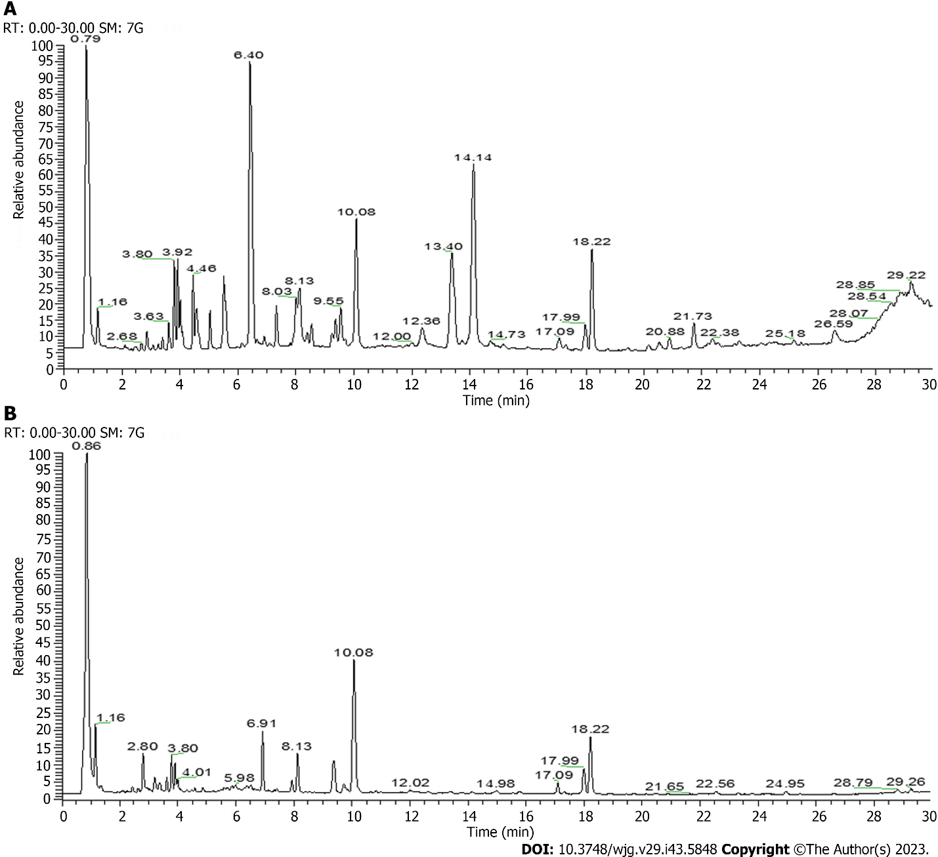
Figure 1 Total ion current chromatogram of Atractylodes japonica by liquid chromatography-tandem mass spectrometry. A: Positive ion mode; B: Negative ion mode.

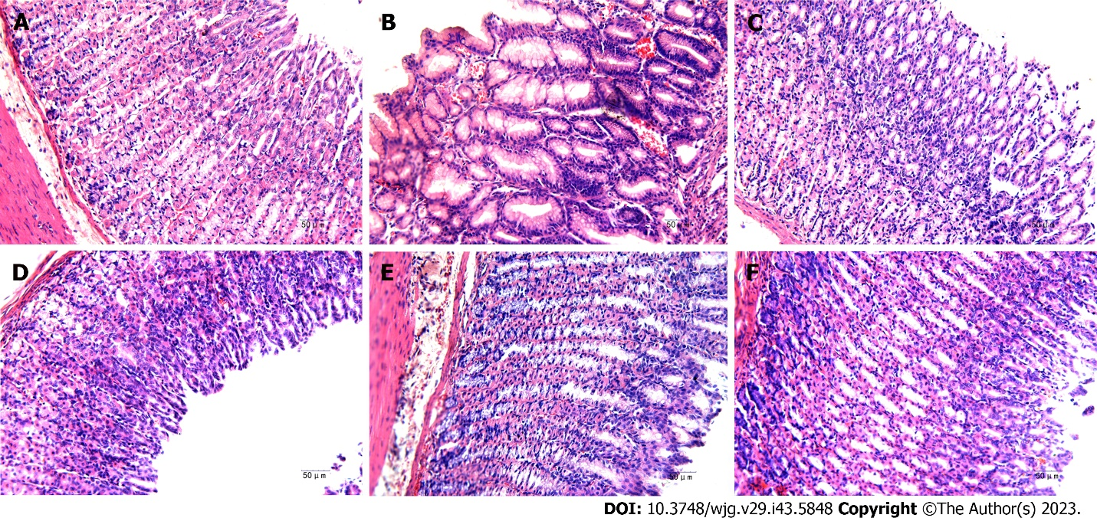
Figure 2 Effect of Atractylodes japonica on pathological changes of gastric tissues in gastric ulcer rats after 10 d of treatment (n = 8). A-F: Histological analysis was performed by hematoxylin and eosin staining (200 × original magnification, scale bar 50 μm). Normal group (A); acetic acid-induced model group (B); omeprazole group (C); low dose group of Atractylodes japonica (A. japonicaI) (D); middle dose group of A. japonica (E); high dose group of A. japonica (F).
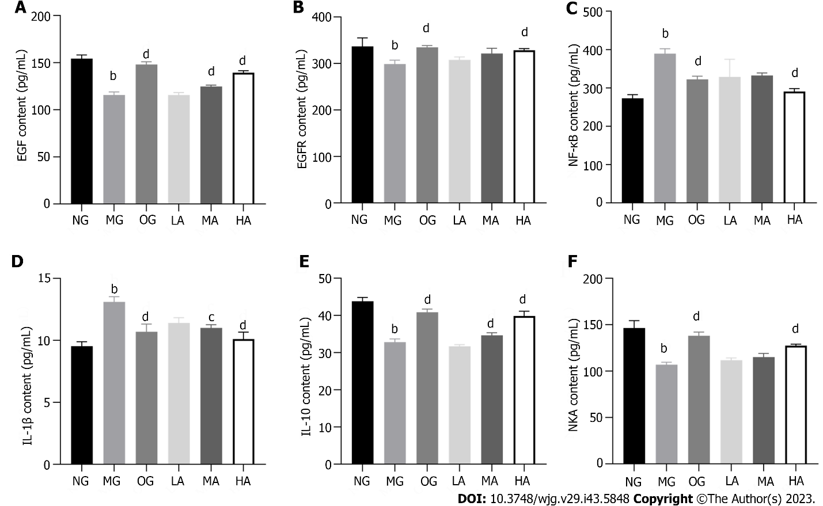
Figure 3 Effect of Atractylodes japonica on gastric ulcer-associated factors level in serum of gastric ulcer rats (n = 8). A-F: The epidermal growth factor (EGF), EGF receptor, nuclear factor kappa-B, interleukin-1β (IL-1β), IL-10, and Na⁺-K⁺-ATPase levels were detected by enzyme-linked immunosorbent assay in serum of gastric ulcer rats. ^{b}P < 0.01 vs normal group; ^{c}P < 0.05 and ^{d}P < 0.01 vs model group. EGF: Epidermal growth factor; EGFR: Epidermal growth factor receptor; NF-κB: Nuclear factor kappa-B; IL: Interleukin; NKA: Na⁺-K⁺-ATPase; NG: Normal group; MG: Model group; OG: Omeprazole group; LA: Low dose group of Atractylodes japonica; MA: Middle dose group of Atractylodes japonica; HA: High dose group of Atractylodes japonica.

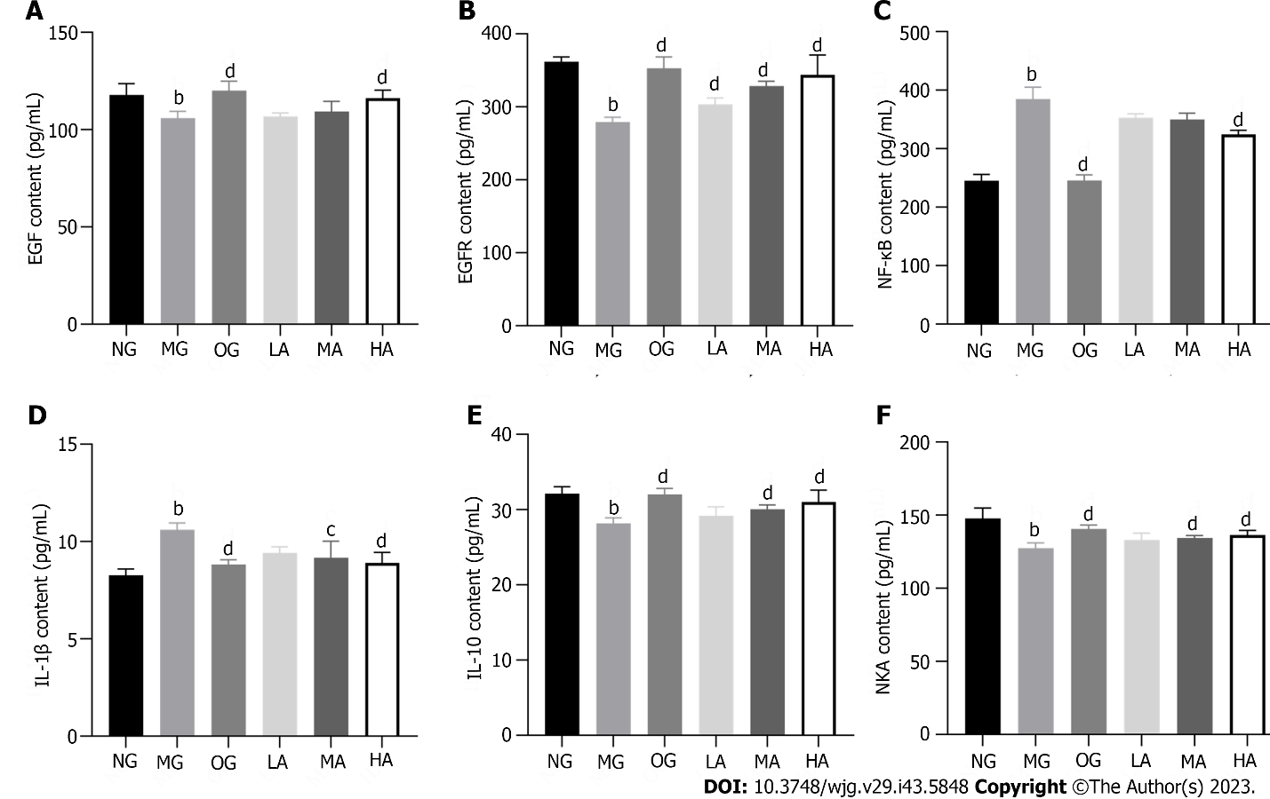
Figure 4 Effect of Atractylodes japonica on gastric ulcer-associated factors level in gastric tissues of gastric ulcer rats (n = 8). A-F: The epidermal growth factor (EGF), EGF receptor, nuclear factor kappa-B, interleukin-1β (IL-1β), IL-10, and Na⁺-K⁺-ATPase levels were detected by enzyme-linked immunosorbent assay in gastric tissues of gastric ulcer rats. ^{b}P < 0.01 vs normal group; ^{c}P < 0.05 and ^{d}P < 0.01 vs model group. EGF: Epidermal growth factor; EGFR: Epidermal growth factor receptor; NF-κB: Nuclear factor kappa-B; IL: Interleukin; NKA: Na⁺-K⁺-ATPase; NG: Normal group; MG: Model group; OG: Omeprazole group; LA: Low dose group of Atractylodes japonica; MA: Middle dose group of Atractylodes japonica; HA: High dose group of Atractylodes japonica.

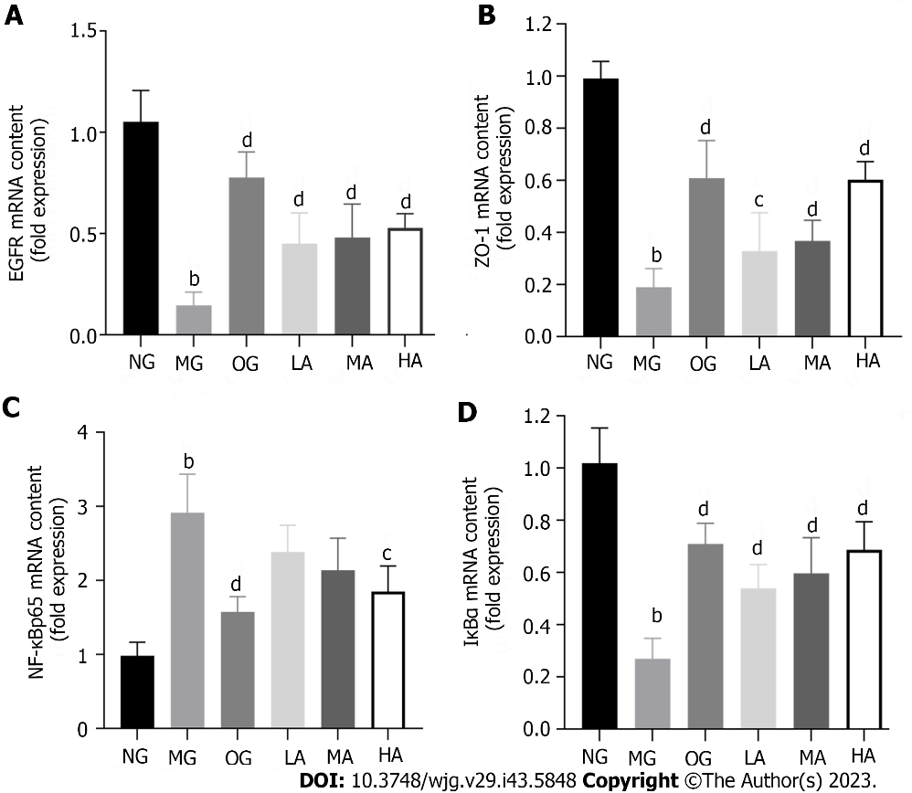
Figure 5 Effect of Atractylodes japonica on gastric ulcer-associated genes in acid-induced gastric tissues (n = 8). A-D: The mRNA levels of epidermal growth factor receptor, Zonula Occludens-1, nuclear factor kappa-B p65, IkappaBalpha in gastric tissues were analysed by real-time reverse transcription polymerase chain reaction. ^{b}P < 0.01 vs normal group; ^{c}P < 0.05 and ^{d}P < 0.01 vs model group. EGFR: Epidermal growth factor receptor; ZO-1: Zonula Occludens-1; NF-κB: Nuclear factor kappa-B; IκBα: IkappaBalpha; NG: Normal group; MG: Model group; OG: Omeprazole group; LA: Low dose group of Atractylodes japonica; MA: Middle dose group of Atractylodes japonica; HA: High dose group of Atractylodes japonica.

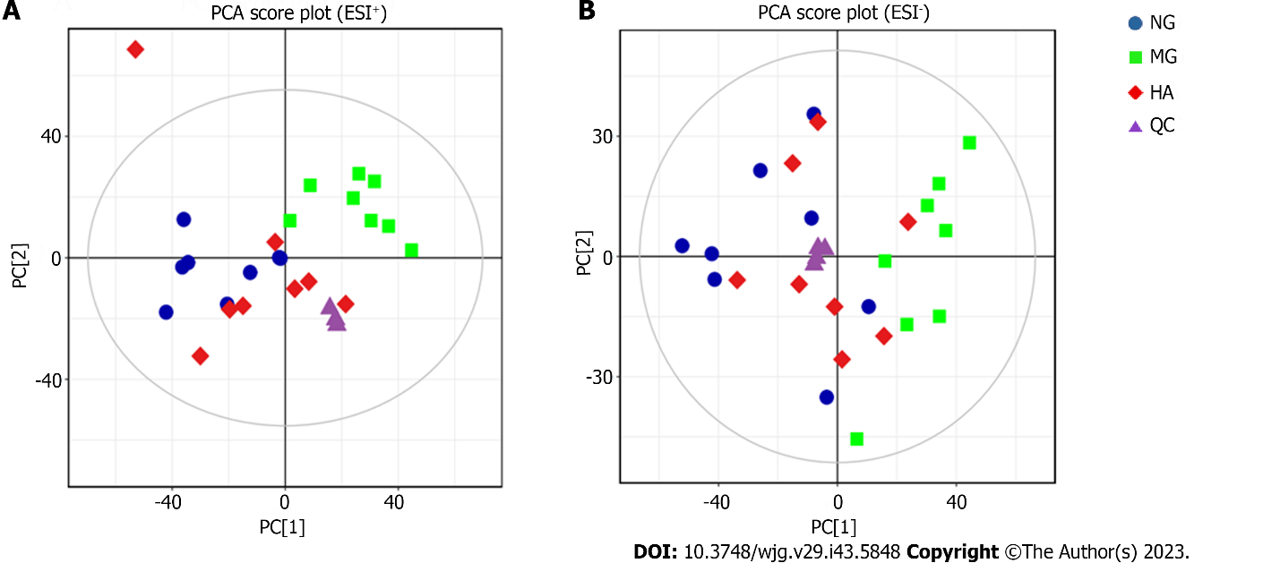Figure 6 Principal component analysis score plots of plasma metabolomics analysis (n = 8). Principal component analysis score plots among normal group, model group, high dose group of Atractylodes japonica and quality control groups. A: Positive ion mode (ESI⁺); B: Negative ion mode (ESI⁻). PCA: Principal component analysis; NG: Normal group; MG: Model group; HA: High dose group of Atractylodes japonica; QC: Quality control.
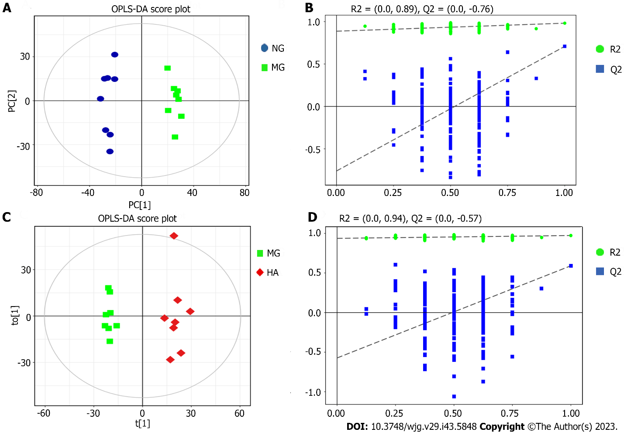Figure 7 Orthogonal projections to latent structures-discriminant analysis score plots and 200-permutation test of plasma metabolomics analysis (n = 8). A: Orthogonal projections to latent structures-discriminant analysis (OPLS-DA) score plots between normal group (NG) and model group (MG) groups; B: 200-permutation test between NG and MG groups; C: OPLS-DA score plots between MG and high dose group of Atractylodes japonica (HA) groups; D: 200-permutation test between MG and HA groups. OPLS-DA: Orthogonal projections to latent structures-discriminant analysis; MG: Model group; HA: High dose group of Atractylodes japonica.

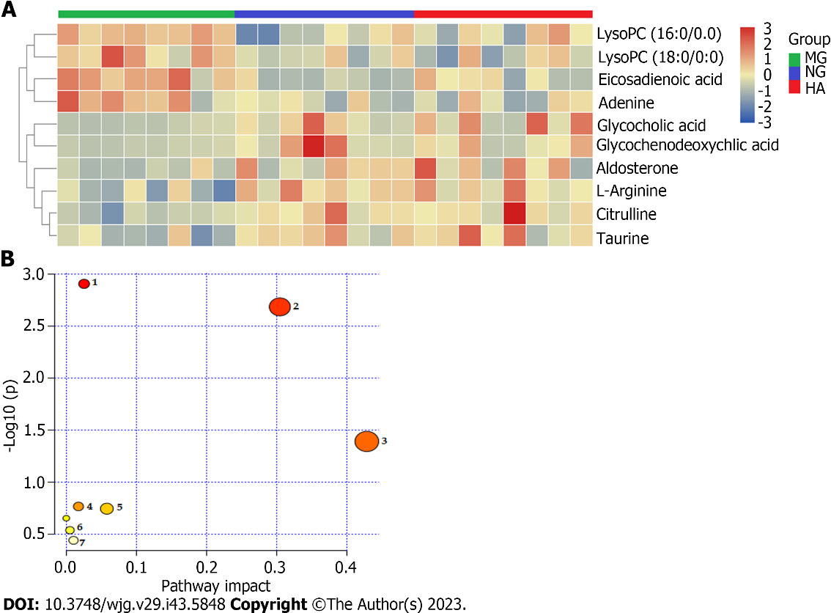
Figure 8 Enrichment analysis of metabolic markers (n = 8). A: Heatmap of potential biomarkers and the degree of the changes are marked in red (up-regulation) and blue (down-regulation); B: Metabolic pathways involved in the therapeutic effects of Atractylodes japonica on gastric ulcer. NG: Normal group; MG: Model group; HA: High dose group of Atractylodes japonica.

Table 1 Sequences of the primers for real-time reverse transcription polymerase chain reaction
Gene | Forward primer | Reverse primer | Length
EGFR | CCTATGGGCCAAAGATCCCA | GAGGTTCCACGAGCTCTCTC | 162 bp
ZO-1 | CACCACAGACATCCAACCAG | CACCAACCACTCTCCCTTGT | 230 bp
NF-κBp65 | AGGCCATTGAAGTGATCCAG | CAGTGAGGGACTCCGAGAAG | 204 bp
IκBα | CACGGAAGATGAGTTGCCCT | CAAGTCCACGTTCCTTTGGC | 91 bp
GAPDH | AGACAGCCGCATCTTCTTGT | CTTGCCGTGGGTAGAGTCAT | 207 bp
EGFR: Epidermal growth factor receptor; ZO-1: Zonula Occludens-1; NF-κB: Nuclear factor kappa-B; IκBα: IkappaBalpha.

Table 2 Identification of chemical constituents of Atractylodes japonica by UPLC Q-Exactive Orbitrap MS
No. | tR/min | Compound | Molecular formula | Adduct ion | Theoretical (m/z) | Measured (m/z) | Error (ppm)
1 | 0.83 | Asparagine | C₄H₈N₂O₃ | [M+H]⁺ | 133.06076 | 133.06033 | -3.297
2 | 0.85 | Sucrose | C₁₂H₂₂O₁₁ | [M−H+HCOOH]⁻ | 387.11441 | 387.11374 | -1.741
3 | 0.86 | Manninotriose | C₁₈H₃₂O₁₆ | [M−H]⁻ | 503.16092 | 503.16175 | -1.665
4 | 0.85 | Valine | C₅H₁₁NO₂ | [M+H]⁺ | 118.08625 | 118.08591 | -2.923
5 | 0.87 | 5-hydroxymethylfurfural | C₆H₆O₃ | [M+H]⁺ | 127.03897 | 127.03864 | -2.602
6 | 0.91 | Niacinamide | C₆H₆N₂O | [M+H]⁺ | 123.05529 | 123.05509 | -1.620
7 | 1.19 | Pyroglutamic acid | C₅H₇NO₃ | [M+H]⁺ | 130.04986 | 130.04953 | -2.612
8 | 1.25 | Tyrosine | C₉H₁₁NO₃ | [M+H]⁺ | 182.08116 | 182.08063 | -2.964
9 | 1.27 | Citric acid | C₆H₈O₇ | [M−H]⁻ | 191.01972 | 191.01880 | -4.847
10 | 1.35 | Isoleucine | C₆H₁₃NO₂ | [M+H]⁺ | 132.10190 | 132.10153 | -2.840
11 | 1.46 | Leucine | C₆H₁₃NO₂ | [M+H]⁺ | 132.10190 | 132.10153 | -2.840
12 | 2.10 | Phenylalanine | C₉H₁₁NO₂ | [M+H]⁺ | 166.08625 | 166.08577 | -2.921
13 | 2.25 | Neochlorogenic acid | C₁₆H₁₈O₉ | [M−H]⁻ | 353.08781 | 353.08783 | 0.050
14 | 2.44 | Chlorogenic acid | C₁₆H₁₈O₉ | [M−H]⁻ | 353.08781 | 353.08752 | -0.808
15 | 2.44 | Atractyloside A | C₂₁H₃₆O₁₀ | [M−H+HCOOH]⁻ | 493.22905 | 493.22864 | -0.831
16 | 2.80 | Cryptochlorogenic acid | C₁₆H₁₈O₉ | [M−H]⁻ | 353.08781 | 353.08728 | -1.488
17 | 2.86 | Caffeic acid | C₉H₈O₄ | [M+H]⁺ | 181.04953 | 181.04890 | -3.509
18 | 2.86 | 7-hydroxycoumarin | C₉H₆O₃ | [M+H]⁺ | 163.03897 | 163.03841 | -3.439
19 | 3.17 | Catechin | C₁₅H₁₄O₆ | [M−H]⁻ | 289.07176 | 289.07172 | -0.143
20 | 3.19 | Isochlorogenic acid B | C₂₅H₂₄O₁₂ | [M−H]⁻ | 515.11950 | 515.11890 | -1.163
21 | 3.27 | Isoorientin | C₂₁H₂₀O₁₁ | [M+H]⁺ | 449.10784 | 449.10669 | -2.556
22 | 3.51 | Rutin | C₂₇H₃₀O₁₆ | [M−H]⁻ | 609.14610 | 609.14630 | 0.315
23 | 3.52 | Hyperoside | C₂₁H₂₀O₁₂ | [M−H]⁻ | 463.08819 | 463.08826 | 0.131
24 | 3.52 | Quercetin | C₁₅H₁₀O₇ | [M+H]⁺ | 303.04992 | 303.04895 | -3.528
25 | 3.68 | Kaempferol-3-O- rutinoside | C₂₇H₃₀O₁₅ | [M−H]⁻ | 593.15119 | 593.15125 | 0.096
26 | 3.77 | Isorhamnetin 3-O-neohesperidin | C₂₈H₃₂O₁₆ | [M−H]⁻ | 623.16176 | 623.16107 | -1.104
27 | 3.78 | Narcissoside | C₂₈H₃₂O₁₆ | [M+H]⁺ | 625.17631 | 625.17371 | -4.161
28 | 3.78 | Isorhamnetin | C₁₆H₁₂O₇ | [M+H]⁺ | 317.06558 | 317.06421 | -4.318
29 | 3.83 | Vanillin | C₈H₈O₃ | [M+H]⁺ | 153.05462 | 153.05406 | -3.663
30 | 3.86 | Isochlorogenic acid A | C₂₅H₂₄O₁₂ | [M−H]⁻ | 515.11950 | 515.11914 | -0.697
31 | 3.96 | Isochlorogenic acid C | C₂₅H₂₄O₁₂ | [M−H]⁻ | 515.11950 | 515.11896 | -1.047
32 | 6.40 | Palmitic acid | C₁₆H₃₂O₂ | [M+NH₄]⁺ | 274.27406 | 274.27292 | -4.141
33 | 6.47 | Cinnamyl alcohol | C₉H₁₀O | [M+H]⁺ | 135.08044 | 135.07999 | -3.343
34 | 6.51 | Curcumenol | C₁₅H₂₂O₂ | [M+H]⁺ | 235.16925 | 235.16826 | -4.237
35 | 7.34 | Atractylenolide III | C₁₅H₂₀O₃ | [M+H]⁺ | 249.14852 | 249.14752 | -4.018
36 | 7.62 | Atractylenolactam | C₁₅H₁₉NO | [M+H]⁺ | 230.15394 | 230.15340 | -2.350
37 | 9.24 | 3β-hydroxyatractylone | C₁₅H₂₀O₂ | [M+H]⁺ | 233.15361 | 233.15279 | -3.502
38 | 9.55 | Atractylenolide II | C₁₅H₂₀O₂ | [M+H]⁺ | 233.15361 | 233.15274 | -3.716
39 | 12.00 | Atractylenolide VI | C₁₅H₂₂ | [M+H]⁺ | 203.17943 | 203.17889 | -2.644
40 | 12.01 | α-linolenic acid | C₁₈H₃₀O₂ | [M+H]⁺ | 279.23185 | 279.23108 | -2.782
41 | 12.14 | 3β-acetoxyatracty | C₁₇H₂₂O₃ | [M+H]⁺ | 275.16417 | 275.16333 | -3.057
42 | 12.38 | Atractylenolide I | C₁₅H₁₈O₂ | [M+H]⁺ | 231.13796 | 231.13721 | -3.229
43 | 12.95 | Atractylenolide V | C₁₅H₂₀O₄ | [M+H]⁺ | 265.14343 | 265.14258 | -3.227
44 | 13.42 | (6E,12E)-tetradecadiene-8,10-diyne-1,3-diol diacetate | C₁₈H₂₂O₄ | [M+H]⁺ | 303.15908 | 303.15805 | -3.416
45 | 13.97 | β-elemene | C₁₅H₂₄ | [M+H]⁺ | 205.19508 | 205.19443 | -3.155
46 | 14.14 | Eudesma-4(15),7(11)-dien-8-one | C₁₅H₂₂O | [M+H]⁺ | 219.17434 | 219.17346 | -4.024
47 | 20.55 | Atractylon | C₁₅H₂₀O | [M+H]⁺ | 217.15869 | 217.15800 | -3.186
48 | 21.83 | Biatractylolide | C₃₀H₃₈O₄ | [M+H]⁺ | 463.28428 | 463.28290 | -2.992

Table 3 Identified metabolites of plasma
No. | Compound name | R.T. (min) | Formula | Exact mass (m/z) | HMDB ID | MG vs NG | P value | HA vs MG | P value
1 | L-arginine | 0.77 | C₆H₁₄N₄O₂ | 174.1116 | HMDB0000517 | Decreased | < 0.01 | Increased | < 0.05
2 | Citrulline | 0.79 | C₆H₁₃N₃O₃ | 175.0956 | HMDB0000904 | Decreased | < 0.01 | Increased | < 0.05
3 | Taurine | 0.79 | C₂H₇NO₃S | 125.0146 | HMDB0000251 | Decreased | < 0.05 | Increased | < 0.05
4 | Adenine | 1.42 | C₅H₅N₅ | 135.0545 | HMDB0000034 | Increased | < 0.05 | Decreased | < 0.05
5 | Glycocholic acid | 6.31 | C₂₆H₄₃NO₆ | 465.3090 | HMDB0000138 | Decreased | < 0.05 | Increased | < 0.05
6 | Aldosterone | 7.59 | C₂₁H₂₈O₅ | 360.1936 | HMDB0000037 | Decreased | < 0.05 | Increased | < 0.05
7 | Glycochenodeoxycholic acid | 8.09 | C₂₆H₄₃NO₅ | 449.3138 | HMDB0000637 | Decreased | < 0.05 | Increased | < 0.05
8 | LysoPC (16:0/0:0) | 10.17 | C₂₄H₅₀NO₇P | 495.3324 | HMDB0010382 | Increased | < 0.01 | Decreased | < 0.01
9 | LysoPC (18:0/0:0) | 11.20 | C₂₆H₅₄NO₇P | 523.3637 | HMDB0010384 | Increased | < 0.05 | Decreased | < 0.05
10 | Eicosadienoic acid | 13.76 | C₂₀H₃₆O₂ | 308.2715 | HMDB0005060 | Increased | < 0.01 | Decreased | < 0.05
MG: Model group; NG: Normal group; HA: High dose group of the crude Atractylodes japonica.

Table 4 Results of enrichment analysis of biomarkers
No. | Pathway name | Match status | P value | -Log (P) | Impact
1 | Primary bile acid biosynthesis | 3/46 | 0.0012354 | 2.9082 | 0.0254
2 | Arginine biosynthesis | 2/14 | 0.0020576 | 2.6866 | 0.30457
3 | Taurine and hypotaurine metabolism | 1/8 | 0.040642 | 1.391 | 0.42857
4 | Glycerophospholipid metabolism | 1/36 | 0.17174 | 0.76513 | 0.01736
5 | Arginine and proline metabolism | 1/38 | 0.18047 | 0.74359 | 0.05786
6 | Purine metabolism | 1/65 | 0.29073 | 0.53651 | 0.00528
7 | Steroid hormone biosynthesis | 1/85 | 0.3638 | 0.43913 | 0.01032

Published by Baishideng Publishing Group Inc
7041 Koll Center Parkway, Suite 160, Pleasanton, CA 94566, USA
Telephone: +1-925-3991568
E-mail: bpgoffice@wjgnet.com
Help Desk: https://www.f6publishing.com/helpdesk
https://www.wjgnet.com

© 2023 Baishideng Publishing Group Inc. All rights reserved.

