Name of Journal: World Journal of Clinical Cases
Manuscript NO: 60462
Manuscript Type: CASE REPORT

Nonalcoholic fatty liver disease as a risk factor for cytomegalovirus hepatitis in an immunocompetent patient: A case report

Khiatah B et al. NAFLD as a risk for CMV hepatitis

Bashar Khiatah, Laya Nasrollah, Stephen Covington, Deborah Carlson

Bashar Khiatah, Deborah Carlson, Internal Medicine, Community Memorial Hospital, Ventura, CA 93003, United States

Laya Nasrollah, Stephen Covington, Department of Gastroenterology, Community Memorial Hospital, Ventura, CA 93003, United States

Author contributions: Khiatah B wrote the main manuscript; Nasrollah L, Covington S and Carlson D provided expert input and editing; all of the authors provided direct care to the patient.

Corresponding author: Bashar Khiatah, MD, Doctor, Internal Medicine, Community Memorial Hospital, 147 N Brent Street, Ventura, CA 93003, United States. bkhiatah@gmail.com

Received: November 4, 2020
Revised: December 13, 2020
Accepted: December 27, 2020
Published online:

Abstract
BACKGROUND
Almost 80 percent of adults in the United States have had cytomegalovirus (CMV) infection by age 40. The number of symptomatic CMV hepatitis cases has been increasing along with non-alcoholic fatty liver disease (NAFLD) cases in the United States that is estimated to be 25 percent of the population. In this paper, we try to link these two entities together.

CASE SUMMARY
In this case report, we describe a young female who presented with fever, nausea, and vomiting who was found to have NAFLD and CMV hepatitis that was treated supportively.

CONCLUSION
In this case report, we describe NAFLD as a risk factor for CMV hepatitis and discuss the possible impact on clinical practice. We believe, it is essential to consider NAFLD and it’s disease mechanisms’ localized immunosuppression, as a risk factor of CMV hepatitis and severe coronavirus disease 2019 infection.

Key Words: Non-alcoholic fatty liver disease; Cytomegalovirus hepatitis; Immunocompetent; Female health; Global impact; Hepatology; Case report

Khiatah B, Nasrollah L, Covington S, Carlson D. Nonalcoholic fatty liver disease as a risk factor for cytomegalovirus hepatitis in an immunocompetent patient: A case report. World J Clin Cases 2020; In press

Core Tip: It is essential to consider non-alcoholic fatty liver disease and it’s disease mechanisms’ localized immunosuppression, as a risk factor of cytomegalovirus hepatitis and possible other viral diseases. Also, with non-alcoholic fatty liver disease raising numbers it is worthwhile to screen for it in high risk population to prevent from it's complications and risks to develop severe viral diseases in case of infection that could be life threatening.
INTRODUCTION
Cytomegalovirus (CMV) is a herpesviridae family member that causes a spectrum of human illness that is mostly dependent on the host. Infection in an immunocompetent patient is usually asymptomatic or might present as a mononucleosis syndrome. Occasionally, primary CMV infection can lead to severe organ-specific complications with significant morbidity and mortality^{[1,2]}. CMV hepatitis in immunocompetent patients has been reported frequently in the literature, increasing the awareness of this disease^{[3]}. Reports over the last decade have informed us that non-alcoholic fatty liver disease (NAFLD) is a multisystem disease affecting multiple extrahepatic organs and regulatory pathways, proving that NAFLD's clinical burden is not limited to liver-related morbidity and mortality^{[4]}. NAFLD is an excessive infiltration of fat in the liver in individuals not consuming or consuming in small amounts of alcohol defined as ≤ 20 g per day for women and ≤ 30 g per day for men. Diagnosis usually requires the elimination of secondary causes of fatty infiltration of the liver, including hepatitis C virus infection, the use of glucocorticoids, celiac disease, Wilson disease, familial hypobetalipoproteinemia, and autoimmune disorders^{[5]}.

CASE PRESENTATION
Chief complaints
Six-day history of fever, night sweats, myalgia, nausea, and vomiting.

History of present illness
A 34-year-old Hispanic female presents to the emergency room (ER) with a six-day history of fever, night sweats, myalgia, nausea, and vomiting. Coronavirus disease 2019 testing was negative, and she was sent home on antiemetics. She developed intermittent abdominal pain in the right upper quadrant of 5/10 intensity, sharp, non-radiating associated with mild headache and lightheadedness that prompted her to return to the ER. She has no sick contacts. She is up to date on her vaccinations, monogamous, practices all social distancing precautions, and is a housewife and a mother of 3 healthy children. She denies having pain with any specific foods, including fatty foods, recent travel, IV drug abuse, alcohol, smoking, and all other symptoms. Her only medications were Ondansetron and Acetaminophen.

History of past illness
Remote history of intermittent asthma.

Personal and family history
Family history is remarkable for diabetes.

Physical examination
On physical exam, her body mass index is 33.1 kg/m²; she has a temperature of 101.2 F and is mildly tender to palpation in the epigastric area. Otherwise, her physical exam is benign.

Laboratory examinations
Laboratory studies are shown in Tables 1 and 2.

Imaging examinations
Radiologic studies revealed fatty liver, as shown in Figures 1 and 2, compared to normal liver imaging in 2015.

FINAL DIAGNOSIS
CMV Hepatitis in the setting of NAFLD. She is admitted for observation and found to have CMV hepatitis, as shown in Tables 1 and 2.

TREATMENT
Supportive treatment with Ibuprofen 400 mg every 6 h for fever.

OUTCOME AND FOLLOW-UP
She was discharged home and instructed to follow up with both her primary care doctor and the Gastroenterologist. Education was provided on a low-fat diet, exercise, and the importance of weight loss. One week after discharge, she was seen in the primary clinic for follow up. She reported continuous yet less frequent symptoms of fever, myalgias, and night sweats controlled with Acetaminophen, Ibuprofen, and Ondansetron. Her liver enzymes were trending down. Two weeks after discharge, she was symptom-free with normalized liver enzymes.

DISCUSSION
The liver is a unique immune environment containing lymphocytes, monocytes, Kupffer cells, Natural-killers, astrocytes dendritic, and many other immigrant cells associated with the immune system. It is responsible for synthesizing various proteins such as acute-phase proteins, complements, cytokines, chemokines, lipid messengers, and reactive oxygen species. Insulin resistance, oxidative stress, endoplasmic reticulum stress, endotoxins from the intestinal flora, and genetic predispositions are all involved in developing NAFLD, causing an imbalance of the immune system in the liver^{[4,5]}. This imbalance translates as an elevation of Interleukin-6 (IL-6), IL-15, IL-17, IL18, Tumor Necrosis Factor-alpha, Interferon gamma-induced protein 10, and Transforming growth factor beta-3^{[5]}. A recently published study where authors reported NAFLD's significance as a significant risk factor affecting the severity of coronavirus disease 2019 emphasizes the importance of this imbalance^{[6]}.

CONCLUSION
Finally, in the United States, with an estimated 25 percent of the population with NAFLD, and almost 80 percent of adults having CMV infection by age 40, it is essential to consider NAFLD and it’s disease mechanisms’ localized immunosuppression, as a risk factor of CMV hepatitis. Further studies and research are required to understand NAFLD as a risk for viral diseases.

REFERENCES
1 Horwitz CA, Henle W, Henle G, Snover D, Rudnick H, Balfour HH Jr, Mazur MH, Watson R, Schwartz B, Muller N. Clinical and laboratory evaluation of cytomegalovirus-induced mononucleosis in previously healthy individuals. Report of 82 cases. Medicine (Baltimore) 1986; 65: 124-134 [PMID: 3005799 DOI: 10.1097/00005792-198603000-00005]
2 Cohen JI, Corey GR. Cytomegalovirus infection in the normal host. Medicine (Baltimore) 1985; 64: 100-114 [PMID: 2983175 DOI: 10.1097/00005792-198503000-00003]
3 Wreghitt TG, Teare EL, Sule O, Devi R, Rice P. Cytomegalovirus infection in immunocompetent patients. Clin Infect Dis 2003; 37: 1603-1606 [PMID: 14689339 DOI: 10.1086/379711]
4 Byrne CD, Targher G. NAFLD: a multisystem disease. J Hepatol 2015; 62: S47-S64 [PMID: 25920090 DOI: 10.1016/j.jhep.2014.12.012]
5 Kosmalski M, Mokros Ł, Kuna P, Witusik A, Pietras T. Changes in the immune system - the key to diagnostics and therapy of patients with non-alcoholic fatty liver disease. Cent Eur J Immunol 2018; 43: 231-239 [PMID: 30135638 DOI: 10.5114/ceji.2018.77395]
6 Boettler T, Marjot T, Newsome PN, Mondelli MU, Maticic M, Cordero E, Jalan R, Moreau R, Cornberg M, Berg T. Impact of COVID-19 on the care of patients with liver disease: EASL-ESCMID position paper after 6 months of the pandemic. JHEP Rep 2020; 2: 100169 [PMID: 32835190 DOI: 10.1016/j.jhepr.2020.100169]

Footnotes
Informed consent statement: Informed consent was taken from the patient.

Conflict-of-interest statement: All authors declare no conflict of interest.

CARE Checklist (2016) statement: The authors have read the CARE Checklist (2016), and the manuscript was prepared and revised according to the CARE Checklist (2016).

Open-Access: This article is an open-access article that was selected by an in-house editor and fully peer-reviewed by external reviewers. It is distributed in accordance with the Creative Commons Attribution NonCommercial (CC BY-NC 4.0) license, which permits others to distribute, remix, adapt, build upon this work non-commercially, and license their derivative works on different terms, provided the original work is properly cited and the use is non-commercial. See: http://creativecommons.org/Licenses/by-nc/4.0/

Manuscript source: Unsolicited manuscript

Peer-review started: November 4, 2020
First decision: December 13, 2020
Article in press:

Specialty type: Medicine, research and experimental
Country/Territory of origin: United States
Peer-review report’s scientific quality classification
Grade A (Excellent): 0
Grade B (Very good): B
Grade C (Good): 0
Grade D (Fair): 0
Grade E (Poor): 0

P-Reviewer: Schmitz SMT S-Editor: Zhang L L-Editor: P-Editor:
Figure Legends
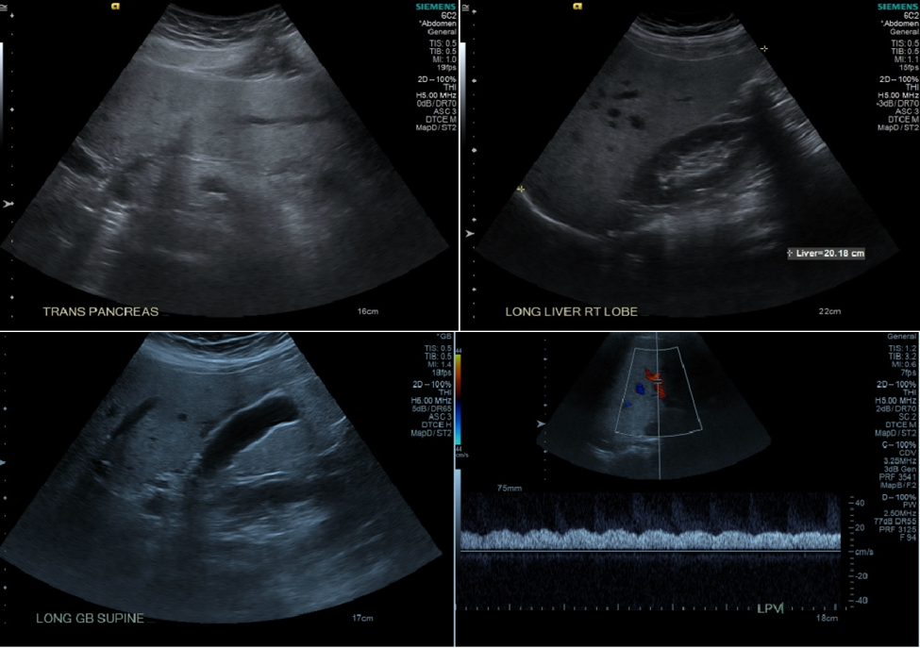
Figure 1 Intrahepatic vessels appear unremarkable including the hepatic veins. Increased liver echogenicity with moderately enlarged liver most consistent with fatty infiltration. Mild heterogeneous liver around the gallbladder fossa likely related parenchymal sparing in an otherwise fatty liver.
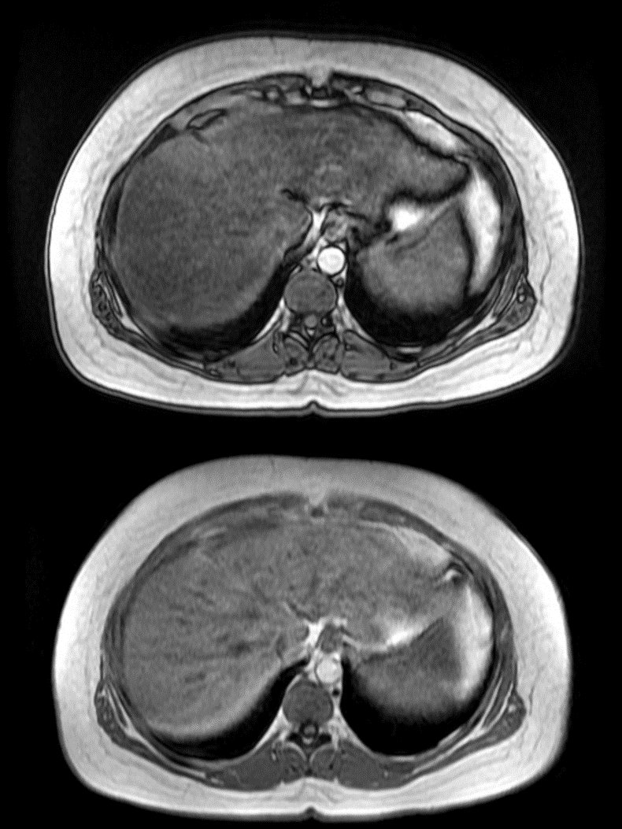
Figure 2 Magnetic resonance cholangiopancreatography results. Mild hepatosplenomegaly and hepatic steatosis.
Table 1 Laboratory trend
 | Day 1 | Day 2 | Day 3 (discharge day)
Hemoglobin (range 12.0-16.0 g/dL) | 14.6 | 12.8 | 12.6
White blood count (range 4.8-10/8 k/µL) | 11.4 | 8.9 | 9.0
Platelet count (range 150-400 k/µL) | 173 | 156 | 162
Serum sodium (range 135-145 mEq/L) | 133 | 133 | 133
Serum bicarbonate (Range 24-30 mEq/L) | 25 | 22 | 22
Blood urea nitrogen (range 8-26 mg/dL) | 6 | 5 | 4
Creatinine, serum (range 0.5-1.5 mg/dL) | 0.91 | 0.73 | 0.81
Protein, serum (g/dL) (range 6.0-8.5 g/dL) | 6.7 | 5.8 | 5.8
Albumin, serum (g/dL) (range 3.4-4.8 g/dL) | 3.1 | 2.6 | 2.6
Alanine aminotransferases (range 5-40 unit/L) | 319 | 234 | 200
Aspartate aminotransferase (range 9-48 unit/L) | 210 | 130 | 118
Alkaline phosphatase (range 53-128 unit/L) | 372 | 302 | 314
Total bilirubin (range 0.2-1.2 mg/dL) | 1 | 1.2 | 1.1
Direct bilirubin (range 0-0.3 mg/dL) | 0.4 | 0.4 | 0.4

Table 2 Hepatitis workup
Test | Result
Hepatitis A IgM | Negative
Hepatitis Be Antigen | Negative
Hepatitis Be antibody | Negative
Hepatitis C | Negative
Hepatitis E antibody IGG | Detected
Hepatitis E antibody IGM | Negative
HIV antibody | Negative
Blood culture | Negative
Urine culture | Negative
Pregnancy test, Urine | Negative
Serum CMV DNA PCR (normal range < 200.00 IU/mL) | 13700 IU/mL
Cytomegalovirus IgM (normal range < 29.9 U/mL) | 47.7AU/mL
Influenza A and B rapid test | Negative
Epstein-Barr virus DNA PCR (Negative) | Negative
HIV-1/2 antibody/antigen | Negative
SARS-COV-2 IGM/IGG | Negative
Acetaminophen (range 10-30 µg/mL) | < 10 µg/mL
Antinuclear antibodies | Negative
Anti-smooth muscle antibody | Negative
Anti-mitochondrial | Negative
Tissue transglutaminase antibody | Negative
Liver kidney microsomal assay (negative range ≤ 20.0 units) | < 20.0 units
Ferritin | 384 ng/mL
Erythrocyte sedimentation rate (range 0-30.0 mm/h) | 16 mm/h
24 h Urine Copper (3.0-45.0 µg/d) | 48 µg/d
C-reactive protein (0.00-0.80 mg/dL) | 5.8 mg/dL
CMV: Cytomegalovirus; PCR: Polymerase chain reaction; SARS-COV-2: Severe acute respiratory syndrome coronavirus; IGG: Immunoglobulin G.

