Name of journal: World Journal of Gastroenterology
ESPS Manuscript NO: 28433
Manuscript Type: ORIGINAL ARTICLE

Basic Study
Transient receptor potential vanilloid 1-immunoreactive signals in murine enteric glial cells

Yamamoto M et al. TRPV1 and enteric glia

Masahiro Yamamoto, Mitsue Nishiyama, Seiichi Iizuka, Shigeaki Suzuki, Norihiro Suzuki, Sadakazu Aiso, Jin Nakahara

Masahiro Yamamoto, Mitsue Nishiyama, Seiichi Iizuka, Tsumura Research Laboratories, Tsumura & Co., Ibaraki 300-1192, Japan

Shigeaki Suzuki, Norihiro Suzuki, Jin Nakahara, Department of Neurology, Keio University School of Medicine, Tokyo 160-0016 , Japan

Sadakazu Aiso, Department of Anatomy, Keio University School of Medicine, Tokyo 160-0016, Japan

Author contributions: Yamamoto M conceived, designed, and performed the in vitro cell culture experiments and immunocytochemistry, analyzed the data, and wrote the manuscript; Nishiyama M and Iizuka S bred mice and prepare specimens for further analyses; Suzuki S, Suzuki N and Aiso S contributed to experimental design and data analysis; Nakahara J conceived the study and designed and performed immunohistochemistry experiments; all authors read and approved the final version of the manuscript.

Institutional review board statement: This study was approved by the Institutional Review Boards of Keio University School of Medicine and Tsumura Research Laboratories.

Institutional animal care and use committee statement: All experimental procedures were performed according to the Guidelines for the Care and Use of Laboratory Animals of Tsumura & Co. Ethical approval (Approval #14-088) for the experimental procedures used in this study was obtained from the Laboratory Animal Committee of Tsumura & Co. All animal procedures were conducted in accordance with the National Institutes of Health Guide for the Care and Use of Laboratory Animals.

Conflict-of-interest statement: No potential conflicts of interest relevant to this article were reported.

Data sharing statement: Technical appendix and dataset are available from the corresponding author at hirokoma@h.email.ne.jp.

Open-Access: This article is an open-access article which was selected by an in-house editor and fully peer-reviewed by external reviewers. It is distributed in accordance with the Creative Commons Attribution Non Commercial (CC BY-NC 4.0) license, which permits others to distribute, remix, adapt, build upon this work non-commercially, and license their derivative works on different terms, provided the original work is properly cited and the use is non-commercial. See: http://creativecommons.org/licenses/by-nc/4.0/

Manuscript source: Unsolicited manuscript

Correspondence to: Masahiro Yamamoto, PhD, Tsumura Research Laboratories, Tsumura & Co., 3586 Yoshiwara, Ami, Inashiki, IBARAKI 300-1192, Japan. hirokoma@h.email.ne.jp
Telephone: +81-29-8893851
Fax: +81-29-8892158

Received: June 30, 2016
Peer-review started: July 1, 2016
First decision: August 29, 2016
Revised: September 2, 2016
Accepted: October 10, 2016
Article in press:
Published online:
Abstract
AIM
To investigate the possible involvement of transient receptor potential vanilloid 1 (TRPV1) in maturation of enteric glial cells (EGCs).

METHODS
Immunohistochemical and immunocytochemical techniques were used to analyze EGC markers in myenteric plexus (MP) as well as cultured MP cells and EGCs using TRPV1 knockout (KO) mice.

RESULTS
We detected TRPV1-immunoreactive signals in EGC in the MP of wild-type (WT) but not KO mice. Expression of glial fibrillary acidic protein (GFAP) immunoreactive signals was lower at postnatal day (PD) 6 in KO mice, though the difference was not clear at PD 13 and PD 21. When MP cells were isolated and cultured from isolated longitudinal muscle-MP preparation from WT and KO mice, the yield of KO EGC was lower than that of WT EGC, while the yield of KO and WT smooth muscle cells showed no difference. Addition of BCTC, a TRPV1 antagonist, to enriched EGC culture resulted in a decrease in the protein ratio of GFAP to S100B, another EGC/astrocyte-specific marker.

CONCLUSION
These results address the possibility that TRPV1 may be involved in the maturation of EGC though further studies are necessary to validate this possibility.

Key words: Enteric glial cells; Enteric nervous system; Glial fibrillary acidic protein; S100B; Smooth muscle cells

© The Author(s) 2016. Published by Baishideng Publishing Group Inc. All rights reserved.

Core tip: We report that immunosignals of glial fibrillary acidic protein (GFAP) in myenteric ganglia in transient receptor potential vanilloid 1 (TRPV1) knockout (KO) mice are weaker than in wild-type mice in the early postnatal period suggesting the possibility that the maturation of enteric glial cells (EGCs) might be retarded at least temporally in TRPV1 KO mice. Accordingly, in in vitro culture of isolated myenteric plexus cells/EGCs suggest that GFAP expression is affected by gene KO and an antagonist toTRPV1. The expression and function of TRPV1 in EGC merits further investigation.

Yamamoto M, Nishiyama M, Iizuka S, Suzuki S, Suzuki N, Aiso S, Nakahara J. Transient receptor potential vanilloid 1-immunoreactive signals in murine enteric glial cells. World J Gastroenterol 2016; In press

INTRODUCTION
The enteric nervous system (ENS), an integrative neuronal network that resides within the gut wall, autonomously controls gastrointestinal motility, secretion, and blood flow without major inputs from the brain^{[1,2]}. The ENS is composed of two main cell types, neurons and enteric glial cells (EGC), the latter being several fold more abundant than neurons^{[3-5]}. EGC share many phenotypical features with astrocytes, and were long believed to function mainly as support cells for neurons. However, emerging evidence has elucidated their regulatory role in a wide array of gastrointestinal (GI) physiological and pathophysiological processes^{[6]} including neurotransmission^{[7,8]}, motility^{[9-11]}, and inflammation^{[8]}, as well as in secretory/absorptive^{[12,13]}, barrier^{[8,14-16]} and repair^{[17]} functions of the intestinal epithelium and host defense against pathogens^{[18]}.
Transient receptor potential vanilloid receptor 1 (TRPV1) is a nonselective cation channel activated by exogenous plant-derived vanilloid compounds such as capsaicin and resiniferatoxin as well as by endogenous membrane-derived lipid endocannabinoids such as anandamine, 2-arachidonoyl-glycerol, and N-arachidonoyl-dopamine^{[19]}. Moreover, TRPV1 is known to be a transducer channel activated by high temperature, low pH, and mechanical/osmotic stimuli. Although attention has been directed mainly to sensory neurons as the site of TRPV1 localization, TRPV1 expression has been detected in non-neuronal tissues/cells including keratinocytes of the epidermis, bladder urothelium, smooth muscles, liver, polymorphonuclear granulocytes, mast cells, and macrophages^{[19]}.
TRPV1 has been reported to be present in astrocytes in brain^{[20]}, spinal cord^{[21]} and retina^{[22]} and possibly to be involved in glial activation^{[23]}, cell migration^{[24]}, amyloid-β-induced inflammation^{[25]} and traumatic brain injury^{[26]}. However, it is unknown whether TRPV1 is present and functional in enteric glia. In the present study, using TRPV1-deficient (KO) mice and an acid-ethanol fixation protocol, specific TRPV1-immunoreactive (TRPV1-IR) signal was detected in wild-type (WT) EGC. In addition, the possible involvement of TRPV1 in the differentiation of EGC was investigated.

MATERIALS AND METHODS
Antibodies
Details of the primary antibodies used in the present study are shown in Table 1. The specificity of anti-TRPV1 antibodies is presented in Supplementary Figures S1 and S2. The secondary antibodies used were FITC-labeled donkey anti-mouse IgG antibody and Cy3-labeled donkey anti-rabbit IgG (Jackson ImmunoResearch, West Grove, PA) for intestinal tissues and Alexa488-conjugated goat anti-mouse antibody and Alexa568-conjugated goat anti-rabbit antibody (Molecular Probes, Eugene, OR) for isolated longitudinal muscle layer-myenteric plexus (LM-MP) and cultured cells.

Animals
C57Bl/6 mice were from Charles River Laboratories Japan Inc. (Kanagawa, Japan). TRPV1-deficient (B6.129X1-Trpv1<tm1Jul>/J) mice originally obtained from Jackson Laboratories (Bar Harbor, ME) were maintained at Charles River Laboratories Japan Inc. and transported to the animal facilities of Tsumura Laboratories on gestational day 14 (dams, 1 dam per cage) or at the age of 7 weeks (adult males, 4 mice per cage). The animals were allowed free access to water and standard laboratory food, and were housed at a temperature of 23 ± 2 °C with relative humidity of 55 ± 10%, and a 12:12-h light/dark cycle with lights on from 0700 to 1900 daily. All experimental procedures were performed according to the Guidelines for the Care and Use of Laboratory Animals of Tsumura & Co. Ethical approval for the experimental procedures used in this study was obtained from the Laboratory Animal Committee of Tsumura & Co. All animal procedures were conducted in accordance with the National Institutes of Health Guide for the Care and Use of Laboratory Animals.

Sample collection
For the preliminary screening, 2 TRPV1-deficient (KO) and 2 C57/Bl6 wild-type (WT) dams were used. A total of 2 pups (each pup isolated from different dams) were randomly selected and sacrificed at each time point for both the KO and WT groups. Samples were collected on the day of birth (PD 0) and at around postnatal day 10 (PD 10-12), day 20 d (PD 20-21), day 30 (PD 30-33), day 60 (PD 61-62) and day 90 (PD 91-92). After anesthesia with isoflurane, animals were transcardially perfused with ice-cold normal saline followed by ice-cold acid-ethanol solution (a mixed solution of ethanol and acetic acid at a ratio of 20:1 v/v) to fix the tissues. Large and small intestines (LI and SI, respectively) were dissected and further fixed in acid-ethanol solution overnight at 4 °C, then cryoprotected and embedded in O.C.T. Compound (Sakura Finetech, Tokyo, Japan) for frozen sections according to standard procedures. For the confirmation analysis, 6 KO and 6 WT dams were used. A total of 6 pups (each pup isolated from different dams) were sacrificed at PD 6, PD 13 and PD 21. Intestinal tissue samples were collected as described above.

Immunohistochemistry of intestinal tissue sections
Ten μm-thick frozen sections were incubated in phosphate-buffered saline (PBS) for 10 min at room temperature, and then incubated with a mixture of primary antibodies overnight at 4 °C. After a thorough wash with PBS, sections were incubated with a mixture of secondary antibodies with nuclear counterstain (TO-PRO3, Molecular Probes, Eugene, OR) for 1 h at room temperature, washed and finally mounted with Vectashield (Vector, Burlingame, CA). Sections were observed and digital images were recorded with a confocal laser scanning microscope (C-1; Nikon, Tokyo, Japan).

IHC of whole-mount preparation of longitudinal muscle layer-myenteric plexus
LI segments were isolated from 5 week old mice and the layer-myenteric plexus (LM-MP) was peeled off. The peeled LM-MPs were stretched taut, pinned flat to a silicone ring and fixed with ice-cold acetone for 30 min. After fixation, each preparation was washed 3 times for 10 min each in PBS. The preparations were placed in Superblock (Thermo Fischer Scientific, Rockford, IL) containing 0.3% Triton X-100 overnight at 4 °C. The preparations were then placed in a mixture of primary antibodies diluted in antibody diluent (DAKO Japan, Tokyo, Japan) overnight at 4 °C. After removal from the primary antibody, the tissues were rinsed 3 times for 10 min per rinse with PBS and then incubated with a mixture of the relevant secondary antibodies overnight at 4 °C. After a final set of rinses, the preparations were mounted on microslides and coverslipped with Prolong Gold antifade reagent (Molecular Probes). The slides were observed using confocal laser microscopy FV-100D (Olympus, Tokyo, Japan).

Co-culture of myenteric plexus cells and smooth muscle cells
We prepared myenteric plexus cells (MPC)/ smooth muscle cells (SMC)mixture from SI, because a far smaller number of MPC/SMC were obtained from LM-MP of LI, presumably due to the short length of the LI tract and inefficient cellular liberation from the tissue. SI segments were isolated from 5-wk-old WT and KO mice and the LM-MP was peeled off. LM-MP was digested in digestion buffer containing 0.1% type II collagenase and 0.1% soybean trypsin inhibitor (Sigma-Aldrich) at 31 °C for 30 min. The buffer was then replaced with new digestion buffer and the mixture incubated at 31 °C for an additional 30 min. The remaining tissue pieces were dissociated by mechanical shear through micropipette tips. The cells were spun down at 200 g for 5 min and suspended in HuMedia-SG2 (Kurabo, Osaka, Japan). The cells were plated in type IV-collagen coated plates (BD Biosciences, San Jose, CA). The medium was replaced on the next day which led to discarding of almost all of the cells. The remaining attached cells, which were round and small, began to proliferate discernibly by around day 3. The cells were cultured for an additional 8 days. A representative image of the cells is shown in Supplementary Figure S3. Analysis by phase-contrast microscopy showed no apparent difference in the number and appearance of the cells between cultures derived from WT and KO mice.

Enriched EGC culture
Co-culture of MPC and SMC was initiated as described in the previous section. On day 5 of the co-culture, the cells were trypsinized, washed and labeled with anti-NGF receptor p75 rabbit polyclonal antibody^{[27]} for 5 min on ice. The cells were then washed and incubated with biotinylated anti-rabbit IgG antibody (BD Biosciences) for 5 min on ice. The cells were subsequently washed and mixed with magnetic beads conjugated with streptavidin. MACS system (Miltenyi Biotec GmbH, Bergisch Gladbach, Germany) was used to enrich NGF-receptor p75-positive cells, which are derived from the neural crest. The cells were plated on poly-D-lysine-coated plate and cultured for an additional 6 days. Enriched EGC culture was performed using WT mice only, because the culture protocol has been found to be inapplicable to KO mice (the resultant culture contained only a trace number of surviving cells).

Immunocytochemistry for enriched EGC cultures
The cells were fixed with 4% phosphate-buffered paraformaldehyde for 15 min. The cells were then washed twice with PBS and permeabilized in 0.3% Triton-100 in PBS for 15 min. After being rinsed with PBS, sections were incubated overnight with in a mixture of the primary antibodies. The cells were incubated in a mixture of the relevant secondary antibodies (1:1000; Molecular Probes) for 60 min at room temperature. For TRPV1-staining, biotin-labeled anti-mouse IgG (BD Biosciences) and streptavidin-conjugated Alexa Fluor 647 (Molecular Probes) were used to amplify the signal intensity. Nuclei were stained with 2-(4-amidinophenyl)-1H -indole-6-carboxamidine (DAPI, Life Technologies). The cells were visualized, photographed and analyzed using Celaview RS100 (Olympus) or Image Xpress (Molecular Probes) cell imaging systems.

Imaging analysis for IHC
In IHC from intestinal sections, the green fluorescence of GFAP in MP was extracted and quantitated using Image J image analysis software (version 1.40g, National Institute of Health, Bethesda, MD, http://rsbweb.nih.gov/ij/) ^{[28]}. The fluorescence intensity was normalized to the circumferential length of the intestinal tract.

Imaging analysis for MPC and SMC co-culture system
The MPC and SMC co-culture system contained a large number of α smooth muscle actin (αSMA)-positive cells (i.e., SMC) and a small population of GFAP⁺ cells and GFAP⁻ αSMA⁻ cells. Virtually no PGP9.5⁺ cells were detected. After eliminating GFAP⁻ αSMA⁻ cells by imaging analysis, αSMA⁺ SMC and GFAP⁺ cells were easily distinguished by DAPI fluorescence; SMC have large nuclei with weak DAPI staining and EGC have small nuclei with bright DAPI staining (Supplementary Figures S3 and S4). We counted the number of small bright nuclei and large dim nuclei separately by setting the gate for size and brightness of the nucleus image (Supplementary Figure S4). The number of eliminated cells was then counted. The percentage of GFAP⁺ cells and SMC was defined as the ratio of the number of the cells in the respective populations to the total number of total MPC (DAPI-stained cells”).

Imaging analysis for enriched EGC culture
In enriched EGC culture, the majority of SMC was eliminated and most cells (> 90%) were stained with anti-GFAP, anti-S100B, or both antibodies. GFAP was stained with mouse monoclonal antibody and visualized with Alexa488-conjugated anti-mouse IgG. S100B was stained with rabbit polyclonal antibody and visualized with Alexa568-conjugated anti-rabbit IgG using Celaview (Supplementary Figure S5). For quantitation of fluorescence, we used a different laser source with a different wavelength (excitation wavelengths 488 and 568 nm, respectively) through different band path filters under different exposure setting optimal for each fluorescence. Therefore it was not possible to directly compare fluorescence intensity values obtained using different methods and measuring rules. As a result, in this analysis we measured the fluorescence of GFAP and S100B separately comparing the BCTC-treated wells and control wells. These cells had been isolated from a single preparation and dispensed into the wells at the same density.

Statistical analysis
Data are expressed as mean ± SEM. Unpaired Student’s t-test was used to analyze differences between 2 groups. For comparison among 3 groups, Dunnett test was performed. P < 0.05 was considered a significant difference.
RESULTS
Expression of TRPV1 and GFAP was analyzed in LI and SI, of WT and KO young adult mice by IHC (Figure 1). While a similar level of GFAP-IR signals was detected in both WT and KO mice, TRPV1-IR signal was abolished in KO mice. Several antibodies against TRPV1, including both monoclonal and polyclonal antibodies, gave essentially the same result (2 examples of which are shown in Supplementary Figures S1 and S2). In magnified view, TRPV1-IR signals were detected in a population of GFAP-positive cells (i.e., EGC) mainly within the MP in both LI and SI (Figure 2). These data suggest that, at least some fractions of type I (intraganglionic) and/or type II (interganglionic) EGC^{[5]} in the myenteric plexus express TRPV1. The observation was further supported by high magnification IHC using isolated LM-MP. As shown in Figure 3, TRPV1-IR signal co-existed with GFAP-IR signals but not with the enteric neuron marker PGP9.5-IR.
To investigate the functional role of TRPV1 in the postnatal development of EGC, we screened a series of LI and SI samples both from WT and KO mice at various postnatal days ranging from PD 0 to PD 92 by visual inspection. Only the samples obtained at PD 5 showed an apparent difference in GFAP-IR signals between WT and KO mice. Accordingly, image analysis was used to quantitated GFAP-IR signals at PD 6, PD 13 and PD 21 in WT and KO mice (n = 6 per time point). The results revealed that GFAP-IR signals at PD 6 were significantly weaker in KO mice compared with WT, both in LI and SI; however this difference was not observed at PD 13 nor PD 21 (Figures 4 and 5).
To obtain information about the possible influence of TRPV1 on EGC, we subsequently performed experiments using a co-culture system with MPC and SMC. Expression of GFAP and αSMA protein started at around culture day 5. At the end of the culture period, as described in Materials and Methods, most of the cells were αSMA⁺ SMC and the remainder was GFAP⁺ cells and αSMA⁻GFAP⁻ cells. The results are in good accordance with those of previous studies^{[29-32]}.
Using the same digestion solution and preparation procedure as described above, cells were prepared from LM-MP of WT and KO mice simultaneously. The cells were cultured for 11 d and the number of αSMA⁺SMC, GFAP⁺ cells and αSMA⁻GFAP⁻ cells was counted and represented as the ratio of the number of each cell population to the total cell number. The experiment was repeated 4 times; the results are summarized in Figure 6. The yield of GFAP⁺ cells was significantly lower in KO than WT mice while the yield of SMC was not.
Enriched EGC were prepared from the 5-day co-cultures as described in Materials and Methods and the resultant culture contained EGC as the major cell population and a smaller population of SMC. The IHC results for the enriched EGC culture are shown in Figure 7. TRPV1-IR signal was present in GFAP⁺ and/or S100B⁺cells but not in αSMA⁺ cells.
Finally, we examined the effect of the TRPV1 agonist capsaicin and the TRPV1 antagonist BCTC on the expression of glial markers in enriched EGC cultures (Figure 8). GFAP-IR signals, but not S100B-IR signals, were significantly decreased by BCTC at 3 μmol/L. Capsaicin at concentrations of 33, 100, 3000 and 10000 nmol/L had no effect (data not shown).
DISCUSSION
Many researchers have reported the presence of functional TRPV1 in the sensory nerves of the GI tract^{[33-36]} and some have also reported its presence in intrinsic enteric nerves of the MP^{[37-39]}. It is controversial as to whether TRPV1 exists in GI structures other than extrinsic nerves, apart from in infiltrating inflammatory cells^{[40,41]}. The immunostaining pattern shown in the present study resembled that of previous studies^{[37-39]}, demonstrating TRPV1-IR signals in intrinsic enteric nerves of the MP of guinea pig SI and LI. Thus, to our knowledge, our study is the first and only report addressing the possible presence of TRPV1 in EGC. The specificity of the antibodies used in this study was validated using TRPV1 KO mice (Figures 1 and 2) and recombinant TRPV1-expressing cells (Supplementary Figure S2). There are several possible reasons for the apparent discrepancies between our results and those of previous studies.
Firstly, the different antibodies may specifically detect different forms of TRPV1 protein. Buckinx and colleagues^{[39]} have reported that a guinea pig and a rabbit antibody raised against slightly different regions of the c-terminus of mouse TRPV1 yielded different staining patterns; i.e., the former stained cytosolic IR signals and the latter stained fibrous IR signals. The antibodies used in the present study appeared to stain both cell bodies and fibers. TRPV1 protein is suggested to be present and functional in the cell membranes as well as intracellular organelles such as the endoplasmic reticulum, Golgi bodies and mitochondria^{[42-48]}. These different staining patterns might therefore result from conformational differences between intracellular and plasmalemmal TRPV1. Differences in interacting molecules also influence epitope recognition by antibodies. It should be noted the C-terminal region of TRPV1 contains several modulatory regions, such as phosphorylation sites and binding sites for calmodulin and phosphatidylinositol 4,5-bisphosphate^{[49, 50]}.
Secondly, we use acid ethanol fixation while the above-mentioned studies used methanol, Zamboni’s, and paraformaldehyde fixation. IHC of certain glial proteins has been known to provide different results depending on the fixation procedure. For example, certain anti-GFAP antibodies were reported to detect mainly fibrous astrocytes in brain white matter after acid-alcohol fixation while protoplastic astrocytes are detected in brain grey matter after aldehyde-based fixation^{[51]}. Comparison of the intensity of IHC with the amount of GFAP protein estimated by enzyme-linked immunosorbent assay has suggested that ethanol-based fixation provides better results than aldehyde-based fixation^{[52]}. Vimentin in astrocytes and Bergmann glial fibers in cattle, rabbit and rat brain^{[53]}, and P-glycoprotein in rat brain astrocytes^{[54]} were also reported to be detected only after ethanol-acid fixation. Along these lines, in the course of our research on EGC ontogeny, we have found that acid-ethanol fixation provides stronger and more specific IHC for GFAP in EGC of the mucosal and smooth muscle layers of SI and LI.
Thirdly, it should be noted that the present data does not exclude the possibility of the presence of TRPV1 in enteric nerves. We did not detect the co-existence of TRPV1-IR signals with PGP9.5-IR signals, but this might have been due to the relatively poor sensitivity and resolution of the immunostaining patterns of PGP9.5 in the present study. Furthermore, previous studies demonstrating the existence of TRPV1-IR signals in intrinsic myenteric neurons used antibodies to choline acetyltransferase, calbindin and calretinin^{[37,38]}. Matsumoto and colleagues also reported that TRPV1-IR did not co-localize with PGP9.5 and NeuN in cell bodies of the MP^{[40]}. We found immunohistochemically-stained TRPV1⁺GFAP⁻ areas in the LM-MP. Because the GFAP antibody appeared to mainly stain fibrous structures inside the cells, the TRPV1⁺GFAP⁻ area could represent EGCs. However, it is possible that these areas are contained in structures other than EGCs. Extensive research, including studies on cellular and/or intracellular TRPV1-mediated calcium mobilization in these cell types, will be needed to clarify these issues.
TRPV1 has been reported to be expressed by astrocytes in mouse spinal cord^{[21]}; in mouse, rat and human brain^{[20,23,55]}; in rat retina^{[22]}; and in in vitro cultured rat astrocytes^{[56]}. Treatment with the TRPV1 agonist resiniferatoxin was reported to increase Fos expression by astrocytes in mouse brain. Furthermore, injection of capsaicin, another TRPV1 agonist, led to an increase in markers for microglia (ionized calcium-binding adapter molecule 1, Iba1) as well as astrocytes (GFAP) in the dorsal horn of the spinal cord after adjuvant-induced arthritis or partial sciatic nerve ligation^{[23]}, and in the trigeminal nucleus caudalis^{[57]} Treatment with TRPV1 antagonist decreased the migration of reactive astrocytes isolated from the wounded retina^{[24]}. These data suggest that TRPV1 stimulation resulted in the activation of astrocytes and, presumably, microglia. TRPV1 in astrocytes has also been suggested to be involved in the pathogenesis and epileptogenesis of human mesial temporal lobe epilepsy^{[55]}. These reports suggest that TRPV1 in astrocytes is functional and plays certain roles in astroglial biology.
In the present study, firstly, TRPV1 KO mice showed weaker GFAP-IR signals only at PD 6, but not at PD 13 nor PD 21. Secondly, the number of GFAP-expressing cells developed from the isolated MPC was significantly lower in TRPV1 KO mice than in WT mice. Thirdly, treatment of isolated WT MPC with the TRPV1 antagonist BCTC resulted in a decrease in the expression ratio of GFAP to S100B; the latter is another frequently-used EGC/astrocyte-specific marker^{[58]}. S100B is a diffusible Ca⁺²/Zn⁺²-binding protein that is considered to be a “janus face” neurotrophin for neuron and astrocytes^{[59]} and to act as a proinflammatory cytokine involved in gut inflammation with specific relevance to nitric oxide production^{[60]}. It has been speculated that the intensity and differential intracellular localization of GFAP-IR and S100B-IR signals is related to the degree of differentiation and/or functional diversity of astrocytes^{[39,61-64]}. These data suggest that TRPV1 signaling may interfere with GFAP expression in EGC, at least during certain period of EGC maturation.
Because GFAP is widely recognized as an astrocyte differentiation marker, constituting the major intermediate filament protein of mature astrocyte^{[65-67]}, the present finding suggest that TRPV1 might be involved in the differentiation/maturation of EGC. The ENS originates in the neural crest, which invades, proliferates, and migrates within the intestinal wall until the entire bowel is colonized with enteric neural crest-derived cells (ENCDC)^{[68]}. After initial migration, ENCDC differentiate into glia and neuronal subtypes and form a critical constituent for nervous system function. Although little is known about mechanisms controlling the development and differentiation of EGC, it has been suggested that Sox-10, Lgl4, ADAM22 and bone morphogenetic proteins are involved^{[4]}. GFAP appears later at the end of the mouse embryonic stage. Cells with functions similar to those of ENCDC exist in the bowel of adult and newborn humans and rodents^{[69,70]}. The present data indicate that TRPV1 might be involved in the regulation of GFAP expression in in vitro cultured MPC prepared from young adult animals as well as in vivo in the early postnatal period (around PD 6). Although the present study did not examined ENCDC markers, the methods similar to ours have been used to obtain enteric neural stem cells for enteric neural stem cell therapy^{[71,72]}.
The following three points, however, should be noted. Firstly, we did not examine the functions of EGC. As reported for CNS astrocytes, deletion or alteration of TRPV1 signaling might influence EGC function. Further intensive investigation will be needed to clarify this point. Secondly, although a normal microenvironment around EGC can compensate for the effect of TRPV1 deletion, at least until PD 10 in the case of diseased intestines (e.g., due to damage of neurons, SMCs and mucosa, the effect of TRPV1 deficiency might be more severe because of a lack of compensatory signals. Along these lines, we could not obtain enriched EGC from TRPV1 KO mice as described in Methods. Because enriched EGC cultures contain far smaller numbers of SMC compared to unenriched MPC culture, the signals from SMC may be important for compensation. Additional studies are needed to determine the possible effects of TRPV1 deletion on diseased intestine, such as intestinal inflammation, hyperalgesia after psychological or surgical stress, and functional dysregulation (e.g., dismotility, nutrient malabsorption and diarrhea/constipation). It is possible that TRPV1 plays an important role in the repair/recovery/restore stage in GI tissues. Finally, the present study suggests the possible existence of TRPV1 in EGC mainly by immunohistochemical/immunocytochemical techniques. Biochemical isolation and identification of TRPV1 protein and functional validation of TRPV1 such as agonist-specific Ca²⁺ influx and Na⁺ current are necessary to establish the existence and function of TRPV1 in EGC.
In conclusion, a combination of immunohistochemistry, immunocytochemistry and isolated cell culture using TRPV1 KO mice addressed the possibility that EGCs express TRPV1 and play a role in cell maturation. Further extensive studies are needed to validate this possibility.

ACKNOWLEDMENTS
The authors thank to Mr. Kunitsugu Kubota, Ms. Naoko Tsuchiya, Dr. Katsuya Ohbuchi, Mr. Hiroaki Matsushima (Tsumura Res. Labs), Dr. Michiko Maeda and Ms. Mika Nakai (Keio University) for technical assistance, and Dr. Kenichiro Tsunematsu (Keio University) for helpful discussion.

COMMENTS
Background
The transient receptor potential vanilloid 1 channel (TRPV1) is a non-selective cation channel that is activated by a wide variety of exogenous and endogenous physical and chemical stimuli including heat, acidic condition and capsaicin. Enteric glial cells (EGCs) are one of major cell types comprising ENS. This study explored TRPV1 expression in mouse EGCs.

Research frontiers
Although the presence of TRPV1 in astrocytes in central nervous system has been reported, the presence in EGCs has not.

Innovations and breakthroughs
TRPV1-immunoreactive signal (TRPV1-IR) is detected in EGCs. The temporal retardation of postnatal maturation of EGCs in TRPV1 knockout mice is suggested.

Applications
The present results address possible involvement of TRPV1 in postnatal development/maturation of EGC. Dietary TRPV1 stimulation in the weaning period may affect postnatal ENS development. However the expression and biological function of TRPV1 in EGC requires further evaluation.

Terminology
TRPV1 is a non-selective cation channel that is activated by a wide variety of exogenous and endogenous physical and chemical stimuli including heat, acidic condition and various pungent materials.

Peer-review
The authors are to be commended for the work in the manuscript entitled " TRPV1-immunoreactive signals in murine enteric glial cells". This is an interesting paper highlighting the expression profiles of TRPV1 murine enteric glial cells.

REFERENCES
1 Furness JB. The enteric nervous system and neurogastroenterology. Nat Rev Gastroenterol Hepatol 2012; 9: 286-294 [PMID: 22392290 DOI: 10.1038/nrgastro.2012.32]
2 Furness JB, Callaghan BP, Rivera LR, Cho HJ. The enteric nervous system and gastrointestinal innervation: integrated local and central control. Adv Exp Med Biol 2014; 817: 39-71 [PMID: 24997029 DOI: 10.1007/978-1-4939-0897-4_3]
3 De Giorgio R, Giancola F, Boschetti E, Abdo H, Lardeux B, Neunlist M. Enteric glia and neuroprotection: basic and clinical aspects. Am J Physiol Gastrointest Liver Physiol 2012; 303: G887-G893 [PMID: 22878122 DOI: 10.1152/ajpgi.00096.2012]
4 Neunlist M, Rolli-Derkinderen M, Latorre R, Van Landeghem L, Coron E, Derkinderen P, De Giorgio R. Enteric glial cells: recent developments and future directions. Gastroenterology 2014; 147: 1230-1237 [PMID: 25305504 DOI: 10.1053/j.gastro.2014.09.040]
5 Sharkey KA. Emerging roles for enteric glia in gastrointestinal disorders. J Clin Invest 2015; 125: 918-925 [PMID: 25689252 DOI: 10.1172/jci76303]
6 Gulbransen BD, Sharkey KA. Novel functional roles for enteric glia in the gastrointestinal tract. Nat Rev Gastroenterol Hepatol 2012; 9: 625-632 [PMID: 22890111 DOI: 10.1038/nrgastro.2012.138]
7 Boesmans W, Cirillo C, Van den Abbeel V, Van den Haute C, Depoortere I, Tack J, Vanden Berghe P. Neurotransmitters involved in fast excitatory neurotransmission directly activate enteric glial cells. Neurogastroenterol Motil 2013; 25: e151-e160 [PMID: 23279281 DOI: 10.1111/nmo.12065]
8 Sharkey KA, Savidge TC. Reprint of: Role of enteric neurotransmission in host defense and protection of the gastrointestinal tract. Auton Neurosci 2014; 182: 70-82 [PMID: 24674836 DOI: 10.1016/j.autneu.2014.03.004]
9 Bassotti G, Villanacci V, Antonelli E, Morelli A, Salerni B. Enteric glial cells: new players in gastrointestinal motility? Lab Invest 2007; 87: 628-632 [PMID: 17483847 DOI: 10.1038/labinvest.3700564]
10 Bassotti G, Villanacci V, Fisogni S, Rossi E, Baronio P, Clerici C, Maurer CA, Cathomas G, Antonelli E. Enteric glial cells and their role in gastrointestinal motor abnormalities: introducing the neuro-gliopathies. World J Gastroenterol 2007; 13: 4035-4041 [PMID: 17696219]
11 Stoffels B, Hupa KJ, Snoek SA, van Bree S, Stein K, Schwandt T, Vilz TO, Lysson M, Veer CV, Kummer MP, Hornung V, Kalff JC, de Jonge WJ, Wehner S. Postoperative ileus involves interleukin-1 receptor signaling in enteric glia. Gastroenterology 2014; 146: 176-87.e1 [PMID: 24067878 DOI: 10.1053/j.gastro.2013.09.030]
12 Aubé AC, Cabarrocas J, Bauer J, Philippe D, Aubert P, Doulay F, Liblau R, Galmiche JP, Neunlist M. Changes in enteric neurone phenotype and intestinal functions in a transgenic mouse model of enteric glia disruption. Gut 2006; 55: 630-637 [PMID: 16236773 DOI: 10.1136/gut.2005.067595]
13 MacEachern SJ, Patel BA, McKay DM, Sharkey KA. Nitric oxide regulation of colonic epithelial ion transport: a novel role for enteric glia in the myenteric plexus. J Physiol 2011; 589: 3333-3348 [PMID: 21558161 DOI: 10.1113/jphysiol.2011.207902]
14 Bush TG, Savidge TC, Freeman TC, Cox HJ, Campbell EA, Mucke L, Johnson MH, Sofroniew MV. Fulminant jejuno-ileitis following ablation of enteric glia in adult transgenic mice. Cell 1998; 93: 189-201 [PMID: 9568712]
15 Cornet A, Savidge TC, Cabarrocas J, Deng WL, Colombel JF, Lassmann H, Desreumaux P, Liblau RS. Enterocolitis induced by autoimmune targeting of enteric glial cells: a possible mechanism in Crohn's disease? Proc Natl Acad Sci U S A 2001; 98: 13306-13311 [PMID: 11687633 DOI: 10.1073/pnas.231474098]
16 Yu YB, Li YQ. Enteric glial cells and their role in the intestinal epithelial barrier. World J Gastroenterol 2014; 20: 11273-11280 [PMID: 25170211 DOI: 10.3748/wjg.v20.i32.11273]
17 Van Landeghem L, Chevalier J, Mahé MM, Wedel T, Urvil P, Derkinderen P, Savidge T, Neunlist M. Enteric glia promote intestinal mucosal healing via activation of focal adhesion kinase and release of proEGF. Am J Physiol Gastrointest Liver Physiol 2011; 300: G976-G987 [PMID: 21350188 DOI: 10.1152/ajpgi.00427.2010]
18 da Silveira AB, de Oliveira EC, Neto SG, Luquetti AO, Fujiwara RT, Oliveira RC, Brehmer A. Enteroglial cells act as antigen-presenting cells in chagasic megacolon. Hum Pathol 2011; 42: 522-532 [PMID: 21208643 DOI: 10.1016/j.humpath.2010.06.016]
19 Bevan S, Quallo T, Andersson DA. TRPV1. Handb Exp Pharmacol 2014; 222: 207-245 [PMID: 24756708 DOI: 10.1007/978-3-642-54215-2_9]
20 Tóth A, Boczán J, Kedei N, Lizanecz E, Bagi Z, Papp Z, Edes I, Csiba L, Blumberg PM. Expression and distribution of vanilloid receptor 1 (TRPV1) in the adult rat brain. Brain Res Mol Brain Res 2005; 135: 162-168 [PMID: 15857679 DOI: 10.1016/j.molbrainres.2004.12.003]
21 Doly S, Fischer J, Salio C, Conrath M. The vanilloid receptor-1 is expressed in rat spinal dorsal horn astrocytes. Neurosci Lett 2004; 357: 123-126 [PMID: 15036590 DOI: 10.1016/j.neulet.2003.12.051]
22 Leonelli M, Martins DO, Kihara AH, Britto LR. Ontogenetic expression of the vanilloid receptors TRPV1 and TRPV2 in the rat retina. Int J Dev Neurosci 2009; 27: 709-718 [PMID: 19619635 DOI: 10.1016/j.ijdevneu.2009.07.003]
23 Chen Y, Willcockson HH, Valtschanoff JG. Influence of the vanilloid receptor TRPV1 on the activation of spinal cord glia in mouse models of pain. Exp Neurol 2009; 220: 383-390 [PMID: 19815011 DOI: 10.1016/j.expneurol.2009.09.030]
24 Ho KW, Lambert WS, Calkins DJ. Activation of the TRPV1 cation channel contributes to stress-induced astrocyte migration. Glia 2014; 62: 1435-1451 [PMID: 24838827 DOI: 10.1002/glia.22691]
25 Benito C, Tolón RM, Castillo AI, Ruiz-Valdepeñas L, Martínez-Orgado JA, Fernández-Sánchez FJ, Vázquez C, Cravatt BF, Romero J. β-Amyloid exacerbates inflammation in astrocytes lacking fatty acid amide hydrolase through a mechanism involving PPAR-α, PPAR-γ and TRPV1, but not CB₁ or CB₂ receptors. Br J Pharmacol 2012; 166: 1474-1489 [PMID: 22321194 DOI: 10.1111/j.1476-5381.2012.01889.x]
26 Cohen-Yeshurun A, Willner D, Trembovler V, Alexandrovich A, Mechoulam R, Shohami E, Leker RR. N-arachidonoyl-L-serine (AraS) possesses proneurogenic properties in vitro and in vivo after traumatic brain injury. J Cereb Blood Flow Metab 2013; 33: 1242-1250 [PMID: 23695434 DOI: 10.1038/jcbfm.2013.75]
27 Stemple DL, Anderson DJ. Isolation of a stem cell for neurons and glia from the mammalian neural crest. Cell 1992; 71: 973-985 [PMID: 1458542]
28 Antunes E, Borrecho G, Oliveira P, Brito J, Águas A, Martins dos Santos J. Immunohistochemical evaluation of cardiac connexin43 in rats exposed to low-frequency noise. Int J Clin Exp Pathol 2013; 6: 1874-1879 [PMID: 24040453]
29 Boesmans W, Lasrado R, Vanden Berghe P, Pachnis V. Heterogeneity and phenotypic plasticity of glial cells in the mammalian enteric nervous system. Glia 2015; 63: 229-241 [PMID: 25161129 DOI: 10.1002/glia.22746]
30 Brighton PJ, Wise A, Dass NB, Willars GB. Paradoxical behavior of neuromedin U in isolated smooth muscle cells and intact tissue. J Pharmacol Exp Ther 2008; 325: 154-164 [PMID: 18180374 DOI: 10.1124/jpet.107.132803]
31 Laranjeira C, Sandgren K, Kessaris N, Richardson W, Potocnik A, Vanden Berghe P, Pachnis V. Glial cells in the mouse enteric nervous system can undergo neurogenesis in response to injury. J Clin Invest 2011; 121: 3412-3424 [PMID: 21865647 DOI: 10.1172/jci58200]
32 Smith TH, Ngwainmbi J, Grider JR, Dewey WL, Akbarali HI. An in-vitro preparation of isolated enteric neurons and glia from the myenteric plexus of the adult mouse. J Vis Exp 2013; (78) [PMID: 23962959 DOI: 10.3791/50688]
33 Blackshaw LA, Brierley SM, Hughes PA. TRP channels: new targets for visceral pain. Gut 2010; 59: 126-135 [PMID: 20007960 DOI: 10.1136/gut.2009.179523]
34 Chan CL, Facer P, Davis JB, Smith GD, Egerton J, Bountra C, Williams NS, Anand P. Sensory fibres expressing capsaicin receptor TRPV1 in patients with rectal hypersensitivity and faecal urgency. Lancet 2003; 361: 385-391 [PMID: 12573376]
35 Matsumoto K, Hosoya T, Tashima K, Namiki T, Murayama T, Horie S. Distribution of transient receptor potential vanilloid 1 channel-expressing nerve fibers in mouse rectal and colonic enteric nervous system: relationship to peptidergic and nitrergic neurons. Neuroscience 2011; 172: 518-534 [PMID: 20951772 DOI: 10.1016/j.neuroscience.2010.10.024]
36 Ward SM, Bayguinov J, Won KJ, Grundy D, Berthoud HR. Distribution of the vanilloid receptor (VR1) in the gastrointestinal tract. J Comp Neurol 2003; 465: 121-135 [PMID: 12926020 DOI: 10.1002/cne.10801]
37 Anavi-Goffer S, Coutts AA. Cellular distribution of vanilloid VR1 receptor immunoreactivity in the guinea-pig myenteric plexus. Eur J Pharmacol 2003; 458: 61-71 [PMID: 12498908]
38 Anavi-Goffer S, McKay NG, Ashford ML, Coutts AA. Vanilloid receptor type 1-immunoreactivity is expressed by intrinsic afferent neurones in the guinea-pig myenteric plexus. Neurosci Lett 2002; 319: 53-57 [PMID: 11814652]
39 Buckinx R, Van Nassauw L, Avula LR, Alpaerts K, Adriaensen D, Timmermans JP. Transient receptor potential vanilloid type 1 channel (TRPV1) immunolocalization in the murine enteric nervous system is affected by the targeted C-terminal epitope of the applied antibody. J Histochem Cytochem 2013; 61: 421-432 [PMID: 23482327 DOI: 10.1369/0022155413484764]
40 Matsumoto K, Lo MW, Hosoya T, Tashima K, Takayama H, Murayama T, Horie S. Experimental colitis alters expression of 5-HT receptors and transient receptor potential vanilloid 1 leading to visceral hypersensitivity in mice. Lab Invest 2012; 92: 769-782 [PMID: 22330338 DOI: 10.1038/labinvest.2012.14]
41 Tokita Y, Yamamoto M, Satoh K, Nishiyama M, Iizuka S, Imamura S, Kase Y. Possible involvement of the transient receptor potential vanilloid type 1 channel in postoperative adhesive obstruction and its prevention by a kampo (traditional Japanese) medicine, daikenchuto. J Pharmacol Sci 2011; 115: 75-83 [PMID: 21186335]
42 Gallego-Sandín S, Rodríguez-García A, Alonso MT, García-Sancho J. The endoplasmic reticulum of dorsal root ganglion neurons contains functional TRPV1 channels. J Biol Chem 2009; 284: 32591-32601 [PMID: 19778904 DOI: 10.1074/jbc.M109.019687]
43 Kárai LJ, Russell JT, Iadarola MJ, Oláh Z. Vanilloid receptor 1 regulates multiple calcium compartments and contributes to Ca2+-induced Ca2+ release in sensory neurons. J Biol Chem 2004; 279: 16377-16387 [PMID: 14963041 DOI: 10.1074/jbc.M310891200]
44 Liu M, Liu MC, Magoulas C, Priestley JV, Willmott NJ. Versatile regulation of cytosolic Ca2+ by vanilloid receptor I in rat dorsal root ganglion neurons. J Biol Chem 2003; 278: 5462-5472 [PMID: 12454015 DOI: 10.1074/jbc.M209111200]
45 Miyake T, Shirakawa H, Nakagawa T, Kaneko S. Activation of mitochondrial transient receptor potential vanilloid 1 channel contributes to microglial migration. Glia 2015; 63: 1870-1882 [PMID: 26010461 DOI: 10.1002/glia.22854]
46 Olah Z, Szabo T, Karai L, Hough C, Fields RD, Caudle RM, Blumberg PM, Iadarola MJ. Ligand-induced dynamic membrane changes and cell deletion conferred by vanilloid receptor 1. J Biol Chem 2001; 276: 11021-11030 [PMID: 11124944 DOI: 10.1074/jbc.M008392200]
47 Turner H, Fleig A, Stokes A, Kinet JP, Penner R. Discrimination of intracellular calcium store subcompartments using TRPV1 (transient receptor potential channel, vanilloid subfamily member 1) release channel activity. Biochem J 2003; 371: 341-350 [PMID: 12513687 DOI: 10.1042/bj20021381]
48 Wisnoskey BJ, Sinkins WG, Schilling WP. Activation of vanilloid receptor type I in the endoplasmic reticulum fails to activate store-operated Ca2+ entry. Biochem J 2003; 372: 517-528 [PMID: 12608892 DOI: 10.1042/bj20021574]
49 Bhave G, Gereau RW. Posttranslational mechanisms of peripheral sensitization. J Neurobiol 2004; 61: 88-106 [PMID: 15362155 DOI: 10.1002/neu.20083]
50 Messeguer A, Planells-Cases R, Ferrer-Montiel A. Physiology and pharmacology of the vanilloid receptor. Curr Neuropharmacol 2006; 4: 1-15 [PMID: 18615132]
51 Shehab SA, Cronly-Dillon JR, Nona SN, Stafford CA. Preferential histochemical staining of protoplasmic and fibrous astrocytes in rat CNS with GFAP antibodies using different fixatives. Brain Res 1990; 518: 347-352 [PMID: 2202491]
52 Martin PM, O'Callaghan JP. A direct comparison of GFAP immunocytochemistry and GFAP concentration in various regions of ethanol-fixed rat and mouse brain. J Neurosci Methods 1995; 58: 181-192 [PMID: 7475226]
53 Urban K, Hewicker-Trautwein M. Fixation-dependent vimentin immunoreactivity of mono- and polyclonal antibodies in brain tissue of cattle, rabbits, rats and mice. Acta Histochem 1994; 96: 365-377 [PMID: 7536376 DOI: 10.1016/s0065-1281(11)80020-6]
54 Volk H, Potschka H, Löscher W. Immunohistochemical localization of P-glycoprotein in rat brain and detection of its increased expression by seizures are sensitive to fixation and staining variables. J Histochem Cytochem 2005; 53: 517-531 [PMID: 15805426 DOI: 10.1369/jhc.4A6451.2005]
55 Sun FJ, Guo W, Zheng DH, Zhang CQ, Li S, Liu SY, Yin Q, Yang H, Shu HF. Increased expression of TRPV1 in the cortex and hippocampus from patients with mesial temporal lobe epilepsy. J Mol Neurosci 2013; 49: 182-193 [PMID: 22936245 DOI: 10.1007/s12031-012-9878-2]
56 Huang C, Hu ZL, Wu WN, Yu DF, Xiong QJ, Song JR, Shu Q, Fu H, Wang F, Chen JG. Existence and distinction of acid-evoked currents in rat astrocytes. Glia 2010; 58: 1415-1424 [PMID: 20549751 DOI: 10.1002/glia.21017]
57 Kuroi T, Shimizu T, Shibata M, Toriumi H, Funakubo M, Iwashita T, Sato H, Koizumi K, Suzuki N. Alterations in microglia and astrocytes in the trigeminal nucleus caudalis by repetitive TRPV1 stimulation on the trigeminal nociceptors. Neuroreport 2012; 23: 560-565 [PMID: 22562048 DOI: 10.1097/WNR.0b013e3283546242]
58 Ferri GL, Probert L, Cocchia D, Michetti F, Marangos PJ, Polak JM. Evidence for the presence of S-100 protein in the glial component of the human enteric nervous system. Nature 1982; 297: 409-410 [PMID: 7043279]
59 Cirillo C, Sarnelli G, Esposito G, Turco F, Steardo L, Cuomo R. S100B protein in the gut: the evidence for enteroglial-sustained intestinal inflammation. World J Gastroenterol 2011; 17: 1261-1266 [PMID: 21455324 DOI: 10.3748/wjg.v17.i10.1261]
60 Van Eldik LJ, Wainwright MS. The Janus face of glial-derived S100B: beneficial and detrimental functions in the brain. Restor Neurol Neurosci 2003; 21: 97-108 [PMID: 14530573]
61 Burette A, Jalenques I, Romand R. Developmental distribution of astrocytic proteins in the rat cochlear nucleus. Brain Res Dev Brain Res 1998; 107: 179-189 [PMID: 9593885]
62 Bushong EA, Martone ME, Ellisman MH. Maturation of astrocyte morphology and the establishment of astrocyte domains during postnatal hippocampal development. Int J Dev Neurosci 2004; 22: 73-86 [PMID: 15036382 DOI: 10.1016/j.ijdevneu.2003.12.008]
63 Rühl A. Glial cells in the gut. Neurogastroenterol Motil 2005; 17: 777-790 [PMID: 16336493 DOI: 10.1111/j.1365-2982.2005.00687.x]
64 Stiene-Martin A, Knapp PE, Martin K, Gurwell JA, Ryan S, Thornton SR, Smith FL, Hauser KF. Opioid system diversity in developing neurons, astroglia, and oligodendroglia in the subventricular zone and striatum: impact on gliogenesis in vivo. Glia 2001; 36: 78-88 [PMID: 11571786]
65 Bramanti V, Tomassoni D, Avitabile M, Amenta F, Avola R. Biomarkers of glial cell proliferation and differentiation in culture. Front Biosci (Schol Ed) 2010; 2: 558-570 [PMID: 20036968]
66 Gomes FC, Paulin D, Moura Neto V. Glial fibrillary acidic protein (GFAP): modulation by growth factors and its implication in astrocyte differentiation. Braz J Med Biol Res 1999; 32: 619-631 [PMID: 10412574]
67 Middeldorp J, Hol EM. GFAP in health and disease. Prog Neurobiol 2011; 93: 421-443 [PMID: 21219963 DOI: 10.1016/j.pneurobio.2011.01.005]
68 Lake JI, Heuckeroth RO. Enteric nervous system development: migration, differentiation, and disease. Am J Physiol Gastrointest Liver Physiol 2013; 305: G1-24 [PMID: 23639815 DOI: 10.1152/ajpgi.00452.2012]
69 Heanue TA, Pachnis V. Enteric nervous system development and Hirschsprung's disease: advances in genetic and stem cell studies. Nat Rev Neurosci 2007; 8: 466-479 [PMID: 17514199 DOI: 10.1038/nrn2137]
70 Hotta R, Natarajan D, Burns AJ, Thapar N. Stem cells for GI motility disorders. Curr Opin Pharmacol 2011; 11: 617-623 [PMID: 22056114 DOI: 10.1016/j.coph.2011.09.004]
71 Binder E, Natarajan D, Cooper J, Kronfli R, Cananzi M, Delalande JM, McCann C, Burns AJ, Thapar N. Enteric neurospheres are not specific to neural crest cultures: implications for neural stem cell therapies. PLoS One 2015; 10: e0119467 [PMID: 25799576 DOI: 10.1371/journal.pone.0119467]
72 Soret R, Coquenlorge S, Cossais F, Meurette G, Rolli-Derkinderen M, Neunlist M. Characterization of human, mouse, and rat cultures of enteric glial cells and their effect on intestinal epithelial cells. Neurogastroenterol Motil 2013; 25: e755-e764 [PMID: 23991747 DOI: 10.1111/nmo.12200]

P-Reviewer: Bratz IN, Zakharian E S-Editor: Qi Y L-Editor: E-Editor:
Specialty type: Gastroenterology and hepatology
Country of origin: Japan
Peer-review report classification
Grade A (Excellent): 0
Grade B (Very good): 0
Grade C (Good): C, C
Grade D (Fair): 0
Grade E (Poor): 0

Table1 Summary of the primary antibodies used in this study

Antibody | Provider | Source and type | Product/Clone number | Immunogen | Usage
TRPV1 | Bios | rabbit polyclonal | bs-1931R | a.a.825-835 of human TRPV1  (EDAEVFKDSMAPGEK) | Figures 1-3, Supple Figure S1
 | LifeSpan | mouse monoclonal | LS-C122800 | a.a. 819-835 of rat TRPV1 (CGSLKPEDAEVFKDSMVPGEK) | Figure 6, Figure 7, Supple Figure S1
GFAP | BD | mouse monoclonal | cocktail of 4A11, 1B4 and 2E1 | cow spinal cord homogenate (4A11, 1B4) or human /bovine GFAP (2E1) | Figures 1-3, Supple Figure S1
 | DAKO | rabbit polyclonal | Z0344 | isolated GFAP from cow spinal cord | Figure 6, Figure 7
 | CST | mouse monoclonal | GA5 | isolated GFAP from pig spinal cord | Supple Figure 2
PGP9.4 | Abcam | Guinea pig serum | ab10410 | a.a. 175-191 of human PGP9.5 (GASSEDTLLKDAAKVCL) | Figure 6, Figure 7
S100β | Proteintech | rabbit polyclonal | 15146-1-AP | recombinant human S100β | Figure 7, Figure 8, Supple Figure S3
αSMA | Novus | rabbit monoclonal | E184 | synthetic peptides corresponding to N-terminus (human) | Supple Figure S2
The negative controls of immunostaining performed in this study were shown in Supplementary Figure S6. Corresponding sequence of mouse TRPV1: TGSLKPEDAEVFKDSMAPGEK. The amino acid underlined is different from rat and the amino acid double-underlined is different from human. TRPV1 KO mice used in the present study preserved this sequence but the signal of immunohistochemistry in KO mice is faint, even in case detected, compared to that in WT mice, in the same staining and signal development protocols on the same slide on which the specimens from KO and WT mice were mounted together. Similar observations have been reported by Yamada et al, J Histochem Cytochem 2009; 57: 277-287.

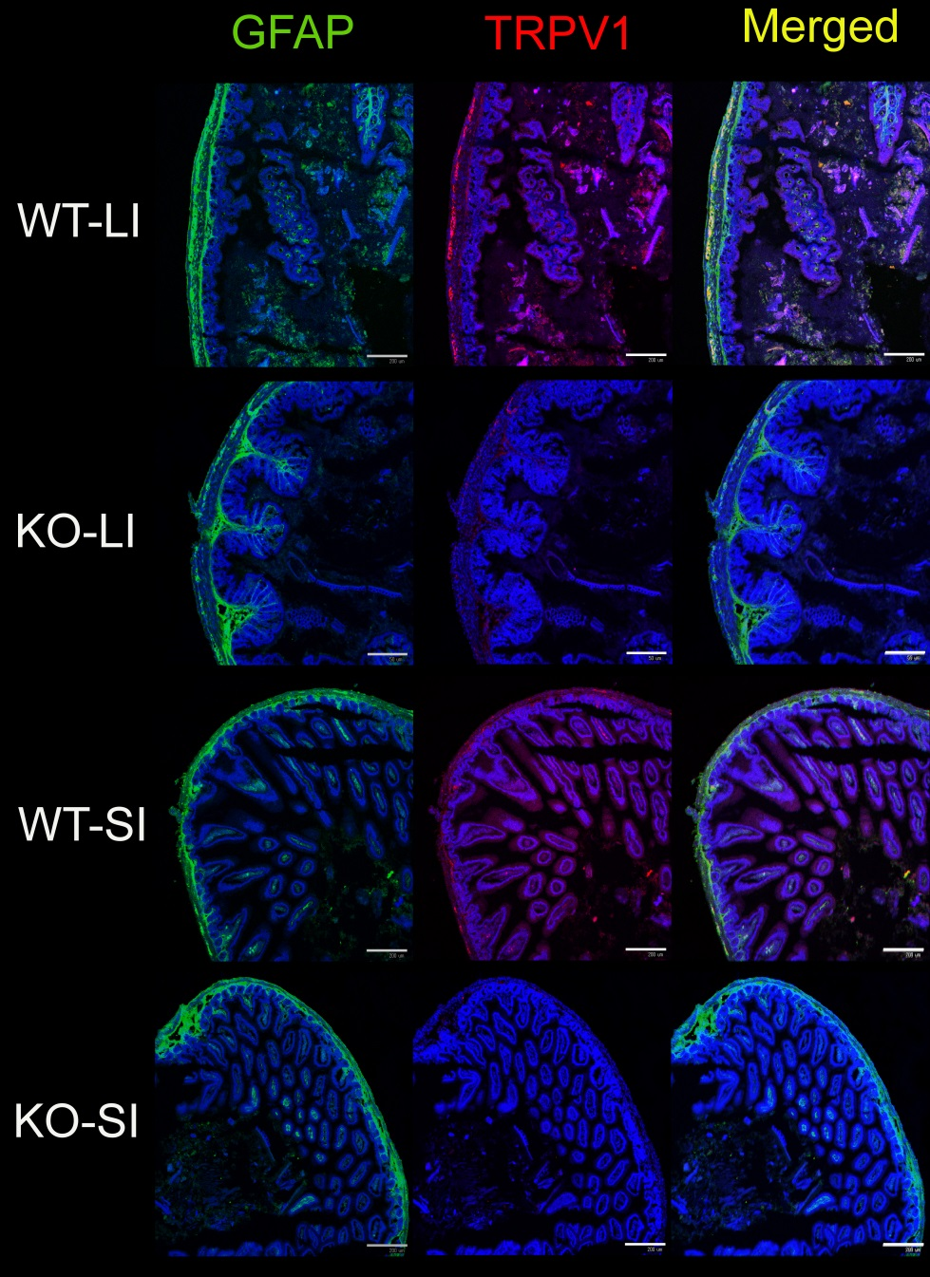
Figure 1 Double immunostaining with glial fibrillary acidic protein and transient receptor potential vanilloid 1of small (SI) and large intestines of wildtype and TRPV1-deficient (KO) mice. The degree of GFAP-IR signal observed in the enteric nervous system was similar in WT and KO mice. TRPV1-IR signal was observed only in WT mice and was located in a confined area of the smooth muscle layer. Nuclei were stained with TO-PRO3. Representative data from 2 experiments using 2 mice per time point are shown. Scale bar represents 200 μm.

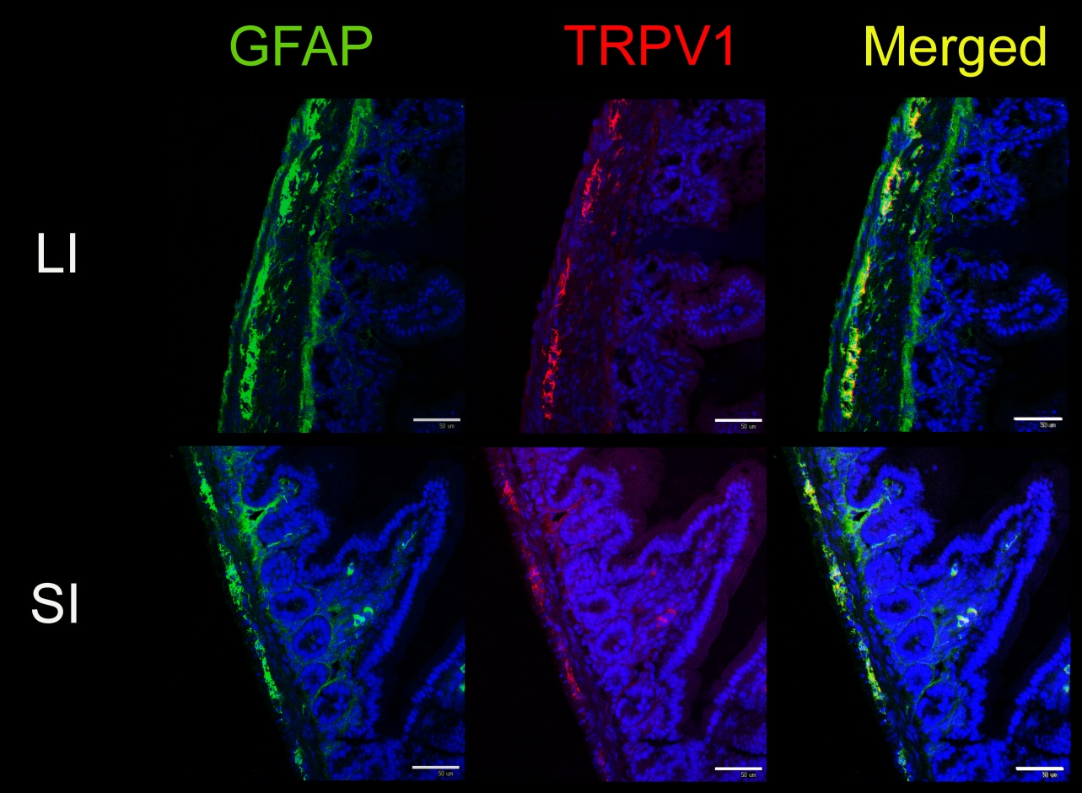
Figure 2 Enlarged view of glial fibrillary acidic protein/transient receptor potential vanilloid 1-stained SI and large intestines of wildtype mice. Certain parts of Figure 1 were magnified. Glial fibrillary acidic protein (GFAP) is located in the myenteric plexus, submucosal plexus and fibrous structures penetrating into the circular muscle layer and mucosal layer (in WT LI, serosal membrane was also stained with GFAP; however, serosal membrane is known to show false-positive immunosignals with various antibodies). The location of TRPV1-IR signal coincided with some portions of GFAP-IR signal in the myenteric plexus. Nuclei were stained with TO-PRO3. Representative data from 2 experiments using 2 mice per time point are shown. Scale bar represents 50 μm.

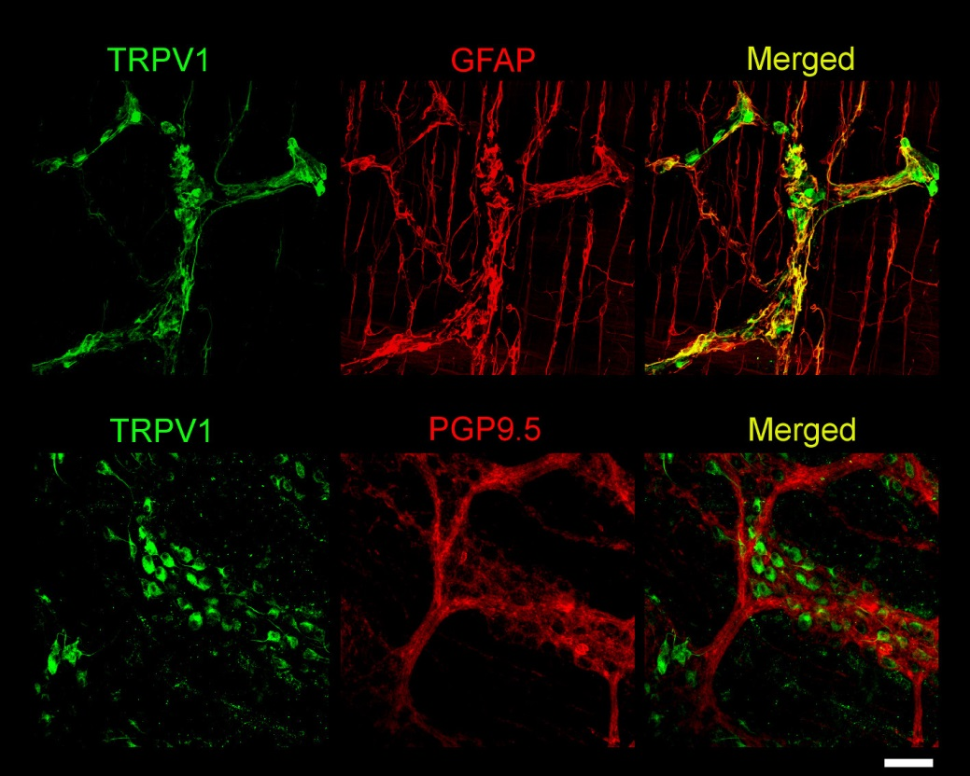
Figure 3 Double immunostaining with transient receptor potential vanilloid 1and glial fibrillary acidic protein or PGP9.5 of LI-LMMP of wildtype mice. LM-MP was isolated from 5 week old mice and whole-mount IHC was performed as described in Materials and Methods. Transient receptor potential vanilloid 1 (TRPV1) stained both cell bodies and fibers while GFAP stained mainly fibers and some portions of their IR signals were co-localized. Co-localization of PGP9.5 and TRPV1 IR signals was not observed. Nuclei were stained with DAPI. Representative data from 2 experiments using 2 mice per time point are shown. Scale bar represents 50 μm.

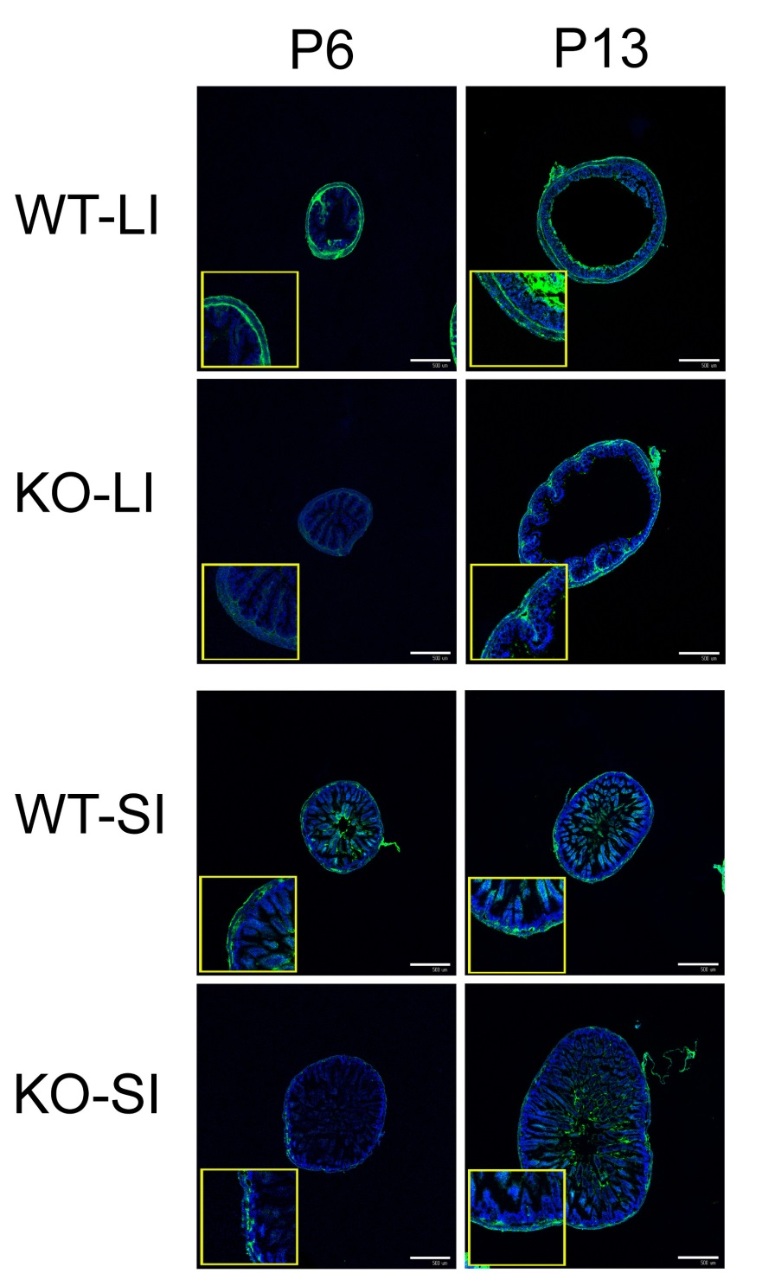
Figure 4 Difference of glial fibrillary acidic protein immunosignals between wildtype and KO mice (image). LI and SI samples were isolated from wildtype (WT) and KO mice on PD 6 and PD 13. While the glial fibrillary acidic protein (GFAP)-IR signal was similar in WT and KO mice on PD 13, the signal on PD 6 was weaker in KO mice than in WT mice, both in SI and LI. Nuclei were stained with TO-PRO3. Representative data of an experiment using 6 mice per each time point/group. Scale bar represents 500 μm.

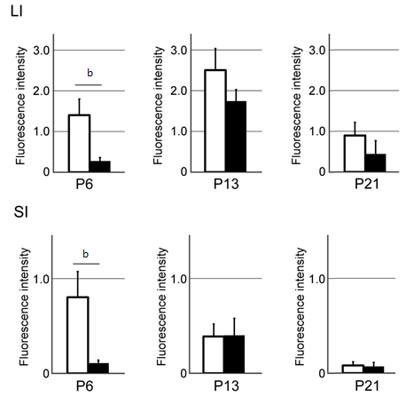
Figure 5 Difference in GFAP-IR signals between wildtype and KO mice. The intensity of GFAP-IR signal for WT and KO mice on PD 6, PD 13 and PD 21 was quantitated by imaging analysis as described in Materials and Methods. The amount of GFAP-IR fluorescence was normalized to the circumferential length of the intestinal tract. Data represent mean ± SEM, n = 5-6. ^{b}P < 0.01.

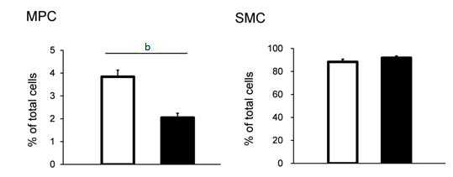
Figure 6 Specific decrease in the number of myenteric plexus cells in KO mice. The cells were prepared from LM-MP of WT and KO mice simultaneously, using the same digestion solution in a single preparation. After 11-day culture, the numbers of αSMA⁺SMC, GFAP⁺ cells and αSMA⁻ GFAP⁻ cells were determined as described in Materials and Methods. Nuclei were stained with DAPI. The percentage of GFAP⁺ cells and SMC was calculated as the ratio of the number of each cell population to the number of total DAPI⁺ cells. The yield of EGC (GFAP⁺ cells) in KO mice was significantly lower than that in WT mice while the number of SMC obtained was similar for both types of mice. Data represent mean ± SEM, n = 4. ^{b}P < 0.01.

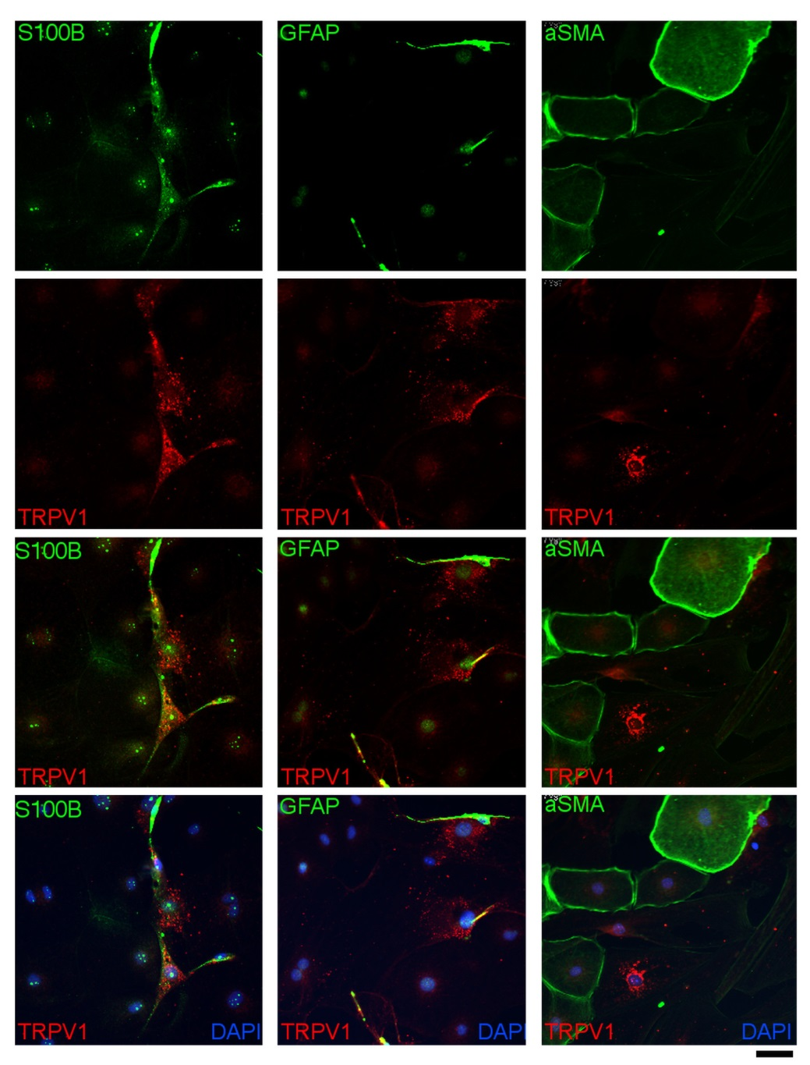
Figure 7 Immunostaining of transient receptor potential vanilloid 1 in enriched enteric glial cells culture. Enriched enteric glial cells (EGCs) were isolated and cultured as described in Materials and Methods. The cells were labeled with antibodies to GFAP, S100B, or SMC. The cultures contained many EGC and a small percentage of SMC. The location of TRPV1-IR signal is coincided with that of GFAP-IR signal and S100B-IR signal but not with αSMA-IR signal. Nuclei were stained with DAPI. Scale bar represents 20 μm.

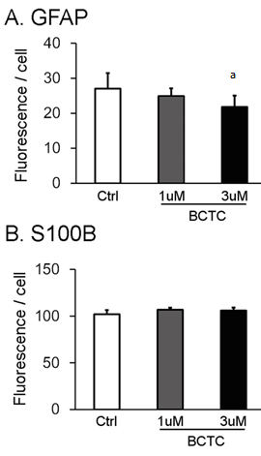
Figure 8 Effect of Transient receptor potential vanilloid 1agonist/antagonist on the signal ratio of glial fibrillary acidic protein -IR to S100B-IR. Enriched enteric glial cells (EGCs) (prepared from day 5 MPC/SMC co-culture) were plated and cultured for an additional 5 d. The transient receptor potential vanilloid 1 (TRPV1) antagonist BCTC was added and after 24 h the cells were fixed. The cells were stained with antibodies and imaging analysis was performed using a Celaview system as described in Materials and Methods. BCTC (3 μmol/L) decreased the GFAP-IR signal but the S-100B-IR signal was unchanged. Data represent mean ± SEM, n = 5 - 8. ªP < 0.05.

