Name of Journal: World Journal of Clinical Oncology
Manuscript NO: 33141
Manuscript Type: Review

Magnetic resonance imaging for diagnosis and neoadjuvant treatment evaluation in locally advanced rectal cancer: A pictorial review

Engin G et al. MRI in locally advanced rectal cancer

Gulgun Engin, Rasul Sharifov

Gulgun Engin, Oncology Institute, Istanbul University, 34390 Capa, Istanbul, Turkey

Rasul Sharifov, Department of Radiology, Bezmialem Vakif University, 34093 Fatih, Istanbul, Turkey

Author contributions: Engin G designed and wrote the paper; Sharifov R performed MRI.

Conflict-of-interest statement: Authors declare no conflict of interests for this article.

Open-Access: This article is an open-access article which was selected by an in-house editor and fully peer-reviewed by external reviewers. It is distributed in accordance with the Creative Commons Attribution Non Commercial (CC BY-NC 4.0) license, which permits others to distribute, remix, adapt, build upon this work non-commercially, and license their derivative works on different terms, provided the original work is properly cited and the use is non-commercial. See: http://creativecommons.org/licenses/by-nc/4.0/

Manuscript source: Invited manuscript

Correspondence to: Gulgun Engin, MD, Oncology Institute, Istanbul University, Millet Street, 34390 Capa, Istanbul, Turkey. gengin@istanbul.edu.tr
Telephone: +90-212-4142000
Fax: +90-212-5348078

Received: January 28, 2017
Peer-review started: February 10, 2017
First decision: March 27, 2017
Revised: May 4, 2017
Accepted: May 18, 2017
Article in press:
Published online:

Abstract
High-resolution pelvic magnetic resonance imaging (MRI) is the primary method for staging rectal cancer. MRI is highly accurate in the primary staging of rectal cancer; however, it has not proven to be effective in re-staging, especially in complete response evaluation after neoadjuvant therapy. Neoadjuvant chemoradiotherapy produces many changes in rectal tumors and on adjacent area, as a result, local tumor extent may not be accurately determined. However, adding diffusion-weighted sequences to the standard approach can improve diagnostic accuracy. In this pictorial review, an overview of the situation of MRI in the staging and re-staging of rectal cancer is exhibited as a pictorial assay. An experience- and literature-based discussion of limitations and difficulties in interpretation are also presented.

Key words: Rectal cancer; Locally advanced; Magnetic resonance imaging; Staging; Neoadjuvant treatment

© The Author(s) 2017. Published by Baishideng Publishing Group Inc. All rights reserved.

Core tip: Accurate staging and circumferential resection margin evaluation significantly impacts determining optimal treatment scheme. Preoperative magnetic resonance imaging (MRI) is highly accurate; however, it has yet to be proved as effective in re-staging. The adding of diffusion-weighted sequences to standard T2-weighted MRI can positively affect its diagnostic accuracy.

Engin G, Sharifov R. Magnetic resonance imaging for diagnosis and neoadjuvant treatment evaluation in locally advanced rectal cancer: A pictorial review. World J Clin Oncol 2017; In press

INTRODUCTION
Multimodal treatment of rectal cancer, with the combination of preoperative (neoadjuvant) chemoradiatherapy (CRT) followed by surgery increases local control in locally advanced cancers and has become the standard approach to such rectal cancers^{[1-5]}.
High-resolution pelvic magnetic resonance imaging (MRI) is the primary method for evaluation in rectal cance^{r[6-10]}. When applied according to the optimal protocols, high-resolution MRI accurately determining patients regarding neoadjuvant CRT requirement^{[11]}. Moreover, assessing treatment response in tumors using MRI also predicts probable survival outcomes, and could be used in the future to further adjust treatment according to the patients’ response^{[12]}. In recurrent rectal cancer, MRI enables the depiction of the extent of tumor growth, and can establish the resectability of disease^{[13,14]}.
MRI has not met expectations in re-staging, especially in complete response evaluation after neoadjuvant CRT because of post-therapeutic fibrosis and inflammation^{[15-19]}. However, adding functional MR sequences such as dynamic contrast-enhanced and diffusion-weighted sequences to the standard approach can improve diagnostic accuracy of MRI^{[20-23]}.
In this pictorial review, we present a synopsis of the current standing of MRI in the staging and re-staging of rectal cancer. We also present an experience- and literature-based discussion of limitations and difficulties in interpretation.

MRI TECHNIQUE
Rectal MRI should be performed with pelvic phased-array coils. Rectal MRI using this technique provides overall assessment of the rectal wall layers with high-spatial-resolution and benefits from a large field of view^{[15,24]}.

PATIENT PREPARATION
Routine rectal filling using endoluminal contrast agents such as ultrasonography gel is discouraged^{[24]} because this can distend of the rectum and compress the mesorectal fat, which may result in overestimation of fascial involvement and interfere with assessment of mesorectal nodes^{[25]}.
Bowel preparation is generally not necessary before the examination, but spasmolytics can be used when excessive fecal matter is visible on the planning images^{[15,24]}. For this purpose, a dose of 40 mg butylscopolamine is used intramuscularly unless contraindicated, immediately prior to placing the patient on the MRI table.

IMAGING PROTOCOL
Standard MR rectal protocols must at least include 2D T2-weighted sequences in sagittal, axial, and oblique coronal planes with 1-3 mm slice thicknesses. Sagittal sequences are used to identify the longitudinal tumor axis such that axial and coronal planes may be angled as perpendicular and parallel to the tumor axis as possible, respectively. Coronal planes must be angled in line with the anal canal for low tumors in order to evaluate the relation to the anal complex and pelvic floor muscles^{[15,24,26]} (Figure 1). Axial images are useful for evaluation of the tumor and its relationship with the intestinal wall, mesorectal fascia (MRF), and the adjacent pelvic tissue. Sagittal images are useful for the assessment of the tumor height and length and its relationship with peritoneum and other adjacent tissue.
In addition to T2-weighted sequences, diffusion-weighted imaging (DWI) sequences are recommended for inclusion in restaging protocols. DWI provides no additional benefit in primary staging; however, evidence is accumulating suggesting that it increases the diagnostic capability of MRI in the assessment of therapy response (yT-stage) after CRT^{[24]}). DWI also helps T2-weighted fast-spinecho (FSE) sequences to distinguish patients having good versus poor response^{[20-23]}. However, there is not adequate proof for supporting the usage of DWI for primary T-staging and lymph node assessment^{[27]}.

ANATOMIC LANDMARKS
The rectum is approximately 15 cm in length from the anal verge, which is the lowest part of the anal canal. The rectum has traditionally been divided into three segments according to the distance from the anal verge: Upper (> 10 cm), middle (5-10 cm), and lower (< 5 cm)^{[27,28]} (Figure 2).
The upper and middle rectal walls consist of three separate layers that can be distinguished in MRI. T2-weighted MRI sequences are the best for visualizing rectal wall anatomy. The internal hyperintense layer represents the mucosa and submucosa (no distinction is possible between in two layers); the medial hypointense layer and external hyperintense area represent the muscularis propria and the mesorectum, respectively^{[15,29]} (Figure 3).
The puborectal sling constitutes the upper limit of the anal canal. The inner muscular wall of the anal canal comprises the internal sphincter, which is the direct continuation of the circular layer of the muscularis propria of the rectum. The outer muscular wall of the anal canal is cranially composed of the puborectal muscle and caudally of the external sphincter^{[15,26]} (Figure 4).
The puborectal sling constitutes the upper limit of the anal canal. The internal sphincter (the internal muscular wall) of the anal canal is consisted of the direct continuity of the muscularis propria circular layer of the rectum. The external muscular wall of the anal canal is formed by the puborectal muscle in cranially and the external sphincter in caudally^{[15,26]} (Figure 4).
The peritoneal reflection covers the anterior wall of the upper rectum; the risk of peritoneal perforation in upper rectal tumors is high^{[27]}. The peritoneal reflection can be easily displayed on sagittal and axial high-resolution T2-weighted images. In sagittal images, it can be depicted whereon upper pole of the seminal vesicles in men and at the uterocervical angle in women^{[15]}. The evaluation of the peritoneal invasion is very important in staging, because rectal tumor is staged as T4a in the presence of peritoneal invasion (Figure 5).
The middle rectum, which lies below the peritoneal reflection, is completely surrounded by mesorectal fatty tissue which is called the mesorectum. Mesorectum is encircled by the MRF which is constitutes the circumferential resection margin (CRM)^{[26-29]}. The MRF can be seen as a thin, low-signal intensity envelop which surrounds the rectum and mesorectum (Figure 6). MRF tapers downward at the lower rectal level^{[26]}. The MRF is easily seen in posterolateral views, although it is difficult to distinguish it from Denonvilliers’ fascia in the anterior wall^{[30]}.

PRIMARY STAGING OF RECTAL CANCER
Tumor height and length
Tumor height and length should be routinely reported because outcomes and surgical management are affected by the location of the tumor^{[24]}.
The distance and length are measured on a line drawn on the sagittal MR images. For tumor localization, the distance of the lowest portion of the tumor from the anal verge is measured. Rectal tumors are classified as high, middle or low when their most caudal border is > 10 cm, 5-10 cm, or < 5 cm from the anal verge, respectively^{[15]} (Figure 7).

T staging for middle and high tumors
On T2-weighted imaging, the muscularis propria is seen as a hypointense line between the hyperintense mesorectal fat and the inner submucosa and mucosa, which show intermediate to mild hyperintensity. The signal intensity of a rectal tumor on T2-weighted images is typically intermediate between the signal intensity of the muscularis propria and mucosa (Figure 8).
T1 tumors are confined to the submucosa; T2 tumors extend into, but not beyond, the muscularis propria. The differentiation of T1 tumors from T2 tumors on MRI is usually not reliable without an endorectal coil or endorectal ultrasound, and tumors should generally be staged as T1/T2^{[15]}. A tumor is staged as T3 when it extends beyond the muscularis propria and strands the mesorectal fat. Disruption of the muscularis propria because of penetrating vessels should not be overstaged as T3 (Figures 8 and 9).
The extramural depth of invasion refers to extension of tumor beyond the muscularis propria^{[31]}. The American Joint Committee on Cancer suggested an optional stratification of T3 tumors based on the extramural depth of invasion: less than 5 mm, T3a; 5-10 mm, T3b; and more than 10 mm, T3c^{[32]}. An extramural depth of invasion of less than 5 mm presents a significantly higher survival rate, and these early T3 tumors may be adequately managed with surgery alone and have a prognosis comparable to that of tumors characterized as T1/T2^{[33]}. T4 tumors extend onto the surface of the visceral peritoneum or an adjacent structure (Table 1, Figures 8 and 10).

Distance to the mesorectal fascia
For T3 tumors, the shortest distance between the most penetrating parts of the tumor and the MRF should be measured^{[34,35]}. The distance to the MRF is a critical local prognostic factor for rectal cancer^{[36,37]}. A tumor-MRF distance of more than 1 mm is a reliable predictor for negative margins after TME^{[38]}. In the presence of satellite nodules such as tumor deposits, lymph nodes or extramural vascular invasion (EMVI), the shortest distance between the nodules and the MRF should also be reported^{[15]} (Figures 11 and 12).

EMVI
EMVI is associated with local and distant recurrence and poor survival^{[39]}. It is defined as the presence of malignant cells within blood vessels located beyond the muscularis propria in the mesorectal fat. EMVI is suggested when vessels close to the tumor are obviously irregular or expanded by tumoral signal intensity^{[39]} (Figure 13).
The assessment of EMVI is a routine component of MR evaluation for primary staging; however, for restaging, there is no agreement as to whether evaluation of EMVI remains beneficial^{[24]}.

T staging for low tumors
A specific T staging system is used to identify tumors and its circumferential resection margin (CRM)^{[40]} (Table 1, Figures 14 and 15).

N-staging
Staging of nodes is very important for planning preoperative treatment^{[41]}. In the TNM system, disease involving only the regional nodes, including the mesorectal and internal iliac nodes, accounts for the N stage (Table 1); involvement of other nodes is regarded as metastasis^{[38]}.
Mesorectal nodes are often the first and the most commonly involved group of nodes. Nodal metastases are usually within the proximal 5 cm of the tumor^{[41]}.
Extramesorectal nodes (iliac, superior rectal or inferior mesenteric nodes) are generally involved in locally advanced cancers^{[42]}. Low rectal tumors can also spread superficial inguinal nodes and imply poor prognosis^{[43]}.
Node size is the usual criterion in nodal staging using MRI. Lymph nodes are usually considered pathologic when their short axis is longer than 0.5 cm; however, no optimal cut-off threshold exists for involved nodes^{[24]}. The inclusion of morphologic features such as round shape, irregular contour, and nonhomogeneous signal intensity to a size cutoff increases the accuracy of MR^{[44]}. Although DW MRI is not accurate enough for characterizing nodes, it may be useful for locating them^{[45]} (Figure 16).

RESTAGING AFTER NEOADJUVANT TREATMENT
Neoadjuvant CRT provides downstaging and downsizing along with improvement in less extensive surgery, decreased local recurrence, and general survival^{[12,46]}. Tumor restaging involves correlating the posttreatment images with the pretreatment images with respect to all the elements assessed in the initial staging, and necessitates image acquisition with almost the same protocol and on the same planes.

T staging
Post-CRT restaging using conventional MR sequences is less accurate than primary staging, especially when confirming complete response (yT0), mostly because it is difficult to distinguish fibrosis, edema and normal mucosa from small foci of residual tumor^{[46-48]}. As such, a normal, two-layered rectal wall after CRT is indicative of complete response, whereas residual fibrosis indicates either residual tumor or complete response (Figure 17). In practice, areas of fibrosis have very low signal intensity on post-CRT T2-weighted MRI, in contrast, areas of residual tumor have intermediate signal-intensity^{[46]}. Careful review of high-resolution images and DWI can enable distinction of small residual tumor within fibrosis (Figure 18).
In addition to morphologic findings, DWI can provide functional information that can be correlated with changes at the cellular level in response to treatment. After CRT, the decrease in cellularity and development of fibrosis or necrosis in responders results in an increase in diffusion, which decreases diffusion signal intensity in diffusion-weighted images and increases ADC values and ADC signal intensity in ADC images^{[20,23]} (Figures 18 and 19). Although DWI can differentiate viable tumor from fibrosis and good and bad response, it does not allow for predicting complete response^{[19]} (Figure 20). Moreover, the response of mucinous tumors to CRT cannot be assessed using DWI because they exhibit ADC hyperintensity even before treatment (Figure 21).

DISTANCE TO THE MESORECTAL FASCIA
CRM is considered uninvolved if a tumor free margin is seen at least 1 mm from MRF after CRT. This finding has strong negative predictive value (98%) of MR imaging for CRM involvement, whereas it has low positive predictive value^{[49]}. In some rectal tumor, however, CRT results in a markedly reduction tumor volume, but also in retraction of pre-existing contacts with MRF. It is difficult to determine whether this area contains tumor cells or completely devoid of tumor cells^{[50]} (Figures 22 and 23).

N-staging
After CRT, nodal size (short axis diameter) is more reliable for nodal re-staging. It is difficult to differentiate a metastatic lymph node from a healthy lymph node with irradiation changes using morphologic criteria or DWI; therefore, lymph node restaging often results in overstaging^{[27,50]} (Figures 24 and 25).
The accuracy of MRI for restaging is generally lower than the accuracy of MRI for initial staging, mainly owing to overstaging of nodal disease, failure to differentiate tumoral infiltration or residual tumor from desmoplastic reaction or radiation fibrosis^{[50]}. According to recent meta-analysis results, MRI accuracy was variable for restaging rectal cancer after neoadjuvant treatment; however, significantly better results were achieved when DWI was used or with experienced observers. The authors also reported that MRI could be used for evaluating CRM staging, but nodal staging remained a challenge^{[51]}.
In conclusion, using high-resolution MRI, standardizing image acquisition techniques and interpretation of images, comparative evaluation of pre- and post-CRT MR images, adding DWI to the standard approach, and importantly, experience and awareness of the limitations can improve diagnostic accuracy of MRI for re-staging.

REFERENCES
1 National Institute for Health and Clinical Excellence. NICE guidelines [CG131]. Colorectal cancer: the diagnosis and management of colorectal cancer. [accessed 2017 Jan 2]. Available from: URL: https://www.nice.org.uk/Guidance/CG131
2 van de Velde CJ, Boelens PG, Borras JM, Coebergh JW, Cervantes A, Blomqvist L, Beets-Tan RG, van den Broek CB, Brown G, Van Cutsem E, Espin E, Haustermans K, Glimelius B, Iversen LH, van Krieken JH, Marijnen CA, Henning G, Gore-Booth J, Meldolesi E, Mroczkowski P, Nagtegaal I, Naredi P, Ortiz H, Påhlman L, Quirke P, Rödel C, Roth A, Rutten H, Schmoll HJ, Smith JJ, Tanis PJ, Taylor C, Wibe A, Wiggers T, Gambacorta MA, Aristei C, Valentini V. EURECCA colorectal: multidisciplinary management: European consensus conference colon & amp; rectum. Eur J Cancer 2014; 50: 1.e1-1.e34 [PMID: 24183379 DOI: 10.1016/j.ejca.2013.06.048]
3 Watanabe T, Itabashi M, Shimada Y, Tanaka S, Ito Y, Ajioka Y, Hamaguchi T, Hyodo I, Igarashi M, Ishida H, Ishihara S, Ishiguro M, Kanemitsu Y, Kokudo N, Muro K, Ochiai A, Oguchi M, Ohkura Y, Saito Y, Sakai Y, Ueno H, Yoshino T, Boku N, Fujimori T, Koinuma N, Morita T, Nishimura G, Sakata Y, Takahashi K, Tsuruta O, Yamaguchi T, Yoshida M, Yamaguchi N, Kotake K, Sugihara K. Japanese Society for Cancer of the Colon and Rectum (JSCCR) Guidelines 2014 for treatment of colorectal cancer. Int J Clin Oncol 2015; 20: 207-239 [PMID: 25782566 DOI: 10.1007/s10147-015-0801-z]
4 Monson JR, Weiser MR, Buie WD, Chang GJ, Rafferty JF, Buie WD, Rafferty J. Practice parameters for the management of rectal cancer (revised). Dis Colon Rectum 2013; 56: 535-550 [PMID: 23575392 DOI: 10.1097/DCR.0b013e31828cb66c]
5 Millard T, Kunk PR, Ramsdale E, Rahma OE. Current debate in the oncologic management of rectal cancer. World J Gastrointest Oncol 2016; 8: 715-724 [PMID: 27795811 DOI: 10.4251/wjgo.v8.i10.715]
6 Bosset JF, Collette L, Calais G, Mineur L, Maingon P, Radosevic-Jelic L, Daban A, Bardet E, Beny A, Ollier JC. Chemotherapy with preoperative radiotherapy in rectal cancer. N Engl J Med 2006; 355: 1114-1123 [PMID: 16971718]
7 Roh MS, Colangelo LH, O'Connell MJ, Yothers G, Deutsch M, Allegra CJ, Kahlenberg MS, Baez-Diaz L, Ursiny CS, Petrelli NJ, Wolmark N. Preoperative multimodality therapy improves disease-free survival in patients with carcinoma of the rectum: NSABP R-03. J Clin Oncol 2009; 27: 5124-5130 [PMID: 19770376 DOI: 10.1200/JCO.2009.22.0467]
8 Network, N.C.C. NCCN clinical practice guidelines in oncology: rectal cancer, version 2.2017. J Natl Compr Cancer Netw 2016
9 Poston GJ, Tait D, O'Connell S, Bennett A, Berendse S. Diagnosis and management of colorectal cancer: summary of NICE guidance. BMJ 2011; 343: d6751 [PMID: 22074710 DOI: 10.1136/bmj.d6751]
10 Bipat S, Glas AS, Slors FJ, Zwinderman AH, Bossuyt PM, Stoker J. Rectal cancer: local staging and assessment of lymph node involvement with endoluminal US, CT, and MR imaging--a meta-analysis. Radiology 2004; 232: 773-783 [PMID: 15273331 DOI: 10.1148/radiol.2323031368]
11 Lahaye MJ, Engelen SM, Nelemans PJ, Beets GL, van de Velde CJ, van Engelshoven JM, Beets-Tan RG. Imaging for predicting the risk factors--the circumferential resection margin and nodal disease--of local recurrence in rectal cancer: a meta-analysis. Semin Ultrasound CT MR 2005; 26: 259-268 [PMID: 16152740]
12 Patel UB, Taylor F, Blomqvist L, George C, Evans H, Tekkis P, Quirke P, Sebag-Montefiore D, Moran B, Heald R, Guthrie A, Bees N, Swift I, Pennert K, Brown G. Magnetic resonance imaging-detected tumor response for locally advanced rectal cancer predicts survival outcomes: MERCURY experience. J Clin Oncol 2011; 29: 3753-3760 [PMID: 21876084 DOI: 10.1200/JCO.2011.34.9068]
13 Georgiou PA, Tekkis PP, Constantinides VA, Patel U, Goldin RD, Darzi AW, John Nicholls R, Brown G. Diagnostic accuracy and value of magnetic resonance imaging (MRI) in planning exenterative pelvic surgery for advanced colorectal cancer. Eur J Cancer 2013; 49: 72-81 [PMID: 23036847 DOI: 10.1016/j.ejca.2012.06.025]
14 Chew MH, Brown WE, Masya L, Harrison JD, Myers E, Solomon MJ. Clinical, MRI, and PET-CT criteria used by surgeons to determine suitability for pelvic exenteration surgery for recurrent rectal cancers: a Delphi study. Dis Colon Rectum 2013; 56: 717-725 [PMID: 23652745 DOI: 10.1097/DCR.0b013e3182812bec]
15 Jhaveri KS, Hosseini-Nik H. MRI of Rectal Cancer: An Overview and Update on Recent Advances. AJR Am J Roentgenol 2015; 205: W42-W55 [PMID: 26102418 DOI: 10.2214/AJR.14.14201]
16 Chen CC, Lee RC, Lin JK, Wang LW, Yang SH. How accurate is magnetic resonance imaging in restaging rectal cancer in patients receiving preoperative combined chemoradiotherapy? Dis Colon Rectum 2005; 48: 722-728 [PMID: 15747073]
17 Kuo LJ, Chern MC, Tsou MH, Liu MC, Jian JJ, Chen CM, Chung YL, Fang WT. Interpretation of magnetic resonance imaging for locally advanced rectal carcinoma after preoperative chemoradiation therapy. Dis Colon Rectum 2005; 48: 23-28 [PMID: 15690653]
18 Patel UB, Brown G, Rutten H, West N, Sebag-Montefiore D, Glynne-Jones R, Rullier E, Peeters M, Van Cutsem E, Ricci S, Van de Velde C, Kjell P, Quirke P. Comparison of magnetic resonance imaging and histopathological response to chemoradiotherapy in locally advanced rectal cancer. Ann Surg Oncol 2012; 19: 2842-2852 [PMID: 22526897 DOI: 10.1245/s10434-012-2309-3]
19 Curvo-Semedo L, Lambregts DM, Maas M, Thywissen T, Mehsen RT, Lammering G, Beets GL, Caseiro-Alves F, Beets-Tan RG. Rectal cancer: assessment of complete response to preoperative combined radiation therapy with chemotherapy--conventional MR volumetry versus diffusion-weighted MR imaging. Radiology 2011; 260: 734-743 [PMID: 21673229 DOI: 10.1148/radiol.11102467]
20 Kim SH, Lee JY, Lee JM, Han JK, Choi BI. Apparent diffusion coefficient for evaluating tumour response to neoadjuvant chemoradiation therapy for locally advanced rectal cancer. Eur Radiol 2011; 21: 987-995 [PMID: 20978768 DOI: 10.1007/s00330-010-1989-y]
21 Sun YS, Zhang XP, Tang L, Ji JF, Gu J, Cai Y, Zhang XY. Locally advanced rectal carcinoma treated with preoperative chemotherapy and radiation therapy: preliminary analysis of diffusion-weighted MR imaging for early detection of tumor histopathologic downstaging. Radiology 2010; 254: 170-178 [PMID: 20019139 DOI: 10.1148/radiol.2541082230]
22 Kim SH, Lee JM, Hong SH, Kim GH, Lee JY, Han JK, Choi BI. Locally advanced rectal cancer: added value of diffusion-weighted MR imaging in the evaluation of tumor response to neoadjuvant chemo- and radiation therapy. Radiology 2009; 253: 116-125 [PMID: 19789256 DOI: 10.1148/radiol.2532090027]
23 Engin G, Sharifov R, Güral Z, Sağam EK, Sağlam S, Balik E, Asoğu O, Yamaner S, Güllüoğu M, Kapran Y, Özel S. Can diffusion-weighted MRI determine complete responders after neoadjuvant chemoradiation for locally advanced rectal cancer? Diagn Interv Radiol 2012; 18: 574-581 [PMID: 22798154 DOI: 10.4261/1305-3825.DIR.5755-12.1]
24 Beets-Tan RG, Lambregts DM, Maas M, Bipat S, Barbaro B, Caseiro-Alves F, Curvo-Semedo L, Fenlon HM, Gollub MJ, Gourtsoyianni S, Halligan S, Hoeffel C, Kim SH, Laghi A, Maier A, Rafaelsen SR, Stoker J, Taylor SA, Torkzad MR, Blomqvist L. Magnetic resonance imaging for the clinical management of rectal cancer patients: recommendations from the 2012 European Society of Gastrointestinal and Abdominal Radiology (ESGAR) consensus meeting. Eur Radiol 2013; 23: 2522-2531 [PMID: 23743687 DOI: 10.1007/s00330-013-2864-4]
25 Slater A, Halligan S, Taylor SA, Marshall M. Distance between the rectal wall and mesorectal fascia measured by MRI: Effect of rectal distension and implications for preoperative prediction of a tumour-free circumferential resection margin. Clin Radiol 2006; 61: 65-70 [PMID: 16356818 DOI: 10.1016/j.crad.2005.08.010]
26 Salerno G, Daniels IR, Brown G. Magnetic resonance imaging of the low rectum: defining the radiological anatomy. Colorectal Dis 2006; 8 Suppl 3: 10-13 [PMID: 16813585 DOI: 10.1111/j.1463-1318.2006.01063.x]
27 Nougaret S, Reinhold C, Mikhael HW, Rouanet P, Bibeau F, Brown G. The use of MR imaging in treatment planning for patients with rectal carcinoma: have you checked the "DISTANCE"? Radiology 2013; 268: 330-344 [PMID: 23882096 DOI: 10.1148/radiol.13121361]
28 Gowdra Halappa V, Corona Villalobos CP, Bonekamp S, Gearhart SL, Efron J, Herman J, Kamel IR. Rectal imaging: part 1, High-resolution MRI of carcinoma of the rectum at 3 T. AJR Am J Roentgenol 2012; 199: W35-W42 [PMID: 22733930 DOI: 10.2214/AJR.11.8134]
29 Torkzad MR, Påhlman L, Glimelius B. Magnetic resonance imaging (MRI) in rectal cancer: a comprehensive review. Insights Imaging 2010; 1: 245-267 [PMID: 22347920 DOI: 10.1007/s13244-010-0037-4]
30 Lindsey I, Warren B, Mortensen N. Optimal total mesorectal excision for rectal cancer is by dissection in front of Denonvilliers' fascia (Br J Surg 2004; 91: 121-123). Br J Surg 2004; 91: 897 [PMID: 15227702 DOI: 10.1002/bjs.4769]
31 Cho SH, Kim SH, Bae JH, Jang YJ, Kim HJ, Lee D, Park JS. Prognostic stratification by extramural depth of tumor invasion of primary rectal cancer based on the Radiological Society of North America proposal. AJR Am J Roentgenol 2014; 202: 1238-1244 [PMID: 24848820 DOI: 10.2214/AJR.13.11311]
32 Edge SB, Byrd DR, Compton CC. AJCC cancer staging handbook: from the AJCC cancer staging manual, 7th ed. New York, NY: Springer, 2010: 718
33 Taylor FG, Quirke P, Heald RJ, Moran B, Blomqvist L, Swift I, Sebag-Montefiore DJ, Tekkis P, Brown G. Preoperative high-resolution magnetic resonance imaging can identify good prognosis stage I, II, and III rectal cancer best managed by surgery alone: a prospective, multicenter, European study. Ann Surg 2011; 253: 711-719 [PMID: 21475011 DOI: 10.1097/SLA.0b013e31820b8d52]
34 Rao SX, Zeng MS, Xu JM, Qin XY, Chen CZ, Li RC, Hou YY. Assessment of T staging and mesorectal fascia status using high-resolution MRI in rectal cancer with rectal distention. World J Gastroenterol 2007; 13: 4141-4146 [PMID: 17696238]
35 Brown G, Kirkham A, Williams GT, Bourne M, Radcliffe AG, Sayman J, Newell R, Sinnatamby C, Heald RJ. High-resolution MRI of the anatomy important in total mesorectal excision of the rectum. AJR Am J Roentgenol 2004; 182: 431-439 [PMID: 14736677 DOI: 10.2214/ajr.182.2.1820431]
36 Cawthorn SJ, Parums DV, Gibbs NM, A'Hern RP, Caffarey SM, Broughton CI, Marks CG. Extent of mesorectal spread and involvement of lateral resection margin as prognostic factors after surgery for rectal cancer. Lancet 1990; 335: 1055-1059 [PMID: 1691810]
37 Wibe A, Rendedal PR, Svensson E, Norstein J, Eide TJ, Myrvold HE, Søreide O. Prognostic significance of the circumferential resection margin following total mesorectal excision for rectal cancer. Br J Surg 2002; 89: 327-334 [PMID: 11872058 DOI: 10.1046/j.0007-1323.2001.02024.x]
38 Taylor FG, Quirke P, Heald RJ, Moran B, Blomqvist L, Swift I, St Rose S, Sebag-Montefiore DJ, Tekkis P, Brown G. One millimetre is the safe cut-off for magnetic resonance imaging prediction of surgical margin status in rectal cancer. Br J Surg 2011; 98: 872-879 [PMID: 21480194 DOI: 10.1002/bjs.7458]
39 Smith NJ, Barbachano Y, Norman AR, Swift RI, Abulafi AM, Brown G. Prognostic significance of magnetic resonance imaging-detected extramural vascular invasion in rectal cancer. Br J Surg 2008; 95: 229-236 [PMID: 17932879 DOI: 10.1002/bjs.5917]
40 Taylor FG, Swift RI, Blomqvist L, Brown G. A systematic approach to the interpretation of preoperative staging MRI for rectal cancer. AJR Am J Roentgenol 2008; 191: 1827-1835 [PMID: 19020255]
41 Koh DM, Brown G, Temple L, Blake H, Raja A, Toomey P, Bett N, Farhat S, Norman AR, Daniels I, Husband JE. Distribution of mesorectal lymph nodes in rectal cancer: in vivo MR imaging compared with histopathological examination. Initial observations. Eur Radiol 2005; 15: 1650-1657 [PMID: 15868124 DOI: 10.1007/s00330-005-2751-8]
42 Engelen SM, Beets-Tan RG, Lahaye MJ, Kessels AG, Beets GL. Location of involved mesorectal and extramesorectal lymph nodes in patients with primary rectal cancer: preoperative assessment with MR imaging. Eur J Surg Oncol 2008; 34: 776-781 [PMID: 18039560 DOI: 10.1016/j.ejso.2007.10.007]
43 Luna-Pérez P, Corral P, Labastida S, Rodríguez-Coria D, Delgado S. Inguinal lymph node metastases from rectal adenocarcinoma. J Surg Oncol 1999; 70: 177-180 [PMID: 10102348]
44 Brown G, Richards CJ, Bourne MW, Newcombe RG, Radcliffe AG, Dallimore NS, Williams GT. Morphologic predictors of lymph node status in rectal cancer with use of high-spatial-resolution MR imaging with histopathologic comparison. Radiology 2003; 227: 371-377 [PMID: 12732695 DOI: 10.1148/radiol.2272011747]
45 Mir N, Sohaib SA, Collins D, Koh DM. Fusion of high b-value diffusion-weighted and T2-weighted MR images improves identification of lymph nodes in the pelvis. J Med Imaging Radiat Oncol 2010; 54: 358-364 [PMID: 20718916 DOI: 10.1111/j.1754-9485.2010.02182.x]
46 Blazic IM, Campbell NM, Gollub MJ. MRI for evaluation of treatment response in rectal cancer. Br J Radiol 2016; 89: 20150964 [PMID: 27331883 DOI: 10.1259/bjr.20150964]
47 Patel UB, Blomqvist LK, Taylor F, George C, Guthrie A, Bees N, Brown G. MRI after treatment of locally advanced rectal cancer: how to report tumor response--the MERCURY experience. AJR Am J Roentgenol 2012; 199: W486-W495 [PMID: 22997398 DOI: 10.2214/AJR.11.8210]
48 De Nardi P, Carvello M. How reliable is current imaging in restaging rectal cancer after neoadjuvant therapy? World J Gastroenterol 2013; 19: 5964-5972 [PMID: 24106396 DOI: 10.3748/wjg.v19.i36.5964]
49 Salerno G, Daniels IR, Moran BJ, Wotherspoon A, Brown G. Clarifying margins in the multidisciplinary management of rectal cancer: the MERCURY experience. Clin Radiol 2006; 61: 916-923 [PMID: 17018303 DOI: 10.1016/j.crad.2006.06.005]
50 Kim DJ, Kim JH, Lim JS, Yu JS, Chung JJ, Kim MJ, Kim KW. Restaging of Rectal Cancer with MR Imaging after Concurrent Chemotherapy and Radiation Therapy. Radiographics 2010; 30: 503-516 [PMID: 20228331]
51 van der Paardt MP, Zagers MB, Beets-Tan RG, Stoker J, Bipat S. Patients who undergo preoperative chemoradiotherapy for locally advanced rectal cancer restaged by using diagnostic MR imaging: a systematic review and meta-analysis. Radiology 2013; 269: 101-112 [PMID: 23801777 DOI: 10.1148/radiol.13122833]

P-Reviewer: Kim HS, Koda K, Li XX S-Editor: Ji FF L-Editor: E-Editor:

Specialty type: Oncology
Country of origin: Turkey
Peer-review report classification
Grade A (Excellent): A
Grade B (Very good): B, B
Grade C (Good): 0
Grade D (Fair): 0
Grade E (Poor): 0

Table 1 Staging systems for rectal cancer

Stage | MRI findings
T stage for middle and high tumorsª
T1 | Tumor signal intensity is confined to the submucosal layer
T2 | Tumor signal intensity extends into the muscle layer, with loss of the interface between the submucosa and circular muscle layer
T3 | Tumor signal intensity extends through the muscle layer into the perirectal fat, with obliteration of the interface between muscle and perirectal fat
T3a | Tumor < 5 mm into the perirectal fat
T3b | Tumor 5–10 mm into the perirectal fat
T3c | Tumor >10 mm into the perirectal fat
T4a | Tumor signal intensity extends to surface of visceral peritoneum
T4b | Tumor signal intensity extends into an adjacent structure or viscus
T stage for low tumors^{b}
T1 | Tumor signal intensity confined to bowel wall, outer muscle coat intact
T2 | Tumor signal intensity replaces muscle coat but does not enter intersphincteric plane
T3 | Tumor signal intensity extends intersphincteric plane or lies within 1 mm of levator muscle
T4 | Tumor signal intensity extends external anal sphincter or is within1 mm or beyond levator muscle with/without adjacent organ invasion
N stage
Nx | Regional lymph nodes cannot be assessed
N0 | No regional lymph node metastasis
N1 | Metastasis in 1-3 regional lymph nodes
N2 | Metastasis in > 3 regional lymph nodes

ªAdapted from ref. [32]: Edge SB, Byrd DR, Compton CC. AJCC cancer staging handbook: from the AJCC cancer staging manual, 7th ed. New York, NY: Springer, 2010: 718; ^{b}Adapted from ref. [40]: Taylor FG, Swift RI, Blomqvist L, Brown G. A systematic approach to the interpretation of preoperative staging MRI for rectal cancer. AJR 2008; 191:1827-1835.

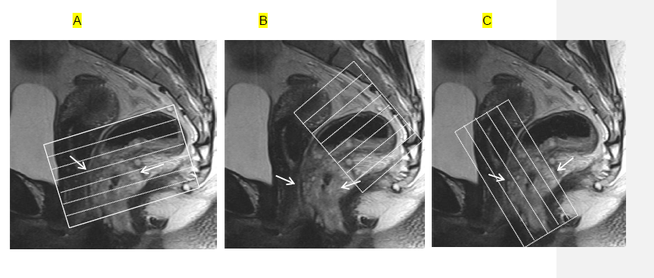
Figure 1 Magnetic resonance imaging planes. T2-weighted sagittal images are used to determine the longitudinal tumor axis in order to angle the axial and coronal planes. A: Oblique axial plane is obtained perpendicular to the rectal wall at the level of the rectal mass; B: Oblique axial plane is angled perpendicular to the pelvic floor, used to cover lymph node drainage territory; C: Coronal plane is angled parallel to the anal canal for imaging of low rectal tumors. Rectal tumor is indicated by arrows.

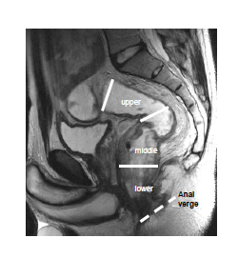
Figure 2 Rectal segments. T2-weighted sagittal image shows rectal segments: Lower, < 5 cm; middle, 5-10 cm; upper, > 10 cm from the anal verge.

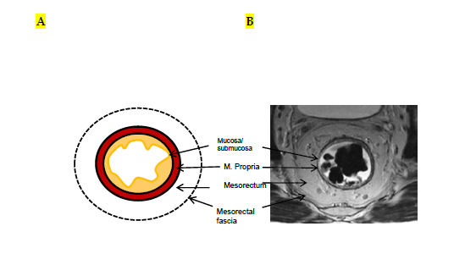
Figure 3 Normal rectal wall anatomy of higher and middle rectum. Schematic (A) and T2-weighted axial magnetic resonance imaging (B) presentation. The internal hyperintense layer represents the mucosa and submucosa (no distinction is possible between in two layers); the medial hypointense layer and external hyperintense area represent the muscularis propria and the mesorectum, respectively. Mesorectal fascia is seen thin hypointense layer enveloping the mesorectum (arrows).

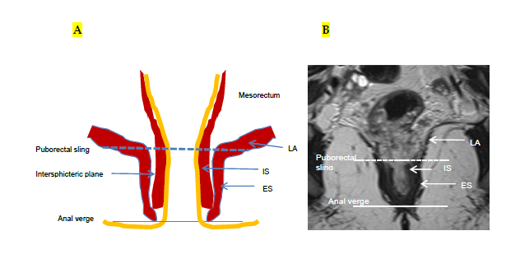
Figure 4 Normal anatomy of lower rectum. Schematic (A) and coronal plane T2-weighted (B) magnetic resonance imaging presentation. Puborectal sling, the upper portion of the puborectal muscle displaying the uppermost portion of the anal canal (intermittent line). Anal verge is the lowermost portion of the anal canal (line). LA: Levator ani muscle; IS: Internal sphincter; ES: External sphincter.

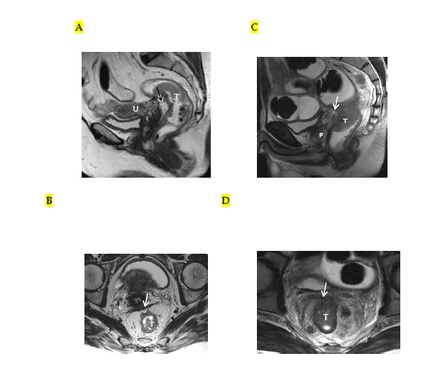
Figure 5 Periton invasion in female (A, B) and male (C, D) patients with T4a rectal tumors. On sagittal T2-weighted images, periton is seen as a hypointense linear structure in front of the tumor (arrows in A, C). On axial T2-weighted images, the peritoneum has a V shape and attaches onto the anterior aspect of the rectal cancer (arrows in B, D). T: Tumor; U: Uterus; P: Prostate.

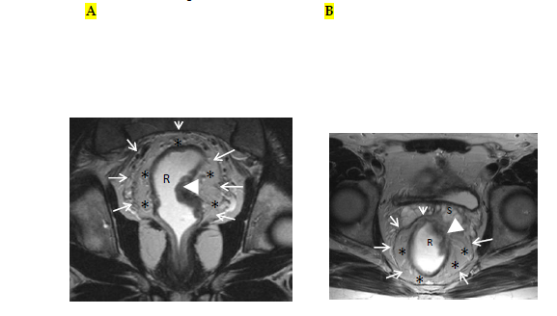
Figure 6 Magnetic resonance imaging anatomy of mesorectum and mesorectal fascia. On T2-weighted (A) axial and (B) coronal plane magnetic resonance images, mesorectal fascia (arrows) is seen as a thin, low-signal intensity layer enveloping the mesorectal fatty tissue (*) and rectum in a male patient with rectal carcinoma.

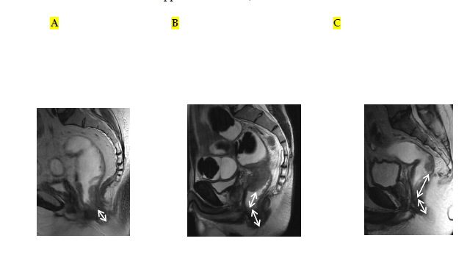
Figure 7 Rectal tumor levels. T2-weighted sagittal images in different patients with rectal carcinoma show distance from the anal verge (double-headed arrows) in (A) low rectal, (B) midrectal, and (C) upper rectal tumors (low rectal tumor, < 5 cm; midrectal, 5-10 cm; upper rectal, > 10 cm).

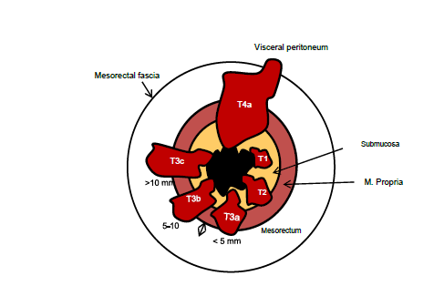
Figure 8 Rectal tumor T staging. The American Joint Committee on Cancer suggested an optional stratification of T3 tumors based on the extramural depth of invasion: less than 5 mm, T3a; 5-10 mm, T3b; and more than 10 mm, T3c (adapted from ref. [27]: Nougaret S, Reinhold C, Mikhael HW, Rouanet P, Bibeau F, Brown G. The use of MR imaging in treatment planning for patients with rectal carcinoma: have you checked the “DISTANCE”? Radiology 2013; 268: 330-344).

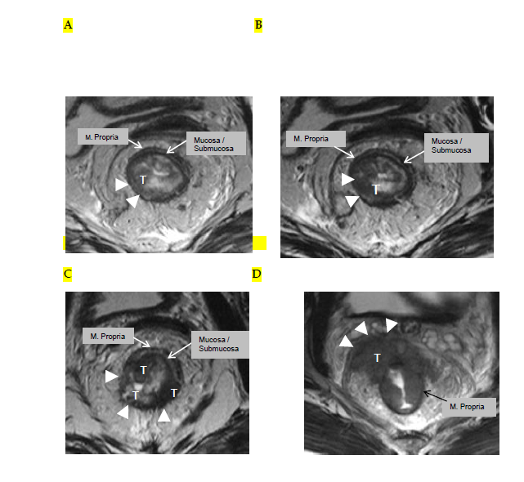
Figure 9 Rectal cancer T staging on magnetic resonance imaging. T2-weighted axial images showing rectal carcinomas with different T stages. A: T1 tumor is confined to the submucosa, has not entered the muscularis propria (arrowheads); B: T2 tumor extends into, but not beyond, the muscularis propria (arrowheads); C: T3 tumor extends beyond the muscularis propria and strands into mesorectal fat (arrowheads). D: T4a tumor invades the visceral peritoneum (arrowheads). T: Tumor.

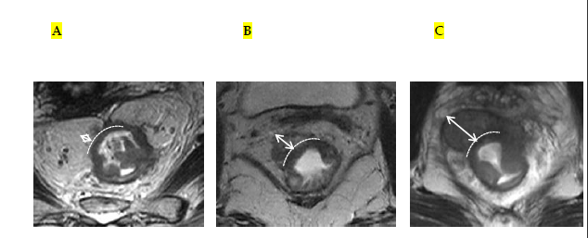
Figure 10 Stratification of T3 tumors on magnetic resonance imaging. T2-weighted axial magnetic resonance images in different patients with T3 rectal carcinoma showing extension of the tumor beyond the muscularis propria (double-headed arrows). The distance A: Less than 5 mm, T3a; B: 5-10 mm, T3b; and C: More than 10 mm, T3c.

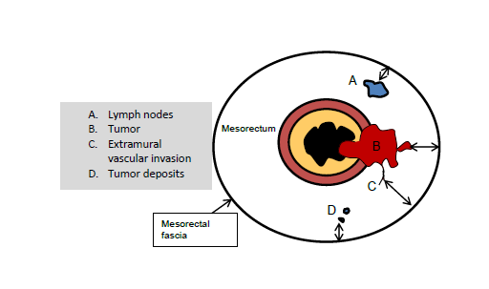
Figure 11 Schematic representation of positive resection margin. For T3 tumors, the shortest distance between the most penetrating parts of the tumor and the MRF is measured (double-headed arrows). A tumor mesorectal fascia distance of more than 1 mm is a reliable predictor for negative margins. In the presence of satellite nodules such as tumor deposits, lymph nodes or EMVI the shortest distance between the nodules and the MRF should also be reported (Adapted from ref. [27]: Nougaret S, Reinhold C, Mikhael HW, Rouanet P, Bibeau F, Brown G. The use of MR imaging in treatment planning for patients with rectal carcinoma: have you checked the “DISTANCE”? Radiology 2013; 268: 330-344). EMVI: Extramural vascular invasion; MRF: Mesorectal fascia.

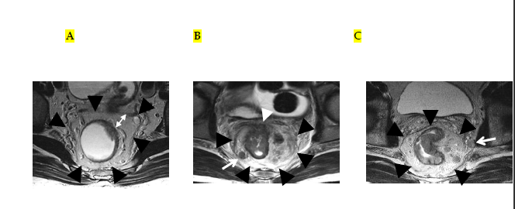
Figure 12 Distance to mesorectal fascia and mesorectal fascia invasion in different patients on T2-weighted axial images. A: T3a tumor is far away from the mesorectal fascia (double-headed arrow); B: T4a tumor (white arrowhead) and a suspicious mesorectal lymph node (arrow) are abutting the mesorectal fascia; C: Rectal tumor is lying > 1 mm from the mesorectal fascia; however, a suspicious lymph node, located out of the mesorectal fascia, is lying within < 1 mm of the mesorectal fascia (arrow). Mesorectal fascia is indicated with black arrowheads.

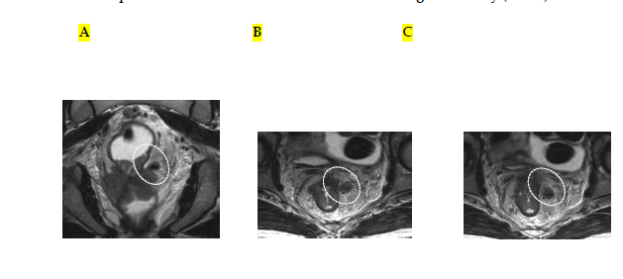
Figure 13 Extramural vascular invasion. T2-weighted (A) coronal and (B, C) serial axial magnetic resonance images in the same patient with T4a rectal cancer showing an irregular and expanded vessel insert to the tumor with tumoral signal intensity (circles).

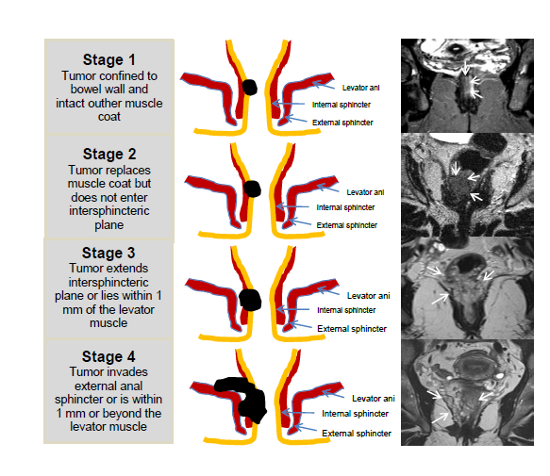
Figure 14 Schematic and high-spatial-resolution coronal T2-weighted magnetic resonance images for each stage according to the low rectal cancer. Rectal tumors in different patients are indicated with arrows on magnetic resonance images (Adapted from ref. [27]: Nougaret S, Reinhold C, Mikhael HW, Rouanet P, Bibeau F, Brown G. The use of MR imaging in treatment planning for patients with rectal carcinoma: have you checked the “DISTANCE”? Radiology 2013; 268: 330-344).

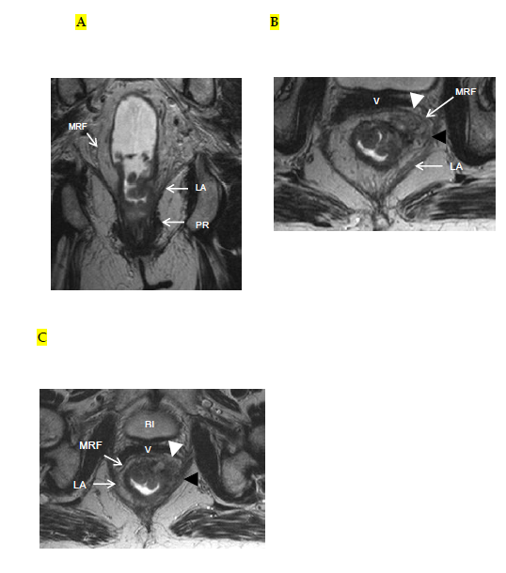
Figure 15 Stage 4 low rectal cancer. On T2-weighted (A) coronal (B, C) serial axial magnetic resonance images, rectal cancer showing invasion of levator ani (black arrowheads) and mesorectal fascia (white arrowhead). LA: Levator ani; PR: Puborectal; MRF: Mesorectal fascia; BL: Bladder; V: Vagina.

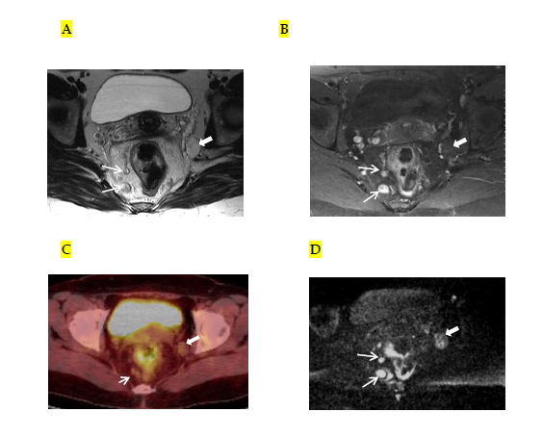
Figure 16 Mesorectal and extramesorectal lymph node involvement in rectal cancer. A: T2-weighted; B: T1-weighted contrast-enhanced axial MR images; C: ^{18F}FDG PET-CT; D: DWI showing suspicious lymph nodes in mesorectal (thin arrows) and extramesorectal areas (thick areas). On DWI, extramesorectal lymph node is more remarkable than T2W and contrast-enhanced T1W sequences. DWI: Diffusion-weighted imaging; ^{18F}FDG PET-CT: 18F-fluorodeoxyglucosepositron emission tomography-computedtomography.

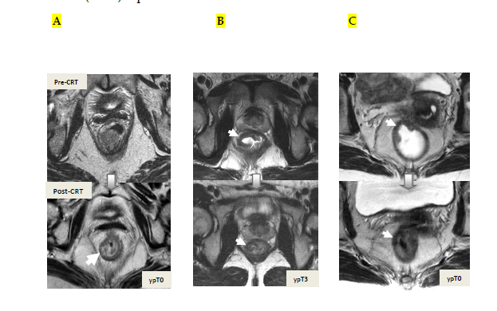
Figure 17 Tumor restaging after neoadjuvant chemoradiotherapy. On T2-weighted MR images in different patients showing baseline and post-CRT images on upper and lower series, respectively. A: In ypT0 rectal tumor, posttreatment axial image shows a normal, two-layered rectal wall (arrow), corresponding to complete response; B: In ypT3 rectal tumor, posttreatment axial image shows normal, two-layered rectal wall (arrow). This is an example for false-negative MR assessment of complete tumor regression; C: In ypT0 rectal tumor, posttreatment axial image shows thick, fibrotic low signal intensity scar (arrow) in pretreatment T3 tumor area. CRT: Chemoradiotherapy.

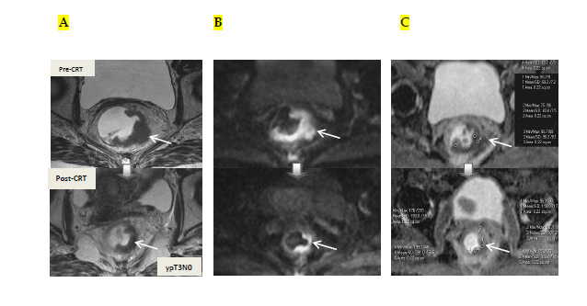
Figure 18 Post-chemoradiotherapy restaging using diffusion-weighted imaging in ypT3 rectal tumor. On T2-weighted (A), DW (B) and ADC (C) images in the same patient, baseline and post-CRT images are shown on upper and lower series, respectively. A: Posttreatment T2-weighted axial image shows semiannular infiltrating tumor, compatible with a residual T3 tumor (arrow); B: Posttreatment DW; C: ADC images delinate high and low signal-intensity corresponding to the tumor, respectively (arrow). Pre- and post-treatment mean ADC values are 0.68-0.72, 1.22-1.44 × 10⁻³ mm²/s, respectively, in the tumor area. Post-therapy ADC increase is compatible with therapy response. CRT: Chemoradiotherapy.

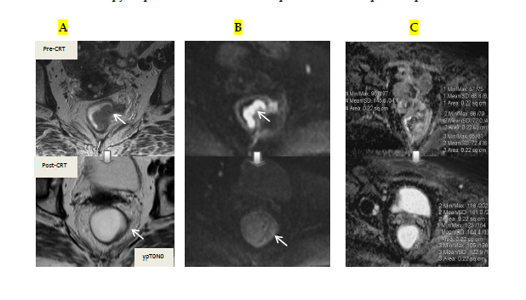
Figure 19 Post-chemoradiotherapy restaging using diffusion-weighted imaging in ypT0 rectal tumor. On T2-weighted (A), DW (B) and ADC (C) images in the same patient, baseline and post-CRT images are shown on upper and lower series, respectively. A: Posttreatment T2-weighted axial image shows a thick wall of low-signal-intensity fibrosis in the previous rectal tumor area (arrow). It is difficult to determine whether this area contains tumor cells or completely devoid of tumor cells (complete response); B: On posttreatment DW image (B-800), there is no diffusion signal in previous tumor area (arrows), compatible with complete response. In this case, DWI allows the correct differentiation of viable tumor from fibrosis. C: ADC images show post-therapy mean ADC increase (0.70 × 10⁻³ mm²/s vs 1.40 × 10⁻³ mm²/s) compatible with therapy response, but does not allow prediction of complete response. DWI: Diffusion-weighted imaging; CRT: Chemoradiotherapy.

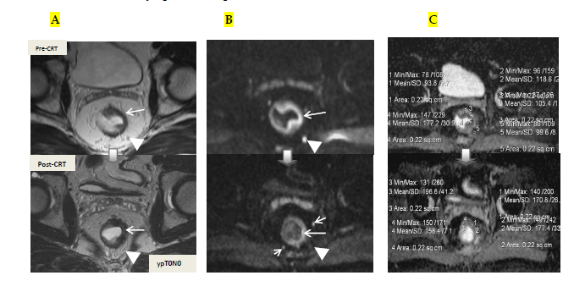
Figure 20 Post-chemoradiotherapy restaging using diffusion-weighted imaging in ypT0 rectal tumor. On T2-weighted (A), DW (B) and ADC (C) images in the same patient, baseline and post-CRT images are shown on upper and lower series, respectively. A: Posttreatment T2-weighted axial image shows a thick wall of low-signal-intensity fibrosis and areas suspicious for residual tumor have intermediate signal-intensity in the previous rectal tumor area (long arrow); B: Posttreatment DW images delinate a small foci of intermediate and low signal-intensity, respectively, compatible with residual tumor (long arrow); C: ADC images show post-threrapy mean ADC increase (1.05 × 10⁻³ mm²/s vs 1.80 × 10⁻³ mm²/s), compatible with therapy response, but not with complete response. The suspicious mesorectal lymph node (arrowheads) is invisible on T2 and DWI after CRT, but the other two are still visible (short arrows). This case is an example for false-positive tumor and lymph node response evaluation of DWI. DWI: Diffusion-weighted imaging; CRT: Chemoradiotherapy.

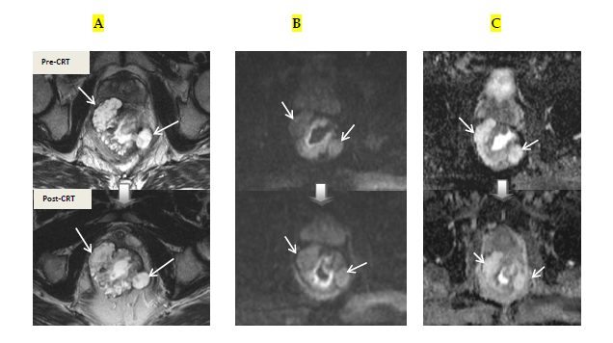
Figure 21 Mucinous adenocarcinoma. A: T2; B: Diffusion-weighted; C: ADC images in the same patient, baseline and post-CRT images are shown on upper and lower series, respectively. The mucinous tumor exhibits hyperintensity on T2, diffusion, and ADC images before and after treatment regardless of their response to treatment. Pre-and post-treatment ADC values are 1.70 × 10⁻³ mm²/s and 2.10 × 10⁻³ mm²/s, respectively. Their response to CRT cannot be assessed using diffusion-weighted imaging. CRT: Chemoradiotherapy.

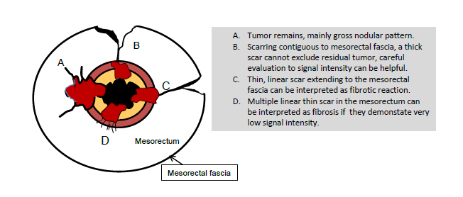
Figure 22 Schematic representation of effects of chemoradiotherapy on a rectal tumor and circumferential resection margins. Adapted from ref. [27]: Nougaret S, Reinhold C, Mikhael HW, Rouanet P, Bibeau F, Brown G. The use of MR imaging in treatment planning for patients with rectal carcinoma: have you checked the “DISTANCE”? Radiology 2013; 268: 330-344.

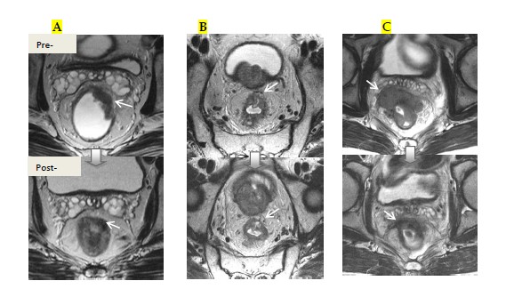
Figure 23 The effects of chemoradiotherapy on a rectal tumor and circumferential resection margins. T2-weighted axial magnetic resonance images in different patients show baseline and post-CRT images on upper and lower series, respectively. A: Overstaging due to thick, hypointense tissue infiltration at the mesorectal fascia (arrow) in ypT2 rectal tumor with no MRF invasion; B: In ypT3 rectal tumor with no MRF invasion, thick fibrous retractions of the tumor, suspicious for CRM positivity (arrow). C: Rectal mass is markedly shrunken with low-signal-intensity tissue infiltration at the mesorectal fascia (arrow). At surgery, there was tumor invasion of the mesorectal fascia. CRM: Circumferential resection margins; MRF: Mesorectal fascia; CRT: Chemoradiotherapy.

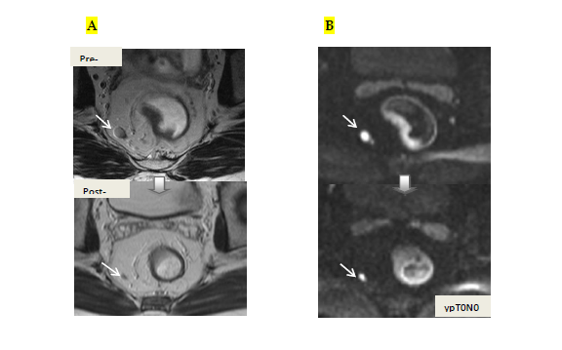
Figure 24 On diffusion-weighted imaging, false-positive mesorectal lymph node evaluation after chemoradiotherapy in ypT0N0 rectal cancer. A: T2-weighted axial magnetic resonance images show significant diminution in nodal size after chemoradiotherapy, compatible with negative lymph node (arrows); B: Diffusion-weighted images, high diffusion signal continues after treatment in the perirectal lymph node, compatible with positive lymph node (arrows). CRT: Chemoradiotherapy.

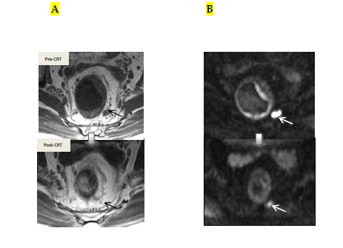
Figure 25 On diffusion-weighted imaging, false-positive mesorectal lymph node after chemoradiotherapy in ypT0N0 rectal cancer. A: T2-weighted axial images show significant diminution in nodal size, compatible with complete response; B: The contuniation of high diffusion signal intensity on residual fibrotic lymph node incorrectly corresponds to a metastatic lymph node (arrows). CRT: Chemoradiotherapy.

