Name of Journal: World Journal of Clinical Cases
Manuscript NO: 64452
Manuscript Type: ORIGINAL ARTICLE

Observational Study
Quantification analysis of pleural line movement for the diagnosis of pneumothorax

Xiao R et al. Quantify pleural line diagnosis pneumothorax

Rui Xiao, Qiang Shao, Ning Zhao, Fen Liu, Ke-Jian Qian

Rui Xiao, Qiang Shao, Ning Zhao, Fen Liu, Ke-Jian Qian, Department of Intensive Care Medicine, First Affiliated Hospital of Nanchang University, Nanchang 330006, Jiangxi Province, China

Author contributions: Xiao R and Qian KJ were the guarantors and designed the study; Xiao R and Zhao N participated in the acquisition, analysis, and interpretation of the data, and drafted the initial manuscript; Shao Q and Liu F revised the manuscript.

Corresponding author: Ke-Jian Qian, MD, PhD, Full Professor, Department of Intensive Care Medicine, First Affiliated Hospital of Nanchang University, No. 17 Yongwaizheng Road, Nanchang 330006, Jiangxi Province, China. ndyfyicu@email.ncu.edu.cn

Received: February 19, 2021
Revised: March 19, 2021
Accepted: June 1, 2021
Published online: July 26, 2021

Abstract
BACKGROUND
There is no research on quantitative pleural line movement. In this study, we assume that tissue Doppler and its quantitative technology can quantify the pleural line movement and can be used to diagnose pneumothorax.

AIM
To evaluate the quantitative assessment of pleural line movement measured by tissue Doppler imaging (TDI) for pneumothorax diagnosis.

METHODS
Adult patients (n = 45) diagnosed with unilateral pneumothorax were included in this study. Each patient underwent TDI of both lungs. The pneumothorax side and contralateral normal lung side were compared using several indices obtained from TDI: peak pleural line velocity (PVmax), peak chest wall tissue velocity (CVmax), peak pleural line strain value (PS_{max}), peak chest wall tissue strain value (CS_{max}), PV_{max}/CV_{max} and PS_{max}/CS_{max}. The receiver operating characteristic analysis was used to evaluate the performance of these quantitative assessments for pneumothorax diagnosis.

RESULTS
Various quantitative variables of the pneumothorax side were all lower than that of the non-pneumothorax side and included the PV_{max} (0.36 cm/s vs 0.59 cm/s, P < 0.001), PS_{max} (1.14% vs 1.90%, P = 0.001), PV_{max}/CV_{max} (1.06 vs 4.93, P < 0.001), and PS_{max}/CS_{max} (0.76 vs 1.74, P < 0.001). For the discrimination of pneumothorax, the cut-off values of the PV_{max}, PS_{max}, PV_{max}/CV_{max}, and PS_{max}/CS_{max} were calculated as 0.50 cm/s, 0.94%, 1.96, and 1.12, respectively. Similarly, the sensitivities and specificities of PV_{max}, PS_{max}, PV_{max}/CV_{max}, and PS_{max}/CS_{max} were 96% and 62%, 47% and 91%, 93% and 96%, and 82% and 93%, respectively. The area under the receiver operating characteristic curve were 0.84, 0.72, 0.99, and 0.91, respectively, for PV_{max}, PS_{max}, PV_{max}/CV_{max}, and PS_{max}/CS_{max}.

CONCLUSION
Quantification analysis of pleural line movement using TDI is a useful tool for the diagnosis of pneumothorax.

Key Words: Lung ultrasound; Pneumothorax; Tissue Doppler imaging; Pleural line movement

©The Author(s) 2021. Published by Baishideng Publishing Group Inc. All rights reserved.

Citation: Xiao R, Shao Q, Zhao N, Liu F, Qian KJ. Quantification analysis of pleural line movement for the diagnosis of pneumothorax. World J Clin Cases 2021; 9(21): 5889-5899
URL: https://www.wjgnet.com/2307-8960/full/v9/i21/5889.htm
DOI: https://dx.doi.org/10.12998/wjcc.v9.i21.5889

Core Tip: This study used tissue Doppler to quantify the movement of the pleural line for the diagnosis of pneumothorax in patients with unilateral pneumothorax. Various quantitative variables of the pneumothorax side were all lower than that of the non-pneumothorax side. Peak pleural line velocity/peak chest wall tissue velocity was the best variable to diagnose pneumothorax (area under receiver operating characteristic curve, 0.99). Tissue Doppler quantitative technique is an effective tool for the diagnosis of pneumothorax.

INTRODUCTION
Pneumothorax is characterized by sudden dyspnea, respiratory distress, chest pain, cough, or decreased blood oxygen saturation and is a common and critical acute condition. A timely diagnosis can improve patient outcomes. However, in practice pneumothorax diagnosis requires further discrimination with other conditions. Pneumothorax is easily diagnosed using radiological tools, such as chest radiograph and computed tomography (CT)^{[1]}. For pneumothorax diagnosis, CT has several disadvantages, such as radiation exposure, cost, and availability^{[2]}. Although chest radiograph is more convenient than CT, its sensitivity in the diagnosis of pneumothorax is relatively low and is estimated to be only around 20.9%^{[3]}.
Due to its easy access, ultrasound has been widely used in emergency departments and intensive care units. Recently, lung ultrasound has been evaluated for the diagnosis of pneumothorax. For example, among intensive care unit patients, lung ultrasound was found to be a useful tool for pneumothorax diagnosis with a sensitivity of 75% and a specificity of 93%^{[4]}. Currently, the criteria of ultrasound diagnosis for pneumothorax are as follows: absence of lung sliding^{[5]}, lung point^{[6,7]}, and barcode sign^{[6]}. Of these, the absence of lung sliding is the most common sign for pneumothorax diagnosis and has been listed in the bedside lung ultrasound in emergency protocol^{[8]}. Unfortunately, pneumothorax diagnosis using lung ultrasound still faces several challenges. First, the ultrasonic features of pneumothorax are similar to a wide range of other diseases that include severe asthma^{[9]}, pulmonary bullae^{[10]}, and chronic obstructive pulmonary disease^{[11]}. Second, the ultrasonic method for pneumothorax diagnosis depends on the physician’s experience and training^{[12]}. Third, the movement of the pleural line is based on the movement of the visceral and parietal pleura during respiration, and the evaluation of movement using ultrasound is subjective and may vary between observers. In addition, patient postures may also have a significant impact on the diagnosis^{[13]}.
Usually, tissue Doppler imaging (TDI) is performed to quantitatively evaluate cardiac function, including systolic and diastolic cycles^{[14,15]}. Moreover, it is also advised to evaluate the synchronization of left ventricular myocardial contraction by tissue velocity imaging and strain quantitative technology^{[16]}. Recently, we found that TDI can quantify the movement of the pleural line. Therefore, in this prospective study, we aimed to evaluate the performance of TDI for pneumothorax diagnosis by quantitative analysis of pleural line movement during respiration.

MATERIALS AND METHODS
Ethics
This study was approved by the Ethics Committee of the First Affiliated Hospital of Nanchang University, and written consent was obtained from all subjects. This study was performed in accordance with the Declaration of Helsinki (2013).

Patients
Between September 2019 and May 2020, adult patients (> 18 years) who were admitted to the emergency department and intensive care unit at our center with unilateral pneumothorax confirmed by CT were included for further analysis. Lung ultrasound was performed 2 h after CT examination. Patients were excluded if they presented with bilateral pneumothorax, if cardiac monitoring was absent from ultrasound images, or if invasive mechanical ventilation was performed. Patient characteristics such as age, sex, weight, height, etiology, and pneumothorax side were collected for further analysis.

Lung ultrasound
Ultrasound examination was performed by a senior physician with > 5 years of experience in lung ultrasonography. The examination was performed with a Mindray Ultrasound Scanning machine (M8/M9, Mindray, Shenzhen, China) equipped with low frequency transducers (1-5 MHz and 2-4 MHz). Ultrasonic images were analyzed with the TDI-QA software (Mindray, Shenzhen, China). Lung ultrasound was performed for patients with pneumothorax by a specific investigator (RX). Briefly, the ultrasound was performed as follows. First, the patient laid in the supine position, and the probe was positioned perpendicularly to the chest wall. For the pneumothorax side, if the pleural line movement disappeared, tissue Doppler was switched, and ultrasonic images were collected for at least 20 s. For the non-pneumothorax side, ultrasound images were collected at the contralateral site.
Ultrasonographic data were selected retrospectively. Quantitative analysis of ultrasonic images was performed as shown in Figures 1 and 2. Briefly, the diameter of the region of interest (ROI) was adjusted to the width of the pleural line, and then the first ROI (ROI1, red) was placed at the midpoint of the pleural line. Subsequently, a velocity-time curve and a strain-time curve were generated automatically. Meanwhile, the maximum velocity and strain were calculated based on the quantitative analysis and included the peak pleural line velocity (PV_{max}) and peak pleural line strain value (PS_{max}). The second ROI (ROI2, yellow) was placed in the chest wall tissue about 0.5 cm from ROI1. The software automatically generated a velocity-time curve and a strain-time curve, measuring the maximum chest wall tissue velocity and maximum strain. These parameters are called peak chest wall tissue velocity (CV_{max}) and peak chest wall tissue strain value (CS_{max}). All above-mentioned indexes, including the PV_{max}/CV_{max} and PS_{max}/CS_{max} ratios were calculated based on data collected from the pneumothorax and non-pneumothorax side separately.

Statistical analysis
SPSS 17.0 (IBM, Armonk, NY, United States) was used for statistical analysis. Normally distributed data were reported as the mean (± standard deviation), and non-normally distributed data were expressed as the median (interquartile range). Comparisons between paired samples were performed using a Wilcoxon test. The receiver operating characteristic curve was constructed to evaluate the diagnostic performance of biomarkers to detect pneumothorax. The best cut-off values were defined using Youden’s index. Sensitivity, specificity, positive predictive value, negative predictive value, positive likelihood ratio, negative likelihood ratio, and the corresponding 95% confidence intervals (CIs) were estimated with these cut-off values. Interobserver and intraobserver agreements were evaluated using intraclass correlation coefficients by comparing measurements made by the senior physician (RX) and resident (NZ). A P value < 0.05 was considered statistically significant.

RESULTS
Patient characteristics
During the study period, 61 suspected patients were admitted to our center, and a total of 45 patients were included for further analysis. The flowchart of patient selection is given in Figure 3. Of these patients, 28 were male, and the median age was 38 years. The etiology of pneumothorax was as follows: spontaneous pneumothorax (n = 16) and traumatic pneumothorax (n = 29). Eighteen patients had pneumothorax on the left side and twenty-seven patients on the right side (Table 1).

Comparison between the pneumothorax and non-pneumothorax side
A total of 90 images of the included patients were obtained. Tissue Doppler features (Figures 4 and 5 and Videos 1-4) are shown in Table 2. The CV_{max} was found to be 0.30 (0.15, 0.39) cm/s at the pneumothorax side and 0.13 (0.09, 0.19) cm/s at the non-pneumothorax side. The PS_{max} was found to be 1.62% (1.16%, 2.06%) at the pneumothorax side and 1.00% (0.71%, 1.98%) at the non-pneumothorax side. Statistical analysis showed that quantitative variables, such as the PV_{max} [0.36 (0.23, 0.41) vs 0.59 (0.38, 0.80) cm/s, P < 0.001], the PS_{max} [1.14 (0.41, 1.85) vs 1.90 (1.30, 3.34) %, P = 0.001)], the PV_{max}/CV_{max} ratio [1.06 (0.85, 1.53) vs 4.93 (3.40, 7.52), P < 0.001], and the PS_{max}/CS_{max} ratio [0.76 (0.32, 1.05) vs 1.74 (1.30, 2.66), P < 0.001] of the pneumothorax side were all lower than the non-pneumothorax counterparts.

Diagnostic value of TDI measurements
The performance of TDI measurements in the diagnosis of pneumothorax are presented in Table 3. The results of the receiver operating characteristic analysis are shown in Figure 6. The areas under the receiver operating characteristic curve of the PV_{max}, PS_{max}, PV_{max}/CV_{max}, and PS_{max}/CS_{max} were 0.84 (95%CI: 0.75, 0.92), 0.72 (95%CI: 0.62, 0.83), 0.99 (95%CI: 0.96, 1.00), and 0.91 (95%CI: 0.84, 0.97), respectively. For the discrimination of pneumothorax, the cut-off values of the PV_{max}, PS_{max}, PV_{max}/CV_{max}, and PS_{max}/CS_{max} were calculated as 0.50 cm/s, 0.94%, 1.96, and 1.12, respectively. The corresponding sensitivities and specificities of PV_{max}, PS_{max}, PV_{max}/CV_{max}, and PS_{max}/CS_{max} were 96% and 62%, 47% and 91%, 93% and 96%, and 82% and 93%, respectively.

B-Mode ultrasound
Another two physicians (one senior physician and one resident) who were blinded to the clinical diagnosis were recruited to evaluate the 90 images in B-Mode (mainly using A-line, lung sliding, lung pulse). Eighty-five episodes were correctly diagnosed by the senior physician, with the sensitivity, specificity, positive predictive value, negative predictive value, and accuracy calculated as 93%, 96%, 95%, 93% and 94%, respectively. Meanwhile, eighty-four episodes were correctly diagnosed by the resident, with the sensitivity, specificity, positive predictive value, negative predictive value and accuracy calculated as 91%, 96%, 95%, 91% and 93%, respectively. Hence, it appears that the sensitivity and specificity of the TDI method are consistent with those of the senior physician and are better than those of the resident.

Variability of TDI measurements
The intraobserver variabilities of the PV_{max}, CV_{max}, PS_{max}, and CS_{max} were 0.88 (95%CI: 0.79; 0.93), 0.82 (95%CI: 0.59; 0.92), 0.85 (95%CI: 0.75; 0.92), and 0.86 (95%CI: 0.77; 0.92), respectively (Table 4). The interobserver variabilities of the PV_{max}, CV_{max}, PS_{max}, and CS_{max} were 0.79 (95%CI: 0.64; 0.88), 0.75 (95%CI: 0.48; 0.87), 0.72 (95%CI: 0.54; 0.84), and 0.75 (95%CI: 0.59; 0.86), respectively. Further analysis showed that there was no clinically significant difference in the intraobserver variability between the two physicians (RX and NZ).

DISCUSSION
In this study, several measurements (e.g., PV_{max}, CV_{max}, PS_{max}, and CS_{max}) obtained using the TDI method were evaluated for the detection of pneumothorax. Our results showed that compared with other indices, the PV_{max}/CV_{max} ratio exhibited the best diagnostic performance in the diagnosis of pneumothorax. Our data demonstrated that quantification analysis of pleural line movement using TDI is useful for the diagnosis of pneumothorax. To the best of our knowledge, this is the first time that measurements obtained by TDI quantification analysis of pleural line movement have been used as a diagnostic tool for pneumothorax.
The performance of lung ultrasound has been previously evaluated. However, the performance has varied widely between studies. For example, Ziapour and Haji^{[17]} found that if the pleural movement disappears and the B-line is used, lung ultrasound exhibited a sensitivity of 78% and a specificity of 92% for pneumothorax diagnosis^{[17]}. Press et al^{[18]} found a sensitivity of 91.95% and a specificity of 89.10% for the performance of pneumothorax detection via lung ultrasound^{[18]}. In addition, lung ultrasound has also been reported to exhibit low sensitivity for pneumothorax diagnosis^{[19]}. This may be explained by the criterion of lung sliding disappearance that is often used for pneumothorax diagnosis, in which particular expertise and training is required^{[20]}. The Mindray ultrasound device has a very useful feature by which tissue Doppler can analyze the movements of several selected arbitrary ROIs without the need to generate a heart model. Therefore, the velocity and strain of visceral and partial pleura during respiration are easy to evaluate and can be measured with pleural line movement. Hence, tissue velocity and strain imaging in the current work were innovatively used to analyze the movement of pleural movement for the pneumothorax diagnosis. In addition, our data suggest that the interobserver variabilities of the measured indexes are moderate, and the intraobserver variabilities are low. The moderate interobserver variability is mainly due to the manual selection of ROIs. A good intraobserver agreement suggests that TDI can be well repeated by a clinical physician, indicating that this method is easy to access for the diagnosis of pneumothorax.
We found that the PV_{max}/CV_{max} calculated by data obtained from the non-pneumothorax side was greater than that from the pneumothorax side and that the PS_{max}/CS_{max} from the non-pneumothorax side was greater than that from the pneumothorax side. Compared with other indices, the PV_{max}/CV_{max} ratio exhibited the largest area under receiver operating characteristic curve for the diagnosis of pneumothorax. This suggests that the PV_{max}/CV_{max} ratio was the strongest biomarker in the diagnosis of pneumothorax in our study. In lungs under normal conditions, the velocity and strain of the pleural line seen via ultrasound represent the movement of the visceral pleura during respiration. By contrast, in the state of pneumothorax, the velocity and strain of the pleural line represent the movement of the parietal pleura during respiration. Therefore, when in the normal state, the velocity and strain describing the movements of the visceral and parietal pleura were higher than those in the state of pneumothorax. In addition, the pleural strain had a low sensitivity but a high specificity for pneumothorax diagnosis. This may be due to the perpendicular position of the imaging plane and that changes in the velocity of visceral pleura may be easier to find when compared with changes in the strain.
Our study also had several limitations. First, although some interesting points have been raised, the study had a small sample size. Second, most patients included in our study were thin, and our findings must be validated in obese patients as well. Third, Mindray’s TDI-QA ultrasound image analysis software was used, which allows cardiac probes of the pleural line, whereas other software packages are not useful without a ventricular shape. The widespread use of this method may be limited by this shortcoming. Fourth, due to poor resolution of high-frequency probes, a phased array probe would benefit quantitative assessment of pleural line movement. Fifth, a lung ultrasound loop based on the combination of respiratory cycle and ultrasound may be more useful for the quantitative analysis of lung ultrasound^{[21]}. Unfortunately, conventional TDI software is only applicable in echocardiography where the respiratory circle is unavailable. Therefore, the respiratory cycle may need to be introduced into the software package. Finally, a larger sample size and a prospective diagnostic study is still needed to confirm our findings.

CONCLUSION
The current study utilized TDI and quantification analysis of pleural line movement to extract several indices such as the PV_{max}, PS_{max}, CV_{max}, and CS_{max}. Our findings showed that the PV_{max}, PS_{max}, PV_{max}/CV_{max}, and PS_{max}/CS_{max} are good diagnostic biomarkers for pneumothorax. Compared with the other three biomarkers, the PV_{max}/CV_{max} ratio exhibited a better diagnostic performance. Overall, quantification analysis of pleural line movement using TDI is a useful tool for the diagnosis of pneumothorax.

ARTICLE HIGHLIGHTS
Research background
The criteria for pneumothorax using ultrasound is usually based on qualitative methodologies.

Research motivation
Tissue Doppler imaging (TDI) technology might discriminate pneumothorax by quantifying pleural line movement. Based on that, pneumothorax might be diagnosed in an objective way.

Research objectives
TDI can quantify pleural line movement while diagnosing pneumothorax.

Research methods
Forty-five patients with unilateral pneumothorax were recruited. The pneumothorax side and contralateral normal lung side were then compared using several indices extracted from TDI, such as peak pleural line velocity (PVmax), peak chest wall tissue velocity (CVmax), peak pleural line strain value (PSmax), peak chest wall tissue strain value, PVmax/CVmax, and PSmax/peak chest wall tissue strain value. Receiver operating characteristic analysis was used to evaluate the performance of these quantitative assessments for pneumothorax diagnosis.

Research results
PVmax, PSmax, PVmax/CVmax, PSmax/peak chest wall tissue strain value obtained on the pneumothorax side were lower than those on the non-pneumothorax side. The PVmax/CVmax was the best index for the detection of pneumothorax with an area under receiver operating characteristic curve of 0.99.

Research conclusions
Therefore, we concluded that TDI is an effective tool for the diagnosis of pneumothorax.

Research perspectives
Further research is required to validate our findings in suspected cases.

REFERENCES
1 Kelly AM, Weldon D, Tsang AY, Graham CA. Comparison between two methods for estimating pneumothorax size from chest X-rays. Respir Med 2006; 100: 1356-1359 [PMID: 16406560 DOI: 10.1016/j.rmed.2005.11.022]
2 Beckmann U, Gillies DM, Berenholtz SM, Wu AW, Pronovost P. Incidents relating to the intra-hospital transfer of critically ill patients. An analysis of the reports submitted to the Australian Incident Monitoring Study in Intensive Care. Intensive Care Med 2004; 30: 1579-1585 [PMID: 14991102 DOI: 10.1007/s00134-004-2177-9]
3 Kirkpatrick AW, Sirois M, Laupland KB, Liu D, Rowan K, Ball CG, Hameed SM, Brown R, Simons R, Dulchavsky SA, Hamiilton DR, Nicolaou S. Hand-held thoracic sonography for detecting post-traumatic pneumothoraces: the Extended Focused Assessment with Sonography for Trauma (EFAST). J Trauma 2004; 57: 288-295 [PMID: 15345974 DOI: 10.1097/01.ta.0000133565.88871.e4]
4 Xirouchaki N, Magkanas E, Vaporidi K, Kondili E, Plataki M, Patrianakos A, Akoumianaki E, Georgopoulos D. Lung ultrasound in critically ill patients: comparison with bedside chest radiography. Intensive Care Med 2011; 37: 1488-1493 [PMID: 21809107 DOI: 10.1007/s00134-011-2317-y]
5 Lichtenstein DA, Menu Y. A bedside ultrasound sign ruling out pneumothorax in the critically ill. Lung sliding. Chest 1995; 108: 1345-1348 [PMID: 7587439 DOI: 10.1378/chest.108.5.1345]
6 Lichtenstein D, Mezière G, Biderman P, Gepner A. The "lung point": an ultrasound sign specific to pneumothorax. Intensive Care Med 2000; 26: 1434-1440 [PMID: 11126253 DOI: 10.1007/s001340000627]
7 Moreno-Aguilar G, Lichtenstein D. Lung ultrasound in the critically ill (LUCI) and the lung point: a sign specific to pneumothorax which cannot be mimicked. Crit Care 2015; 19: 311 [PMID: 26345706 DOI: 10.1186/s13054-015-1030-6]
8 Lichtenstein DA, Mezière GA. Relevance of lung ultrasound in the diagnosis of acute respiratory failure: the BLUE protocol. Chest 2008; 134: 117-125 [PMID: 18403664 DOI: 10.1378/chest.07-2800]
9 Del Colle A, Carpagnano GE, Feragalli B, Foschino Barbaro MP, Lacedonia D, Scioscia G, Quarato CMI, Buonamico E, Tinti MG, Rea G, Cipriani C, Frongillo E, De Cosmo S, Guglielmi G, Sperandeo M. Transthoracic ultrasound sign in severe asthmatic patients: a lack of "gliding sign" mimic pneumothorax. BJR Case Rep 2019; 5: 20190030 [PMID: 31938562 DOI: 10.1259/bjrcr.20190030]
10 Gelabert C, Nelson M. Bleb point: mimicker of pneumothorax in bullous lung disease. West J Emerg Med 2015; 16: 447-449 [PMID: 25987927 DOI: 10.5811/westjem.2015.3.24809]
11 Slater A, Goodwin M, Anderson KE, Gleeson FV. COPD can mimic the appearance of pneumothorax on thoracic ultrasound. Chest 2006; 129: 545-550 [PMID: 16537850 DOI: 10.1378/chest.129.3.545]
12 Ding W, Shen Y, Yang J, He X, Zhang M. Diagnosis of pneumothorax by radiography and ultrasonography: a meta-analysis. Chest 2011; 140: 859-866 [PMID: 21546439 DOI: 10.1378/chest.10-2946]
13 Schrift D, Barron K, Wagner M, Arya R. A case report of lung ultrasound missing a pneumothorax due to patient positioning. Ultrasound 2017; 25: 248-250 [PMID: 29163662 DOI: 10.1177/1742271X17708473]
14 Mullens W, Borowski AG, Curtin RJ, Thomas JD, Tang WH. Tissue Doppler imaging in the estimation of intracardiac filling pressure in decompensated patients with advanced systolic heart failure. Circulation 2009; 119: 62-70 [PMID: 19075104 DOI: 10.1161/CIRCULATIONAHA.108.779223]
15 Hoffmann S, Mogelvang R, Sogaard P, Iversen AZ, Hvelplund A, Schaadt BK, Fritz-Hansen T, Galatius S, Risum N, Biering-Sørensen T, Jensen JS. Tissue Doppler echocardiography reveals impaired cardiac function in patients with reversible ischaemia. Eur J Echocardiogr 2011; 12: 628-634 [PMID: 21757478 DOI: 10.1093/ejechocard/jer094]
16 Yu CM, Gorcsan J 3rd, Bleeker GB, Zhang Q, Schalij MJ, Suffoletto MS, Fung JW, Schwartzman D, Chan YS, Tanabe M, Bax JJ. Usefulness of tissue Doppler velocity and strain dyssynchrony for predicting left ventricular reverse remodeling response after cardiac resynchronization therapy. Am J Cardiol 2007; 100: 1263-1270 [PMID: 17920368 DOI: 10.1016/j.amjcard.2007.05.060]
17 Ziapour B, Haji HS. "Anterior convergent" chest probing in rapid ultrasound transducer positioning vs formal chest ultrasonography to detect pneumothorax during the primary survey of hospital trauma patients: a diagnostic accuracy study. J Trauma Manag Outcomes 2015; 9: 9 [PMID: 26697105 DOI: 10.1186/s13032-015-0030-5]
18 Press GM, Miller SK, Hassan IA, Alade KH, Camp E, Junco DD, Holcomb JB. Prospective evaluation of prehospital trauma ultrasound during aeromedical transport. J Emerg Med 2014; 47: 638-645 [PMID: 25281177 DOI: 10.1016/j.jemermed.2014.07.056]
19 Trovato G, Sperandeo M. Lung Ultrasound in Pneumothorax: The Continuing Need for Radiology. J Emerg Med 2016; 51: 189-191 [PMID: 27317611 DOI: 10.1016/j.jemermed.2015.01.045]
20 Alrajab S, Youssef AM, Akkus NI, Caldito G. Pleural ultrasonography vs chest radiography for the diagnosis of pneumothorax: review of the literature and meta-analysis. Crit Care 2013; 17: R208 [PMID: 24060427 DOI: 10.1186/cc13016]
21 Duclos G, Bobbia X, Markarian T, Muller L, Cheyssac C, Castillon S, Resseguier N, Boussuges A, Volpicelli G, Leone M, Zieleskiewicz L. Speckle tracking quantification of lung sliding for the diagnosis of pneumothorax: a multicentric observational study. Intensive Care Med 2019; 45: 1212-1218 [PMID: 31359081 DOI: 10.1007/s00134-019-05710-1]

Footnotes
Institutional review board statement: This study was approved by the Ethics Committee of the First Affiliated Hospital of Nanchang University.

Informed consent statement: Written consent was obtained from all subjects.

Conflict-of-interest statement: The authors have no conflicts of interest to disclose.

Data sharing statement: The datasets used and/or analyzed during the current study are available from the corresponding author on reasonable request.

STROBE statement: The authors have read the STROBE Statement, and the manuscript was prepared and revised according to the STROBE Statement.

Open-Access: This article is an open-access article that was selected by an in-house editor and fully peer-reviewed by external reviewers. It is distributed in accordance with the Creative Commons Attribution NonCommercial (CC BY-NC 4.0) license, which permits others to distribute, remix, adapt, build upon this work non-commercially, and license their derivative works on different terms, provided the original work is properly cited and the use is non-commercial. See: http://creativecommons.org/Licenses/by-nc/4.0/

Manuscript source: Unsolicited manuscript

Peer-review started: February 19, 2021
First decision: March 11, 2021
Article in press: June 1, 2021

Specialty type: Medicine, research and experimental
Country/Territory of origin: China
Peer-review report’s scientific quality classification
Grade A (Excellent): 0
Grade B (Very good): 0
Grade C (Good): C
Grade D (Fair): 0
Grade E (Poor): 0

P-Reviewer: Vetrugno L S-Editor: Fan JR L-Editor: Filipodia P-Editor: Xing YX

Figure Legends
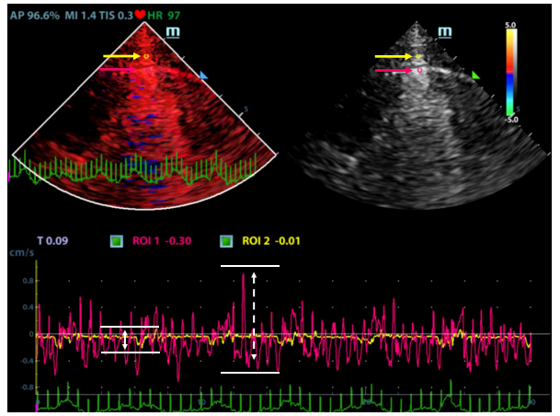
Figure 1 Peak velocity measurement. Tissue Doppler image (left), ultrasound image (right); region of interest 1 (ROI1, red dot) at the midpoint of the pleural line, ROI2 (yellow dot), 0.5 cm from the pleural line; velocity-time curve of ROI1 (red curve), velocity-time curve of ROI2 (yellow curve); velocity of ROI1 (white arrow, dotted line), peak velocity of ROI2 (white arrow, solid line).
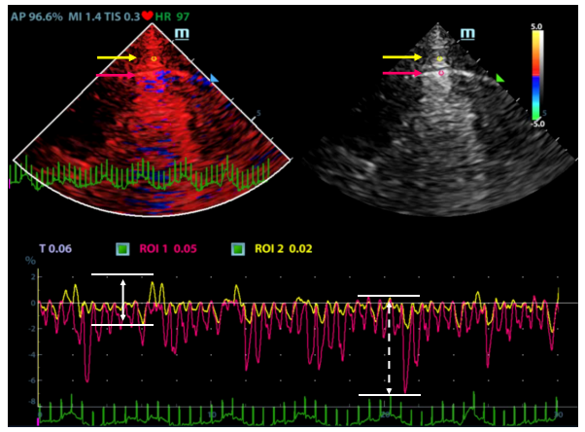
Figure 2 Peak strain measurement. Tissue Doppler image (left), ultrasound image (right); region of interest 1 (ROI1, red dot) at the midpoint of the pleural line, ROI2 (yellow dot), 0.5 cm from the pleural line; strain-time curve of ROI1 (red curve), strain-time curve of ROI2 (yellow curve); peak strain of ROI1 (white arrow, dotted line), peak strain of ROI2 (white arrow, solid line).
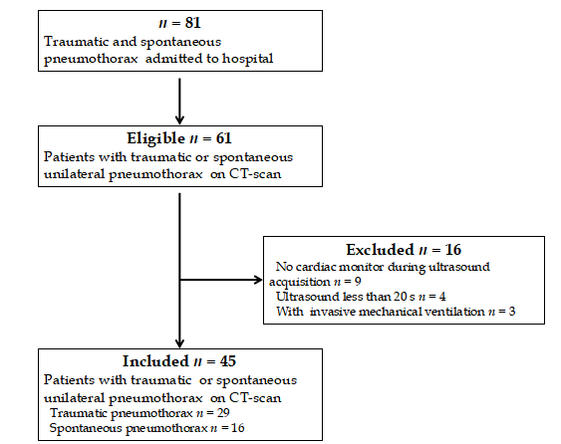
Figure 3 A flowchart of patient selection for our study. CT: Computed tomography.
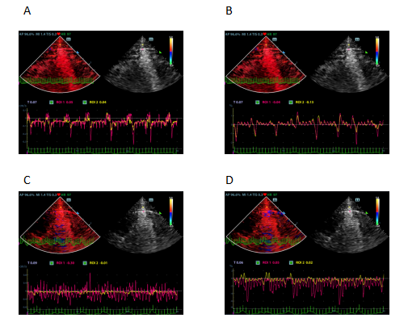
Figure 4 Tissue Doppler imaging of the pneumothorax side and the non-pneumothorax side. A: Velocity-time curve (pneumothorax side); B: Strain-time curve (pneumothorax side); C: Velocity-time curve (non-pneumothorax side); D: Strain-time curve (non-pneumothorax side).
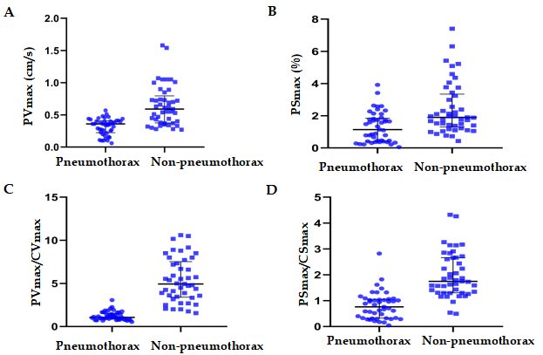
Figure 5 Scatter plot of measurements obtained by tissue Doppler imaging. A: Scatter plot of peak pleural line velocity; B: Scatter plot of peak pleural line strain value; C: Scatter plot of peak pleural line velocity/peak chest wall tissue velocity; D: Scatter plot of peak pleural line strain value/peak chest wall tissue strain value. Data are expressed as the median and interquartile range. PV_{max}: Peak pleural line velocity; CV_{max}: Peak chest wall tissue velocity; PS_{max}: Peak pleural line strain value; CS_{max}: Peak chest wall tissue strain value.

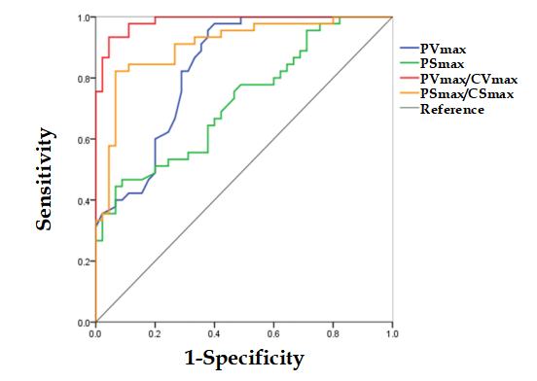
Figure 6 Receiver operating characteristic analysis of the extracted measurements obtained by tissue Doppler imaging. PV_{max}: Peak pleural line velocity; CV_{max}: Peak chest wall tissue velocity; PS_{max}: Peak pleural line strain value; CS_{max}: Peak chest wall tissue strain value.

Table 1 Clinical characteristics of patients included in our study
characteristics | Value
n | 45
Male | 28 (62)
Age (yr)  Weight (kg)  Height (cm) | 38 (21, 59)  63 (60, 70)  16 (163, 175)
Etiology for pneumothorax
Spontaneous pneumothorax | 16 (36)
Trauma | 29 (64)
Pneumothorax features
Left | 18 (40)
Right | 27 (60)
Data are expressed as n (%) or median (interquartile range).
Table 2 Comparison of measurements obtained by tissue Doppler imaging between the pneumothorax and non-pneumothorax sides
 | Pneumothorax side, n = 45 | Non-pneumothorax side, n = 45 | P value
PV_{max} (cm/s) | 0.36 (0.23, 0.41) | 0.59 (0.38, 0.80) | < 0.001
PS_{max} (%) | 1.14 (0.41, 1.85) | 1.90 (1.30, 3.34) | 0.001
CV_{max} (cm/s) | 0.30 (0.15, 0.39) | 0.13 (0.09, 0.19) | < 0.001
CS_{max} (%) | 1.62 (1.16, 2.06) | 1.00 (0.71, 1.98) | 0.075
PV_{max}/CV_{max} | 1.06 (0.85, 1.53) | 4.93 (3.40, 7.52) | < 0.001
PS_{max}/CS_{max} | 0.76 (0.32, 1.05) | 1.74 (1.30, 2.66) | < 0.001
Data are expressed as the median and interquartile range. PV_{max}: Peak pleural line velocity; CV_{max}: Peak chest wall tissue velocity; PS_{max}: Peak pleural line strain value; CS_{max}: Peak chest wall tissue strain value.
Table 3 The diagnostic performance of measurements obtained by tissue Doppler imaging in the diagnosis of pneumothorax
 | AUC | P value | Cut-off value | Sensitivity | Specificity | PLR | NLR | PPV | NPV
PV_{max} (cm/s) | 0.84 (0.75, 0.92) | < 0.001 | 0.50 | 96% | 62% | 2.53 | 0.07 | 0.72 | 0.93
PS_{max} (%) | 0.72 (0.62, 0.83) | < 0.001 | 0.94 | 47% | 91% | 5.25 | 0.84 | 0.84 | 0.63
PV_{max}/CV_{max} | 0.99 (0.96, 1.00) | < 0.001 | 1.96 | 93% | 96% | 21.00 | 0.07 | 0.95 | 0.93
PS_{max}/CS_{max} | 0.91 (0.84, 0.97) | < 0.001 | 1.12 | 82% | 93% | 12.33 | 0.19 | 0.93 | 0.84
AUC: Area under receiver operating characteristic curve; PV_{max}: Peak pleural line velocity; CV_{max}: Peak chest wall tissue velocity; PS_{max}: Peak pleural line strain value; CS_{max}: Peak chest wall tissue strain value; PLR: Positive likelihood ratio; NLR: Negative likelihood ratio; PPV: Positive predictive value; NPV: Negative predictive value.
Table 4 Variability of tissue Doppler imaging measurements
 | PV_{max} | CV_{max} | PS_{max} | CS_{max}
Senior physician
Pneumothorax | 0.87 (0.78, 0.93) | 0.85 (0.73, 0.91) | 0.84 (0.72, 0.91) | 0.88 (0.79, 0.93)
Non-pneumothorax | 0.88 (0.79, 0.93) | 0.82 (0.59, 0.92) | 0.85 (0.75, 0.92) | 0.86 (0.77, 0.92)
Resident
Pneumothorax | 0.75 (0.59, 0.87) | 0.67 (0.47, 0.81) | 0.64 (0.43, 0.79) | 0.72 (0.48, 0.85)
Non-pneumothorax | 0.79 (0.64, 0.88) | 0.75 (0.48, 0.87) | 0.72 (0.54, 0.84) | 0.75 (0.59, 0.86)
Total
Pneumothorax | 0.77 (0.65, 0.85) | 0.73 (0.60, 0.83) | 0.68 (0.54, 0.80) | 0.80 (0.69, 0.89)
Non-pneumothorax | 0.80 (0.69, 0.87) | 0.75 (0.62, 0.85) | 0.76 (0.64, 0.85) | 0.74 (0.62, 0.84)
PV_{max}: Peak pleural line velocity; CV_{max}: Peak chest wall tissue velocity; PS_{max}: Peak pleural line strain value; CS_{max}: Peak chest wall tissue strain value.

Published by Baishideng Publishing Group Inc
7041 Koll Center Parkway, Suite 160, Pleasanton, CA 94566, USA
Telephone: +1-925-3991568
E-mail: bpgoffice@wjgnet.com
Help Desk: https://www.f6publishing.com/helpdesk
https://www.wjgnet.com

© 2021 Baishideng Publishing Group Inc. All rights reserved.

