Name of journal: World Journal of Gastroenterology
ESPS Manuscript NO: 14027
Columns: CASE REPORT

Complete remission of advanced hepatocellular carcinoma by radiofrequency ablation after sorafenib therapy

Park JG et al. Complete remission of advanced hepatocellular carcinoma

Jung Gil Park, Soo Young Park, Hye Won Lee
Jung Gil Park, Division of Gastroenterology and Hepatology, Department of Internal Medicine, CHA University, Gumi CHA Medical Center, Gumi 730-728, South Korea

Soo Young Park, Division of Gastroenterology and Hepatology, Department of Internal Medicine, School of Medicine, Kyungpook National University, Daegu 700-721, South Korea

Hye Won Lee, Department of Pathology, School of Medicine, Kyungpook National University, Daegu 700-721, South Korea

Author contributions: Park JG designed the report and collected the patient’s clinical data; Park SY performed the radiofrequency ablation; Lee HW analyzed histology and created histologic figure; Park JG and Park SY wrote the paper.

Correspondence to: Soo Young Park, MD, PhD, Division of Gastroenterology and Hepatology, Department of Internal Medicine, School of Medicine, Kyungpook National University, 130 Dongdeok-ro, Jung-gu, Daegu 700-721, South Korea. psyoung0419@gmail.com
Telephone: +82-53-2005519 Fax: +82-53-4268773

Received: September 14, 2014 Revised: October 18, 2014
Accepted: November 7, 2014

Published online:

Abstract
Sorafenib, a potent multikinase inhibitor, lead to a significant improvement in progression free survival and overall survival in patients with advanced hepatocellular carcinoma (HCC). Though sorafenib has proven its efficacy in advanced stage HCC, there are limited reports on the role of sorafenib allowing for curative treatment by down-staging. We herein report a case of advanced HCC with vascular invasion, which showed treatment response by sorafenib therapy as to allow for radiofrequency ablation as curative treatment. The patient was followed-up for 6 mo without recurrence with continued sorafenib therapy.

© 2014 Baishideng Publishing Group Inc. All rights reserved.

Key words: Hepatocellular carcinoma; Radiofrequency ablation; Sorafenib; Down-staging; Complete remission

Core tip: Though sorafenib is well known to efficacy in advanced hepatocellular carcinoma (HCC), the consensus of its role as down-staging is limited. Depending on response after sorafenib therapy, active strategy should be needed to offer chance for cure in advanced stage HCC.

Park JG, Park SY, Lee HW. Complete remission of advanced hepatocellular carcinoma by radiofrequency ablation after sorafenib therapy. World J Gastroenterol 2014; In Press

INTRODUCTION
Hepatocellular carcinoma (HCC) ranks fifth most common malignant tumor globally accounting for third most common cause of cancer-related death^{[1]}. However, only 30% to 40% of patients are diagnosed in the early stage of HCC, which is eligible for curative treatment such as surgery, radiofrequency ablation (RFA), percutaneous ethanol injection, and liver transplantation^{[2]}. Majority of HCC patients are still diagnosed late in advanced stage, in which only sorafenib is regarded as a standard therapy^{[3]}. Although sorafenib therapy has shown significant survival benefit in patients with advanced HCC, overall survival is still unsatisfactory, especiallyin Asian countries^{[4]}. However, as a potent multi-tyrosine-kinase inhibitor, sorafenib showed remarkable treatment response in selected patients^{[4-6]}. Currently there are no treatment strategies for patients who are downstaged by sorafenib as to get allowed for locoregional therapies as curative treatment. We herein report a case of advanced HCC with vascular invasion, which were completely treated by RFA after downstaging by sorafenib therapy.

CASE REPORT
A 59-year-old male patient was referred to Kyungpook National University Hospital for evaluation of liver mass on abdominal ultrasound. He had history of chronic hepatitis B, which wasnever evaluated or treated. Laboratory findings were as follows: White blood cells 3900/mm³, hemoglobin 11.4 g/dL, platelet, 200000 /uL, aspartate aminotransferase 54 IU/L, alanine aminotransferase 77 IU/L, total bilirubin 0.22 mg/dL, albumin 3.2 g/dL, prothrombin time 11.8 seconds. Virologic tests revealed positive HBsAg and HBeAg with hepatitis B virus (HBV) DNA 718742 IU/mL by real-time polymerase chain reaction (Roche diagnostics, Basel, Switzerland). Serum alpha-fetoprotein (AFP) level and protein induced by vitamin K absence or antagonist-II (PIVKA-II) level were 8300 ng/mL and 7651 mAU/mL, respectively. Dynamic multiphasic abdominal computed tomogram (CT) scans revealed a 12.5 cm sized huge arterial enhancing mass with tumor thrombus in right and middle hepatic vein extending to intrahepatic inferior vena cava (Figure 1). We performed ultrasound guided needle biopsy of hepatic mass andconfirmed HCC histologically (Figure 2). There was no evidence of distance metastasis in chest, brain, and Positron emission tomography (PET)-CT scans of whole body. He was treated with sorafenib (Nexavar; Bayer Healthcare Pharmaceuticals, Leverkusen, Germany) 400mg twice a day and tenofovir (Viread; Gilead, CA, United States) 300 mg once a day. After 6 mo of sorafenib therapy, tumor size was decreased to 4.8 cm with 2.7 cm sized arterial enhancing viable portionwithin tumor mass. The tumor thrombosis in hepatic vein and portal vein disappeared with thin streaky low density lesion in middle hepatic vein. Serum AFP and PIVKA-II level were markedly decreased to 1210 ng/mL and 982 mAU/mL. In contrast to serum PIVKA-II level and tumor size which remained stable, serum AFP level started to increase in 6 mo after sorafenib therapy (Figure 3). In 12 mo after sorafenib therapy, abdominal CT scans revealed a 3 cm sized tumor in liver dome within which a 1.5 cm sized arterial enhancing nodule are observed. After confirming viable tumor by contrast (Sonovue; Bracco, Italy) enhanced ultrasound, percutaneous ultrasound guided RFA was performed with assisting by artificial ascites (Figure 4). Post-RFA abdominal CT scan showed no enhancing lesions in liver with normalization of serum AFP and PIVKA-II levels. Up to 6 mo after RFA, there was no sign of residual viable tumor without complication and serum AFP and PIVKA-II levels were stable.

DISCUSSION
Efficacy of sorafenib in advanced HCC wasconfirmed in two large randomized, double-blinded, controlled trials^{[3,4]}. However, there were only limited cases of clinical response in these clinical trials, which is unsatisfactory to clinicians as well as patients in practice. Currently, there are several investigations ongoing for better outcome of sorafenib in patients with unresectable HCC. Strategies to improve the outcomes of sorafenib include combination with transarterial chemoembolization, other chemotherapeutic agents, and radiation therapy^{[2,7-11]}. However the benefits of these treatments are marginal and unsatisfactory and some of studies are still awaited.
The present case shows the possible role of sorafenib as down-staging advanced HCC allowing for curative treatment such as surgical resection or locoregional treatments. There is a case report in which sorafenib allowed surgical resection by down-staging the tumor in patients with advanced HCC^{[12]}. In present case, we performed RFA as a minimally invasive treatment modality for complete treatment of tumor because contrast enhanced ultrasound could help confirming arterial enhancing viable tumor portion by realtime imaging. In addition, tumors in liver dome could be safely visualized and ablated by inducing artificial ascites during RFA procedure^{[13]}. We kept continuing sorafenib therapy supposing that sorafenib showed very good treatment response in present case and tumor markers did not returned to normal values completely, which reflects the possibility of micrometastasis of tumor cells in remnant liver.
There are cases reporting complete remission of advanced HCC after sorafenib therapy^{[5,12,14-16]}. However, these cases are extremely rare in clinical practice and there are no reports on the long-term treatment outcome in these patients. Therefore, in cases of downstaging by sorafenib, it might be more practical and desirable strategy to adopt treatment options in earlier stage whichoffer better treatment outcome. In this case, good treatment response was predictable by rapid decrease of serum tumor markers, which is consistent with previous studies^{[5,17]}. In present case, rapid drop of serum AFP after RFA explains the surge of serum AFP level after 6 months originated from viable tumor portion in main tumor mass. The present case also suggests the role of tumor markers in judging and predicting treatment response during sorafenib therapy along with radiologic follow-up imaging studies^{[17,18]}.
In conclusion, this report demonstrates the possible role of sorafenib to downstage advanced HCC for locoregional therapy achieving complete remission. Therefore, in a patients who shows treatment response by radiologic imaging studies and serum tumor markers after therapy, active treatment strategies for complete remission should be considered for the chance of long-term disease free survival.

COMMENTS
Case characteristics
A 59-year-old malewith a history of chronic hepatitis B referred for evaluation of hugh liver mass on ultrasound.

Clinical diagnosis
Liver was palpable on right upper area of abdomen.

Differential diagnosis
Hepatocellular carcinoma, Cholangiocarcinoma.

Laboratory diagnosis
WBC 3900/mm³, hemoglobin 11.4 g/dL, platelet, 200,000/uL, AST 54 IU/L, ALT 77 IU/L, total bilirubin 0.22 mg/dL, albumin 3.2 g/dL, PT 11.8 s; Virologic tests: HBsAg (+), HBeAg(+) and HBV DNA 718742 IU/mL; Tumor marker: alpha-fetoprotein (AFP) 8300 ng/mL, PIVKA-II7651 mAU/mL.

Imaging diagnosis
Dynamic multiphasic abdominal computed tomography scans revealed a 12.5 cm sized huge arterial enhancing mass with tumor thrombus in right and middle hepatic vein extending to intrahepatic inferior vena cava.

Pathologic diagnosis
Ultrasound guided needle biopsy of hepatic mass revealed hepatocellular carcinoma with Edmonson-Steiner’s grade III showing psedoglandular or trabecular pattern.

Treatment
The patient was treated with radiofrequency ablation following sorafenib therapy.

Related reports
There are limited reports on the role of sorafenib allowing for curative treatment by down-staging.

Term explanation
There is no uncommon term.

Experiences and lesions
Depending on response after sorafenib therapy, active strategy should be needed to offer chance for cure in advanced stage hepatocellular carcinoma (HCC).

Peer review
Though complete remission was based on radiological diagnosis, response of serum AFP level predict prognosis of patients with HCC.

REFERENCES
1 Parkin DM, Bray F, Ferlay J, Pisani P. Global cancer statistics, 2002. CA Cancer J Clin 2005; 55: 74-108 [PMID: 15761078]
2 Marrero JA. Multidisciplinary management of hepatocellular carcinoma: where are we today? Semin Liver Dis 2013; 33 Suppl 1: S3-10 [PMID: 23457037 DOI: 10.1055/s-0033-1333631]
3 Llovet JM, Ricci S, Mazzaferro V, Hilgard P, Gane E, Blanc JF, de Oliveira AC, Santoro A, Raoul JL, Forner A, Schwartz M, Porta C, Zeuzem S, Bolondi L, Greten TF, Galle PR, Seitz JF, Borbath I, Häussinger D, Giannaris T, Shan M, Moscovici M, Voliotis D, Bruix J. Sorafenib in advanced hepatocellular carcinoma. N Engl J Med 2008; 359: 378-390 [PMID: 18650514 DOI: 10.1056/NEJMoa0708857]
4 Cheng AL, Kang YK, Chen Z, Tsao CJ, Qin S, Kim JS, Luo R, Feng J, Ye S, Yang TS, Xu J, Sun Y, Liang H, Liu J, Wang J, Tak WY, Pan H, Burock K, Zou J, Voliotis D, Guan Z. Efficacy and safety of sorafenib in patients in the Asia-Pacific region with advanced hepatocellular carcinoma: a phase III randomised, double-blind, placebo-controlled trial. Lancet Oncol 2009; 10: 25-34 [PMID: 19095497 DOI: 10.1016/S1470-2045(08)70285-7]
5 Ahn SY, Lee HS, Kweon YO, Tak WY, Park SY. Sustained remission over 36 months of advanced hepatocellular carcinoma after short-term sorafenib therapy. Dig Dis Sci 2013; 58: 1428-1432 [PMID: 23306847 DOI: 10.1007/s10620-012-2522-8]
6 Curtit E, Thiery-Vuillemin A, Nguyen T, Heyd B, Pivot X, Di Martino V, Borg C. Complete histologic response induced by sorafenib in advanced hepatocellular carcinoma: a case report. J Clin Oncol 2011; 29: e330-e332 [PMID: 21263091 DOI: 10.1200/JCO.2010.32.6785]
7 Pawlik TM, Reyes DK, Cosgrove D, Kamel IR, Bhagat N, Geschwind JF. Phase II trial of sorafenib combined with concurrent transarterial chemoembolization with drug-eluting beads for hepatocellular carcinoma. J Clin Oncol 2011; 29: 3960-3967 [PMID: 21911714 DOI: 10.1200/JCO.2011.37.1021]
8 Abou-Alfa GK, Johnson P, Knox JJ, Capanu M, Davidenko I, Lacava J, Leung T, Gansukh B, Saltz LB. Doxorubicin plus sorafenib vs doxorubicin alone in patients with advanced hepatocellular carcinoma: a randomized trial. JAMA 2010; 304: 2154-2160 [PMID: 21081728 DOI: 10.1001/jama.2010.1672]
9 Dal Lago L, D'Hondt V, Awada A. Selected combination therapy with sorafenib: a review of clinical data and perspectives in advanced solid tumors. Oncologist 2008; 13: 845-858 [PMID: 18695262 DOI: 10.1634/theoncologist.2007-0233]
10 Dawson LA. Overview: Where does radiation therapy fit in the spectrum of liver cancer local-regional therapies? Semin Radiat Oncol 2011; 21: 241-246 [PMID: 21939852 DOI: 10.1016/j.semradonc.2011.05.009]
11 Zhu AX, Blaszkowsky LS, Ryan DP, Clark JW, Muzikansky A, Horgan K, Sheehan S, Hale KE, Enzinger PC, Bhargava P, Stuart K. Phase II study of gemcitabine and oxaliplatin in combination with bevacizumab in patients with advanced hepatocellular carcinoma. J Clin Oncol 2006; 24: 1898-1903 [PMID: 16622265 DOI: 24/12/1898]
12 Irtan S, Chopin-Laly X, Ronot M, Faivre S, Paradis V, Belghiti J. Complete regression of locally advanced hepatocellular carcinoma induced by sorafenib allowing curative resection. Liver Int 2011; 31: 740-743 [PMID: 21457447 DOI: 10.1111/j.1478-3231.2010.02441.x]
13 Park SY, Tak WY, Jeon SW, Cho CM, Kweon YO, Kim SK, Choi YH. The efficacy of intraperitoneal saline infusion for percutaneous radiofrequency ablation for hepatocellular carcinoma. Eur J Radiol 2010; 74: 536-540 [PMID: 19398290 DOI: 10.1016/j.ejrad.2009.03.037]
14 Kim MS, Jin YJ, Lee JW, Lee JI, Kim YS, Lee SY, Chae MH. Complete remission of advanced hepatocellular carcinoma by sorafenib: A case report. World J Gastrointest Oncol 2013; 5: 38-42 [PMID: 23556056 DOI: 10.4251/wjgo.v5.i2.38]
15 Kim R, Aucejo F. Radiologic complete response with sirolimus and sorafenib in a hepatocellular carcinoma patient who relapsed after orthotopic liver transplantation. J Gastrointest Cancer 2011; 42: 50-53 [PMID: 20714941 DOI: 10.1007/s12029-010-9196-2]
16 Wang SX, Byrnes A, Verma S, Pancoast JR, Rixe O. Complete remission of unresectable hepatocellular carcinoma treated with reduced dose of sorafenib: a case report. Target Oncol 2010; 5: 59-63 [PMID: 20309643 DOI: 10.1007/s11523-010-0133-x]
17 Personeni N, Bozzarelli S, Pressiani T, Rimassa L, Tronconi MC, Sclafani F, Carnaghi C, Pedicini V, Giordano L, Santoro A. Usefulness of alpha-fetoprotein response in patients treated with sorafenib for advanced hepatocellular carcinoma. J Hepatol 2012; 57: 101-107 [PMID: 22414760 DOI: 10.1016/j.jhep.2012.02.016]
18 Riaz A, Ryu RK, Kulik LM, Mulcahy MF, Lewandowski RJ, Minocha J, Ibrahim SM, Sato KT, Baker T, Miller FH, Newman S, Omary R, Abecassis M, Benson AB, Salem R. Alpha-fetoprotein response after locoregional therapy for hepatocellular carcinoma: oncologic marker of radiologic response, progression, and survival. J Clin Oncol 2009; 27: 5734-5742 [PMID: 19805671 DOI: 10.1200/JCO.2009.23.1282]

P-Reviewers: Jin B, Morales-Gonzalez JA, Pan GD S-Editor: Qi Y
L-Editor: E-Editor:

Figure 1 Arterial phase scans of contrast enhanced multiphase computed tomogram of abdomen. A: Baseline abdominal computed tomogram (CT) scan showed 12.5 cm sized enhancing mass in segment 8 with tumor thrombus in middle, right hepatic vein extending to intrahepatic inferior vena cava; B: The size of tumor decreased to 4.8 cm with 2.7 cm sized enhancing nodule in tumor in 6 mo-follow-up CT scans; C: The tumor size further decreased to 3.0 cm with 1.5 cm sized enhancing nodule within tumor in 12 month-follow-up CT scans with resolution of tumor thrombus in hepatic vein and portal vein. D: There was no arterial enhancing viable portion in ablated tumor in abdominal CT scans 6 mo after radiofrequency ablation.
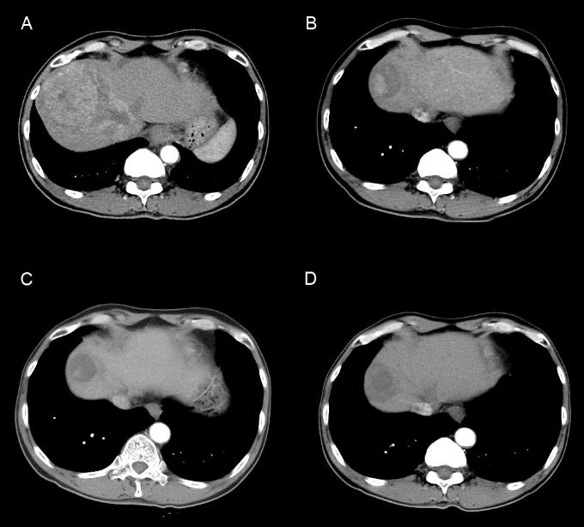

Figure 2 Liver biopsy revealed hepatocellular carcinoma with Edmonson-Steiner’s grade III showing psedoglandular or trabecular pattern. A: HE, × 100; B: HE, × 200.
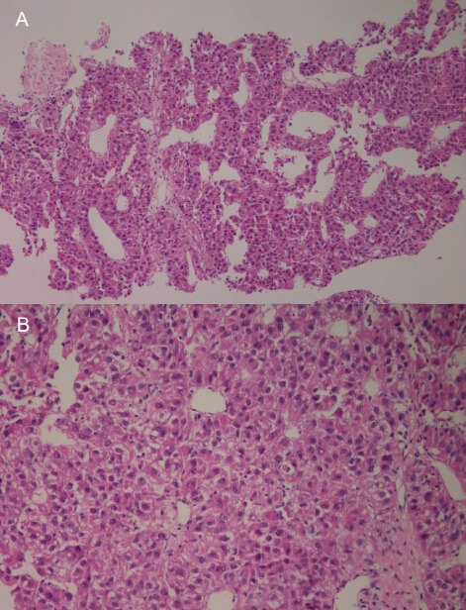

Figure 3 Clinical course and serial changes of patient’s serum level of alpha-fetoprotein, protein induced by vitamin K absence or antagonist-II andtumor size accessed by respose evaluation criteria in solid tumors 1.1 and mRespose evaluation criteria in solid tumors 1.1. AFP: Alpha-fetoprotein; PIVKA-II: Protein induced by vitamin K absence or antagonist-II; RECIST: Respose evaluation criteria in solid tumors.
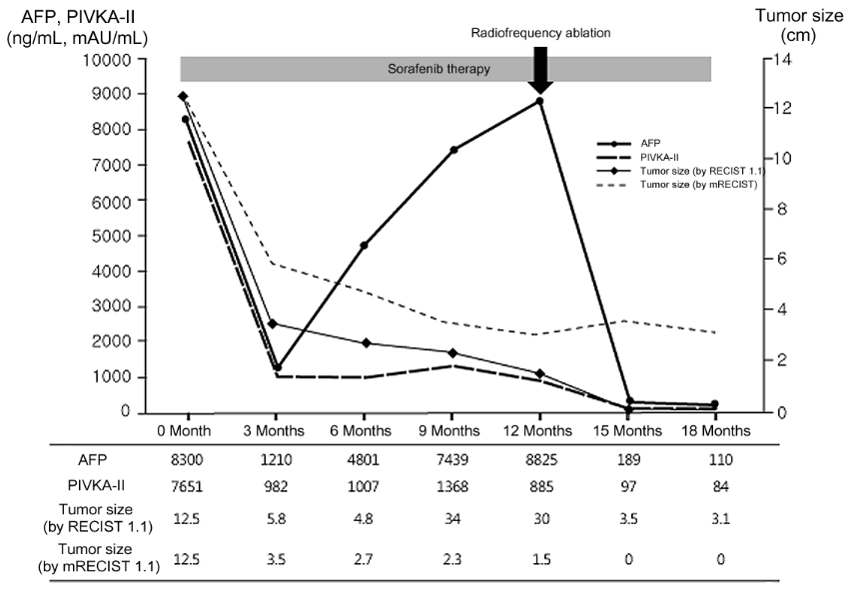

Figure 4 After confirming viable tumor by contrast enhanced ultrasound, radiofrequency ablation was performed. A: Contrast enhanced ultrasound revealed two arterial enhancing nodules in tumor; B: Percutaneous ultrasound guided radiofrequency ablation was performed for residual viable tumor by inducing artificial ascites.
