Name of Journal: World Journal of Gastrointestinal Oncology
Manuscript NO: 69092
Manuscript Type: ORIGINAL ARTICLE

Basic Study
Lnc524369 promotes hepatocellular carcinoma progression and predicts poor survival by activating YWHAZ-RAF1 signaling

Zheng et al. Lnc524369/YWHAZ/RAF1 in HCC progression and survival

Wei Zheng, Guo-Liang Shen, Ke-Yang Xu, Qiao-Qiao Yin, Tian-Chen Hui, Zhe-Wen Zhou, Cheng-An Xu, Shou-Hao Wang, Wen-Hao Wu, Ling-Fei Shi, Hong-Ying Pan

Wei Zheng, Department of Clinical Medicine, Medical College of Soochow University, Suzhou 215006, Jiangsu Province, China

Wei Zheng, Qiao-Qiao Yin, Hong-Ying Pan, Department of Infectious Diseases, Zhejiang Provincial People’s Hospital, People’s Hospital of Hangzhou Medical College, Hangzhou 310014, Zhejiang Province, China

Guo-Liang Shen, Department of Hepatobiliary & Pancreatic Surgery and Minimally Invasive Surgery, Zhejiang Provincial People’s Hospital, People’s Hospital of Hangzhou Medical College, Hangzhou 310014, Zhejiang Province, China

Ke-Yang Xu, School of Chinese Medicine, Hongkong Baptist university, Hong Kong 999777, China

Tian-Chen Hui, Zhe-Wen Zhou, Department of Graduate School, Bengbu Medical College, Bengbu 233030, Anhui Province, China

Cheng-An Xu, Second Clinical Medical College, Zhejiang Chinese Medical University, Hangzhou 310053, Zhejiang Province, China

Shou-Hao Wang, Wen-Hao Wu, Medical Department of Qingdao University, Qingdao University, Qingdao 266071, Shandong, China

Ling-Fei Shi, Diagnosis and Treatment Center of Osteoporosis, Zhejiang Provincial People’s Hospital, People’s Hospital of Hangzhou Medical College, Hang Zhou 310014, Zhejiang Province, China

Author contributions: Zheng W designed the report and wrote the paper; Hui TC, Yin QQ, Zhou ZW, Xu CA, and Shi LF performed the majority of experiments and analyzed the data; Wu WH and Wang SH performed the molecular investigations; Shen GL designed and coordinated the research; Xu KY and Pan HY revised the paper.

Supported by the Medical and Health Science and Technology Project of Zhejiang Province (No. 2021KY043) and Chinese Foundation for Hepatitis Prevention and Control-TianQing Liver Disease Research Fund Subject (No. TQGB2020168).

Corresponding author: Hong-Ying Pan, MD, Chief Doctor, Department of Infectious Diseases, Zhejiang Provincial People’s Hospital, People’s Hospital of Hangzhou Medical College, No. 158 Shangtang Road, Hangzhou 310014, Zhejiang Province, China. hypanhz@139.com

Received: June 22, 2021
Revised: July 28, 2021
Accepted: September 16, 2021
Published online:

Abstract
BACKGROUND
Liver cancer is one of the most highly malignant cancers, characterized by easy metastasis and chemoradiotherapy resistance. Emerging evidence indicates that long noncoding RNAs (LncRNAs), including Lnc524369, are highly involved in the initiation, progression, radioresistance, and chemoresistance of hepatocellular carcinoma (HCC). However, the function of Lnc524369 remains unclear.

AIM
To explore the function of Lnc524369 in HCC.

METHODS
To investigate the effect of Lnc524369, tissue from 41 HCC patients were analyzed using CCK8, migration, and invasion assays. Lnc524369 and YWHAZ (also named 14-3-3ζ) mRNA were detected by qPCR, and YWHAZ and RAF1 proteins were detected by western blot in liver cancer cell lines and human HCC tissues. The Cancer Cell Line Encyclopedia (CCLE) databases, STRING database, Human Protein Atlas database, and the TCGA database were used for bioinformatic analysis.

RESULTS
Lnc524369 was significantly upregulated in the nucleus of liver cancer cells and human HCC tissues. Overexpression of Lnc524369 was associated with the proliferation, migration, and invasion of liver cancer cells. YWHAZ and RAF1 proteins and YWHAZ mRNA were overexpressed in liver cancer, which could be attenuated by overexpression of Lnc524369. Lnc524369 and its downstream target YWHAZ and RAF1 proteins were negatively associated with overall survival time.

CONCLUSION
Lnc524369 might be a promising target of HCC as it can enhance liver cancer progression and decrease the overall survival time of HCC by activating the YWHAZ/RAF1 pathway.

Key Words: Long noncoding RNAs; Lnc524369; Hepatocellular carcinoma; YWHAZ; RAF1

Zheng W, Shen GL, Xu KY, Yin QQ, Hui TC, Zhou ZW, Xu CA, Wang SH, Wu WH, Shi LF, Pan HY. Lnc524369 promotes hepatocellular carcinoma progression and predicts poor survival by activating YWHAZ-RAF1 signaling. World J Gastroenterol Oncol 2021; In press

Core Tip: Lnc524369 is expressed at low levels in the cytoplasm but enriched in the nucleus of hepatocellular carcinoma (HCC) cells and might be strongly coexpressed with YWHAZ. Overexpression of Lnc524369 promoted the proliferation, migration, and invasion of liver cancer cells. The Lnc524369-mediated YWHAZ/RAF1 pathway was negatively associated with the overall survival time of HCC patients.
INTRODUCTION
Hepatocellular carcinoma (HCC) is the most common pathological type of primary liver cancer^{[1]}. Among all cancers, the incidence and mortality rates of HCC rank sixth and second in the world, respectively^{[2]}. Common risk factors leading to HCC are hepatitis B virus (HBV), hepatitis C virus (HCV), alcoholism, obesity, environmental toxins, and metabolic diseases^{[3]}. At present, approximately 93 million hepatitis B carriers are at least partially responsible for the high incidences of liver fibrosis, cirrhosis, and HCC in China^{[4]}. Due to HCC’s high malignancy and insensitivity to chemoradiotherapy, the potential mechanisms of HCC need to be further clarified.
Long noncoding RNAs (lncRNAs) are a class of RNA transcripts with a length of more than 200 nucleotides that lack protein coding potential^{[5]}. Increasing evidence shows that lncRNAs can regulate many important pathophysiological processes, especially in the occurrence and development of malignant tumors^{[6]}. For example, lncRNAs such as HOTAIR, HULC, and MALAT-1, are closely related to the proliferation, apoptosis, angiogenesis, invasion, metastasis, and prognosis of HCC^{[6]}. Therefore, lncRNAs have therapeutic potential and diagnostic value in HCC. A previous study had suggested that Lnc524369 (ap003469.2) is expressed at low levels in the cytoplasm but enriched in the nucleus of HCC and might be strongly coexpressed with 14-3-3 protein zeta/delta (YWHAZ) using a fractionation-then-sequencing approach^{[7]}. YWHAZ is clearly upregulated in HCC, promotes cell proliferation and metastasis, and its expression is a predictor of poor survival^{[8-11]}. Analysis of the protein-to-protein interaction network indicated that YWHAZ is strongly coexpressed with RAF1 (Figure 3E). Furthermore, analysis of the Cancer Cell Line Encyclopedia (CCLE) revealed that overexpression of the YWHAZ and RAF1 proteins occurs frequently in liver cancer cell lines (Figure 1G and 1H). In this study, we aimed to determine the function of Lnc524369 in the development of HCC.

MATERIALS AND METHODS
The human liver cancer cell lines Huh7 and HepG2, as well as 41 human HCC samples from Zhejiang Provincial People's Hospital, were used to determine Lnc524369 expression levels. However, due to limited human HCC sample tissue, only 5 of 41 HCC samples (as well as the liver cell lines) were used to examine YWHAZ and RAF1 protein or mRNA levels. The whole study was approved by the Ethics Committee of Zhejiang Provincial People's Hospital.

Bioinformatic analysis
We analyzed the protein expression of YWHAZ and RAF1 in liver cancer cell lines by using data obtained from the CCLE (http://www.broadinstitute.org/ccle). In addition, we conducted survival analysis of YWHAZ and RAF1 by using the Human Protein Atlas database (http://www.proteinatlas.org/) and the Cancer Genome Atlas (TCGA) database (https://www.cancer.gov/about-nci/organization/ccg/research/structural-genomics/tcga).

RNA isolation (cytoplasmic and nuclear)
RNA was isolated from 1 10⁶ Huh7 cells or 15 mg human HCC tissue using a cytoplasmic and nuclear RNA purification kit from Norgen Biotek Corp. (Ontario, Canada). Cells or tissues washed with phosphate-buffered saline (PBS) were lysed with ice-cold lysis solution, and then the lysate was transferred to a microcentrifuge tube and spun at maximum speed for three minutes. The supernatant contained cytoplasmic RNA, while the pellet contained nuclear RNA. Binding solution was then added to the supernatant and pellet separately, and each fraction was mixed and resuspended well. The RNA samples were then bound to separate spin columns using centrifugation. Next, the columns were washed twice with 400 μL of the provided wash solution, and the fractionated RNA was eluted from the columns using 50 μL of the provided elution buffer.

Real-time PCR
Real-time PCR was performed to determine Lnc524369 expression in HepG2 and Huh7 cell lines, as well as human HCC and paracancerous tissue. Cells treated with the pcDNA3 control plasmid and the Lnc524369-pcdna3.1 overexpression plasmid, as well as human HCC and paracancerous tissue, were collected for analysis. A cytoplasmic and nuclear RNA purification kit (NGB21000; Norgen Biotek Corp.) was used to extract RNA from cells and tissues. Total RNA was extracted by TRIzol reagent, and cDNA was synthesized according to the instructions of the Quantitect reverse transcription kit (Qiagen, Hilden, German). Using GAPDH as an internal reference, real-time PCR was performed with a Powerup SYBRTM Green master mix kit (Thermo Fisher Scientific, Waltham, MA, United States). The specific primer sequences are shown in Table 1. Each experiment was repeated three times, and three complex holes were set in each sample. The relative expression was calculated by the 2^{-∆∆Ct} method.

Western blot
Western blotting was performed to determine YWHAZ and RAF1 expression in the Huh7 cell line, as well as human HCC and paracancerous tissue. Anti-rabbit YWHAZ (1:2000; Proteintech, Rosemont, IL, United States), anti-mouse RAF1 (1:1000; Proteintech), and anti-rabbit GAPDH (internal reference, 1:10000; Abcam, Cambridge, United Kingdom) were added to the cell or tissue samples and incubated overnight at 4 °C. Goat anti-rabbit IgG HRP secondary antibody (1:5000; Thermo Fisher Scientific) was added to the membrane for film exposure. After the film was exposed in a dark room, the optical density of the strips was analyzed by Image-Pro Plus 6.0 software, and the results were analyzed with GAPDH as an internal reference. Each experiment was repeated 3 times, and the results are expressed as the mean ± standard deviation (SD).

Culture of human liver cancer cell lines Huh7 and HepG2
The human liver cell lines Huh7 and HepG2 were purchased from the Shanghai Cell Bank of the Chinese Academy of Sciences. They were resuspended in DMEM high glucose (containing 10% FBS and double antibodies). The cells were cultured at 37 °C and 5% CO₂ until the confluence was approximately 90%.

Construction of the Lnc524369-pcdna3.1 overexpression vector
According to the sequence of the Lnc524369 gene, the whole gene was synthesized by Shenggong Bioengineering (Shanghai) Co., Ltd. (Shanghai, China) with the addition of BamHI and EcoRI restriction sites the ends of the gene. The synthetic products of the Lnc524369 and pcDNA3.1 plasmids (Invitrogen, Waltham, MA, United States) were digested, purified, and linked with BamHI and EcoRI, respectively, and then transformed into E. coli DH5α competent cells and cultured overnight at 37 °C. The recombinant plasmid Lnc524369-pcDNA3.1 was extracted and sequenced. After identification, an endofree plasma maxi kit (Qiagen) was used to extract the Lnc524369-pcDNA3.1 overexpression plasmid and pcDNA3.1 control plasmid for subsequent transfection experiments.

Transfection of Lnc524369-pcdna3.1 overexpression vector
Huh7 cells were inoculated into 6 well plates at a density of 5 10⁵ cells/mL and incubated overnight in a 5% CO₂ incubator at 37 °C. When the confluence of the Huh7 cells reached 70%-80%, the Lnc524369-pcDNA3.1 overexpression plasmid and pcDNA3.1 control plasmid were transfected according to the instructions of Lipofectamine 3000 (Thermo Fisher Scientific). After 8 h, the media was replaced with fresh complete culture medium. After 48 h, the total RNA was extracted for subsequent qPCR analysis and the protein was extracted for subsequent western blot detection.

CCK8 assay for cell proliferation
Huh7 cells transfected for 24 h with the pcDNA3.1 control plasmid and the Lnc524369-pcDNA3.1 overexpression plasmid were digested and collected, and the cell density was adjusted. According to the cell density of 2 × 10³/100 μL in each well, the cells were recorded as 0 h after adherence. After 0 h, 24 h, 48 h and 72 h, 10 μL CCK8 was added to each well and incubated at 37 °C and 5% CO₂ for 2 h. Next, the absorbance value at 450 nm was detected using an enzyme-labeled measurement instrument.

Migration transwell assay
After counting, the density of Huh7 cells was 2 10⁵/mL, and 200 μL transwell cell suspension in serum free mediums was added to each transwell chamber (8.0 μm), and 600 μL containing 15% FBS medium was added to the incubator, incubated 48 h in the 5% CO₂ incubator at 37 °C. The cells were then fixed with 4% paraformaldehyde for 30 min, and stained with 0.1% crystal violet for 30 min. After washing with PBS, an inverted microscope was used to take pictures and count the cells. Each group was provided with 3 multiple holes. Five visual fields were randomly selected from each well, and the average number of migrating cells was counted.

Invasion transwell assay
The 24 well Matrigel invasion chamber was taken out and allowed to recover to room temperature. Then, 500 μL serum-free medium was added and incubated at 37 °C for 2 h. The basement membrane was hydrated and the excess liquid was absorbed for standby. The cells were resuspended in serum-free medium for 24 h, and the cell concentration was adjusted to 2 10⁵/mL. Two hundred microliters of cell suspension was added to the upper chamber, and 600 μL of cell culture medium containing 15% FBS was added to the lower chamber. After 48 h incubation in a 5% CO₂ incubator at 37 °C, the cells were fixed with 4% paraformaldehyde for 30 min and stained with 0.1% crystal violet for 30 min. After washing with PBS, an inverted microscope was used for counting the cells. Each group included 3 wells, and 5 visual fields were randomly selected under 200 magnification for each well, and the average number of invasive cells was counted.

Statistical analysis
SPSS 19.0 software (IBM Corp., Armonk, NY, United States) was used for statistical analysis. The results were expressed as the mean ± SD. Independent sample t tests or paired sample t tests were used for mean comparisons between the two groups, and one-way ANOVA was used for multigroup mean comparisons. The Spearman method was used for correlation analysis. Kaplan–Meier method was used for survival analysis. When P < 0.05 (*), the difference was significant; when P < 0.01 (**), the difference was very significant; and when P < 0.001 (***), the difference was extremely significant.

RESULTS
The transcriptional level of Lnc524369 level in HepG2 and Huh7 cells
The Lnc524369 level was relatively higher in Huh7 cells than in HepG2 cells and L02 cells (Figure 1A) and enriched in the nucleus of Huh7 cells (Figure 1B). Considering the weaker invasion and lower Lnc524369 level of HepG2, Huh7 cells were used to investigate overexpression of Lnc524369.

Lnc524369 upregulated the YWHAZ and RAF1 expression in Huh7 cells
Real-time PCR results showed that compared with the blank and pcDNA3.1 transfection groups, lnc52436-pcDNA3.1 was upregulated 443-fold in Huh7 cells, as shown in Figure 1C (P < 0.01). Compared with the blank and pcDNA3.1 transfection groups, the YWHAZ protein and mRNA levels, as well as the RAF1 protein levels in the Lnc52436-pcDNA3.1 transfection group were significantly increased, as shown in Figures 1D-F and 2B (P < 0.01).

Lnc524369 promoted the liver cancer cell proliferation, migration, and invasion
The CCK-8 assay was used to detect the viability of Huh7 cells after overexpression of Lnc524369. Compared with the blank and pcDNA3.1 groups, the viability of Huh7 cells increased significantly from 48 h (Figure 3A, P < 0.01). This result indicated that the proliferation of liver cancer cells was enhanced by overexpression of Lnc524369. Transwell assay results showed that compared with the blank and pcDNA3.1 transfection groups, the number of migrated Lnc52436-pcDNA3.1 cells was significantly increased, as shown in Figure 3B and 3D (P < 0.01). This result indicated that the migration of liver cancer cells could be enhanced by overexpression of Lnc524369. Transwell assay results showed that compared with the blank and pcDNA3.1 transfection groups, the number of cells passing through the basement membrane in the Lnc52436-pcDNA3.1 transfection group was significantly increased (Figure 3C and 3D) (P < 0.01). This result indicated that the invasion of liver cancer cells could be enhanced by overexpression of Lnc524369.

Lnc524369 was overexpressed in human HCC samples and predicted poor prognosis
Forty-one confirmed HCC patients were included in this study according to the HCC guidelines^{[12]}, and their baseline characteristics are shown in Table 2. Human HCC and para-HCC tissues were acquired by surgical resection, which was further confirmed by two histopathological doctors. The relative nuclear Lnc524369 expression level was significantly higher in HCC tissues than in para-HCC tissues (P < 0.001) (Figure 2A). There was a positive correlation between Lnc524369 and the pathological grade of HCC (correlation coefficient RS: 0.604, P < 0.001) (Figure 4D). The survival rate of patients with high expression of Lnc524369 was significantly lower than that of patients with low expression (P = 0.013) (Figure 4G).

YWHAZ and RAF1 levels in human HCC samples and survival analysis of the TCGA database
YWHAZ mRNA and protein levels were determined in our five included HCC samples by real-time PCR and western blot. Our results showed that the YWHAZ mRNA level and protein were significantly higher in HCC tissues than in para-HCC tissues (P < 0.05) (Figures 2C, 4E and 4J); RAF1 protein was also significantly higher in HCC tissues than in para-HCC tissues (P < 0.05) (Figure 4F and 4J). In addition, the YWHAZ mRNA data of 235 live and 130 deceased HCC patients (264 male; 119 female) in the TCGA database were included for survival analysis. The survival probability of patients with high YWHAZ and RAF1 mRNA expression was significantly decreased compared with those patients with low YWHAZ expression (P < 0.001) (Figure 4H and 4K).

DISCUSSION
Recently, lncRNAs have emerged as critical molecules in multiple biological processes involved in virus infection, metabolic diseases, vascular diseases, stem cell biology, fibrosis, and cancer^{[13-16]}. Currently, the roles of lncRNAs have been widely reported in the progression of HCC and liver cancer stem cells^{[17]}. A large number of lncRNAs localize in the nucleus and are highly involved in several cellular components, biological processes, and molecular functions, such as chromatin organization, structural scaffolds of nuclear domains, and transcriptional and posttranscriptional gene expression^{[18]}. Previous fractionation-then-sequencing data from human HCC tissues have shown that Lnc524369 is enriched in the nucleus of liver cancer but not the cytoplasm^{[7]}. In our study, we also confirmed that Lnc524369 expression was enriched in the nucleus of Huh 7 cells.
Furthermore, we illustrated that the expression of nuclear Lnc524369 was significantly increased in human HCC tissues compared to HCC adjacent tissues (P < 0.01). Additionally, we found that the overexpression of Lnc524369 could clearly promote the proliferation, migration, and invasion of liver cancer cells and simultaneously enhance YWHAZ and RAF1 expression. This result suggested that Lnc524369 might positively correlate with the expression of YWHAZ and RAF1 in the development of HCC. Lnc524369 was significantly correlated with a poor survival rate of HCC patients.
YWHAZ has been shown to be commonly upregulated in multiple cancers, especially HCC, as it can promote tumorigenesis, metastasis, and chemoresistance in the progression of cancer^{[19-21]}. Our bioinformatic analysis showed that RAF1 was strongly coexpressed with YWHAZ (Figure 3E). RAF1 is also highly involved in the development of HCC^{[22]}. Again, our analysis of the CCLE databases revealed that YWHAZ and RAF1 were frequently expressed in liver cancer cell lines. Our study indicated that YWHAZ transcriptional and posttranscriptional levels were both overexpressed in HCC tissues compared to HCC adjacent tissues (P < 0.01). In addition, we found that YWHAZ and RAF1 mRNA levels were negatively related to overall survival time in the TCGA database. Previous studies have suggested that multiple noncoding RNAs, such as miR-451a, miR-22, and the long noncoding RNA MIR4435-2HG, are involved in HCC proliferation, invasion, and metastasis by targeting YWHAZ^{[8,9,11]}. These results indicate that the overexpression of YWHAZ plays a critical role in the initiation and progression of HCC; therefore, the YWHAZ/RAF1 protein might have significant clinical potential for targeted therapy and early diagnosis.
There are some limitations in this study that will be improved in further studies. First, the expression of Lnc524369, YWHAZ, and RAF1 should be further knocked down for malignant function confirmation; second, the effect of Lnc524369 and YWHAZ in rodent models should be further studied; third, the included number of HCC patients for this study should be further enlarged. In summary, Lnc524369 and its downstream targets YWHAZ and RAF1 play a crucial role in the development of HCC and are negatively associated with the overall survival times of HCC patients, which provides new insight into the early diagnosis and targeted treatment of HCC (Figure 5).

CONCLUSION
Because Lnc524369 can enhance liver cancer progression and decrease the overall survival time of HCC by activating the YWHAZ/RAF1 pathway, might be a promising target of HCC.

ARTICLE HIGHLIGHTS
Research background
Long noncoding RNAs, including Lnc524369, have the potential to regulate unknown cellular and molecular mechanisms in the initiation, progression, diagnosis, and prognosis of hepatocellular carcinoma (HCC). However, a critical gap in our knowledge is understanding how nucleus-enriched Lnc524369 promotes liver cancer growth.

Research motivation
To discover specific targets for the diagnosis and treatment of HCC.

Research objectives
To investigate the underlying mechanisms of Lnc524369 in HCC.

Research methods
The expression of Lnc524369, YWHAZ, and RAF1 was determined by qPCR or western blot. CCK-8, migration, and invasion assays were used to investigate Lnc524369 function. Forty-one HCC patients, the Cancer Cell Line Encyclopedia databases, STRING database, Human Protein Atlas database and the TCGA database were used for survival analysis.

Research results
Lnc524369 was significantly upregulated in the nucleus of HCC, which promoted the proliferation, migration, and invasion of liver cancer cells by upregulating YWHAZ and RAF1 expression. Lnc524369 and its downstream target YWHAZ/RAF1 protein could predict the poor overall survival time of HCC patients.

Research conclusions
The Lnc524369-mediated YWHAZ/RAF1 pathway is highly involved in the progression and prognosis of HCC.

Research perspectives
In the future, we will reveal the critical role of Lnc524369, which might enhance the early diagnosis of HCC and facilitate the further development of targeted therapy.

REFERENCES
1 Massarweh NN, El-Serag HB. Epidemiology of Hepatocellular Carcinoma and Intrahepatic Cholangiocarcinoma. Cancer Control 2017; 24: 1073274817729245 [PMID: 28975830 DOI: 10.1177/1073274817729245]
2 Bray F, Ferlay J, Soerjomataram I, Siegel RL, Torre LA, Jemal A. Global cancer statistics 2018: GLOBOCAN estimates of incidence and mortality worldwide for 36 cancers in 185 countries. CA Cancer J Clin 2018; 68: 394-424 [PMID: 30207593 DOI: 10.3322/caac.21492]
3 Fujiwara N, Friedman SL, Goossens N, Hoshida Y. Risk factors and prevention of hepatocellular carcinoma in the era of precision medicine. J Hepatol 2018; 68: 526-549 [PMID: 28989095 DOI: 10.1016/j.jhep.2017.09.016]
4 Trépo C, Chan HL, Lok A. Hepatitis B virus infection. Lancet 2014; 384: 2053-2063 [PMID: 24954675 DOI: 10.1016/S0140-6736(14)60220-8]
5 Quinn JJ, Chang HY. Unique features of long non-coding RNA biogenesis and function. Nat Rev Genet 2016; 17: 47-62 [PMID: 26666209 DOI: 10.1038/nrg.2015.10]
6 Cai Z, Xu K, Li Y, Lv Y, Bao J, Qiao L. Long noncoding RNA in liver cancer stem cells. Discov Med 2017; 24: 87-93 [PMID: 28972877]
7 Chow EY, Zhang J, Qin H, Chan TF. Characterization of Hepatocellular Carcinoma Cell Lines Using a Fractionation-Then-Sequencing Approach Reveals Nuclear-Enriched HCC-Associated lncRNAs. Front Genet 2019; 10: 1081 [PMID: 31781161 DOI: 10.3389/fgene.2019.01081]
8 Wei GY, Hu M, Zhao L, Guo WS. MiR-451a suppresses cell proliferation, metastasis and EMT via targeting YWHAZ in hepatocellular carcinoma. Eur Rev Med Pharmacol Sci 2019; 23: 5158-5167 [PMID: 31298411 DOI: 10.26355/eurrev_201906_18180]
9 Chen M, Hu W, Xiong CL, Qu Z, Yin CQ, Wang YH, Luo CL, Guan Q, Yuan CH, Wang FB. miR-22 targets YWHAZ to inhibit metastasis of hepatocellular carcinoma and its down-regulation predicts a poor survival. Oncotarget 2016; 7: 80751-80764 [PMID: 27811373 DOI: 10.18632/oncotarget.13037]
10 Zhao JF, Zhao Q, Hu H, Liao JZ, Lin JS, Xia C, Chang Y, Liu J, Guo AY, He XX. The ASH1-miR-375-YWHAZ Signaling Axis Regulates Tumor Properties in Hepatocellular Carcinoma. Mol Ther Nucleic Acids 2018; 11: 538-553 [PMID: 29858089 DOI: 10.1016/j.omtn.2018.04.007]
11 Shen X, Ding Y, Lu F, Yuan H, Luan W. Long noncoding RNA MIR4435-2HG promotes hepatocellular carcinoma proliferation and metastasis through the miR-22-3p/YWHAZ axis. Am J Transl Res 2020; 12: 6381-6394 [PMID: 33194037]
12 Zhou J, Sun HC, Wang Z, Cong WM, Wang JH, Zeng MS, Yang JM, Bie P, Liu LX, Wen TF, Han GH, Wang MQ, Liu RB, Lu LG, Ren ZG, Chen MS, Zeng ZC, Liang P, Liang CH, Chen M, Yan FH, Wang WP, Ji Y, Cheng WW, Dai CL, Jia WD, Li YM, Li YX, Liang J, Liu TS, Lv GY, Mao YL, Ren WX, Shi HC, Wang WT, Wang XY, Xing BC, Xu JM, Yang JY, Yang YF, Ye SL, Yin ZY, Zhang BH, Zhang SJ, Zhou WP, Zhu JY, Liu R, Shi YH, Xiao YS, Dai Z, Teng GJ, Cai JQ, Wang WL, Dong JH, Li Q, Shen F, Qin SK, Fan J. Guidelines for Diagnosis and Treatment of Primary Liver Cancer in China (2017 Edition). Liver Cancer 2018; 7: 235-260 [PMID: 30319983 DOI: 10.1159/000488035]
13 Liu Y, Feng J, Sun M, Yang G, Yuan H, Wang Y, Bu Y, Zhao M, Zhang S, Zhang X. Long non-coding RNA HULC activates HBV by modulating HBx/STAT3/miR-539/APOBEC3B signaling in HBV-related hepatocellular carcinoma. Cancer Lett 2019; 454: 158-170 [PMID: 30981758 DOI: 10.1016/j.canlet.2019.04.008]
14 Li Y, Xu K, Xu K, Chen S, Cao Y, Zhan H. Roles of Identified Long Noncoding RNA in Diabetic Nephropathy. J Diabetes Res 2019; 2019: 5383010 [PMID: 30891461 DOI: 10.1155/2019/5383010]
15 Chen S, Sun X, Wu S, Jiang J, Zhu C, Xu K, Xu K. Role of identified noncoding RNA in erectile dysfunction. Andrologia 2020; 52: e13596 [PMID: 32441367 DOI: 10.1111/and.13596]
16 Prabhakar B, Lee S, Bochanis A, He W, Manautou JE, Rasmussen TP. lnc-RHL, a novel long non-coding RNA required for the differentiation of hepatocytes from human bipotent progenitor cells. Cell Prolif 2021; 54: e12978 [PMID: 33393114 DOI: 10.1111/cpr.12978]
17 Lv H, Lv G, Han Q, Yang W, Wang H. Noncoding RNAs in liver cancer stem cells: The big impact of little things. Cancer Lett 2018; 418: 51-63 [PMID: 29307614 DOI: 10.1016/j.canlet.2018.01.001]
18 Sun Q, Hao Q, Prasanth KV. Nuclear Long Noncoding RNAs: Key Regulators of Gene Expression. Trends Genet 2018; 34: 142-157 [PMID: 29249332 DOI: 10.1016/j.tig.2017.11.005]
19 Liu Y, Guo J, Shen K, Wang R, Chen C, Liao Z, Zhou J. Paclitaxel Suppresses Hepatocellular Carcinoma Tumorigenesis Through Regulating Circ-BIRC6/miR-877-5p/YWHAZ Axis. Onco Targets Ther 2020; 13: 9377-9388 [PMID: 33061425 DOI: 10.2147/OTT.S261700]
20 Zhao J, Fu X, Chen H, Min L, Sun J, Yin J, Guo J, Li H, Tang Z, Ruan Y, Wang X, Sun Y, Huang L. G3BP1 interacts with YWHAZ to regulate chemoresistance and predict adjuvant chemotherapy benefit in gastric cancer. Br J Cancer 2021; 124: 425-436 [PMID: 32989225 DOI: 10.1038/s41416-020-01067-1]
21 Hui C, Tian L, He X. Circular RNA circNHSL1 Contributes to Gastric Cancer Progression Through the miR-149-5p/YWHAZ Axis. Cancer Manag Res 2020; 12: 7117-7130 [PMID: 32848466 DOI: 10.2147/CMAR.S253152]
22 Ghousein A, Mosca N, Cartier F, Charpentier J, Dupuy JW, Raymond AA, Bioulac-Sage P, Grosset CF. miR-4510 blocks hepatocellular carcinoma development through RAF1 targeting and RAS/RAF/MEK/ERK signalling inactivation. Liver Int 2020; 40: 240-251 [PMID: 31612616 DOI: 10.1111/liv.14276]

Footnotes
Institutional review board statement: This study was reviewed and approved by the Zhejiang Provincial People’s Hospital Ethics Committee.

Informed consent statement: All patients in our study provided informed consent.

Conflict-of-interest statement: The authors declare no conflict of interest.

Data sharing statement: No additional data are available.

ARRIVE guidelines statement: The authors have read the ARRIVE guidelines, and the manuscript was prepared and revised according to the ARRIVE guidelines.

Open-Access: This article is an open-access article that was selected by an in-house editor and fully peer-reviewed by external reviewers. It is distributed in accordance with the Creative Commons Attribution NonCommercial (CC BY-NC 4.0) license, which permits others to distribute, remix, adapt, build upon this work non-commercially, and license their derivative works on different terms, provided the original work is properly cited and the use is non-commercial. See: http://creativecommons.org/Licenses/by-nc/4.0/

Manuscript source: Unsolicited manuscript

Peer-review started: June 22, 2021
First decision: July 4, 2021
Article in press:

Specialty type: Oncology
Country/Territory of origin: China
Peer-review report’s scientific quality classification
Grade A (Excellent): 0
Grade B (Very good): 0
Grade C (Good): C
Grade D (Fair): 0
Grade E (Poor): 0

P-Reviewer: Youness RA S-Editor: Wang JJ L-Editor: Filipodia P-Editor:

Figure Legends
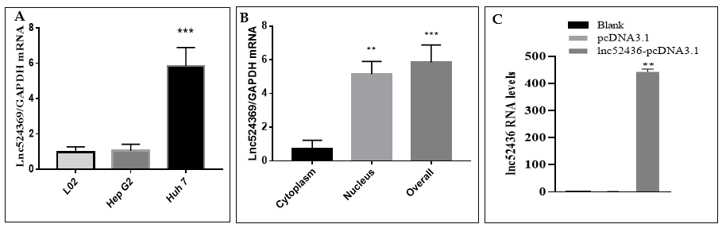
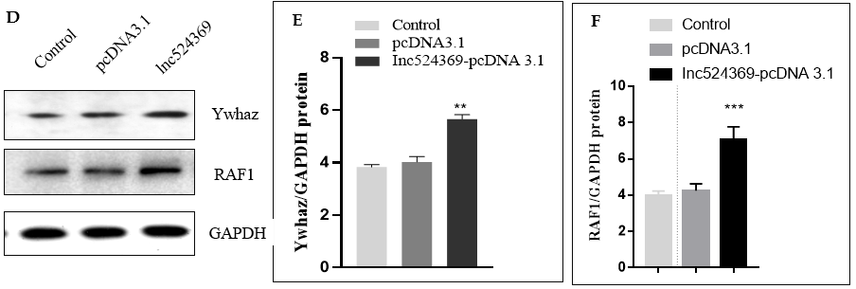
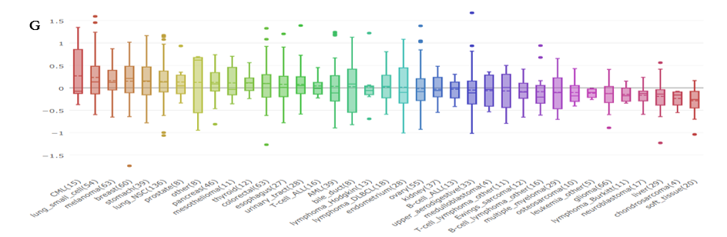
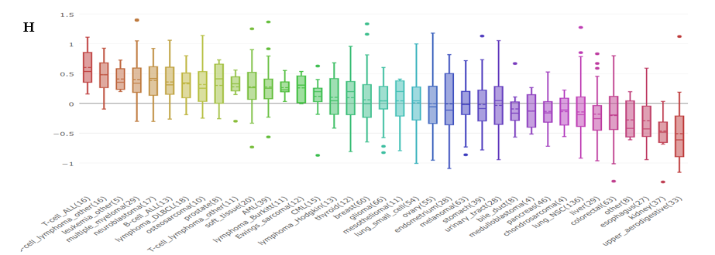
Figure 1 Expression of Lnc524369/YWHAZ/RAF1 in vitro. A: Expression of Lnc524369 in human cancer cell lines (HepG2 and Huh 7) and normal liver cells (L02); B: Expression of Lnc524369 in the cytoplasm and nucleus of Huh 7 cells; C: Knock-in of Lnc524369 in Huh 7 cells; D: Western blot bands of YWHAZ and RAF1 protein; E: YWHAZ expression was increased by overexpression of Lnc524369; F: RAF1 expression was increased by overexpression of Lnc524369; G: YWHAZ protein was expressed in liver cancer cell lines from the Cancer Cell Line Encyclopedia (CCLE) database; H: RAF1 protein was expressed in liver cancer cell lines from the CCLE database.
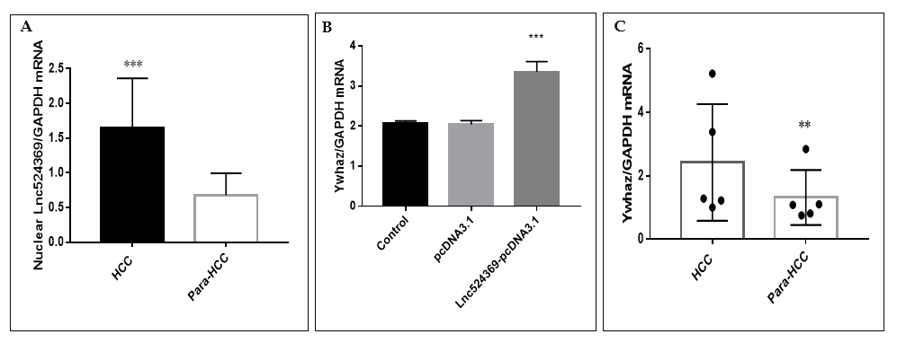
Figure 2 The expression of Lnc542369 and YWHAZ mRNA in vitro and in hepatocellular carcinoma patients. A: Nuclear Lnc542369 was significantly upregulated in hepatocellular carcinoma (HCC) tissues compared with para-HCC tissues; B: YWHAZ mRNA was significantly upregulated by overexpression of Lnc542369; C: YWHAZ mRNA was significantly upregulated in HCC tissues compared with para-HCC tissues.
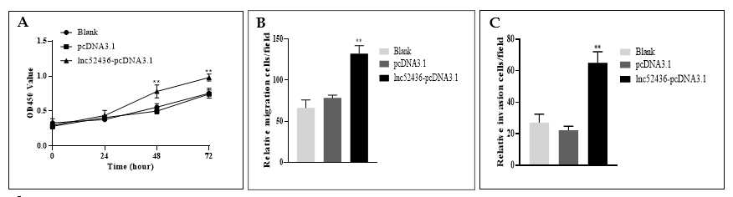
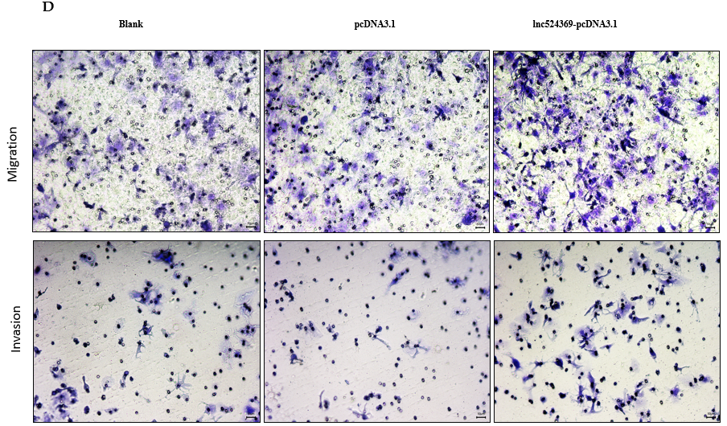
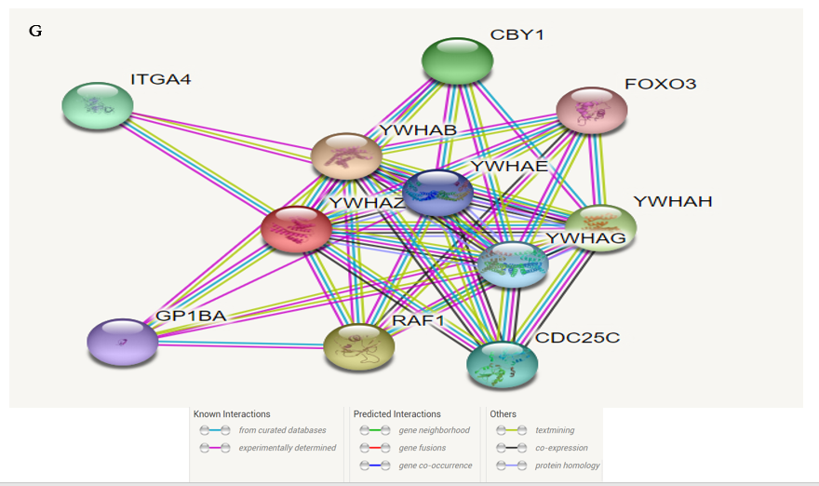
Figure 3 Overexpression of Lnc524369 in vitro and the protein-protein-interaction network of YWHAZ. A: Overexpression of Lnc524369 promoted the proliferation of Huh7 cells; B: Overexpression of Lnc524369 promoted the migration of Huh7 cells; C: Overexpression of Lnc524369 promoted the invasion of Huh7 cells; D: Images of migration and invasion; E: The protein-protein-interaction network of YWHAZ-RAF1 in the STRING database.
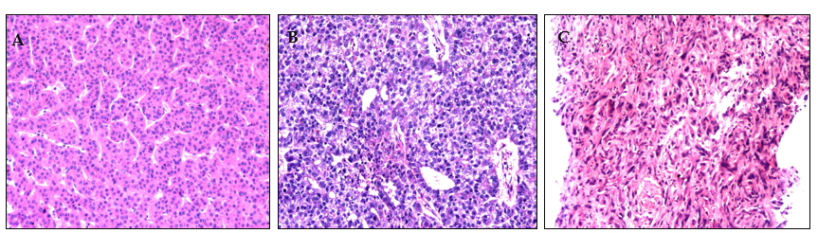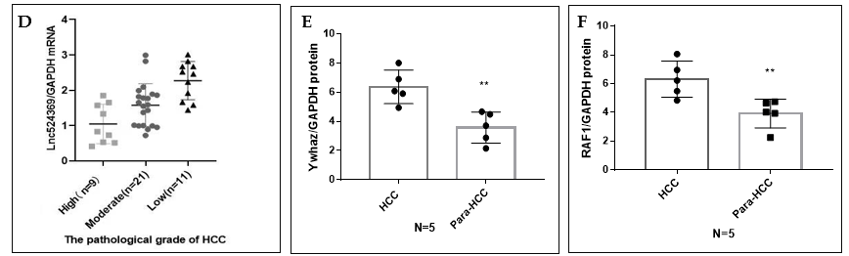
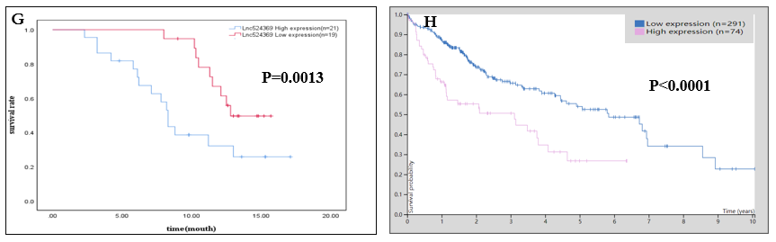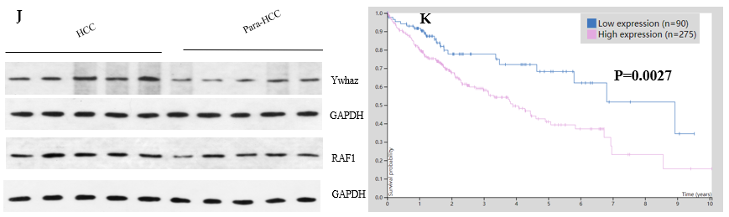
Figure 4 The expression of Lnc524369/YWHAZ/RAF1 protein in hepatocellular carcinoma patients and its survival analysis. A: High differentiation of human hepatocellular carcinoma (HCC) pathology; B: Moderate differentiation of human HCC pathology; C: Low differentiation of human HCC pathology; D: Lnc524369 relative level was positively corelated with pathological grade of HCC (RS: 0.604, P < 0.01); E: YWHAZ protein level was higher in HCC tissue than para-HCC tissue (P < 0.01); F: RAF1 protein level was higher in HCC tissue than para-HCC tissue (P < 0.001); G: Western blot of YWHAZ protein; H: Survival analysis for YWHAZ mRNA of HCC patients from the TCGA database; K: Survival analysis for RAF1 mRNA of HCC patients from the TCGA database.

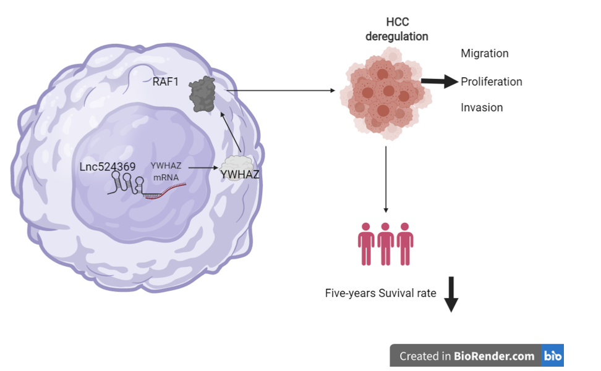
Figure 5 Possible mechanism of Lnc524369 effect on hepatocellular carcinoma. Lnc529439 might increase the expression of YWHAZ mRNA and then upregulate the YWHAZ protein level, which triggers RAF1 activation to promote hepatocellular carcinoma (HCC) progression.
Table 1 Primer sequences used in study
Gene name | Gene accession No. | Primer (5'→3') | Length (bp)
Lnc524369 | ENST00000524369.1 | F: CAGCAGAACTGGGTGTTGGA | 90
 |  | R: GCGCTGCAGTTTCCTCCTT
GAPDH | NM_002046.5 | F: CCATGACAACTTTGGTATCGTGGAA | 107
 |  | R: GGCCATCACGCCACAGTTTC

Table 2 Hepatocellular carcinoma patients based on Lnc524369 levels
 |  | Higher expression (n = 22) | Lower expression (n = 19) | t/χ² | P
Age |  | 57.68 ± 10.77 | 54.21 ± 11.44 | 1.000 | 0.688
Male |  | 13 (59.1%) | 12 (63.16%) | 0.004 | 0.952
Pathological grading | Low | 9 (40.91%) | 2 (10.53%)
 | Moderate | 11 (50.00%) | 10 (52.63%) | - | 0.009
 | High | 2 (9.09%) | 7 (36.84%)
Fisher's exact test was used.

