Name of journal: World Journal of Gastroenterology
ESPS Manuscript NO: 27546
Manuscript Type: LETTERS TO THE EDITOR

Hepatic epithelioid hemangioendothelioma: Dilemma and challenges in the preoperative diagnosis

Hu HJ et al. Challenges in the diagnosis of HEHE

Hai-Jie Hu, Yan-Wen Jin, Qiu-Yang Jing, Anuj Shrestha, Nan-Sheng Cheng, Fu-Yu Li

Hai-Jie Hu, Yan-Wen Jin, Anuj Shrestha, Nan-Sheng Cheng, Fu-Yu Li, Department of Biliary Surgery, West China Hospital of Sichuan University, Chengdu 610041, Sichuan Province, China

Qiu-Yang Jing, Department of Pathology, West China Hospital of Sichuan University, Chengdu 610041, Sichuan Province, China

Anuj Shrestha, Department of General Surgery, Gandaki Medical College, 33700 Pokhara, Nepal

Author contributions: Hu HJ and Jin YW contributed equally to this paper; Hu HJ and Jin YW contributed to data acquisition and drafted the manuscript; Jing QY contributed to data acquisition; Shrestha A and Cheng NS were involved in the revision of the manuscript; Li FY conceived and designed the study and revised the manuscript.

Supported by National Nature Science of China, No. 30801111; Science and Technology Support Project of Sichuan Province, No. 2014SZ0002-10.
Informed consent statement: The patient gave written informed consent prior to the study inclusion.

Conflict-of-interest statement: The authors declared that there is no conflict of interest related to this study.

Open-Access: This article is an open-access article which was selected by an in-house editor and fully peer-reviewed by external reviewers. It is distributed in accordance with the Creative Commons Attribution Non Commercial (CC BY-NC 4.0) license, which permits others to distribute, remix, adapt, build upon this work non-commercially, and license their derivative works on different terms, provided the original work is properly cited and the use is non-commercial. See: http://creativecommons.org/licenses/by-nc/4.0/

Manuscript source: Unsolicited manuscript

Correspondence to: Fu-Yu Li, MD, PhD, Department of Biliary Surgery, West China Hospital of Sichuan University, 37 Guoxue Xiang, Wuhou District, Chengdu 610041, Sichuan Province, China. lfy_74@hotmail.com
Telephone: + 86-28-85422465
Fax: +86-28-85422465

Received: June 3, 2016
Peer-review started: June 5, 2016
First decision: July 29, 2016
Revised: August 9, 2016
Accepted: August 23, 2016
Article in press:
Published online:
Abstract
Hepatic epithelioid hemangioendothelioma (HEHE) is a rare category of vascular tumor with uncertain malignant potential. It commonly presents nonspecific and variable clinical manifestations, ranging from asymptomatic to hepatic failure. In addition, laboratory measurements and imaging features also lack specificity in the diagnosis of HEHE. The aim of the present study is to highlight the dilemma and challenges in the preoperative diagnosis of HEHE, and to enhance awareness of the range of hepatobiliary surgery available in patients with multiple hepatic nodular lesions on imaging. In these patients, HEHE should at least be considered in the differential diagnosis.

Key words: Hepatic epithelioid hemangioendothelioma; Vascular tumors; Diagnosis; Dilemma; Challenges

© The Author(s) 2016. Published by Baishideng Publishing Group Inc. All rights reserved.

Core tip: Hepatic epithelioid hemangioendothelioma (HEHE) is a rare category of vascular tumor with uncertain malignant potential. In the present study, by illustrating a case, we aimed to highlight the dilemma and challenges in the preoperative diagnosis of HEHE, and to enhance awareness of the range of hepatobiliary surgery available in patients with multiple hepatic nodular lesions on imaging. In these patients, HEHE should at least be considered in the differential diagnosis.

Hu HJ, Jin YW, Jing QY, Shrestha A, Cheng NS, Li FY. Hepatic epithelioid hemangioendothelioma: Dilemma and challenges in the preoperative diagnosis. World J Gastroenterol 2016; In press

TO THE EDITOR
Originating from endothelial cells, hepatic epithelioid hemangioendothelioma (HEHE) is a rare category of vascular tumor with uncertain malignant potential, and some present as slow-growing lesions while others are rapidly progressive tumors^{[1,2]}. HEHE was first identified by Ishak et al^{[5]} in 1984 and usually presents as a multi-nodular lesion imitating metastases with low-to-intermediate grade malignancy^{[1,3-5]}. Based on radiological imaging, HEHE can be classified into a solitary nodular or diffuse nodular phenotype. The clinical biological features of HEHE are similar to those of a benign hemangioma and malignant angiosarcoma^{[6]}. HEHE is resistant to chemotherapy and radiotherapy, thus, complete surgical resection is performed in patients with early stage monolobar disease, and liver transplantation is the only curative treatment in specific patients with diffuse liver involvement^{[7-9]}. However, HEHE commonly presents nonspecific and variable clinical manifestations, ranging from asymptomatic to portal hypertension, Budd–Chiari syndrome or hepatic failure^{[10,11]}. In addition, laboratory measurements also lack specificity in the diagnosis of HEHE, which typically manifests as a “halo” sign and “capsular retraction” on imaging^{[3,12]}. However, most lesions have nonspecific features. Thus, the preoperative diagnosis of HEHE is difficult and most previously published cases were misdiagnosed as metastatic carcinoma, hepatocellular carcinoma, cholangiocarcinoma, or other types of vascular lesions preoperatively^{[13, 14]}.
We report a patient whose primary diagnosis was metastatic carcinoma while the final pathological diagnosis was HEHE. The 40-year-old female patient was investigated due to persistent right epigastric pain for more than two months. She had no previous history of gastrointestinal or immunological diseases or previous surgical history. Physical examination was unremarkable. Laboratory tests, including liver biochemical tests, routine blood examination and serum tumor markers, were all within the normal range. Serological testing for hepatitis B and C were also negative. Abdominal contrast-enhanced computerized tomography revealed multiple low density nodular lesions scattered in the liver parenchyma, involving the right lobe and left medial segment, with inhomogeneous enhancement (Figure 1). Contrast-enhanced ultrasonography indicated multiple hypoechoic nodules with peripheral hyper-enhancement during the arterial phase and hypo-enhancement during the portal phase (Figure 2). Thus, an initial diagnosis of metastatic carcinoma was made and 18[F]-fluorodeoxyglucose positron emission tomography / computed tomography (18F-FDG PET/CT) was then performed. The hepatic masses showed low glycometabolism (Figure 3) and no specific primary lesion was found, precluding metastases. We then obtained intraoperative frozen sections and the patient underwent extended right hemihepatectomy with complete resection of all lesions under the guidance of intraoperative ultrasonography. The lesions were grey-white in color and ranged in size from 0.7 to 5 cm. The results of hematoxylin/eosin staining were suspicious for a tumor of vascular origin (Figure 4A). Immunohistochemically, the lesions were positive for CD34 (Figure 4B), and CD31 (Figure 4C), supporting the diagnosis of HEHE.
For patients with liver masses, correct preoperative diagnosis is necessary to guarantee an appropriate therapeutic approach. Given the rarity and unpredictable natural of HEHE, it is not possible to make an accurate diagnosis from heterogeneous clinical manifestations and nonspecific laboratory measurements. Most of these lesions also lack typical manifestations such as a “halo” sign and “capsular retraction” on imaging and present with nonspecific features. Thus, only histopathological results can guarantee an accurate diagnosis. In this study, the patient who had multiple hepatic nodules was examined using preoperative contrast-enhanced computerized tomography and contrast-enhanced ultrasonography, which indicated a diagnosis of metastatic carcinoma. PET-CT was then performed to detect the primary lesions. Surprisingly, no primary lesion was identified, and the hepatic lesions with low glycometabolism did not support the diagnosis of metastatic carcinoma. Thus, a tumor of vascular origin was then suspected and after clinical discussion, an extended right hemihepatectomy was carried out and the final histological results confirmed the diagnosis of HEHE.
HEHE has heterogeneous clinical features, nonspecific radiological characteristics and a variable natural history with a highly unpredictable clinical course. PET-CT may provide more information to help with the preoperative differential diagnosis; however, PET-CT is associated with high costs and sometimes only provides us with a reference and cannot guarantee an accurate diagnosis. One of the aims of the current study was to enhance awareness of the range of hepatobiliary surgery available in patients with multiple nodular lesions on imaging. In these patients, HEHE should at least be considered in the differential diagnosis. Multicenter studies based on the analysis of more practical and economic diagnostic tools are required to establish better regimens and subsequently guide the preoperative diagnosis of HEHE. Further studies focusing on the etiology of HEHE to improve preoperative diagnosis are also required.

REFERENCES
1 Campione S, Cozzolino I, Mainenti P, D'Alessandro V, Vetrani A, D'Armiento M. Hepatic epithelioid hemangioendothelioma: Pitfalls in the diagnosis on fine needle cytology and "small biopsy" and review of the literature. Pathol Res Pract 2015; 211: 702-705 [PMID: 26187370 DOI: 10.1016/j.prp.2015.06.009]
2 Makhlouf HR, Ishak KG, Goodman ZD. Epithelioid hemangioendothelioma of the liver: a clinicopathologic study of 137 cases. Cancer 1999; 85: 562-582 [PMID: 10091730]
3 Mistry AM, Gorden DL, Busler JF, Coogan AC, Kelly BS. Diagnostic and therapeutic challenges in hepatic epithelioid hemangioendothelioma. J Gastrointest Cancer 2012; 43: 521-525 [PMID: 22544493 DOI: 10.1007/s12029-012-9389-y]
4 Uchimura K, Nakamuta M, Osoegawa M, Takeaki S, Nishi H, Iwamoto H, Enjoji M, Nawata H. Hepatic epithelioid hemangioendothelioma. J Clin Gastroenterol 2001; 32: 431-434 [PMID: 11319317]
5 Ishak KG, Sesterhenn IA, Goodman ZD, Rabin L, Stromeyer FW. Epithelioid hemangioendothelioma of the liver: a clinicopathologic and follow-up study of 32 cases. Hum Pathol 1984; 15: 839-852 [PMID: 6088383]
6 Hsieh MS, Liang PC, Kao YC, Shun CT. Hepatic epithelioid hemangioendothelioma in Taiwan: a clinicopathologic study of six cases in a single institution over a 15-year period. J Formos Med Assoc 2010; 109: 219-227 [PMID: 20434030 DOI: 10.1016/S0929-6646(10)60045-9]
7 Mosoia L, Mabrut JY, Adham M, Boillot O, Ducerf C, Partensky C, Baulieux J. Hepatic epithelioid hemangioendothelioma: long-term results of surgical management. J Surg Oncol 2008; 98: 432-437 [PMID: 18792957 DOI: 10.1002/jso.21132]
8 Remiszewski P, Szczerba E, Kalinowski P, Gierej B, Dudek K, Grodzicki M, Kotulski M, Paluszkiewicz R, Patkowski W, Zieniewicz K, Krawczyk M. Epithelioid hemangioendothelioma of the liver as a rare indication for liver transplantation. World J Gastroenterol 2014; 20: 11333-11339 [PMID: 25170219 DOI: 10.3748/wjg.v20.i32.11333]
9 Lakkis Z, Kim S, Delabrousse E, Jary M, Nguyen T, Mantion G, Heyd B, Lassabe C, Borg C. Metronomic cyclophosphamide: an alternative treatment for hepatic epithelioid hemangioendothelioma. J Hepatol 2013; 58: 1254-1257 [PMID: 23402747 DOI: 10.1016/j.jhep.2013.01.043]
10 Wang LR, Zhou JM, Zhao YM, He HW, Chai ZT, Wang M, Ji Y, Chen Y, Liu C, Sun HC, Wu WZ, Ye QH, Zhou J, Fan J, Tang ZY, Wang L. Clinical experience with primary hepatic epithelioid hemangioendothelioma: retrospective study of 33 patients. World J Surg 2012; 36: 2677-2683 [PMID: 22890877 DOI: 10.1007/s00268-012-1714-x]
11 Thin LW, Wong DD, De Boer BW, Ferguson JM, Adams L, Macquillan G, Delriviere L, Mitchell A, Jeffrey GP. Hepatic epithelioid haemangioendothelioma: challenges in diagnosis and management. Intern Med J 2010; 40: 710-715 [PMID: 19712200 DOI: 10.1111/j.1445-5994.2009.02043.x]
12 Woodall CE, Scoggins CR, Lewis AM, McMasters KM, Martin RC. Hepatic malignant epithelioid hemangioendothelioma: a case report and review of the literature. Am Surg 2008; 74: 64-68 [PMID: 18274433]
13 Deng Y, Zhou Y, Cheng N. Laparoscopic liver biopsy in the diagnosis of hepatic epithelioid hemangioendothelioma: A case report. Oncol Lett 2014 [PMID: 25120715 DOI: 10.3892/ol.2014.2308]
14 Ben-Haim M, Roayaie S, Ye MQ, Thung SN, Emre S, Fishbein TA, Sheiner PM, Miller CM, Schwartz ME. Hepatic epithelioid hemangioendothelioma: Resection or transplantation, which and when? Liver Transp Surg 1999; 5: 526-531 [DOI: 10.1002/Lt.500050612]

P-Reviewer: Morales-Gonzalez J, Strom SC S-Editor: Qi Y L-Editor: E-Editor:

Specialty type: Gastroenterology and hepatology
Country of origin: China
Peer-review report classification
Grade A (Excellent): A
Grade B (Very good): B
Grade C (Good): 0
Grade D (Fair): 0
Grade E (Poor): 0

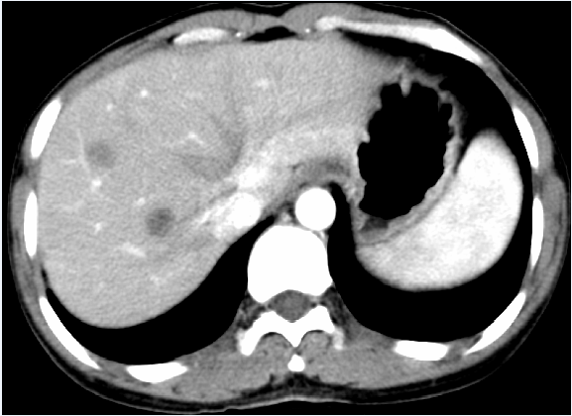Figure 1 Abdominal contrast-enhanced computerized tomography findings. Abdominal contrast-enhanced computerized tomography (CT) revealed multiple low density nodular lesions scattered in the liver parenchyma, involving the right lobe and left medial segment, with inhomogeneous enhancement.

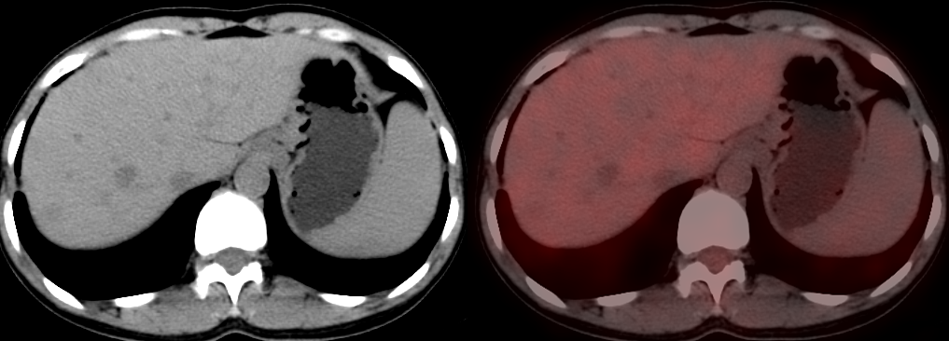Figure 2 Contrast-enhanced ultrasonography findings. Contrast-enhanced ultrasonography indicated multiple hypoechoic nodules with peripheral hyper-enhancement during the arterial phase and hypo-enhancement during the portal phase.

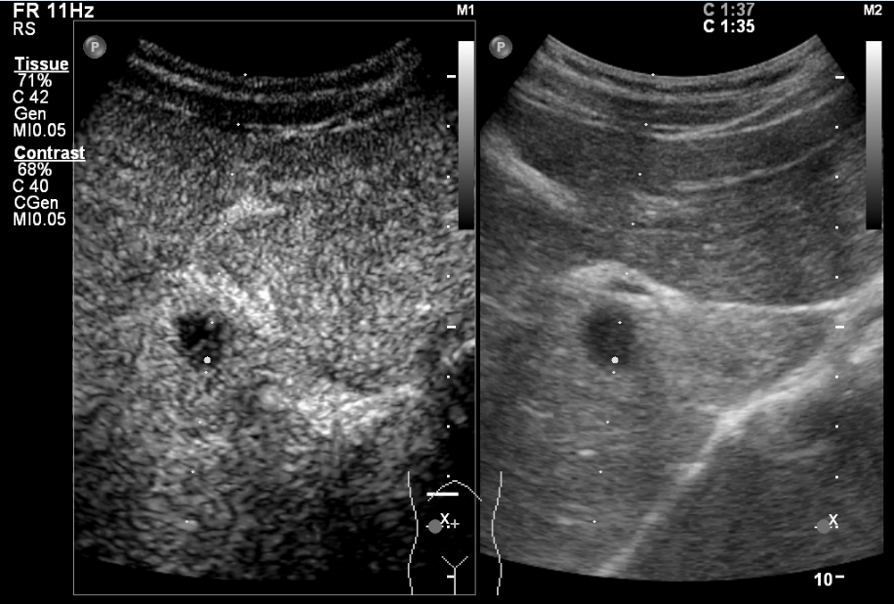Figure 3 PET-CT findings. PET-CT showed that the hepatic masses had low glycometabolism.

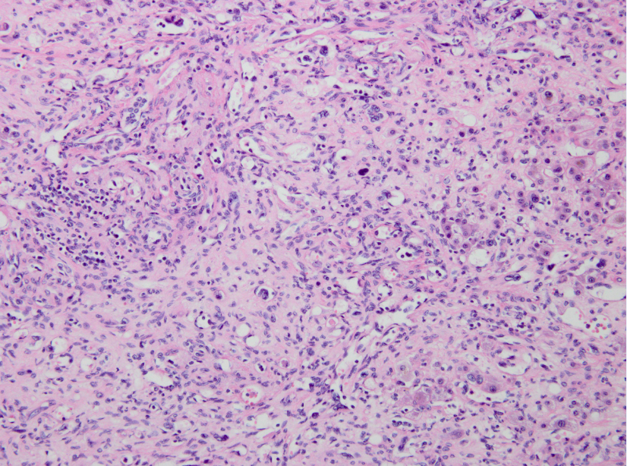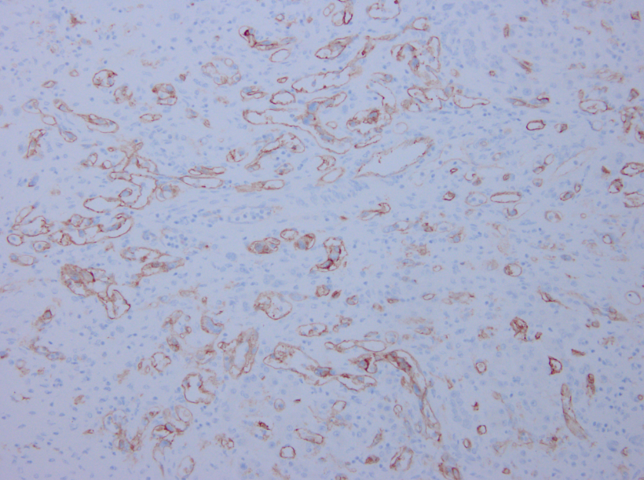
A B
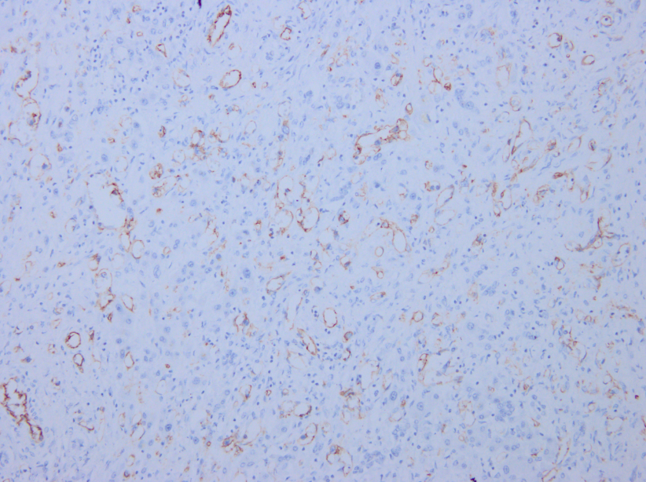
C

Figure 4 Pathological findings. Pathological investigations identified hepatic epithelioid hemangioendothelioma: A: Hematoxylin-eosin staining revealed abnormal hyperplasia of fibrous tissue combined with vessel-like formations, with scattered neoplastic epithelioid cells; B: Immunohistochemistry showed that the tumor was positive for CD34; C: Immunohistochemistry showed that the tumor was positive for CD31.

