Name of Journal: World Journal of Gastroenterology
Manuscript NO: 34004
Manuscript Type: ORIGINAL ARTICLE

Basic Study
Estrogen receptor expression in chronic hepatitis C and hepatocellular carcinoma pathogenesis

Iyer JK et al. ER expression in hepatitis C-mediated pathogenesis

Janaki K Iyer, Mamta Kalra, Anil Kaul, Mark E Payton, Rashmi Kaul

Janaki K Iyer, Rashmi Kaul, Department of Biochemistry and Microbiology, Oklahoma State University-Center for Health Sciences, Tulsa, Ok 74107, United States

Mamta Kalra, Immatics US Inc, Houston, TX 77077, United States

Anil Kaul, Department of Obstetrics and Gynecology, Oklahoma State University-Center for Health Sciences, Tulsa, Ok 74107, United States

Mark E Payton, Department of Statistics, Oklahoma State University, Stillwater, Ok 74078, United States

Author contributions: Kaul R, Kaul A designed and coordinated this study; Iyer JK, Kalra M and Kaul R acquired and analyzed the data after performing the molecular investigations; Payton ME performed the statistics on acquired data; Iyer JK, Kalra M, Kaul A and Kaul R contributed to writing and final approval of the article.

supported by Cancer Sucks, Bixby, Oklahoma Research grant to Kaul R.

Institutional review board statement: The research study protocol was approved by expedited review procedure by the Institutional Review Board of University of Minnesota (FWA 00000312) and Oklahoma State University –Center for Health sciences (2003012-OSU-CHS).

Conflict-of-interest statement: The authors declare no conflict of interest.

Data sharing statement: All available data can be obtained by contacting the corresponding author.

Open-Access: This article is an open-access article which was selected by an in-house editor and fully peer-reviewed by external reviewers. It is distributed in accordance with the Creative Commons Attribution Non Commercial (CC BY-NC 4.0) license, which permits others to distribute, remix, adapt, build upon this work non-commercially, and license their derivative works on different terms, provided the original work is properly cited and the use is non-commercial. See: http://creativecommons.org/licenses/by-nc/4.0/

Manuscript source: Unsolicited manuscript

Correspondence to: Rashmi Kaul, PhD, Associate Professor, Department of Biochemistry and Microbiology, Oklahoma State University - Center for Health Sciences, Tulsa, OK 74012, United States. rashmi.kaul10@okstate.edu
Telephone: +1-918-5611231
Fax: +1-918-5618276

Received: March 20, 2017
Peer-review started: March 22, 2017
First decision: April 21, 2017
Revised: May 12, 2017
Accepted: July 22, 2017
Article in press:
Published online:

Abstract
AIM
To investigate gender-specific liver estrogen receptor (ER) expression in normal subjects and patients with hepatitis C virus (HCV)-related cirrhosis and hepatocellular carcinoma (HCC).

METHODS
Liver tissues from normal donors and patients diagnosed with HCV-related cirrhosis and HCV-related HCC were obtained from the NIH Liver Tissue and Cell Distribution System. The expression of ER subtypes, ERα and ERβ, were evaluated by Western blotting and real-time RT-PCR. The subcellular distribution of ERα and ERβ was further determined in nuclear and cytoplasmic tissue lysates along with the expression of inflammatory [activated NF-κB and IκB-kinase (IKK)] and oncogenic (cyclin D1) markers by Western blotting and immunohistochemistry. The expression of ERα and ERβ was correlated with the expression of activated NF-κB, activated IKK and cyclin D1 by Spearman’s correlation.

RESULTS
Both ER subtypes were expressed in normal livers but male livers showed significantly higher expression of ERα than females (P < 0.05). We observed significantly higher mRNA expression of ERα in HCV-related HCC liver tissues as compared to normals (P < 0.05) and ERβ in livers of HCV-related cirrhosis and HCV-related HCC subjects (P < 0.05). At the protein level, there was a significantly higher expression of nuclear ERα in livers of HCV-related HCC patients and nuclear ERβ in HCV-related cirrhosis patients as compared to normals (P < 0.05). Furthermore, we observed a significantly higher expression of phosphorylated NF-κB and cyclin D1 in diseased livers (P < 0.05). There was a positive correlation between the expression of nuclear ER subtypes and nuclear cyclin D1 and a negative correlation between cytoplasmic ER subtypes and cytoplasmic phosphorylated IKK in HCV-related HCC livers. These findings suggest that dysregulated expression of ER subtypes following chronic HCV-infection may contribute to the progression of HCV-related cirrhosis to HCV-related HCC.

CONCLUSION
Gender differences were observed in ERα expression in normal livers. Alterations in ER subtype expression observed in diseased livers may influence gender-related disparity in HCV-related pathogenesis.

Key words: Estrogen receptor α; Estrogen receptor β; Hepatitis C virus-related cirrhosis; Hepatitis C virus-related hepatocellular carcinoma; sex and gender; normal liver

© The Author(s) 2017. Published by Baishideng Publishing Group Inc. All rights reserved.

Core tip: Our study, for the first time, demonstrates gender-based differences in basal expression of estrogen receptor α (ERα) in the liver of normal males and females. Altered nuclear and cytoplasm liver ER subtype protein expression was also observed in hepatitis C virus (HCV)-cirrhosis and HCV-related hepatocellular carcinoma (HCC) that correlate with the inflammatory and oncogenic markers activated NF-κB and cyclin D1 implicating their role in chronic cirrhosis and malignant transformation. These findings may have an impact on future planning strategies for the development of novel treatments or prognostic markers by targeting ERs or their signaling pathways during chronic HCV-related cirrhosis and HCC development.

Iyer JK, Kalra M, Kaul A, Payton ME, Kaul R. Estrogen receptor expression in chronic hepatitis C and hepatocellular carcinoma pathogenesis. World J Gastroenterol 2017; In press

INTRODUCTION
Hepatitis C virus (HCV) infection is a major health problem in the United States^{[1]}. HCV-infection tends to be asymptomatic for long periods of time during which fibrosis and cirrhosis can develop, resulting in end-stage liver disease^{[2,3]}. No viable vaccine is currently available for HCV prevention and, while newer and expensive direct acting antivirals are available for treating early HCV-infection, transplantation is the only effective treatment for patients with advanced or end stage liver disease^{[4,5]}. HCV-infection related fibrosis and cirrhosis are associated with the development of chronic liver disease that eventually leads to hepatocellular carcinoma (HCC), the most common type of liver cancer^{[6-8]}. The latest epidemiological data shows that HCC has the fastest growing death rate in the United States^{[9]}. Thus, there is an urgent need to develop novel, effective and affordable therapeutics to treat chronic HCV-infections.
Understanding the contribution of host factors that directly or indirectly interact with HCV is central to finding new treatment modalities^{[10]}. Striking gender disparity in HCV and HCC pathogenesis has led to the investigation of estrogen as one of the key host players in modulating the course of HCV-pathogenesis. Epidemiological and clinical studies have shown that chronic HCV-infections are more prevalent in males and progress more rapidly to cancer development as compared to females^{[11,12]}. Similar to males, postmenopausal females lacking circulating estrogen show accelerated progression of HCV-infection to fibrosis and HCC development^{[12,13]}. In contrast, physiological estrogen levels seen in premenopausal females, have been associated with less severity and slow progression through all stages of HCV infection^{[11,14]}. Direct evidence of the therapeutic potential of estrogen has come from experimental studies demonstrating that administration of 17β-estradiol inhibits HCC development in in vitro and in vivo animal models^{[15,16]}. However, clinical trials evaluating hormonal therapy using selective estrogen receptor modulators (SERMs) have shown inconsistent outcomes in HCC patients^{[17-19]}. These inconsistencies may be attributed to the differences in the expression of estrogen receptors (ERs) in the liver^{[20]}.
Liver is a sexually dimorphic organ and expresses the ERs, ERα and ERβ, making it responsive to the actions of estrogen^{[21,22]}. These receptors classically function as transcription factors, shuttling between the cytoplasm and nucleus for regulating the expression of various genes involved in cell cycle, proliferation, apoptosis and inflammation^{[23]}. More recently, the non-classical role of ERs in cell signaling has become increasingly evident^{[24,25]}. The two subtypes, ERα and ERβ share significant structural homology and ligand binding properties and yet function very differently, often antagonizing each other’s actions^{[26]}. Thus, the relative expression of the two subtypes can have a significant impact on net cellular responses to estrogen.
In breast cancer, ERα:ERβ expression ratio is thought to play a key role in estrogen-dependent tumor development^{[27,28]}. Like breast cancer, aberrant increase in ER gene expression has been reported in liver tumors when compared to normal or non-tumor parts of the liver in HCC patients^{[29,30]}. However, there is very limited information available on the relative expression of ERα and ERβ subtypes and ERα:ERβ expression ratio in livers of normals, HCV-related cirrhosis and HCV-related HCC.
We hypothesized that basal liver ERα and ERβ expression differs in males vs females and this differential expression dictates host susceptibility to chronic HCV or its progression to hepatocellular carcinoma. In the present study, we evaluated the expression of ERα and ERβ in the livers of normals, HCV-cirrhosis and HCV-related HCC at the mRNA and protein levels using different techniques. We further determined the correlation of ER subtype expression with the levels of inflammatory and oncogenic markers like NF-κB and cyclin D1. Our findings show that the basal expression of ER subtypes is different between normal males and females. Furthermore, sub-cellular expression of both ER subtypes is altered in HCV cirrhosis and HCV-related HCC livers as compared to normals and correlates with the expression of inflammatory and oncogenic markers. This altered expression of ER subtypes in the liver may contribute to the progression of cirrhosis and cancer development during HCV-pathogenesis.

MATERIAL AND METHODS
Patients
Explant liver tissues from normal donors and HCV-related cirrhosis and HCV-related HCC patients (Tables 1-3) were obtained from the NIH Liver Tissue and Cell Distribution System (LTCDS) at the University of Minnesota. Liver explants were aseptically collected under the institutional review board (IRB) guidelines of University of Minnesota. The study was conducted at Oklahoma State University-Center for Health Sciences under IRB guidelines. In order to avoid interference of other co-factors, patients co-infected with human immunodeficiency virus (HIV) or hepatitis B virus (HBV) or with a history of alcohol consumption or drug use were excluded from the study. Liver explants were snap frozen in liquid nitrogen and stored at -80 °C until further use.

Western blot analysis
Whole tissue lysates were prepared by homogenizing ~200 to 300 mg of liver tissues in liquid nitrogen followed by lysis in buffer comprising of 50 mmol/L Tris-HCl (pH 8.0), 400 mmol/L KCl, 10 mmol/L EDTA, 2 mmol/L phenylmethylsulfonyl fluoride, 1 μg/mL aprotinin and 1 μg/mL leupeptin. The homogenates were centrifuged at 30000 × g for 1 h at 4 °C. The supernatants were collected and stored at -80 °C until further use. Cytoplasmic and nuclear fractions were prepared from liver tissues using the NE-PER kit (Pierce Chemical Co., Rockland, IL, United States) as per the manufacturer’s instructions. Protein concentrations were determined by Bicinchoninic acid assay (Pierce Chemical Co., Rockland, IL, United States). Thirty micrograms of protein from each lysate (whole tissue lysate, cytoplasmic or nuclear tissue lysates) was resolved on 4%-12% Bis–Tris Gel (Invitrogen, Carlsbad, CA, United States). The separated proteins were electrophoretically transblotted on to a 0.2 μm nitrocellulose membrane. Purified recombinant ERα and ERβ proteins were included as positive controls. The membrane was blocked in 5% non-fat dry milk made in TBS (20 mmol/L Tris-HCl, pH 7.6 and 136 mmol/L NaCl) containing 0.1% Tween-20 for 2 h and probed with antibodies specific for human ERα (rat monoclonal against human ERα, H222, Fitzgerald Industries International Inc., Concord, MA, United States), human ERβ (mouse monoclonal against amino acids 1-153 of human ERβ, 14C8, Affinity Bioreagents, Golden, CO, United States), phosphorylated IκB-kinase (IKK) αβ (rabbit polyclonal against a phosphopeptide corresponding to amino acids surrounding Ser176/180 of human IKKα, Cell signaling Technology, Danvers, MA, United States), IKKα (rabbit polyclonal against a peptide corresponding to 20 amino-terminal amino acids of human IKKα, Cell signaling Technology, Danvers, MA, United States), Cyclin D1 (rabbit polyclonal against amino acids 1-295 of human cyclin D1, H-295, Santa Cruz Biotechnology, Dallas, TX, United States), phosphorylated NF-κB (mouse monoclonal against a phosphopeptide corresponding to amino acids surrounding Ser536 of human NF-κB p65 subunit, Cell signaling Technology, Danvers, MA, United States), NF-κB (rabbit monoclonal against a peptide corresponding to amino acids near the amino-terminus of human NF-κB p65 subunit, Cell signaling Technology, Danvers, MA, United States) and β–actin (rabbit polyclonal against a peptide corresponding to amino acid 20-33 of actin, Sigma-Aldrich, St. Louis, MO, United States). After incubation with alkaline phosphatase conjugated secondary antibodies (Sigma-Aldrich, St. Louis, MO, United States), the protein bands were detected by enhanced chemiluminescence (Pierce Chemical Co., Rockland, IL, United States). To ensure the purity of cytoplasmic and nuclear fractions, the blots were also probed with anti-GAPDH (rabbit monoclonal against a peptide corresponding to a part of the carboxyl terminus of human GAPDH, Cell signaling Technology, Danvers, MA, United States) and anti-histone H1 (mouse monoclonal against nuclei from biopsies of myeloid leukemia cells, EMD Millipore, Billerica, MA, United States) antibodies respectively. Images of the protein bands were digitally captured with Alpha Innotech instrumentation (Alpha Innotech Corp, San Leandro, CA, United States) and quantified with Image analysis program, ImageJ (NIH, Bethesda, MD, United States). The phosphorylated forms were expressed as a ratio of the phosphorylated protein to total protein.

Immunohistochemistry
Immunohistochemistry was performed on normal and diseased explant liver tissue sections to confirm the protein expression of ERα, ERβ and cyclin D1. Formalin-fixed liver tissues were embedded in paraffin and sectioned into 4- μm thick sections. Non-enzymatic antigen retrieval was performed in citrate buffer (pH 6.0) using a microwave procedure. Slides were allowed to cool down for 20 min at room temperature and endogenous peroxidase was quenched with Dako EnVision system kit according to manufacturer’s instructions (Dako, Carpintaria, CA, United States). The sections were washed and incubated for 30 minutes with 0.5% Triton X-100 in PBS followed by 5% rabbit serum. The tissue sections were incubated overnight with primary antibodies against ERα (rabbit polyclonal against a peptide corresponding to the carboxyl terminus of mouse ERα, MC-20, 1:50 dilution, Santa Cruz Biotechnology, Dallas, TX, United States), or ERβ (mouse monoclonal against peptide corresponding to the carboxyl terminus of ERβ, PPG5/10, 1:20 dilution, Dako, Carpinteria, CA, United States) at 4°C. Slides were washed with PBS containing 0.05% Tween and treated for one hour at room temperature with corresponding HRP labeled secondary antibodies (Dako, Carpinteria, CA, United States). The tissue sections were stained with 3,3’-diaminobenzidine and the nuclei were counterstained with Mayer’s hematoxylin. A similar immunostaining procedure was used for cyclin D1 (rabbit polyclonal antibody against amino acids 1-295 of human cyclin D1, H-295, 1:150 dilution, Santa Cruz Biotechnology, Dallas, TX, United States). For negative controls, sections were incubated with PBS instead of the primary antibody. The stained sections were visualized using Nikon microscope (Nikon H600 L) and sections with staining of ≥ 10 % of the cells were defined as positive.

Real-time RT-PCR
Total RNA was isolated from liver tissues with Trizol (Thermo Fisher Scientific, Waltham, MA, United States) followed by purification on RNAeasy columns (Qiagen, Valencia, CA, United States) as per the manufacturer’s instructions. Total RNA from each sample was treated with DNase (Thermo Fisher Scientific, Waltham, MA, United States) and then reverse-transcribed to synthesize cDNA using the High capacity cDNA synthesis kit (Applied Biosystems, Foster City, CA, United States). The expression of target genes was evaluated by quantitative real-time PCR using commercially available ERα and ERβ specific Taqman primers and probe assay mixes (Applied Biosystems, Foster City, CA, United States) on an ABI StepOne Real-Time PCR System (Applied Biosystems Foster City, CA, United States). Hypoxanthine-guanine phosphoribosyl transferase (HPRT) was included as the endogenous control. Relative differences in gene expression between groups were determined using the 2^{-ΔΔC}_{T} method using the normal group for normalization^{[31]}.

Statistical analysis
The statistical methods of this study were performed and reviewed by Dr. Mark E. Payton from Department of Statistics, Oklahoma State University, Stillwater, USA. Data obtained from Western blotting and real time RT-PCR experiments were analyzed statistically using SAS software v9.4 (SAS Institute Inc., Cary, NC, United States). Statistical significance between appropriate groups was determined by non-parametric analyses that included the Kruskall-Wallis test and Mann Whitney U test. Post-hoc analyses were performed using Fisher’s Protected Least Significant Difference comparisons using rank data test. Correlations of ER subtypes with other proteins were analyzed by using the Spearman’s rank correlation test. P ≤ 0.05 was considered statistically significant. All graphs were made and depicted using the GraphPad Prism v6 software (GraphPad Software Inc, La Jolla, CA, United States).

RESULTS
Basal expression of ERα is significantly higher in liver of normal males than females
Due to the well-established gender disparity in HCC prevalence, we initiated this study by investigating the expression of ERα and ERβ in normal males and females. Whole tissue lysates of liver explants obtained from normal females and normal males (Table 1) were evaluated by Western blotting using validated ERα and ERβ directed antibodies (Figure 1A). Densitometric analysis of protein bands showed comparable ER subtype expression in normal male and female tissues when the gender data was pooled (Figure 1B). However, when ER subtype expression data was segregated based on gender, we found that there was a significantly higher expression of ERα in males as compared to females (Figure 1C). No difference was found in the expression of ERβ between males and females. Since physiological outcomes are determined by the expression of both, ERα and ERβ, we compared the ERα:ERβ expression ratio between male and females and found that males showed a significantly higher ERα:ERβ expression ratio compared to females (Figure 1D).

Altered expression of ERα is observed in males with HCV-related cirrhosis and HCV-related HCC
The expression of ER subtypes was compared in liver explants of normals, HCV-related cirrhosis and HCV-related HCC (Tables 1 and 2) by real time RT-PCR and Western blotting (Figure 2). At the transcriptional level, there was an increase in the liver mRNA expression of ERα (ESR1) and ERβ (ESR2) subtypes in chronic HCV and HCV-related HCC as compared to normals (Figure 2A and B). This change in expression significantly decreased the ER subtype ratio in the HCV-related cirrhosis group compared to normal (Figure 2C), suggesting that HCV infection may result in altering the expression of ER subtypes.
When we measured ER subtype protein levels by Western blotting, we could not detect any significant differences among the three groups when the data was evaluated without gender segregation (Figure 2 D-G). However, upon separating males and females, we observed a significant decrease in the expression of ERα in diseased livers (HCV as well as HCC) compared to normal livers (Fig. 2H) but no difference in the expression of ERβ (Figure 2I) in males. This resulted in a significant decrease in ERα:ERβ expression ratio in male diseased livers (HCV as well as HCC) compared to normal male livers (Figure 2J). Among the females, we could compare the expression of ER subtypes between normals and HCV-related cirrhosis only as there were no females in the HCV-related HCC category. We found that there were no significant differences in protein levels of ERα and ERβ between normal livers and HCV-related cirrhotic livers in females (Figure 2H and I). We further observed a positive-correlation between the expression of ERα and ERβ in HCV-related cirrhosis and HCV-related HCC group based on gender-pooled data (Table 4).
Thus the results from the mRNA and protein analyses performed in whole tissue extracts showed different trends. Since classical ERs shuttle between the nuclear and cytoplasmic compartments of the cells and mediate their regulatory functions by binding to estrogen response elements on DNA, we evaluated the expression of ER subtypes in nuclear and cytoplasmic extracts of liver tissues.

Increased nuclear translocation of ER subtypes is observed in HCV-related cirrhosis and HCV-related HCC
The distribution and expression of ERα and ERβ in nuclear and cytoplasmic extracts of normal, HCV-related cirrhosis and HCV-related HCC group is depicted in Figure 3. We observed a higher expression of ERα in the nuclear extracts of normal males as compared to normal females but the increase was not statistically significant, probably due to the small sample size (Supplementary Figure 1). There was no change in the expression of nuclear ERβ. These observations in normals for the expression of nuclear ERα and ERβ were similar to the results observed in whole tissue extracts.
When we compared the expression of ER subtypes in nuclear and cytoplasmic extracts of normal and diseased livers, we could not perform statistically relevant gender analyses due to the small sample size and scarcity of female subjects in the diseased groups. Hence we have reported our results without gender segregation. We observed a significant increase in the expression of nuclear ERα and ERβ in HCV–related HCC and HCV-related cirrhosis (Figure 3A, B and D) respectively when compared to normals. However, there was no significant difference in the expression of cytoplasmic ERα, while HCV-related HCC group showed a significantly higher expression of cytoplasmic ERβ compared to HCV–related cirrhosis group (Figure 3C and E). An increase in the nuclear:cytoplasmic ratio of both, ERα and ERβ, in the diseased groups were observed compared to the normals (Supplementary Figure 1) suggesting that there is increased transcriptional activation of ER subtypes in the progression to HCV-related cirrhosis to HCV-related HCC. Furthermore, there was a significant increase in the ratio ERα:ERβ in the cytoplasmic compartment of the HCV-related cirrhosis and HCV-related HCC groups compared to normals (Figure 3G) but there was no significant difference in the ratio of the nuclear ER subtypes (Figure 3F).

HCV-related cirrhosis and HCV-related HCC group show higher activation of NF-κB
HCV infection is known to trigger inflammatory pathways and livers displaying chronic inflammation are more at risk of developing hepatocellular carcinoma^{[32,33]}. Most inflammatory pathways involve NF-κB, hence we evaluated the activation of the NF-κB signaling pathway by detecting the phosphorylation of the p65 subunit and IKK; the kinase that phosphorylates IκB, resulting in its dissociation from NF-κB and degradation by the proteasome. Livers chronically infected with HCV and HCV-related HCC tissues showed significantly higher expression of phosphorylated NF-κB (Figure 4A and B) compared to normals. There was an increase in the expression of pIKK from normal livers to HCV cirrhosis and HCV-related HCC, but the increase was not statistically significant (Figure 4C). We also observed a weak negative correlation between nuclear ERα and pNF-κB in normal liver tissues (r = -0.62968, P = 0.0511; Table 5). On the contrary, HCV-related HCC group demonstrated a weak positive correlation between nuclear ERα and pNF-κB (r = 0.4793, P = 0.0516; Table 5). In addition, expression levels of pIKK and the cytoplasmic ER subtypes showed a strong negative correlation in the HCC group (ERα: r = -0.56014, P = 0.0194; ERβ: r = -0.60848, P = 0.0095; Table 6).

ERα levels correlate with expression of cyclin D1 in both HCV cirrhosis and HCV-related HCC
In order to study the correlation of ERs with oncogenic markers in diseased livers, we determined the expression of cyclin D1 in the nuclear and cytoplasmic liver tissue extracts of normals, HCV-related cirrhosis and HCV-related HCC group by Western blotting (Table 3). As shown in Figure 5, there was a significant increase in the expression of cyclin D1 in both, the nuclear and cytoplasmic fractions of diseased livers, suggesting that chronic HCV infection primes hepatocytes to proliferate. A positive-correlation between the expression of nuclear ERα and ERβ with nuclear cyclin D1 was observed in both HCV-related cirrhosis (ERα: r = 0.75728, P = 0.0043; ERβ: r = 0.64445, P = 0.0237; Table 5) and HCV-related HCC (ERα: r = 0.55714, P = 0.0202; ERβ: r = 0.51223, P = 0.0355; Table 5) groups but not in normals, signifying the importance of ER subtypes in cyclin D1 activation (Table 5). We further determined the expression of ER subtypes and cyclin D1 by immunohistochemistry (IHC). As observed with Western blotting, IHC showed over-expression of ERα and cyclin D1 in HCV-related cirrhosis and HCV-related HCC groups (Figure 5D, Supplementary tables 1-3).

DISCUSSION
Various epidemiological studies around the globe have recognized the role of gender bias in the progression of HCV infection to chronic liver disease and cirrhosis due to poor therapeutic responses or further development of HCV-related HCC in these patients^{[34]}. Remarkable differences have been observed in the incidence, progression of HCV-related chronic liver disease and outcome of interferon therapy in males, postmenopausal females and premenopausal females^{[13,35]}. This has generated a significant interest in the scientific community to investigate the role of estrogen as the key host factor in HCV-related pathogenesis. Recent studies in postmenopausal women with HCV-related fibrosis clearly show clinical benefits from estrogen replacement therapy in conjunction with standard HCV treatment^{[12]}. One of the most compelling evidence is the inhibition of HCV life cycle by 17β-estradiol in an ERα dependent manner in human liver cell lines^{[36,37]}. Raloxifene, a SERM, treatment has been shown to improve the efficacy of antiviral treatment in HCV-infected postmenopausal women^{[38]}. These findings suggest a protective role of estrogen affecting not only viral replication but also HCV pathogenesis in the host.
Despite the recognition of estrogen as a potentially significant host factor in HCV pathogenesis, little progress has been made to understand the underlying mechanisms on how ER subtypes may be involved in progression to HCV chronic disease in some patients and rapid clearance of HCV in others. Perhaps this gap in understanding is one of the major factors contributing to the current debatable potential of estrogen therapy^{[17,19]}. In addition, most of the clinical studies did not monitor ERα and ERβ expression in the liver of the enrolled patients or the hormonal status of females at the time of recruitment or during treatment^{[20]}. Some studies evaluated ER subtype expression by measuring mRNA levels in the liver or performing less specific ligand binding assays^{[39, 40]}.
One of the most important premises of the current study was to evaluate the gender-based (males vs females) ER subtype protein expression in the liver of normals (basal expression) and further evaluate the changes in expression of these subtypes in HCV-related cirrhosis or HCV-related HCC patients. Further, we employed subcellular fractionation (nuclear verses cytoplasmic) protein studies to examine the relative expression of ER subtypes and correlate their presence with activation of NF-κB or cyclin D1 in these fractions. Our findings in whole tissue extracts of normal livers indicated that males express significantly higher levels of ERα protein compared to females but comparable levels of ERβ. We also found a significant increase in the ERα:ERβ expression ratio in males as compared to females. To our knowledge, this is the first report demonstrating gender-based differences in ERα at the basal level thereby affecting the ratio of ER subtypes in the liver. Whether these differences in ER subtype expression at basal levels predispose males to severe and fast disease progression of HCV infection needs further investigation.
We were able to detect ERα and ERβ transcripts in normal, HCV-related cirrhosis and HCV-related HCC groups. Similar observations were made in a Korean population study where they observed ERα and ERβ mRNA transcripts in more than 95% of HCV-related HCC liver tissues^{[40]}. There was an increase of ERα and ERβ transcripts in diseased livers compared to normals but there were no changes in the protein levels of ERs among the groups in whole tissue lysates. However, gender analyses of ER expression in whole tissue lysates revealed that there was a significant decrease in ERα but not ERβ expression only in diseased male patients suggesting its disease specific role in these patients. These findings are in agreement with Villa et al who showed that there was reduction or even loss of wild-type ERα in male HCV-related HCC livers but an increase in the expression of variant ERα, which we have not evaluated^{[41,42]}.
Further, ER expression in the nuclear and cytoplasmic fractions from gender-pooled diseased livers differed when compared to normals. In the nuclear fraction, we found a higher expression of ERα and ERβ subtypes in HCV-mediated HCC and HCV-mediated cirrhosis tissues respectively compared to normal liver tissues, which is in contrast to the findings in the whole tissue extracts. HCV-mediated HCC tissues also showed significantly higher expression of cytoplasmic ERβ only when compared to HCV-cirrhosis tissues. We found a significant increase in the ERα to ERβ ratio in the cytoplasmic fraction than in the nuclear fraction of both HCV-related cirrhosis and HCV-related HCC livers as compared to normal livers. The clinical relevance of these changes in ER subtype expression in the subcellular compartments needs to be further investigated. ER protein levels have been shown to vary under physiological states during breast tumor progression and hormonal therapy^{[43]}. A recent study in the MCF7 cell-line has shown that estrogen stimulation involves dynamic changes in protein subcellular spatial distribution rather than changes in total protein abundance and propose that cells may be transformed by perturbations in nucleocytoplasmic shuttling of nuclear hormone receptors and other proteins^{[44,45]}. In addition to breast cancer, ERs have also been implicated to play important roles in gastrointestinal cancers like gastric, colon and colorectal cancers^{[46-48]}. Since ERs primarily function as nuclear receptors and act as transcription factors for gene regulation, we propose that evaluating the expression of these proteins in cellular fractions as opposed to the whole tissue lysates would be a more accurate representation of their biological activity. Furthermore, our immunohistochemistry analysis also supported the increase in nuclear and cytoplasmic expression of ERα in both groups of diseased livers compared to normal livers (Supplementary Table 1). The expression of cytoplasmic ERβ was comparable among all the three groups by immunostaining. However, we observed a loss of nuclear ERβ in some HCC tissues (Supplementary Table 2). Loss of ERβ was also reported by Iavarone et al^{[39]}, who evaluated the expression of ER subtype mRNA in liver cancer tissues. Additionally, in breast, colon and prostate cancers, there are reports that indicate that presence of ERβ leads to better prognosis^{[49-52]}. These findings about differential expression of nuclear or cytoplasmic ERβ expression in HCV cirrhosis or HCC can be substantiated only by increasing the sample size in the study.
Inflammation has been associated with the initiation and progression of hepatocarcinogenesis^{[53]}. Since HCV infection triggers inflammation, and chronic inflammation promotes carcinogenesis, NF-κB has been viewed as an important player in inflammation-induced cancer^{[54,55]}. In the current study, we found a significant increase in activated NF-κB in HCV-related cirrhosis and in HCV-related HCC liver tissues. Significant increase in ERs in the cytoplasmic fraction of diseased livers may modulate the activity of pIKK thereby influencing the activation of NF-κB and inflammation outcome. ERα and NF-κB have been shown to directly interact in the nuclei of U2-OS cells treated with 17β-estradiol and aberrant ERα and NF-κB expression correlated with invasion and metastasis in HCC^{[56,57]}. 17β-estradiol, via ERα, can also inhibit the transport of p65 to the nucleus and downregulate inflammation^{[58]}. Detailed mechanistic studies are warranted to explore the cross talk between ERα and NF-κB to unfold the nature of their interaction in a HCV infection setting.
Unlike mammary carcinoma, the target genes and mechanism for ER regulation in liver are not well studied. There is a correlation between dysregulation in ER subtype with the overexpression of cyclin D1^{[59]}. In our study, we observed increased expression of cyclin D1 in HCV-related cirrhosis and HCV-related HCC compared to normal livers and the expression of nuclear cyclin D1 correlated with the expression of nuclear ER subtypes in diseased livers. These findings along with other studies suggest that ERs may play a role in dysregulation of cellular proliferation by participating in increased transcription of cyclin D1 that aids in the progression of HCV infection to cirrhosis and eventually to hepatocellular carcinoma^{[60]}. Cyclin D1 expression can also be regulated by ERα via non-genomic signaling. Treatment of HepG2 cells with 17β-estradiol activates the MAPK/ERK pathway by membrane-localized ERs resulting in increased expression of the cyclin D1 gene^{[61]}. Apart from its role in cell cycle progression, cyclin D1 has recently been recognized to play a role in influencing sex steroid metabolism by increasing estrogen levels and decreasing androgen levels^{[62]}. This is the first study that correlates the expression of ER subtypes with cyclin D1 in HCV-related cirrhosis and HCV-related HCC.
Increased expression of different isoforms or variants of ERα in diseased livers has been reported by mRNA studies and their involvement to activate oncogenic signaling pathways in cell lines has been reported^{[63,64]}. The variants, ERα36 and ERα46 have been shown to modulate signaling pathways linked to proliferation and apoptosis^{[65, 66]}. Differential expression of ERα36 has been observed in various cancers like breast, gastric, and endometrial cancer^{[67]} and its expression correlates with a worse prognosis in breast cancer^{[68]} but its role in HCV-mediated HCC has not been thoroughly investigated. Various ERβ variants have also been detected in different tissues but their role in carcinogenesis has not been evaluated as extensively as the ERα variants^{[69]}. The present study focused to fill the gap in knowledge for the expression of wild type ERα and ERβ in normal and diseased livers. However, the expression of variant ER receptors also needs to be investigated to understand their role, if any, in HCV-related carcinogenesis. In addition to ER subtypes, the expression of androgen receptors should also be evaluated as HCV infection enhances androgen receptor-mediated signaling in an in vitro model^{[70]} but it is not clear if androgen receptors play a role in carcinogenesis due to existing conflicting reports^{[71,72]}.
Finally, in the current study, we have demonstrated for the first time that the basal expression of wild-type ERα in the liver is higher in males than females. Furthermore, the increased sub-cellular expression of ER subtypes observed in diseased livers correlates with the expression of inflammatory and oncogenic markers. This altered expression of ER subtypes in the liver may contribute to the progression of cirrhosis and cancer development during HCV-pathogenesis. These observations have been made in end stage HCV–related cirrhosis and HCC. In future, early disease or stage specific prospective longitudinal studies that include a larger sample size (in both males and females category) can be conducted to further clarify the role of nuclear or cytoplasmic ER expression at early stages of HCV-related cirrhosis or HCV-related HCC. Impact of gender associated ER subtype ratio distribution in the liver can also be studied relative to oncogenic markers and that may help us to monitor host therapeutic responses, viral clearance or improved prognosis during the carcinogenesis process. In conclusion, we expect that by evaluating the expression of sex hormone receptors and understanding the signaling pathways they affect, gender and stage-related personalized therapies can be designed to treat and manage chronic HCV infections and HCV-related HCC.

Acknowledgements
We thank Dr. Senait Assefa and Zachary Lovato for their technical assistance and Ayantika Sen for reviewing this manuscript. Liver tissues were obtained from the NIH Liver Tissue and Cell Distribution System (LTCDS; Contract No. HHSN276201200017C).

COMMENTS
Background
hepatitis C virus (HCV) infection-related fibrosis and cirrhosis lead to the development of chronic liver disease that can ultimately result in hepatocellular carcinoma (HCC). According to epidemiological and clinical studies, chronic HCV infection mediated cirrhosis is more prevalent in males and progresses to cancer development faster as compared to premenopausal females who show better therapeutic responses and clear the infection. However, females with menopausal estrogen deficiency may have reactivation of the HCV infection resulting in accelerated progression to fibrosis and HCC development, confirming estrogen related etiology. Previous hormonal therapies in HCC have been inconclusive perhaps due to our poor understanding of estrogen receptor (ER) subtype expression in the normal livers from both males and females and also how changes in the expression of ERs may contribute to HCV-related disease progression. In the current study, we evaluated the basal liver ERα and ERβ expression in males versus females and have studied the changes in liver ER subtype expression and their correlation with inflammatory and proliferative markers in HCV-related cirrhosis and HCV-related HCC

Research Frontiers
Gender disparity in immunity to chronic infectious disease, autoimmunity and cancer development is increasingly being recognized in various clinical and experimental studies. Systemic estrogens in females play an important role in host innate immunity, however, the contributions of estrogen receptors are poorly recognized. In addition to hormonal cancers like breast, prostate and uterus, ER subtypes are being increasingly implicated in non-hormonal tissue cancers as well that include liver, colon, pancreas and stomach.

Innovations and breakthroughs
This is the first report demonstrating gender-based differences in the basal expression of ERα in the liver that also results in change in ER subtype ratio. In addition to ER subtype expression in the whole liver tissue extracts, subcellular fractionation of liver extracts for expression of ER subtypes, inflammatory and proliferative markers in nucleus and cytoplasm of both, normal and diseased livers, were also evaluated. To our knowledge, this is the first study that correlates the expression of ER subtypes with cyclin D1 in livers of HCV-related cirrhosis and HCV-related HCC.

Applications
Investigating gender associated changes in ER subtype ratio in the liver during the course of HCV–related disease progression along with oncogenic marker expression may help us to monitor gender specific host therapeutic responses, viral clearance and cancer development more effectively. Furthermore, these ER subtype expression studies will further complement existing treatments and pave the way to develop gender and stage-related personalized therapies that are highly needed to treat and manage chronic HCV infections and HCV-related HCC.

Terminology
Cirrhosis of the liver is damage caused by chronic Hepatitis C viral infection. Cirrhosis involves replacement of normal liver tissue with scar tissue that affects liver function and leads to end-stage disease.

Peer-review
Authors investigated ER expression in liver hepatocytes from normal subjects and patients with hepatitis C virus-related cirrhosis and Hepatocellular Carcinoma. The expression of ER subtypes, ERα and ERβ, were evaluated for the first time in relation to gender.

REFERENCES
1 Holmberg SD, Spradling PR, Moorman AC, Denniston MM. Hepatitis C in the United States. N Engl J Med 2013; 368: 1859-1861 [PMID: 23675657 DOI: 10.1056/NEJMp1302973]
2 Davis GL, Alter MJ, El-Serag H, Poynard T, Jennings LW. Aging of hepatitis C virus (HCV)-infected persons in the United States: a multiple cohort model of HCV prevalence and disease progression. Gastroenterology 2010; 138: 513-521, 521.e1-521.e6 [PMID: 19861128 DOI: 10.1053/j.gastro.2009.09.067]
3 Dhingra S, Ward SC, Thung SN. Liver pathology of hepatitis C, beyond grading and staging of the disease. World J Gastroenterol 2016; 22: 1357-1366 [PMID: 26819505 DOI: 10.3748/wjg.v22.i4.1357]
4 Bidell MR, McLaughlin M, Faragon J, Morse C, Patel N. Desirable Characteristics of Hepatitis C Treatment Regimens: A Review of What We Have and What We Need. Infect Dis Ther 2016; 5: 299-312 [PMID: 27384319 DOI: 10.1007/s40121-016-0118-x]
5 Ferrarese A, Zanetto A, Gambato M, Bortoluzzi I, Nadal E, Germani G, Senzolo M, Burra P, Russo FP. Liver transplantation for viral hepatitis in 2015. World J Gastroenterol 2016; 22: 1570-1581 [PMID: 26819523 DOI: 10.3748/wjg.v22.i4.1570]
6 Bruno S, Silini E, Crosignani A, Borzio F, Leandro G, Bono F, Asti M, Rossi S, Larghi A, Cerino A, Podda M, Mondelli MU. Hepatitis C virus genotypes and risk of hepatocellular carcinoma in cirrhosis: a prospective study. Hepatology 1997; 25: 754-758 [PMID: 9049231 DOI: 10.1002/hep.510250344]
7 El-Serag HB. Hepatocellular carcinoma. N Engl J Med 2011; 365: 1118-1127 [PMID: 21992124 DOI: 10.1056/NEJMra1001683]
8 Levrero M. Viral hepatitis and liver cancer: the case of hepatitis C. Oncogene 2006; 25: 3834-3847 [PMID: 16799625 DOI: 10.1038/sj.onc.1209562]
9 McGlynn KA, Petrick JL, London WT. Global epidemiology of hepatocellular carcinoma: an emphasis on demographic and regional variability. Clin Liver Dis 2015; 19: 223-238 [PMID: 25921660 DOI: 10.1016/j.cld.2015.01.001]
10 Scheel TK, Rice CM. Understanding the hepatitis C virus life cycle paves the way for highly effective therapies. Nat Med 2013; 19: 837-849 [PMID: 23836234 DOI: 10.1038/nm.3248]
11 Shimizu I. Impact of oestrogens on the progression of liver disease. Liver Int 2003; 23: 63-69 [PMID: 12640729]
12 Di Martino V, Lebray P, Myers RP, Pannier E, Paradis V, Charlotte F, Moussalli J, Thabut D, Buffet C, Poynard T. Progression of liver fibrosis in women infected with hepatitis C: long-term benefit of estrogen exposure. Hepatology 2004; 40: 1426-1433 [PMID: 15565616 DOI: 10.1002/hep.20463]
13 Yu JW, Sun LJ, Zhao YH, Kang P, Yan BZ. Impact of sex on virologic response rates in genotype 1 chronic hepatitis C patients with peginterferon alpha-2a and ribavirin treatment. Int J Infect Dis 2011; 15: e740-e746 [PMID: 21803628 DOI: 10.1016/j.ijid.2011.05.018]
14 Iwamura K. Clinical significance of estrogens in chronic aggressive hepatitis. Acta Hepatogastroenterol (Stuttg) 1979; 26: 267-278 [PMID: 495023]
15 Nakatani T, Roy G, Fujimoto N, Asahara T, Ito A. Sex hormone dependency of diethylnitrosamine-induced liver tumors in mice and chemoprevention by leuprorelin. Jpn J Cancer Res 2001; 92: 249-256 [PMID: 11267934]
16 Naugler WE, Sakurai T, Kim S, Maeda S, Kim K, Elsharkawy AM, Karin M. Gender disparity in liver cancer due to sex differences in MyD88-dependent IL-6 production. Science 2007; 317: 121-124 [PMID: 17615358 DOI: 10.1126/science.1140485]
17 Di Maio M, De Maio E, Morabito A, D'Aniello R, De Feo G, Gallo C, Perrone F. Hormonal treatment of human hepatocellular carcinoma. Ann N Y Acad Sci 2006; 1089: 252-261 [PMID: 17261772 DOI: 10.1196/annals.1386.007]
18 Tamoxifen in treatment of hepatocellular carcinoma: a randomised controlled trial. CLIP Group (Cancer of the Liver Italian Programme) Lancet 1998; 352: 17-20 [PMID: 9800740]
19 Liu CL, Fan ST, Ng IO, Lo CM, Poon RT, Wong J. Treatment of advanced hepatocellular carcinoma with tamoxifen and the correlation with expression of hormone receptors: a prospective randomized study. Am J Gastroenterol 2000; 95: 218-222 [PMID: 10638587 DOI: 10.1111/j.1572-0241.2000.01688.x]
20 Kalra M, Mayes J, Assefa S, Kaul AK, Kaul R. Role of sex steroid receptors in pathobiology of hepatocellular carcinoma. World J Gastroenterol 2008; 14: 5945-5961 [PMID: 18932272 DOI: 10.3748/wjg.14.5945]
21 Eisenfeld AJ, Aten R, Weinberger M, Haselbacher G, Halpern K, Krakoff L. Estrogen receptor in the mammalian liver. Science 1976; 191: 862-865 [PMID: 175442]
22 Porter LE, Elm MS, Van Thiel DH, Dugas MC, Eagon PK. Characterization and quantitation of human hepatic estrogen receptor. Gastroenterology 1983; 84: 704-712 [PMID: 6825981]
23 Heldring N, Pike A, Andersson S, Matthews J, Cheng G, Hartman J, Tujague M, Ström A, Treuter E, Warner M, Gustafsson JA. Estrogen receptors: how do they signal and what are their targets. Physiol Rev 2007; 87: 905-931 [PMID: 17615392 DOI: 10.1152/physrev.00026.2006]
24 Levin ER. Integration of the extranuclear and nuclear actions of estrogen. Mol Endocrinol 2005; 19: 1951-1959 [PMID: 15705661 DOI: 10.1210/me.2004-0390]
25 Ordóñez-Morán P, Muñoz A. Nuclear receptors: genomic and non-genomic effects converge. Cell Cycle 2009; 8: 1675-1680 [PMID: 19448403 DOI: 10.4161/cc.8.11.8579]
26 Matthews J, Gustafsson JA. Estrogen signaling: a subtle balance between ER alpha and ER beta. Mol Interv 2003; 3: 281-292 [PMID: 14993442 DOI: 10.1124/mi.3.5.281]
27 Leygue E, Dotzlaw H, Watson PH, Murphy LC. Altered estrogen receptor alpha and beta messenger RNA expression during human breast tumorigenesis. Cancer Res 1998; 58: 3197-3201 [PMID: 9699641]
28 Madeira M, Mattar A, Logullo AF, Soares FA, Gebrim LH. Estrogen receptor alpha/beta ratio and estrogen receptor beta as predictors of endocrine therapy responsiveness-a randomized neoadjuvant trial comparison between anastrozole and tamoxifen for the treatment of postmenopausal breast cancer. BMC Cancer 2013; 13: 425 [PMID: 24047421 DOI: 10.1186/1471-2407-13-425]
29 Villa E, Moles A, Ferretti I, Buttafoco P, Grottola A, Del Buono M, De Santis M, Manenti F. Natural history of inoperable hepatocellular carcinoma: estrogen receptors' status in the tumor is the strongest prognostic factor for survival. Hepatology 2000; 32: 233-238 [PMID: 10915729 DOI: 10.1053/jhep.2000.9603]
30 Zhao Y, Li Z. Interplay of estrogen receptors and FOXA factors in the liver cancer. Mol Cell Endocrinol 2015; 418 Pt 3: 334-339 [PMID: 25661537 DOI: 10.1016/j.mce.2015.01.043]
31 Schmittgen TD, Livak KJ. Analyzing real-time PCR data by the comparative C(T) method. Nat Protoc 2008; 3: 1101-1108 [PMID: 18546601]
32 Nakagawa H, Maeda S. Inflammation- and stress-related signaling pathways in hepatocarcinogenesis. World J Gastroenterol 2012; 18: 4071-4081 [PMID: 22919237 DOI: 10.3748/wjg.v18.i31.4071]
33 Sun B, Karin M. Inflammation and liver tumorigenesis. Front Med 2013; 7: 242-254 [PMID: 23681888 DOI: 10.1007/s11684-013-0256-4]
34 Corsi DJ, Karges W, Thavorn K, Crawley AM, Cooper CL. Influence of female sex on hepatitis C virus infection progression and treatment outcomes. Eur J Gastroenterol Hepatol 2016; 28: 405-411 [PMID: 26745470 DOI: 10.1097/MEG.0000000000000567]
35 Villa E, Karampatou A, Cammà C, Di Leo A, Luongo M, Ferrari A, Petta S, Losi L, Taliani G, Trande P, Lei B, Graziosi A, Bernabucci V, Critelli R, Pazienza P, Rendina M, Antonelli A, Francavilla A. Early menopause is associated with lack of response to antiviral therapy in women with chronic hepatitis C. Gastroenterology 2011; 140: 818-829 [PMID: 21167831 DOI: 10.1053/j.gastro.2010.12.027]
36 Hayashida K, Shoji I, Deng L, Jiang DP, Ide YH, Hotta H. 17β-estradiol inhibits the production of infectious particles of hepatitis C virus. Microbiol Immunol 2010; 54: 684-690 [PMID: 21044142 DOI: 10.1111/j.1348-0421.2010.00268.x]
37 Hillung J, Ruiz-López E, Bellón-Echeverría I, Clemente-Casares P, Mas A. Characterization of the interaction between hepatitis C virus NS5B and the human oestrogen receptor alpha. J Gen Virol 2012; 93: 780-785 [PMID: 22170636 DOI: 10.1099/vir.0.039396-0]
38 Furusyo N, Ogawa E, Sudoh M, Murata M, Ihara T, Hayashi T, Ikezaki H, Hiramine S, Mukae H, Toyoda K, Taniai H, Okada K, Kainuma M, Kajiwara E, Hayashi J. Raloxifene hydrochloride is an adjuvant antiviral treatment of postmenopausal women with chronic hepatitis C: a randomized trial. J Hepatol 2012; 57: 1186-1192 [PMID: 22889955 DOI: 10.1016/j.jhep.2012.08.003]
39 Iavarone M, Lampertico P, Seletti C, Francesca Donato M, Ronchi G, del Ninno E, Colombo M. The clinical and pathogenetic significance of estrogen receptor-beta expression in chronic liver diseases and liver carcinoma. Cancer 2003; 98: 529-534 [PMID: 12879470 DOI: 10.1002/cncr.11528]
40 Wang AG, Lee KY, Kim SY, Choi JY, Lee KH, Kim WH, Wang HJ, Kim JM, Park MG, Yeom YI, Kim NS, Yu DY, Lee DS. The expression of estrogen receptors in hepatocellular carcinoma in Korean patients. Yonsei Med J 2006; 47: 811-816 [PMID: 17191310 DOI: 10.3349/ymj.2006.47.6.811]
41 Villa E, Camellini L, Dugani A, Zucchi F, Grottola A, Merighi A, Buttafoco P, Losi L, Manenti F. Variant estrogen receptor messenger RNA species detected in human primary hepatocellular carcinoma. Cancer Res 1995; 55: 498-500 [PMID: 7834616]
42 Villa E, Dugani A, Moles A, Camellini L, Grottola A, Buttafoco P, Merighi A, Ferretti I, Esposito P, Miglioli L, Bagni A, Troisi R, De Hemptinne B, Praet M, Callea F, Manenti F. Variant liver estrogen receptor transcripts already occur at an early stage of chronic liver disease. Hepatology 1998; 27: 983-988 [PMID: 9537437 DOI: 10.1002/hep.510270413]
43 Liedtke C, Broglio K, Moulder S, Hsu L, Kau SW, Symmans WF, Albarracin C, Meric-Bernstam F, Woodward W, Theriault RL, Kiesel L, Hortobagyi GN, Pusztai L, Gonzalez-Angulo AM. Prognostic impact of discordance between triple-receptor measurements in primary and recurrent breast cancer. Ann Oncol 2009; 20: 1953-1958 [PMID: 19596702 DOI: 10.1093/annonc/mdp263]
44 Pinto G, Alhaiek AA, Amadi S, Qattan AT, Crawford M, Radulovic M, Godovac-Zimmermann J. Systematic nucleo-cytoplasmic trafficking of proteins following exposure of MCF7 breast cancer cells to estradiol. J Proteome Res 2014; 13: 1112-1127 [PMID: 24422525 DOI: 10.1021/pr4012359]
45 Tschugguel W, Dietrich W, Zhegu Z, Stonek F, Kolbus A, Huber JC. Differential regulation of proteasome-dependent estrogen receptor alpha and beta turnover in cultured human uterine artery endothelial cells. J Clin Endocrinol Metab 2003; 88: 2281-2287 [PMID: 12727987 DOI: 10.1210/jc.2002-021165]
46 Principi M, Barone M, Pricci M, De Tullio N, Losurdo G, Ierardi E, Di Leo A. Ulcerative colitis: from inflammation to cancer. Do estrogen receptors have a role? World J Gastroenterol 2014; 20: 11496-11504 [PMID: 25206257 DOI: 10.3748/wjg.v20.i33.11496]
47 Ur Rahman MS, Cao J. Estrogen receptors in gastric cancer: Advances and perspectives. World J Gastroenterol 2016; 22: 2475-2482 [PMID: 26937135 DOI: 10.3748/wjg.v22.i8.2475]
48 Xu CY, Guo JL, Jiang ZN, Xie SD, Shen JG, Shen JY, Wang LB. Prognostic role of estrogen receptor alpha and estrogen receptor beta in gastric cancer. Ann Surg Oncol 2010; 17: 2503-2509 [PMID: 20339947 DOI: 10.1245/s10434-010-1031-2]
49 Maehle BO, Collett K, Tretli S, Akslen LA, Grotmol T. Estrogen receptor beta--an independent prognostic marker in estrogen receptor alpha and progesterone receptor-positive breast cancer? APMIS 2009; 117: 644-650 [PMID: 19703124 DOI: 10.1111/j.1600-0463.2009.02510.x]
50 Mann S, Laucirica R, Carlson N, Younes PS, Ali N, Younes A, Li Y, Younes M. Estrogen receptor beta expression in invasive breast cancer. Hum Pathol 2001; 32: 113-118 [PMID: 11172304 DOI: 10.1053/hupa.2001.21506]
51 Yeh CR, Da J, Song W, Fazili A, Yeh S. Estrogen receptors in prostate development and cancer. Am J Clin Exp Urol 2014; 2: 161-168 [PMID: 25374919]
52 Nguyen-Vu T, Wang J, Mesmar F, Mukhopadhyay S, Saxena A, McCollum CW, Gustafsson JÅ, Bondesson M, Williams C. Estrogen receptor beta reduces colon cancer metastasis through a novel miR-205 - PROX1 mechanism. Oncotarget 2016; 7: 42159-42171 [PMID: 27283988 DOI: 10.18632/oncotarget.9895]
53 Liu P, Kimmoun E, Legrand A, Sauvanet A, Degott C, Lardeux B, Bernuau D. Activation of NF-kappa B, AP-1 and STAT transcription factors is a frequent and early event in human hepatocellular carcinomas. J Hepatol 2002; 37: 63-71 [PMID: 12076863]
54 Karin M. NF-kappaB as a critical link between inflammation and cancer. Cold Spring Harb Perspect Biol 2009; 1: a000141 [PMID: 20066113 DOI: 10.1101/cshperspect.a000141]
55 Luedde T, Schwabe RF. NF-κB in the liver--linking injury, fibrosis and hepatocellular carcinoma. Nat Rev Gastroenterol Hepatol 2011; 8: 108-118 [PMID: 21293511 DOI: 10.1038/nrgastro.2010.213]
56 Sheng ML, Xu GL, Zhang CH, Jia WD, Ren WH, Liu WB, Zhou T, Wang YC, Lu ZL, Liu WF, Dong XZ, Wang XJ, Lv Y. Aberrant estrogen receptor alpha expression correlates with hepatocellular carcinoma metastasis and its mechanisms. Hepatogastroenterology 2014; 61: 146-150 [PMID: 24895811]
57 Quaedackers ME, van den Brink CE, van der Saag PT, Tertoolen LG. Direct interaction between estrogen receptor alpha and NF-kappaB in the nucleus of living cells. Mol Cell Endocrinol 2007; 273: 42-50 [PMID: 17590503 DOI: 10.1016/j.mce.2007.05.002]
58 Ghisletti S, Meda C, Maggi A, Vegeto E. 17beta-estradiol inhibits inflammatory gene expression by controlling NF-kappaB intracellular localization. Mol Cell Biol 2005; 25: 2957-2968 [PMID: 15798185 DOI: 10.1128/MCB.25.8.2957-2968.2005]
59 Ravikumar G, Ananthamurthy A. Cyclin D1 expression in ductal carcinoma of the breast and its correlation with other prognostic parameters. J Cancer Res Ther 2014; 10: 671-675 [PMID: 25313758 DOI: 10.4103/0973-1482.138135]
60 Bassiouny AE, Nosseir MM, Zoheiry MK, Ameen NA, Abdel-Hadi AM, Ibrahim IM, Zada S, El-Deen AH, El-Bassiouni NE. Differential expression of cell cycle regulators in HCV-infection and related hepatocellular carcinoma. World J Hepatol 2010; 2: 32-41 [PMID: 21160954 DOI: 10.4254/wjh.v2.i1.32]
61 Marino M, Acconcia F, Bresciani F, Weisz A, Trentalance A. Distinct nongenomic signal transduction pathways controlled by 17beta-estradiol regulate DNA synthesis and cyclin D(1) gene transcription in HepG2 cells. Mol Biol Cell 2002; 13: 3720-3729 [PMID: 12388769 DOI: 10.1091/mbc.E02-03-0153]
62 Mullany LK, Hanse EA, Romano A, Blomquist CH, Mason JI, Delvoux B, Anttila C, Albrecht JH. Cyclin D1 regulates hepatic estrogen and androgen metabolism. Am J Physiol Gastrointest Liver Physiol 2010; 298: G884-G895 [PMID: 20338923 DOI: 10.1152/ajpgi.00471.2009]
63 Miceli V, Cocciadiferro L, Fregapane M, Zarcone M, Montalto G, Polito LM, Agostara B, Granata OM, Carruba G. Expression of wild-type and variant estrogen receptor alpha in liver carcinogenesis and tumor progression. OMICS 2011; 15: 313-317 [PMID: 21348637 DOI: 10.1089/omi.2010.0108]
64 Villa E, Colantoni A, Grottola A, Ferretti I, Buttafoco P, Bertani H, De Maria N, Manenti F. Variant estrogen receptors and their role in liver disease. Mol Cell Endocrinol 2002; 193: 65-69 [PMID: 12161003]
65 Chaudhri RA, Schwartz N, Elbaradie K, Schwartz Z, Boyan BD. Role of ERα36 in membrane-associated signaling by estrogen. Steroids 2014; 81: 74-80 [PMID: 24252378 DOI: 10.1016/j.steroids.2013.10.020]
66 Klinge CM, Riggs KA, Wickramasinghe NS, Emberts CG, McConda DB, Barry PN, Magnusen JE. Estrogen receptor alpha 46 is reduced in tamoxifen resistant breast cancer cells and re-expression inhibits cell proliferation and estrogen receptor alpha 66-regulated target gene transcription. Mol Cell Endocrinol 2010; 323: 268-276 [PMID: 20302909 DOI: 10.1016/j.mce.2010.03.013]
67 Sołtysik K, Czekaj P. ERα36--Another piece of the estrogen puzzle. Eur J Cell Biol 2015; 94: 611-625 [PMID: 26522827 DOI: 10.1016/j.ejcb.2015.10.001]
68 Pelekanou V, Notas G, Kampa M, Tsentelierou E, Radojicic J, Leclercq G, Castanas E, Stathopoulos EN. ERα36, a new variant of the ERα is expressed in triple negative breast carcinomas and has a specific transcriptomic signature in breast cancer cell lines. Steroids 2012; 77: 928-934 [PMID: 22198466 DOI: 10.1016/j.steroids.2011.12.016]
69 Taylor SE, Martin-Hirsch PL, Martin FL. Oestrogen receptor splice variants in the pathogenesis of disease. Cancer Lett 2010; 288: 133-148 [PMID: 19608332 DOI: 10.1016/j.canlet.2009.06.017]
70 Kanda T, Steele R, Ray R, Ray RB. Hepatitis C virus core protein augments androgen receptor-mediated signaling. J Virol 2008; 82: 11066-11072 [PMID: 18768969 DOI: 10.1128/JVI.01300-08]
71 Kanda T, Jiang X, Yokosuka O. Androgen receptor signaling in hepatocellular carcinoma and pancreatic cancers. World J Gastroenterol 2014; 20: 9229-9236 [PMID: 25071315 DOI: 10.3748/wjg.v20.i28.9229]
72 Ma WL, Lai HC, Yeh S, Cai X, Chang C. Androgen receptor roles in hepatocellular carcinoma, fatty liver, cirrhosis and hepatitis. Endocr Relat Cancer 2014; 21: R165-R182 [PMID: 24424503 DOI: 10.1530/ERC-13-0283]
P-Reviewer: Sukocheva OA S-Editor: Gong ZM
L-Editor: E-Editor:
Specialty type: Gastroenterology and hepatology
Country of origin: United States
Peer-review report classification
Grade A (Excellent): 0
Grade B (Very good): B
Grade C (Good): 0
Grade D (Fair): 0
Grade E (Poor): 0
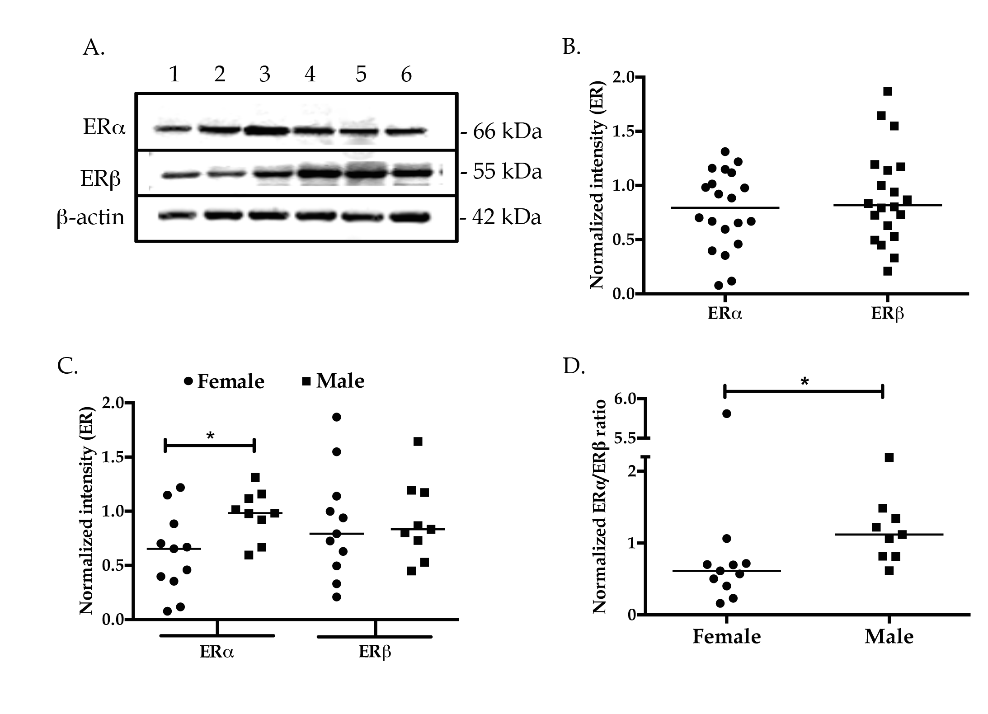
a
Figure 1 Expression of estrogen receptor subtypes in whole tissue lysates from normal male and female subjects. A: Whole tissue lysates from liver tissues of normal donors were subjected to Western blotting and probed with antibodies against ERα, ERβ and β-actin. A representative blot is shown. B-D: The bands corresponding to ERα, ERβ and β-actin were quantified by densitometric analyses using ImageJ. Each symbol represents one individual. Expression of the ER subtypes was normalized to the expression of β-actin and plotted (B). Gender-based ER subtype expression was evaluated by segregating the gender and plotted (C). The ERα:ERβ expression ratio was also plotted for each gender group (D). ªP < 0.05 was considered significant. ER: estrogen receptor.

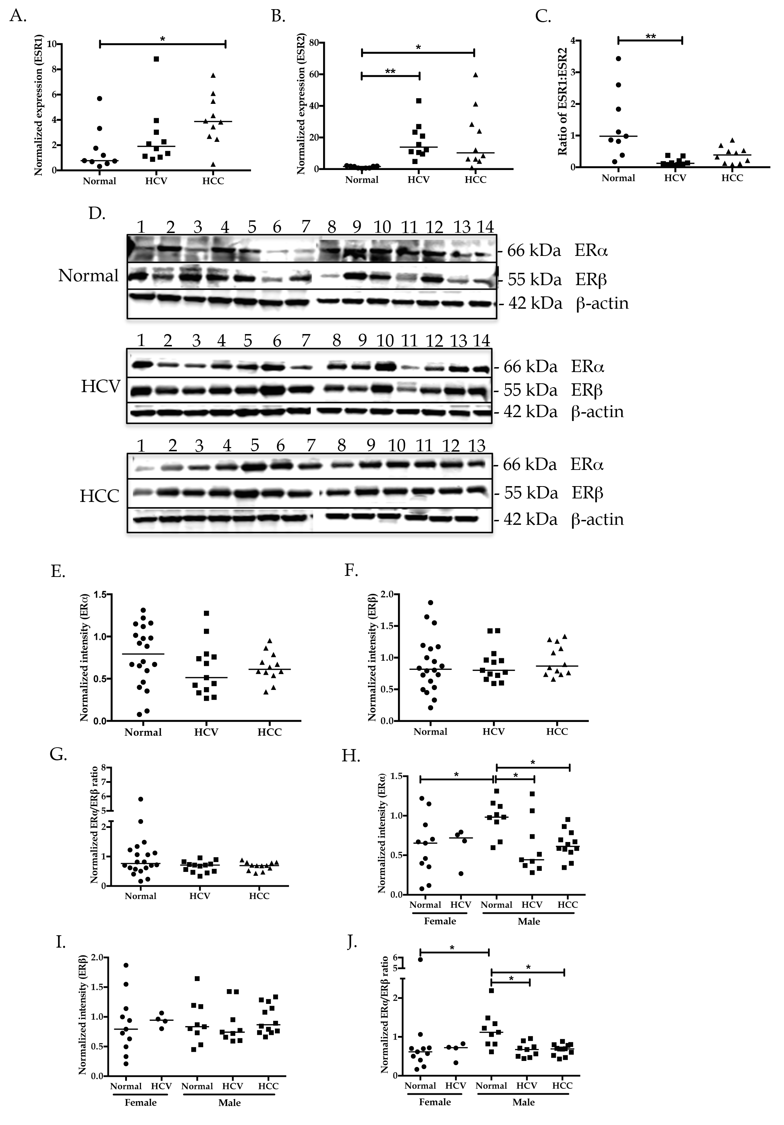
Figure 2 Expression of estrogen receptor subtypes from normal and diseased subjects. A-C: Total RNA extracted from normal, HCV-related cirrhosis and HCV-related HCC livers was subjected to RT-PCR. The abundance of ESR1 (A) and ESR2 (B) transcripts was determined by real time PCR and normalized to the expression of HPRT. ESR1:ESR2 expression ratio was also plotted for the three groups (C). ªP < 0.05 or ^{b}P < 0.001 was considered significant. D: Whole tissue lysates from liver tissues of normal, HCV and HCC subjects were subjected to Western blotting and probed with antibodies against ERα, ERβ and β-actin. Representative blots for each group are depicted. E-J: The bands corresponding to ERα, ERβ and β-actin were quantified by densitometric analyses using ImageJ. Expression of the ERα and ERβ was normalized to the expression of β-actin and plotted (E and F). The ERα:ERβ expression ratio was also plotted for normal, HCV and HCC group (G). Expression of ER subtypes and ERα:ERβ expression ratio in the male population of normal, HCV and HCC groups was plotted separately (H-J). ªP < 0.05 was considered significant. HCV: hepatitis C virus; HCC: hepatocellular carcinoma; ER: estrogen receptor.

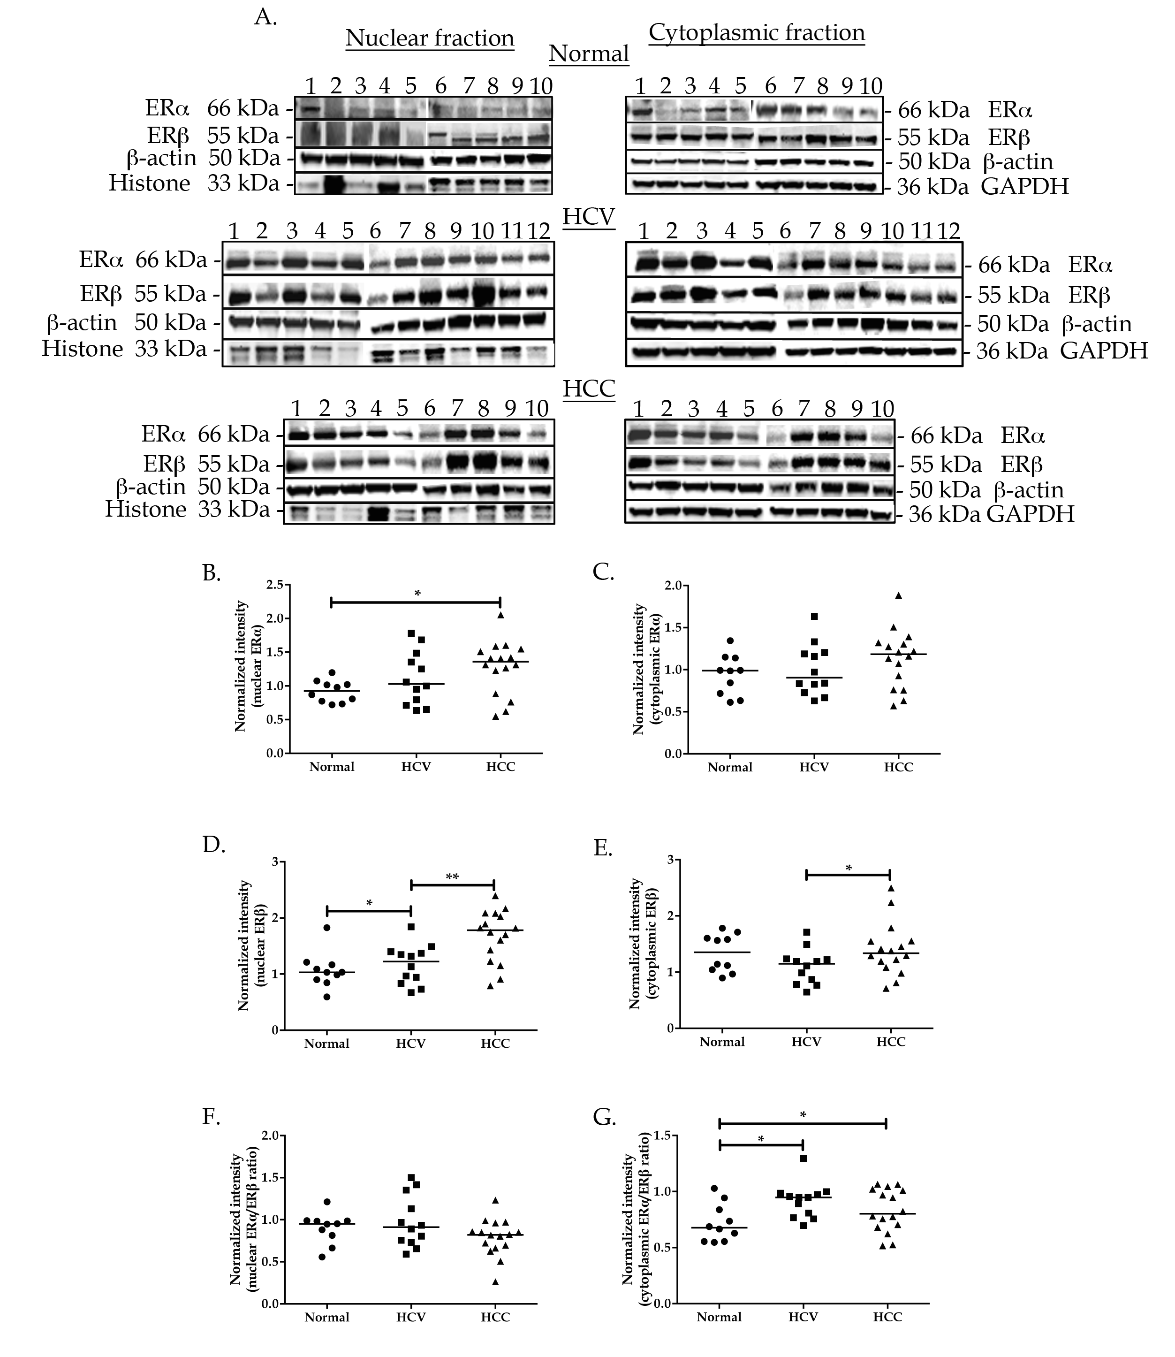
Figure 3 Expression of estrogen receptor subtypes in nuclear and cytoplasmic tissue lysates from normal and diseased subjects. A: Lysates prepared from nuclear and cytoplasmic fractions of liver tissues from normal, HCV and HCC subjects were subjected to Western blotting and probed with antibodies against ERα, ERβ, β-actin, histone (nuclear lysates only) and GAPDH (cytoplasmic lysates only). Representative blots for each group are depicted. B-G: The bands corresponding to ERα, ERβ and β-actin were quantified by densitometric analyses using ImageJ. Expression of the ERα and ERβ was normalized to the expression of β-actin and plotted with (B and C). The ERα:ERβ expression ratio was also plotted for normal, HCV and HCC group (D). Expression of ER subtypes and ERα:ERβ expression ratio in the male population of normal, HCV and HCC groups was plotted separately (E-G). ªP < 0.05 or ^{b}P < 0.001 was considered significant. HCV: hepatitis C virus; HCC: hepatocellular carcinoma; ER: estrogen receptor.

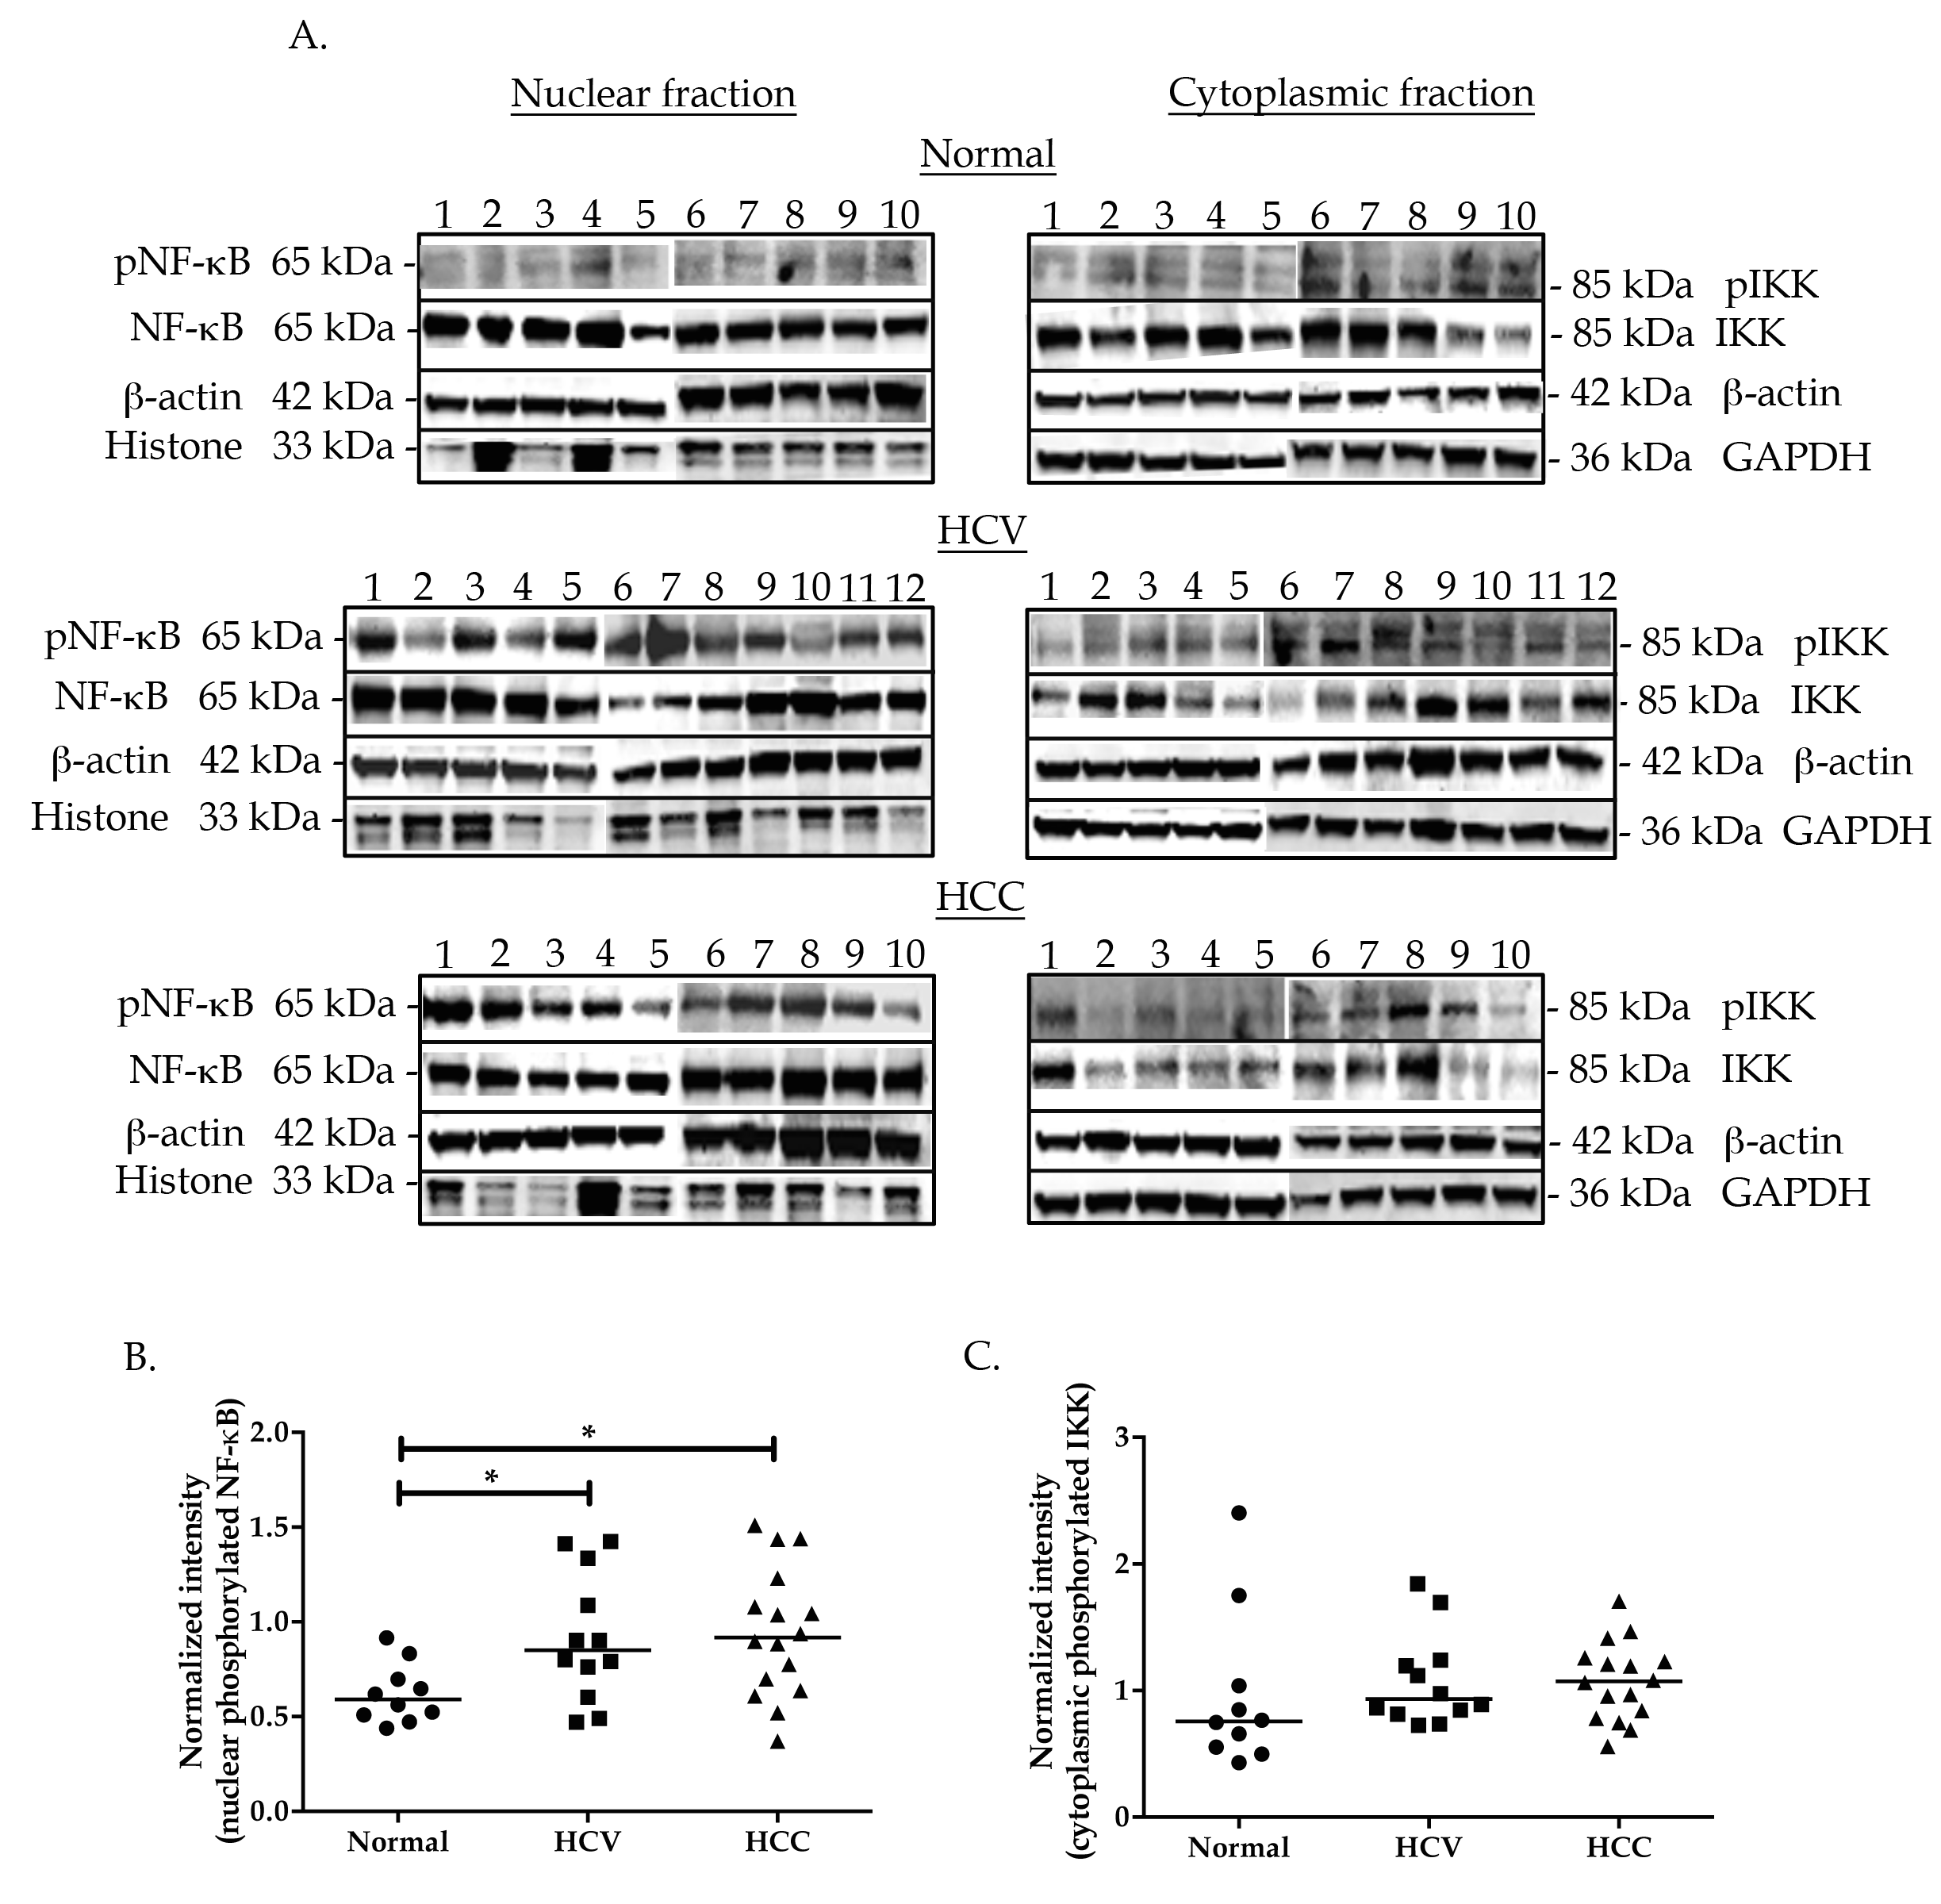
Figure 4 Expression of pNF-κB and pIKK in nuclear and cytoplasmic tissue lysates from normal and diseased subjects. A: Lysates prepared from nuclear and cytoplasmic fractions of liver tissues from normal, HCV and HCC subjects were subjected to Western blotting. Nuclear tissue lysates were probed with antibodies against pNF-κB, NF-κB, β-actin, and histones while cytoplasmic tissue lysates were probed with antibodies against pIKK, IKK, β-actin and GAPDH. Representative blots for each group are depicted (A). B and C: The bands corresponding to pNF-κB, NF-κB, pIKK, IKK and β-actin were quantified by densitometric analyses using ImageJ. The ratio of pNF-κB:NF-κB was normalized to the expression of β-actin and plotted (B). The ratio of pIKK:IKK was normalized to the expression of β-actin and plotted with gender pooled (C) subjects. ªP < 0.05 was considered significant. HCV: hepatitis C virus; HCC: hepatocellular carcinoma; ER: estrogen receptor.

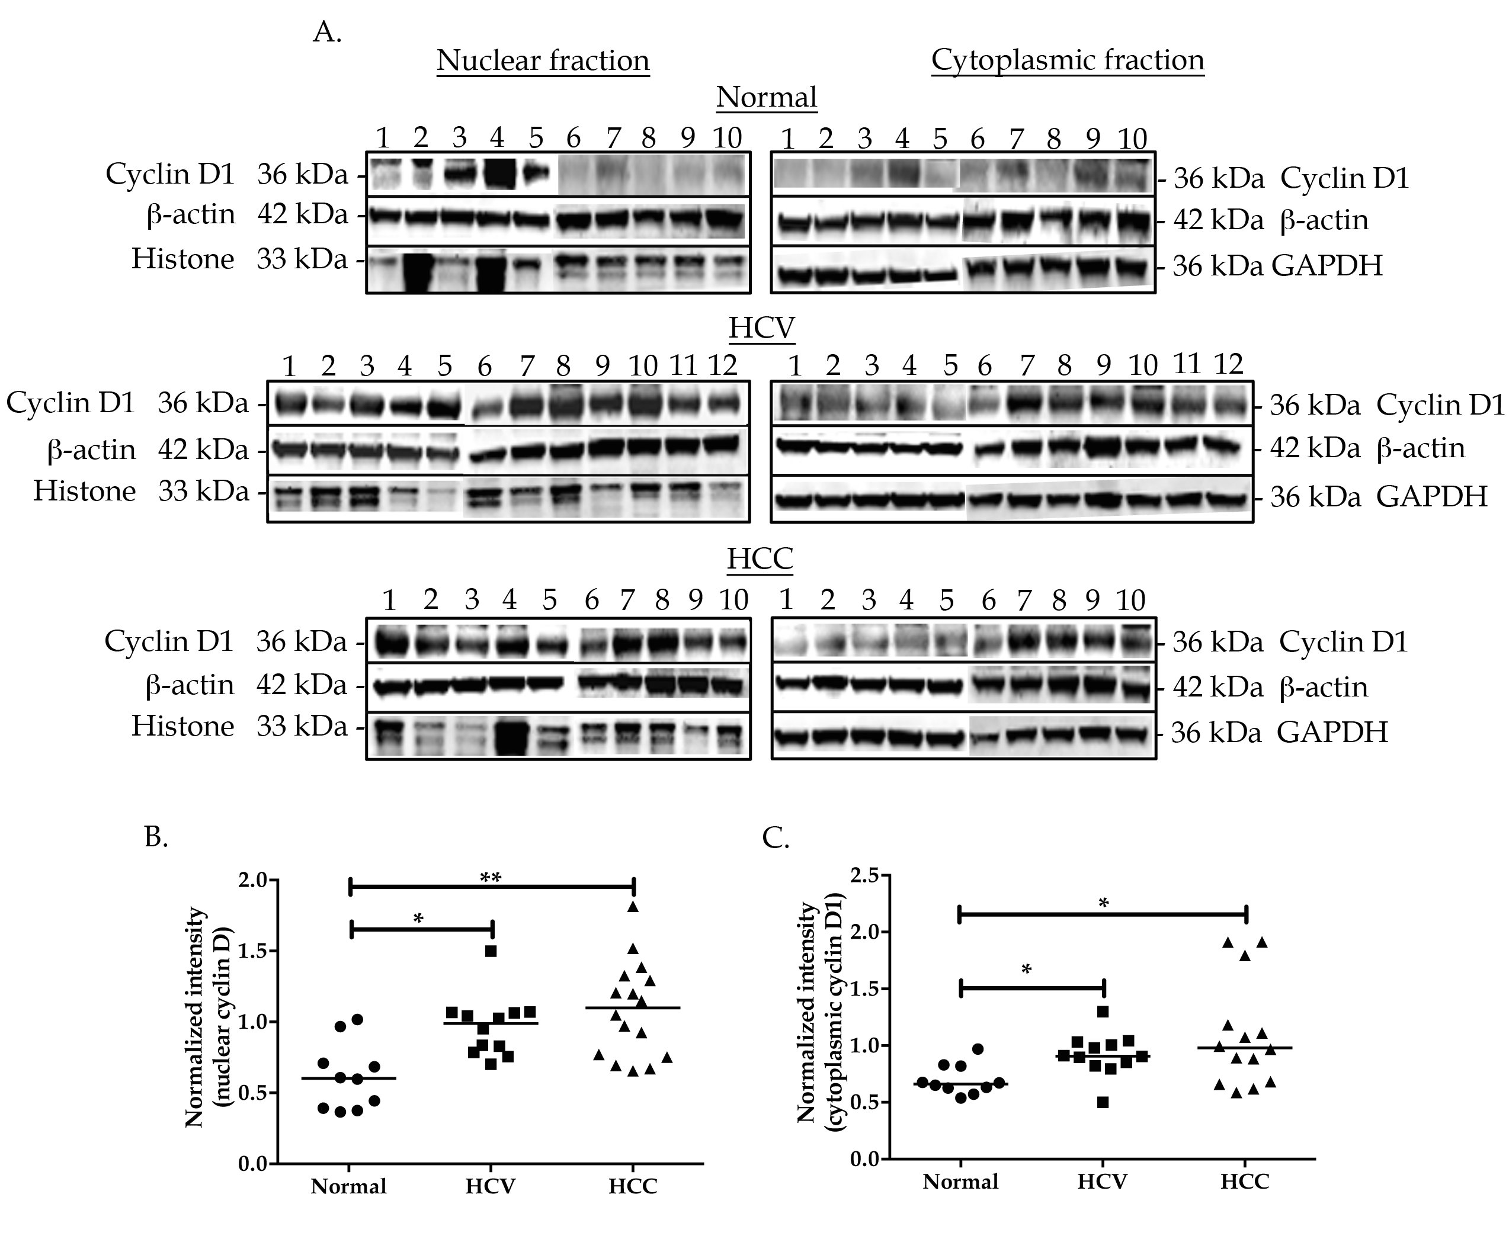
D.
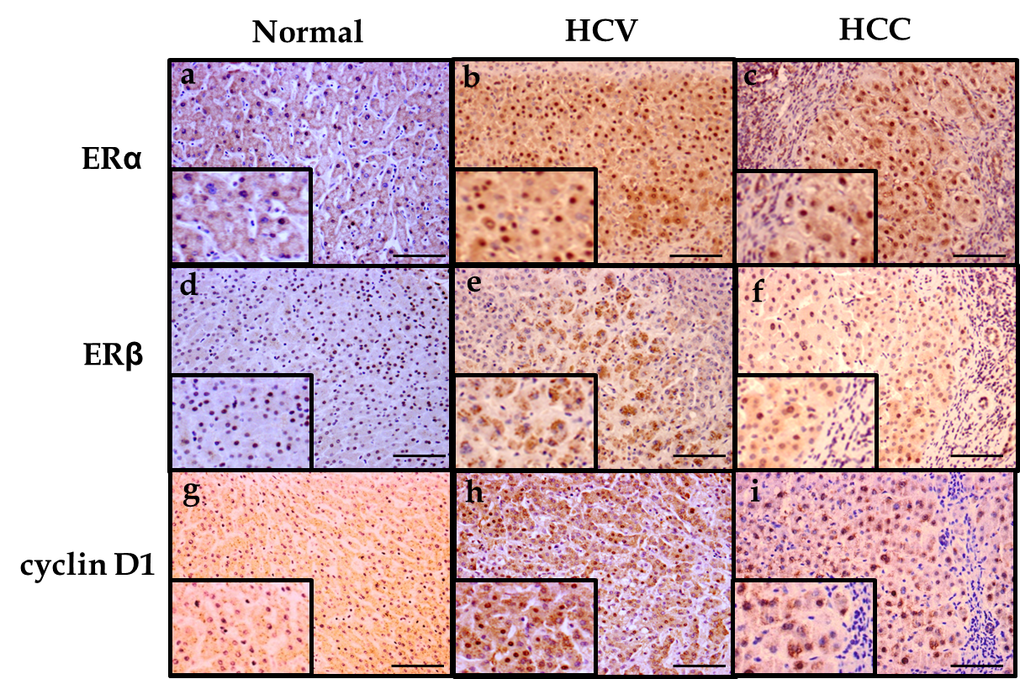
Figure 5 Expression of cyclin D1 in nuclear and cytoplasmic tissue lysates from normal and diseased subjects. A: Lysates prepared from nuclear and cytoplasmic fractions of liver tissues from normal, HCV and HCC subjects were subjected to Western blotting and probed with antibodies against cyclin D1, β-actin, histones (nuclear lysates only) and GAPDH (cytoplasmic lysates only). Representative blots for each group are depicted. B and C: The bands corresponding to cyclin D1 and β-actin were quantified by densitometric analyses using ImageJ. Expression of cyclin D1 was normalized to the expression of β-actin in nuclear (B) and cytoplasmic (C) lysates and plotted. ªP < 0.05 or ^{b}P < 0.001 was considered significant. D: Immunohistochemical staining of ERα, ERβ and cyclin D1 in normal (a, d, g), HCV-related cirrhosis (b, e, h) and HCV-related HCC (c, f, i) is depicted. A magnified region of the stained tissue section is depicted as an inset in each corresponding image. Scale bar = 100 μm. HCV: hepatitis C virus; HCC: hepatocellular carcinoma.

Table 1 Age ranges of normal and diseased subjects in whole tissue lysates
Group | No. of subjects | No. of females | Age range (yr) | No. of males | Age range (yr)
Normal | 20 | 11 | 42-67 | 9 | 34-64
HCV | 14 | 4 | 53-60 | 10 | 43-55
HCC | 14 | 1 | 56 | 13 | 44-66
HCV: hepatitis C virus; HCC: hepatocellular carcinoma.

Table 2 Age ranges of normal and diseased subjects in mRNA analysis
Group | No. of subjects | No. of females | Age range (yr) | No. of males | Age range (yr)
Normal | 20 | 11 | 42-67 | 9 | 34-64
HCV | 14 | 4 | 53-60 | 10 | 43-55
HCC | 14 | 1 | 56 | 13 | 44-66
HCV: hepatitis C virus; HCC: hepatocellular carcinoma.

Table 3 Age ranges of normal and diseased subjects in nuclear and cytoplasmic tissue lysates
HCV: hepatitis C virus; HCC: hepatocellular carcinoma.
Group | No. of subjects | No. of females | Age range (yr) | No. of males | Age range (yr)
Normal | 10 | 5 | 43-67 | 5 | 50-64
HCV | 12 | 3 | 51-60 | 9 | 46-53
HCC | 16 | 0 | NA | 16 | 44-66

Table 4 Spearman correlations of ERα and ERβ expression in whole tissue lysates with nuclear cyclin D1, nuclear phosphorylated NF-κB and cytoplasmic phosphorylated IKK expression
Correlations with WTL ERα
 | r-coefficient (P value)
 | Normal | HCV | HCC
ERβ | 0.4154 (0.0692) | 0.81944 (0.0006)^{b} | 0.70339 (0.0107)ª
Nuclear cyclin D1 | 0.62189 (0.0549) | 0.88842 (0.0075)ª | -0.29785 (0.3737)
Nuclear pNF-κB | 0.02757 (0.9397) | 0.84435 (0.0169)ª | 0.19351 (0.5686)
Cytoplasmic pIKK | -0.21577 (0.5494) | -0.09787 (0.8346) | -0.37679 (0.2534)
Correlations with WTL ERβ
Nuclear cyclin D1 | -0.03251 (0.9290) | 0.92648 (0.0027)ª | -0.70135 (0.0162)ª
Nuclear pNF-κB | -0.18056 (0.6176) | 0.71732 (0.0696) | 0.41196 (0.2080)
Cytoplasmic pIKK | 0.24608 (0.4931) | -0.21801 (0.6386) | -0.03438 (0.9201)
ªP < 0.05, ^{b}P < 0.001. HCV: hepatitis C virus; HCC: hepatocellular carcinoma; ER: estrogen receptor; WTL: whole tissue lysates.

Correlations with nuclear ERα
 | r-coefficient (P value)
 | Normal | HCV | HCC
Nuclear ERβ | 0.63880 (0.0468)ª | 0.63539 (0.0264)ª | 0.73192 (0.0008)^{b}
Nuclear cyclin D1 | 0.12049 (0.7402) | 0.75728 (0.0043)ª | 0.55714 (0.0202)ª
Nuclear pNF-κB | -0.62968 (0.0511)^{c} | 0.207 (0.5186) | 0.4793 (0.0516)^{c}
Correlations with nuclear ERβ
Nuclear cyclin D1 | 0.44012 (0.2031) | 0.64445 (0.0237)ª | 0.51223 (0.0355)ª
Nuclear pNF-κB | -0.52091 (0.1226) | 0.10243 (0.7514) | 0.25861 (0.3162)
Table 5 Spearman correlations of ERα and ERβ expression in nuclear tissue lysates with nuclear cyclin D1 and nuclear phosphorylated NF-κB expression
ªP < 0.05, ^{b}P < 0.001, ^{c}P < 0.055. HCV: hepatitis C virus; HCC: hepatocellular carcinoma; ER: estrogen receptor.
Correlations with cytoplasmic ERα
 | r-coefficient (P value)
 | Normal | HCV | HCC
Cytoplasmic ERβ | 0.61233 (0.0599) | 0.74376 (< 0.0001)ª | 0.79765 (0.0158)^{b}
Cytoplasmic pIKK | -0.66837 (0.0346)ª | -0.00698 (0.9828) | -0.56014 (0.0194)ª
Correlations with cytoplasmic ERβ
Cytoplasmic ERα | 0.61233 (0.0599) | 0.91363 (< 0.0001)^{b} | 0.79765 (0.0001)^{b}
Cytoplasmic pIKK | -0.60909 (0.0616) | -0.29717 (0.3482) | -0.60848 (0.0095)ª
Table 6 Spearman correlations of ERα and ERβ expression in cytoplasmic tissue lysates with cytoplasmic pIKK
ªP < 0.05, ^{b}P < 0.001. HCV: hepatitis C virus; HCC: hepatocellular carcinoma; ER: estrogen receptor.

