Name of Journal: World Journal of Clinical Cases
Manuscript NO: 62218
Manuscript Type: CASE REPORT

Laterally spreading tumor-like primary rectal mucosa-associated lymphoid tissue lymphoma: A case report

Wei YL et al. Primary rectal MALT lymphoma

Ya-Li Wei, Cong-Cong Min, Lin-Lin Ren, Shan Xu, Yun-Qing Chen, Qi Zhang, Wen-Jun Zhao, Cui-Ping Zhang, Xiao-Yan Yin

Ya-Li Wei, Cong-Cong Min, Lin-Lin Ren, Shan Xu, Qi Zhang, Wen-Jun Zhao, Cui-Ping Zhang, Xiao-Yan Yin, Department of Gastroenterology, The Affiliated Hospital of Qingdao University, Qingdao 266003, Shandong Province, China

Yun-Qing Chen, Department of Pathology, The Affiliated Hospital of Qingdao University, Qingdao 266003, Shandong Province, China

Author contributions: Wei YL wrote the manuscript; Yin XY performed endoscopic submucosal dissection for the patient and revised the article; Min CC and Ren LL revised the manuscript; Chen YQ contributed to the histopathology and immunohistochemistry staining; all other authors reviewed and approved the final manuscript to be published.

Corresponding author: Xiao-Yan Yin, MD, PhD, Chief Doctor, Department of Gastroenterology, The Affiliated Hospital of Qingdao University, No. 16 Jiangsu Road, Qingdao 266003, Shandong Province, China. yxy4503@163.com

Received: January 2, 2021
Revised: January 31, 2021
Accepted: March 9, 2021
Published online: June 6, 2021

Abstract
BACKGROUND
Colorectal mucosa-associated lymphoid tissue (MALT) lymphoma is a rare disease, and only a few cases have been reported to date. It has no specific clinical presentations and shows various endoscopic appearances. There is no uniform consensus on its treatment. With the advancement of endoscopic technology, endoscopic treatment has achieved better results in individual case reports of early-stage patients.

CASE SUMMARY
We report a case of rectal MALT in a 57-year-old Chinese man with no symptoms who received endoscopy as part of a routine physical examination, which incidentally found a 25 mm × 20 mm, laterally spreading tumor (LST)-like elevated lesion in the rectum. Therefore, he was referred to our hospital for further endoscopic treatment. Complete and curable removal of the tumor was performed by endoscopic submucosal dissection. We observed enlarged and dilated branch-like vessels similar to those of gastric MALT lymphoma on magnifying endoscopy with narrow-band imaging. And immunopathological staining showed hyperplastic capillaries in the mucosa. Histopathological findings revealed diffusely hyperplastic lymphoid tissue in the lamina propria, with a visible lymphoid follicle structure surrounded by a large number of diffusely infiltrated lymphoid cells that had a relatively simple morphology and clear cytoplasm. In addition, immunohistochemical analysis suggested strongly positive expression for CD20 and Bcl-2. Gene rearrangement results showed positivity for IGH-A, IGH-C, IGK-B, and IGL. Taking all the above findings together, we arrived at a diagnosis of extranodal marginal zone B-cell lymphoma of MALT lymphoma. Positron emission tomography-computed tomography examination showed no other lesions involved. The patient will be followed by periodic endoscopic observation.

CONCLUSION
In conclusion, we report a case of rectal MALT with an LST-like appearance treated by endoscopic submucosal dissection. Further studies will be needed to explore the clinical behavior, endoscopic appearance, and treatment of rectal MALT.

Key Words: Primary rectal mucosa-associated lymphoid tissue lymphoma; Laterally spreading tumor; Endoscopic submucosal dissection; Mucosa-associated lymphoid tissue; Case report

©The Author(s) 2021. Published by Baishideng Publishing Group Inc. All rights reserved.

Wei YL, Min CC, Ren LL, Xu S, Chen YQ, Zhang Q, Zhao WJ, Zhang CP, Yin XY. Laterally spreading tumor-like primary rectal mucosa-associated lymphoid tissue lymphoma: A case report. World J Clin Cases 2021; 9(16): 3988-3995 URL: https://www.wjgnet.com/2307-8960/full/v9/i16/3988.htm DOI: https://dx.doi.org/10.12998/wjcc.v9.i16.3988

Core Tip: Compared to mucosa-associated lymphoid tissue (MALT) in the stomach, primary rectal MALT lymphoma remains a rare disease. There are no representative clinical symptoms or endoscopic features reported in the literature. We report a case of rectal MALT lymphoma with a laterally spreading tumor-like appearance. The lesion presented enlarged and dilated vessels on the surface. Endoscopic submucosal dissection was performed. The histopathological and immunohistochemical findings led to a diagnosis of rectal MALT lymphoma.
INTRODUCTION
Mucosa-associated lymphoid tissue (MALT) lymphoma is a subtype of B cell lymphoma occurring in the extranodal lymphoid tissue marginal zone. It can involve various organs, including the gastrointestinal tract, salivary glands, thyroid, lung, and breast^{[1]}. The stomach is one of the organs where MALT lymphoma most commonly occurs. Its development is thought to be closely associated with Helicobacter pylori (H. pylori) infection^{[2,3]}. Unlike gastric MALT, the occurrence of colorectal MALT is extremely rare, and only a few cases have been reported to date. Its clinical presentations, endoscopic features, and treatment outcomes have not been established because of its rarity.
Here, we present a case of rectal MALT treated by endoscopic submucosal dissection (ESD) and discuss the clinical behaviors, endoscopic features, and treatment outcomes of rectal MALT through a brief review of the literature.

CASE PRESENTATION
Chief complaints
A 57-year-old Chinese man presented to our hospital for further management of a laterally spreading tumor (LST)-like lesion in the proximal rectum accidently discovered on colonoscopy over 1 mo prior.

History of present illness
The biopsy results indicated an inflammatory hyperplastic polyp. The patient had no obvious symptoms and received screening endoscopy as part of a routine health examination. Gastroscopy showed chronic atrophic gastritis and inflammation of the cardia.

History of past illness
The patient had a history of diabetes mellitus for more than 6 mo and was administered metformin and other drugs to control his blood sugar. He also had a history of hypertension for more than 1 mo without medication.

Personal and family history
He had a long smoking history of over 30 years, with an average of 20 cigarettes per day. He also had a drinking history for more than 30 years, with half a catty of liquor per day.

Physical examination
Physical examination upon admission showed that the patient was 1.82 m in height and 94 kg in weight. He had a blood pressure of 139/84 mmHg with a heart rate of 68 beat/min. He had clear lungs and normal heart sounds with no murmurs or gallops on auscultation. There were no obvious pathognomonic signs during physical examination of the abdomen.

Laboratory examinations
No significant abnormal laboratory results were recorded in this patient.

Imaging examinations
Colonoscopy in our hospital also revealed a 25 mm × 20 mm, LST-like slightly elevated lesion in the proximal rectum with a red color (Figure 1A). To observe the microstructure and capillaries of the lesion, magnifying endoscopy with narrow-band imaging (NBI) was carried out. It showed enlarged and dilated branch-like vessels on the surface of the tumor similar to those of gastric MALT lymphoma (Figure 1B). The margin of the lesion became clearer, and a type II pit pattern was observed on magnifying endoscopy after indigo carmine staining (Figure 1C and D). Gastroscopy revealed atrophic gastritis and cardia mucosa erosion with irregular microstructure and capillaries on magnifying endoscopy. The biopsy pathology indicated cardia inflammation with mild glandular atypia in the absence of H. pylori. Therefore, there were no endoscopic and pathological findings indicating gastric MALT lymphoma. Abdominal computed tomography showed no obvious abnormalities.

FINAL DIAGNOSIS
Based on endoscopic performance, histopathologic characteristics, and gene arrangement results, the patient was finally diagnosed with extranodal marginal zone B-cell lymphoma of MALT lymphoma.

TREATMENT
To obtain the specimen for pathology and treat the lesion, the patient underwent curative ESD. On assessment of the ESD specimen, a slightly elevated, LST-like lesion measuring 25 mm × 20 mm was identified in the mucosal layer (Figure 1E).
Histopathological findings of the ESD specimen showed diffusely hyperplastic lymphoid tissue in the lamina propria with a lymphoid follicle structure surrounded by an abundance of diffusely infiltrated lymphoid cells. These lymphoid cells exhibited clear cytoplasm and similar sizes (Figure 2). The margins were negative.
On immunohistochemical examination, BCL-2 and CD20 were strongly expressed in the tumor (Figure 3A and B), CD3 and CD21 were positive (Figure 3C and D), and CD10 and BCL-6 showed scattered positivity in the lesion (Figure 3E and F). CKpan was expressed in the residual epithelium, and CyclinD1 was negative in the tumor (Figure 3G and H). The Ki-67 labeling index was 20% (Figure 3I).
CD31 was used to mark the vascular endothelium in the mucosa, which showed hyperplastic capillaries but not obvious branch-like (Figure 4). Desmin labeling the muscularis mucosa indicated that the tumor was located in the mucosal layer and did not break through the muscularis mucosa. The tumor showed expansive growth, which made the muscularis mucosa obviously thinner (Figure 5).
Gene arrangement analysis showed that the specific IG genes in the original B lymphocytes were rearranged and displayed positive reactions for IGH-A, IGH-C, IGK-B, and IGL. IGH-B formed a typical monoclonal peak, but not in the positive range.

OUTCOME AND FOLLOW-UP
Complete and curable removal by ESD was performed. According to the suggestion of the hematology department, positron emission tomography-computed tomography was also performed, and no obvious tumor was found throughout the body. The patient required regular clinical and colonoscopic follow-up. The first endoscopy will be performed approximately 6 mo later, followed by a period of 6 mo to 1 year.

DISCUSSION
Primary gastrointestinal mucosa-associated non-Hodgkin lymphoma is most often located in the stomach, and the large intestine is rarely involved^{[4,5]}. Primary colorectal lymphoma accounts for approximately 10% of all gastrointestinal lymphomas and 0.2% of colorectal malignancies^{[6,7]}. Li et al^{[8]} reported that abdominal pain was the most common symptom of primary colorectal lymphoma, and other symptoms, including diarrhea, blood stool, nausea, and changes in defecation habits, could also occur in primary colorectal lymphoma, according to their retrospective analysis of the clinical features of 40 cases of primary colorectal MALT lymphoma. Later, Jeon et al^{[9]} reported that half of 51 cases were asymptomatic, and their lesions were discovered through screening colonoscopies in asymptomatic adults. Our patient also had no obvious symptoms, and the lesion was found only by routine endoscopy examination. Therefore, it is difficult to make a diagnosis through the clinical symptoms alone.
By reviewing the colonoscopy images of 51 patients, Jeon et al^{[9]} divided the gross morphology of MALT lymphoma into polyposis, subepithelial tumor, epithelial mass, and ileitis type under white light endoscopy. However, there has been no further observation or study of the vessel and structure under image-enhanced colonoscopy. Tree-like-appearance blood vessels observed on magnified NBI have become the key to the diagnosis of gastric MALT lymphoma^{[10,11]}. Unlike in the stomach, there are no qualitative endoscopic features to assist in the diagnosis of intestinal lymphoma. Hasegawa et al^{[12]} reported a case of colon MALT lymphoma with magnified NBI in 2013 and found that the surface blood vessels showed dilated dendritic changes. In our case, LST was diagnosed under white light endoscopy. Magnifying endoscopy with narrowband imaging showed dilated branch-like vessels on the surface of the tumor, and a type II pit pattern was observed by indigo carmine staining. To further analyze the pathological characteristics of vessels, CD31 staining showed hyperplastic capillaries in the mucosa, but no obvious branch-like structures. Therefore, we suggest that dilated branch-like vessels may be a typical endoscopic feature of colorectal MALT, similar to gastric MALT. But it still needs more endoscopic and pathological studies to verify the meaning of the vessels.
The association of H. pylori and gastric MALT lymphoma is unquestioned, but the correlation with colorectal MALT lymphoma is uncertain. Matsuo et al^{[13]} reported a case of H. pylori-positive colon MALT lymphoma but did not report H. pylori eradication treatment. Kelley^{[14]} retrospectively analyzed 51 primary rectal lymphoma patients, only 12 of whom were H. pylori-positive, and did not confirm a relationship between this bacterium and the disease because there was no direct pathological evidence on rectal biopsy. Kikuchi et al^{[15]} summarized the literature on antibiotic treatment in patients with H. pylori-negative primary colorectal lymphoma and found that it may be associated with other luminal microorganisms. Therefore, the relationship between primary colorectal MALT lymphoma and H. pylori or other microbes needs further investigation.
There is no uniform standard for the treatment of colorectal MALT lymphoma. According to the Lugano staging system, lymphoma confined to the gastrointestinal tract is stage I^{[16]}, which can have better outcomes from advanced endoscopic therapy^{[17]}. Kajihara^{[18]} reported that endoscopic mucosal resection was performed for primary rectal MALT lymphoma, with no sign of recurrence at the 5-year follow-up. Akasaka et al^{[19]} reported on two colorectal lymphoma patients who underwent ESD treatment, and no clinical evidence of recurrence was found after regular examination. Besides, radiotherapy is also effective. Okamura et al^{[20]} reported that three stage I cases achieved complete remission by radiotherapy. This clinical effect was also confirmed in case reports of Amouri et al^{[21]}, Foo et al^{[22]}, and Hayakawa et al^{[23]}. The lesion in our case, limited to the rectum with no other tumor, was classified as stage I and was completely removed by ESD. The patient will be regularly monitored by clinical and colonoscopic follow-up.

CONCLUSION
In summary, primary rectal MALT lymphoma is a rare clinical entity. The clinical symptoms and endoscopic appearances are not specific, so more studies need to investigate them. With the continuous advancements in endoscopy, endoscopic treatment may become the priority for early-stage lesions.

ACKNOWLEDGEMENTS
We thank all the authors who contributed to this article.

REFERENCES
1 Zucca E, Conconi A, Pedrinis E, Cortelazzo S, Motta T, Gospodarowicz MK, Patterson BJ, Ferreri AJ, Ponzoni M, Devizzi L, Giardini R, Pinotti G, Capella C, Zinzani PL, Pileri S, López-Guillermo A, Campo E, Ambrosetti A, Baldini L, Cavalli F; International Extranodal Lymphoma Study Group. Nongastric marginal zone B-cell lymphoma of mucosa-associated lymphoid tissue. Blood 2003; 101: 2489-2495 [PMID: 12456507 DOI: 10.1182/blood-2002-04-1279]
2 Parsonnet J, Hansen S, Rodriguez L, Gelb AB, Warnke RA, Jellum E, Orentreich N, Vogelman JH, Friedman GD. Helicobacter pylori infection and gastric lymphoma. N Engl J Med 1994; 330: 1267-1271 [PMID: 8145781 DOI: 10.1056/NEJM199405053301803]
3 Wotherspoon AC, Ortiz-Hidalgo C, Falzon MR, Isaacson PG. Helicobacter pylori-associated gastritis and primary B-cell gastric lymphoma. Lancet 1991; 338: 1175-1176 [PMID: 1682595 DOI: 10.1016/0140-6736(91)92035-z]
4 Zucca E, Roggero E, Bertoni F, Cavalli F. Primary extranodal non-Hodgkin's lymphomas. Part 1: Gastrointestinal, cutaneous and genitourinary lymphomas. Ann Oncol 1997; 8: 727-737 [PMID: 9332679 DOI: 10.1023/a:1008282818705]
5 Zinzani PL, Magagnoli M, Pagliani G, Bendandi M, Gherlinzoni F, Merla E, Salvucci M, Tura S. Primary intestinal lymphoma: clinical and therapeutic features of 32 patients. Haematologica 1997; 82: 305-308 [PMID: 9234576 DOI: 10.2139/ssrn.614864]
6 Kim YH, Lee JH, Yang SK, Kim TI, Kim JS, Kim HJ, Kim JI, Kim SW, Kim JO, Jung IK, Jung SA, Jung MK, Kim HS, Myung SJ, Kim WH, Rhee JC, Choi KY, Song IS, Hyun JH, Min YI. Primary colon lymphoma in Korea: a KASID (Korean Association for the Study of Intestinal Diseases) Study. Dig Dis Sci 2005; 50: 2243-2247 [PMID: 16416168 DOI: 10.1007/s10620-005-3041-7]
7 Dionigi G, Annoni M, Rovera F, Boni L, Villa F, Castano P, Bianchi V, Dionigi R. Primary colorectal lymphomas: review of the literature. Surg Oncol 2007; 16 Suppl 1: S169-S171 [PMID: 18024019 DOI: 10.1016/j.suronc.2007.10.021]
8 Li B, Shi YK, He XH, Zou SM, Zhou SY, Dong M, Yang JL, Liu P, Xue LY. Primary non-Hodgkin lymphomas in the small and large intestine: clinicopathological characteristics and management of 40 patients. Int J Hematol 2008; 87: 375-381 [PMID: 18409078 DOI: 10.1007/s12185-008-0068-5]
9 Jeon MK, So H, Huh J, Hwang HS, Hwang SW, Park SH, Yang DH, Choi KD, Ye BD, Myung SJ, Yang SK, Byeon JS. Endoscopic features and clinical outcomes of colorectal mucosa-associated lymphoid tissue lymphoma. Gastrointest Endosc 2018; 87: 529-539 [PMID: 28882576 DOI: 10.1016/j.gie.2017.08.027]
10 Nonaka K, Nishimura M, Kita H. Role of narrow band imaging in endoscopic submucosal dissection. World J Gastrointest Endosc 2012; 4: 387-397 [PMID: 23125896 DOI: 10.4253/wjge.v4.i9.387]
11 Nonaka K, Ohata K, Matsuhashi N, Shimizu M, Arai S, Hiejima Y, Kita H. Is narrow-band imaging useful for histological evaluation of gastric mucosa-associated lymphoid tissue lymphoma after treatment? Dig Endosc 2014; 26: 358-364 [PMID: 24118642 DOI: 10.1111/den.12169]
12 Hasegawa D, Yoshida N, Ishii M, Takamasu M, Kishimoto M, Yagi N, Naitou Y, Yanagisawa A. [A case of colonic mucosa-associated lymphoid tissue lymphoma observed under endoscopy with narrow-band imaging]. Nihon Shokakibyo Gakkai Zasshi 2013; 110: 2100-2106 [PMID: 24305098]
13 Matsuo S, Mizuta Y, Hayashi T, Susumu S, Tsutsumi R, Azuma T, Yamaguchi S. Mucosa-associated lymphoid tissue lymphoma of the transverse colon: a case report. World J Gastroenterol 2006; 12: 5573-5576 [PMID: 17007004 DOI: 10.3748/wjg.v12.i34.5573]
14 Kelley SR. Mucosa-associated lymphoid tissue (MALT) variant of primary rectal lymphoma: a review of the English literature. Int J Colorectal Dis 2017; 32: 295-304 [PMID: 27995323 DOI: 10.1007/s00384-016-2734-z]
15 Kikuchi Y, Matsui T, Hisabe T, Wada Y, Hoashi T, Tsuda S, Yao T, Iwashita A, Imamura K. Deep infiltrative low-grade MALT (mucosal-associated lymphoid tissue) colonic lymphomas that regressed as a result of antibiotic administration: endoscopic ultrasound evaluation. J Gastroenterol 2005; 40: 843-847 [PMID: 16143891 DOI: 10.1007/s00535-005-1639-3]
16 Rohatiner A, d'Amore F, Coiffier B, Crowther D, Gospodarowicz M, Isaacson P, Lister TA, Norton A, Salem P, Shipp M. Report on a workshop convened to discuss the pathological and staging classifications of gastrointestinal tract lymphoma. Ann Oncol 1994; 5: 397-400 [PMID: 8075046 DOI: 10.1093/oxfordjournals.annonc.a058869]
17 Schwartz BL, Lowe RC. Successful Endoscopic Resection of Mucosa-Associated Lymphoid Tissue Lymphoma of the Colon. ACG Case Rep J 2019; 6: e00228 [PMID: 31832456 DOI: 10.14309/crj.0000000000000228]
18 Kajihara Y. Mucosa-associated lymphoid-tissue (MALT) lymphoma of the rectum. QJM 2018; 111: 573 [PMID: 29474645 DOI: 10.1093/qjmed/hcy036]
19 Akasaka R, Chiba T, Dutta AK, Toya Y, Mizutani T, Shozushima T, Abe K, Kamei M, Kasugai S, Shibata S, Abiko Y, Yokoyama N, Oana S, Hirota S, Endo M, Uesugi N, Sugai T, Suzuki K. Colonic mucosa-associated lymphoid tissue lymphoma. Case Rep Gastroenterol 2012; 6: 569-575 [PMID: 23012617 DOI: 10.1159/000342726]
20 Okamura T, Suga T, Iwaya Y, Ito T, Yokosawa S, Arakura N, Ota H, Tanaka E. Helicobacter pylori-Negative Primary Rectal MALT Lymphoma: Complete Remission after Radiotherapy. Case Rep Gastroenterol 2012; 6: 319-327 [PMID: 22754493 DOI: 10.1159/000339461]
21 Amouri A, Chtourou L, Mnif L, Mdhaffar M, Abid M, Ayedi L, Daoud J, Elloumi M, Boudawara T, Tahri N. [MALT lymphoma of the rectum: a case report treated by radiotherapy]. Cancer Radiother 2009; 13: 61-64 [PMID: 19101191 DOI: 10.1016/j.canrad.2008.11.001]
22 Foo M, Chao MW, Gibbs P, Guiney M, Jacobs R. Successful treatment of mucosa-associated lymphoid tissue lymphoma of the rectum with radiation therapy: report of a case. Dis Colon Rectum 2008; 51: 1719-1723 [PMID: 18633678 DOI: 10.1007/s10350-008-9379-0]
23 Hayakawa T, Nonaka T, Mizoguchi N, Hagiwara Y, Shibata S, Sakai R, Nakayama N, Yokose T, Nakayama Y. Radiotherapy for mucosa-associated lymphoid tissue (MALT) lymphoma of the rectum: a case report. Clin J Gastroenterol 2017; 10: 431-436 [PMID: 28815477 DOI: 10.1007/s12328-017-0769-5]

Footnotes
Informed consent statement: Written informed consent from the patient was obtained.

Conflict-of-interest statement: The authors declare that they have no conflict of interest to report.

CARE Checklist (2016) statement: The authors have read the CARE Checklist (2016), and the manuscript was prepared and revised according to the CARE Checklist (2016).

Open-Access: This article is an open-access article that was selected by an in-house editor and fully peer-reviewed by external reviewers. It is distributed in accordance with the Creative Commons Attribution NonCommercial (CC BY-NC 4.0) license, which permits others to distribute, remix, adapt, build upon this work non-commercially, and license their derivative works on different terms, provided the original work is properly cited and the use is non-commercial. See: http://creativecommons.org/Licenses/by-nc/4.0/

Manuscript source: Unsolicited manuscript

Peer-review started: January 2, 2021
First decision: January 27, 2021
Article in press: March 9, 2021

Specialty type: Medicine, research and experimental
Country/Territory of origin: China
Peer-review report’s scientific quality classification
Grade A (Excellent): A, A
Grade B (Very good): B
Grade C (Good): C
Grade D (Fair): D
Grade E (Poor): 0

P-Reviewer: Naem A, Strainiene S, Trifan A, Uesato M S-Editor: Gao CC L-Editor: Wang TQ P-Editor: Ma YJ
Figure Legends
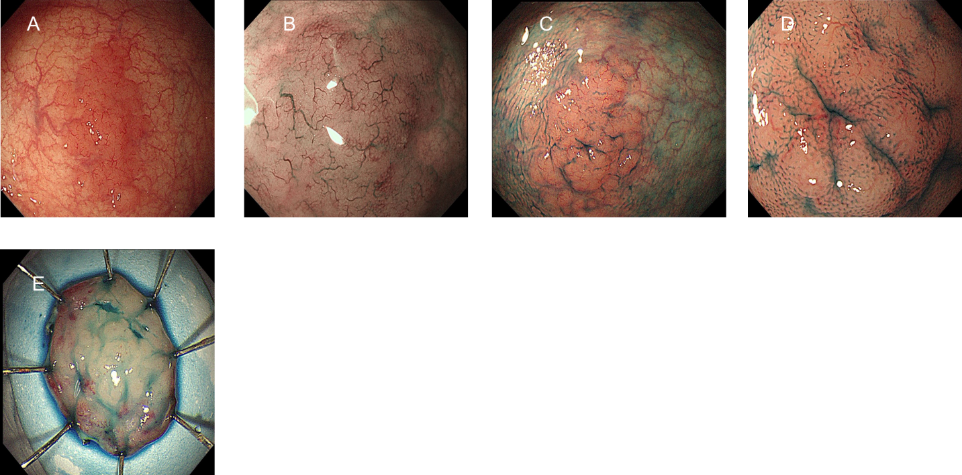
Figure 1 Endoscopic findings. A: A laterally spreading tumor-like elevated lesion was observed on white light endoscopy in the rectum; B: Narrow band imaging showed enlarged branch-like vessels on the surface of the lesion; C and D: Indigo carmine staining made the lesion margin clearer (C), and pit pattern II was observed on magnifying endoscopy (D); E: On assessment of the endoscopic submucosal dissection specimen, a slightly elevated, laterally spreading tumor measuring 25 mm × 20 mm was identified in the mucosal layer.
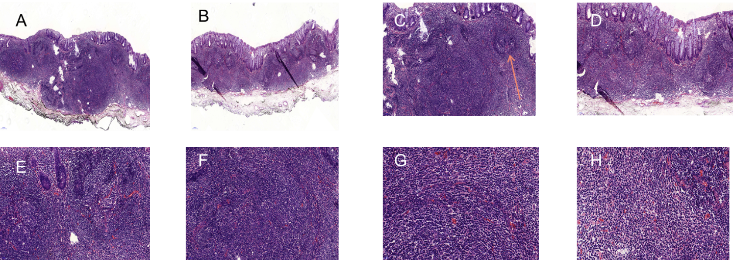
Figure 2 Histopathological findings (hematoxylin and eosin staining). Diffusely hyperplastic lymphoid tissue could be observed in the lamina propria with visible lymphoid follicle structures (orange arrow, C). There were a large number of lymphoid cells around the lymphoid follicles that had clear cytoplasm and similar sizes. A and B: Magnification 50 ×; C and D: Magnification 100 ×; E and F: Magnification 200 ×; G and H Magnification 400 ×.
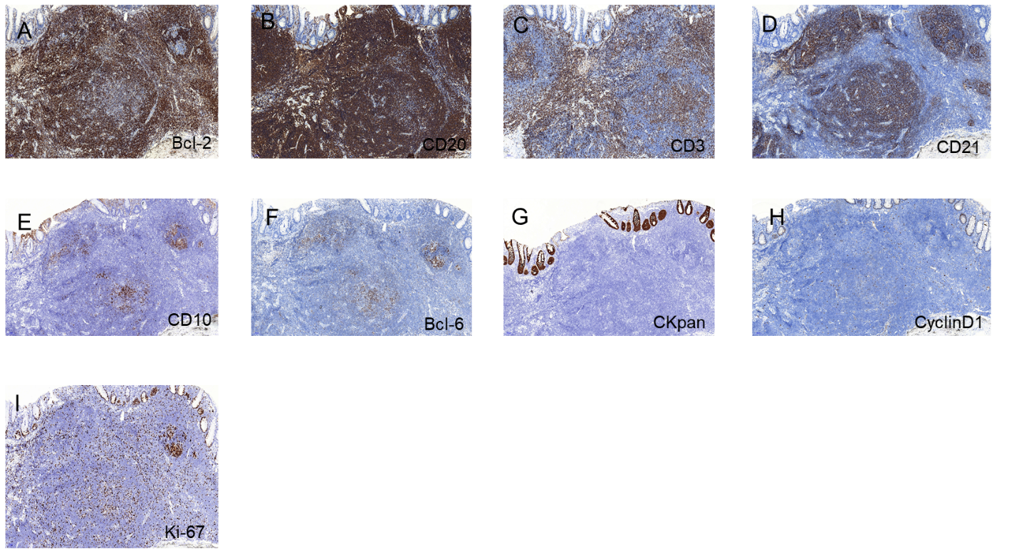
Figure 3 Immunohistochemical findings. A and B: BCL-2 and CD20 were strongly expressed in the tumor; C and D: CD3 and CD21 were positive; E and F: CD10 and BCL-6 showed scattered positivity in the tumor; G: CKpan was expressed in the residual epithelium; H: CyclinD1 was negative in the tumor; I: The Ki-67 labeling index was 20%. Magnification of all photographs is 100 ×.
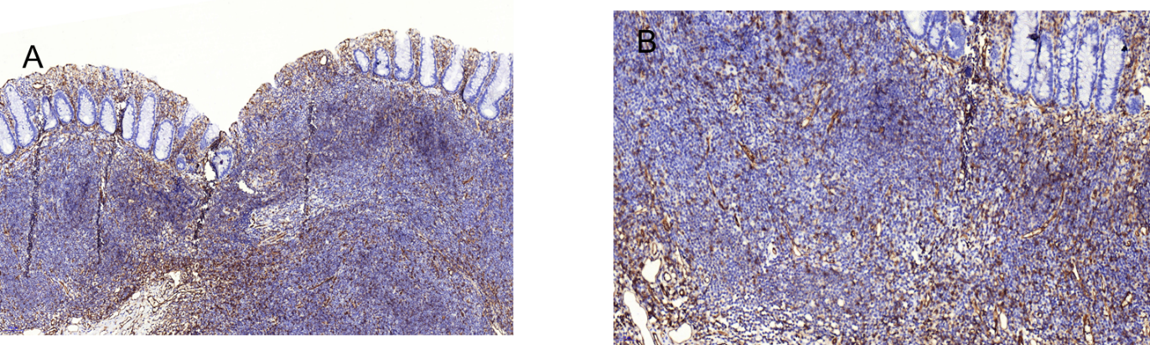
Figure 4 Immunohistochemical findings (CD31 marker). Hyperplastic capillaries can be seen in the mucosa, but the branch-like structures were not obvious. A: Magnification 100 ×; B: Magnification 200 ×.
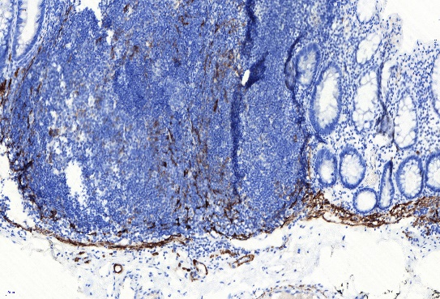
Figure 5 Immunohistochemical findings (Desmin marker). The tumor was located above the muscularis mucosa and did not involve the submucosa, and the expansive growth of the tumor made the muscularis mucosa thinner.

Published by Baishideng Publishing Group Inc
7041 Koll Center Parkway, Suite 160, Pleasanton, CA 94566, USA
Telephone: +1-925-3991568
E-mail: bpgoffice@wjgnet.com
Help Desk: https://www.f6publishing.com/helpdesk
https://www.wjgnet.com

© 2021 Baishideng Publishing Group Inc. All rights reserved.

