Name of Journal: World Journal of Gastroenterology
Manuscript NO: 87571
Manuscript Type: ORIGINAL ARTICLE

Observational Study
Inflammatory bowel diseases patients suffer from significant low levels and barriers to physical activity: The “BE-FIT-IBD” study

Gravina AG et al. BE-FIT-IBD study

Antonietta Gerarda Gravina, Raffaele Pellegrino, Tommaso Durante, Giovanna Palladino, Rossella D’Onofrio, Simone Mammone, Giusi Arboretto, Salvatore Auletta, Giuseppe Imperio, Andrea Ventura, Mario Romeo, Alessandro Federico

Antonietta Gerarda Gravina, Raffaele Pellegrino, Giovanna Palladino, Rossella D’Onofrio, Simone Mammone, Giusi Arboretto, Salvatore Auletta, Giuseppe Imperio, Andrea Ventura, Mario Romeo, Alessandro Federico, Department of Precision Medicine, Hepatogastroenterology Unit, University of Campania Luigi Vanvitelli, Naples 80138, Italy

Tommaso Durante, Mental Health Department, S. Pio Hospital, Benevento 82100, Italy

Author contributions: Gravina AG, Pellegrino R, and Federico A designed the study; all authors participated in the acquisition and interpretation of the data and drafted the initial manuscript; Pellegrino R performed the analysis; all the authors revised the article critically for important intellectual content.

Corresponding author: Raffaele Pellegrino, MD, Doctor, Research Assistant, Research Scientist, Department of Precision Medicine, Hepatogastroenterology Unit, University of Campania Luigi Vanvitelli, Via L. de Crecchio, Naples 80138, Italy. raffaele.pellegrino@unicampania.it

Received: August 16, 2023
Revised: October 9, 2023
Accepted: October 23, 2023
Published online:

Abstract
BACKGROUND
The place regular physical activity (PA) should occupy in managing patients with inflammatory bowel diseases (IBD) is unclear.

AIM
To assess PA levels and barriers in a southern Italian IBD population.

METHODS
IBD patients with non-severe disease activity [assessed with partial Mayo score for ulcerative colitis (UC) and Harvey-Bradshaw index for Crohn’s disease] were approached to receive an anonymous online questionnaire to assess PA levels using the International Physical Activity Questionnaire (IPAQ) and to assess disease activity as patient-reported outcomes 2 (PRO-2) and finally to assess habits, beliefs and barriers in conducting regular PA. Clinical, anthropometric and demographic data of patients were also collected. PA was expressed as continuous units of resting metabolic rate (Met) in min/wk. Three PA groups were identified: Inactive (< 700 Met min/wk), sufficiently active (700-2500 Met min/wk) and health enhancing PA (HEPA) (i.e., HEPA active, > 2500 Met min/wk) patients.

RESULTS
Included patients (219) showed overall PA levels of 834.5 Met min/wk, with a large proportion (94, 42.9%) classified as inactive while only a minority (9, 4.1%) as health-enhancing PA. Patients without dyslipidaemia (P < 0.0001) or on biologics therapy (P = 0.022) showed better IPAQ scores in moderate activities. UC PRO-2 correlated negatively with IPAQ intense activities scores (τ = -0.156, P = 0.038). PRO-2 did not show notable sensitivity/specificity in predicting IPAQ inactivity (AUC < 0.6). IBD activity did not differ between active and inactive patients (P > 0.05). Active patients expressed the need to discuss PA with their gastroenterologist. Some barriers (e.g., diagnosis of IBD and fear of flare-ups after PA) are significantly more reported by inactive patients.

CONCLUSION
A significant rate of physical inactivity was recorded in this setting. IPAQ showed good feasibility. PA should be an element of discussion in IBD visits assessed quickly with non-invasive questionnaires.

Key Words: Crohn’s disease; Inflammatory bowel disease; International Physical Activity Questionnaire; Physical activity; Ulcerative colitis

Gravina AG, Pellegrino R, Durante T, Palladino G, D’Onofrio R, Mammone S, Arboretto G, Auletta S, Imperio G, Ventura A, Romeo M, Federico A. Inflammatory bowel diseases patients suffer from significant low levels and barriers to physical activity: The “BE-FIT-IBD” study. World J Gastroenterol 2023; In press

Core Tip: The place regular physical activity (PA) should occupy in managing patients with Inflammatory Bowel Diseases (IBD) is unclear. IBD patients were approached to receive an anonymous questionnaire to assess PA levels using the International Physical Activity Questionnaire (IPAQ), assess disease activity as patient-reported outcomes 2, and assess habits, beliefs and barriers in conducting regular PA. A large proportion of included IBD patients were classified as inactive. Patients on biologics therapy showed better IPAQ scores in moderate activities. Inactive patients report some barriers. PA should be an element of discussion in IBD gastroenterology visits.

INTRODUCTION
Inflammatory bowel diseases (IBD), mainly comprising Crohn’s disease (CD) and ulcerative colitis (UC), underlie sustained and chronic gastrointestinal inflammation^{[1]} associated with varying disabilities, including those in the psychological sphere^{[2,3]}, impacting patients’ quality of life (QoL)^{[4]}. Physical activity (PA) is part of and positively affects QoL^{[5]}. A recent consensus encouraged regular PA (consistent with individual tolerance level) to ameliorate the IBD course^{[6]}. PA is, by definition, the use of skeletal muscles with energy expenditure and can promote an anti-inflammatory phenotype in various tissues (such as muscle, adipose tissue, and heart)^{[7]}. It is also widely framed as a modifiable risk factor for several chronic diseases, such as cardiovascular and metabolic as well as neoplastic ones and, in some, such as rheumatoid arthritis, has even shown the ability to associate with a milder disease course^{[8]}.
Moreover, low-intensity PA can positively impact mild/remission CD patients’ QoL^{[9]}, and no change in CD activity nor predisposition to flare-ups had been observed^{[10]}. Finally, a further study on the IBD population also showed how higher PA associates with better QoL, excluding sweat-inducing exercises^{[11]}.
In addition, IBD patients seem less likely to perform PA, and, despite the potential benefits of it, precise recommendations and guidelines on how to approach this subject in IBD have not yet been codified^{[12]}. IBD patients often suffer from sarcopenia, which is, among other things, also a predictive factor for the need to incur surgery and worsening the risk of postoperative complications^{[13]}. PA improves muscle mass and poses as an ameliorative measure of sarcopenia^{[14,15]}. In addition, the World Health Organization recommends, generally for every age group as well as for adults with disabilities, regular PA stigmatizing its multidimensional benefits (from cardioprotective effects to beneficial psychological effects)^{[16]}.
Ultimately, the epidemiologic data regarding PA levels in IBD is severely lacking. The barriers that block patients from practising regular PA and what factors instead are facilitators of this are unknown. Even less evidence is definitive on what impact PA (splitting the data even by intensity) may have on IBD activity. Therefore, this study aimed to assess self-reported PA levels in an IBD population and to examine whether there are differences in that setting concerning clinical/demographic, patient-reported IBD activity and reported barriers to regular PA.

MATERIALS AND METHODS
Study design
This cross-sectional observational study was conducted at the Hepatogastroenterology Unit of the University of Campania Luigi Vanvitelli in the first half of 2023. IBD participants included were given an online questionnaire to fill out anonymously. This study was written following the “strengthening the reporting of observational studies in epidemiology” (i.e., STROBE) checklist. The study was conducted in compliance with the Declaration of Helsinki and received approval from the Ethics Committee of the University of Campania Luigi Vanvitelli (protocol number 7892, 15 March 2023).

Inclusion and exclusion criteria
Patients with an established histologic diagnosis of IBD (i.e., CD or UC) were included. Patients with known psychiatric conditions and severe comorbidities, recent surgery, clinically significant infection (e.g., Clostridioides difficile), hospitalised or who had received contraindications to performing any form and degree of PA were, instead, excluded. In addition, patients with severe disease activity assessed (within one month before the inclusion) by partial Mayo score^{[17]} for UC patients (i.e., score > 7) and by Harvey-Bradshaw index for CD patients (i.e., score > 16)^{[18]} were also excluded.

Collected variables
Through the questionnaire, several variables were collected. First, demographic and anthropometric data were, in detail, collected, such as sex, age, weight (in Kg), height (in cm), body mass index (BMI) (in Kg/m²), level of education, employment, smoking status, alcohol consumption (the patient was defined as an alcohol user if daily consumption was ≥ 20 g in female or ≥ 30 g in the male)^{[19]} as well as, finally, having or not having a partner. Concerning IBD, the type (i.e., CD or UC), age at diagnosis of IBD, the current treatments, and previous biologic failure were collected. IBD disease activity was assessed with patient-reported outcomes 2 (PRO-2) for both CD^{[20]} and UC^{[21]}. Therefore, the sub-score on stool frequency (SF) and abdominal pain (AP) for patients with CD was evaluated. On the other hand, the subscore, SF and that on rectal bleeding (RB) were examined for UC patients.
Finally, patients were also asked whether they had comorbidities (such as diabetes, hypertension, nephropathies, dyslipidaemia, or pneumopathies) or extra-intestinal manifestations.

PA Assessment
The international PA questionnaire (IPAQ) showed good validity and reliability characteristics^{[22,23]} and was used to assess PA in this study. IPAQ evaluate the PA type and amount performed by the compiler by referring to the past 7 d. IPAQ contemplates intense activities (such as aerobic activities like running), moderate activities (such as carrying light weights) and mild activities (walking for at least 10 min). IPAQ identifies three categories of respondents based on PA levels: Type 1 (i.e., inactive), type 2 (i.e., minimally active), and, finally, type 3, also defined as health enhancing PA (HEPA) (i.e., HEPA active).
The IPAQ score was made continuous using multiples of the resting metabolic rate [i.e., metabolic rate (Met)] as units. Therefore, the Met of PA was calculated by level and specifically for intense (minutes × days × 8 Met), moderate (minutes × days × 4 Met) and, finally, for mild/walking (minutes × days × X Met) activities. The value of X for the last activities is a function of a multiplier based on the steep grade. Specifically, for an intense stride that gave the compiler a marked perceived increase in respiratory rate relative to normal, the multiplier is 3.3; for a moderate stride that increased respiratory rate at a rate only moderately higher than usual, the multiplier is 3 while, finally, for a slow stride with no change in respiratory rate the multiplier is 2.5. PA levels were, therefore, ultimately expressed as Met min/wk. IPAQ has, moreover, already been employed in IBD^{[24]}. IPAQ was scored according to the available guidelines (http://www.ipaq.ki.se/) using the Italian-validated IPAQ version^{[25]}. Patients were finally considered inactive (< 700 Met min/wk), sufficiently active (700-2500 Met min/wk), or active/HEPA (> 2500 Met min/wk)^{[23,26]}.
In addition, the link provided to patients included additional questions to weigh the possible presence of barriers/facilitators to performing regular PA. These questions associate with five levels of agreement (with extremes from completely agree to disagree) responses. Finally, an 11-point Likert scale question was administered to understand how important the patient thought it was from 0 to 10 to discuss PA with their gastroenterologist during outpatient visits.

Statistical analysis
Descriptive statistics were used for data presentation. Continuous variables are presented as a median and relative interquartile range, while categorical and ordinal variables as a percentage of the total (%) for each degree of freedom. The Kolmogorov-Smirnov test preliminarily evaluated variables distribution to choose between parametric and nonparametric analyses for data analysis according to study outcomes. The Chi-square and Fisher's exact test were used for the relationship between categorical variables. The Mann-Whitney U-test compared ordinal continuous variables with two-level categorical independent variables. In the case of ordinal variables with multiple degrees of freedom, Kruskal-Wallis’s test was used instead. The strength of correlations between the variables of interest was probed with Kendall's tau-b test. If it was necessary to categorize PA levels dichotomously (active/inactive), that of 699 Met wk/min (according to IPAQ scoring) was chosen as the threshold, defining active as those who had a PA > of this threshold.
To evaluate the predictors of physical inactivity, the independent variables of the implemented logistic regression model coincided with the other continuous and/or categorical variables deemed relevant. The regression model was evaluated according to the goodness of fit according to Hosmer-Lemeshow (as well as according to Cox and Snell R² and Nagelkerke R² values) by expressing the data as an exponential value of B, i.e., exp (B). The latter was presented as the odds ratio, and the risk measure was expressed as the OR and its 95% confidence interval (95%CI).
The receiver operating characteristic (ROC) method was used to weigh the specificity/sensitivity of any variables regarding PA levels. These assessments were performed after checking for the existence of an adequate area under the ROC curve (AUC) > 0.699, which was calculated along with its 95%CI.
To evaluate the internal reliability of the questions in our survey to assess patient barriers to PA, we analysed Cronbach's alpha coefficient, recording a value of 0.7. In addition, a statistical significance value was accepted for P < 0.05 (two-tailed) values, placing an alpha error of 0.05. Statistical analyses were performed with IBM® SPSS® software, graphs with GraphPad PRISM®, and sample size calculation with G*Power software.

RESULTS
Sample characteristics
Figure 1 describes the steps for the enrolment of all patients. Two hundred nineteen patients were finally included, and Table 1 summarizes their characteristics by stratifying by type of IBD. Most of the sample, 127 (58%) patients, had UC.
Some differences emerged between IBD subgroups. CD patients had a higher rate of biologics use than the UC ones (i.e., 82.6% vs 61.4%, P = 0.001) and unemployment (60.9% vs 40.2%, P = 0.009). In addition, females had a significantly lower age than males [38 (28-50) vs 45 (31-56), P = 0.017].
Most of the sample was on subcutaneous biologic drug therapy (113, 51.6%), while a minority were taking intravenous (24, 11%) or oral (17, 7.8%) biological treatment, while the remainder (65, 29.7%) were not taking biologics. The overall failure rate of a previous biologic was 21.5% (47/219).

PA levels
Most of the sample (116, 53%) met the IPAQ criteria for sufficiently active, while only a minority (9, 4.1%) met the criteria for HEPA activity. On the contrary, a large sample portion was classified as inactive (94, 42.9%). The overall IPAQ total score was 834.5 (384.5 – 1424) Met min/wk. Gender did not seem particularly impactful concerning PA (Figure 2A). The other variables in Table 1 showed no variations when stratified by PA grade (Table 2). IBD type did not result in variations in PA levels (see Table 3 and Figure 2B) since both the type of PA (i.e., intense, moderate, or mild) and the class of PA (i.e., inactive, sufficiently or HEPA active) did not vary particularly differentially between CD and UC patients. In addition, the comorbidities most represented in our sample, hypertension (P = 0.095), arthritis (P = 0.101), or Hashimoto’s thyroiditis (P = 0.540), did not particularly impact IPAQ total score levels. In contrast, PA levels differed according to dyslipidaemia (P < 0.0001). In detail, dyslipidaemia patients presented higher [956 (325 - 1622)] levels of PA than those without dyslipidaemia [811 (393.75 - 1358.77)]. However, in contrast, the moderate activity score was higher in healthy patients than in those with dyslipidaemia [176 (0-567)] vs 160 (0-480), P < 0.0001].
Patients on biological therapy showed some advantage over those on standard therapy [246 (0-642) vs 56 (0-394), P = 0.022], as shown in Figure 2C. At bivariate analysis, neither age (τ = -0.27, P = 0.550) nor BMI (τ = 0.75, P = 0.100) showed correlations with IPAQ total score.
In this work, we detected a significantly higher unemployment rate in patients with CD on bivariate analysis. This finding led us to consider whether work occupation could impact PA levels. By processing the specific variable categorically over the entire sample (employed/unemployed), PA levels (as IPAQ total score) were not found to be impacted by employment rate (P = 0.851). This trend was also preserved when filtering by IBD type in both UC (P = 0.654) and CD (P = 0.481). Furthermore, the result was also maintained by comparing the employment and PA rates using the Chi-square test (Χ² = 0.321, P = 0.588).

Disease activity and PA levels
PA levels (i.e., as IPAQ total score in Met min/wk) were not different concerning PRO-2 measured IBD activity. In detail, this trend was confirmed by stratifying by PA intensity (i.e., intense, moderate and mild/walking) and total score (Figure 2D). PRO-2 data are summarized in Table 4 and related to the PA intensity.
Considering the whole sample, the SF of CD patients showed a median of 4.5 (2 - 8) bowel movements, while AP was reported as absent in 56 (60.9%) patients, as mild in 24 (26.1%) and finally, as moderate in 12 (13%) patients. UC patients, on the other hand, reported normal SF in most cases (92, 72.4%), increased 1-2 times in 17 (13.4%) and increased 3-4 times in 18 (14.2%) cases. Moreover, UC patients concerning RB reported no visible blood in most cases (91, 71.7%), traces in less than half of bowel movements in 27 (21.3%) cases and, finally, visible blood in most bowel movements in 9 (7.1%) cases. In general, as shown in Table 4, even in the absence of significance, CD patients in remission with regular PA had better disease activity scores than those with mild and moderate activity, while this trend was not superimposable in the case of UC. At bivariate analysis, the UC PRO-2 score negatively correlated with the IPAQ intense activity subscore (τ = -0.156, P = 0.038). This correlation was not met by CD patients (τ = 0.114, P = 0.160). PRO-2 showed no other relationships with other IPAQ parameters (P > 0.05). Finally, on ROC analysis, neither PRO-2 in the UC (AUC = 0.512, 95%CI 0.409-0.614) nor CD (AUC = 0.431, 95%CI 0.311-0.551) showed notable AUCs.

IBD patient's beliefs and barriers toward PA
The sample felt, on average, essential to discuss PA with their gastroenterologist during outpatient visits, as evidenced by a median of 6 (4-8) on the 11-point Likert scale administered to patients (Figure 3A and B) and active patients tended to respond more frequently with scores at the positive extreme (i.e., 9, 10, P = 0.044). Figure 3C resumes sports practised by patients, and differences in the chosen sport between active and inactive in terms of PA were not found (P = 0.445). In addition, several IBD-related barriers to PA were reported (Figure 3D), with some reported more frequently by inactive patients, specifically diarrhoea and evacuation urgency (P = 0.004). Table 5 reports the central beliefs of our patients about several PA aspects. In this context, 63.8% (60/94) were wholly convinced that PA could reactivate/worsen the clinical activity of their IBD. Sixty percent (75/125) of PA active patients thoroughly reported the opposite (P < 0.001). In addition, 46.8% (44/94) of PA inactive believed (entirely or partially) that the diagnosis of IBD was the starting point of their distrust of PA. The trend was predictably opposite in PA active patients (P < 0.001).
A traceable element, in general, is how the patients’ social network in majority urged the patient to practice regular PA. In contrast, less than half of the patients felt adequately informed by their family doctor or gastroenterologist about the possibility of performing regular PA.
Finally, a binary logistic regression analysis was conducted to investigate physical inactivity predictors among all the study variables, not recording any significant predictor (Figure 4 and Table 6).

DISCUSSION
This study weighed patient-reported PA in a group of IBD European patients. In this study, IBD adults showed a particularly worrying rate of physical inactivity (i.e., 42.9%), with only 4.1% of the sample meeting the HEPA criteria. Median overall PA levels (i.e., 834.5 Met min/wk) were just above the IPAQ threshold for inactivity (i.e., 700 Met min/wk).
In this experience, PA showed no relationship with IBD activity (employing the PRO-2 tool), except for a negative relationship between UC PRO-2 and moderate PA levels. Clinical PROs, as moreover measured by PRO-2, have been shown in a recent cross-sectional study to associate with daily activities impairment compared with physician-reported ones^{[27]}. PA and IBD relationship is still highly controversial and under study. Khalili et al^{[28]}, in a cohort study, showed an inverse association between PA and the risk of CD but not UC.
In contrast, another Japanese study showed an inverse association between intense-type PA and mucosal healing but not with clinical remission^{[29]}. Much of the available evidence, albeit little, seems to suggest in IBD a moderate and, in a significant minority, mild PA intensity, and it appears that this increased PA is associated with better management of symptoms (including fatigue) as well as better psychological outcomes and QoL^{[30]}. Despite this, there are still no detailed recommendations on the best sport to suggest, at what intensity and for how long for IBD patients.
Complicating the picture, there are vast geographical differences in conceptions of PA^{[31]}. A previous New Zealand survey (which examined a smaller sample of 77 patients) found a higher rate of PA (i.e., 66%) and PA levels (1613 vs 834.5 Met min/wk) than ours^{[32]}. In each case, however, this study also found similar barriers reported by patients with IBD to PA (i.e., evacuation urgency). These data were also similar to that of Tew et al^{[24]}.
Whether regular PA can give tangible benefits to IBD activity is still not completely clear. However, it appears that PA may increase the T-regulatory lymphocytes expression, reduce the immunoglobulins secretion by negatively regulating T helper 1 Lymphocytes, and increase the anti-inflammatory cytokine IL-10 production^{[8]}. However, as in our study, all in all, not a strong relationship between PA and IBD activity was also obtained from another American sample of about 250 patients with an average age similar to ours (i.e., 39.6 years)^{[33]}. In contrast, in another study, more marked differences in PA had emerged between patients with active disease and in remission, postulating a negative role of disease activity^{[24]}. These differences may be partially explained by the fact that a higher rate of patients in our study was on biologics, which have a pronounced impact on the course of the disease^{[34]}. Not surprisingly, as written before, we observed how being on biological therapy provided an advantage toward moderate PA activities (P = 0.022, Figure 2C).
This study also examined the potential impact of work employment on PA levels by leaning toward the little impact of the former on the latter. Although not detailed in IBD, this finding contrasts with what is already reported in the general population^{[35]}. This matter is difficult to interpret in a population (i.e., IBD) already heavily impacted by unemployment^{[36]}. Not coincidentally, our unemployment rate was high (i.e., 48.9%, 107/219), so studies including a larger sample of employed people probably need to verify a real difference in PA levels.
The comorbidities we noted did not have much effect on PA levels. However, to assess arthritis, we did not evaluate clinical activity because of the study design and purpose. Therefore, although having or not having this comorbidity did not impact PA levels in our setting, the limitation of not grading joint disease/disability activity must be considered. We also found better PA levels in dyslipidaemia-affected patients. However, we believe the small number of dyslipidaemia-affected patients must weigh this result compared to healthy ones, so a subgroup analysis should be considered merely exploratory. In any case, IBD patients without dyslipidaemia tolerated higher activity levels better than those with dyslipidaemia, as reported in a non-IBD setting^{[37]}.
The problem of physical inactivity in IBD is relevant because an inactive patient risks losing the potential benefits that PA can provide in several aspects already undergoing impairment in such patients (such as mood disorders^{[38]}, metabolic syndrome^{[39]}, and sarcopenia^{[14]}).
To recover inactive patients (in terms of PA), our study offers several insights. The first point is probably, to discuss with the patient of PA during the gastroenterology visit and identify the patient's fears. Secondly, providing the patient with a cognitive intervention is necessary by discussing possible solutions to the barriers for PA (i.e., evacuation urgency, thinking that there may be disease reactivation and the like).
In view also that our inactive patients significantly identified the core of their PA-related fears at the diagnosis of IBD (Table 5, P < 0.001) compared with active patients, this suggests that these complementary aspects should be discussed at diagnosis before patients integrate misconceptions into the management of their IBD and PA.
In addition, as exhibited in Table 5 (questions 7, 8), a not insignificant percentage of patients feel uninformed about the IBD-PA relationship by their family physician and gastroenterologist. Therefore, training courses that aim to provide general knowledge about the possibilities of practising PA in patients with chronic digestive diseases should solve this unmet patient need.
Moreover, regular PA can pose a valuable strategy for reducing inflammatory burden, especially in diseases with inflammatory pathogenesis, such as IBD. Exercise can contribute to the promotion of an anti-inflammatory phenotype in several ways.
In fact, at the level of fatty tissue, it can downregulate several pro-inflammatory cytokines such as IL-1, IL-16 and tumour necrosis factor (TNF), and, in addition, it can promote the M2 cytotype of macrophages (i.e., their anti-inflammatory cytotype) and act against oxidative stress^{[7]}. In the context of muscle tissue, moreover, these actions are, to a large extent, repeated^{[7]} with an increase also in peroxisome proliferator-activated receptor γ co-activator 1α, a molecule that in knockout mice for the same, results in the promotion of IL-6 and TNF^{[40]}. Repeated exercise also appears to induce adaptive changes in the immune system by predisposing to lower neutrophil recruitment^{[41]}. For these reasons, exercise has been repeatedly proposed to counter chronic inflammation^{[42]}.
In addition to the above, regular PA can improve vascular endothelial balance by ameliorating oxidative stress and nitric oxide availability^{[43]}.
Although set in a research context severely lacking solid evidence already available, this study has several limitations. The data are from a single-centre experience, and future multicentre evidence would be desirable; our subgroup analyses are, by definition, exploratory; therefore, studies of larger sample sizes are desirable to confirm them. In addition, it will be preferable to confirm and strengthen our data even more a multicentre, prospective study design to bring out more differences in population subgroups.

CONCLUSION
IBD southern Italian patients seem physically inactive and may be exposed to all the complications of not practising regular PA. This does not seem totally dependent on disease activity but is affected by patients' beliefs about PA's impact on underlining IBD. Using validated and feasible questionnaires (e.g., IPAQ) could be a strategy to weigh patient-reported PA levels and get an initial idea about which patients have insufficient PA levels.

ARTICLE HIGHLIGHTS
Research background
Patients with inflammatory bowel diseases (IBD) often experience reduced quality of life (QoL) and disability. Regular physical activity (PA) determines QoL. Initial studies have shown that mild PA seems safe in IBD and is not associated with an increased risk of flare-ups.

Research motivation
There are no precise guidelines on what type of PA and the intensity to recommend for patients with IBD. Epidemiological levels of PA in the IBD population are not yet fully known, nor are the barriers that block patients from practising regular PA.

Research objectives
This study aimed to weigh PA levels with standardised instruments in an Italian IBD population to examine PA's relationship with IBD disease activity and identify barriers to PA.

Research methods
This cross-sectional study employed the standardised International Physical Activity Questionnaire (IPAQ) to weigh PA and the patient-reported outcome 2 (PRO-2) to assess IBD disease activity. PA was expressed as multiples of resting metabolic rate (Met) in Met min/wk. This study included only patients with confirmed, excluding patients with severe or hospitalised activity.

Research results
Two hundred nineteen patients were included. Fifty-three per cent were found to be sufficiently active, 42.9% as inactive, and only 4.1% as health-enhancing PA active. Median overall PA levels were 834.5 Met min/wk, just above the threshold for inactivity (i.e., 700 Met min/wk). Ulcerative colitis PRO-2 showed a negative correlation with intense PA activities. Several barriers to PA were identified (e.g., fear of IBD flare-up, fears initiated as early as IBD diagnosis).

Research conclusions
Patients with IBD were found in this setting to be burdened by a significant rate of physical inactivity. Barriers persist on which to act to regain adherence to regular PA. As measured by the PRO-2, disease activity did not drastically affect PA. The IPAQ questionnaire showed excellent feasibility and ease of completion and interpretation.

Research perspectives
Regular PA has multiple benefits (from cardiovascular health to psychological health), and it is necessary to make sure that patients with IBD practice it so that these benefits are not lost. It is appropriate for gastroenterologists to pay more attention to this aspect during medical visits. IPAQ can be a potential tool for recognising and monitoring physically inactive patients.

REFERENCES
1 Chang JT. Pathophysiology of Inflammatory Bowel Diseases. N Engl J Med 2020; 383: 2652-2664 [PMID: 33382932 DOI: 10.1056/NEJMra2002697]
2 Lo B, Prosberg MV, Gluud LL, Chan W, Leong RW, van der List E, van der Have M, Sarter H, Gower-Rousseau C, Peyrin-Biroulet L, Vind I, Burisch J. Systematic review and meta-analysis: assessment of factors affecting disability in inflammatory bowel disease and the reliability of the inflammatory bowel disease disability index. Aliment Pharmacol Ther 2018; 47: 6-15 [PMID: 28994131 DOI: 10.1111/apt.14373]
3 Byrne G, Rosenfeld G, Leung Y, Qian H, Raudzus J, Nunez C, Bressler B. Prevalence of Anxiety and Depression in Patients with Inflammatory Bowel Disease. Can J Gastroenterol Hepatol 2017; 2017: 6496727 [PMID: 29181373 DOI: 10.1155/2017/6496727]
4 Knowles SR, Graff LA, Wilding H, Hewitt C, Keefer L, Mikocka-Walus A. Quality of Life in Inflammatory Bowel Disease: A Systematic Review and Meta-analyses-Part I. Inflamm Bowel Dis 2018; 24: 742-751 [PMID: 29562277 DOI: 10.1093/ibd/izx100]
5 Ruegsegger GN, Booth FW. Health Benefits of Exercise. Cold Spring Harb Perspect Med 2018; 8 [PMID: 28507196 DOI: 10.1101/cshperspect.a029694]
6 Ananthakrishnan AN, Kaplan GG, Bernstein CN, Burke KE, Lochhead PJ, Sasson AN, Agrawal M, Tiong JHT, Steinberg J, Kruis W, Steinwurz F, Ahuja V, Ng SC, Rubin DT, Colombel JF, Gearry R; International Organization for Study of Inflammatory Bowel Diseases. Lifestyle, behaviour, and environmental modification for the management of patients with inflammatory bowel diseases: an International Organization for Study of Inflammatory Bowel Diseases consensus. Lancet Gastroenterol Hepatol 2022; 7: 666-678 [PMID: 35487235 DOI: 10.1016/S2468-1253(22)00021-8]
7 Metsios GS, Moe RH, Kitas GD. Exercise and inflammation. Best Pract Res Clin Rheumatol 2020; 34: 101504 [PMID: 32249021 DOI: 10.1016/j.berh.2020.101504]
8 Sharif K, Watad A, Bragazzi NL, Lichtbroun M, Amital H, Shoenfeld Y. Physical activity and autoimmune diseases: Get moving and manage the disease. Autoimmun Rev 2018; 17: 53-72 [PMID: 29108826 DOI: 10.1016/j.autrev.2017.11.010]
9 Ng V, Millard W, Lebrun C, Howard J. Low-intensity exercise improves quality of life in patients with Crohn's disease. Clin J Sport Med 2007; 17: 384-388 [PMID: 17873551 DOI: 10.1097/JSM.0b013e31802b4fda]
10 Loudon CP, Corroll V, Butcher J, Rawsthorne P, Bernstein CN. The effects of physical exercise on patients with Crohn's disease. Am J Gastroenterol 1999; 94: 697-703 [PMID: 10086654 DOI: 10.1111/j.1572-0241.1999.00939.x]
11 Kim B, Chae J, Kim EH, Yang HI, Cheon JH, Kim TI, Kim WH, Jeon JY, Park SJ. Physical activity and quality of life of patients with inflammatory bowel disease. Medicine (Baltimore) 2021; 100: e26290 [PMID: 34232167 DOI: 10.1097/MD.0000000000026290]
12 Mareschal J, Douissard J, Genton L. Physical activity in inflammatory bowel disease: benefits, challenges and perspectives. Curr Opin Clin Nutr Metab Care 2022; 25: 159-166 [PMID: 35238803 DOI: 10.1097/MCO.0000000000000829]
13 Ryan E, McNicholas D, Creavin B, Kelly ME, Walsh T, Beddy D. Sarcopenia and Inflammatory Bowel Disease: A Systematic Review. Inflamm Bowel Dis 2019; 25: 67-73 [PMID: 29889230 DOI: 10.1093/ibd/izy212]
14 Beaudart C, Dawson A, Shaw SC, Harvey NC, Kanis JA, Binkley N, Reginster JY, Chapurlat R, Chan DC, Bruyère O, Rizzoli R, Cooper C, Dennison EM; IOF-ESCEO Sarcopenia Working Group. Nutrition and physical activity in the prevention and treatment of sarcopenia: systematic review. Osteoporos Int 2017; 28: 1817-1833 [PMID: 28251287 DOI: 10.1007/s00198-017-3980-9]
15 Distefano G, Goodpaster BH. Effects of Exercise and Aging on Skeletal Muscle. Cold Spring Harb Perspect Med 2018; 8 [PMID: 28432116 DOI: 10.1101/cshperspect.a029785]
16 World Health Organization. Physical activity. 2022. Available from: https://www.who.int/news-room/fact-sheets/detail/physical-activity
17 Lewis JD, Chuai S, Nessel L, Lichtenstein GR, Aberra FN, Ellenberg JH. Use of the noninvasive components of the Mayo score to assess clinical response in ulcerative colitis. Inflamm Bowel Dis 2008; 14: 1660-1666 [PMID: 18623174 DOI: 10.1002/ibd.20520]
18 Harvey RF, Bradshaw JM. A simple index of Crohn's-disease activity. Lancet 1980; 1: 514 [PMID: 6102236 DOI: 10.1016/s0140-6736(80)92767-1]
19 Ratziu V, Bellentani S, Cortez-Pinto H, Day C, Marchesini G. A position statement on NAFLD/NASH based on the EASL 2009 special conference. J Hepatol 2010; 53: 372-384 [PMID: 20494470 DOI: 10.1016/j.jhep.2010.04.008]
20 Khanna R, Zou G, D'Haens G, Feagan BG, Sandborn WJ, Vandervoort MK, Rolleri RL, Bortey E, Paterson C, Forbes WP, Levesque BG. A retrospective analysis: the development of patient reported outcome measures for the assessment of Crohn's disease activity. Aliment Pharmacol Ther 2015; 41: 77-86 [PMID: 25348809 DOI: 10.1111/apt.13001]
21 Jairath V, Khanna R, Zou GY, Stitt L, Mosli M, Vandervoort MK, D'Haens G, Sandborn WJ, Feagan BG, Levesque BG. Development of interim patient-reported outcome measures for the assessment of ulcerative colitis disease activity in clinical trials. Aliment Pharmacol Ther 2015; 42: 1200-1210 [PMID: 26388424 DOI: 10.1111/apt.13408]
22 Cleland C, Ferguson S, Ellis G, Hunter RF. Validity of the International Physical Activity Questionnaire (IPAQ) for assessing moderate-to-vigorous physical activity and sedentary behaviour of older adults in the United Kingdom. BMC Med Res Methodol 2018; 18: 176 [PMID: 30577770 DOI: 10.1186/s12874-018-0642-3]
23 Craig CL, Marshall AL, Sjöström M, Bauman AE, Booth ML, Ainsworth BE, Pratt M, Ekelund U, Yngve A, Sallis JF, Oja P. International physical activity questionnaire: 12-country reliability and validity. Med Sci Sports Exerc 2003; 35: 1381-1395 [PMID: 12900694 DOI: 10.1249/01.MSS.0000078924.61453.FB]
24 Tew GA, Jones K, Mikocka-Walus A. Physical Activity Habits, Limitations, and Predictors in People with Inflammatory Bowel Disease: A Large Cross-sectional Online Survey. Inflamm Bowel Dis 2016; 22: 2933-2942 [PMID: 27824653 DOI: 10.1097/MIB.0000000000000962]
25 Iona T, Masala D, La Torre G, Imbrogna A, Mannocci A. International Physical Activity Questionnaire for ITalian Elderly (IPAQ-EIT): reliability in an Italian sample. Clin Ter 2022; 173: 546-550 [PMID: 36373453 DOI: 10.7417/CT.2022.2480]
26 Abate Daga F, Agostino S, Peretti S, Beratto L. COVID-19 nationwide lockdown and physical activity profiles among North-western Italian population using the International Physical Activity Questionnaire (IPAQ). Sport Sci Health 2021; 17: 459-464 [PMID: 33688376 DOI: 10.1007/s11332-021-00745-8]
27 Decker B, Tuzil J, Lukas M, Cerna K, Bortlik M, Velackova B, Pilnackova B, Dolezal T. Patient-reported symptoms are a more reliable predictor of the societal burden compared to established physician-reported activity indices in inflammatory bowel disease: a cross-sectional study. Expert Rev Gastroenterol Hepatol 2023; 17: 99-108 [PMID: 36537197 DOI: 10.1080/17474124.2023.2161047]
28 Khalili H, Ananthakrishnan AN, Konijeti GG, Liao X, Higuchi LM, Fuchs CS, Spiegelman D, Richter JM, Korzenik JR, Chan AT. Physical activity and risk of inflammatory bowel disease: prospective study from the Nurses' Health Study cohorts. BMJ 2013; 347: f6633 [PMID: 24231178 DOI: 10.1136/bmj.f6633]
29 Watanabe J, Furukawa S, Yagi S, Shiraishi K, Hanayama M, Tange K, Hashimoto Y, Kitahata S, Mori K, Ninomiya T, Suzuki S, Shibata N, Murakami H, Ohashi K, Hasebe A, Tomida H, Yamamoto Y, Takeshita E, Ikeda Y, Hiasa Y. Time spent per day in strenuous activity and total physical activity are inversely associated with mucosal healing but not with clinical remission in patients with ulcerative colitis. Ann Gastroenterol 2021; 34: 796-801 [PMID: 34815645 DOI: 10.20524/aog.2021.0663]
30 Davis SP, Crane PB, Bolin LP, Johnson LA. An integrative review of physical activity in adults with inflammatory bowel disease. Intest Res 2022; 20: 43-52 [PMID: 33472342 DOI: 10.5217/ir.2020.00049]
31 Sohn EK, Porch T, Hill S, Thorpe RJ Jr. Geography, Race/Ethnicity, and Physical Activity Among Men in the United States. Am J Mens Health 2017; 11: 1019-1027 [PMID: 28147893 DOI: 10.1177/1557988316689498]
32 Fagan G, Osborne H, Schultz M. Physical Activity in Patients with Inflammatory Bowel Disease: A Cross-Sectional Study. Inflamm Intest Dis 2021; 6: 61-69 [PMID: 34124177 DOI: 10.1159/000511212]
33 Taylor K, Scruggs PW, Balemba OB, Wiest MM, Vella CA. Associations between physical activity, resilience, and quality of life in people with inflammatory bowel disease. Eur J Appl Physiol 2018; 118: 829-836 [PMID: 29411129 DOI: 10.1007/s00421-018-3817-z]
34 Berg DR, Colombel JF, Ungaro R. The Role of Early Biologic Therapy in Inflammatory Bowel Disease. Inflamm Bowel Dis 2019; 25: 1896-1905 [PMID: 30934053 DOI: 10.1093/ibd/izz059]
35 Ali SM, Lindström M. Psychosocial work conditions, unemployment, and leisure-time physical activity: a population-based study. Scand J Public Health 2006; 34: 209-216 [PMID: 16581714 DOI: 10.1080/14034940500307515]
36 Yuasa A, Yonemoto N, Kamei K, Murofushi T, LoPresti M, Taneja A, Horgan J, Ikeda S. Systematic Literature Review of the Use of Productivity Losses/Gains in Cost-Effectiveness Analyses of Immune-Mediated Disorders. Adv Ther 2022; 39: 5327-5350 [PMID: 36205907 DOI: 10.1007/s12325-022-02321-z]
37 Harraqui K, Oudghiri DE, Mrabti HN, Hannoun Z, Lee LH, Assaggaf H, Qasem A, Goh KW, Ming LC, Tan CS, Bouyahya A, Bour A. Association between Physical Activity, Body Composition, and Metabolic Disorders in Middle-Aged Women of Ksar el Kebir (Morocco). Int J Environ Res Public Health 2023; 20 [PMID: 36767104 DOI: 10.3390/ijerph20031739]
38 Peluso MA, Guerra de Andrade LH. Physical activity and mental health: the association between exercise and mood. Clinics (Sao Paulo) 2005; 60: 61-70 [PMID: 15838583 DOI: 10.1590/s1807-59322005000100012]
39 Myers J, Kokkinos P, Nyelin E. Physical Activity, Cardiorespiratory Fitness, and the Metabolic Syndrome. Nutrients 2019; 11 [PMID: 31331009 DOI: 10.3390/nu11071652]
40 Handschin C, Choi CS, Chin S, Kim S, Kawamori D, Kurpad AJ, Neubauer N, Hu J, Mootha VK, Kim YB, Kulkarni RN, Shulman GI, Spiegelman BM. Abnormal glucose homeostasis in skeletal muscle-specific PGC-1alpha knockout mice reveals skeletal muscle-pancreatic beta cell crosstalk. J Clin Invest 2007; 117: 3463-3474 [PMID: 17932564 DOI: 10.1172/JCI31785]
41 Suzuki K, Naganuma S, Totsuka M, Suzuki KJ, Mochizuki M, Shiraishi M, Nakaji S, Sugawara K. Effects of exhaustive endurance exercise and its one-week daily repetition on neutrophil count and functional status in untrained men. Int J Sports Med 1996; 17: 205-212 [PMID: 8739575 DOI: 10.1055/s-2007-972833]
42 Suzuki K. Chronic Inflammation as an Immunological Abnormality and Effectiveness of Exercise. Biomolecules 2019; 9 [PMID: 31181700 DOI: 10.3390/biom9060223]
43 El Assar M, Álvarez-Bustos A, Sosa P, Angulo J, Rodríguez-Mañas L. Effect of Physical Activity/Exercise on Oxidative Stress and Inflammation in Muscle and Vascular Aging. Int J Mol Sci 2022; 23 [PMID: 35955849 DOI: 10.3390/ijms23158713]

Footnotes
Institutional review board statement: The study was conducted in compliance with the Declaration of Helsinki and received approval from the Ethics Committee of the University of Campania Luigi Vanvitelli (protocol number 7892, 15 March 2023).

Informed consent statement: All study participants, or their legal guardian, provided informed written consent prior to study enrollment.

Conflict-of-interest statement: There are no conflicts of interest to report.

Data sharing statement: No additional data are available.

STROBE statement: The authors have read the STROBE Statement—checklist of items, and the manuscript was prepared and revised according to the STROBE Statement—checklist of items.

Open-Access: This article is an open-access article that was selected by an in-house editor and fully peer-reviewed by external reviewers. It is distributed in accordance with the Creative Commons Attribution NonCommercial (CC BY-NC 4.0) license, which permits others to distribute, remix, adapt, build upon this work non-commercially, and license their derivative works on different terms, provided the original work is properly cited and the use is non-commercial. See: https://creativecommons.org/Licenses/by-nc/4.0/

Provenance and peer review: Invited article; Externally peer reviewed.

Peer-review model: Single blind
Corresponding Author's Membership in Professional Societies: United European Gastroenterology.

Peer-review started: August 16, 2023
First decision: October 8, 2023
Article in press:

Specialty type: Gastroenterology and hepatology
Country/Territory of origin: Italy
Peer-review report’s scientific quality classification
Grade A (Excellent): A
Grade B (Very good): B
Grade C (Good): C
Grade D (Fair): 0
Grade E (Poor): 0

P-Reviewer: Sipos F, Hungary; Wang LH, China; Ferenc Sipos, Hungary S-Editor: Lin C L-Editor: P-Editor:
Figure Legends
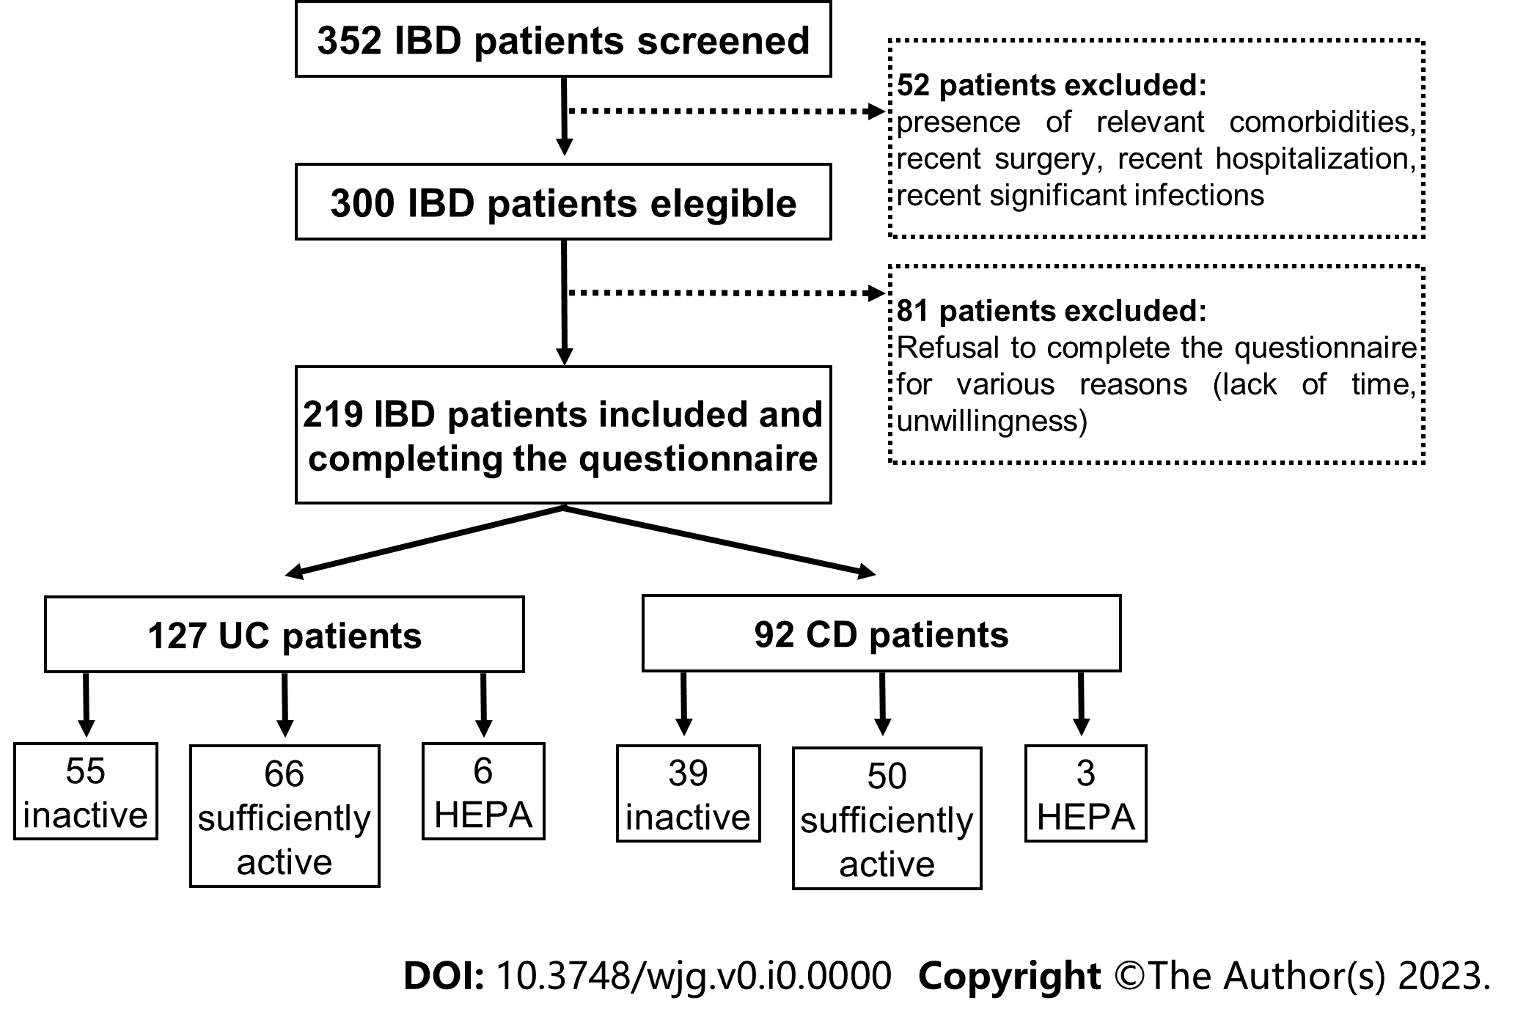
Figure 1 Flow chart summarizing the inclusion in the study patients, divided by type of inflammatory bowel disease and resulting physical activity levels. HEPA: Health enhancing physical activity; IBD: Inflammatory bowel disease; CD: Crohn's disease.

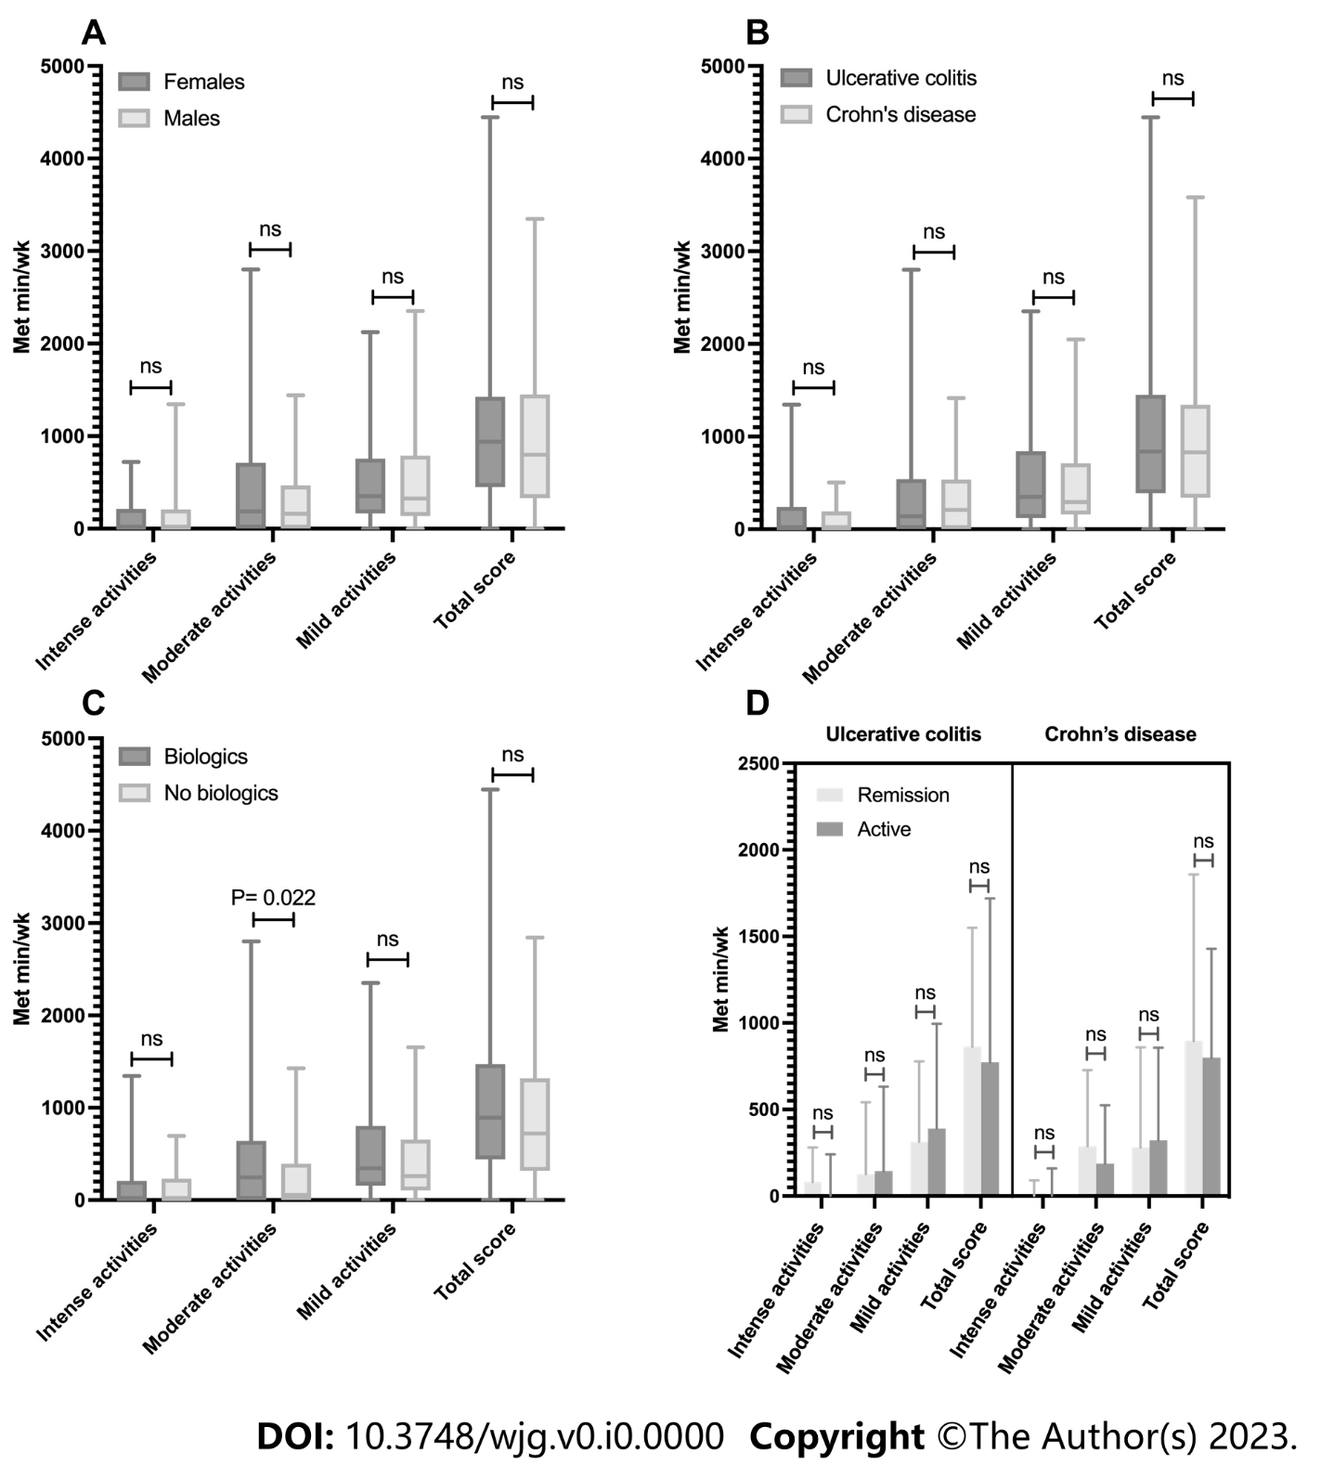
Figure 2 Physical activity levels in the main subgroups examined. A-D: Physical activity levels observed in males and females (A), patients with ulcerative colitis and Crohn's disease (B), patients on treatment and not on biologics (C), and, finally, patients physically active or inactive concerning baseline disease activity (D). Met: Metabolic rate; ns: Nonsignificant.
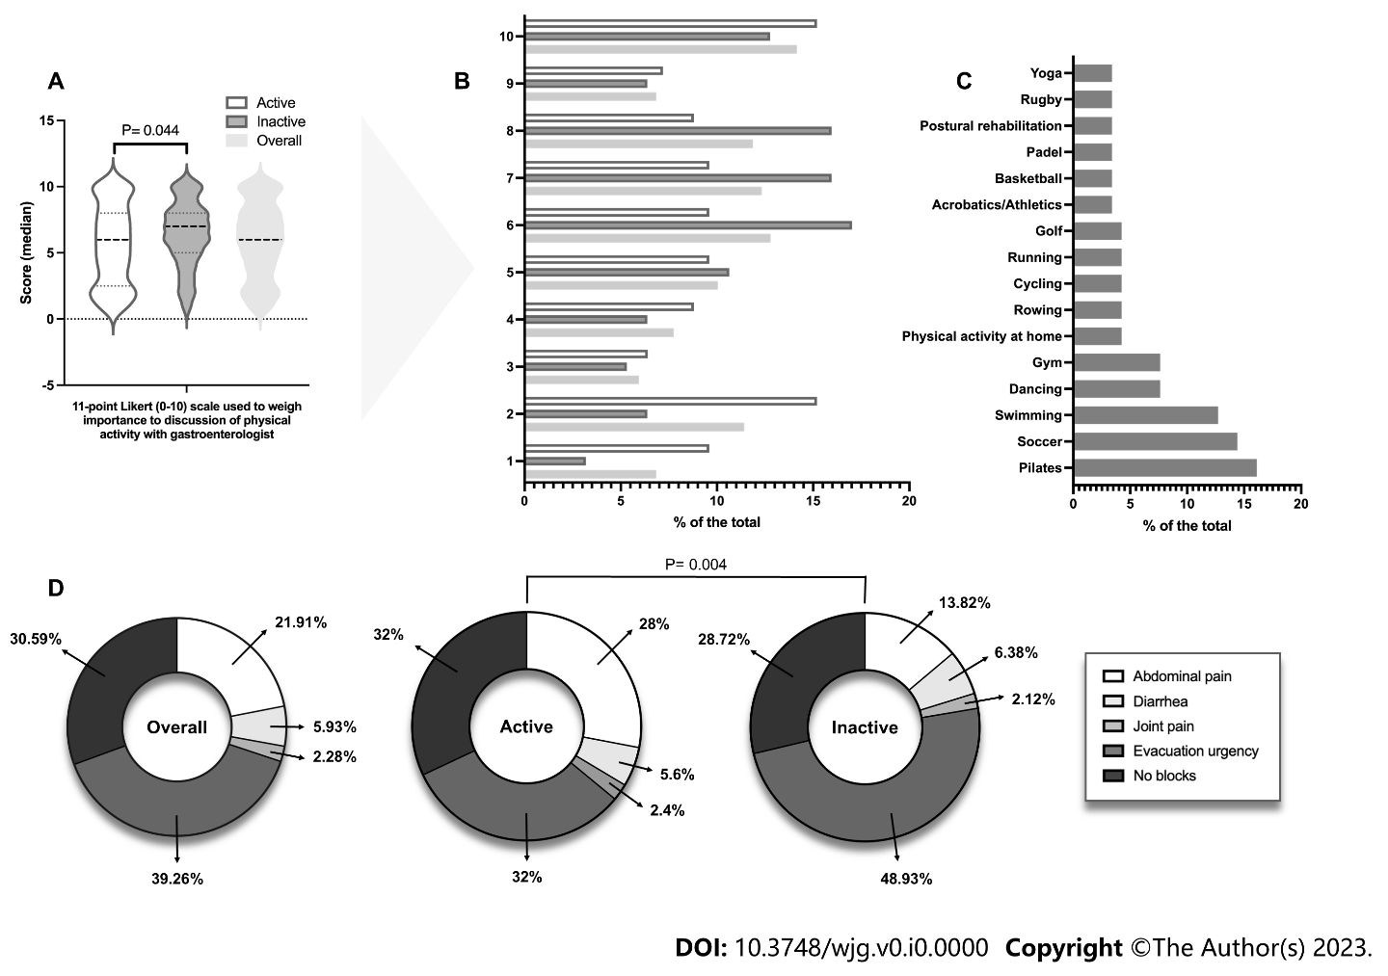
Figure 3 Importance given by patients to discuss physical activity with their gastroenterologist, major sports played by them, and barriers to physical activity related to inflammatory bowel disease. A and B: The importance given by patients to discuss with their gastroenterologist physical activity stratified by physical activity level (A) and detailed by individual Likert scale score (B); C: Main sports stated by participants; D: Factors related to inflammatory bowel disease hinder regular physical activity.

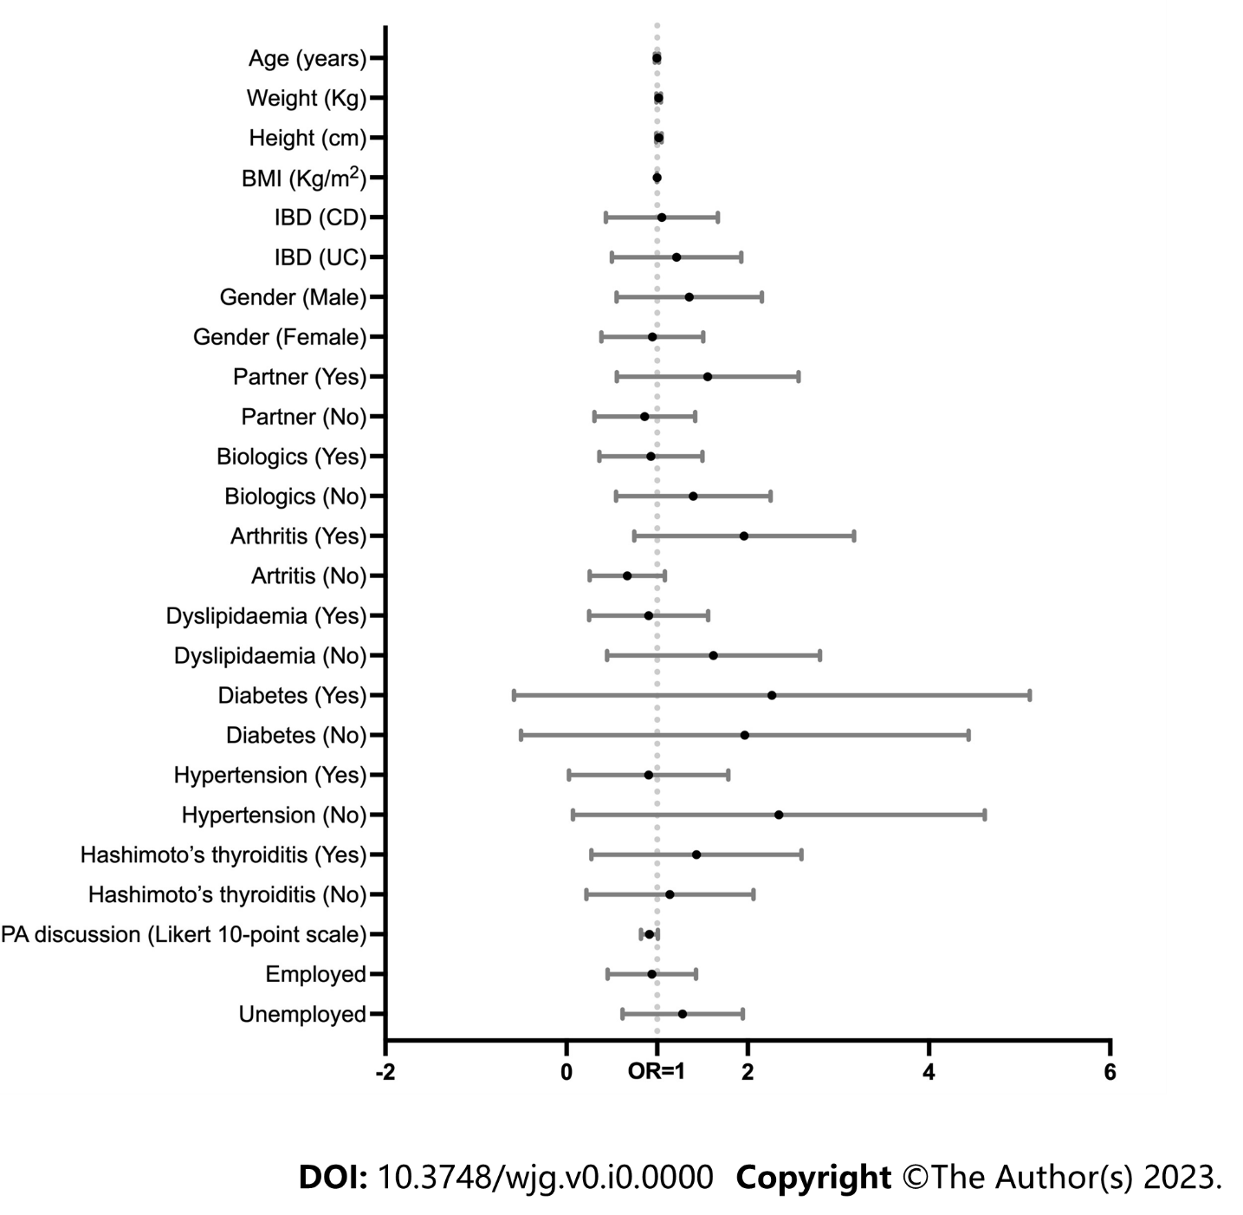
Figure 4 Forest plot showing predictors analysis of physical inactivity analysis among clinical and demographic variables evaluated by binary logistic regression. CD: Crohn's disease; UC: Ulcerative colitis; OR: Odds ratio.

Table 1 Sample characteristics concerning the type of inflammatory bowel disease
Variable | Crohn’s disease  (n = 92) | Ulcerative colitis  (n = 127) | P value¹
Age | 43.5 (29-53) | 41 (30-55) | 0.871
BMI | 23.8 (20.8-26.4) | 23.8 (21.4-25.9) | 0.787
Gender |  |  | 0.157²
Male | 44 (47.8%) | 73 (57.5%)
Female | 48 (52.5%) | 54 (42.5%)
Education |  |  | 0.192
Primary school | 32 (24.8%) | 27 (21.3%)
Secondary school | 52 (56.5%) | 78 (61.4%)
Degree | 8 (8.7%) | 22 (17.3%)
Job |  |  | 0.009
Unemployed | 56 (60.9%) | 51 (40.2%)
Employee | 16 (17.4%) | 38 (29.9%)
Entrepreneur | 8 (8.7%) | 16 (12.6%)
Worker | 4 (4.3%) | 7 (5.5%)
Student | 8 (8.7%) | 15 (11.8%)
Smoking status |  |  | 0.003
Active smoker | 16 (17.4%) | 20 (15.7%)
Past smoker | 32 (34.8%) | 16 (12.6%)
Non-smoker | 44 (47.8%) | 91 (71.7%)
Alcohol consumer |  |  | 0.827²
Yes | 8 (8.7%) | 10 (7.9%)
No | 84 (91.4%) | 117 (92.1%)
Comorbidity |  |  | 0.256
Diabetes | 8 (8.7%) | 4 (3.1%)
Hypertension | 20 (21.7%) | 10 (7.9%)
Recurrent UTI | 2 (2.2%) | 4 (3.1%)
Chronic renal failure | 1 (1.1%) | 2 (1.6%)
Nephrolithiasis | 3 (3.3%) | 1 (0.8%)
Asthma | 3 (3.3%) | -
COPD | 2 (2.2%) | 1 (0.8%)
Previous pneumonia | 1 (1.1%) | 1 (0.8%)
Dyslipidaemia | 12 (13%) | 35 (27.6%)
Arthritis | 32 (34.8%) | 34 (26.8%)
Hashimoto’s thyroiditis | 7 (7.6%) | 15 (11.8%)
Partner |  |  | 0.322²
Yes | 68 (73.9%) | 86 (67.7%)
No | 24 (26.1%) | 41 (32.3%)
Biologics (yes) | 76 (82.6%) | 78 (61.4%) | 0.001²
Steroids (yes) | 4 (4.3%) | 8 (6.3%) | 0.531²
BMI: Body mass index; COPD: Chronic obstructive pulmonary disease.
¹The P value was calculated by checking the difference in the distribution of different variables between the two identified groups (i.e., Crohn's disease and ulcerative colitis).
²The Chi-square test or Fisher’s exact test was employed for evaluation.
Data are expressed for continuous variables as median (interquartile range) and, for categorical and ordinal variables, as numerosity (%). Significant P values are indicated in bold.

Table 2 Sample characteristics concerning the levels of physical activity
Variable | Physically active  (n = 125) | Physically inactive  (n = 94) | P value¹
IBD |  |  | 0.892²
Crohn’s disease | 53 (42.4%) | 39 (41.5%)
Ulcerative colitis | 72 (57.6%) | 55 (58.5%)
Age | 39 (29.5-52) | 44 (29-55.25) | 0.506
BMI | 24.25 (21.47-26.28) | 22.72 (20.95-25.71) | 0.185
Gender |  |  | 0.952²
Male | 67 (53.6%) | 50 (53.2%)
Female | 58 (46.4%) | 44 (46.8%)
Education |  |  | 0.903
Primary school | 34 (27.2%) | 25 (26.6%)
Secondary school | 75 (60%) | 55 (58.5%)
Degree | 16 (12.8%) | 14 (14.9%)
Job |  |  | 0.432
Unemployed | 59 (47.2%) | 48 (51.1%)
Employee | 30 (24%) | 24 (25.5%)
Entrepreneur | 15 (12%) | 9 (9.6%)
Worker | 6 (4.8%) | 5 (5.3%)
Student | 15 (12%) | 8 (8.5%)
Smoking status |  |  | 0.607
Active smoker | 21 (16.8% | 15 (16%)
Past smoker | 29 (23.2%) | 19 (20.2%)
Non-smoker | 75 (60%) | 60 (63.8%)
Alcohol consumer |  |  | 0.892²
Yes | 10 (8%) | 4 (4.3%)
No | 115 (92%) | 90 (95.7%)
Comorbidity |  |  | 0.899
Diabetes | 8 (6.4%) | 4 (4.3%)
Hypertension | 20 (16%) | 10 (10.6%)
Recurrent UTI | 3 (3.2%) | 2 (2.1%)
Chronic renal failure | - | 1 (1.1%)
Nephrolithiasis | 3 (2.4%) | 2 (2.1%)
Asthma | 2 (1.6%) | 2 (2.1%)
COPD | 1 (0.8%) | 1 (1.1%)
Previous pneumonia | 2 (1.6%) | -
Dyslipidaemia | 28 (22.4%) | 19 (20.2%)
Arthritis | 32 (25.6%) | 34 (36.2%)
Hashimoto’s Thyroiditis | 12 (9.6%) | 10 (10.6%)
Partner |  |  | 0.570²
Yes  No | 86 (68.8%)  39 (31.2%) | 68 (72.3%)  26 (27.7%)
Biologics (yes) | 91 (72.8%) | 63 (67%) | 0.354²
Steroids (yes) | 10 (8%) | 2 (2.1%) | 0.059²
BMI: Body mass index; COPD: Chronic obstructive pulmonary disease; UTI: Urinary tract infections.
¹The P value was calculated by checking the difference in the distribution of different variables between the two identified groups (i.e., physically active or inactive).
²The Chi-square test or Fisher’s exact test was employed for evaluation.
Data are expressed for continuous variables as median (interquartile range) and, for categorical and ordinal variables, as numerosity (%).

Table 3 Physical activity concerning the type of inflammatory bowel disease
PA variable | Crohn’s disease  (n = 92) | Ulcerative colitis  (n = 127) | P value¹
Intense activities (Met min/wk) | 0 (0-192) | 0 (0-240) | 0.099
Moderate activities (Met min/wk) | 208 (0-536) | 140 (0-540) | 0.590
Mild activities (Met min/wk) | 293.75 (158.12-711.6) | 350 (120-840) | 0.940
Sitting time at work (min) | 210 (113-292.5) | 215 (125-292) | 0.719
Sitting time at home (min) | 174 (118.75-221.75) | 177 (115-229) | 0.855
Total score (Met min/wk) | 828.25 (339.37-1343.5) | 839 (390-1451) | 0.678
PA level |  |  | 0.995
Inactive | 39 (42.4%) | 55 (43.3%)
Sufficiently active | 50 (54.3%) | 66 (52%)
HEPA active | 3 (3.3%) | 6 (4.7%)
HEPA: Health enhancing physical activity; PA: Physical activity.
¹The P value was calculated by checking the difference in the distribution of different variables between the two identified groups (i.e., Crohn's disease and ulcerative colitis).
Data are expressed for continuous variables as median (interquartile range) and, for categorical and ordinal variables, as numerosity (%).

Table 4 Disease activity and physical activity levels expressed as total International Physical Activity Questionnaire score.
PA variable | n (%) | PA active (Met min/wk) | PA inactive (Met min/wk) | P value¹
PRO-2 CD | n = 92 | n = 53 | n = 39
Remission | 27 (29.3%) | 1353 (1026.5-2064) | 210.75 (101.25-313.75) | 0.303
Mild | 24 (26.1%) | 1213.65 (1039.52-1534.75) | 346.25 (229.62-566.37)
Moderate | 41 (44.6%) | 1240.75 (879.67-1950) | 352.5 (45-468.75)
Overall | 92 (100%) | 1234 (981.75-1769.25) | 280 (157.5-465)
PRO-2 UC | n = 127 | n = 72 | n = 55
Remission | 74 (58.3%) | 1345.35 (1057.5-1766.75) | 321.25 (204.25-535.87) | 0.994
Active | 53 (41.7%) | 1457 (952-1964.75) | 350 (0-574)
Overall | 127 (100%) | 1373.35 (990-1792.62) | 325 (111.5-538.5)
PRO: Patient reported outcome; CD: Crohn’s disease; UC: Ulcerative Colitis; IPAQ: International Physical Activity Questionnaire; PA: Physical activity.
¹The P value was calculated by checking the difference in the distribution of different variables between the two identified groups (i.e., active and inactive patients).
Data are expressed for continuous variables as median (interquartile range) and, for categorical and ordinal variables, as numerosity (%).

Table 5 Beliefs about physical activity of patients included
Question (n = 219) | Completely agree | I think it is irrelevant | Partially agree | Partially disagree | Completely disagree | P value¹
I think my IBD is a block to doing regular PA | 12 (5.5%) | 65 (29.7%) | 58 (26.5%) | 28 (12.8%) | 56 (25.6%) | 0.957
The treatment I am taking for my IBD is a block to performing regular PA. | 5 (2.3%) | 78 (35.6%) | 15 (6.8%) | 16 (7.3%) | 105 (47.9%) | 0.520
I believe that engaging in regular PA may reactivate my IBD or, if already active, make it worse | 61 (27.9%) | 43 (19.6%) | 18 (8.2%) | 19 (8.7%) | 78 (35.6%) | < 0.001
I believe that performing regular PA may result in complications in my IBD (e.g., fistula formation, abscesses or other) | 13 (5.9%) | 45 (20.5%) | 21 (9.6%) | 26 (11.9%) | 114 (52.1%) | 0.527
I believe that performing regular PA can improve my IBD. | 28 (12.8%) | 55 (25.1%) | 87 (39.7%) | 6 (2.7%) | 43 (19.6%) | 0.942
I believe that performing regular PA can protect me from new IBD recurrence | 25 (11.4%) | 74 (33.8%) | 87 (39.7%) | 18 (8.2%) | 15 (6.8%) | 0.538
My family doctor adequately informed me regarding the possibility of performing regular PA | 52 (23.7%) | 45 (20.5%) | 51 (23.3%) | 18 (8.2%) | 53 (24.2%) | 0.936
My gastroenterologist adequately informed me regarding the possibility of performing regular PA | 76 (34.7%) | 26 (11.9%) | 80 (36.5%) | 10 (4.6%) | 27 (12.3%) | 0.871
People close to me (e.g., relatives and friends) have repeatedly urged me to conduct a regular PA | 91 (41.6%) | 22 (10%) | 69 (31.5%) | 18 (8.2%) | 19 (8.7%) | 0.795
People close to me (relatives, friends) have repeatedly advised/banned me from conducting regular PA | 0 (%) | 35 (16%) | 29 (13.2%) | 24 (11%) | 131 (59.8%) | 0.291
Before receiving the diagnosis of IBD, I was more inclined to perform regular PA, but now, upon receiving the diagnosis, I feel less convinced to perform PA | 41 (18.7%) | 45 (20.5%) | 45 (20.5%) | 13 (5.9%) | 75 (34.2%) | < 0.001
IBD: Inflammatory bowel disease; PA: Physical activity.
¹The P value was calculated by checking the difference in the distribution of different variables between the two identified groups (i.e., active and inactive patients). Data are expressed as numerosity (%). Significant P values are indicated in bold.

Table 6 Predictors of physical inactivity analysis among clinical and demographic variables evaluated by binary logistic regression
Variable | Exp (B)/Odds ratio | 95% CI | P value
Age (yr) | 0.996 | 0.976-1.018 | 0.743
Weight (Kg) | 1.017 | 0.992-1.041 | 0.180
Height (cm) | 1.018 | 0.989-1.048 | 0.231
BMI (Kg/m²) | 0.999 | 0.998-1.001 | 0.867
IBD (CD) | 0.931 | 0.503-1.721 | 0.819
IBD (UC) | 1.074 | 0.581-1.987
Gender (Male) | 1.196 | 0.642-2.225 | 0.573
Gender (Female) | 0.836 | 0.449-1.556
Partner (Yes) | 1.343 | 0.681-2.652 | 0.395
Partner (No) | 0.744 | 0.377-1.469
Biologics (Yes) | 0.816 | 0.430-1.549 | 0.534
Biologics (No) | 1.225 | 0.646-2.325
Arthritis (Yes) | 1.710 | 0.892-3.278 | 0.106
Arthritis (No) | 0.585 | 0.305-1.121
Dyslipidaemia (Yes) | 0.747 | 0.343-1.627 | 0.463
Dyslipidaemia (No) | 1.338 | 0.615-2.913
Diabetes (Yes) | 1.074 | 0.209-5.517 | 0.932
Diabetes (No) | 0.931 | 0.181-4.786
Hypertension (Yes) | 0.622 | 0.204-1.893 | 0.403
Hypertension (No) | 1.608 | 0.528-4.893
Hashimoto’s thyroiditis (Yes) | 1.121 | 0.462-2.717 | 0.800
Hashimoto’s thyroiditis (No) | 0.892 | 0.368-2.162
Importance PA discussion (Likert 10-point scale) | 0.911 | 0.823-1.008 | 0.072
Employed | 0.857 | 0.501-1.464 | 0.571
Unemployed | 1.167 | 0.683-1.994
Risk is expressed as the exponential value of B, or Exp(B), presented in odds ratio with a relative 95% confidence interval and relative P value. 95%CI: 95% confidence interval; IBD: Inflammatory bowel disease; CD: Crohn’s disease; UC: Ulcerative Colitis; PA: Physical activity.

