Name of Journal: World Journal of Hepatology
ESPS Manuscript NO: 26022
Manuscript Type: Original Article

Clinical Trials Study
Transjugular intrahepatic portosystemic shunt combined with esophago-gastricvariceal embolization in the treatment of a huge gastrorenal shunt

Jiang Q et al. TIPS + SEVE in the treatment of a huge gastrorenal shunt

Qin Jiang, Ming-Quan Wang, Guo-Bing Zhang, Qiong Wu, Jian-Ming Xu, De-Run Kong

Qin Jiang, Department of Gastroenterology, 161 Hospital of Chinese People’s Liberation Army, Wuhan 430000, Hubei Province, China

Qin Jiang, Qiong Wu, Jian-Ming Xu, De-Run Kong, Department of Gastroenterology, First Affiliated Hospital of Anhui Medical University, Hefei 230022, Anhui Province, China

Ming-Quan Wang, Guo-Bing Zhang, Department of Intervention, First Affiliated Hospital of Anhui Medical University, Hefei 230022, Anhui Province, China

Author contributions: Kong DR and Jiang Q designed the research; Jiang Q and Wu Q performed the research; Jiang Q was involved in analysis and interpretation of data, and drafting of the manuscript; Zhang GB, Xu JM and Wang MQ provided TIPS technical support and was involved in study supervision; Kong DR and Xu JM were involved in study design, analysis and interpretation of data, critical revision of the manuscript and study supervision.

Supported by National Natural Science Foundation of China, Nos. 81070337 and 81271736

Institutional review board statement: The study was approved by the Ethics Committee of Anhui Medical University.

Informed consent statement: All involved patients gave their informed written consent prior to study inclusion.

Conflict-of-interest statement: We declare that we have no financial and personal relationships with other people or organizations that can inappropriately influence our work, there is no professional or other personal interest of any nature or kind in any product, service and/or company that could be construed as influencing the position presented in, or the review of, the manuscript entitled.

Data sharing statement: Technical appendix, statistical code, and dataset could be available from the corresponding author at kdr168@sohu.com. Participants gave informed consent for data sharing.

Open-Access: This article is an open-access article which selected by an in-house editor and fully peer-reviewed by external reviewers. It distributed in accordance with the Creative Commons Attribution Non Commercial (CC BY-NC 4.0) license, which permits others to distribute, remix, adapt, build upon this work non-commercially, and license their derivative works on different terms, provided the original work is properly cited and the use is non-commercial. See: http://creativecommons.org/licenses/by-nc/4.0/

Manuscript source: Invited manuscript

Correspondence to: De-Run Kong, MD, Department of Gastroenterology, First Affiliated Hospital of Anhui Medical University, Jixi Road 218, Hefei 230022, Anhui Province, China. kdr168@sohu.com
Fax: +86-551-65120742

Received: March 27, 2016
Peer-review started: March 28, 2016
First decision: April 19, 2016
Revised: May 5, 2016
Accepted: May 31, 2016
Article in press:
Published online:

Abstract
AIM: To evaluate the efficacy and safety of transjugular intrahepatic portosystemic shunt (TIPS) combined with stomach and esophageal variceal embolization (SEVE) in cirrhotic patients with a huge gastrorenal vessel shunt (GRVS).

METHODS: Eighty-one cirrhotic patients with gastric variceal bleeding (GVB) associated with a GRVS were enrolled in the study and accepted TIPS combined with SEVE (TIPS + SEVE) by which portosystemic pressure gradient (PPG), biochemical, TIPS-related complications, shunt dysfunction, rebleeding and death were evaluated respectively.

RESULTS: The PPGs before TIPS were greater than 12 mmHg in eight-one patients. TIPS + SEVE treatment caused a significant decrease in PPG (from 37.97 ± 6.36 mmHg to 28.15 ± 6.52 mmHg, t = 19.22, P < 0.001). The percentage of reduction in PPG was greater than 20% from baseline. There were no significant differences in albumin, alanine aminotransferase, aspartate aminotransferase, bilirubin, prothrombin time and Child-Pugh score respectively, before and after operation. In all patients, the rebleeding rates were 3%, 6%, 12%, 18% and 18%, respectively, at 1, 3, 6, 12 and 18 mo. Five patients (6.2%) were diagnosed as having hepatic encephalopathy. The rates of shunt dysfunction were 0%, 4%, 9%, 26% and 26%, respectively, at 1, 3, 6, 12 and 18 mo. The cumulative survival rates in 1, 3, 6, 12 and 18 mo were 100%, 100%, 95%, 90% and 90%, respectively.

CONCLUSION: Our preliminary results indicated that the efficacy and safety of TIPS + SEVE were satisfactory in cirrhotic patients with GVB associated with a GRVS (GVB + GRVS).

Key words: Transjugular intrahepatic portosystemic shunt; Cirrhosis; Gastric varices; Variceal embolization; Gastrorenal shunt

© The Author(s) 2016. Published by Baishideng Publishing Group Inc. All rights reserved.

Core tip: The optimal treatment of gastric variceal bleeding (GVB) + gastrorenal vessel shunt (GRVS) remains uncertain. Transjugular intrahepatic portosystemic shunt (TIPS) alone cannot be widely used in the treatment of GVB + GRVS. Some studies have evaluated the short outcomes of cirrhosis treated with TIPS combined with variceal embolization. In this study, we found that the efficacy and safety of TIPS + stomach and esophageal variceal embolization were satisfactory for patients with GVB + GRVS.

Jiang Q, Wang MQ, Zhang GB, Wu Q, Xu JM, Kong DR. Transjugular intrahepatic portosystemic shunt combined with esophago-gastricvariceal embolization in the treatment of a huge gastrorenal shunt. World J Hepatol 2016; In press

INTRODUCTION
The rate of gastric variceal bleeding (GVB) is significantly lower than that of esophageal variceal bleeding (EVB)^{[1,2]}, but bleeding is usually more severe, requires more transfusions, and is associated with higher mortality than EVB^{[1-3]}. Up to now, the optimal treatment of GVB remains a difficult issue for clinicians. In terms of recommendatory therapy for gastric varices, there are various primary options, including surgery, endoscopic variceal obturation with tissue adhesive, TIPS placement, and balloon-occluded retrograde transvenous obliteration (BRTO)^{[4,5]}. However, the first-line therapies for gastric varices were endoscopically administered tissue adhesives and TIPS placement.
GVB is often associated with a gastrorenal vessel shunt (GRVS)^{[6]}. The safety of endoscopically administered tissue adhesives in patients with GVB + GRVS is controversial, due to the potential cerebral or pulmonary embolism secondary to migration of cyanoacrylate into the systemic circulation through GRVS^{[7]}. TIPS placement has been widely accepted as an effective and safe treatment for GVB in cirrhotic patients^{[4,8]}. However, because the portosystemic pressure gradient (PPG) in patient with GVB + GRVS is lower than that in patient with EV, TIPS placement alone seldom is used in the treatment of GVB + GRVS^{[9-13]}.
Recent years, some studies have shown TIPS combined with variceal embolization has been advocated to prevent recurrent variceal bleeding and improve liver function^{[14,15]}. However, there are no similar studies to evaluate the effectiveness of combination of these two methods for patients with GVB + GRVS. The aim of this study was to evaluate the efficacy and safety of TIPS + SEVE for patients with GVB + GRVS.

MATERIALS AND METHODS
Patients
Between October 2013 and December2015, a total of 107 patients in whom the TIPS + SEVE had been successfully performed in our hospital was recruited in this study. Inclusion criteria were as follow: (1) age > 18 years; (2) history of cirrhosis and GVB (based on findings of histological or typical cross-sectional imaging such as ultrasound, endoscopy, computed tomography, or magnetic resonance imaging); and (3) the patients were diagnosed as having GRVS by computed tomography angiography (CTA). Exclusion criteria were: (1) hepatocellular carcinoma or other malignancies; (2) chronic renal failure; (3) portal vein thrombosis; (4) infection; and (5) coagulation disorder. Of 107 patients, 26 patients with EVB or GVB without GRVS were excluded from this study. Thus, the final population for study consisted of 81 patients. The main clinical and biochemical characteristics of these 81 patients are presented in Table 1. All patients signed informed consent. The study was conducted in accordance with the ethical principles of the Declaration of Helsinki and was approved by the Ethics Committee of Anhui Medical University.

Procedural protocol
Procedures were performed with general anesthesia in the angiography suite. The procedure of TIPS + SEVE has been described previously^{[14-16]}. Briefly, before the catheterization of hepatic vein was performed through the right internal jugular vein, inferior vena cava pressure was measured when the tip of the catheter floated in the inferior vena cava at the junction with the hepatic vein. A needle and a guide-wire were advanced through the liver parenchyma into a branch of the portal vein with fluoroscopic guidance, and then direct portography and the measurement of portal vein pressure were performed. A catheter was then passed into gastroesophageal collateral vessels, and thus embolization of the collateral vessels was formed with coils of varying diameters, which resulted in the disappearance of varices at post embolization angiography, and the catheter was finally exited to the liver parenchyma. After the parenchymal tract between the hepatic vein and portal vein was dilated with an angioplasty balloon catheter, the patency of the TIPS was facilitated by deployment of covered stent (8 mm in diameter, BARD E LUMINEXX Vascular stent, France). The PPG was thus resulted from the difference between the portal vein pressure and inferior vena cava pressure. The mid-chest was used as the external zero reference. Pressure tracings must remain stable during at least 30 s to be considered satisfactory. The mean value of two PPG measurements was to be for analysis.
All patients received intravenous antibiotic prophylaxis 1 d before the procedure. Intravenous heparin was given as anticoagulation during the procedure and continued for 1 wk, then changed to oral aspirin and warfarin for 1 year. Oral lactulose was used to prevent the hepatic encephalopathy (HE).

Follow-up
All patients were asked to enroll in the follow-up protocol. PPG, biochemical examination, TIPS-related complications, post-HE, primary patency, rebleeding and death were recorded respectively. Patients were examined during followed up with Doppler ultrasound, endoscopy, and CTA at 1, 3, 6 and 12 mo respectively, after TIPS placement and then every 6 mo thereafter. Once the patients had HE, rebleeding, or other severe complications, they were invited to our TIPS unit at any time. Liver functions were assessed by testing albumin, alanine aminotransferase (ALT), aspartate aminotransferase (AST), bilirubin, prothrombin time (PT) levels and Child-Pugh score respectively, at 1 wk before and 1 mo after TIPS. TIPS patency could be assessed by Doppler ultrasonography. Endoscopy confirmed the sources of bleeding and the variceal disappearance. CTA was used to define the GRVS. Patients were followed until death or liver transplantation the first rebleeding, the first HE, the first shunt insufficiency up to a maximum of 2 years of follow-up (closure date December 31, 2015).

Definitions
The following definitions were used: (1) Rebleeding: Any subsequent haematemesis or melaena was confirmed endoscopically; (2) HE: The diagnosis of HE was made according to the final report of the 1998 Working Party at the 11th World Congresses of Gastroenterology in Vienna^{[17]}, patients with clinical evidence of HE, the West Haven criteria grades: HE ≥ grade I; (3) shunt dysfunction^{[18]}: Doppler criteria for shunt insufficiency was that maximal flow velocity was less than 50 cm/s or absence of flow within the shunt. And suspected shunt dysfunction was confirmed by portography that showed a shunt stenosis > 50%; (4) primary patency: The absence of shunt insufficiency without intervention during TIPS surveillance; and (5) endoscopic findings of esophago-gastric varices were recorded as proposed by the Japanese Society for portal hypertension^{[19]}.

Statistical analysis
The data were expressed as means ± SD. Quantitative variables were compared using Student’s t test. The rates of primary patency, HE, survival and variceal rebleeding were analysed using the Kaplan-Meier analyses. A statistically significant difference was assessed for any of the analyses with results of P < 0.05. Analyses were performed using the SPSS 10.0 software package.

RESULTS
Basic data
Table 2 summarizes the basic clinical and biochemical characteristic of patients. As shown, the PPG before TIPS placement was greater than 12 mmHg in all patients. The mean PPG dropped from 37.97 ± 6.36 mmHg to 28.15 ± 6.52 mmHg, respectively, before and after TIPS (t = 19.22, P < 0.001), with reductions in PPG greater than 20% from baseline. There were no significant differences in albumin, ALT, AST, bilirubin, PT and Child-Pugh score respectively, at 1 wk before and 1 mo after operation.

Rebleeding
Rebleeding from the upper gastrointestinal tract occurred in ten patients (12.3%) after TIPS placement. One patient was transfused 4 U of blood within 24 h after TIPS procedure and thereafter no symptom of rebleeding was observed. The cumulative rates of rebleeding (Kaplan-Meier estimation) after 1, 3, 6, 12 and 18 mo were 3%, 6%, 12%, 18% and 18%, respectively. The actual probability of rebleeding is presented in Figure 1. One patient underwent tissue adhesives administration 6 mo after TIPS implantation and is, to date, well and free of rebleeding. One patient was found to have portal hypertensive gastropathy, which resulted in rebleeding. The other rebleeders were found to have shunt stenosis or obstruction.

Survival
Five patients died within the follow-up period because of procedure-related complications. Specifically, the shunt obstruction was observed 6 months after TIPS placement, refused reintervention treatment, and died seven months after TIPS because of a recurrent bleeding. The other four patients died 5 to 12 mo after the TIPS placement. The cumulative rates of survival (Kaplan-Meier estimation) after 1, 3, 6, 12 and 18 mo were 100%, 100%, 95%, 90% and 90%, respectively. Survival curves are shown in Figure 2.

HE
Five patients experienced HE sometimes before TIPS operation, and were diagnosed as having HE as well after TIPs placement. A protein-restricted diet and/or lactulose treatment were given to prevent the recurrence of HE. The cumulative rates of HE (Kaplan-Meier estimation) after 1, 3, 6, 12 and 18 mo were 9%, 13%, 18%, 18% and 18%, respectively (Figure 3).

Primary shunt patency
The cumulative rates of primary shunt patency (Kaplan-Meier estimation) after 1, 3, 6, 12 and 18 mo were 100%, 96%, 91%, 74% and 74%, respectively (Figure 4). During the follow-up period, ten (12.3%) patients were diagnosed as shunt stenosis or obstruction, of which eight patients successfully underwent shunt recanalization with balloon angioplasty, and to date, has stayed patent, one patient, as previously mentioned, had shunt obstruction and died 7 mo after TIPS, and remaining one patient received anticoagulant therapy and is, to date, alive and well.

Other complications
During the follow-up period, a rare complication, hepatic myelopathy (HM), occurred in two patients 6 to 8 mo after the TIPS procedure. In these patients exerts significant impact on mobility and quality of life. Due to economic factors, the patients received conservative medical treatment and are, alive.

DISCUSSION
The rate of GVB is significantly lower than that of EVB^{[1,2]}, but the bleeding is usually more severe, requires more transfusions, and is associated with higher mortality than EVB^{[1-3]}. However, the optimal treatment of GVB remains a difficult issue for clinicians.
Variceal embolotherapy was recognized as an efficient method for preventing bleeding caused by portal hypertension^{[19,20]}. TIPS is used worldwide for the prevention of variceal bleeding^{[4,5,8]}. Previous studies have shown TIPS combined with variceal embolization has been advocated to prevent recurrent variceal bleeding and improve liver function^{[14,15]}. However, there are no any similar studies evaluating the combination of these two methods in patients with GVB + GRVS.
In this study, we found that the PPG before TIPS placement was greater than 12 mmHg in patients with GVB + GRVS. All of our patients had previously experienced at least one time of bleeding. Tripathi et al^{[21]} found that 35% (14/40) patients with GVB had a PPG ≤ 12 mmHg at the time of TIPS^{[22]}. Given that the different results may be related to the number of cases and the size of spontaneous GRVS in our study, despite previous studies have illustrated that PPG appears to correlate inversely with the presence and size of spontaneous GRVS^{[6,21]}, to date, there have been no attempts to measure the size of GRVS, and the definitions of the GRVS size remains to be determined.
It has been reported that patients with large GV have a lower PPG than those with EV, which may be as a result of the development of GRVS^{[6,23]}. Several studies found decompressive methods such as TIPS would not seem to confer much of benefits for GVB + GRVS^{[9-13]}. Our results suggest that the rebleeding rate after TIPS was 12% at 1 year, which was similar to the result that was usually reported between 10% to 40%^{[24,25]}, while the reduction in PPG was greater than 20% from baseline. Moreover, we noticed that TIPS + SEVE may reduce the risk of rebleeding. It should be noted that previous studies of TIPS differed from our study in which they used bare stents with TIPS alone placement, or did not limit the stent diameter. In our study, all patients underwent decompressive operation and embolotherapyby using coil, and an extensive collateral circulation such as short or posterior gastric vein were embolized, which may contribute to the occlusion of GRVS. And all covered stents were dilated to 8 mm, which may be regarded as limited shunt and accord with the natural hemodynamic features.
Survival is usually regarded as the strongest evidence for evaluating the effectiveness of a therapy. In the previous studies, the total survival of 1-year post-TIPS ranged from 58% to 80%, depending mainly on the severity of the underlying liver disease^{[25,26]}.The survival rate was 94% at 1 year in our study, such high rate may be related to the patient's liver function (76.5% patients with Child-Pugh class A or B). Although our results support patients with Child-Pugh class C as well, TIPS placement should be used with extreme caution. Taken these together improving liver function before TIPS may increase the survival rates.
TIPS has been extensively used within the last 20 years. Previous studies showed that TIPS increases the incidence of HE without improving survival^{[27-29]}, which may be the reason why TIPS is currently recommended only as a rescue therapy. HE has been reported to occur in 16%-31% of patients who receive a TIPS in the presence of GVB + GRS^{[30]}. Our results indicated that fifteen percent of our patients was diagnosed as having HE after TIPS placement, which is very similar to those reports in other studies, and that only one patient required admission. Importantly, our results were attributed to three effective improvements. First, oral lactulose was used to prevent the HE after operation. Second, the left portal vein could be successfully punctured in 58% patients. As we know, the left portal vein receives blood from the splenic vein and inferior mesenteric vein which has fewer digestive products but more electrolytes. Most recent studies have illustrated that creation of a TIPS to the left portal vein instead of the right portal vein could decrease the risk of HE^{[31-33]}. Third, 8 mm stents were used in patients. Previous literature reported that the incidence of portosystemic HE increased with increasing diameter of the stent^{[31]}.
Indeed, as it has been showed, occlusion or stenosis is the main disadvantages of TIPS. Studies have demonstrated that stent insufficiency occurs in 14% to 82% by 1 years after TIPS^{[25,33]}. Our findings suggest that 12% of patients was diagnosed as stenosis or obstruction one year after TIPS. Compared to historical data, our results show higher patency rates. It was reported that the routine administration of anticoagulants and the use of covered stents play important roles in the improved patency rate^{[34-36]}. Thus, the higher patency rate of our patients was partially attributed to the use of covered stents and anticoagulant therapy. Another possible reason for our results is that regular followed-up and TIPS that placed to the left portal vein have been working well.
During the follow-up period, two patients was diagnosed with HM, in which the spontaneous shunt found by CTA was not completely closed, and embolization only with coils may be an insufficient embolization factor that was thought to be secondary to the increased systemic circulation of shunting of portal venous toxins from hypoperfusion and ischemia of the hepatocytes. Studies showed that a liver transplant could fully reverse the effects of HM in patients with the disease at early stage^{[37,38]}, however, due to economic factors, the patients only received conservative medical treatment. Despite previous studies have shown TIPS combined with variceal embolization has been advocated to improve liver function^{[15,39]}, there were no significant differences in liver functions before and after TIPS placement in our study.
In spite of these, we may conclude that the PPG before TIPS placement may be greater than 12 mmHg in patients with GVB + GRVS, and the efficacy and safety of TIPS + SEVE were satisfactory in these patients.

ACKNOWLEDGMENTS
The authors thank all the patients who are involved in this study. We would like to thank Professor Keyang Chen from Temple University School of Medicine, for language assistance.

COMMENTS
Background
Theoptimal treatment for gastric variceal bleeding (GVB) + gastrorenal vessel shunt (GRVS) is still controversial. Transjugular intrahepatic portosystemic shunt (TIPS) alone cannot be widely used in the treatment for GVB + GRVS. Previous studies have shown TIPS combined with variceal embolization has been advocated to prevent recurrent variceal bleeding and improving liver function. However, the efficacy and safety of TIPS + stomach and esophageal variceal embolization (SEVE) in patients with GVB + GRVS were unclear.

Research frontiers
More and more patients underwent the TIPS procedure for the prevention of variceal bleeding. For the use of TIPS procedure, the research hot spot is how to increase the patient survival rate and reduce complications by bettering the patient selection and improving techniques. Interestingly, TIPS + SEVE may decrease the portal pressure and embolize an extensive collateral circulation, which may reduce the risk of rebleeding.

Innovations and breakthroughs
Most GVs are associated with a GRVS. The efficacy of tissue adhesives in patients with GVB + GRVS is controversial, due to the potential of systemic embolism secondary to migration of cyanoacrylate into the systemic circulation through a GRVS. TIPS alone cannot be widely used in the treatment for GVB + GRVS. In our study, all patients underwent TIPS + SEVE with use of coil, an extensive collateral circulation such as short or posterior gastric vein, which may contribute to the occlusion of GRVS. In this study, the authors found that the efficacy and safety of TIPS + SEVE were satisfactory in patients with GVB + GRVS.

Applications
The results suggest that the efficacy and safety of TIPS + SEVE were satisfactory in patients with GVB + GRVS. Additional studies with long-term follow-up are needed to confirm the results.

Peer-review
The authors have provided a well-designed study that showed satisfactory efficacy and safety of the combination TIPS + SEVE in cirrhotic patients with gastric variceal bleeding associated with a gastrorenal vessel shunt.

REFERENCES
1 Sarin SK, Lahoti D, Saxena SP, Murthy NS, Makwana UK. Prevalence, classification and natural history of gastric varices: a long-term follow-up study in 568 portal hypertension patients. Hepatology 1992; 16: 1343-1349 [PMID: 1446890 DOI: 10.1002/hep.1840160607]
2 Kim T, Shijo H, Kokawa H, Tokumitsu H, Kubara K, Ota K, Akiyoshi N, Iida T, Yokoyama M, Okumura M. Risk factors for hemorrhage from gastric fundal varices. Hepatology 1997; 25: 307-312 [PMID: 9021939 DOI: 10.1002/hep.510250209]
3 Thakeb F, Salem SA, Abdallah M, el Batanouny M. Endoscopic diagnosis of gastric varices. Endoscopy 1994; 26: 287-291 [PMID: 8076547 DOI: 10.1055/s-2007-1008969]
4 Boyer TD, Haskal ZJ. The Role of Transjugular Intrahepatic Portosystemic Shunt (TIPS) in the Management of Portal Hypertension: update 2009. Hepatology 2010; 51: 306 [PMID: 19902484 DOI: 10.1002/hep.23383]
5 de Franchis R. Revising consensus in portal hypertension: report of the Baveno V consensus workshop on methodology of diagnosis and therapy in portal hypertension. J Hepatol 2010; 53: 762-768 [PMID: 20638742 DOI: 10.1016/j.jhep.2010.06.004]
6 Watanabe K, Kimura K, Matsutani S, Ohto M, Okuda K. Portal hemodynamics in patients with gastric varices. A study in 230 patients with esophageal and/or gastric varices using portal vein catheterization. Gastroenterology 1988; 95: 434-440 [PMID: 3391371]
7 Irisawa A, Obara K, Sato Y, Saito A, Orikasa H, Ohira H, Sakamoto H, Sasajima T, Rai T, Odajima H, Abe M, Kasukawa R. Adherence of cyanoacrylate which leaked from gastric varices to the left renal vein during endoscopic injection sclerotherapy: a histopathologic study. Endoscopy 2000; 32: 804-806 [PMID: 11068842 DOI: 10.1055/s-2000-7702]
8 García-Pagán JC, Caca K, Bureau C, Laleman W, Appenrodt B, Luca A, Abraldes JG, Nevens F, Vinel JP, Mössner J, Bosch J. Early use of TIPS in patients with cirrhosis and variceal bleeding. N Engl J Med 2010; 362: 2370-2379 [PMID: 20573925 DOI: 10.1056/NEJMoa0910102]
9 Caldwell S. Gastric varices: is there a role for endoscopic cyanoacrylates, or are we entering the BRTO era? Am J Gastroenterol 2012; 107: 1784-1790 [PMID: 23211846 DOI: 10.1038/ajg.2012.160]
10 Matsumoto A, Matsushita M, Sugano Y, Takimoto K, Yasuda M, Inokuchi H. Limitations of transjugular intrahepatic portosystemic shunt for management of gastric varices. Gastroenterology 2004; 126: 380-381 [PMID: 14753222 DOI: 10.1053/j.gastro.2003.07.021]
11 Ryan BM, Stockbrugger RW, Ryan JM. TIPS for gastric varices. Gut 2003; 52: 772; author reply 772 [PMID: 12692074 DOI: 10.1136/gut.52.5.772]
12 Sanyal AJ, Freedman AM, Luketic VA, Purdum PP, Shiffman ML, DeMeo J, Cole PE, Tisnado J. The natural history of portal hypertension after transjugular intrahepatic portosystemic shunts. Gastroenterology 1997; 112: 889-898 [PMID: 9041251 DOI: 10.1053/gast.1997.v112.pm9041251]
13 Choi YH, Yoon CJ, Park JH, Chung JW, Kwon JW, Choi GM. Balloon-occluded retrograde transvenous obliteration for gastric variceal bleeding: its feasibility compared with transjugular intrahepatic portosystemic shunt. Korean J Radiol 2003; 4: 109-116 [PMID: 12845306 DOI: 10.3348/kjr.2003.4.2.109]
14 Tesdal IK, Filser T, Weiss C, Holm E, Dueber C, Jaschke W. Transjugular intrahepatic portosystemic shunts: adjunctive embolotherapy of gastroesophageal collateral vessels in the prevention of variceal rebleeding. Radiology 2005; 236: 360-367 [PMID: 15955858 DOI: 10.1148/radiol.2361040530]
15 Chen S, Li X, Wei B, Tong H, Zhang MG, Huang ZY, Cao JW, Tang CW. Recurrent variceal bleeding and shunt patency: prospective randomized controlled trial of transjugular intrahepatic portosystemic shunt alone or combined with coronary vein embolization. Radiology 2013; 268: 900-906 [PMID: 23657891 DOI: 10.1148/radiol.13120800]
16 Rössle M, Haag K, Ochs A, Sellinger M, Nöldge G, Perarnau JM, Berger E, Blum U, Gabelmann A, Hauenstein K. The transjugular intrahepatic portosystemic stent-shunt procedure for variceal bleeding. N Engl J Med 1994; 330: 165-171 [PMID: 8264738 DOI: 10.1056/NEJM199401203300303]
17 Ferenci P, Lockwood A, Mullen K, Tarter R, Weissenborn K, Blei AT. Hepatic encephalopathy--definition, nomenclature, diagnosis, and quantification: final report of the working party at the 11th World Congresses of Gastroenterology, Vienna, 1998. Hepatology 2002; 35: 716-721 [PMID: 11870389 DOI: 10.1053/jhep.2002.31250]
18 Han G, Qi X, He C, Yin Z, Wang J, Xia J, Yang Z, Bai M, Meng X, Niu J, Wu K, Fan D. Transjugular intrahepatic portosystemic shunt for portal vein thrombosis with symptomatic portal hypertension in liver cirrhosis. J Hepatol 2011; 54: 78-88 [PMID: 20932597 DOI: 10.1016/j.jhep.2010.06.029]
19 Tajiri T, Yoshida H, Obara K, Onji M, Kage M, Kitano S, Kokudo N, Kokubu S, Sakaida I, Sata M, Tajiri H, Tsukada K, Nonami T, Hashizume M, Hirota S, Murashima N, Moriyasu F, Saigenji K, Makuuchi H, Oho K, Yoshida T, Suzuki H, Hasumi A, Okita K, Futagawa S, Idezuki Y. General rules for recording endoscopic findings of esophagogastric varices (2nd edition). Dig Endosc 2010; 22: 1-9 [PMID: 20078657 DOI: 10.1111/j.1443-1661]
20 Kwok AC, Wang F, Maher R, Harrington T, Gananadha S, Hugh TJ, Samra JS. The role of minimally invasive percutaneous embolisation technique in the management of bleeding stomal varices. J Gastrointest Surg 2013; 17: 1327-1330 [PMID: 23546560 DOI: 10.1007/s11605-013-2180-y]
21 Ou HY, Huang TL, Chen TY, Tsang LL, Concejero AM, Chen CL, Cheng YF. Emergency splenic arterial embolization for massive variceal bleeding in liver recipient with left-sided portal hypertension. Liver Transpl 2005; 11: 1136-1139 [PMID: 16123955 DOI: 10.1002/lt.20543]
22 Tripathi D, Therapondos G, Jackson E, Redhead DN, Hayes PC. The role of the transjugular intrahepatic portosystemic stent shunt (TIPSS) in the management of bleeding gastric varices: clinical and haemodynamic correlations. Gut 2002; 51: 270-274 [PMID: 12117893 DOI: 10.1136/gut.51.2.270]
23 Ohnishi K, Nakayama T, Koen H, Saito M, Saito M, Chin N, Terabayashi H, Iida S, Nomura F, Okuda K. Interrelationship between type of spontaneous portal systemic shunt and portal vein pressure in patients with liver disease. Am J Gastroenterol 1985; 80: 561-564 [PMID: 4014107]
24 Chao Y, Lin HC, Lee FY, Wang SS, Tsai YT, Hsia HC, Lin WJ, Lee SD, Lo KJ. Hepatic hemodynamic features in patients with esophageal or gastric varices. J Hepatol 1993; 19: 85-89 [PMID: 8301048 DOI: 10.1016/S0168-8278(05)80180-1]
25 Garcia-Pagán JC, Barrufet M, Cardenas A, Escorsell A. Management of gastric varices. Clin Gastroenterol Hepatol 2014; 12: 919-928.e1; quiz e51-52 [PMID: 23899955 DOI: 10.1016/j.cgh.2013.07.015]
26 Ryan BM, Stockbrugger RW, Ryan JM. A pathophysiologic, gastroenterologic, and radiologic approach to the management of gastric varices. Gastroenterology 2004; 126: 1175-1189 [PMID: 15057756 DOI: 10.1053/j.gastro.2004.01.058]
27 Berry K, Lerrigo R, Liou IW, Ioannou GN. Association Between Transjugular Intrahepatic Portosystemic Shunt and Survival in Patients With Cirrhosis. Clin Gastroenterol Hepatol 2016; 14: 118-123 [PMID: 26192147 DOI: 10.1016/j.cgh.2015.06.042]
28 Papatheodoridis GV, Goulis J, Leandro G, Patch D, Burroughs AK. Transjugular intrahepatic portosystemic shunt compared with endoscopic treatment for prevention of variceal rebleeding: A meta-analysis. Hepatology 1999; 30: 612-622 [PMID: 10462365 DOI: 10.1002/hep.510300316]
29 Khan S, Tudur Smith C, Williamson P, Sutton R. Portosystemic shunts versus endoscopic therapy for variceal rebleeding in patients with cirrhosis. Cochrane Database Syst Rev 2006; (4): CD000553 [PMID: 17054131]
30 Escorsell A, Bañares R, García-Pagán JC, Gilabert R, Moitinho E, Piqueras B, Bru C, Echenagusia A, Granados A, Bosch J. TIPS versus drug therapy in preventing variceal rebleeding in advanced cirrhosis: a randomized controlled trial. Hepatology 2002; 35: 385-392 [PMID: 11826413 DOI: 10.1053/jhep.2002.30418]
31 Sabri SS, Abi-Jaoudeh N, Swee W, Saad WE, Turba UC, Caldwell SH, Angle JF, Matsumoto AH. Short-term rebleeding rates for isolated gastric varices managed by transjugular intrahepatic portosystemic shunt versus balloon-occluded retrograde transvenous obliteration. J Vasc Interv Radiol 2014; 25: 355-361 [PMID: 24468043 DOI: 10.1016/j.jvir.2013.12.001]
32 Xue H, Yuan J, Chao-Li Y, Palikhe M, Wang J, Shan-Lv L, Qiao W. Follow-up study of transjugular intrahepatic portosystemic shunt in the treatment of portal hypertension. Dig Dis Sci 2011; 56: 3350-3356 [PMID: 21643741 DOI: 10.1007/s10620-011-1744-5]
33 Chen L, Xiao T, Chen W, Long Q, Li R, Fang D, Wang R. Outcomes of transjugular intrahepatic portosystemic shunt through the left branch vs. the right branch of the portal vein in advanced cirrhosis: a randomized trial. Liver Int 2009; 29: 1101-1109 [PMID: 19386025 DOI: 10.1111/j.1478-3231.2009.02016.x]
34 Bai M, He CY, Qi XS, Yin ZX, Wang JH, Guo WG, Niu J, Xia JL, Zhang ZL, Larson AC, Wu KC, Fan DM, Han GH. Shunting branch of portal vein and stent position predict survival after transjugular intrahepatic portosystemic shunt. World J Gastroenterol 2014; 20: 774-785 [PMID: 24574750 DOI: 10.3748/wjg.v20.i3.774]
35 Bureau C, Garcia-Pagan JC, Otal P, Pomier-Layrargues G, Chabbert V, Cortez C, Perreault P, Péron JM, Abraldes JG, Bouchard L, Bilbao JI, Bosch J, Rousseau H, Vinel JP. Improved clinical outcome using polytetrafluoroethylene-coated stents for TIPS: results of a randomized study. Gastroenterology 2004; 126: 469-475 [PMID: 14762784 DOI: 10.1053/j.gastro.2003.11.016]
36 Yang Z, Han G, Wu Q, Ye X, Jin Z, Yin Z, Qi X, Bai M, Wu K, Fan D. Patency and clinical outcomes of transjugular intrahepatic portosystemic shunt with polytetrafluoroethylene-covered stents versus bare stents: a meta-analysis. J Gastroenterol Hepatol 2010; 25: 1718-1725 [PMID: 21039832 DOI: 10.1111/j.1440-1746.2010.06400.x]
37 Sauer P, Theilmann L, Herrmann S, Bruckner T, Roeren T, Richter G, Stremmel W, Stiehl A. Phenprocoumon for prevention of shunt occlusion after transjugular intrahepatic portosystemic stent shunt: a randomized trial. Hepatology 1996; 24: 1433-1436 [PMID: 8938176 DOI: 10.1002/hep.510240622]
38 Baccarani U, Zola E, Adani GL, Cavalletti M, Schiff S, Cagnin A, Poci C, Merkel C, Amodio P, Montagnese S. Reversal of hepatic myelopathy after liver transplantation: fifteen plus one. Liver Transpl 2010; 16: 1336-1337 [PMID: 21031552 DOI: 10.1002/lt.22149]
39 Weissenborn K, Tietge UJ, Bokemeyer M, Mohammadi B, Bode U, Manns MP, Caselitz M. Liver transplantation improves hepatic myelopathy: evidence by three cases. Gastroenterology 2003; 124: 346-351 [PMID: 12557140 DOI: 10.1053/gast.2003.50062]

P-Reviewer: Garbuzenko DV, Nakamura S S-Editor: Ji FF L-Editor: E-Editor:

Table 1 Characteristics of the 81 patients treated with transjugular intrahepatic portosystemic shunt + stomach and esophageal variceal embolization

No. of patients | 81 (%)
Men | 63 (77.8)
Female | 9 (22.2)
Age (yr)
Mean ± SD | 50.9 ± 10.9
Range | 25-76
Cause of liver disease | n (%)
Viral | 61 (75.4)
Alcoholic | 7 (8.7)
Viral and alcoholic | 1 (1.2)
Primary biliary cirrhosis | 4 (4.9)
Autoimmune hepatitis | 1 (1.2)
Cryptogenic | 7 (8.6)
Child-Pugh class | n (%)
A | 15 (18.5)
B | 47 (58.0)
C | 19 (23.5)
Endoscopic findings
IGV1 | 25 (30.9)
GOV1 | 10 (12.3)
GOV2 | 46 (56.8)
Pre-PPG (mmHg)
Mean ± SD | 38.0 ± 6.4
Range | 26.0-48.0
Follow-up (mo)
Mean ± SD | 7.87 ± 5.57
Range | 1-18

PPG: Portosystemic pressure gradient.

Table 2 Comparison of main biochemical data and portosystemic pressure gradient before and after the transjugular intrahepatic portosystemic shunt + stomach and esophageal variceal embolization
 | Before TIPS | After TIPS | P
Albumin (mg/dl) | 32.24 ± 5.88 | 33.90 ± 7.26 | 0.199
ALT (u/L) | 30.00 ± 17.51 | 30.85 ± 20.60 | 0.806
AST (u/L) | 38.00 ± 25.95 | 41.88 ± 24.03 | 0.318
Bilirubin (mg/dL) | 1.41 ± 0.76 | 1.45 ± 0.65 | 0.561
PT (%) | 52 ± 14 | 51 ± 15 | 0.903
Creatinine (mg/dL) | 1 ± 0.3 | 1 ± 0.4 | 0.58
Child-Pugh score | 6.91 ± 1.44 | 6.79 ± 1.34 | 0.563
PPG (mmHg) | 38.0 ± 6.4 | 28.2 ± 6.5 | < 0.001

PPG: Portosystemic pressure gradient; TIPS: Transjugular intrahepatic portosystemic shunt; ALT: Alanine aminotransferase; AST: Aspartate aminotransferase; PT: Prothrombin time.

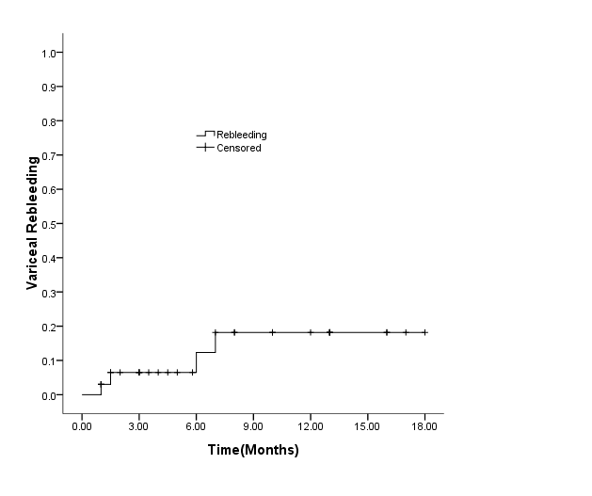
Figure 1 Graph of Kaplan-Meier estimation of cumulative percentages of rebleeding.

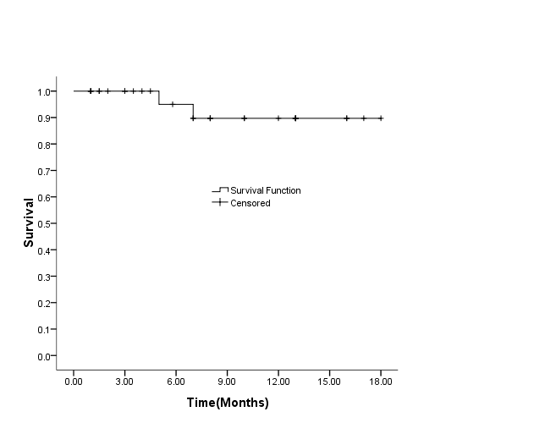
Figure 2 Kaplan-Meier plot shows the rates of survival after transjugular intrahepatic portosystemic shunt placement.

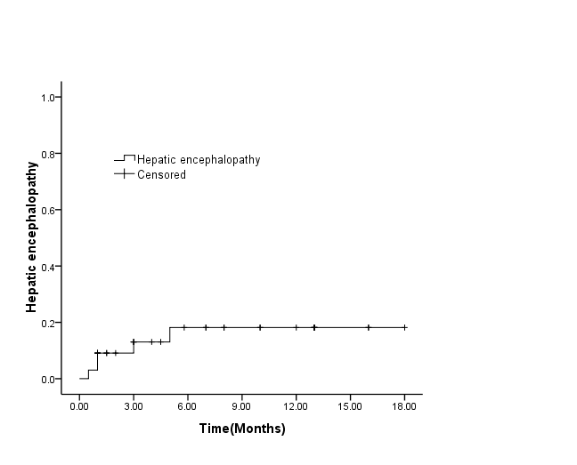
Figure 3 Actuarial probability of hepatic encephalopathy in 81 patients treated with transjugular intrahepatic portosystemic shunt + stomach and esophageal variceal embolization.

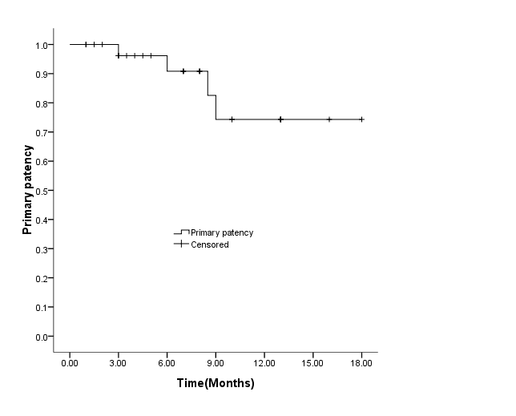
Figure 4 Graph of Kaplan-Meier estimation of cumulative percentages of patients primary shunt patency in all patients undergoing transjugular intrahepatic portosystemic shunt + stomach and esophageal variceal embolization.

