Name of journal: World Journal of Gastroenterology
ESPS Manuscript NO: 15261
Columns: CASE REPORT

Esophageal subepithelial lesion diagnosed as malignant gastrointestinal neuroectodermal tumor

Kim SB et al. Esophageal malignant gastrointestinal neuroectodermal tumor

Sung Bum Kim, Si Hyung Lee, Mi Jin Gu

Sung Bum Kim, Si Hyung Lee, Department of Internal Medicine, Yeungnam University Hospital, Daegu 705-802, South Korea

Mi Jin Gu, Department of Pathology, Yeungnam University Hospital, Daegu 705-802, South Korea

Author contributions: Lee sh supervised, proof-read and made corrections required; all authors contributed to designing the report and editing and writing of the manuscript.

Ethics approval: This study was reviewed and approved by the institutional review board of Yeungnam University Hospital.

Informed consent: The patient has signed the informed consent.

Conflict-of-interest: No potential conflict of interest relevant to this article was reported.

Open-Access: This article is an open-access article which was selected by an in-house editor and fully peer-reviewed by external reviewers. It is distributed in accordance with the Creative Commons Attribution Non Commercial (CC BY-NC 4.0) license, which permits others to distribute, remix, adapt, build upon this work non-commercially, and license their derivative works on different terms, provided the original work is properly cited and the use is non-commercial. See: http://creativecommons.org/licenses/by-nc/4.0/

Correspondence to: Si Hyung Lee, MD, Department of Internal Medicine, Yeungnam University Hospital, 170 Hyeonchung-ro, Nam-gu, Daegu 705-802, South Korea. dr9696@nate.com

Telephone: +82-53-6203830
Fax: +82-53-6548386
Received: November 18, 2014
Peer-review started: November 19, 2014
First decision: January 8, 2015
Revised: January 28, 2015
Accepted: February 11, 2015

Article in press:
Published online:

Abstract
A 21-year-old male visited our hospital with a complaint of aggravating dysphagia and odynophagia for a few days. Esophagogastroduodenoscopy showed huge bulging mucosa with intact surface causing luminal narrowing at 35cm from incisor teeth. Endoscopic ultrasonography showed about 35 mm sized irregular margined in-homogenous hypoechoic lesion with obscure layer of origin. Endoscopic ultrasonography fine needle aspiration revealed spindle cells proliferation without immunoreactivity for CD117, SMA and cytokeratin. The patient underwent excision of subepithelinal lesion at distal esophagus. On pathologic examination of specimen, tumor was composed of short fascicles of oval to spindle cells with eosinophilic and clear cytoplasm and vesicular nuclei. The tumor cells were positive for S-100 and SOX10 and negative for CD117, SMA, HMB-45, Melan A, cytokeratin and CD99. The split-apart signal was detected in EWSR1 on FISH suggesting malignant gastrointestinal neuroectodermal tumor. Patient is now on radiation therapy at operated site of esophagus and doing well without recurrence for three months. Malignant gastrointestinal neuroectodermal tumor is a rare gastrointestinal tumor with features of clear cell sarcoma and without melanocytic differentiation and shows poor prognosis. This is the first to report a case of malignant gastrointestinal neuroectodermal tumor arising as subepithelial lesion in esophagus.

Key words: Subepithelial lesion; Esophagus; Malignant gastrointestinal neuroectodermal tumor; Ewing sarcoma break point region 1 gene; Fluorescence in situ hybridization

© The Author(s) 2015. Published by Baishideng Publishing Group Inc. All rights reserved.

Core tip: This is the first report of malignant gastrointestinal neuroectodermal tumor arising in esophagus. Malignant gastrointestinal neuroectodermal tumor is a tumor with similar morphology, immunophenotype, molecular genetic features of clear cell sarcoma of tendons and aponeurosis lacking melanocytic differentiation arising in the gastrointestinal tract. The malignant gastrointestinal neuroectodermal tumor shows aggressive disease behavior with poor prognosis.

Kim SB, Lee SH, Gu MJ. Esophageal subepithelial lesion diagnosed as malignant gastrointestinal neuroectodermal tumor. World J Gastroenterol 2015; In press

Introduction
Subepithelial lesion (SEL) of the gastrointestinal tract is defined as any bulging covered with intact mucosa and represents either intraluminal lesions arising from any layers of the gastrointestinal wall or external compression caused by neighboring organs^{[1]}. Most SELs are found incidentally during esophagogastroduodenoscopy and in some cases, SEL may cause symptoms. Endoscopic ultrasonography and/or fine needle aspiration is useful in making differential diagnosis of SEL and average accuracy of fine needle aspiration reaches 80%^{[2]}. Differential diagnosis of esophageal SEL includes leiomyoma, granular cell tumor, glomus tumor, gastrointestinal stromal tumor, lipoma, cyst, varices, submucosal cancer or metastasis, or external compression by adjacent structures. The majority of mesenchymal tumors of the gastrointestinal tract are gastrointestinal stromal tumor and leiomyoma and diagnosis of malignant gastrointestinal neuroectodermal tumor (MGINET) has been reported in rare cases^{[3]}.
We report on a case of a subepithelial lesion of the esophagus diagnosed as MGINET, which is the first to be reported in esophagus. We also provided a short review of literature on MGINET.

Case report
A 21-year-old male visited our hospital with a complaint of aggravating dysphagia for a few days. The patient had experienced intermittent dysphagia after overeating for a year. He had no significant past medical or familial history. He was a non-smoker and a social alcohol drinker. On physical examination, he had relatively well-being appearance with alert mentality and soft, non-tender abdomen with no palpable mass. Initial vital signs included blood pressure 140/90 mmHg, heart rate 97 beats/min, respiration rate 20 breaths/min, and body temperature 36.9 °C, respectively. The initial laboratory findings were as follows; white blood cell 9820 cells/μL, hemoglobin 16.5 g/dL, platelet 2.09 x 10⁵ cells/ μL, total bilirubin 0.67 mg/dL, total protein 7.18 g/dL, albumin 4.18 g/dL, aspartate aminotransferase 13 IU/L, alanine aminotransferase 24 IU/L, alkaline phosphatase 263 IU/L, γ-glutamyl transpeptidase 166 IU/L, lactate dehydrogenase 301 IU/L, prothrombin time 12.0 s, blood urea nitrogen 7.5 mg/dL, creatinine 1.01 mg/dL, Na⁺ 134 mEq/L, K⁺ 4 mEq/L and Cl⁻ 97 mEq/L. Esophagogastroduodenoscopy showed huge bulging mucosa with intact surface causing luminal narrowing at 35 cm from incisor teeth (Figure 1). On endoscopic ultrasonography (EUS), an irregular margined in-homogenous hypoechoic lesion measuring approximately 35 mm in size with obscure layer of origin was observed (Figure 2). EUS guided fine needle aspiration was performed and on microscopic view, spindle cell proliferation without immunoreactivity for CD117, CD34. DOG-1, smooth muscle actin and cytokeratin were observed. Abdominal computed tomography scan showed a well defined round mass measuring approximately 3.5 cm in size in distal esophagus (Figure 3). The patient underwent excision of the subepithelial lesion at the distal esophagus. Gross finding showed a mass measuring 3.5 cm x 3.5 cm in size and the cut surface showed heterogeneous white grayish appearance with focal hemorrhage. On microscopic examination of the specimen, the tumor was composed of short fascicles of oval to spindle cells with eosinophilic and clear cytoplasm and vesicular nuclei (Figure 4). Mitosis was seen frequently with mitotic count of 55/50 high power field. The tumor cells were positive for S-100, SOX10 (Figure 5a, b) and vimentin and negative for CD117, CD34, Dog-1, smooth muscle actin, desmin, HMB-45, Melan A, cytokeratin (AE1/AE3) and CD99. The split-apart signal was detected in Ewing sarcoma break point region 1 gene (EWSR1) on Fluorescence In Situ Hybridization. Further evaluation with positron emission tomography showed no evidence of regional or distant metastasis. The patient is now on radiation therapy at the operated site of the esophagus and doing well without recurrence for 5 mo.

Discussion
Clear cell sarcoma of tendons and aponeurosis is a malignant melanoma arising in soft parts with characteristic features of melanocytic differentiation and chromosomal translocation of EWSR1-ATF1 t(11;22)(q13;q12). Tumors with similar morphology, immunophenotype, molecular genetic features of clear cell sarcoma of tendons and aponeurosis lacking melanocytic differentiation arising in the gastrointestinal tract have been reported. Zambrano first designated these tumors as clear cell sarcoma like tumor of the gastrointestinal tract in 2003^{[4]}. Further studies have demonstrated that clear cell sarcoma like tumor of the gastrointestinal tract arises from the autonomic nervous system and Stockman et al^{[3]} re-designated clear cell sarcoma like tumor of the gastrointestinal tract as MGINET in 2012. Immunohistochemical staining of MGINET characteristically shows positive results for vimentin, S100 and SOX10 and negative results for human melanoma black (HMB) 45, melan A, tyrosinase, CD 117, CD 34, DOG-1, CD 99, α-smooth muscle actin, desmin and glial fibrillary acidic protein. Conflicting immunohistochemical staining results for CD 56, synaptophysin, NB 84, non-specific enolase and neurofilament protein have been reported. Consistent with previous reports^{[3,5-11]}, our case showed positive immunohistochemical staining results for S-100 protein, SOX 10 and vimentin and negative results for HMB 45 and melan A. Differential diagnosis with GIST was made by negative immunohistochemical staining results for CD 117, CD 34 and DOG-1. In our case, final diagnosis of MGINET was confirmed by split-apart signal detected in Ewing sarcoma break point region 1 gene (EWSR1) on Fluorescence In Situ Hybridization.
Review of the case reports written in English searched through PubMed and Google Scholar® found 39 cases of MGINET and we reviewed 40 cases of MGINET, including our case^{[3-16]}. Median age of the 40 patients diagnosed as MGINET was 35 years (range: 10-81) and 25 (62.5%) patients were diagnosed at age below 40. Male to female ratio was equal. The most common affected site of MGINET was small intestine with 28 patients (70%), followed by stomach in 8 (20%) cases, colon in 3 (7.5%) cases and esophagus in 1 (2.5%) case. Mean size of the primary tumor was 4.86 cm. Among 33 patients with information on lymph node status, 23 (69.7%) patients had lymph node metastasis at initial diagnosis and among 36 patients with information on local or distant metastasis, 14 (38.9%) patients had local or distant metastasis at initial diagnosis. The most common site of metastasis in MGINET was liver with 16 cases (40%), followed by peritoneum, mesentery, omentum, pelvis, and lung. Among 13 patients with information on tumor invasion depth, 11 (84.6%) patients had transluminal involvement. Stockman et al^{[3]} reported clinical follow up data of 12 patients with MGINET; six patients died with tumor, four patients were alive with regional or distant metastasis and only two patients were alive without recurrence. MGINET showed aggressive clinical feature with high rate of recurrence even after complete resection and high mortality rate. Among 12 patients with both initial and follow up clinical information, even patients with small tumor size of 3.5 cm developed liver metastasis at 12 mo. Among two patients with intact serosa, one patient developed liver metastasis at 24 mo and one had no metastasis at 24 mo. Among five patients with positive lymph node metastasis, three patients developed or died from metastasis and among four patients without lymph node metastasis, two patients developed or died from metastasis. Four patients were free of disease at last follow up, however long term data were not available. As one patient developed metastasis at 60 mo from initial diagnosis, further follow up may increase the incidence of metastasis or death from tumor in these patients. Involved site, tumor, size, presence of trans-mural involvement and lymph node involvement at initial diagnosis do not appear to affect prognosis of MGINET. More cases and further follow up data are needed in order to understand behavior of MGINET. In our case, the patient had localized disease resected with negative margin and had no evidence of regional or distant metastasis on imaging studies, including computed tomography and PET, and early detection of the esophageal lesion due to symptoms caused by narrowing of esophageal lumen might have led to better prognosis in our patients, however further clinical follow up data are needed. We report on a case of subepithelial lesion diagnosed as malignant gastrointestinal neuroectodermal tumor, which is the first report found in esophagus.

COMMENTS
Case characteristics
A 21-year-old male presented with aggravating dysphagia for a few days.

Clinical diagnosis
Physical examination on the abdomen revealed unremarkable findings.
Differential diagnosis
Leiomyoma, granular cell tumor, glomus tumor, gastrointestinal stromal tumor, lipoma, cyst, varices, submucosal cancer or metastasis, or external compression by adjacent structures.

Laboratory findings
Initial laboratory findings were unremarkable.

Imaging diagnosis
Esophagogastroduodenoscopy revealed a huge bulging mucosa with intact surface causing luminal narrowing at 35 cm from incisor teeth, endoscopic ultrasonography showed an irregular margined inhomogeneous hypoechoic lesion measuring approximately 35 mm x 32 mm in size with obscure layer of origin, and abdominal computed tomography scan showed a well-defined mass measuring approximately 35 mm in size in the distal esophagus.

Pathological diagnosis
Histological examination showed spindle cells with eosinophilic and clear cytoplasm and vesicular nuclei and positive immunohistochemical staining results for S-100 protein, SOX 10, and vimentin and negative results for HMB 45 and melan and the final pathological result was confirmed as malignant gastrointestinal neuroectodermal tumor.

Treatment
The patient received excision of the subepithelial lesion in distal esophagus and subsequently treated with radiation therapy.

Related reports
Malignant gastrointestinal neuroectodermal tumor most commonly involves small intestine, followed by stomach and colon.

Term explanation
Malignant gastrointestinal neuroectodermal tumor is a tumor with similar morphology, immunophenotype, molecular genetic features of clear cell sarcoma of tendons and aponeurosis lacking melanocytic differentiation arising in the gastrointestinal tract

Experiences and lessons
This case report presents a case of malignant gastrointestinal neuroectodermal tumor arising in esophagus and most malignant gastrointestinal neuroectodermal tumor shows aggressive behavior and poor prognosis.

Peer-review
The case report on the esophageal subepithelial lesion diagnosed as malignant gastrointestinal neuroectodermal tumor is well written. The topic of the paper is interesting and important.

REFERENCES
1 Hawes RH, Fockens P, Varadarajulu S. Endosonography: Expert Consult - Online and Print, 3e. Saunders Pub, 2014: 400
2 Hoda KM, Rodriguez SA, Faigel DO. EUS-guided sampling of suspected GI stromal tumors. Gastrointest Endosc 2009; 69: 1218-1223 [PMID: 19394006 DOI: 10.1016/j.gie.2008.09.045]
3 Stockman DL, Miettinen M, Suster S, Spagnolo D, Dominguez-Malagon H, Hornick JL, Adsay V, Chou PM, Amanuel B, Vantuinen P, Zambrano EV. Malignant gastrointestinal neuroectodermal tumor: clinicopathologic, immunohistochemical, ultrastructural, and molecular analysis of 16 cases with a reappraisal of clear cell sarcoma-like tumors of the gastrointestinal tract. Am J Surg Pathol 2012; 36: 857-868 [PMID: 22592145 DOI: 10.1097/PAS.0b013e31824644ac]
4 Zambrano E, Reyes-Mugica M, Franchi A, Rosai J. An osteoclast-rich tumor of the gastrointestinal tract with features resembling clear cell sarcoma of soft parts: reports of 6 cases of a GIST simulator. Int J Surg Pathol 2003; 11: 75-81 [PMID: 12754623 DOI: 10.1177/106689690301100202]
5 Antonescu CR, Nafa K, Segal NH, Dal Cin P, Ladanyi M. EWS-CREB1: a recurrent variant fusion in clear cell sarcoma--association with gastrointestinal location and absence of melanocytic differentiation. Clin Cancer Res 2006; 12: 5356-5362 [PMID: 17000668 DOI: 10.1158/1078-0432.CCR-05-2811]
6 Friedrichs N, Testi MA, Moiraghi L, Modena P, Paggen E, Plötner A, Wiechmann V, Mantovani-Löffler L, Merkelbach-Bruse S, Buettner R, Wardelmann E. Clear cell sarcoma-like tumor with osteoclast-like giant cells in the small bowel: further evidence for a new tumor entity. Int J Surg Pathol 2005; 13: 313-318 [PMID: 16273186 DOI: 10.1177/106689690501300402]
7 Shenjere P, Salman WD, Singh M, Mangham DC, Williams A, Eyden BP, Howard N, Knight B, Banerjee SS. Intra-abdominal clear-cell sarcoma: a report of 3 cases, including 1 case with unusual morphological features, and review of the literature. Int J Surg Pathol 2012; 20: 378-385 [PMID: 22084426 DOI: 10.1177/1066896911425485]
8 Donner LR, Trompler RA, Dobin S. Clear cell sarcoma of the ileum: the crucial role of cytogenetics for the diagnosis. Am J Surg Pathol 1998; 22: 121-124 [PMID: 9422325 DOI: 10.1097/00000478-199801000-00016]
9 Huang W, Zhang X, Li D, Chen J, Meng K, Wang Y, Lu Z, Zhou X. Osteoclast-rich tumor of the gastrointestinal tract with features resembling those of clear cell sarcoma of soft parts. Virchows Arch 2006; 448: 200-203 [PMID: 16220298 DOI: 10.1007/s00428-005-0051-y]
10 Joo M, Chang SH, Kim H, Gardner JM, Ro JY. Primary gastrointestinal clear cell sarcoma: report of 2 cases, one case associated with IgG4-related sclerosing disease, and review of literature. Ann Diagn Pathol 2009; 13: 30-35 [PMID: 19118779 DOI: 10.1016/j.anndiagpath.2008.10.003]
11 Terazawa K, Otsuka H, Morita N, Yamashita K, Nishitani H. Clear-cell sarcoma of the small intestine detected by FDG-PET/CT during comprehensive examination of an inflammatory reaction. J Med Invest 2009; 56: 70-75 [PMID: 19262017 DOI: 10.2152/jmi.56.70]
12 Lagmay JP, Ranalli M, Arcila M, Baker P. Clear cell sarcoma of the stomach. Pediatr Blood Cancer 2009; 53: 214-216 [PMID: 19350639 DOI: 10.1002/pbc.22014]
13 Venkataraman G, Quinn AM, Williams J, Hammadeh R. Clear cell sarcoma of the small bowel: a potential pitfall. Case report. APMIS 2005; 113: 716-719 [PMID: 16309433 DOI: 10.1111/j.1600-0463.2005.apm_243.x]
14 Pauwels P, Debiec-Rychter M, Sciot R, Vlasveld T, den Butter B, Hagemeijer A, Hogendoorn PC. Clear cell sarcoma of the stomach. Histopathology 2002; 41: 526-530 [PMID: 12460205 DOI: 10.1046/j.1365-2559.2002.01509.x]
15 Granville L, Hicks J, Popek E, Dishop M, Tatevian N, Lopez-Terrada D. Visceral clear cell sarcoma of soft tissue with confirmation by EWS-ATF1 fusion detection. Ultrastruct Pathol 2006; 30: 111-118 [PMID: 16517477 DOI: 10.1080/01913120500406400]
16 Comin CE, Novelli L, Tornaboni D, Messerini L. Clear cell sarcoma of the ileum: report of a case and review of literature. Virchows Arch 2007; 451: 839-845 [PMID: 17636326 DOI: 10.1007/s00428-007-0454-z]

P-Reviewer: Guo YM, Saha L S-Editor: Ma YJ L-Editor: E-Editor:

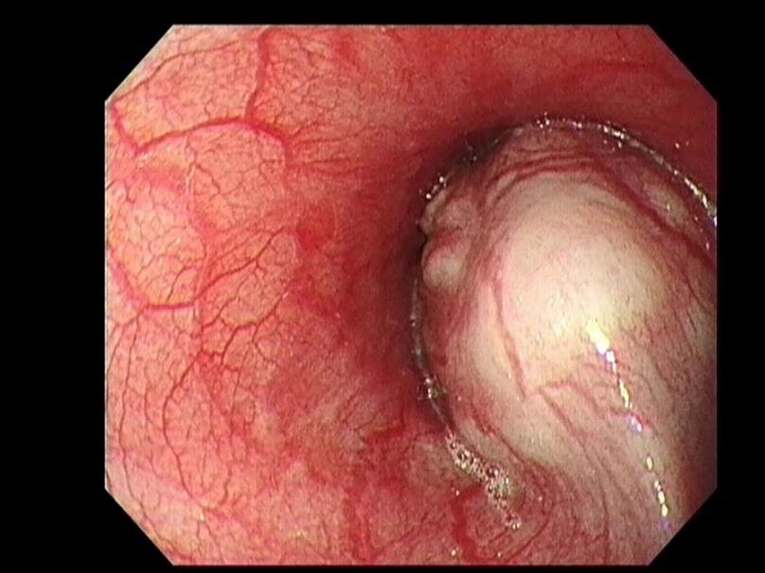
Figure 1 Esophagogastroduodenoscopy at admission. A huge bulging mucosa with intact surface causing luminal narrowing at 35 cm from incisor teeth was seen.

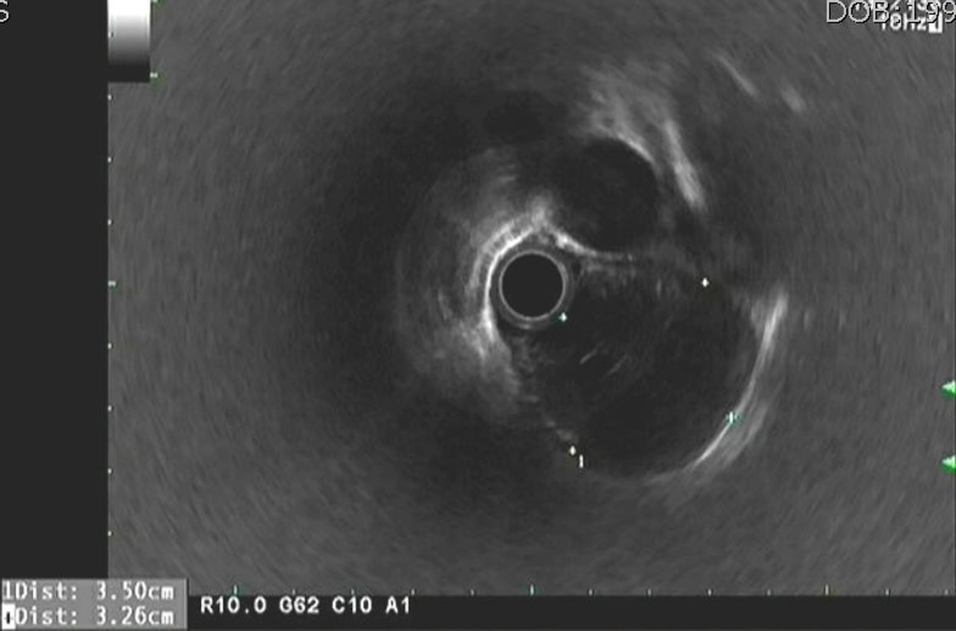
Figure 2 Endoscopic ultrasonography at admission. (A) Irregular margined inhomogeneous hypoechoic lesion measuring approximately 35 mm x 22 mm in size with obscure layer of origin was noted.

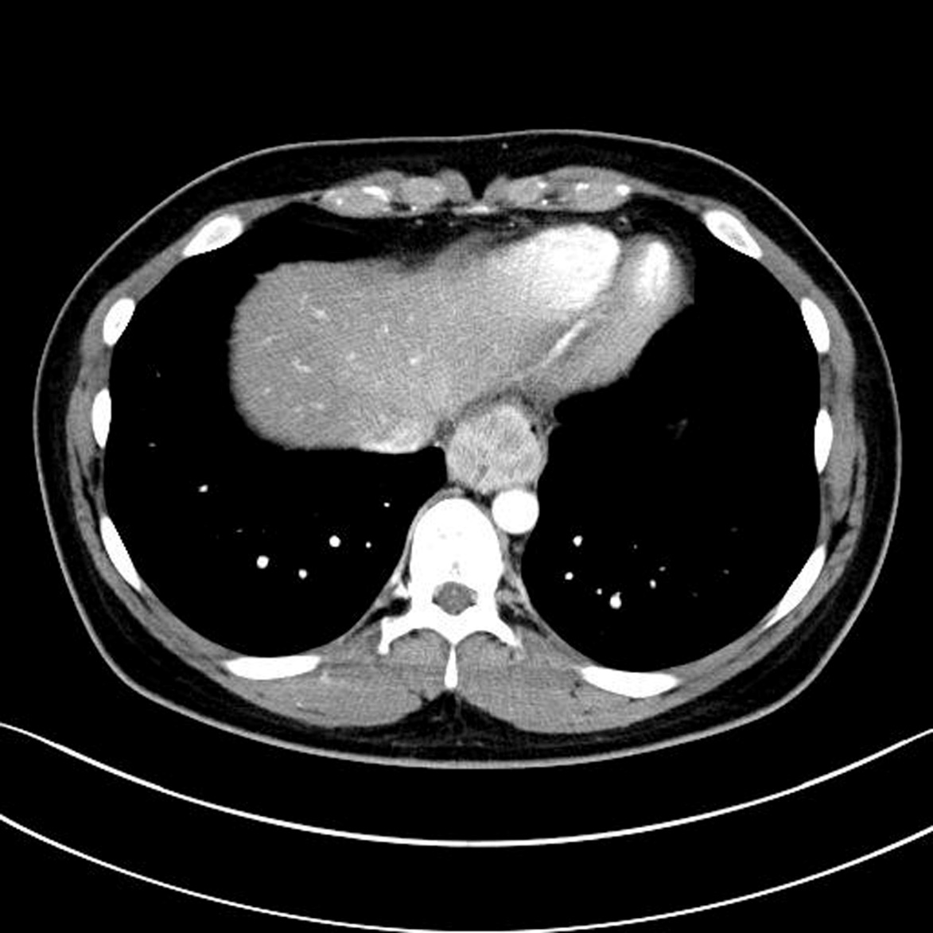
Figure 3 Abdominal computed tomography scan at admission. A well defined mass measuring 35 mm in size in distal esophagus was noted (arrow).

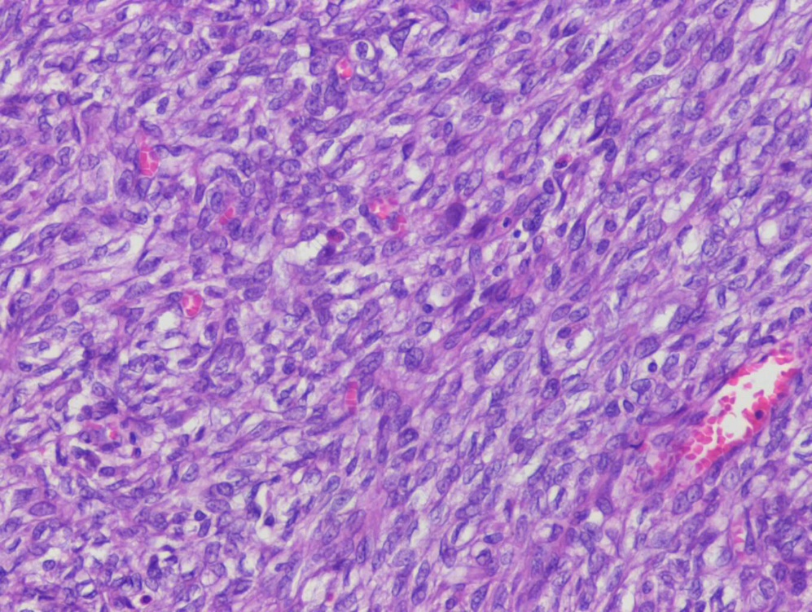
Figure 4 Histologic examination. Malignant gastrointestinal neuroectodermal tumor consisting of spindle cells with eosinophilic and clear cytoplasm and vesicular nuclei was noted. (HE stain, x 200).

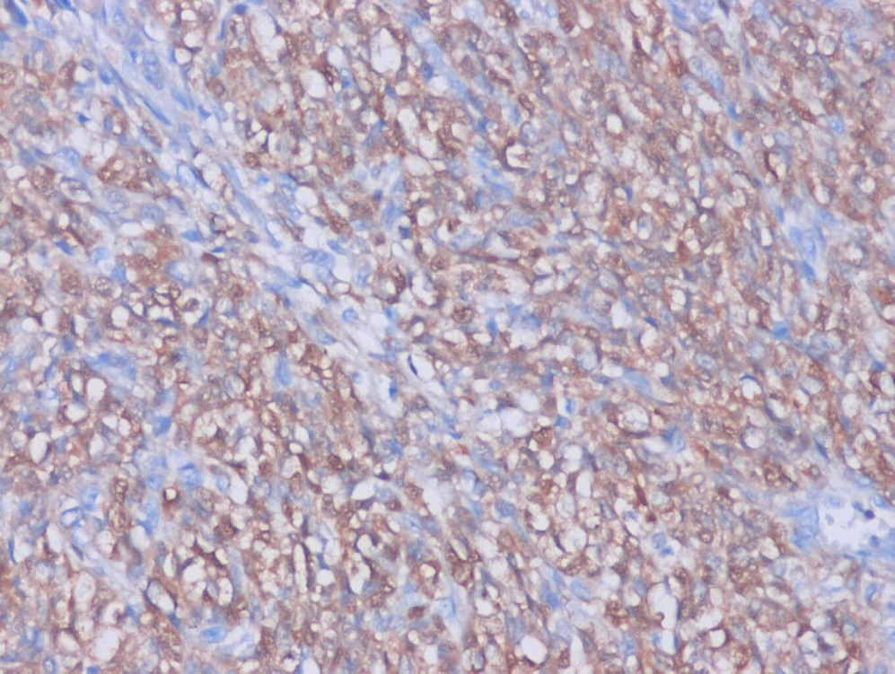
a
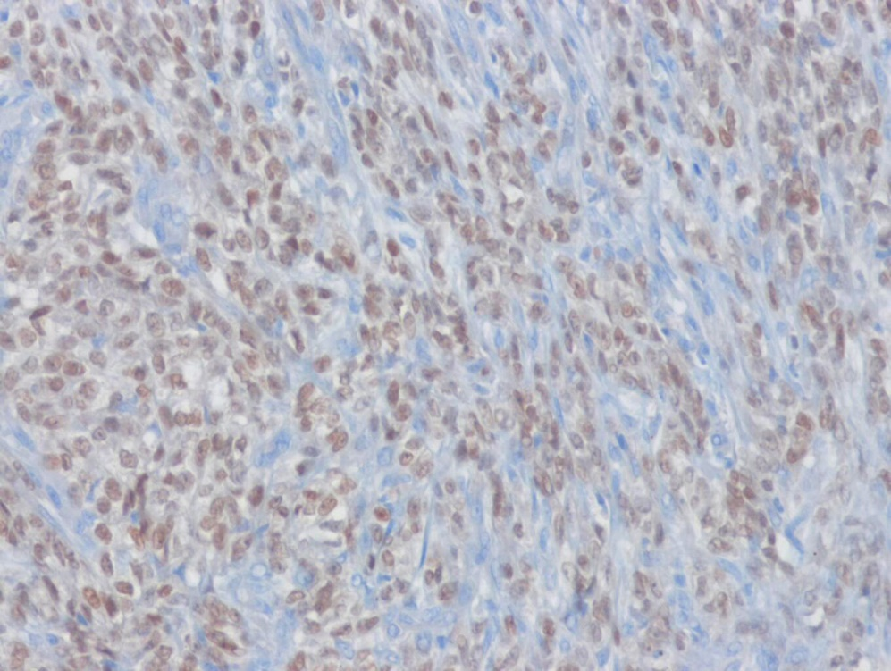
b
Figure 5 Histologic examination with immunohistochemical staining. a positive for S-100 (A) and positive for SOX10 (B) was noted (x 200).

