Name of Journal: World Journal of Nephrology
Manuscript NO: 87232
Manuscript Type: MINIREVIEWS

Cryptococcosis in kidney transplant recipients: Current understanding and practices

Meena P et al. Cryptococcosis in kidney transplant recipients

Priti Meena, Vinant Bhargava, Kulwant Singh, Jasmine sethi, Aniketh Prabhakar, Sandip panda

Priti Meena, Sandip Panda, Department of Nephrology, All India Institute of Medical Sciences, Bhubaneswar 751019, Odhisha, India

Vinant Bhargava, Department of Nephrology, Sir Ganga Ram Hospital New Delhi, New Delhi 110001, New Delhi, India

Kulwant Singh, Department of Nephrology, Ivy Hospital, Mohali Punjab, Mohali 160071, Punjab, India

Jasmine sethi, Department of Nephrology, Post Graduate Institute of Medical Education & Research, Chandigarh 160012, Punjab, India

Aniketh Prabhakar, Department of Nephrology, Consultant Nephrologist, Sigma Hospital, Mysore 570009, Karnataka, India

Author contributions: Meena P and Sethi J drafted the manuscript; Bhargava V conceptualized the idea and helped in writing; Singh K helped in reviewing and writing of the manuscript; Prabhakar A and Panda S edited the manuscipt.

Corresponding author: Priti Meena, MBBS, MD, DNB Nephrology, FASN, Assistant professor, Department of Nephrology, All India Institute of Medical Sciences, Bhubaneswar 751019, Odisha, India. pritimn@gmail.com

Received: August 3, 2023
Revised: October 15, 2023
Accepted: November 2, 2023
Published online:

Abstract
Cryptococcosis is the third most commonly occurring invasive fungal disease in solid organ transplant recipients (SOT). It is caused by encapsulated yeast, Cryptococcus species, predominantly Cryptococcus neoformans and Cryptococcus gattii. Though kidney transplant recipients are at the lowest risk of cryptococcosis when compared to other solid organ transplant recipients such as lung, liver or heart, still this opportunistic infection causes significant morbidity and mortality in this subset of patients. Mortality rates with cryptococcosis range from 10%-25%, while it can be as high as 50% in SOT recipients with central nervous system involvement. The main aim of diagnosis is to find out if there is any involvement of the central nervous system in disseminated disease or whether there is only localized pulmonary involvement as it has implications for both prognostication and treatment. Detection of cryptococcal antigen (CrAg) in cerebrospinal fluid or plasma is a highly recommended test as it is more sensitive and specific than India ink and fungal cultures. The CrAg lateral flow assay is the single point of care test that can rapidly detect cryptococcal polysaccharide capsule. Treatment of cryptococcosis is challenging in kidney transplant recipients. Apart from the reduction or optimization of immunosuppression, lipid formulations of amphotericin B are preferred as induction antifungal agents. Consolidation and maintenance are done with fluconazole; carefully monitoring its interactions with calcineurin inhibitors. This review further discusses in depth the evolving developments in the epidemiology, pathogenesis, diagnostic assays, and management approach of cryptococcosis in kidney transplant recipients.

Key Words: Cryptococcosis; Kidney transplant recipients; Amphotericin B; Immunosuppression; Fluconazole

Meena P, Bhargava V, Singh K, sethi J, Prabhakar A, panda S. Cryptococcosis in kidney transplant recipients: Current understanding and practices. World J Nephrol 2023; In press

Core Tip: Cryptococcosis is the third most common invasive fungal infection in solid organ transplant recipients. As an opportunistic infection, it poses substantial morbidity and mortality in kidney transplant recipients. Mortality rates for cryptococcosis range from 10% to 25%. In immunocompromised patients, especially in cryptococcus-endemic areas, cryptococcosis must be suspected and diagnosed with a low threshold. Compared to India ink and fungal cultures, tests for the cryptococcal antigen detection in cerebrospinal fluid or plasma test are more sensitive and specific. The management of cryptococcosis poses considerable difficulties, mostly done with reduction or optimization of immunosuppression in addition to lipid formulations of amphotericin B and fluconazole.

INTRODUCTION
With the advent of a successful kidney transplantation way back in 1954, we have been able to ensure good initial graft outcomes with potent immunosuppression. Though potent, these drugs have their own side effect profiles^{[1]}. Amongst these side effects, the most profound is higher rates of infections. Fungal infections occur in 15%-42% of organ transplant recipients. However, newer antifungal drugs have ensured a decline in these rates, especially invasive candidate infection. Cryptococcal infections generally are seen in the late post-transplant period, the time when anti-fungal prophylaxis is stopped^{[2]}. Majority of these infections are due to the reactivation of pre-existing latent infections. Mortality rates are variable ranging from 33%-40% and are highest in those with central nervous system involvement^{[3]}. Calcineurin inhibitors interestingly have anti-fungal activity in vitro. Tacrolimus showed more promising antifungal activity compared to cyclosporin and that might be due to efflux pump inhibition which is not present in cyclosporin^{[4]}. Mammalian target of rapamycin inhibitors like rapamycin, and everolimus exhibit in vitro antifungal activity^{[5,6]}. This however may not be truly protective against fungal infection in the real world. Considering the high mortality and even higher morbidity, there is a growing need for easily available highly specific diagnostic modalities for early diagnosis and treatment initiation. In this manuscript, we highlight the disease burden, the latest identification tools and outcomes in renal allograft recipients with present-day immunosuppression and anti-fungal therapy.

MICROBIOLOGY OF CRYPTOCOCCUS
Cryptococcus is a genus of basidiomycetous fungi with more than thirty species commonly found in the environment. There are only two species commonly known to be pathogenic, C neoformans and C gattii. C neoformans was first identified as human pathogen in the late 19th century but was recognized as a common human causative organism of human disease in late 1970s^{[7]}. The pathogenic yeasts can be subclassified into four serotypes based upon capsular agglutination reactions and are designated A, B, C or D. From a clinical prospective it is reasonable to divide cryptococcus into two species complexes: C neoformans (serotype A, D) and c gattii (serotype B, C)^{[8]}. Majority of cryptococcal infection (around 95%) are caused by C neoformans serotype A where as only 4%-5% infections are caused by C neoformans serotype D or C gattii serotype B, C. C neoformans is found throughout the world in association with birds excreta like pigeons, environmental scavengers like amoeba and in a variety of tree species. C gattii is commonly associated with several species of trees in tropical and subtropical climates^{[9-11]}. The life cycle of cryptococcus involves both asexual and sexual forms. The asexual form exists as haploid encapsulated yeast and reproduces by budding. The yeasts are the only form of cryptococcus that have isolated from human infections. The sexual form is observed only in the laboratory^{[12]}. Cryptococcus causes infection following inhalation of aerosolized infectious particles like desiccated yeast cells and basidiospores through the respiratory tract. Cryptococcal infection is acquired from the environment and the spread of infection from person to person has not been documented except with transplanted tissue^{[7,13]}.

EPIDEMIOLOGY
Cryptococcosis is an important opportunistic infection that leads to significant morbidity and mortality in transplant recipients. In solid organ transplant (SOT) recipients, it is the third most commonly occurring invasive fungal infection (IFI) after candidiasis and aspergillosis^{[14]}. Though one recent retrospective observational study from Northern India highlighted the recent rise in angio-invasive fungal infections like mucormycosis and aspergillosis. Cryptococcosis was the fourth most commonly reported infection in this study preceded by mucormycosis, aspergillosis and pneumocystis jiroveci^{[15]}.
Cryptococcosis accounts for 8-10% of the invasive fungal infections in SOT recipients^{[15]}. Its overall incidence in various cohorts of SOT recipients ranges from 0.2% to 5% depending on the type of organ transplanted^{[14,16,17]}. As per a recently published retrospective analysis of the cohort of patients after organ transplantation from three states of the United States, the incidence of cryptococcosis was 0.32% after kidney transplantation which was lower than both lung and liver transplant recipients^{[18]}. Shenoy et al^{[19]} in their recent retrospective analysis showed a very low incidence of 0.04%.
Cryptococcosis primarily occurs due to the reactivation of the latent infection in the post-transplant period^{[20]}. Two decades back, it occurred primarily amongst patients with human immunodeficiency virus (HIV), but now the majority of infections occur in non-HIV population, particularly immunosuppressed SOT recipients (60%-70% of the total cases)^{[21]}. This may be explained by the emergence of highly active antiretroviral therapy for the treatment of HIV, along with an increase in the number of patients undergoing transplantation and the use of immunosuppressants. Calcineurin inhibitors (CNI) can affect the extent of the disease. Patients receiving CNIs were less likely to have disseminated disease due to their in vitro antifungal properties by targeting fungal homologs of calcineurin^{[22]}. Steroids and T cell-depleting induction agents (antithymocyte or alemtuzumab) are associated with an increased risk of cryptococcosis^{[23,24]}.
Cryptococcosis is a late-occurring invasive fungal infection (after 1 year). It has a longer (574 d) median time to onset from the date of transplant as compared to invasive candidiasis (103 d) and aspergillosis (184 d)^{[25]}. Based on the organ transplanted, the median time to onset is earlier after lung (191 d), heart (195 d) and liver (200 d) as compared to kidney transplantation (616 d)^{[18]}.
Mortality rates with cryptococcosis range from 10%-25%, while it can be as high as 50 % in SOT recipients with cryptococcal meningitis^{[26]}.

PATHOPHYSIOLOGY
C. neoformans is detected by a number of innate receptors, including Toll-like receptors, mannose receptors and -glucan receptors in the body during infection. Cells of innate immunity such as natural killer cells, dendritic cells, macrophages and neutrophils are primarily involved in C. neoformans killing in the host^{[27]}. In particular, the establishment of Th1 and Th17 responses following the activation of macrophages is responsible for fungus clearance. Th1 and Th17 cells produce inflammatory cytokines such as IFN-, IL-17, and IL-22 in response to C. neoformans infection, resulting in robust antimicrobial and phagocytic responses^{[28]}. Recently, studies have shown that mediators of death receptor-triggered extrinsic apoptosis, FADD and RIPK3 (immune regulators) control excessive inflammation during C. neoformans infection^{[29]}. Replication of C. neoformans inside macrophages has been shown to be directly correlated with the susceptibility of the host to infection. Factors and conditions that modulate macrophage function causing T-cell function impairment such as in recipients of SOT can result in cryptococcal disease as a result of the reduced antifungal capacity of cells, facilitating the intracellular growth of C. neoformans^{[30]}. C. neoformans releases an array of molecules such as prostaglandins and leukotrienes and virulence-associated enzymes that alter the local immune response of the host by having direct effects on inflammatory cells. Cryptococcal polysaccharides interfere with the migration of leukocytes toward chemoattractants^{[31]}. The robust immune responses can at times be destructive to the organs of the host, especially to the lung parenchyma. Mouse models suggest CD4+ T cells mediates inflammation and host damage in the setting of C. neoformans infection^{[32]}. Rarely, transmission can also occur from a donor allograft^{[33]}.

CLINICAL MANIFESTATION
Depending on the host's immunological condition, clinical signs of cryptococcal infection in a kidney transplant recipients (KTR) might range from asymptomatic colonization of the respiratory tract to wide dissemination^{[34]}. The central nervous system (CNS) is the primary target site. C. neoformans is typically acquired through inhalation into the lungs, where it can spread to the skin, bone, myocardium, transplanted kidney and other organs. The cryptococcal infection in kidney transplant recipients might be the result of a recent acquisition or the recurrence of a latent or dormant infection. Epidemiological data has long suggested that cryptococcal infections exhibit dormancy and reactivation^{[22]}. Cryptococcus neoformans possess the traits required for dormant infection in humans. In an analysis, of 52% of transplant recipients with cryptococcosis, there was evidence of a latent infection before the organ transplant^{[35]}. Figure 1 shows various organ involvement of the human body in cryptococcal infection.
Up to 70% of patients with cryptococcal illness have involvement of the central nervous system. Leptomeningeal or parenchymal lesions, as well as hydrocephalus, can be seen. Frequent clinical signs of CNS involvement include fever, headache, altered mental status, vomiting, seizure, and visual and auditory complaints^{[36]}.
Other major organs affected include the lungs, skin, soft tissues, and osteoarticular. Generalized lymphadenopathy with constitutional symptoms and weight loss can be a presentation that can mimic post transplant lymphoproliferative disease.
The typical signs of pulmonary involvement in a cryptococcus infection include fever, lethargy, night sweats, weight loss, sputum-producing cough, dyspnea, hemoptysis, and rarely severe respiratory failure. Only about one-third of people with cryptococcosis have a lung-only disease, which is usually part of an infection that has spread to other parts of the body^{[30]}. A chest X-ray may reveal multiple or a single nodule, nodular or alveolar infiltrates, a cavitary lesion, a consolidation, a mass, or a pleural effusion. One-third or more of patients with pulmonary cryptococcosis may be asymptomatic^{[37]}. Compared to patients with consolidations, pleural effusions, and infiltrates, patients with nodular densities or mass lesions were less likely to be symptomatic. Rarely severe cryptococcal infection especially with lung involvement can be complicated by the development of hemophagocytic lymphohistiocytosis (HLH) associated with very high mortality. A high index of suspicion is needed to make an early diagnosis which can help to incorporate specific therapy for HLH earlier which may improve outcomes^{[38]}.
Rarely, skin involvement is also seen with cryptococcal infection. Studies have shown that skin involvement can be the first sign of a disseminated cryptococcal illness^{[39]}. Primary cutaneous cryptococcosis may act as a portal of entry for secondary disseminated cryptococcosis. Skin lesions might include cellulitis, panniculitis, subcutaneous nodules, abscesses, and acneiform papules. Umbilicated papules resembling Molluscum contagiosum are often present in hemogenous cryptococcal skin changes.
Another condition for the disease's localized form is cryptococcoma^{[33]}. Most of them are recognized radiologically. Localized cryptococcal lesions typically coexist with a systemic illness. These are more typical in infections caused by Cryptococcus gattii. Cryptococcoma mainly affects the CNS and very infrequently the lungs and the transplanted kidney.
Both symptomatic cryptococcal pyelonephritis and graft involvement have been reported in cryptococcal infection^{[40]}. Laryngeal cryptococcus and renal arterial rupture related to cryptococcus have also been described^{[41,42]}.

DIAGNOSIS OF CRYPTOCOCCAL INFECTION
Diagnosis can be challenging, especially in transplant recipients. One must have a high index of suspicion and a low diagnostic threshold to diagnose cryptococcosis, especially in regions with high prevalence. Any clinical signs of disease like subacute headache, fever, cough and weakness should prompt rapid cryptococcal testing. All transplant recipients with suspected or proven cryptococcosis should undergo a thorough evaluation for extrapulmonary sites of infection including a lumbar puncture [large volume cerebrospinal fluid (CSF) sample] and blood/urine cultures. This is important to delineate the site and extent of disease in order to decide the duration of antifungal treatment. The methods used to confirm the infection include direct microscopic examination, culture, histopathology, serology and molecular detection. Antigen tests from blood or culture are rarely positive unless there is disseminated cryptococcal infection.

Imaging: CNS and chest
Cerebral cryptococcosis are more common with C gatti than with C neoformans infection. Normal brain imaging always does not exclude meningoencephalitis. Magnetic resonance imaging (MRI) (magnetic resonance imaging) brain is the preferred modality of imaging to diagnose cerebral cryptococcosis. The MRI findings of CNS cryptococcosis are leptomeningeal/pachymeningeal enhancement, dilated perivascular space, cryptococcal granuloma, hydrocephalus, miliary nodule and plexitis which can occur in isolation or in various combinations^{[43]}. Chest imaging in pulmonary infection is non-specific with solitary/ multiple nodules or diffuse interstitial infiltrates^{[37]}.
CSF examination: The CSF picture in cryptococcal meningoencephalitis classically demonstrates increased opening CSF pressure, low white cell count with a mononuclear predominance, and slightly elevated protein with low/normal glucose concentration^{[44]}. Neuroimaging should be done prior to lumbar puncture to exclude hydrocephalus and mass lesions. Cryptococcal antigen testing from the CSF or serum is the preferred strategy to diagnose infection. India ink testing on CSF is no longer recommended because it can miss low burden infections due to the low sensitivity and specificity.

Microscopy and culture
Visualization of encapsulated yeast forms with narrow budding in the sputum, bronchoalveolar lavage (BAL) or lung tissue biopsy specimens is suggestive of cryptococcal infection. The pellet from pleural fluid or BAL can be mixed with India Ink and observed under a microscope^{[45]}. A lung biopsy from a nodule of uncertain aetiology requires a fungal culture to be done, in addition to a histopathology examination. Samples for culture should be placed on Sabouraud dextrose agar at 30°C for 7 d, in aerobic conditions, and observed daily^{[46]}. Cryptococcus appears as mucoid creamy colonies. C. neoformans are identified generally as smooth colonies while C. gattii mostly appears as mucoid colonies. Canavanine-glycine-bromothymol blue (CGB) agar can be used to differentiate between C. neoformans and C. gattii. Colonies of C. neoformans will not cause changes in CGB agar. On the other hand, C. gattii produces a blue colour in CGB agar.

Histopathology
A lung biopsy is the best diagnostic option when sputum or bronchoscopy specimens are unavailable or negative. Gamori’s methenamine silver or periodic acid Schiff stain identifies the organism as narrow-based budding yeasts (4-10 μm), usually surrounded by thick capsules in the lung tissue. Mucicarmine stain can be used to highlight the cryptococcal capsule as rose burgundy. Histopathological methods and cryptococcal antigen testing cannot differentiate between C neoformans and C gattii^{[47]}. Lung histopathology in pulmonary cryptococcal infection varies from well-formed granulomas to minimal inflammation. Positive histology does not always correlate with culture result. A negative culture might be caused by nonviable organisms in the sample^{[30]}. Figure 2 shows the histopathology of a patient with pulmonary cryptococcosis (H & E stain) and Figure 3 shows the histopathology of a patient with pulmonary cryptococcosis (Alcian blue -PAS stain). India Ink of Cryptococcus neoformans is provided in Figure 4.

Cryptococcal antigen testing
Capsular polysaccharides of Cryptococcus can be detected by using specific anti C. neoformans antisera in the serum, CSF, BAL, and urine by two formats- the latex agglutination test and the recently approved lateral flow immunoassay (LFA)^{[48]}. LFA is the preferred method recommended for diagnosis given its low cost and high sensitivity. These cryptococcal antigen (CrAg) detection tests are rapid, sensitive and specific for diagnosis. These tests have not been standardised for respiratory specimens such as BAL, pleural fluid, or sputum. Pulmonary cryptococcal infection is usually associated with false negative serum CrAg, probably because of the low fungal burden outside the lung or the capsule-deficient strain of Cryptococcus^{[37]}. Serum CrAg titres are typically higher in patients with disseminated diseases/CNS involvement. A prozone effect can occur in high cryptococcal burden states and recognition of this with appropriate dilution of the sample may be required.

Molecular detection
This may be required in specific situations where other diagnostic tests have failed to confirm the diagnosis. These molecular methods include pan-fungal polymerase chain reaction (PCR), deoxyribonucleic acid sequencing for identification, multiplex PCR, isothermal amplification method, and probe-based microarrays. Species identification of cryptococcus is also important as it may affect the choice of antifungal therapy and affect the clinical outcomes. Where possible, isolates should be subjected to either PCR or matrix-assisted laser desorption ionization-time of flight mass spectrometry (MALDI-TOF MS) for genotypic identification. Antifungal susceptibility testing is routinely not recommended for cryptococcal infection^{[49]}. However, in patients with C neoformans infection who have failed primary therapy or relapsed, or in patients with recent antifungal exposure (i.e. antifungal prophylaxis), antifungal susceptibility testing for fluconazole is recommended^{[50]}. Table 1 shows modalities for the diagnosis of post-transplant cryptococcosis.

TREATMENT
Much of the data on the treatment of patients with cryptococcal infections has been extrapolated from trials on HIV Infected patients^{[51]} and also retrospective data from kidney and other SOT patients as there are no randomized controlled trials for the therapy^{[52-54]}. Recommendations herein are consistent with the guidelines of the American Society of Transplantation Infectious Diseases^{[50]}.

Management of cryptococcus has 3 main aspects
Antifungal therapy: As discussed, earlier patients with Cryptococcal infections can present with either isolated pulmonary involvement, neurological Involvement or disseminated disease. The Therapy thus also depends on the site and extent of involvement. (1) In patients with CNS disease, Disseminated Disease or Moderate to severe pulmonary involvement the antifungal therapy of choice in kidney transplant recipients would be Liposomal Amphotericin B Conventional amphotericin B is nephrotoxic and found to be inferior to the liposomal form on comparison of 90-d mortality between the two forms^{[54,55]}. The addition of 5-flucytosine as a part of induction therapy reduces the chances of treatment failure^{[56]}. The induction therapy is usually followed by a consolidation phase and maintenance phase. Doses of flucytosine and Fluconazole should be adjusted according to the glomerular filtration rate. Monitoring of flucytosine level is recommended (2 h post-dose 30-80 mcg/mL). Extended doses may be required as per clinical status. Figure 5 shows therapy for patients with CNS disease, Disseminated Disease or Moderate to severe Pulmonary involvement; and (2) In patients with mild pulmonary disease use of fluconazole 400 mg/d for 6-12 mo is recommended. Even asymptomatically detected (Cryptococcus positive on Sputum culture) pulmonary disease needs to be treated with the same regimen. In all these cases extrapulmonary disease should be excluded. Longer duration of Induction should be considered for patients who are clinically deteriorating, persistent comatose state, and persistently elevated intracranial pressure^{[16]}. In case flucytosine is not available an extended duration of amphotericin B can be used lasting 4-6 wk. Use of extended-spectrum azoles like itraconazole, Voriconazole, Posaconazole, Isavuconazole, do not offer any advantage over fluconazole, but should be used in fluconazole-resistant C. gatti^{[57,58]}.

Supportive therapy: (1) Management of elevated Intracranial Pressure: 50% to 70% of patients with cryptococcal meningitis have elevated intracranial pressure due to reduced CSF absorption secondary to a film formed over the pial layer due to significant inflammatory response. This is a significant factor in morbidity and mortality of the patient as it can lead to hydrocephalous, blindness deafness or death^{[59]}. Lumbar puncture should be done in all patients and opening pressure should be noted. If pressure is above 25 mmHg then a large volume of CSF should be removed, and attempts should be made to keep it below 20 mmHg using repeated lumbar puncture or by using drains from CSF cavities to the peritoneum^{[60]}. Maintaining pressures below 25mmhg was associated with 69% relative survival protection^{[61]}; and (2) Use of Dexamethasone: When Dexamethasone was added to adjunctive therapy on HIV patients showed slower clearance of CSF, Increased serious infections and no impact on mortality compared to placebo. But can be used after clearance of infection^{[62,63]}.

Change in immunosuppression: As this disease is a direct result of the immunocompromised state of the patient there should be an attempt to reduce the immunosuppressive medications. Although nothing can be done about the T cell depleting agents given in the beginning slow reduction in dose of other immunosuppression with a low threshold for diagnosis of rejection should be done aiming for eradication of the fungus and preservation of allograft. The overall immunosuppression should be minimized during therapy; however, the specific approach to achieve this must be tailored to each individual instance. The expeditious decrease in the administration of immunosuppressive drugs may give rise to unfavorable consequences, including the occurrence of organ rejection and/or immune reconstitution inflammatory syndrome (IRIS). Therefore, it is advisable to strategically implement a progressive decrease in dosage with the administration of antifungal therapy. The primary objective is to achieve complete elimination of the infection while simultaneously ensuring the maintenance of allograft functionality. The interaction of azoles with CNI should be kept in mind and frequent monitoring of levels along with dose reduction should be done. The reduction of immunosuppression in KTR along with antifungal therapy initiation can also lead to the development of IRIS^{[64]}. The incidence of this is 5%-12% in SOT recipients and it mimics a worsening cryptococcal disease and can also lead to rejection and graft loss^{[21,24,65]}. It occurs 4-6 wk after initiation of the therapy and is found to be associated more with CNS disease and stoppage of CNI^{[16,66]}. After ruling out the presence of fungi in the body IRIS can be tackled by increasing the dose of corticosteroids^{[64,67]}.

Prognosis and outcomes
Mortality rates in organ transplant recipients with cryptococcosis range from 33%-42% and may be as high as 49% in those with CNS disease and as low as 2.8% in those with isolated pulmonary involvement^{[2,21,50,51]}. Recently, Ponzio et al^{[65]} demonstrated an overall mortality rate of 49%. Independent risk factors for mortality include abnormal mental status, renal failure at baseline, fungemia and disseminated infection^{[24]}. Patients receiving tacrolimus are less likely to have central nervous system involvement and more likely to have skin, soft-tissue, and osteoarticular involvement. Improved outcomes with the use of calcineurin-inhibitor agents may be attributable in part to their synergistic interactions with antifungal agents^{[5,68]}. A significant percentage of patients (up to 20%) progress to graft loss after the infection^{[55]}. Risk factors for graft loss after cryptococcosis include disseminated infection, higher baseline creatinine levels, graft dysfunction concomitant with amphotericin B deoxycholate therapy and an additional nephrotoxic condition^{[56]}. Therefore, the clinical focus should be on the use of less nephrotoxic lipid formulations of amphotericin B in this specific population.

CONCLUSION
Cryptococcal infection accounts for < 10% of IFI and is seen in the late transplant period. Mortality rates are higher for those with meningeal involvement. The advent of newer diagnostic modalities and treatment has reduced infection-related morbidity but has not yet been able to reduce mortality beyond a level. Newer therapeutics with liposomal Amphotericin B. Fluconazole, and 5-flucytosine have improved survival. However, a significant proportion of these patients progress to graft loss either due to reduced immunosuppression, infection or nephrotoxic therapeutic agents. Early detection however has resulted in better survival in the subset of patients.

ACKNOWLEDGEMENTS
Dr Pritinanda Mishra, Additional Professor of Pathology & Lab Medicine, AIIMS-Bhubaneswar (For Image 2A and 2B). Dr Vinaykumar Hallur, Additional Professor of Microbiology and In Charge of ICMR Advanced Molecular Diagnostic and Research Centre, AIIMS-Bhubaneswar (For Image 3).

REFERENCES
1 Kanj SS, Welty-Wolf K, Madden J, Tapson V, Baz MA, Davis RD, Perfect JR. Fungal infections in lung and heart-lung transplant recipients. Report of 9 cases and review of the literature. Medicine (Baltimore) 1996; 75: 142-156 [PMID: 8965683 DOI: 10.1097/00005792-199605000-00004]
2 Fortún J, Martín-Davila P, Moreno S, Barcena R, de Vicente E, Honrubia A, García M, Nuño J, Candela A, Uriarte M, Pintado V. Prevention of invasive fungal infections in liver transplant recipients: the role of prophylaxis with lipid formulations of amphotericin B in high-risk patients. J Antimicrob Chemother 2003; 52: 813-819 [PMID: 14563893 DOI: 10.1093/jac/dkg450]
3 John GT, Mathew M, Snehalatha E, Anandi V, Date A, Jacob CK, Shastry JC. Cryptococcosis in renal allograft recipients. Transplantation 1994; 58: 855-856 [PMID: 7940723 DOI: 10.1097/00007890-199410150-00020]
4 Borba-Santos LP, Reis de Sá LF, Ramos JA, Rodrigues AM, de Camargo ZP, Rozental S, Ferreira-Pereira A. Tacrolimus Increases the Effectiveness of Itraconazole and Fluconazole against Sporothrix spp. Front Microbiol 2017; 8: 1759 [PMID: 28966608 DOI: 10.3389/fmicb.2017.01759]
5 Jiang H, Xiong J, Tan L, Jin P, Sun Y, Yang L, Tan J. In Vitro Interactions of Antifungal Agents and Everolimus Against Aspergillus Species. Front Cell Infect Microbiol 2022; 12: 936814 [PMID: 35865820 DOI: 10.3389/fcimb.2022.936814]
6 Rohde JR, Cardenas ME. Nutrient signaling through TOR kinases controls gene expression and cellular differentiation in fungi. Curr Top Microbiol Immunol 2004; 279: 53-72 [PMID: 14560951 DOI: 10.1007/978-3-642-18930-2_4]
7 Kwon-Chung KJ, Bennett JE, Wickes BL, Meyer W, Cuomo CA, Wollenburg KR, Bicanic TA, Castañeda E, Chang YC, Chen J, Cogliati M, Dromer F, Ellis D, Filler SG, Fisher MC, Harrison TS, Holland SM, Kohno S, Kronstad JW, Lazera M, Levitz SM, Lionakis MS, May RC, Ngamskulrongroj P, Pappas PG, Perfect JR, Rickerts V, Sorrell TC, Walsh TJ, Williamson PR, Xu J, Zelazny AM, Casadevall A. The Case for Adopting the "Species Complex" Nomenclature for the Etiologic Agents of Cryptococcosis. mSphere 2017; 2 [PMID: 28101535 DOI: 10.1128/mSphere.00357-16]
8 MacDougall L, Fyfe M, Romney M, Starr M, Galanis E. Risk factors for Cryptococcus gattii infection, British Columbia, Canada. Emerg Infect Dis 2011; 17: 193-199 [PMID: 21291588 DOI: 10.3201/eid1702.101020]
9 Steenbergen JN, Shuman HA, Casadevall A. Cryptococcus neoformans interactions with amoebae suggest an explanation for its virulence and intracellular pathogenic strategy in macrophages. Proc Natl Acad Sci U S A 2001; 98: 15245-15250 [PMID: 11742090 DOI: 10.1073/pnas.261418798]
10 Ellis DH, Pfeiffer TJ. Natural habitat of Cryptococcus neoformans var. gattii. J Clin Microbiol 1990; 28: 1642-1644 [PMID: 2199524 DOI: 10.1128/jcm.28.7.1642-1644.1990]
11 EMMONS CW. Saprophytic sources of Cryptococcus neoformans associated with the pigeon (Columba livia). Am J Hyg 1955; 62: 227-232 [PMID: 13268414 DOI: 10.1093/oxfordjournals.aje.a119775]
12 Hull CM, Heitman J. Genetics of Cryptococcus neoformans. Annu Rev Genet 2002; 36: 557-615 [PMID: 12429703 DOI: 10.1146/annurev.genet.36.052402.152652]
13 Saul N, Krockenberger M, Carter D. Evidence of recombination in mixed-mating-type and alpha-only populations of Cryptococcus gattii sourced from single eucalyptus tree hollows. Eukaryot Cell 2008; 7: 727-734 [PMID: 18281600 DOI: 10.1128/EC.00020-08]
14 Pappas PG, Alexander BD, Andes DR, Hadley S, Kauffman CA, Freifeld A, Anaissie EJ, Brumble LM, Herwaldt L, Ito J, Kontoyiannis DP, Lyon GM, Marr KA, Morrison VA, Park BJ, Patterson TF, Perl TM, Oster RA, Schuster MG, Walker R, Walsh TJ, Wannemuehler KA, Chiller TM. Invasive fungal infections among organ transplant recipients: results of the Transplant-Associated Infection Surveillance Network (TRANSNET). Clin Infect Dis 2010; 50: 1101-1111 [PMID: 20218876 DOI: 10.1086/651262]
15 Gupta KL, Bagai S, Ramachandran R, Kumar V, Rathi M, Kohli HS, Sharma A, Chakrabarti A. Fungal infection in post-renal transplant patient: Single-center experience. Indian J Pathol Microbiol 2020; 63: 587-592 [PMID: 33154310 DOI: 10.4103/IJPM.IJPM_306_19]
16 Perfect JR, Dismukes WE, Dromer F, Goldman DL, Graybill JR, Hamill RJ, Harrison TS, Larsen RA, Lortholary O, Nguyen MH, Pappas PG, Powderly WG, Singh N, Sobel JD, Sorrell TC. Clinical practice guidelines for the management of cryptococcal disease: 2010 update by the infectious diseases society of america. Clin Infect Dis 2010; 50: 291-322 [PMID: 20047480 DOI: 10.1086/649858]
17 Shoham S, Marr KA. Invasive fungal infections in solid organ transplant recipients. Future Microbiol 2012; 7: 639-655 [PMID: 22568718 DOI: 10.2217/fmb.12.28]
18 George IA, Santos CAQ, Olsen MA, Powderly WG. Epidemiology of Cryptococcosis and Cryptococcal Meningitis in a Large Retrospective Cohort of Patients After Solid Organ Transplantation. Open Forum Infect Dis 2017; 4: ofx004 [DOI: 10.1093/ofid/ofv131.53]
19 Shenoy R, Prasad N, Kaul A, Bhadauria DS. POS-106 Profile of cryptococcal infections in renal transplant recipients in a tertiary care hospital in North India. Kidney Int Rep 2022; 7: S514-S515 [DOI: 10.1016/j.ekir.2022.07.124]
20 Garcia-Hermoso D, Janbon G, Dromer F. Epidemiological evidence for dormant Cryptococcus neoformans infection. J Clin Microbiol 1999; 37: 3204-3209 [PMID: 10488178 DOI: 10.1128/JCM.37.10.3204-3209.1999]
21 Patel V, Desjardins M, Cowan J. Shift in Epidemiology of Cryptococcal Infections in Ottawa with High Mortality in Non-HIV Immunocompromised Patients. J Fungi (Basel) 2019; 5 [PMID: 31717662 DOI: 10.3390/jof5040104]
22 Singh N, Alexander BD, Lortholary O, Dromer F, Gupta KL, John GT, del Busto R, Klintmalm GB, Somani J, Lyon GM, Pursell K, Stosor V, Munoz P, Limaye AP, Kalil AC, Pruett TL, Garcia-Diaz J, Humar A, Houston S, House AA, Wray D, Orloff S, Dowdy LA, Fisher RA, Heitman J, Wagener MM, Husain S; Cryptococcal Collaborative Transplant Study Group. Cryptococcus neoformans in organ transplant recipients: impact of calcineurin-inhibitor agents on mortality. J Infect Dis 2007; 195: 756-764 [PMID: 17262720 DOI: 10.1086/511438]
23 Silveira FP, Husain S, Kwak EJ, Linden PK, Marcos A, Shapiro R, Fontes P, Marsh JW, de Vera M, Tom K, Thai N, Tan HP, Basu A, Soltys K, Paterson DL. Cryptococcosis in liver and kidney transplant recipients receiving anti-thymocyte globulin or alemtuzumab. Transpl Infect Dis 2007; 9: 22-27 [PMID: 17313467 DOI: 10.1111/j.1399-3062.2006.00149.x]
24 Diamond RD, Bennett JE. Prognostic factors in cryptococcal meningitis. A study in 111 cases. Ann Intern Med 1974; 80: 176-181 [PMID: 4811791 DOI: 10.7326/0003-4819-80-2-176]
25 Maziarz EK, Perfect JR. Cryptococcosis. Infect Dis Clin North Am 2016; 30: 179-206 [PMID: 26897067 DOI: 10.1016/j.idc.2015.10.006]
26 Neofytos D, Fishman JA, Horn D, Anaissie E, Chang CH, Olyaei A, Pfaller M, Steinbach WJ, Webster KM, Marr KA. Epidemiology and outcome of invasive fungal infections in solid organ transplant recipients. Transpl Infect Dis 2010; 12: 220-229 [PMID: 20113459 DOI: 10.1111/j.1399-3062.2010.00492.x]
27 Casadevall A, Coelho C, Alanio A. Mechanisms of Cryptococcus neoformans-Mediated Host Damage. Front Immunol 2018; 9: 855 [PMID: 29760698 DOI: 10.3389/fimmu.2018.00855]
28 Alanio A, Desnos-Ollivier M, Dromer F. Dynamics of Cryptococcus neoformans-macrophage interactions reveal that fungal background influences outcome during cryptococcal meningoencephalitis in humans. mBio 2011; 2 [PMID: 21828220 DOI: 10.1128/mBio.00158-11]
29 Fa Z, Xie Q, Fang W, Zhang H, Zhang H, Xu J, Pan W, Xu J, Olszewski MA, Deng X, Liao W. RIPK3/Fas-Associated Death Domain Axis Regulates Pulmonary Immunopathology to Cryptococcal Infection Independent of Necroptosis. Front Immunol 2017; 8: 1055 [PMID: 28919893 DOI: 10.3389/fimmu.2017.01055]
30 Setianingrum F, Rautemaa-Richardson R, Denning DW. Pulmonary cryptococcosis: A review of pathobiology and clinical aspects. Med Mycol 2019; 57: 133-150 [PMID: 30329097 DOI: 10.1093/mmy/myy086]
31 Yauch LE, Lam JS, Levitz SM. Direct inhibition of T-cell responses by the Cryptococcus capsular polysaccharide glucuronoxylomannan. PLoS Pathog 2006; 2: e120 [PMID: 17096589 DOI: 10.1371/journal.ppat.0020120]
32 Zaragoza O, Alvarez M, Telzak A, Rivera J, Casadevall A. The relative susceptibility of mouse strains to pulmonary Cryptococcus neoformans infection is associated with pleiotropic differences in the immune response. Infect Immun 2007; 75: 2729-2739 [PMID: 17371865 DOI: 10.1128/IAI.00094-07]
33 Santos DWCL, Hagen F, Meis JF, Cristelli MP, Viana LA, Bernardi FDC, Tedesco-Silva H, Medina-Pestana JO, Colombo AL. Donor-Derived Transmission of Cryptococcus gattii sensu lato in Kidney Transplant Recipients. Emerg Infect Dis 2020; 26: 1329-1331 [PMID: 32441623 DOI: 10.3201/eid2606.191765]
34 Chen S, Sorrell T, Nimmo G, Speed B, Currie B, Ellis D, Marriott D, Pfeiffer T, Parr D, Byth K. Epidemiology and host- and variety-dependent characteristics of infection due to Cryptococcus neoformans in Australia and New Zealand. Australasian Cryptococcal Study Group. Clin Infect Dis 2000; 31: 499-508 [PMID: 10987712 DOI: 10.1086/313992]
35 Saha DC, Goldman DL, Shao X, Casadevall A, Husain S, Limaye AP, Lyon M, Somani J, Pursell K, Pruett TL, Singh N. Serologic evidence for reactivation of cryptococcosis in solid-organ transplant recipients. Clin Vaccine Immunol 2007; 14: 1550-1554 [PMID: 17959819 DOI: 10.1128/CVI.00242-07]
36 Singh N, Lortholary O, Dromer F, Alexander BD, Gupta KL, John GT, del Busto R, Klintmalm GB, Somani J, Lyon GM, Pursell K, Stosor V, Munoz P, Limaye AP, Kalil AC, Pruett TL, Garcia-Diaz J, Humar A, Houston S, House AA, Wray D, Orloff S, Dowdy LA, Fisher RA, Heitman J, Wagener MM, Husain S; Cryptococcal Collaborative Transplant Study Group. Central nervous system cryptococcosis in solid organ transplant recipients: clinical relevance of abnormal neuroimaging findings. Transplantation 2008; 86: 647-651 [PMID: 18791444 DOI: 10.1097/TP.0b013e3181814e76]
37 Singh N, Dromer F, Perfect JR, Lortholary O. Cryptococcosis in solid organ transplant recipients: current state of the science. Clin Infect Dis 2008; 47: 1321-1327 [PMID: 18840080 DOI: 10.1086/592690]
38 Singh PK, Kodati R, Rohilla M, Sharma P. Hemophagocytic lymphohistiocytosis: a rare association with pulmonary cryptococcosis. BMJ Case Rep 2019; 12 [PMID: 31401574 DOI: 10.1136/bcr-2019-230255]
39 Chakradeo K, Paul Chia YY, Liu C, Mudge DW, De Silva J. Disseminated cryptococcosis presenting initially as lower limb cellulitis in a renal transplant recipient - a case report. BMC Nephrol 2018; 19: 18 [PMID: 29374464 DOI: 10.1186/s12882-018-0815-7]
40 Muranda AZ, Greeff L, Sathekge MM, Lengano T, Karusseit VOL. Cryptococcoma of a transplanted kidney in a patient presenting with recurrent urinary tract infection: a case report. BMC Nephrol 2018; 19: 94 [PMID: 29688849 DOI: 10.1186/s12882-018-0891-8]
41 Sandhu J, Sandhu JS, Kaur Puri H, Munjal M. Laryngeal cryptococcus: a rare cause of hoarseness in renal allograft recipient. J Nephropharmacol 2017; 6: 27-29 [PMID: 28197527 DOI: 10.4103/0971-4065.116333]
42 Hellman RN, Hinrichs J, Sicard G, Hoover R, Golden P, Hoffsten P. Cryptococcal pyelonephritis and disseminated cryptococcosis in a renal transplant recipient. Arch Intern Med 1981; 141: 128-130 [PMID: 7004368 DOI: 10.1001/archinte.1981.00340010120023]
43 Duarte SBL, Oshima MM, Mesquita JVDA, do Nascimento FBP, de Azevedo PC, Reis F. Magnetic resonance imaging findings in central nervous system cryptococcosis: comparison between immunocompetent and immunocompromised patients. Radiol Bras 2017; 50: 359-365 [PMID: 29307925 DOI: 10.1590/0100-3984.2016.0017]
44 Abassi M, Boulware DR, Rhein J. Cryptococcal Meningitis: Diagnosis and Management Update. Curr Trop Med Rep 2015; 2: 90-99 [PMID: 26279970 DOI: 10.1007/s40475-015-0046-y]
45 Birkhead M, Naicker SD, Blasich NP, Rukasha I, Thomas J, Sriruttan C, Abrahams S, Mavuso GS, Govender NP. Cryptococcus neoformans: Diagnostic Dilemmas, Electron Microscopy and Capsular Variants. Trop Med Infect Dis 2018; 4 [PMID: 30577542 DOI: 10.3390/tropicalmed4010001]
46 Liu L, Du L, He S, Sun T, Kong F, Liu Y, Xu Y. Subculturing and Gram staining of blood cultures flagged negative by the BACTEC™ FX system: Optimizing the workflow for detection of Cryptococcus neoformans in clinical specimens. Front Microbiol 2023; 14: 1113817 [PMID: 37007533 DOI: 10.3389/fmicb.2023.1113817]
47 Shibuya K, Coulson WF, Wollman JS, Wakayama M, Ando T, Oharaseki T, Takahashi K, Naoe S. Histopathology of cryptococcosis and other fungal infections in patients with acquired immunodeficiency syndrome. Int J Infect Dis 2001; 5: 78-85 [PMID: 11468102 DOI: 10.1016/S1201-9712(01)90030-X]
48 Dominic RS, Prashanth H, Shenoy S, Baliga S. Diagnostic value of latex agglutination in cryptococcal meningitis. J Lab Physicians 2009; 1: 67-68 [PMID: 21938253 DOI: 10.4103/0974-2727.59702]
49 Martins Mdos A, Brighente KB, Matos TA, Vidal JE, Hipólito DD, Pereira-Chioccola VL. Molecular diagnosis of cryptococcal meningitis in cerebrospinal fluid: comparison of primer sets for Cryptococcus neoformans and Cryptococcus gattii species complex. Braz J Infect Dis 2015; 19: 62-67 [PMID: 25523072 DOI: 10.1016/j.bjid.2014.09.004]
50 Baddley JW, Forrest GN; AST Infectious Diseases Community of Practice. Cryptococcosis in solid organ transplantation-Guidelines from the American Society of Transplantation Infectious Diseases Community of Practice. Clin Transplant 2019; 33: e13543 [PMID: 30900315 DOI: 10.1111/ctr.13543]
51 van der Horst CM, Saag MS, Cloud GA, Hamill RJ, Graybill JR, Sobel JD, Johnson PC, Tuazon CU, Kerkering T, Moskovitz BL, Powderly WG, Dismukes WE. Treatment of cryptococcal meningitis associated with the acquired immunodeficiency syndrome. National Institute of Allergy and Infectious Diseases Mycoses Study Group and AIDS Clinical Trials Group. N Engl J Med 1997; 337: 15-21 [PMID: 9203426 DOI: 10.1056/NEJM199707033370103]
52 Husain S, Wagener MM, Singh N. Cryptococcus neoformans infection in organ transplant recipients: variables influencing clinical characteristics and outcome. Emerg Infect Dis 2001; 7: 375-381 [PMID: 11384512 DOI: 10.3201/eid0703.010302]
53 Sun HY, Wagener MM, Singh N. Cryptococcosis in solid-organ, hematopoietic stem cell, and tissue transplant recipients: evidence-based evolving trends. Clin Infect Dis 2009; 48: 1566-1576 [PMID: 19402789 DOI: 10.1086/598936]
54 Sun HY, Alexander BD, Huprikar S, Forrest GN, Bruno D, Lyon GM, Wray D, Johnson LB, Sifri CD, Razonable RR, Morris MI, Stosor V, Wagener MM, Singh N. Predictors of immune reconstitution syndrome in organ transplant recipients with cryptococcosis: implications for the management of immunosuppression. Clin Infect Dis 2015; 60: 36-44 [PMID: 25210020 DOI: 10.1093/cid/ciu711]
55 O'Connor L, Livermore J, Sharp AD, Goodwin J, Gregson L, Howard SJ, Felton TW, Schwartz JA, Neely MN, Harrison TS, Perfect JR, Hope WW. Pharmacodynamics of liposomal amphotericin B and flucytosine for cryptococcal meningoencephalitis: safe and effective regimens for immunocompromised patients. J Infect Dis 2013; 208: 351-361 [PMID: 23599314 DOI: 10.1093/infdis/jit164]
56 Dromer F, Bernede-Bauduin C, Guillemot D, Lortholary O; French Cryptococcosis Study Group. Major role for amphotericin B-flucytosine combination in severe cryptococcosis. PLoS One 2008; 3: e2870 [PMID: 18682846 DOI: 10.1371/journal.pone.0002870]
57 Dodds-Ashley E. Management of drug and food interactions with azole antifungal agents in transplant recipients. Pharmacotherapy 2010; 30: 842-854 [PMID: 20653361 DOI: 10.1592/phco.30.8.842]
58 Thompson GR 3rd, Rendon A, Ribeiro Dos Santos R, Queiroz-Telles F, Ostrosky-Zeichner L, Azie N, Maher R, Lee M, Kovanda L, Engelhardt M, Vazquez JA, Cornely OA, Perfect JR. Isavuconazole Treatment of Cryptococcosis and Dimorphic Mycoses. Clin Infect Dis 2016; 63: 356-362 [PMID: 27169478 DOI: 10.1093/cid/ciw305]
59 Liliang PC, Liang CL, Chang WN, Chen HJ, Su TM, Lu K, Lu CH. Shunt surgery for hydrocephalus complicating cryptococcal meningitis in human immunodeficiency virus-negative patients. Clin Infect Dis 2003; 37: 673-678 [PMID: 12942399 DOI: 10.1086/377208]
60 Kagimu E, Engen N, Ssebambulidde K, Kasibante J, Kiiza TK, Mpoza E, Tugume L, Nuwagira E, Nsangi L, Williams DA, Hullsiek KH, Boulware DR, Meya DB, Rhein J, Abassi M, Musubire AK. Therapeutic Lumbar Punctures in Human Immunodeficiency Virus-Associated Cryptococcal Meningitis: Should Opening Pressure Direct Management? Open Forum Infect Dis 2022; 9: ofac416 [PMID: 36092828 DOI: 10.1093/ofid/ofac416]
61 Chang CC, Perfect JR. Repeated therapeutic lumbar punctures in cryptococcal meningitis - necessity and/or opportunity? Curr Opin Infect Dis 2016; 29: 539-545 [PMID: 27607912 DOI: 10.1097/QCO.0000000000000315]
62 Beardsley J, Wolbers M, Kibengo FM, Ggayi AB, Kamali A, Cuc NT, Binh TQ, Chau NV, Farrar J, Merson L, Phuong L, Thwaites G, Van Kinh N, Thuy PT, Chierakul W, Siriboon S, Thiansukhon E, Onsanit S, Supphamongkholchaikul W, Chan AK, Heyderman R, Mwinjiwa E, van Oosterhout JJ, Imran D, Basri H, Mayxay M, Dance D, Phimmasone P, Rattanavong S, Lalloo DG, Day JN; CryptoDex Investigators. Adjunctive Dexamethasone in HIV-Associated Cryptococcal Meningitis. N Engl J Med 2016; 374: 542-554 [PMID: 26863355 DOI: 10.1056/NEJMoa1509024]
63 Panackal AA, Marr KA, Williamson PR. Dexamethasone in Cryptococcal Meningitis. N Engl J Med 2016; 375: 188 [PMID: 27410935 DOI: 10.1056/NEJMc1605205]
64 Singh N, Perfect JR. Immune reconstitution syndrome associated with opportunistic mycoses. Lancet Infect Dis 2007; 7: 395-401 [PMID: 17521592 DOI: 10.1016/S1473-3099(07)70085-3]
65 Ponzio V, Camargo LF, Medina-Pestana J, Perfect JR, Colombo AL. Outcomes of cryptococcosis in renal transplant recipients in a less-resourced health care system. Transpl Infect Dis 2018; 20: e12910 [PMID: 29677399 DOI: 10.1111/tid.12910]
66 Legris T, Massad M, Purgus R, Vacher-Coponat H, Ranque S, Girard N, Berland Y, Moal V. Immune reconstitution inflammatory syndrome mimicking relapsing cryptococcal meningitis in a renal transplant recipient. Transpl Infect Dis 2011; 13: 303-308 [PMID: 21159113 DOI: 10.1111/j.1399-3062.2010.00592.x]
67 Wiesner DL, Boulware DR. Cryptococcus-Related Immune Reconstitution Inflammatory Syndrome(IRIS): Pathogenesis and Its Clinical Implications. Curr Fungal Infect Rep 2011; 5: 252-261 [PMID: 22389746 DOI: 10.1007/s12281-011-0064-8]
68 Cruz MC, Del Poeta M, Wang P, Wenger R, Zenke G, Quesniaux VF, Movva NR, Perfect JR, Cardenas ME, Heitman J. Immunosuppressive and nonimmunosuppressive cyclosporine analogs are toxic to the opportunistic fungal pathogen Cryptococcus neoformans via cyclophilin-dependent inhibition of calcineurin. Antimicrob Agents Chemother 2000; 44: 143-149 [PMID: 10602736 DOI: 10.1128/AAC.44.1.143-149.2000]

Footnotes
Conflict-of-interest statement: Authors declare no conflict of interest for this article.

Open-Access: This article is an open-access article that was selected by an in-house editor and fully peer-reviewed by external reviewers. It is distributed in accordance with the Creative Commons Attribution NonCommercial (CC BY-NC 4.0) license, which permits others to distribute, remix, adapt, build upon this work non-commercially, and license their derivative works on different terms, provided the original work is properly cited and the use is non-commercial. See: https://creativecommons.org/Licenses/by-nc/4.0/

Provenance and peer review: Invited article; Externally peer reviewed.
Peer-review model: Single blind

Peer-review started: August 3, 2023
First decision: August 24, 2023
Article in press:

Specialty type: Infectious diseases
Country/Territory of origin: India
Peer-review report’s scientific quality classification
Grade A (Excellent): 0
Grade B (Very good): B
Grade C (Good): C, C
Grade D (Fair): 0
Grade E (Poor): 0

P-Reviewer: Ali A, Iraq; Sureshkumar KK, United States; Taheri S, Iran S-Editor: Liu JH L-Editor: A P-Editor:
Figure Legends
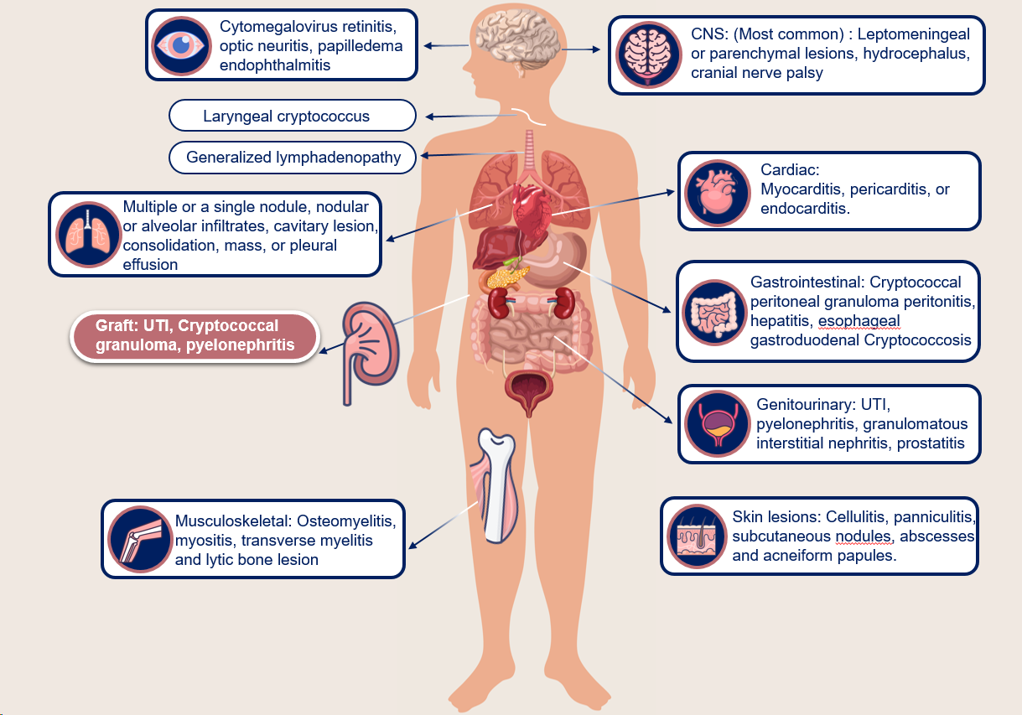
Figure 1 Various organ involvement of the human body in cryptococcal infection. UTI: Urinary tract infection; CNS: Central nervous system.
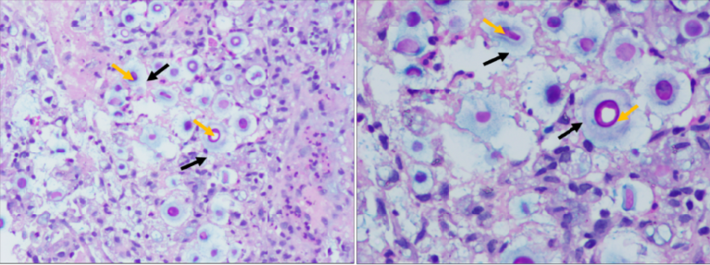
Figure 2 Histopathology of a patient with pulmonary cryptococcosis, hematoxylin and eosin stain and Alcian blue stain. A: At ×100 magnification; B: At ×200 magnification. Alcian blue-PAS stain atains the yeast forms of cryptococcus. Alcian blue stains the capsule blue colour (black arrow) and PAS stains the cell wall of the yeast magenta colour (yellow arrow).
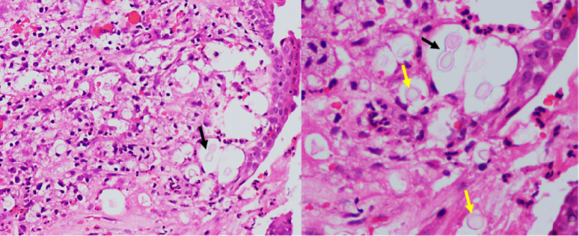
Figure 3 India ink of cryptococcus neoformans. Endobronchial mucosa shows squamous metaplasia and the sub epithelium shows inflammatory exudates along with variably sized round to oval encapsulated yeast (yellow arrow) with thin walls and narrow based budding (black arrow). A: At ×100 magnification; B: At ×200 magnification.

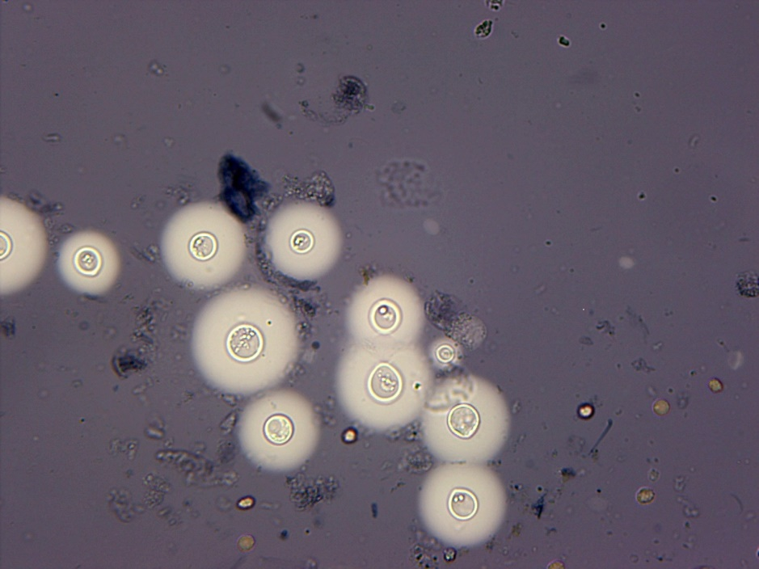
Figure 4 India ink cryptococcus neoformans.

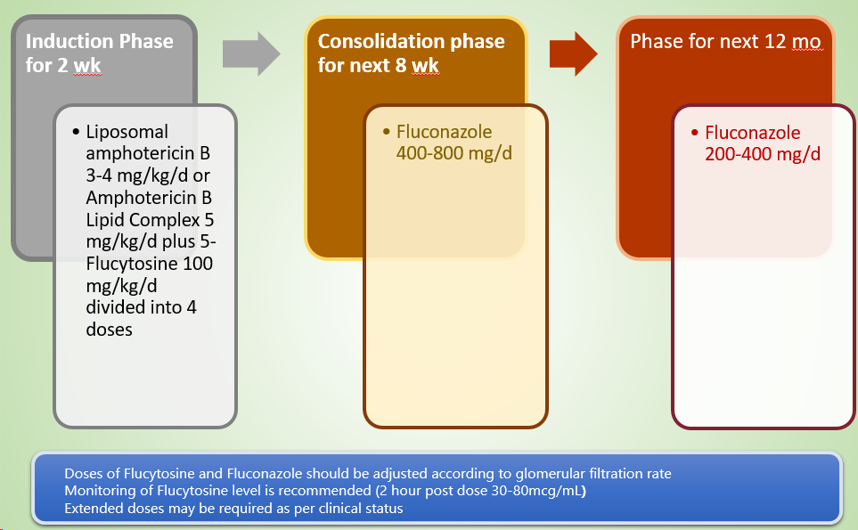
Figure 5 Therapy for patients with central nervous system disease, disseminated disease or moderate to severe pulmonary involvement.

Table 1 Modalities for the diagnosis of post-transplant cryptococcosis
Method | Advantages | Disadvantages
Direct microscopic examination | Cryptococcus is identified as narrow budding encapsulated yeasts after mixing sample with India ink. | Direct microscopic examination
Culture | Identify the species and susceptibility patterns | Time consuming. More than 1 wk must elapse for fungal growth to occur
Histopathology | Gomori methenamine silver, and periodic acid-Schiff are used to detect Cryptococcus that appears as narrow-based budding yeasts (4-10 μm), usually surrounded by thick capsules in the lung tissue | Histopathology
Antigen detection | Inexpensive point-of-care testing, simple, cheap and rapid diagnosis in developing country, high sensitivity and specificity | Isolated pulmonary cryptococcal infection is usually associated with false negative serum CrAg, probably because of the low fungal burden outside the lung or the capsule-deficient strain of Cryptococcus  One must be aware of the prozone effectwhile interpreting these tests
Molecular detection | Required in specific situations where other diagnostic tools have failed to confirm a diagnosis of cryptococcosis, highly specific (almost 100%) | Expensive and not routinely available
CrAg: Cryptococcal antigen.

