Name of Journal: World Journal of Clinical Oncology
Manuscript NO: 62613
Manuscript Type: EDITORIAL

New Year’s greeting and overview of World Journal of Clinical Oncology in 2021

Gong ZM et al. New Year’s greeting and overview of WJCO in 2021

Ze-Mao Gong, Hiten RH Patel

Ze-Mao Gong, Editorial Office, Baishideng Publishing Group Inc, Pleasanton, CA 94566, United States

Hiten RH Patel, Department of Urology, University Hospital North Norway, Tromso 9038, Norway

Author contributions: Gong ZM drafted the editorial; Patel HRH reviewed and revised the manuscript.

Corresponding author: Ze-Mao Gong, MSc, Director, Editorial Office, Baishideng Publishing Group Inc, 7041 Koll Center Parkway, Suite 160, Pleasanton, CA 94566, United States. z.m.gong@wjgnet.com

Received: January 13, 2021
Revised: February 2, 2021
Accepted: February 5, 2021
Published online:

Abstract
although the whole world has been suffering under the Coronavirus Disease 2019 epidemic, the World Journal of Clinical Oncology (WJCO) was able to productively direct our efforts in the field through 2020. This was only accomplished through the collective efforts and support of our Editorial Board members, peer reviewers, authors, readers and editorial office staff. In 2020, the WJCO published 12 issues encompassing 84 papers, a 115.4% increase over 2019 (39 papers). In December of 2020, we strategized a plan to solicit even more high-quality contributions for WJCO in 2021. So far, we have registered and accepted 188 manuscript titles, including 132 reviews and 56 original articles. In the New Year, we will work with our internal and external colleagues who care about and support the development of wjco with the express aim of improving the academic rank of WJCO in the field of oncology. Ultimately, our goal is to merit and gain inclusion in the Science Citation Index Expanded, with the first impact factor being awarded as soon as possible.

Key Words: World Journal of Clinical Oncology; Publication; Editorial board; Oncology

Gong ZM, Patel HR. New Year’s greeting and overview of World Journal of Clinical Oncology in 2021. World J Clin Oncol 2021; In press

Core Tip: This editorial introduces the development of World Journal of Clinical Oncology (WJCO) in 2020. We also discuss some of the limitations currently facing the journal and propose solutions that can positively influence the academic rank of WJCO. Finally, we thank all those who have contributed to the development of WJCO and look forward to continuing our collective efforts to strengthen the field of clinical oncology.

INTRODUCTION
The World Journal of Clinical Oncology (WJCO, World J Clin Oncol) was launched in 2010 as a high-quality, monthly, online, open-access, single-blind, peer-reviewed journal published by the Baishideng Publishing Group^{[1]}. Since then, the WJCO has been abstracted and indexed in PubMed, PubMed Central^{[2]}, and Emerging Sources Citation Index (Web of Science). This journal mainly publishes basic or clinical research in the field of oncology, and the types of articles published in WJCO include Review, Original Article, Case Report, etc.^{[1]}.

Achievements of wjco in 2020
As editors of the WJCO, it is our great pleasure to take this opportunity to wish all of our authors, readers, Editorial Board members, independent expert referees, and staff of the editorial office a Very Happy New Year. On behalf of the Editorial Team, we would like to express our gratitude to all authors who have contributed their valuable manuscripts, to the independent referees, and to our readers for their continuous support, dedication, and encouragement. The collective team effort by our Editorial Board members and Editorial Office staff allowed the WJCO to advance further in 2020.

Published articles in 2020
The Wjco published 12 issues in 2020, encompassing 84 articles. These articles included 29 unsolicited manuscripts (34.5%, 29/84) and 55 invited manuscripts (65.5%, 55/84). Of these manuscripts, there were 22 original articles (26.2%, 22/84), 40 review articles (47.6%, 40/84), 5 editorials (6.0%, 5/84), 16 case reports (19.0%, 16/84), and 1 ‘other’ type (1.2%, 1/84) (Figure 1). Overall, the number of publications of wjco in 2020 represented a remarkable increase over the previous year (115.4%, 39 more articles).

Metrics for manuscripts submitted and published in 2020
In 2020, the wjco received a total of 125 manuscript submissions for consideration of publication after peer review. Among them, 107 received a first decision by the science Editor development department with 18 (14.4%, 18/125) being rejected and 53 (45.2%, 53/125) ultimately being published online by the production department. Those 53 articles included 31 invited manuscripts (58.5%, 31/53) and 22 unsolicited manuscripts (41.5%, 22/53). Among them were 12 original articles (22.6%, 26/53), 25 reviews (47.2%, 25/53), 4 editorials (7.5%, 4/53), 11 case reports (20.7%, 11/53), and 1 ‘other’ type article (1.9%, 1/53). The authors hailed from 22 countries and regions mostly from the United States (24.5%, 13/53), Spain (15.1%, 8/53), and China, Japan, and Italy (5.7%, 3/53); various other countries or regions accounted for the remaining 23 articles (43.4%, 23/53) (Figure 2).

Peer review of manuscripts
In 2020, the wjco invited a total of 4379 peer reviewers and Editorial Board members to review manuscripts. These invitations garnered 645 (14.7%, 645/4379) acceptances to perform the peer review, 697 (15.9%, 697/4379) declinations to perform the peer review, and 2648 (60.5%, 2648/4379) nonresponses. Among the 645 reviewers who accepted the invitation, 234 (36.3%, 234/645) submitted peer review reports, 398 (61.7%, 425/645) failed to submit peer review reports, and 13 (2.0%, 13/645) have not yet submitted the peer review report.

Citation
As of January 10, 2021, according to data from the Web of Science, the WJCO published 64 articles in 2018 (25) and 2019 (39) from authors in 27 countries or regions. These 64 published articles included 55 classified as “article” or “review” and were cited 166 times in 2020.

Editorial Board members
In 2020, the Editorial Board of wjco was composed of 73 members from 23 countries and regions^{[3]}, including 12 (16.4%) from China, 12 (16.4%) from the United States, 9 (12.3%) from Italy, 4 (5.5%) from Greece, 4 (5.5%) from India, and 32 (43.8%) from various other countries and regions (Figure 3). Considering the small number of Editorial Board members and the uneven distribution of regions and disciplines, the Editorial Office will invite more experts from the oncology field to join the wjco Editorial Board in 2021.

Soliciting contributions
by the end of 2020, the Editorial Office of wjco had formulated a plan for soliciting contributions from authors in 2021. We have now invited the Editorial Board members and high-level scientists in the field of oncology to solicit contributions for reviews and original articles. so far, 188 invited manuscript titles have been registered by authors and accepted for upcoming submission and review of the full papers; these have included proposals for 132 review articles and 56 original articles. The solicitation of original articles is ongoing.

limitations and solutions
although the wjco achieved phased success in 2020, it has not yet reached our pinnacle goals. at present, the wjco still faces some challenges that need to be overcome: (1) The sources of manuscripts are lacking, especially for high-quality original and review manuscripts; (2) There are not enough experts to participate in peer review for each manuscript, leading to a low rate of final submission of peer-review reports; and (3) due to the insufficient number of Editorial Board members and the uneven distribution of regions and disciplines, some manuscripts progress through the review process too slowly. in 2021, it is imperative to solve these problems.
first, we need to establish a connection with high-level oncology experts and promote their submissions of high-quality original or review articles. second, the number of Editorial Board members must be increased with an eye towards balancing the distribution of experts in different areas and disciplines. third, we need to further optimize the entire review-to-publication process with the aims of shortening the time of peer review and providing high-quality and efficient peer-review reports. finally, we need to continue our latest company-wide strategy of sending the journal’s latest published articles to target readers via email; this is an effective activity by which we will increase the exposure rate and citation rate of these articles, thereby expanding the academic influence of our authors.

CONCLUSION
With the continued efforts and support of all internal and external contributors to the WJCO, we expect to make greater strides forward in 2021. For our part, we commit to working diligently alongside all of you to raise the academic rank of WJCO in 2021 and merit inclusion in the Science Citation Index Expanded as soon as possible. We appreciate that the achievement of these goals is reliant upon the continuous support and submissions from authors worldwide and the dedicated efforts and expertise by our invited reviewers, many who also serve on our Editorial Board. We are also open to any suggestions that could improve the WJCO’s operation and publication. Please feel free to contact us at editorialoffice@wjgnet.com with any questions on your submission or suggestions.
Once again, on behalf of the WJCO’s Editorial Office, we wish you and your families the best for the New Year.

REFERENCES
1 Baishideng Publishing Group. The home page of World Journal of Clinical Oncology. Available from: https://www.wjgnet.com/2218-4333/index.htm
2 PubMed Central. World Journal of Clinical Oncology. Available from: https://www.ncbi.nlm.nih.gov/pmc/journals/1494/
3 Baishideng Publishing Group. Editorial Board Members. Available from: https://www.wjgnet.com/2218-4333/editorialboard.htm

Footnotes
Conflict-of-interest statement: The authors declare no conflict of interests for this article.

Open-Access: This article is an open-access article that was selected by an in-house editor and fully peer-reviewed by external reviewers. It is distributed in accordance with the Creative Commons Attribution NonCommercial (CC BY-NC 4.0) license, which permits others to distribute, remix, adapt, build upon this work non-commercially, and license their derivative works on different terms, provided the original work is properly cited and the use is non-commercial. See: http://creativecommons.org/Licenses/by-nc/4.0/

Manuscript source: Invited manuscript

Peer-review started: January 13, 2021
First decision: January 29, 2021
Article in press:

Specialty type: Oncology
Country/Territory of origin: United States
Peer-review report’s scientific quality classification
Grade A (Excellent): A
Grade B (Very good): 0
Grade C (Good): 0
Grade D (Fair): 0
Grade E (Poor): 0

P-Reviewer: Sato H S-Editor: Wang JL L-Editor: Filipodia P-Editor:

Figure Legends

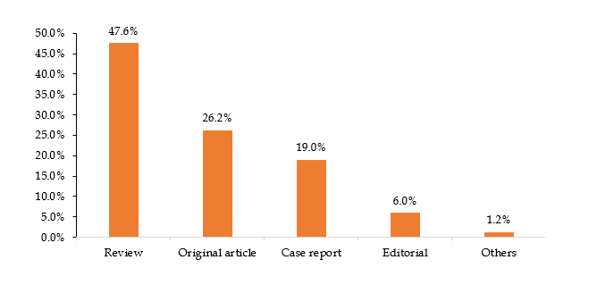 Figure 1 Column type distribution of manuscripts published in World Journal of Clinical Oncology in 2020.

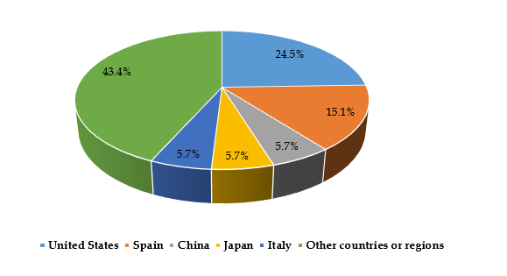 Figure 2 Distribution of authors’ countries for the manuscripts published in World Journal of Clinical Oncology in 2020.

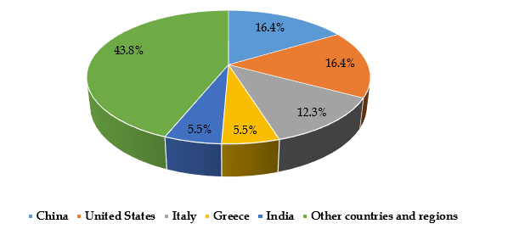 Figure 3 Country distribution of Editorial Board members of the World Journal of Clinical Oncology.

