Name of Journal: World Journal of Clinical Cases
Manuscript NO: 91841
Manuscript Type: ORIGINAL ARTICLE

Clinical and Translational Research
Exploring the autophagy-related pathogenesis of active ulcerative colitis

Gong ZZ et al. Autophagy in active UC

Zhuo-Zhi Gong, Teng Li, He Yan, Min-Hao Xu, Yue Lian, Yi-Xuan Yang, Wei Wei, Tao Liu

Zhuo-Zhi Gong, Teng Li, He Yan, Yue Lian, Wei Wei, Tao Liu, Wangjing Hospital, China Academy of Chinese Medical Sciences, Beijing 100102, China

Min-Hao Xu, College of Traditional Chinese Medicine, School of Traditional Chinese Medicine, Beijing 100102, China

Yi-Xuan Yang, Guang’anmen Hospital, China Academy of Chinese Medical Sciences, Beijing 100053, China

Author contributions: Gong ZZ and Li T designed and supervised this study, wrote the manuscript; Yan H collated the data; Xu MH and Lian Y analyzed the data; Wei W and Liu T supervised this study and guided the revision of the article; all authors approved the final version of the article.

Corresponding author: Tao Liu, PhD, Associate Professor, Chief Doctor, Wangjing Hospital, China Academy of Chinese Medical Sciences, Huajiadi Street, Chaoyang District, Beijing 100102, China. ltlyf2@163.com

Received: January 7, 2024
Revised: January 23, 2024
Accepted: February 27, 2024
Published online:

Abstract
BACKGROUND
The pathogenesis of ulcerative colitis (UC) is complex, and recent therapeutic advances remain unable to fully alleviate the condition.

AIM
To inform the development of novel UC treatments, bioinformatics was used to explore the autophagy-related pathogenesis associated with the active phase of UC.

METHODS
The GEO database was searched for UC-related datasets that included healthy controls who met the screening criteria. Differential analysis was conducted to obtain differentially expressed genes (DEGs). Autophagy-related targets were collected and intersected with the DEGs to identiy differentially expressed autophagy-related genes (DEARGs) associated with active UC. DEARGs were then subjected to KEGG, GO, and DisGeNET disease enrichment analyses using R software. Differential analysis of immune infiltrating cells was performed using the CiberSort algorithm. The least absolute shrinkage and selection operator algorithm and protein-protein interaction network were used to narrow down the DEARGs, and the top five targets in the Dgree ranking were designated as core targets.

RESULTS
A total of 4822 DEGs were obtained, of which 58 were classified as DEARGs. SERPINA1, BAG3, HSPA5, CASP1, and CX3CL1 were identified as core targets. GO enrichment analysis revealed that DEARGs were primarily enriched in processes related to autophagy regulation and macroautophagy. KEGG enrichment analysis showed that DEARGs were predominantly associated with NOD-like receptor signaling and other signaling pathways. Disease enrichment analysis indicated that DEARGs were significantly linked to diseases such as malignant glioma and middle cerebral artery occlusion. Immune infiltration analysis demonstrated a higher presence of immune cells like activated memory CD4 T cells and follicular helper T cells in active UC patients than in healthy controls.

CONCLUSION
Autophagy is closely related to the active phase of UC and the potential targets obtained from the analysis in this study may provide new insight into the treatment of active UC patients.

Key words: Ulcerative colitis; Autophagy; Bioinformatic; Targets; Pathogenesis

Gong ZZ, Li T, Yan H, Xu MH, Lian Y, Yang YX, Wei W, Liu T. Exploring the autophagy-related pathogenesis of active ulcerative colitis. World J Clin Cases 2024; In press

Core Tip: This study used bioinformatics to explore the autophagy-related pathogenesis of ulcerative colitis (UC) during its active phase. A total of 58 differentially expressed autophagy-related genes (DEARGs) were found in gene expression datasets from UC patients and healthy controls. Of these, SERPINA1, BAG3, HSPA5, CASP1, and CX3CL1 were identified as core targets. Enrichment analysis highlighted the involvement of DEARGs in autophagy regulation, and macroautophagy, in addition to NOD-like receptor signaling and other pathways. These DEARGs were also shown to be associated with diseases like malignant glioma and middle cerebral artery occlusion. Immune infiltration analysis revealed an increased presence of immune cells, including activated memory CD4 T cells and follicular helper T cells in active UC patients than in healthy controls. This study suggests that autophagy plays a significant role in the active phase of UC and identifies potential targets for novel UC treatments.

INTRODUCTION
Ulcerative colitis (UC) is a chronic, recurrent inflammatory disease in humans that profoundly affects normal functioning^{[1]}. It has both active and remission phases that are classified according to disease severity. UC is characterized by symptoms such as weight loss, diarrhea, rectal bleeding, abdominal pain, and inflammation of the mucous membranes that extend from the rectum to the distal part of the colon^{[2]}. Approximately 5 million people are affected by UC worldwide and recent studies indicate that the incidence is increasing^{[3]}. UC is thought to result from a combination of genetic and environmental factors and is closely linked to compromised intestinal epithelial barriers, a dysregulated microbiome, and impaired immune responses^{[3]}.
Autophagy is a finely coordinated process that segregates misfolded proteins, damaged or aged organelles, and mutated proteins into double-membrane vesicles called autophagosomes. The autophagosomes later merge with lysosomes and degrade these components^{[4]}. Three main forms of autophagy have been described to date: microautophagy, chaperone-mediated autophagy, and macroautophagy^{[5]}. Autophagy is shown to be a key mediator in the pathophysiological processes of UC. From a physiological perspective, autophagy plays a critical role in maintaining intestinal balance, regulating interactions between gut microbiota and both the innate and adaptive immune systems, and protecting the host against intestinal pathogens^{[5]}. Autophagy also reduces endoplasmic reticulum stress associated with diverse inflammatory and immune disorders^{[6]}, helping to restore gut homeostasis. For example, estrogen-related receptor alpha (ESRRa) contributes to maintaining intestinal balance by activating autophagy and regulating the gut microbiome, thereby protecting the host from inflammation and mitochondrial dysfunction^{[7]}. Meanwhile, autotaxin (ATX) inhibits autophagy through the mTOR pathway, causing significant damage to the intestinal epithelial barrier of colitis patients^{[8]}. During intestinal inflammation, specific bacterial species in the microbiome, including adherent invasive Escherichia coli, can adhere to intestinal epithelial cells and evade autophagic elimination by phagocytic macrophages^{[9]}. The situational or excessive induction of autophagy can adversely impact cells by initiating autophagic cell death. The lack of erbin, a protein essential for epithelial cell polarity, markedly worsens the initiation of autophagic processes and autophagic cell death in mice with DSS-induced colitis^{[10]}. Damage to intestinal epithelial cells initiates inflammation and intensifies the severity of UC symptoms^{[11]}.
Given the importance of autophagy in preserving intestinal balance and the role of autophagy dysfunction in UC development, identifying autophagy-related disease predictors is essential for the design of new UC treatments. The current study uses bioinformatics to define gene expression patterns associated with the autophagy-related pathogenesis of active UC (Figure 1).

MATERIALS AND METHODS
Identification of active UC targets and difference analysis
Datasets related to active UC which included normal control and active UC samples and had a sample size > 30 were obtained from the GEO database (https://www.ncbi.nlm.nih.gov/gds/). The selected data set was normalized and the “limma” package was downloaded using “Bioconductor.” R 4.3.1 software was then used to perform differential gene analysis on targets identified in the dataset. A |log FC| ≥ 0.585 and an adj. P < 0.05 were used to obtain differentially expressed genes (DEGs).

Acquisition of differentially expressed autophagy-related genes in patients with active UC
To obtain differentially expressed autophagy-related genes (DEARGs), autophagy-related genes were downloaded from the Human Autophagy Database (http://www.autophagy.lu/). Using the “Venn Diagram” package in R, autophagy-related targets were intersected with the DEGs, identifying DEARGs as the central targets for further analysis. DEARG heat maps were generated using the “limma” and “pheatmap” packages.

Analysis of immune cell infiltration
The immune microenvironment is typically composed of immune cells, inflammatory cells, fibroblasts, and mesenchymal stem cells, along with various cytokines and chemokines. Assessing immune cell infiltration is vital for predicting disease progression and treatment response. Several methods exist to analyze immune cell infiltration, including CiberSort, an inverse convolution algorithm developed by BinderG. This method calculates the cellular composition of complex tissues based on normalized gene expression data, allowing specific cell types to be quantified. The CiberSort deconvolution algorithm was used with 100 simulations and subsequent analyses were conducted with a significance threshold of P < 0.05 to determine the proportion of immune cells in different samples. The results were visualized using the “ggpubr” package in R.

Assessment of biological variables associated with the DEARGs
Gene ontology (GO) analysis categorizes genes into biological processes (BP), molecular functions (MF), and cellular components (CC), which help to inform their biological functions. The Kyoto Encyclopedia of Genes and Genomes (KEGG) is a database that integrates genomic, chemical, and systemic information. It is often used for the functional annotation of genes to understand their associated activities and pathways of action. To further understand the target functions of autophagy in patients with active UC and the associated signaling pathways, the “clusterProfiler” package was downloaded from Bioconductor, and GO and KEGG enrichment analysis of the DEARGs was conducted using R. The “clusterProfiler” package was downloaded from “Bioconductor” and the DEARGs were analyzed by GO and KEGG enrichment analysis using R with a threshold value of P < 0.05.

Analysis of disease enrichment in DisGeNET
To explore the role of autophagy in UC-related diseases, DEARGs were input into the Metascape platform (https://metascape.org/) using “H. sapiens” as the species setting for both “Input” and “Analysis.” The “Summary of enrichment analysis in DisGeNET” was then exported.

Construction of the least absolute shrinkage and selection operator algorithm and protein-protein interaction network
For more precise identification of the core targets, the least absolute shrinkage and selection operator (LASSO) algorithm was used along with the construction of a protein-protein interaction (PPI) network to refine DEARG selection and predict key biomarkers. The LASSO algorithm is more effective than ordinary least squares estimation at extracting essential variables and simplifying the model, particularly when using multiple variables. PPI analysis helps identify interactions among DEARGs and refine the selection.
The LASSO algorithm was used for DEARG validation and feature gene selection using the “glmnet” package in R. The identified genes were then uploaded to the String database (https://cn.string-db.org/) with a “minimum required interaction score” of 0.15 and the results were imported into Cytoscape 3.9.1. To further refine the selection, the “CytoNCA” plugin was used to rank the targets based on degree values, selecting the top five as core targets.

RESULTS
Acquisition of DEGs
GEO database screening identified two UC-related datasets: GSE87466 and GSE53306. GSE53306 includes data on differential gene expression between the active and quiescent stages of UC, providing insight into the disease characteristics. The dataset, which has information on 40 individuals, including 16 active UC cases and 12 normal controls, was published on December 13, 2014, and last updated on December 22, 2017. GSE87466 includes data on gene expression in mucosal biopsies from adult patients with moderate to severe active UC. The dataset has information on 87 UC active samples and 21 normal control samples and was first published on September 29, 2016, and last updated on March 2, 2019. The datasets were downloaded and exported, the data were de-duplicated and normalized, and differential analysis was conducted with R software using GSE87466 and GSE53306 as the base and supplemental datasets, respectively. GPL13158 and GPL14951 were used as the platform files. This analysis yielded 4,822 DEGs from the GSE87466 and GSE53306 datasets.

DEARG acquisition
A total of 232 autophagy-related genes were obtained from the Human Autophagy Database (http://www.autophagy.lu/). These autophagy-related genes were intersected with the DEGs, resulting in 58 DEARGs (Figure 2). R was then used to analyze the DEARGs and generate heat map and volcano map (Figure 3).

Analysis of immune cell infiltration
The Cibersort algorithm was used to evaluate immune cell infiltration in two distinct immune states. The following immune cell types were more abundant in active UC cases than in healthy controls: activated memory CD4 T cells, follicular helper T cells, γδ T cells, M0 macrophages, M1 macrophages, activated dendritic cells, activated mast cells, and neutrophils. The “ggpubr” package in R was used to visualize the differential analysis results of immune cell infiltration in each sample. A P < 0.05 was considered statistically significant.
The following immune cell types were significantly higher in the UC group than in the healthy control group: activated memory CD4 T cells (P < 0.001), follicular helper T cells (P < 0.05), gamma delta T cells (P < 0.05), M0 macrophages (P < 0.001), M1 macrophages (P < 0.001), activated dendritic cells (P < 0.001), activated mast cells (P < 0.001), and neutrophils (P <0.001). Meanwhile, CD8 T cells (P < 0.05), resting memory CD4 T cells (P < 0.05), regulatory T cells (Tregs) (P < 0.001), activated NK cells (P < 0.01), monocytes (P < 0.01), M2 macrophages (P < 0.001), resting dendritic cells (P < 0.05), and resting mast cells (P < 0.001) were significantly higher in the healthy control group than in the active UC group. No significant differences were observed in naive B cells, memory B cells, plasma cells, naive CD4 T cells, resting NK cells, and eosinophils between active UC cases and healthy controls (Figure 4).

Biological variables related to the DEARGs
BP analysis revealed that the DEARGs were primarily associated with the regulation of autophagy, macroautophagy, autophagosome assembly, autophagosome organization, and vacuole organization. CC analysis showed that the DEARGs were primarily enriched in autophagosomes, phagophore assembly sites, and phagophore assembly site membranes. MF analysis found that DEARGs were mainly involved in chaperone binding, ubiquitin protein ligase binding, and heat shock protein binding (Figure 5A). KEGG enrichment analysis indicated that the DEARGs were predominantly enriched in autophagy-animal, autophagy-other, lipid and atherosclerosis, protein processing in the endoplasmic reticulum, and influenza A-related pathways (Figure 5B).

DisGeNET disease enrichment analysis
The Metascape “Summary of enrichment analysis in DisGeNET” revealed that the DEARGs were mainly enriched in malignant glioma, middle cerebral artery occlusion, infection, glomerulonephritis, and other diseases (Figure 6).

Construction of the LASSO algorithm and PPI
The LASSO algorithm narrowed the range of DEARGs and identified 13 targets: proliferation and apoptosis adaptor protein 15 (PEA15), heat shock 70-kDa protein 5 (HSPA5), caspase 1 (CASP1), serine protease inhibitor A1 (SERPINA1), C-X3-C chemokine ligand 1 (CX3CL1), Bcl2-associated athanogene 3 (BAG3), tumor protein p53 inducible nuclear protein 2 (TP53INP2), and peroxisomal biogenesis factor 14 (PEX14) (Figure 7). Their relationships were further established using the String database. The Cytoscape 3.9.1 software “CytoNCA” plug-in was used to sort the 13 targets according to their degree values, and the top five were selected as the core targets. The Fold Change (logFC) of these targets was obtained from the difference analysis results. All five were up-regulated and had the following parameters: SERPINA1 (logFC = 1.051), BAG3 (logFC = 0.661), HSPA5 (logFC = 0.790), CASP1 (logFC = 1.231), and CX3CL1 (logFC = 0.837) (Figure 8).

DISCUSSION
The current study identified HSPA5, CASP1, SERPINA1, CX3CL1, and BAG3 as core autophagy-related targets in active UC, all of which were upregulated during the disease. Key signaling pathways linked to these targets included autophagy in animals, other autophagy pathways, and lipid and atherosclerosis pathways. DisGeNET enrichment analysis found that middle cerebral artery occlusion, glomerulonephritis, and active UC were interrelated risk factors associated with autophagy. Active UC patients were found to have significantly higher counts of activated memory CD4 T cells, follicular helper T cells, gamma delta T cells, M0 macrophages, M1 macrophages, activated dendritic cells, mast cells, and neutrophils than healthy controls.
The results, including those predicted using core targeting and immune infiltration analysis, are supported by existing literature. R-HSPA5 is a specific form of HSPA5 that is localized in the endoplasmic reticulum (ER) and shown to play a critical role in autophagy-mediated lysosomal protein hydrolysis. Significant overexpression of HSPA5 mRNA and protein is found in UC patient tissues^{[12-14]}. CASP1 expression in macrophages impairs autophagy, triggering inflammatory vesicle activation, a key factor associated with diseases such as active UC^{[15]}. Activated CASP1 is critical for DSS-induced colitis^{[16-18]}. Soendergaard et al^{[19]} identified SERPINA1 as a potential biomarker of mild to moderate UC activity. Elevated CX3CL1 levels interact with CX3CR1, inhibiting autophagy in Kupffer cells^{[20]}. CX3CL1 induces the infiltration and activation of CX3CR1-expressing cells, stimulating iNOS expression, a key mediator in DSS-induced colitis. These findings suggest that CX3CL1 may have potential for use in UC treatments^{[21,22]}. Effector memory CD4 T cells induce IL-7 expression, leading to inflammation in the lamina propria of the intestinal mucosa^{[23]}. During UC pathogenesis, Tfh cell functional abnormalities and imbalances disrupt the immune barrier of the intestinal mucosa, triggering immune disorders and the development of UC^{[24]}. Inagaki-Ohara et al^{[25]} found that UC naturally occurs in γδ T-cell-deficient mice. Mast cells (MC), commonly found in capillaries of the intestinal mucosa, are increased in inflammatory bowel disease (IBD) patients. They contain basophilic granules that release inflammatory factors during stress^{[26,27]}. The IL-33/ST2 pathway, together with IgE signaling, mediates MC degranulation, inducing the release of inflammatory factors and initiating a cascade response^{[28]}. Reduced NK cell levels affect mucosal flora responses, resulting in immune abnormalities and inflammatory changes in the colon^{[29]}. Cherfane et al^{[30]} identified an association between the number of peripheral blood mononuclear cells in UC patients and disease activity, suggesting that monocyte count could serve as a potential UC biomarker. The Th1/Th2 cell imbalance, along with the overexpression and activation of co-stimulatory molecules on dendritic cells, can trigger monocyte migration to the intestine, causing inflammation and potential damage to the intestinal mucosa^{[31,32]}.
The disease enrichment analysis results discussed here are confirmed by prior studies. Different stages of IBD are linked to the development of thrombosis, with IBD episodes or activity serving as a primary risk factor^{[33]}. The predicted core genes are critical to the pathogenesis+ADs- hSPA5, for example, offering neuroprotection in ischemic strokes^{[34]}. BAG3 overexpression is shown to improve neurological outcomes associated with middle cerebral artery embolism in mice, reducing infarct volume and enhancing cell survival by activating autophagy and inhibiting apoptosis^{[35]}. Ischemia-induced neuronal autophagy is shown to exacerbate microglial inflammation post-stroke, possibly due to the reduced CX3CL1 expression in autophagic neurons^{[36]}. Growing evidence suggests that autophagy plays a role in renal disease pathogenesis^{[37,38]}. Glomerulonephritis emergence or exacerbation often coincides with IBD and subsides following effective IBD treatment^{[39]}. CX3CL1 and CXCL10, induced by the core targets in this study, initiate activated leukocyte infiltration into glomerular cells^{[40-42]}. The NLRP3-ASC-caspase-1 inflammasome mitigates glomerular dysfunction by producing IL-1^{[43,44]}.

CONCLUSION
In summary, HSPA5, CASP1, SERPINA1, CX3CL1, and BAG3 were identified as core autophagy-related targets that are upregulated in active UC patients. These targets are associated with key signaling pathways, including autophagy in animals, other autophagy pathways, and lipid and atherosclerosis pathways. DisGeNET enrichment analysis also revealed a significant connection between middle cerebral artery occlusion, glomerulonephritis, and the autophagy-related pathogenesis of active UC. In addition, active UC patients exhibited significantly higher counts of various immune cells than healthy controls, indicating the occurrence of immune dysregulation. These findings provide valuable insight into the role of autophagy in UC pathogenesis and have potential implications for the development of novel targeted therapies.

ARTICLE HIGHLIGHTS
Research background
The etiology of ulcerative colitis (UC), a chronic inflammatory bowel disease (IBD), remains poorly understood. The pathogenesis of UC is complex and is influenced by genetic, environmental, and immune-related factors. While some recent progress has been made in the development of effective UC treatments, few patients experience complete relief of their symptoms. Thus, finding new therapeutic avenues to improve UC patient quality of life remains an urgent need. Autophagy is a cellular self-degradation and repair process that can help remove harmful proteins and organelles from cells and maintain intracellular homeostasis. Recent studies suggest that autophagy may play a key role in the pathogenesis and progression of IBD.

Research motivation
The motivation of this study was to provide an in-depth investigation of the autophagy-related pathogenesis of active phase UC. Bioinformatics analysis was used to better understand whether autophagy plays a key role in active UC and which autophagy-related genes may contribute to the disease process.

Research objectives
This study sought to provide new ideas and potential therapeutic targets for the treatment of active UC to better understand the pathogenesis of the disease and improve clinical symptoms.

Research methods
A bioinformatics approach was used to compare gene expression data between patients with active UC and healthy controls to identify core genes associated with autophagy and to obtain more information about the role of autophagy in this disease.

Research results
HSPA5, CASP1, SERPINA1, CX3CL1, and BAG3 were identified as core targets associated with autophagy-related pathogenesis in active UC, all of which were upregulated. Key signaling pathways linked to these targets include autophagy in animals, other autophagy pathways, and lipids and atherosclerosis pathways. DisGeNET enrichment analysis showed that middle cerebral artery occlusion, glomerulonephritis, and active UC were interrelated risk factors associated with autophagy. Active UC patients had significantly higher counts of activated memory CD4 T cells, follicular helper T cells, gamma delta T cells, M0 macrophages, M1 macrophages, activated dendritic cells, mast cells, and neutrophils than healthy controls.

Research conclusions
HSPA5, CASP1, SERPINA1, CX3CL1, and BAG3 were identified as core autophagy-related targets in active UC patients, all of which were upregulated. These targets are associated with key signaling pathways, including autophagy in animals, other autophagy pathways, and lipid and atherosclerosis pathways. DisGeNET enrichment analysis revealed a significant connection between middle cerebral artery occlusion, glomerulonephritis, and the autophagy-related pathogenesis of active UC. In addition, active UC patients had significantly elevated counts of various immune cells, indicating that immune function is dysregulated. These findings provide valuable insight into the role of autophagy in UC pathogenesis and could be used to inform the development of targeted therapeutic interventions.

Research perspectives
Future research in this field should focus on better understanding the molecular mechanisms by which HSPA5, CASP1, SERPINA1, CX3CL1, and BAG3 contribute to autophagy in patients with active UC. Investigating the specific roles of these core targets in UC pathogenesis and their interactions with the identified key signaling molecules should be a priority. Interventions that target the core autophagy-related genes and pathways could offer promising treatment options for active UC patients. It is also important to further explore the immune dysregulation observed in UC patients, particularly the elevated immune cell counts, to understand better the inflammatory processes involved and inform the development of immunomodulatory strategies to manage UC.

ACKNOWLEDGEMENTS
We thank the GEO database for providing their platforms and contributors for their valuable datasets.

REFERENCES
1 Mandlik DS, Mandlik SK, Patel S. Protective effect of sarsasapogenin in TNBS induced ulcerative colitis in rats associated with downregulation of pro-inflammatory mediators and oxidative stress. Immunopharmacol Immunotoxicol 2021; 43: 571-583 [PMID: 34338577 DOI: 10.1080/08923973.2021.1955919]
2 Kobayashi T, Siegmund B, Le Berre C, Wei SC, Ferrante M, Shen B, Bernstein CN, Danese S, Peyrin-Biroulet L, Hibi T. Ulcerative colitis. Nat Rev Dis Primers 2020; 6: 74 [PMID: 32913180 DOI: 10.1038/s41572-020-0205-x]
3 Le Berre C, Honap S, Peyrin-Biroulet L. Ulcerative colitis. Lancet 2023; 402: 571-584 [PMID: 37573077 DOI: 10.1016/S0140-6736(23)00966-2]
4 Behrends C, Sowa ME, Gygi SP, Harper JW. Network organization of the human autophagy system. Nature 2010; 466: 68-76 [PMID: 20562859 DOI: 10.1038/nature09204]
5 Mizushima N. A brief history of autophagy from cell biology to physiology and disease. Nat Cell Biol 2018; 20: 521-527 [PMID: 29686264 DOI: 10.1038/s41556-018-0092-5]
6 Cao SS. Endoplasmic reticulum stress and unfolded protein response in inflammatory bowel disease. Inflamm Bowel Dis 2015; 21: 636-644 [PMID: 25581827 DOI: 10.1097/MIB.0000000000000238]
7 Kim S, Lee JY, Shin SG, Kim JK, Silwal P, Kim YJ, Shin NR, Kim PS, Won M, Lee SH, Kim SY, Sasai M, Yamamoto M, Kim JM, Bae JW, Jo EK. ESRRA (estrogen related receptor alpha) is a critical regulator of intestinal homeostasis through activation of autophagic flux via gut microbiota. Autophagy 2021; 17: 2856-2875 [PMID: 33172329 DOI: 10.1080/15548627.2020.1847460]
8 Shi W, Peng K, Yu H, Wang Z, Xia S, Xiao S, Tian D, Vallance BA, Yu Q. Autotaxin (ATX) inhibits autophagy leading to exaggerated disruption of intestinal epithelial barrier in colitis. Biochim Biophys Acta Mol Basis Dis 2023; 1869: 166647 [PMID: 36746254 DOI: 10.1016/j.bbadis.2023.166647]
9 Palmela C, Chevarin C, Xu Z, Torres J, Sevrin G, Hirten R, Barnich N, Ng SC, Colombel JF. Adherent-invasive Escherichia coli in inflammatory bowel disease. Gut 2018; 67: 574-587 [PMID: 29141957 DOI: 10.1136/gutjnl-2017-314903]
10 Shao BZ, Yao Y, Zhai JS, Zhu JH, Li JP, Wu K. The Role of Autophagy in Inflammatory Bowel Disease. Front Physiol 2021; 12: 621132 [PMID: 33633585 DOI: 10.3389/fphys.2021.621132]
11 Shen T, Li S, Cai LD, Liu JL, Wang CY, Gan WJ, Li XM, Wang JR, Sun LN, Deng M, Liu YH, Li JM. Erbin exerts a protective effect against inflammatory bowel disease by suppressing autophagic cell death. Oncotarget 2018; 9: 12035-12049 [PMID: 29552291 DOI: 10.18632/oncotarget.23925]
12 Cha-Molstad H, Sung KS, Hwang J, Kim KA, Yu JE, Yoo YD, Jang JM, Han DH, Molstad M, Kim JG, Lee YJ, Zakrzewska A, Kim SH, Kim ST, Kim SY, Lee HG, Soung NK, Ahn JS, Ciechanover A, Kim BY, Kwon YT. Amino-terminal arginylation targets endoplasmic reticulum chaperone BiP for autophagy through p62 binding. Nat Cell Biol 2015; 17: 917-929 [PMID: 26075355 DOI: 10.1038/ncb3177]
13 Bogaert S, De Vos M, Olievier K, Peeters H, Elewaut D, Lambrecht B, Pouliot P, Laukens D. Involvement of endoplasmic reticulum stress in inflammatory bowel disease: a different implication for colonic and ileal disease? PLoS One 2011; 6: e25589 [PMID: 22028783 DOI: 10.1371/journal.pone.0025589]
14 Lie MRKL, van der Giessen J, Fuhler GM, de Lima A, Peppelenbosch MP, van der Ent C, van der Woude CJ. Low dose Naltrexone for induction of remission in inflammatory bowel disease patients. J Transl Med 2018; 16: 55 [PMID: 29523156 DOI: 10.1186/s12967-018-1427-5]
15 Chiu HW, Chen CH, Chang JN, Chen CH, Hsu YH. Erratum to: Far-infrared promotes burn wound healing by suppressing NLRP3 inflammasome caused by enhanced autophagy. J Mol Med (Berl) 2016; 94: 821 [PMID: 27255500 DOI: 10.1007/s00109-016-1436-x]
16 Siegmund B, Lehr HA, Fantuzzi G, Dinarello CA. IL-1 beta -converting enzyme (caspase-1) in intestinal inflammation. Proc Natl Acad Sci U S A 2001; 98: 13249-13254 [PMID: 11606779 DOI: 10.1073/pnas.231473998]
17 Bauer C, Duewell P, Lehr HA, Endres S, Schnurr M. Protective and aggravating effects of Nlrp3 inflammasome activation in IBD models: influence of genetic and environmental factors. Dig Dis 2012; 30 Suppl 1: 82-90 [PMID: 23075874 DOI: 10.1159/000341681]
18 Bauer C, Duewell P, Mayer C, Lehr HA, Fitzgerald KA, Dauer M, Tschopp J, Endres S, Latz E, Schnurr M. Colitis induced in mice with dextran sulfate sodium (DSS) is mediated by the NLRP3 inflammasome. Gut 2010; 59: 1192-1199 [PMID: 20442201 DOI: 10.1136/gut.2009.197822]
19 Soendergaard C, Nielsen OH, Seidelin JB, Kvist PH, Bjerrum JT. Alpha-1 antitrypsin and granulocyte colony-stimulating factor as serum biomarkers of disease severity in ulcerative colitis. Inflamm Bowel Dis 2015; 21: 1077-1088 [PMID: 25803506 DOI: 10.1097/MIB.0000000000000348]
20 Li Y, Chen Y, Xiao X, Deng S, Kuang J, Wang Y. CX3CL1 represses autophagy via CX3CR1/ CaMKIIδ/HDAC4/Rubicon axis and exacerbates chronic intermittent hypoxia induced Kupffer cell apoptosis. Cell Signal 2023; 111: 110873 [PMID: 37640194 DOI: 10.1016/j.cellsig.2023.110873]
21 Kostadinova FI, Baba T, Ishida Y, Kondo T, Popivanova BK, Mukaida N. Crucial involvement of the CX3CR1-CX3CL1 axis in dextran sulfate sodium-mediated acute colitis in mice. J Leukoc Biol 2010; 88: 133-143 [PMID: 20335311 DOI: 10.1189/jlb.1109768]
22 Ishida Y, Hayashi T, Goto T, Kimura A, Akimoto S, Mukaida N, Kondo T. Essential involvement of CX3CR1-mediated signals in the bactericidal host defense during septic peritonitis. J Immunol 2008; 181: 4208-4218 [PMID: 18768878 DOI: 10.4049/jimmunol.181.6.4208]
23 Nemoto Y, Kanai T, Takahara M, Oshima S, Nakamura T, Okamoto R, Tsuchiya K, Watanabe M. Bone marrow-mesenchymal stem cells are a major source of interleukin-7 and sustain colitis by forming the niche for colitogenic CD4 memory T cells. Gut 2013; 62: 1142-1152 [PMID: 23144054 DOI: 10.1136/gutjnl-2012-302029]
24 Wang X, Zhu Y, Zhang M, Hou J, Wang H, Jiang Y, Wang H, Gao P. The shifted balance between circulating follicular regulatory T cells and follicular helper T cells in patients with ulcerative colitis. Clin Sci (Lond) 2017; 131: 2933-2945 [PMID: 29109300 DOI: 10.1042/CS20171258]
25 Inagaki-Ohara K, Chinen T, Matsuzaki G, Sasaki A, Sakamoto Y, Hiromatsu K, Nakamura-Uchiyama F, Nawa Y, Yoshimura A. Mucosal T cells bearing TCRgammadelta play a protective role in intestinal inflammation. J Immunol 2004; 173: 1390-1398 [PMID: 15240735 DOI: 10.4049/jimmunol.173.2.1390]
26 Pastorelli L, Garg RR, Hoang SB, Spina L, Mattioli B, Scarpa M, Fiocchi C, Vecchi M, Pizarro TT. Epithelial-derived IL-33 and its receptor ST2 are dysregulated in ulcerative colitis and in experimental Th1/Th2 driven enteritis. Proc Natl Acad Sci U S A 2010; 107: 8017-8022 [PMID: 20385815 DOI: 10.1073/pnas.0912678107]
27 Chu HQ, Li J, Huang HP, Hao WD, Duan LP, Wei XT. Protective effects of tranilast on oxazolone-induced rat colitis through a mast cell-dependent pathway. Dig Liver Dis 2016; 48: 162-171 [PMID: 26455295 DOI: 10.1016/j.dld.2015.09.002]
28 Lopetuso LR, De Salvo C, Pastorelli L, Rana N, Senkfor HN, Petito V, Di Martino L, Scaldaferri F, Gasbarrini A, Cominelli F, Abbott DW, Goodman WA, Pizarro TT. IL-33 promotes recovery from acute colitis by inducing miR-320 to stimulate epithelial restitution and repair. Proc Natl Acad Sci U S A 2018; 115: E9362-E9370 [PMID: 30224451 DOI: 10.1073/pnas.1803613115]
29 Lai LJ, Shen J, Ran ZH. Natural killer T cells and ulcerative colitis. Cell Immunol 2019; 335: 1-5 [PMID: 30638678 DOI: 10.1016/j.cellimm.2018.08.010]
30 Cherfane CE, Gessel L, Cirillo D, Zimmerman MB, Polyak S. Monocytosis and a Low Lymphocyte to Monocyte Ratio Are Effective Biomarkers of Ulcerative Colitis Disease Activity. Inflamm Bowel Dis 2015; 21: 1769-1775 [PMID: 25993688 DOI: 10.1097/MIB.0000000000000427]
31 Pinelli DF, Ford ML. Novel insights into anti-CD40/CD154 immunotherapy in transplant tolerance. Immunotherapy 2015; 7: 399-410 [PMID: 25917630 DOI: 10.2217/imt.15.1]
32 Rescigno M. Dendritic cell-epithelial cell crosstalk in the gut. Immunol Rev 2014; 260: 118-128 [PMID: 24942686 DOI: 10.1111/imr.12181]
33 Barclay AR, Keightley JM, Horrocks I, Garrick V, McGrogan P, Russell RK. Cerebral thromboembolic events in pediatric patients with inflammatory bowel disease. Inflamm Bowel Dis 2010; 16: 677-683 [PMID: 19824070 DOI: 10.1002/ibd.21113]
34 Peng ZF, Zhang NB, Meng J, Zhang JH. Early Aerobic Exercise Promotes Neurological Function Recovery of Rats after Cerebral Ischemia/Reperfusion by Upregulating the Expression of Heat Shock Protein A5. Curr Med Sci 2022; 42: 267-273 [PMID: 35305213 DOI: 10.1007/s11596-022-2537-0]
35 Liu X, Ye Q, Huang Z, Li X, Zhang L, Liu X, Wu YC, Brockmeier U, Hermann DM, Wang YC, Ren L. BAG3 Overexpression Attenuates Ischemic Stroke Injury by Activating Autophagy and Inhibiting Apoptosis. Stroke 2023; 54: 2114-2125 [PMID: 37377010 DOI: 10.1161/STROKEAHA.123.041783]
36 He HY, Ren L, Guo T, Deng YH. Neuronal autophagy aggravates microglial inflammatory injury by downregulating CX3CL1/fractalkine after ischemic stroke. Neural Regen Res 2019; 14: 280-288 [PMID: 30531011 DOI: 10.4103/1673-5374.244793]
37 Choi ME. Autophagy in Kidney Disease. Annu Rev Physiol 2020; 82: 297-322 [PMID: 31640469 DOI: 10.1146/annurev-physiol-021119-034658]
38 Minami S, Yamamoto T, Yamamoto-Imoto H, Isaka Y, Hamasaki M. Autophagy and kidney aging. Prog Biophys Mol Biol 2023; 179: 10-15 [PMID: 36849016 DOI: 10.1016/j.pbiomolbio.2023.02.005]
39 Oikonomou K, Kapsoritakis A, Eleftheriadis T, Stefanidis I, Potamianos S. Renal manifestations and complications of inflammatory bowel disease. Inflamm Bowel Dis 2011; 17: 1034-1045 [PMID: 20842645 DOI: 10.1002/ibd.21468]
40 Yoshimoto S, Nakatani K, Iwano M, Asai O, Samejima K, Sakan H, Terada M, Harada K, Akai Y, Shiiki H, Nose M, Saito Y. Elevated levels of fractalkine expression and accumulation of CD16+ monocytes in glomeruli of active lupus nephritis. Am J Kidney Dis 2007; 50: 47-58 [PMID: 17591524 DOI: 10.1053/j.ajkd.2007.04.012]
41 Hirono K, Imaizumi T, Aizawa T, Watanabe S, Tsugawa K, Shiratori T, Kawaguchi S, Seya K, Matsumiya T, Ito E, Tanaka H. Endothelial expression of fractalkine (CX3CL1) is induced by Toll-like receptor 3 signaling in cultured human glomerular endothelial cells. Mod Rheumatol 2020; 30: 1074-1081 [PMID: 31625434 DOI: 10.1080/14397595.2019.1682768]
42 Ding X, Ren Y, He X. IFN-I Mediates Lupus Nephritis From the Beginning to Renal Fibrosis. Front Immunol 2021; 12: 676082 [PMID: 33959133 DOI: 10.3389/fimmu.2021.676082]
43 Xiong J, Wang Y, Shao N, Gao P, Tang H, Su H, Zhang C, Meng XF. The Expression and Significance of NLRP3 Inflammasome in Patients with Primary Glomerular Diseases. Kidney Blood Press Res 2015; 40: 344-354 [PMID: 26160272 DOI: 10.1159/000368511]
44 Zhang C, Boini KM, Xia M, Abais JM, Li X, Liu Q, Li PL. Activation of Nod-like receptor protein 3 inflammasomes turns on podocyte injury and glomerular sclerosis in hyperhomocysteinemia. Hypertension 2012; 60: 154-162 [PMID: 22647887 DOI: 10.1161/HYPERTENSIONAHA.111.189688]

Footnotes
Institutional review board statement: The data of this study are publicly available on the GEO database, Human Autophagy database.

Conflict-of-interest statement: The authors declare no competing interests.

Data sharing statement: The data of this study are publicly available on the GEO database, Human Autophagy database.

Open-Access: This article is an open-access article that was selected by an in-house editor and fully peer-reviewed by external reviewers. It is distributed in accordance with the Creative Commons Attribution NonCommercial (CC BY-NC 4.0) license, which permits others to distribute, remix, adapt, build upon this work non-commercially, and license their derivative works on different terms, provided the original work is properly cited and the use is non-commercial. See: https://creativecommons.org/Licenses/by-nc/4.0/

Provenance and peer review: Unsolicited article; Externally peer reviewed.
Peer-review model: Single blind

Peer-review started: January 7, 2024
First decision: January 16, 2024
Article in press:

Specialty type: Gastroenterology & hepatology
Country/Territory of origin: China
Peer-review report’s scientific quality classification
Grade A (Excellent): 0
Grade B (Very good): 0
Grade C (Good): C
Grade D (Fair): 0
Grade E (Poor): 0

P-Reviewer: Lin SR, Taiwan S-Editor: Gong ZM L-Editor: A P-Editor

Figure Legends
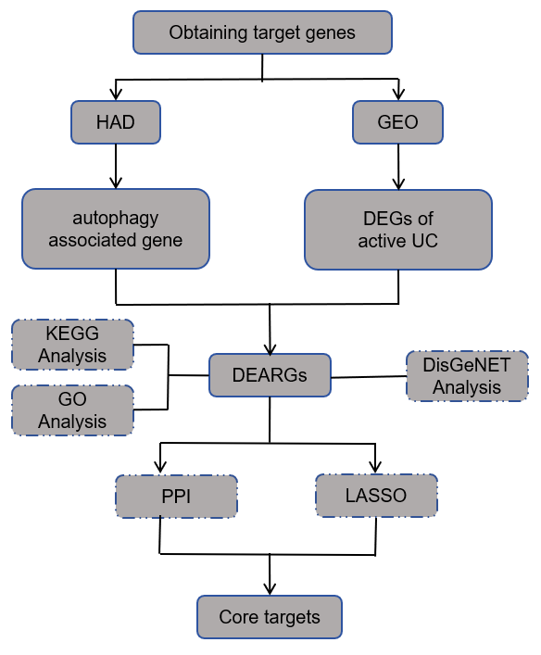
Figure 1 Study flow chart. HAD: Human Autophagy Database; GEO: Gene Expression Omnibus database; UC: Ulcerative colitis; DEGs: Differentially expressed genes; DEARGs: Differentially expressed autophagy-related genes; KEGG: Kyoto Encyclopedia of Genes and Genomes; GO: Gene Ontology; PPI: Protein-Protein Interaction; LASSO: Least absolute shrinkage and selection operator.

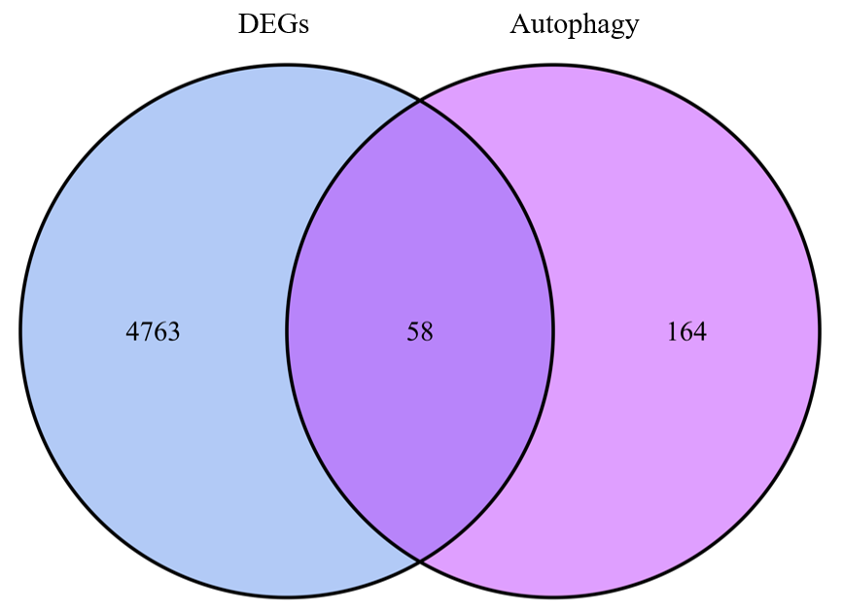
Figure 2 Intersection of autophagy-related targets and differentially expressed genes. There are 4821 differentially expressed genes and 232 autophagy-related targets. A total of 58 differentially expressed autophagy-related genes intersected. DEGs: Differentially expressed genes.

A
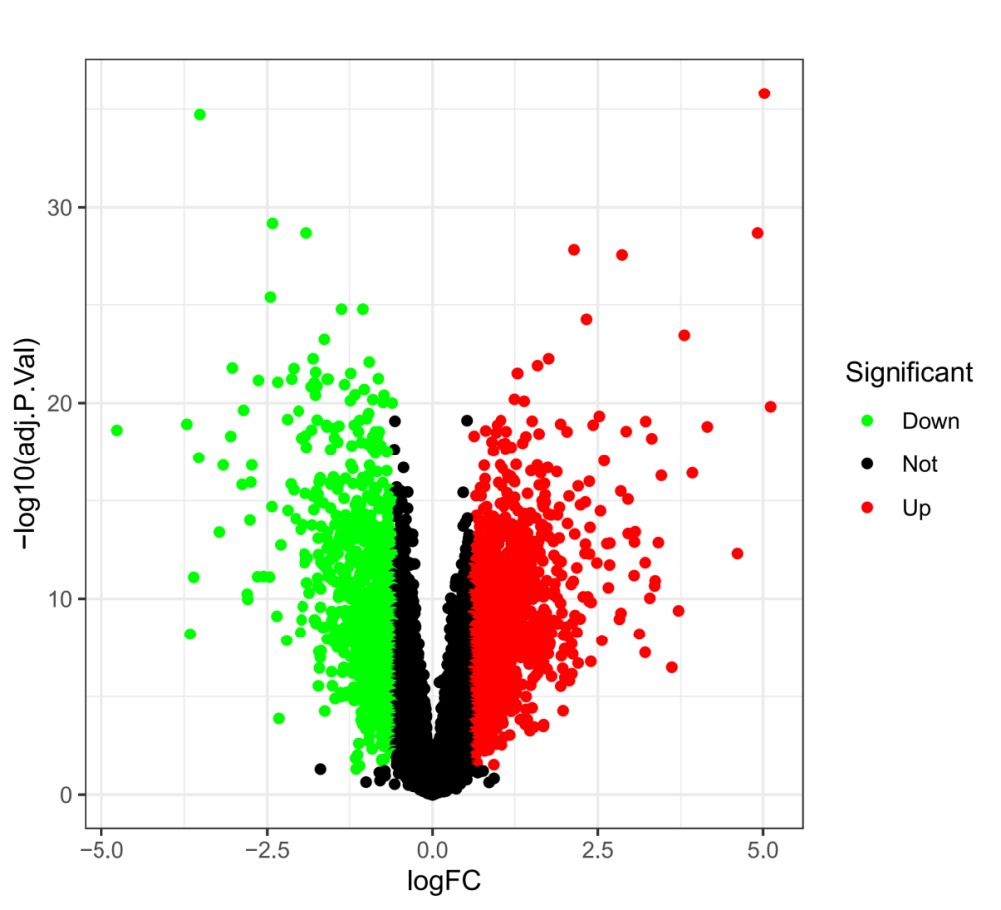
B
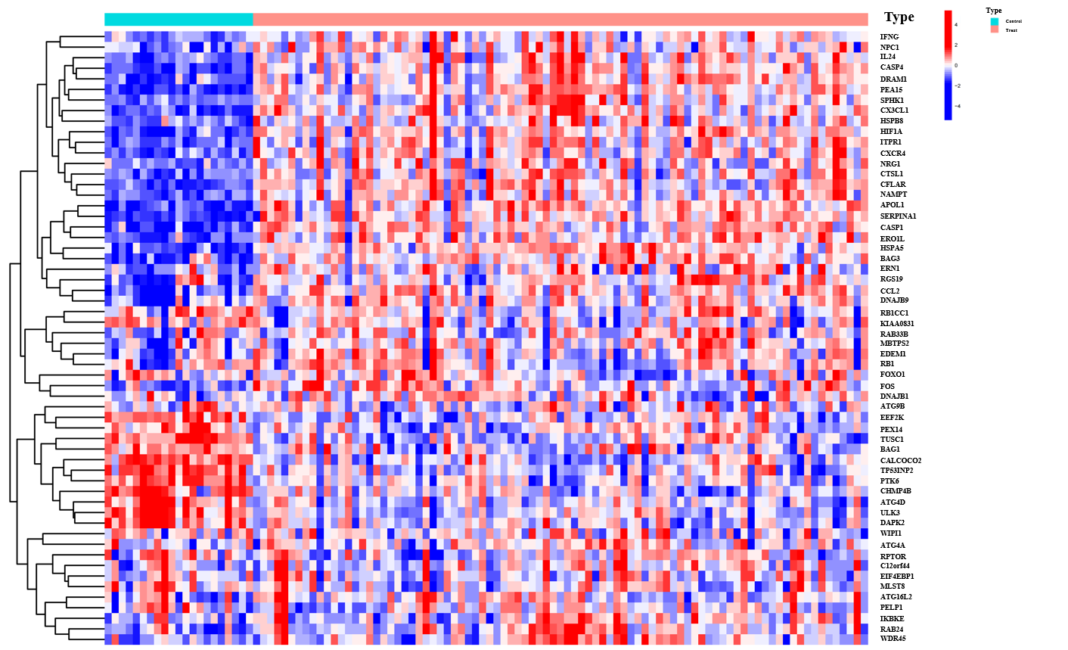
Figure 3 Volcano map and heat map showing expression of the differentially expressed autophagy-related genes. A: The downregulated targets are represented by green dots, the upregulated targets are represented by red dots, and the black dots indicate no significant difference in expression between active ulcerative colitis patients and healthy controls. Heat map showing expression of the differentially expressed autophagy-related genes; B: The blue color indicates low expression, while the red color indicates high expression.

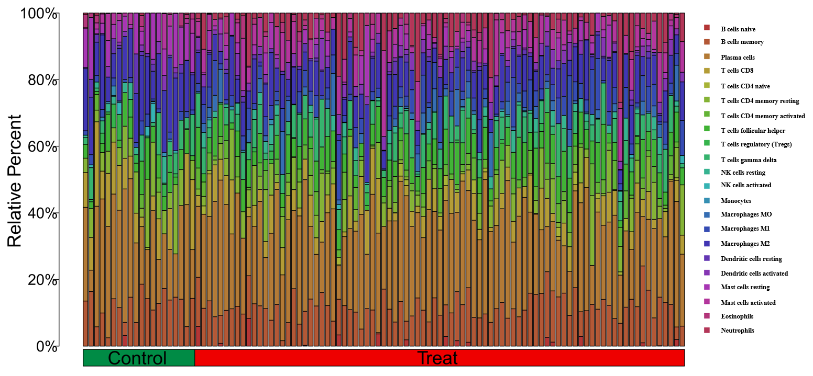
Figure 4 Proportion of immune cells in samples from the active ulcerative colitis group and healthy controls.

A
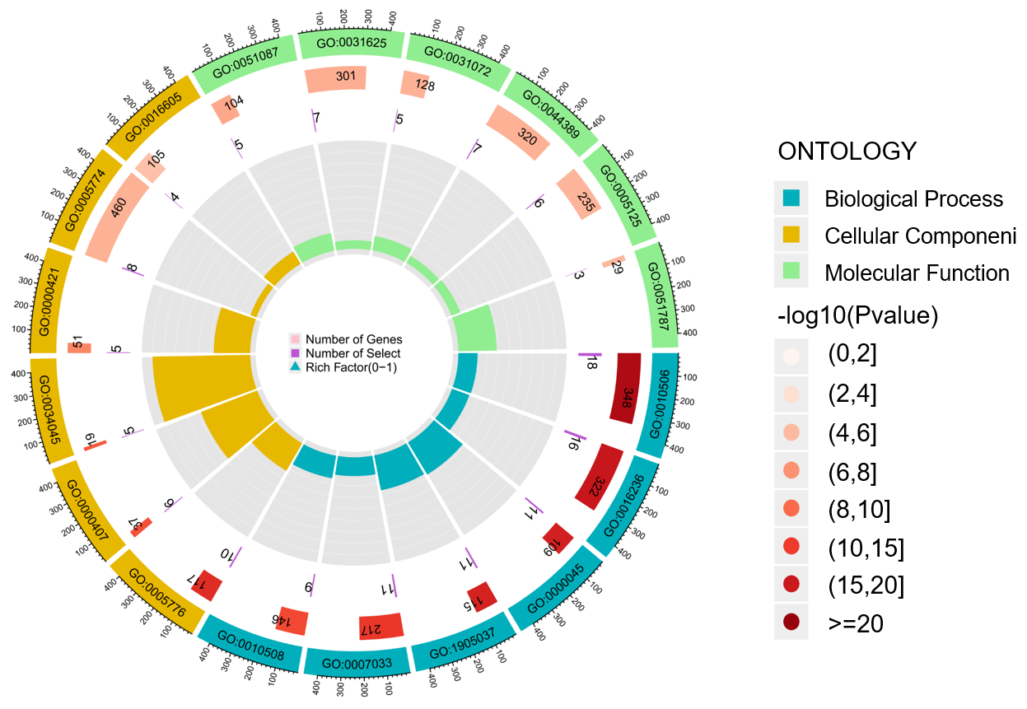
B
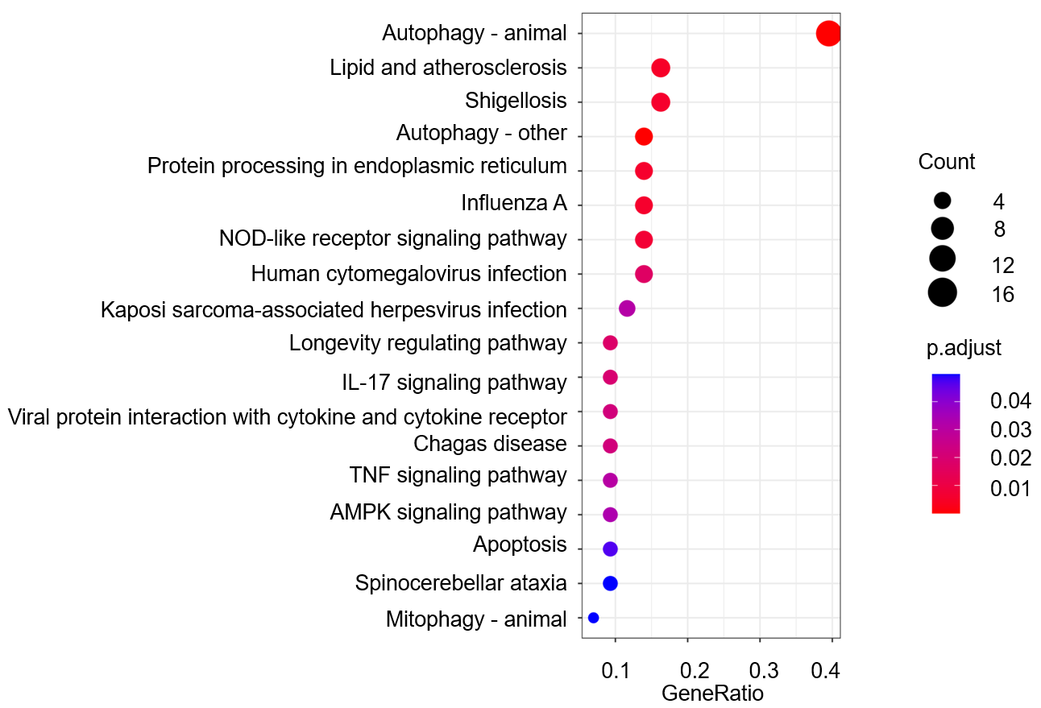
Figure 5 Results of gene ontology enrichment analysis. A: The blue part represents biological processes, the yellow part represents cellular components and the green part represents molecular functions. the height of the bar in the inner circle is proportional to the degree of enrichment. Results of Kyoto Encyclopedia of Genes and Genomes enrichment analysis; B: The horizontal coordinate is the number of enriched differentially expressed autophagy-related genes and the color of the node changes from red to purple according to the adjustment.

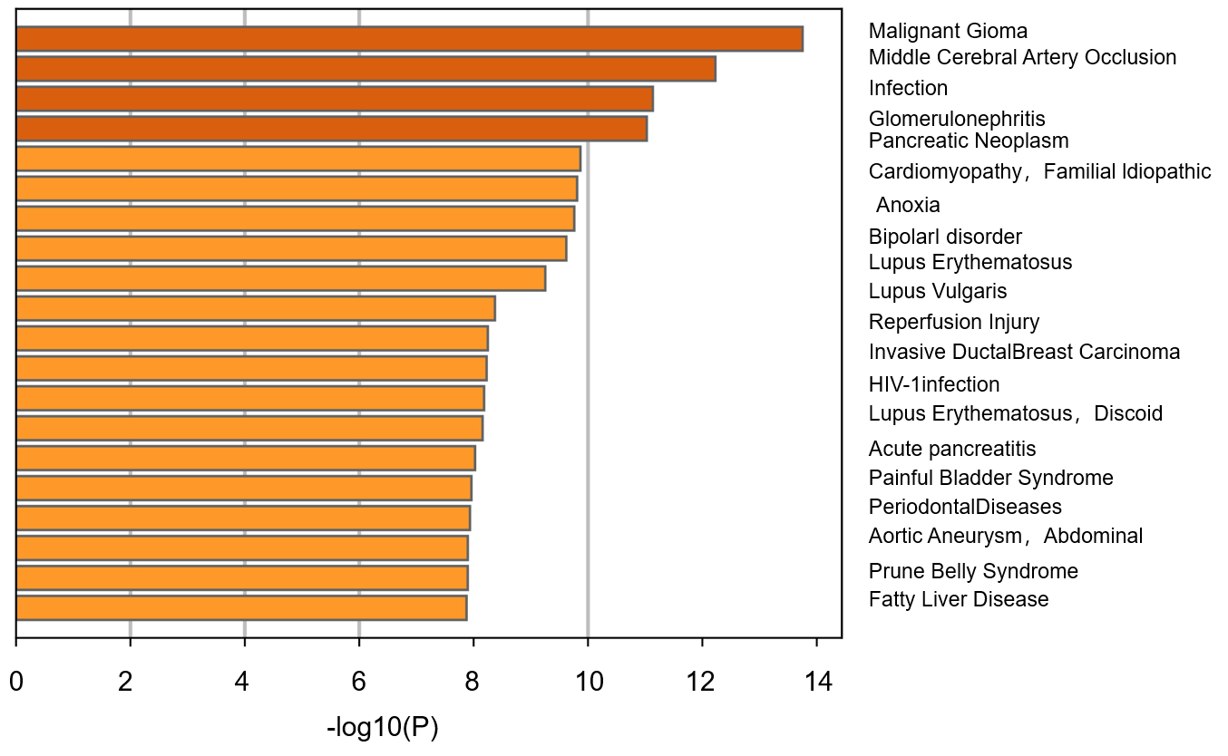
Figure 6 Validation of core targets in DisGeNET. The more yellow the color of the bar, the higher the correlation.

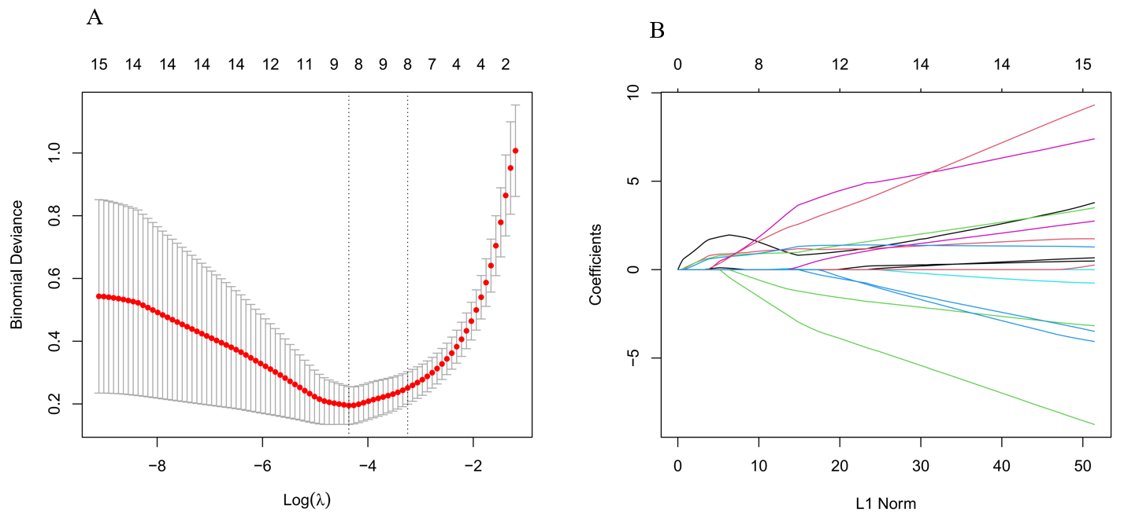
Figure 7 Results of least absolute shrinkage and selection operator regression model. A: Cross-validation error curve; B: Least absolute shrinkage and selection operator regression coefficient path plot.

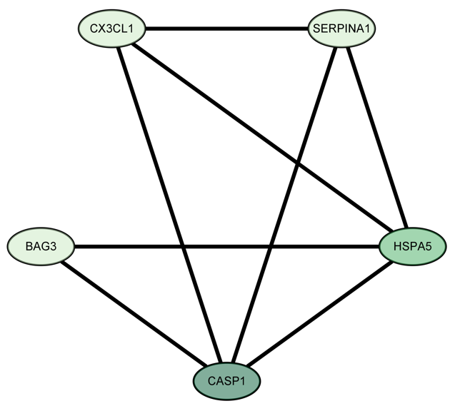
Figure 8 The five core targets and their relationship. The greener the color of the node, the higher the value of the degree, and the more important the relationship.

