Name of Journal: World Journal of Hepatology
ESPS Manuscript NO: 19707
Manuscript Type: Review

Management before hepatectomy for hepatocellular carcinoma with cirrhosis

Nakayama H et al. Perioperative management for HCC with LC

Hisashi Nakayama, Tadatoshi Takayama

Hisashi Nakayama, Tadatoshi Takayama, Department of Digestive Surgery, Nihon University School of Medicine, Itabashi-ku, Tokyo 173-8610, Japan

Author contributions: Both authors contributed to this work.

Supported by A Grant-in-Aid for Scientific Research (C) 25350856 from the Ministry of Education, Culture, Sports, Science and Technology (MEXT), Japan.

Conflict-of-interest statement: The authors declare no conflict of interest.

Open-Access: This article is an open-access article which was selected byan in-house editor and fully peer-reviewed by external reviewers. It is distributed in accordance with the Creative Commons Attribution Non Commercial (CC BY-NC 4.0) license, which permits others to distribute, remix, adapt, build upon this work non-commercially, and license their derivative works on different terms, provided the original work is properly cited and the use is non-commercial. See: http://creativecommons.org/licenses/by-nc/4.0/

Correspondence to: Hisashi Nakayama, MD, PhD, Department of Digestive Surgery, Nihon University School of Medicine, 30-1, Oyaguchikami-machi, Itabashi-ku, Tokyo 173-8610, Japan. nakayama.hisashi@nihon-u.ac.jp
Telephone: +81-3-35542345
Fax: +81-3-39578299

Received: May 18, 2015
Peer-review started: May 19, 2015
First decision: July 6, 2015
Revised: August 4, 2015
Accepted: August 30, 2015
Article in press:
Published online:

Abstract
The global distribution of hepatocellular carcinoma (HCC) varies markedly among regions, and patients in East Asia and Central Africa account for about 80% of all cases. The risk factors are hepatitis B, hepatitis C, alcohol, and etc. The risk of carcinogenesis further increases with progression to hepatic cirrhosis in all liver disorders. Radical treatment of HCC by liver resection without causing liver failure has been established as a safe approach through selection of an appropriate range of resection of the damaged liver. This background indicates that both evaluation of hepatic functional reserve and measures against concomitant diseases such as thrombocytopenia accompanying portal hypertension, prevention of rupture of esophageal varices, reliable control of ascites, and improvement of hypoalbuminemia are important issues in liver resection in patients with hepatic cirrhosis. We review the latest information on perioperative management of liver resection in HCC patients with hepatic cirrhosis.

Key words: Hepatocellular carcinoma; Liver resection; Liver cirrhosis; Portal hypertension

© The Author(s) 2015. Published by Baishideng Publishing Group Inc. All rights reserved.

Core tip: Radical treatment of hepatocellular carcinoma (HCC) by liver resection without causing liver failure has been established as a safe approach through selection of an appropriate range of resection of the damaged liver. This background indicates that both evaluation of hepatic functional reserve and measures against concomitant diseases such as thrombocytopenia accompanying portal hypertension, prevention of rupture of esophageal varices, reliable control of ascites, and improvement of hypoalbuminemia are important issues in liver resection in patients with hepatic cirrhosis. The latest information on perioperative management of liver resection in HCC patients with hepatic cirrhosis was reviewed.

Nakayama H, Takayama T. Management before hepatectomy for hepatocellular carcinoma with cirrhosis. World J Hepatol 2015; In press

INTRODUCTION
The global distribution of hepatocellular carcinoma (HCC) varies markedly among regions, and patients in East Asia and Central Africa account for about 80% of all cases^{[1,2]}. The risk factors are hepatitis B and aflatoxin in these regions^{[3]}, whereas hepatitis C and alcohol are risk factors in North America, Europe and Japan^{[4,5]}. The risk of carcinogenesis further increases with progression to hepatic cirrhosis in all liver disorders. Hepatic cirrhosis is an irreversible pathological change and inhibition of disease progression has previously been considered difficult. However, advances in antiviral therapy now permit eradication or inhibition of replication of viruses^{[6]}.
Radical treatment of HCC by liver resection without causing liver failure has been established as a safe approach through selection of an appropriate range of resection of the damaged liver^{[7,8]}. In the HCC practice guidelines of the Barcelona Clinic Liver Cancer (BCLC) staging system, liver resection is not recommended for patients with portal hypertension^{[9]}, and radiofrequency ablation (RFA) and transcatheter arterial chemoembolization (TACE) are selected in many countries. In Japan, liver resection using appropriate preoperative management has been found to be safe and to improve the prognosis for patients with portal hypertension^{[10]}.
This background indicates that both evaluation of hepatic functional reserve^{[11]} and measures against concomitant diseases such as thrombocytopenia accompanying portal hypertension, prevention of rupture of esophageal varices, reliable control of ascites, and improvement of hypoalbuminemia are important issues in liver resection in patients with hepatic cirrhosis^{[12]}. In this report, we review the latest information on perioperative management of liver resection in HCC patients with hepatic cirrhosis.

DEFINITION OF HEPATIC CIRRHOSIS
Hepatic cirrhosis is the terminal stage of chronic liver disease, in which fibrous tissue accumulation due to necrotizing inflammatory reactions makes the liver surface rough and irregular^{[12]}. Histologically, lobular structure remodeling and pseudolobule formation are observed; i.e., hepatic cirrhosis is a morphologically defined disease^{[13]}.

Classification
Hepatic cirrhosis is classified based on (1) cause, (2) function and clinical stage, and (3) node size-based morphology (WHO classification). In (2), hepatic cirrhosis is classified into compensated and decompensated phases, and by the Child-Pugh classification, as described below. In (3), hepatic cirrhosis is classified into three types: micro-nodular type, with nodes < 3 mm, macro-nodular type, with nodes ≥ 3 mm, and mixed nodular type, in which both nodules are mixed.

Cause
Persistent hepatitis virus B and C infections and excessive alcohol intake are the causes in many patients. The specific types are primary biliary hepatic cirrhosis (PBC); autoimmune hepatitis (AIH); non-alcoholic steatohepatitis (NASH); and metabolic (Wilson disease, hemochromatosis), congestive (Budd-Chiari syndrome), parasitic, and drug-induced types^{[12]}.

Diagnosis
Hepatic cirrhosis is definitively diagnosed by histological confirmation of lobular structure remodeling and pseudolobule formation on liver biopsy. However, liver biopsy is not optimal because performance of this procedure before liver resection has a risk of complications. Thus, it is desirable to evaluate the presence of hepatic cirrhosis based on blood chemistry and diagnostic imaging. Several formulas for this purpose using blood tests have been reported^{[14-17]} (Table 1). The AST-platelet ratio index (APRI) is based on the AST level and platelet count. The diagnostic performance for hepatic cirrhosis C using a cut-off of 1.0 is about 77% sensitivity and 75% specificity^{[16]}.
In imaging diagnosis, transient elastography (FibroScanTM) can be used for noninvasive measurement of liver stiffness (stiffness), in which liver elasticity is determined by measuring the velocity of transmission in the liver of a single shear wave emitted from a specific probe of an ultrasonic diagnostic device^{[18,19]}. A strong correlation between liver elasticity and fibrosis stage has been reported^{[20]}.

Staging
The most common hepatic cirrhosis classification is the Child-Pugh classification, in which 5 factors are scored: encephalopathy, ascites, serum bilirubin level, serum albumin level, and prothrombin activity^{[21,22]}. However, diagnoses of encephalopathy and ascites are subjective, and evaluation of liver function is determined specifically at the time of the test, which are disadvantages in evaluation of hepatic functional reserve for liver resection. In planning for liver resection, the liver damage classification is more appropriate, particularly for HCC^{[23]}. This classification uses the indocyanine green retention rate at 15 min (ICG-R₁₅), instead of encephalopathy in the Child-Pugh classification, and stricter measurements of serum albumin and prothrombin levels. This classification is particularly useful for preoperative selection of patients with favorable hepatic functional reserve^{[24]}.
The prognosis of HCC depends on the hepatic functional reserve and tumor stage. These variables are integrated in staging systems including the model for end-stage liver disease (MELD)^{[25]}, OKUDA^{[26]}, Cancer of the liver Italian program (CLIP) (Table 2)^{[27]}, Japan integrated staging (JIS) score (Table 3)^{[28]}, modified-JIS score^{[29]}, and the Tokyo score^{[30]}, all of which are useful predictors of outcomes. Kudo et al^{[31]} proposed the JIS score, in which the TNM stage and Child-Pugh classification are integrated. This score has advantages over the CLIP score (integration of the Child-Pugh classification, tumor morphology, AFP, and portal vein tumor thrombosis) because (1) stratification of scores is distinct, (2) the prognosis of score-0 liver cancer is favorable, and (3) there is a definitive JIS score for cases with a poor prognosis. Integrated staging is useful for prediction of outcomes, but inappropriate for selection and comparison of treatment methods.

TREATMENT OF THROMBOCYTOPENIA
A reduced platelet count is an indicator of hepatic cirrhosis, and liver resection requires measures against thrombocytopenia to reduce the risk of hemorrhage^{[12]}. Low preoperative platelet count is independently associated with increased major complications, postoperative liver insufficiency, and mortality after resection of HCC^{[32]}.
Partial splenic embolization (PSE) is performed to improve hypersplenism through partially necrotizing the spleen by embolization of the splenic artery with a gelatin sponge or metal coil^{[33,34]}. Long-term maintenance of the increased platelet count requires extensive splenic embolization of about 80% (splenic volumes ≤ 700 mL)^{[35]}, but this treatment is accompanied by risks of complications such as abdominal pain (82.4%), fever (94.1%), and splenic abscess (1.2%)^{[36]}. A short-term minimum effect of embolization is believed to be sufficient to prevent hemorrhage after liver resection^{[37]}.
Splenectomy reliably improves portal hypertension and hypersplenism. In HCC accompanied by hepatic cirrhosis, splenectomy improves the serum bilirubin, albumin, and prothrombin levels, and splenectomy performed before liver resection has a significant benefit^{[38]}. In contrast, splenectomy before brain dead liver transplantation causes an increase in infection, decrease in survival rate, and high mortality^{[39,40]}. Thus, it has been suggested that cases should be carefully selected for splenectomy. Also, since immune function is reduced in patients with hepatic cirrhosis, overwhelming post-splenectomy infection syndrome (OPSI) is a concern^{[41]}. OPSI is a complication that develops rapidly regardless of the time after surgery and has a poor prognosis and high mortality (50%-70%)^{[42-44]}. Pneumococcus is the causative bacteria in 80% of cases and a pneumococcus vaccine is recommended for splenectomized patients. Interferon administration following splenectomy may also induce OPSI; thus, antiviral therapy should be performed carefully. The incidences of portal vein thrombosis after splenectomy are 9%-29% and 1.6%-8.0% in patients with and without concomitant spleen enlargement, respectively^{[45-48]}. Doppler ultrasonography and contrast CT are useful for early diagnosis of portal vein thrombosis following splenectomy. The timing of splenectomy varies among institutions (Table 4). Sugawara et al^{[49]} recommended simultaneous splenectomy for readily resectable HCC in cases with favorable liver function and general conditions, and earlier splenectomy if these criteria are not met.

TREATMENT OF ESOPHAGEAL VARIX
The prognosis for patients with cirrhosis primarily depends on the occurrence of hemorrhage from esophageal varices and gastropathy. General rules for recording endoscopic findings of esophagogastric varices is formatted with location, form, color, red color signs, bleeding sings and mucosal findings (Table 5)^{[50]}. According to the UK guide lines, esophageal varices are classified into 3 grades based on the size of varices^{[51]}. Grade II/III varices (large) are indicated to beta-blocker or variceal ligation (Figure 1). McCormack classification is useful to definite of portal hypertensive gastropathy (Table 6)^{[52]}. Thus, endoscopy should be performed before liver resection to avoid overlooking esophageal varices because the portal blood pressure rises after liver resection and this may aggravate varices. For patients with a history of hemorrhage from a varix, treatment of the varix before liver resection is required. For patients with a large (F2 or larger) varix accompanied by red color sign based on above general rules, preventive treatment is indicated^{[53]}.
Currently, endoscopic treatment is the standard for esophageal varices, using endoscopic injection sclerotherapy and endoscopic variceal ligation^{[54]}. Balloon-occluded retrograde transvenous obliteration (BRTO) improves the varix and ICG-R₁₅ value in patients with a gastric varix^{[55]}, but there is no evidence that BRTO improves the safety of liver resection. The endoscopic F factor (large varices) rating of bleeding esophageal varices can be a significant predictive factor for HCC^{[56]}. So the screening of HCC is required after the treatment of large varices.

CONTROL OF ASCITES
Ascites accompanying hepatic cirrhosis involves interactions among various factors, including enhancement of liver lymph production with elevation of the portal blood pressure, enhancement of intra-abdominal portal permeability, reduction of the effective circulating blood volume, and enhancement of the sympathetic nervous system^{[12]}. Treatment of fluid retention, which manifests as ascites, includes restriction of salts and water, administration of diuretics, and transfusion of an albumin preparation. If no effect is obtained in a short time, the patient is at high risk of liver or multiple organ failure, and liver resection should be avoided^{[57]}. Selection of the smallest possible range of resection in patients with relatively favorable liver function and early resolution of ascites is the key to safe and successful liver resection^{[11]}.

IMPROVEMENT OF NUTRITIONAL STATUS
The association between preoperative sarcopenia and postoperative morbidity/mortality has been reported for various types of surgeries. Preoperative sarcopenia increased the morbidity rate including the rate of liver failure, in patients who underwent major hepatectomy with extrahepatic bile duct resection ^{[58]}. European Society for Parenteral and Enteral Nutrition (ESPEN) guidelines recommended an energy intake of 35–40 kcal/kgBW per day (147–168 kJ/kgBW per day) and a protein intake of 1.2–1.5 g/kgBW per day for cirrhotic patients perioperatively^{[59]}.
Protein-energy malnutrition (PEM) occurs in 27%-87% of patients with hepatic cirrhosis, and the level of branched-chain amino acids (BCAAs) is markedly reduced^{[60]}. In PEM, hypoalbuminemia is observed and BCAAs are used for processing of ammonia and as an energy source for gluconeogenesis in skeletal muscle. In hepatic cirrhosis, serum albumin and plasma BCAA levels are positively correlated, and the prognosis is significantly poorer when serum albumin is < 3.5 g/dL^{[61,62]}. Oral administration of BCAAs is of interest as a pharmacological and nutritional approach for improvement of hypoalbuminemia and insulin resistance, inhibition of angiogenesis, and activation of immune function^{[63]}. In a randomized controlled trial (RCT) in 646 patients with decompensated hepatic cirrhosis who were divided into groups with and without treatment with oral BCAAs for 2 years, the incidences of death, liver cancer, rupture of esophageal varix, and liver failure were lower in the BCAA group and the prognosis was improved^{[64]}.

SELECTION OF LIVER RESECTION RANGE
In Japan, East Asia and some European countries, ICG-R₁₅ is used as an index of hepatic functional reserve. ICG-R₁₅ is also a predictor of morbidity and mortality after surgery^{[65,66]} and can be used to determine the acceptable liver resection range. In the therapeutic strategy for HCC, the BCLC staging system recommended by AASLD and EASL is used worldwide^{[9]}. In Japan, the “treatment algorithm” described in the Clinical Guidelines for HCC is widely used to select the optimum treatment based on the liver function and tumor status (Figure 2)^{[67]}. The Japanese treatment algorithm differs markedly from the BCLC system with regard to HCC with concomitant portal hypertension^{[68]}. In the BCLC system, liver resection is not indicated if portal hypertension is present, and liver transplantation and RFA are recommended. In contrast, liver resection is recommended based on the ICG-R₁₅ level in the Japanese treatment algorithm, and favorable outcomes have been reported^{[10]}.
Liver resection for HCC is chosen based on the balance between tumor status and liver function. Resection exceeding the hepatic functional reserve with the goal of cancer cure may lead to liver failure, whereas insufficient resection of the cancer due to excessive safety concerns may have a high risk of early recurrence. Therefore, it is important to select the optimum surgical procedure based on the tumor advancement and the acceptable liver resection range. Preoperative liver function can be evaluated using a galactose tolerance test, ^{99m}Tc-GSA liver scintigraphy, and an ICG tolerance test. The Makuuchi criteria are particularly useful for chronic hepatitis and hepatic cirrhosis cases (Figure 3)^{[11]}. These criteria use the presence or absence of ascites, serum bilirubin level, and ICG-R₁₅ as evaluation items. Surgery is not indicated for cases with persistent ascites despite treatment with diuretics or if the serum bilirubin level is consistently > 2.0 mg/dL. The range of resection is determined based on ICG-R₁₅ in patients with a normal bilirubin level of ≤ 1.0 mg/dL, i.e., procedures can be selected for resection of up to 2/3 of the total liver volume (such as right lobectomy) in patients with normal ICG-R₁₅ (< 10%), up to 1/3 of the total liver volume (such as left lobectomy) for patients with ICG-R₁₅ of 10%-19%, and up to 1/6 of the total liver volume (Couinaud’s segmentectomy) for patients with ICG-R₁₅ of 20%-29%. When ICG-R₁₅ exceeds 30%, surgery is limited to partial resection or enucleation. In a study in 1056 patients who underwent liver resection based on these criteria, the surgical mortality was 0%^{[8]}.
Systematic resection of cancer-containing regions perfused by branches of the portal vein should be performed within the range allowed by the liver function and with consideration of HCC invasion of the portal vein. Systematic subsegmentectomy of the liver was developed to overcome two contradictory goals: cancer curability and conservation of liver function^{[69]}. Since HCC develops in a liver damaged by chronic hepatitis and hepatic cirrhosis in many cases, an insufficient volume of residual liver after major hepatectomy, such as lobectomy, may result in liver failure. To prevent liver failure, portal vein embolization (PE) is applied to the branch of the portal vein perfusing the planned region for resection to induce compensatory hypertrophy of the region remaining after liver resection^{[70]}. PE is indicated for cases with ICG-R₁₅ < 10% and a ratio of the non-tumorous parenchymal volume of the resected liver to that of the whole liver (R2) of ≥ 60%, and for cases with ICG-R₁₅ ≥ 10% to < 20% and R2 of 40%-60%^{[71]}. Both degree of liver hypertrophy and growth rate after PE are strong predictors of post-hepatectomy liver failure^{[72]}. Recent introduction of 3-dimensional CT has enabled simple and accurate determination of the positional relationship between the main vessels and the tumor, the range of resection, and measurement of the residual liver volume^{[73]}.
Since 1990, liver resection for HCC has been performed with acceptable blood loss at high-volume medical centers, and centers performing surgery with blood loss of about 500 mL have increased^{[74-77]}. Blood transfusion may promote cancer recurrence and is likely to induce hyperbilirubinemia and liver failure^{[78]}. Since a low hematocrit value is preferable for microcirculation of the liver, perioperative allogeneic transfusion should be avoided as much as possible in liver resection. Autologous blood transfusion is safe and useful for avoidance of allogeneic transfusion without increasing the risk of cancer recurrence^{[79]}. Administration of fresh frozen plasma is recommended to supplement coagulation factors and maintain the effective plasma volume^{[80]}, but administration of fresh frozen plasma does not influence the course after liver resection and is not necessary if the serum albumin level 2 d after surgery is ≥ 2.4 g/dL in Child-Pugh class A cases with intraoperative blood loss of < 1000 mL^{[81]}.
The immunosuppressed state after liver resection may lead to progression of liver failure and DIC. In a RCT of steroid administration after liver resection, postoperative liver function was compared between groups treated with and without 500 mg/body hydrocortisone before liver resection. Serum bilirubin significantly decreased 2 d after surgery in the steroid group and there were significant differences in the time-courses of the bilirubin level and the prothrombin activity for 7 d after surgery. These results show the efficacy of steroid administration for liver resection^{[82]}.

POSTOPERATIVE ANTIVIRAL TREATMENT FOR HCC
HCC often recurs even after curative liver resection or RFA. It has been believed that controlling hepatitis and ameliorating the symptoms of cirrhosis prevent the recurrence of HCC. Several studies have examined the adjuvant therapies for their ability to prevent recurrence^{[83]}. Eight RCTs were carried out to verify the efficacy of adjuvant interferon therapy for postoperative HCC^{[84-91]}. It is suggested that adjuvant interferon-α reduced HCC recurrence and improved overall survival in patients with hepatitis C virus-infected HCC following curative treatment. The available evidence suggests that antivirus therapy with nucleoside analogs (lamivudine) should be recommended a postoperative preventive therapy for patients with hepatitis B virus-related HCC (> 500 copies of hepatitis B virus DNA/mL)^{[92,93]}.

CONCLUSION
Perioperative management is important in liver resection for patients with HCC and hepatic cirrhosis. New methods for evaluation and improvement of liver function are likely to facilitate expansion of the indication for liver resection.

REFERENCES
1 Tejeda-Maldonado J, García-Juárez I, Aguirre-Valadez J, González-Aguirre A, Vilatobá-Chapa M, Armengol-Alonso A, Escobar-Penagos F, Torre A, Sánchez-Ávila JF, Carrillo-Pérez DL. Diagnosis and treatment of hepatocellular carcinoma: An update. World J Hepatol 2015; 7: 362-376 [PMID: 25848464 DOI: 10.4254/wjh.v7.i3.362]
2 Forner A, Llovet JM, Bruix J. Hepatocellular carcinoma. Lancet 2012; 379: 1245-1255 [PMID: 22353262 DOI: 10.1016/s0140-6736(11)61347-0]
3 Trépo C, Chan HL, Lok A. Hepatitis B virus infection. Lancet 2014; 384: 2053-2063 [PMID: 24954675 DOI: 10.1016/s0140-6736(14)60220-8]
4 Webster DP, Klenerman P, Dusheiko GM. Hepatitis C. Lancet 2015; 385: 1124-1135 [PMID: 25687730 DOI: 10.1016/s0140-6736(14)62401-6]
5 Echeverría N, Moratorio G, Cristina J, Moreno P. Hepatitis C virus genetic variability and evolution. World J Hepatol 2015; 7: 831-845 [PMID: 25937861 DOI: 10.4254/wjh.v7.i6.831]
6 Muir AJ, Poordad F, Lalezari J, Everson G, Dore GJ, Herring R, Sheikh A, Kwo P, Hézode C, Pockros PJ, Tran A, Yozviak J, Reau N, Ramji A, Stuart K, Thompson AJ, Vierling J, Freilich B, Cooper J, Ghesquiere W, Yang R, McPhee F, Hughes EA, Swenson ES, Yin PD. Daclatasvir in combination with asunaprevir and beclabuvir for hepatitis C virus genotype 1 infection with compensated cirrhosis. JAMA 2015; 313: 1736-1744 [PMID: 25942724 DOI: 10.1001/jama.2015.3868]
7 Zhou Y, Lei X, Wu L, Wu X, Xu D, Li B. Outcomes of hepatectomy for noncirrhotic hepatocellular carcinoma: a systematic review. Surg Oncol 2014; 23: 236-242 [PMID: 25465529 DOI: 10.1016/j.suronc.2014.11.001]
8 Imamura H, Seyama Y, Kokudo N, Maema A, Sugawara Y, Sano K, Takayama T, Makuuchi M. One thousand fifty-six hepatectomies without mortality in 8 years. Arch Surg 2003; 138: 1198-206; discussion 1206 [PMID: 14609867 DOI: 10.1001/archsurg.138.11.1198]
9 Bruix J, Sherman M. Management of hepatocellular carcinoma: an update. Hepatology 2011; 53: 1020-1022 [PMID: 21374666 DOI: 10.1002/hep.24199]
10 Ishizawa T, Hasegawa K, Aoki T, Takahashi M, Inoue Y, Sano K, Imamura H, Sugawara Y, Kokudo N, Makuuchi M. Neither multiple tumors nor portal hypertension are surgical contraindications for hepatocellular carcinoma. Gastroenterology 2008; 134: 1908-1916 [PMID: 18549877 DOI: 10.1053/j.gastro.2008.02.091]
11 Makuuchi M, Kosuge T, Takayama T, Yamazaki S, Kakazu T, Miyagawa S, Kawasaki S. Surgery for small liver cancers. Semin Surg Oncol 1993; 9: 298-304 [PMID: 8210909]
12 Tsochatzis EA, Bosch J, Burroughs AK. Liver cirrhosis. Lancet 2014; 383: 1749-1761 [PMID: 24480518 DOI: 10.1016/s0140-6736(14)60121-5]
13 Hytiroglou P, Snover DC, Alves V, Balabaud C, Bhathal PS, Bioulac-Sage P, Crawford JM, Dhillon AP, Ferrell L, Guido M, Nakanuma Y, Paradis V, Quaglia A, Theise ND, Thung SN, Tsui WM, van Leeuwen DJ. Beyond "cirrhosis": a proposal from the International Liver Pathology Study Group. Am J Clin Pathol 2012; 137: 5-9 [PMID: 22180471 DOI: 10.1309/ajcp2t2ohtapbtmp]
14 Ikeda K, Saitoh S, Kobayashi M, Suzuki Y, Tsubota A, Suzuki F, Arase Y, Murashima N, Chayama K, Kumada H. Distinction between chronic hepatitis and liver cirrhosis in patients with hepatitis C virus infection. Practical discriminant function using common laboratory data. Hepatol Res 2000; 18: 252-266 [PMID: 11058829]
15 Koda M, Matunaga Y, Kawakami M, Kishimoto Y, Suou T, Murawaki Y. FibroIndex, a practical index for predicting significant fibrosis in patients with chronic hepatitis C. Hepatology 2007; 45: 297-306 [PMID: 17256741 DOI: 10.1002/hep.21520]
16 Wai CT, Greenson JK, Fontana RJ, Kalbfleisch JD, Marrero JA, Conjeevaram HS, Lok AS. A simple noninvasive index can predict both significant fibrosis and cirrhosis in patients with chronic hepatitis C. Hepatology 2003; 38: 518-526 [PMID: 12883497 DOI: 10.1053/jhep.2003.50346]
17 Sterling RK, Lissen E, Clumeck N, Sola R, Correa MC, Montaner J, S Sulkowski M, Torriani FJ, Dieterich DT, Thomas DL, Messinger D, Nelson M. Development of a simple noninvasive index to predict significant fibrosis in patients with HIV/HCV coinfection. Hepatology 2006; 43: 1317-1325 [PMID: 16729309 DOI: 10.1002/hep.21178]
18 Sandrin L, Fourquet B, Hasquenoph JM, Yon S, Fournier C, Mal F, Christidis C, Ziol M, Poulet B, Kazemi F, Beaugrand M, Palau R. Transient elastography: a new noninvasive method for assessment of hepatic fibrosis. Ultrasound Med Biol 2003; 29: 1705-1713 [PMID: 14698338]
19 Lucidarme D, Foucher J, Le Bail B, Vergniol J, Castera L, Duburque C, Forzy G, Filoche B, Couzigou P, de Lédinghen V. Factors of accuracy of transient elastography (fibroscan) for the diagnosis of liver fibrosis in chronic hepatitis C. Hepatology 2009; 49: 1083-1089 [PMID: 19140221 DOI: 10.1002/hep.22748]
20 Castéra L, Vergniol J, Foucher J, Le Bail B, Chanteloup E, Haaser M, Darriet M, Couzigou P, De Lédinghen V. Prospective comparison of transient elastography, Fibrotest, APRI, and liver biopsy for the assessment of fibrosis in chronic hepatitis C. Gastroenterology 2005; 128: 343-350 [PMID: 15685546]
21 Child CG. The liver and portal hypertension. 3rd ed. Philadelphia: WB Saunders, 1964
22 Pugh RN, Murray-Lyon IM, Dawson JL, Pietroni MC, Williams R. Transection of the oesophagus for bleeding oesophageal varices. Br J Surg 1973; 60: 646-649 [PMID: 4541913]
23 [No authors listed]. The general rules for the clinical and pathological study of primary liver cancer. Liver Cancer Study Group of Japan. Jpn J Surg 1989; 19: 98-129 [PMID: 2659865]
24 Minagawa M, Ikai I, Matsuyama Y, Yamaoka Y, Makuuchi M. Staging of hepatocellular carcinoma: assessment of the Japanese TNM and AJCC/UICC TNM systems in a cohort of 13,772 patients in Japan. Ann Surg 2007; 245: 909-922 [PMID: 17522517 DOI: 10.1097/01.sla.0000254368.65878.da]
25 Kamath PS, Wiesner RH, Malinchoc M, Kremers W, Therneau TM, Kosberg CL, D'Amico G, Dickson ER, Kim WR. A model to predict survival in patients with end-stage liver disease. Hepatology 2001; 33: 464-470 [PMID: 11172350 DOI: 10.1053/jhep.2001.22172]
26 Okuda K, Ohtsuki T, Obata H, Tomimatsu M, Okazaki N, Hasegawa H, Nakajima Y, Ohnishi K. Natural history of hepatocellular carcinoma and prognosis in relation to treatment. Study of 850 patients. Cancer 1985; 56: 918-928 [PMID: 2990661]
27 [No authors listed]. A new prognostic system for hepatocellular carcinoma: a retrospective study of 435 patients: the Cancer of the Liver Italian Program (CLIP) investigators. Hepatology 1998; 28: 751-755 [PMID: 9731568 DOI: 10.1002/hep.510280322]
28 Kudo M, Chung H, Haji S, Osaki Y, Oka H, Seki T, Kasugai H, Sasaki Y, Matsunaga T. Validation of a new prognostic staging system for hepatocellular carcinoma: the JIS score compared with the CLIP score. Hepatology 2004; 40: 1396-1405 [PMID: 15565571 DOI: 10.1002/hep.20486]
29 Ikai I, Takayasu K, Omata M, Okita K, Nakanuma Y, Matsuyama Y, Makuuchi M, Kojiro M, Ichida T, Arii S, Yamaoka Y. A modified Japan Integrated Stage score for prognostic assessment in patients with hepatocellular carcinoma. J Gastroenterol 2006; 41: 884-892 [PMID: 17048053 DOI: 10.1007/s00535-006-1878-y]
30 Tateishi R, Yoshida H, Shiina S, Imamura H, Hasegawa K, Teratani T, Obi S, Sato S, Koike Y, Fujishima T, Makuuchi M, Omata M. Proposal of a new prognostic model for hepatocellular carcinoma: an analysis of 403 patients. Gut 2005; 54: 419-425 [PMID: 15710994 DOI: 10.1136/gut.2003.035055]
31 Mise Y, Tani K, Aoki T, Sakamoto Y, Hasegawa K, Sugawara Y, Kokudo N. Virtual liver resection: computer-assisted operation planning using a three-dimensional liver representation. J Hepatobiliary Pancreat Sci 2013; 20: 157-164 [PMID: 23135735 DOI: 10.1007/s00534-012-0574-y]
32 Maithel SK, Kneuertz PJ, Kooby DA, Scoggins CR, Weber SM, Martin RC, McMasters KM, Cho CS, Winslow ER, Wood WC, Staley CA. Importance of low preoperative platelet count in selecting patients for resection of hepatocellular carcinoma: a multi-institutional analysis. J Am Coll Surg 2011; 212: 638-48; discussion 648-50 [PMID: 21463803 DOI: 10.1016/j.jamcollsurg.2011.01.004]
33 Yoshida H, Mamada Y, Taniai N, Tajiri T. Partial splenic embolization. Hepatol Res 2008; 38: 225-233 [PMID: 18034810 DOI: 10.1111/j.1872-034X.2007.00302.x]
34 Hayashi H, Beppu T, Shirabe K, Maehara Y, Baba H. Management of thrombocytopenia due to liver cirrhosis: a review. World J Gastroenterol 2014; 20: 2595-2605 [PMID: 24627595 DOI: 10.3748/wjg.v20.i10.2595]
35 Hayashi H, Beppu T, Okabe K, Masuda T, Okabe H, Ishiko T, Baba H. Therapeutic factors considered according to the preoperative splenic volume for a prolonged increase in platelet count after partial splenic embolization for liver cirrhosis. J Gastroenterol 2010; 45: 554-559 [PMID: 20047119 DOI: 10.1007/s00535-009-0185-9]
36 Sakai T, Shiraki K, Inoue H, Sugimoto K, Ohmori S, Murata K, Takase K, Nakano T. Complications of partial splenic embolization in cirrhotic patients. Dig Dis Sci 2002; 47: 388-391 [PMID: 11855556]
37 Hadduck TA, McWilliams JP. Partial splenic artery embolization in cirrhotic patients. World J Radiol 2014; 6: 160-168 [PMID: 24876920 DOI: 10.4329/wjr.v6.i5.160]
38 Takayama T, Makuuchi M, Yamazaki S, Hasegawa H. [The role of splenectomy in patients with hepatocellular carcinoma and hypersplenism as an aid to hepatectomy]. Nihon Geka Gakkai Zasshi 1989; 90: 1043-1048 [PMID: 2552282]
39 Lüsebrink R, Blumhardt G, Lohmann R, Bachmann S, Knoop M, Lemmens HP, Neuhaus P. Does concommitant splenectomy raise the mortality of liver transplant recipients? Transpl Int 1994; 7 Suppl 1: S634-S636 [PMID: 11271326]
40 Samimi F, Irish WD, Eghtesad B, Demetris AJ, Starzl TE, Fung JJ. Role of splenectomy in human liver transplantation under modern-day immunosuppression. Dig Dis Sci 1998; 43: 1931-1937 [PMID: 9753254]
41 Okabayashi T, Hanazaki K. Overwhelming postsplenectomy infection syndrome in adults - a clinically preventable disease. World J Gastroenterol 2008; 14: 176-179 [PMID: 18186551]
42 Waghorn DJ, Mayon-White RT. A study of 42 episodes of overwhelming post-splenectomy infection: is current guidance for asplenic individuals being followed? J Infect 1997; 35: 289-294 [PMID: 9459404]
43 Waghorn DJ. Overwhelming infection in asplenic patients: current best practice preventive measures are not being followed. J Clin Pathol 2001; 54: 214-218 [PMID: 11253134]
44 Sinwar PD. Overwhelming post splenectomy infection syndrome - review study. Int J Surg 2014; 12: 1314-1316 [PMID: 25463041 DOI: 10.1016/j.ijsu.2014.11.005]
45 Kercher KW, Carbonell AM, Heniford BT, Matthews BD, Cunningham DM, Reindollar RW. Laparoscopic splenectomy reverses thrombocytopenia in patients with hepatitis C cirrhosis and portal hypertension. J Gastrointest Surg 2004; 8: 120-126 [PMID: 14746844]
46 Yoshida M, Watanabe Y, Horiuchi A, Yamamoto Y, Sugishita H, Kawachi K. Portal and splenic venous thrombosis after splenectomy in patients with hypersplenism. Hepatogastroenterology 2009; 56: 538-541 [PMID: 19579638]
47 Stamou KM, Toutouzas KG, Kekis PB, Nakos S, Gafou A, Manouras A, Krespis E, Katsaragakis S, Bramis J. Prospective study of the incidence and risk factors of postsplenectomy thrombosis of the portal, mesenteric, and splenic veins. Arch Surg 2006; 141: 663-669 [PMID: 16847237 DOI: 10.1001/archsurg.141.7.663]
48 Winslow ER, Brunt LM, Drebin JA, Soper NJ, Klingensmith ME. Portal vein thrombosis after splenectomy. Am J Surg 2002; 184: 631-65; discussion 631-65; [PMID: 12488196]
49 Sugawara Y, Yamamoto J, Shimada K, Yamasaki S, Kosuge T, Takayama T, Makuuchi M. Splenectomy in patients with hepatocellular carcinoma and hypersplenism. J Am Coll Surg 2000; 190: 446-450 [PMID: 10757382]
50 Tajiri T, Yoshida H, Obara K, Onji M, Kage M, Kitano S, Kokudo N, Kokubu S, Sakaida I, Sata M, Tajiri H, Tsukada K, Nonami T, Hashizume M, Hirota S, Murashima N, Moriyasu F, Saigenji K, Makuuchi H, Oho K, Yoshida T, Suzuki H, Hasumi A, Okita K, Futagawa S, Idezuki Y. General rules for recording endoscopic findings of esophagogastric varices (2nd edition). Dig Endosc 2010; 22: 1-9 [PMID: 20078657 DOI: 10.1111/j.1443-1661.2009.00929.x]
51 Tripathi D, Stanley AJ, Hayes PC, Patch D, Millson C, Mehrzad H, Austin A, Ferguson JW, Olliff SP, Hudson M, Christie JM. UK guidelines on the management of variceal haemorrhage in cirrhotic patients. Gut 2015: [PMID: 25887380 DOI: 10.1136/gutjnl-2015-309262]
52 McCormack TT, Sims J, Eyre-Brook I, Kennedy H, Goepel J, Johnson AG, Triger DR. Gastric lesions in portal hypertension: inflammatory gastritis or congestive gastropathy? Gut 1985; 26: 1226-1232 [PMID: 3877665]
53 Liu HT, Cheng SB, Wu CC, Yeh HZ, Chang CS, Wang J. Impact of severe oesophagogastric varices on liver resection for hepatocellular carcinoma in cirrhotic patients. World J Surg 2015; 39: 461-468 [PMID: 25338186 DOI: 10.1007/s00268-014-2811-9]
54 Sarin SK, Govil A, Jain AK, Guptan RC, Issar SK, Jain M, Murthy NS. Prospective randomized trial of endoscopic sclerotherapy versus variceal band ligation for esophageal varices: influence on gastropathy, gastric varices and variceal recurrence. J Hepatol 1997; 26: 826-832 [PMID: 9126795]
55 Akahane T, Iwasaki T, Kobayashi N, Tanabe N, Takahashi N, Gama H, Ishii M, Toyota T. Changes in liver function parameters after occlusion of gastrorenal shunts with balloon-occluded retrograde transvenous obliteration. Am J Gastroenterol 1997; 92: 1026-1030 [PMID: 9177524]
56 Nakayama H, Masuda H, Miyake H, Takayama T, Yokoyama E. Endoscopic prediction of hepatocellular carcinoma by evaluation of bleeding esophageal varices. Digestion 2004; 70: 233-239 [PMID: 15627772 DOI: 10.1159/000082895]
57 Donadon M, Costa G, Cimino M, Procopio F, Fabbro DD, Palmisano A, Torzilli G. Safe hepatectomy selection criteria for hepatocellular carcinoma patients: a validation of 336 consecutive hepatectomies. The BILCHE score. World J Surg 2015; 39: 237-243 [PMID: 25217112 DOI: 10.1007/s00268-014-2786-6]
58 Otsuji H, Yokoyama Y, Ebata T, Igami T, Sugawara G, Mizuno T, Nagino M. Preoperative sarcopenia negatively impacts postoperative outcomes following major hepatectomy with extrahepatic bile duct resection. World J Surg 2015; 39: 1494-1500 [PMID: 25651963 DOI: 10.1007/s00268-015-2988-6]
59 Plauth M, Cabré E, Riggio O, Assis-Camilo M, Pirlich M, Kondrup J, Ferenci P, Holm E, Vom Dahl S, Müller MJ, Nolte W. ESPEN Guidelines on Enteral Nutrition: Liver disease. Clin Nutr 2006; 25: 285-294 [PMID: 16707194 DOI: 10.1016/j.clnu.2006.01.018]
60 McCullough AJ, Bugianesi E. Protein-calorie malnutrition and the etiology of cirrhosis. Am J Gastroenterol 1997; 92: 734-738 [PMID: 9149179]
61 Plauth M, Cabré E, Campillo B, Kondrup J, Marchesini G, Schütz T, Shenkin A, Wendon J. ESPEN Guidelines on Parenteral Nutrition: hepatology. Clin Nutr 2009; 28: 436-444 [PMID: 19520466 DOI: 10.1016/j.clnu.2009.04.019]
62 Nishiguchi S, Habu D. Effect of oral supplementation with branched-chain amino acid granules in the early stage of cirrhosis. Hepatol Res 2004; 30S: 36-41 [PMID: 15607137 DOI: 10.1016/j.hepres.2004.08.009]
63 Suzuki K, Endo R, Kohgo Y, Ohtake T, Ueno Y, Kato A, Suzuki K, Shiraki R, Moriwaki H, Habu D, Saito M, Nishiguchi S, Katayama K, Sakaida I. Guidelines on nutritional management in Japanese patients with liver cirrhosis from the perspective of preventing hepatocellular carcinoma. Hepatol Res 2012; 42: 621-626 [PMID: 22686857 DOI: 10.1111/j.1872-034X.2012.00990.x]
64 Muto Y, Sato S, Watanabe A, Moriwaki H, Suzuki K, Kato A, Kato M, Nakamura T, Higuchi K, Nishiguchi S, Kumada H. Effects of oral branched-chain amino acid granules on event-free survival in patients with liver cirrhosis. Clin Gastroenterol Hepatol 2005; 3: 705-713 [PMID: 16206505]
65 Lau H, Man K, Fan ST, Yu WC, Lo CM, Wong J. Evaluation of preoperative hepatic function in patients with hepatocellular carcinoma undergoing hepatectomy. Br J Surg 1997; 84: 1255-1259 [PMID: 9313707]
66 Nakayama H, Takayama T, Okubo T, Higaki T, Midorikawa Y, Moriguchi M, Aramaki O, Yamazaki S. Subcutaneous drainage to prevent wound infection in liver resection: a randomized controlled trial. J Hepatobiliary Pancreat Sci 2014; 21: 509-517 [PMID: 24519844 DOI: 10.1002/jhbp.93]
67 Kokudo N, Hasegawa K, Akahane M, Igaki H, Izumi N, Ichida T, Uemoto S, Kaneko S, Kawasaki S, Ku Y, Kudo M, Kubo S, Takayama T, Tateishi R, Fukuda T, Matsui O, Matsuyama Y, Murakami T, Arii S, Okazaki M, Makuuchi M. Evidence-based Clinical Practice Guidelines for Hepatocellular Carcinoma: The Japan Society of Hepatology 2013 update (3rd JSH-HCC Guidelines). Hepatol Res 2015; 45: [PMID: 25625806 DOI: 10.1111/hepr.12464]
68 Nakayama H, Takayama T. Role of surgical resection for hepatocellular carcinoma based on Japanese clinical guidelines for hepatocellular carcinoma. World J Hepatol 2015; 7: 261-269 [PMID: 25729481 DOI: 10.4254/wjh.v7.i2.261]
69 Makuuchi M, Hasegawa H, Yamazaki S. Ultrasonically guided subsegmentectomy. Surg Gynecol Obstet 1985; 161: 346-350 [PMID: 2996162]
70 Makuuchi M, Thai BL, Takayasu K, Takayama T, Kosuge T, Gunvén P, Yamazaki S, Hasegawa H, Ozaki H. Preoperative portal embolization to increase safety of major hepatectomy for hilar bile duct carcinoma: a preliminary report. Surgery 1990; 107: 521-527 [PMID: 2333592]
71 Kubota K, Makuuchi M, Kusaka K, Kobayashi T, Miki K, Hasegawa K, Harihara Y, Takayama T. Measurement of liver volume and hepatic functional reserve as a guide to decision-making in resectional surgery for hepatic tumors. Hepatology 1997; 26: 1176-1181 [PMID: 9362359 DOI: 10.1053/jhep.1997.v26.pm0009362359]
72 Leung U, Simpson AL, Araujo RL, Gönen M, McAuliffe C, Miga MI, Parada EP, Allen PJ, D'Angelica MI, Kingham TP, DeMatteo RP, Fong Y, Jarnagin WR. Remnant growth rate after portal vein embolization is a good early predictor of post-hepatectomy liver failure. J Am Coll Surg 2014; 219: 620-630 [PMID: 25158914 DOI: 10.1016/j.jamcollsurg.2014.04.022]
73 Saito S, Yamanaka J, Miura K, Nakao N, Nagao T, Sugimoto T, Hirano T, Kuroda N, Iimuro Y, Fujimoto J. A novel 3D hepatectomy simulation based on liver circulation: application to liver resection and transplantation. Hepatology 2005; 41: 1297-1304 [PMID: 15846773 DOI: 10.1002/hep.20684]
74 Grazi GL, Ercolani G, Pierangeli F, Del Gaudio M, Cescon M, Cavallari A, Mazziotti A. Improved results of liver resection for hepatocellular carcinoma on cirrhosis give the procedure added value. Ann Surg 2001; 234: 71-78 [PMID: 11420485]
75 Jarnagin WR, Schwartz LH, Gultekin DH, Gönen M, Haviland D, Shia J, D'Angelica M, Fong Y, Dematteo R, Tse A, Blumgart LH, Kemeny N. Regional chemotherapy for unresectable primary liver cancer: results of a phase II clinical trial and assessment of DCE-MRI as a biomarker of survival. Ann Oncol 2009; 20: 1589-1595 [PMID: 19491285 DOI: 10.1093/annonc/mdp029]
76 Poon RT, Fan ST, Lo CM, Liu CL, Lam CM, Yuen WK, Yeung C, Wong J. Improving perioperative outcome expands the role of hepatectomy in management of benign and malignant hepatobiliary diseases: analysis of 1222 consecutive patients from a prospective database. Ann Surg 2004; 240: 698-708; discussion 708-10 [PMID: 15383797]
77 Aramaki O, Takayama T, Higaki T, Nakayama H, Ohkubo T, Midorikawa Y, Moriguchi M, Matsuyama Y. Decreased blood loss reduces postoperative complications in resection for hepatocellular carcinoma. J Hepatobiliary Pancreat Sci 2014; 21: 585-591 [PMID: 24638988 DOI: 10.1002/jhbp.101]
78 Katz SC, Shia J, Liau KH, Gonen M, Ruo L, Jarnagin WR, Fong Y, D'Angelica MI, Blumgart LH, Dematteo RP. Operative blood loss independently predicts recurrence and survival after resection of hepatocellular carcinoma. Ann Surg 2009; 249: 617-623 [PMID: 19300227 DOI: 10.1097/SLA.0b013e31819ed22f]
79 Ishizawa T, Hasegawa K, Tsuno NH, Tanaka M, Mise Y, Aoki T, Imamura H, Beck Y, Sugawara Y, Makuuchi M, Takahashi K, Kokudo N. Predeposit autologous plasma donation in liver resection for hepatocellular carcinoma: toward allogenic blood-free operations. J Am Coll Surg 2009; 209: 206-214 [PMID: 19632597 DOI: 10.1016/j.jamcollsurg.2009.03.004]
80 Makuuchi M, Takayama T, Gunvén P, Kosuge T, Yamazaki S, Hasegawa H. Restrictive versus liberal blood transfusion policy for hepatectomies in cirrhotic patients. World J Surg 1989; 13: 644-648 [PMID: 2554598]
81 Yamazaki S, Takayama T, Kimura Y, Moriguchi M, Higaki T, Nakayama H, Fujii M, Makuuchi M. Transfusion criteria for fresh frozen plasma in liver resection: a 3 + 3 cohort expansion study. Arch Surg 2011; 146: 1293-1299 [PMID: 22106322 DOI: 10.1001/archsurg.2011.293]
82 Hayashi Y, Takayama T, Yamazaki S, Moriguchi M, Ohkubo T, Nakayama H, Higaki T. Validation of perioperative steroids administration in liver resection: a randomized controlled trial. Ann Surg 2011; 253: 50-55 [PMID: 21233606 DOI: 10.1097/SLA.0b013e318204b6bb]
83 Zhong JH, Ma L, Li LQ. Postoperative therapy options for hepatocellular carcinoma. Scand J Gastroenterol 2014; 49: 649-661 [PMID: 24716523 DOI: 10.3109/00365521.2014.905626]
84 Chen LT, Chen MF, Li LA, Lee PH, Jeng LB, Lin DY, Wu CC, Mok KT, Chen CL, Lee WC, Chau GY, Chen YS, Lui WY, Hsiao CF, Whang-Peng J, Chen PJ. Long-term results of a randomized, observation-controlled, phase III trial of adjuvant interferon Alfa-2b in hepatocellular carcinoma after curative resection. Ann Surg 2012; 255: 8-17 [PMID: 22104564 DOI: 10.1097/SLA.0b013e3182363ff9]
85 Ikeda K, Arase Y, Saitoh S, Kobayashi M, Suzuki Y, Suzuki F, Tsubota A, Chayama K, Murashima N, Kumada H. Interferon beta prevents recurrence of hepatocellular carcinoma after complete resection or ablation of the primary tumor-A prospective randomized study of hepatitis C virus-related liver cancer. Hepatology 2000; 32: 228-232 [PMID: 10915728 DOI: 10.1053/jhep.2000.9409]
86 Kubo S, Nishiguchi S, Hirohashi K, Tanaka H, Shuto T, Kinoshita H. Randomized clinical trial of long-term outcome after resection of hepatitis C virus-related hepatocellular carcinoma by postoperative interferon therapy. Br J Surg 2002; 89: 418-422 [PMID: 11952580 DOI: 10.1046/j.0007-1323.2001.02054.x]
87 Lin SM, Lin CJ, Hsu CW, Tai DI, Sheen IS, Lin DY, Liaw YF. Prospective randomized controlled study of interferon-alpha in preventing hepatocellular carcinoma recurrence after medical ablation therapy for primary tumors. Cancer 2004; 100: 376-382 [PMID: 14716774 DOI: 10.1002/cncr.20004]
88 Lo CM, Liu CL, Chan SC, Lam CM, Poon RT, Ng IO, Fan ST, Wong J. A randomized, controlled trial of postoperative adjuvant interferon therapy after resection of hepatocellular carcinoma. Ann Surg 2007; 245: 831-842 [PMID: 17522506 DOI: 10.1097/01.sla.0000245829.00977.45]
89 Shiratori Y, Shiina S, Teratani T, Imamura M, Obi S, Sato S, Koike Y, Yoshida H, Omata M. Interferon therapy after tumor ablation improves prognosis in patients with hepatocellular carcinoma associated with hepatitis C virus. Ann Intern Med 2003; 138: 299-306 [PMID: 12585827]
90 Sun HC, Tang ZY, Wang L, Qin LX, Ma ZC, Ye QH, Zhang BH, Qian YB, Wu ZQ, Fan J, Zhou XD, Zhou J, Qiu SJ, Shen YF. Postoperative interferon alpha treatment postponed recurrence and improved overall survival in patients after curative resection of HBV-related hepatocellular carcinoma: a randomized clinical trial. J Cancer Res Clin Oncol 2006; 132: 458-465 [PMID: 16557381 DOI: 10.1007/s00432-006-0091-y]
91 Mazzaferro V, Romito R, Schiavo M, Mariani L, Camerini T, Bhoori S, Capussotti L, Calise F, Pellicci R, Belli G, Tagger A, Colombo M, Bonino F, Majno P, Llovet JM. Prevention of hepatocellular carcinoma recurrence with alpha-interferon after liver resection in HCV cirrhosis. Hepatology 2006; 44: 1543-1554 [PMID: 17133492 DOI: 10.1002/hep.21415]
92 Yin J, Li N, Han Y, Xue J, Deng Y, Shi J, Guo W, Zhang H, Wang H, Cheng S, Cao G. Effect of antiviral treatment with nucleotide/nucleoside analogs on postoperative prognosis of hepatitis B virus-related hepatocellular carcinoma: a two-stage longitudinal clinical study. J Clin Oncol 2013; 31: 3647-3655 [PMID: 24002499 DOI: 10.1200/jco.2012.48.5896]
93 Wong JS, Wong GL, Tsoi KK, Wong VW, Cheung SY, Chong CN, Wong J, Lee KF, Lai PB, Chan HL. Meta-analysis: the efficacy of anti-viral therapy in prevention of recurrence after curative treatment of chronic hepatitis B-related hepatocellular carcinoma. Aliment Pharmacol Ther 2011; 33: 1104-1112 [PMID: 21488914 DOI: 10.1111/j.1365-2036.2011.04634.x]
94 Lin MC, Wu CC, Ho WL, Yeh DC, Liu TJ, P'eng FK. Concomitant splenectomy for hypersplenic thrombocytopenia in hepatic resection for hepatocellular carcinoma. Hepatogastroenterology 1999; 46: 630-634 [PMID: 10370587]
95 Shimada M, Hashizume M, Shirabe K, Takenaka K, Sugimachi K. A new surgical strategy for cirrhotic patients with hepatocellular carcinoma and hypersplenism. Performing a hepatectomy after a laparoscopic splenectomy. Surg Endosc 2000; 14: 127-130 [PMID: 10656943]
96 Oh JW, Ahn SM, Kim KS, Choi JS, Lee WJ, Kim BR. The role of splenectomy in patients with hepatocellular carcinoma and secondary hypersplenism. Yonsei Med J 2003; 44: 1053-1058 [PMID: 14703616]
97 Wu CC, Cheng SB, Ho WM, Chen JT, Yeh DC, Liu TJ, P'eng FK. Appraisal of concomitant splenectomy in liver resection for hepatocellular carcinoma in cirrhotic patients with hypersplenic thrombocytopenia. Surgery 2004; 136: 660-668 [PMID: 15349116 DOI: 10.1016/j.surg.2004.01.010]
98 Chen XP, Wu ZD, Huang ZY, Qiu FZ. Use of hepatectomy and splenectomy to treat hepatocellular carcinoma with cirrhotic hypersplenism. Br J Surg 2005; 92: 334-339 [PMID: 15672441 DOI: 10.1002/bjs.4776]
99 Sugimachi K, Ikeda Y, Tomikawa M, Taketomi A, Tsukamoto S, Kawasaki K, Yamamura S, Korenaga D, Maehara Y, Takenaka K. Appraisal of hepatic resection in the treatment of hepatocellular carcinoma with severe thrombocytopenia. World J Surg 2008; 32: 1077-1081 [PMID: 18338210 DOI: 10.1007/s00268-007-9442-3]
100 Zhang XY, Li C, Wen TF, Yan LN, Li B, Yang JY, Wang WT, Jiang L. Synchronous splenectomy and hepatectomy for patients with hepatocellular carcinoma and hypersplenism: A case-control study. World J Gastroenterol 2015; 21: 2358-2366 [PMID: 25741142 DOI: 10.3748/wjg.v21.i8.2358]

P- Reviewer: Wang K S- Editor: Song XX L- Editor: E- Editor:

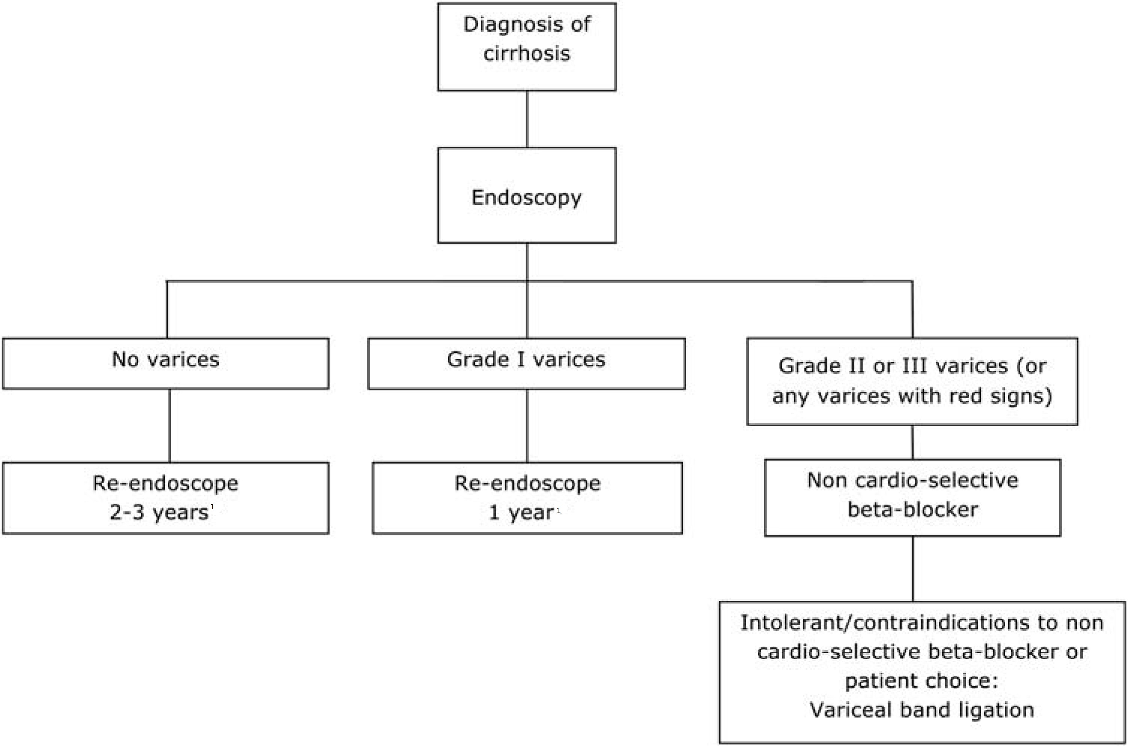
Figure 1 United Kingdom guidelines. Algorithm for surveillance of varices and primary prophylaxis in cirrhosis. ¹If there is clear evidence of disease progression this interval can be modified by clinician. Endoscopy should also be offered at time of decompensation^{[51]}.

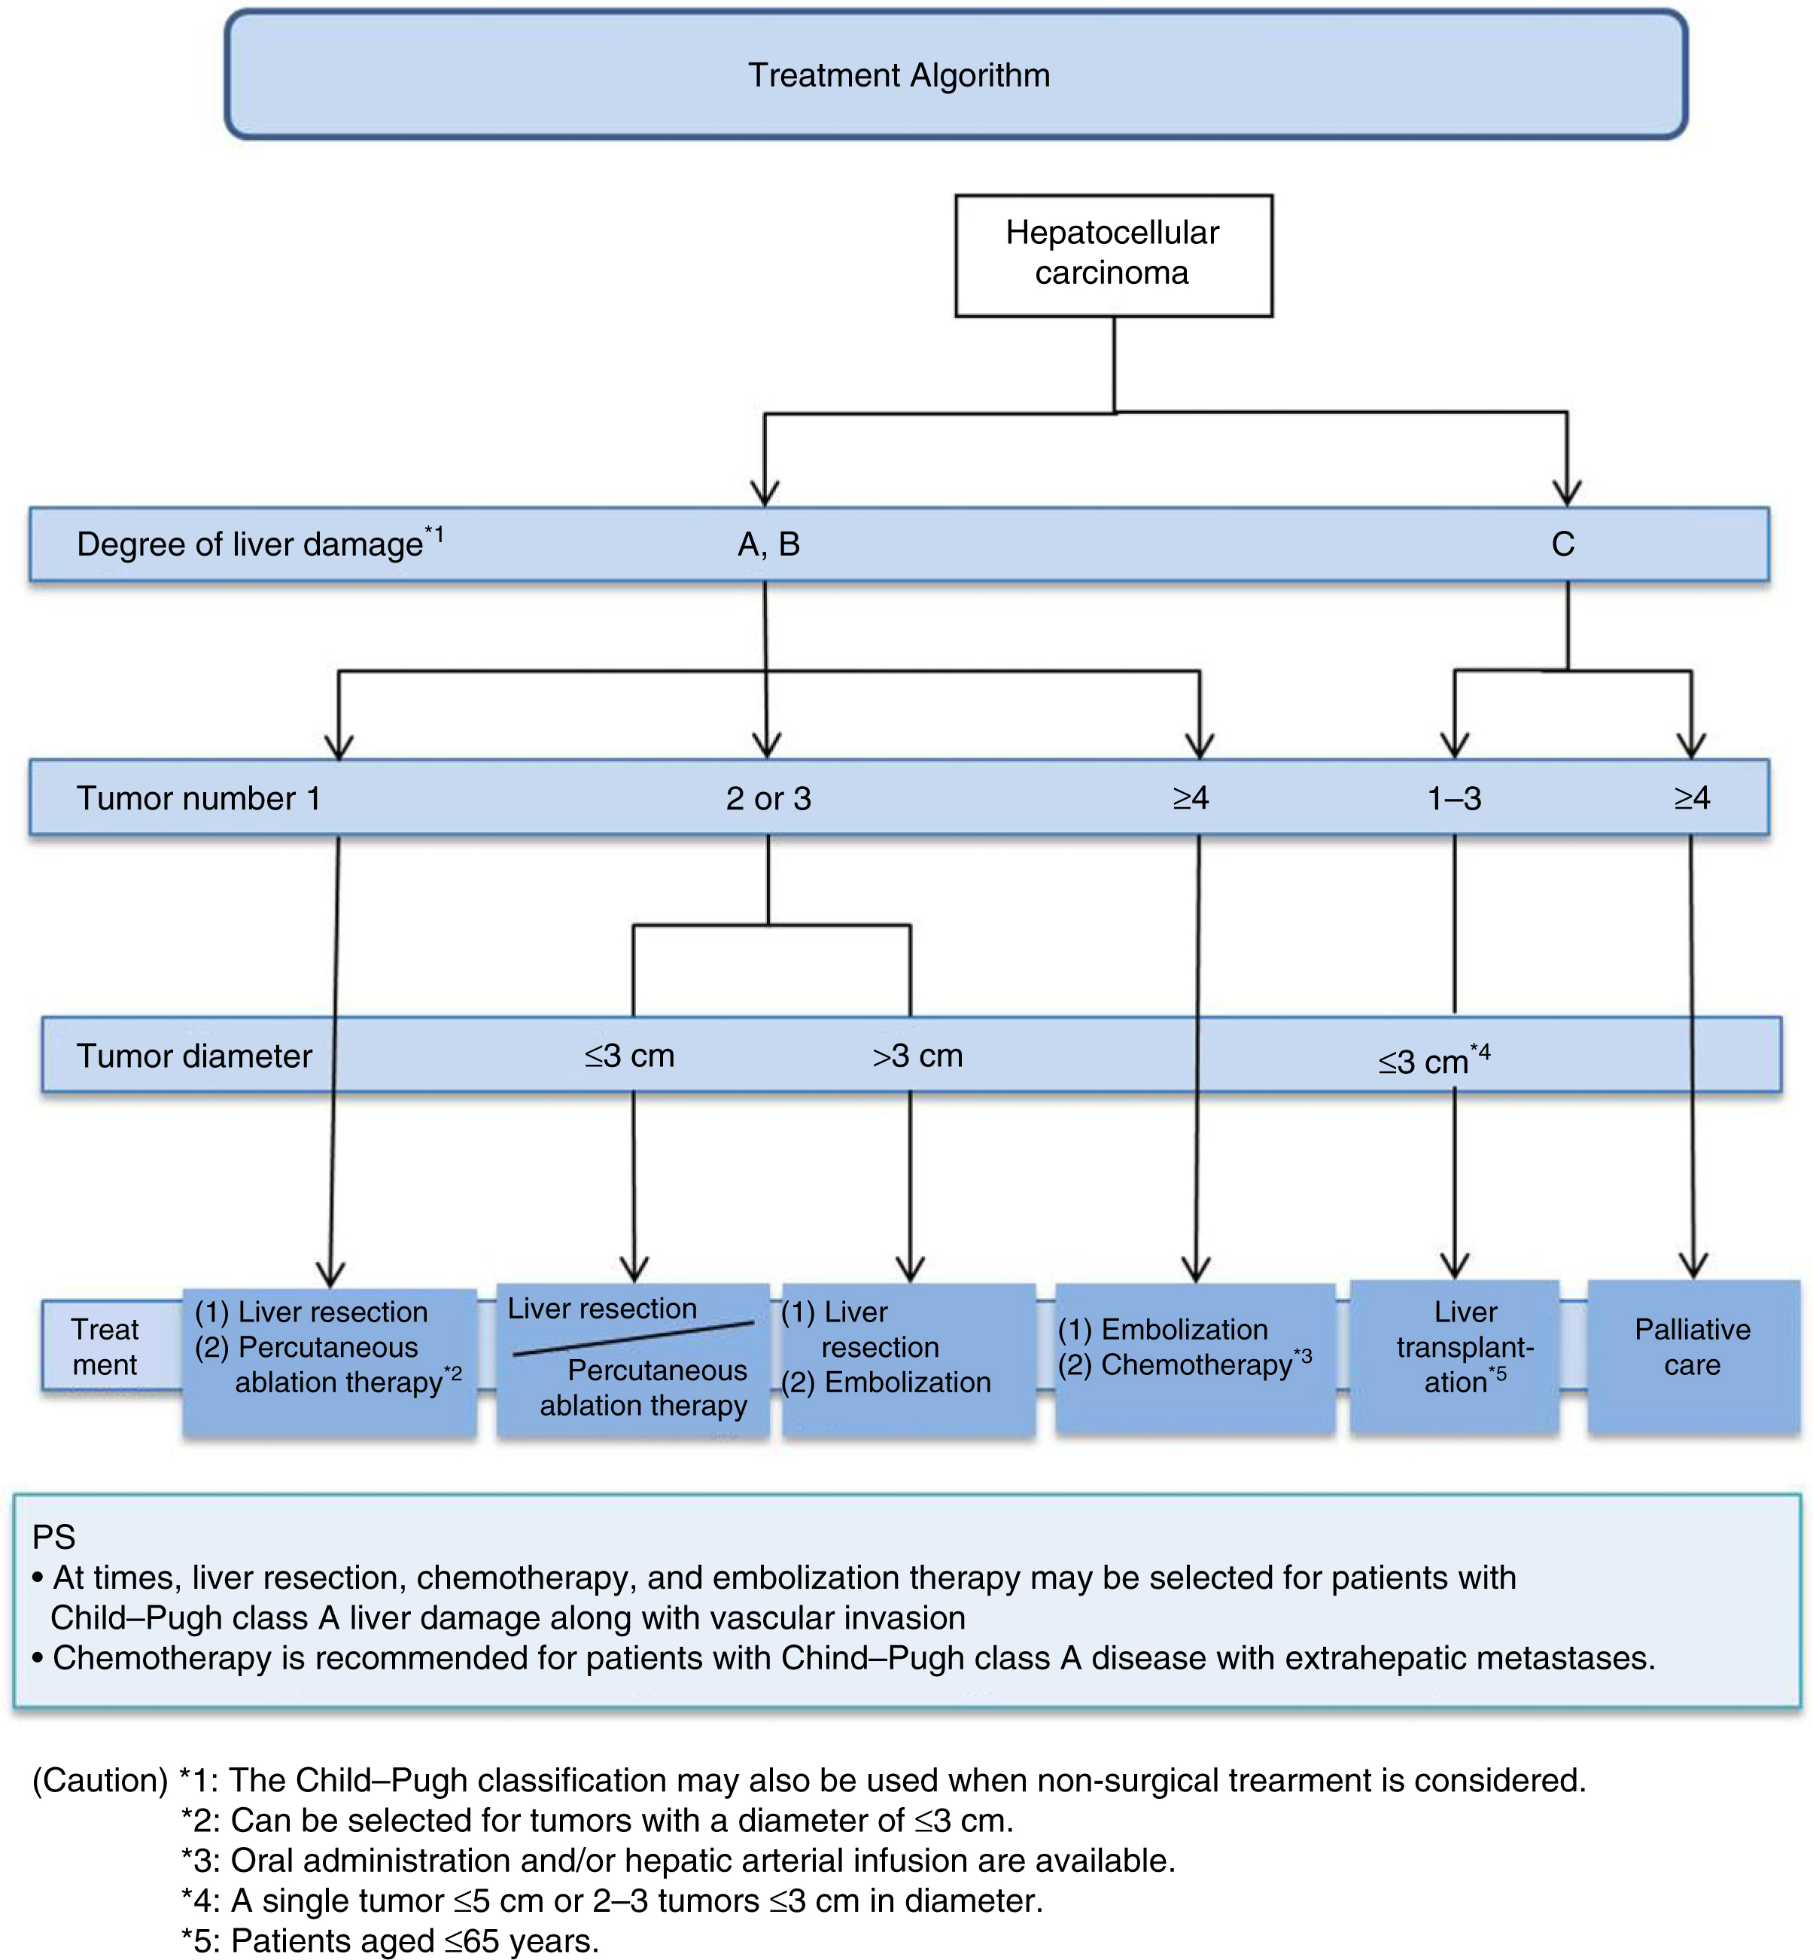
Figure 2 Algorithm for treatment in Japanese hepatocellular carcinoma guidelines^{[67]}. This algorithm has been simple and easy to memorize, consisting of three factors: (1) degree of liver damage; (2) number of tumors; and (3) tumor diameter. The recommendable treatment options are narrowed down to one or two by referring to this algorithm.

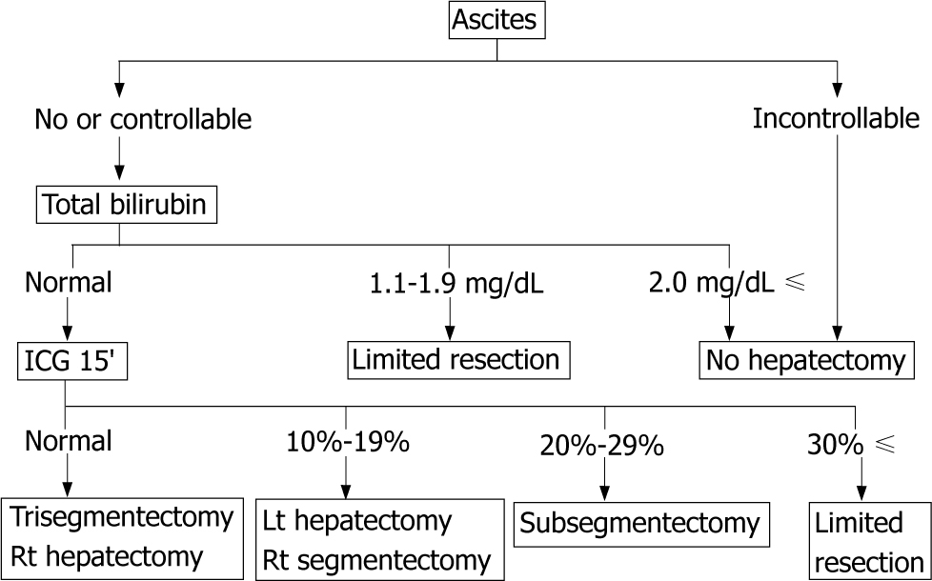
Figure 3 Makuuchi’s criteria. Algorithm before proceeding to safety hepatectomy for hepatocellular carcinoma with cirrhotic liver. Makuuchi's criteria include three factors: ascites, total serum bilirubin, and the ICG-R15: indocyanine green 15 min retention rate. This algorithm shows the maximal area for which an operation can be performed safely (modified ref.11).
Table 1 Prediction formula and discriminating factors for hepatic cirrhosis
Year | Author | Formula
2000 | Ikeda^{[14]} | Z = (0.124) × [γ globulin(%)] + (0.001) × hyaluronic acid (ng/mL) + (0.075) × platelet count (10⁴/μL) + (-0.413) × gender (male = 1, female = 2) + (-2.005)  The condition is hepatic cirrhosis when Z is positive, and chronic hepatitis when Z is negative
2007 | Koda^{[15]} | Fibroindex = (1.738) + (-0.064) × platelet count (10⁴/μL) + (0.005) × AST (IU/L) + (0.463) × [γ globulin (g/dL)]  The fibroindex value corresponds to fibrosis stage
2003 | Wai^{[16]} | APRI= 100 × [AST level/(upper limit of normal AST)/platelet count (× 10⁹/L)]
2006 | Sterling^{[17]} | FIB-4 = [age × AST (U/L)]/[platelet count (× 10⁹/L) × ALT(U/L)]

Table 2 Definitions of the Cancer of the liver Italian program score^{[27]}
Variable | Score
 | 0 | 1 | 2
Child-Pugh stage | A | B | C
Tumor morphology | Uninodular and extension ≤ 50% | Multinodular and extension ≤ 50% | Massive or extension > 50%
AFP (ng/mL) | < 400 | ≥ 400
Portal vein thrombosis | No | Yes

Table 3 Definitions of the Japan integrated staging score^{[28]}
Variable | 0 | 1 | 2 | 3
Child-Pugh stage | A | B | C
TNM stage¹ | I | II | III | IV
¹By Liver cancer study group of Japan.

Table 4 Reports on liver resection and splenectomy for hepatocellular carcinoma complicated by hepatic cirrhosis accompanied by hypersplenism
Year | Author | Simultaneous splenectomy, 2-stage (number of patients) | Platelet count (×10⁴/μL) | Child-Pugh  (A/B/C) | Mortality | Morbidity | Survival rate | Effect
1989 | Takayama^{[38]} | Simultaneous (12), 2-stage (8) | 4.6 | N | N | N | N | Expansion of indication of liver resection
1999 | Lin^{[94]} | Simultaneous (11) | 5.2±1.5 | 5/6/0 | 9.1% | 27.3% | 5 yr recurrence-free 66.7% | Improvement of serum bilirubin level
2000 | Sugawara^{[49]} | Simultaneous (35), 2-stage (13) | 4.7±0.3 | N | 0 | 47.9 | 3/5 yr survival rate: 72.3%/38.9% | Improvement of safety
2000 | Shimada^{[95]} | 2-stage (6) | 5.2±1.5 | 1/4/1 | 0 | 17 | N | Improvement of platelet count, albumin level, and Child classification
2003 | Oh^{[96]} | Simultaneous (12), no sp (6) | 5.5±1.5 | 10/8/0 | 11.1 | 66.7 | N | Expansion of indication of liver resection
2004 | Wu^{[97]} | Simultaneous (41), no sp (485) | 3.8±2.1 | 419/85/23 | 1.5 | 20.5 | N | Improvement of recurrence-free survival rate
2005 | Chen^{[98]} | Simultaneous (94), no sp (110) | 6.2 | 125/79/0 | N | 15.2 | 5 yr survival 56%, recurrence-free survival 35% | Improvement of recurrence-free survival rate
2008 | Sugimachi^{[99]} | Simultaneous (4),  no sp (11) | 4.2±0.8 | 9/6/0 | 6.7 | 47 | N | 3-year survival rate equivalent to that after conventional liver resection
2025 | Zhang^{[100]} | Simultaneous (84)/no sp (84) | 6.1±4. | 84/0/0 | 0 | 39.3 | 1/3/5 yr survival:  90/78/66% | Improvement of recurrence-free survival rate
N: Details unknown.

Table 5 General rules for recording endoscopic findings of esophagogastric varices^{[50]}
Category | Code subcategory
Location (L) | Ls: Locus superior
 | Lm: Locus medialis
 | Li: Locus inferior
 | Lg-c: Adjacent to the cardiac orifice
 | Lg-cf: Extension from the cardiac orifice to the fornix
 | Lg-f: Isolated in the fornix
 | Lg-b: Located in the gastric body
 | Lg-a: Located in the gastric antrum
Form (F) | F0: No varicose appearance
 | F1: Straight, small-caliber varices
 | F2: Moderately enlarged, beady varices
 | F3: Markedly enlarged, nodular or tumor-shaped varices
Color (C) | Cw:White varices
 | Cb: Blue varices
 | Cw-Th: Thrombosed white varices
 | Cb-Th: Thrombosed blue varices
Red color signs (RC) | RWM: Red wale markings
 | CRS: Cherry red spots
 | HCS: Hematocystic spots
 | Esophageal varices: RC0, RC1, RC2, RC3
 | Gastric varices: RC0, RC1
 | Te: Telangiectasia
Bleeding signs | Gushing bleeding
 | Spurting bleeding
 | Oozing bleeding
 | Red plug
 | White plug
Mucosal findings | E: Erosion
 | Ul: Ulcer
 | S: Scar

Table 6 McCormack classification for the presence of portal hypertension and portal hypertensive gastropathy^{[52]}
Mild gastropathy | Fine pink speckling
 | Superficial reddening
 | Snakeskin (Mosaic-like) appearance
Severe gastropathy | Cherry-red spots
 | Diffuse hemorrhagic lesion

