Name of Journal: World Journal of Clinical Cases
Manuscript NO: 80353
Manuscript Type: CASE REPORT

Acute diffuse peritonitis secondary to a seminal vesicle abscess: A case report

Li K et al. ADP secondary to a seminal vesicle abscess

Kun Li, Nan-Bin Liu, Jiang-Xi Liu, Quan-Ning Chen, Bao-Min Shi

Kun Li, Nan-Bin Liu, Jiang-Xi Liu, Quan-Ning Chen, Bao-Min Shi, Department of General Surgery, Tongji Hospital of Tongji University, Shanghai 200065, China

Nan-Bin Liu, National and Local Joint Engineering Research Center of Biodiagnosis and Biotherapy, The Second Affiliated Hospital of Xi'an Jiaotong University, Xi'an 710000, Shaanxi Province, China

Author contributions: Shi BM and Chen QN contributed to the conception and design of the study and performed the operation on the patient; Li K and Liu NB collected the data, performed the data analysis, and wrote the initial draft of the manuscript; Liu JX participated in the clinical management and follow-up of the patient, and analyzed and interpreted the data; all authors contributed to drafting and revising the manuscript and approved the submitted version.

Corresponding author: Bao-Min Shi, Doctor, MD, PhD, Chief Doctor, Professor, Surgeon, Department of General Surgery, Tongji Hospital of Tongji University, No. 389 Xincun Road, Putuo District, Shanghai 200065, China. tjshibaomin@tongji.edu.cn

Received: September 26, 2022
Revised: November 18, 2022
Accepted: January 3, 2023
Published online:

Abstract
BACKGROUND
Seminal vesicle abscess (SVA) is the manifestation of a relatively rare urinary system infection. In response to urinary system inflammation, an abscess forms in special locations. However, acute diffuse peritonitis (ADP) induced by SVA is unusual.

CASE SUMMARY
We report a case of a left SVA in a male patient complicated with pelvic abscess, ADP, multiple organ dysfunction syndrome, infectious shock, bacteremia, and acute appendiceal extraserous suppurative inflammation as a result of a long-term indwelling urinary catheter. The patient received a course of morinidazole + cefminol antibiotics but showed no obvious relief, so the perineal SVA underwent puncture drainage and abdominal abscess drainage + appendectomy was performed. The operations were successful. After the operation, anti-infection, anti-shock, and nutritional support treatments were continued and various laboratory indicators were regularly reviewed. The patient was discharged from the hospital after recovery. This disease is a challenge for the clinician because of the unusual spreading path of the abscess. Moreover, appropriate intervention and adequate drainage of abdominal and pelvic lesions are necessary, especially when the primary focus cannot be determined.

CONCLUSION
The etiology of ADP varies, but acute peritonitis secondary to SVA is very rare. In this patient, the left SVA not only affected the adjacent prostate and bladder but also spread retrogradely through the vas deferens, forming a pelvic abscess in the loose tissues of the extraperitoneal fascia layer. Inflammation involving the peritoneal layer led to ascites and pus accumulation in the abdominal cavity, and appendix involvement led to extraserous suppurative inflammation. In clinical practice, surgeons need to consider the results of various laboratory tests and imaging examinations to make comprehensive judgments involving the diagnosis and treatment plan.

Key Words: Seminal vesicle abscess; Acute diffuse peritonitis; Acute appendicitis; Multiple organ dysfunction syndrome; Case report

Li K, Liu NB, Liu JX, Chen QN, Shi BM. Acute diffuse peritonitis secondary to a seminal vesicle abscess: A case report. World J Clin Cases 2023; In press

Core Tip: Seminal vesicle abscess (SVA) is a relatively rare urinary system infection, and acute diffuse peritonitis (ADP) induced by SVA is unusual. We report a male patient who had a left SVA induced by a long-term indwelling urinary catheter, and this condition was complicated with pelvic abscess, ADP, multiple organ dysfunction syndrome, infectious shock, bacteremia, and acute appendiceal extraserous suppurative inflammation. With no obvious relief by conservative treatment, puncture drainage of the perineal SVA and abdominal abscess drainage + appendectomy was performed. In this case, the left SVA not only affected the adjacent prostate and bladder but also spread retrogradely through the vas deferens, forming a pelvic abscess in the loose tissues of the extraperitoneal fascia layer. Inflammation involving the peritoneal layer led to ascites and pus accumulation in the abdominal cavity, and appendix involvement led to extraserous suppurative inflammation.

INTRODUCTION
Acute diffuse peritonitis (ADP) is a common acute abdominal complication of general surgery. It has a high risk of mortality due to its rapid onset, rapid progression, and poor prognosis. The causes of ADP vary, but most cases are due to secondary infections. However, emergency surgery is needed regardless of the cause^{[1]}. The main function of the seminal vesicles is to secrete nutrients and dilute the fluid in which the sperm resides. An infection of the seminal vesicle most commonly causes inflammation. Seminal vesicle abscess (SVA) is relatively rare, and diseases that develop from the “SVA–pelvic abscess–ADP” pathogenesis circuit, where the associated bacteria originate from the seminal vesicles and SVA, are even rarer. In 1978, Rajfer et al^{[2]} reported the first case of SVA. According to Rajfer et al^{[2]}, less than 100 cases of SVA have been reported worldwide. Here, we report a male patient who developed a SVA due to a long-term indwelling catheter, analyze the basic condition and outcome, and provide the clinical diagnosis and treatment ideas.

CASE PRESENTATION
Chief complaints
An 86-year-old man was admitted to our hospital for lower abdominal distension and pain that lasted for 5 d. The patient had a sudden high fever of 39 °C.

History of present illness
Five days prior to hospital admission, the patient suffered from intermittent abdominal distension and pain. He did not visit his doctor, the symptoms of lower abdominal pain gradually worsened the night prior, and the symptoms were accompanied by frequent nausea, vomiting, and loose watery stools. After symptomatic treatment in a local hospital, there was no obvious remission, so he came to our hospital for emergency treatment. He had no jaundice or anorexia symptoms.

History of past illness
The patient underwent surgical treatment for benign prostatic hyperplasia 2 years prior and took finasteride + tamsulosin hydrochloride intermittently after the operation. Last year, he had difficulty urinating. Ultrasound examination showed that there was an increase in the residual urine volume and urinary retention. He had an indwelling catheter. The catheter was regularly removed and replaced in the outpatient clinic, which led to dysuria recurrence. The patient also experienced hypertension for many years, which was partly controlled with medications.

Personal and family history
No relevant family history, travel history, or animal contact was reported.

Physical examination
The patient’s initial vital signs at admission were as follows: Blood pressure 146/79 mmHg, pulse 62 bpm, respiratory rate 18 breaths/min, and body temperature 39 °C. He had an altered mental state, slight abdominal distension, slightly weak bowel sounds (3/min), obvious tenderness and rebound pain in the lower abdomen, slightly tense abdominal muscles, and percussive tympany abdominal sounds. He had an indwelling urinary catheter, drainage was unobstructed, urine was dark yellow, and flocculent was visible. Scrotal symmetry, bilateral testis, and epididymis tenderness were observed.

Laboratory examinations
The in-hospital laboratory examination showed the following: White blood cell (WBC) count: 12.61 × 10⁹/L (79.1% neutrophils and 11.7% lymphocytes); C-reactive protein: 82.6 mg/L. The routine urine examination showed red blood cells 85/UL and WBCs 291/UL, indicating hematuria and pyuria. However, the patient's liver and kidney function, electrolytes, myocardial enzymes, and coagulation at the first day of admission were normal.

Imaging examinations
Pelvic magnetic resonance imaging (MRI) was performed 2 d after admission, which showed a lumpy and patchy left lower abdomen, with a high possibility of inflammation, a thickened sigmoid wall, blurred fatty space surrounding the pelvic cavity, and a possible left SVA (Figure 1). Combined pelvic and abdominal computed tomography (CT) showed encapsulated effusion and gas accumulation in the left lower abdomen with peripheral exudative changes, suggesting the possibility of an abscess. The left seminal vesicle was unclear with corresponding cystic foci, suggesting the possibility of an abscess (Figure 2A and B). Chest CT revealed scattered chronic inflammation in both lungs.

FINAL DIAGNOSIS
The discharge diagnoses were: (1) Septic shock; (2) ADP and acute extraserous suppurative appendicitis; (3) Left SVA; (4) Pelvic abscess; and (5) Hypertension grade 3 (high risk).

TREATMENT
After admission, the patient's condition gradually worsened. Morlinidazole + cefminol was administered as anti-infection agents, and fluid resuscitation, abrosia, nutritional support, and other treatments were administered. Four days after admission, puncture drainage of the perineal SVA was performed, and a small amount of purulent fluid (bacterial culture: Klebsiella pneumoniae) was drained. Infection with Gram-positive cocci and Candida parapsilosis was detected in urine smears. However, multiple cultures were negative, so the possibility of sample contamination was considered. Abdominal pain was not obviously relieved postoperatively, and on the 5th day, blood pressure decreased and septic shock symptoms, such as weak consciousness, liver and kidney insufficiency, and abnormal coagulation function, were observed (Table 1). His vital signs at that time were as follows: Blood pressure 76/40 mmHg, pulse 118 bpm, respiratory rate 22 breaths/min, and body temperature 39 °C. The Acute Physiology and Chronic Health Evaluation II score was 15, and the Sequential Organ Failure Assessment score was 7. Considering that the patient's vital signs were not stable and after communicating with his family, it was decided to perform emergency exploratory laparotomy for active fluid replacement, volume expansion, and vital sign monitoring to identify the focus of infection and to fully drain the abscess.
After preoperative preparation and general anesthesia, the patient underwent surgery in the supine position, and the surgery was performed by the attending physician, who had approximately 25 years of specialized training. During the operation, the intraperitoneal suppurative fluid volume was approximately 100 mL and was mainly found in the intestines and around the appendix. The head and body of the appendix were suppurated, and a large amount of pus was around the surface of the surrounding intestinal canal and sigmoid colon, without obvious intestinal perforation or tumor formation. Thus, abdominal abscess drainage + appendectomy was performed (Figure 3A-C).
After the operation, the patient was transferred to the intensive care unit due to his critical condition. He fasted and underwent electrocardiogram monitoring and continued anti-infection, anti-shock, and nutritional support treatments. The internal environment and water electrolyte balance was maintained. The function of various organs was monitored. Plasma was infused to achieve coagulation, and wound dressings were changed regularly. Various laboratory indicators were routinely checked. On the 1st day after the operation, the patient had dyspnea and atrial fibrillation with a fast ventricular rate after taking off the line. He received high flow oxygen inhalation and his heart rate was regulated with amiodarone. Treatment to resolve abdominal distension and promote gastrointestinal motility was performed. The pus culture showed Klebsiella pneumoniae infection. A combination of meropenem and linezolid was administered, and the patient's symptoms and signs were gradually resolved. On the 3rd day after the operation, the patient's heart rate returned to normal, oxygen saturation was maintained with low-flow oxygen inhalation, the infection was eradicated, and abdominal distension was relieved. Later, the patient returned to general surgery ward for further treatment. On the 4th day after the operation, a liquid diet was initiated. The amount of intravenous fluid replacement was reduced and he was encouraged to get out of bed to prevent embolization. On the 7th day after the operation, abdominal distension recurred. He continued to fast, and the wound suture was removed. On the 10th day after the operation, the patient complained of hunger but abdominal distension was relieved. Abdominal CT showed less abdominal inflammation than before (Figure 2C and D). Three days later, the patient’s diet was changed to a semiliquid diet. Two days later, the patient did not complain of any special discomfort, his body temperature returned to normal, and he was allowed to resume a normal diet. The other catheter was replaced, and the patient was discharged.

OUTCOME AND FOLLOW-UP
Postoperative pathology of the appendix showed extraserous suppurative inflammation, AB (+), and PAS (+) (Figure 3D). After discharge, the patient underwent a 1-year follow-up. The two inflammatory foci were managed and their size was gradually reduced after treatment and follow-up (Figure 2E-H).

DISCUSSION
The seminal vesicles are located at the bottom of the bladder and the outer side of the ampulla of the ureter. Together with the ampulla of the vas deferens and the ejaculatory duct, they form the distal structure of the seminal tract^{[3]}. Seminal vesicle secretions account for approximately 60% of the total semen volume and include high concentrations of fructose, prostaglandin, and other substances^{[4]}. SVA is very rare. In 2004, Sağlam et al^{[5]} pointed out that a total of 26 related cases were reported in the literature. By searching PubMed, ScienceDirect, and other literature databases, as of August 2022, a total of 51 cases of SVA were idenfied worldwide. Table 2 shows the SVA cases reported since 2004. SVA can occur in all age groups and is more common unilaterally, and Escherichia coli is the main pathogenic bacteria. The etiology of SVA is unknown, but long-term indwelling catheters, diabetes, prostate puncture biopsy, and endoscopic operation are factors contributing to the susceptibility to this disease^{[6,7]}. SVAs are mostly secondary to urinary tract infections such as prostatitis. Infections causing a SVA can also involve the blood, lymph, and other pathways^{[8]}. In our case, the patient underwent surgical treatment of benign prostatic hyperplasia. He suffered difficulty urinating and had a long-term indwelling urinary catheter. We speculate that his previous medical history is an important risk factor for SVA.
SVA lacks specific clinical symptoms. Because the vesicles are anatomically adjacent to the bladder and other tissues, dysuria, testicular and groin pain, tenesmus, etc. are common clinical manifestations. Pandey et al^{[9]} reviewed reports on these clinical manifestations; 74% of patients had fever, 58% had dysuria, and 32% had mild prostatitis^{[9]}. Swollen glands can be found on digital anal examination. Ultrasound, CT, and other imaging examinations are the methods used for diagnosing SVA^{[6]}. The typical CT manifestations include unilateral or bilateral seminal vesicle dilation, central irregular low-density areas, and thickening of adjacent organs^{[5]}. On MRI, the abscesses are usually round, with low T1-weighted imaging and high T2-weighted imaging signals^{[10]}.
Infectious diseases can occur in the seminal vesicles, for which antibiotic anti-infective treatment is the first choice. However, once an abscess is formed, conservative treatment is often ineffective^{[5]}. Because of the trauma and long recovery time of open surgery, abscess puncture and drainage is currently the first choice for treatment. The common puncture methods include transurethral/transvesical drainage under cystoscopy and ultrasound-guided transrectal drainage^{[11,12]}. Regarding the diagnosis and treatment of this case, the patient was admitted to the hospital and due to the ineffectiveness of conservative treatment, the left SVA of the perineum was punctured and drained under local anesthesia, and a small amount of purulent fluid was aspirated out. However, the symptoms were not significantly relieved after puncture, and the infection was exacerbated. In addition, abdominal CT showed the possibility of an abdominal abscess, so an exploratory laparotomy was performed.
Abdominal cavity infection is a common and frequently occurring disease in general surgery and is caused by bacteria, chemical stimulation, and other factors. Intraperitoneal organ rupture, perforation, trauma, and other diseases are common causes of peritonitis. The common pathogenic bacteria of peritonitis include hemolytic Streptococcus, Pneumococcus, and Escherichia coli^{[13,14]}. Direct diffusion is one of the main routes by which bacteria enter the abdominal cavity. In this case, neither preoperative imaging examination nor intraoperative exploration revealed perforation or rupture of any abdominal organs that may have led to secondary peritonitis. Culture of the pus showed Klebsiella pneumoniae, which is not surprising, considering that this species originates from the urinary system. By repeating the preoperative abdominal imaging examination, we found that the primary foci of the SVA spread through the ejaculatory duct-vas deferens and accumulated in the loose connective tissue of the extraperitoneal fascia to form secondary foci. The transverse abdominis muscle was anterior to the secondary abscess, and the peritoneal reflex was superior, where purulent material contacted the peritoneum, resulting in acute peritonitis and intra-abdominal inflammation (Figures 4 and 5).

CONCLUSION
By reviewing the diagnosis and treatment of this case, we summarize our experience and conclusions as follows: (1) An indwelling urinary catheter increases the risk of urinary tract infection, and the catheter indwelling time should be shortened as much as possible. For patients who must have a long-term indwelling catheter, the catheter should be replaced regularly, and high-quality nursing care should be actively performed. Elderly and frail patients with urinary tract infection should be treated in a timely manner to prevent the occurrence of complications; (2) For bacterial resistance, multiple infections, and other problems, broad-spectrum antibiotics are used for anaerobic bacteria and Gram-negative bacteria; and (3) Early primary disease and complications should be considered at the same time, including the full drainage of SVA in the early stage, as well as active surgical intervention for abdominal infection. Clinicians can use various imaging examinations to fully understand the occurrence, development, and prognosis of the disease. In this case, the general condition of the patient before surgery was poor, and the patient’s condition was complicated with sepsis. Early exploratory laparotomy, removal of the abscess, and adequate drainage were the best options.

ACKNOWLEDGEMENTS
We sincerely thank Sheng-Song Huang and Wei Le for their help in the treatment and differential diagnosis of this patient.

REFERENCES
1 Hoshino N, Endo H, Hida K, Kumamaru H, Hasegawa H, Ishigame T, Kitagawa Y, Kakeji Y, Miyata H, Sakai Y. Laparoscopic Surgery for Acute Diffuse Peritonitis Due to Gastrointestinal Perforation: A Nationwide Epidemiologic Study Using the National Clinical Database. Ann Gastroenterol Surg 2022; 6: 430-444 [PMID: 35634193 DOI: 10.1002/ags3.12533]
2 Rajfer J, Eggleston JC, Sanders RC, Walsh PC. Fever and prostatic mass in a young man. J Urol 1978; 119: 555-558 [PMID: 650769 DOI: 10.1016/s0022-5347(17)57546-1]
3 Nguyen HT, Etzell J, Turek PJ. Normal human ejaculatory duct anatomy: a study of cadaveric and surgical specimens. J Urol 1996; 155: 1639-1642 [PMID: 8627842 DOI: 10.1016/s0022-5347(01)66150-0]
4 Huang YH, Chen YH, Lin CM, Ciou YY, Kuo SP, Chen CT, Shih CM, Chang EE. Suppression effect of seminal vesicle autoantigen on platelet-activating factor-induced mouse sperm capacitation. J Cell Biochem 2007; 100: 941-951 [PMID: 17131380 DOI: 10.1002/jcb.21050]
5 Sağlam M, Uğurel S, Kilciler M, Taşar M, Somuncu I, Uçöz T. Transrectal ultrasound-guided transperineal and transrectal management of seminal vesicle abscesses. Eur J Radiol 2004; 52: 329-334 [PMID: 15643719 DOI: 10.1016/j.ejrad.2003.11.006]
6 Patel B, Gujral S, Jefferson K, Evans S, Persad R. Seminal vesicle cysts and associated anomalies. BJU Int 2002; 90: 265-271 [PMID: 12133063 DOI: 10.1046/j.1464-410x.2002.02883.x]
7 Saha S, Wright G, Arulampalam T, Corr J. An unusual groin mass. Seminal vesicle abscess: a case report. Cases J 2009; 2: 6531 [PMID: 19829819 DOI: 10.1186/1757-1626-2-6531]
8 Zhang JQ, He CC, Yuan B, Liu R, Qi YJ, Wang ZX, He XN, Li YM. Fatal systemic emphysematous infection caused by Klebsiella pneumoniae: A case report. World J Clin Cases 2022; 10: 2610-2615 [PMID: 35434061 DOI: 10.12998/wjcc.v10.i8.2610]
9 Pandey P, Peters J, Shingleton WB. Seminal vesicle abscess: a case report and review of literature. Scand J Urol Nephrol 1995; 29: 521-524 [PMID: 8719375 DOI: 10.3109/00365599509180039]
10 Chen X, Wang H, Wu RP, Liang H, Mao XP, Mao CQ, Zhu HZ, Qiu SP, Wang DH. The performance of transrectal ultrasound in the diagnosis of seminal vesicle defects: a comparison with magnetic resonance imaging. Asian J Androl 2014; 16: 907-911 [PMID: 25337847 DOI: 10.4103/1008-682X.142768]
11 Bayne CE, Davis WA, Rothstein CP, Engel JD. Seminal vesicle abscess following prostate biopsy requiring transgluteal percutaneous drainage. Can J Urol 2013; 20: 6811-6814 [PMID: 23783054]
12 Sihra N, Aboelsoud M, Oliyide A, Counsell A, Gall Z. Seminal Vesicle Abscess-An Unusual Complication Following Vasectomy. Urology 2018; 116: 20-22 [PMID: 29305203 DOI: 10.1016/j.urology.2017.12.015]
13 Labricciosa FM, Sartelli M, Abbo LM, Barbadoro P, Ansaloni L, Coccolini F, Catena F. Epidemiology and Risk Factors for Isolation of Multi-Drug-Resistant Organisms in Patients with Complicated Intra-Abdominal Infections. Surg Infect (Larchmt) 2018; 19: 264-272 [PMID: 29298133 DOI: 10.1089/sur.2017.217]
14 Inoue M, Kako E, Kinugasa R, Sano F, Iguchi H, Sobue K. Necrotizing fasciitis following primary peritonitis caused by Streptococcus pyogenes with covS mutation in a healthy woman: a case report. JA Clin Rep 2019; 5: 29 [PMID: 32025929 DOI: 10.1186/s40981-019-0249-7]
15 Dewani CP, Dewani N, Bhatia D. Case report: tubercular cold abscess of seminal vesicle: minimally invasive endoscopic management. J Endourol 2006; 20: 436-442 [PMID: 16808660 DOI: 10.1089/end.2006.20.436]
16 Chong Vh VH, Sharif F, Bickle I. Urogenital melioidosis: a review of clinical presentations, characteristic and outcomes. Med J Malaysia 2014; 69: 257-260 [PMID: 25934955]
17 Hammad FT. Seminal vesicle cyst forming an abscess and fistula with the rectum review of perianal drainage and treatment. Scand J Urol Nephrol 2006; 40: 426-428 [PMID: 17060091 DOI: 10.1080/00365590600795313]
18 Fujinaga S, Hirano D, Hara S, Uchida H, Kitano Y, Kobayashi K, Tada M, Someya T, Ohtomo Y, Shimizu T. Seminal vesicle abscesses associated with ipsilateral multicystic dysplastic kidney in an infant. Pediatr Nephrol 2008; 23: 1551-1554 [PMID: 18458954 DOI: 10.1007/s00467-008-0839-5]
19 Wadei HM, Brumble L, Broderick GA, Gonwa TA. Polymicrobial seminal vesical abscess in a kidney transplant recipient. Urology 2008; 72: 296 [PMID: 18468658 DOI: 10.1016/j.urology.2008.03.039]
20 Talwar HS, Mittal A, Narain TA, Panwar VK. A wide spectrum of rare clinical variants of Zinner syndrome. BMJ Case Rep 2021; 14 [PMID: 33462046 DOI: 10.1136/bcr-2020-239254]
21 Monzó JI, Garcia EL, Benavente R, Moralejo Gárate M, Cordero J, Fernández C. Absceso Primario de vesícula seminal: Diagnóstico y tratamiento mediante ecografía transrectal. ACTAS UROL ESP 2005; 29 [DOI: 10.4321/S0210-48062005000500015]
22 Machida H, Ueno E, Nakazawa H, Fujimura M, Ito F. Spermatic cord abscess with concurrent prostatic abscess involving the seminal vesicle. Radiat Med 2008; 26: 81-83 [PMID: 18301983 DOI: 10.1007/s11604-007-0193-8]
23 Bradley ME, Scoular SK. Metastatic Klebsiella pneumoniae Invasive Liver Abscess Syndrome in Denver, Colorado. J Pharm Pract 2021; 34: 332-336 [PMID: 31645222 DOI: 10.1177/0897190019882867]
24 Imperatore V, Creta M, Di Meo S, Buonopane R, Spirito L, Mirone V. Seminal vesicle abscess causing unilateral hydroureteronephrosis: A case report. Arch Ital Urol Androl 2017; 89: 321-322 [PMID: 29473388 DOI: 10.4081/aiua.2017.4.321]
25 Zheng X, Wang X, Zhou J, Xiang J, Xie L. Diagnosis and treatment of community-associated methicillin-resistant Staphylococcus aureus prostatic abscess involving the seminal vesicle: A case report. Exp Ther Med 2015; 9: 835-838 [PMID: 25667637 DOI: 10.3892/etm.2014.2147]
26 Cui ZQ, Wang YC, Du J, Zhou HJ, Yu ZY, Gao EJ, Lu HK. [Transurethral seminal vesiculoscopy combined with finasteride for recurrent hematospermia]. Zhonghua Nan Ke Xue 2014; 20: 536-538 [PMID: 25029861]
27 Kuribayashi S, Tanigawa G, Okuda Y, Kawamura M, Kishimoto N, Takezawa K, Tsutahara K, Takao T, Yamaguchi S. [Seminal Vesicle Abscess Associated with Zinner Syndrome]. Hinyokika Kiyo 2017; 63: 439-443 [PMID: 29103260 DOI: 10.14989/ActaUrolJap_63_10_439]
28 Somiya S, Tamaki M, Fujikawa S, Yamada Y, Kamiyama Y, Kanaoka T. [A Case of Seminal Vesicle Cyst Incidentally Diagnosed during Rupture of Abdominal Subcutaneous Abscess]. Hinyokika Kiyo 2018; 64: 193-195 [PMID: 29772623 DOI: 10.14989/ActaUrolJap_64_4_193]

Footnotes
Informed consent statement: Informed written consent was obtained from the patient for publication of this report and any accompanying images.

Conflict-of-interest statement: All the authors report no relevant conflicts of interest for this article.

CARE Checklist (2016) statement: The authors have read the CARE Checklist (2016), and the manuscript was prepared and revised according to the CARE Checklist (2016).

Open-Access: This article is an open-access article that was selected by an in-house editor and fully peer-reviewed by external reviewers. It is distributed in accordance with the Creative Commons Attribution NonCommercial (CC BY-NC 4.0) license, which permits others to distribute, remix, adapt, build upon this work non-commercially, and license their derivative works on different terms, provided the original work is properly cited and the use is non-commercial. See: https://creativecommons.org/Licenses/by-nc/4.0/

Provenance and peer review: Unsolicited article; Externally peer reviewed.

Peer-review model: Single blind

Peer-review started: September 26, 2022
First decision: November 11, 2022
Article in press:

Specialty type: Medicine, research and experimental
Country/Territory of origin: China
Peer-review report’s scientific quality classification
Grade A (Excellent): 0
Grade B (Very good): 0
Grade C (Good): C
Grade D (Fair): D
Grade E (Poor): 0

P-Reviewer: Abd EL hafez A, Egypt; Tomizawa M, Japan S-Editor: Fan JR L-Editor: Wang TQ P-Editor: Fan JR

Figure Legends
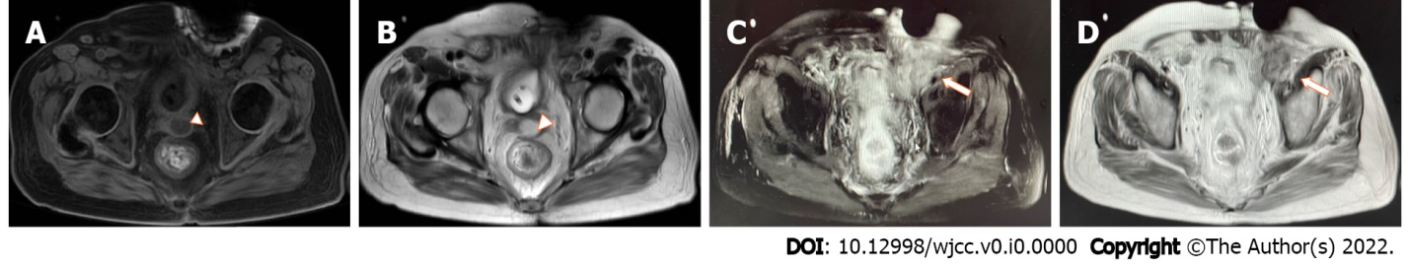
Figure 1 Magnetic resonance imaging results of the patient after admission. A and B: Pelvic magnetic resonance imaging (MRI) showed a rounded abnormal signal shadow in the left seminal vesicle, with low signal on T1-weighted imaging (T1WI) and high signal on T2-weighted imaging (T2WI) + lipid inhibition, and a size of approximately 2.3 cm × 1.6 cm; C and D: Pelvic MRI showed a nodular mass in the left inguinal region, with low signal on T1WI and high signal on T2WI + lipid inhibition, and a size of approximately 5.0 cm × 4.0 cm. The white arrowheads show the left seminal vesicle. The white arrows show the pelvic abscess (secondary focus).

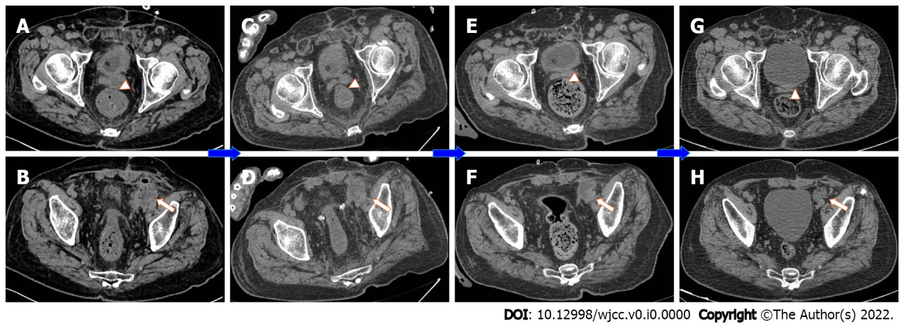
Figure 2 Computed tomography results of the patient throughout the diagnosis and treatment processes. A-D: The results of pelvic computed tomography examinations on the 2nd day after admission, on the 10th day after surgery, at 1 mo after discharge, and at 3 mo after discharge; E-H: The primary focus of the left seminal vesicle abscess and the secondary focus of the extraperitoneal fascial abscess were gradually controlled and narrowed after treatment and outpatient and emergency follow-up. The white arrowheads show the left seminal vesicle. The white arrows show the pelvic abscess (secondary focus).

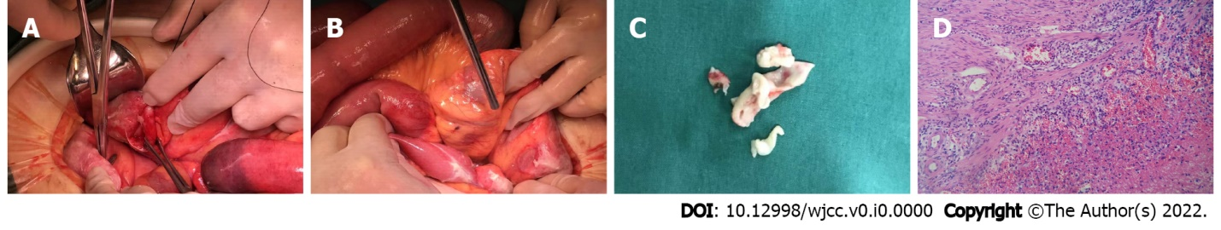
Figure 3 The appendix. A and B: During the operation, the appendix was congested and edematous, with accumulation of the surrounding suppurative fluid, and the sigmoid colon was coated with a large amount of pus; C: A section of the appendix with a length of 3.5 cm and a diameter of 0.8-1.2 cm was cut; D: The suppurative inflammation of the appendix was confined outside the serosa (microscopy, × 100).

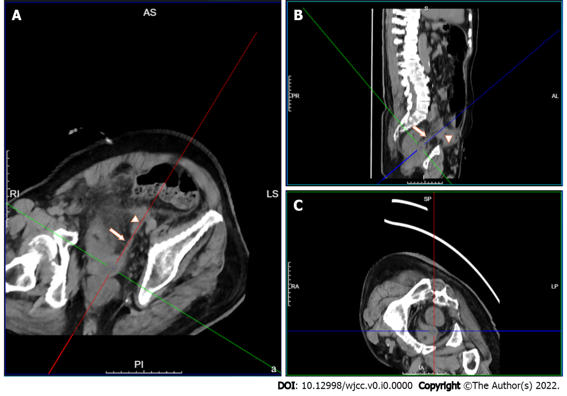
Figure 4 Three-dimensional computed tomography reconstruction showing the primary and secondary abscesses. A: Transverse view; B: Sagittal view; C: Coronal view. The primary focus is located at the baseline center, the white arrows indicate the vas deferens, and the arrowheads show the secondary focus.

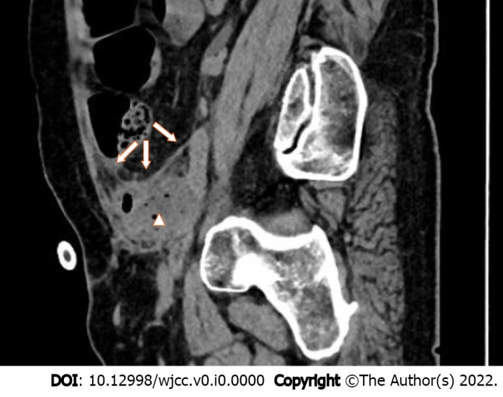
Figure 5 Sagittal computed tomography image showing the relationship between the secondary focus and the pelvis and abdominal cavity. The white arrows indicate the peritoneum, and the arrowhead shows the secondary focus.

Table 1 Change trend of the patient's laboratory indexes
Date | Leukocytes (× 10⁹/L) | Creatinine (μmol/L) | Albumin (g/L) | Prothrombin time (s) | C-reactive protein (mg/L)
DBO5 | 13 | 92 | 34.3 | 13.1 | 151.77
DBO4 | 11.62 | 81 | 31.5 | 15.7 | 157.74
DBO2 | 22.41 | 157 | 30.1 | 17.9 | 227.71
DBO1 | 34.67 | 153 | 18.2 | 18.6 | 239.87
OD | 23.85 | 173 | 25.0 | 17.7 | 177.34
POD1 | 20.35 | 158 | 28.4 | 16.6 | 204.14
POD2 | 14.96 | 128 | 34.2 | 16.0 | 177.26
POD3 | 11.29 | 109 | 34.4 | 15.5 | 141.1
POD4 | 11.41 | 104 | 35.6 | 14.1 | 99.55
POD6 | 16.98 | 88 | 35.3 | 14.2 | 57.6
POD8 | 15.39 | 85 | 33.5 | 15.0 | 37.0
POD10 | 13.07 | 91 | 33.5 | 14.4 | 99.3
POD12 | 7.3 | 87 | 30.2 | 14.3 | 118.73
POD15 | 6.78 | 78 | 30.6 | 14.1 | 66.02
Leukocytes (× 10⁹/L); Creatinine (μmol/L); Albumin (g/L); Prothrombin time (s); C-reactive protein (mg/L). DBO: Days before operation, DBO5 refers to the day of admission; OD: Operation day, referring to the date of performing exploratory laparotomy; POD: Postoperative days, POD15 refers to discharge date.

Table 2 Summary of literature on primary seminal vesicle abscess treated by surgery since 2004
Ref. | Year | No. | Age | Complaints | Imaging | Surgery | Pathogens | Location | Underlying causes
Dewani et al^{[15]} | 2006 | 1 | 35 | Infertility, hemospermia | CUS, US | Abscess incision, catheterization | Acid-fast bacilli | Unilateral | N/A
Chong et al^{[16]} | 2014 | 1 | 38 | Fever, lethargy, rigor, anorexia | N/A | Percutaneous drainage | Burkholderia pseudomallei | N/A | Melioidosis, diabetes
Bayne et al^{[11]} | 2013 | 1 | 67 | Myalgias, chills | MRI, IVP | Percutaneous drainage | Escherichia coli | Left | Transrectal biopsy
Hammad^{[17]} | 2006 | 1 | 24 | Urinary frequency, urgency, urge incontinence | CUS, CT, IVP | Perirectal incision and drainage | N/A | Left | N/A
Fujinaga et al^{[18]} | 2008 | 1 | 2 ms | Fever with leukocyturia | CUS, CT | Percutaneous transrectal aspiration | Escherichia coli | Left | Dysplastic left kidney
Wadei et al^{[19]} | 2008 | 1 | 29 | Fever, dysuria, right-sided testicular pain | CT, MRI | Transrectal aspiration | Staphylococcus, Proteus mirabilis, Clostridium species | Right | Donor kidney transplant
Talwar et al^{[20]} | 2021 | 1 | 20 | Fever, oliguria and uremic symptoms | MRI | Transrectal aspiration | Escherichia coli | Left | Zinner syndrome
Monzó et al^{[21]} | 2005 | 1 | 38 | Dysuria, frequent urination and fever | US | Transrectal puncture drainage | Escherichia coli | Left | Bilateral orchiopexy
Machida et al^{[22]} | 2008 | 1 | 81 | Swelling and left inguinal pain | CT | Inguinal canal ligation and percutaneous suprapubic vesical catheterization | Escherichia coli | Left | Diabetes
Bradley and Scoular^{[23]} | 2021 | 1 | 42 | Subjective fevers and worsening fatigue | CT | Transurethral resection of the prostate | Candida parapsilosis, Candida glabrata, Bacteroides fragilis | Left | Diabetes
Sağlam et al^{[5]} | 2004 | 6 | 18-47 | Rectal discomfort, left inguinal tender-swelling | N/A | Transrectal (2)/Transperineal (4) puncture and aspiration | Escherichia coli | Bilateral (4)/Unilateral (2) | 2 with rectal cancer
Sihra et al^{[12]} | 2018 | 1 | 29 | Right hemiscrotal pain, swelling, and pyrexia | US, CUS | Incision, drainage, transvesical deroofing of abscess | Staphylococcus aureus | Right | Elective vasectomy
Saha et al^{[7]} | 2009 | 1 | 49 | Gradually enlarging, exquisitely tender groin mass | CT, MRI, CUS, IVP | Laparoscopic drainage of the abscess | Escherichia coli | Left | Drainage of perianal abscess
Imperatore et al^{[24]} | 2017 | 1 | 58 | Dysuria and fever | CT | Open abdominal pus drainage | N/A | Bilateral | N/A
Zheng et al^{[25]} | 2015 | 1 | 42 | Severe dysuria abdominal pain | US, MRI | Percutaneously drainage | Staphylococcus aureus and Candida albicans | Left | Diabetes
Cui et al^{[26]} | 2014 | 3 | 31-58 | N/A | US, CT | F4 single "J" catheterization | N/A | N/A | N/A
Kuribayashi et al^{[27]} | 2017 | 1 | 26 | Fever and right seminal vesicle swelling | US, CT | Transperineal needle aspiration | Staphylococcus aureus | Right | Zinner syndrome
Somiya et al^{[28]} | 2018 | 1 | 89 | Left lower quadrant bulge | CT, CUS | Transperineal needle aspiration | Streptococcus viridans | Right | Transurethral prostate resection
US: Ultrasound; CT: Computed tomography; MRI: Magnetic resonance imaging; IVP: Intravenous pyelography; CUS: Cystourethroscopy; N/A: Not applicable.

