Name of Journal: World Journal of Clinical Cases
Manuscript NO: 72089
Manuscript Type: CASE REPORT

Paradoxical carbon dioxide embolism during laparoscopic hepatectomy without intracardiac shunt: A case report

Jeon S et al. Paradoxical carbon dioxide embolism during laparoscopic surgery

Soeun Jeon, Jeong-Min Hong, Hyeon Jeong Lee, Yesul Kim, Hyunjong Kang, Boo-Young Hwang, Dowon Lee, Young-Hoon Jung

Soeun Jeon, Jeong-Min Hong, Hyeon Jeong Lee, Yesul Kim, Hyunjong Kang, Boo-Young Hwang, Dowon Lee, Young-Hoon Jung, Department of Anesthesia and Pain Medicine, Pusan National University, School of Medicine, Busan 49241, South Korea

Soeun Jeon, Jeong-Min Hong, Hyeon Jeong Lee, Boo-Young Hwang, Dowon Lee, Young-Hoon Jung, Biomedical Research Institute, Pusan National University Hospital, Busan 49241, South Korea

Author contributions: Jeon S and Hong JM designed the study; Jeon S, Hong JM, and Lee HJ drafted the manuscript; Kim Y, Kang H, and Jung Y collected data and pictures; Jeon S, Hong JM, Lee HJ, Hwang B, and Lee D reviewed the literature and edited the manuscript; all authors agreed to be accountable for all aspects of the work, and all authors issued final approval for the version to be submitted.

Supported by Clinical Research Grant from Pusan National University Hospital in 2020.

Corresponding author: Jeong-Min Hong, MD, PhD, Assistant Professor, Doctor, Department of Anesthesia and Pain Medicine, Pusan National University, School of Medicine, Busan 49241, South Korea. ccarrot@pusan.ac.kr

Received: October 5, 2021
Revised: December 15, 2021
Accepted: February 20, 2022
Published online:

Abstract
BACKGROUND
Laparoscopic hepatectomy has recently become popular because it results in less bleeding than open hepatectomy. However, CO₂ embolism occurs more frequently. Most CO₂ embolisms during laparoscopic surgery are self-resolving and non-symptomatic; however, severe CO₂ embolism may cause hypotension, cyanosis, arrhythmia, and cardiovascular collapse. In particular, paradoxical CO₂ embolisms are highly likely to cause neurological deficits. We report a case of paradoxical CO₂ embolism found on transesophageal echocardiography (TEE) during laparoscopic hepatectomy, although the patient had no intracardiac shunt.

CASE SUMMARY
A 71-year-old man was admitted for laparoscopic left hemihepatectomy. During left hepatic vein ligation, the inferior vena cava was accidentally torn. We observed a sudden drop in oxygen saturation to 85%, decrease in systolic blood pressure (SBP) below 90 mmHg, and reduction in end-tidal CO₂ to 24 mmHg. A “mill-wheel” murmur was auscultated over the precordium. The fraction of inspired oxygen was increased to 100% with 5 cmH₂O of positive end-expiratory pressure (PEEP) and hyperventilation was maintained. Norepinephrine infusion was increased to maintain SBP above 90 mmHg. A TEE probe was inserted, revealing gas bubbles in the right side of the heart, left atrium, left ventricle, and ascending aorta. The surgeon reduced the pneumoperitoneum pressure from 17 to 14 mmHg and repaired the damaged vessel laparoscopically. Thereafter, the patient’s hemodynamic status stabilized. The patient was transferred to the intensive care unit, recovering well without complications.

CONCLUSION
TEE monitoring is important to quickly determine the presence and extent of embolism in patients undergoing laparoscopic hepatectomy.

Key Words: Carbon dioxide; Embolism; Laparoscopy; Pneumoperitoneum; Transesophageal echocardiography; Case report

Jeon S, Hong JM, Lee HJ, Kim Y, Kang H, Hwang BY, Lee D, Jung YH. Paradoxical carbon dioxide embolism during laparoscopic hepatectomy without intracardiac shunt: A case report. World J Clin Cases 2022; In press

Core Tip: CO₂ embolism is a rare but potentially life-threatening complication of laparoscopic surgery. In particular, paradoxical CO₂ embolisms are highly associated with postoperative neurologic deficits. We report a case of paradoxical CO₂ embolism identified using transesophageal echocardiography (TEE) during laparoscopic hepatectomy even though the patient did not have an intracardiac shunt. Generally, EtCO₂ monitoring is a sensitive method for detecting gas embolism, but it is difficult to identify the extent or detailed status, such as paradoxical embolism. Intraoperative TEE can help quickly identify the presence and extent of CO₂ embolism, which will help provide appropriate treatment and predicting postoperative complications.

INTRODUCTION
Laparoscopic surgery is an alternative to conventional laparotomy and is widely used because of its advantages including less postoperative pain, earlier recovery after surgery, and reduced postoperative complications such as infection or incisional hernia^{[1]}. In particular, laparoscopic hepatectomy has recently become popular because it leads to less bleeding than open hepatectomy. However, laparoscopic hepatectomy requires low central venous pressure, high pneumoperitoneum pressure, and Pringle maneuvers, all of which increase the likelihood of CO₂ embolism^{[2]}. Therefore, CO₂ embolism occurs more frequently in laparoscopic hepatectomy than in general laparoscopic surgery. Most CO₂ embolisms during laparoscopic surgery are microembolisms and may be self-resolving without any symptoms or clinical signs due to the high solubility of CO₂ in blood. However, severe CO₂ embolism may cause hypotension, cyanosis, arrhythmia, cardiovascular collapse, neurologic deficits, or even arrest^{[3]}. In particular, paradoxical CO₂ embolisms are highly likely to cause neurological deficits^{[4]}.
We describe a case of paradoxical CO₂ embolism found using transesophageal echocardiography (TEE) during laparoscopic hepatectomy even though the patient did not have an intracardiac shunt.

CASE PRESENTATION
Chief complaints
A 71-year-old man (height, 169.4 cm; weight, 80.5 kg) presented with sudden hypoxia, hypotension, and decreased end-tidal carbon dioxide (EtCO₂) during laparoscopic left hemi-hepatectomy.

History of present illness
The patient was diagnosed with hepatocellular carcinoma and was admitted to our hospital for laparoscopic left hemi-hepatectomy. Preoperative ECG, chest radiography, and laboratory findings were within the normal range except renal function test results [blood urea nitrogen (BUN): 20.4 mg/dL, creatinine: 1.44 mg/dL, and glomerular filtration rate: (GFR) 48.2 mL/min/1.73 m²]. Preoperative transthoracic echocardiography (TTE) revealed degenerative moderate/severe aortic stenosis [aortic valve peak velocity: 3.2 m/s, peak pressure gradient (PG), 41 mmHg; mean PG, 20 mmHg]. For further evaluation, TEE was performed, and the aortic valve area on three dimensional multiplanar reconstruction planimetry was 1.13 cm². The biventricular and other valves were normal or had mild degenerative changes.
Glycopyrrolate 0.2 mg was administered as premedication. In the operating room, standard monitoring [ECG, pulse oximetry (SpO₂), noninvasive blood pressure, end-tidal CO₂ (EtCO₂), and esophageal stethoscope temperature], bispectral index (BIS), train of four, pleth variability index (PVI), and urine output monitoring were performed, and the patient’s initial (pre-induction) heart rate (HR), SpO₂, systolic blood pressure (SBP), diastolic blood pressure (DBP), EtCO₂, and respiratory rate (RR) were 68 beats/min, 99%, 186 mmHg, 89 mmHg, 36 mmHg, and 16 breaths/min, respectively. The vital signs, administered drugs, and arterial blood gas analysis (ABGA) values during surgery are shown in Figure 1. The operation was performed under general anesthesia. Before induction, arterial catheterization of the left radial artery was performed under local anesthesia for real-time blood pressure monitoring. Anesthesia was induced using propofol (70 mg), remifentanil [4.0 ng/mL; effect-site concentration (Ce), target-controlled infusion (TCI) based on the Minto Model], and atracurium (25 mg). After anesthesia induction, a central line was cautiously placed via the right internal jugular vein. To prevent hypotension, phenylephrine infusion was administered at 0.5 µg/kg/min. Anesthesia was maintained with 4-6 vol% desflurane, and continuous infusion of remifentanil (0.1-4.0 ng/mL). Atracurium (4 µg/kg/min) was infused to induce muscle relaxation during surgery. Volume-controlled ventilation with the following parameters was adopted: tidal volume, 425 mL; respiratory rate, 12-14 breaths/min, inspiratory-to-expiratory time (I:E) ratio 1:2; and FiO₂ 0.5, without positive end-expiratory pressure (PEEP). Intraoperative fluid was restricted to lower central venous pressure (CVP) during surgery, and intermittent boluses of fluid were administered to maintain urine output (0.5 mL/kg/h). When the patient was draped, hydrocortisone (100 mg) was administered via slow intravenous injection. After three trocars were inserted, the patient was placed in the reverse Trendelenburg position with a left tilt, and CO₂ was insufflated to a pressure of 17 mmHg. During the surgical procedure, hypotension (SBP/DBP, 90/45 mmHg) was observed despite continuous phenylephrine infusion; therefore, norepinephrine infusion was administered at 0.1-0.2 µg/kg/min and phenylephrine was tapered. After administration of norepinephrine, the patient’s vital signs remained stable. During ligation of the left hepatic vein, the inferior vena cava (IVC) was accidentally torn. The patient’s SpO₂ suddenly dropped from 97% to 85%. His blood pressure decreased to 89/40 mmHg (SBP/DBP). The EtCO₂ dropped from 30 to 24 mmHg. A “mill-wheel” murmur was auscultated over the precordium.

History of past illness
He had a history of hypertension, diabetes, and stage 3a chronic kidney disease. He was taking aspirin, lercanidipine, gemigliptin, insulin glargine, kalimate (polystyrene sulfonate calcium), and renamezin (spherical adsorptive carbon).

Personal and family history
There was no remarkable personal and family history.

Physical examination
The “mill-wheel” murmur was auscultated over precordium at the same time as sudden hypoxia, hypotension, and decrease in EtCO₂ (from 30 mmHg to 24 mmHg, Figure 1).

Laboratory examinations
When paradoxical CO₂ embolism occurred, ABGA was performed and revealed a pH of 7.112, PCO₂ of 78.8mmHg, and PO₂ of 73.3 mmHg.

Imaging examinations
Given the clinical signs, we suspected that CO₂ gas had entered the injured vessel. However, since the patient also had moderate aortic valve stenosis, TEE was immediately performed for accurate differentiation and diagnosis. TEE revealed that gas bubbles were scattered in the right side of the heart, and a few were detected in the left atrium, left ventricle, and ascending aorta (Figure 2). Intracardiac shunts, such as a patent foramen ovale (PFO) or ventricular septal defect (VSD), were not observed.

FINAL DIAGNOSIS
The patient was diagnosed with paradoxical CO₂ embolism developed during laparoscopic hepatectomy.

TREATMENT
Fluid resuscitation for blood loss due to the torn IVC was initiated. To correct the sudden onset hypoxia, the infused oxygen concentration was increased immediately from 50% to 100% with 5 cmH₂O of PEEP, and hyperventilation was maintained to wash out CO₂. To correct the hypotension, the infusion of norepinephrine was increased to maintain systolic blood pressure above 90 mmHg. Immediately after confirming paradoxical CO₂ embolism using TEE, we informed the surgeon of the situation, and the surgeon then reduced the insufflation pressure from 17 mmHg to 14 mmHg. After the torn IVC was repaired laparoscopically and the bleeding was controlled, the size of the gas bubble on TEE reduced, and the patient’s hemodynamic state stabilized. No more air was observed on the TEE performed 30 min later (Figure 3). The norepinephrine infusion was gradually tapered. The SpO₂ increased to 99%, and FiO₂ reduced to 0.5. At the end of the operation, the ABGA revealed a pH of 7.282, PCO₂ of 50.5 mmHg, and PO₂ of 111.1 mmHg. The total anesthesia time and operation time were 290 min and 265 min, respectively. The estimated blood loss was 1000 mL, and the total intraoperative urine output was 560 mL. Crystalloid (1700 mL), 5% albumin (250 mL), and packed red blood cells (1 unit) were administered during the operation.

OUTCOME AND FOLLOW-UP
The patient was transferred to the surgical intensive care unit for close monitoring and ventilator care under sedation. Bedside TTE confirmed that definite CO₂ bubbles had disappeared. Brain computed tomography was performed on postoperative day (POD) 1 to exclude embolic stroke, and it revealed no abnormalities. Ventilator weaning and extubation were performed on POD2 and the patient was transferred from the intensive care unit to the general ward on POD3 without any cardiovascular or neurologic complications. The postoperative laboratory examination results on POD3 were within normal range, except for ALT, 59 U/L; BUN/Cr, 46.2/1.31 mg/dL; GFR, 53.8 mL/min/1.73 m²; PT, 14.1 s; and INR, 1.25. This study was approved by the Institutional Review Board of Pusan National University Hospital, Republic of Korea (ID: 2105-009-102).

DISCUSSION
Gas embolism during laparoscopic surgery is reported as a rare complication, with an overall incidence of 0.014%-0.6%^{[3,5]}. However, in cases of clinically significant CO₂ embolism, mortality is reported to be 28%^{[6]}. CO₂ embolism is mainly caused by incorrect insertion of a Veress needle, and surgical sites with many venous channels or the generation of pressure gradients for gas entry into circulation also increase the risk of CO₂ embolism during laparoscopic surgery^{[7]}. Particularly, the risk may increase in patients with primary biliary cirrhosis by upregulated angiogenesis or with unanticipated anatomical variations such as patent paraumbilical veins^{[8,9]}. The incidence of gas embolism is further increased in laparoscopic hepatectomy (1.2%-4.6%)^{[10]}. Laparoscopic hepatectomy, which has recently become a popular surgical method, is performed as it is associated with less bleeding, less postoperative pain, and faster recovery. Low CVP, high-pressure pneumoperitoneum, and the Pringle maneuver are required for successful laparoscopic hepatectomy. However, these methods are believed to be associated with an increased risk of CO₂ embolism. High-pressure pneumoperitoneum with low CVP creates a pressure gradient, which increases the likelihood of CO₂ embolism. The Pringle maneuver is a method of controlling bleeding by inhibiting blood flow through the portal vein and hepatic artery. When this maneuver is implemented, the intrahepatic pressure becomes equal to the CVP, which may contribute to the increased risk of CO₂ embolism^{[2,10]}.
All these methods were used in this case. In particular, a higher pneumoperitoneum pressure (17 mmHg) was used. Typically, pressures of 12 mmHg or less are used to reduce the risk of gas embolism, and a pressure of 12-15 mmHg is used for bleeding control in some institutions^{[10]}. Chiu et al^{[11]} reported that the incidence of CO₂ embolism was higher in a high insufflation pressure group than in a low pressure group. According to animal studies, intraoperative bleeding is lower when a high pneumoperitoneum pressure is used; however the risk of CO₂ embolism increases^{[12,13]}. Although the biggest cause of embolism in this case was the rapid inflow of CO₂ gas into the injured vessel, it is presumed that all these factors may have increased the effect.
Clinical manifestations of CO₂ embolism include hypotension, tachycardia, arrhythmia, dyspnea, cyanosis, and cardiovascular collapse^{[3]}. CO₂ embolism can be caused by unintended placement of a Veress needle or trocar into a blood vessel. Additionally, CO₂ entering injured blood vessels or surgical sites during surgery may lead to embolism. The CO₂ bubbles can move to the vena cava and right ventricle (RV), which may limit venous return and cause RV outflow obstruction^{[14]}. The “mill-wheel” murmur, which is described as loud, harsh, splashing, or machine-like sound, can be auscultated when a large amount of gas is entrapped. Moreover, a sudden decrease in EtCO₂ is also a clinical sign of gas embolism, which is caused by an obstruction of the pulmonary circulation^{[15]}. In this case, hypoxia, hypotension, decreased EtCO₂, and mill-wheel murmur occurred after IVC injury; therefore, we suspected CO₂ embolism and confirmed it using TEE. Furthermore, we confirmed that paradoxical CO₂ embolism had occurred when TEE was used.
Paradoxical air embolism is generally known to occur in the presence of an intracardiac shunt, such as patent foramen ovale (PFO), ventricular septal defect (VSD), and patent ductus arteriosus^{[16]}. However, in this case, no intracardiac shunt was found on preoperative or intraoperative echocardiographic examinations. Similar to our case, several reports have described paradoxical air embolism that occurred during laparoscopic surgery even though the patients did not have an intracardiac shunt^{[4,17–19]}. In these reports, the authors described three possible mechanisms. First, it may be caused by temporarily opened PFO; second, it may be caused by pulmonary vascular dilation and arteriovenous communication in patients with liver cirrhosis; and third, CO₂ embolism may be caused by the overflow of venous gas bubbles into the arterial circulation through the lung^{[4]}. In our patient, no VSD or PFO was observed during the preoperative and intraoperative TEE. Furthermore, the patient did not have liver cirrhosis. The existence of communication of pulmonary arterioles and venous cannot be completely excluded in this patient. For confirmation, the agitated saline test may be helpful. If the left side gas bubble appears after 3 to 8 heartbeats, the existence of the abnormal communication of pulmonary arterioles and venous may be suspected^{[20]}. However, considering the improvement of symptoms after repairing damaged blood vessels, we presumed that the overflow of a large amount of venous gas bubbles entering the damaged blood vessel was the main mechanism.
Although our patient fortunately did not exhibit any neurological deficit after surgery, previous reports have indicated that paradoxical gas embolism may cause neurological deficits such as cerebral infarction^{[4]}. Considering this point, it is important to quickly identify paradoxical CO₂ embolisms and to pay attention to complications such as neurological deficits after surgery.
We confirmed paradoxical CO₂ embolism using immediate TEE. TEE, the most sensitive diagnostic tool, can detect a much smaller amount of gas, as little as 0.2 mL/kg, than can be detected using EtCO₂^{[15,16]}. CO₂ embolism is usually diagnosed with clinical symptoms alone when TEE cannot be used. Therefore, most reported cases of CO₂ embolism are accompanied by serious symptoms, such as hemodynamic deterioration. However, although not reported, it is assumed that many cases of CO₂ embolism occurred without symptoms and then disappeared without being recognized by anesthesiologists and surgeons. Derouin reported that the incidence of CO₂ embolism was 69% during laparoscopic cholecystectomy when TEE was pre-inserted^{[21]}. Furthermore, Kim reported that venous air embolism was observed in all patients during laparoscopic hysterectomy, and 37.5% of these emboli were present in significant amounts^{[22]}. However, neither study showed any hemodynamic instability. Therefore, it is not sufficient to diagnose CO₂ embolism based on symptoms alone. Moreover, it is difficult to identify paradoxical CO₂ embolism, as in this case, only based on clinical symptoms without the use of TEE. In particular, cases in which the absence of an intracardiac shunt is confirmed by preoperative examination are more likely to be excluded. TEE can also diagnose CO₂ embolism quickly and accurately, so it can differentiate it from other causes of hemodynamic deterioration. The patient in this case had moderate-to-severe aortic stenosis. Because symptoms such as hypotension, hypoxia, and decreased EtCO₂ may also occur due to aortic stenosis, it is difficult to make an accurate diagnosis based on clinical symptoms alone. Therefore, if CO₂ embolism is suspected or if it is necessary to differentiate it from other causes, we recommend quick identification using TEE. Kim et al^{[22]} described that although most venous air embolism is asymptomatic, caution is needed because fatal air embolism can occur in patients with cardiopulmonary disease or intracardiac shunt. Therefore, pre-insertion of TEE may be helpful for these patients.
When CO₂ embolism is suspected, the anesthesiologist should promptly inform the surgeon, and the CO₂ insufflation should be stopped to prevent additional gas entrainment. Hyperventilation with 100% oxygen was used to eliminate CO₂. Further, PEEP can be applied to prevent additional gas entrapment. A Trendelenburg or left lateral decubitus position is helpful in preventing the progression of CO₂ embolism^{[3]}. CO₂ aspiration through the central venous catheter may also be considered. In this case, the surgeon did not switch to open surgery and only reduced the peritoneum pressure and sutured the damaged vessel. This is because it was judged that if the pneumoperitoneum was stopped and there was a conversion to open surgery, the bleeding could become more severe and the vital signs would worsen during the conversion. Although the Trendelenburg position is helpful, the position was not changed to ensure optimal viewing of the surgical field during laparoscopic repair in this case. Therefore, communication with the surgeon is essential for such a complex surgery, and a dedicated and well-trained team is important.
Herein, we report a case of paradoxical CO₂ embolism during laparoscopic hepatectomy. Anesthesiologists should be aware that CO₂ embolism can occur during laparoscopic surgery, particularly during laparoscopic hepatectomy. Additionally, paradoxical embolism should be considered even in the absence of an intracardiac shunt. Therefore, TEE is important to quickly confirm the presence and extent of CO₂ embolism and to prevent complications.

CONCLUSION
Laparoscopic surgery, especially laparoscopic hepatectomy, inevitably carries the risk of CO₂ embolism, including paradoxical CO₂ embolism. Paradoxical CO₂ embolism can occur even without an intracardiac shunt, and it is difficult to diagnose based on symptoms alone. Intraoperative TEE can help quickly identify the presence and extent of CO₂ embolism, which will help with appropriate treatment and prediction of postoperative complications.

REFERENCES
1 Buia A, Stockhausen F, Hanisch E. Laparoscopic surgery: A qualified systematic review. World J Methodol 2015; 5: 238-254 [PMID: 26713285 DOI: 10.5662/wjm.v5.i4.238]
2 Takechi K, Ito M, Peng Y, Daizen W, Shimizu I. Laparoscopic image of carbon dioxide embolism during laparoscopic hepatectomy: a case report. JA Clin Rep 2020; 6: 39 [PMID: 32474661 DOI: 10.1186/s40981-020-00345-4]
3 Park EY, Kwon JY, Kim KJ. Carbon dioxide embolism during laparoscopic surgery. Yonsei Med J 2012; 53: 459-466 [PMID: 22476987 DOI: 10.3349/ymj.2012.53.3.459]
4 Kawahara T, Hagiwara M, Takahashi H, Tanaka M, Imai K, Sawada J, Kunisawa T, Furukawa H. Cerebral Infarction by Paradoxical Gas Embolism During Laparoscopic Liver Resection with Injury of the Hepatic Vessels in a Patient without a Right-to-Left Systemic Shunt. Am J Case Rep 2017; 18: 687-691 [PMID: 28630395 DOI: 10.12659/ajcr.903777]
5 Burcharth J, Burgdorf S, Lolle I, Rosenberg J. Successful resuscitation after carbon dioxide embolism during laparoscopy. Surg Laparosc Endosc Percutan Tech 2012; 22: e164-e167 [PMID: 22678344 DOI: 10.1097/SLE.0b013e31825150a9]
6 Cottin V, Delafosse B, Viale JP. Gas embolism during laparoscopy: a report of seven cases in patients with previous abdominal surgical history. Surg Endosc 1996; 10: 166-169 [PMID: 8932621 DOI: 10.1007/s004649910038]
7 de Jong KIF, de Leeuw PW. Venous carbon dioxide embolism during laparoscopic cholecystectomy a literature review. Eur J Intern Med 2019; 60: 9-12 [PMID: 30352722 DOI: 10.1016/j.ejim.2018.10.008]
8 Cadis AS, Velasquez CD, Brauer M, Hoak B. Intraoperative management of a carbon dioxide embolus in the setting of laparoscopic cholecystectomy for a patient with primary biliary cirrhosis: A case report. Int J Surg Case Rep 2014; 5: 833-835 [PMID: 25462045 DOI: 10.1016/j.ijscr.2014.09.002]
9 Mattei P, Tyler DC. Carbon dioxide embolism during laparoscopic cholecystectomy due to a patent paraumbilical vein. J Pediatr Surg 2007; 42: 570-572 [PMID: 17336203 DOI: 10.1016/j.jpedsurg.2006.10.051]
10 Otsuka Y, Katagiri T, Ishii J, Maeda T, Kubota Y, Tamura A, Tsuchiya M, Kaneko H. Gas embolism in laparoscopic hepatectomy: what is the optimal pneumoperitoneal pressure for laparoscopic major hepatectomy? J Hepatobiliary Pancreat Sci 2013; 20: 137-140 [PMID: 23001192 DOI: 10.1007/s00534-012-0556-0]
11 Chiu KM, Lin TY, Wang MJ, Chu SH. Reduction of carbon dioxide embolism for endoscopic saphenous vein harvesting. Ann Thorac Surg 2006; 81: 1697-1699 [PMID: 16631658 DOI: 10.1016/j.athoracsur.2005.12.040]
12 Kobayashi S, Honda G, Kurata M, Tadano S, Sakamoto K, Okuda Y, Abe K. An Experimental Study on the Relationship Among Airway Pressure, Pneumoperitoneum Pressure, and Central Venous Pressure in Pure Laparoscopic Hepatectomy. Ann Surg 2016; 263: 1159-1163 [PMID: 26595124 DOI: 10.1097/SLA.0000000000001482]
13 Eiriksson K, Fors D, Rubertsson S, Arvidsson D. High intra-abdominal pressure during experimental laparoscopic liver resection reduces bleeding but increases the risk of gas embolism. Br J Surg 2011; 98: 845-852 [PMID: 21523699 DOI: 10.1002/bjs.7457]
14 Smith HJ. Carbon dioxide embolism during pneumoperitoneum for laparoscopic surgery: a case report. AANA J 2011; 79: 371-373 [PMID: 23256265]
15 O'Sullivan DC, Micali S, Averch TD, Buffer S, Reyerson T, Schulam P, Kavoussi LR. Factors involved in gas embolism after laparoscopic injury to inferior vena cava. J Endourol 1998; 12: 149-154 [PMID: 9607442 DOI: 10.1089/end.1998.12.149]
16 Muth CM, Shank ES. Gas embolism. N Engl J Med 2000; 342: 476-482 [PMID: 10675429 DOI: 10.1056/NEJM200002173420706]
17 Hou W, Zhong J, Pan B, Huang J, Wang B, Sun Z, Miao C. Paradoxical carbon dioxide embolism during laparoscopic surgery without intracardiac right-to-left shunt: two case reports and a brief review of the literature. J Int Med Res 2020; 48: 300060520933816 [PMID: 32776784 DOI: 10.1177/0300060520933816]
18 Hieber C, Ihra G, Nachbar S, Aloy A, Kashanipour A, Coraim F. Near-fatal paradoxical gas embolism during gynecological laparoscopy. Acta Obstet Gynecol Scand 2000; 79: 898-899 [PMID: 11304980]
19 Huang YY, Wu HL, Tsou MY, Zong HJ, Guo WY, Chan KH, Ting CK. Paradoxical carbon dioxide embolism during pneumoperitoneum in laparoscopic surgery for a huge renal angiomyolipoma. J Chin Med Assoc 2008; 71: 214-217 [PMID: 18436506 DOI: 10.1016/S1726-4901(08)70107-2]
20 Saboo SS, Chamarthy M, Bhalla S, Park H, Sutphin P, Kay F, Battaile J, Kalva SP. Pulmonary arteriovenous malformations: diagnosis. Cardiovasc Diagn Ther 2018; 8: 325-337 [PMID: 30057879 DOI: 10.21037/cdt.2018.06.01]
21 Derouin M, Couture P, Boudreault D, Girard D, Gravel D. Detection of gas embolism by transesophageal echocardiography during laparoscopic cholecystectomy. Anesth Analg 1996; 82: 119-124 [PMID: 8712385 DOI: 10.1097/00000539-199601000-00021]
22 Kim CS, Kim JY, Kwon JY, Choi SH, Na S, An J, Kim KJ. Venous air embolism during total laparoscopic hysterectomy: comparison to total abdominal hysterectomy. Anesthesiology 2009; 111: 50-54 [PMID: 19512874 DOI: 10.1097/ALN.0b013e3181a05ac7]

Footnotes
Informed consent statement: Informed written consent was obtained from the patient for publication of this report and any accompanying images.

Conflict-of-interest statement: The authors declare that they have no conflicts of interest.

CARE Checklist (2016) statement: The authors have read the CARE Checklist (2016), and the manuscript was prepared and revised according to the CARE Checklist (2016).

Open-Access: This article is an open-access article that was selected by an in-house editor and fully peer-reviewed by external reviewers. It is distributed in accordance with the Creative Commons Attribution NonCommercial (CC BY-NC 4.0) license, which permits others to distribute, remix, adapt, build upon this work non-commercially, and license their derivative works on different terms, provided the original work is properly cited and the use is non-commercial. See: https://creativecommons.org/Licenses/by-nc/4.0/

Provenance and peer review: Unsolicited article; externally peer reviewed.
Peer-review model: Single blind

Peer-review started: October 5, 2021
First decision: December 2, 2021
Article in press:

Specialty type: Anesthesiology
Country/Territory of origin: South Korea
Peer-review report’s scientific quality classification
Grade A (Excellent): 0
Grade B (Very good): B
Grade C (Good): C
Grade D (Fair): 0
Grade E (Poor): 0

P-Reviewer: Costa T, Li BB S-Editor: Liu JH L-Editor: A P-Editor: Liu JH
Figure Legends
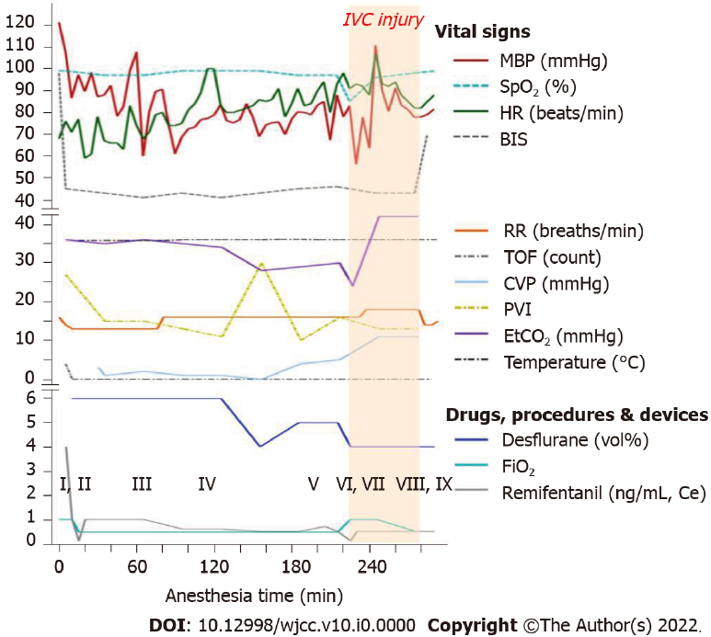
Figure 1 Case report timeline. The vital signs, administered drugs, and laboratory findings during the operation. I: Propofol (70 mg) and atracurium (25 mg) i.v., start of phenylephrine infusion; II: Hydrocortisone (100 mg) i.v.; III: End of phenylephrine infusion and start of norepinephrine infusion; IV: 1st ABGA (pH, 7.300; PCO₂, 48.2 mmHg; PO₂, 100.7 mmHg; Hb, 13.9 g/dL; Na⁺, 140 mmol/L; K⁺, 4.3 mmol/L; lactic acid, 1.43 mmol/L); V: 2nd ABGA (pH, 7.161; PCO₂, 70.9 mmHg; PO₂, 121.8 mmHg; Hb, 13.1 g/dL; Na⁺, 142 mmol/L; K⁺, 4.2 mmol/L; lactic acid, 2.23 mmol/L); VI: “Mill-wheel” murmur auscultated over the precordium; 3rd ABGA (pH, 7.112; PCO₂, 78.8 mmHg; PO₂, 73.3 mmHg; Hb, 12.7 g/dL; Na⁺, 142 mmol/L; K⁺, 4.2 mmol/L; lactic acid, 2.47 mmol/L]; TEE: gas bubble scattered in right and left heart, and ascending aorta; VII: Start of transfusion of 1 unit packed red blood cells; VIII: 4th ABGA (pH, 7.282; PCO₂, 50.5 mmHg; PO₂, 111.1 mmHg; Hb, 13.1 g/dL; Na⁺, 141 mmol/L; K⁺, 4.6 mmol/L; lactic acid, 2.31 mmol/L); TEE: CO₂ gas bubble reduced; IX: The patient was transferred to a surgical intensive care unit. IVC: Inferior vena cava, MBP: Mean blood pressure, SpO₂: Pulse oximetry, HR: Heart rate, BIS: Bispectral index, RR: Respiratory rate, TOF: Train of four, CVP: Central venous pressure, PVI: Pleth variability index, EtCO₂: End-tidal CO₂, Ce: Effect-site concentration, iv: Intravenous, ABGA: Arterial blood gas analysis, PCO₂: Arterial carbon dioxide partial pressure, PO₂: Arterial oxygen partial pressure, TEE: Transesophageal echocardiography.
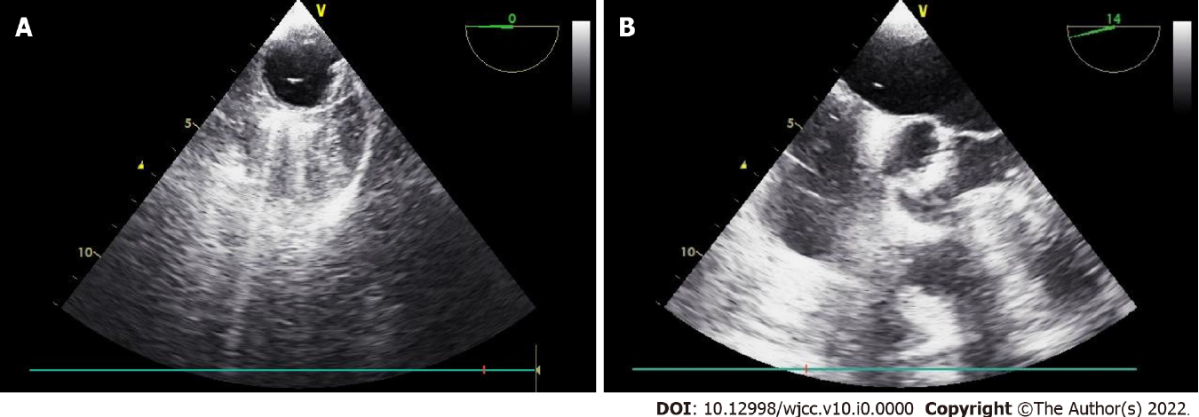
Figure 2 Intraoperative transesophageal echocardiography. A: On the descending aortic short axis view, transesophageal echocardiography (TEE) shows gas bubbles in the aorta. B: On the mid-esophageal aortic valve short axis view, TEE shows gas bubbles in both the atrium and aortic valve.
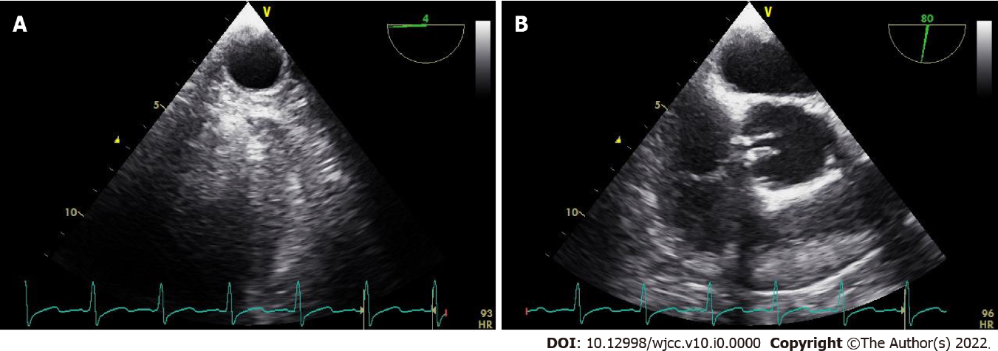
Figure 3 Intraoperative transesophageal echocardiography after 30 minutes. A: On the descending aortic short axis view, gas bubbles are not seen. B: On the mid-esophageal aortic valve short axis view, gas bubbles are not seen.

