Name of Journal: World Journal of Orthopedics
Manuscript NO: 82911
Manuscript Type: ORIGINAL ARTICLE

Retrospective Study
Locking plates for distal fibula fractures in young and elderly patients: A retrospective study

Evola FR et al. A new malleolus locking plate

Francesco Roberto Evola, Giovanni Francesco Di Fede, Giuseppe Evola, Martina Barchitta, Antonella Agodi, Gianfranco Longo

Francesco Roberto Evola, Gianfranco Longo, Department of Surgery, Division of Orthopedics and Trauma Surgery, “Cannizzaro” Hospital, Catania 95100, Italy

Giovanni Francesco Di Fede, Department of Radiodiagnostics, Division of Radiology, “S. Marta and S. Venera” Hospital, Acireale 95024, Italy

Giuseppe Evola, Department of Surgery, Division of Surgery, “Garibaldi” Hospital, Catania 95100, Italy

Martina Barchitta, Antonella Agodi, Department of Medical and Surgical Sciences and Advanced Technologies “GF Ingrassia”, University of Catania, Catania 95100, Italy

Author contributions: All authors designed the study, acquired and interpreted the data, wrote the manuscript, and approved the final version of the article; Evola FR and Di Fede GF designed and performed the research; Evola FR and Evola G contributed to the literature research; Agodi A and Barchitta M analysed the data; Evola FR wrote the paper; Longo G revised the manuscript; All authors read and approved the final manuscript.

Corresponding author: Francesco Roberto Evola, MD, PhD, Additional Professor, Department of Surgery, Division of Orthopedics and Trauma Surgery, “Cannizzaro” Hospital, MESSINA n° 829, Catania 95100, Italy. robertoevola@virgilio.it

Received: December 29, 2022
Revised: April 16, 2023
Accepted: June 6, 2023
Published online:

Abstract
BACKGROUND
Ankle fractures are common injuries in the young and elderly populations. To prevent post-traumatic arthritis, an anatomic reconstruction of the ankle structure is mandatory. Open reduction and internal fixation is the treatment of choice among orthopaedics. Conventional plates allow stability of the fracture if bone quality is present. Locking plates might offer an advantage for the treatment of lateral malleolar fracture in patients with comminution, severe instability, distal fractures, or osteoporotic bone. Our hospital introduced a new locking plate for fracture of the distal fibula.

AIM
To evaluate locking plates in terms of outcomes and complications in young and elderly patients.

METHODS
We retrospectively reviewed a total of 67 patients treated for displaced distal fibula fractures. Demographic data, number of comorbidities, use of inter fragmentary screw, complication, time of fracture healing, partial or full weight bearing, and reoperation were recorded for all patients. Clinical outcome was assessed by the American Orthopedic Foot and Ankle Society clinical scoring system. Radiographs were obtained at 4, 8, 12, 16, 20, and 24 wk until radiographic union was obtained.

RESULTS
All patients displayed complete bony union on radiographic assessment, and no patients developed any serious complications. We observed two superficial infections, one delayed wound healing, and two plate intolerances. Significant differences were observed between the two age groups in terms of radiographic healing (11.9 wk in younger patients vs 13.7 wk in older patients; P = 0.011) and in the American Orthopedic Foot and Ankle Society score at 6 mo after surgery (88.2 in younger patients vs 86.0 in older patients; P = 0.001) and at 12 mo after surgery (92.6 in younger patients vs 90.0 in older patients; P = 0.000).

CONCLUSION
Locking plates provide a stable and rigid fixation in multifragmentary and comminuted fractures or in the presence of poor bone quality.

Key Words: Ankle fracture; Locking plate; Distal fibula fracture; Outcome; Complications; Osteoporosis

Evola FR, Di Fede GF, Evola G, Barchitta M, Agodi A, Longo G. Locking plates for distal fibula fractures in young and elderly patients: A retrospective study. World J Orthop 2023; In press

Core Tip: Ankle fractures are common injuries in the young and elderly populations. Fibula locking plate is used for the older population due to osteoporotic bone or for the younger population with multifragmentary and comminuted fractures. We introduced a new locking plate for fracture of the distal fibula and evaluated it for lateral malleolar fixation in terms of outcomes and complications in young and elderly patients. We were interested in determining whether the use of this locking plate would provide the same advantage and outcomes that were described in literature.

INTRODUCTION
Ankle fractures are common injuries and represent 9% of all fractures^{[1,2]}. These fractures, often due to low energy trauma, have an annual incidence of 122-184/100000 people^{[2,3]} and represent the third most common fracture, after hip and wrist fractures^{[4]}. The repair process of these fractures is classified into primary and secondary fracture healing. Primary healing is direct bone repair without cartilaginous callus formation where bone remodelling occurs with rigid fixation and no gap formation; secondary healing is typically characterised by callus formation due to the presence of movement at the fracture site. The key to the repair process is the appropriate stability of the fracture site to obtain a biological healing response.
Several fixation methods may be used including one-third tubular plate, dynamic compression plate, and locking plate. The treatment in the elderly population must consider the presence of osteoporosis as the decisive factor for the type of implant to be used. Conventional plates allow stability of the fracture if bone quality is present. Loosening or toggling of screws represent a failure of fixation due to loss of friction between the plate and the bone^{[1]}. Locking plates might offer an advantage in patients with osteoporotic bone. The stability does not depend on bone-plate friction because the screw head locks into the threaded hole of the plate. These plates reduce periosteal compression and improve bone healing through increased blood supply^{[5]}. Precontoured locking plates facilitate placement and fixation of fractures in elderly and young patients and must be reserved for distal fractures that have limited places available for distal screw insertion through multiple multidirectional metaphyseal locked screws. Unfortunately, locking plates form a stiffer screw-plate construct that can cause greater rigidity compared to conventional plates, affecting fracture healing and causing delayed union or non-union.
In February 2017, our unit introduced a new locking plate for the fracture of the distal fibula. The aim of this study was to evaluate the new locking plate for lateral malleolar fixation in terms of outcomes and complications in young and elderly patients. We were interested in determining whether the use of this locking plate would provide the same advantage and outcomes that were described in the literature.

MATERIALS AND METHODS
We retrospectively reviewed a consecutive cohort of patients admitted from February 2017 to September 2018 for fixation of a distal fibula fracture with a follow-up of 1 year. Permission for this study was obtained from our institutional ethics committee for the use of patient data for publication purposes (n°161/2020/CA). The eligibility criteria were displaced distal fibula fractures classified as a Dannis-Weber type B or C after a low-energy trauma, minimum follow-up of 1 year, and patient ambulatory prior to injury. Open ankle fracture, pilon fracture, bilateral ankle fractures, pathologic fractures, paediatric fractures, previous malleolar fractures history, fracture treated temporarily with external fixator, fracture treated with syndesmotic screws, patients with cognitive impairment, and polytrauma were excluded from study.
A total of 67 patients treated for displaced Dannis-Weber type B or C distal fibula fractures were included in this study. The implant used was a 3.0/3.5 mm precontoured anatomical locking plate for the distal fibula, manufactured by Hofer Medical Italy (Inteos plate). This implant provides a unicortical locking system to allow fixation in metaphyseal bone with 3.0 mm distal screws. The plate has a low profile and multiple smaller screws distally to obtain adequate distal fixation through multiple multidirectional locked screws. The use of a lag screw was left to the discretion of the surgeon, depending on the pattern of fracture.
Patients were divided into two groups based on age: Group 1 patients were under 60-years-old; and group 2 patients were aged 60 years and over. Demographic data (age, sex, type of fracture), number of comorbidities (diabetes, history of deep venous thrombosis or limb vascular disease), use of inter fragmentary screws, complications (superficial or deep infection, loss of reduction, loose screw, non-union, nerve injury, delayed wound healing, skin irritation), time of fracture healing, partial or full weight bearing, and reoperation were recorded for all patients.
Clinical outcome was assessed by the American Orthopedic Foot and Ankle Society (AOFAS), with clinical scoring at 6 and 12 mo after surgery. The AOFAS score has a maximum value of 100 points (50 points for function, 40 for pain, 10 for alignment). Complications were recorded at every clinical and radiographic follow-up. Radiographs of the anterior-posterior, lateral, and mortise view were obtained at 4 wk postoperatively and then at 8, 12, 16, 20, and 24 wk until radiographic union was obtained. Fracture healing was defined by the identification of three of the four cortices to be bridged by visible callus on X-ray exam, determined by a single radiologist that was not involved in this study, and full weight bearing without pain.
All patients received antibiotic prophylaxis with a single dose of 2 g of a second-generation cephalosporin. In case of allergy, the patients received teicoplanin or levofloxacin according to hospital protocol. All patients received low-molecular-weight heparin for thrombo prophylaxis from 6 h postoperatively and for the duration of immobilisation (30 d). Possible syndesmotic injuries (talar tilt or increase in tibial medial space) were evaluated during the surgery with external rotation stress test under fluoroscopy. In the event of a syndesmotic injury, the patient was excluded from the study. A short leg cast was applied for the first 2 wk, and then a brace for another 2 wk. Full weight bearing with a brace was allowed at 4 or 6 wk after surgery, depending on the radiographic result, while full weight bearing without a brace was allowed about 8 or 10 wk after surgery.
Statistical analysis was conducted using the IBM Statistical Package for Social Sciences, version 26. Descriptive statistics were calculated. Depending on the variable analysed, χ² test and t-test were used to compare the two age groups. All P values ≤ 0.05 were considered statistically significant.

RESULTS
A total of 67 patients (55.2% females), mean age 58.5 ± 16.2 years, were included in the study since their data were available for complete analysis and comparison. Among them, 43.3% of patients were in group 1 (< 60-years-old), and 56.7% were in group 2 (≥ 60-years-old). The majority of patients (79.1%) had a Dannis-Weber type B distal fibula fracture. In 9 patients (13.4 %), there was at least one comorbidity at the time of surgery.
All 67 patients displayed complete bony union on radiographic assessment. Radiographic union was obtained in 8 patients (11.9%) at 8 wk, in 40 patients (59.7%) at 12 wk, in 15 patients (22.4%) at 16 wk, and in 4 patients (6.0%) at 20 wk. Plates with a lag screw were used in 26 fractures (38.8%) and without in 41 fractures (61.2%), suggesting that these fractures frequently do not require a lag screw due to stabile fixation of locking plates. Full weight bearing with a brace was allowed at 4 wk after surgery in 54 patients and at 6 wk in 13 patients. Full weight bearing without a brace was allowed at 8 wk in 54 patients and at 10 wk in 13 patients. No patients developed any serious complications, including non-union, malunion, loss of fixation, loose screws, deep infection, peroneal tendinitis, nerve injury, and post-traumatic osteoarthritis. We observed two (3%) superficial infections (1 case in group 1, 1 case in group 2), which completely resolved after antibiotic treatment, one (1.5%) delayed wound healing (1 case in group 2), which was treated with medications, and two (3%) plate intolerances (1 case in group 1, 1 case in group 2) due to incorrect positioning that required removal of the implant. Patients with superficial infection or delayed wound healing had at least one comorbidity at the time of surgery.
Table 1 reports results of the comparison between group 1 and group 2. Significant differences were observed between the two age groups in terms of radiographic healing (11.9 wk in younger patients vs 13.7 wk in older patients; P = 0.011) and in the AOFAS score at 6 mo after surgery (88.2 in younger patients vs 86.0 in older patients; P = 0.001) and at 12 mo after surgery (92.6 in younger patients vs 90.0 in older patients; P = 0.000).

DISCUSSION
Fibula locking plate is used for the older population due to osteoporotic bone or for the younger population in multifragmentary and comminuted fractures. Biomechanical studies have shown that locking plates in an osteoporotic fibula have greater torque and axial and angle resistance at failure than conventional plates^{[6]}. The use of two distal unicortical screws was mechanically equivalent to three distal cortical screws of standard plate^{[1,6,7]}. In conventional devices, the plate-bone construct is dependent on bone mineral density, while in locking devices, bone quality does not influence the biomechanical resistance of the implant because the plate produces stability through a fixed-angle structure without the need for contact between the bone and the plate^{[8]}. Locking plates do not offer an advantage in stable fractures with normal mineral density^{[9,10]}. In addition, the fixation of the distal fibula could be inappropriate with a standard plate because it depends on the mechanical strength of a single cortex and cancellous bone of the distal fragment. The locking plates produce a fixed-angle structure without the need for anchorage of the screws on both corticales; therefore, these plates are useful in multifragmentary and distal fractures in young patients.
Wound infection, delayed wound healing, and skin irritation are common postoperative complications of ankle fixation and sometimes require revision or removal of metalwork^{[11,12]}. Other postsurgical complications described in the literature are non-union, malunion, loss of fixation, loose screws, peroneal tendinitis, nerve injury, and post-traumatic osteoarthritis^{[5]}.
In the literature, there is a debate on clinical results, incidence of complications, and advantages on the use of locking plates. Generally, complications after locking plate osteosynthesis can reach 20%^{[1,13-15]} and even 40% according to other authors^{[16]}. Naumann et al^{[17]} retrospectively reviewed 997 patients following surgery for ankle fractures and reported that 17.0% required implant removal and 2.6% required infection treatment. Lynde et al^{[18]}, through a retrospective study, found that there was no difference in the complication rates between locking vs non-locking plates used for distal fibula fracture. Lyle et al^{[1]} and Tsukada et al^{[19]} did not observe any clinical advantage in the use of locking plates and found no difference in complication rates between locking plates and conventional plates.
Huang et al^{[20]} compared one-third tubular plates with locking compression plates and showed a higher functional score and less healing time in locking plates. Schepers et al^{[21]}, through a retrospective study, advised against the use of locking plates because of increased wound complication with respect to conventional plates (17.5% vs 5.5%). Herrera-Pérez et al^{[4]} observed similar outcomes in both locking and conventional plates but recommended the use of locking plates in patients with concomitant soft tissue damage or who cannot tolerate prolonged immobilisation, as it reduces non-weight-bearing time. Takemoto et al^{[22]} observed that in multifragmentary fractures, lag screws are used half as often with locking plates compared to conventional plates because locking plates provide the necessary fixation. Kim et al^{[7]}, using a biomechanical study, compared semitubular locking and non-locking plates and observed that both implants were similar. However, locking plates were independent of bone mineral density and were advantageous for elderly patients with osteoporosis.
In our study, we used locking plates in both young and elderly patients (Figures 1 and 2) and found no differences in the complication rates between the two groups. Moreover, the complication rates were in line with those found in the literature for the treatment of distal fibula fractures.
In this study, we observed a significant difference between the two groups in terms of radiographic healing (11.9 wk in younger patients vs 13.7 wk in older patients) and in the AOFAS score at 6 mo (88.2 in younger patients vs 86.0 in older patients) and at 12 mo (92.6 in younger patients vs 90.0 in older patients). Our findings indicated a high efficacy of these plates in lateral malleolar fixation. Therefore, in this study, locking plates seemed to offer an advantage in young patients with normal bone mineral density for the treatment of multifragmentary and comminuted fractures, permitting early rehabilitation and full weight bearing through a rigid fixation of the malleolar fracture. In elderly patients, this locking plate showed excellent results, as already known in the literature for the other devices.
The present retrospective study was limited because it was not randomised, did not have a control group, had a short follow-up, and had a limited sample of patients. Further studies, especially prospective, are needed to confirm clinical and radiological outcomes of locking plates in displaced malleolar fractures.

CONCLUSION
Locking plates provide a stable and rigid fixation in multifragmentary and comminuted fractures or in the presence of poor bone quality. The cost is greater than conventional plates but decreases the risk of displacement of fractures or further intervention of revisions in patients with osteoporotic bone or unstable fractures. In the young population, anatomical locking plates are useful to obtain stable fixation for distal fractures with comminution that have limited places available for distal screws. In the elderly population, locking plates offer an advantage in the presence of poor bone quality, avoiding screws loosening and subsequently coming out. Although locking plates have been associated with delayed union or non-union in the literature, we did not observe this in our study. However, the observation time was not very long and the overall included samples were limited. The locking plate utilised in this study showed few complications and complete bone union in all patients.

ARTICLE HIGHLIGHTS
Research background
Ankle fractures are common injuries in the young and elderly populations. Locking plates might offer an advantage for the treatment of these fractures in patients with comminution, severe instability, distal fractures, or osteoporotic bone.

Research motivation
The aim of this study was to evaluate our hospital’s new locking plate for lateral malleolar fixation in terms of outcomes and complications in young and elderly patients.

Research objectives
We were interested in determining whether the use of a locking plate would provide the same advantage and outcomes that were described in literature.

Research methods
We retrospectively reviewed a consecutive cohort of patients for fixation of distal fibula fracture with a follow-up of 1 year.

Research results
Significant differences were observed between the two age groups in terms of radiographic healing and in the American Orthopedic Foot and Ankle Society score at 6 mo and at 12 mo after surgery.

Research conclusions
The locking plate utilized in this study showed few complications and complete bone union in all patients.

Research perspectives
Prospective studies with larger patient samples and longer follow-up are needed.

REFERENCES
1 Lyle SA, Malik C, Oddy MJ. Comparison of Locking Versus Nonlocking Plates for Distal Fibula Fractures. J Foot Ankle Surg 2018; 57: 664-667 [PMID: 29681437 DOI: 10.1053/j.jfas.2017.11.035]
2 Court-Brown CM, Caesar B. Epidemiology of adult fractures: A review. Injury 2006; 37: 691-697 [PMID: 16814787 DOI: 10.1016/j.injury.2006.04.130]
3 Evola FR, Cucuzza ME, Longo G. Management of posterior malleolus in ankle fractures. Euromediterranean Bio J 2019; 14: 20-23 [DOI: 10.3269/1970-5492.2019.14.05]
4 Herrera-Pérez M, Gutiérrez-Morales MJ, Guerra-Ferraz A, Pais-Brito JL, Boluda-Mengod J, Garcés GL. Locking vs non-locking one-third tubular plates for treating osteoporotic distal fibula fractures: a comparative study. Injury 2017; 48 Suppl 6: S60-S65 [PMID: 29162244 DOI: 10.1016/S0020-1383(17)30796-9]
5 Bilgetekin YG, Çatma MF, Öztürk A, Ünlü S, Ersan Ö. Comparison of different locking plate fixation methods in lateral malleolus fractures. Foot Ankle Surg 2019; 25: 366-370 [PMID: 30321977 DOI: 10.1016/j.fas.2018.01.004]
6 Zahn RK, Frey S, Jakubietz RG, Jakubietz MG, Doht S, Schneider P, Waschke J, Meffert RH. A contoured locking plate for distal fibular fractures in osteoporotic bone: a biomechanical cadaver study. Injury 2012; 43: 718-725 [PMID: 21813124 DOI: 10.1016/j.injury.2011.07.009]
7 Kim T, Ayturk UM, Haskell A, Miclau T, Puttlitz CM. Fixation of osteoporotic distal fibula fractures: A biomechanical comparison of locking vs conventional plates. J Foot Ankle Surg 2007; 46: 2-6 [PMID: 17198946 DOI: 10.1053/j.jfas.2006.09.009]
8 Yeo ED, Kim HJ, Cho WI, Lee YK. A Specialized Fibular Locking Plate for Lateral Malleolar Fractures. J Foot Ankle Surg 2015; 54: 1067-1071 [PMID: 26213160 DOI: 10.1053/j.jfas.2015.06.002]
9 Nguyentat A, Camisa W, Patel S, Lagaay P. A Biomechanical Comparison of Locking Versus Conventional Plate Fixation for Distal Fibula Fractures in Trimalleolar Ankle Injuries. J Foot Ankle Surg 2016; 55: 132-135 [PMID: 26497086 DOI: 10.1053/j.jfas.2015.08.017]
10 Sessa G, Evola FR, Costarella L. Osteosynthesis systems in fragility fracture. Aging Clin Exp Res 2011; 23: 69-70 [PMID: 21970929]
11 Agodi A, Auxilia F, Barchitta M, Cristina ML, D’Alessandro D, Mura I, Nobile M, Pasquarella C, Gisio-SItI G; GISIO – Italian Study Group of Hospital Hygien. Risk of surgical site infections following hip and knee arthroplasty: results of the ISChIA-GISIO study. Ann Ig 2017; 29: 422-430 [PMID: 28715055 DOI: 10.7416/ai.2017.2174]
12 Jensen SL, Andresen BK, Mencke S, Nielsen PT. Epidemiology of ankle fractures. A prospective population-based study of 212 cases in Aalborg, Denmark. Acta Orthop Scand 1998; 69: 48-50 [PMID: 9524518 DOI: 10.3109/17453679809002356]
13 Zaghloul A, Haddad B, Barksfield R, Davis B. Early complications of surgery in operative treatment of ankle fractures in those over 60: a review of 186 cases. Injury 2014; 45: 780-783 [PMID: 24388418 DOI: 10.1016/j.injury.2013.11.008]
14 Hallbauer J, Gräfenstein A, Rausch S, Knobe M, Simons P, Mückley T, Hofmann GO, Klos K. Biomechanical analysis of polyaxial locking vs. non-locking plate fixation of unstable fractures of the distal fibula: A cadaver study with a bone only model. Foot Ankle Surg 2018; 24: 326-329 [PMID: 29409241 DOI: 10.1016/j.fas.2017.03.008]
15 Kilian M, Csörgö P, Vajczikova S, Luha J, Zamborsky R. Antiglide vs lateral plate fixation for Danis-Weber type B malleolar fractures caused by supination-external rotation injury. J Clin Orthop Trauma 2017; 8: 327-331 [PMID: 29062213 DOI: 10.1016/j.jcot.2017.06.005]
16 Anderson SA, Li X, Franklin P, Wixted JJ. Ankle fractures in the elderly: initial and long-term outcomes. Foot Ankle Int 2008; 29: 1184-1188 [PMID: 19138481 DOI: 10.3113/FAI.2008.1184]
17 Naumann MG, Sigurdsen U, Utvåg SE, Stavem K. Incidence and risk factors for removal of an internal fixation following surgery for ankle fracture: A retrospective cohort study of 997 patients. Injury 2016; 47: 1783-1788 [PMID: 27262772 DOI: 10.1016/j.injury.2016.05.011]
18 Lynde MJ, Sautter T, Hamilton GA, Schuberth JM. Complications after open reduction and internal fixation of ankle fractures in the elderly. Foot Ankle Surg 2012; 18: 103-107 [PMID: 22443995 DOI: 10.1016/j.fas.2011.03.010]
19 Tsukada S, Otsuji M, Shiozaki A, Yamamoto A, Komatsu S, Yoshimura H, Ikeda H, Hoshino A. Locking vs non-locking neutralization plates for treatment of lateral malleolar fractures: a randomized controlled trial. Int Orthop 2013; 37: 2451-2456 [PMID: 24077867 DOI: 10.1007/s00264-013-2109-9]
20 Huang Z, Liu L, Tu C, Zhang H, Fang Y, Yang T, Pei F. Comparison of three plate system for lateral malleolar fixation. BMC Musculoskelet Disord 2014; 15: 360 [PMID: 25358474 DOI: 10.1186/1471-2474-15-360]
21 Schepers T, Van Lieshout EM, De Vries MR, Van der Elst M. Increased rates of wound complications with locking plates in distal fibular fractures. Injury 2011; 42: 1125-1129 [PMID: 21329921 DOI: 10.1016/j.injury.2011.01.009]
22 Takemoto RC, Sugi MT, Kummer F, Koval KJ, Egol KA. The effects of locked and unlocked neutralization plates on load bearing of fractures fixed with a lag screw. J Orthop Trauma 2012; 26: 519-522 [PMID: 22437420 DOI: 10.1097/BOT.0b013e31823b3dd1]

Footnotes
Institutional review board statement: The permission of this study was obtained from our Institutional Ethics Committee for the use of patient data for publication purpose (n°161/2020/CA).

Informed consent statement: Patients were not required to give informed consent to the study because the analysis used anonymous clinical data obtained after each patient agreed to treatment by written consent.

Conflict-of-interest statement: The authors declare that they have no conflicts of interest.

Data sharing statement: No additional data are available.

Open-Access: This article is an open-access article that was selected by an in-house editor and fully peer-reviewed by external reviewers. It is distributed in accordance with the Creative Commons Attribution NonCommercial (CC BY-NC 4.0) license, which permits others to distribute, remix, adapt, build upon this work non-commercially, and license their derivative works on different terms, provided the original work is properly cited and the use is non-commercial. See: https://creativecommons.org/Licenses/by-nc/4.0/

Provenance and peer review: Unsolicited article; Externally peer reviewed.

Peer-review model: Single blind

Peer-review started: December 29, 2022
First decision: March 14, 2023
Article in press:

Specialty type: Orthopedics
Country/Territory of origin: Italy
Peer-review report’s scientific quality classification
Grade A (Excellent): 0
Grade B (Very good): B
Grade C (Good): C, C, C
Grade D (Fair): 0
Grade E (Poor): 0

P-Reviewer: Li Z, China; Papazafiropoulou A, Greece; Tsikopoulos K, United Kingdom S-Editor: Fan JR L-Editor: Filipodia P-Editor: Fan JR

Figure Legends
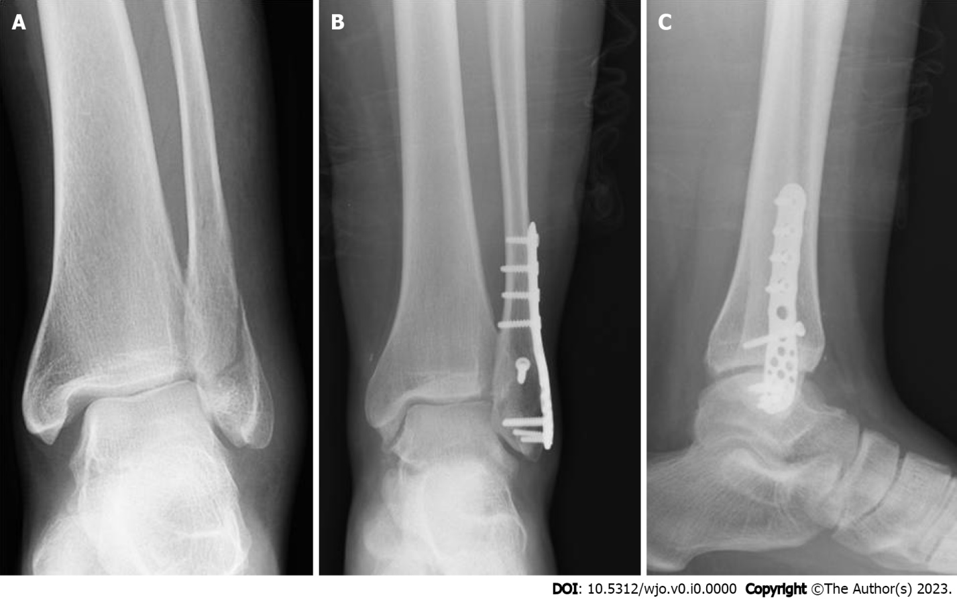
Figure 1 Fixation of a lateral malleolus fracture with locking plate in a young patient. A: Preoperative X-ray; B: Anterior-posterior X-ray at follow-up; C: Lateral X-ray at follow-up.

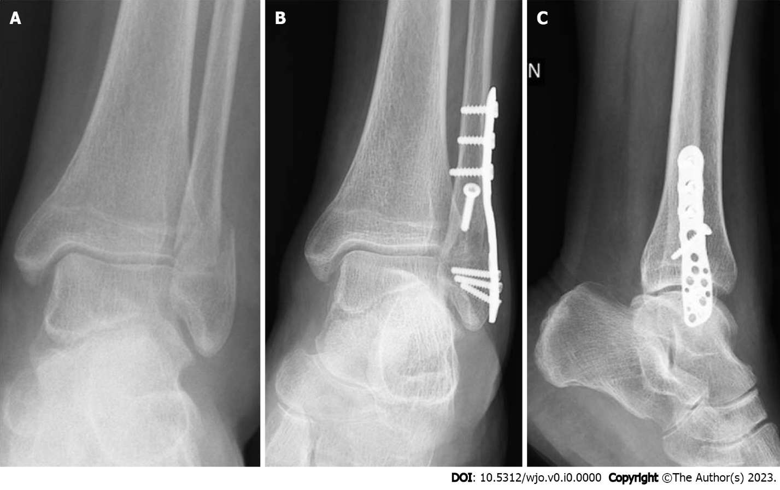
Figure 2 Fixation of a lateral malleolus fracture with locking plate in an elderly patient. A: Preoperative X-ray; B: Anterior-posterior X-ray at follow-up; C: Lateral X-ray at follow-up.

Table 1 Comparison between group 1 and group 2 (mean ± SD)
Feature | Total, n = 67 | Group 1 < 60 yr, n = 29 | Group 2 ≥ 60 yr, n = 38 | P value
Age in yr | 58.5 ± 16.2 | 42.4 ± 11.7 | 70.7 ± 2.9 | NA
Female sex | 55.2% | 55.2% | 55.3% | 0.994
Weber classification
B | 79.1% | 79.3% | 78.9% | 0.971
C | 20.9% | 20.7% | 21.1%
Radiographic healing in wk | 12.9 ± 2.9 | 11.9 ± 3.1 | 13.7 ± 2.6 | 0.011
Partial load with brace in wk | 4.4 ± 0.8 | 4.3 ± 0.8 | 4.4 ± 0.8 | 0.701
Total load without brace in wk | 8.4 ± 0.8 | 8.3 ± 0.8 | 8.4 ± 0.8 | 0.701
AOFAS score at 6 mo after surgery | 86.9 ± 2.8 | 88.2 ± 1.9 | 86.0 ± 3.0 | 0.001
AOFAS score at 12 mo after surgery | 91.1 ± 2.7 | 92.6 ± 2.4 | 90.0 ± 2.3 | 0.000
AOFAS: American Orthopedic Foot and Ankle Society; NA: Not assessed; SD: Standard deviation.

