Name of Journal: World Journal of Clinical Cases
Manuscript NO: 86439
Manuscript Type: CASE REPORT

Primary cutaneous anaplastic large cell lymphoma with over-expressed Ki-67 transitioning into systemic anaplastic large cell lymphoma: A case report

Mu HX et al. Anaplastic large cell lymphoma

Hai-Xi Mu, Xiao-Qiong Tang

Hai-Xi Mu, Xiao-Qiong Tang, Department of Hematology, The First Affiliated Hospital of Chongqing Medical University, Chongqing 400010, China

Author contributions: Mu HX contributed to manuscript writing and editing and data collection; Tang XQ contributed to conceptualization and supervision; all authors have read and approved the final manuscript.

Corresponding author: Xiao-Qiong Tang, MD, Chief Physician, Department of Hematology, The First Affiliated Hospital of Chongqing Medical University, No. 1 Yixueyuan Road, Yuzhong, Chongqing 400010, China. tangxiaoqiong@126.com

Received: June 19, 2023
Revised: August 30, 2023
Accepted: September 6, 2023
Published online:

Abstract
BACKGROUND
Primary cutaneous anaplastic large cell lymphoma (PC-ALCL) differs from systemic anaplastic large cell lymphoma (sALCL) in cell biological behavior, clinical features, treatment, and outcome. PC-ALCL has been reported to rarely transition into sALCL, but the underlying mechanism is not clear. Here we report such a case with certain characteristics that shed light on this.

CASE SUMMARY
Herein, we report a 43-year-old male with symptoms of a skin nodule and histologically confirmed PC-ALCL with high expression of Ki-67. After three months of observation, two skin nodules re-appeared with muscle layer involvement and was histologically confirmed as sALCL. Seventeen months after receiving six cycles of CHOP regimen, the patient had pain in the chest and back, cough, shortness of breath, and night sweats. This was confirmed as relapse of sALCL by immunohistochemistry and several organs, such as the lung were involved as shown by positron emission tomography/computed tomography. After four cycles of DICE plus chidamide regimens followed by auto-hematopoietic stem cell transplantation (ASCT), complete remission (CR) duration was achieved for twelve months while the patient was on maintenance with chidamide (20 mg) pills.

CONCLUSION
This case had significantly high expression of Ki-67 when diagnosed as PC-ALCL initially and then transitioned into sALCL, which is rare. Auto-ASCT combined with demethylation drugs effectively maintained CR and prolonged progression free survival.

Key Words: Cutaneous lymphoma; Anaplastic large cell lymphoma; Ki-67; Auto hematopoietic stem cell transplantation; Case report

Mu H, Tang XQ. Primary cutaneous anaplastic large cell lymphoma with over-expressed Ki-67 transitioning into systemic anaplastic large cell lymphoma: A case report. World J Clin Cases 2023; In press

Core Tip: Primary cutaneous anaplastic large cell lymphoma (PC-ALCL) is a primary cutaneous lymphoma and differs from systemic anaplastic large cell lymphoma (sALCL), which is a peripheral T cell lymphoma. There is no direct connection between them. This is the first report of the medical management, including auto-hematopoietic stem cell transplantation (ASCT) of a 43-year-old male patient who transitioned from the cutaneous to the systemic form of ALCL in Asia, and the second to be reported in world (the first being a Bulgarian treated with Brentuximab vedontin). We found high expression of Ki-67 in this case, for the first time, which may have played a role in the transition. This is also the first instance of application of auto-ASCT followed by maintenance with oral chidamide. In the future, an increasing number of patients will probably receive this therapy, and therein lies the significance of this case report.

INTRODUCTION
Primary cutaneous anaplastic large cell lymphoma (PC-ALCL) accounts for about 8% of all cutaneous T-cell lymphomas^{[1]}. In the 2022 revision of the World Health Organization classification of lymphoid neoplasms, PC-ALCL is categorized under primary cutaneous T-cell lymphoid proliferations and lymphomas^{[2]}. PC-ALCL exhibits an indolent clinical course with a highly favorable outcome; 5-year survival ranges between 85% and 100%, although cutaneous relapses are common^{[3,4]}. The median age at diagnosis is six decades for anaplastic lymphoma kinase (ALK) negative PC-ALCL. Clinical features typically include solitary, grouped skin lesions and uncommonly localized nodules or tumors. Extracutaneous disease occurs in about 10% of cases, usually involving regional lymph nodes^{[3]}.
Peripheral T cell lymphoma (PTCL), an aggressive disease that belongs to a heterogeneous group of mature T-cell lymphomas, develops rapidly and has a poor prognosis. ALK-negative ALCL, as one kind of PTCL, has been acknowledged as a heterogeneous entity. Only one case of transition from PC-ALCL to systemic ALCL (sALCL) has been reported so far in the literature^{[5]}. However, little is known about the underlying mechanism. Here, we report a 43-year-old male patient diagnosed as PC-ALCL who then transitioned into ALK-negative sALCL. We analyzed molecular markers, including Ki-67 and DUSP22 rearrangement to provide additional information.

CASE PRESENTATION
Chief complaints
Awareness of skin nodules for 4 years; thoracalgia and shortness of breath for 2 years.

History of present illness
A 43-year-old male presented with a left sided 2 cm × 2 cm, hard arm swelling without itching or pain (Figure 1A). There were no other skin lesions or lymphadenopathy or significant organomegaly. The local lesion was excised. On histopathology, a diagnosis of ALK-negative PC-ALCL was made (Figure 1B–H). This patient then underwent observation for recurrence.
Three months later, two subcutaneous hard nodules recurred at the same spot on the left arm. They were 1 cm × 2 cm and 0.5 cm × 1 cm in dimensions. The skin lesions were confirmed as relapsed lymphoma with muscle layer infiltration on histopathology (Figure 1I–M). We diagnosed this new disease entity as systemic ALK-negative ALCL since the muscle was involved, although bone marrow biopsy and aspirate and whole-body CT scan were normal. The patient underwent treatment with six cycles of multiagent chemotherapy, CHOP (cyclophosphamide 750 mg/m², theprubicin 30 mg/m², vindesine 3 mg/m², prednisone 100 mg). He refused treatment with brentuximab and auto-ASCT, and instead chose follow-up.
Two years later, this patient suffered from chest pain, shortness of breath, cough, and night sweats.

History of past illness
The patient reported no other medical history, such as hypertension and diabetes.

Personal and family history
The patient denied any personal and family history of illness.

Physical examination
The patient’s height was 189 cm and his weight was 103 kg. He was clear-headed and energetic, and had no swelling of superficial lymph nodes. He had a 1 cm × 1 cm subcutaneous nodule on his back with clear border. He had tenderness in the mid-sternum and bilateral anterior chest wall, clear breath sounds in both lungs, uniform cardiac rhythm, and no obvious murmurs in the apical area. The abdomen was flat and soft, without tenderness and rebound pain, and the liver and spleen were not palpable below the costal margin. Murphy’s sign was negative. There was no percussion pain in bilateral kidney area and no tenderness in bilateral ureter running area. There was no edema in both lower limbs. Neurological tests were negative.

Laboratory examinations
The patient had an increased lactic dehydrogenase of 255 U/L (upper limit: 250 U/L). Blood tests, hepatic function tests, and other biochemical tests were within normal limits.

Imaging examinations
Positron emission tomography/computed tomography scan revealed the subcutaneous nodule on the back as tumor invasion since there was higher 18F-flurodeoxyglucose (18F-FDG) uptake activity, and also involvement of liver, bone, right lung, and widespread lymph nodes (Figure 2A–D).

FINAL DIAGNOSIS
Systemic ALK-negative ALCL, Stage IV group B.

TREATMENT
DICE chemotherapeutic regimen (ifosfamide 1000 mg/m², cisplatin 25 mg/m², etoposide 60 mg/m², dexamethasone 9 mg/m²) combined with chidamide (30 mg, 2 d a week for 2 wk) instead of brentuximab was administered, due to the patient’s economic conditions. Complete response was achieved after four cycles of this regimen (Figure 2E–H). Then, he underwent ASCT. Cyclophosphamide 2 g/m² and granulocyte-colony stimulating factor 8 µg/kg/d were given to promote hematopoietic stem cell (HSC) mobilization from the bone marrow to the peripheral blood. HSCs were collected in a dose of mononuclear cells 9.46 × 10⁸/kg, CD34+ 1.86 × 10⁶/kg. Then BEAM preparative regimen (carmustine 300 mg/m², cytarabine 150 mg/m², etoposide 100 mg/m², melphalan 140 mg/m²) was administered. Neutrophil engraftment occurred on Day +11 and platelet engraftment occurred on Day +14. As maintenance therapy, chidamide (20 mg, two days a week) was administered, without occurrence of adverse events.

OUTCOME AND FOLLOW-UP
The patient has been in complete remission for 12 mo until the last follow up in November 2021. This is similar to the progression-free survival of 12 mo, as reported in the literature^{[6]}.

DISCUSSION
PC-ALCL is sensitive to drugs; however, it has a high relapse rate with some studies reporting a rate of 42%^{[4]}. Patients with early cutaneous relapse have a poorer 5-year specific survival (64%) than those with late or no relapse (96%)^{[7]}. Multiple skin tumors in one limb and extracutaneous disease when this disease has progressed, are individual factors associated with poorer outcomes^{[8]}. This case had both these two poor prognostic factors.
We used immunohistochemistry (IHC) and fluorescence in situ hybridization (FISH) to further study the molecular mechanism of transition of this cutaneous ALCL to sALCL. We found the proliferation index Ki-67 was significantly high (80%) when the primary cutaneous disease occurred (Figure 1F). Furthermore, Ki67 was subsequently upregulated when this disease progressed into sALCL (95% on first relapse, Figure 1M; 90% on second relapse, Figure 1O). It is abnormal to find this indicator in indolent lymphomas, especially in a disease with a good prognosis, such as primary cutaneous T-cell lymphoma. The Ki-67 index was less than 45% in 82.8% of indolent lymphomas, and we can differentiate indolent lymphomas from aggressive ones with the cut-off value of 45%^{[9]}. Ki-67 is also an independent adverse prognostic factor in cutaneous T-cell lymphomas^{[10]}.
For this case, we found that interferon regulatory factor 4 (IRF4) break was obvious and was consistently associated with the disease process on FISH (80% on first relapse, Figure 1N; 70% on second relapse, Figure 1P), which represented the DUSP22-IRF4 rearrangement. Recurrent rearrangement of the DUSP22-IRF4 locus on chromosome 6p25.3 is related to a favorable prognosis in systemic ALK-negative ALCL, with a 5-year OS rate of 80%–90%, similar to that of ALK-positive ALCL^{[11,12]}. This is much better than that of the other two subtypes of ALK-negative ALCL; 42% for triple negative (ALK, DUSP22, and TP63 rearrangements), 17% for TP63-rearranged^{[13]}. DUSP22 rearrangement results in decreased expression of dual-specificity phosphatase-22, decreased STAT3 activation, and decreased activity of immune and autoimmune-mediated mechanisms regulated by T-cells^{[14]}. DUSP22-IRF4 translocation was identified in 20%–57% of the cases of PC-ALCL^{[15]}. A panel of cases of PC-ALCL with DUSP22–IRF4 Locus translocations had features with a distinctive biphasic histopathological pattern, with small cerebriform lymphocytes in the epidermis, and larger transformed lymphocytes in the dermis^{[16]}. However, we know little about the independent influence of DUSP22–IRF4 rearrangement on prognosis in PC-ALCL.

CONCLUSION
This case was initially diagnosed as primary cutaneous anaplastic large cell lymphoma through histopathological features and IHC parameters, including CD30, ALK, CD3, CD4, CD8, GRB, TIA-1, EMA, CD20, PAX5, CD10, and BCL6. The patient progressed to sALCL, which has rarely been reported. Three clinical features in this patient, including cutaneous relapse, multiple skin tumors in one limb, and extracutaneous disease are poor prognosis factors, according to the literature. High Ki-67 expression in this case is a potential poor prognosis marker, indicating need for more aggressive therapy when present in PC-ALCL. There is a need for more retrospective case control studies for further evaluation.

REFERENCES
1 Willemze R, Cerroni L, Kempf W, Berti E, Facchetti F, Swerdlow SH, Jaffe ES. The 2018 update of the WHO-EORTC classification for primary cutaneous lymphomas. Blood 2019; 133: 1703-1714 [PMID: 30635287 DOI: 10.1182/blood-2018-11-881268]
2 Alaggio R, Amador C, Anagnostopoulos I, Attygalle AD, Araujo IBO, Berti E, Bhagat G, Borges AM, Boyer D, Calaminici M, Chadburn A, Chan JKC, Cheuk W, Chng WJ, Choi JK, Chuang SS, Coupland SE, Czader M, Dave SS, de Jong D, Du MQ, Elenitoba-Johnson KS, Ferry J, Geyer J, Gratzinger D, Guitart J, Gujral S, Harris M, Harrison CJ, Hartmann S, Hochhaus A, Jansen PM, Karube K, Kempf W, Khoury J, Kimura H, Klapper W, Kovach AE, Kumar S, Lazar AJ, Lazzi S, Leoncini L, Leung N, Leventaki V, Li XQ, Lim MS, Liu WP, Louissaint A Jr, Marcogliese A, Medeiros LJ, Michal M, Miranda RN, Mitteldorf C, Montes-Moreno S, Morice W, Nardi V, Naresh KN, Natkunam Y, Ng SB, Oschlies I, Ott G, Parrens M, Pulitzer M, Rajkumar SV, Rawstron AC, Rech K, Rosenwald A, Said J, Sarkozy C, Sayed S, Saygin C, Schuh A, Sewell W, Siebert R, Sohani AR, Tooze R, Traverse-Glehen A, Vega F, Vergier B, Wechalekar AD, Wood B, Xerri L, Xiao W. The 5th edition of the World Health Organization Classification of Haematolymphoid Tumours: Lymphoid Neoplasms. Leukemia 2022; 36: 1720-1748 [PMID: 35732829 DOI: 10.1038/s41375-022-01620-2]
3 Bekkenk MW, Geelen FA, van Voorst Vader PC, Heule F, Geerts ML, van Vloten WA, Meijer CJ, Willemze R. Primary and secondary cutaneous CD30(+) lymphoproliferative disorders: a report from the Dutch Cutaneous Lymphoma Group on the long-term follow-up data of 219 patients and guidelines for diagnosis and treatment. Blood 2000; 95: 3653-3661 [PMID: 10845893 DOI: 10.1182/blood.V95.12.3653]
4 Liu HL, Hoppe RT, Kohler S, Harvell JD, Reddy S, Kim YH. CD30+ cutaneous lymphoproliferative disorders: the Stanford experience in lymphomatoid papulosis and primary cutaneous anaplastic large cell lymphoma. J Am Acad Dermatol 2003; 49: 1049-1058 [PMID: 14639383 DOI: 10.1016/s0190-9622(03)02484-8]
5 Popova TN, Radinov A, Stavrov K, Temelkova I, Terziev I, Lozev I, Lukanova D, Mangarov H, Wollina U, Tchernev G. Primary Cutaneous CD30+/ALK- ALCL with Transition into sALCL: Favourable Response after Systemic Administration with Brentuximab Vedotin! Unique Presentation in a Bulgarian Patient!. Open Access Maced J Med Sci 2018; 6: 1275-1277 [PMID: 30087736 DOI: 10.3889/oamjms.2018.289]
6 Fu C, Yang C, Li Q, Wang L, Zou L. Glans metastatic extra-nodal natural killer/T-cell lymphoma, nasal-type with HDAC inhibitor as maintenance therapy: a rare case report with literature review. Ann Palliat Med 2020; 9: 3602-3608 [PMID: 32527129 DOI: 10.21037/apm-19-430b]
7 Fernández-de-Misa R, Hernández-Machín B, Combalía A, García Muret MP, Servitje O, Muniesa C, Gallardo F, Pujol RM, Martí RM, Ortiz-Brugués A, Maroñas-Jiménez L, Ortiz-Romero PL, Blanch Rius L, Izu R, Román C, Cañueto J, Blanes M, Morillo M, Bastida J, Peñate Y, Pérez Gala S, Espinosa Lara P, Pérez Gil A, Estrach T. Prognostic factors in patients with primary cutaneous anaplastic large cell lymphoma: a multicentric, retrospective analysis of the Spanish Group of Cutaneous Lymphoma. J Eur Acad Dermatol Venereol 2020; 34: 762-768 [PMID: 31591786 DOI: 10.1111/jdv.16006]
8 Benner MF, Willemze R. Applicability and prognostic value of the new TNM classification system in 135 patients with primary cutaneous anaplastic large cell lymphoma. Arch Dermatol 2009; 145: 1399-1404 [PMID: 20026848 DOI: 10.1001/archdermatol.2009.280]
9 Broyde A, Boycov O, Strenov Y, Okon E, Shpilberg O, Bairey O. Role and prognostic significance of the Ki-67 index in non-Hodgkin's lymphoma. Am J Hematol 2009; 84: 338-343 [PMID: 19384938 DOI: 10.1002/ajh.21406]
10 Mitani S, Tango T, Sonobe Y, Baba N, Nagatani T, Nomoto S, Mori S. Expression of three cell proliferation-associated antigens, DNA polymerase alpha, Ki-67 antigen and transferrin receptor in nodal and cutaneous T-cell lymphomas. Int J Hematol 1991; 54: 385-393 [PMID: 1756249]
11 Pedersen MB, Hamilton-Dutoit SJ, Bendix K, Ketterling RP, Bedroske PP, Luoma IM, Sattler CA, Boddicker RL, Bennani NN, Nørgaard P, Møller MB, Steiniche T, d'Amore F, Feldman AL. DUSP22 and TP63 rearrangements predict outcome of ALK-negative anaplastic large cell lymphoma: a Danish cohort study. Blood 2017; 130: 554-557 [PMID: 28522440 DOI: 10.1182/blood-2016-12-755496]
12 Savage KJ, Slack GW. DUSP22-rearranged ALK-negative anaplastic large cell lymphoma is a pathogenetically distinct disease but can have variable clinical outcome. Haematologica 2023; 108: 1463-1467 [PMID: 36453106 DOI: 10.3324/haematol.2022.282025]
13 Parrilla Castellar ER, Jaffe ES, Said JW, Swerdlow SH, Ketterling RP, Knudson RA, Sidhu JS, Hsi ED, Karikehalli S, Jiang L, Vasmatzis G, Gibson SE, Ondrejka S, Nicolae A, Grogg KL, Allmer C, Ristow KM, Wilson WH, Macon WR, Law ME, Cerhan JR, Habermann TM, Ansell SM, Dogan A, Maurer MJ, Feldman AL. ALK-negative anaplastic large cell lymphoma is a genetically heterogeneous disease with widely disparate clinical outcomes. Blood 2014; 124: 1473-1480 [PMID: 24894770 DOI: 10.1182/blood-2014-04-571091]
14 Ortiz-Hidalgo C, Pina-Oviedo S. Primary Cutaneous Anaplastic Large Cell Lymphoma-A Review of Clinical, Morphological, Immunohistochemical, and Molecular Features. Cancers (Basel) 2023; 15 [PMID: 37627126 DOI: 10.3390/cancers15164098]
15 Wada DA, Law ME, Hsi ED, Dicaudo DJ, Ma L, Lim MS, Souza Ad, Comfere NI, Weenig RH, Macon WR, Erickson LA, Ozsan N, Ansell SM, Dogan A, Feldman AL. Specificity of IRF4 translocations for primary cutaneous anaplastic large cell lymphoma: a multicenter study of 204 skin biopsies. Mod Pathol 2011; 24: 596-605 [PMID: 21169992 DOI: 10.1038/modpathol.2010.225]
16 Onaindia A, Montes-Moreno S, Rodríguez-Pinilla SM, Batlle A, González de Villambrosía S, Rodríguez AM, Alegre V, Bermúdez GM, González-Vela C, Piris MA. Primary cutaneous anaplastic large cell lymphomas with 6p25.3 rearrangement exhibit particular histological features. Histopathology 2015; 66: 846-855 [PMID: 25131361 DOI: 10.1111/his.12529]

Footnotes
Informed consent statement: Informed written consent was obtained from the patient for publication of this report and any accompanying images.

Conflict-of-interest statement: All the authors declare that they have no conflict of interest to disclose.

CARE Checklist (2016) statement: The authors have read the CARE Checklist (2016), and the manuscript was prepared and revised according to the CARE Checklist (2016).

Open-Access: This article is an open-access article that was selected by an in-house editor and fully peer-reviewed by external reviewers. It is distributed in accordance with the Creative Commons Attribution NonCommercial (CC BY-NC 4.0) license, which permits others to distribute, remix, adapt, build upon this work non-commercially, and license their derivative works on different terms, provided the original work is properly cited and the use is non-commercial. See: https://creativecommons.org/Licenses/by-nc/4.0/

Provenance and peer review: Unsolicited article; Externally peer reviewed.
Peer-review model: Single blind

Peer-review started: June 19, 2023
First decision: August 16, 2023
Article in press:

Specialty type: Hematology
Country/Territory of origin: China
Peer-review report’s scientific quality classification
Grade A (Excellent): 0
Grade B (Very good): B, B
Grade C (Good): C
Grade D (Fair): 0
Grade E (Poor): 0

P-Reviewer: Alkhatib AJ, Jordan; Goebel WS, United States; Shahriari M, Iran S-Editor: Liu JH L-Editor: A P-Editor: Liu JH
Figure Legends
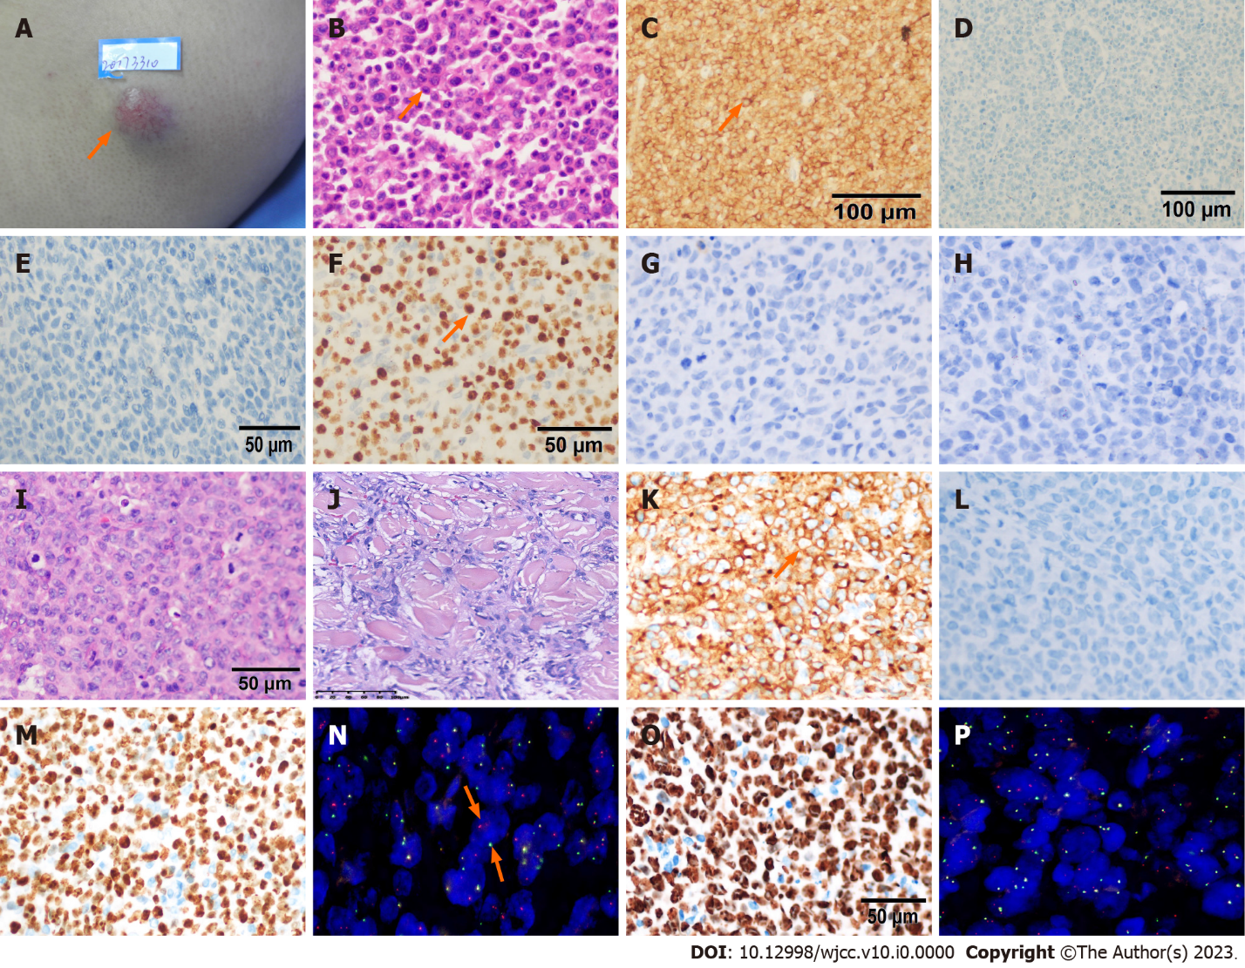
Figure 1 Morphologic and immunohistochemical characterization of this patient’s primary cutaneous anaplastic large cell lymphoma (A-H) and the markers at two times of his relapses (I-N for first relapse, O-P for second relapse). Unless otherwise indicated, the images are taken using 400× magnification. A: A 2 cm × 2 cm cutaneous swelling at left upper arm with many capillaries on the surface (arrow); B: Anaplastic large cell lymphoma with diffuse, cohesive sheets of enlarged cells with anaplastic morphology by hematoxylin and eosin (HE) (arrow); C: CD30 was strong, diffusely positive (80%) on the membrane of tumor cells (arrow), ×200; D: ALK was nagative in both cell nucleus and cytoplasma, ×200; E: EMA was cytoplasmic and membranaous nagative; F: Ki-67 was positive in 80% nucleoplasm and nucleoli rim (arrow). G: CD20 was negative. H: PAX5 was negative. I: Diffuse, cohesive lymphoma cells with anaplastic, pleomorphic appearance when the patient first relapsed by HE; J: Anaplastic large cell lymphoma tumor cells infiltrating in muscle layer; K: CD30 was difuse membranous positive (arrow); L: Anaplastic lymphoma kinase staining was negative; M: Ki67 was 95% in nucleus positive; N: Interferon regulatory factor 4 (IRF4) breakage was detected in 80% tumor cells by immunofluorescence hybridization (arrow). Spectrum Red stands for 5’ IRF4, Spectrum Green stands for 3’ IRF4; O: Ki67 was 90% positive when this patient relapsed secondly; P: IRF4 breakage was positive in 70% tumor cells.
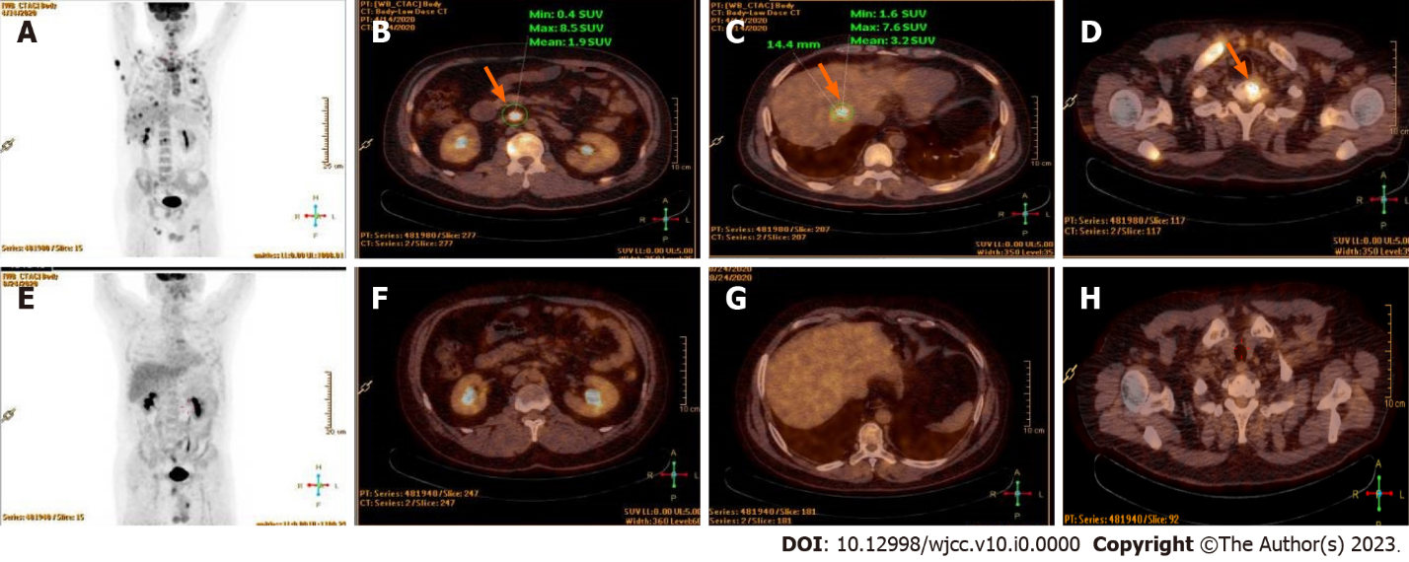
Figure 2 The results of positron emission tomography/computed tomography when the patient relapsed secondly. A: Lymphoma cells were widespread in this patient before the chemical treatment; B: Para-aortic node involved as the arrow showed (arrow); C: Liver involved as the arrow showed (arrow); D: Cervical vertebra was involved (arrow); E: No tumor found after the chemotherapy treatment; F-H: No 18F-flurodeoxyglucose uptakings were found in the organs mentioned above.

