Name of Journal: World Journal of Orthopedics
Manuscript NO: 87822
Manuscript Type: CASE REPORT

Unicompartimental knee arthroplasty metallosis treated with uni-on-uni revision: A case report

Toro G et al. Uka metallosis treated with uni-on-uni revision

Giuseppe Toro, Adriano Braile, Gianluca Conza, Annalisa De Cicco, Assala Abu Mukh, Giacomo Placella, Vincenzo Salini

Giuseppe Toro, Adriano Braile, Gianluca Conza, Annalisa De Cicco, Department of Medical and Surgical Specialties and Dentistry, University of Campania “Luigi Vanvitelli”, Naples 80138, Italy

Assala Abu Mukh, Giacomo Placella, Vincenzo Salini, Department of Orthopaedics and Traumatology, San Raffaele Hospital, Milan 20132, Italy

Author contributions: Braile A, Conza G and Salini V performed material preparation and data collection; Placella G, Toro G, Salini V performed data analysis and interpretation; Abu Mukh A and De Cicco A written the first draft of the manuscript; Placella G and Toro G revised the paper and wrote the final version of the manuscript; Toro G and Salini V supervised the entire study; all authors commented on previous versions of the manuscript; all authors read and approved the final manuscript; all authors contributed to the study conception and design.

Corresponding author: Giuseppe Toro, MD, PhD, Research Assistant Professor, Department of Medical and Surgical Specialties and Dentistry, University of Campania “Luigi Vanvitelli,” No. 4 Via L. De Crecchio, Naples 80138, Italy. giuseppe.toro@unicampania.it

Received: August 29, 2023
Revised: October 15, 2023
Accepted: November 9, 2023
Published online: December 18, 2023

Abstract
BACKGROUND
Metallosis is the result of metallic wear debris in the soft tissues and is associated to both local and systemic inflammatory response. Metallosis has been reported after total hip and total knee arthroplasty (TKA), but rarely after a unicompartimental knee arthroplasty (UKA). In the context of UKA metallosis, surgeons often opt for revision using a TKA. However, in this paper, the authors successfully treated UKA revising the metal back only.

CASE SUMMARY
Prior to treat our patient we conducted a literature research through which we identified eleven cases of metallosis after UKA, ten (90.9%) were treated revising using though a TKA. Only one case was managed through a uni-on-uni revision, reporting high knee function. Our patient complained worsening pain and function after a snap occurred at 16 mo after UKA implantation. At 18 mo following surgical debridment and uni-on-uni revision surgery, our patient exhibited a relevant improvement in Oxford Knee Score and a reduction of metal ion levels in the blood.

CONCLUSION
Our study highlights that in case of metallosis after UKA, the treatment may be based on surgical debridement and just revising the mobilized components.

Key Words: Metallosis; Unicompartimental knee arthroplasty; Revision; Uni-on-uni revision; case report; Review; Case report

©The Author(s) 2023. Published by Baishideng Publishing Group Inc. All rights reserved.

Citation: Toro G, Braile A, Conza G, De Cicco A, Abu Mukh A, Placella G, Salini V. Unicompartimental knee arthroplasty metallosis treated with uni-on-uni revision: A case report. World J Orthop 2023; 14(12): 889-896
URL: https://www.wjgnet.com/2218-5836/full/v14/i12/889.htm
DOI: https://dx.doi.org/10.5312/wjo.v14.i12.889

Core Tip: Metallosis is a rare but serious complication of unicompartimental knee arthroplasty. It is generally treated through surgical debridment and revision to a total knee arthroplasty. However, in case of absence of critical signs of implant malpositioning, soft tissue impairment or bone loss, it could be successfully resolved through surgical debridment and uni-on-uni revision.
INTRODUCTION
Metallosis is a condition in which prosthetic metallic wear produces debris that could be observed in soft tissues, causing both local and systemic inflammation, and could be associated to malignant tumors and systemic toxicity^{[1,2]}. Metallosis had been associated mainly with total hip arthroplasty (THA)^{[3]}. In fact, it could be observed in 2%-5% of metal-on-metal THA implants, yet it was also described in the context of total knee arthroplasty (TKA) and less frequently unicompartimental knee arthroplasty (UKA)^{[4]}. Metallosis treatment contemplates wide surgical debridement and revision surgery. Nevertheless, the authors noticed that the revision seems to differ from the damage entity. The rare cases of metallosis after an UKA are generally treated through a revision with TKA^{[5-15]}. In this article, we review the literature and introduce a case of 77 years old man presenting an UKA metallosis treated with debridement and UKA tibial metalback revision.

CASE PRESENTATION
Chief complaints
This article reports the case of a 77 years old patient with a metallosis after a UKA.

History of present illness
13-mo before, the patient perceived a “snap”, that was initially conservatively treated, considering the complete and painless range of motion documented during outpatient evaluation.

History of past illness
Sixteen months prior to the metallosis diagnosis, the patient underwent to a medial UKA for unicompartimental knee osteoarthritis.

Personal and family history
The patient had no other relevant co-morbidities.

Physical examination
In the three months after the “snap,” the patient started to report a constant worsening of knee pain and a substantial reduction of joint function [oxford knee score (OKS) of 27/48].

Laboratory examinations
Baseline blood ion levels were in line with a diagnosis of metallosis (Chrome 1.26 µg/L, Cobalt 3.94 µg/L).

Imaging examinations
The imaging performed at that time confirmed tibial implant loosening (Figure 1) and revision surgery was necessary after excluding infection^{[16-18]}.

Multidisciplinary expert consultation
Prior to treat the patient, the research team decided to evaluate all the possible procedures. Therefore, a literature research was conducted through PubMed by two independent reviewers (Braile A and Conza G) using the following terms in their various combinations “Unicompartmental knee arthroplasty,” “metallosis,” “liner dislocation”, “fixed-bearing”, “mobile-bearing”. Studies compatible with our criteria were included and controversies between the two reviewers were analyzed by a third author for the inclusion decision (Salini V).
The literature search was conducted only in PubMed given that 90% of high-quality studies can be retrieved from this database, as reported by Rollin et al^{[19]}. Therefore, to summarize the knowledge around a specific topic, PubMed research should be considered cost-effective as practitioners are able to easily retrieve most of the literature by using it^{[19,20]}. All articles on metallosis after UKA in English, Spanish and Italian languages were included and analyzed in the present review. Articles with incomplete follow-up were excluded. The references cited in the included articles were also reviewed to identify further relevant studies. Data from each retrieved study were collected using a pre-arranged form. Out of 45 records identified, 20 presented criteria for further review. Eleven articles were then excluded after abstract review because did not meet the inclusion criteria. One further article was included after reviewing references cited in the included articles. Therefore, 10 articles, including 11 patients were retrieved and analyzed in the present study (Figure 2).
Patient age averaged 66.4 years (54-76 years), metallosis occurred at a mean time of 42.58 mo from the UKA. Out of 11 patients, 9 (81.8%) were treated through revision TKA. Two cases necessitated a second revision TKA at a mean of 39 mo. The functional outcome improved in all eleven cases (Table 1).

FINAL DIAGNOSIS
Intraoperatively, signs of soft tissue metallosis were evident (Figure 3). Following soft-tissue debridement and specimen collection, a component stability test confirmed isolated loosening of the tibial implant. Surgical specimen and baseline blood ion levels confirmed metallosis (Chrome 1.26 µg/L, Cobalt 3.94 µg/L).

TREATMENT
The mobilized tibial component was revised using a larger Genus UNI Alderortho implant (Cormano, Italy).

OUTCOME AND FOLLOW-UP
We assessed the patient functional status through OKS and blood ion levels as previously recommended^{[21,22]}. The patient presented a normal postoperative course. Complete range of motion, OKS score improvement (40/48), and good knee alignment were reported at 18 mo (Figure 4), while normalization of Ion blood levels (Chrome 0.95 µg/L, Cobalt 1.06 µg/L) were documented at 30 d after the uni-on-uni revision (Table 2).

DISCUSSION
Although UKA is an effective bone-preserving surgical option for unicompartmental symptomatic knee osteoarthritis in young and middle-aged patients^{[23]}, several complications may arise after its implantation. Due to the increasing number of arthroplasties performed yearly, optimizing the complication management is necessary.
In our case, we attributed metallosis and implant failure due to the progressive subclinical spinout of the polyethylene liner in an undersized tibial component which led to a posterior overload on the tibial implant. The surgeons performed UKA revision with a new UKA larger tibial implant against general recommendations because no tibial slope or coronal malalignment were present^{[24-27]}.
Very few cases of UKA revision with a new UKA implant were described in the available literature. Luyet et al^{[12]} in a case of anterior dislocation of the polyethylene liner at 6 wk, presenting as a painful and swollen knee^{[13]} furtherly complicated by metallosis decided to treat it through a uni-on-uni revision. Following the surgery, the patient presented good clinical and radiological outcomes in a 2 year follow-up^{[12]}. Good clinical outcomes were reported after a Uni-on-uni revision also in an another a recent review about metallosis after knee replacement^{[4]}. Epinette et al^{[27]} in a retrospective study of 36 UKA-to-UKA revision surgery described this treatment as a reliable option, with lower morbidity and better functional outcomes compared with UKA-to-TKA revision. The authors suggested to reserve in patients with limited bone defects and no extension of the lesions^{[27]}.
Our review is limited by several factors including low patient number, the absence of a statistical analysis related to the nature of the review, and lack of literature on UKA metallosis. However, to the best of our knowledge, this is the first study reporting bloodstream ion changes while confirming clinical improvement following uni-on-uni revision in case of UKA metallosis. However, we believe that further analysis is necessary to confirm successful uni-on-uni revisions in case of metallosis.

CONCLUSION
In conclusion, we suggest that aseptic UKA metallosis without critical signs of malpositioning, soft tissue impairment or bone loss could be treated with surgical debridement and unicompartimental knee revision arthroplasty. This kind of approach could lead to a significant improvement of functional outcomes, and blood ion levels.

REFERENCES
1 Toro G, De Cicco A, Braile A, Landi G, Schiavone Panni A. New insights on metal allergy in total joint arthroplasty. J Biol Regul Homeost Agents 2020; 34: 125-130. IORS Special Issue on Orthopedics [PMID: 33739017]
2 Pesce V, Maccagnano G, Vicenti G, Notarnicola A, Lovreglio P, Soleo L, Pantalone A, Salini V, Moretti B. First case report of vanadium metallosis after ceramic-on-ceramic total hip arthroplasty. J Biol Regul Homeost Agents 2013; 27: 1063-1068 [PMID: 24382188]
3 Goderecci R, Fidanza A, Necozione S, Francione V, Indelli PF, Calvisi V. Ultrasound-based decision making following metal-on-metal hip arthroplasty. J Clin Orthop Trauma 2020; 11: 79-84 [PMID: 32001990 DOI: 10.1016/j.jcot.2019.04.009]
4 Sahan I, Anagnostakos K. Metallosis after knee replacement: a review. Arch Orthop Trauma Surg 2020; 140: 1791-1808 [PMID: 32715399 DOI: 10.1007/s00402-020-03560-x]
5 Sanchis-Alfonso V. Severe metallosis after unicompartmental knee arthroplasty. Knee Surg Sports Traumatol Arthrosc 2007; 15: 361-364 [PMID: 17028866 DOI: 10.1007/s00167-006-0207-6]
6 Apostolopoulos AP, Katsougrakis I, Fanous R, Harrison A, Saavedra E. Severe metallosis following polyethylene dislocation in a mobile-bearing medial unicompartmental knee replacement. J Long Term Eff Med Implants 2014; 24: 147-150 [PMID: 25272213 DOI: 10.1615/jlongtermeffmedimplants.2014010563]
7 Fujii T, Matsui Y, Noboru M, Inagaki Y, Kadoya Y, Tanaka Y. Meniscal Bearing Dislocation of Unicompartmental Knee Arthroplasty with Faint Symptom. Case Rep Orthop 2015; 2015: 217842 [PMID: 26137336 DOI: 10.1155/2015/217842]
8 Vajapey SP, Alvarez PM, Chonko D. Bearing failure in a mobile bearing unicompartmental knee arthroplasty: an uncommon presentation of an implant-specific complication. Arthroplasty 2021; 3: 16 [PMID: 35236477 DOI: 10.1186/s42836-021-00073-9]
9 Foran JR, Brown NM, Della Valle CJ, Berger RA, Galante JO. Long-term survivorship and failure modes of unicompartmental knee arthroplasty. Clin Orthop Relat Res 2013; 471: 102-108 [PMID: 22895691 DOI: 10.1007/s11999-012-2517-y]
10 Vecchini E, Ditta A, Gelmini M, Maluta T, Valentini R, Ricci M, Magnan B. Rupture of the femoral component and severe metallosis of the knee 10 years after unicompartmental knee arthroplasty (UKA): a case report. Acta Biomed 2019; 90: 198-202 [PMID: 30715025 DOI: 10.23750/abm.v90i1-S.8082]
11 Greco N, Berend K. Polyethylene liner dislocation of fixed-bearing medial oxinium unicompartmental arthroplasty with severe metallosis. Knee 2018; 25: 341-345 [PMID: 29525546 DOI: 10.1016/j.knee.2018.01.004]
12 Luyet A, Fischer JF, Jolles BM, Lunebourg A. Unexpected wear of an unicompartimental knee arthroplasty in oxidized zirconium. Acta Orthop Belg 2015; 81: 790-795 [PMID: 26790806]
13 Rajgopal A, Panda I, Tyagi VC. Early failure with massive metallosis and posteromedial wear following atraumatic anterior cruciate ligament rupture after medial unicompartmental knee arthroplasty. Arthroplast Today 2018; 4: 15-19 [PMID: 29560389 DOI: 10.1016/j.artd.2017.09.007]
14 Kiran M, Kho J, Hepburn E, Chakraverty J, Davies H. Chronic Wear-Induced Bearing Dislocation in a Fixed-Bearing Unicompartmental Knee Arthroplasty: A Case Report. JBJS Case Connect 2021; 11 [PMID: 34491688 DOI: 10.2106/JBJS.CC.21.00364]
15 Pescador D, Calero-Paniagua I, Sánchez-González MD, Montilla C. Metallosis as a cause of pain and inflammation in a patient with a knee replacement: A case description. Reumatol Clin 2016; 12: 112-113 [PMID: 26099454 DOI: 10.1016/j.reuma.2015.04.005]
16 Toro G, Braile A, Zappulo E, Panni AS, Indelli PF. Does D-Dimer really help in the diagnosis of chronic periprosthetic joint infections (PJI)? A case-control study. Journal of Arthroscopy and Joint Surgery 2020; 7: 189-193 [DOI: 10.1016/j.jajs.2020.08.006]
17 Panni AS, Ascione F, Rossini M, Braile A, Corona K, Vasso M, Hirschmann MT. Tibial internal rotation negatively affects clinical outcomes in total knee arthroplasty: a systematic review. Knee Surg Sports Traumatol Arthrosc 2018; 26: 1636-1644 [PMID: 29247357 DOI: 10.1007/s00167-017-4823-0]
18 Vasso M, Braile A, Ascione F, Toro G, De Cicco A, Lepore F, Schiavone Panni A. Two-stage reimplantation in periprosthetic knee infection. Eur Rev Med Pharmacol Sci 2019; 23: 51-58 [PMID: 30977871 DOI: 10.26355/eurrev_201904_17474]
19 Rollin L, Darmoni S, Caillard JF, Gehanno JF. Searching for high-quality articles about intervention studies in occupational health--what is really missed when using only the Medline database? Scand J Work Environ Health 2010; 36: 484-487 [PMID: 20740265 DOI: 10.5271/sjweh.3082]
20 Pillastrini P, Vanti C, Curti S, Mattioli S, Ferrari S, Violante FS, Guccione A. Using PubMed search strings for efficient retrieval of manual therapy research literature. J Manipulative Physiol Ther 2015; 38: 159-166 [PMID: 25499192 DOI: 10.1016/j.jmpt.2014.11.005]
21 Swiatkowska I, Martin N, Hart AJ. Blood titanium level as a biomarker of orthopaedic implant wear. J Trace Elem Med Biol 2019; 53: 120-128 [PMID: 30910194 DOI: 10.1016/j.jtemb.2019.02.013]
22 Cobalt Blood Level. Science Direct Topics. Available from: https://www.sciencedirect.com/topics/nursing-and-health-professions/cobalt-blood-level
23 Johal S, Nakano N, Baxter M, Hujazi I, Pandit H, Khanduja V. Unicompartmental Knee Arthroplasty: The Past, Current Controversies, and Future Perspectives. J Knee Surg 2018; 31: 992-998 [PMID: 29514367 DOI: 10.1055/s-0038-1625961]
24 Hernigou P, Deschamps G. Posterior slope of the tibial implant and the outcome of unicompartmental knee arthroplasty. J Bone Joint Surg Am 2004; 86: 506-511 [PMID: 14996875 DOI: 10.2106/00004623-200403000-00007]
25 Crawford DA, Berend KR, Lombardi AV. Management of the Failed Medial Unicompartmental Knee Arthroplasty. J Am Acad Orthop Surg 2018; 26: e426-e433 [PMID: 30113345 DOI: 10.5435/JAAOS-D-17-00107]
26 Lombardi AV Jr, Kolich MT, Berend KR, Morris MJ, Crawford DA, Adams JB. Revision of Unicompartmental Knee Arthroplasty to Total Knee Arthroplasty: Is It as Good as a Primary Result? J Arthroplasty 2018; 33: S105-S108 [PMID: 29691172 DOI: 10.1016/j.arth.2018.03.023]
27 Epinette JA, Leyder M, Saragaglia D, Pasquier G, Deschamps G; Société Française de la Hanche et du Genou. Is unicompartmental-to-unicompartmental revision knee arthroplasty a reliable option? Case-control study. Orthop Traumatol Surg Res 2014; 100: 141-145 [PMID: 24373806 DOI: 10.1016/j.otsr.2013.10.013]

Footnotes
Informed consent statement: Informed written consent was obtained from the patient for publication of this report and any accompanying images.

Conflict-of-interest statement: The authors declare that they have no conflict of interest.

CARE Checklist (2016) statement: The authors have read the CARE Checklist (2016), and the manuscript was prepared and revised according to the CARE Checklist (2016).

Open-Access: This article is an open-access article that was selected by an in-house editor and fully peer-reviewed by external reviewers. It is distributed in accordance with the Creative Commons Attribution NonCommercial (CC BY-NC 4.0) license, which permits others to distribute, remix, adapt, build upon this work non-commercially, and license their derivative works on different terms, provided the original work is properly cited and the use is non-commercial. See: https://creativecommons.org/Licenses/by-nc/4.0/

Provenance and peer review: Unsolicited article; Externally peer reviewed.

Peer-review model: Single blind

Peer-review started: August 29, 2023
First decision: October 9, 2023
Article in press: November 9, 2023

Specialty type: Orthopedics
Country/Territory of origin: Italy
Peer-review report’s scientific quality classification
Grade A (Excellent): 0
Grade B (Very good): 0
Grade C (Good): C
Grade D (Fair): 0
Grade E (Poor): 0

P-Reviewer: OOMMEN AT, India S-Editor: Qu XL L-Editor: A P-Editor: Yuan YY

Figure Legends
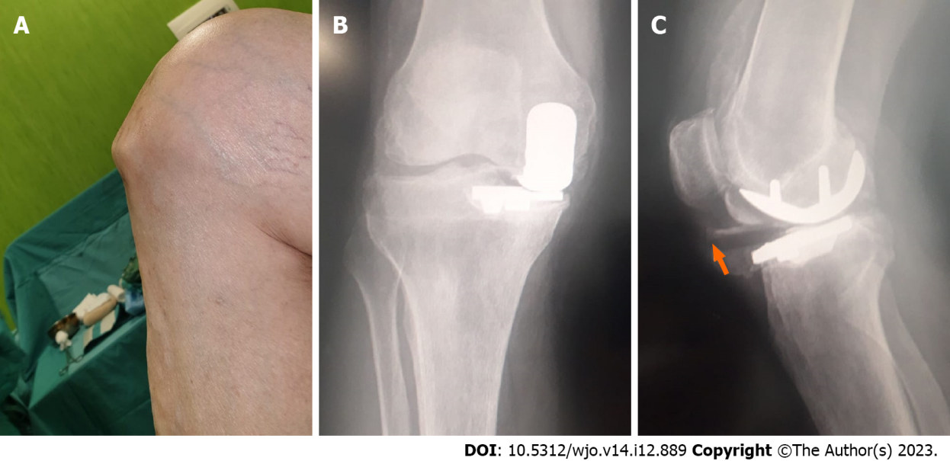
Figure 1 Patient’s preoperative evaluation. A: Clinics; B: Radiographs; C: Liner dislocation is indicated with white arrow.
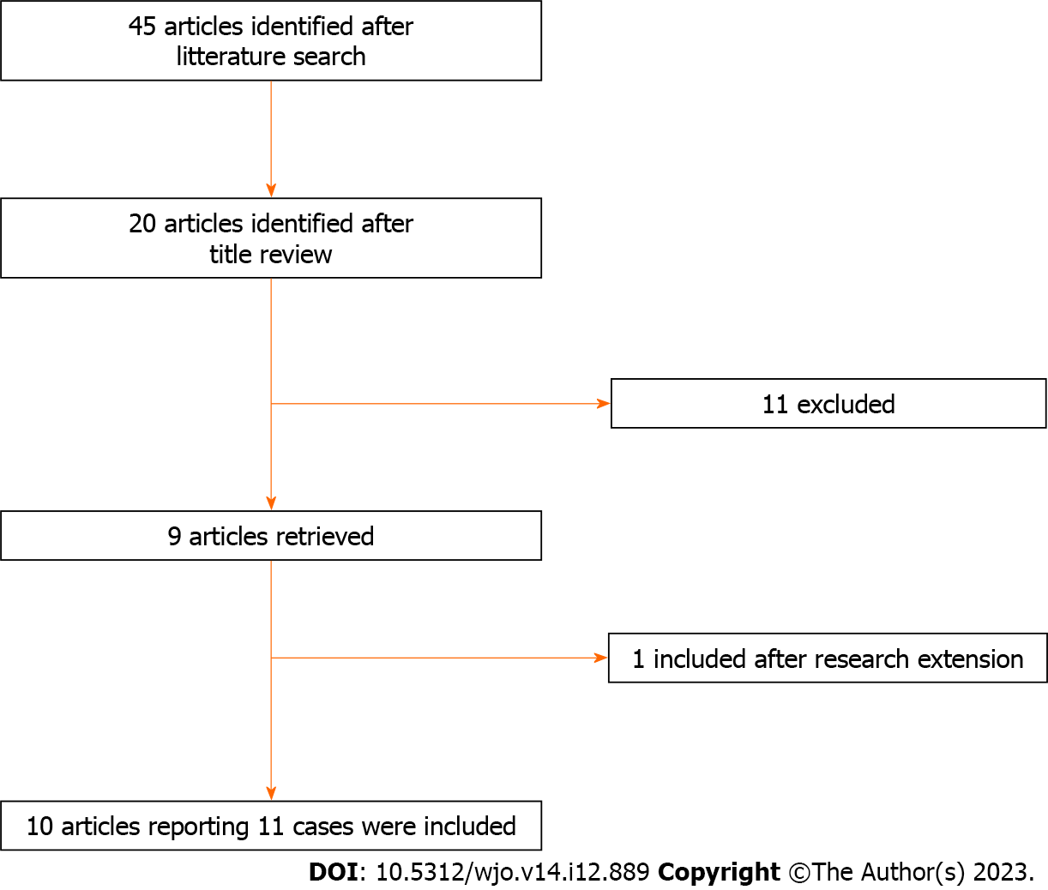
Figure 2 Summary of article inclusion process.
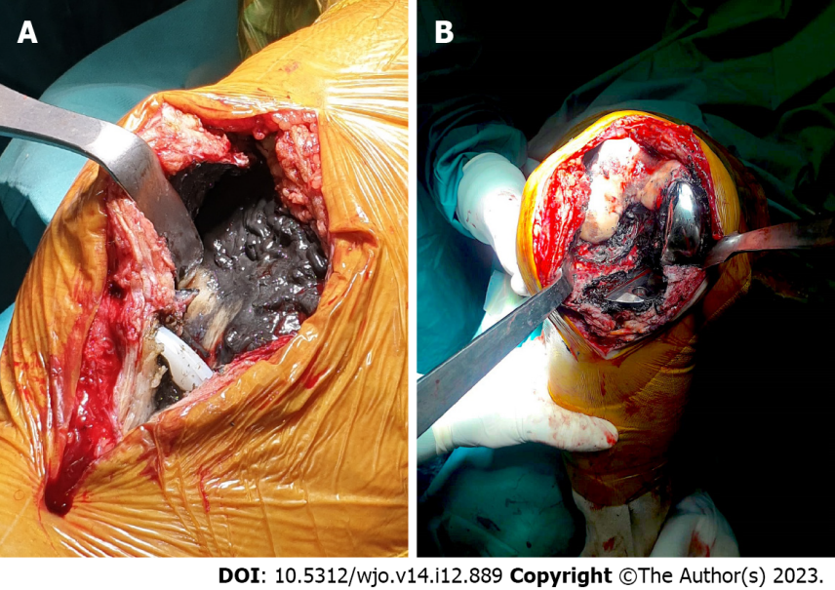
Figure 3 Intraoperative photographs documenting peri-prosthetic soft tissue metallosis. A: Note the luxated bearing; B: Note the metal back debris.
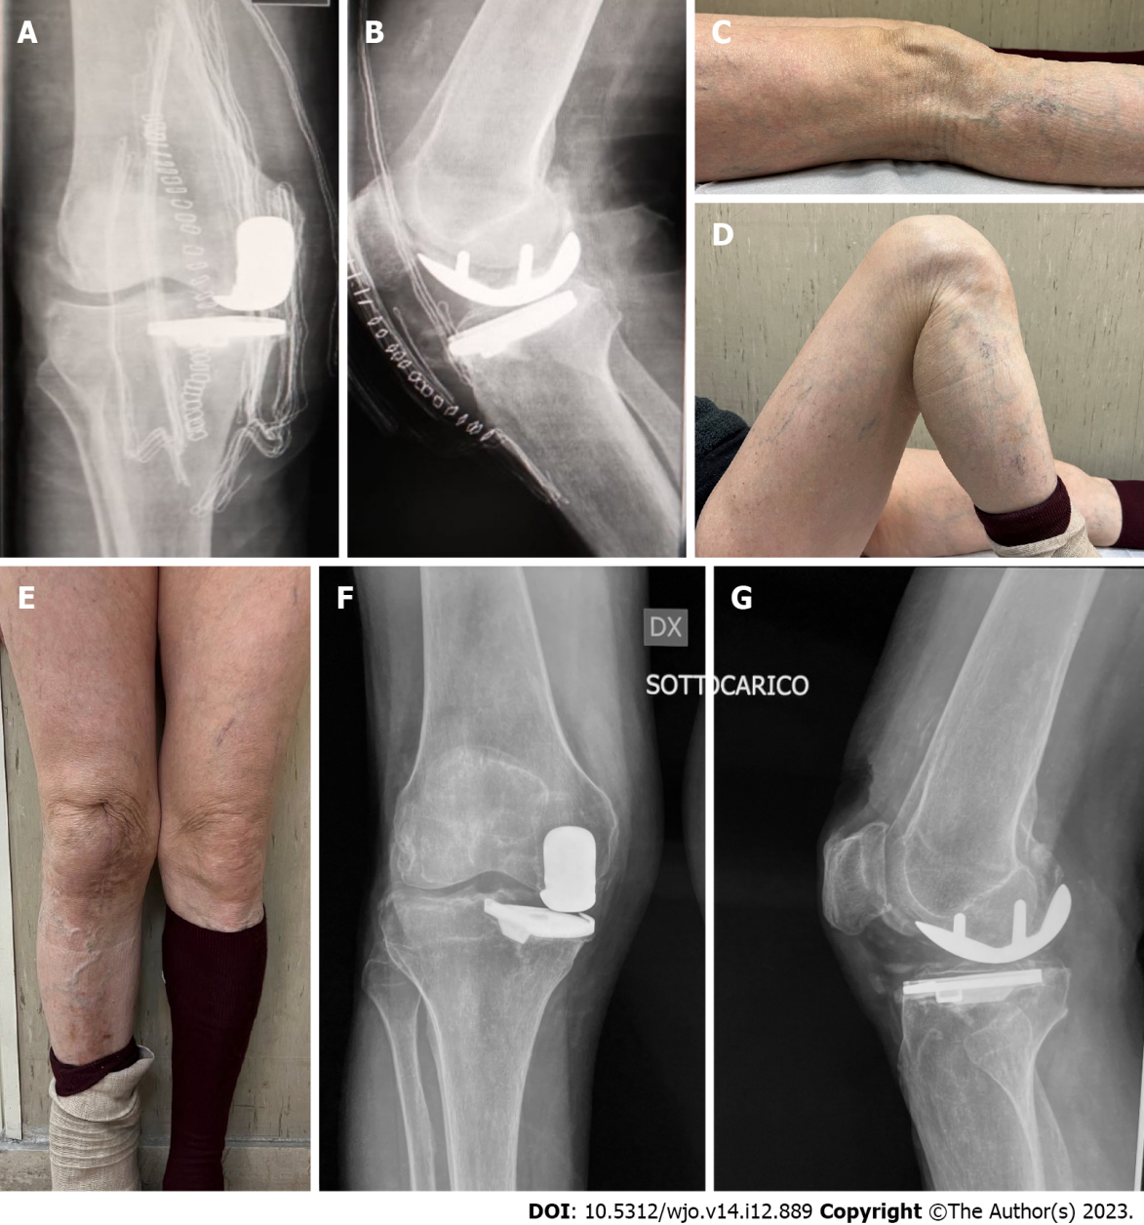
Figure 4 Postoperative history. A and B: Postoperative X-rays; C-E: Clinical evaluation documenting range of motion at final follow-up; F and G: Radiographies documenting implant alignment at final follow-up.
Table 1 Litterature review
Article info |  |  |  |  | Studied population |  |  |  |  |  |  |  |  | Outcomes
N. | Ref. | Year | Journal | Type | Population (n.) | Sex | Age (yr) | Implant type | Months elapsed between implantation and bearing dislocation | Metal ions (Cr/Cb) | Type of precedure | Function pre-op | Knee ROM pre-op | Metal ions (Cr/Cb) last follow-up | Function last follow-up | Knee ROM last follow-up | General complications | Infection | Fracture | Implant loosening (yes /months)
1 | Sanchis-Alfonso et al^{[5]} | 2007 | KSSTA | Case report | 1 | M | 54 | Fixed bearing |  | NA | Revision with TKA |  |  | NA
2 | Apostolopoulos et al^{[6]} | 2014 | J Long Term Eff Med Implants | Case report | 1 | M | 67 | Mobile bearing | 54 | NA |  |  |  | NA |  |  | None | No | No | Yes /54
3 | Vecchini et al^{[10]} | 2019 | Acta Biomed | Case report | 1 | M | 71 | NA |  | NA | Revision with TKA |  | 10-110 | NA |  | 0-130 | None | No | No
4 | Greco et al^{[11]} | 2018 | The knee | Case report | 1 | M | 72 | Fixed bearing |  | NA | Revision with TKA |  |  | NA |  |  | None | No | No
5 | Rajgopal et al^{[13]} | 2018 | Arthroplast today | Case report | 1 | M | 58 | NA | 24 | NA | Revision with TKA | KSS 48 OKS 19 UCLA 3 | 0-100 | NA | KSS 82 OKS 40 UCLA 7 |  | None | No | No | Yes /24
6 | Vajapey et al^{[8]} | 2021 | Arthroplasty | Case series | 2 | F | 76 | NA | 60 | NA | Revision with TKA |  | 30-120 | NA |  |  | None | No | No
7 | Kiran et al^{[14]} | 2021 | JBJS Case connector | Case report | 1 | M | 61 | Fixed bearing | 60 | NA | Revision with TKA |  | NA | NA | OKS 39 |  | None | None | None
8 | Foran et al^{[9]} | 2013 | Clin Orthop Relat Res | Case series | 1 | NA | NA | NA | 56 | NA | Revision with TKA |  |  | NA
9 | Luyet et al^{[12]} | 2015 | Acta Ortop. Belg. | Case report | 1 | F | 67 | NA | 1,5 | NA | Revision with UKA | ksk 59 KSF 60 | 0-90 | NA | Ksk 87 KSF 90 | 0-110 |  | No | No
10 | Pescador et al^{[15]} | 2016 | Reumatol Clin. | Case report | 1 | F | 72 | NA |  | NA | Revision with TKA |  |  | NA
TOT. |  |  |  |  | 11 | 6 M /4 F | Mean: 66, 4 | 3 Fixed /1 Mobile | Mean: 42, 58 |  | 9 TKA /1 UKA
NA: Not available; TKA: Total knee arthroplasty; UKA: Unicompartmental knee artrhoplasthy; KSS: Knee society score; UCLA: UCLA activity scale; OKS: Oxford knee score; KSF: Knee society function score.

Table 2 Illustrating oxford knee score and blood ion levels before and after revision surgery
 | Pre-revision | Last follow-up
OKS | 27 | 40
Chrome (µg/L) | 126 | 106
Cobalt (µg/L) | 334 | 95
OKS: Oxford knee score.

Published by Baishideng Publishing Group Inc
7041 Koll Center Parkway, Suite 160, Pleasanton, CA 94566, USA
Telephone: +1-925-3991568
E-mail: bpgoffice@wjgnet.com
Help Desk: https://www.f6publishing.com/helpdesk
https://www.wjgnet.com

© 2023 Baishideng Publishing Group Inc. All rights reserved.

