Name of Journal: World Journal of Clinical Cases
Manuscript NO: 66764
Manuscript Type: ORIGINAL ARTICLE

Retrospective Study
Retrospective study of effect of whole-body vibration training on balance and walking function in stroke patients

Xie L et al. Whole-body vibration training in stroke patients

Lei Xie, Shi-Xiong Yi, Qi-Feng Peng, Pei Liu, Heng Jiang

Lei Xie, Shi-Xiong Yi, Qi-Feng Peng, Pei Liu, Heng Jiang, Department of Rehabilitation, Chongqing Traditional Chinese Medicine Hospital, Chongqing 400021, China

Author contributions: Jiang H provided conceptualization and methodology and supervised the report; Xie L and Yi SY wrote and reviewed the paper; Liu P contributed to the analysis; Peng QF provided data curation.

Supported by Chongqing Science and Technology Bureau, No. cstc2019jxjl130023.

Corresponding author: Heng Jiang, MM, Associate Chief Physician, Department of Rehabilitation, Chongqing Traditional Chinese Medicine Hospital, No. 6 Seventh Branch Panxi Road, Jiangbei District, Chongqing 400021, China. 1933286638@qq.com

Received: April 7, 2021
Revised: May 7, 2021
Accepted: May 24, 2021
Published online: August 6, 2021

Abstract
BACKGROUND
Dysfunction in stroke patients has been a problem that we committed to solve and explore. Physical therapy has some effect to regain strength, balance, and coordination. However, it is not a complete cure, so we are trying to find more effective treatments.

AIM
To observe the effect of whole-body vibration training (WVT) on the recovery of balance and walking function in stroke patients, which could provide us some useful evidence for planning rehabilitation.

METHODS
The clinical data of 130 stroke participants who underwent conventional rehabilitation treatment in our hospital from January 2019 to August 2020 were retrospectively analyzed. The participants were divided into whole-body vibration training (WVT) group and non-WVT (NWVT) group according to whether they were given WVT. In the WVT group, routine rehabilitation therapy was combined with WVT by the Galileo Med L Plus vibration trainer at a frequency of 20 Hz and a vibration amplitude of 0+ACY-plusmn+ADs-5.2 mm, and in the NWVT group, routine rehabilitation therapy only was provided. The treatment course of the two groups was 4 wk. Before and after treatment, the Berg balance scale (BBS), 3 m timed up-and-go test (TUGT), the maximum walking speed test (MWS), and upper limb functional reaching (FR) test were performed.

RESULTS
After 4 wk training, in both groups, the BBS score and the FR distance respectively increased to a certain amount (WVT = 46.08 ± 3.41 vs NWVT = 40.22 ± 3.75; WVT = 20.48 ± 2.23 vs NWVT = 16.60 ± 2.82), with P < 0.05. Furthermore, in the WVT group, both BBS score and FR distance (BBS: 18.32 ± 2.18; FR: 10.00 ± 0.92) increased more than that in the NWVT group (BBS: 13.29 ± 1.66; FR: 6.16 ± 0.95), with P < 0.05. Meanwhile, in both groups, the TUGT and the MWS were improved after training (WVT = 32.64 ± 3.81 vs NWVT = 39.56 ± 3.68; WVT = 12.73 ± 2.26 vs NWVT = 15.04 ± 2.27, respectively), with P < 0.05. The change in the WVT group (TUGT: 17.49 ± 1.88; MWS: 6.79 ± 0.81) was greater than that in the NWVT group (TUGT: 10.76 ± 1.42; MWS: 4.84 ± 0.58), with P < 0.05.

CONCLUSION
The WVT could effectively improve the balance and walking function in stroke patients, which may be good for improving their quality of life.

Key Words: Balance function; Berg balance scale; Maximum walking speed test; Stroke; Timed up-and-go test; Vibration training

©The Author(s) 2021. Published by Baishideng Publishing Group Inc. All rights reserved.

Citation: Xie L, Yi SX, Peng QF, Liu P, Jiang H. Retrospective study of effect of whole-body vibration training on balance and walking function in stroke patients. World J Clin Cases 2021; 9(22): 6268-6277 URL: https://www.wjgnet.com/2307-8960/full/v9/i22/6268.htm DOI: https://dx.doi.org/10.12998/wjcc.v9.i22.6268

Core Tip: It is widely known that stroke victims have problems with walking, standing, balance, etc. In these populations, after training with a whole-body vibrator, there were some implications for rehabilitation, as follows: the patient’s quality of movement was improved, which included movements such as standing up, sitting down, standing independently, standing with the eyes closed, standing with the arms held out in front of the body, turning around, crossing with both feet, and standing on one leg; and the speed of the patient’s movement was faster, such as walking straight, getting up from the chair, and sitting down.
INTRODUCTION
Stroke is a cardiovascular disease associated with high disability and mortality rates^{[1,2]}. In recent years, epidemiological studies have shown that the incidence of stroke is increasing and that the age of onset is becoming younger^{[3]}. Stroke patients often have many dysfunctions, such as motor, speech, and swallowing dysfunction. Among them, balance dysfunction is the most common^{[4,5]}. Vibration training can create mechanical vibrations that stimulate proprioceptors, such as Golgi’s body, and then trigger the stretch reflex, thereby enhancing muscle function and the adaptability of the nervous system^{[6-8]}. This study aimed to explore the effect of vibration training on the balance ability of stroke patients.

MATERIALS AND METHODS
General information
The study is a retrospective study, which a total of 159 participants with stroke were in the Rehabilitation Department of Chongqing Traditional Chinese Medicine Hospital for treatment from January 2019 to August 2020. There were 5 patients who dropped out during the inpatient stay. Another 24 patients were excluded because no assessment could be performed in all 4 investigations. In total 130 participants were eligible (Figure 1). All the participants underwent conventional rehabilitation treatment and were divided into whole-body vibration training (WVT) group and non-WVT (NWVT) group according to whether they were given WVT. The WVT group included 65 participants, 41 with cerebral hemorrhage and 24 with cerebral infarction. The mean age was 60.42 ± 6.39 years. There were 32 males and 33 females. There were 36 cases of left hemiplegia and 29 cases of right hemiplegia. In the NWVT group, there were 65 participants, including 37 participants with cerebral hemorrhage and 28 participants with cerebral infarction. The mean age was 59.82 ± 6.62 years, and there were 33 males and 32 females. There were 32 cases of left hemiplegia and 33 cases of right hemiplegia. Detailed information on the two groups is provided in Table 1.

Inclusion criteria
All participants were in the recovery phase after cerebral infarction or cerebral hemorrhage, as confirmed by brain computed tomography or magnetic resonance imaging. All cases were of the first onset, the course of disease was within 6 mo, and the conditions of the participants were stable. The inclusion criteria also included stable vital signs, the absence of cognitive impairment, a Mini-mental State Examination score ≥ 24, a Brunnstrom stage of IV or higher, a modified Ashworth scale score of less than 2, and a standing balance score of 3.

Exclusion criteria
Participants with training contraindications (a fresh fracture, deep venous thrombosis, malignant tumor, etc.), unilateral neglect, severe sensory impairment with vestibular or cerebellar dysfunction, the inability to complete training, or changes in the disease during the study period were excluded.

Research methods
For the NWVT group, conventional rehabilitation therapy included acupuncture, physical therapy, occupational therapy, and speech and swallowing therapy, combined with balance board training. For the WVT group, routine rehabilitation therapy was combined with WVT with the Galileo Med L Plus vibration trainer from Germany, with a frequency of 20 Hz^{[9]} and a vibration amplitude of 0 ± 5.2 mm. Each patient stood on the vibrating plate with bare feet, held the handle with both hands, kept their body upright, and maintained a knee flexion angle of 30° to 45°. Each training session included 5 sets of 2 min trials, and a rest interval of 1 min was provided after each set; the sessions were performed 6 d per wk, allowing for 1 d of rest. The participants in both groups trained for 4 wk and underwent tests before and after training.

The indicators
The Berg balance scale (BBS) includes 14 items involving movements such as standing up, sitting down, standing independently, standing with the eyes closed, standing with the arms held out in front of the body, turning around, crossing with both feet, and standing on one leg; each item received a score of 0-4 points, for a total of 56 points. The higher the score was, the better the patient’s balance ability. It is the main scale used to evaluate the balance ability of stroke clinically, with high reliability and validity. All patients’ evaluations were performed by the same therapist.
For the timed up-and-go test (TUGT), a chair is set up and a mark is made 3 m in front of the chair. After getting up from the chair, the participants walked forward 3 m, turned around at the marking, walked to the chair, and sat down, and the total time that the patient took to complete this task was recorded. The TUGT involves standing, moving, turning, changing direction, etc., which can reflect a patient’s dynamic balance ability well. Each test was performed three times, and the average time across the three trials was used for analysis.
For the maximum walking speed (MWS) test, a 16 m long straight line is marked with brightly colored markers. The starting point, 3 m, 13 m, and the end point of the line are marked. The participants were asked to walk as fast as possible from the start to the end, and a stopwatch was used to record the patient’s time between the 3 m and 13 m marks. Each test was performed three times, and the average value was used for analysis.
For the functional reaching (FR) test, the participants stood parallel to the wall on both feet, with their hands in the Bobath handshake and the shoulder flexed to 90°. A scale was fixed parallel to the patient’s upper limb, and then the patient bent forward as far as possible. The upper limb was stretched to the critical point of balance, with the patient’s middle finger as the measurement point, and the patient’s forward stretching distance was measured. FR can reflect the maximum stress deviation of a patient’s balance pressure center and static balance ability well. The test was performed three times, and the average value was used for analysis.

Statistical analysis
SPSS 21 was used for statistical analysis. The measurement data are expressed as (mean ± standard deviation), and the data met the requirements for normality and homogeneity of variance. Independent samples t tests were used for intergroup comparisons, and paired samples t tests were used for intragroup comparisons. P < 0.05 was considered statistically significant.

RESULTS
Before training, there were no statistically significant differences in the BBS score between the two groups (WVT = 27.75 ± 2.87; NWVT = 26.92 ± 3.24). After 4 wk of training, the BBS score in both groups increased (WVT = 46.08 ± 3.41; NWVT = 40.22 ± 3.75), with P < 0.05. The BBS score of the WVT group after training was higher than that of the NWVT group (WVT = 18.32 ± 2.18; NWVT = 13.29 ± 1.66), as shown in Table 2 and Figure 2.
There were no statistically significant differences in the TUGT time between the two groups before training (WVT = 50.13 ± 3.91; NWVT = 50.32 ± 3.38). After 4 wk, both groups exhibited shorter TUGT times (WVT = 32.64 ± 3.81; NWVT = 39.56 ± 3.68), with P < 0.05. The change of TUGT time in the WVT group was more than that in the NWVT group (WVT = 17.49 ± 1.88; NWVT = 10.76 ± 1.42) (Table 2 and Figure 3).
There were no statistically significant differences in the MWS between the two groups before training (WVT = 19.52 ± 2.03; NWVT = 19.89 ± 2.10). Training for 4 wk, the MWS in both groups decreased (WVT = 12.73 ± 2.26; NWVT = 15.04 ± 2.27), with P < 0.05. The change of MWS in the WVT group was greater than that of the NWVT group (WVT = 6.79 ± 0.81; NWVT = 4.84 ± 0.58) (Table 2 and Figure 4).
Before training, there were no statistically significant differences in FR between the two groups (WVT = 10.47 ± 1.95; NWVT = 10.44 ± 2.61). After training, the FR distance increased in both groups (WVT = 20.48 ± 2.23; NWVT = 16.60 ± 2.82), and the increased FR distance in the WVT group was longer than that in the NWVT group (WVT = 10.00 ± 0.92; NWVT = 6.16 ± 0.95), with P < 0.05, as shown in Table 2 and Figure 5.

DISCUSSION
Strokes are often accompanied by balance dysfunction. The main types of balance are dynamic and static balance. Good balance function is crucial for patients to resume walking and freely move their upper limbs^{[10]}. Improvements in balance ability can effectively prevent patients from falling and reduce their risk of reinjury^{[11]}. Kerse et al^{[12]} conducted return visits with patients who had strokes within 6 mo in New Zealand and found that the incidence of falls was 37%, which was twice that in the general elderly population. Pouwels et al^{[13]} reported that people with stroke have a three times higher risk of fall-related fractures than do those without stroke. Weerdesteyn et al^{[14]} showed that among stroke patients who experienced fractures, only 38% could regain the ability to walk independently, which was far lower than the rate in the general population.
Vibration training can induce neuromuscular adaptation by mechanical vibration, and this method has been widely used in balance and lower limb function training programs in recent years^{[15]}. Currently, there are no standards for the frequency and amplitude of vibration training^{[16]}. Rittweger et al^{[17]} conducted a systematic review and reported that when the vibration frequency of total-body vibration training was between 20-45 Hz, its influence on muscles was mostly positive. Moreover, Rittweger et al^{[18]} studied young subjects and found that when the vibration frequency was less than 20 Hz, the muscle relaxation effect was better. When the vibration frequency was higher than 50 Hz, muscle pain and hematomas occurred; when the vibration frequency was 26 Hz, neural-muscle excitability was particularly high. Gusi et al^{[19]} applied vibration training with a vibration frequency of 12.6 Hz and vibration amplitude of 3 mm in postmenopausal women for a period of 8 mo. The results showed that WVT improved hip bone density and balance ability in postmenopausal women. Zhang et al^{[20]} performed 6-26 Hz full-body vibration training in elderly people. After training, knee extension strength increased by 4.3 kg on average, and the TUGT time decreased by 19 s on average.
All participants in this study had a course of disease of less than 6 mo, were in the Brunnstrom stage III or higher, and had a stable condition. In the analysis of the balance and gait of the participants at this stage, some specific conditions were observed: when a patient stands, the center of gravity compensates by shifting toward the healthy side; and the affected foot cannot carry weight well, so the static balance is poor. During walking, due to poor weight transfer, the center of gravity does not completely transfer to the affected side, resulting in a shorter swing time on the healthy side and abnormal gait; abnormal muscle tone in the lower extremities and abnormal gait increase the risk of falling during weight transfer and walking. This vibration training study is based on the above situation, and the results show that the BBS, 3 m TUGT, 10 m MWS test, and FR test results were better in the WVT group than in the NWVT group after training. For this reason, it can be concluded that whole-body vibration can improve the dynamic and static balance ability and walking ability of patients and is a safe and effective treatment for patients with stroke.
WVT can improve patient balance and walking ability due to the following factors. First, WVT can deliver bilateral vibrations repeatedly and continuously to the brain and compensate for the limitations and discontinuity of weight training. Moreover, the training is relatively convenient and easy for patients to understand and perform^{[21]}. Second, during vibration training, the patient’s feet are required to have direct contact with the treatment plane, which directly stimulates proprioceptors in the plantar fascia, thereby increasing the patient’s sensory input and enhancing the excitability and coordination of motor nerves, ultimately improving the patient’s balance ability^{[22]}. Third, vibration stimulation repeatedly squeezes the hip, knee, and ankle, produces traction for the ligaments and surrounding tendons, and increases proprioceptive stimuli, causing extensor muscle spindle excitement in muscles, such as the quadriceps, glutes, and back muscles. This process accelerates the sarcoplasmic reticulum release of Ca²⁺, promoting motor unit recruitment, enhancing muscle strength, strengthening the weight-bearing capacity of the lower limbs, and improving the patient’s balance and walking abilities^{[23]}. Fourth, it has been reported that WVT for stroke patients can reduce muscle tension in the hip adductor, hamstring, and soleus muscles^{[24]}. Vibration stimulation can induce presynaptic inhibition in Ia afferent fibers and hinder the release of neurotransmitters. Moreover, when the knee is bent to 30°-45°, the quadriceps femoris, triceps of the lower leg, and Achilles tendon are pulled, thus reducing the stretch reflex myotatic reflex of the lower limb and inhibiting the spasm mode of the lower limb; thus, patients can complete alternate swinging motions in a more effective and coordinated way when walking^{[25]}. Fifth, at the central level, vibration can transmit stimulations to the brain through bones, activate the precentral motor area, establish new synapses, and cause central remodeling, which reinnervates the lower limbs on the affected side, increasing the coordination between bilateral muscle groups and allowing patients to effectively walk at all stages, ultimately improving their walking ability^{[17]}.

CONCLUSION
It is concluded that WVT can effectively improve the dynamic and static balance ability and the walking ability of stroke participants, so this training is worthy for clinical application.

ARTICLE HIGHLIGHTS
Research background
Dysfunction is a serious problem in stroke patients. Physical therapy is the most common treatment, which has some effect to regain strength, balance, and coordination. However, the effects of physical therapy have not yet met our wishes, so we are trying to find more effective treatments.

Research motivation
Kinds of physical means and brace therapy are important ways to improve function for stroke patients. However, it is well known that limb dysfunction in stroke patients is due to denervation, so we expected to find a treatment that could enhance neuromuscular reflex.

Research objectives
The aim of this study was to observe the effect of whole-body vibration training (WVT) on the recovery of balance and walking function in stroke patients, which could provide us some useful evidence for planning rehabilitation. The plan of the WVT, such as the training time and vibration frequency, is worth further exploration.

Research methods
The clinical data of 130 stroke participants who underwent conventional rehabilitation treatment in our hospital from January 2019 to August 2020 were retrospectively analyzed. The participants were divided into the WVT group and non-WVT (NWVT) group according to whether they were given WVT. In the WVT group, routine rehabilitation therapy was combined with WVT by the Galileo Med L Plus vibration trainer at a frequency of 20 Hz and a vibration amplitude of 0+ACY-plusmn+ADs-5.2 mm, and in the NWVT group, routine rehabilitation therapy only was given. The treatment course of the two groups was 4 wk. Before and after treatment, the Berg balance scale, 3 m timed up-and-go test, the maximum walking speed test, and upper limb functional reaching test were performed.

Research results
After 4 wk of training in the WVT group, both Berg balance scale score and functional reaching distance increased more than that in the NWVT group. Meanwhile, the timed up-and-go test and the maximum walking speed test were improved after training, and the change in the WVT group was greater than that in the NWVT group. Although there were further improvements in these indicators mentioned above, most patients still did not fully return to normal.

Research conclusions
The WVT could be routinely used for stroke patients if they are able to complete the treatment program.

Research perspectives
To improve the limb function of stroke patients, we think that it is better to be treated by enhancing the neuromuscular reflex. There should be more basic research on neuromuscular reflex in the future.

ACKNOWLEDGEMENTS
The authors would like to thank Dr. Zhou J, the Director of Department of Rehabilitation at the Chongqing Traditional Chinese Medicine Hospital, Chongqing for his comments and revisions of the manuscript.

REFERENCES
1 Navis A, Garcia-Santibanez R, Skliut M. Epidemiology and Outcomes of Ischemic Stroke and Transient Ischemic Attack in the Adult and Geriatric Population. J Stroke Cerebrovasc Dis 2019; 28: 84-89 [PMID: 30297169 DOI: 10.1016/j.jstrokecerebrovasdis.2018.09.013]
2 Han L, Li SG, Zhai HW, Guo PF, Chen W. Effects of weight training time on bone mineral density of patients with secondary osteoporosis after hemiplegia. Exp Ther Med 2017; 13: 961-965 [PMID: 28450926 DOI: 10.3892/etm.2017.4078]
3 Wang J, Bai L, Shi M, Yang L, An Z, Li B, Zhao W, Gu H, Zhan C, Tu J, Ning X. Trends in Age of First-Ever Stroke Following Increased Incidence and Life Expectancy in a Low-Income Chinese Population. Stroke 2016; 47: 929-935 [PMID: 26869385 DOI: 10.1161/STROKEAHA.115.012466]
4 Van Bloemendaal M, Bout W, Bus SA, Nollet F, Geurts AC, Beelen A. Validity and reproducibility of the Functional Gait Assessment in persons after stroke. Clin Rehabil 2019; 33: 94-103 [PMID: 30084264 DOI: 10.1177/0269215518791000]
5 Khalifeloo M, Naghdi S, Ansari NN, Akbari M, Jalaie S, Jannat D, Hasson S. A study on the immediate effects of plantar vibration on balance dysfunction in patients with stroke. J Exerc Rehabil 2018; 14: 259-266 [PMID: 29740561 DOI: 10.12965/jer.1836044.022]
6 Lee G. Whole-Body Vibration in Horizontal Direction for Stroke Rehabilitation: A Randomized Controlled Trial. Med Sci Monit 2019; 25: 1621-1628 [PMID: 30825302 DOI: 10.12659/MSM.912589]
7 Yang F, Butler AJ. Efficacy of Controlled Whole-Body Vibration Training on Improving Fall Risk Factors in Stroke Survivors: A Meta-analysis. Neurorehabil Neural Repair 2020; 34: 275-288 [PMID: 32106762 DOI: 10.1177/1545968320907073]
8 Alashram AR, Padua E, Annino G. Effects of Whole-Body Vibration on Motor Impairments in Patients With Neurological Disorders: A Systematic Review. Am J Phys Med Rehabil 2019; 98: 1084-1098 [PMID: 31246611 DOI: 10.1097/PHM.0000000000001252]
9 Choi W, Han D, Kim J, Lee S. Whole-Body Vibration Combined with Treadmill Training Improves Walking Performance in Post-Stroke Patients: A Randomized Controlled Trial. Med Sci Monit 2017; 23: 4918-4925 [PMID: 29031023 DOI: 10.12659/msm.904474]
10 Kesar TM, Reisman DS, Higginson JS, Awad LN, Binder-Macleod SA. Changes in Post-Stroke Gait Biomechanics Induced by One Session of Gait Training. Phys Med Rehabil Int 2015; 2 [PMID: 27819067]
11 Gu SY, Hwangbo K. Effects of horizontal- and vertical-vibration exercises using a blade on the balance ability of patient with hemiplegic. J Phys Ther Sci 2016; 28: 896-899 [PMID: 27134380 DOI: 10.1589/jpts.28.896]
12 Kerse N, Parag V, Feigin VL, McNaughton H, Hackett ML, Bennett DA, Anderson CS; Auckland Regional Community Stroke (ARCOS) Study Group. Falls after stroke: results from the Auckland Regional Community Stroke (ARCOS) Study, 2002 to 2003. Stroke 2008; 39: 1890-1893 [PMID: 18483413 DOI: 10.1161/STROKEAHA.107.509885]
13 Pouwels S, Lalmohamed A, Leufkens B, de Boer A, Cooper C, van Staa T, de Vries F. Risk of hip/femur fracture after stroke: a population-based case-control study. Stroke 2009; 40: 3281-3285 [PMID: 19661475 DOI: 10.1161/STROKEAHA.109.554055]
14 Weerdesteyn V, de Niet M, van Duijnhoven HJ, Geurts AC. Falls in individuals with stroke. J Rehabil Res Dev 2008; 45: 1195-1213 [PMID: 19235120 DOI: 10.1682/JRRD.2007.09.0145]
15 Fischer M, Vialleron T, Laffaye G, Fourcade P, Hussein T, Chèze L, Deleu PA, Honeine JL, Yiou E, Delafontaine A. Long-Term Effects of Whole-Body Vibration on Human Gait: A Systematic Review and Meta-Analysis. Front Neurol 2019; 10: 627 [PMID: 31316447 DOI: 10.3389/fneur.2019.00627]
16 Constantino C, Galuppo L, Romiti D. Efficacy of mechano-acoustic vibration on strength, pain, and function in poststroke rehabilitation: a pilot study. Top Stroke Rehabil 2014; 21: 391-399 [PMID: 25341384 DOI: 10.1310/tsr2105-391]
17 Rittweger J. Vibration as an exercise modality: how it may work, and what its potential might be. Eur J Appl Physiol 2010; 108: 877-904 [PMID: 20012646 DOI: 10.1007/s00421-009-1303-3]
18 Rittweger J, Mutschelknauss M, Felsenberg D. Acute changes in neuromuscular excitability after exhaustive whole body vibration exercise as compared to exhaustion by squatting exercise. Clin Physiol Funct Imaging 2003; 23: 81-86 [PMID: 12641601 DOI: 10.1046/j.1475-097x.2003.00473.x]
19 Gusi N, Raimundo A, Leal A. Low-frequency vibratory exercise reduces the risk of bone fracture more than walking: a randomized controlled trial. BMC Musculoskelet Disord 2006; 7: 92 [PMID: 17137514 DOI: 10.1186/1471-2474-7-92]
20 Zhang L, Weng C, Liu M, Wang Q, Liu L, He Y. Effect of whole-body vibration exercise on mobility, balance ability and general health status in frail elderly patients: a pilot randomized controlled trial. Clin Rehabil 2014; 28: 59-68 [PMID: 23864514 DOI: 10.1177/0269215513492162]
21 Cochrane DJ. The potential neural mechanisms of acute indirect vibration. J Sports Sci Med 2011; 10: 19-30 [PMID: 24149291 DOI: 10.1055/s-0030-1268489]
22 Lam FM, Chan PF, Liao LR, Woo J, Hui E, Lai CW, Kwok TC, Pang MY. Effects of whole-body vibration on balance and mobility in institutionalized older adults: a randomized controlled trial. Clin Rehabil 2018; 32: 462-472 [PMID: 29019274 DOI: 10.1177/0269215517733525]
23 Fagnani F, Giombini A, Di Cesare A, Pigozzi F, Di Salvo V. The effects of a whole-body vibration program on muscle performance and flexibility in female athletes. Am J Phys Med Rehabil 2006; 85: 956-962 [PMID: 17117001 DOI: 10.1097/01.phm.0000247652.94486.92]
24 Miyara K, Matsumoto S, Uema T, Noma T, Ikeda K, Ohwatashi A, Kiyama R, Shimodozono M. Effect of whole body vibration on spasticity in hemiplegic legs of patients with stroke. Top Stroke Rehabil 2018; 25: 90-95 [PMID: 29032720 DOI: 10.1080/10749357.2017.1389055]
25 Palop Montoro MV, Párraga Montilla JA, Lozano Aguilera E, Arteaga Checa M. [The vibration training as sarcopenia intervention: impact on the neuromuscular system of the elderly]. Nutr Hosp 2015; 32: 1454-1461 [PMID: 26545504 DOI: 10.3305/nh.2015.32.4.9505]

Footnotes
Institutional review board statement: This study was reviewed and approved by the Ethics Committee of the Chongqing Traditional Chinese Medicine Hospital.

Informed consent statement: Patients were not required to give informed consent to the study because the analysis used anonymous clinical data that were obtained after each patient agreed to treatment by written consent.

Conflict-of-interest statement: We have no financial relationships to disclose.

Data sharing statement: No additional data are available.

Open-Access: This article is an open-access article that was selected by an in-house editor and fully peer-reviewed by external reviewers. It is distributed in accordance with the Creative Commons Attribution NonCommercial (CC BY-NC 4.0) license, which permits others to distribute, remix, adapt, build upon this work non-commercially, and license their derivative works on different terms, provided the original work is properly cited and the use is non-commercial. See: http://creativecommons.org/Licenses/by-nc/4.0/

Manuscript source: Unsolicited manuscript

Peer-review started: April 7, 2021
First decision: April 28, 2021
Article in press: May 24, 2021

Specialty type: Rehabilitation
Country/Territory of origin: China
Peer-review report’s scientific quality classification
Grade A (Excellent): 0
Grade B (Very good): B, B
Grade C (Good): 0
Grade D (Fair): 0
Grade E (Poor): 0

P-Reviewer: Glumac S, Hernandez-Ramos FJ S-Editor: Yan JP L-Editor: Filipodia P-Editor: Liu JH

Figure Legends
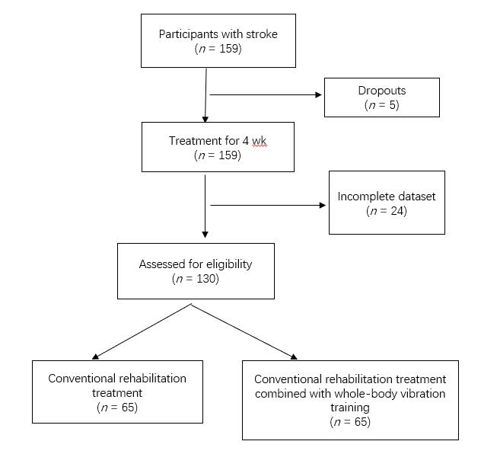
Figure 1 Flow chart on sample selection and criteria.

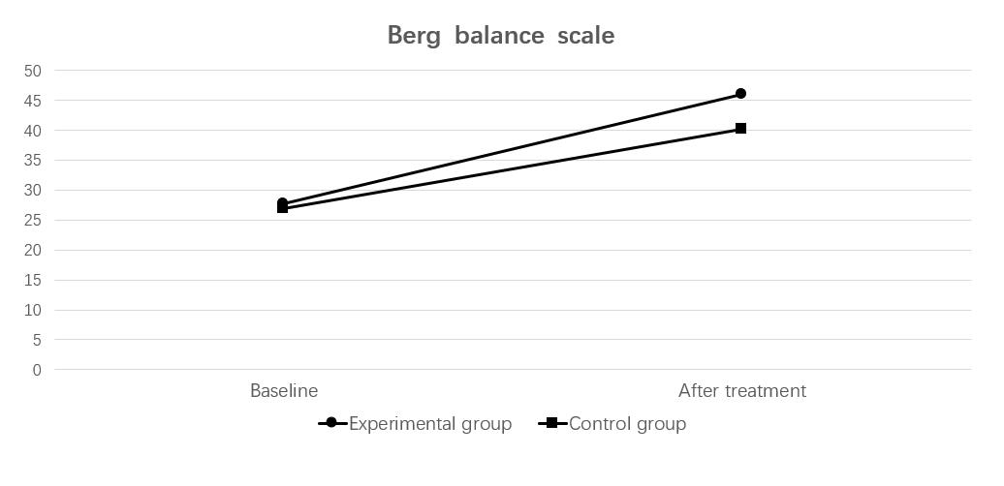
Figure 2 Berg balance scale. Experimental group: whole-body vibration training group; Control group: non-whole-body vibration training group.

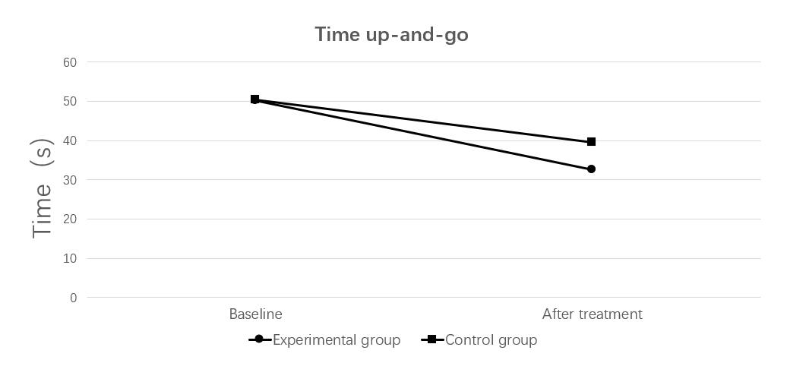
Figure 3 Timed up-and-go test. Experimental group: whole-body vibration training group; Control group: non-whole-body vibration training group.

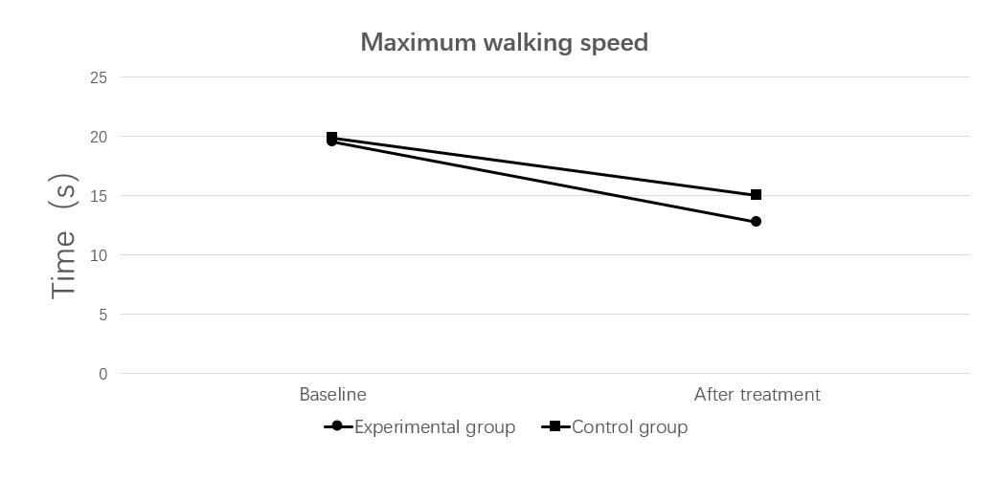
Figure 4 Maximum walking speed test. Experimental group: whole-body vibration training group; Control group: non-whole-body vibration training group.

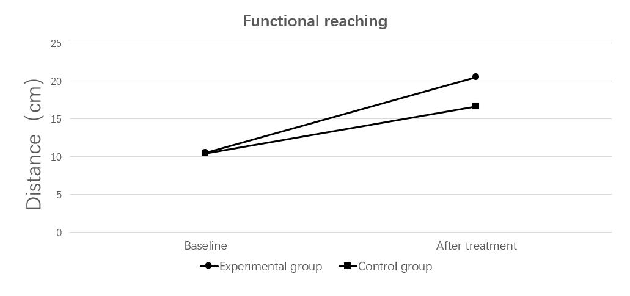
Figure 5 Functional reaching test. Experimental group: whole-body vibration training group; Control group: non-whole-body vibration training group.

Table 1 Demographics of the groups
 | WVT | NWVT | P value
Number | 65 | 65 | -
Male/female | 32/33 | 33/32 | 0.862
Age (yr) | 60.42 ± 6.39 | 59.82 ± 6.62 | 0.600
Height (cm) | 165.71 ± 7.73 | 165.83 ± 7.16 | 0.925
Weight (kg) | 67.33 ± 7.70 | 66.03 ± 7.83 | 0.339
Course of disease | 3.22 ± 1.35 | 3.09 ± 1.01 | 0.557
Hematencephalon | 41 | 37 | 0.478
Cerebral infarction | 24 | 28
Affected side (L/R) | 36/29 | 32/33 | 0.486
L: Left; NWVT: Non-whole-body vibration training group; R: Right; WVT: Whole-body vibration training group.

Table 2 Assessment of balance and functional mobility parameters
 | WVT |  | NWVT |  | WVT vs NWVT
 | Mean ± SD | P value | Mean ± SD | P value | P value
Berg balance scale
Baseline | 27.75 ± 2.87 | 0.000¹ | 26.92 ± 3.24 | 0.000¹ | 0.124
After treatment | 46.08 ± 3.41 |  | 40.22 ± 3.75 |  | 0.000
Amount of change | 18.32 ± 2.18 |  | 13.29 ± 1.66 |  | 0.000
Time up-and-go (s)
Baseline | 50.13 ± 3.91 | 0.000¹ | 50.32 ± 3.38 | 0.000¹ | 0.768
After treatment | 32.64 ± 3.81 |  | 39.56 ± 3.68 |  | 0.000
Amount of change | 17.49 ± 1.88 |  | 10.76 ± 1.42 |  | 0.000
Maximum walking speed (s)
Baseline | 19.52 ± 2.03 | 0.000¹ | 19.89 ± 2.10 | 0.000¹ | 0.307
After treatment | 12.73 ± 2.26 |  | 15.04 ± 2.27 |  | 0.000
Amount of change | 6.79 ± 0.81 |  | 4.84 ± 0.58 |  | 0.000
Functional reaching (cm)
Baseline | 10.47 ± 1.95 | 0.000¹ | 10.44 ± 2.61 | 0.000¹ | 0.930
After treatment | 20.48 ± 2.23 |  | 16.60 ± 2.82 |  | 0.000
Amount of change | 10.00 ± 0.92 |  | 6.16 ± 0.95 |  | 0.000
¹Baseline vs after treatment. NWVT: Non-whole-body vibration training group; SD: Standard deviation; WVT: Whole-body vibration training group.

Published by Baishideng Publishing Group Inc
7041 Koll Center Parkway, Suite 160, Pleasanton, CA 94566, USA
Telephone: +1-925-3991568
E-mail: bpgoffice@wjgnet.com
Help Desk: https://www.f6publishing.com/helpdesk
https://www.wjgnet.com

© 2021 Baishideng Publishing Group Inc. All rights reserved.

