Name of journal: World Journal of Gastroenterology
ESPS Manuscript NO: 12383
Columns: CASE REPORT

Colonic mucosa-associated lymphoid tissue-lymphoma identified by narrow-band imaging mode and indigocarmine chromoendoscopy

Seo SW et al. Colonic MALT lymphoma

Sang-Wook Seo, Seung-Hwa Lee, Duck-Joo Lee, Kwang-Min Kim, Joon-Koo Kang, Do-Wan Kim, Jeong-Hun Lee

Sang-Wook Seo, Seung-Hwa Lee, Duck-Joo Lee, Kwang-Min Kim, Center for Health Promotion, Department of Family Practice and Community Health, Ajou University School of Medicine, Suwon 443-380, South Korea

Joon-Koo Kang, Department of Gastroenterology, Ajou University School of Medicine, Suwon 443-380, South Korea

Do-Wan Kim, Department of Anesthesiology, Ajou University School of Medicine, Suwon 443-380, South Korea

Jeong-Hun Lee, Department of Surgery, Ajou University School of Medicine, Suwon 443-380, South Korea

Author contributions: Seo SW contributed in drafting of the report; Lee SH involved in design and critical revision of the manuscript; Lee DJ, Kim KM, Kang JK, Kim DW, and Lee JH reviewed and revised the paper.

Correspondence to: Seung-Hwa Lee, MD, Professor, Center for Health Promotion, Department of Family Practice and Community Health, Ajou University School of Medicine, 164 Worldcup-ro, Yeongtong-gu, Gyeonggi-do, Suwon 443-380, South Korea. drhwa@ajou.ac.kr

Telephone: +82-31-2197164 Fax: +82-31-2195561
Received: July 5, 2014 Revised: August 18, 2014
Accepted: October 15, 2014

Published online:

Abstract
Colonic mucosa-associated lymphoid tissue (MALT) lymphomas are a rare occurrence and the definitive treatment has not been established. Solitary or multiple, elevated or polypoid lesions are the usual appearances of MALT lymphoma in the large intestine and sometimes the surface may reveal abnormal vascularity. Herein, we report a case of colonic MALT lymphoma and review the relevant literature. On colonoscopy, suggestive pathologic lesion was observed in the proximal transverse colon. After using narrow-band imaging mode and indigocarmine-dye spraying method (chromoendoscopy), this lesion could be distinguished more prominently. Histopathologic examination of this biopsy specimen revealed lymphoepithelial lesions with diffuse proliferation of atypical lymphoid cells effacing the glandular architecture and centrocyte-like cells infiltrating the lamina propria. On immunohistochemical analyses, tumor cells were positive for CD20 and Bcl-2e; whereas the tumor cells were negative for CD10, CD23, and Bcl-6. According to Ann-Arbor staging system, the patient had the stage II_{E}. A partial colectomy with dissection of the paracolic lymph nodes was performed. Until now, there is no recurrence of lymphoma at follow-up.

© 2014 Baishideng Publishing Group Inc. All rights reserved.

Key words: Mucosa-associated lymphoid tissue; Lymphoma; Narrow-band imaging mode; Chromoendoscopy

Core tip: Mucosa-associated lymphoid tissue (MALT) lymphoma in large intestine is a rare disease, but it is a clinically important condition which requires proper evaluation. Most of the colonic MALT lymphomas mainly present as a protruding and/or an ulcerative lesion, and rarely present as flat lesion. It is not easy to detect MALT lymphoma of the flat type and could be misdiagnosed. Thus, greater attention is needed for the detection and differential diagnosis of these lesions. The narrow-band imaging mode plus indigocarmine-dye spraying method (chromoscopy) or/and endoscopic biopsy may be helpful for making the diagnosis.
Seo SW, Lee SH, Lee DJ, Kim KM, Kang JK, Kim DW, Lee JH. Colonic mucosa-associated lymphoid tissue-lymphoma identified by narrow-band imaging mode and indigocarmine chromoendoscopy. World J Gastroenterol 2014; In press

INTRODUCTION
Lymphomas are malignancies of the lymphatic system and mucosa-associated lymphoid tissue (MALT) lymphoma is one of the types of lymphomas. Since the term of MALT lymphoma was first introduced by Isaacson and Wright^{[1]} in 1983, it has been widely used. Recently, it was categorized as extranodal marginal zone B cell lymphoma of MALT type by the World Health Organization. Although MALTs are found in many parts of the body besides the gastrointestinal (GI) tract, the most predominant site with the highest volume of this tissue is the GI tract^{[2]}. Therefore, the alimentary tract is the most common location of extranodal lymphomas including MALT lymphoma. However, the stomach and small bowel are the most common sites for 50%-60% and 20%-30% of GI lymphomas, respectively; while colorectal lymphomas account for only 15%-20% of GI lymphomas^{[3]}, 1.4% of all non-Hodgkin’s lymphomas^{[4]}, and less than 1% of colorectal malignant tumors^{[5]}. Colorectal MALT lymphoma is a rare disease, which accounts for a small proportion of both colorectal malignancies and GI lymphomas. Due to the rarity of the disease, colorectal MALT lymphomas have not been well investigated when compared to gastric MALT lymphomas. There are various identifying colonoscopic features of MALT lymphoma in the large intestine. Most of the colonic MALT lymphomas mainly present as a protruding and/or an ulcerative lesion, and rarely present as flat lesion^{[6]}. As already known, it is difficult to identify a flat pathologic lesion in the large intestine, such as discoloration, and/or diffuse granularity, and/or loss of vascularity, although the endoscopist has a lot of experiences. Herein, we report a case of an asymptomatic patient with MALT lymphoma that was detected accidentally during screening colonoscopy for colorectal cancer. The lesion manifested as diffuse loss of vascularity and discovered by narrow-band imaging (NBI) mode and indigocarmine-dye spraying method (chromoendoscopy).

CASE REPORT
An asymptomatic 64-year-old man with a family history of colorectal cancer visited our hospital for routine medical check-up including upper GI endoscopy and colonoscopy for surveillance of GI cancer. He had dyslipidemia that was well controlled with medications, but he had no other medical illness or surgical history. The patient had been a smoker, 10 to 15 cigarettes per day, since the age of 30 years. However, he never drank alcohol.
On general examination, the patient did not look sick, but he was slightly thin (height, 165.3 cm; weight, 47.2 kg; waist circumference 70.1 cm; body mass index, 17.3 kg/m²). The patient’s initial vital signs were a blood pressure of 95/60 mmHg, a regular heart rate of 62 beats/min, a respiratory rate of 15 breaths/min, and a body temperature of 36.2°C. Other physical examinations including that of the abdomen were unremarkable. The results of all laboratory tests such as complete blood cell count, aspartate aminotransferase, alanine aminotransferase, protein, albumin, electrolyte, blood urea nitrogen, creatinine, electrolyte, lipid profile (total cholesterol, triglyceride, high-density lipoprotein cholesterol, low-density lipoprotein cholesterol), fasting glucose, urine analysis, and stool examination, were within their normal limits. Also, although the abdominal ultrasonography showed a small 3 mm benign gall-bladder polyp, other radiologic evaluations, including chest X-ray, abdomen supine/erect X-ray did not show any abnormal findings.
Due to the benefits of same-day bidrectional endoscopy compared to alternate-day endoscopy (shorter hospital stay, fewer hospital visits, and reduced medical costs), we decided to perform same-day bidirectional endoscopy, esophagogastroduo- denoscopy (EGD) followed by colonoscopy. He underwent bowel preparation using 3 L of polyethylene glycol solution (Colyte-F; Taejoon Pharmaceutical Co., Seoul, South Korea) on the day before and 1 L on the day of colonoscopy. Written informed consent was obtained from the patient. The endoscopic examinations (EGD, colonoscopy) were performed under conscious sedation with combinations of intravenous midazolam (Dormicum; Roche Korea Pharmaceutical Co., Seoul, South Korea) and propofol (Pofol; Jeil Pharmaceutical Co., Seoul, South Korea). Also, an antispasmodic agent, cimetropium bromide (Algiron; Green-Cross Pharmaceutical Co., Yongin, Gyeonggi-do, South Korea), was given intravenously immediately before the procedure to prevent upper and lower GI movements, which can interfere with a detailed and complete inspection. The endoscopist performed the procedure in the patient with an Olympus video endoscope (Olympus Optical Co., Ltd., Tokyo, Japan), GIF-H260 for EGD and CF-H260L for colonoscopy, respectively. During the endoscopic procedure, the patient's blood pressure, pulse, and oxygen saturation were monitored.
The EGD findings were unremarkable, except for chronic atrophic gastritis. In the colonoscopic examination, a suggestive pathologic lesion (diffuse granularity of the mucosa with loss of vascularity) was observed in the proximal transverse colon (Figure 1A). After using the NBI mode, this lesion was distinguished more prominently from the surrounding normal colonic mucosa and it showed an abnormal branch-like capillary-pattern in patches (Figure 1B). Also, after indigocarmine-dye spraying (Figure 1C-F), this lesion was distinguished more prominently (Figure 1G, H). A punch biopsy was performed in this lesion, and then the biopsy specimen was sent for histopathological examination.
Histopathologic examination of this biopsy specimen with hematoxylin-eosin stain revealed lymphoepithelial lesions with diffuse proliferation of atypical lymphoid cells effacing the glandular architecture and centrocyte-like (CCL) cells infltrating the lamina propria (Figure 2A-C). Immunohistochemical staining was positive for Bcl-2 and CD20 (Figure 2D, E), and it was negative for CD10, CD23 and Bcl-6 (Figure 2F-H). These findings were compatible with MALT lymphoma.
After, the diagnosis of MALT lymphoma of the transverse colon was confirmed, further evaluation was performed assessment of the stage and metastasis. There was no evidence of distant lymph node (LN) metastasis or any other organ involvement on thoracic and abdominal computed tomography (CT), and positron emission tomography (PET) scan. Urea-breath test for the diagnosis of Helicobacter pylori (H. pylori) infection was negative. In our case, the stage of colonic MALT lymphoma was II_{E} according to the Ann-Arbor staging system. A partial colectomy with dissection of the paracolic LNs was performed. Resected specimens (Figure 3) were histologically and immunohistochemically reconfirmed to be MALT lymphoma with adjacent nodal involvement. The patient is being follow-up at our outpatient clinics, and he is still alive without any recurrence of the disease at 12 mo after the diagnosis with follow-up evaluations including colonoscopy, thoracic and abdominal CT, and PET scan.

DISCUSSION
Lymphomas are malignancies of the lymphatic system with a wide variety of histologic subtypes and a broad spectrum of clinical behavior, aggressiveness, and prognosis. Lymphomas can be largely classified as non-Hodgkin’s lymphomas (NHL) or Hodgkin’s lymphoma^{[4]}. MALT lymphoma is a subtype of NHL, which is a precursor B cell neoplasm^{[7]}. MALT is diffusion system of small concentrations of lymphoid tissue. Although the predominant site of these tissues are the GI tract, they are also found in various parts of the body such as lung, thyroid, breast, synovium, lacrimal and salivary glands, orbit, dura, skin and soft tissues^{[8-18]}. MALTs are populated by lmphocytes such as T cells and B cells, as well as plasma cells and macrophages. They play an important role in normal mucosal regeneration and immune response to specific antigens encountered along all mucosal surface^{[19]}. However, cells in MALT may occasionally undergo abnormal proliferation and give rise to lymphoma of the MALT type, i.e., carcinogenesis^{[20]}.
The GI tract is the predominant location of extranodal lymphoma involvement. However, colorectal MALT lymphomas are relatively rarer than those arising from the stomach or small intestine. It has been reported that only 2.5% of all MALT-type lymphomas have been identified as originated from the colon^{[21]}. Although the epidemiology of MALT lymphoma in large intestine has not been established due to the rarity of them, most patients were approximately 60 years old with similar numbers of men and women^{[22,23]}. The clinical presentation of MALT lymphoma is varies and it may also present with generalized symptoms of weight loss, fever, abdominal pain, chronic fatigue, nausea, hematochezia^{[24]}. However, MALT lymphoma of GI tract are usually asymptomatic because most of them are well localized and slow-growing. Our patient was 64-year-old man and also asymptomatic. Therefore, it was discovered incidentally during screening colonoscopy.
The majority of colorectal lymphomas are found in the cecum or ascending colon. More than 70% of colorectal lymphomas are proximal to the hepatic flexure^{[3]}. In our patient, MALT lymphoma was also located in the proximal transverse colon near to the end of ascending colon (hepatic flexure). When grossly visible by colonoscopy, MALT-type lymphomas are mostly observed as a single mass and the appearance of the lesion is generaaly protruding and ulcerative^{[22]}. By contrast, colonoscopic examination of the current patient revealed flat lesion with diffuse granularity of the mucosa and loss of vascularity. Although endoscopists are experienced, flat lesions have been recognized as more difficuly to detect than protruding or ulcerative lesions. In our case, there was difficulty in differentiating the lesion from the surrounding mucosa. Therefore, we could have missed the lesion, if we had not used NBI mode and/or chromoendoscopy during colonoscopy^{[6,25]}.
Microscopically, MALT-type lymphomas usually reveals lymphoepithelial lesions with irregular nuclei and hyperchromasia^{[5,26,27]}. Similar formations involving reactive lymphoid infiltrates may also appear in benign conditions involving inflammation. However, lymphoid cells of MALT lymphoma may expand in the lamina propria and occasionally infiltrate the muscularis mucosa. Infiltration through the muscularis propria may be manifested as mucosal ulcers. In our case, atypical lymphoid cells and CCL cells infiltrating through the lamina propria were noted as well. Immunohistochemical analyses are very useful for confirming the diagnosis. These can distinguish MALT lymphoma from other low-grade lymphomas by detecting positivity for superficial Ig and pan B antigens (CD19, CD20, CD79) without expression of CD5, CD10, CD23, and cyclin D1 (Bcl-1)^{[18,28]}. Tumor cells of MALT-type lymphoma are also positive for Bcl-2 and negative for Bcl-6^{[18]}. In the present case, the immunohistochemical results of the colonic lesion were positive for CD20 and Bcl-2 and negative for CD10, CD23, and Bcl-6.
NHL including MALT-type lymphoma could be evaluated by the Ann-Arbor Staging Classification^{[29,30]}. This staging system focuses on the number of tumor sites (nodal vs extranodal), location, and the presence or absence of systemic B symptoms (weight loss, night sweating, unexplained persistent or recurrent fever). In the present case, the patient was evaluated by chest and abdomen CT and torso-PET. The result of surgical biopsy showed MALT lymphoma with regional LN involvement. Thus, the stage was II_{E} in our patient according to the Ann-Arbor System (single extranodal site and involvement of adjacent lymph nodes).
Although the pathogenesis of MALT lymphoma has yet to be clearly elucidated, several etiologic factors have been postulated to explain this rare disease: (1) chromosomal abnormalities including trisomy 3 and translocations [t(11;18)(q21;q21), t(14;18)(q32;q21), t(1;14)(p22;q32), t(3;14)(p13;q32)]^{[31-33]}; (2) autoimmune disorders such as rhematoid arthritis, Sjögren's syndrome, relapsing polychondritis, Hashimoto's thyroiditis, systemic lupus erythematosus, Wegener’s granulomatosis^{[34-36]}; (3) immunodeficiency and immunosuppression; (4) celiac disease^{[37]}; (5) inflammatory bowel disease including as Crohn’s disease and ulcerative colitis^{[38,39]}; and (6) bacterial infection such as H. pylori, Borrelia afzelii, Campylobacter jejuni, Chlamydia psittaci, Mycobacterium species^{[19,40-42]}. Notably, more than 90% of MALT-type lymphomas of the stomach are associated with H. pylori infections^{[43]}. According to numerous reports, H. pylori eradication often results in an excellent remission in patients with gastric MALT-type lymphomas. However, the treatment of colonic lymphoma is still inconclusive. Hence, further studies will be needed to clarify the efficacy of the eradication of H. pylori for treatment of colonic MALT lymphoma.
Because of the lack of a definite etiology and the rarity of the disease, the treatment of colorectal MALT lymphoma has been as yet debated^{[44,45]}. In the absence of standardized treatment, various treatment methods have been used which include surgery, chemotherapy, and radiation. However, the data in various literatures suggest both surgery and chemotherapy as a first step therapy in patients with MALT-type lymphoma of large intestine^{[45]}. The colorectal regions are particularly susceptible to complications of radiation therapy, and therefore external beam radiation is not a preferred option in the treatment of colorectal lymphoma. Thus, some advocated that surgical resection might be the best choice^{[46,47]}. In clinical practice, most of locally extented MALT-type lymphoma such as our patient lymphoma are treated by surgical resection. However, many recent studies show that chemotherapy alone can be effective for colorectal MALT lymphoma^{[48,49]}. Additionally, chemotherapy has the advantage of organ preservation and is effective for micro-metastasis^{[45]}. The CHOP-regimen (cyclophosphamide, doxorubicine, vincristine, prednisone) is well known as the first-line and mainstay chemotherapy for colorectal lymphoma. However, further large-scale studies are required to establish the standard strategy of treatment for this disease. Unfortunately, the majority of patients with primary colorectal lymphoma ultimately have recurrences and dies from their disease^{[8,50]}. However, because most of them are low-grade and less aggressive, their 5-year overall survival rate (range: 55%-79%) is relatively higher than other-type colorectal lymphoma^{[24,26,51,52]}.
In conclusion, colonic MALT lymphoma is a rare occurrence, but it is a clinically important condition which requires proper evaluation for guiding therapy. Additionally, it is not easy to detect MALT lymphoma of the flat type and could be misdiagnosed. Thus, greater attention is needed for the detection and differential diagnosis of these lesions. The NBI mode plus indigocarmine-dye spraying method (chromoendoscopy) or/and endoscopic biopsy may be helpful for making the diagnosis.

comments
Case characteristics
An asymptomatic 64-year-old man with a family history of colorectal cancer visited our hospital for routine medical check-up including upper gastrointestinal endoscopy and colonoscopy.

Differential diagnosis
This lesion should be differentiated from other colonic lesions such as adenocarcinoma, gastrointestinal stromal tumor, amyloidosis.

Laboratory diagnosis
All of the laboratory tests were within normal limits.

Imaging diagnosis
The colonoscopic examination revealed a flat lesion with diffuse granularity of the mucosa and loss of vascularity.

Pathological diagnosis
The histopathologic examination with hematoxylin-eosin staining revealed atypical lymphoid cells and centrocyte-like cells infiltrating through the lamina propria. In addition, the immunohistochemical analyses of the lesion of our patient were positive for CD20 and Bcl-2 and negative for CD10, CD23, and Bcl-6.

Treatment
A partial colectomy including pathologic lesion and dissections of the paracolic lymph nodes were performed.

Related reports
Because of the lack of a definite etiology and the rarity of the disease, the treatment of colorectal mucosa-associated lymphoid tissue (MALT) lymphoma has been as yet debated.

Term explanation
Narrow band imaging (NBI) mode is defined as imaging technique for endoscopic examination, where light of specific blue and green wavelengths is used to enhance visualization of certain mucosal details.

Experiences and lessons
More attention should be paid for the detection of colonic MALT-type lymphoma, and the NBI mode and indigocarmine dye spraying method may be also helpful in establishing the diagnosis.

Peer review
The article presents the detailed clinical feature, endoscopic and histologic finding, diagnostic procedure, and treatment strategy of colonic MALT lypmphoma with flat lesion.

REFERENCES
1 Isaacson P, Wright DH. Malignant lymphoma of mucosa-associated lymphoid tissue. A distinctive type of B-cell lymphoma. Cancer 1983; 52: 1410-1416 [PMID: 6193858]
2 Koch P, del Valle F, Berdel WE, Willich NA, Reers B, Hiddemann W, Grothaus-Pinke B, Reinartz G, Brockmann J, Temmesfeld A, Schmitz R, Rübe C, Probst A, Jaenke G, Bodenstein H, Junker A, Pott C, Schultze J, Heinecke A, Parwaresch R, Tiemann M. Primary gastrointestinal non-Hodgkin's lymphoma: II. Combined surgical and conservative or conservative management only in localized gastric lymphoma--results of the prospective German Multicenter Study GIT NHL 01/92. J Clin Oncol 2001; 19: 3874-3883 [PMID: 11559725]
3 Koch P, del Valle F, Berdel WE, Willich NA, Reers B, Hiddemann W, Grothaus-Pinke B, Reinartz G, Brockmann J, Temmesfeld A, Schmitz R, Rübe C, Probst A, Jaenke G, Bodenstein H, Junker A, Pott C, Schultze J, Heinecke A, Parwaresch R, Tiemann M. Primary gastrointestinal non-Hodgkin's lymphoma: I. Anatomic and histologic distribution, clinical features, and survival data of 371 patients registered in the German Multicenter Study GIT NHL 01/92. J Clin Oncol 2001; 19: 3861-3873 [PMID: 11559724]
4 Doolabh N, Anthony T, Simmang C, Bieligk S, Lee E, Huber P, Hughes R, Turnage R. Primary colonic lymphoma. J Surg Oncol 2000; 74: 257-262 [PMID: 10962456]
5 Fan CW, Changchien CR, Wang JY, Chen JS, Hsu KC, Tang R, Chiang JM. Primary colorectal lymphoma. Dis Colon Rectum 2000; 43: 1277-1282 [PMID: 11005497]
6 Saito T, Toyoda H, Yamaguchi M, Nakamura T, Nakamura S, Mukai K, Fuke H, Wakita Y, Iwata M, Adachi Y, Shiku H. Ileocolonic lymphomas: a series of 16 cases. Endoscopy 2005; 37: 466-469 [PMID: 15844027 DOI: 10.1055/s-2005-861093]
7 Armitage JO, Weisenburger DD. New approach to classifying non-Hodgkin's lymphomas: clinical features of the major histologic subtypes. Non-Hodgkin's Lymphoma Classification Project. J Clin Oncol 1998; 16: 2780-2795 [PMID: 9704731]
8 Radaszkiewicz T, Dragosics B, Bauer P. Gastrointestinal malignant lymphomas of the mucosa-associated lymphoid tissue: factors relevant to prognosis. Gastroenterology 1992; 102: 1628-1638 [PMID: 1568573]
9 Rosado MF, Byrne GE, Jr., Ding F, Fields KA, Ruiz P, Dubovy SR, Walker GR, Markoe A, Lossos IS. Ocular adnexal lymphoma: a clinicopathologic study of a large cohort of patients with no evidence for an association with Chlamydia psittaci. Blood 2006; 107: 467-472 [PMID: 16166588 DOI: 10.1182/blood-2005-06-2332]
10 Iwamoto FM, DeAngelis LM, Abrey LE. Primary dural lymphomas: a clinicopathologic study of treatment and outcome in eight patients. Neurology 2006; 66: 1763-1765 [PMID: 16769960 DOI: 10.1212/01.wnl.0000218284.23872.eb]
11 Tu PH, Giannini C, Judkins AR, Schwalb JM, Burack R, O'Neill BP, Yachnis AT, Burger PC, Scheithauer BW, Perry A. Clinicopathologic and genetic profile of intracranial marginal zone lymphoma: a primary low-grade CNS lymphoma that mimics meningioma. J Clin Oncol 2005; 23: 5718-5727 [PMID: 16009945 DOI: 10.1200/jco.2005.17.624]
12 Zucca E, Conconi A, Pedrinis E, Cortelazzo S, Motta T, Gospodarowicz MK, Patterson BJ, Ferreri AJ, Ponzoni M, Devizzi L, Giardini R, Pinotti G, Capella C, Zinzani PL, Pileri S, López-Guillermo A, Campo E, Ambrosetti A, Baldini L, Cavalli F. Nongastric marginal zone B-cell lymphoma of mucosa-associated lymphoid tissue. Blood 2003; 101: 2489-2495 [PMID: 12456507 DOI: 10.1182/blood-2002-04-1279]
13 Ikeda J, Morii E, Yamauchi A, Kohara M, Hashimoto N, Yoshikawa H, Iwasaki M, Aozasa K. Extranodal marginal zone B-cell lymphoma of mucosa-associated lymphoid tissue type developing in gonarthritis deformans. J Clin Oncol 2007; 25: 4310-4312 [PMID: 17878483 DOI: 10.1200/jco.2007.12.7092]
14 Servitje O, Gallardo F, Estrach T, Pujol RM, Blanco A, Fernández-Sevilla A, Pétriz L, Peyrí J, Romagosa V. Primary cutaneous marginal zone B-cell lymphoma: a clinical, histopathological, immunophenotypic and molecular genetic study of 22 cases. Br J Dermatol 2002; 147: 1147-1158 [PMID: 12452864]
15 Welsh JS, Howard A, Hong HY, Lucas D, Ho T, Reding DJ. Synchronous bilateral breast mucosa-associated lymphoid tissue lymphomas addressed with primary radiation therapy. Am J Clin Oncol 2006; 29: 634-635 [PMID: 17149003 DOI: 10.1097/01.coc.0000248930.12423.2e]
16 Troch M, Formanek M, Streubel B, Müllauer L, Chott A, Raderer M. Clinicopathological aspects of mucosa-associated lymphoid tissue (MALT) lymphoma of the parotid gland: a retrospective single-center analysis of 28 cases. Head Neck 2011; 33: 763-767 [PMID: 20737498 DOI: 10.1002/hed.21533]
17 Koss MN. Pulmonary lymphoid disorders. Semin Diagn Pathol 1995; 12: 158-171 [PMID: 7638448]
18 Shimura T, Kuwano H, Kashiwabara K, Kojima M, Masuda N, Suzuki H, Kanoh K, Saitoh T, Asao T. Mucosa-associated lymphoid tissue lymphoma of the extrahepatic bile duct. Hepatogastroenterology 2005; 52: 360-362 [PMID: 15816435]
19 Lugton I. Mucosa-associated lymphoid tissues as sites for uptake, carriage and excretion of tubercle bacilli and other pathogenic mycobacteria. Immunol Cell Biol 1999; 77: 364-372 [PMID: 10457205 DOI: 10.1046/j.1440-1711.1999.00836.x]
20 Thieblemont C, Bastion Y, Berger F, Rieux C, Salles G, Dumontet C, Felman P, Coiffier B. Mucosa-associated lymphoid tissue gastrointestinal and nongastrointestinal lymphoma behavior: analysis of 108 patients. J Clin Oncol 1997; 15: 1624-1630 [PMID: 9193362]
21 Hahn JS, Kim YS, Lee YC, Yang WI, Lee SY, Suh CO. Eleven-year experience of low grade lymphoma in Korea (based on REAL classification). Yonsei Med J 2003; 44: 757-770 [PMID: 14584090]
22 Kim MH, Jung JT, Kim EJ, Kim TW, Kim SY, Kwon JG, Kim EY, Sung WJ. A case of mucosa-associated lymphoid tissue lymphoma of the sigmoid colon presenting as a semipedunculated polyp. Clin Endosc 2014; 47: 192-196 [PMID: 24765604 DOI: 10.5946/ce.2014.47.2.192]
23 Akasaka R, Chiba T, Dutta AK, Toya Y, Mizutani T, Shozushima T, Abe K, Kamei M, Kasugai S, Shibata S, Abiko Y, Yokoyama N, Oana S, Hirota S, Endo M, Uesugi N, Sugai T, Suzuki K. Colonic mucosa-associated lymphoid tissue lymphoma. Case Rep Gastroenterol 2012; 6: 569-575 [PMID: 23012617 DOI: 10.1159/000342726]
24 Nathwani BN, Anderson JR, Armitage JO, Cavalli F, Diebold J, Drachenberg MR, Harris NL, MacLennan KA, Müller-Hermelink HK, Ullrich FA, Weisenburger DD. Marginal zone B-cell lymphoma: A clinical comparison of nodal and mucosa-associated lymphoid tissue types. Non-Hodgkin's Lymphoma Classification Project. J Clin Oncol 1999; 17: 2486-2492 [PMID: 10561313]
25 Cyrany J, Pintér M, Tycová V, Krejsek J, Belada D, Rejchrt S, Bures J. Trimodality imaging of colonic lymphoma. Endoscopy 2009; 41 Suppl 2: E1-E2 [PMID: 19177289 DOI: 10.1055/s-2007-995696]
26 Traverse-Glehen A, Felman P, Callet-Bauchu E, Gazzo S, Baseggio L, Bryon PA, Thieblemont C, Coiffier B, Salles G, Berger F. A clinicopathological study of nodal marginal zone B-cell lymphoma. A report on 21 cases. Histopathology 2006; 48: 162-173 [PMID: 16405665 DOI: 10.1111/j.1365-2559.2005.02309.x]
27 Sipos F, Muzes G. Isolated lymphoid follicles in colon: switch points between inflammation and colorectal cancer? World J Gastroenterol 2011; 17: 1666-1673 [PMID: 21483625 DOI: 10.3748/wjg.v17.i13.1666]
28 Toyomasu Y, Tsutsumi S, Yamaguchi S, Mochiki E, Asao T, Kuwano H. Laparoscopy-assisted ileocecal resection for mucosa-associated lymphoid tissue lymphoma of the appendix: case report. Hepatogastroenterology 2009; 56: 1078-1081 [PMID: 19760945]
29 Izumi T, Ozawa K. [Clinical staging classification of non-Hodgkin's lymphoma]. Nihon Rinsho 2000; 58: 598-601 [PMID: 10741131]
30 Lalitha N. Clinical staging of adult non-Hodgkin's lymphoma. Oncology 1990; 47: 327-333 [PMID: 2367060]
31 Ho L, Davis RE, Conne B, Chappuis R, Berczy M, Mhawech P, Staudt LM, Schwaller J. MALT1 and the API2-MALT1 fusion act between CD40 and IKK and confer NF-kappa B-dependent proliferative advantage and resistance against FAS-induced cell death in B cells. Blood 2005; 105: 2891-2899 [PMID: 15598810 DOI: 10.1182/blood-2004-06-2297]
32 Novak U, Basso K, Pasqualucci L, Dalla-Favera R, Bhagat G. Genomic analysis of non-splenic marginal zone lymphomas (MZL) indicates similarities between nodal and extranodal MZL and supports their derivation from memory B-cells. Br J Haematol 2011; 155: 362-365 [PMID: 21883140 DOI: 10.1111/j.1365-2141.2011.08841.x]
33 Libra M, Gloghini A, Malaponte G, Gangemi P, De Re V, Cacopardo B, Spandidos DA, Nicoletti F, Stivala F, Zignego AL, Carbone A. Association of t(14; 18) translocation with HCV infection in gastrointestinal MALT lymphomas. J Hepatol 2008; 49: 170-174 [PMID: 18538438 DOI: 10.1016/j.jhep.2008.03.031]
34 Ambrosetti A, Zanotti R, Pattaro C, Lenzi L, Chilosi M, Caramaschi P, Arcaini L, Pasini F, Biasi D, Orlandi E, D'Adda M, Lucioni M, Pizzolo G. Most cases of primary salivary mucosa-associated lymphoid tissue lymphoma are associated either with Sjoegren syndrome or hepatitis C virus infection. Br J Haematol 2004; 126: 43-49 [PMID: 15198730 DOI: 10.1111/j.1365-2141.2004.04993.x]
35 Nocturne G, Boudaoud S, Miceli-Richard C, Viengchareun S, Lazure T, Nititham J, Taylor KE, Ma A, Busato F, Melki J, Lessard CJ, Sivils KL, Dubost JJ, Hachulla E, Gottenberg JE, Lombès M, Tost J, Criswell LA, Mariette X. Germline and somatic genetic variations of TNFAIP3 in lymphoma complicating primary Sjogren's syndrome. Blood 2013; 122: 4068-4076 [PMID: 24159176 DOI: 10.1182/blood-2013-05-503383]
36 Smedby KE, Hjalgrim H, Askling J, Chang ET, Gregersen H, Porwit-MacDonald A, Sundström C, Akerman M, Melbye M, Glimelius B, Adami HO. Autoimmune and chronic inflammatory disorders and risk of non-Hodgkin lymphoma by subtype. J Natl Cancer Inst 2006; 98: 51-60 [PMID: 16391371 DOI: 10.1093/jnci/djj004]
37 Tursi A, Inchingolo CD. Synchronous gastric and colonic MALT-lymphoma in coeliac disease: a long-term follow-up on gluten-free diet. Dig Liver Dis 2007; 39: 1035-1038 [PMID: 16971196 DOI: 10.1016/j.dld.2006.07.016]
38 García-Sánchez MV, Poyato-González A, Giráldez-Jiménez MD, Gómez-Camacho F, Espigares del Aguila A, de Dios-Vega JF. [MALT lymphoma in a patient with Crohn's disease. A causal or incidental association?]. Gastroenterol Hepatol 2006; 29: 74-76 [PMID: 16448608]
39 Mangla V, Pal S, Dash NR, Das P, Ahuja V, Sharma A, Sahni P, Chattopadhyay TK. Rectal MALT lymphoma associated with ulcerative colitis. Trop Gastroenterol 2012; 33: 225-228 [PMID: 23600057]
40 Al-Saleem T, Al-Mondhiry H. Immunoproliferative small intestinal disease (IPSID): a model for mature B-cell neoplasms. Blood 2005; 105: 2274-2280 [PMID: 15542584 DOI: 10.1182/blood-2004-07-2755]
41 Goodlad JR, Davidson MM, Hollowood K, Ling C, MacKenzie C, Christie I, Batstone PJ, Ho-Yen DO. Primary cutaneous B-cell lymphoma and Borrelia burgdorferi infection in patients from the Highlands of Scotland. Am J Surg Pathol 2000; 24: 1279-1285 [PMID: 10976703]
42 Husain A, Roberts D, Pro B, McLaughlin P, Esmaeli B. Meta-analyses of the association between Chlamydia psittaci and ocular adnexal lymphoma and the response of ocular adnexal lymphoma to antibiotics. Cancer 2007; 110: 809-815 [PMID: 17594698 DOI: 10.1002/cncr.22843]
43 Stolte M, Bayerdörffer E, Morgner A, Alpen B, Wündisch T, Thiede C, Neubauer A. Helicobacter and gastric MALT lymphoma. Gut 2002; 50 Suppl 3: III19-III24 [PMID: 11953328]
44 Psyrri A, Papageorgiou S, Economopoulos T. Primary extranodal lymphomas of stomach: clinical presentation, diagnostic pitfalls and management. Ann Oncol 2008; 19: 1992-1999 [PMID: 18647965 DOI: 10.1093/annonc/mdn525]
45 Avilés A, Nambo MJ, Neri N, Huerta-Guzmán J, Cuadra I, Alvarado I, Castañeda C, Fernández R, González M. The role of surgery in primary gastric lymphoma: results of a controlled clinical trial. Ann Surg 2004; 240: 44-50 [PMID: 15213617]
46 Yoon SS, Coit DG, Portlock CS, Karpeh MS. The diminishing role of surgery in the treatment of gastric lymphoma. Ann Surg 2004; 240: 28-37 [PMID: 15213615]
47 Takada M, Ichihara T, Fukumoto S, Nomura H, Kuroda Y. Laparoscopy-assisted colon resection for mucosa-associated lymphoid tissue (MALT) lymphoma in the cecum. Hepatogastroenterology 2003; 50: 1003-1005 [PMID: 12845967]
48 Aguiar-Bujanda D, Llorca-Martinez I, Rivero-Vera JC, Blanco-Sanchez MJ, Jimenez-Gallego P, Mori-De Santiago M, Limeres-Gonzalez MA, Cabrera-Marrero JC, Hernandez-Sosa M, Galvan-Ruiz S, Hernandez-Sarmiento S, Saura Grau S, Bohn-Sarmiento U. Treatment of gastric marginal zone B-cell lymphoma of the mucosa-associated lymphoid tissue with rituximab, cyclophosphamide, vincristine and prednisone. Hematol Oncol 2013; In press [PMID: 24123108 DOI: 10.1002/hon.2105]
49 Curcio A, Bertelli R, Gentilini P, Ronconi S, Saragoni L, Vagliasindi A, Mura G, Mazza P, Framarini M, Verdecchia GM. [Multimodal treatment of gastric MALT lymphoma: our experience]. Suppl Tumori 2005; 4: S77-S78 [PMID: 16437915]
50 d'Amore F, Brincker H, Grønbaek K, Thorling K, Pedersen M, Jensen MK, Andersen E, Pedersen NT, Mortensen LS. Non-Hodgkin's lymphoma of the gastrointestinal tract: a population-based analysis of incidence, geographic distribution, clinicopathologic presentation features, and prognosis. Danish Lymphoma Study Group. J Clin Oncol 1994; 12: 1673-1684 [PMID: 8040680]
51 Arcaini L, Paulli M, Burcheri S, Rossi A, Spina M, Passamonti F, Lucioni M, Motta T, Canzonieri V, Montanari M, Bonoldi E, Gallamini A, Uziel L, Crugnola M, Ramponi A, Montanari F, Pascutto C, Morra E, Lazzarino M. Primary nodal marginal zone B-cell lymphoma: clinical features and prognostic assessment of a rare disease. Br J Haematol 2007; 136: 301-304 [PMID: 17233821 DOI: 10.1111/j.1365-2141.2006.06437.x]
52 Nathwani BN, Drachenberg MR, Hernandez AM, Levine AM, Sheibani K. Nodal monocytoid B-cell lymphoma (nodal marginal-zone B-cell lymphoma). Semin Hematol 1999; 36: 128-138 [PMID: 10319381]

P-Reviewer: Skok P S-Editor: Gou SX L-Editor: E-Editor:

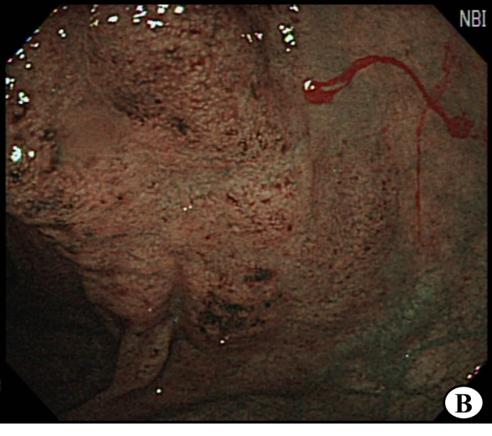
Figure 1
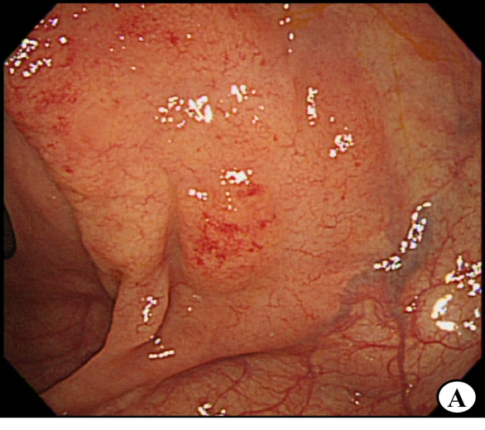
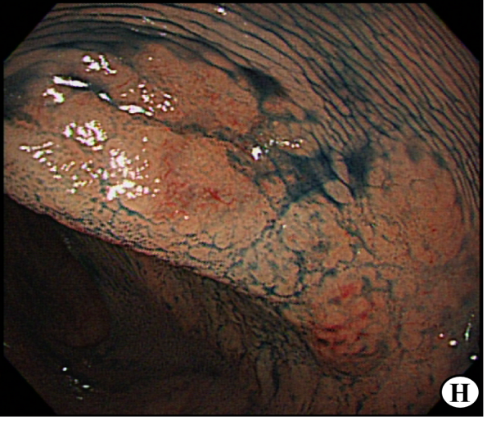
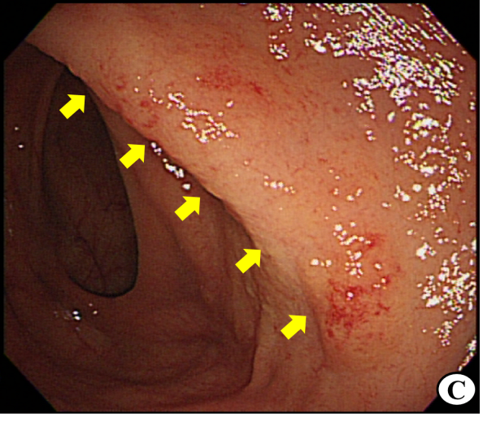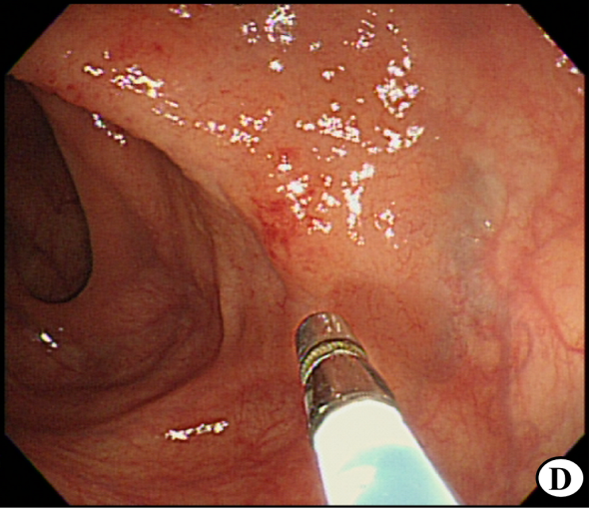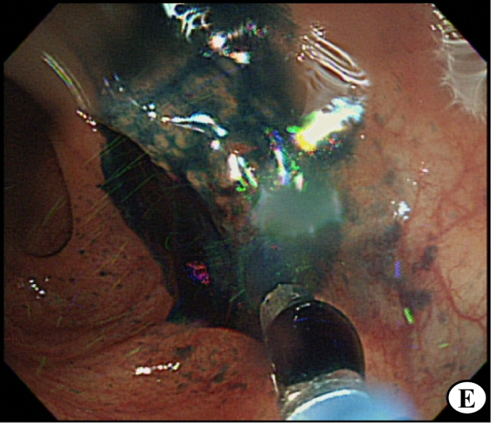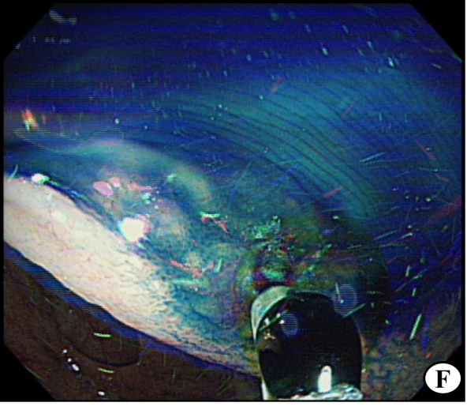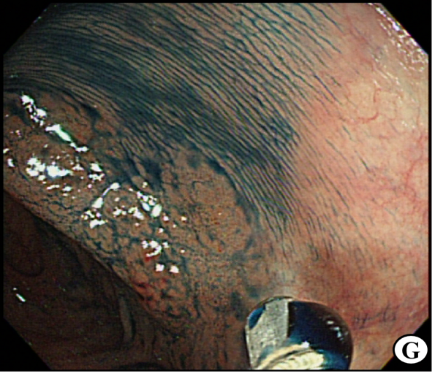
Figure 1 Colonoscopic findings. A, B: Before/after narrow-band imaging mode of the lesion; C: Diffuse granularity of the mucosa with loss of vascularity (arrows) was seen in the proximal transverse colon; D-F: Indigocarmine-dye spraying at this suggestive pathologic lesion; G, H: After the indigocarmine-dye contrast method, the lesion was distinguished more prominently from the surrounding normal colonic mucosa.

Figure 2
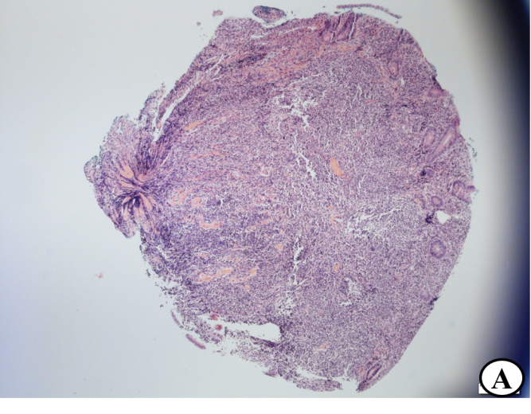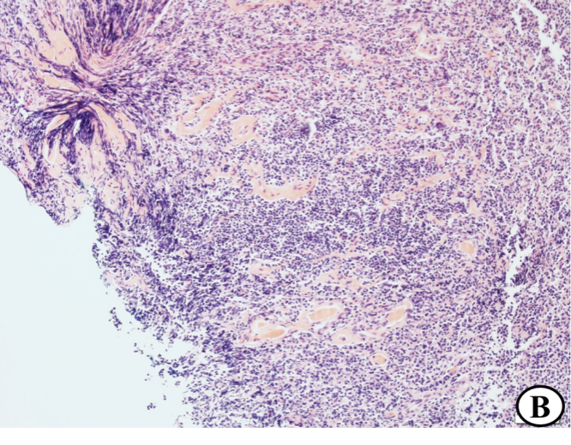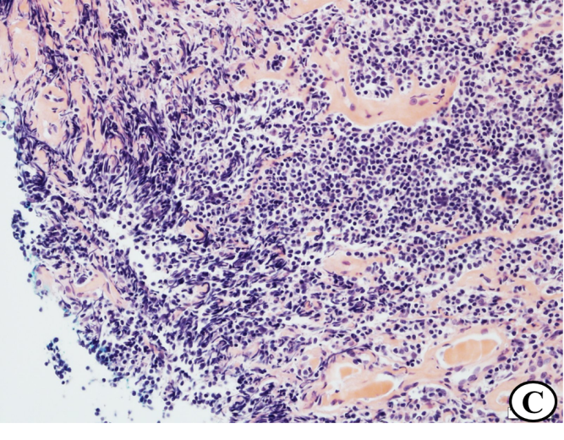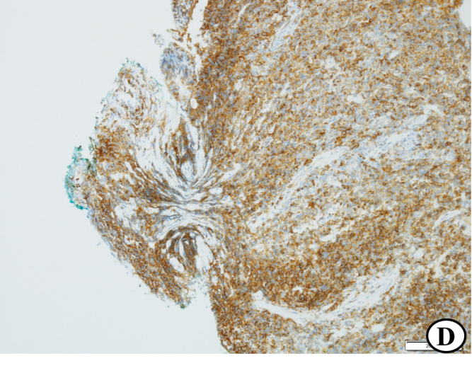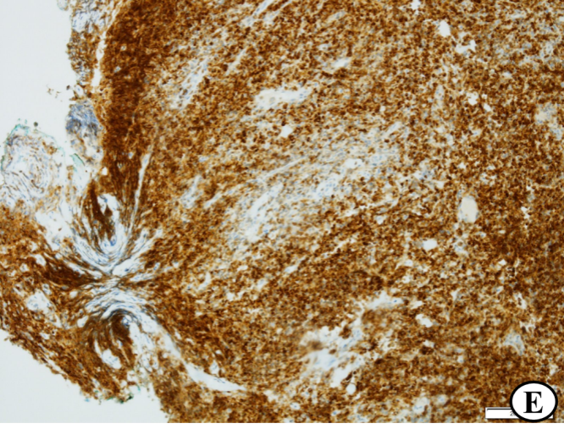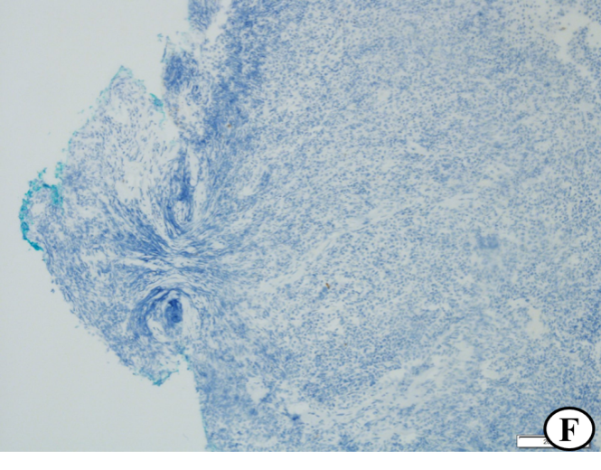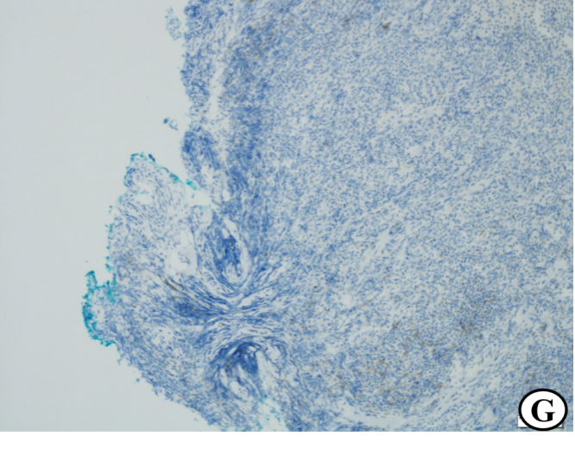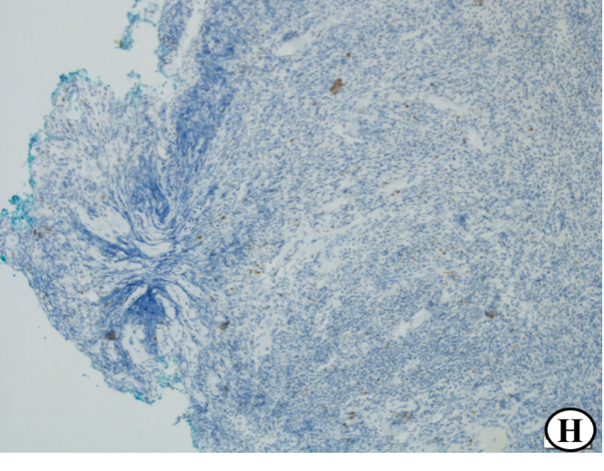
Figure 2 Histopathological findings. A-C: Histological features of the biopsy specimen showing dense proliferation of atypical lymphoid cells and infiltrated centrocyte-like cells in the mucosal layer; hematoxylin-eosin (HE) stain, × 40 (magnification) (A); HE stain, × 100 (B); HE stain, × 200 (C); D-H: Immunohisto- chemical features of the biopsy specimen; CD20: positive, × 100 (D); Bcl-2: positive, × 100 (E); CD10: negative, × 100 (F); CD23: negative (G); Bcl-6: negative, × 100 (H).

Figure 3
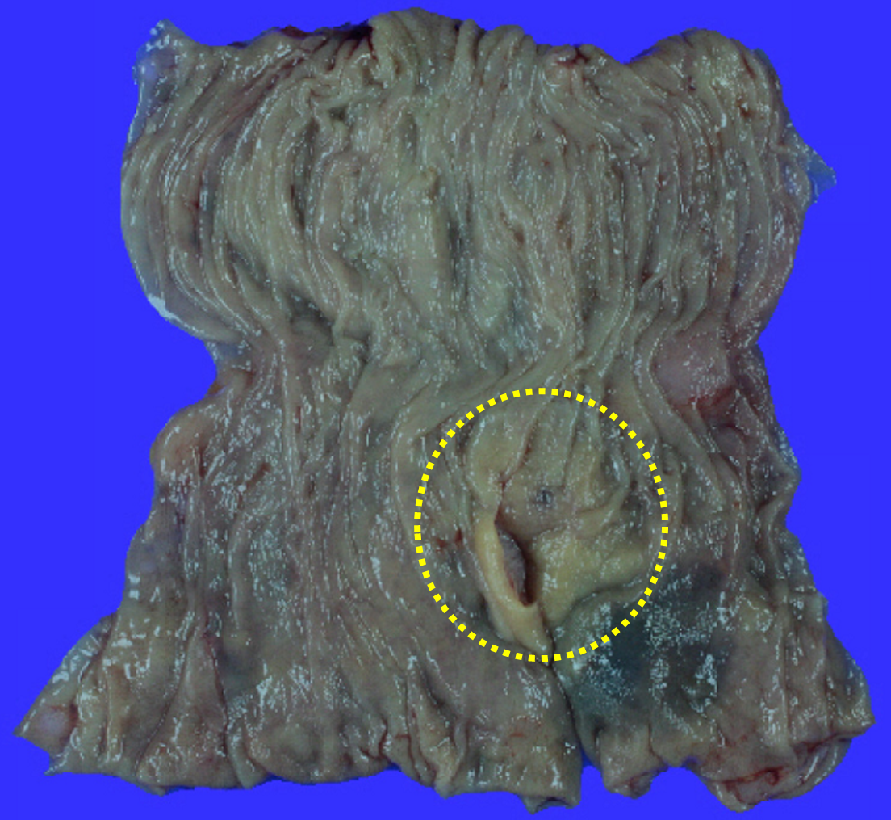
Figure 3 Surgical finding of the resected specimens. An ill-defined irregularly elevated mucosal lesion measuring 25 mm × 25 mm in diameter was observed (circle curve).

