Name of journal: World Journal of Hypertension
ESPS Manuscript NO: 15702
Columns: Minireviews

Multi-slice computerized tomography critical role in transcatheter aortic valve implantation plan: Review of current literature

Koifman E et al. The role of MSCT in TAVI

Edward Koifman, Ashraf Hamdan

Edward Koifman, Ashraf Hamdan, Leviev Heart Center, Chaim Sheba Medical Center, Tel-Hashomer 52621, Israel

Author contributions: All authors contributed to the writing, editing and reviewing of the manuscript.

Conflict-of-interest: None.

Open-Access: This article is an open-access article which was selected by an in-house editor and fully peer-reviewed by external reviewers. It is distributed in accordance with the Creative Commons Attribution Non Commercial (CC BY-NC 4.0) license, which permits others to distribute, remix, adapt, build upon this work non-commercially, and license their derivative works on different terms, provided the original work is properly cited and the use is non-commercial. See: http://creativecommons.org/licenses/by-nc/4.0/

Correspondence to: Dr. Ashraf Hamdan, MD, Leviev Heart Center, Chaim Sheba Medical Center, Tel-Hashomer 52621, Israel. hamdashraf@gmail.com

Telephone: +972-3-5302604
Fax: +972-3-5353441

Received: December 4, 2014
Peer-review started: December 4, 2014
First decision: February 7, 2015
Revised: April 29, 2015
Accepted: May 16, 2015
Article in press:
Published online:

Abstract
Transcatheter aortic valve implantation (TAVI) has been shown in improve outcome of severe aortic stenosis (AS) patients, deemed surgical high-risk or inoperable, and has grown popular in the past decade. The procedure requires accurate prior planning, and demands an integration of a “Heart Team” consisted from cardiac surgeons, interventional cardiologist, and imaging expert. The role of cardiac imaging and especially multi-slice computerized tomography (MSCT) has been a mainstay of pre-evaluation of severe AS patients and allows accurately depict and size the cardiac and vascular structures, and has become the primary tool for procedural planning.
This article is aimed to evaluate current uses of MSCT in severe AS patients undergoing TAVI, delineate the various measurements derived from this modality and review current literature regarding it’s advantages over other techniques.

Key words: Transcatheter aortic valve implantation; Multi-slice computerized tomography; Aortic annular sizing; Vascular access

© The Author(s) 2015. Published by Baishideng Publishing Group Inc. All rights reserved.

Core tip: Transcatheter aortic valve implantation (TAVI) has been shown in improve outcome of severe aortic stenosis (AS) patients, deemed surgical high-risk or inoperable, and has grown popular in the past decade. The procedure requires accurate prior planning, and demands an integration of a “Heart Team” approach consisted from cardiac surgeons, interventional cardiologist, and imaging expert. The role of cardiac imaging and especially multi-slice computerized tomography (MSCT) has been a mainstay of TAVI evaluation, and allows accurate depiction and sizing of the cardiac and vascular structures. This article is aimed to review current use of MSCT in TAVI patients.

Koifman E, Hamdan A. Multi-slice computerized tomography critical role in transcatheter aortic valve implantation plan: Review of current literature. World J Hypertens 2015; In press

INTRODUCTION
Transcatheter aortic valve implantation (TAVI) has been shown to improve outcome of severe aortic stenosis patients deemed inoperable^{[1]} or high risk^{[2]}, with mortality rates lower than surgical aortic valve replacement^{[3]}. However, this procedure incurs complications such as paravalvular aortic regurgitation, vascular access complications, stroke, conduction defects requiring pacemaker implantation, and less common, annular rupture ^{[4,5]}.
A “heart team” approach is recommended in any patient considered for TAVI^{[6,7]}. This team is comprised of a multidisciplinary team including general cardiologists, cardiac surgeons, interventional cardiologists, anesthesiologists and imaging cardiologists. The assessment of each patient requires evaluation of symptoms, cardiac and valvular function^{[8]} to determine the severity of aortic stenosis and appropriateness of intervention. Once a patient is considered for intervention, the risk of surgery should be determined according to comorbidities, patient function and frailty and technical aspects such as porcelain aorta and prior cardiac surgery^{[9,10]}. In case of inoperability or high surgical risk, additional imaging should be performed for the evaluation of TAVI in order to determine annular size, distance between annulus and coronary artery ostium, implantation angle, and vascular access. This can be done by various methods, most commonly by multi-slice computerized tomography (MSCT). This review aim is to describe MSCT for evaluation of patients referred for TAVI.

MSCT DATA
Unlike surgery, where direct visualization and sizing of the valve is done, TAVI is performed with a 2-dimentional fluoroscopy guidance, where it is difficult to asses proper valvular size and access routes. MSCT enables extracting a large amount of data from a 3-dimentional image which include access options by measuring the diameters of the arteries and aorta in the perpendicular plane, establishing the presence of protruding atherosclerotic plaques, assessing the calcification of the arteries and aortic annulus and evaluating annular dimensions and its proximity to important anatomical landmarks such as the coronary arteries ostium (Table 1). These measurements require an accurate alignment of images in the appropriate plane done by an imaging expert and reviewed by the interventional cardiologist.

MSCT DATA ACQUISITION
The acquisition of the CT data should be performed during an inspiratory breathhold while the electrocardiogram (ECG) should be recorded simultaneously to allow retrospective or prospective gating of the data. Imaging of the annulus in systole, when the aortic annulus size increases^{[11]}, may be preferable over the diastole; however, analysis of the aorta and peripheral arteries can be performed without ECG synchrony.

ASSESSMENT OF THE AORTIC ANNULUS
The aortic root is a complex anatomic structure comprised from a tri-leaflet valve inserted in a semi-lunar mode into the left ventricle and aortic root, which creates the sinuses of valsava that accommodate the coronaries origin. It lies in a close proximity to the atrioventricular node and the left bundle of the cardiac conduction system^{[12]}.
Accurate measurement of the aortic annulus is a critical step in the planning of TAVI, since it enables proper valve sizing, grades calcification of aortic annulus and measure the distance to the coronaries origin. These parameters point to possible complications including paravalvular leaks^{[13,14]}, annular rupture^{[15,16]} and coronary arteries obstruction^{[17,18]}, all of which have adverse impact on patients outcome^{[19,20]}.
The aortic annulus has an oval shape, thus measuring its diameter in a single plane is inaccurate and misleads the operators when sizing the valve^{[21]}. Therefore measuring annular diameter by 2D echocardiography usually provides the shorter diameter and consequently undersizes annular dimensions^{[22]}. Precise measurement of annular dimensions requires alignment of the image in a perpendicular plane to the basal part of leaflets insertion (Figure 1). The parameters derived from annular measurements include short and long diameters, mean diameter, perimeter and area. The aortic annulus, generally elliptic, assumes a more round shape in systole, thus increasing cross sectional area without substantial change in perimeter. Perimeter changes are negligible in patients with calcified valves, because tissue properties allow very little expansion. Aortic annulus perimeter appears therefore ideally suited for accurate sizing in TAVI^{[11]}. Inter- and Intra-observer variability of these measurement by MSCT is small and highly reproducible as shown in a recent study^{[23]} and studies comparing different modalities for prosthesis sizing have shown reduction in paravalvular leak with MSCT measurement compared with 2D echocardiography^{[24,25]} and therefore MSCT is currently regarded as an essential tool for accurate prosthesis sizing.

CORONARY ARTERY OSTIA AND ADDITIONAL AORTIC ROOT DIMENSIONS
Besides aortic annular dimension, other considerations should be taken into account upon deciding valve brand and size. Coronary ostia height and sinus of valsalva diameter should be measured (Figures 2 and 3), and coronary obstruction risk must be assessed since the native valve leaflets are displaced and could potentially obstruct the coronary flow. In a multicenter registry, coronary obstruction was reported in less than 1% of TAVI patients^{[17]}. Predictors of coronary obstruction were low coronary ostia height and small sinus of valsalva diameter along with female gender, valve-in-valve procedure and balloon expandable valve^{[17]}. The outcome of this complication is catastrophic with a 30-d mortality rate of more than 40%. Therefore, it is crucial to measure coronary ostia height, ensure adequate sinus of valsalva diameter and height according to the device requirements, as published by the manufacturer.
Sinutubular junction diameter (Figure 4) should also be considered since a smaller diameter than the valve implanted could pose a risk of aortic injury upon balloon inflation in balloon expandable valves. In self-expandable valves the ascending aorta (Figure 5) acts as an anchorage point, hence, large diameters as in aortic aneurysm are a contraindication for the use of this type of valve.

AORTIC ANNULUS PLANE FOR FLUOROSCOPY
Positioning of the valve is a critical step in TAVI procedure, which is usually performed under angiography guidance. Since, angiography is a 2D image, precise planar projection is required for accurate centered implantation of the valve in a perpendicular angle to the native valve plane. Assessment of the proper implantation plane can be located by angiography, however, this methods has some caveats such as, additional contrast injection and radiation exposure along with the inherent requirement for interpreting a 2D image in a 3 dimensional manner. Moreover, certain anatomic features can complicate this task, like severe calcification of the aortic valve and root, which can obscure the leaflet insertion, and chest deformation, which can require extreme angles for implantation. MSCT allows a 3D image reconstruction without the need for additional contrast or radiation, and has been shown to accurately predict the valve deployment projection^{[26]}, by creating a “line of perpendicularity” which denotes the projections that can be used in order to implant the valve in an orthogonal plane to the native valve^{[26]}.

ACCESS ROUTE EVALUATION
The transfemoral route is currently the default approach for TAVI procedure. The femoral arteries can accommodate a sheath with slightly higher diameter if it is not calcified; however, circumferential calcification and tortuosity especially with involvement of bifurcations are predictors of vascular complication. Thus, utilization of transfemoral approach requires precise evaluation of vascular diameters, calcification and tortuosity (Figure 6). This can be achieved by MSCT, which properly depicts the vascular anatomy in a 3D imaging. Vascular complications have been shown to impact outcome of TAVI patients, and its incidence was above 30% in the PARTNER trial^{[1]}, where route assessment was performed by angiography. The utilization of MSCT have reduced major vascular complications rate from 8% to 1% and minor vascular complications from 24% to 8% over the 2-year study period. The vessel minimal luminal diameter being smaller than the sheath external diameter (23% vs 5%) and the presence of calcified vessels (29% vs 9%) were strong predictors for vascular complications^{[27]}.
Measurements of minimal vessel diameters should be performed after a multi-planar reconstruction along the entire course of the vessels in order to attain a perpendicular image. Vessel calcifications should be assessed according to circumferential involvement due to its limitations in accommodating the sheath, and prohibiting the safe passage of the delivery system. Vessel calcification can falsely cause underestimation of its diameter due to the “blooming” effect, in which the calcified segment appears larger than it true dimension thus reducing the size of the true lumen. Tortuosity can be evaluated after 3D reconstruction the aorta and iliofemoral vessels^{[28]}, and although severe tortuosity can be straightened. Assessment of alternative routes can be performed by reconstructing images depicting the subclavian artery diameter, calcification and course for this route, and aortic calcification for a transaortic route.

CONCLUSION
TAVI frequency is growing worldwide, and accordingly the experience with regard to planning the procedure, avoiding complications, and treating them when they occur. The utilization of advanced imaging techniques such as MSCT, with sophisticated data acquisition protocols have significantly improved our ability to assess the access site, accurately size the aortic root dimension and select the appropriate device size, and importantly estimate and avoid fatal complications. Accordingly, most of TAVI programs include an imaging specialist in the heart team. We expect that the use and experience of MSCT will grow and enhanced techniques and algorithms will allow us to further improve the outcome of patients undergoing TAVI in light of the large number of new devices that are currently available or on trial。

REFERENCES
1 Leon MB, Smith CR, Mack M, Miller DC, Moses JW, Svensson LG, Tuzcu EM, Webb JG, Fontana GP, Makkar RR, Brown DL, Block PC, Guyton RA, Pichard AD, Bavaria JE, Herrmann HC, Douglas PS, Petersen JL, Akin JJ, Anderson WN, Wang D, Pocock S. Transcatheter aortic-valve implantation for aortic stenosis in patients who cannot undergo surgery. N Engl J Med 2010; 363: 1597-1607 [PMID: 20961243 DOI: 10.1056/NEJMoa1008232]
2 Smith CR, Leon MB, Mack MJ, Miller DC, Moses JW, Svensson LG, Tuzcu EM, Webb JG, Fontana GP, Makkar RR, Williams M, Dewey T, Kapadia S, Babaliaros V, Thourani VH, Corso P, Pichard AD, Bavaria JE, Herrmann HC, Akin JJ, Anderson WN, Wang D, Pocock SJ. Transcatheter versus surgical aortic-valve replacement in high-risk patients. N Engl J Med 2011; 364: 2187-2198 [PMID: 21639811 DOI: 10.1056/NEJMoa1103510]
3 Adams DH, Popma JJ, Reardon MJ, Yakubov SJ, Coselli JS, Deeb GM, Gleason TG, Buchbinder M, Hermiller J, Kleiman NS, Chetcuti S, Heiser J, Merhi W, Zorn G, Tadros P, Robinson N, Petrossian G, Hughes GC, Harrison JK, Conte J, Maini B, Mumtaz M, Chenoweth S, Oh JK. Transcatheter aortic-valve replacement with a self-expanding prosthesis. N Engl J Med 2014; 370: 1790-1798 [PMID: 24678937 DOI: 10.1056/NEJMoa1400590]
4 Eltchaninoff H, Prat A, Gilard M, Leguerrier A, Blanchard D, Fournial G, Iung B, Donzeau-Gouge P, Tribouilloy C, Debrux JL, Pavie A, Gueret P. Transcatheter aortic valve implantation: early results of the FRANCE (FRench Aortic National CoreValve and Edwards) registry. Eur Heart J 2011; 32: 191-197 [PMID: 20843959 DOI: 10.1093/eurheartj/ehq261]
5 Zahn R, Gerckens U, Grube E, Linke A, Sievert H, Eggebrecht H, Hambrecht R, Sack S, Hauptmann KE, Richardt G, Figulla HR, Senges J. Transcatheter aortic valve implantation: first results from a multi-centre real-world registry. Eur Heart J 2011; 32: 198-204 [PMID: 20864486 DOI: 10.1093/eurheartj/ehq339]
6 Nishimura RA, Otto CM, Bonow RO, Carabello BA, Erwin JP, Guyton RA, O'Gara PT, Ruiz CE, Skubas NJ, Sorajja P, Sundt TM, Thomas JD. 2014 AHA/ACC guideline for the management of patients with valvular heart disease: a report of the American College of Cardiology/American Heart Association Task Force on Practice Guidelines. J Am Coll Cardiol 2014; 63: e57-185 [PMID: 24603191 DOI: 10.1016/j.jacc.2014.02.537]
7 Vahanian A, Alfieri O, Andreotti F, Antunes MJ, Barón-Esquivias G, Baumgartner H, Borger MA, Carrel TP, De Bonis M, Evangelista A, Falk V, Iung B, Lancellotti P, Pierard L, Price S, Schäfers HJ, Schuler G, Stepinska J, Swedberg K, Takkenberg J, Von Oppell UO, Windecker S, Zamorano JL, Zembala M. Guidelines on the management of valvular heart disease (version 2012). Eur Heart J 2012; 33: 2451-2496 [PMID: 22922415 DOI: 10.1093/eurheartj/ehs109]
8 Zoghbi WA, Enriquez-Sarano M, Foster E, Grayburn PA, Kraft CD, Levine RA, Nihoyannopoulos P, Otto CM, Quinones MA, Rakowski H, Stewart WJ, Waggoner A, Weissman NJ. Recommendations for evaluation of the severity of native valvular regurgitation with two-dimensional and Doppler echocardiography. J Am Soc Echocardiogr 2003; 16: 777-802 [PMID: 12835667 DOI: 10.1016/S0894-7317(03)00335-3]
9 Hattler BG, Madia C, Johnson C, Armitage JM, Hardesty RL, Kormos RL, Pham SM, Payne DN, Griffith BP. Risk stratification using the Society of Thoracic Surgeons Program. Ann Thorac Surg 1994; 58: 1348-1352 [PMID: 7979657 DOI: 10.1016/0003-4975(94)91911-9]
10 Roques F, Nashef SA, Michel P, Gauducheau E, de Vincentiis C, Baudet E, Cortina J, David M, Faichney A, Gabrielle F, Gams E, Harjula A, Jones MT, Pintor PP, Salamon R, Thulin L. Risk factors and outcome in European cardiac surgery: analysis of the EuroSCORE multinational database of 19030 patients. Eur J Cardiothorac Surg 1999; 15: 816-822; discussion 822-823 [PMID: 10431864 DOI: 10.1016/S1010-7940(99)00106-2]
11 Hamdan A, Guetta V, Konen E, Goitein O, Segev A, Raanani E, Spiegelstein D, Hay I, Di Segni E, Eldar M, Schwammenthal E. Deformation dynamics and mechanical properties of the aortic annulus by 4-dimensional computed tomography: insights into the functional anatomy of the aortic valve complex and implications for transcatheter aortic valve therapy. J Am Coll Cardiol 2012; 59: 119-127 [PMID: 22222074 DOI: 10.1016/j.jacc.2011.09.045]
12 Piazza N, de Jaegere P, Schultz C, Becker AE, Serruys PW, Anderson RH. Anatomy of the aortic valvar complex and its implications for transcatheter implantation of the aortic valve. Circ Cardiovasc Interv 2008; 1: 74-81 [PMID: 20031657 DOI: 10.1161/CIRCINTERVENTIONS.108.780858]
13 Hayashida K, Lefèvre T, Chevalier B, Hovasse T, Romano M, Garot P, Bouvier E, Farge A, Donzeau-Gouge P, Cormier B, Morice MC. Impact of post-procedural aortic regurgitation on mortality after transcatheter aortic valve implantation. JACC Cardiovasc Interv 2012; 5: 1247-1256 [PMID: 23257373 DOI: 10.1016/j.jcin.2012.09.003]
14 Sinning JM, Hammerstingl C, Vasa-Nicotera M, Adenauer V, Lema Cachiguango SJ, Scheer AC, Hausen S, Sedaghat A, Ghanem A, Müller C, Grube E, Nickenig G, Werner N. Aortic regurgitation index defines severity of peri-prosthetic regurgitation and predicts outcome in patients after transcatheter aortic valve implantation. J Am Coll Cardiol 2012; 59: 1134-1141 [PMID: 22440213 DOI: 10.1016/j.jacc.2011.11.048]
15 Rezq A, Basavarajaiah S, Latib A, Takagi K, Hasegawa T, Figini F, Cioni M, Franco A, Montorfano M, Chieffo A, Maisano F, Corvaja N, Alfieri O, Colombo A. Incidence, management, and outcomes of cardiac tamponade during transcatheter aortic valve implantation: a single-center study. JACC Cardiovasc Interv 2012; 5: 1264-1272 [PMID: 23257375 DOI: 10.1016/j.jcin.2012.08.012]
16 Hayashida K, Bouvier E, Lefèvre T, Hovasse T, Morice MC, Chevalier B, Romano M, Garot P, Farge A, Donzeau-Gouge P, Cormier B. Potential mechanism of annulus rupture during transcatheter aortic valve implantation. Catheter Cardiovasc Interv 2013; 82: E742-E746 [PMID: 22718400 DOI: 10.1002/ccd.24524]
17 Ribeiro HB, Webb JG, Makkar RR, Cohen MG, Kapadia SR, Kodali S, Tamburino C, Barbanti M, Chakravarty T, Jilaihawi H, Paradis JM, de Brito FS, Cánovas SJ, Cheema AN, de Jaegere PP, del Valle R, Chiam PT, Moreno R, Pradas G, Ruel M, Salgado-Fernández J, Sarmento-Leite R, Toeg HD, Velianou JL, Zajarias A, Babaliaros V, Cura F, Dager AE, Manoharan G, Lerakis S, Pichard AD, Radhakrishnan S, Perin MA, Dumont E, Larose E, Pasian SG, Nombela-Franco L, Urena M, Tuzcu EM, Leon MB, Amat-Santos IJ, Leipsic J, Rodés-Cabau J. Predictive factors, management, and clinical outcomes of coronary obstruction following transcatheter aortic valve implantation: insights from a large multicenter registry. J Am Coll Cardiol 2013; 62: 1552-1562 [PMID: 23954337 DOI: 10.1016/j.jacc.2013.07.040]
18 Ribeiro HB, Nombela-Franco L, Urena M, Mok M, Pasian S, Doyle D, DeLarochellière R, Côté M, Laflamme L, DeLarochellière H, Allende R, Dumont E, Rodés-Cabau J. Coronary obstruction following transcatheter aortic valve implantation: a systematic review. JACC Cardiovasc Interv 2013; 6: 452-461 [PMID: 23602458 DOI: 10.1016/j.jcin.2012.11.014]
19 Tamburino C, Capodanno D, Ramondo A, Petronio AS, Ettori F, Santoro G, Klugmann S, Bedogni F, Maisano F, Marzocchi A, Poli A, Antoniucci D, Napodano M, De Carlo M, Fiorina C, Ussia GP. Incidence and predictors of early and late mortality after transcatheter aortic valve implantation in 663 patients with severe aortic stenosis. Circulation 2011; 123: 299-308 [PMID: 21220731 DOI: 10.1161/CIRCULATIONAHA.110.946533]
20 Seiffert M, Conradi L, Baldus S, Schirmer J, Blankenberg S, Reichenspurner H, Diemert P, Treede H. Severe intraprocedural complications after transcatheter aortic valve implantation: calling for a heart team approach. Eur J Cardiothorac Surg 2013; 44: 478-484; discussion 484 [PMID: 23389474 DOI: 10.1093/ejcts/ezt032]
21 Tops LF, Wood DA, Delgado V, Schuijf JD, Mayo JR, Pasupati S, Lamers FP, van der Wall EE, Schalij MJ, Webb JG, Bax JJ. Noninvasive evaluation of the aortic root with multislice computed tomography implications for transcatheter aortic valve replacement. JACC Cardiovasc Imaging 2008; 1: 321-330 [PMID: 19356444 DOI: 10.1016/j.jcmg.2007.12.006]
22 Ng AC, Delgado V, van der Kley F, Shanks M, van de Veire NR, Bertini M, Nucifora G, van Bommel RJ, Tops LF, de Weger A, Tavilla G, de Roos A, Kroft LJ, Leung DY, Schuijf J, Schalij MJ, Bax JJ. Comparison of aortic root dimensions and geometries before and after transcatheter aortic valve implantation by 2- and 3-dimensional transesophageal echocardiography and multislice computed tomography. Circ Cardiovasc Imaging 2010; 3: 94-102 [PMID: 19920027 DOI: 10.1161/CIRCIMAGING.109.885152]
23 Schuhbaeck A, Achenbach S, Pflederer T, Marwan M, Schmid J, Nef H, Rixe J, Hecker F, Schneider C, Lell M, Uder M, Arnold M. Reproducibility of aortic annulus measurements by computed tomography. Eur Radiol 2014; 24: 1878-1888 [PMID: 24845112 DOI: 10.1007/s00330-014-3199-5]
24 Jilaihawi H, Kashif M, Fontana G, Furugen A, Shiota T, Friede G, Makhija R, Doctor N, Leon MB, Makkar RR. Cross-sectional computed tomographic assessment improves accuracy of aortic annular sizing for transcatheter aortic valve replacement and reduces the incidence of paravalvular aortic regurgitation. J Am Coll Cardiol 2012; 59: 1275-1286 [PMID: 22365424 DOI: 10.1016/j.jacc.2011.11.045]
25 Hayashida K, Bouvier E, Lefèvre T, Hovasse T, Morice MC, Chevalier B, Romano M, Garot P, Mylotte D, Farge A, Donzeau-Gouge P, Cormier B. Impact of CT-guided valve sizing on post-procedural aortic regurgitation in transcatheter aortic valve implantation. EuroIntervention 2012; 8: 546-555 [PMID: 22995080 DOI: 10.4244/EIJV8I5A85]
26 Kurra V, Kapadia SR, Tuzcu EM, Halliburton SS, Svensson L, Roselli EE, Schoenhagen P. Pre-procedural imaging of aortic root orientation and dimensions: comparison between X-ray angiographic planar imaging and 3-dimensional multidetector row computed tomography. JACC Cardiovasc Interv 2010; 3: 105-113 [PMID: 20129578 DOI: 10.1016/j.jcin.2009.10.014]
27 Toggweiler S, Gurvitch R, Leipsic J, Wood DA, Willson AB, Binder RK, Cheung A, Ye J, Webb JG. Percutaneous aortic valve replacement: vascular outcomes with a fully percutaneous procedure. J Am Coll Cardiol 2012; 59: 113-118 [PMID: 22222073 DOI: 10.1016/j.jacc.2011.08.069]
28 Achenbach S, Delgado V, Hausleiter J, Schoenhagen P, Min JK, Leipsic JA. SCCT expert consensus document on computed tomography imaging before transcatheter aortic valve implantation (TAVI)/transcatheter aortic valve replacement (TAVR). J Cardiovasc Comput Tomogr 2012; 6: 366-380 [PMID: 23217460 DOI: 10.1016/j.jcct.2012.11.002]

P-Reviewer: Castillo R, Li JD S-Editor: Ji FF L-Editor: E-Editor:

Table 1 Data derived from multi-slice computerized tomography imaging
Assessment of the aortic annulus
Annular shape
Calcification
Annular diameters, area and perimeter coronary artery ostia and additional Aortic root dimensions
Coronary ostium height
Sinus of valsava diameter and height
Sinutubular junction diameter
Ascending aorta diameter
Aortic annulus plane for fluoroscopy
Degree of aortic angulation in relation to the annulus
Optimal projection angle
Access route evaluation
Pelvic and aortic minimal diameters
Vascular calcification
Vascular tortuosity
Presence of protruding atherosclerotic plaques and thrombi

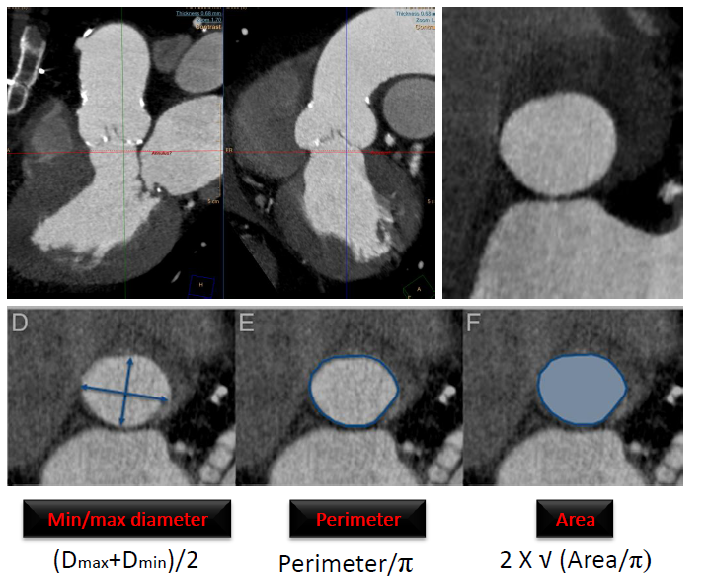
Figure 1 Aortic annulus dimensions.
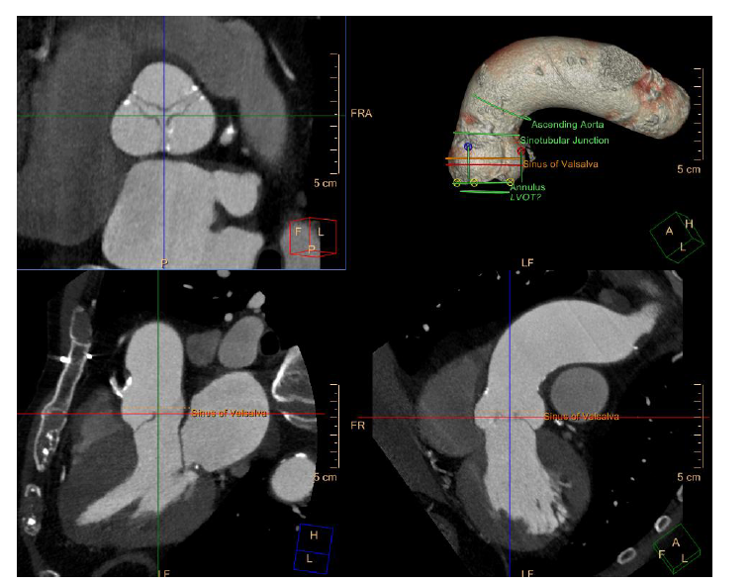
Figure 2 Coronary ostial height distances for the right coronary artery (right image) and left main artery (left image).

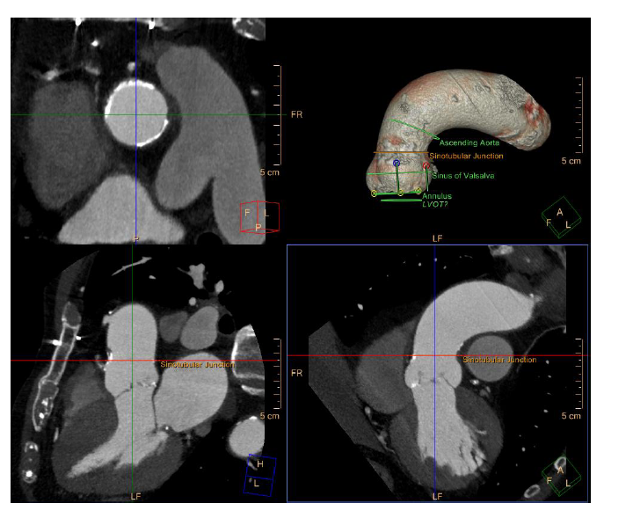
Figure 3 Sinus of Valsalva dimensions.
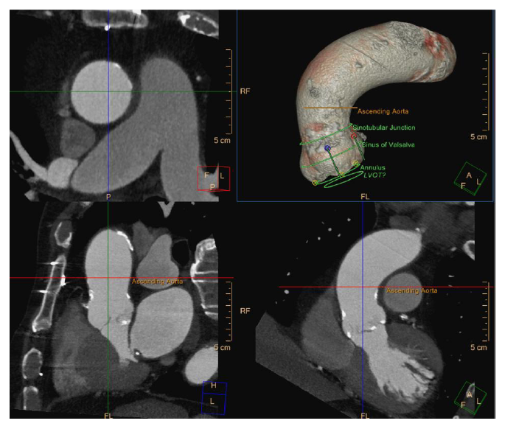
Figure 4 Sinotubular junction dimensions.
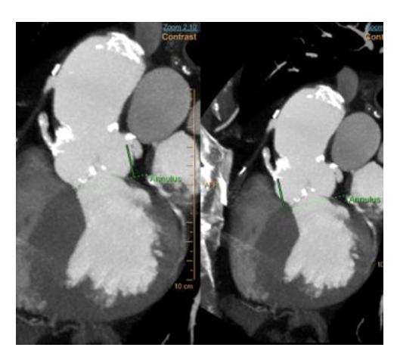
Figure 5 Ascending aorta dimensions.
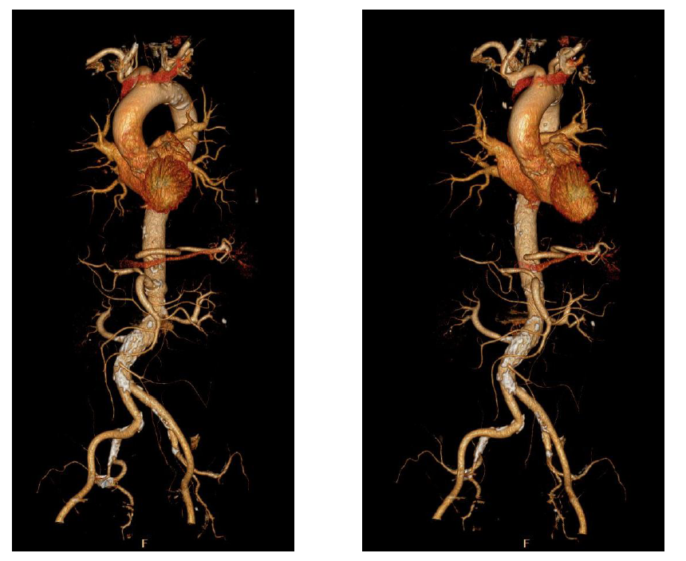
Figure 6 Aorta and iliac arteries 3D reconstruction.

