Name of Journal: World Journal of Clinical Cases
Manuscript NO: 47793
Manuscript Type: CASE REPORT

Termination of a partial hydatidiform mole and coexisting fetus: A case report

Zhang RQ et al. A case of PHMCF

Rui-Qing Zhang, Jia-Rong Zhang, Shuang-Di Li

Rui-Qing Zhang, Jia-Rong Zhang, Shanghai General Hospital, School of Medicine, Shanghai Jiao Tong University, Shanghai 200120, China

Shuang-Di Li, Shanghai First Maternity and Infant Hospital, Shanghai 200120, China

ORCID number: Rui-Qing Zhang (0000-0001-5909-322X); Shuang-Di Li (0000-0003-4172-5051); Jia-Rong Zhang (0000-0002-7524-5753).

Author contributions: Li SD and Zhang JR contributed equally to this work; Li SD and Zhang JR put forward the idea; Zhang RQ collected and analyzed the data; Li SD and Zhang RQ wrote the paper.

Informed consent statement: All study participants provided written informed consent prior to study enrollment.

Conflict-of-interest statement: All authors declare no conflict of interest.

CARE Checklist (2016) statement: The authors have read the CARE Checklist (2016), and the manuscript was prepared and revised according to the CARE Checklist (2016).

Open-Access: This article is an open-access article which was selected by an in-house editor and fully peer-reviewed by external reviewers. It is distributed in accordance with the Creative Commons Attribution Non Commercial (CC BY-NC 4.0) license, which permits others to distribute, remix, adapt, build upon this work non-commercially, and license their derivative works on different terms, provided the original work is properly cited and the use is non-commercial. See: http://creativecommons.org/licenses/by-nc/4.0/

Manuscript source: Unsolicited manuscript

Corresponding author: Shuang-Di Li, MD, PhD, Doctor, Shanghai First Maternity and Infant Hospital, Pudong New Area, Shanghai 200120, China. lishuangdi21@126.com
Telephone: +86-21-37798537
Fax: +86-21-37798537

Received: April 6, 2019
Peer-review started: April 8, 2019
First decision: August 1, 2019
Revised: August 22, 2019
Accepted: September 9, 2019
Article in press: September 9, 2019
Published online: October 6, 2019

Abstract
BACKGROUND
We describe the treatment strategy for a patient who was found to have a partial hydatidiform mole and coexisting fetus (PHMCF) during the second trimester. The patient was a 38-year-old Chinese woman who had become pregnant following in vitro fertilization and embryo transplantation. We wanted to determine the safest therapeutic strategy to terminate the PHMCF during the second trimester.

CASE SUMMARY
In this case, we present a patient who was found to have a PHMCF complicated with serious continuous vaginal bleeding and pre-eclampsia during the second trimester. After careful evaluation, the pregnancy was considered to be unsustainable and was terminated via caesarean section (CS). An infant with weak vital signs and a partially cystic placenta measuring 110 mm × 95 mm × 35 mm were delivered by CS. The patient was discharged after 4 d. The serum levels of β-human chorionic gonadotropin decreased to within a normal range 5 wk after the operation, and no evidence of persistent trophoblastic disease or lung metastases was noticed at the 6-mo follow-up.

CONCLUSION
CS termination of PHMCF during the second trimester may be a relatively safe therapeutic strategy.

Key words: Partial hydatidiform mole and coexisting fetus; Caesarean section; Second trimester; Case report

© The Author(s) 2019. Published by Baishideng Publishing Group Inc. All rights reserved.

Core tip: A partial hydatidiform mole and coexisting fetus (PHMCF), a rare phenomenon in the past, is showing an upward trend in frequency due to the increasing use of assisted reproductive technologies. Our main objective was to find the safest therapeutic strategy to terminate a PHMCF during the second trimester. We determined that termination of PHMCF during the second trimester via caesarean section is a relatively safe therapeutic strategy.

Citation: Zhang RQ, Li SD, Zhang JR. Termination of a partial hydatidiform mole and coexisting fetus: A case report. World J Clin Cases 2019; 7(20): 3289-3295
URL: https://www.wjgnet.com/2307-8960/full/v7/i20/3289.htm
DOI: https://dx.doi.org/10.12998/wjcc.v7.i20.3289

INTRODUCTION
A partial hydatidiform mole and coexisting fetus (PHMCF), a rare phenomenon of the past, is showing an upward trend in frequency due to the increasing use of assisted reproductive technologies (ART). The reported incidence of complete hydatidiform mole and coexisting fetus, which is essentially a twin pregnancy, is 1 in 22000-100000 pregnancies^{[1]}. However, a PHMCF is a single pregnancy and the reported prevalence is 0.005%-0.01% of all pregnancies^{[2]}. The management of such pregnancies creates a dilemma for both the physician and the parents, particularly when the PHMCF occurs during the second trimester of pregnancy. Empirically, the pregnancy is allowed to proceed provided that severe maternal complications are controlled, and the fetal karyotype and development are normal^{[3]}. A small number of cases of PHMCF have been reported with certain couples choosing to continue the pregnancy until 28 wk of gestation and delivery was achieved via caesarean section (CS) resulting in a number of healthy babies^{[4,5]}. Unfortunately, in most patients, serious complications can occur, posing significant challenges and difficult choices for both the obstetrician and the patients. For these patients, the main problem is to determine whether the pregnancy is sustainable, and if not, the best way to terminate the pregnancy. Herein, we report the case of a PHMCF patient with severe complications during the second trimester, whose pregnancy was considered unsustainable after careful evaluation and eventually terminated by CS. The timeline is shown in Figure 1.

CASE PRESENTATION
Chief complaints
A 38-year-old Chinese woman was found to have blood pressure instability at 21 wk of gestation and was admitted to our hospital for pre-eclampsia.

History of present illness
The patient became pregnant following in vitro fertilization and embryo transplantation (IVF-ET). Three embryos were transferred into the uterus and only one embryo survived. In early pregnancy, the patient had recurrent episodes of fresh vaginal bleeding. On admission, the couple was informed of the high probability for a poor obstetrical outcome with complications; however, they wished to continue the pregnancy.

History of past illness
The patient (gravida 2, para 0) denied having had hypertension, diabetes and coronary heart disease. The patient denied having had hepatitis and tuberculosis. Moreover, the patient denied a history of food and drug allergy.

Personal and family history
The patient denied a history of drug abuse, smoking, and drinking. The patient denied a family history of genetic disease and cancer.

Physical examination upon admission
The patient’s blood pressure at admission was 160/87 mmHg, and heart rate was 115 bpm. Her temperature and pulse were normal. The fetal heart rate was 140 bpm.

Laboratory examinations
At 13 wk and 3 d, the measurement of serum β-human chorionic gonadotropin (β-HCG) rose to 271600 IU/L, and the result of the Down’s syndrome screening showed a low-risk status. At 21 wk and 4 d, her serum β-HCG level rose to 510427 IU/L, which was abnormally high for the corresponding gestational age.

Imaging examinations
An ultrasound sonographic examination at 55 d of gestational age revealed a single live intrauterine fetus of 7 wk and 4 d, and a blood clot beside it. At 10 wk and 3 d, an ultrasound examination revealed a single live intrauterine fetus of 10 wk and 3 d with a suspected partial hydatidiform mole. However, at 13 wk and 3 d of gestational age, vaginal bleeding disappeared and an ultrasound examination merely revealed a single live intrauterine fetus. At 21 wk and 3 d, a transvaginal sonographic examination revealed a single live intrauterine fetus of 21 wk and 4 d. The left part of the placenta was composed of multiple cystic areas, measuring 126 mm × 42 mm × 114 mm (Figure 2). Two days later, enhanced magnetic resonance imaging revealed a single live intrauterine fetus and abnormal intensified signals at the left part of the placenta with no clear demarcations between the myometrium and placental tissue (Figure 3). The chest computed tomography result was normal.

FINAL DIAGNOSIS
The histopathology was consistent with molar changes (Figure 4).

TREATMENT
A detailed counseling session was provided to discuss the risks of maternal complications, and the couple decided to terminate the pregnancy following careful consideration. CS was chosen because of the heavy vaginal bleeding and the high probability that a medical induction of labor may lead to an incomplete evacuation of the uterus. An infant with weak vital signs and a partially cystic placenta measuring 110 mm × 95 mm × 35 mm were delivered by CS. Thereafter, vesicular tissue, measuring 180 mm × 160 mm × 45 mm, was extracted and the uterus was completely evacuated (Figure 5).

OUTCOME AND FOLLOW-UP
The serum β-HCG levels of the patient decreased to 5258 IU/L after a week. The patient was discharged and her weekly follow-up of serum β-HCG levels showed an obvious downward trend. After 5 wk, her serum β-HCG levels decreased to the normal range and no evidence of persistent trophoblastic disease (PTD) or lung metastases was noticed at the 6-mo follow-up.

DISCUSSION
A PHMCF is always associated with complications such as fetal death, vaginal bleeding, early onset pre-eclampsia, hyperthyroidism, and a risk of gestational trophoblastic neoplasia. Consequently, an early diagnosis of PHMCF has been recommended in order to treat this disease. The diagnosis of PHMCF during the first trimester of pregnancy is mainly revealed by ultrasonographic examinations. Unfortunately, a misdiagnosis is not uncommon on the initial ultrasonography due to the reassuring presence of a fetal heartbeat and the misinterpretation of abnormal placental echoes such as those associated with hematomas^{[2]}. Moreover, partial molar pregnancies often present minor cystic changes of the placenta^{[6]}, which makes PHMCFs even more difficult to diagnosis. In our case, the ultrasound examination at 55 d revealed a single live intrauterine fetus with a blood clot beside it. At 13 wk of pregnancy, it merely revealed a single live intrauterine fetus. Magnetic resonance imaging can be a useful adjunct to ultrasound for visualizing the normal placental site, the relationship between the fetus and vesicles, and the extension of the disease to the myometrium and parametrium. However, its diagnostic effect in early pregnancy remains unclear^{[7]}. Although several PHMCF cases have been successfully diagnosed during the first trimester^{[8-11]}, the overall diagnosis rate is still low. Further investigations are required to find more ideal methods to diagnose PHMCF in the first trimester.
When we failed to diagnose PHMCF early and the pregnancy progressed to the second trimester, we considered two factors to determine whether the pregnancy was sustainable. First, severe maternal complications were controlled, and second, the fetal karyotype and development were normal, as stated above. However, even if the pregnancy is allowed to proceed, the overall live birth rate is very low, as listed in Table 1. In addition, a partial molar pregnancy with an embryo of a normal karyotype during the second trimester, may end up as a fetal demise in the third trimester which may be due to placental mosaicism or placental mesenchymal dysplasia^{[12,13]}. In our case, we could not acquire the fetal karyotype information because the patient refused to allow an amniocentesis since the fetus appeared normal on sonographic examination. Moreover, the onset of severe vaginal bleeding at 22 wk rendered the pregnancy unsustainable.
Several methods have been reported to terminate PHMCFs during the second trimester. Suction curettage is a safe way to terminate hydatidiform moles^{[14]}. However, a mid-term pregnancy with a relatively large fetus precludes the use of suction curettage. Medical termination (using rivanol or misoprostol) is not recommended for molar evacuations since these methods increase maternal complications, including blood loss, incomplete evacuation^{[15]}, and the development of PTD due to increased intrauterine pressure^{[16]}. Dilatation and evacuation have been recommended by the Evidence-based Practice Guidelines of the Royal College of Obstetricians and Gynecologists as a safe method for termination of pregnancies > 15 wk. However, it should be performed by a skilled specialist, and its use in PHMCFs is still questionable. CS has also been reported for terminating PHMCFs. So far, no PTDs have been reported to develop after this procedure. However, the relatively low survival rate of the neonate and the presence of a uterine scar make the CS procedure a difficult choice for both physicians and patients. Hysterectomy is a viable management choice for women in an emergent situation not wishing to maintain fertility^{[17]}. Bearing in mind that PHMCF patients often are relatively young, this procedure can cause emotional distress and should be considered very carefully. Moreover, PTDs can still develop after a hysterectomy.
To the best of our knowledge, 12 PHMCF cases during the second trimester have previously been reported (Table 1). Three of these cases^{[15,18,19]} of PHMCF were treated with medical termination; unfortunately, all of them resulted in PTDs and metastases. In contrast, two cases^{[20,21]} (and our case) were terminated using CSs and no PTDs or metastases developed. Therefore, these results led to the hypothesis that CS termination may be a safer therapeutic strategy during the second trimester with regard to the risk of developing PTDs.
A plausible relationship between gestational trophoblastic disease (GTD) and ART has been established^{[15]}. This may be because the clinical factors (advanced maternal age, poor oocyte quality and so on) that exist in IVF patients may also predispose them to GTDs. As PHMCF is a rare kind of GTD, it is imaginable that the PHMCF incidence increases along with the increase in the use of ART. Although no statistical analysis can be done due to the small case numbers, our literature review showed that, in addition to our case, three more cases (1/7)^{[4,15,19]} of PHMCF developed following IVF-ET. This highlighted the possible link between IVF-ET and PHMCF.
A PHMCF during the second trimester poses a considerable challenge both for the patients and the doctors. Once the pregnancy is confirmed to be unsustainable, a suitable termination method should be carefully chosen. According to the knowledge gained from the current case and from the literature review, we can conclude that, compared to medical terminations and dilatation and evacuations, CS is a difficult choice, but may be ultimately safer with regard to the risk of developing PTDs or distant metastases.

CONCLUSION
The CS termination of PHMCFs during the second trimester may be the safest method.

ACKNOWLEDGEMENTS
We thank the Department of Shanghai General Hospital, School of Medicine, Shanghai Jiao Tong University and our patient with her family for their extreme cooperation and support.

REFERENCES
1 Sebire NJ, Foskett M, Paradinas FJ, Fisher RA, Francis RJ, Short D, Newlands ES, Seckl MJ. Outcome of twin pregnancies with complete hydatidiform mole and healthy co-twin. Lancet 2002; 359: 2165-2166 [PMID: 12090984 DOI: 10.1016/S0140-6736(02)09085-2]
2 Albers E, Daneshmand S, Hull A. Placental pathology casebook. Complete hydatidiform mole with coexistent term twin pregnancy. J Perinatol 2001; 21: 72-75 [PMID: 11268872 DOI: 10.1038/sj.jp.7200491]
3 Chu W, Chapman J, Persons DL, Fan F. Twin pregnancy with partial hydatidiform mole and coexistent fetus. Arch Pathol Lab Med 2004; 128: 1305-1306 [PMID: 15504073]
4 Sun CJ, Zhao YP, Yu S, Fan L, Wu QQ, Li GH, Zhang WY. Twin pregnancy and partial hydatidiform mole following in vitro fertilization and embryos transfer: a novel case of placental mosaicism. Chin Med J (Engl) 2012; 125: 4517-4519 [PMID: 23253730]
5 Copeland JW, Stanek J. Dizygotic twin pregnancy with a normal fetus and a nodular embryo associated with a partial hydatidiform mole. Pediatr Dev Pathol 2010; 13: 476-480 [PMID: 20151788 DOI: 10.2350/09-11-0735-CR.1]
6 Savage JL, Maturen KE, Mowers EL, Pasque KB, Wasnik AP, Dalton VK, Bell JD. Sonographic diagnosis of partial versus complete molar pregnancy: A reappraisal. J Clin Ultrasound 2017; 45: 72-78 [PMID: 27696434 DOI: 10.1002/jcu.22410]
7 Herek D, Karabulut N. The role of magnetic resonance imaging in the diagnosis of complete hydatidiform mole in a twin pregnancy. Int J Gynaecol Obstet 2013; 123: 77 [PMID: 23850032 DOI: 10.1016/j.ijgo.2013.04.020]
8 Teng NN, Ballon SC. Partial hydatidiform mole with diploid karyotype: report of three cases. Am J Obstet Gynecol 1984; 150: 961-964 [PMID: 6507534 DOI: 10.1016/0002-9378(84)90391-0]
9 Gupta K, Venkatesan B, Kumaresan M, Chandra T. Early Detection by Ultrasound of Partial Hydatidiform Mole With a Coexistent Live Fetus. WMJ 2015; 114: 208-11; quiz 212 [PMID: 26726342]
10 Ingec M, Borekci B, Altas S, Kadanali S. Twin pregnancy with partial hydatidiform mole and coexistent normal fetus. J Obstet Gynaecol 2006; 26: 379-380 [PMID: 16753704 DOI: 10.1080/01443610600618747]
11 Tay ET. Partial hydatidiform mole and coexisting viable twin pregnancy. Pediatr Emerg Care 2013; 29: 1298-1300 [PMID: 24300477 DOI: 10.1097/PEC.0000000000000052]
12 Guven ES, Ozturk N, Deveci S, Hizli D, Kandemir O, Dilbaz S. Partial molar pregnancy and coexisting fetus with diploid karyotype. J Matern Fetal Neonatal Med 2007; 20: 175-181 [PMID: 17437217 DOI: 10.1080/14767050601134991]
13 Papoutsis D, Mesogitis S, Antonakou A, Goumalatsos N, Daskalakis G, Papantoniou N, Papaspyrou I, Zirganos N, Antsaklis A. Partial molar pregnancy with a chromosomically and phenotypically normal embryo: presentation of an extremely rare case and review of literature. J Matern Fetal Neonatal Med 2011; 24: 1289-1293 [PMID: 21410424 DOI: 10.3109/14767058.2011.561892]
14 Tidy JA, Gillespie AM, Bright N, Radstone CR, Coleman RE, Hancock BW. Gestational trophoblastic disease: a study of mode of evacuation and subsequent need for treatment with chemotherapy. Gynecol Oncol 2000; 78: 309-312 [PMID: 10985885 DOI: 10.1006/gyno.2000.5839]
15 Zhou X, Chen Y, Li Y, Duan Z. Partial hydatidiform mole progression into invasive mole with lung metastasis following in vitro fertilization. Oncol Lett 2012; 3: 659-661 [PMID: 22740971 DOI: 10.3892/ol.2011.542]
16 Deaton JL, Hoffman JS, Saal H, Allred C, Koulos JP. Molar pregnancy coexisting with a normal fetus: a case report. Gynecol Oncol 1989; 32: 394-397 [PMID: 2920964 DOI: 10.1016/0090-8258(89)90649-5]
17 Hurteau JA. Gestational trophoblastic disease: management of hydatidiform mole. Clin Obstet Gynecol 2003; 46: 557-569 [PMID: 12972737 DOI: 10.1097/00003081-200309000-00007]
18 Wang Y, Qian H, Wang J. Medical termination of a partial hydatidiform mole and coexisting fetus during the second trimester: A case report. Oncol Lett 2015; 10: 3625-3628 [PMID: 26788180 DOI: 10.3892/ol.2015.3743]
19 Kim CH, Kim YH, Kim JW, Kim KM, Cho MK, Kim SM, Nam JH, Song TB. Triplet pregnancy with partial hydatidiform mole coexisting with two fetuses: a case report. J Obstet Gynaecol Res 2008; 34: 641-644 [PMID: 18840171 DOI: 10.1111/j.1447-0756.2008.00899.x]
20 Crooij MJ, Van der Harten JJ, Puyenbroek JI, Van Geijn HP, Arts NF. A partial hydatidiform mole, dispersed throughout the placenta, coexisting with a normal living fetus. Case report. Br J Obstet Gynaecol 1985; 92: 104-106 [PMID: 3881121 DOI: 10.1111/j.1471-0528.1985.tb01057.x]
21 Lembet A, Zorlu CG, Yalçin HR, Seçkin B, Ekici E. Partial hydatidiform mole with diploid karyotype in a live fetus. Int J Gynaecol Obstet 2000; 69: 149-152 [PMID: 10802083 DOI: 10.1016/S0020-7292(00)00179-X]
22 Cheung NY, Ngan HY, Ghosh A. Persistent gestational trophoblastic disease after a diploid partial hydatidiform mole coexisting with a normal living fetus. Int J Gynaecol Obstet 1992; 38: 238-239 [PMID: 1360430 DOI: 10.1016/0020-7292(82)90137-0]
23 Sánchez-Ferrer ML, Ferri B, Almansa MT, Carbonel P, López-Expósito I, Minguela A, Abad L, Parrilla JJ. Partial mole with a diploid fetus: case study and literature review. Fetal Diagn Ther 2009; 25: 354-358 [PMID: 19776602 DOI: 10.1159/000235885]
24 Feinberg RF, Lockwood CJ, Salafia C, Hobbins JC. Sonographic diagnosis of a pregnancy with a diffuse hydatidiform mole and coexistent 46,XX fetus: a case report. Obstet Gynecol 1988; 72: 485-488 [PMID: 3043299]

P-Reviewer: Raja SG S-Editor: Dou Y L-Editor: Wang TQ E-Editor: Wu YXJ
Specialty type: Medicine, Research and Experimental
Country of origin: China
Peer-review report classification
Grade A (Excellent): 0
Grade B (Very good): B
Grade C (Good): 0
Grade D (Fair): 0
Grade E (Poor): 0

Table 1 Previously reported cases of PHMCF during the second trimester in the literature
Time of pregnancy termination | β-HCG before termination (IU/L) | Methods for pregnancy termination | Live fetus | Persistent trophoblastic disease | Metastasis | IVF-ET | Reference
17 wk | 449078 | Rivanol and aspiration curettage | No | Yes | Lung metastasis | No | [18]
16 wk | 800842 | Rivanol | No | Yes | Lung metastasis | Yes | [15]
14 wk | 229000 | Misoprostol | No | Yes | Lung metastasis | Yes | [19]
15 wk | 270000 | Suction curettage | No | Yes | No | No | [8]
20 wk | 878000 | Suction curettage | No | No | No | No | [8]
27 wk | Unknown | Spontaneous abortion | No | Yes | Lung metastasis | No | [22]
21 wk | 1100000 | Spontaneous abortion | No | Yes | No | No | [23]
23 wk | 133100 | Spontaneous abortion | No | No | No | No | [24]
15 wk | 600000 | Hysterectomy | No | Yes | No | No | [16]
27 wk | Unknown | Cesarean section | No | No | No | No | [20]
23 wk | 76642 | Cesarean section | No | No | No | No | [21]
23 wk | 510427 | Cesarean section | No | No | No | Yes | Present
PHMCF: Partial hydatidiform mole and coexisting fetus; IVF-ET: In vitro fertilization and embryo transfer.

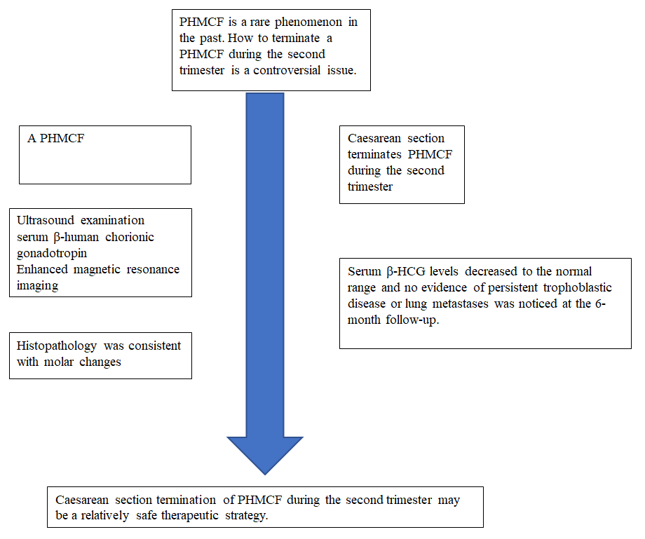
Figure 1 Timeline. PHMCF: Partial hydatidiform mole and coexisting fetus.

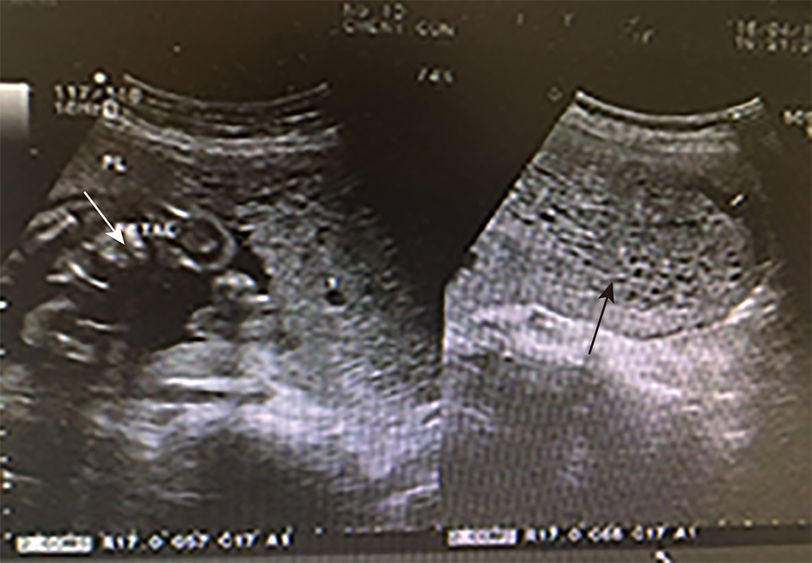
Figure 2 Transvaginal ultrasonographic images. A: Transvaginal ultrasonographic image showing a normal fetus (white arrow); B: Transvaginal ultrasonographic image showing multiple echogenic areas (black arrow) that are suggestive of molar degeneration.

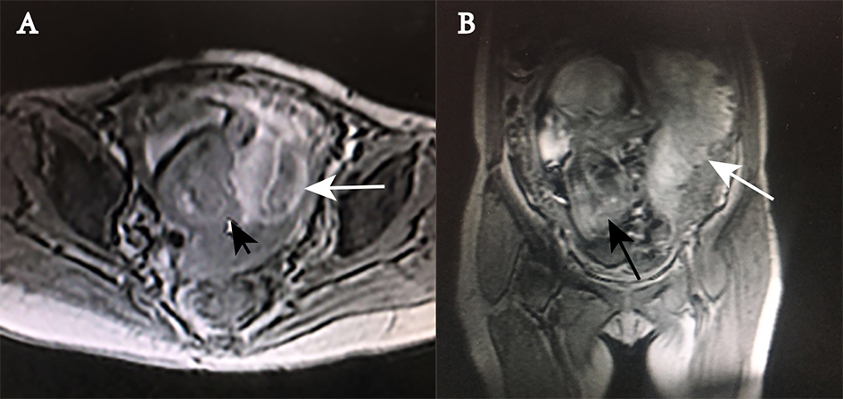
Figure 3 Magnetic resonance imaging scans. The placental tissue with abnormal signal intensity in the left portion of the uterus (white arrow), the unclear relationship between the myometrium and placental tissue, and a normal fetus (black arrow) are shown. A: Transverse view; B: Coronal view.

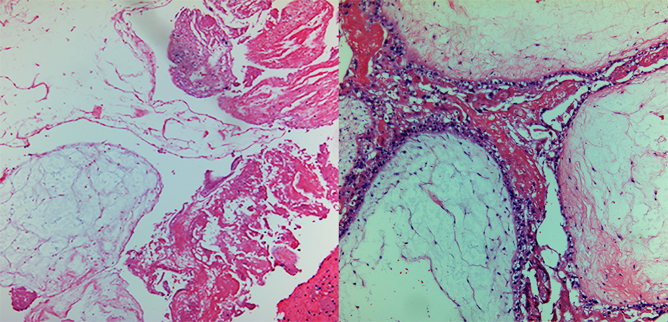
Figure 4 Histopathology of the hydatidiform mole. Chorionic villi of varying sizes and shapes and focal trophoblastic hyperplasia (hematoxylin and eosin staining; magnification, ×40). A and B: Focal hydropic villi with an irregular scalloped outline and focal trophoblastic hyperplasia between hydrops.

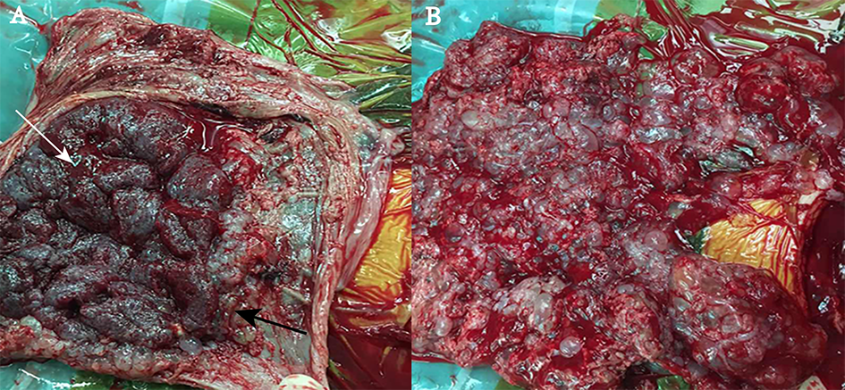
Figure 5 Images of the gross specimen. A: The partially cystic placenta (specimen size: 110 mm × 95 mm × 35 mm) containing vesicular tissue (black arrow) and normal (white arrow) sections; B: The vesicular tissue (specimen size: 180 mm × 160 mm × 45 mm).

