Name of Journal: World Journal of Clinical Cases
Manuscript NO: 79591
Manuscript Type: MINIREVIEWS

Antenatal imaging: A pictorial review

Ece B et al. Antenatal imaging

Bunyamin Ece, Sonay Aydın, Mecit Kantarci

Bunyamin Ece, Department of Radiology, Kastamonu University, Kastamonu 37150, Turkey

Sonay Aydın, Mecit Kantarci, Department of Radiology, Erzincan University, Erzincan 24142, Turkey

Author contributions: Ece B, Aydın S, and Kantarcı M designed the article together; Ece B wrote the manuscript; Aydın S and Kantarcı M reviewed, corrected, and contributed to the manuscript; all authors have read and approve the final manuscript.

Corresponding author: Bunyamin Ece, MD, Assistant Professor, Doctor, Department of Radiology, Kastamonu University, Kuzeykent 57, Alay Street No. 4 Kastamonu 37150, Turkey. bunyaminece@hotmail.com

Received: August 28, 2022
Revised: October 17, 2022
Accepted: November 28, 2022
Published online: December 16, 2022

Abstract
Today, in parallel with the use of imaging modalities increases in all fields, the use of imaging methods in pregnant women is increasing. Imaging has become an integral component of routine pregnancy follow-up. Imaging provides parents with an early opportunity to learn about the current situation, including prenatal detection of anomalies or diseases, etiology, prognosis, and the availability of prenatal or postnatal treatments. Various imaging modalities, especially ultrasonography, are frequently used for imaging both maternal and fetal imaging. The goal of this review was to address imaging modalities in terms of usefulness and safety, as well as to provide demonstrative examples for disorders. And this review provides current information on selecting a safe imaging modality to evaluate the pregnant and the fetus, the safety of contrast medium use, and summarizes major pathological situations with demonstrative sonographic images to assist radiologists and obstetricians in everyday practice.

Key Words: Prenatal Diagnosis; Fetal Imaging; Ultrasound; Pregnancy; Fetal Diseases; Reliability

©The Author(s) 2022. Published by Baishideng Publishing Group Inc. All rights reserved.

Citation: Ece B, Aydın S, Kantarci M. Antenatal imaging: A pictorial review. World J Clin Cases 2022; 10(35): 12854-12874
URL: https://www.wjgnet.com/2307-8960/full/v10/i35/12854.htm
DOI: https://dx.doi.org/10.12998/wjcc.v10.i35.12854

Core Tip: Today, in parallel with the use of imaging modalities increases in all fields, the use of imaging methods in pregnant women is increasing. Imaging has become an integral component of routine pregnancy follow-up. Various imaging modalities, especially ultrasonography, are frequently used for imaging both maternal and fetal imaging. The current study provides current information on selecting a safe imaging modality to evaluate the pregnant and the fetus, the safety of contrast medium use, and summarizes major pathological situations with demonstrative sonographic images to assist radiologists and obstetricians in everyday practice.

INTRODUCTION
In recent years, the use of imaging modalities for both the fetus and the mother has been increasing^{[1]}. Increased availability of imaging modalities, routine ultrasonography scans, the desire of clinicians to make the accurate diagnosis and the fear of malpractice, placental disorders, trauma, pulmonary embolism, and acute abdomen are the primary causes of the increasing use of imaging modalities in pregnancy. Imaging pregnant women is important to physicians and radiologists because it can affect the mother's and fetus's health. An increase in imaging raises concerns about rising healthcare costs and exposure to radiation^{[2–5]}. Before imaging the pregnant woman, the medical necessity of imaging should be reviewed. Consideration should be given to whether the clinical status of the pregnant patient will change with imaging, whether imaging may be delayed until after pregnancy, whether the diagnosis can be achieved without the use of ionizing radiation, and whether intravenous contrast material is necessary. According to the recommendations of the American College of Gynecology and Obstetrics, pregnant women should be reviewed on a case-by-case basis, and all clinicians involved should conduct a risk-benefit analysis. In all cases, it is suggested that informed consent be obtained. Informed consent gives accurate information about the risks and advantages of the imaging process for mother and the fetus health, which reduces maternal worry about the procedure and may be useful in the event of future medicolegal issues^{[3,6-8]}.
The goal of this review was to address imaging modalities in terms of usefulness and safety, as well as to provide demonstrative examples for disorders.

IMAGING METHODS - EFFICIENCY AND RELIABILITY
X-ray
X-ray exams that do not directly expose the fetus or abdomen-pelvis result in nearly zero radiation exposure. Even if the developing embryo or fetus is within the scope of the investigation, no diagnostic roentgen examination contains a dose of radiation high enough to cause harm. For the vast majority of routine roentgenographs, estimated conceptus doses are substantially lower than the cut-off limit of 100 mGy^{[3,9]}.

Ultrasound - doppler ultrasound
Ultrasound is a non-ionizing imaging modality that uses high-frequency sound waves and has no harmful effects on humans. It provides real-time and cost-effective imaging with a high resolution. For this reason, ultrasound is usually the first imaging method for pregnant patients. Ultrasonography is widely used for fetal scanning and biometry, and for diagnosis and follow-up in many cases during pregnancy. Color Doppler ultrasound examination is frequently used in daily practice in the evaluation of fetal and placental circulation due to its non-invasiveness and easy applicability like ultrasound. It is used to evaluate fetal blood circulation, vascular anatomy, fetal heart defects, corpus callosum, umbilical cord anomalies and placental disorders. There is consensus that using ultrasonography during pregnancy is safe. But, color Doppler and spectral Doppler examinations pose a theoretical danger of fetal warming due to their high acoustic frequency. For this reason, it is recommended to keep acoustic output levels low with the principle of "as low as reasonably achievable" (ALARA principle). For this reason, in the first trimester of pregnancy, it is recommended that the duration of the examination and the number of Doppler examinations be kept to a minimum^{[3,6,9–11]}.

Magnetic resonance imaging
Due to the absence of ionizing radiation, MRI is preferred for the imaging of pregnant patients in the event that an ultrasound examination shows suspicious results. It has been stated that exposure to a static magnetic field during the first trimester of pregnancy may result in an abortion due to a possible effect on cellular proliferation and migration. Although this issue has only been theorized, its detrimental consequences on humans have yet to be shown. In magnetic resonance imaging, exposure to pulsed radiofrequency fields and tissue heating is related to tissue closeness to the scanner. As a result, it is highest in the anterior abdominal region of pregnant women and is deemed insignificant for the fetus^{[3,6,12]}.

Computed tomography
If imaging methods without radiation are unsuitable, such as in cases of severe trauma, studies with radiation can be used for quick examination of pregnant, but only after a rigorous risk analysis and optimizing of the dosage to the patient. Teratogenesis is a serious worry about the effects of radiation on the fetus. The risk of fetal malformation is highly correlated with weeks of gestation and radiation exposure. Cellular injury typically results in abortion during the first two weeks of pregnancy; if the pregnancy survives, the risk of damage from foetal radiation is extremely low ("all or none effect"). According to a number of consensus declarations, the probability of congenital abnormalities following fetal exposure to levels less than 100 mGy is small in comparison to other pregnancy concerns. The majority of diagnostic imaging studies produce dosages that are lower than the anticipated threshold level, making them safe for the fetus. The American College of Obstetricians and Gynecologists determined that exposure to diagnostic fetal radiation during pregnancy poses a very minimal risk of carcinogenesis, recommending that abortion is not advised^{[3,13-16]}.

USE AND SAFETY OF CONTRAST AGENTS
Intravenous use of a paramagnetic contrast material is generally discouraged unless possible advantage to the mother outweighs the possible dangers of prolonged exposure of the growing fetus to gadolinium. High and repeated doses of paramagnetic contrast material have been reported to be teratogenic in animal studies. The FDA has categorized gadolinium-based contrast agents as Class C drugs. The amount of paramagnetic contrast material transferred from breast milk to the fetus in lactating women is extremely low. There is no need to discontinue breastfeeding for more than 24 h^{[3,17-19]}. The ACR contrast agent guidelines state that the use of iodinated contrast agents in pregnant women should be restricted since "the consequences on the human embryo or fetus are not fully recognized". Both iodinated contrast agents and GBCAs are able to penetrate the blood-placental barrier and reach the fetal blood. They are subsequently released through the amniotic fluid, ingested by the foetus, and reabsorbed into the fetal blood. Because of these pharmacokinetic characteristics, the growing fetus is exposed to contrast agent chemicals for a longer period of time. Oral iodinated contrast materials are not absorbed by the mother and hence pose no risk. Iodinated contrast materials are categorized as FDA Category B drugs when used intravenously or orally. The thyroid function of newborns should be evaluated immediately after birth^{[3,6,9,18,19]}.

ANTENATAL IMAGING WITH CASES
Anembryonic pregnancy
Anembryonic pregnancy, also known as the blighted ovum, is characterized by the failure of the embryo to develop despite the growth of the gestational sac. Diagnosis is made by seeing an empty gestational sac without an embryo on an ultrasonographic examination. In order to diagnose an anembryonic pregnancy, the mean sac diameter (MSD) in transvaginal ultrasonography must be at least 25 mm. In addition, if there is a yolk sac in the first examination, no embryo is found in the sonographic examination performed after 11 days or more, or if only the gestational sac is shown in the first examination, the diagnosis is made by the absence of embryo or yolk sac in the control sonography performed after 14 days. Early intrauterine pregnancy, ectopic pregnancy, pseudogestational sac, and gestational trophoblastic disease should be considered in differential diagnoses^{[20,21]} (Figure 1).

Lower uterine segment gestation
Typically, the location of the gestational sac is in the middle of the uterine body segment. If the gestational sac is seen close to the cervix and located lower than normal, several pathologies should be considered. Impending or ongoing miscarriage, cervical pregnancy, cesarean scar ectopic pregnancy, cervico isthmic implantation, fundal fibroid or other mass compressing the sac downward should be considered in the differential diagnosis^{[22]} (Figure 2).

Abortus – miscarriage
Miscarriage is defined as the spontaneous termination of a pregnancy before 20 wk of gestation. A complete miscarriage is defined as the absence of retained fetal tissue or a gestational sac in the uterine cavity. A missed miscarriage is the absence of fetal heartbeat even though the CRL is greater than 7 mm. An empty sac miscarriage is the absence of the yolk sac or embryonic pol, although the MSD is greater than 25 mm^{[23]}. Before diagnosing a total miscarriage, ectopic pregnancy, pregnancy too early to be detected and pregnancy of unknown location should be considered in the differential diagnosis (Figure 3).

Subamniotic - retroplacental hemorrhage
During pregnancy, bleeding may occur due to the separation of the placenta, chorion and amniotic membranes. If the bleeding area is posterior to the placenta, it is called retroplacental hemorrhage; if it is merely on the border of the placenta, it is called marginal subchorionic hemorrhage; and if it lies anterior to the placenta, it is called subamniotic hemorrhage. Subamniotic hemorrhage is usually limited to the umbilical cord. Although it is usually seen as oval-shaped hypoechoic areas on ultrasound, it can also be seen isoechoic or hyperechoic in cases of acute hemorrhage^{[24]} (Figure 4).

Intraamniotic hemorrhage
In the presence of a hematoma affecting the intrauterine membranes, blood may enter the amniotic space if the amniotic membrane ruptures. It usually limits itself after a while and causes no serious harm to the fetus. Primary intraamniotic hemorrhage most often develops secondary to trauma. It also often develops after amniocentesis. Intraamniotic fibrin materials and septa formations might be seen in the chronic process after active bleeding has ceased. In the amniotic fluid, echogenic particles resulting from bleeding are seen during ultrasonography. Ingestion of the free bleeding by the fetus may result in the appearance of a false mass in the stomach and increase in small intestine echogenicity^{[24]} (Figure 5).

Molar pregnancy - gestational trophoblastic disease
Gestational trophoblastic disease is caused by the aberrant proliferation of trophoblastic tissue. The patient presents with findings such as abnormally elevated levels of beta - human chorionic gonadotropin (HCG), hyperemesis and hypertension. On ultrasonography, a complete hydatid mole appears as a complex multicystic heterogeneous echogenic mass that largely fills the intrauterine cavity, causes uterine enlargement, and contains multiple millimetric cystic areas. This view is defined as the "bunch of grapes" sign. These cystic regions are the result of hydropic chorionic villi. In addition to small cystic cavities, larger irregular fluid collections may also be seen. There is no fetus or fetal component in complete hydatiform mole. In subsequent weeks of pregnancy, the mass appearance and cystic areas become larger. In addition, theca lutein cysts can be seen in both ovaries due to beta HCG stimulation. In partial hydatiform mole, gestational sac and yolk sac can be seen. The placenta is abnormally large and contains numerous microcystic areas. Doppler ultrasonography shows low-resistance, high-velocity blood flow in both molar pregnancies^{[25,26]} (Figure 6).

Chorioamniotic separation
Before the 14th week of pregnancy, it is considered normal for the chorion and amnion to appear separate. Generally, chorioamniotic fusion occurs between the 14th and 16th weeks of pregnancy. It is uncommon and abnormal for it to appear separately after the 16th week of pregnancy. Chorioamniotic separation may occur spontaneously or iatrogenically as a result of interventions like amniocentesis, fetal surgery, or fetal blood sampling. Chorioamniotic separation has been linked to fetal aneuploidy, especially trisomy 21, premature membrane rupture, preterm birth, and fetal growth restriction^{[27,28]} (Figure 7).

Cystic hygroma
Nuchal translucency (NT), defined as the normal fluid-filled subcutaneous space behind the fetal neck, is measured between 11 wk 3 days and 13 wk 6 days of pregnancy. Cystic hygroma can usually be detected during NT measurement in the first trimester ultrasonography. Septations are seen in the thickened NT in cystic hygroma. It can be seen as evidence of fetal anasarca or hydrops fetalis. The presence of septation is indicative of a poor prognosis. Compared to thickened NT, cystic hygroma has a higher risk of aneuploidy, cardiac anomaly and fetal demise (Figure 8).

Thickened nuchal fold
The nuchal fold measurement is made between the outer edge of the occipital bone and the outer edge of the skin in the transcerebellar plane. The nuchal fold is measured in the 2nd trimester and greater than 6 mm is defined as the thickened nuchal fold. It is one of the most specific markers identified for trisomy 21. However, it can be detected in normal fetuses when detected in isolated. In addition, the presence of a thickened nuchal fold requires a thorough screening for congenital cardiac disease^{[29,30]} (Figure 9).

Single umbilical artery
Normally, the umbilical chord contains two umbilical arteries and one umbilical vein. If there is only one artery and one vein, it is referred to as a single umbilical artery. It is more common in twin pregnancies. The size of a single artery is typically larger than average and approaches that of the adjacent umbilical vein. It is best visualized in the axial plane of the umbilical cord. In addition, Doppler ultrasonography reveals a solitary artery at the level of the bladder in the fetal pelvis. When detected isolated single umbilical artery, it is generally no clinical significance, but there is an increased incidence of intrauterine growth restriction. When present with other fetal anomalies, it may be associated with chromosomal abnormalities such as trisomy 21, trisomy 18 and trisomy 13^{[31,32]} (Figure 10).

Acrania – exencephaly – anencephaly sequence
The fetal skull bones should have formed by 11 wk. Absence of fetal cranial bone structures in the first trimester ultrasonography scan performed between 11 wk and 13.6 wk is called acranii. Eccentric placement of fetal brain tissue due to the absence of cranial bone structures is called exancephaly. Unprotected fetal brain tissue degenerates over time due to friction, mechanical, and chemical traumas due to fetal movements in the amniotic fluid. Absence of fetal brain tissue is called anencephaly. These three interrelated pathological processes are called the acrania-exencephaly-anencephaly sequence^{[33,34]} (Figures 11 and 12).

Alobar holoprosencephaly
Alobar holoprosencephaly is a subtype of holoprosencephaly and is the most severe of the classic three subtypes. Other types of holoprosencephaly are semilobar and lobar holoprosencephaly. It is characterized by the failure of diencephalon and telencephalon transverse cleavage between 4-6 wk of gestation and the inability to separate the two hemispheres. Monoventricle, fused thalami, absent corpus callosum, absent interhemispheric fissure, absent cavum septi pellucidi, absence of 3rd ventricle, a single monoventricle that may communicate with a large dorsal cyst and severe facial malformations are seen in alober holoprosencephaly. Lateral and third ventricles are absent and single midline monoventricle appearance is seen. In addition, craniofacial anomalies such as proboscis, mono-orbit/cyclopia, midline facial anomalies including clefts, mononostril, hypotelorism, cebocephaly may also be seen. Holoprosencephaly may be associated with chromosomal anomalies, especially trisomy 13 and trisomy 18. Additionally, congenital renal and congenital cardiac anomalies may be detected^{[35,36]} (Figure 13).

Hydrocephalus - ventriculomegaly
The enlargement of the cerebral ventricles is called ventriculomegaly. It is a significant finding because it is related to other anomalies of the central nervous system. The width of the lateral ventricle should be less than 10 mm. The width of the lateral ventricle between 10-12 mm is classified as mild ventriculomegaly, between 12-15 mm as moderate ventriculomegaly, and greater than 15 mm as severe ventriculomegaly-hydrocephalus. Even if there is no accompanying structural anomaly, the detection of mild ventriculomegaly is considered as a soft antenatal marker for underlying chromosomal abnormalities. Therefore, careful evaluation is required for other sonographic anomalies. The dangling choroid sign, a characteristic finding of ventriculomegaly, is the appearance of drooping choroid plexuses caused by the loss of their parallel extension to the ventricles as a result of the enlargement of the ventricles^{[37–39]} (Figure 14).

Choroid plexus cyst
Choroid plexus cysts are sonolucent cysts in the lateral ventricle, that are usually detected in the second trimester. It is considered as one of the soft ultrasound markers affecting the risk of aneuploidy. Choroid plexus cysts are hypoechoic, but the cyst wall can be seen as echogenic due to the surrounding choroid plexus tissue. Choroid plexus cysts usually disappear at 26-28 wk of pregnancy and in most cases are of no significance. However, if it is detected, the fetus should be carefully evaluated due to a slight increase in the risk of karyotype anomalies, particularly trisomy 18. If a choroid plexus cyst is greater than 1 centimeter, bilateral, multiple and there are other accompanying anomalies, it is cause for concern. If it is seen together with other anomalies, amniocentesis is recommended^{[29,40]} (Figure 15).

Spinal dysraphism, myelomeningocele, banana sign, lemon sign
Congenital malformations of the spine and spinal cord are commonly referred to as spinal dysraphism. Neural tube defects are the most common congenital anomaly after congenital heart diseases. It is most commonly seen in the lumbosacral region. They are divided into two categories as open and closed spinal dysraphism, depending on whether there is skin tissue or not. The usage of folic acid before and throughout pregnancy reduces its incidence. In addition, neurological damage can be reduced by intrauterine surgeries. With spinal malformation, the neural tissue protrudes through the spina bifida opening with the surrounding enlarged subarachnoid space. Myelomeningocele refers to the presence of a sac containing neural tissue and subarachnoid fluid. Meningocele refers to the presence of only subarachnoid space in the sac, and myelocele refers to the presence of only neural tissue in the sac. Chiari 2 malformation is characterized by a small posterior fossa and inferior heniation of the brain stem and cerebellar tonsils from the foramen magnum, ventricular dilatation and callosal dysgenesis in accompanying all cases of open spinal dysraphism^{[41]}. The banana sign appears when the inferiorly herniated cerebellum is tightly wrapped around the brain stem and the cisterna magna disappears. In addition, the lemon sign describing the appearance of an indentation in the bone can be seen in the frontoparietal suture. In the presence of isolated lemon sign, craniosynostosis should also be included in the differential diagnosis^{[41,42]} (Figures 16 and 17).

Occipital encephalocele
Encephalocele is a neural tube defect characterized by the herniation of brain tissue and meninges through a cranial defect. The occipital encephalocele is the most common type of encephalocele. Frontoethmoidal, basal, temporal and parietal encephaloceles can also be seen. Occipital encephalocele may be associated with Chiari malformations, Dandy Walker malformations and Meckel Gruber syndrome^{[43,44]} (Figure 18).

Bladder outlet obstruction, fetal megacystis
Fetal bladder outlet obstruction or lower urinary tract obstruction is most commonly caused by posterior urethral valve or second most frequently by urethral atresia. Kidney development is impaired and may lead to pulmonary hypoplasia. It is associated with a high rate of perinatal morbidity and mortality. It occurs due to an obstruction in the lower urinary tract (bladder outlet), leading to megacystis, a thickened bladder wall, and bilateral hydronephrosis. It may be accompanied by renal cystic dysplasia. Oligohydramnios and secondary clubfoot and pulmonary hypoplasia may be present. If bladder or kidney rupture occurs, there may be urinary acid and perinephric urinomas. For the diagnosis of megacystis in the first trimester, the maximum sagittal length of the bladder is considered to be 7 mm. In the 2nd and 3rd trimesters, there is no clearly defined value. There are studies describing the removal of 5 mm from the gestational week as the limit in the second and third trimesters. The keyhole appearance is observed in the posterior urethral valve and indicates an enlarged posterior urethra. Lower urinary tract obstruction is usually seen in isolated. Differential diagnosis includes Prune-Belly syndrome, aneuploidy, megacystis-megaureter syndrome and megacystis-microcolon syndrome^{[45–47]} (Figure 19).

Urinary tract dilation
There are numerous terms for urinary tract dilatation, including pyelectasis, pelviectasis, and hydronephrosis. In urinary tract dilatation, the anterior-posterior diameter of the renal pelvis is measured in the axial plane. Less than 4 mm in the 2nd trimester and less than 7 mm in the 3rd trimester are normal. Pyelectasis and pelviectasis are generally used instead of mild hydronephrosis, and 4-7 mm in the 2nd trimester and 7-10 mm in the 3rd trimester are mild hydronephrosis. More than 10 mm in the 2nd trimester and more than 15 mm in the 3rd trimester is severe hydronephrosis. Urinary tract dilatation is often transient and a common variation. Urinary tract dilatation can be a marker of trisomy 21 as well as kidney and urinary tract pathologies. It is considered a soft marker for trisomy 21. 80% of patients with mild hydronephrosis measuring 4-7 mm in the 2nd trimester recover spontaneously in the 3rd trimester. It is recommended to follow up the child after birth. The most common pathological causes of urinary tract dilatation include vesicoureteral reflux, ureteropelvic junction obstruction, and posterior urethral valve^{[29,48–50]} (Figure 20).

Multicystic dysplastic kidney
Most renal anomalies are isolated and the risk of association with aneuploidy or genetic syndromes is low. The exception is autosomal dominant or autosomal recessive polycystic kidney disease. Therefore, in the presence of cystic kidney disease, a careful evaluation should be made in terms of other anomalies and hereditary diseases^{[50]}.
The multicystic dysplastic kidney is characterized by unrelated and varied size multiple cysts, increased echogenicity and increased diameters of kidney without hydronephrosis. It is often unilateral and generally has a good prognosis. Rarely, the prognosis may be poor if the disease is bilateral or accompanied by additional anomalies. Absence of a fluid-filled bladder and oligohydramnios indicate an anomaly in the contralateral kidney. Compensatory hypertrophy may accompany if the contralateral kidney is normal^{[51,52]} (Figure 21).

Autosomal recessive polycystic kidney disease
Autosomal recessive polycystic kidney disease is caused by a rare genetic disorder. It has a poor prognosis, especially when diagnosed prenatally, and is associated with a high rate of morbidity and mortality. On ultrasonography, both kidneys are enlarged and hyperechoic, and there is loss of corticomedullary differentiation. Millimetric cystic areas can be seen. In addition, oligohydramnios or anhydramnios is common. It may be accompanied by pulmonary hypoplasia. In the third trimester, the size of millimeter-sized cysts may exceed 3 mm. Rarely, no abnormality is detected in antenatal ultrasonography. Although hepatic fibrosis and biliary dysgenesis are common in affected patients, prenatal detection of these conditions is frequently not possible. Differential diagnosis includes Bardet-Biedl syndrome and Meckel Gruber syndrome. Postaxial polydactyly is common in Bardet-Biedl syndrome and the renal parenchyma appears more homogeneous. Cysts usually appear earlier in Meckel-Gruber syndrome, and central nervous system malformations and postaxial polydactyly are common^{[53,54]} (Figure 22).

Persistent right umbilical vein
Early in fetal development, both umbilical veins are connected to the sinus venosus. Between the 4-7th weeks of pregnancy, the right umbilical vein obliterates and the left umbilical vein carries all of the blood to the portal vein. Persistent right umbilical vein is an embryological development characterized by the regression of the left umbilical vein and the persistence of the right umbilical vein. Persistent right umbilical vein has a generally good prognosis. However, it may also be associated with congenital absence of the ductus venosus and other serious fetal malformations. Absence of the ductus venosus may result in hemodynamic decompensation. On ultrasonography, the umbilical vein has an abnormal path towards the stomach. The gallbladder medializes towards the umbilical vein. Normally, the arrangement in the form of stomach-umbilical vein-gallbladder is seen as the stomach-gallbladder-umbilical vein, respectively. It may be isolated or associated with chromosomal abnormalities. It can also be seen together with a single umbilical artery^{[55–57]} (Figure 23).

Orofacial cleft
Orofacial clefts are a common facial anomaly, most frequently manifesting as a cleft lip and a cleft palate. Isolated cleft lip or isolated cleft palate are also common. Most clefts are paramedian. It can be unilateral or bilateral. The cleft palate may extend to include the premaxillary region-hard palate or more dorsally the soft palate. Isolated cleft palate often evades prenatal diagnosis. Cleft palate and cleft lip can be seen isolated or as an additional finding in many genetic anomalies. If there is a cleft palate or cleft lip, a detailed neurosonogram and fetal echocardiogram and genetic analysis should be performed to identify any additional anomalies^{[58,59]} (Figure 24).

Cystic lymphangioma
Fetal lymphangioma is a rare congenital lymphatic malformation affecting the skin and subcutaneous tissue. It is usually seen in the neck and is called cystic hygroma. There is an increased risk of chromosomal anomalies, especially trisomy 21. It can be seen in localizations such as the chest wall, abdomen, pelvis, extremities and axilla. It looks like a mass lesion with multiple cystic areas on ultrasonography. On color Doppler examination, no vascularity is detected^{[60,61]} (Figure 25).

Echogenic intracardiac focus
Intracardiac echogenic focus is defined as an echogenic focus that is less than 6 millimeters in diameter and as bright as a bone, and is often visible in a four-chamber image within the heart, viewed in at least two planes. Although it is more common on the left ventricle, it can seen in both ventricles. It is believed to represent microcalcification within the papillary muscles. Generally, it disappears in the 3rd trimester. It is not a structural or functional cardiac anomaly. It is not associated with cardiac malformations. It is considered a soft marker for trisomy 21. No additional diagnostic procedure is required if it is detected isolated, but amniocentesis is recommended if it is seen together with other anomalies^{[29,62,63]} (Figure 26).

Amniotic band sequence
The amniotic band sequence is a series of malformations that the result of fetal parts being compressed by intrauterine fibrous amniotic bands. Depending on the affected organ, the severity of amniotic band syndrome can be so severe as to be fatal to the fetus. It most frequently results in limb deformities. Typically, constriction ring deformities are seen in the extremities. These include edematous and non-edematous fingers and toes, usually in the distal extremity. These constriction rings can lead to amputation of limbs or fingers and the appearance of syndactyly on ultrasound (pseudosyndactyly). Craniofacial deformities may include single orbital involvement, severe clefts that do not conform to the normal pattern, severe nasal deformity, or asymmetric encephaloceles^{[64,65]} (Figure 27).

Echogenic fetal bowel
An echogenic fetal bowel finding is the appearance of fetal bowels that are echogenic or more echogenic than the neighboring iliac bone. It is often detected isolated in second trimester ultrasonography. If echogenic fetal bowel is present, there is an increased incidence of renal and cardiac anomalies. Although transient or idiopathic, it may also be associated with various pathological conditions such as aneuploidy, cystic fibrosis, congenital viral infection, primary gastrointestinal pathology, intraamniotic hemorrhage and fetal growth restriction. The most common associated aneuploidy is trisomy 21. In addition to having an echogenic bowel, having dilated bowel loops increases the risk of cystic fibrosis. In this situation, the parents' cystic fibrosis carriage can be explored. The most common congenital infection is cytomegalovirus, but toxoplasma, rubella, herpes, chickenpox, and parvovirus infections are also seen. Additionally, it is possible to observe primary gastrointestinal diseases such as intestinal obstruction, atresia, and perforation^{[29,66]} (Figure 28).

Omphalocele
Omphalocele is the herniation of abdominal contents through the anterior abdominal wall near the umbilical cord's base. It occurs when the physiological herniation of the intestine does not end up to 10-12 wk and does not return to the abdomen. Omphalocele is usually associated with chromosomal anomalies. An omphalocele is detected during routine ultrasonographic examination of the fetus or during investigation of an elevated level of alpha-fetoprotein^{[67]} (Figure 29).

CONCLUSION
Antenatal imaging is a burgeoning discipline with significant implications for early diagnosis and treatment, as well as reducing medicolegal issues. This review provides current information on selecting a safe imaging modality to evaluate the pregnant and the fetus, the safety of contrast medium use, and summarizes major pathological situations with demonstrative sonographic images to assist radiologists and obstetricians in everyday practice.

REFERENCES
1 Lazarus E, Debenedectis C, North D, Spencer PK, Mayo-Smith WW. Utilization of imaging in pregnant patients: 10-year review of 5270 examinations in 3285 patients--1997-2006. Radiology 2009; 251: 517-524 [PMID: 19293204 DOI: 10.1148/radiol.2512080736]
2 Kwan ML, Miglioretti DL, Marlow EC, Aiello Bowles EJ, Weinmann S, Cheng SY, Deosaransingh KA, Chavan P, Moy LM, Bolch WE, Duncan JR, Greenlee RT, Kushi LH, Pole JD, Rahm AK, Stout NK, Smith-Bindman R; Radiation-Induced Cancers Study Team. Trends in Medical Imaging During Pregnancy in the United States and Ontario, Canada, 1996 to 2016. JAMA Netw Open 2019; 2: e197249 [PMID: 31339541 DOI: 10.1001/jamanetworkopen.2019.7249]
3 Bourgioti C, Konidari M, Gourtsoyianni S, Moulopoulos LA. Imaging during pregnancy: What the radiologist needs to know. Diagn Interv Imaging 2021; 102: 593-603 [PMID: 34059484 DOI: 10.1016/j.diii.2021.05.003]
4 Matin A, Bates DW, Sussman A, Ros P, Hanson R, Khorasani R. Inpatient radiology utilization: trends over the past decade. AJR Am J Roentgenol 2006; 186: 7-11 [PMID: 16357370 DOI: 10.2214/ajr.04.0633]
5 Karavas E, Ece B, Aydın S, Kocak M, Cosgun Z, Bostanci IE, Kantarci M. Are we aware of radiation: A study about necessity of diagnostic X-ray exposure. World J Methodol 2022;12:264–73 [PMID: 36159099 DOI: 10.5662/wjm.v12.i4.264]
6 American College of Obstetricians and Gynecologists' Committee on Obstetric Practice. Committee Opinion No. 656: Guidelines for Diagnostic Imaging During Pregnancy and Lactation. Obstet Gynecol 2016; 127: e75-e80 [PMID: 26942391 DOI: 10.1097/AOG.0000000000001316]
7 Chen MM, Coakley FV, Kaimal A, Laros RK Jr. Guidelines for computed tomography and magnetic resonance imaging use during pregnancy and lactation. Obstet Gynecol 2008; 112: 333-340 [PMID: 18669732 DOI: 10.1097/AOG.0b013e318180a505]
8 Patel SJ, Reede DL, Katz DS, Subramaniam R, Amorosa JK. Imaging the pregnant patient for nonobstetric conditions: algorithms and radiation dose considerations. Radiographics 2007; 27: 1705-1722 [PMID: 18025513 DOI: 10.1148/rg.276075002]
9 Tirada N, Dreizin D, Khati NJ, Akin EA, Zeman RK. Imaging Pregnant and Lactating Patients. Radiographics 2015; 35: 1751-1765 [PMID: 26466183 DOI: 10.1148/rg.2015150031]
10 Abramowicz JS, Kossoff G, Marsal K, Ter Haar G; International Society of Ultrasound in Obstetrics and Gynecology Bioeffects and Safety Committee. Executive Board of the International Society of Ultrasound in Obstetrics and Gynecology. Safety Statement, 2000 (reconfirmed 2003). International Society of Ultrasound in Obstetrics and Gynecology (ISUOG). Ultrasound Obstet Gynecol 2003; 21: 100 [PMID: 12528176 DOI: 10.1002/uog.36]
11 Leung KY, Wan YL. Update on Color Flow Imaging in Obstetrics. Life (Basel) 2022; 12 [PMID: 35207514 DOI: 10.3390/LIFE12020226]
12 Ciet P, Litmanovich DE. MR safety issues particular to women. Magn Reson Imaging Clin N Am 2015; 23: 59-67 [PMID: 25476674 DOI: 10.1016/J.MRIC.2014.09.002]
13 International Commission on Radiological Protection. Pregnancy and medical radiation. Ann ICRP 2000; 30: iii-viii, 1-43 [PMID: 11108925 DOI: 10.1016/s0146-6453(00)00037-3]
14 McCollough CH, Schueler BA, Atwell TD, Braun NN, Regner DM, Brown DL, LeRoy AJ. Radiation exposure and pregnancy: when should we be concerned? Radiographics 2007; 27: 909-17; discussion 917-8 [PMID: 17620458 DOI: 10.1148/RG.274065149]
15 Gjelsteen AC, Ching BH, Meyermann MW, Prager DA, Murphy TF, Berkey BD, Mitchell LA. CT, MRI, PET, PET/CT, and ultrasound in the evaluation of obstetric and gynecologic patients. Surg Clin North Am 2008; 88: 361-390, vii [PMID: 18381118 DOI: 10.1016/j.suc.2008.01.005]
16 Kelaranta A, Mäkelä T, Kaasalainen T, Kortesniemi M. Fetal radiation dose in three common CT examinations during pregnancy - Monte Carlo study. Phys Med 2017; 43: 199-206 [PMID: 28941740 DOI: 10.1016/j.ejmp.2017.09.120]
17 Tremblay E, Thérasse E, Thomassin-Naggara I, Trop I. Quality initiatives: guidelines for use of medical imaging during pregnancy and lactation. Radiographics 2012; 32: 897-911 [PMID: 22403117 DOI: 10.1148/rg.323115120]
18 ACR manual on contrast media. Version 10.3 [Internet]. 2018; Available from: https://www.acr.org/-/media/ACR/files/clinical-resources/contrast_media.pdf
19 ESUR guidelines on contrast agents. V.10 [Internet]. ESUR Web Site2018; Available from: https://www.esur.org/wp-content/uploads/2022/03/ESUR-Guidelines-10_0-Final-Version.pdf
20 Chaudhry K, Tafti D, Siccardi MA. Anembryonic Pregnancy. 2022 May 16. In: StatPearls [Internet]. Treasure Island (FL): StatPearls Publishing; 2022 Jan- [PMID: 29763113]
21 Doubilet PM, Benson CB, Bourne T, Blaivas M; Society of Radiologists in Ultrasound Multispecialty Panel on Early First Trimester Diagnosis of Miscarriage and Exclusion of a Viable Intrauterine Pregnancy, Barnhart KT, Benacerraf BR, Brown DL, Filly RA, Fox JC, Goldstein SR, Kendall JL, Lyons EA, Porter MB, Pretorius DH, Timor-Tritsch IE. Diagnostic criteria for nonviable pregnancy early in the first trimester. N Engl J Med 2013; 369: 1443-1451 [PMID: 24106937 DOI: 10.1056/NEJMra1302417]
22 Dewald O, Hoffman JT. Gestational Sac Evaluation. 2022 May 2. In: StatPearls [Internet]. Treasure Island (FL): StatPearls Publishing; 2022 Jan- [PMID: 31869088]
23 Condous G. Ultrasound diagnosis of miscarriage: new guidelines to prevent harm. Australas J Ultrasound Med 2011; 14: 2 [PMID: 28191122 DOI: 10.1002/j.2205-0140.2011.tb00127.x]
24 Trop I, Levine D. Hemorrhage during pregnancy: sonography and MR imaging. AJR Am J Roentgenol 2001; 176: 607-615 [PMID: 11222189 DOI: 10.2214/AJR.176.3.1760607]
25 Shaaban AM, Rezvani M, Haroun RR, Kennedy AM, Elsayes KM, Olpin JD, Salama ME, Foster BR, Menias CO. Gestational Trophoblastic Disease: Clinical and Imaging Features. Radiographics 2017; 37: 681-700 [PMID: 28287945 DOI: 10.1148/rg.2017160140]
26 Benson CB, Genest DR, Bernstein MR, Soto-Wright V, Goldstein DP, Berkowitz RS. Sonographic appearance of first trimester complete hydatidiform moles. Ultrasound Obstet Gynecol 2000; 16: 188-191 [PMID: 11117091 DOI: 10.1046/J.1469-0705.2000.00201.X]
27 Bibbo C, Little SE, Bsat J, Botka KA, Benson CB, Robinson JN. Chorioamniotic Separation Found on Obstetric Ultrasound and Perinatal Outcome. AJP Rep 2016; 6: e337-e343 [PMID: 27683622 DOI: 10.1055/s-0036-1593407]
28 Ulm B, Ulm MR, Bernaschek G. Unfused amnion and chorion after 14 wk of gestation: associated fetal structural and chromosomal abnormalities. Ultrasound Obstet Gynecol 1999; 13: 392-395 [PMID: 10423801 DOI: 10.1046/J.1469-0705.1999.13060392.X]
29 Society for Maternal-Fetal Medicine (SMFM). Prabhu M, Kuller JA, Biggio JR. Society for Maternal-Fetal Medicine Consult Series #57: Evaluation and management of isolated soft ultrasound markers for aneuploidy in the second trimester: (Replaces Consults #10, Single umbilical artery, October 2010; #16, Isolated echogenic bowel diagnosed on second-trimester ultrasound, August 2011; #17, Evaluation and management of isolated renal pelviectasis on second-trimester ultrasound, December 2011; #25, Isolated fetal choroid plexus cysts, April 2013; #27, Isolated echogenic intracardiac focus, August 2013). Am J Obstet Gynecol 2021; 225: B2-B15 [PMID: 34171388 DOI: 10.1016/j.ajog.2021.06.079]
30 Benacerraf BR. The history of the second-trimester sonographic markers for detecting fetal Down syndrome, and their current role in obstetric practice. Prenat Diagn 2010; 30: 644-652 [PMID: 20572106 DOI: 10.1002/pd.2531]
31 Geipel A, Germer U, Welp T, Schwinger E, Gembruch U. Prenatal diagnosis of single umbilical artery: determination of the absent side, associated anomalies, Doppler findings and perinatal outcome. Ultrasound Obstet Gynecol 2000; 15: 114-117 [PMID: 10775992 DOI: 10.1046/J.1469-0705.2000.00055.X]
32 Hua M, Odibo AO, Macones GA, Roehl KA, Crane JP, Cahill AG. Single umbilical artery and its associated findings. Obstet Gynecol 2010; 115: 930-934 [PMID: 20410765 DOI: 10.1097/AOG.0b013e3181da50ed]
33 Martins Santana EF, Araujo Júnior E, Tonni G, Costa FDS, Meagher S. Acrania-exencephaly-anencephaly sequence phenotypic characterization using two- and three-dimensional ultrasound between 11 and 13 wk and 6 days of gestation. J Ultrason 2018; 18: 240-246 [PMID: 30451407 DOI: 10.15557/JoU.2018.0035]
34 Fong KW, Toi A, Salem S, Hornberger LK, Chitayat D, Keating SJ, McAuliffe F, Johnson JA. Detection of fetal structural abnormalities with US during early pregnancy. Radiographics 2004; 24: 157-174 [PMID: 14730044 DOI: 10.1148/RG.241035027]
35 Winter TC, Kennedy AM, Woodward PJ. Holoprosencephaly: a survey of the entity, with embryology and fetal imaging. Radiographics 2015; 35: 275-290 [PMID: 25590404 DOI: 10.1148/rg.351140040]
36 Dubourg C, Bendavid C, Pasquier L, Henry C, Odent S, David V. Holoprosencephaly. Orphanet J Rare Dis 2007; 2: 8 [PMID: 17274816 DOI: 10.1186/1750-1172-2-8]
37 Ritner JA, Frates MC. Fetal CNS: a systematic approach. Radiol Clin North Am 2014; 52: 1253-1264 [PMID: 25444104 DOI: 10.1016/j.rcl.2014.07.012]
38 Mehta TS, Levine D. Imaging of fetal cerebral ventriculomegaly: a guide to management and outcome. Semin Fetal Neonatal Med 2005; 10: 421-428 [PMID: 15985390 DOI: 10.1016/J.SINY.2005.05.002]
39 Wax JR, Bookman L, Cartin A, Pinette MG, Blackstone J. Mild fetal cerebral ventriculomegaly: diagnosis, clinical associations, and outcomes. Obstet Gynecol Surv 2003; 58: 407-414 [PMID: 12775945 DOI: 10.1097/01.OGX.0000070069.43569.D7]
40 Coco C, Jeanty P. Karyotyping of fetuses with isolated choroid plexus cysts is not justified in an unselected population. J Ultrasound Med 2004; 23: 899-906 [PMID: 15292557 DOI: 10.7863/JUM.2004.23.7.899]
41 Trapp B, de Andrade Lourenção Freddi T, de Oliveira Morais Hans M, Fonseca Teixeira Lemos Calixto I, Fujino E, Alves Rojas LC, Burlin S, Cerqueira Costa DM, Carrete Junior H, Abdala N, Tobaru Tibana LA, Takehara ET, Dalul Gomez G. A Practical Approach to Diagnosis of Spinal Dysraphism. Radiographics 2021; 41: 559-575 [PMID: 33449837 DOI: 10.1148/rg.2021200103]
42 Kunpalin Y, Richter J, Mufti N, Bosteels J, Ourselin S, De Coppi P, Thompson D, David AL, Deprest J. Cranial findings detected by second-trimester ultrasound in fetuses with myelomeningocele: a systematic review. BJOG 2021; 128: 366-374 [PMID: 32926566 DOI: 10.1111/1471-0528.16496]
43 Society for Maternal-Fetal Medicine. Monteagudo A. Posterior Encephalocele. Am J Obstet Gynecol 2020; 223: B9-B12 [PMID: 33168216 DOI: 10.1016/j.ajog.2020.08.177]
44 Diebler C, Dulac O. Cephaloceles: clinical and neuroradiological appearance. Associated cerebral malformations. Neuroradiology 1983; 25: 199-216 [PMID: 6633855 DOI: 10.1007/BF00540233]
45 Society for Maternal-Fetal Medicine (SMFM). Mardy A. Bladder outlet obstruction. Am J Obstet Gynecol 2021; 225: B9-B11 [PMID: 34507791 DOI: 10.1016/j.ajog.2021.06.039]
46 Taghavi K, Sharpe C, Stringer MD. Fetal megacystis: A systematic review. J Pediatr Urol 2017; 13: 7-15 [PMID: 27889224 DOI: 10.1016/j.jpurol.2016.09.003]
47 Maizels M, Alpert SA, Houston JT, Sabbagha RE, Parilla BV, MacGregor SN. Fetal bladder sagittal length: a simple monitor to assess normal and enlarged fetal bladder size, and forecast clinical outcome. J Urol 2004; 172: 1995-1999 [PMID: 15540775 DOI: 10.1097/01.JU.0000142136.17222.07]
48 Nguyen HT, Benson CB, Bromley B, Campbell JB, Chow J, Coleman B, Cooper C, Crino J, Darge K, Herndon CD, Odibo AO, Somers MJ, Stein DR. Multidisciplinary consensus on the classification of prenatal and postnatal urinary tract dilation (UTD classification system). J Pediatr Urol 2014; 10: 982-998 [PMID: 25435247 DOI: 10.1016/j.jpurol.2014.10.002]
49 Nyberg DA, Souter VL, El-Bastawissi A, Young S, Luthhardt F, Luthy DA. Isolated sonographic markers for detection of fetal Down syndrome in the second trimester of pregnancy. J Ultrasound Med 2001; 20: 1053-1063 [PMID: 11587012 DOI: 10.7863/JUM.2001.20.10.1053]
50 Society for Maternal-Fetal Medicine (SMFM). Norton ME, Cheng Y, Chetty S, Chyu JK, Connolly K, Ghaffari N, Hopkins LM, Jelin A, Mardy A, Osmundson SS, Sparks TN, Sperling J, Swanson K, Zuckerwise LC, Kuller JA. SMFM Fetal Anomalies Consult Series #4: Genitourinary anomalies. Am J Obstet Gynecol 2021; 225: B2-B35 [PMID: 34507800 DOI: 10.1016/j.ajog.2021.06.009]
51 Society for Maternal-Fetal Medicine (SMFM). Chetty S. Multicystic dysplastic kidney. Am J Obstet Gynecol 2021; 225: B21-B22 [PMID: 34507790 DOI: 10.1016/j.ajog.2021.06.046]
52 Scala C, McDonnell S, Murphy F, Leone Roberti Maggiore U, Khalil A, Bhide A, Thilaganathan B, Papageorghiou AT. Diagnostic accuracy of midtrimester antenatal ultrasound for multicystic dysplastic kidneys. Ultrasound Obstet Gynecol 2017; 50: 464-469 [PMID: 27643400 DOI: 10.1002/uog.17305]
53 Society for Maternal-Fetal Medicine (SMFM). Swanson K. Autosomal recessive polycystic kidney disease. Am J Obstet Gynecol 2021; 225: B7-B8 [PMID: 34507795 DOI: 10.1016/j.ajog.2021.06.038]
54 Avni FE, Garel L, Cassart M, Massez A, Eurin D, Didier F, Hall M, Teele RL. Perinatal assessment of hereditary cystic renal diseases: the contribution of sonography. Pediatr Radiol 2006; 36: 405-414 [PMID: 16463027 DOI: 10.1007/S00247-005-0075-0]
55 Krzyżanowski A, Swatowski D, Gęca T, Kwiatek M, Stupak A, Woźniak S, Kwaśniewska A. Prenatal diagnosis of persistent right umbilical vein - Incidence and clinical impact. A prospective study. Aust N Z J Obstet Gynaecol 2019; 59: 77-81 [PMID: 29498037 DOI: 10.1111/ajo.12791]
56 Hajdú J, Marton T, Kozsurek M, Pete B, Csapó Z, Beke A, Papp Z. Prenatal diagnosis of abnormal course of umbilical vein and absent ductus venosus--report of three cases. Fetal Diagn Ther 2008; 23: 136-139 [PMID: 18046072 DOI: 10.1159/000111594]
57 Lide B, Lindsley W, Foster MJ, Hale R, Haeri S. Intrahepatic Persistent Right Umbilical Vein and Associated Outcomes: A Systematic Review of the Literature. J Ultrasound Med 2016; 35: 1-5 [PMID: 26635256 DOI: 10.7863/ultra.15.01008]
58 Society for Maternal-Fetal Medicine. Benacerraf BR, Bromley B, Jelin AC. Paramedian Orofacial Cleft. Am J Obstet Gynecol 2019; 221: B8-B12 [PMID: 31679595 DOI: 10.1016/j.ajog.2019.08.050]
59 Offerdal K, Jebens N, Syvertsen T, Blaas HG, Johansen OJ, Eik-Nes SH. Prenatal ultrasound detection of facial clefts: a prospective study of 49,314 deliveries in a non-selected population in Norway. Ultrasound Obstet Gynecol 2008; 31: 639-646 [PMID: 18381773 DOI: 10.1002/uog.5280]
60 Saccone G, Di Meglio L, Di Meglio L, Zullo F, Locci M, Zullo F, Berghella V, Di Meglio A. Prenatal ultrasound diagnosis of fetal chest wall cystic lymphangioma: An Italian case series. Eur J Obstet Gynecol Reprod Biol 2019; 236: 139-142 [PMID: 30909010 DOI: 10.1016/j.ejogrb.2019.03.014]
61 Rasidaki M, Sifakis S, Vardaki E, Koumantakis E. Prenatal diagnosis of a fetal chest wall cystic lymphangioma using ultrasonography and MRI: a case report with literature review. Fetal Diagn Ther 2005; 20: 504-507 [PMID: 16260884 DOI: 10.1159/000088039]
62 Winn VD, Sonson J, Filly RA. Echogenic intracardiac focus: potential for misdiagnosis. J Ultrasound Med 2003; 22: 1207-14; quiz 1216-7 [PMID: 14620892 DOI: 10.7863/JUM.2003.22.11.1207]
63 Rodriguez R, Herrero B, Bartha JL. The continuing enigma of the fetal echogenic intracardiac focus in prenatal ultrasound. Curr Opin Obstet Gynecol 2013; 25: 145-151 [PMID: 23340246 DOI: 10.1097/GCO.0b013e32835e14eb]
64 Society for Maternal-Fetal Medicine. Gandhi M, Rac MWF, McKinney J. Amniotic Band Sequence. Am J Obstet Gynecol 2019; 221: B5-B6 [PMID: 31787161 DOI: 10.1016/j.ajog.2019.09.020]
65 Barzilay E, Harel Y, Haas J, Berkenstadt M, Katorza E, Achiron R, Gilboa Y. Prenatal diagnosis of amniotic band syndrome - risk factors and ultrasonic signs. J Matern Fetal Neonatal Med 2015; 28: 281-283 [PMID: 24735486 DOI: 10.3109/14767058.2014.915935]
66 D'Amico A, Buca D, Rizzo G, Khalil A, Silvi C, Makatsariya A, Nappi L, Liberati M, D'Antonio F. Outcome of fetal echogenic bowel: A systematic review and meta-analysis. Prenat Diagn 2021; 41: 391-399 [PMID: 31981377 DOI: 10.1002/pd.5638]
67 Som PP, Naik S. Antenatal Diagnosis of Omphalocele. Med J Armed Forces India 2008; 64: 276-277 [PMID: 27408166 DOI: 10.1016/S0377-1237(08)80118-9]

Footnotes
Conflict-of-interest statement: The authors have no conflicts of interest to declare.

Open-Access: This article is an open-access article that was selected by an in-house editor and fully peer-reviewed by external reviewers. It is distributed in accordance with the Creative Commons Attribution NonCommercial (CC BY-NC 4.0) license, which permits others to distribute, remix, adapt, build upon this work non-commercially, and license their derivative works on different terms, provided the original work is properly cited and the use is non-commercial. See: https://creativecommons.org/Licenses/by-nc/4.0/

Provenance and peer review: Invited article; Externally peer reviewed.
Peer-review model: Single blind

Peer-review started: August 28, 2022
First decision: October 12, 2022
Article in press: November 28, 2022

Specialty type: Radiology, nuclear medicine and medical imaging
Country/Territory of origin: Turkey
Peer-review report’s scientific quality classification
Grade A (Excellent): 0
Grade B (Very good): 0
Grade C (Good): C, C
Grade D (Fair): 0
Grade E (Poor): 0

P-Reviewer: Xu G; Zhang XQ, China S-Editor: Ma YJ L-Editor: A P-Editor: Ma YJ
Figure Legends
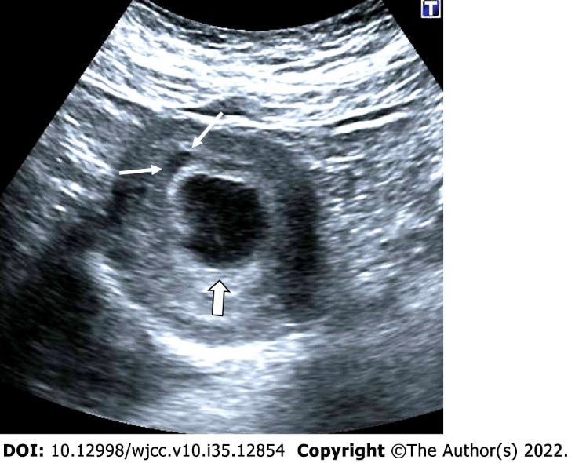
Figure 1 Anembryonic pregnancy. 30-year-old, first pregnancy, complaining of vaginal bleeding. Ultrasonography revealed a gestational sac, slightly irregular border with a mean sac diameter of 28 mm (thick arrow). There was no yolk sac or embryo in the sac. There was also minimal perigestational hemorrhage in the superolateral of the sac (thin arrows).
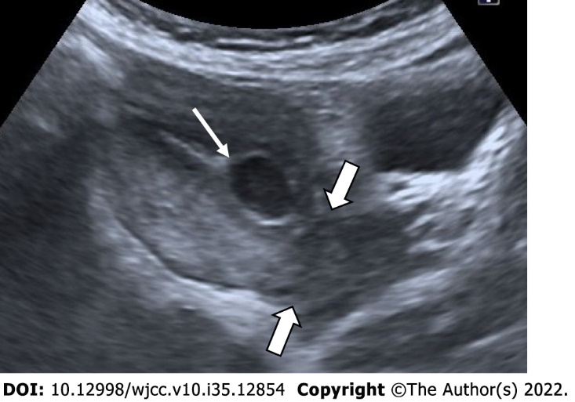
Figure 2 Lower Uterine Segment Gestation. 25-year-old, first pregnancy. On ultrasonography, a 6-week well-circumscribed gestational sac is seen low located close to the cervix (Thick arrows: Cervix; thin arrow: Gestational sac).

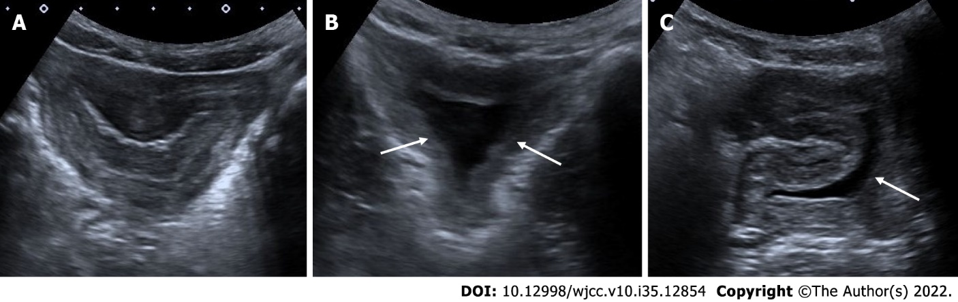
Figure 3 Complete miscarriage. A: 26-year-old, first pregnancy, 6 wk pregnant by date of the last menstrual period and complaining of vaginal bleeding. No gestational sac or fetal structure was seen in the endometrial cavity on axial section ultrasonography; There was enlargement in the cervical canal and hypoechoic collection at this level B: Coronal section; C: Sagittal section, thin arrows. On ultrasonography performed 3 days ago, a gestational sac was seen in the uterine cavity (not shown in the figure).

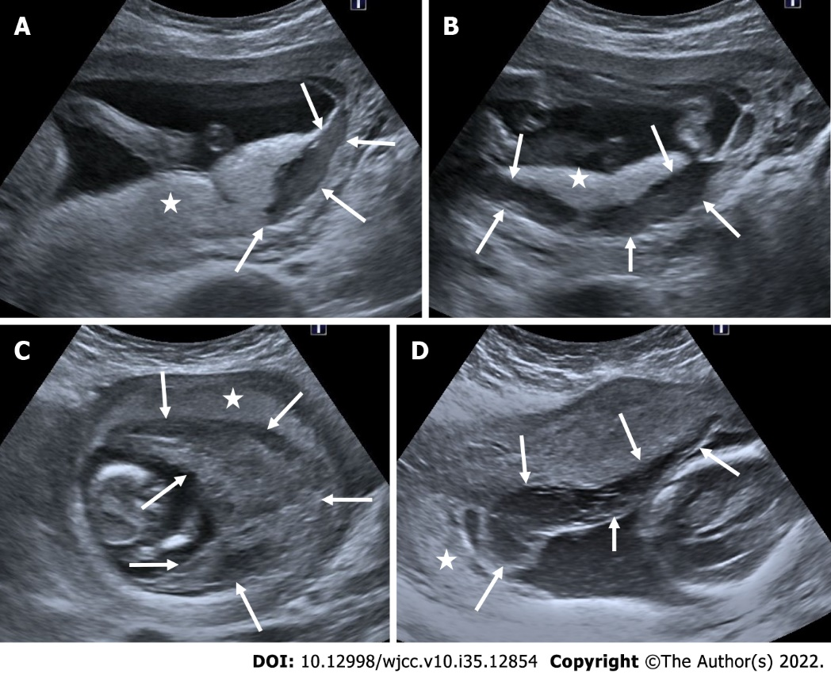
Figure 4 Subamniotic and retroplacental hemorrhage. A and B: Retroplacental hemorrhage. 18 wk pregnant, complaining of vaginal bleeding. On ultrasonography, there was a hypoechoic collection area (arrows) extending in a long segment posterior to the placenta (asterisk); C: Subamniotic hemorrhage, 12 wk pregnant, complaining of pain. On ultrasonography, there was a heterogeneous collection area (arrows) located anterior of the placenta, reaching 10 cm at its widest part (asterisk: Placenta); D: Subamniotic hemorrhage, 18 wk pregnant. On ultrasonography, there was a hypoechoic, minimally heterogeneous collection area (arrows) anterior to the placenta (asterisk: Placenta).
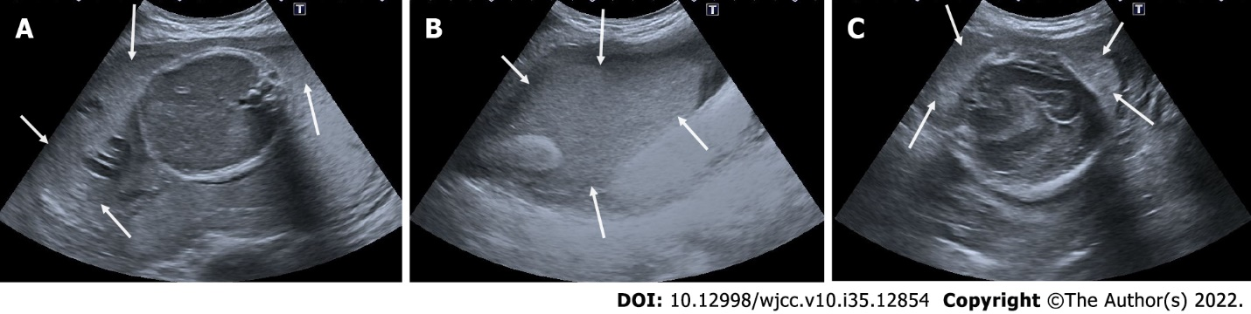
Figure 5 Intraamniotic hemorrhage. A-C: 21 wk pregnant, on ultrasonography, there were diffuse moving echogenicities (arrows) filling the entire amniotic cavity.

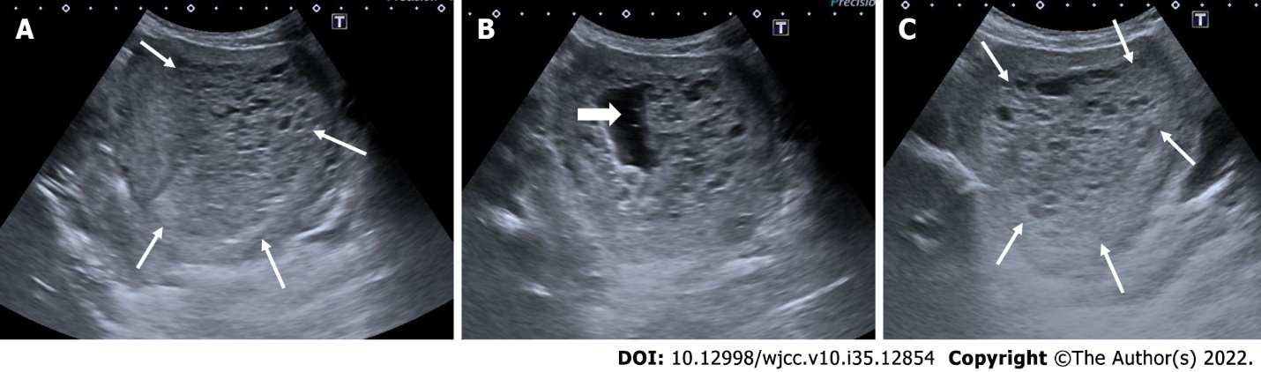
Figure 6 Partial hydatiform mole. 27-year-old, third pregnancy, 7 wk pregnant by date of the last menstrual period, complaining of pain, beta HCG value greater than 200000. A and C: On ultrasonography, there was a heterogeneous, echogenic mass appearance-enlarged multicystic placenta (thin arrows) that filled the endometrial cavity to a large extent, containing multiple millimetric cystic areas; B: The gestational sac was irregular and contained millimetric yolk sac (thick arrow).

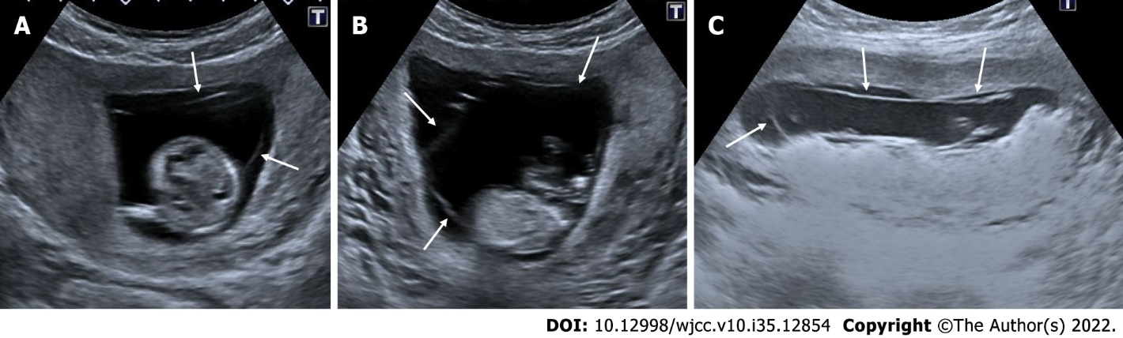
Figure 7 Chorioamniotic separation. A-C: In 3 different pregnant women between 14th and 15th weeks, separation is seen in the chorion and amniotic membranes (arrows). In the follow-ups, fusion occurred and no persistence was observed in the chorioamniotic separation (not shown in the figure).

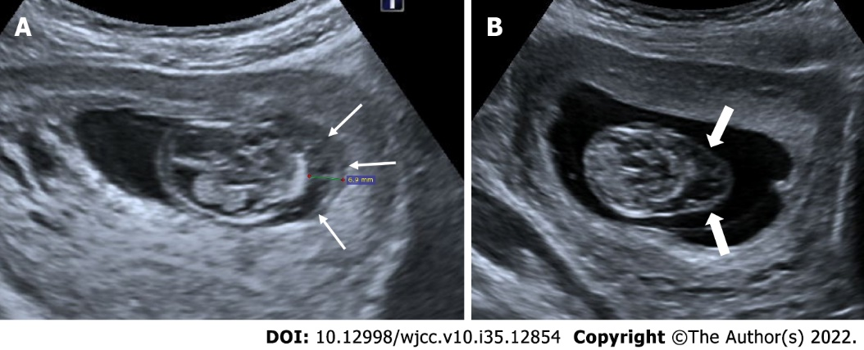
Figure 8 Cystic hygroma. 24-year-old, first pregnancy, 12 wk of gestation. A: On ultrasonography, there was an increase in nuchal translucency (thin arrows); B: cystic areas of cystic hygroma (thick arrows) in the fetal cervical region.
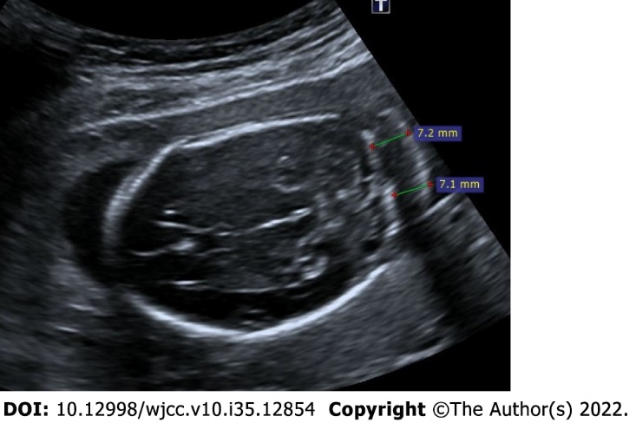
Figure 9 Thickened nuchal fold. 25-year-old, first pregnancy, 19 wk of gestation. On ultrasonography, there was an increase in the thickness of the nuchal fold measuring 7.2 mm.
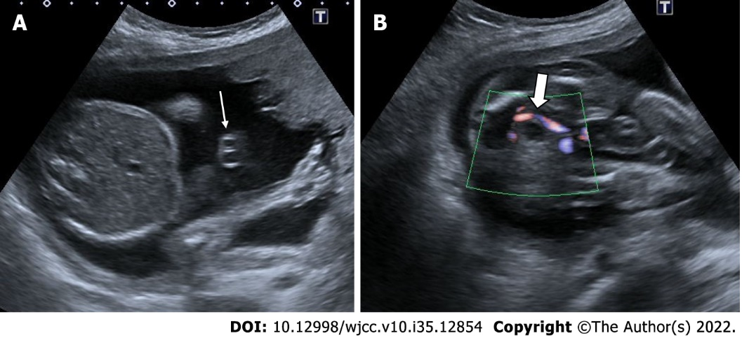
Figure 10 Single umbilical artery. 29-years-old, first pregnancy, 21 wk of gestation. A: On ultrasonography, there was one artery (thin arrow) and one vein in the umbilical cord; B: Doppler ultrasonography reveals a solitary artery at the level of the bladder in the fetal pelvis (thick arrow).

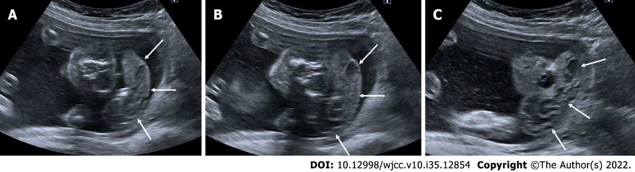
Figure 11 Acrania – exencephaly – anencephaly sequence. 21-year-old, pregnancy without follow-up, first examination. A-C: On ultrasonography, there was absence of fetal cranial bone structures (acrani) and exophytic extension of fetal cerebral tissue (exencephaly) (arrows).
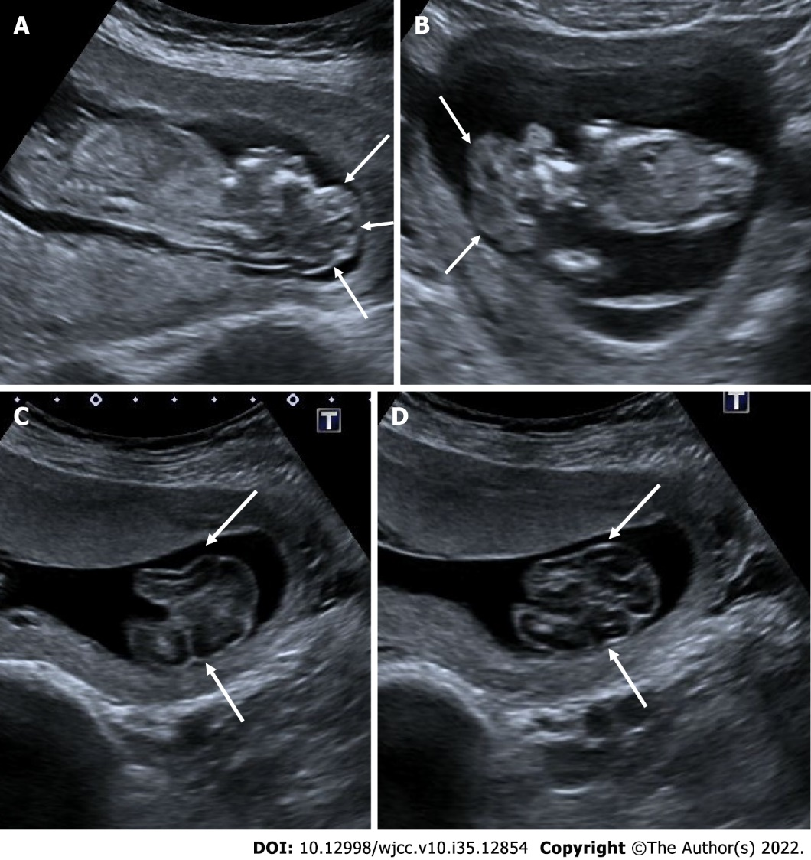
Figure 12 Acrania – exencephaly – anencephaly sequence. A and B: On ultrasonography, first case had absence of cranial bone structures (acrani) and cerebral tissue with exophytic extension (exencephaly) (arrows); C and D: there is another case had acrani and exencephaly (arrows) on ultrasonography.
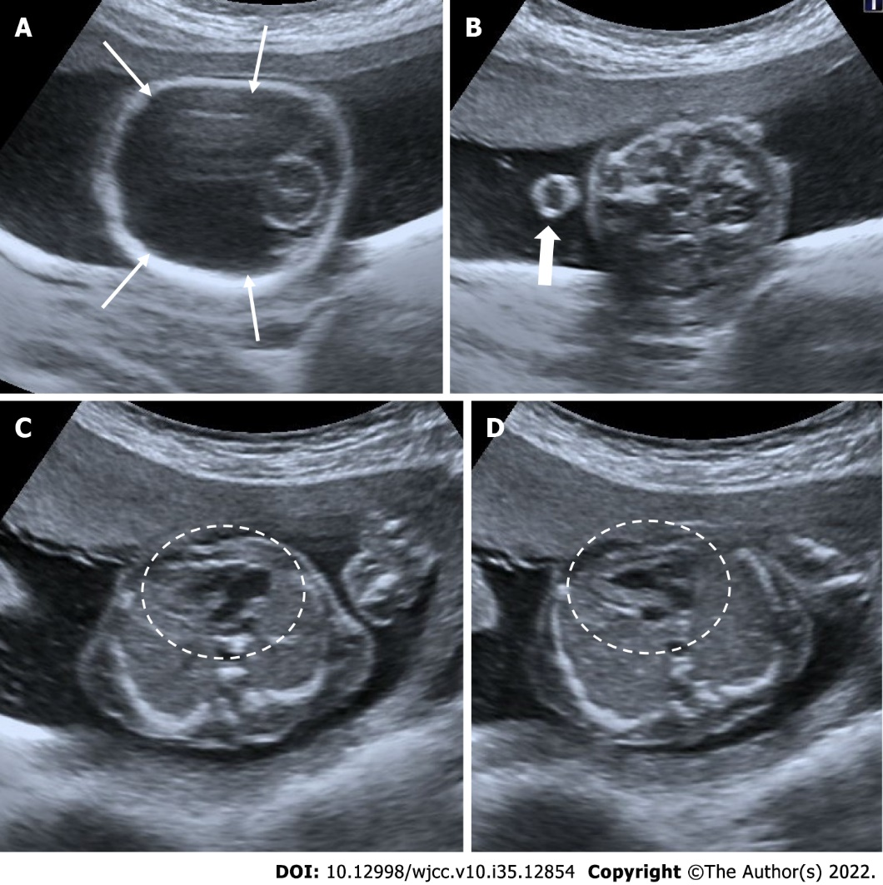
Figure 13 Alobar holoprosencephaly. 30-year-old, 21 wk of gestation. A: On ultrasonography, supratentorial cerebral structures are absent (thin arrows); B: There was bilateral hypotelorism-anophthalmia and a single orbital structure with exophytic extension from the midline (cyclopi) (thick arrow); C and D: The same patient also had a major cardiac anomaly (circle).
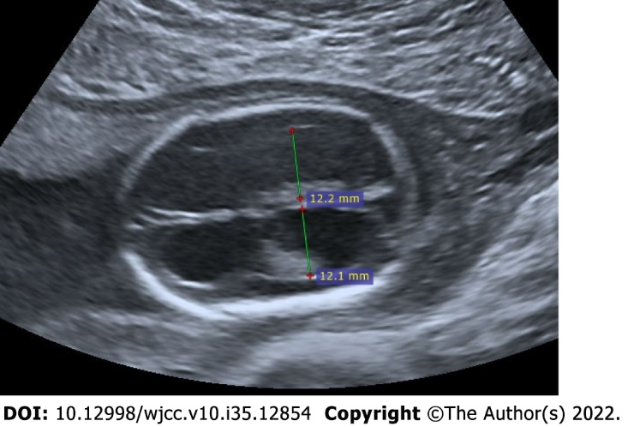
Figure 14 Isolated bilateral mild ventriculomegaly. 22-year-old, first pregnancy, 19 wk of gestation. On ultrasonography, the measurements of both ventricles were 12 mm and larger than normal.
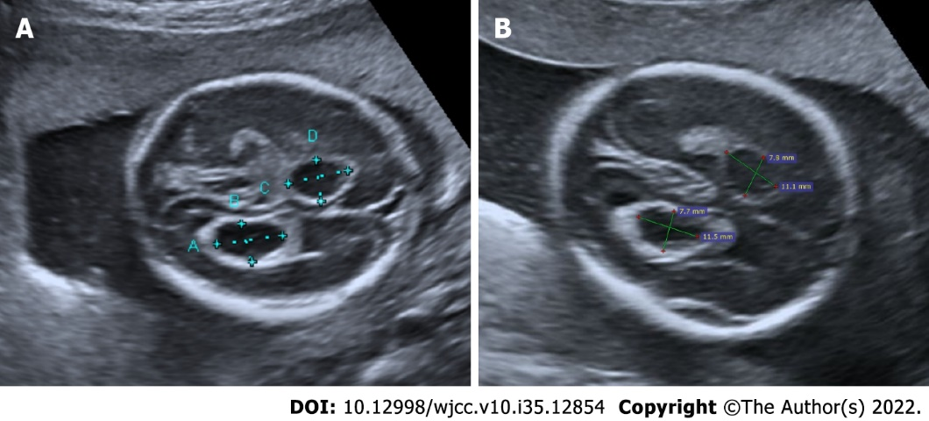
Figure 15 Isolated choroid plexus cysts. 25-year-old, second pregnancy, 20 wk of gestation. A and B: On ultrasonography, there were anechoic choroid plexus cysts bilaterally reaching 1 cm diameter (diameters).
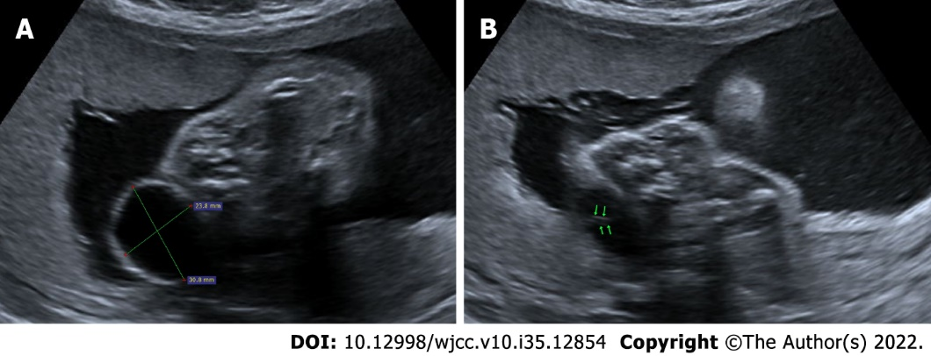
Figure 16 Myelomeningocele. A: Ultrasonography showed an anechoic sac (diameters) extending outward from the posterior defect at the cervical level, reaching 3 cm in diameter; B: There is seen neural roots (arrows) within the sac.
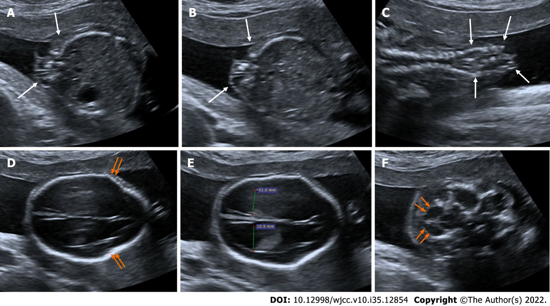
Figure 17 Spinal dysraphism. A-C: On ultrasonography, spina bifida was seen in the vertebral column at the lumbar-sacral level (arrows); D: There were lemon sign characterized by angulation in the bilateral frontoparietal suture (arrows); E: Additionaly, there were bilateral mild ventriculomegaly (diameters); F: There were banana sign (arrows) in the posterior fossa.
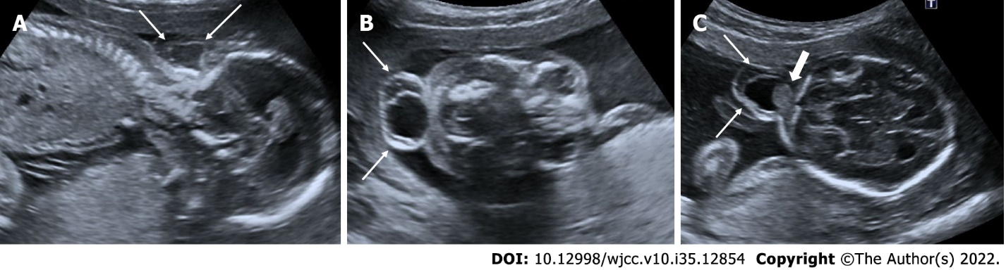
Figure 18 Occipital encephalocele. 30-year-old, second pregnancy, 20 wk of gestation. A-C: On ultrasonography, there was a herniated sac from the bone defect in the occipital region (thin arrows); C: A portion of the occipital lobe was present in the sac (thick arrow).

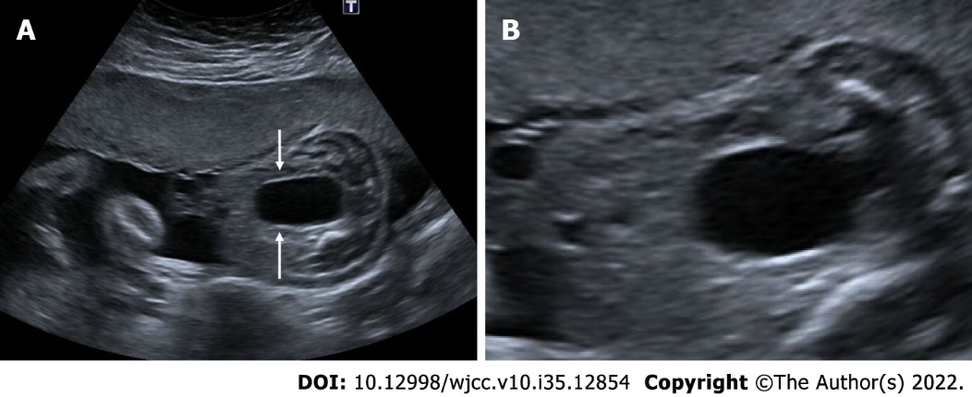
Figure 19 Megacystis. A: 25 wk of gestation. On ultrasonography, there was a distension reaching 4.5 cm in the bladder that did not regress in the follow-ups (arrows); B: Keyhole sign indicating an enlarged urethra is seen in the inferior of the bladder.
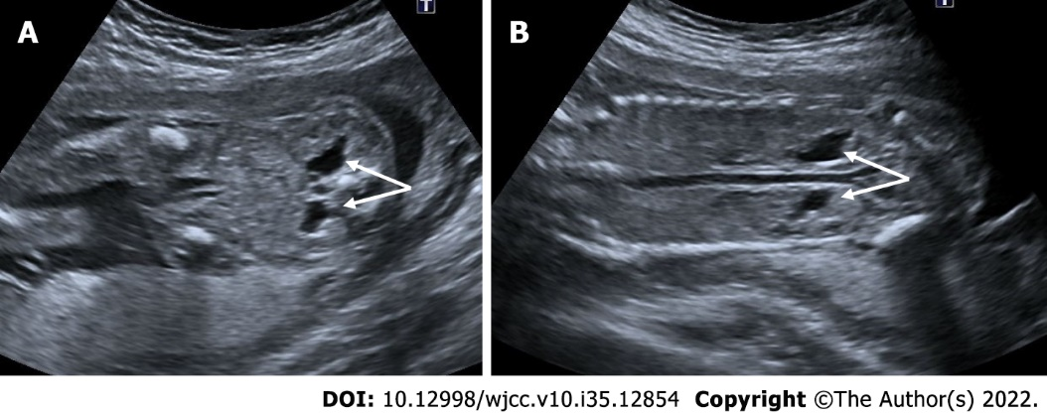
Figure 20 Bilateral mild hydronephrosis. A and B: 23 wk of gestation. On ultrasonography, bilateral renal pelvis was wider than normal (arrows). Renal pelvis diameters were 6 mm on the right and 5 mm on the left. There was no dilatation of the bilateral ureters.
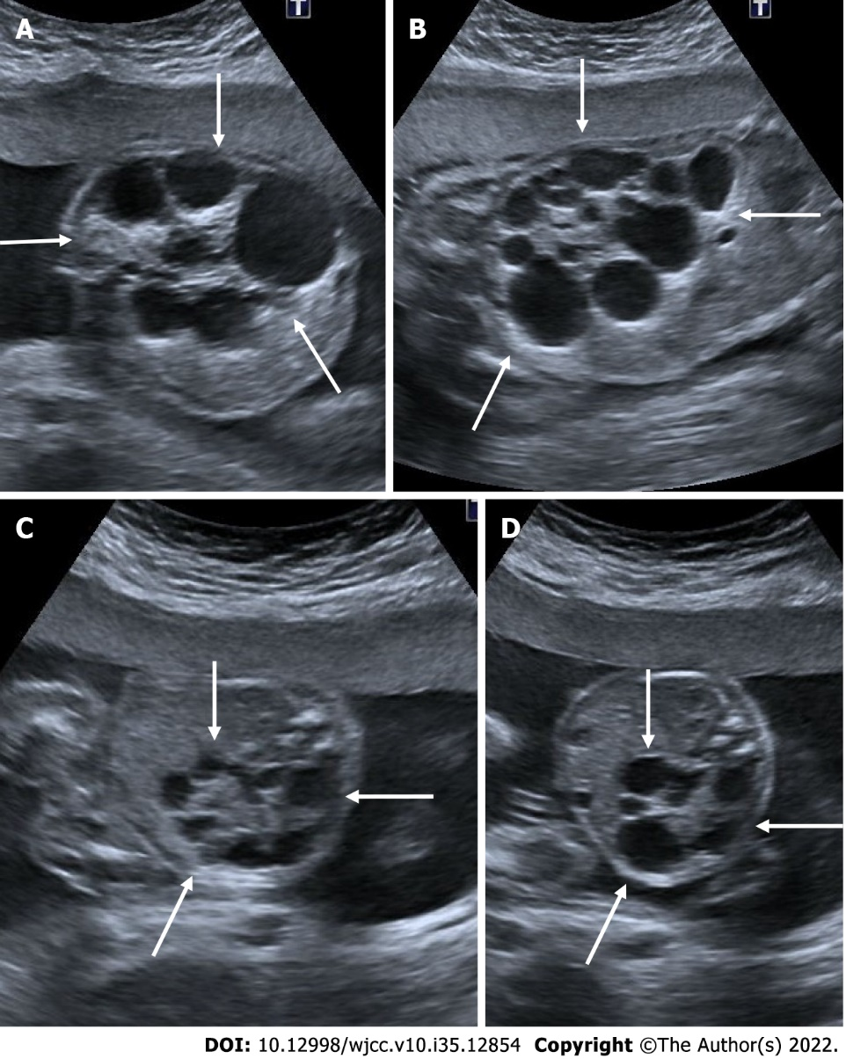
Figure 21 Multicystic dysplastic kidney. In two different pregnant women who underwent 2nd trimester obstetric sonography. A and B: Case 1, there was a multicystic appearance in different sizes with an increase in size in one kidney (arrows); C and D: Case 2; there was another case with a multicystic appearance in different sizes in one kidney (arrows).
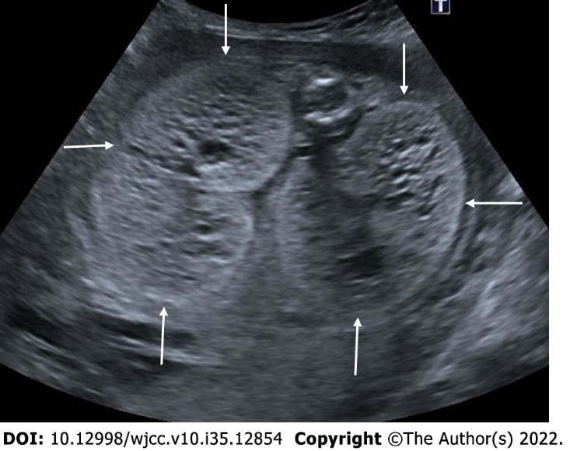
Figure 22 Autosomal recessive polycystic kidney disease. 27 wk of gestation. On ultrasonography, there was a significant increase in bilateral kidney sizes, multiple millimetric cystic heterogeneous echogenic kidneys (arrows). The patient also had oligohydramnios, cardiac and cranial anomalies (not shown in the figure).

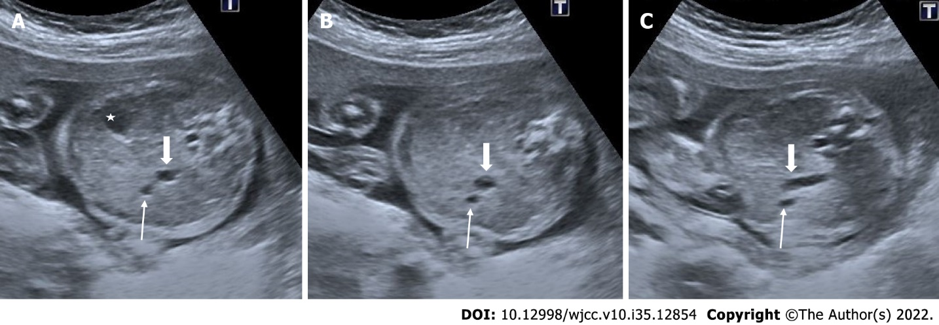
Figure 23 Persistent right umbilical vein. 22 wk of gestation. A: On ultrasonography, while the stomach was in its normal position (asterisk); B and C: the umbilical vein (thin arrow) was seen to the right of the gallbladder (thick arrow).
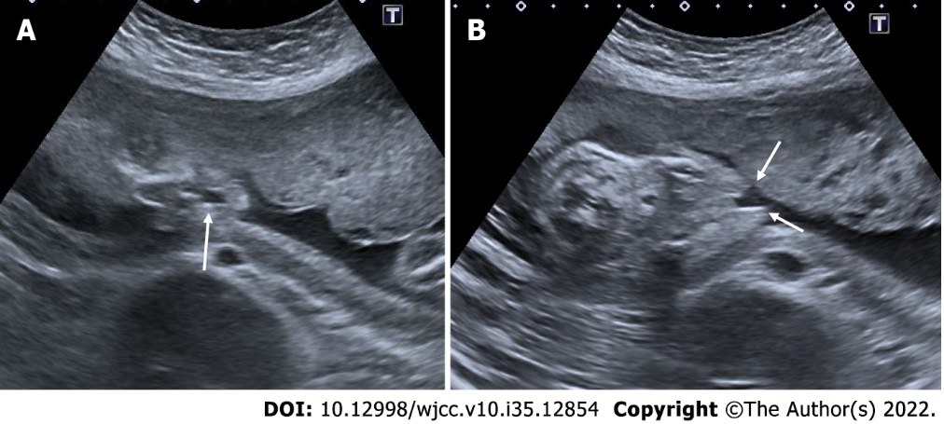
Figure 24 Isolated cleft lip. 23 wk of gestation. A: Isolated cleft lip view in coronal section (arrow); B: Isolated cleft lip view in axial section (arrows).
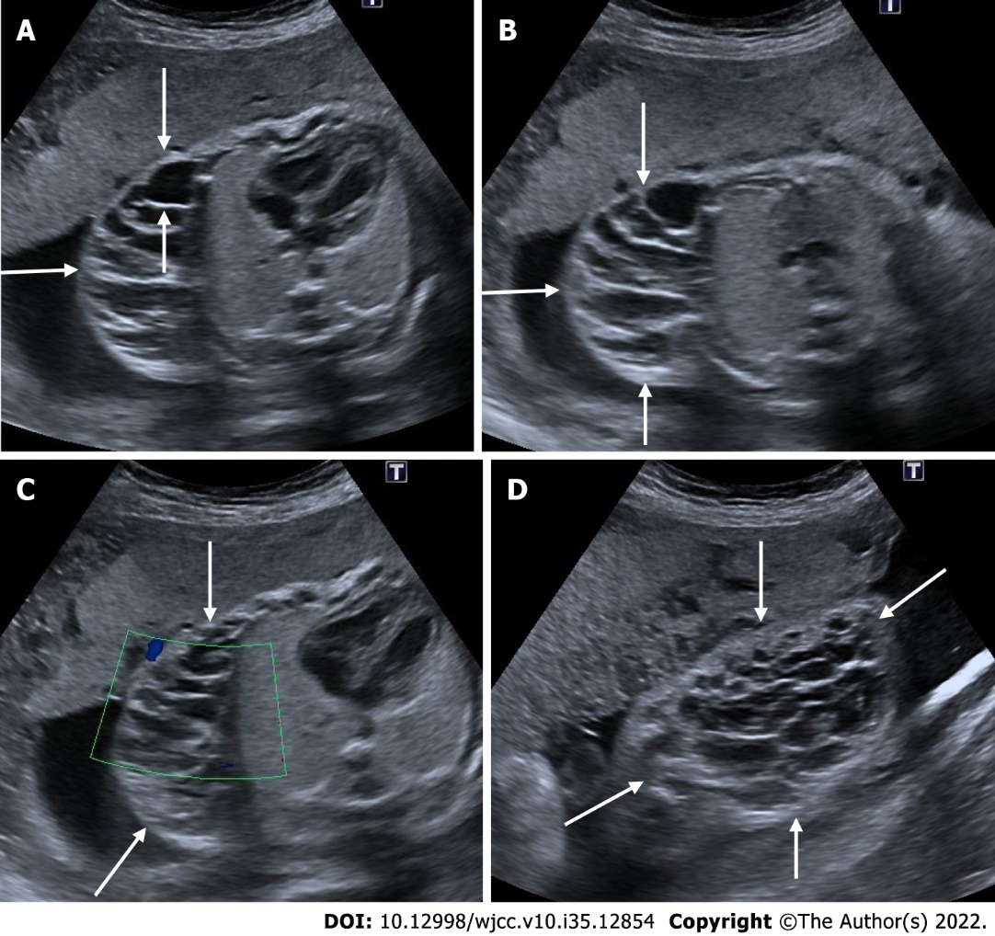
Figure 25 Cystic lymphangioma. 24 wk of gestation. A and B: On ultrasonography, a complex cystic heterogeneous lesion with multicystic areas on the right side of the fetal thoracic wall, under the skin (arrows); C: There was seen no vascularity on Doppler sonography; D: There is a view of the cystic lesion (arrows) on the chest wall from a different section.
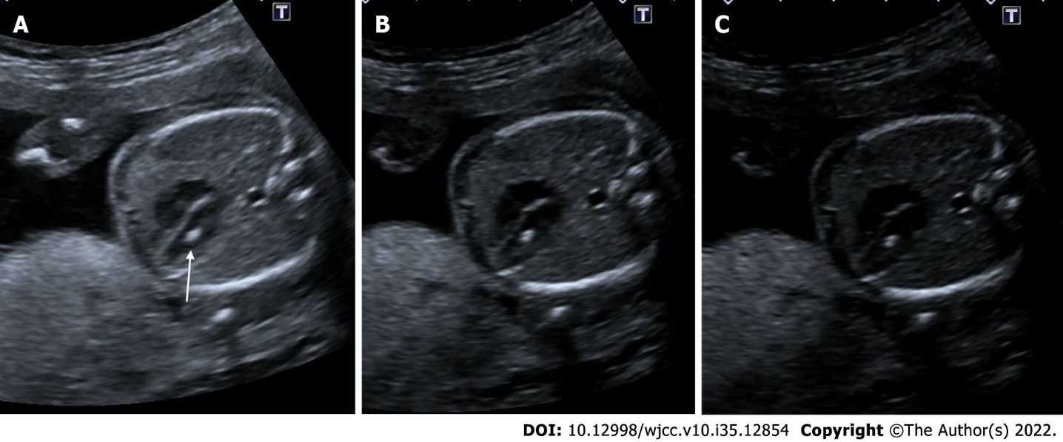
Figure 26 Echogenic intracardiac focus. 21 wk of gestation. A: On ultrasonography, there was one echogenic focus (arrow) in the left ventricle of the fetal heart; B and C: Although the gain settings were decreased, the hyperechoic appearance persisted.
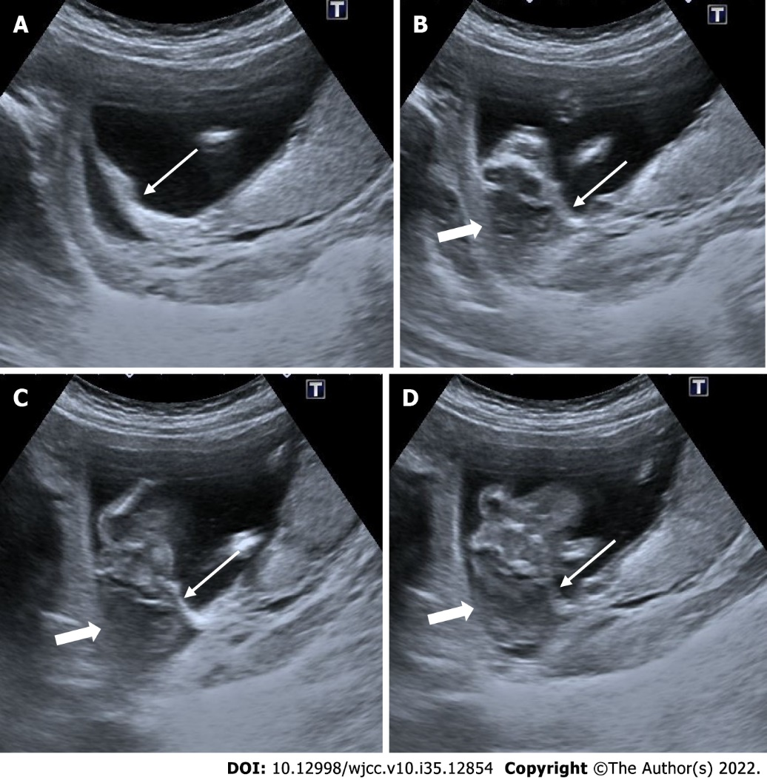
Figure 27 Amniotic band sequence. 16 wk of gestation. A: On ultrasonography, there was amniotic band formation (thin arrows) in the right half of the amniotic cavity; B-D: Fetal cranium (thick arrows) was fixed in the secondary cavity formed at this level, and a deformed appearance was noted in the fetal cranium.

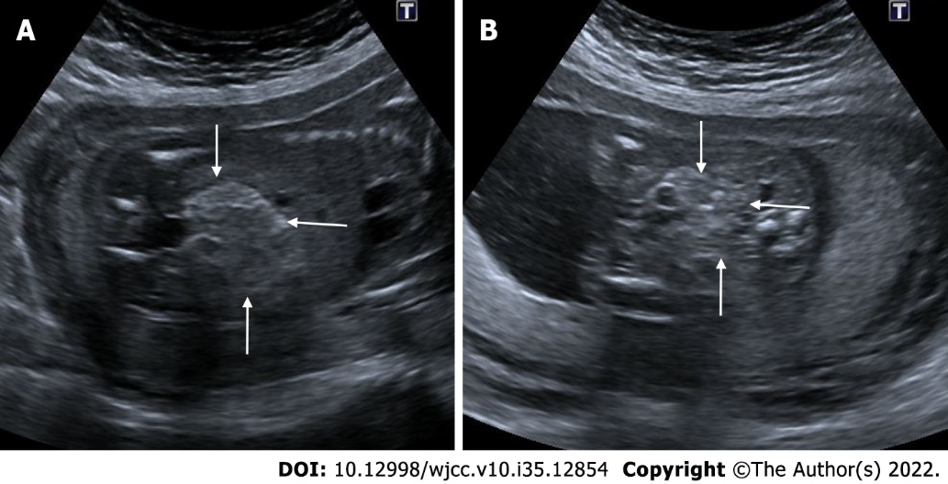
Figure 28 Echogenic fetal bowel. 22 wk of gestation. A and B: On ultrasonography, the intestines showed a diffuse echogenicity increase (arrows). Although intestinal echogenicity was not as echogenic as the bone structures in the same section, this case was later diagnosed as prenatal trisomy 21.
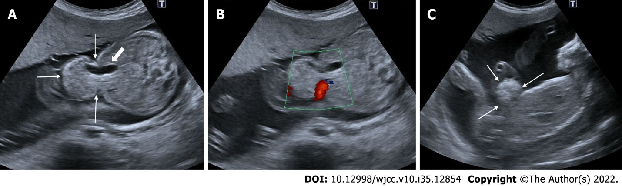
Figure 29 Omphalocele. 24 wk of gestation. A: On ultrasonography, abdominal wall defect and herniation at the level of umbilical cord insertion (thin arrows) are observed and the presence of intra-abdominal tissues and gall bladder (thick arrow) was noted within the herniation; B: The level of herniation is from the side of the umbilical cord, and the umbilical cord is seen in color Doppler; C: There is seen sagittal section view of the herniation.

Published by Baishideng Publishing Group Inc
7041 Koll Center Parkway, Suite 160, Pleasanton, CA 94566, USA
Telephone: +1-925-3991568
E-mail: bpgoffice@wjgnet.com
Help Desk: https://www.f6publishing.com/helpdesk
https://www.wjgnet.com

© 2022 Baishideng Publishing Group Inc. All rights reserved.

