Name of Journal: World Journal of Diabetes
Manuscript NO: 81580
Manuscript Type: MINIREVIEWS

AT1 receptor downregulation: A mechanism for improving glucose homeostasis

Lopez DL et al. Chronic AT1 receptor activation induces insulin resistance

Diana L Lopez, Oscar E Casillas, Hiram J Jaramillo, Tatiana Romero-Garcia, J. Gustavo Vazquez-Jimenez

Diana L Lopez, Hiram J Jaramillo, Department of Internal Medicine, General Hospital of Mexicali, Mexicali 21000, Baja California, Mexico

Oscar E Casillas, J. Gustavo Vazquez-Jimenez, Faculty of Medicine, Autonomous University of Baja California, Mexicali 21000, Baja California, Mexico

Tatiana Romero-Garcia, Faculty of Sports, Autonomous University of Baja California, Mexicali 21289, Baja California, Mexico

Author contributions: Vazquez-Jimenez JG designed the research study; Lopez DL and Jaramillo HJ performed the research; Casillas OE, Romero-Garcia T, and Vazquez-Jimenez JG analyzed the data and wrote the manuscript; all authors have read and approved the final manuscript.

Corresponding author: J. Gustavo Vazquez-Jimenez, MD, PhD, Doctor, Research Scientist, Research Scientist, Faculty of Medicine, Autonomous University of Baja California, Centro Cívico, Mexicali 21000, Baja California, Mexico. gustavo.vazquez@uabc.edu.mx

Received: November 15, 2022
Revised: January 13, 2023
Accepted: February 22, 2023
Published online:

Abstract
There is a pathophysiological correlation between arterial hypertension and diabetes mellitus, established since the pre-diabetic state in the entity known as insulin resistance. It is known that high concentrations of angiotensin-II enable chronic activation of the AT1 receptor, promoting sustained vasoconstriction and the consequent development of high blood pressure. Furthermore, the chronic activation of the AT1 receptor has been associated with the development of insulin resistance. From a molecular outlook, the AT1 receptor signaling pathway can activate the JNK kinase. Once activated, this kinase can block the insulin signaling pathway, favoring the resistance to this hormone. In accordance with the previously mentioned mechanisms, the negative regulation of the AT1 receptor could have beneficial effects in treating metabolic syndrome and type 2 diabetes mellitus. This review explains the clinical correlation of the metabolic response that diabetic patients present when receiving negatively regulatory drugs of the AT1 receptor.

Key Words: Type 2 diabetes mellitus; High blood pressure; Insulin receptor; Insulin signaling pathway; AT1 receptor; Angiotensin II signaling pathway

Lopez DL, Casillas OE, Jaramillo HJ, Romero-Garcia T, Vazquez-Jimenez JG. AT1 receptor downregulation: A mechanism for improving glucose homeostasis. World J Diabetes 2023; In press

Core Tip: Type 2 diabetes mellitus (T2DM) is one of the most prevalent diseases in the world, whose chronic lack of control is associated with the development of several manifestations that can incapacitate the patient. Recently, it has been described that the prescription of antihypertensive drugs in the presence of proteinuria in diabetic patients can prevent kidney failure, and notably, antihypertensive drugs can also be coadjuvant to improve glucose homeostasis. In this review, we disclose the pathophysiological mechanism in which hypertension is related to the development of insulin resistance, contrasting it with the results obtained during clinical practice, giving a new approach to the use of antihypertensive drugs that beyond avoiding kidney damage, are coadjuvant in the treatment of T2DM.

INTRODUCTION
Diabetes is defined by The American Diabetes Association as a complex, chronic illness requiring continuous medical care with multifactorial risk-reduction strategies beyond glycemic control. Ongoing diabetes self-management education and support are critical to preventing acute complications and reducing the risk of long-term complications^{[1]}. In 2019, an estimated 442 million adults had been diagnosed with diabetes globally, and this number continues to rise at a rapid rate^{[2,3]}.
Notably, in patients with type 2 diabetes mellitus (T2DM), high blood pressure (HBP) prevalence is very high. It has been established that the association between these two diseases occurs from the prediabetic state known as metabolic syndrome, which is characterized by disturbances in lipid metabolism, insulin resistance, and HBP^{[4,5]}. One of the mechanisms involved in the development of insulin resistance and hypertension is the chronic activation of the AT1 receptor (AT1R) by angiotensin-II (ANG-II). AT1R activation results in the c-Jun N-terminal kinase (JNK) activation enabling the insulin signaling pathway blocking^{[6]}, thus as a consequence of this mechanism, T2DM patients present higher blood pressure values^{[7]} and in accordance, patients with HBP have carbohydrate metabolism disturbances^{[5]}.
This review aims to facilitate the reader’s understanding of the mechanism of insulin resistance associated with BPH; therefore, we will describe the physiology of insulin and ANG-II signaling pathways before depicting the pathophysiology of these signaling pathways, emphasizing on the insulin resistance emergence via the chronic activation of the AT1R. Furthermore, we will delve into the clinical contrast between the treatment with hypoglycemic agents (metformin) in comparison to the treatment with hypoglycemic agents plus an AT1R downregulation drug.

Insulin Effects
Insulin is an anabolic hormone that regulates the metabolism of carbohydrates, lipids, and proteins. Apart from promoting glucose uptake, this protein monitors the levels of this monosaccharide and other carbohydrates as well as the levels of fatty acids, thus controlling the distribution, use, and storage of these through the activation of metabolic pathways such as glycogenesis, lipogenesis, and protein synthesis. In addition, insulin promotes cell division and growth^{[6,8,9]}.

Insulin signaling pathway
Insulin exerts its effects by interacting with the insulin receptor (IR), which belongs to the tyrosine kinase receptor family constituted by two extracellular α-subunits and two intracellular β-subunits^{[10]}. Insulin binding in at least one of the four IR insulin-binding sites produces a conformational change that leads to auto-phosphorylation of tyrosine residues inducing the recruitment of ISR-1 and ISR-2, which serve as adapters of the molecular complex^{[11,12]}.
ISR 1/2 serves as a scaffold for phosphatidylinositol-3 kinase (PI3K), allowing PI3K catalytic domains to be closer to the cell membrane, where it phosphorylates phosphatidylinositol 4-phosphate (PI4-P) and phosphatidylinositol 4,5-bisphosphate (PI4,5-P2) to transform them into phosphatidylinositol 3,4-bisphosphate (PIP2) and phosphatidylinositol 3,4,5-triphosphate (PIP3)^{[9,10]}.
PIP3 molecules serve as docking sites for kinases such as phosphoinositide-dependent protein kinase-1 (PDK1) and also for Akt^{[13]}, which can be activated via its phosphorylation by PDK1 and PDK2. In fact, it is through the activation of the Akt kinase that insulin exerts its effects, such as phosphorylation of downstream proteins involved in lipid synthesis, glycogenesis, and glycolysis, as well as being involved in apoptosis disruption and cell differentiation induction^{[14]}. Hence, Akt has an essential effect on glucose uptake through the phosphorylation of AS160, allowing Rab GTPase to be activated, which increases the trafficking of glucose transporter 4 storage vesicles to the cell membrane and thus allows glucose uptake^{[15,16]}.
The mitogenic effects of insulin are carried out through the mitogen-activated kinase (MAPK)/Ras pathway, in which these two proteins are activated after insulin binds to the receptor. Then this phosphorylates the protein with the SH domain (Shc), promoting the interaction of protein 2 binding to growth factor receptor (Grb2) and the son of sevenless (SOS) complex with Shc^{[17]}. Afterward, SOS can exchange guanine nucleotides converting guanosine diphosphate (GDP) into guanosine triphosphate (GTP), activating Ras proteins. Activated Ras (GTP-Ras) binds to Raf-1, which phosphorylates and recruits extracellular signal-regulated kinases (ERK) 1/2. Finally, activated ERK1 and ERK2 can translocate to the nucleus to promote the expression of genes involved in cell differentiation, growth, and proliferation^{[9,10,17]}. IR and insulin receptor substrate (IRS) 1/2 proteins, due to their function as coupling proteins, play an essential role in insulin signaling cascade regulation^{[6]}.

Insulin signaling pathway regulation
IR is upregulated by phosphorylation on tyrosine residues, so its dephosphorylation diminishes activation of the pathway^{[11]}. In this respect, it has been proven that phosphotyrosine phosphatase 1B (PTP-1B) is the phosphatase with the highest activity, significantly downregulating the activation of the IR^{[17-19]}. However, this is not the only mechanism for negative regulation of the insulin signaling pathway since the phosphorylation of IR and IRS 1/2 on serine and threonine residues has similar effects. This phosphorylation is mainly carried out by protein kinase C (PKC); however, other kinases can phosphorylate serine and threonine residues, such as protein kinase A, JNK, protein p38-kDa MAPK, and ERK1/2^{[10,12,20]}. In addition, another form of negative regulation of this pathway is caused by an impairment in the interaction between IR and IRS 1/2, where the suppressor of cytokine signaling (SOCS) plays a vital role since it promotes IRS 1/2 degradation^{[17]}.
Moreover, downstream mechanisms can block the signaling pathway; for example, the phosphatase and tension homologue (PTEN) can dephosphorylate PI3K. Also, PTEN can modulate insulin signaling negatively by dephosphorylating IRS 1/2^{[17,20]}. Another example is the SH-2 domain containing inositol 5-phosphatase-2 (SHIP-2) that dephosphorylates PIP3^{[21]}. Specifically, these mechanisms interfere with properly activating the PI3K/Akt signaling pathway.

ANG-II effects
ANG-II is produced as a derivative of angiotensinogen, whose primary source is the liver, although angiotensinogen expression has also been reported in other tissues^{[22,23]}. For angiotensinogen to transform into ANGII, a series of proteolytic events are necessary, with renin as the hormone initiating this process. First, renin converts angiotensinogen to ANG-I; subsequently, ANG-I is hydrolyzed by angiotensin-converting enzyme (ACE) to form ANG-II^{[23,24]}.
ANG-II effects are mediated by AT1R and depend on the target organ^{[22,23]}. For instance, in blood vessels, ANG-II produces vasoconstriction and increases blood pressure; in the heart enhances contractility; in the kidney promotes sodium reabsorption and inhibits renin production; and in the adrenal cortex stimulates aldosterone production; while at the cellular level, ANG-II has effects on growth, proliferation, and inflammatory responses^{[24-27]}.

ANG-II signaling pathway
AT1R is activated by ANG-II and is responsible for translating the effects of this hormone, producing most of the physiological and pathophysiological outcomes. The activation of AT1R allows the transduction of the G protein (Gαq) signaling pathway^{[28]}; specifically, the interaction of ANG-II with ATR1 produces a conformational change in Gαq which induces the exchange of a GDP for a GTP, thereby Gαq-GDP can interact with phospholipase C (PLC) to activate it^{[29]}.
PLC can cleave PIP2 to form inositol triphosphate (IP3) and diacylglycerol (DAG). Regarding IP3, the interaction with its receptor (IP3 receptor; IP3R) in the sarcoplasmic reticulum induces the release of calcium, promoting muscle contraction (also the contraction of blood vessels), while released calcium and DAG can activate PKC. Although PKC promotes aldosterone production (in the adrenal gland), it can also function as a regulator of other signaling pathways^{[30,31]}. As well as the activation of AT1R is associated with the activation of proinflammatory responses, this receptor can also trigger the activation of the MAPK pathway and the activation of JNK, whose chronic activation contributes to the development of insulin resistance^{[23,32-34]}.

Molecular mechanisms of insulin resistance
From the clinical outlook, insulin resistance is defined as the decreased ability of tissues to take up glucose as a consequence of reduced insulin sensitivity, while from a molecular perspective, insulin resistance is due to the reduced activation of the PI3K pathway by insulin^{[35]}. Also, another mechanism involved is the sustained activation of phosphatases that negatively regulate the PI3K pathway, such as PTP-1B^{[36,37]}.
One of the most studied mechanisms associated with the downregulation of the PI3K signaling pathway is the phosphorylation of RI and IRS 1/2 in serine residues by kinases like PKC, JNK, and MAPK^{[34,38]}. Interestingly, the activation of these kinases is mediated by several physiological processes, with obesity being a pathophysiological entity associated with all of them. Obesity is a state of chronic inflammation where the growth of adipose tissue leads to the release of adipokines (leptin and adiponectin) and proinflammatory cytokines (tumor necrosis factor α and interleukins 6, 8, and 18) and free fatty acids (FFA)^{[39]}. Adipokines and cytokines activate the Toll-like receptors (TLR), particularly TLR2 and TLR4 variants. When TLR4 is activated, an increase in the expression of JNK and MAPK is induced, which can block the insulin signaling pathway. Furthermore, FFA promotes mitochondrial dysfunction through disturbances on β-oxidation, then mitochondrial dysfunction produces reactive oxygen species (ROS), which can also activate kinases such as JNK and PKC^{[34,40,41]}.
As shown in Figure 1, there is evidence that chronically elevated ANG-II levels may promote the development of insulin resistance. Indeed, many molecular mechanisms that generate insulin resistance conjugate high concentrations of FFA and elevated levels of ANG-II. For instance, insulin resistance as a consequence of high concentrations of ANG-II develops through the activation of proinflammatory effects, such as increasing ROS production as a result of the activation of NADPH oxidase; thereby, the increase in ROS production triggers JNK activation. On the other hand, activation of AT1R induces the activation of PKC and MAPK^{[32,42]}, which means that the chronic activation of AT1R is not only associated with vasoconstriction and increased blood pressure but also with the development of insulin resistance. Therefore, decreasing AT1R activity could be associated with better management of blood glucose levels in T2DM patients.

AT1R inhibition improves glucose homeostasis in patients with T2DM
There is substantial evidence of the role of ANG-II on insulin resistance emergence^{[43,44]}; accordingly, inhibiting the activation of the AT1R could improve the efficiency of the T2DM treatment. That premise could be supported by Dominguez et al^{[45]}, who reported that patients with T2DM who took ACE inhibitors (drugs that decrease ANG-II levels) had enhanced IR activation compared to those who took a placebo. Furthermore, the DREAM trial investigators carried out a clinical trial including 5269 patients with impaired glucose tolerance; in this double-blind protocol, one treatment group received ACE inhibitors, and the other group received a placebo. After three years of follow-up, T2DM incidence was lower in patients who took ACE inhibitors^{[46]}. Likewise, the NAVIGATOR study group also conducted a randomized clinical trial including 9306 patients with impaired glucose tolerance. In this study, one group of patients received AT1R antagonists (drugs that bind to AT1R acting as antagonists, thus blocking the action of ANG-II), and the other group received a placebo; after an average follow-up of 5 years, it was demonstrated that patients who received AT1R antagonists had a lower risk of developing T2DM^{[47]}.
In accordance with these reports, our results in clinical practice are represented in Figures 2 and 3, which show two groups of patients who attended the internal medicine department for consultation to manage their condition: On the one hand patients who only suffer from T2DM and on the other hand patients with HBP and T2DM. As shown in Figure 2, glycemic control in patients with HBP and T2DM is easier than those with just T2DM, as the hemoglobin A1c (HbA1c) levels are close to therapeutic goals^{[48-51]}. This response could be due to the fact that the second group of patients, apart from treatment for T2DM (metformin), received AT1R antagonists (losartan or telmisartan) or ACE inhibitors (captopril or enalapril) as hypertension treatment as either of these drugs decreases the activation of the AT1R^{[52,53]}. The ability of the AT1R to activate the JNK kinase is evident^{[31]}, and as previously mentioned, JNK inhibits the insulin signaling pathway. In fact, it has been shown in a human umbilical cord endothelial cell model that inhibiting JNK activation prevents the state of resistance to insulin^{[54]}. Therefore, prevention of AT1R activation could prevent the blockade of the insulin signaling pathway, so this mechanism could be considered to improve the efficiency of T2DM treatment. Although renal insufficiency was not diagnosed among these patients, previous data, such as that of Brenner et al^{[55]}, proved that these antihypertensive drugs help improve function and prevent kidney damage, being well tolerated by patients with T2DM.
Furthermore, our data demonstrated that patients with lower HbA1c also presented a higher body mass index (BMI) (Figure 2); this fact was correlated with an upward trend in the serum levels of total cholesterol (Figure 3B), triglycerides (Figure 3C), and HDL cholesterol (Figure 3D). The preceding could be linked to the fact that in a condition with better glucose homeostasis, the activation of the pathways that promote gluconeogenesis decreases, preventing the muscle and adipose tissue lysis, and enabling the patient to gain weight^{[38]}. Taken together, these data allow us to conclude that the decrease in AT1R activation could be an adjuvant for T2DM treatment.

CONCLUSION
In conclusion, this is a new prospect for the use of antihypertensive drugs in patients with T2DM. The ADA (American Diabetes Association) guideline on the treatment of diabetes mellitus mentions the use of ACE inhibitors or AT1R antagonists in patients with proteinuria and hypertension to reduce the albuminuria progression; still in no-hypertensive patients the evidence is low. However, the Kidney Disease Improving Global Outcomes recommend the administration of these drugs in patients with albuminuria^{[56-58]}. It is important to mention that the use of antihypertensive medications in diabetic patients should not be provided just as a protector of renal function but also as an improver of glucose homeostasis.

REFERENCES
1 American Diabetes Association. Introduction: Standards of Medical Care in Diabetes-2022. Diabetes Care 2022; 45: S1-S2 [PMID: 34964812 DOI: 10.2337/dc22-Sint]
2 Saeedi P, Petersohn I, Salpea P, Malanda B, Karuranga S, Unwin N, Colagiuri S, Guariguata L, Motala AA, Ogurtsova K, Shaw JE, Bright D, Williams R; IDF Diabetes Atlas Committee. Global and regional diabetes prevalence estimates for 2019 and projections for 2030 and 2045: Results from the International Diabetes Federation Diabetes Atlas, 9(th) edition. Diabetes Res Clin Pract 2019; 157: 107843 [PMID: 31518657 DOI: 10.1016/j.diabres.2019.107843]
3 Passarella P, Kiseleva TA, Valeeva FV, Gosmanov AR. Hypertension Management in Diabetes: 2018 Update. Diabetes Spectr 2018; 31: 218-224 [PMID: 30140137 DOI: 10.2337/ds17-0085]
4 Fahed G, Aoun L, Bou Zerdan M, Allam S, Bou Zerdan M, Bouferraa Y, Assi HI. Metabolic Syndrome: Updates on Pathophysiology and Management in 2021. Int J Mol Sci 2022; 23 [PMID: 35054972 DOI: 10.3390/ijms23020786]
5 Rochlani Y, Pothineni NV, Kovelamudi S, Mehta JL. Metabolic syndrome: pathophysiology, management, and modulation by natural compounds. Ther Adv Cardiovasc Dis 2017; 11: 215-225 [PMID: 28639538 DOI: 10.1177/1753944717711379]
6 Vázquez-Jiménez JG, Roura-Guiberna A, Jiménez-Mena LR, Olivares-Reyes JA. El papel de los ácidos grasos libres en la resistencia a la insulina. Gac Med Mex 2017; 153: 852-863 [PMID: 29414963 DOI: 10.24875/GMM.17002714]
7 Tsimihodimos V, Gonzalez-Villalpando C, Meigs JB, Ferrannini E. Hypertension and Diabetes Mellitus: Coprediction and Time Trajectories. Hypertension 2018; 71: 422-428 [PMID: 29335249 DOI: 10.1161/HYPERTENSIONAHA.117.10546]
8 Vargas E, Joy NV, Carrillo Sepulveda MA. Biochemistry, Insulin Metabolic Effects. 2022 Sep 26. In: StatPearls [Internet]. Treasure Island (FL): StatPearls Publishing; 2022 Jan- [PMID: 30252239]
9 Petersen MC, Shulman GI. Mechanisms of Insulin Action and Insulin Resistance. Physiol Rev 2018; 98: 2133-2223 [PMID: 30067154 DOI: 10.1152/physrev.00063.2017]
10 Olivares-Reyes JA, Arellano-Plancarte A. Bases Moleculares de las acciones de la insulina. Revista de Educación Bioquímica 2008; 27; 1 [DOI: 10.33588/rn.4511.2006612]
11 Saltiel AR, Kahn CR. Insulin signalling and the regulation of glucose and lipid metabolism. Nature 2001; 414: 799-806 [PMID: 11742412 DOI: 10.1038/414799a]
12 Boura-Halfon S, Zick Y. Phosphorylation of IRS proteins, insulin action, and insulin resistance. Am J Physiol Endocrinol Metab 2009; 296: E581-E591 [PMID: 18728222 DOI: 10.1152/ajpendo.90437.2008]
13 Saltiel AR. Insulin signaling in health and disease. J Clin Invest 2021; 131 [PMID: 33393497 DOI: 10.1172/JCI142241]
14 Manning BD, Cantley LC. AKT/PKB signaling: navigating downstream. Cell 2007; 129: 1261-1274 [PMID: 17604717 DOI: 10.1016/j.cell.2007.06.009]
15 Klip A, Sun Y, Chiu TT, Foley KP. Signal transduction meets vesicle traffic: the software and hardware of GLUT4 translocation. Am J Physiol Cell Physiol 2014; 306: C879-C886 [PMID: 24598362 DOI: 10.1152/ajpcell.00069.2014]
16 Eguez L, Lee A, Chavez JA, Miinea CP, Kane S, Lienhard GE, McGraw TE. Full intracellular retention of GLUT4 requires AS160 Rab GTPase activating protein. Cell Metab 2005; 2: 263-272 [PMID: 16213228 DOI: 10.1016/j.cmet.2005.09.005]
17 Taniguchi CM, Emanuelli B, Kahn CR. Critical nodes in signalling pathways: insights into insulin action. Nat Rev Mol Cell Biol 2006; 7: 85-96 [PMID: 16493415 DOI: 10.1038/nrm1837]
18 Klaman LD, Boss O, Peroni OD, Kim JK, Martino JL, Zabolotny JM, Moghal N, Lubkin M, Kim YB, Sharpe AH, Stricker-Krongrad A, Shulman GI, Neel BG, Kahn BB. Increased energy expenditure, decreased adiposity, and tissue-specific insulin sensitivity in protein-tyrosine phosphatase 1B-deficient mice. Mol Cell Biol 2000; 20: 5479-5489 [PMID: 10891488 DOI: 10.1128/MCB.20.15.5479-5489.2000]
19 Youngren JF. Regulation of insulin receptor function. Cell Mol Life Sci 2007; 64: 873-891 [PMID: 17347799 DOI: 10.1007/s00018-007-6359-9]
20 Shi Y, Wang J, Chandarlapaty S, Cross J, Thompson C, Rosen N, Jiang X. PTEN is a protein tyrosine phosphatase for IRS1. Nat Struct Mol Biol 2014; 21: 522-527 [PMID: 24814346 DOI: 10.1038/nsmb.2828]
21 Suwa A, Kurama T, Shimokawa T. SHIP2 and its involvement in various diseases. Expert Opin Ther Targets 2010; 14: 727-737 [PMID: 20536411 DOI: 10.1517/14728222.2010.492780]
22 Molla Y, Sisay M. The role of angiotensin ii type 2 receptors (at2rs) in the regulation of cardio-renal and neuroprotective activities: potential therapeutic implications. J Drug Deliv 2017; 7 [DOI: 10.22270/jddt.v7i2.1356]
23 Ryu WS, Kim SW, Kim CJ. Overview of the Renin-Angiotensin System. Korean Circ J 2007; 37: 91-96 [DOI: 10.4070/kcj.2007.37.3.91]
24 Reudelhuber TL. The renin-angiotensin system: peptides and enzymes beyond angiotensin II. Curr Opin Nephrol Hypertens 2005; 14: 155-159 [PMID: 15687842 DOI: 10.1097/00041552-200503000-00011]
25 Atlas SA. The renin-angiotensin aldosterone system: pathophysiological role and pharmacologic inhibition. J Manag Care Pharm 2007; 13: 9-20 [PMID: 17970613 DOI: 10.18553/jmcp.2007.13.s8-b.9]
26 Brewster UC, Perazella MA. The renin-angiotensin-aldosterone system and the kidney: effects on kidney disease. Am J Med 2004; 116: 263-272 [PMID: 14969655 DOI: 10.1016/j.amjmed.2003.09.034]
27 Benigni A, Cassis P, Remuzzi G. Angiotensin II revisited: new roles in inflammation, immunology and aging. EMBO Mol Med 2010; 2: 247-257 [PMID: 20597104 DOI: 10.1002/emmm.201000080]
28 Thomas WG, Mendelsohn FA. Angiotensin receptors: form and function and distribution. Int J Biochem Cell Biol 2003; 35: 774-779 [PMID: 12676163 DOI: 10.1016/s1357-2725(02)00263-7]
29 Pérez-Díaz I, Hiriart M, Olivares-Reyes JA. Receptores para la angiotensina II diferentes a los clásicos receptores membranales AT1 y AT2: Características y su papel en el funcionamiento celular. Rev Educ Bioquimica 2006; 25: 55-60 [DOI: 10.11606/d.87.2012.tde-05022013-083629]
30 Oro C, Qian H, Thomas WG. Type 1 angiotensin receptor pharmacology: signaling beyond G proteins. Pharmacol Ther 2007; 113: 210-226 [PMID: 17125841 DOI: 10.1016/j.pharmthera.2006.10.001]
31 Mehta PK, Griendling KK. Angiotensin II cell signaling: physiological and pathological effects in the cardiovascular system. Am J Physiol Cell Physiol 2007; 292: C82-C97 [PMID: 16870827 DOI: 10.1152/ajpcell.00287.2006]
32 Yaghooti H, Firoozrai M, Fallah S, Khorramizadeh MR. Angiotensin II induces NF-κB, JNK and p38 MAPK activation in monocytic cells and increases matrix metalloproteinase-9 expression in a PKC- and Rho kinase-dependent manner. Braz J Med Biol Res 2011; 44: 193-199 [PMID: 21271181 DOI: 10.1590/s0100-879x2011007500008]
33 Eguchi S, Dempsey PJ, Frank GD, Motley ED, Inagami T. Activation of MAPKs by angiotensin II in vascular smooth muscle cells. Metalloprotease-dependent EGF receptor activation is required for activation of ERK and p38 MAPK but not for JNK. J Biol Chem 2001; 276: 7957-7962 [PMID: 11116149 DOI: 10.1074/jbc.M008570200]
34 Olivares-Reyes JA, Arellano-Plancarte A, Castillo-Hernandez JR. Angiotensin II and the development of insulin resistance: implications for diabetes. Mol Cell Endocrinol 2009; 302: 128-139 [PMID: 19150387 DOI: 10.1016/j.mce.2008.12.011]
35 Wilcox G. Insulin and insulin resistance. Clin Biochem Rev 2005; 26: 19-39 [PMID: 16278749]
36 Saini V. Molecular mechanisms of insulin resistance in type 2 diabetes mellitus. World J Diabetes 2010; 1: 68-75 [PMID: 21537430 DOI: 10.4239/wjd.v1.i3.68]
37 Hall C, Yu H, Choi E. Insulin receptor endocytosis in the pathophysiology of insulin resistance. Exp Mol Med 2020; 52: 911-920 [PMID: 32576931 DOI: 10.1038/s12276-020-0456-3]
38 Samuel VT, Shulman GI. The pathogenesis of insulin resistance: integrating signaling pathways and substrate flux. J Clin Invest 2016; 126: 12-22 [PMID: 26727229 DOI: 10.1172/JCI77812]
39 Wondmkun YT. Obesity, Insulin Resistance, and Type 2 Diabetes: Associations and Therapeutic Implications. Diabetes Metab Syndr Obes 2020; 13: 3611-3616 [PMID: 33116712 DOI: 10.2147/DMSO.S275898]
40 Galindo-Hernandez O, Leija-Montoya AG, Romero-Garcia T, Vazquez-Jimenez JG. Palmitic acid decreases cell migration by increasing RGS2 expression and decreasing SERCA expression. Genet Mol Biol 2021; 44: e20200279 [PMID: 33729330 DOI: 10.1590/1678-4685-GMB-2020-0279]
41 Solinas G, Becattini B. JNK at the crossroad of obesity, insulin resistance, and cell stress response. Mol Metab 2017; 6: 174-184 [PMID: 28180059 DOI: 10.1016/j.molmet.2016.12.001]
42 Wei Y, Sowers JR, Clark SE, Li W, Ferrario CM, Stump CS. Angiotensin II-induced skeletal muscle insulin resistance mediated by NF-kappaB activation via NADPH oxidase. Am J Physiol Endocrinol Metab 2008; 294: E345-E351 [PMID: 18073321 DOI: 10.1152/ajpendo.00456.2007]
43 Gutierrez-Rodelo C, Arellano-Plancarte A, Hernandez-Aranda J, Landa-Galvan HV, Parra-Mercado GK, Moreno-Licona NJ, Hernandez-Gonzalez KD, Catt KJ, Villalobos-Molina R, Olivares-Reyes JA. Angiotensin II Inhibits Insulin Receptor Signaling in Adipose Cells. Int J Mol Sci 2022; 23 [PMID: 35682723 DOI: 10.3390/ijms23116048]
44 Souza-Mello V. Hepatic structural enhancement and insulin resistance amelioration due to AT1 receptor blockade. World J Hepatol 2017; 9: 74-79 [PMID: 28144388 DOI: 10.4254/wjh.v9.i2.74]
45 Dominguez LJ, Barbagallo M, Jacober SJ, Jacobs DB, Sowers JR. Bisoprolol and captopril effects on insulin receptor tyrosine kinase activity in essential hypertension. Am J Hypertens 1997; 10: 1349-1355 [PMID: 9443770 DOI: 10.1016/s0895-7061(97)00320-8]
46 DREAM Trial Investigators, Bosch J, Yusuf S, Gerstein HC, Pogue J, Sheridan P, Dagenais G, Diaz R, Avezum A, Lanas F, Probstfield J, Fodor G, Holman RR. Effect of ramipril on the incidence of diabetes. N Engl J Med 2006; 355: 1551-1562 [PMID: 16980380 DOI: 10.1056/NEJMoa065061]
47 NAVIGATOR Study Group, McMurray JJ, Holman RR, Haffner SM, Bethel MA, Holzhauer B, Hua TA, Belenkov Y, Boolell M, Buse JB, Buckley BM, Chacra AR, Chiang FT, Charbonnel B, Chow CC, Davies MJ, Deedwania P, Diem P, Einhorn D, Fonseca V, Fulcher GR, Gaciong Z, Gaztambide S, Giles T, Horton E, Ilkova H, Jenssen T, Kahn SE, Krum H, Laakso M, Leiter LA, Levitt NS, Mareev V, Martinez F, Masson C, Mazzone T, Meaney E, Nesto R, Pan C, Prager R, Raptis SA, Rutten GE, Sandstroem H, Schaper F, Scheen A, Schmitz O, Sinay I, Soska V, Stender S, Tamás G, Tognoni G, Tuomilehto J, Villamil AS, Vozár J, Califf RM. Effect of valsartan on the incidence of diabetes and cardiovascular events. N Engl J Med 2010; 362: 1477-1490 [PMID: 20228403 DOI: 10.1056/NEJMoa1001121]
48 Fan W, Zheng H, Wei N, Nathan DM. Estimating HbA1c from timed Self-Monitored Blood Glucose values. Diabetes Res Clin Pract 2018; 141: 56-61 [PMID: 29673846 DOI: 10.1016/j.diabres.2018.04.023]
49 Gómez-Pérez FJ. Glycated Hemoglobin, Fasting, Two-hour Post-challenge and Postprandial Glycemia in the Diagnosis and Treatment of Diabetes Mellitus: Are We Giving Them the Right Interpretation and Use? Rev Invest Clin 2015; 67: 76-79 [PMID: 25938839]
50 Intensive blood-glucose control with sulphonylureas or insulin compared with conventional treatment and risk of complications in patients with type 2 diabetes (UKPDS 33). UK Prospective Diabetes Study (UKPDS) Group. Lancet 1998; 352: 837-853 [PMID: 9742976]
51 Effect of intensive blood-glucose control with metformin on complications in overweight patients with type 2 diabetes (UKPDS 34). UK Prospective Diabetes Study (UKPDS) Group. Lancet 1998; 352: 854-865 [PMID: 9742977]
52 Sica DA, Gehr TW, Ghosh S. Clinical pharmacokinetics of losartan. Clin Pharmacokinet 2005; 44: 797-814 [PMID: 16029066 DOI: 10.2165/00003088-200544080-00003]
53 Kaya A, Tatlisu MA, Kaplan Kaya T, Yildirimturk O, Gungor B, Karatas B, Yazici S, Keskin M, Avsar S, Murat A. Sublingual vs. Oral Captopril in Hypertensive Crisis. J Emerg Med 2016; 50: 108-115 [PMID: 26409670 DOI: 10.1016/j.jemermed.2015.07.017]
54 Gustavo Vazquez-Jimenez J, Chavez-Reyes J, Romero-Garcia T, Zarain-Herzberg A, Valdes-Flores J, Manuel Galindo-Rosales J. Palmitic acid but not palmitoleic acid induces insulin resistance in a human endothelial cell line by decreasing SERCA pump expression. Cell Signal 2016; 28: 53-59 [DOI: 10.1016/j.cellsig.2015.10.001]
55 Brenner BM, Cooper ME, de Zeeuw D, Keane WF, Mitch WE, Parving HH, Remuzzi G, Snapinn SM, Zhang Z, Shahinfar S; RENAAL Study Investigators. Effects of losartan on renal and cardiovascular outcomes in patients with type 2 diabetes and nephropathy. N Engl J Med 2001; 345: 861-869 [PMID: 11565518 DOI: 10.1056/NEJMoa011161]
56 American Diabetes Association Professional Practice Committee. 11. Chronic Kidney Disease and Risk Management: Standards of Medical Care in Diabetes-2022. Diabetes Care 2022; 45: S175-S184 [PMID: 34964873 DOI: 10.2337/dc22-S011]
57 Kidney Disease: Improving Global Outcomes (KDIGO) Diabetes Work Group. KDIGO 2020 Clinical Practice Guideline for Diabetes Management in Chronic Kidney Disease. Kidney Int 2020; 98: S1-S115 [PMID: 32998798 DOI: 10.1016/j.kint.2020.06.019]
58 Rossing P, Caramori ML, Chan JCN, Heerspink HJL, Hurst C, Khunti K, Liew A, Michos ED, Navaneethan SD, Olowu WA, Sadusky T, Tandon N, Tuttle KR, Wanner C, Wilkens KG, Zoungas S, Craig JC, Tunnicliffe DJ, Tonelli MA, Cheung M, Earley A, de Boer IH. Executive summary of the KDIGO 2022 Clinical Practice Guideline for Diabetes Management in Chronic Kidney Disease: an update based on rapidly emerging new evidence. Kidney Int 2022; 102: 990-999 [PMID: 36272755 DOI: 10.1016/j.kint.2022.06.013]

Footnotes
Conflict-of-interest statement: There are no conflicts of interest to report.

Open-Access: This article is an open-access article that was selected by an in-house editor and fully peer-reviewed by external reviewers. It is distributed in accordance with the Creative Commons Attribution NonCommercial (CC BY-NC 4.0) license, which permits others to distribute, remix, adapt, build upon this work non-commercially, and license their derivative works on different terms, provided the original work is properly cited and the use is non-commercial. See: https://creativecommons.org/Licenses/by-nc/4.0/

Provenance and peer review: Invited article; Externally peer reviewed.
Peer-review model: Single blind

Peer-review started: November 15, 2022
First decision: December 26, 2022
Article in press:

Specialty type: Endocrinology and metabolism
Country/Territory of origin: Mexico
Peer-review report’s scientific quality classification
Grade A (Excellent): 0
Grade B (Very good): B
Grade C (Good): C, C, C
Grade D (Fair): 0
Grade E (Poor): 0

P-Reviewer: Liu Y, United States; Ma JH, China; Tang P, China S-Editor: Chen YL L-Editor: Wang TQ P-Editor: Chen YL
Figure Legends
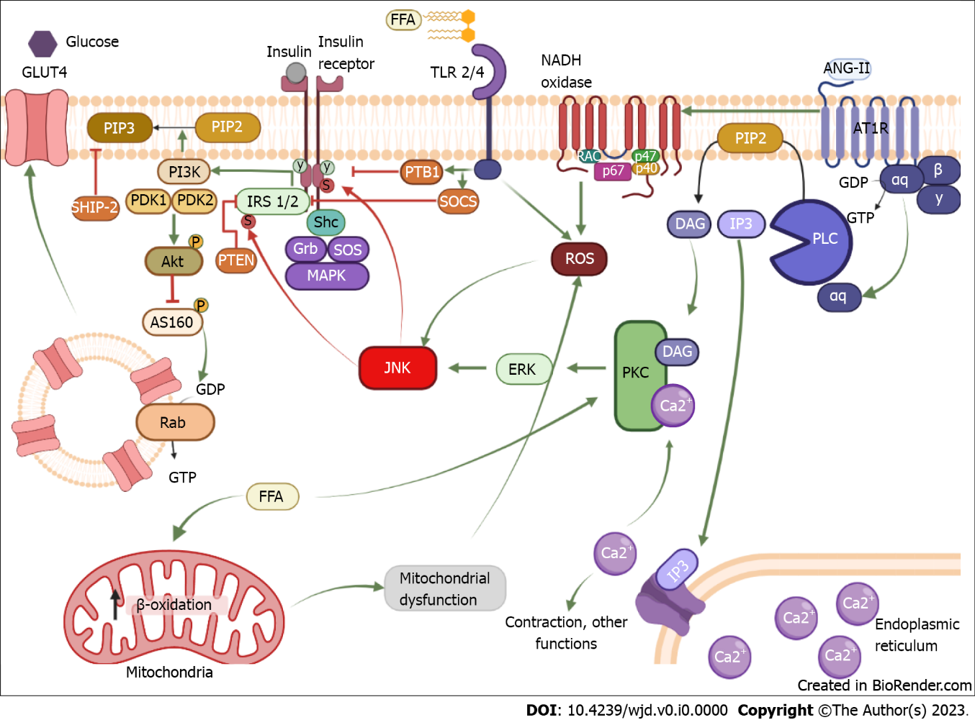
Figure 1 Mechanism of insulin resistance induced by chronic activation of the AT1 receptor. The binding of insulin to its receptor induces phosphorylation in tyrosine residues of the receptor; from there insulin can exert its function through two signaling pathways. In the first pathway, tyrosine phosphorylation allows the coupling of the IRS1/2, which serves as a scaffold protein for phosphatidylinositol-3 kinase (PI3K). In this way, PI3K has access to plasmatic membrane lipids and phosphorylates phosphatidylinositol 3,4-bisphosphate (PIP2) and converts them into phosphatidylinositol 3,4,5-triphosphate (PIP3). This serves as a storage site for phosphoinositide-dependent protein kinase 1 (PDK1), which together with PDK2 causes the activation of Akt. When Akt is active, it inhibits AS160, allowing GLUT 4 to be released to the cell membrane. The second pathway is the mitogen-activated kinase (MAPK) kinase. This signaling pathway starts with Shc coupling, which serves as a scaffold protein for Grb and son of sevenless (SOS). Activation of SOS can transform guanosine diphosphate or guanosine triphosphate in small G proteins, inducing the MAPK pathway which results in cellular growth and proliferation. Conversely, insulin signaling is negatively regulated by various proteins phosphatases like PTB1B that acts by inhibiting the receptor, phosphatase and tension homologue and suppressor of cytokine signaling (SOCS), which inhibit IRS 1/2 or SH-2 domain containing inositol 5-phosphatase-2 that dephosphorylates PIP3. Chronic activation of the AT1 receptor by angiotensin II induces activation of phospholipase C transforming PIP2 into IP3 and diacylglycerol (DAG). IP3 heads to the reticulum and releases calcium, so by itself it is involved in contraction. Together with DAG, IP3 can activate protein kinase C (PKC), which phosphorylates extracellular signal-regulated kinases and activates it; once activated it can phosphorylate c-Jun N-terminal kinase (JNK). When JNK is activated, it can phosphorylate the insulin receptor and IRS on serine residues, reducing IR and IRS function and resulting in insulin resistance development. Indeed, AT1R can induce NADPH oxidase activation, which produces reactive oxygen species that can activate JNK in a PKC-independent pathway. Another mechanism to activate JNK is through free fatty acid (FFA), these lipids can be sensed by TLR 2/4, and the activation of TLR promotes the enhancement of PTB1 and SOCS as well as the production of reactive oxygen species by the inflammatory response, ultimately activating JNK. Also, an increase in FFA in the mitochondria promotes excessive β-oxidation and induces mitochondrial dysfunction, resulting in oxidative stress and JNK activation. FFA: Free fatty acid; ISR 1/2: Insulin receptor substrate; ANG-II: Angiotensin II; GDP: Guanin diphosphate; GTP: Guanin triphosphate; PLC: Phospholipase C; PIP2: Phosphatidylinositol biphosphate; DAG: Diacylglycerol; IP3: Inositol-3-phosphate; PKC: Protein kinase C; ROS: Reactive oxygen species; PI3K: Phosphatidylinositol-3-kinase; PIP3: Phosphatidylinositol triphosphate; PDK1/2: Phosphoinositide-dependent protein kinase-1/2; AS160: Akt substrate of 160b; ERK: Extracellular regulated kinase; Shc: Src homology and collagen; SOCS: Suppressor of cytokine signaling; SOS: Sons of sevenless complex; Grb: Growth factor receptor binding protein; PTP-1B: Phosphotyrosine phosphatase 1-B; JNK: c-Jun amino-terminal kinase; PTEN: Phosphatase and tensin homolog; SHIP-2: The SH-2 domain containing inositol 5-phosphatase-2; MAPK: Mitogen-activated protein kinase. Created with BioRender.com.

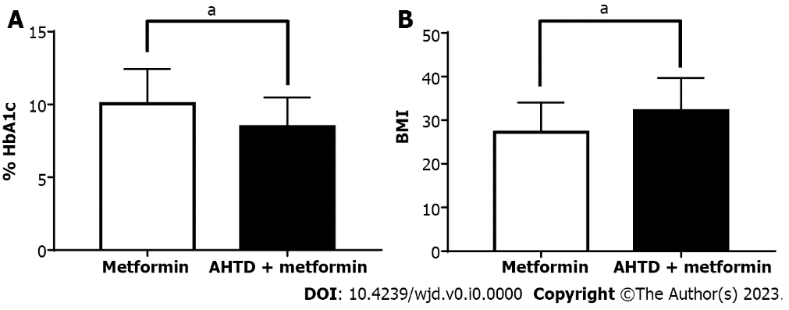
Figure 2 AT1 receptor antagonists boost glucose homeostasis and body mass index increase in type 2 diabetes mellitus patients. A and B: Comparison between type 2 diabetes mellitus patients and patients diagnosed with type 2 diabetes mellitus and high blood pressure, whose treatment consisted of metformin or metformin + antihypertensive drugs (AHTD), respectively. Glycated hemoglobin A1c was determined for these two groups (A), as well as body mass index (B). Data are expressed as the mean ± SE using GraphPad 7.0 for Windows. n = 18 patients for the metformin group (white bars) and 43 patients for AHTD + metformin group (black bars). Data was collected from the database of patients who came to the internal medicine clinic at Mexicali General Hospital. The protocols carried out in the present study were previously approved by the Hospital General 5 de Diciembre of ISSSTE Mexicali, Mexico, ethics committee (Circular Letter number 0985/2017). ªP < 0.05. AHTD: Antihypertensive drugs; BMI: Body mass index; HbA1c: Hemoglobin A1c.

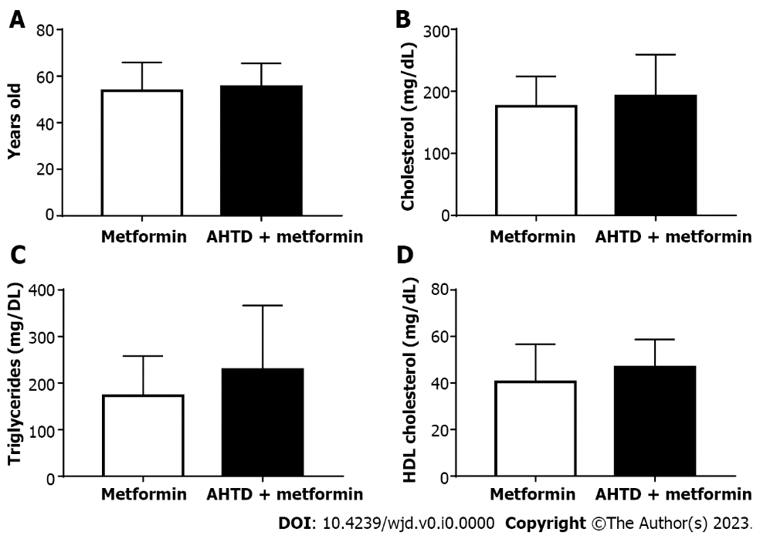
Figure 3 AT1 receptor antagonists promote gluconeogenesis decrease in type 2 diabetes mellitus patients. A-D: Comparison between type 2 diabetes mellitus patients and patients diagnosed with type 2 diabetes mellitus and high blood pressure, whose treatment consisted of metformin or metformin + antihypertensive drugs (AHTD), respectively. The age of the patients was reported (A), and the levels of total cholesterol (B), triglycerides (C), and HDL cholesterol (D) in the blood were determined. Data are expressed as the mean ± SE using GraphPad 7.0 for Windows. n = 18 patients for the metformin group (white bars) and 43 patients for AHTD + metformin group (black bars). Data was collected from the database of patients who came to the internal medicine clinic at Mexicali General Hospital. The protocols carried out in the present study were previously approved by the Hospital General 5 de Diciembre of ISSSTE Mexicali, Mexico, ethics committee (Circular Letter number 0985/2017). AHTD: Antihypertensive drugs.

