Name of Journal: World Journal of Gastrointestinal Oncology
Manuscript NO: 70554
Manuscript Type: META-ANALYSIS

Increased risk of colorectal neoplasia in inflammatory bowel disease patients with post-inflammatory polyps: A systematic review and meta-analysis

He DG et al. Risk of CRN in IBD patients

De-Gao He, Xi-Jie Chen, Juan-Ni Huang, Jun-Guo Chen, Min-Yi Lv, Tian-Ze Huang, Ping Lan, Xiao-Sheng He

De-Gao He, Xi-Jie Chen, Jun-Guo Chen, Min-Yi Lv, Tian-Ze Huang, Ping Lan, Xiao-Sheng He, Department of Colorectal Surgery, The Sixth Affiliated Hospital, Sun Yat-sen University, Guangdong Institute of Gastroenterology, Guangdong Provincial Key Laboratory of Colorectal and Pelvic Floor Diseases, Guangzhou 510655, Guangdong Province, China

Juan-Ni Huang, Department of Geriatrics, the first Affiliated Hospital, Guangzhou Medical University, Guangzhou 510120, Guangdong Province, China

Author contributions: He DG, Chen XJ and Huang JN contributed equally to this work; He DG, Chen XJ and He XS designed study; He DG, Chen XJ, performed literature search and review, He DG, Chen XJ, Huang JN, Chen JG, Lv MY and Huang TZ collected data; He DG, Chen XJ, Huang JN and He XS wrote and edited the manuscript; He DG and Lan P did statistical analysis; He DG, Chen XJ, Huang JN, Chen JG, Lv MY and Huang TZ contributed to methodological quality assessment; Lan P and He XS reviewed manuscript; All authors have read and approved the final manuscript.

Supported by The National Key R&D Program of China, No. 2017YFC1308800; National Natural Science Foundation of China, No. 81970482; Natural Science Foundation of Guangdong Province, China, No. 2019A1515011313; Sun Yat-Sen University 5010 Project, No. 2010012; and the Fundamental Research Funds for the Central Universities, No. 19ykpy05, and National Key Clinical Discipline.

Corresponding author: Xiao-Sheng He, MD, PhD, Doctor, Department of Colorectal Surgery, The Sixth Affiliated Hospital, Sun Yat-sen University, Guangdong Institute of Gastroenterology, Guangdong Provincial Key Laboratory of Colorectal and Pelvic Floor Diseases, No. 26 Yuancun Er Heng Road, Guangzhou 510655, Guangdong Province, China. hexsheng@mail.sysu.edu.cn

Received: August 6, 2021
Revised: September 8, 2021
Accepted: November 24, 2021
Published online: January 15, 2022

Abstract
BACKGROUND
Inflammatory bowel disease (IBD) patients with post-inflammatory polyps (PIPs) may carry an increased risk of colorectal neoplasia (CRN) including dysplasia and cancer. Current guidelines recommend active colonoscopy follow-up for these patients. However, the evidence for guidelines is still poor. In addition, some recent high-quality reports present a different view, which challenges the current guidelines. We hypothesize that IBD patients with PIPs are at increased risk of CRN.

AIM
To evaluate the risk of CRN in IBD patients with and without PIPs.

METHODS
A systematic search of PubMed, Embase, Cochrane Library, and Web of Science was performed to identify studies that compared the risk of CRN in IBD patients with and without PIPs. In addition, we screened the reference lists and citation indices of the included studies. Quality assessment was performed using the Newcastle–Ottawa Scale. Pooled odds ratio (OR) was calculated using the random-effects model to explore the final pooled effect size of the included studies and determine whether PIPs increase the risk of CRN. Sensitivity analysis, subgroup analysis, and assessment of publication bias were performed to examine the sources of heterogeneity.

RESULTS
Twelve studies with 5819 IBD patients, including 1281 (22.01%) with PIPs, were considered eligible for this meta-analysis. We found that IBD patients with PIPs were at an increased risk of CRN as compared to those without PIPs [OR 2.01; 95% confidence interval (CI): 1.43–2.83]. The results were similar when colorectal cancer was used as the study endpoint (OR 2.57; 95%CI: 1.69–3.91). Furthermore, the risk of CRN was still increased (OR 1.80; 95%CI: 1.12–2.91) when restricted to ulcerative colitis patients. Heterogeneity was high among the included studies (I² = 75%). Subgroup analysis revealed that the high heterogeneity was due to the study design. Sensitivity analysis showed that the main statistical outcomes did not essentially change after excluding any one of the included studies. No significant publication bias was found in the funnel plots.

CONCLUSION
IBD patients with PIPs have an increased risk of CRN as compared with those without PIPs, which support the current guidelines. However, a high-quality randomized controlled trial is warranted.

Key Words: Colorectal neoplasia; Inflammatory bowel disease; Ulcerative colitis; Post-inflammatory polyps; Pseudopolyps; Meta-analysis

©The Author(s) 2022. Published by Baishideng Publishing Group Inc. All rights reserved.

Citation: He DG, Chen XJ, Huang JN, Chen JG, Lv MY, Huang TZ, Lan P, He XS. Increased risk of colorectal neoplasia in inflammatory bowel disease patients with post-inflammatory polyps: A systematic review and meta-analysis. World J Gastrointest Oncol 2022; 14(1): 348-361
URL: https://www.wjgnet.com/1948-5204/full/v14/i1/348.htm
DOI: https://dx.doi.org/10.4251/wjgo.v14.i1.348

Core Tip: Inflammatory bowel disease (IBD) patients with post-inflammatory polyps (PIPs) may carry an increased risk of colorectal neoplasia (CRN). Current guidelines recommend active colonoscopy follow-up for these patients. However, the evidence is still poor. We found that IBD patients with PIPs have a higher risk of CRN than those without PIPs. The results were similar when colorectal cancer was used as the endpoint of the study. Our findings not only confirm the viewpoint of the guidelines, but may also improve the degree of evidence. We expect that our study will provide a reference for the development of surveillance strategies for IBD patients.

INTRODUCTION
Post-inflammatory polyps (PIPs), commonly known as pseudopolyps in the past, are islets of mucosa that develop after severe ulceration and disruption of mucosal integrity in the setting of chronic inflammation, such as inflammatory bowel disease (IBD)^{[1-3]}. PIPs can be classified into four pathologic types: (1) Ragged mucosal remnant; (2) Granulation tissue polyps; (3) Mixed polyps; and (4) “hyperplastic-adenomatous” polyps^{[1,4-6]}. Whether different types of PIPs lead to the same risk of colorectal neoplasia (CRN) in IBD patients awaits further study. The prevalence of PIPs in IBD patients was reported to range from 10% to 40%^{[7-24]}. This discrepancy may be due to the differences in diagnostic criteria, study year, and study population. PIPs are found more often in ulcerative colitis (UC) than in Crohn’s disease (CD)^{[25]}, and can be even 2-fold more in some studies^{[6,13]}. In addition, the incidence can increase with the extent and duration of colitis^{[9,10,16,26]}.
Colorectal cancer (CRC) is a serious complication in long-standing IBD and significantly increases the mortality rate due to this disease. Guidelines for Colorectal Cancer Screening and Surveillance in Moderate and High-Risk Groups (update from 2002)^{[27]} recommend surveillance intervals among IBD patients according to risk stratification. Several risk factors such as duration and severity of disease, young age at IBD diagnosis, family history of CRC, whether accompanied by primary sclerosing cholangitis and stricture, categorize IBD patients into low-, medium-, and high-risk groups. Patients with PIPs are included in the medium-risk group and colonoscopy is recommended every three years. Similarly, the AGA technical review on the diagnosis and management of CRN in IBD^{[28]} recommend that patients with multiple inflammatory pseudopolyps should undergo more frequent colonoscopy surveillance.
Both guidelines recommend the presence of PIPs as a risk factor for CRC in IBD patients. However, the literature cited in the guidelines comes from small case-control studies, indicating an insufficient level of evidence^{[14,29]}. In addition, different opinions have been raised in some recent high-quality literature^{[30-32]}. To comprehensively assess the impact of the presence of PIPs, we aimed to conduct a meta-analysis to quantify the impact of co-existing PIPs on the risk of CRN in IBD patients. We hypothesized that IBD patients with PIPs had an increased risk of CRN.

MATERIALS AND METHODS
Our study followed PICOS principles and was performed in accordance with the Preferred Reporting Items for Systematic Reviews and Meta-Analyses (PRISMA) statement^{[33]}.

Search strategy
A systematic literature search strategy was designed to determine all published or unpublished studies comparing the risk of CRN in IBD patients with and without PIPs. A comprehensive literature search of the following databases was conducted: PubMed, Embase, Cochrane Library, and Web of Science (English literature only, each from inception to October 22, 2020). We used medical subject headings and all free texts to retrieve the following keywords: ‘ulcerative colitis’, ‘crohn’s disease’, ‘inflammatory bowel disease’, ‘post-inflammatory polyps’, ‘colorectal neoplasms’, ‘colonic neoplasms’, ‘rectal neoplasms’ and ‘dysplasia’. All searches were performed separately by two researchers strictly following our pre-designed search strategy. After consulting with the senior investigators (He XS and Lan P) regarding queries, we reached an agreement for the retrieval results. Also, citations from each article on the topic were manually searched for other potentially eligible studies.

Study selection
According to the inclusion and exclusion criteria, two investigators (He DG and Chen XJ) independently reviewed all the searched literature and resolved any discrepancies through discussion to reach a consensus. Studies meeting the following criteria were included: (1) A comparison of IBD patients with and without PIPs, with CRN as the endpoint; (2) A detailed number of IBD patients with and without PIPs, as well as the number of CRN cases among these patients; and (3) For republished studies, we included the most recent publications.
Studies were excluded if (1) They were review articles, case reports, letters, or laboratory studies; (2) Important data of interest were missing; (3) Republished literature; and (4) Not English literature. Twelve eligible studies were finally included in our meta-analysis^{[14,29,31,32,34-41]}.

Data extraction
Raw data included in the study were extracted by two researchers (He DG and Huang JN) according to our pre-designed data extraction form. After discussing the deviations in detail with the senior investigator (He XS), we agreed on each study. The information extracted from the article were: study author, published year, published journal, study design, study type, surveillance period, sources of patients, race, age at IBD diagnosis, IBD type, quantitative data on the number of IBD patients, and the number IBD patients with concomitant PIPs, male gender and the presence of neoplasia or cancer.

Outcome measures
The primary outcome of the current study was whether PIPs increased the risk of CRN (including dysplasia and cancer) in IBD patients. The secondary outcome was whether PIPs increased the risk of CRC in IBD patients.

Methodological quality assessment of the included studies
The quality of the included studies was assessed using the Newcastle-Ottawa Scale (NOS), designed specifically for non-randomized studies in meta-analysis^{[42]}. The included studies were evaluated based on population selection (4 options), comparability (2 options), outcome of interest (cohort study) or determination of exposure (case-control study) (3 options). One point was assigned for each option, for a total of 9 points (Supplementary Table 1). A high-quality study required a score of 7 or above.

Statistical analysis
The primary data extracted from the included studies were dichotomous variables. The pooled odds ratio (OR) and 95% confidence interval (CI) were used to represent the pooled effect size. Study heterogeneity was assessed by the Q test and the I² statistic (which could quantify the level of heterogeneity). An I² value more than 50% or P value less than 0.10 in the Q-test represented substantial heterogeneity. When study heterogeneity was present (I² > 50% or P < 0.10), the random-effects model was used to assess the pooled effect, otherwise, the fixed-effects model was used. Subgroup analysis was performed as stratified based on IBD subtype and study type. Publication bias in the included studies was assessed by funnel plots. If potential biases were detected, we performed further sensitivity analyses to assess the robustness of pooled effect estimates and the likely impact of biases. We also performed a sensitivity analysis to investigate the impact of each study on the overall risk estimate by omitting one study in turn. A two-sided P value less than 0.05 was considered statistically significant. All the statistics were analyzed by Review Manager 5.4 (Cochrane Collaboration, Oxford, UK) and STATA 15.1 (StataCorp, College Station, Texas, USA). The statistical methods used in this study were reviewed by Ping Lan from the Department of Colorectal Surgery, the Sixth Affiliated Hospital, Sun Yat-sen University.

RESULTS
Study selection
In the initial search, a total of 618 related articles were obtained according to the research strategy. We also obtained 7 articles from the reference lists and citation indices of the included studies^{[29,31,34,38,41,43,44]}. Twenty articles^{[14,29-32,34-41,45-51]} that might be eligible for inclusion were reviewed. Among them, 12 articles met our inclusion criteria (Figure 1)^{[14,29,31,32,34-41]}. Five studies were excluded due to duplication^{[45-49]}, 2 studies due to incomplete data of interest^{[30,50]}, and one due to lack of a control group^{[51]}.

Study characteristics
The baseline characteristics of the included studies are described in Table 1. Overall, the 12 included studies were published between 2004 and 2020. A total of 5819 IBD patients, including 1821 (22.01%) IBD patients who also had PIPs, were identified. Of these studies, 5 studies were cohort studies^{[31,32,34-36]}, 6 were case-control studies^{[14,29,37,38,40,41]} and one was a cross-sectional study^{[39]}. One was a prospective study^{[39]} and the others were retrospective studies^{[14,29,31,32,34-38,40,41]}. In addition, 7 studies contained data that could be used to independently analyze UC patients^{[14,29,34-37,39]}, one study contained data that could be used to independently analyze CD patients^{[36]}, and in 5 studies we were unable to distinguish the data between UC patients and CD patients^{[31,32,38,40,41]}. In addition, all studies included raw data with the endpoint as CRN, and 6 studies reported on the number of IBD patients who developed CRC^{[29,31,34,36,38,41]}.

Quality assessment of the included studies
The quality of each study was evaluated separately using the NOS. The results showed that the scores of the studies ranged from 5 to 9 points, and most scored 7 or above[14,29,31,32,34,35,37,38,40,41]. Table 2 shows the NOS results for the included studies.

Quantitative summary (meta-analysis)
PIPs were associated with a higher risk of CRN in IBD patients (OR 2.01; 95%CI: 1.43–2.83) (Figure 2). When CRC was used as an endpoint, patients with PIPs had an approximately 2.5-fold increased risk compared to those without PIPs (OR 2.57; 95%CI: 1.69–3.91) (Figure 3). When UC patients were analyzed separately, the pooled OR was 1.80 (95%CI: 1.12–2.97), suggesting that the existence of PIPs was related to a higher risk of CRN in UC patients (Figure 4). Limited data prevented us from performing a meta-analysis in CD patients, but the study by Ma et al^{[36]} indicated that no association was observed between PIPs and CRN in these patients (OR 1.27; 95%CI: 0.24–6.75). However, there was high heterogeneity among studies (I² = 75%); therefore, the Mantel-Haenszel random-effects model was used to test the results. Furthermore, the sources of heterogeneity were assessed by subgroup analyses, sensitivity analysis, and assessment of publication bias.

Subgroup analysis
Subgroup analysis based on study types (cohort, case-control, cross-sectional) showed a significant reduction in heterogeneity (Figure 5). In other words, different study types may be a source of heterogeneity. An increased risk of CRN was found in cohort studies (OR 1.73; 95%CI: 1.12–2.66)^{[31,32,34-36]} and case-control studies (OR 2.31; 95%CI: 1.45–3.67)^{[14,29,37,38,40,41]}. Nevertheless, no association between PIPs and CRN was found in cross-sectional studies (OR 0.49; 95%CI: 0.09–2.70)^{[39]}.

Sensitivity analysis
Sensitivity analysis was performed with the pooled OR and 95%CI. The results were essentially unchanged in the statistical outcomes of all the indicators after excluding any one study. The results are shown in Table 3.

Assessment of publication bias
A funnel plot with 12 studies was used to evaluate publication bias (Figure 6). It can be seen that the scatter point distribution was basically symmetrical, indicating no significant publication bias in the current meta-analysis.

DISCUSSION
Currently, the leading guidelines from Europe and the United States recommend more frequent colonoscopy for IBD patients with PIPs, in order to detect CRN in a timely manner^{[27,28]}. However, several high-quality studies have recently shown that the presence of PIPs is not an independent risk factor for CRN in IBD patients^{[30-32]}. The current meta-analysis of 12 observational studies including 1821 (22.01%) patients with PIPs indicated that IBD patients with PIPs had an approximately 2-fold increased risk of CRN. It is worth mentioning that we included two abstracts^{[36,40]} with required data in our analysis, which may have introduced bias. However, even when we excluded these abstracts, we came to the same conclusion (OR 1.99; 95%CI: 1.37-2.88). Even when excluding dysplasia, the risk of CRC was still increased by approximately 2.5-fold in IBD patients with PIPs as compared with those without PIPs. In addition, UC patients with PIPs had an approximately 1.8-fold increased risk of CRN as compared with those without PIPs. Limited data on the risk of CRN in CD patients with PIPs may be related to the low incidence of PIPs among CD patients.
The reasons and mechanisms for the increased risk of CRN in IBD patients with concomitant PIPs remain unclear. One possible reason for this association is that PIPs are thought to be markers of previous episodes of severe inflammation. The incidence of PIPs increases with the severity of colitis, which may accelerate the development of CRN^{[9,32,52]}. Another possible reason is that multiple PIPs may weaken the ability of endoscopy to detect dysplastic lesions^{[29,31]}. However, both of these reasons only indicate that PIPs are indirect signs of increased risk of CRN in IBD patients. At present, it is generally believed that PIPs are benign and do not directly cause malignant transformation, even though there have been occasional reports of malignant transformation of PIPs^{[53,54]}. However, Jawad et al^{[55]} reported that PIPs may be the source of precancerous mutations following the analysis of DNA extracted from 30 different PIPs samples in which 4 identifiable mutations were found. In addition, Lozyns'ka^{[56]} found 21.4% chromosomal anomalies in PIPs samples from IBD patients. Taken together, these findings suggest that we may have to re-think whether PIPs can directly lead to malignant transformation and the therapeutic strategy for PIPs may change in the future.
It is interesting to note that most included studies from the last two years^{[31,32,34]} had a contrary conclusion to previous studies^{[14,29,41]}, although the quality of relevant studies was relatively high. Recent studies reported that no independent association between PIPs and CRN was found^{[30-32,34]}, which was contrary to our findings. This may be explained by the differences in the included study population and changes in the treatment patterns of IBD patients in recent years^{[57-60]}. On the one hand, PIPs are the complication of prior extensive colon inflammation, leading to colectomy, and higher rates of early colectomy may result in a lower risk of CRN in these patients. On the other hand, with the widespread application of biological agents (such as infliximab, mesalazine, azathioprine, etc.) in the treatment of IBD, the risk of CRN in IBD patients may decline. Recent studies might have included more better-treated IBD patients, leading to a lower risk of CRN in their study population. However, our study included 5819 IBD patients since 1976, indicating that our results may be less influenced by these factors.
Our findings may have implications for clinical practice as they might provide an individual reference for endoscopic surveillance strategies in IBD patients. The evidence cited in the current guidelines is inadequate. Our study, which included 5,819 IBD patients from 12 studies, confirms the viewpoint of the guidelines for more aggressive colonoscopy in IBD patients with PIPs and further improves the degree of evidence. Above all, we agree that executing an evidence-based risk stratification model to determine surveillance intervals is cost-effective and in line with the concept of individualized treatment. In addition, it is necessary to identify the time period of higher incidence of CRN in IBD patients with PIPs. In this time period, patients with PIPs will receive more frequent endoscopic surveillance to detect CRN early. Finally, PIPs may weaken the endoscopic recognition of dysplasia. Improving endoscopic techniques to recognize PIPs and dysplasia may further reduce the incidence of CRN in IBD patients with PIPs. Perhaps these proposals could be considered in the IBD surveillance guidelines in the future.
High heterogeneity was found in our study. When subgroup analysis was conducted according to different study types (Figure 5), heterogeneity decreased to an acceptable level. In addition, sensitivity analysis and assessment of publication bias were performed to determine the sources of heterogeneity. We reanalyzed the included studies after excluding two studies with a score below 7^{[36,39]}; however, the results were similar to those before the exclusion of these studies (OR 2.14; 95%CI: 1.50–3.06; I²=78%). Also, when we excluded one of the included studies in turn, there were no significant changes in the results of the pooled effect size (Table 3) and heterogeneity. Furthermore, as shown in the funnel plot (Figure 6), there was no significant publication bias in our included studies. In general, we found that study type may be one of the sources of heterogeneity, and other potential heterogeneity may arise due to internal factors (such as IBD type, study population, statistical methods) within each included study.
Several limitations of our study should be considered. Firstly, heterogeneity was pronounced in our study, which may be related to the study types. Secondly, the studies included did not have standardized reports on PIPs. The reports on PIPs were mainly from endoscopy reports by endoscopists, which may have resulted in misclassification of PIPs. However, the reports on PIPs by a qualified endoscopist were usually reliable, and the relevant pathology reports confirmed the findings. Thirdly, some confounding factors, such as the degree of colitis at the time of the colonoscopy, duration of colitis, and endoscopy interval were not well controlled in the included studies, which prevented us from analyzing their impact on the results. Therefore, controlling these confounding factors and performing higher quality studies is the direction of our efforts in the future. Despite these limitations, to the best of our knowledge, this is currently the most comprehensive and high-quality meta-analysis with the largest population investigating the risk of CRN in IBD patients with PIPs.

CONCLUSION
In summary, IBD patients with PIPs have a higher risk of CRN than those without PIPs. Our best evidence-based study advocates the current guideline that IBD patients with PIPs require more intensive surveillance.

ARTICLE HIGHLIGHTS
Research background
Inflammatory bowel disease (IBD) patients with post-inflammatory polyps (PIPs) may carry an increased risk of colorectal neoplasia (CRN). Current guidelines recommend more aggressive colonoscopy follow-up in these patients. However, the guidelines are based on a low degree of evidence and several recent high-quality studies have shown that the presence of PIPs is not an independent risk factor for CRN in IBD patients.

Research motivation
Whether the risk of CRN in IBD patients with PIPs is increased will have a significant impact on the surveillance strategies of IBD patients.

Research objectives
The current study aimed to evaluate the risk of CRN in IBD patients with and without PIPs.

Research methods
A systematic literature search was performed to identify studies that compared the risk of CRN in IBD patients with and without PIPs. Pooled odds ratio (OR) was calculated using the random-effects model to explore the final pooled effect size of the included studies and determine whether PIPs increase the risk of CRN. Sensitivity analysis, subgroup analysis, and assessment of publication bias were performed to determine the sources of heterogeneity.

Research results
We found that IBD patients with PIPs had an approximately 2-fold increased risk of CRN [OR 2.01; 95% confidence interval (CI): 1.43–2.83]. The results were similar when colorectal cancer was used as the study endpoint (OR 2.57; 95%CI: 1.69–3.91).

Research conclusions
IBD patients with PIPs have a higher risk of CRN than those without PIPs, which support current guidelines that IBD patients with PIPs require more frequent surveillance.

Research perspectives
Our findings not only confirm the viewpoint of the guidelines, but may also improve the degree of evidence. We expect that our study can provide a reference for the development of surveillance strategies for IBD patients.

REFERENCES
1 Politis DS, Katsanos KH, Tsianos EV, Christodoulou DK. Pseudopolyps in inflammatory bowel diseases: Have we learned enough? World J Gastroenterol 2017; 23: 1541-1551 [PMID: 28321155 DOI: 10.3748/wjg.v23.i9.1541]
2 Gallart-Esquerdo A. [Anatomicopathological study of rectocolic inflammatory pseudo-polyposis following mucohemorrhagic rectocolitis (grave ulcerative colitis)]. Rev Bras Gastroenterol 1958; 10: 1-4 [PMID: 13568179]
3 Goldgraber MB. Pseudopolyps in ulcerative colitis. Dis Colon Rectum 1965; 8: 355-363 [PMID: 5830658 DOI: 10.1007/bf02627260]
4 Munyer TP, Montgomery CK, Thoeni RF, Goldberg HI, Margulis AR. Postinflammatory polyposis (PIP) of the colon: the radiologic-pathologic spectrum. Radiology 1982; 145: 607-614 [PMID: 7146388 DOI: 10.1148/radiology.145.3.7146388]
5 Lumb G. Pathology of ulcerative colitis. Gastroenterology 1961; 40: 290-298 [PMID: 13764247]
6 Kelly JK, Gabos S. The pathogenesis of inflammatory polyps. Dis Colon Rectum 1987; 30: 251-254 [PMID: 3829873 DOI: 10.1007/bf02556166]
7 Schneider R, Dickersin GR, Patterson JF. Localized giant pseudopolyposis. A complication of granulomatous colitis. Am J Dig Dis 1973; 18: 265-270 [PMID: 4695612 DOI: 10.1007/bf01070986]
8 Baars JE, Nuij VJ, Oldenburg B, Kuipers EJ, van der Woude CJ. Majority of patients with inflammatory bowel disease in clinical remission have mucosal inflammation. Inflamm Bowel Dis 2012; 18: 1634-1640 [PMID: 22069022 DOI: 10.1002/ibd.21925]
9 De Dombal FT, Watts JM, Watkinson G, Goligher JC. Local complications of ulcerative colitis: stricture, pseudopolyposis, and carcinoma of colon and rectum. Br Med J 1966; 1: 1442-1447 [PMID: 5933046 DOI: 10.1136/bmj.1.5501.1442]
10 Jalan KN, Walker RJ, Sircus W, McManus JP, Prescott RJ, Card WI. Pseudopolyposis in ulcerative colitis. Lancet 1969; 2: 555-559 [PMID: 4185531 DOI: 10.1016/s0140-6736(69)90260-8]
11 Chuttani HK, Nigam SP, Sama SK, Dhanda PC, Gupta PS. Ulcerative colitis in the tropics. Br Med J 1967; 4: 204-207 [PMID: 6053989 DOI: 10.1136/bmj.4.5573.204]
12 Geboes K, Vantrappen G. The value of colonoscopy in the diagnosis of Crohn's disease. Gastrointest Endosc 1975; 22: 18-23 [PMID: 1205096 DOI: 10.1016/s0016-5107(75)73675-1]
13 Margulis AR, Goldberg HI, Lawson TL, Montgomery CK, Rambo ON, Noonan CD, Amberg JR. The overlapping spectrum of ulcerative and granulomatous colitis: a roentgenographic-pathologic study. Am J Roentgenol Radium Ther Nucl Med 1971; 113: 325-334 [PMID: 5098634 DOI: 10.2214/ajr.113.2.325]
14 Rutter MD, Saunders BP, Wilkinson KH, Rumbles S, Schofield G, Kamm MA, Williams CB, Price AB, Talbot IC, Forbes A. Cancer surveillance in longstanding ulcerative colitis: endoscopic appearances help predict cancer risk. Gut 2004; 53: 1813-1816 [PMID: 15542520 DOI: 10.1136/gut.2003.038505]
15 Ray G. Inflammatory bowel disease in India--changing paradigms. Int J Colorectal Dis 2011; 26: 635-644 [PMID: 21063715 DOI: 10.1007/s00384-010-1084-5]
16 Teague RH, Read AE. Polyposis in ulcerative colitis. Gut 1975; 16: 792-795 [PMID: 1205273 DOI: 10.1136/gut.16.10.792]
17 Reinglas J, Gonczi L, Kurt Z, Bessissow T, Lakatos PL. Positioning of old and new biologicals and small molecules in the treatment of inflammatory bowel diseases. World J Gastroenterol 2018; 24: 3567-3582 [PMID: 30166855 DOI: 10.3748/wjg.v24.i32.3567]
18 Teh LB, Koh D, Ng HS, Kwok KC, Lim TC, Ho MS, Seah CS. Ulcerative colitis in Singapore: a clinical study of sixty-one patients. Ann Acad Med Singap 1987; 16: 474-479 [PMID: 2893576]
19 Wright V, Watkinson G. The arthritis of ulcerative colitis. Br Med J 1965; 2: 670-675 [PMID: 14337733 DOI: 10.1136/bmj.2.5463.670]
20 Wang Y, Ouyang Q; APDW 2004 Chinese IBD working group. Ulcerative colitis in China: retrospective analysis of 3100 hospitalized patients. J Gastroenterol Hepatol 2007; 22: 1450-1455 [PMID: 17716349 DOI: 10.1111/j.1440-1746.2007.04873.x]
21 Baars JE, Kuipers EJ, van Haastert M, Nicolaï JJ, Poen AC, van der Woude CJ. Age at diagnosis of inflammatory bowel disease influences early development of colorectal cancer in inflammatory bowel disease patients: a nationwide, long-term survey. J Gastroenterol 2012; 47: 1308-1322 [PMID: 22627504 DOI: 10.1007/s00535-012-0603-2]
22 Chang DK, Kim JJ, Choi H, Eun CS, Han DS, Byeon JS, Kim JO. Double balloon endoscopy in small intestinal Crohn's disease and other inflammatory diseases such as cryptogenic multifocal ulcerous stenosing enteritis (CMUSE). Gastrointest Endosc 2007; 66: S96-S98 [PMID: 17709044 DOI: 10.1016/j.gie.2007.01.016]
23 Luo YY, Chen J. [Clinical and colonoscopic characteristics of pediatric inflammatory bowel disease]. Zhonghua Erke Zazhi 2009; 47: 129-133 [PMID: 19573460]
24 Kosugi I, Tada T, Tsutsui Y, Sato Y, Mitsui T, Itazu I. Giant inflammatory polyposis of the descending colon associated with a Crohn's disease-like colitis. Pathol Int 2002; 52: 318-321 [PMID: 12031089 DOI: 10.1046/j.1440-1827.2002.01348.x]
25 Buck JL, Dachman AH, Sobin LH. Polypoid and pseudopolypoid manifestations of inflammatory bowel disease. Radiographics 1991; 11: 293-304 [PMID: 2028064 DOI: 10.1148/radiographics.11.2.2028064]
26 Bacon HE, Carroll PT, Cates BA, Mcgregor RA, Ouyang LM, Villalba G. Non-specific ulcerative colitis, with reference to mortality, morbidity, complications and long-term survivals following colectomy. Am J Surg 1956; 92: 688-695 [PMID: 13372871 DOI: 10.1016/s0002-9610(56)80140-2]
27 Cairns SR, Scholefield JH, Steele RJ, Dunlop MG, Thomas HJ, Evans GD, Eaden JA, Rutter MD, Atkin WP, Saunders BP, Lucassen A, Jenkins P, Fairclough PD, Woodhouse CR; British Society of Gastroenterology; Association of Coloproctology for Great Britain and Ireland. Guidelines for colorectal cancer screening and surveillance in moderate and high risk groups (update from 2002). Gut 2010; 59: 666-689 [PMID: 20427401 DOI: 10.1136/gut.2009.179804]
28 Farraye FA, Odze RD, Eaden J, Itzkowitz SH. AGA technical review on the diagnosis and management of colorectal neoplasia in inflammatory bowel disease. Gastroenterology 2010; 138: 746-774 [PMID: 20141809 DOI: 10.1053/j.gastro.2009.12.035]
29 Velayos FS, Loftus EV Jr, Jess T, Harmsen WS, Bida J, Zinsmeister AR, Tremaine WJ, Sandborn WJ. Predictive and protective factors associated with colorectal cancer in ulcerative colitis: A case-control study. Gastroenterology 2006; 130: 1941-1949 [PMID: 16762617 DOI: 10.1053/j.gastro.2006.03.028]
30 Al Bakir I, Curtius K, Kabir M, Saunders B, Suzuki N, Thomas-Gibson S, Wilson A, Moorghen M, Graham T, Hart A. Long-term outcomes following endoscopic resection of neoplastic lesions in ulcerative colitis: A large single-centre retrospective study. United Eur Gastroent 2019; 7: 80 [DOI: 10.1177/205064061985467]
31 de Jong ME, Gillis VELM, Derikx LAAP, Hoentjen F. No Increased Risk of Colorectal Neoplasia in Patients With Inflammatory Bowel Disease and Postinflammatory Polyps. Inflamm Bowel Dis 2020; 26: 1383-1389 [PMID: 31677385 DOI: 10.1093/ibd/izz261]
32 Mahmoud R, Shah SC, Ten Hove JR, Torres J, Mooiweer E, Castaneda D, Glass J, Elman J, Kumar A, Axelrad J, Ullman T, Colombel JF, Oldenburg B, Itzkowitz SH; Dutch Initiative on Crohn and Colitis. No Association Between Pseudopolyps and Colorectal Neoplasia in Patients With Inflammatory Bowel Diseases. Gastroenterology 2019; 156: 1333-1344.e3 [PMID: 30529584 DOI: 10.1053/j.gastro.2018.11.067]
33 Shamseer L, Moher D, Clarke M, Ghersi D, Liberati A, Petticrew M, Shekelle P, Stewart LA; PRISMA-P Group. Preferred reporting items for systematic review and meta-analysis protocols (PRISMA-P) 2015: elaboration and explanation. BMJ 2015; 350: g7647 [PMID: 25555855 DOI: 10.1136/bmj.g7647]
34 Ünal NG, Özütemiz Ö, Tekin F, Turan İ, Osmanoğlu N. Colorectal cancer and dysplasia risk of ulcerative colitis patients in a tertiary referral center in Turkey. Turk J Gastroenterol 2019; 30: 139-147 [PMID: 30460897 DOI: 10.5152/tjg.2018.18221]
35 Gu YB, Xu WM, Guo YG, Zhong J, Du P. Risk factors of colorectal stricture associated with developing high-grade dysplasia or cancer in ulcerative colitis: A multicenter long-term follow-up study. J Dig Dis 2019; 20: 26 [DOI: 10.1111/1751-2980.12808]
36 Ma YR, Ko HBM, Zhu H, Harpaz N, Polydorides AD. Gastrointestinal Pathology. Lab Invest 2017; 97: 157-210 [PMID: 28134861 DOI: 10.1038/labinvest.2016.168]
37 Jegadeesan R, Navaneethan U, Gutierrez NG, Venkatesh PG, Hammel JP, Sanaka MR, Shen B. Pattern of Inflammation on Surveillance Colonoscopy Does Not Predict Development of Colitis-associated Neoplasia. Inflamm Bowel Dis 2016; 22: 2221-2228 [PMID: 27542134 DOI: 10.1097/MIB.0000000000000862]
38 Lutgens M, Vermeire S, Van Oijen M, Vleggaar F, Siersema P, van Assche G, Rutgeerts P, Oldenburg B; Dutch Initiative on Crohn and Colitis. A rule for determining risk of colorectal cancer in patients with inflammatory bowel disease. Clin Gastroenterol Hepatol 2015; 13: 148-54.e1 [PMID: 25041864 DOI: 10.1016/j.cgh.2014.06.032]
39 Freire P, Figueiredo P, Cardoso R, Manuel Donato M, Ferreira M, Mendes S, Silva MR, Cipriano MA, Ferreira AM, Vasconcelos H, Portela F, Sofia C. Predictive value of rectal aberrant crypt foci for intraepithelial neoplasia in ulcerative colitis - a cross-sectional study. Scand J Gastroenterol 2014; 49: 1219-1229 [PMID: 25157637 DOI: 10.3109/00365521.2014.951390]
40 Badamas J, Limketkai BN, Lazarev M. Risk of dysplasia according to severity of pseudopolyposis in inflammatory bowel disease. Gastroenterology 2014; 146: S-436 [DOI: 10.1016/S0016-5085(14)61568-7]
41 Baars JE, Looman CW, Steyerberg EW, Beukers R, Tan AC, Weusten BL, Kuipers EJ, van der Woude CJ. The risk of inflammatory bowel disease-related colorectal carcinoma is limited: results from a nationwide nested case-control study. Am J Gastroenterol 2011; 106: 319-328 [PMID: 21045815 DOI: 10.1038/ajg.2010.428]
42 Stang A. Critical evaluation of the Newcastle-Ottawa scale for the assessment of the quality of nonrandomized studies in meta-analyses. Eur J Epidemiol 2010; 25: 603-605 [PMID: 20652370 DOI: 10.1007/s10654-010-9491-z]
43 Okugawa Y, Toiyama Y, Kusunoki M, Goel A. Re: Cumulative burden of inflammation predicts colorectal neoplasia risk in ulcerative colitis: a large single-centre study. Gut 2019; 68: 575 [PMID: 29535153 DOI: 10.1136/gutjnl-2018-316205]
44 Lakatos L, Mester G, Erdelyi Z, David G, Pandur T, Balogh M, Fischer S, Vargha P, Lakatos PL. Risk factors for ulcerative colitis-associated colorectal cancer in a Hungarian cohort of patients with ulcerative colitis: results of a population-based study. Inflamm Bowel Dis 2006; 12: 205-211 [PMID: 16534422 DOI: 10.1097/01.MIB.0000217770.21261.ce]
45 Xu W, Ding W, Gu Y, Cui L, Zhong J, Du P. Risk Factors of Colorectal Stricture Associated with Developing High-Grade Dysplasia or Cancer in Ulcerative Colitis: A Multicenter Long-term Follow-up Study. Gut Liver 2020; 14: 601-610 [PMID: 31816674 DOI: 10.5009/gnl19229]
46 Ando T, Ishiguro K, Maeda O, Watanabe O, Miyake N, Nakamura M, Miyahara R, Ohmiya N, Goto H. Clinicopathological characteristics of colorectal cancer in patients with ulcerative colitis. Gastrointest Endosc 2010; 71: AB345-AB346 [DOI: 10.1016/j.gie.2010.03.919]
47 Lutgens M, Siersema PD, Vleggaar F, Broekman M, Van Bodegraven AA, Dijkstra G, Hommes DW, De Jong D, Stokkers PCF, Van Der Woude CJ, Oldenburg B. Risk factors for inflammatory bowel disease associated colorectal carcinoma. J Crohns Colitis 2011; 5: S12
48 Lutgens MW, Siersema PD, Vleggaar FP, Broekman M, Van Oijen MG, Van Bodegraven AA, Dijkstra G, Hommes DW, De Jong DJ, Ponsioen C, Van Der Woude CJ, Oldenburg B. Risk factors for advanced neoplasia of the rectal stump in IBD patients. Gastroenterology 2011; 140: S351-S352 [DOI: 10.1016/S0016-5085(11)61433-9]
49 Mahmoud R, Shah S, Ten Hove J, Torres J, Mooiweer E, Castaneda D, Glass J, Elman J, Kumar A, Axelrad J, Ullman T, Colombel JF, Oldenburg B, Itzkowitz S. Post-inflammatory polyps do not predict colorectal neoplasia in patients with inflammatory bowel disease: A multinational retrospective cohort study. J Crohns Colitis 2018; 12: S156-S157
50 Lewis AE, Kirchgesner J, Dray X, Svrcek M, Beaugerie L. Clinical Significance of Pseudopolyps for Patients With Inflammatory Bowel Disease. Am J Gastroenterol 2019; 114: S179-S180 [DOI: 10.14309/01.ajg.0000590752.06064.e8]
51 Abou Rached A, Saniour J, Shehab R, Abou Fadel C, Yaghi C, Khairallah S. The association between the severity of histological lesions with the disease location and presence of colonic lesions in patients with ulcerative colitis. J Crohns Colitis 2019; 13: S235-S236 [DOI: 10.1093/ecco-jcc/jjy222.398]
52 Flores BM, O'Connor A, Moss AC. Impact of mucosal inflammation on risk of colorectal neoplasia in patients with ulcerative colitis: a systematic review and meta-analysis. Gastrointest Endosc 2017; 86: 1006-1011.e8 [PMID: 28750838 DOI: 10.1016/j.gie.2017.07.028]
53 Dukes CE. The surgical pathology of ulcerative colitis. Ann R Coll Surg Engl 1954; 14: 389-400 [PMID: 13159102]
54 Kusunoki M, Nishigami T, Yanagi H, Okamoto T, Shoji Y, Sakanoue Y, Yamamura T, Utsunomiya J. Occult cancer in localized giant pseudopolyposis. Am J Gastroenterol 1992; 87: 379-381 [PMID: 1539578]
55 Jawad N, Graham T, Novelli M, Rodriguez-Justo M, Feakins R, Silver A, Wright N, McDonald S. PTU-124 Are pseudopolyps the source of tumorigenic mutations in ulcerative colitis? Gut 2012; 61: A236 [DOI: 10.1136/gutjnl-2012-302514c.124]
56 Lozyns'ka MR. The spectrum of cytogenetic chages in polyps of the large intestine with different histologic structure. Tsitol Genet 2008; 42: 43-49 [PMID: 19253754]
57 Liatsos C, Kyriakos N, Panagou E, Karagiannis S, Salemis N, Mavrogiannis C. Inflammatory polypoid mass treated with Infliximab in a Crohn's disease patient. J Crohns Colitis 2010; 4: 707-708 [PMID: 21122587 DOI: 10.1016/j.crohns.2010.09.006]
58 Cohen-Mekelburg S, Schneider Y, Gold S, Scherl E, Steinlauf A. Advances in the Diagnosis and Management of Colonic Dysplasia in Patients With Inflammatory Bowel Disease. Gastroenterol Hepatol (N Y) 2017; 13: 357-362 [PMID: 28690452]
59 Shah SC, Itzkowitz SH. Management of Inflammatory Bowel Disease-Associated Dysplasia in the Modern Era. Gastrointest Endosc Clin N Am 2019; 29: 531-548 [PMID: 31078251 DOI: 10.1016/j.giec.2019.02.008]
60 Choi YS, Suh JP, Lee IT, Kim JK, Lee SH, Cho KR, Park HJ, Kim DS, Lee DH. Regression of giant pseudopolyps in inflammatory bowel disease. J Crohns Colitis 2012; 6: 240-243 [PMID: 22325179 DOI: 10.1016/j.crohns.2011.08.007]

Footnotes
Conflict-of-interest statement: Authors have no conflicts of interest to declare.

PRISMA 2009 Checklist statement: The authors have read the PRISMA 2009 Checklist, and the manuscript was prepared and revised according to the PRISMA 2009 Checklist.

Open-Access: This article is an open-access article that was selected by an in-house editor and fully peer-reviewed by external reviewers. It is distributed in accordance with the Creative Commons Attribution NonCommercial (CC BY-NC 4.0) license, which permits others to distribute, remix, adapt, build upon this work non-commercially, and license their derivative works on different terms, provided the original work is properly cited and the use is non-commercial. See: https://creativecommons.org/Licenses/by-nc/4.0/

Provenance and peer review: Unsolicited article; Externally peer reviewed.
Peer-review model: Single blind

Peer-review started: August 6, 2021
First decision: August 29, 2021
Article in press: November 24, 2021

Specialty type: Gastroenterology and hepatology
Country/Territory of origin: China
Peer-review report’s scientific quality classification
Grade A (Excellent): 0
Grade B (Very good): B
Grade C (Good): 0
Grade D (Fair): 0
Grade E (Poor): 0

P-Reviewer: Sitkin S S-Editor: Liu M L-Editor: A P-Editor: Liu M

Figure Legends
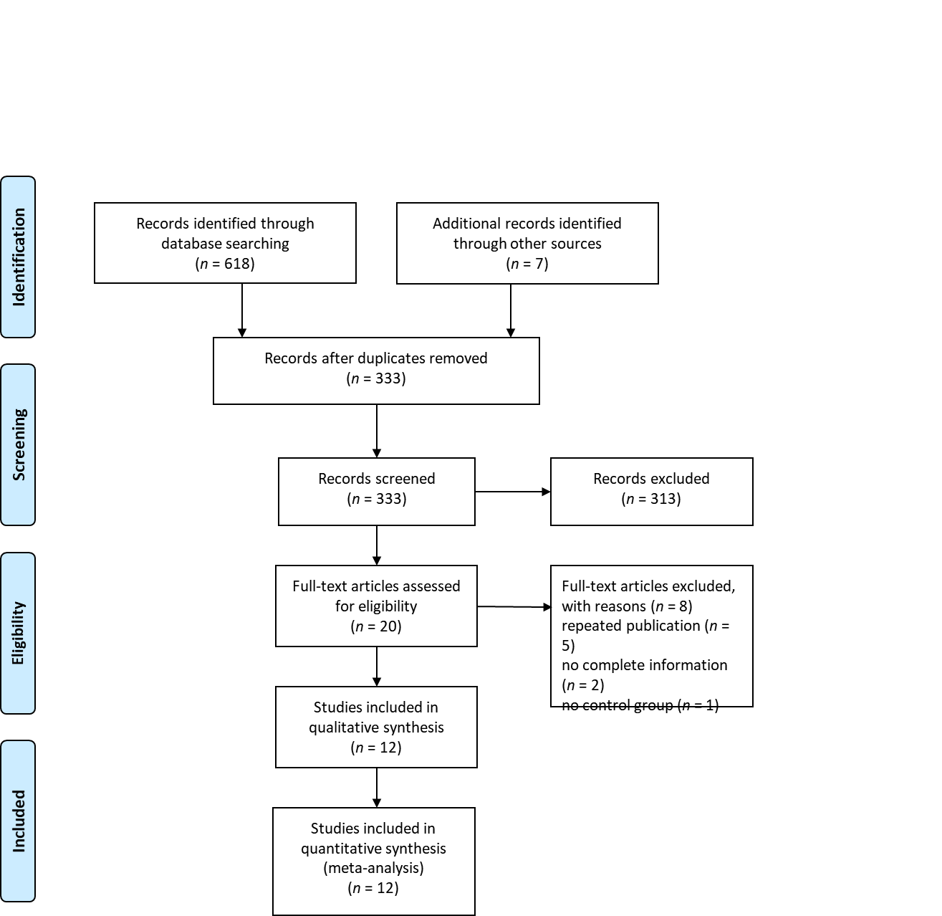
Figure 1 PRISMA flow diagram.
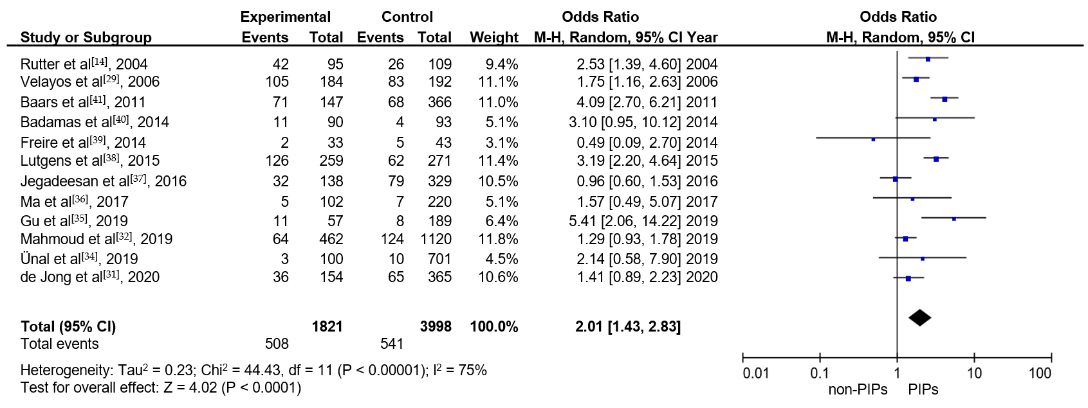
Figure 2 Risk of the development of colorectal neoplasia in inflammatory bowel disease patients with post-inflammatory polyps. M-H: Mantel-Haenszel; CI: Confidence interval; PIPs: Post-inflammatory polyps.
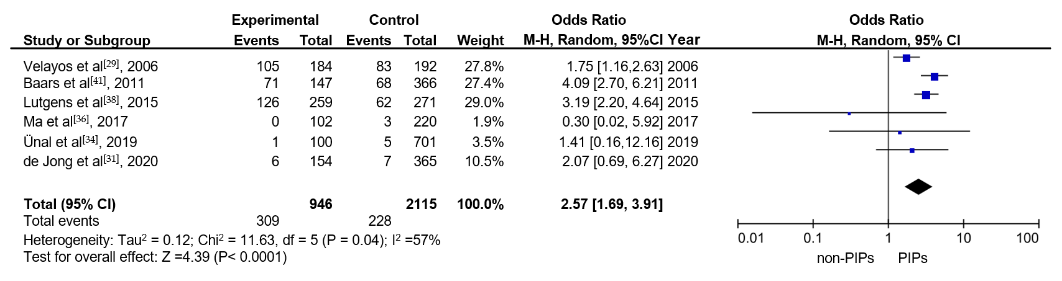
Figure 3 Risk of the development of colorectal cancer in inflammatory bowel disease patients with post-inflammatory polyps. M-H: Mantel-Haenszel; CI: Confidence interval; PIPs: Post-inflammatory polyps.
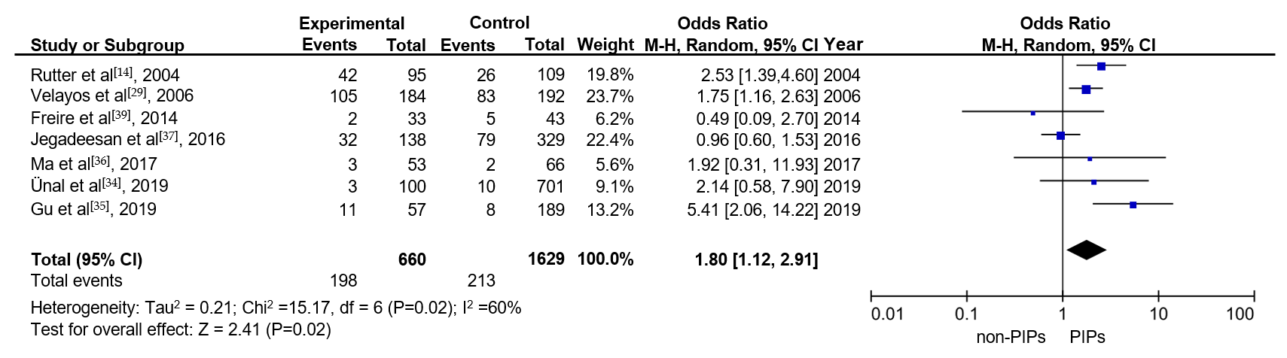
Figure 4 Risk of the development of colorectal neoplasia in ulcerative colitis patients with post-inflammatory polyps. M-H: Mantel-Haenszel; CI: Confidence interval; PIPs: Post-inflammatory polyps.
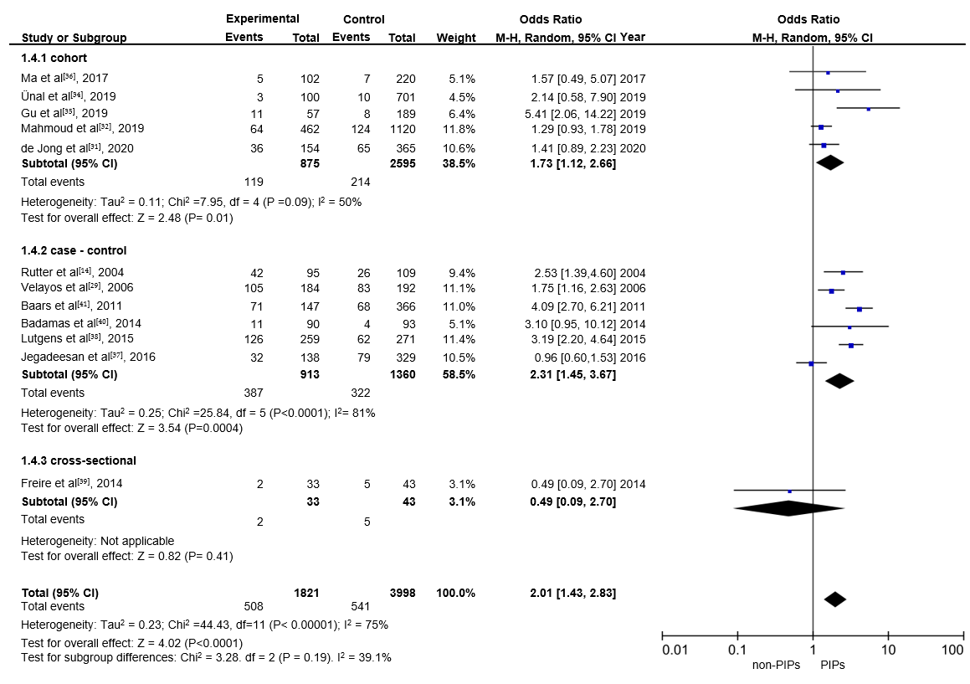
Figure 5 Risk of the development of colorectal neoplasia in inflammatory bowel disease patients with post-inflammatory polyps in cohort, case-control and cross-sectional studies. M-H: Mantel-Haenszel; CI: Confidence interval; PIPs: Post-inflammatory polyps.
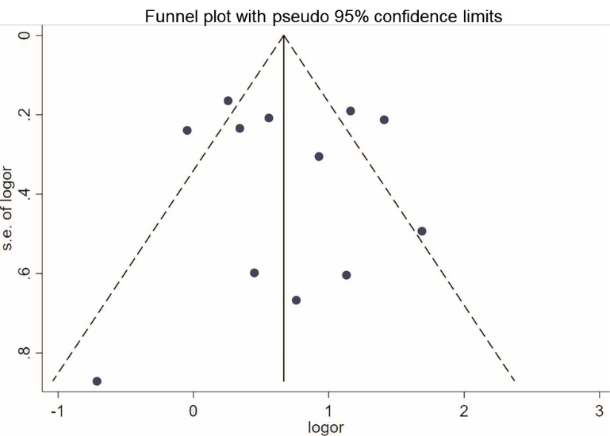
Figure 6 Funnel plots of the included studies.

Table 1 Characteristics of the included studies, n (%)
Ref. | Magazine | Design | Study type | Surveillance period | Sources of patients | Race | Age at IBD diagnosis (years) | IBD type | IBD with/without PIPs | Male gender (%) | Outcome
de Jong et al^{[31]}, 2020 | Inflamm Bowel Dis | Retrospective | Cohort | January 2012 -December 2017 | The Netherlands | Caucasian | 28.5 (± 11.8)/28.9 (± 12.4)¹ | Mixed IBD | 154/365 | 284 (48.2) | Neoplasia
Gu et al^{[35]}, 2019 | Journal of Digestive Diseases | Retrospective | Cohort | June 1986 -July 2018 | China | Asian | 29.5-54.0 | UC | 57/189 | 120 (48.8) | Neoplasia
Mahmoud et al^{[32]}, 2019 | Gastroenterology | Retrospective | Cohort | January 1997 - January 2017 | America, The Netherlands | Caucasian | NA | Mixed IBD | 462/1120 | 835 (52.8) | Neoplasia
Ünal et al^{[34]}, 2019 | Turkish Journal of Gastroenterology | Retrospective | Cohort | 1993-2016 | Turkey | Asian | 40.5 ± 15 | UC | 100/701 | 475 (59.3) | Neoplasia
Ma et al^{[36]}, 2017 | Laboratory Investigation | Retrospective | Cohort | 2006-2016 | NA | NA | NA | Mixed IBD | 102/220 | NA | Neoplasia
Jegadeesan et al^{[37]}, 2016 | Inflamm Bowel Dis | Retrospective | Case–control | 1998-2011 | America | Caucasian | 37 (30.5–50.5)/38 (28.2–23.4)² | UC | 138/329 | 251 (53.7) | Neoplasia
Lutgens et al^{[38]}, 2015 | Clinical Gastroenterology and Hepatology | Retrospective | Case–control | 1990-2011 | Belgium, The Netherlands | Caucasian | NA | Mixed IBD | 259/271 | 276 (52.1) | Cancer
Badamas et al^{[40]}, 2014 | Gastroenterology | Retrospective | Case–control | 2007-2013 | NA | NA | 30.3 (± 15.6)/29.3 (± 13.2) | Mixed IBD | 90/93 | 93 (50.8) | Neoplasia
Freire et al^{[39]}, 2014 | Scand J Gastroenterol | Prospective | Cross-sectional | April 2011 -December 2013 | Portugal | Caucasian | 33.3 ± 11.6 | UC | 33/43 | 30 (39.5) | Neoplasia
Baars et al^{[41]}, 2011 | Am J Gastroenterol | Retrospective | Case – control | January 1990 – July 2006 | The Netherlands | Caucasian | NA | Mixed IBD | 147/366 | 266 (47.1) | Cancer
Velayos et al^{[29]}, 2006 | Gastroenterology | Retrospective | Case – control | January 1976 -December 2002 | America | Caucasian | 25 (6–76)/27 (8–66) | UC | 184/192 | 266 (70.7) | Cancer
Rutter et al^{[14]}, 2004 | Gut | Retrospective | Case – control | January 1988 - January 2002 | Britain | Caucasian | 33 (6–65) | UC | 95/109 | 117 (57) | Neoplasia
¹Data expressed as mean ± SD.
²Data expressed as median (range).
IBD: Inflammatory bowel disease; PIPs: Post-inflammatory polyps; UC: Ulcerative colitis; NA: Not available.

Table 2 Assessment of the quality of studies
Ref. | Selection |  |  |  | Comparability | Outcome
 | 1 | 2 | 3 | 4 | 5 | 6 | 7 | 8 | Score
de Jong et al^{[31]}, 2020 | b¹ | a¹ | a¹ | a¹ | a b² | a¹ | a¹ | a¹ | 9
Gu et al^{[35]}, 2019 | b¹ | a¹ | d | a¹ | a b² | a¹ | a¹ | a¹ | 8
Mahmoud et al^{[32]}, 2019 | b¹ | a¹ | a¹ | a¹ | a b² | a¹ | a¹ | a¹ | 9
Ünal et al^{[34]}, 2019 | b¹ | a¹ | d | a¹ | a b² | a¹ | a¹ | a¹ | 8
Ma et al^{[36]}, 2017 | d | a¹ | a¹ | a¹ | a b² | d | c | d | 5
Jegadeesan et al^{[37]}, 2016 | a¹ | a¹ | b | a¹ | a b² | a¹ | a¹ | a¹ | 8
Lutgens et al^{[38]}, 2015 | a¹ | b | b | a¹ | a b² | a¹ | a¹ | a¹ | 7
Badamas et al^{[40]}, 2014 | a¹ | a¹ | b | a¹ | a b² | a¹ | a¹ | b | 7
Freire et al^{[39]}, 2014 | a¹ | b | b | a¹ | a b² | e | a¹ | a¹ | 6
Baars et al^{[41]}, 2011 | a¹ | a¹ | b | a¹ | a b² | e | a¹ | a¹ | 7
Velayos et al^{[29]}, 2006 | a¹ | a¹ | b | a¹ | a b² | a¹ | a¹ | a¹ | 8
Rutter et al^{[14]}, 2004 | a¹ | a¹ | b | a¹ | a b² | a¹ | a¹ | a¹ | 8
¹Data expressed as mean ± SD.
²Data expressed as median (range). The quality of studies was assessed using the Newcastle-Ottawa Scale (Supplementary Table 1). A high-quality study required a score of 7 or above.
Table 3 Results of the sensitivity analysis in the impact of each study on the overall risk estimate
Ref. | Odds Ratio | 95% Confidence Interval | Heterogeneity (I²)
de Jong et al^{[31]}, 2020 | 2.0980003 | [1.443344, 3.0495887] | 76%
Gu et al^{[35]}, 2019 | 1.8818157 | [1.3357893, 2.6510394] | 75%
Mahmoud et al^{[32]}, 2019 | 2.1335025 | [1.4797615, 3.0760586] | 73%
Ünal et al^{[34]}, 2019 | 2.0057204 | [1.406724, 2.8597751] | 77%
Ma et al^{[36]}, 2017 | 2.0393412 | [1.4283487, 2.9116926] | 77%
Jegadeesan et al^{[37]}, 2016 | 2.1974959 | [1.5660043, 3.0836365] | 71%
Lutgens et al^{[38]}, 2015 | 1.8946518 | [1.3246907, 2.7098444] | 73%
Badamas et al^{[40]}, 2014 | 1.9649121 | [1.3789148, 2.7999403] | 77%
Freire et al^{[39]}, 2014 | 2.1011214 | [1.4932369, 2.9564707] | 76%
Baars et al^{[41]}, 2011 | 1.8324436 | [1.326488, 2.5313833] | 67%
Velayos et al^{[29]}, 2006 | 2.0466876 | [1.3896827, 3.014307] | 77%
Rutter et al^{[14]}, 2004 | 1.9644971 | [1.35726, 2.8434114] | 77%
Combined | 2.011362 | [1.4304829, 2.82812] | 75%

Published by Baishideng Publishing Group Inc
7041 Koll Center Parkway, Suite 160, Pleasanton, CA 94566, USA
Telephone: +1-925-3991568
E-mail: bpgoffice@wjgnet.com
Help Desk: https://www.f6publishing.com/helpdesk
https://www.wjgnet.com

© 2022 Baishideng Publishing Group Inc. All rights reserved.

