Name of Journal: World Journal of Clinical Cases
Manuscript NO: 61089
Manuscript Type: CASE REPORT

Solitary seminal vesicle metastasis from ileal adenocarcinoma presenting with hematospermia: a case report

Cheng XB et al. Seminal vesicle metastasis from ileal adenocarcinoma

Xiao-Bao Cheng, Zhen-Quan Lu, Wayne Lam, MK Yiu, Ji-Shi Li

Xiao-Bao Cheng, Zhen-Quan Lu, Wayne Lam, MK Yiu, Department of Surgery, The university of Hong Kong-Shenzhen Hospital, Shenzhen 518053, Guangdong Province, China

Wayne Lam, MK Yiu, Division of Urology, Department of Surgery, Queen Mary Hospital, The University of Hong Kong, Hong Kong, China

Ji-Shi Li, Department of Oncology, The university of Hong Kong-Shenzhen Hospital, Shenzhen 518053, Guangdong Province, China

Author contributions: Cheng XB, Lu ZQ and Li JS collected the clinical data; Cheng XB searched the literature and wrote the manuscript; Wayne Lam and Yiu MK reviewed and edited the manuscript; all authors have read and approved the final manuscript.

Corresponding author: Xiao-Bao Cheng, MD, Chief Doctor, Surgeon, Surgical Oncologist, Department of Surgery, The University of Hong Kong-Shenzhen Hospital, No. 1 Haiyuan 1st Road, Futian District, Shenzhen 518053, Guangdong Province, China. chengxb@hku-szh.org

Received: March 5, 2021
Revised: May 9, 2021
Accepted: May 19, 2021
Published online:

Abstract
BACKGROUND
Although metastatic adenocarcinoma of the ileum is not uncommon, solitary metastasis to the seminal vesicle has not been reported. We report a patient with recurrent hematospermia diagnosed with metastasis to the seminal vesicle following ileal adenocarcinoma resection, his subsequent management and outcome.

CASE SUMMARY
A 46-year-old man presented with recurrent episodes of painless hematospermia. This was not associated with any lower urinary tract symptoms. He had a past medical history of ileal tumor at the terminal ileum with solitary mesenteric lymph node metastasis on presentation, and underwent partial ileectomy and lymphadenectomy 4 years ago. Subsequent investigations included positron-emission tomography and computed tomography imaging confirmed the very unusual diagnosis of a solitary tumor at the left seminal vesicle. Laparoscopic left-sided vesiculectomy was carried out. Histological analysis with immunohistochemistry showed that CDX-2 was positive and CK7 was negative, and the appearance was consistent with the diagnosis of recurrent metastatic adenocarcinoma of his previously treated intestine primary. The patient had an uneventful post-operative recovery. He received adjuvant chemoradiotherapy following surgery. He remained asymptomatic until he developed multiple bone and pulmonary metastases one year after surgery.

CONCLUSION
Clinicians should be aware of hematospermia as the first symptom of metastatic recurrence in patients with a history of ileal adenocarcinoma.

Key Words: seminal vesicle; metastasis; ileal adenocarcinoma; hematospermia; laparoscopic vesiculectomy; case report

Cheng XB, Lu ZQ, Lam W, Yiu Mk, Li JS. Solitary seminal vesicle metastasis from ileal adenocarcinoma presenting with hematospermia: a case report. World J Clin Cases 2021; In press

Core Tip: A 46-year-old man with a history of a partial ileectomy and adjuvant chemotherapy for ileal adenocarcinoma 4 years prior to presentation at our clinic with hematospermia. Subsequent investigations confirmed the very unusual diagnosis of a solitary tumor at the left seminal vesicle. Laparoscopic left-sided vesiculectomy was carried out. Histological analysis with immunohistochemistry showed that CDX-2 was positive and CK7 was negative, and the appearance was consistent with the diagnosis of recurrent metastatic adenocarcinoma of his previously treated intestine primary. He received adjuvant chemoradiotherapy following surgery. He remained asymptomatic until he developed multiple bone and pulmonary metastasis one year after surgery.

INTRODUCTION
Small bowel adenocarcinoma (SBA) is rare, with an incidence of malignant SBA less than 1 per 100000^{[1]}. Owing to its nonspecific clinical presentation and the lack of effective investigative tools for exploring the small bowel, SBA is usually diagnosed at an advanced stage. At diagnosis, 35% to 40% of patients have distant metastases^{[2,3]}. The most common sites of metastases are liver, lung, and bone^{[4]}. To our knowledge, solitary seminal vesicle (SV) metastasis from SBA has not been reported in the literature.

CASE PRESENTATION
Chief complaints
A 46-year-old man presented to our urology outpatient clinic with recurrent episodes of painless hematospermia.

History of present illness
Hematospermia was not associated with any lower urinary tract symptoms. He had initially been treated with several courses of oral antibiotics for almost three months but did not improve. the patient denied prior trauma or genitourinary tract infection.

History of past illness
He had a past medical history of ileal tumor at the terminal ileum with solitary mesenteric lymph node metastasis on presentation, and underwent partial ileectomy and lymphadenectomy 4 years ago. This was followed by adjuvant capecitabine chemotherapy and intraperitoneal infusion chemotherapy with 5-fluorouracil. The patient had an uneventful recovery and had been in remission since. His tumor markers including carcinoembryonic antigen (CEA), alpha-fetoprotein, human chorionic gonadotropin, and lactate dehydrogenase nadir were within the normal range following treatment.

Personal and family history
This patient had no special personal and family history.

Physical examination
Physical examination of his external genitalia was unremarkable. Testicular and epididymal examinations were normal and his vasa deferens was smooth and not thickened. Digital rectal examination revealed a smooth, small, benign feeling prostate.

Laboratory examinations
Urinalysis and urine culture did not identify evidence of urinary tract infection or hematuria. Semen culture, urethral swabs, mycobacterial cultures and viral serology were all negative. His prostate specific antigen level was not elevated, but interestingly his CEA level was found to be newly elevated to 21 ng/ml.

Imaging examinations
The patient subsequently underwent positron-emission tomography (PET)/computed tomography (CT) imaging. This identified a solitary 2.1 cm × 1.6 cm lesion in the left SV with a standard uptake value of 5.8, the appearance of which was consistent with metastatic recurrence (Figure 1). There was no evidence of tumor recurrence at the original surgical site, or other sites of distal metastasis.

FINAL DIAGNOSIS
Considering the patient’s history, laboratory examinations and imaging examinations, the doctors diagnosed the mass in the SV as a metastatic focus.

TREATMENT
After carefully counselling the patient, he underwent a laparoscopic resection of the single left SV recurrence. Under general anesthesia, a prophylactic left-sided ureteral stent was inserted due to the tumor’s anticipated proximity to the ureter. This was followed by an uneventful laparoscopic transperitoneal complete excision of the left SV. Intraoperative frozen sections showed negative tumor margins.
The patient had an uneventful post-operative recovery, and was discharged home on day 2 post-surgery. Pathology of the excised tumor showed solid nests and tubular patterns (Figure 2). Immunohistochemical examination demonstrated that the tumor cells were positive for CDX-2 and CK20 (Figure 3), but negative for CK7. These findings confirmed the pathological diagnosis of metastatic adenocarcinoma recurrence originating from his SBA. The patient subsequently received adjuvant radiochemotherapy (intensity-modulated radiotherapy combined with capecitabine).

OUTCOME AND FOLLOW-UP
The patient’s hematospermia resolved and he remained asymptomatic following completion of his treatment. Unfortunately, his CEA level, having initially dropped to 6.5 ng/ml following surgery, was found to be elevated at 43.5 ng/ml one year after treatment. A repeat PET/CT scan showed multiple lung and bone metastases. He later also developed visible hematuria and was confirmed to have metastatic recurrence of the disease in the trigone area of his bladder following a cystoscopy and bladder biopsy. The patient is alive with multiple metastases and is now receiving palliative chemotherapy with cetuximab.

DISCUSSION
Primary adenocarcinoma of the SVs is rare and approximately only 60 cases have been reported in the literature^{[5]}. Seminal vesicle metastasis from other organs is even rarer. It has been reported only in renal cell carcinoma, hepatocellular carcinoma, and colon adenocarcinoma^{[6-8]}, and were all case reports.
Hematospermia is generally regarded as a benign condition, with inflammatory causes and infection being the commonest underlying etiology. However, hematospermia has previously been reported as a rare first sign of underlying systemic or urological malignancy^{[9]}. Our case highlights the importance of thorough history taking in patients presenting with hematospermia, and personalized investigations should be arranged accordingly. The determination of CEA level should be considered part of the investigation of hematospermia in patients with a history of colorectal or SBA malignancy. To our knowledge, this is the first case of solitary SV metastasis from a SBA primary presenting as hematospermia.
In this case, elevated CEA prompted subsequent PET/CT imaging, which identified a solitary mass in the left SV. The role of percutaneous or transrectal biopsy of the SV mass can be considered to confirm the diagnosis. However, following careful counselling of the patient, a ‘laparoscopic resection’ approach was agreed for both diagnostic and curative purposes, due to the highly suspicious clinical, biochemical and radiological findings.
Surgical access to the SV tumor can be potentially challenging. Kavoussi et al^{[10]} previously described the principles of the laparoscopic transperitoneal approach to the SV, with the benefits of providing a clear vision when operating deep in the pelvic region, minimal blood loss, reduced post-operative pain and shortened length of stay post-surgery when compared with the open approach. Our case confirmed the safety and feasibility of laparoscopic surgery in treating the SV tumor. Technically, it is also crucial to be aware that the ipsilateral ureter is often in close proximity to the SV tumor. The prophylactic insertion of an ipsilateral ureteric JJ stent, such as in our case, could potentially help in identifying the ureter intra-operatively and avoid ureteric injury.
A previous retrospective study reported that distant recurrence of SBA following treatment of the primary tumor was common, and accounted for 86% of patients with disease recurrence on follow-up^{[11]}. The optimal treatment strategy for patients with SBA has yet to been determined, including the role of adjuvant chemotherapy, radiotherapy and targeted therapy. Radical surgical resection remains the mainstay of treatment in patients with SBA, which has been reported to potentially improve prognosis in patients including in those with distant metastasis or recurrence^{[11]}. As such, our patient underwent a laparoscopic seminal vesiculectomy. However, the reported prognosis of metastatic SBA is poor, with a median overall survival of 19 mo, and the five-year survival rate in patients with metastatic disease is reported to be as low as 3%-4%^{[12]}.

CONCLUSION
In conclusion, we report a rare case of SV metastasis from a SBA primary presenting with hematospermia. Although most patients with hematospermia have a benign underlying etiology, it is essential to undertake a thorough history assessment and physical examination, and arrange for personalized investigations accordingly, especially in patients with a history of malignancy. Laparoscopic seminal vesiculectomy is safe and technically feasible in patients with solitary SV recurrence. However, their prognosis remains poor.

REFERENCES
1 Reynolds I, Healy P, Mcnamara DA. Malignant tumours of the small intestine. Surgeon 2014; 12: 263-270 [PMID: 24637026 DOI: 10.1016/j.surge.2014.02.003]
2 Dabaja BS, Suki D, Pro B, Bonnen M, Ajani J. Adenocarcinoma of the small bowel: presentation, prognostic factors, and outcome of 217 patients. Cancer 2004; 101: 518-526 [PMID: 15274064 DOI: 10.1002/cncr.20404]
3 Talamonti MS, Goetz LH, Rao S, Joehl RJ. Primary cancers of the small bowel: analysis of prognostic factors and results of surgical management. Arch Surg 2002; 137: 564-70; discussion 570-1 [PMID: 11982470 DOI: 10.1001/archsurg.137.5.564]
4 Rompteaux P, Gagnière J, Gornet JM, Coriat R, Baumgaertner I, Lecomte T, Afchain P, Zaanan A, Pocard M, Bachet JB, Bonichon-Lamichhane N, Bouché O, Faucheron JL, Forestier J, Lecaille C, Manfredi S, Tougeron D, Terrebonne E, Chehimi M, Villing AL, Sarda C, Legoux JL, Benamouzig R, Aparicio T. Resection of small bowel adenocarcinoma metastases: Results of the ARCAD-NADEGE cohort study. Eur J Surg Oncol 2019; 45: 331-335 [PMID: 30501999 DOI: 10.1016/j.ejso.2018.11.012]
5 Sollini M, Silvotti M, Casali M, Giovanardi F, Zadro A, Froio A, Erba PA, Versari A. The role of imaging in the diagnosis of recurrence of primary seminal vesicle adenocarcinoma. World J Mens Health 2014; 32: 61-65 [PMID: 24872954 DOI: 10.5534/wjmh.2014.32.1.61]
6 Matsuzaki K, Yasunaga Y, Fukuda S, Oka T. Seminal vesicle metastasis of renal cell carcinoma. Urology 2009; 74: 1017-1018 [PMID: 19589576 DOI: 10.1016/j.urology.2009.04.058]
7 Gong L, Zheng M, Li Y, Zhang W, Bu W, Shi L, Zhang W, Yan H. Seminal vesicle metastasis after partial hepatectomy for hepatocellular carcinoma. BMC Cancer 2011; 11: 111 [PMID: 21443783 DOI: 10.1186/1471-2407-11-111]
8 Hsu YL, Lin IC, Tung CL. 18F-FDG PET/CT of Seminal Vesicle Metastasis From Ascending Colon Adenocarcinoma. Clin Nucl Med 2017; 42: 138-139 [PMID: 28005644 DOI: 10.1097/RLU.0000000000001519]
9 Meng MV, Werboff LH. Hematospermia as the presenting symptom of metastatic malignant melanoma of unknown primary origin. Urology 2000; 56: 330 [PMID: 10925109 DOI: 10.1016/s0090-4295(00)00634-8]
10 Kavoussi LR, Schuessler WW, Vancaillie TG, Clayman RV. Laparoscopic approach to the seminal vesicles. J Urol 1993; 150: 417-419 [PMID: 8326567 DOI: 10.1016/s0022-5347(17)35498-8]
11 Nakanoko T, Koga T, Taketani K, Hirayama Y, Yoshiya S, Minagawa R, Kai M, Kajiyama K, Maehara Y. Characteristics and Treatment Strategies for Small Bowel Adenocarcinoma in Advanced-stage Cases. Anticancer Res 2015; 35: 4135-4138 [PMID: 26124367]
12 Howe JR, Karnell LH, Menck HR, Scott-Conner C. The American College of Surgeons Commission on Cancer and the American Cancer Society. Adenocarcinoma of the small bowel: review of the National Cancer Data Base, 1985-1995. Cancer 1999; 86: 2693-2706 [PMID: 10594865 DOI: 10.1002/(sici)1097-0142(19991215)86:12<2693::aid-cncr14>3.0.co;2-u]

Footnotes
Informed consent statement: Written informed consent for the publication of this case and any accompanying images were obtained from the patient.

Conflict-of-interest statement: The authors declare that there is no conflict of interest.

CARE Checklist (2016) statement: The authors have read the CARE Checklist (2016) statement, and the manuscript was prepared and revised according to the CARE Checklist (2016) statement.

Open-Access: This article is an open-access article that was selected by an in-house editor and fully peer-reviewed by external reviewers. It is distributed in accordance with the Creative Commons Attribution NonCommercial (CC BY-NC 4.0) license, which permits others to distribute, remix, adapt, build upon this work non-commercially, and license their derivative works on different terms, provided the original work is properly cited and the use is non-commercial. See: http://creativecommons.org/Licenses/by-nc/4.0/

Manuscript source: Unsolicited manuscript

Peer-review started: March 5, 2021
First decision: April 29, 2021
Article in press:

Specialty type: Oncology
Country/Territory of origin: China
Peer-review report’s scientific quality classification
Grade A (Excellent): 0
Grade B (Very good): 0
Grade C (Good): C, C
Grade D (Fair): 0
Grade E (Poor): 0

P-Reviewer: Bains L, Mehdipour P S-Editor: Gong ZM L-Editor: Webster JR P-Editor:
Figure Legends
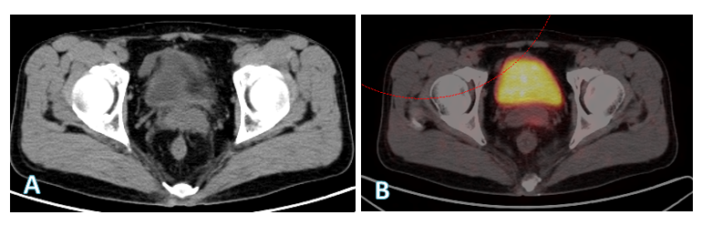
Figure 1 positron-emission tomography/computed tomography image revealed a left seminal mass on baseline examination (A) and on contrast (B).
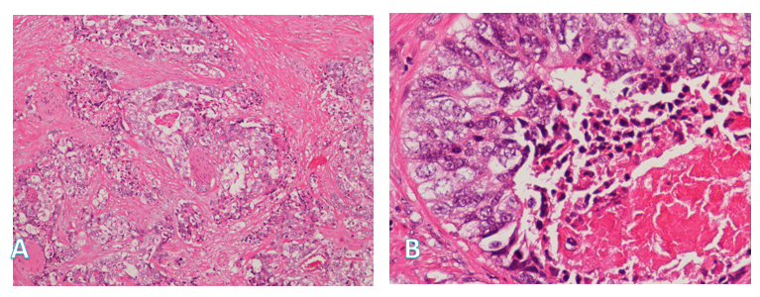
Figure 2 Microscopic view of the tumor in the seminal vesicle: the tumor cells were arranged in trabecular and solid nests, which was compatible with the original small bowel adenocarcinoma. A: HE staining, 100 × magnification; B: HE staining, 400 × magnification.
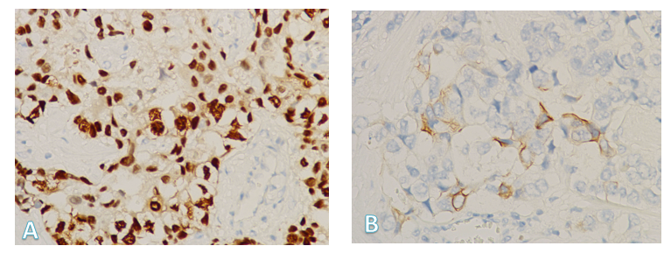
Figure 3 The tumor cells from the seminal vesicle were positive for CDX-2(++++) (A) and CK20(+) (B). A: CDX2 staining, 400 × magnification; B: CK20 staining, 400 × magnification.

