Name of Journal: World Journal of Clinical Cases
Manuscript NO: 90143
Manuscript Type: CASE REPORT

Novel approach of ultrasound-guided lateral recess block for a patient with lateral recess stenosis: A case report

Yang J et al. Ultrasound-guided lateral recess block

Jiao Yang, Xin-Ling Li, Qing-Bing Li

Jiao Yang, Xin-Ling Li, Qing-Bing Li, Department of Rehabilitation Medicine Center, West China Hospital, Chengdu 610041, Sichuan Province, China

Jiao Yang, Xin-Ling Li, Qing-Bing Li, Key Laboratory of Rehabilitation Medicine in Sichuan Province, West China Hospital, Chengdu 610041, Sichuan Province, China

Author contributions: Li XL made substantial contributions to the study conception and design; Yang J was responsible for writing the original draft, reviewing, and editing; Li BQ contributed to the investigation and data curation; All authors approved the final version to be submitted.

Supported by the National Natural Science Foundation of China, No. 82305380; and The Postdoctoral Research Program, West China Hospital, Sichuan University, No. 2020HXBH018.

Corresponding author: Xin Ling Li, PhD, Assistant Professor, Department of Rehabilitation Medicine Center, West China Hospital, No. 37 Guoxue Alley, Wuhou District, Chengdu 610041, Sichuan Province, China. lilingxinlsh@163.com

Received: November 24, 2023
Revised: January 2, 2024
Accepted: January 15, 2024
Published online:

Abstract
BACKGROUND
Ultrasound guide technology, which can provide real-time visualization of the needle tip and tissues and avoid many adverse events, is widely used in minimally invasive therapy. However, the studies on ultrasound-guided Lateral recess block (LRB) are limited, this is probably because there is no recognized standard method for ultrasound scanning. This study aimed to evaluate the effect of ultrasound-guided LRB in patients with lateral recess stenosis (LRS).

CASE SUMMARY
A 65-year-old patient complained of low back pain accompanied occasionally by pain and numbness in the left lower limb. Physical examination showed tenderness on the spinous process and paraspinal muscles from L1 to S1, extensor hallucis longus and tibialis anterior weakness (muscle strength: 4−), and a positive straight leg raising test in the left lower limb (60°). Magnetic resonance imaging showed L4–L5 disc degeneration with left LRS and nerve root entrapment. Subsequently, the patient was diagnosed with LRS. This patient was treated with a novel ultrasound-guided LRB approach. The patient’s symptoms significantly improved without any complications at 1 wk postoperatively and at the 3-month follow-up.

CONCLUSION
This is the first report on the LRS treatment with ultrasound-guided LRB from the contralateral spinous process along the inner side of the articular process by out-plane technique. Further studies are expected to investigate the efficacy and safety of ultrasound-guided LRB for patients with LRS.

Key Words: Lateral recess stenosis; Ultrasound; Lateral recess block; Real-time visualization; Low back pain; Case report

Yang J, Li XL, Li QB. Novel approach of ultrasound-guided lateral recess block for a patient with lateral recess stenosis: A case report. World J Clin Cases 2024; In press

Core Tip: Lateral recess block (LRB) is a common treatment method for lateral recess stenosis (LRS). However, it is an unsatisfactory method because of its high risk of side effects. Ultrasound-guided technology is widely used in minimally invasive therapy, but only a few studies have reported its use in LRB, this is probably because there is no recognized standard method for ultrasound scanning. In order to explore the standard method for ultrasound-guided LRB, we reported a novel ultrasound-guided LRB approach in treating a patient with LRS whose symptoms significantly improved without any complications.

INTRODUCTION
Lateral recess stenosis (LRS) is a common type of lumbar spinal stenosis in elderly individuals^{[1,2]}. In spinal anatomy, the lateral recess is the outermost region of the spinal canal bordered laterally by the pedicle, posteriorly by the superior articular facet and ligamentum flavum, and anteriorly by the vertebral body, endplate, and disc margin^{[3]}, which is considered stenotic when the anteroposterior measurement is < 4 mm^{[4]}. Due to the close proximity within the spinal canal, stenosis in this region always leads to low back pain, numbness, neurogenic claudication and even urination–defecation impairment^{[2]}, which often affect mobility and walking ability, leading to a reduction in patients’ quality of life^{[3,5]}. Lateral recess block (LRB) is commonly used for this condition due to its immediate analgesic effect in approximately 50%–87% of patients^{[6,7]}. To improve efficacy and accuracy, computed tomography (CT), X-ray, and ultrasound guidance are widely used in minimally invasive therapy^{[8]}. However, the studies on ultrasound-guided LRB are limited, this is probably because there is no recognized standard method for ultrasound scanning.
We reported a successful case of a patient with LRS who underwent ultrasound-guided LRB. This case report may provide a new exploration of the standard method of ultrasound-guided LRB. This study followed the CARE Guidelines for consensus-based clinical case reporting guideline development^{[9]}.

CASE PRESENTATION
Chief complaints
A 65-year-old man complained of low back pain accompanied occasionally by pain and numbness in the left lower limb for at least 10 years.

History of present illness
In the past 10 years, his symptoms did not significantly affect his life and work and were relieved after rest or massage therapy. However, his low back pain gradually worsened, and he developed persistent soreness, numbness, and intermittent claudication on the left lower limb, mainly at the lateral thigh, posterolateral, instep, and foot top. Consequently, his life and work were severely affected because his symptoms were unrelieved even after rest or massage.

History of past illness
His medical history was unremarkable.

Personal and family history
His family history was also unremarkable.

Physical examination
Physical examination showed tenderness on the spinous process and paraspinal muscles from L1 to S1, extensor hallucis longus and tibialis anterior weakness (muscle strength: 4⁻), and a positive straight leg raising test in the left lower limb (60°). The visual analog scale (VAS) and Oswestry disability index (ODI) were 8 mm and 51%, respectively.

Laboratory examinations
No laboratory tests.

Imaging examinations
Magnetic resonance imaging (MRI) indicated L4–L5 disc degeneration with left LRS and nerve root entrapment (Figure 1).

FINAL DIAGNOSIS
Based on the clinical and imaging examination, the patient was diagnosed with LRS.

TREATMENT
Oral analgesics and physiotherapy did not benefit the patient. Therefore, we planned to perform left L4–L5 LRB under ultrasound guidance. We used a portable ultrasound imaging device (Lumify, Philips, Shanghai, China) with a 5-2 MHz frequency round probe. Before the procedure, the patient was placed in a prone position with a pillow under the lower abdomen to reduce lumbar lordosis in the operating room and supervised via a continuous electrocardiogram, and his blood pressure and pulse oximetry were supervised using a noninvasive monitor. After the involved lumbar intervertebral space between L4 and L5 was confirmed, the physician’s hands, puncture sites, and ultrasound probe were sterilized. The physician stood on the left side of the patient. Subsequently, ultrasound-guided LRB was divided into four steps. First, the target L4 articular process was identified by locating the lumbosacral junction (L5-S1 gap; Figure 2) on paramedian sagittal scanning, and counting was performed cranially by numbering the lamina and transverse processes of the L5 and L4 vertebrae. Second, after marking the L4 vertebral level, the probe was rotated transversely to obtain the view of the L4 spinous process and interspinous process space between L4 and L5. Third, the probe was slightly moved toward the median line to obtain the view of the articular process, ligamentum flavum, and intraspinal anterior complex (posterior longitudinal ligament, dura mater and lumbar posterior margin) on median axis scanning. The puncture site was 0.8-1.0 cm away from the contralateral spinous process of L4 and L5 (Figure 3). Fourth, the puncture site was infiltrated using 1% lidocaine before insertion. Afterward, a needle was advanced along with the inner side of the articular process at 70°–80° guided by ultrasound in the out-plane technique. The lateral recess of L4 was the target of the needle tip. The needle was withdrawn to exclude vascular injection after the needle tip site was verified under ultrasound, and no blood or cerebrospinal fluid was aspirated. Hypoesthesia of the left medial malleolus was observed 5 min after injection of 2 mL of 0.25% lidocaine. Subsequently, 5 mL mixed injectate consisting of 1 mL triamcinolone, 4 mL 2% lidocaine, 1 mL mecobalamin and 14 mL 0.9% sodium chloride was injected into the lateral recess of L4. To display the needle trajectory more clearly, we used a diagram to illustrate the needle trajectory (Figure 4), but it was difficult to capture the ultrasonic image of the needle during the operation.

OUTCOME AND FOLLOW-UP
We carefully recorded the change in the patient’s symptoms with VAS and ODI before and 30 min, 1 wk, 1 month, and 3 months postoperatively. The patient’s symptoms greatly improved 1 wk postoperatively and at the 3-month follow-up (Table 1). The patient was satisfied with this treatment.

DISCUSSION
We reported a novel approach of ultrasound-guided LRB for LRS treatment. We preliminarily established that ultrasound-guided LRB from the contralateral spinous process along with the inner side of the articular process with the out-plane technique is an effective, accurate, and safe method in LRS treatment.
Surgery, a commonly used treatment method, showed superior outcomes^{[10]}. However, its complications and less satisfaction with the results of surgery in the elderly population make it a difficult choice for clinicians^{[11]}. Thus, nonsurgical treatment is appropriate for patients with mild to moderate symptoms. Some of the commonly used treatment strategies include medication, physical therapy, massage, conventional transforaminal epidural steroid injection (CTFESI), selected nerve root block (SNRB), and LRB^{[12-17]}. Medication, physical therapy, and massage are unsatisfactory choices because of their short-term effect and high recurrence rate^{[15]}. CTFESI and SNRB are widely used in LRS treatment^{[16]}; However, the effective rate of SNRB for patients with LRS has not been satisfactory due to the stenosis pathology occurring in the intraspinal lateral recess but not in the intervertebral foramen outside the spinal canal^{[8]}. Generally, the injectate includes local anesthetics and glucocorticoids. Local anesthetics can achieve analgesic effects by blocking neurological activity. Meanwhile, glucocorticoids reduce inflammation and the immune response by inhibiting prostaglandin synthesis, reducing nociceptor stimulation and sensitization, and decreasing inflammatory mediator release. In addition, it plays an indirect role in decompressing and increasing the blood supply to the nerve, which alleviates the patient’s symptoms^{[18]}. Therefore, accurate injection of the lateral recess is key to successful LRS treatment. The most common technique of SNRB is targeting the spinal nerve root^{[16]}, which is physically distant from the spinal nerve root to the lateral recess^{[2]}. The injectate diffuses from the spinal nerve root to the lateral recess, resulting in a slow effect and weak efficacy, which leads to less satisfaction. Moreover, a retrospective study^{[7]} reported that LRB was considerably safer, with a lower chance of nerve pricks^{[19]} and intravascular dye spread than CTFESI. This study also revealed that a single LRB was significantly better than a single CTFESI in decreasing unilateral radiculopathy pain because the site of drug deposition was more proximal to the discovery interface.
LRB is effective in relieving pain and symptoms of nerve root entrapment^{[11,13]}. However, the potential risk of subdural block, failure block, and intraspinal bleeding still makes it an entangled choice for many physicians^{[8]}. CT, X-ray, and ultrasound guidance are widely used in minimally invasive therapy to improve efficacy, safety, and accuracy^{[8,16]}. Exposure to radiation during the procedure under CT or X-ray guidance may be a problem. Sacaklidir et al^{[20]} reported that radiation exposure for 37.3–46.7s results in a radiation dose between 0.057 and 0.218 mGym². This is equivalent to 15–30 chest radiographs. Because of its real-time visualization of the needle tip and no radiation exposure, ultrasound-guided minimally invasive techniques have been widely adapted in clinical practice. Li et al^{[21]} reported the efficacy of ultrasound-guided nerve blocks of the head and neck for chronic pain management. Takahashi et al^{[22]} validated the efficacy of ultrasound-guided cervical nerve root block for frozen shoulder. However, only a few studies have reported ultrasound-guided LRB due to the lack of precise ultrasound scanning methods. Currently, no standard method of ultrasound-guided LRB exists. In our practice, we selected a new method. A previous study selected an injection point 0.8–1.0 cm away from the ipsilateral spinous process and then along the inner side of the articular pillar under ultrasound guidance^{[8]}. This method increases the risk of total spinal paralysis caused by subdural block, particularly when LRS is associated with nerve root adhesion. In this case, the injection points were 0.8-1.0 cm away from the contralateral spinous process of L4 and L5. Then, the needle was advanced toward the inner side of the articular process at 70°–80° guided by ultrasound with the out-plane technique. This method increases the effectiveness, safety, and accuracy of surgery for patients and provides a new exploration into the standard method of ultrasound-guided LRB.
There are also some limitations in this study. It is difficult for us to capture the ultrasonic image of the needle during the operation. The lack of the ultrasonic image would decrease the illustration of this technology. Hence, we used a diagram to illustrate the needle trajectory in Figure 4. We expect that this image will help understand our needle trajectory more clearly. Moreover, we only reported one successful case, which may restrict the wide use of ultrasound-guided LRB. Further high-quality studies are expected to confirm the efficacy and safety of the use of ultrasound-guided LRB with this novel approach.
In conclusion, this study is the first report of the use of ultrasound-guided LRB from the contralateral spinous process along with the inner side of the articular process with the out-plane technique for LRS treatment, which was preliminarily proven to be effective, accurate, and safe. Further studies are needed to investigate the efficacy and safety of ultrasound-guided LRB for patients with LRS.

CONCLUSION
We reported a case of a patient with LRS who underwent ultrasound-guided LRB. This study is the first report of ultrasound-guided LRB from the contralateral spinous process along with the inner side of the articular process with the out-plane technique for LRS treatment. Further studies are expected to investigate the efficacy and safety of ultrasound-guided LRB for patients with LRS.

ACKNOWLEDGEMENTS
We would like to thank the patient for agreeing to participate in this study.

REFERENCES
1 Wang X, Wu L, Zhao K, Chen D, Su B, Kong Y, Li J, Kang K, Si D. Trephine-based foraminoplasty in PTED treatment of lumbar lateral recess stenosis. Adv Clin Exp Med 2022; 31: 359-367 [PMID: 35068091 DOI: 10.17219/acem/144638]
2 Deer TR, Grider JS, Pope JE, Lamer TJ, Wahezi SE, Hagedorn JM, Falowski S, Tolba R, Shah JM, Strand N, Escobar A, Malinowski M, Bux A, Jassal N, Hah J, Weisbein J, Tomycz ND, Jameson J, Petersen EA, Sayed D. Best Practices for Minimally Invasive Lumbar Spinal Stenosis Treatment 2.0 (MIST): Consensus Guidance from the American Society of Pain and Neuroscience (ASPN). J Pain Res 2022; 15: 1325-1354 [PMID: 35546905 DOI: 10.2147/JPR.S355285]
3 Lee BH, Moon SH, Suk KS, Kim HS, Yang JH, Lee HM. Lumbar Spinal Stenosis: Pathophysiology and Treatment Principle: A Narrative Review. Asian Spine J 2020; 14: 682-693 [PMID: 33108834 DOI: 10.31616/asj.2020.0472]
4 Liu X, Peng Y, Pei L, Zhu Y. Sufficient Lumbar Lateral Recess Decompression Acquired by Undercutting "Superior Articular Process Neck" Plus Intervertebral Disk Annuloplasty in Percutaneous Transforaminal Endoscopic Surgery. Med Sci Monit 2020; 26: e921119 [PMID: 32243427 DOI: 10.12659/MSM.921119]
5 Cheng X, Zhang K, Sun X, Zhao C, Li H, Ni B, Zhao J. Clinical and radiographic outcomes of bilateral decompression via a unilateral approach with transforaminal lumbar interbody fusion for degenerative lumbar spondylolisthesis with stenosis. Spine J 2017; 17: 1127-1133 [PMID: 28416439 DOI: 10.1016/j.spinee.2017.04.011]
6 Thiengwittayaporn S, Koompong P, Khamrailert S, Wetpiriyakul P. Comparison of Clinical Outcomes of Different Rates of Infusion in Caudal Epidural Steroid Injection: A Randomized Controlled Trial. Asian Spine J 2021; 15: 244-251 [PMID: 32703925 DOI: 10.31616/asj.2019.0380]
7 Jain A, Agarwal A, Jain S, Waindeskar V. Comparison Between a Single Subpedicular Transforaminal Epidural Steroid Injection and Lateral Recess Steroid Injection in Reducing Paracentral Disc Herniation-Related Chronic Neuropathic Leg Pain: A Retrospective Study. World Neurosurg 2021; 149: e392-e399 [PMID: 33578022 DOI: 10.1016/j.wneu.2021.02.011]
8 Liang G. Effect of ultrasound-guided lateral recess block in the treatment of patients with lumbar intervertebral disc herniation. Hennan Medical Research 2021; 30: 1638-1640
9 Gagnier JJ, Kienle G, Altman DG, Moher D, Sox H, Riley D; CARE Group. The CARE guidelines: consensus-based clinical case reporting guideline development. Headache 2013; 53: 1541-1547 [PMID: 24266334 DOI: 10.1111/head.12246]
10 Lurie J, Tomkins-Lane C. Management of lumbar spinal stenosis. BMJ 2016; 352: h6234 [PMID: 26727925 DOI: 10.1136/bmj.h6234]
11 Li X, Liu T, Fan J, Zhang H, Yang C, Yin X, Gao H, Qian J, Sun S. Outcome of lumbar lateral recess stenosis with percutaneous endoscopic transforaminal decompression in patients 65 years of age or older and in younger patients. Medicine (Baltimore) 2020; 99: e21049 [PMID: 32702846 DOI: 10.1097/MD.0000000000021049]
12 Chen X, Zheng Z, Lin J. Clinical Effectiveness of Conservative Treatments on Lumbar Spinal Stenosis: A Network Meta-Analysis. Front Pharmacol 2022; 13: 859296 [PMID: 35734403 DOI: 10.3389/fphar.2022.859296]
13 Kim HJ, Kim JH, Park YS, Suk KS, Lee JH, Park MS, Moon SH. Comparative study of the efficacy of limaprost and pregabalin as single agents and in combination for the treatment of lumbar spinal stenosis: a prospective, double-blind, randomized controlled non-inferiority trial. Spine J 2016; 16: 756-763 [PMID: 27045252 DOI: 10.1016/j.spinee.2016.02.049]
14 Jang JH, Lee WY, Kim JW, Cho KR, Nam SH, Park Y. Ultrasound-Guided Selective Nerve Root Block versus Fluoroscopy-Guided Interlaminar Epidural Block versus Fluoroscopy-Guided Transforaminal Epidural Block for the Treatment of Radicular Pain in the Lower Cervical Spine: A Retrospective Comparative Study. Pain Res Manag 2020; 2020: 9103421 [PMID: 32617125 DOI: 10.1155/2020/9103421]
15 Zhang Y. Effects of lateral recess block on pain and functional recovery in patients with lumbar disc herniation. Shiyong Zhongxiyi Jiehe Linchuang 2020; 20: 28-29
16 Yue B, Shen F, Ye ZF, Wang ZH, Yang HL, Jiang GQ. Accurate location and minimally invasive treatment of lumbar lateral recess stenosis with combined SNRB and PTED. J Int Med Res 2020; 48: 300060519884817 [PMID: 31774009 DOI: 10.1177/0300060519884817]
17 Schneider MJ, Ammendolia C, Murphy DR, Glick RM, Hile E, Tudorascu DL, Morton SC, Smith C, Patterson CG, Piva SR. Comparative Clinical Effectiveness of Nonsurgical Treatment Methods in Patients With Lumbar Spinal Stenosis: A Randomized Clinical Trial. JAMA Netw Open 2019; 2: e186828 [PMID: 30646197 DOI: 10.1001/jamanetworkopen.2018.6828]
18 Guyot JP. Lumbar Selective Nerve Root Block: Comparative Study Using Two Pharmacological Formulae. Global Spine J 2018; 8: 374-377 [PMID: 29977722 DOI: 10.1177/2192568217728724]
19 Kim HJ, Park JH, Shin KM, Kang SS, Kim IS, Hong SJ, Song CK, Park JC, Yeom JS. The efficacy of transforaminal epidural steroid injection by the conventional technique in far-lateral herniation of lumbar disc. Pain Physician 2012; 15: 415-420 [PMID: 22996853]
20 Sacaklidir R, Ozturk EC, Sencan S, Gunduz OH. Radiation Doses for Different Approaches of Fluoroscopy-Guided Epidural Injections: An Observational Clinical Study. Pain Physician 2022; 25: E67-E72 [PMID: 35051153]
21 Li J, Szabova A. Ultrasound-Guided Nerve Blocks in the Head and Neck for Chronic Pain Management: The Anatomy, Sonoanatomy, and Procedure. Pain Physician 2021; 24: 533-548 [PMID: 34793642]
22 Takahashi R, Kajita Y, Harada Y, Iwahori Y, Miyashita N, Deie M. Does the timing of shoulder manipulation under ultrasound-guided cervical nerve root block for frozen shoulder affect the clinical outcome? J Orthop Sci 2022; 27: 122-125 [PMID: 33358448 DOI: 10.1016/j.jos.2020.11.002]

Footnotes
Informed consent statement: Informed written consent was obtained from the patient for publication of this report and any accompanying images.

Conflict-of-interest statement: All the authors declare that they have no conflict of interest to disclose.

CARE Checklist (2016) statement: The authors have read the CARE Checklist (2016), and the manuscript was prepared and revised according to the CARE Checklist (2016).

Open-Access: This article is an open-access article that was selected by an in-house editor and fully peer-reviewed by external reviewers. It is distributed in accordance with the Creative Commons Attribution NonCommercial (CC BY-NC 4.0) license, which permits others to distribute, remix, adapt, build upon this work non-commercially, and license their derivative works on different terms, provided the original work is properly cited and the use is non-commercial. See: https://creativecommons.org/Licenses/by-nc/4.0/

Provenance and peer review: Unsolicited article; Externally peer reviewed.
Peer-review model: Single blind

Corresponding Author's Membership(s) in Professional Societies: British Medical Acupuncture Society, 38259.

Peer-review started: November 24, 2023
First decision: December 18, 2023
Article in press:

Specialty type: Integrative & complementary medicine
Country/Territory of origin: China
Peer-review report’s scientific quality classification
Grade A (Excellent): 0
Grade B (Very good): 0
Grade C (Good): C
Grade D (Fair): 0
Grade E (Poor): 0

P-Reviewer: Gousheh M, Iran S-Editor: Liu JH L-Editor: A P-Editor:
Figure Legends
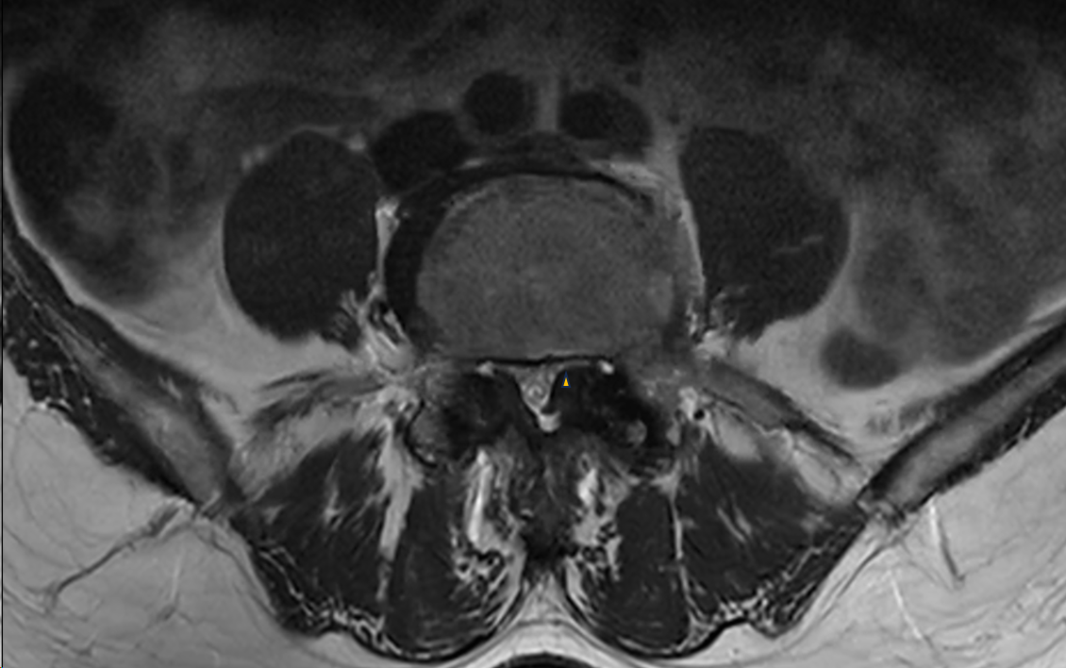
Figure 1 Preoperative magnetic resonance imaging shows lateral recess stenosis at L4–5 (asterisk).
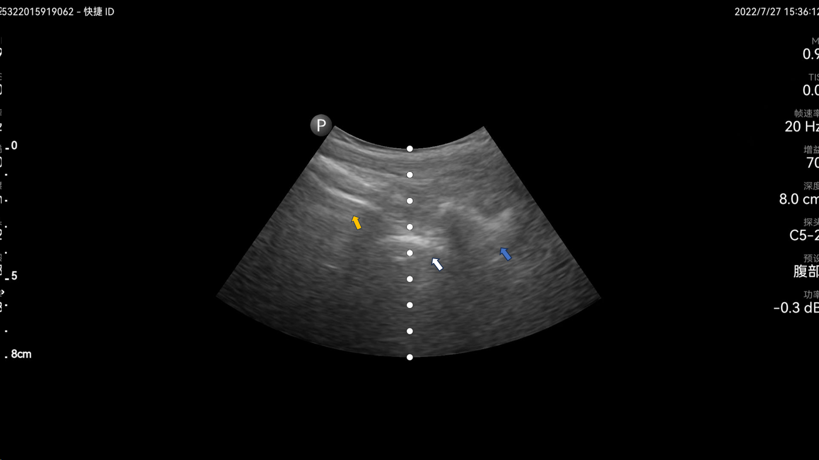
Figure 2 Ultrasound imaging shows the lumbosacral junction at L5–S1 (yellow arrow) and the articular process of L5 (white arrow) and L4 (blue arrow) on paramedian sagittal scanning.
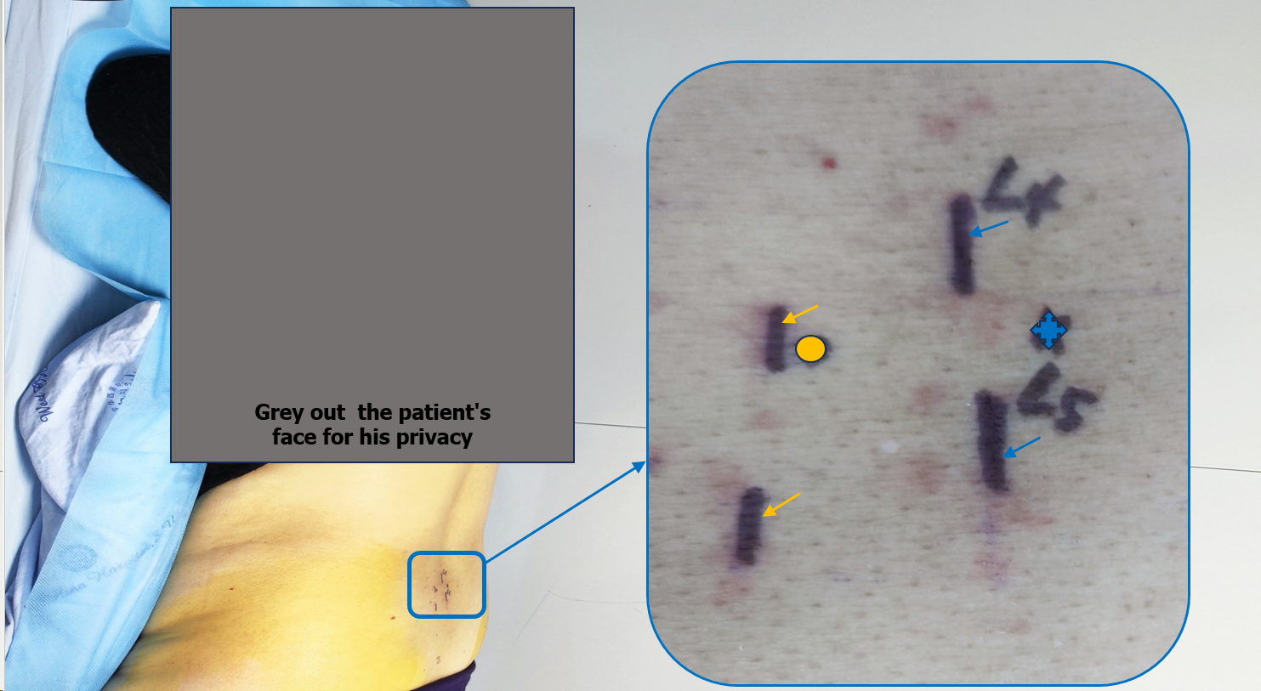
Figure 3 The position of patient on the bed during the procedure and the area of the procedure is marked and zoomed in to show a clearer picture, including spinal process of L4 and L5 (blue arrow), articular process of L4 and L5 (yellow arrow), puncture site (blue asterisk) and body surface projection of target site (yellow circle).
Figure 4 Needle trajectory during lateral recess steroid injection. A: Ultrasound image of needle trajectory, the lateral recess (white triangle), articular process (cyan arrow), ligamentum flavum (white arrow), and intraspinal anterior complex (blue arrow), needle direction (yellow arrow), depth from the target injection point into the skin (yellow line); B: Diagrammatic explanation of the needle trajectory; C: Picture of the right place of probe position and needle insertion.
Table 1 Evaluation of symptoms via visual analog scale and Oswestry Disability Index
Item | Pre-operation | 30 min postoperation | 1 wk postoperation | 1 month postoperation | 3 months postoperation
VAS | 8 | 6 | 4 | 4 | 5
ODI, % | 51 | 51 | 31 | 31 | 33
VAS: Visual analog scale; ODI: Oswestry Disability Index.

