Name of Journal: World Journal of Radiology
Manuscript NO: 61886
Manuscript Type: ORIGINAL ARTICLE

Retrospective Study
“Pulmonary target sign” as a diagnostic feature in chest computed tomography of COVID-19

Jafari R et al. "Pulmonary target sign” appearance in COVID-19

Ramezan Jafari, Nematollah Jonaidi-Jafari, Houshyar Maghsoudi, Fatemeh Dehghanpoor, U Joseph Schoepf, Kyle A Ulversoy, Amin Saburi

Ramezan Jafari, Houshyar Maghsoudi, Fatemeh Dehghanpoor, Department of Radiology, Faculty of Medicine, Baqiyatallah University of Medical Sciences, Tehran 11151877, Iran

Ramezan Jafari, Nematollah Jonaidi-Jafari, Amin Saburi, Health Research Center, Baqiyatallah University of Medical Sciences, Tehran 11151877, Iran

U Joseph Schoepf, Department of Radiology and Radiological Science, Medical University of South Carolina, Charleston, SC 29425, United States

Kyle A Ulversoy, Faculty of Medicine, Augusta University/University of Georgia Medical Partnership, Athens, GA 30606, United States

Amin Saburi, Chemical Injuries Research Center, Systems Biology and Poisonings Institute, Baqiyatallah University of Medical Sciences, Tehran 11151877, Iran

Author contributions: Jafari R, Jonaidi-Jafari N and Saburi A deigned the study; Jafari R, Jonaidi-Jafari N, Maghsoudi H, Dehghanpoor F collected the data; Jafari R, Jonaidi-Jafari N, Schoepf UJ, Ulversoy KA, Saburi A interpreted the data; Schoepf UJ, Ulversoy KA and Saburi A prepared the initial draft; Saburi A, Ulversoy KA and Schoepf UJ edited the final draft; all authors proved the final manuscript.

Correspondence to: Amin Saburi, MD, Doctor, Senior Researcher, Health Research Center, Baqiyatallah University of Medical Sciences, Mollasadra St, Vanak Sq, Tehran 11151877, Iran. aminsaburi@yahoo.com

Received: January 29, 2021
Revised: March 30, 2021
Accepted: June 15, 2021
Published online:

Abstract
BACKGROUND
In chest computed tomography (CT) scan, bilateral peripheral multifocal ground-glass opacities, linear opacities, reversed halo sign, and crazy-paving pattern are suggestive for coronavirus disease 2019 (COVID-19) in clinically suspicious cases, but they are not specific for the diagnosis, as other viral pneumonias, like influenza and some viral pneumonia may show similar imaging findings.

AIM
To find a specific imaging feature of the disease would be a welcome guide in diagnosis and management of challenging cases.

METHODS
Chest CT imaging findings of 650 patients admitted to a university Hospital in Tehran, Iran between January 2020 and July 2020 with confirmed COVID-19 infection by RT-PCR were reviewed by two expert radiologists. In addition to common non-specific imaging findings of COVID-19 pneumonia, radiologic characteristics of “pulmonary target sign” (PTS) were assessed. PTS is defined as a circular appearance of non-involved pulmonary parenchyma, which encompass a central hyperdense dot surrounded by ground-glass or alveolar opacities.

RESULTS
PTS were presented in 32 cases (frequency 4.9%). The location of the lesions in 31 of the 32 cases (96.8%) was peripheral, while 4 of the 31 cases had lesions both peripherally and centrally. In 25 cases, the lesions were located near the pleural surface and considered pleural based and half of the lesions (at least one lesion) were in the lower segments and lobes of the lungs. 22 cases had multiple lesions with a > 68% frequency. More than 87% of cases had an adjacent bronchovascular bundle. Ground-glass opacities were detectable adjacent or close to the lesions in 30 cases (93%) and only in 7 cases (21%) was consolidation adjacent to the lesions.

CONCLUSION
Although it is not frequent in COVID-19, familiarity with this feature may help radiologists and physicians distinguish the disease from other viral and non-infectious pneumonias in challenging cases.

Key Words: Chest computed tomography; Diagnosis; Viral pneumonia; COVID-19; Pulmonary target sign; Case report

Jafari R, Jonaidi-Jafari N, Maghsoudi H, Dehghanpoor F, Schoepf UJ, Ulversoy KA, Saburi A. “Pulmonary target sign” as a diagnostic feature in chest computed tomography of COVID-19. World J Radiol 2021; In press

Core Tip: In this report, a new diagnostic imaging sign in chest computed tomography of coronavirus disease 2019 cases, the "pulmonary target sign", is reported and its characteristics are described. Previous reports are limited to a small number of case reports and this appearance is not fully described.

INTRODUCTION
Coronavirus disease 2019 (COVID-19) is the seventh member of the non-segmented, enveloped, and positive-sense-RNA Coronaviridae family, which causes acute respiratory illness. This new coronavirus was first detected in Wuhan, China, in December 2019. It has since rapidly spread throughout the world and was recognized as a global health emergency^{[1,2]}. COVID-19 presents as a wide spectrum of clinical pictures, from asymptomatic or mild flu-like illness to severe respiratory infection and even death^{[3,4]}.
A definitive diagnosis of COVID-19 mainly relies on RT-PCR testing in suspected cases. Chest computed tomography (CT) also has an undeniable importance in the diagnostic management of COVID-19 due to its high sensitivity and widespread availability^{[5]}. The most common radiologic findings of COVID-19 are bilateral, peripheral, multifocal ground-glass opacities (GGO) and consolidations, linear opacities, reversed halo sign, and crazy-paving pattern^{[4,6]}. These findings are highly suggestive, but not specific, for the diagnosis of COVID-19 infection, as other viral pneumonias, like influenza, severe acute respiratory syndrome and middle east respiratory syndrome, may show similar imaging findings^{[7,8]}. Therefore, finding a specific and unique imaging feature of the disease in chest CT of patients with COVID-19 could be extremely helpful in the diagnostic work-up of these patients by limiting the differential diagnosis.
Some relatively specific features of the disease in chest CT have been discussed in the literature, including the “parallel pleural sign”, “rings of Saturn appearance” and, recently, the “pulmonary target sign (PTS)”^{[9,10]}. The latter imaging finding seems to be more specific for the disease. It was initially reported by Jafari et al^{[11]} and Shaghaghi et al^{[12]} as a hyperattenuating ring surrounding a dense central dot, mimicking a target sign. This was termed a “target-shaped combined halo and reversed-halo sign” and “rings of Saturn”^{[11,12]}. One month later, a similar pattern, named “chest target sign”, was reported by McLaren et al^{[13]} called “Bulls eye sign”. Subsequently, de Farias et al^{[14]} and Müller et al^{[15]} also reported this imaging feature and its variants. Recently, Jafari et al^{[16]} reported four cases of “PTS”. In this contribution, we review chest CT images of 32 cases of PTS.

MATERIALS AND METHODS
Study design
Chest CT imaging findings of 650 patients admitted to a university Hospital in Tehran, Iran with confirmed COVID-19 infection by RT-PCR between January 2020 and July 2020 were reviewed by two expert radiologists.

Imaging protocol
All chest CT scan were obtained using a 16-row detector CT scanner (GE, optima, United States). Based on protocol of COVID-19 low-dose thoracic CT scan, the following items were considered: Tube voltage, 120 kVp; mAs, 30; slice thickness, 2.5 mm; reconstruction interval, 1.25 mm; rotation time, 0.5 s; pitch, 0.984; beam collimation, 40.

Chest CT interpretation
In addition to common non-specific imaging findings of COVID-19 pneumonia, radiologic characteristics of PTS will be presented. This chest CT sign of the disease as a circular appearance of non-involved pulmonary parenchyma with a central hyperdense dot, which is surrounded by ground glass or alveolar opacities, resembling a shooting target.

RESULTS
Of the 650 patients reviewed, 32 cases of PTS were found (4.9% prevalence). The location of the lesions in 31 of the 32 cases was peripheral, while 4 of the 31 cases had lesions both peripherally and centrally. Only one case had an isolated central lesion mimicking a solitary pulmonary nodule (Figures 1 and 2A).
The typical shape of PTS was seen in 31 cases, while 1 case had a PTS variant with double peripheral dense rings, which was previously named “rings of Saturn” (see Figure 2).
In 25 cases, the lesions (at least one if there were multiple) were located near the pleural surface and considered pleural based (see Figure 3). Half of the lesions (at least one lesion) were in the lower segments and lobes of the lungs (see Figure 4).
More than 87% of cases had an adjacent bronchovascular bundle (BVB). This characteristic was reported when a dense branching linear structure was approaching the lesion (see Figure 5).
Of the 32 cases, 22 had multiple lesions with a > 68% frequency (see Figure 6). GGOs were detectable adjacent or close to the lesions in 30 cases (93%) and only in 7 cases (21%) was consolidation adjacent to the lesions, Figure 7.
8 cases showed pulmonary complications of COVID-19, including pneumothorax (1 case) and pleural effusion (7 cases/21%). Three cases (9%) showed parallel pleural sign and 6 cases (18%) showed fibrotic bands (see Figure 8). The characteristics are summarized in Table 1.

DISCUSSION
Regarding the descriptive findings and characteristics of PTS lesions, they tend to be multiple lesions, located in the periphery, and located adjacent to a BVB and GGOs. They are uncommonly seen centrally or basally or with adjoining consolidation. Due to a low frequency of fibrotic bands as a marker of healing and concomitant complications, such as pleural effusion, it seems that PTS appear at early phases.
In such contagious and life-threatening infections as COVID-19, having a consistent and reliable diagnostic and screening tool is vital. Currently, CT, with its high sensitivity and specificity, is one of the most valuable screening and diagnostic tools^{[17,18]}. Although commonly reported findings in COVID-19 CT scans are not specific for a diagnosis of COVID-19 vs other viral pneumonias, some recently reported specific features of the disease, like PTS, can be helpful for this aim.
It is important to know the difference between PTS and the Atoll sign. An Atoll sign has central opacities consisting of GGO, while PTS has a central dot which can represent a filled bronchiole or vessel. Moreover, it was previously noted that “the crescentic appearance of the reversed halo sign is typical on CT whereas the target sign has a polygonal appearance peripherally”^{[19]}. This feature has been frequently reported as Atoll sign, which may be due to the unfamiliarity with this sign among physicians and radiologists^{[20-22]}. For differentiation, it was described that “the peripheral wall of the CT target sign has a polygonal appearance in most patients”, in contrast to the constellation of the reverse halo sign^{[19]}.
Generally, diffuse subpleural and peripheral ill-defined GGO with air-bronchograms, adjacent pleural thickening and septal or interlobular thickening were reported as the imaging hallmark of the novel coronavirus, while hilar or mediastinal lymphadenopathy, pleural effusion, pulmonary nodules and cavitations are unusual findings^{[2]}.
In our contribution, we present 32 PCR confirmed cases of COVID-19 infection with specific findings on their chest CT. As mentioned previously, in addition to common findings of COVID-19 infection, their chest CT revealed a circular appearance of non-involved pulmonary parenchyma, which encompassed a central hyperdense dot surrounded by ground-glass or alveolar opacities. This represents a unique finding that has never been reported in any other disease. We hypothesize that this appearance is due to a pattern of lobar involvement of COVID-19 via bronchiolar and venolymphaticdrainage^{[11,23]}. Interstitial pneumonitis and subsequent organizing pneumonia with diffuse alveolar damage were reported in the advanced phase of the disease^{[19,24]}. Therefore, the PTS feature will likely develop when the venolymphatic drainage system is subject to a considerable load of fluid entrapment, as in the case of alveolar wall injury and bronchial occlusion by this secretion (central dot) secondary to COVID-19.

CONCLUSION
We present specific, unique chest CT imaging features in 32 confirmed cases of COVID-19 infection. Although these findings are not observed in all patients with this disease and it is uncommon (about 5% frequency), we believe PTS to be a specific finding which can distinguish COVID-19 pneumonia from other similar viral pneumonias. However, due to the only recent recognition of this feature and the scarcity of reported cases, it is not yet clear whether PTS is seen only in COVID-19 or will also be observed in other viral pneumonias with similar pathophysiology.

ARTICLE HIGHLIGHTS
Research background
Chest computed tomography scan findings like bilateral ground glass opacities and consolidations are commonly used as distinguishing features in the differential diagnosis of coronavirus disease 2019 (COVID-19). However, a problem in diagnosis arises when other viral or atypical pneumonia infections are suspected, as they may present similarly.

Research motivation
Pulmonary target sign (PTS) is a feature of COVID-19 that has been recently suggested as an atypical presentation of pulmonary involvement and may be used to distinguish COVID-19 from other similar pneumonia infections.

Research objectives
In this paper, the PTS and its characteristics were assessed among COVID-19 confirmed patients.

Research methods
Among all cases of COVID-19 that were referred to a tertiary medical center in Tehran, Iran, chest CT scan findings of 650 serologically positive cases of COVID-19 were evaluated for PTS and its characteristics.

Research results
32 individuals with at least one PTS in their CT scan were identified in which most of the PTSs were multiple in number, in a peripheral location, and near a bronchovascular bundle.

Research conclusions
The PTS has a frequency of about 5% and specific characteristics that may make it useful in the prompt diagnosis of COVID-19.

Research perspectives
The relationship between the presence of the PTS and the prognosis of COVID-19 still needs to be elucidated. Additionally, the mechanisms behind the pathogenesis and the timeline of PTS progression are suggested areas of research for future studies.

REFERENCES
1 Wang D, Hu B, Hu C, Zhu F, Liu X, Zhang J, Wang B, Xiang H, Cheng Z, Xiong Y, Zhao Y, Li Y, Wang X, Peng Z. Clinical Characteristics of 138 Hospitalized Patients With 2019 Novel Coronavirus-Infected Pneumonia in Wuhan, China. JAMA 2020; 323: 1061-1069 [PMID: 32031570 DOI: 10.1001/jama.2020.1585]
2 Shi H, Han X, Jiang N, Cao Y, Alwalid O, Gu J, Fan Y, Zheng C. Radiological findings from 81 patients with COVID-19 pneumonia in Wuhan, China: a descriptive study. Lancet Infect Dis 2020; 20: 425-434 [PMID: 32105637 DOI: 10.1016/S1473-3099(20)30086-4]
3 Kanne JP, Little BP, Chung JH, Elicker BM, Ketai LH. Essentials for Radiologists on COVID-19: An Update-Radiology Scientific Expert Panel. Radiology 2020; 296: E113-E114 [PMID: 32105562 DOI: 10.1148/radiol.2020200527]
4 Saburi A, Schoepf UJ, Ulversoy KA, Jafari R, Eghbal F, Ghanei M. From Radiological Manifestations to Pulmonary Pathogenesis of COVID-19: A Bench to Bedside Review. Radiol Res Pract 2020; 2020: 8825761 [PMID: 33294226 DOI: 10.1155/2020/8825761]
5 Li M, Lei P, Zeng B, Li Z, Yu P, Fan B, Wang C, Li Z, Zhou J, Hu S, Liu H. Coronavirus Disease (COVID-19): Spectrum of CT Findings and Temporal Progression of the Disease. Acad Radiol 2020; 27: 603-608 [PMID: 32204987 DOI: 10.1016/j.acra.2020.03.003]
6 Simpson S, Kay FU, Abbara S, Bhalla S, Chung JH, Chung M, Henry TS, Kanne JP, Kligerman S, Ko JP, Litt H. Radiological Society of North America Expert Consensus Statement on Reporting Chest CT Findings Related to COVID-19. Endorsed by the Society of Thoracic Radiology, the American College of Radiology, and RSNA - Secondary Publication. J Thorac Imaging 2020; 35: 219-227 [PMID: 32324653 DOI: 10.1097/RTI.0000000000000524]
7 Hosseiny M, Kooraki S, Gholamrezanezhad A, Reddy S, Myers L. Radiology Perspective of Coronavirus Disease 2019 (COVID-19): Lessons From Severe Acute Respiratory Syndrome and Middle East Respiratory Syndrome. AJR Am J Roentgenol 2020; 214: 1078-1082 [PMID: 32108495 DOI: 10.2214/AJR.20.22969]
8 Hanfi SH, Lalani TK, Saghir A, McIntosh LJ, Lo HS, Kotecha HM. COVID-19 and its Mimics: What the Radiologist Needs to Know. J Thorac Imaging 2021; 36: W1-W10 [PMID: 32852419 DOI: 10.1097/RTI.0000000000000554]
9 Wang C, Shi B, Wei C, Ding H, Gu J, Dong J. Initial CT features and dynamic evolution of early-stage patients with COVID-19. Radiol Infect Dis 2020; 7: 195-203 [PMID: 32864406 DOI: 10.1016/j.jrid.2020.08.002]
10 Wu J, Pan J, Teng D, Xu X, Feng J, Chen YC. Interpretation of CT signs of 2019 novel coronavirus (COVID-19) pneumonia. Eur Radiol 2020; 30: 5455-5462 [PMID: 32367422 DOI: 10.1007/s00330-020-06915-5]
11 Jafari R, M Colletti P, Saburi A. "Rings of Saturn" appearance: a unique finding in a case of COVID-19 pneumonitis. Diagn Interv Radiol 2021; 27: 154 [PMID: 32673208 DOI: 10.5152/dir.2020.20266]
12 Shaghaghi S, Daskareh M, Irannejad M, Shaghaghi M, Kamel IR. Target-shaped combined halo and reversed-halo sign, an atypical chest CT finding in COVID-19. Clin Imaging 2021; 69: 72-74 [PMID: 32682246 DOI: 10.1016/j.clinimag.2020.06.038]
13 McLaren TA, Gruden JF, Green DB. The bullseye sign: A variant of the reverse halo sign in COVID-19 pneumonia. Clin Imaging 2020; 68: 191-196 [PMID: 32853842 DOI: 10.1016/j.clinimag.2020.07.024]
14 Gomes de Farias LP, Caixeta Souza FH, da Silva Teles GB. The Target Sign and Its Variant in COVID-19 Pneumonia. Radiol Cardiothorac Imaging 2020; 2: e200435 [PMID: 33778617 DOI: 10.1148/ryct.2020200435]
15 Müller CIS, Müller NL. Chest CT target sign in a couple with COVID-19 pneumonia. Radiol Bras 2020; 53: 252-254 [PMID: 32904794 DOI: 10.1590/0100-3984.2020.0089]
16 Jafari R, Maghsoudi H, Saburi A. A Unique Feature of COVID-19 Infection in Chest CT; "Pulmonary Target" Appearance. Acad Radiol 2021; 28: 146-147 [PMID: 33246787 DOI: 10.1016/j.acra.2020.11.004]
17 Ai T, Yang Z, Hou H, Zhan C, Chen C, Lv W, Tao Q, Sun Z, Xia L. Correlation of Chest CT and RT-PCR Testing for Coronavirus Disease 2019 (COVID-19) in China: A Report of 1014 Cases. Radiology 2020; 296: E32-E40 [PMID: 32101510 DOI: 10.1148/radiol.2020200642]
18 Goyal N, Chung M, Bernheim A, Keir G, Mei X, Huang M, Li S, Kanne JP. Computed Tomography Features of Coronavirus Disease 2019 (COVID-19): A Review for Radiologists. J Thorac Imaging 2020; 35: 211-218 [PMID: 32427651 DOI: 10.1097/RTI.0000000000000527]
19 Marchiori E, Nobre LF, Hochhegger B, Zanetti G. CT characteristics of COVID-19: reversed halo sign or target sign? Diagn Interv Radiol 2021; 27: 306-307 [PMID: 33290240 DOI: 10.5152/dir.2020.20734]
20 Hoda A, Arash S. The Role of Chest CT Scan in Diagnosis of COVID-19. Adv J Emerg Med 2020; 4: e64 [DOI: 10.22114/ajem.v4i2s.451]
21 hao L, Chen B, Huang Y, Yang M, Yang J, Zhao Z. A Dynamic Follow-Up of Pneumonia Caused by Coronavirus Disease 2019 (COVID-19) on CT Scan. Iran J Radiol 2020; 17: e102847 [DOI: 10.5812/iranjradiol.102847]
22 Zhang FY, Qiao Y, Zhang H. CT imaging of the COVID-19. J Formos Med Assoc 2020; 119: 990-992 [PMID: 32307320 DOI: 10.1016/j.jfma.2020.04.006]
23 Kambouchner M, Bernaudin JF. Intralobular pulmonary lymphatic distribution in normal human lung using D2-40 antipodoplanin immunostaining. J Histochem Cytochem 2009; 57: 643-648 [PMID: 19289553 DOI: 10.1369/jhc.2009.953067]
24 Elsoukkary SS, Mostyka M, Dillard A, Berman DR, Ma LX, Chadburn A, Yantiss RK, Jessurun J, Seshan SV, Borczuk AC, Salvatore SP. Autopsy Findings in 32 Patients with COVID-19: A Single-Institution Experience. Pathobiology 2021; 88: 56-68 [PMID: 32942274 DOI: 10.1159/000511325]

Footnotes
Institutional review board statement: This study was reviewed and approved by the Ethics Committee of the Baqiyatallah University of Medical sciences, Tehran, Iran.

Conflict-of-interest statement: Schoepf UJ receives institutional research support and / or personal fees for consulting and speaking from Bayer, Bracco, ElucidBioImagingGuerbet, Heart Flow, Inc., Keya Medical, and Siemens Healthineers. Other authors declare no conflicts of interest.

Data sharing statement: No additional data are available.

Open-Access: This article is an open-access article that was selected by an in-house editor and fully peer-reviewed by external reviewers. It is distributed in accordance with the Creative Commons Attribution NonCommercial (CC BY-NC 4.0) license, which permits others to distribute, remix, adapt, build upon this work non-commercially, and license their derivative works on different terms, provided the original work is properly cited and the use is non-commercial. See: http://creativecommons.org/Licenses/by-nc/4.0/

Manuscript source: Invited manuscript

Peer-review started: January 29, 2021
First decision: March 17, 2021
Article in press:

Specialty type: Radiology, nuclear medicine and medical imaging
Country/Territory of origin: Iran
Peer-review report’s scientific quality classification
Grade A (Excellent): 0
Grade B (Very good): 0
Grade C (Good): C
Grade D (Fair): 0
Grade E (Poor): 0

P-Reviewer: Chen X S-Editor: Liu M L-Editor: Filipodia P-Editor:

Figure Legends
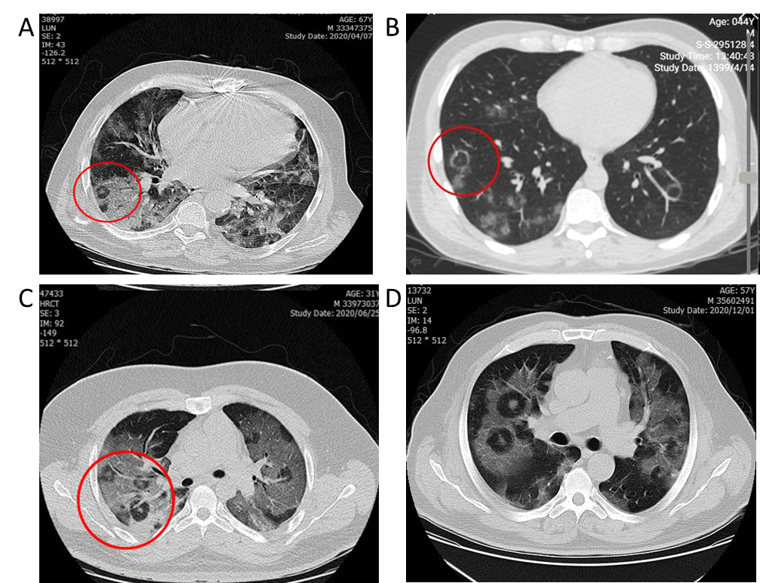
Figure 1 “Pulmonary target sign” in 4 different cases varies according to the location of the lesions. A and B: Peripheral location; C and D: Central location.
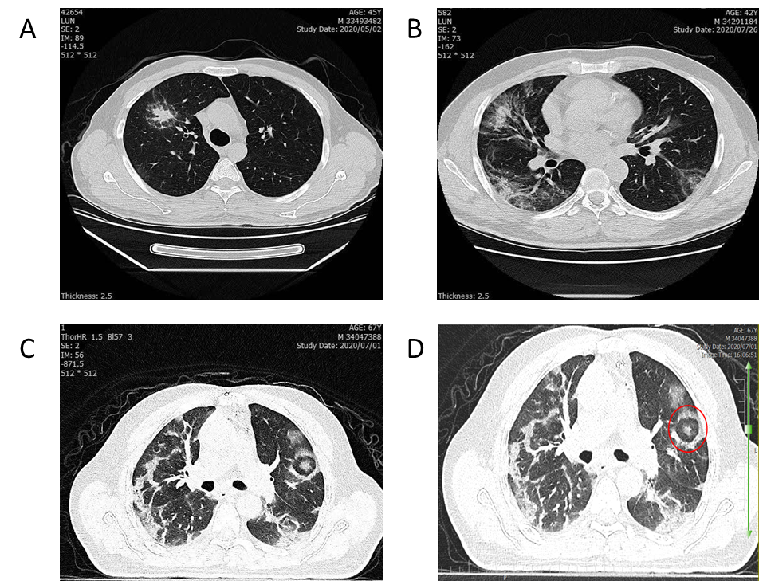
b
a
d
c
Figure 2 Variants of “pulmonary target sign” in 4 different cases. A: “Pulmonary target sign” (PTS) similar to a solitary pulmonary nodule; B: “Rings of Saturn” as a variant of PTS; C and D: PTS with parallel pleural sign.
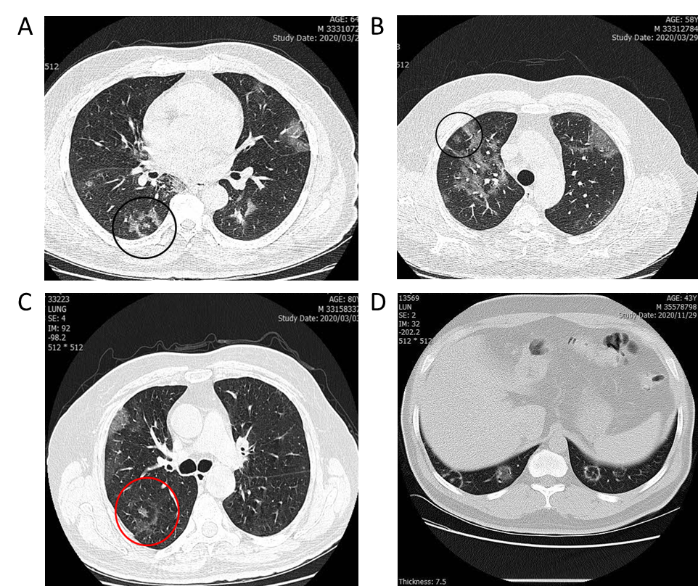
Figure 3 “Pulmonary target sign” in 4 different patients. A and B: “Pulmonary target sign” (PTS) as a pleural based lesion; C: PTS with incomplete peripheral ring; D: Complete peripheral ring.
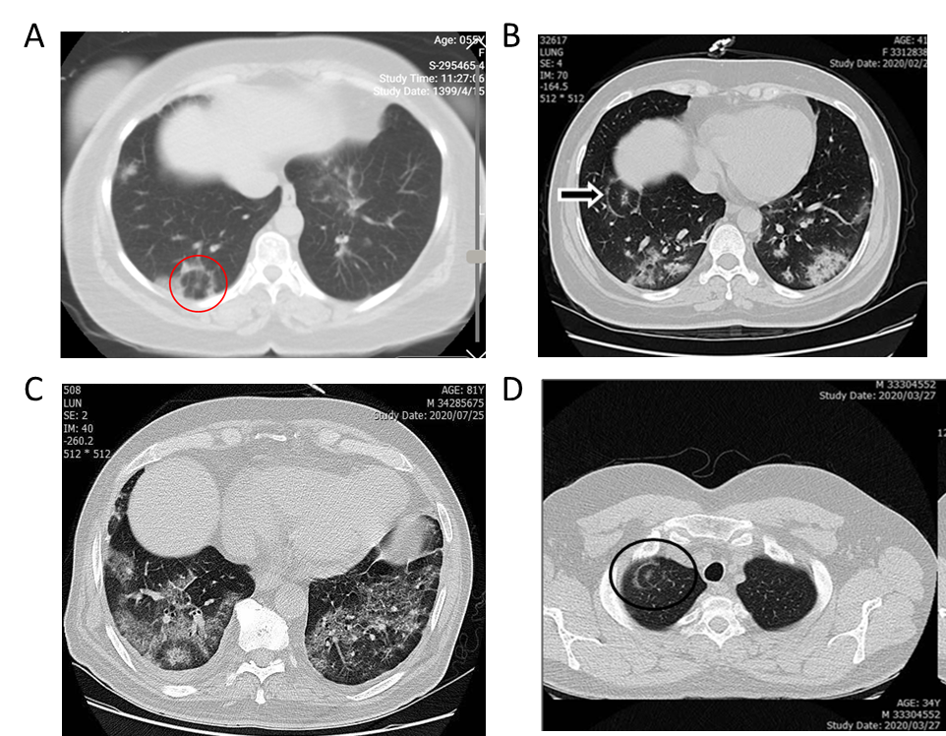
Figure 4 “Pulmonary target sign” in 4 different individuals. A, B and C: Basal location of “pulmonary target sign”; D: Apical location.
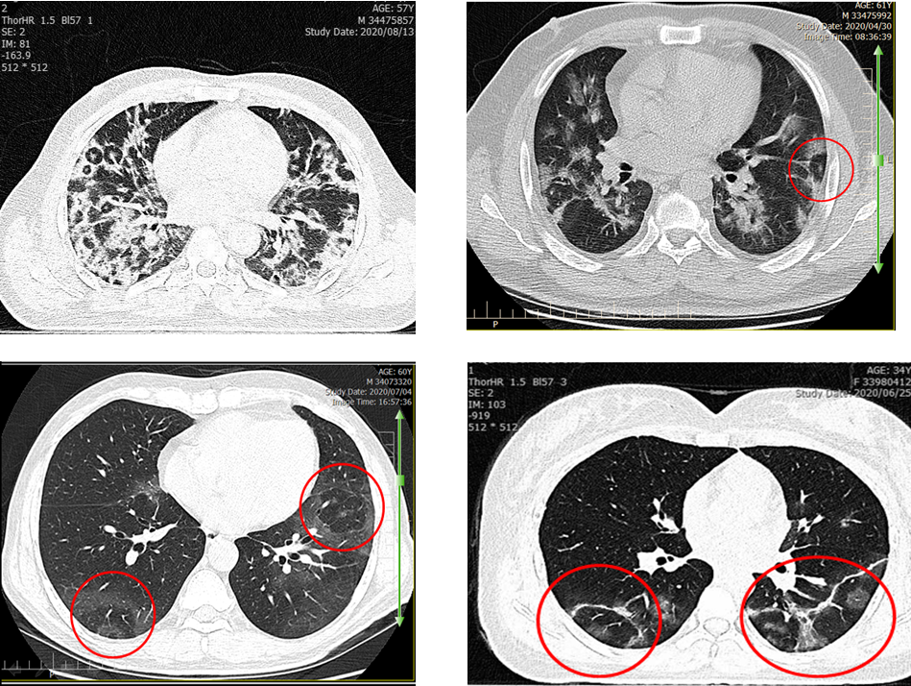
Figure 5 “Pulmonary target sign” in 4 different cases. “Pulmonary target sign” along with a broncho-vascular bundle.
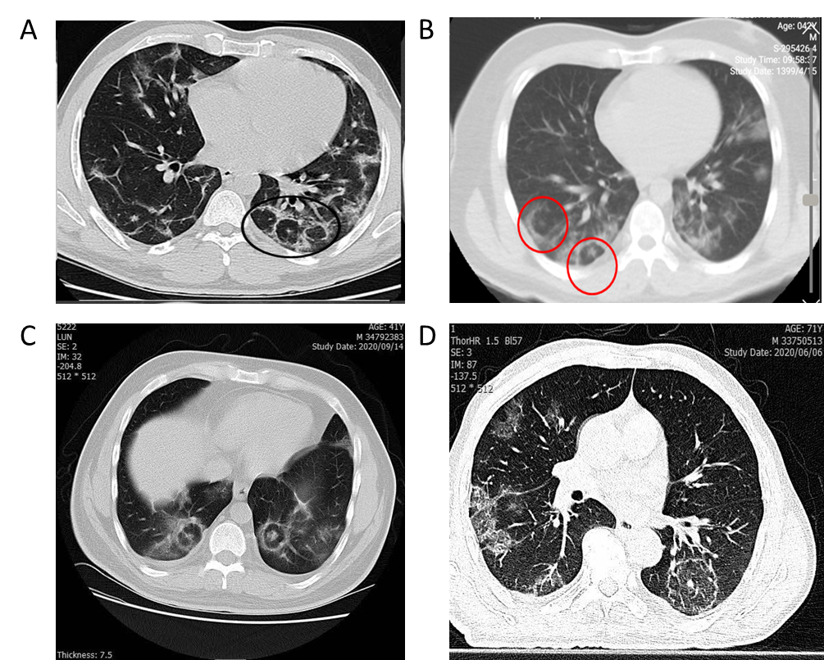
d
Figure 6 Laterality of “pulmonary target sign” in 4 different cases. A and B: Multiple unilateral “pulmonary target sign”; C: bilateral lesions; D: Solitary lesion.
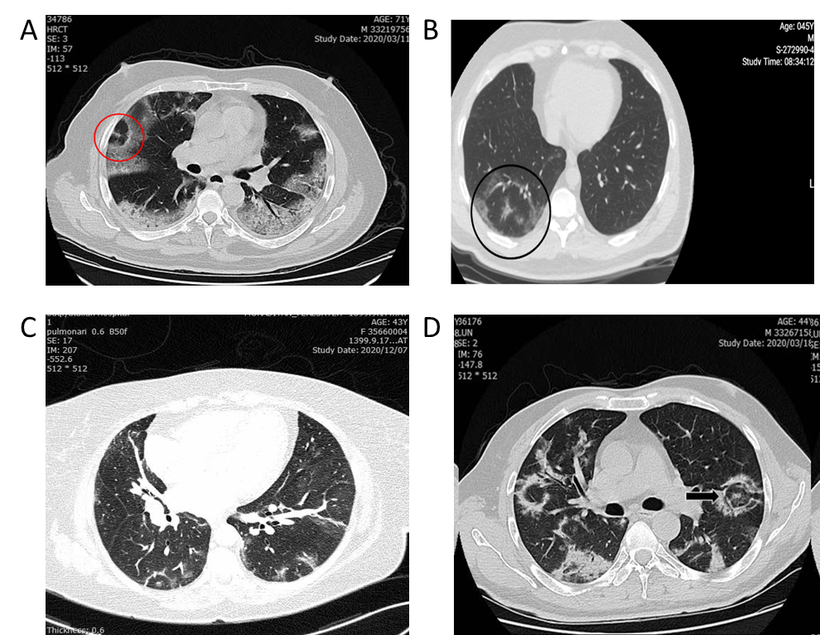
Figure 7 Correlation of “pulmonary target sign” with adjacent ground-glass opacities or consolidation. A: Circular adjacent ground-glass opacities (GGO); B and C: Patchy adjacent GGO; D: adjacent patchy consolidation.
b
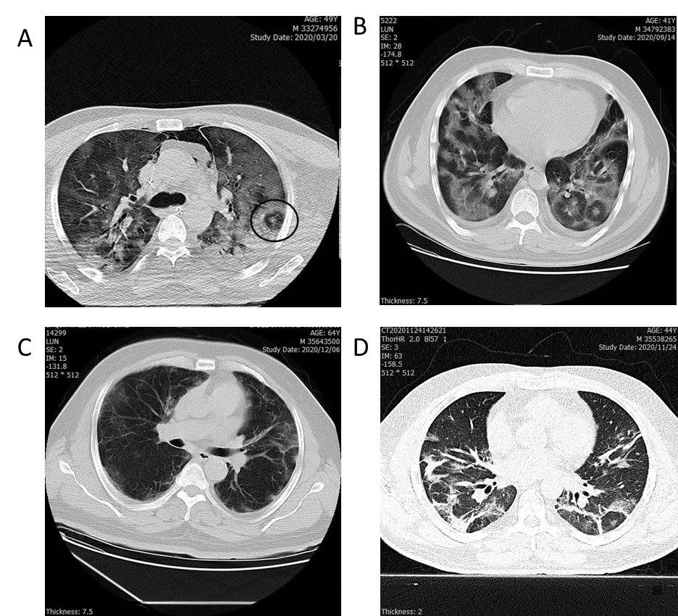
Figure 8 “Pulmonary target sign” with coronavirus disease 2019 complications. A: Pneumothorax and pneumomediastinum; B: Pleural effusion; C: Pleural thickening; D: Fibrotic band.
Table1 Cases characteristics
Characteristics of PTS | Number (32 cases) | Frequency (4.9%)
Only peripheral | 31 | 96.8%
Both central and peripheral | 4 | 12.5%
Age (mean ± SD) | 53.1 ± 13.4 | -
Gender (male) | 28 | 87.5%
Along with BVB | 28 | 87.5%
Pleura-based¹ | 25 | 78.1%
Adjacent GGO | 30 | 93.7%
Adjacent consolidation | 7 | 21.8%
Basal lobes and segments² | 16 | 50.0%
Multiple | 22 | 68.7%
¹Pleura based or close to pleural surface; ²If only one of multiple lesions present at lower segments and lobes, considered positive. BVB: Bronchovascular bundle; GGO: Ground-glass opacities; PTS: Pulmonary target sign.

