Name of Journal: World Journal of Gastroenterology
Manuscript NO: 72634
Manuscript Type: CORRECTION

Correction to “Aberrant methylation of secreted protein acidic and rich in cysteine gene and its significance in gastric cancer”

Shao S et al. Correction to “anti-oncogene role of SPARC in GC”

Shuai Shao, Nuo-Ming Zhou, Dong-Qiu Dai

Shuai Shao, Nuo-Ming Zhou, Dong-Qiu Dai, Department of Gastroenterological Surgery, The Fourth Affiliated Hospital of China Medical University, Shenyang 110032, Liaoning Province, China

Author contributions: Shao S, Zhou NM and Dai DQ contributed to this paper.

Corresponding author: Dong-Qiu Dai, MD, PhD, Chief Doctor, Professor, Surgical Oncologist, Department of Gastrointestinal Surgery and Cancer Center, The Fourth Affiliated Hospital of China Medical University, No. 4 Chongshan East Road, Shenyang 110032, Liaoning Province, China. daidq63@163.com

Received: October 23, 2021
Revised: April 26, 2022
Accepted: May 28, 2022
Published online:

Abstract
We have replaced the misapplied images and the revised Figure 6C is provided.

Key Words: Correction

Shao S, Zhou NM, Dai DQ. Correction to “Aberrant methylation of secreted protein acidic and rich in cysteine gene and its significance in gastric cancer”. World J Gastroenterol 2022; In press

Core Tip: This is a correction to “Aberrant methylation of secreted protein acidic and rich in cysteine gene and its significance in gastric cancer”.
CORRECTION
Correction to: Shao S, Zhou NM, Dai DQ. Aberrant methylation of secreted protein acidic and rich in cysteine gene and its significance in gastric cancer. World J Gastroenterol 2019; 25: 6713-6727 PMID: 31857774 DOI: 10.3748/wjg.v25.i46.6713.
We are deeply regretful that we have misapplied one inappropriate image in this article. We have replaced the misapplied image and the corrected pictures are shown in Figure 1. This correction will have no influence on the interpretation of the entire results and conclusion in this study. We apologize for any inconvenience this may cause.
We have provided the correction document, and we would like to express our sincere apologies to the editors and readers for our mistakes. We are looking forward to hearing from you at your earliest convenience.

REFERENCES
1 Shao S, Zhou NM, Dai DQ. Aberrant methylation of secreted protein acidic and rich in cysteine gene and its significance in gastric cancer. World J Gastroenterol 2019; 25: 6713-6727 [PMID: 31857774 DOI: 10.3748/wjg.v25.i46.6713]

Footnotes
Open-Access: This article is an open-access article that was selected by an in-house editor and fully peer-reviewed by external reviewers. It is distributed in accordance with the Creative Commons Attribution NonCommercial (CC BY-NC 4.0) license, which permits others to distribute, remix, adapt, build upon this work non-commercially, and license their derivative works on different terms, provided the original work is properly cited and the use is non-commercial. See: https://creativecommons.org/Licenses/by-nc/4.0/

Provenance and peer review: Unsolicited article; Externally peer reviewed.
Peer-review model: Single blind

Peer-review started: October 23, 2021
First decision: April 16, 2022
Article in press:

Specialty type: Oncology
Country/Territory of origin: China
Peer-review report’s scientific quality classification
Grade A (Excellent): 0
Grade B (Very good): 0
Grade C (Good): C
Grade D (Fair): 0
Grade E (Poor): 0

P-Reviewer: Shahini E, Italy A-Editor: Zhu JQ, China S-Editor: Zhang H L-Editor: A P-Editor: Zhang H
Figure Legends
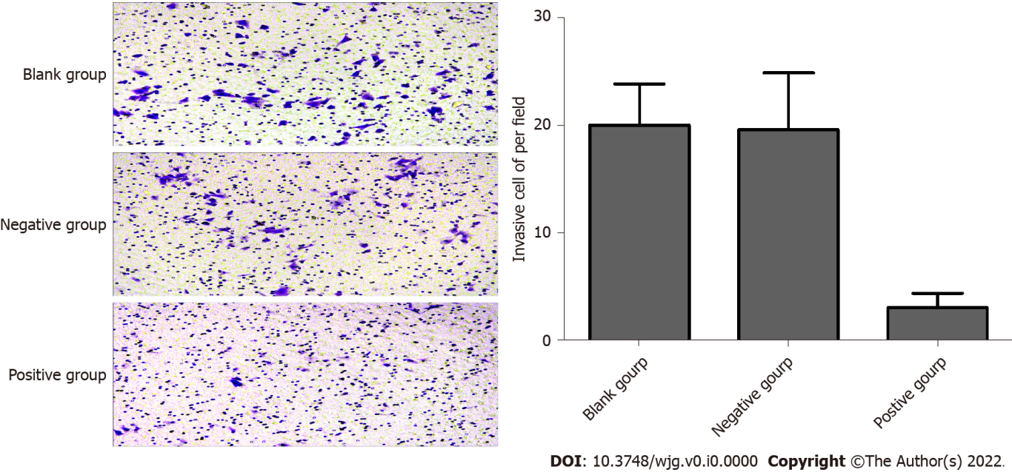
Figure 1 Modification of the Figure 6C in original manuscript.

