Name of Journal: World Journal of Orthopedics
Manuscript NO: 84616
Manuscript Type: ORIGINAL ARTICLE

Observational Study
Clinical outcome of open ankle fractures in patients above 70 years of age

Zahra W et al. Clinical outcome of open ankle fractures

Wajiha Zahra, Mina Seifo, Paul Cool, David Ford, Tosan Okoro

Wajiha Zahra, Mina Seifo, David Ford, Tosan Okoro, Department of Trauma and Orthopedics, Royal Shrewsbury Hospital, Shrewsbury SY3 8XQ, United Kingdom

Paul Cool, David Ford, Tosan Okoro, Department of Trauma and Orthopedics, Robert Jones and Agnes Hunt Orthopaedic Hospital NHS Foundation Trust, Oswestry SY10 7AG, United Kingdom

Paul Cool, Department of Trauma and Orthopedics, Keele University, Stafford ST5 5BG, United Kingdom

Author contributions: Zahra W, Seifo M, and Cool P contributed to data collection; Zahra W and Cool P contributed to data analysis; Cool P and Ford D contributed to supervision; Ford D and Okoro T contributed to project idea; Zahra W contributed to writing the manuscript and literature review; Seifo M contributed to review the manuscript; Okoro T contributed to overall supervision.

Corresponding author: Wajiha Zahra, MBBS, MSc, Doctor, Department of Trauma and Orthopedics, Royal Shrewsbury Hospital, Mytton Oak Road, Shrewsbury SY3 8XQ, United Kingdom. wajiha.zahra@nhs.net

Received: March 26, 2023
Revised: June 6, 2023
Accepted: June 16, 2023
Published online: July 18, 2023

Abstract
BACKGROUND
Open fractures of the ankle are complex injuries requiring multidisciplinary input and are associated with significant morbidity and mortality. However, data on the clinical outcomes of open ankle fracture management in patients older than 70 is minimal.

AIM
To evaluate the clinical outcomes following open ankle fracture management in patients older than 70. Our secondary aim is to look at predictors of poor outcomes.

METHODS
Following local research and audit department registration, 22 years of prospectively collated data from an electronic database in a district general hospital were assessed. All patients older than 70 years of age with an open ankle fracture requiring surgical intervention were identified. Demographic information, the nature, and the number of surgical interventions were collated. Complications, including surgical site infection (SSI), venous thromboembolic events (VTEs) during hospital stay, and mortality rate, were reviewed.

RESULTS
A total of 37 patients were identified (median age: 84 years, range: 70-98); n = 30 females median age: 84 years, range: 70-97); n = 7 males median age: 74 years, range: 71-98)) who underwent surgical intervention after an open ankle fracture. Sixteen patients developed SSIs (43%). Superficial SSIs (n = 8) were managed without surgical intervention and treated with antibiotics and regular dressing changes. Deep SSIs (n = 8; 20%) required a median of 3 (range: 2-9) surgical interventions, with four patients requiring multiple washouts and one patient having metalwork removed. VTE incidence was 5% during the hospital stay. Eight patients died within 30 d, and mortality at one year was 19%. The 10-year mortality rate was 57%. The presence of a history of stroke, cancer, or prolonged inpatient stay was found to be predictive of lower survivorship in this population (log-rank test: cancer P = 0.008, stroke P = 0.001, length of stay > 33 d P = 0.015). The presence of a cardiac history was predictive of wound complications (logistic regression, P = 0.045). Age, number of operations, and diabetic history were found to be predictive of an increase in the length of stay (general linear model; age P < 0.001, number of operations P < 0.001, diabetes P = 0.041).

CONCLUSION
An open ankle fracture in a patient older than 70 years has at least a 20% chance of requiring repeated surgical intervention due to deep SSIs. The presence of a cardiac history appears to be the main predictor for wound complications.

Key Words: Fragility fracture; Open fracture; Clinical outcome; Mortality; Infection; Survival

©The Author(s) 2023. Published by Baishideng Publishing Group Inc. All rights reserved.

Citation: Zahra W, Seifo M, Cool P, Ford D, Okoro T. Clinical outcome of open ankle fractures in patients above 70 years of age. World J Orthop 2023; 14(7): 554-561
URL: https://www.wjgnet.com/2218-5836/full/v14/i7/554.htm
DOI: https://dx.doi.org/10.5312/wjo.v14.i7.554

Core Tip: There is no standard consensus on management of open ankle fractures in patients above 70 years of age. Cardiac issues are the main predictors of poor outcome. 1 in 5 patients above 70 years of age develop deep infection requiring further surgical intervention. High infection increases length of stay in the hospital and mortality.
INTRODUCTION
Open fractures are complex injuries requiring multidisciplinary input^{[1]} and are associated with significant morbidity and mortality^{[2]}. Open ankle fractures account for about 2% of all ankle fractures^{[3]}. About 187 per 100000 adults sustain ankle fractures every year^{[4]}. Ankle fractures can be caused by various modes of trauma, e.g., twisting, impact, and crush injuries. The degree of bony comminution and soft tissue damage is directly related to the energy of trauma^{[5]}. In older patients with unstable ankle fractures, surgical intervention vs application of a contact cast is reported to have an equivalent functional outcome at six months^{[6]}. Surgical intervention is still the first line of management for the elderly with open fractures to minimize the risk of infection^{[7]}. Among the elderly, an open ankle fracture can reduce quality of life by more than half, sharing a similar characteristic to a fragility fracture^{[8]}. Typically, fractures of the hip, pelvis, spine, humerus, wrist, rib, clavicle, scapula, or sternum are described as osteoporotic fractures^{[9,10]}. The incidence of ankle fractures does not increase with age, excluding them from the osteoporotic fracture class^{[11,12]}. Minimal data on the clinical outcome of open ankle fracture management in patients older than 70 is available^{[13]}.
The primary aim of this study is to describe the clinical outcomes following an open ankle fracture in patients older than 70. Our secondary aim is to look at predictors of poor outcomes in this age group.

MATERIALS AND METHODS
Following local research and audit department registration, 22 years of prospectively collated data from an electronic database in a district general hospital (DGH) were reviewed. All patients older than 70 years with an open ankle fracture requiring surgical intervention were identified. Demographic information, the nature, and the number of surgical interventions were collated. All open fractures were classified according to the Gustilo and Anderson classification^{[14]} and the number of malleoli involved^{[15]}.
Complications, including surgical site infection (SSI), venous thromboembolic events (VTE) during hospital stay, and mortality rate at 30 d and one year, were reviewed. The presence of comorbidities, including diabetes mellitus, a history of cancer, and previous thromboembolic disease, and their relationship to poor outcomes, were evaluated.
Statistical analysis was performed using R 4.2.2 (R foundation). With patient factors as explanatory variables, logistic regression was used to predict any wound complication. A general linear model was chosen to identify variables that are predictive of an increased length of hospital stay. Survival analysis was performed with follow up time from admission and death due to any cause as endpoint. The log-rank rest was used to compare variables influencing survival. For all statistical analyses, a P value < 5% was considered significant.

RESULTS
There were 37 patients older than 70 years who underwent surgical intervention after an open ankle fracture. The median age was 84 years (range: 70-98), with 30 females (median age: 84, range: 70-97 years) and seven males (median age: 74, range: 71-98 years).
Twenty-nine patients (78%) sustained bimalleolar ankle fractures; four patients had unimalleolar and another four had trimalleolar ankle fractures. An open wound over the medial malleolus was seen in 89% of the patients. Eight patients had a Gustilo-Anderson Type I fracture, and 24 patients had Type II, with the remaining five patients having Type III. The ankle joint was dislocated at initial assessment in 86% of cases (Table 1). There were no sex differences in the type of ankle fracture sustained or in the incidence of complications (Table 2).
Thirty-two patients (86%) had surgery within 24 h of injury, four underwent surgical intervention within 48 h, and one patient had surgery after six days due to a late presentation to the emergency department. Two patients were allowed to put partial weight on the surgical site following surgery.
The remaining 35 patients were advised to initially mobilize non-weight bearing on the operated site.
All 37 patients had wound washout and debridement at initial surgery. Twenty-one (57%) patients had primary closure, and 25 (68%) underwent definite fixation in the first sitting. Of the 37 patients, 16 wounds (43%) were left to heal by secondary intention. Of these, three patients later required a split skin graft, and seven required vacuum assisted closure (VAC) therapy application to achieve skin closure (Figures 1 and 2).
Out of 16 wound complications, eight were managed with regular dressing changes and antibiotics (superficial SSIs).
The other eight patients required further washout in the operating theatre (deep SSIs). Four patients with deep SSIs required multiple washouts. One of these patients needed to have the metalwork removed for the wound to heal. The maximum number of operations one patient had was nine (requiring washouts and VAC dressing changes). The median number of operations patients with deep SSIs had to undergo was three (range: 2-9). Table 3 describes the instances where either primary or secondary closure was chosen at the initial surgical intervention (Table 3).
The overall mortality rate in this study was 59%. Out of 37, seven (19%) patients died within one year of the open ankle injury. The 30-d mortality rate was 8%, with the 0-year mortality rate at 57%. The median length of stay in the hospital was 26 d (range: 3-84) (Table 4).
The overall mortality rate in this study was 59%. Out of 37, seven (19%) patients died within one year of the open ankle injury. The 30-d mortality rate was 8%, with the 0-year mortality rate at 57%. The median length of stay in the hospital was 26 d (range: 3-84) (Table 5).

DISCUSSION
This is a retrospective study that evaluates the outcome of patients older than 70 who had surgical treatment for an open ankle fracture. Previously, Schermann et al^{[16]} looked at predisposing factors and associated mortality in patients older than 65 years with open ankle fractures. Wijendra et al^{[8]} reviewed outcomes in low-energy open ankle fractures in patients aged 27-100 (mean: 73). We assessed the clinical outcome in this group of patients based on the rate of complications and the number of operations undertaken. Patients requiring multiple operations had a longer hospital stay (median: 26 d, range: 5-84 d). All these patients were initially managed per the BOA Standards for Trauma guidelines^{[7]} for open fractures.
In our study, four out of five Type III open fractures required multiple operations due to wound complications. These results are similar to the meta-analysis by Kortram et al^{[17]} who described the Gustilo-Anderson classification Type III open fracture as a statistically significant risk factor for developing infectious complications. Thangarajah et al^{[18]} showed SSI after fixation to be higher in patients with bimalleolar fractures. However, our study did not show any such relationship. We found that two out of four trimalleolar ankle fractures had a primary closure at the initial operation, while three unimalleolar ankle fractures required multiple operations due to wound complications.
Forty-five percent of patients presenting with an open bimalleolar fracture had definite fixation and primary closure.
The outcome and complication rates after an open ankle fracture dislocation are multifactorial. Factors include multiple comorbidities, the patient’s age, and wound contamination. These findings are similar to Frank et al’s work on dislocated ankles^{[19]}.
Comparing the clinical outcomes of patients who had primary closure vs delayed closure, none of the 21 patients with primary closure and definite fixation required a second operation. Eight patients in this group developed superficial wound infections that could be managed with antibiotics. All patients with external fixation as primary fixation required a split skin graft at a later setting. These patients had the longest length of stay in the hospital. Patients requiring VAC dressing to achieve skin closure were at high risk for deep infections and required multiple washouts in the operating theatre. These findings align with the work done by Ovaska et al^{[15]} and Wijendra et al^{[8]}. We did not find any influence of the fracture pattern or fixation type on clinical outcomes.
Mortality among patients who are older than 65 with open ankle fractures has been reported at about 23%-27% during the first year postoperatively^{[16]}. The mortality rate in our study was 19% at 12 mo and 57% at 10 years. Patients with multiple comorbidities had poor survival. Patients on anticoagulants or antiplatelets medication or patients with a cardiac history had a worse outcome. This is likely due to the poor blood supply to the limb, which disrupts the wound-healing process. In our study, 20 patients were on anticoagulation due to a history of ischemic heart disease or atrial fibrillation. Three patients had a history of pulmonary embolism or deep venous thrombosis. These outcomes are similar to the work done by Schermann et al^{[16]} and Toole et al^{[20]}, who also concluded that ischemic heart disease, chronic kidney disease, diabetes, and peripheral vascular disease are variables for mortality in the elderly population. Deep infection (8%) and skin necrosis (14%) were the most common complications after immediate internal fixation in open ankle fractures. Minimal literature is available on the outcomes of definitive treatment in patients with open ankle fractures^{[16]}. In our study, two patients had a thromboembolic event.
Our results are compatible with other studies that suggest that definite fixation in the initial operation is safe, has fewer complications, and leads to a shorter hospital stay^{[8,21,22]}. An external fixator is best employed in patients with inadequate soft tissue coverage.
There are limitations to this study. First, the total number of patients is relatively small. We operated on nearly 2500 ankle fractures over this 22 year period. This is mainly because this study is undertaken in a DGH, not an orthoplastic center. Second, this study has some selection bias. The data was collected from a database, and medical notes were reviewed retrospectively. The database was used logistically in generating theatre lists and acted as an accurate source of data. However, the surgery description may not always have included an open wound, which could have led to underreporting.

CONCLUSION
An open ankle fracture in a patient older than 70 years of age has at least a 20% chance of requiring repeated surgical intervention due to deep SSI. The presence of a cardiac history appears to be the main predictor for wound complications.

ARTICLE HIGHLIGHTS
Research background
There is no data on the clinical outcomes of patients older than 70 admitted with open ankle fractures. This study sets the foundation for future research trials in elderly population.

Research motivation
This is the only study looking at patients older than 70 with open ankle fractures. This study highlights the multiple factors which can predict the poor outcome in this age group with open ankle fractures. There is no consensus on the best management strategy for these injuries in this population.

Research objectives
The overall objective of this study is to look at the predictors of poor clinical outcome in patients older than 70 with open ankle fractures.

Research methods
This is a retrospective observational study performed on 22 years of prospectively collated data from an electronic database in a district general hospital. We used R 4.2.2 (R foundation) to perform statistical analysis.

Research results
We identified 37 patients above 70 years of age admitted over the period of 22 years with an open ankle fractures. Sixteen patients developed deep surgical site infections, with 4 requiring multiple wash outs. Eight patients developed superficial surgical site infections and were managed with antibiotics and regular dressing change. The 10 years mortality rate in this age group was 57%. The presence of a cardiac and stroke history, cancer, or prolonged inpatient stay were found to be the predictors of mortality.

Research conclusions
We concluded that there is a 20% risk of patients above 70 years of age with open ankle fracture requiring repeated surgical intervention. The need for repeated surgical interventions is mainly due to deep Surgical Site Infections. We identified multiple predictors for worse outcome. However, the presence of a cardiac history appears to be the main predictor for wound complications.

Research perspectives
This study sets the foundation for further research trials in patients above 70 years of age.

REFERENCES
1 BOAST - Open Fractures. Available from: https://www.boa.ac.uk/resources/boast-4-pdf.html
2 Shah A, Judge A, Griffin XL. Incidence and quality of care for open fractures in England between 2008 and 2019: a cohort study using data collected by the Trauma Audit and Research Network. Bone Joint J 2022; 104-B: 736-746 [PMID: 35638205 DOI: 10.1302/0301-620X.104B6.BJJ-2021-1097.R2]
3 Court-Brown CM, McBirnie J, Wilson G. Adult ankle fractures--an increasing problem? Acta Orthop Scand 1998; 69: 43-47 [PMID: 9524517 DOI: 10.3109/17453679809002355]
4 Daly PJ, Fitzgerald RH Jr, Melton LJ, Ilstrup DM. Epidemiology of ankle fractures in Rochester, Minnesota. Acta Orthop Scand 1987; 58: 539-544 [PMID: 3425285 DOI: 10.3109/17453678709146395]
5 Wire J, Hermena S, Slane VH. Ankle Fractures. 2022 Aug 15. In: StatPearls [Internet]. Treasure Island (FL): StatPearls Publishing; 2023 [PMID: 31194464]
6 Willett K, Keene DJ, Mistry D, Nam J, Tutton E, Handley R, Morgan L, Roberts E, Briggs A, Lall R, Chesser TJ, Pallister I, Lamb SE; Ankle Injury Management (AIM) Trial Collaborators. Close Contact Casting vs Surgery for Initial Treatment of Unstable Ankle Fractures in Older Adults: A Randomized Clinical Trial. JAMA 2016; 316: 1455-1463 [PMID: 27727383 DOI: 10.1001/jama.2016.14719]
7 BOAST guidelines for Open Fractures. Available from: https://www.boa.ac.uk/static/3b91ad0a-9081-4253-92f7d90e8df0fb2c/29bf80f1-1cb6-46b7afc761119341447f/open%20fractures.pdf
8 Wijendra A, Alwe R, Lamyman M, Grammatopoulos GA, Kambouroglou G. Low energy open ankle fractures in the elderly: Outcome and treatment algorithm. Injury 2017; 48: 763-769 [PMID: 28093252 DOI: 10.1016/j.injury.2016.11.014]
9 Johnell O, Kanis J. Epidemiology of osteoporotic fractures. Osteoporos Int 2005; 16 Suppl 2: S3-S7 [PMID: 15365697 DOI: 10.1007/s00198-004-1702-6]
10 Kanis JA, Johnell O, De Laet C, Johansson H, Oden A, Delmas P, Eisman J, Fujiwara S, Garnero P, Kroger H, McCloskey EV, Mellstrom D, Melton LJ, Pols H, Reeve J, Silman A, Tenenhouse A. A meta-analysis of previous fracture and subsequent fracture risk. Bone 2004; 35: 375-382 [PMID: 15268886 DOI: 10.1016/j.bone.2004.03.024]
11 Hasselman CT, Vogt MT, Stone KL, Cauley JA, Conti SF. Foot and ankle fractures in elderly white women. Incidence and risk factors. J Bone Joint Surg Am 2003; 85: 820-824 [PMID: 12728031 DOI: 10.2106/00004623-200305000-00008]
12 Eastell R, Reid DM, Compston J, Cooper C, Fogelman I, Francis RM, Hay SM, Hosking DJ, Purdie DW, Ralston SH, Reeve J, Russell RG, Stevenson JC. Secondary prevention of osteoporosis: when should a non-vertebral fracture be a trigger for action? QJM 2001; 94: 575-597 [PMID: 11704688 DOI: 10.1093/qjmed/94.11.575]
13 Simske NM, Audet MA, Kim CY, Vallier HA. Open ankle fractures are associated with complications and reoperations. OTA Int 2019; 2: e042 [PMID: 33937670 DOI: 10.1097/OI9.0000000000000042]
14 Gustilo RB, Mendoza RM, Williams DN. Problems in the management of type III (severe) open fractures: a new classification of type III open fractures. J Trauma 1984; 24: 742-746 [PMID: 6471139 DOI: 10.1097/00005373-198408000-00009]
15 Ovaska MT, Madanat R, Honkamaa M, Mäkinen TJ. Contemporary demographics and complications of patients treated for open ankle fractures. Injury 2015; 46: 1650-1655 [PMID: 25935358 DOI: 10.1016/j.injury.2015.04.015]
16 Schermann H, Ogawa T, Lubberts B, Waryasz GR, Kaiser P, DiGiovanni CW, Guss D. Open Ankle Fractures in the Elderly: Predisposing Factors and the Associated Mortality. Foot Ankle Orthop 2022; 7 [DOI: 10.1177/2473011421S00435]
17 Kortram K, Bezstarosti H, Metsemakers WJ, Raschke MJ, Van Lieshout EMM, Verhofstad MHJ. Risk factors for infectious complications after open fractures; a systematic review and meta-analysis. Int Orthop 2017; 41: 1965-1982 [PMID: 28744800 DOI: 10.1007/s00264-017-3556-5]
18 Thangarajah T, Prasad PS, Narayan B. Surgical site infections following open reduction and internal fixation of ankle fractures. Open Orthop J 2009; 3: 56-60 [PMID: 19657462 DOI: 10.2174/1874325000903010056]
19 Frank AL, Charette RS, Groen K. Ankle Dislocation. [Updated 2022 Dec 1]. In: StatPearls [Internet]. Treasure Island (FL): StatPearls Publishing; 2022. Available from: https://www.ncbi.nlm.nih.gov/books/NBK554610
20 Toole WP, Elliott M, Hankins D, Rosenbaum C, Harris A, Perkins C. Are low-energy open ankle fractures in the elderly the new geriatric hip fracture? J Foot Ankle Surg 2015; 54: 203-206 [PMID: 25488597 DOI: 10.1053/j.jfas.2014.10.015]
21 Hulsker CC, Kleinveld S, Zonnenberg CB, Hogervorst M, van den Bekerom MP. Evidence-based treatment of open ankle fractures. Arch Orthop Trauma Surg 2011; 131: 1545-1553 [PMID: 21713539 DOI: 10.1007/s00402-011-1349-7]
22 Chummun S, Wright TC, Chapman TW, Khan U. Outcome of the management of open ankle fractures in an ortho-plastic specialist centre. Injury 2015; 46: 1112-1115 [PMID: 25601085 DOI: 10.1016/j.injury.2014.12.017]
23 Pott P. Some few general remarks on fractures and dislocations. 1758. Clin Orthop Relat Res 2007; 458: 40-41 [PMID: 17473597 DOI: 10.1097/BLO.0b013e31803dd063]
24 Kim PH, Leopold SS. In brief: Gustilo-Anderson classification. [corrected]. Clin Orthop Relat Res 2012; 470: 3270-3274 [PMID: 22569719 DOI: 10.1007/s11999-012-2376-6]

Footnotes
Institutional review board statement: This project is registered with the audit department of Royal Shrewsbury Hospital.

Informed consent statement: This study is registered with the local audit department and patients data has been used as per the local trust guidelines. This authorization has no expiration date.

Conflict-of-interest statement: We declare no conflict of interest.

Data sharing statement: No additional data are available.

STROBE statement: The authors have read the STROBE Statement—checklist of items, and the manuscript was prepared and revised according to the STROBE Statement—checklist of items.

Open-Access: This article is an open-access article that was selected by an in-house editor and fully peer-reviewed by external reviewers. It is distributed in accordance with the Creative Commons Attribution NonCommercial (CC BY-NC 4.0) license, which permits others to distribute, remix, adapt, build upon this work non-commercially, and license their derivative works on different terms, provided the original work is properly cited and the use is non-commercial. See: https://creativecommons.org/Licenses/by-nc/4.0/

Provenance and peer review: Unsolicited article; Externally peer reviewed.
Peer-review model: Single blind

Peer-review started: March 26, 2023
First decision: May 25, 2023
Article in press: June 16, 2023

Specialty type: Orthopedics
Country/Territory of origin: United Kingdom
Peer-review report’s scientific quality classification
Grade A (Excellent): 0
Grade B (Very good): 0
Grade C (Good): C
Grade D (Fair): D
Grade E (Poor): 0

P-Reviewer: Ahmadabad HN, Iran; Mostafavinia A, Iran S-Editor: Liu JH L-Editor: A P-Editor: Liu JH
Figure Legends
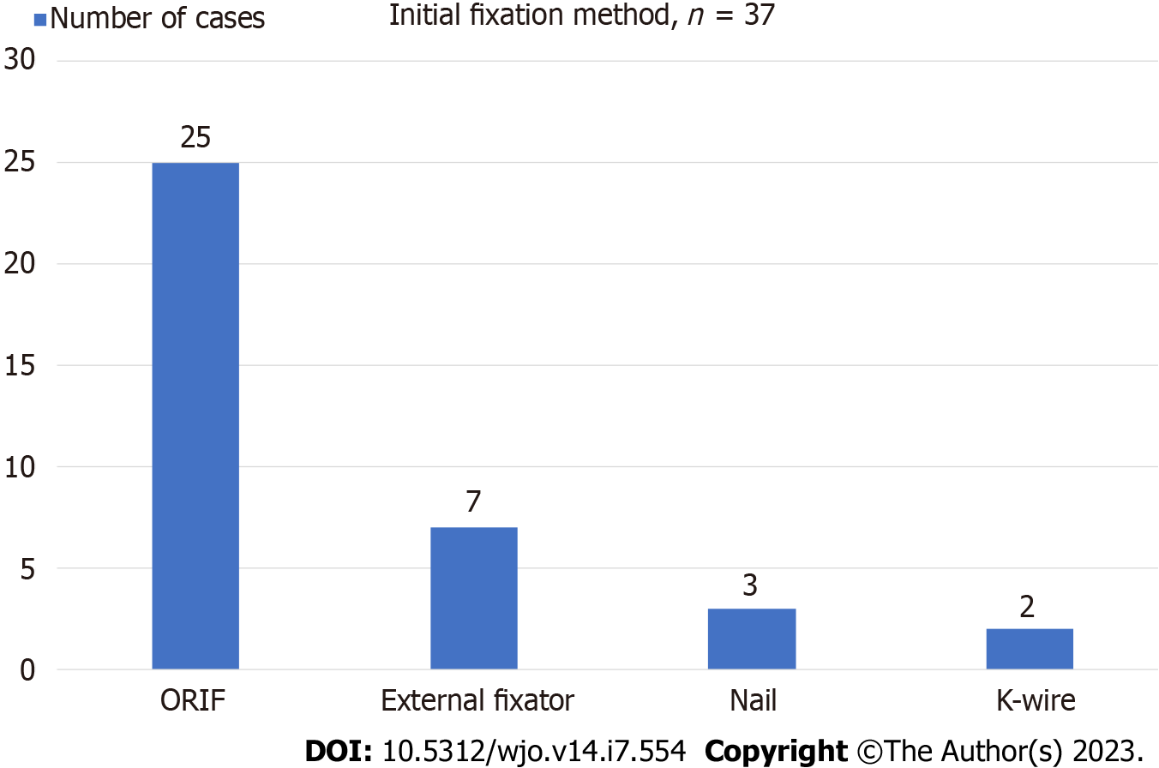
Figure 1 Surgical Interventions performed in patients > 70 years old presenting with open ankle fractures.
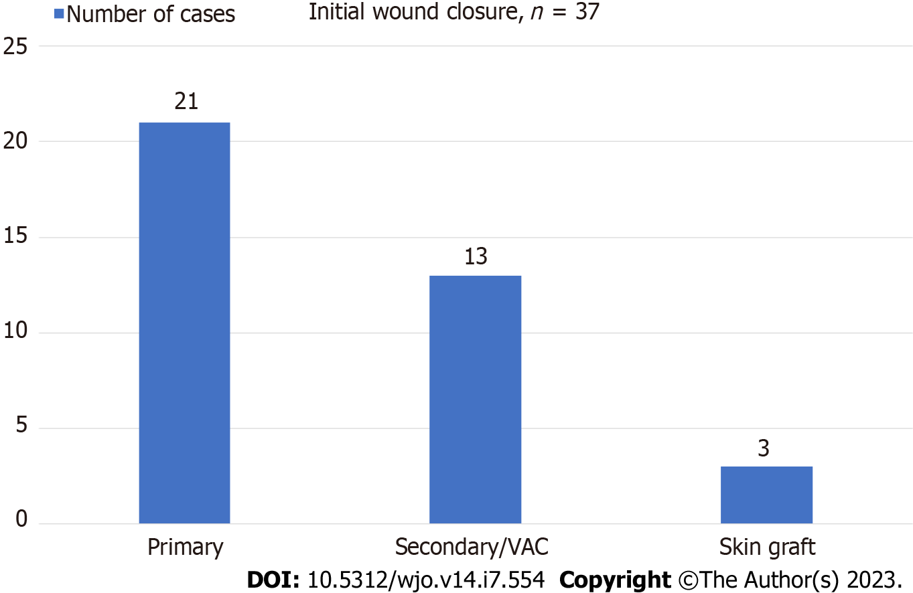
Figure 2 Soft tissue procedures performed in patients > 70 years old presenting with open ankle fractures. VAC: Vacuum assisted closure.
Table 1 Description of clinical features of open ankle fractures in patients > 70 years old
Clinical feature | Number of patients, n (%)
1 Mechanism of injury
Road traffic accident | 4 (11)
Falls | 33 (89)
2 Classification of ankle injuries^{[23]}
Unimalleolar | 4 (11)
Bimalleolar | 29 (78)
Trimalleolar | 4 (11)
3 Site of open wound
Medial | 33 (89)
Lateral | 1 (3)
Anterior | 1 (5)
Medial + lateral + anterior | 1 (3)
4 Gustilo-Anderson classification^{[24]}
Type I | 8 (22)
Type II | 24 (65)
Type III | 5 (13)
5 Joint dislocation at initial assessment
Yes | 32 (86)
No | 5 (13)
Table 2 Male vs female characteristics, n (%)
Gender | Number of patients (n = 37) | Open fracture classification | Number of operations | Complications
Male | 7 (19) | Type I = 3; Type II = 3; Type III = 1 | Range - 1 to 7; Median - 2 | Superficial SSI - 2; Deep SSI - 3
Female | 30 (81) | Type I = 21; Type II = 5; Type III = 4 | Range - 1 to 9; Median - 2 | Superficial SSI - 5; Deep SSI - 6
SSI: Surgical site infections.
Table 3 Type of wounds and joint congruency vs type of closure at initial surgical intervention
Type of wound | Total No. of patients (%) | Primary closure (%) | Secondary (%) | Closure
Gustilo-Anderson classification Type I | 8 (22) | 7 (87) | 1 (13)
Gustilo-Anderson classification Type II | 24 (65) | 13 (54) | 11 (46)
Gustilo-Anderson classification Type III | 5 (13) | 1 (20) | 4 (80)
Dislocated joint | 32 (86) | 20 (62) | 12 (37)
Congruent joint | 5 (13) | 1 (20) | 4 (80)
Medial wound | 33 (89) | 19 (57) | 14 (42)
Lateral wound | 1 (3) | 1 (100) | 0
Anterior wound | 2 (5) | 0 | 2 (100)
Medial + lateral + anterior wound | 1 (3) | 1 (100) | 0
Table 4 Predictors of poor outcome in patients with open ankle fractures > 70 years old
No. | Predictors | Number of patients (%) | P value
1 | Diabetes mellitus | 9 (24) | 0.041
2 | Anticoagulants/Antiplatelets intake: Warfarin/Apixaban; Aspirin/Clopidogrel; Dual antiplatelet therapy | 20 (54); 9 (45); 9 (45); 2 (10)
3 | Cardiac history (IHD, AF) | 21 (57) | 0.045
4 | Chronic kidney disease | 12 (32)
5 | Cancer history | 8 (22) | 0.008
6 | History of thromboembolic disease | 3 (8) | 0.001
7 | Steroids intake | 9 (24) | 0.75
IHD: Ischemic heart disease; AF: Atrial fibrillation.
Table 5 Male vs Female predictors of poor outcome (%)
Gender | Diabetes mellitus | Anticoagulants/Antiplatelets intake | Cardiac history | Chronic kidney disease | Cancer history | History of thromboembolic disease | Steroids intake
Male | 2 (28) | 3 (43) | 3 (43) | 1 (14) | 4 (57) | 0 | 0
Female | 7 (23) | 17 (57) | 18 (60) | 11 (37) | 4 (13) | 3 (10) | 9 (30)

Published by Baishideng Publishing Group Inc
7041 Koll Center Parkway, Suite 160, Pleasanton, CA 94566, USA
Telephone: +1-925-3991568
E-mail: bpgoffice@wjgnet.com
Help Desk: https://www.f6publishing.com/helpdesk
https://www.wjgnet.com

© 2023 Baishideng Publishing Group Inc. All rights reserved.

