Non-Native Speakers of English Editing Certificate

Forte Science Communications
KDX Shinjuku 286 Bldg. 5F, Shinjuku 2-8-6, Shinjuku-ku, Tokyo 160-0022, Japan.
Tel: +81-3-3353-3545 Fax: +81-3-3354-3845
Email: info@forte-science.co.jp
www.forte-science.co.jp
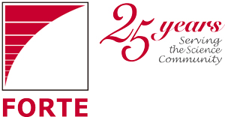
medicine · biotechnology · pharmaceuticals · environmental science · new materials
semiconductors · analytical instruments · food · public health · physics · energy

To: Dr. Kinjo

From: Matt Morgan, Forte Inc.
Date: January 27, 2016
Subject: Translation of revised manuscript (Job No. R1600430)

Dear Dr. Kinjo:

I am sending herewith the translation of your revised manuscript (Job No. R1600430). Please read the text carefully to ensure that the translation reflects your intended meaning. If you have any questions or comments, please make a note of these and return them together with your manuscript for a revision check. However, if you are satisfied with the manuscript in its current form, then we wish you the best of luck with your submission.

Thank you for using Forte. We look forward to working with you again.

Sincerely,

Matt Morgan
Editor
Forte Inc.

