Name of Journal: World Journal of Clinical Cases
Manuscript NO: 64177
Manuscript Type: CASE REPORT

Ultrasound features of primary non-Hodgkin’s lymphoma of the palatine tonsil: A case report

Jiang R et al. Ultrasound features of NHL of the tonsil

Ru Jiang, Hong-Mei Zhang, Lin-Ying Wang, Lin-Ping Pian, Xin-Wu Cui

Ru Jiang, Hong-Mei Zhang, The Third Clinical Medical College of Henan University of Chinese Medicine, Henan University of Chinese Medicine, Zhengzhou 450000, Henan Province, China

Lin-Ying Wang, Lin-Ping Pian, Department of Ultrasound, The First Affiliated Hospital of Henan University of Chinese Medicine, Zhengzhou 450000, Henan Province, China

Xin-Wu Cui, Department of Medical Ultrasound, Tongji Hospital, Tongji Medical College of Huazhong University of Science and Technology, Wuhan 430030, Hubei Province, China

Author contributions: Jiang R drafted the manuscript; Zhang HM was responsible for data analysis and manuscript preparation; Wang LY and Cui XW revised the manuscript; Pian LP supervised the work; all authors issued final approval for the version to be submitted.

Corresponding author: Lin-Ping Pian, MM, Chief Doctor, Department of Ultrasound, The First Affiliated Hospital of Henan University of Chinese Medicine, No. 19 Renmin Avenue, Jinshui District, Zhengzhou 450000, Henan Province, China. plp932@163.com

Received: May 26, 2021
Revised: June 26, 2021
Accepted: July 22, 2021
Published online: October 6, 2021

Abstract
BACKGROUND
Lymphomas are the second most common malignancy of the head and neck. In this region, the vast majority of extranodal lymphomas are located in the palatine tonsil, accounting for about 51%. Tonsillar lymphomas are aggressive tumors with intermediate- or high-grade histology. We here report a case of primary non-Hodgkin’s lymphoma of the palatine tonsil and analyze its ultrasound features.

CASE SUMMARY
A 40-year-old man presented with right palatine tonsil swelling for 2 mo after a cold, accompanied by dysphagia, snoring, and suffocation. He had no sore throat, fever, or history of upper respiratory tract infection or tuberculosis. The patient was generally in good health and denied other diseases. He was diagnosed with acute tonsillitis initially and treated with antibiotics for 7 d. However, there was no improvement with the treatment. Tonsil biopsy and ultrasound-guided biopsy of the biggest lymph node of the right neck showed the typical pathology of non-Hodgkin lymphoma.

CONCLUSION
Primary lymphoma of the tonsils is rare, and its diagnosis is challenging. Ultrasound is a useful modality in diagnosing oropharyngeal diseases, and can clearly show the features of this tumor, but the final diagnosis should be established by histology.

Key Words: Ultrasound; Primary non-Hodgkin’s lymphoma; Palatine tonsil; Case report

©The Author(s) 2021. Published by Baishideng Publishing Group Inc. All rights reserved.

Citation: Jiang R, Zhang HM, Wang LY, Pian LP, Cui XW. Ultrasound features of primary non-Hodgkin’s lymphoma of the palatine tonsil: A case report. World J Clin Cases 2021; 9(28): 8470-8475
URL: https://www.wjgnet.com/2307-8960/full/v9/i28/8470.htm
DOI: https://dx.doi.org/10.12998/wjcc.v9.i28.8470

Core Tip: Primary lymphoma involving the tonsils is a rare malignancy. We report a 40-year-old man presenting with right palatine tonsil swelling for 2 mo confirmed as a tonsillar lymphoma. Ultrasound can clearly show the features of primary non-Hodgkin’s lymphoma of the tonsils and could be a useful imaging modality in diagnosing oropharyngeal diseases.

INTRODUCTION
Lymphomas of the head and neck arise from lymph nodes as well as extranodal sites. Waldeyer’s ring is the most common anatomical site for extraneous lymphoma in this region (35%-65% of all head and neck lymphomas). Within the Waldeyer’s ring, more than 50% of lymphomas arise in the palatine tonsil^{[1,2]}. Patients with tonsillar lymphomas may present with unilateral tonsil enlargement, sore throat, dysphagia, and/or lump in the throat and/or neck^{[3]}. A few patients have fever, emaciation, night sweat, or other systemic symptoms. Diagnosis is challenging because of the unremarkable clinical presentation. Ultrasound is a commonly used modality in the detection of superficial organs, and has advantages including real time and absence of ionizing radiation. We here report a case of primary lymphoma of the palatine tonsil and analyze the ultrasound features for diagnosis.

CASE PRESENTATION
Chief complaints
A 40-year-old man presented with right palatine tonsil swelling for 2 mo.

History of present illness
The patient presented with right palatine tonsil swelling for 2 mo after a cold, accompanied by dysphagia, sleep snoring, and suffocation. He had no sore throat, fever, or history of upper respiratory tract infection or tuberculosis. He was diagnosed with acute tonsillitis initially and treated with antibiotics for 7 d. However, there was no improvement with the treatment.

History of past illness
The patient was generally in good health and denied other diseases.

Personal and family history
The patient did not have any addictions or any significant family history.

Physical examination
Physical examination revealed right-sided tonsillar enlargement (grade III) with surface ulceration, but without pharyngeal portion hyperemia. Several mobile, nontender lymph nodes were palpable in the right swelling submandibular area, with the largest measuring about 5 cm × 7 cm.

Laboratory examinations
Results of biochemical, serologic, and pathologic examinations were all within normal limits. Bone marrow test showed normal erytheroid/myeloid ratio and percentages of myeloid and lymphoid cells.

Imaging examinations
Ultrasound (7-12 MHz linear array transducer, ARIETTA 70, Hitachi Healthcare, Japan) of the right neck and submandibular area demonstrated that the volume of the right tonsil increased significantly. It appeared as a hypoechoic round mass with well-defined margins, homogeneous echo, and rich blood flow signals (Figure 1). In the level IA area of the right neck, multiple enlarged lymph nodes were seen with a clearly defined boundary and hypoechoic internal echoes. They partly integrated without visible echogenic hilar structures and remarkable blood flows could be observed on color Doppler imaging.

FINAL DIAGNOSIS
Non-germinal center type diffuse large B cell lymphoma (DLBCL) (Figure 2).

TREATMENT
The patient underwent chemotherapy followed by radiotherapy. The chemotherapy regimen included six courses of cyclophosphamide, doxorubicin, vincristine, and prednisone.

OUTCOME AND FOLLOW-UP
At the 6-mo follow-up, there were no signs of any recurrence of the tumor. No further follow-up was available to be reported.

DISCUSSION
Primary lymphomas are aggressive tumors of lymphoid tissues that are comprised of lymphocytic or reticulocytic derivatives of varying degrees of differentiation^{[4]}. Lymphomas are the second most common malignancy of the head and neck after squamous cell carcinoma^{[5]}. Approximately 2.5% of malignant lymphomas arise in the oral and paraoral region, mainly from Waldeyer’s ring, including the nasopharynx, palatine tonsils, adenoids, lingual tonsils, and the base of the tongue^{[6,7]}. Within the Waldeyer’s ring, more than 50% of lymphomas arise in the palatine tonsil^{[8,9]}. Most lymphomas involving the tonsil are non-Hodgkin’s lymphomas (NHLs), and the most prevalent lymphoma subtype is DLBCL^{[10,11]}, which comprises approximately 30% of all NHLs^{[12]}. Tonsillar lymphomas are aggressive tumors of intermediate or high grade, mainly occurring in men with a male/female ratio of 1.3:1.1^{[1]}. However, the disease can affect patients with a wide age range including children^{[13,14]}. The tumors may present in early stage and have a favorable outcome despite a high incidence of aggressive histology. Common symptoms include mass in the throat, dysphagia, odynophagia, and sore throat, some of which are similar to those of tonsillitis. Only 25% of patients have systemic symptoms in head and neck lymphomas^{[2]}. Due to the similar clinical presentations, differentiation of primary tonsil lymphoma from tonsillitis or peritonsillitis is difficult. The disease is easily misdiagnosed if patients have no lymphadenopathy symptoms^{[15]}. As in the present case, the patient was misdiagnosed with tonsillitis and received unnecessary treatment of antibiotics. The misdiagnosis resulted in increased mental anguish as well as medical burdens to the patient. Unilateral tonsillar enlargement with regional swollen lymph nodes should raise suspicion for malignancy of the tonsils. Clinicians should be aware of such infrequent primary lymphoma in the tonsils so as to avoid the misdiagnosis. As for the treatment, combined chemotherapy and involved-field radiation therapy is currently the preferred treatment for the majority of patients with localized primary tonsillar lymphoma.
Currently, ultrasound is not routinely used for the diagnosis of oropharyngeal diseases. Coquia et al^{[16]} obtained clear images of tonsils on B mode and color Doppler ultrasound. Normal tonsils are presented on ultrasound as homogeneously ovoid echogenic soft tissue with stripes and internal linear echogenicity. Posterior to the palatine tonsil is the pharyngeal constrictor, which is hypoechoic on the ultrasound. Color Doppler ultrasound can show the multiple vessels of the external carotid artery supplying the palatine tonsil.
According to our observations, the characteristics of primary tonsil lymphomas are as follows: Spherical tonsils with significantly increased volume; hypoechoic structures with the loss of normal striated pattern; and vascular proliferation and the internal irregular color signal (Figure 3).
Contrast-enhanced computed tomography (CT) and positron emission tomography/CT are frequently used to confirm the diagnosis of oropharyngeal tumors. However, they are limited by the high cost, radiation dose, motion, and dental amalgam artifact. Currently, tissue-based histopathological examination remains the only reliable diagnostic method, but it is invasive. Ultrasound could be used for diagnosing oropharyngeal diseases as it is portable, readily available, nonionizing, and with better resolution. The present case suggests that ultrasound is useful for the differential diagnosis of oropharyngeal inflammation and tumor. However, more case studies are needed to establish the best effective diagnostic strategy for lymphoma of the tonsils.

CONCLUSION
Primary lymphoma involving the tonsils is a rare malignancy and it is difficult for clinicians to make a correct diagnosis timely based on the physical examination alone. Currently, multiple imaging modalities have been used in the differential diagnosis of oropharyngeal diseases. Ultrasound can clearly show the features of primary lymphoma of the tonsils and could be a useful imaging modality in diagnosing oropharyngeal diseases. However, a definitive diagnosis can be established only by histopathology.

REFERENCES
1 Mohammadianpanah M, Daneshbod Y, Ramzi M, Hamidizadeh N, Dehghani SJ, Bidouei F, Khademi B, Ahmadloo N, Ansari M, Omidvari S, Mosalaei A, Dehghani M. Primary tonsillar lymphomas according to the new World Health Organization classification: to report 87 cases and literature review and analysis. Ann Hematol 2010; 89: 993-1001 [PMID: 20440503 DOI: 10.1007/s00277-010-0970-9]
2 Cabeçadas J, Martinez D, Andreasen S, Mikkelsen LH, Molina-Urra R, Hall D, Strojan P, Hellquist H, Bandello F, Rinaldo A, Cardesa A, Ferlito A. Lymphomas of the head and neck region: an update. Virchows Arch 2019; 474: 649-665 [PMID: 30778677 DOI: 10.1007/s00428-019-02543-7]
3 Kolokotronis A, Konstantinou N, Christakis I, Papadimitriou P, Matiakis A, Zaraboukas T, Antoniades D. Localized B-cell non-Hodgkin's lymphoma of oral cavity and maxillofacial region: a clinical study. Oral Surg Oral Med Oral Pathol Oral Radiol Endod 2005; 99: 303-310 [PMID: 15716836 DOI: 10.1016/j.tripleo.2004.03.028]
4 Tankwal M, Munjal V. Primary isolated nonhogkin's loymphoma of the tonsil -a case report. Indian J Otolaryngol Head Neck Surg 1999; 52: 68-69 [PMID: 23119627 DOI: 10.1007/BF02996439]
5 Epstein JB, Epstein JD, Le ND, Gorsky M. Characteristics of oral and paraoral malignant lymphoma: a population-based review of 361 cases. Oral Surg Oral Med Oral Pathol Oral Radiol Endod 2001; 92: 519-525 [PMID: 11709688 DOI: 10.1067/moe.2001.116062]
6 Aiken AH, Glastonbury C. Imaging Hodgkin and non-Hodgkin lymphoma in the head and neck. Radiol Clin North Am 2008; 46: 363-378, ix-ix [PMID: 18619385 DOI: 10.1016/j.rcl.2008.03.001]
7 Rayess HM, Nissan M, Gupta A, Carron MA, Raza SN, Fribley AM. Oropharyngeal lymphoma: A US population based analysis. Oral Oncol 2017; 73: 147-151 [PMID: 28939067 DOI: 10.1016/j.oraloncology.2017.08.018]
8 ROSENBERG SA, DIAMOND HD, JASLOWITZ B, CRAVER LF. Lymphosarcoma: a review of 1269 cases. Medicine (Baltimore) 1961; 40: 31-84 [PMID: 13743408 DOI: 10.1097/00005792-196102000-00002]
9 Solomides CC, Miller AS, Christman RA, Talwar J, Simpkins H. Lymphomas of the oral cavity: histology, immunologic type, and incidence of Epstein-Barr virus infection. Hum Pathol 2002; 33: 153-157 [PMID: 11957138 DOI: 10.1053/hupa.2002.30721]
10 Hart S, Horsman JM, Radstone CR, Hancock H, Goepel JR, Hancock BW. Localised extranodal lymphoma of the head and neck: the Sheffield Lymphoma Group experience (1971-2000). Clin Oncol (R Coll Radiol) 2004; 16: 186-192 [PMID: 15191005 DOI: 10.1016/j.clon.2003.10.010]
11 Gao DL, Fu QQ, Zhang TT, Li SL, Pan Y, Zhai QL. [Analysis of Clinicopathological Characteristics and Prognosis of 112 Patients with Primary Waldeyer's Ring Lymphoma]. Zhongguo Shi Yan Xue Ye Xue Za Zhi 2015; 23: 1301-1308 [PMID: 26524027 DOI: 10.7534/j.issn.1009-2137.2015.05.015]
12 Lee YY, Van Tassel P, Nauert C, North LB, Jing BS. Lymphomas of the head and neck: CT findings at initial presentation. AJR Am J Roentgenol 1987; 149: 575-581 [PMID: 3497547 DOI: 10.2214/ajr.149.3.575]
13 Bouayed K, Bousfiha AA, Madani A, Zafad S, Harif M, Benchekroun S. [Unilateral tonsillar enlargement in children: thinking about lymphoma]. Arch Pediatr 2006; 13: 1460-1461 [PMID: 16996253 DOI: 10.1016/j.arcped.2006.08.002]
14 Cuestas G, Martínez Font A, Demarchi MV, Martínez Corvalán MP, García Rivello H, Morandi A, Razetti J, Boccio C. [Palatine tonsil lymphoma in children with tonsillar asymmetry. Case report]. Arch Argent Pediatr 2015; 113: e219-e222 [PMID: 26172022 DOI: 10.5546/aap.2015.e219]
15 Kallel S, Hadj Taieb H, Makni S, Ghorbel A. Lymphoma presenting as a peritonsillar abscess. Eur Ann Otorhinolaryngol Head Neck Dis 2013; 130: 337-339 [PMID: 23562230 DOI: 10.1016/j.anorl.2012.09.012]
16 Coquia SF, Hamper UM, Holman ME, DeJong MR, Subramaniam RM, Aygun N, Fakhry C. Visualization of the Oropharynx With Transcervical Ultrasound. AJR Am J Roentgenol 2015; 205: 1288-1294 [PMID: 26587936 DOI: 10.2214/AJR.15.14299]

Footnotes
Informed consent statement: The patient provided informed written consent for the publication of this case report.

Conflict-of-interest statement: The authors declare that they have no conflict of interest to report.

CARE Checklist (2016) statement: The authors have read the CARE Checklist (2016), and the manuscript was prepared and revised according to the CARE Checklist (2016).

Open-Access: This article is an open-access article that was selected by an in-house editor and fully peer-reviewed by external reviewers. It is distributed in accordance with the Creative Commons Attribution NonCommercial (CC BY-NC 4.0) license, which permits others to distribute, remix, adapt, build upon this work non-commercially, and license their derivative works on different terms, provided the original work is properly cited and the use is non-commercial. See: http://creativecommons.org/Licenses/by-nc/4.0/

Manuscript source: Unsolicited manuscript

Peer-review started: May 26, 2021
First decision: June 15, 2021
Article in press: July 22, 2021

Specialty type: Medicine, research and experimental
Country/Territory of origin: China
Peer-review report’s scientific quality classification
Grade A (Excellent): 0
Grade B (Very good): 0
Grade C (Good): C
Grade D (Fair): 0
Grade E (Poor): 0

P-Reviewer: Machado P S-Editor: Yan JP L-Editor: Wang TQ P-Editor: Yuan YY

Figure Legends
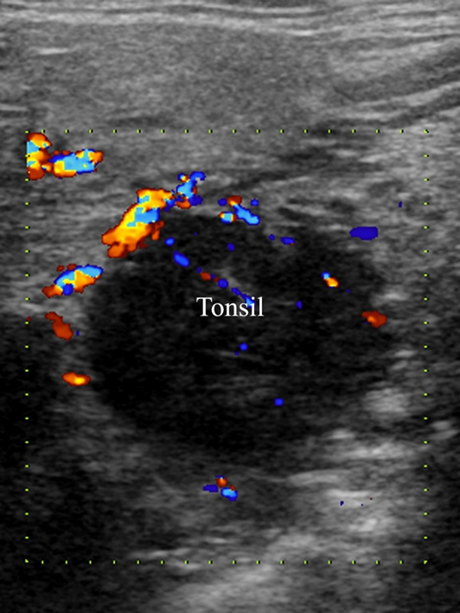
Figure 1 Ultrasound showed a hypoechoic round mass in the right tonsil with well-defined margins, homogeneous echogenicity, and rich irregular blood flow.

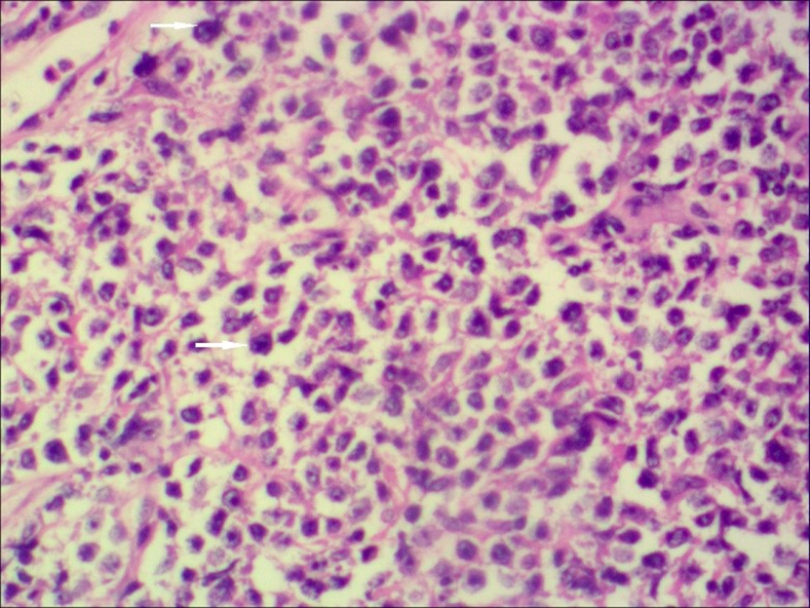
Figure 2 Photomicrograph of a diffuse large B cell lymphoma demonstrating that regional tumor cells (orange arrows) are mononuclear or multinucleated, resembling histiocytes and Reed-Sternberg cells (400 ×, hematoxylin-eosin staining).

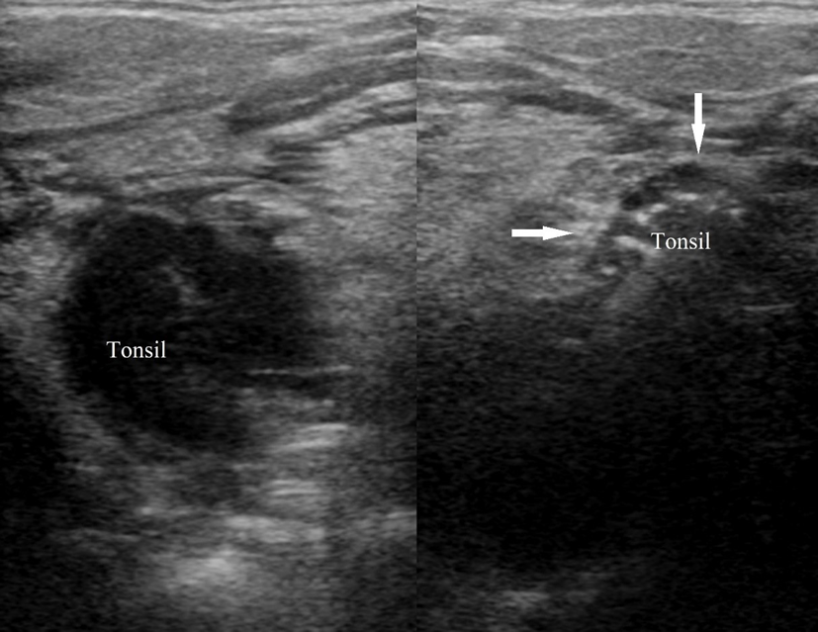
Figure 3 Comparison of bilateral tonsils. The normal tonsil (indicated by the arrows) presents as homogeneously ovoid echogenic soft tissue with stripes and linear echo inside, while the right tonsil as a hypoechoic round mass with the loss of normal striated pattern.

Published by Baishideng Publishing Group Inc
7041 Koll Center Parkway, Suite 160, Pleasanton, CA 94566, USA
Telephone: +1-925-3991568
E-mail: bpgoffice@wjgnet.com
Help Desk: https://www.f6publishing.com/helpdesk
https://www.wjgnet.com

© 2021 Baishideng Publishing Group Inc. All rights reserved.

