Topic | Item | Checklist item description | Line/Page
Title | 1 | Heterotopic Pregnancy after Assisted Reproductive Techniques with Favorable Outcome of the Intrauterine Pregnancy: A Case Report. | Lines 5-6/Page 1
Key Words | 2 | heterotopic pregnancy, assisted reproductive techniques, preterm labor, premature rupture of membranes | Lines 55-56/Page 2
Abstract | 3a | BACKGROUND: Heterotopic pregnancy (HP) is a rare condition in which both ectopic and intrauterine pregnancies occur. Heterotopic pregnancy (HP) is uncommon after natural conception but has recently received more attention due to the widespread use of assisted reproductive techniques (ART) such as ovulation promotion therapy. | Lines 30-34/Page 1
 | 3b | CASE SUMMARY: Here, we describe a case of HP that occurred after assisted reproductive techniques (ART) with concurrent tubal and intrauterine singleton pregnancies. This was treated successfully with surgery to preserve the intrauterine pregnancy, resulting in the birth of a low-weight premature infant. This case report aims to increase awareness of the possibility of HP during routine first-trimester ultrasound examinations, especially in pregnancies resulting from ART and even if multiple intrauterine pregnancies are present. | Lines 36-43/Page 2
 | 3c | CONCLUSION: This case alerts us to the importance of comprehensive data collection during regular consultations. It is important for us to remind ourselves of the possibility of HP in all patients presenting after ART, especially in women with an established and stable intrauterine pregnancy that complain of constant abdominal discomfort and also in women with an unusually raised b-hCG level compared with simplex intrauterine pregnancy. This will allow symptomatic and timeous treatment of patients with better results. | Lines 45-52/Page 2
Introduction | 4 | Ectopic pregnancies occur in 1–2% of all pregnancies1. Heterotopic pregnancy(HP) is a rare type of ectopic pregnancy that involves the coexistence of both intrauterine and ectopic pregnancies. A recently estimated incidence of HP is about 1/30 0001 in spontaneous pregnancies, increasing to 1/360 to 1/1002 in pregnancies resulting from assisted reproductive techniques (ART). ART can result in pelvic inflammatory disease (PID) which also contributes to HP. Here, we describe a case of HP after ART in a 26-year-old woman, and through a literature review of previous cases, we summarize the possible causes and related mechanisms accounting for the higher rate of HP after ART. | Lines 69-77/Page 2
Timeline | 5 | 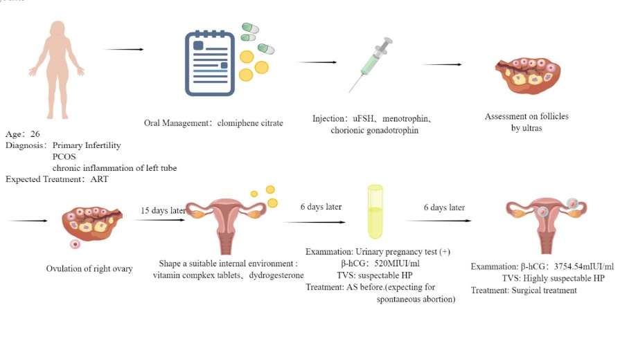 | Lines 122/Figure 1
Patient Information | 6a | A 26-year-old Chinese woman | Lines 81/Page 3
 | 6b | A 26-year-old Chinese woman presented to the gynecology clinic with a complaint that led to the suspicion of HP. | Lines 81-82/Page 3
 | 6c | Three months before, the patient presented to our reproductive department with a complaint of infertility. After a detailed examination, she was diagnosed with primary infertility, polycystic ovary syndrome (PCOS), and compound chronic inflammation of the left fallopian tube. Her husband’s semen analysis revealed mild asthenospermia. After obtaining their consent, ART was performed.  The patient was pretreated with oral medroxyprogesterone pills (2 mg per pill) given at a dose of 20 mg per day for seven days until the following menses. Controlled ovarian hyperstimulation (COH) was performed on the third day of the period with the use of clomiphene citrate pills (100 mg qd) for five days. After completion of this oral management, the controlled ovarian hyperstimulation (COH) was continued with urofollitropin for injection (uFSH) (75 units qd) for four days, with the addition of the same dose of menotrophin for the following four days. Follicle maturation was monitored by ultrasonography. After three days, instead of repeated COH by injection, the patient received further treatment with chorionic gonadotrophin given at a dose of 10 000 units and it was suggested that she had sex on that day with the expectation of natural conception.  Two days later, ovulation of the right ovary was detected on the ultrasound scan, and we suggested that the patient take vitamin complex tablets from then onward as well as dydrogesterone starting two days hence to form a habitable place for a fetus and create a suitable internal environment to nurture a growing child.  The urinary pregnancy test was positive 15 days after ovulation and the serum β-hCG level was 520 mIU/ml. A transvaginal ultrasound examination showed an intrauterine pregnancy with a 10-mm-thick endometrium at the C stage, with six follicles in the right ovary, four echoless regions in the left ovary, and mild pelvic effusion. Early intrauterine pregnancy with additional ectopic pregnancy in the right tube was strongly suspected due to the enhanced clinical clues. As the patient was strongly in favor of continuing the pregnancy, they decided to anticipate spontaneous abortion of the ectopic pregnancy and treated the intrauterine pregnancy as before.  Six days later, the follow-up serum β-hCG level was 3754.54 mIU/mL and transvaginal sonography reexamination showed an intrauterine singleton without a clearly visible yolk sac and multiple echoless areas in the bilateral adnexa. Finally, after another six days had passed, the detection of an intrauterine gestational sac (GS) of 14*6.0 mm, an embryonic bud of 3 mm, an embryonic heartbeat, and a gestational sac (GS) of 9*7 mm with a yolk sac beside the right ovary confirmed the presence of HP. These findings combined with the clinical factors provided the main indications for surgery. (Figure 1) Having taken our advice, the patient (1 gravida, 0 para) presented to the gynecology clinic. | Lines 85-121/Page 3
Physical Exam | 7 | Body temperature, 36.5℃; blood pressure, 115/85 mmHg; heart rate, 97 beats per min; respiratory rate, 19 breaths per min. | Lines129-131/Page 4
Diagnostic Assessment | 8a | The human chorionic gonadotropin (HCG) level was 20 295.14 mIU/ml. An intrauterine gestational sac appropriate for seven weeks of pregnancy was seen on transvaginal sonography. (Figure 2) Both ovaries were larger than normal, with dimensions of 11*5 cm for the right and 8*4 cm. A mass in the right ovary suggested the presence of an ectopic pregnancy. (Figure 3) | Lines133-140/Page 4
 | 8b | Combined with the patient’s medical history and intraoperative findings, the final diagnosis was HP. | Lines164-165/Page 6
 | 8c | 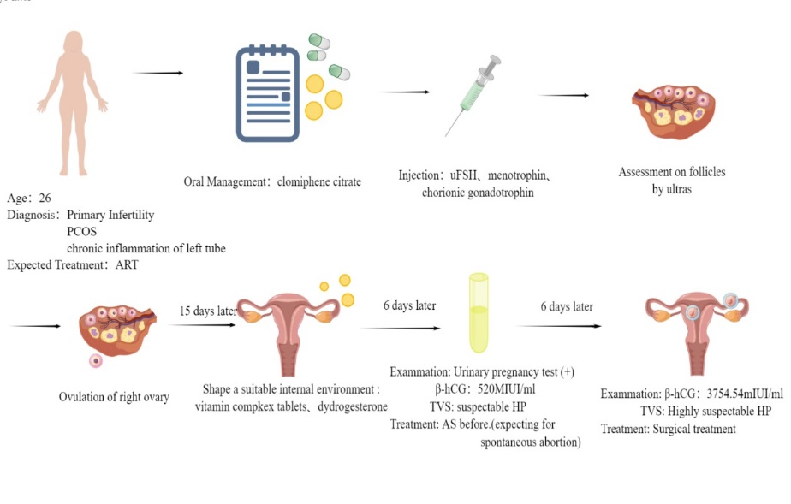 | Lines144-146/Page 5
 | 8d | The reexamined ultrasound showed the same tip as before. | Not Applicable
Interventions | 9a | Laparoscopic surgery | Lines 149/Page 5
 | 9b | Ceftizoxime Sodium injection( 0.2g bid) to prevent inflammation | Lines 157-158/Page 6
 | 9c | Discontinue the Ceftizoxime Sodium due to normal level of WBC’ status in the reexamined routine blood test. | Lines 158-159/Page 6
 | 9d | Change the wound dressing regularly. | Not Applicable
Follow-up and Outcomes | 10a | The patient recovered well during the remaining hospitalization and her reexamination by transvaginal sonography was satisfactory. (Figure 4) | Lines 159-160/Page 6
 | 10b | Postpartum course was unremarkable for the mother as well. | Not Applicable
 | 10c | .The patient’s obstetric follow-ups and fetal assessments were normal showing good fetal growth of her intrauterine singleton. The course of pregnancy was unremarkable until the patient experienced contractions at 30+5 weeks of gestation. She was admitted to the hospital and, after confirming premature rupture of membranes, cervical effacement, and complete cervical dilatation, we continued with the delivery process, resulting in a baby boy with a birth weight of 1430 g. He was admitted to the neonatal unit. The postpartum course was uneventful for both the mother and baby. | Lines 171-177/Page 6
Discussion | 11a | This case report collects a relatively complete process of heterotopic pregnancy after Assisted Reproductive Techniques and notes the follow-up diagnostic evaluations, which gives clinical support for further related research. | Discussion / Page 6
 | 11b | The differences in HP incidence between natural HP and HP after in vitro fertilization and embryo transfer cycles (IVF-ET) are apparent and present an additional problem, namely, how to explain this phenomenon and how to prevent it. To answer this question, we first need to understand the ART procedure itself, which includes all clinical fertility treatments. During the steps described above, there are several factors that predispose to higher rates of HP in pregnant women after ART. | Lines 183-201/Page 7
 | 11c | It’s important for us to remind ourselves of the possibility of HP in all patients presenting after ART, in women with an established and stable intrauterine pregnancy but constantly complaining of abdominal discomfort and also in women with an unusual raised b-hCG level compared to simplex intrauterine pregnancy. | Lines 204-256/Page 8
 | 11d | After knowing the principles, we can carry out treatment for patients more symptomatically with less time and better result. | Lines 257-287/Page 8
Patient Perspective | 12 | The patient became a mother following ART procedures though by a tortuous road. She felt grateful for all the things and thought the baby boy a not bad result. | Line177/Page 6
Informed Consent | 13 | Before any operation, We had taken sufficient and detailed communication with the patient herself and her medical authorizer. | Line89/Page 3
Additional Information | 14 | All of the authors contributed to the conception of the case report. All of the authors performed literature searches and selected the studies and reviews discussed in the manuscript. All authors read and approved the final manuscript. The authors declare that they have no competing interests. | Line16-18/Page 1

