Name of journal: World Journal of Gastroenterology
ESPS Manuscript NO: 15404
Columns: ORIGINAL ARTICLE

Clinical Trials Study
SLITRK3 expression correlation to gastrointestinal stromal tumor risk rating and prognosis

Wang CJ et al. SLITRK3 in GIST risk ratin, prognosis

Chao-Jie Wang, Zi-Zhen Zhang, Jia Xu, Ming Wang, Wen-Yi Zhao, Lin Tu, Chun Zhuang, Qiang Liu, Yan-Yin Shen, Hui Cao, Zhi-Gang Zhang

Chao-Jie Wang, Zi-Zhen Zhang, Jia Xu, Ming Wang, Wen-Yi Zhao, Lin Tu, Chun Zhuang, Hui Cao, Department of General Surgery, Ren Ji Hospital, School of Medicine, Shanghai Jiao Tong University, Shanghai 200127, China

Qiang Liu, Yan-Yin Shen, Department of Pathology, Ren Ji Hospital, School of Medicine, Shanghai Jiao Tong University, Shanghai 200127, China

Chao-Jie Wang, Zhi-Gang Zhang, State Key Laboratory of Oncogenes and Related Genes, Shanghai Cancer Institute, Ren Ji Hospital, School of Medicine, Shanghai Jiao Tong University, Shanghai 200240, China

Author contributions: Wang CJ, Zhang ZZ contributed equally to this study, Co-first author; Wang CJ and Zhang ZZ participated in data collection and analysis, wrote the manuscript; Xu J, Wang M, Zhao WY, Tu L, Zhuang C Liu Q and Shen YY participated in data collection and help to perform the statistical analysis; Cao H and Zhang ZG conceived of the study, participated in its design and provided the critical revision; all authors read and approved the final manuscript.
Supported by National Natural Science Foundation of China General Program, No. 81272743; Shanghai City Committee of Science and Technology Key Project, No. 11411950800; and Key Discipline Project of Renji Hospital, Shanghai Jiaotong University School of Medicine, No. RJ4101304.

Ethics approval: Clinical materials and samples were obtained with approval from the Ethical Committees, Renji Hospital, and Shanghai Jiaotong University School of Medicine.

Clinical trial registration: The clinical investigation was carried out in accordance with the principles expressed in the Declaration of Helsinki.

Informed consent: Written informed consents were obtained from all participants.

Conflict-of-interest: No potential conflicts of interest relevant to this article were reported.

Data sharing: No additional data are available.

Open-Access: This article is an open-access article which was selected by an in-house editor and fully peer-reviewed by external reviewers. It is distributed in accordance with the Creative Commons Attribution Non Commercial (CC BY-NC 4.0) license, which permits others to distribute, remix, adapt, build upon this work non-commercially, and license their derivative works on different terms, provided the original work is properly cited and the use is non-commercial. See: http://creativecommons.org/licenses/by-nc/4.0/

Correspondence to: Hui Cao, MD, Department of General Surgery, Ren Ji Hospital, School of Medicine, Shanghai Jiao Tong University, 1630 Dong fang Road, Shanghai 200127, China. caohuimedsci@126.com
Telephone: +86-21-68383711
Fax: +86-21-58394262
Received: November 25, 2014
Peer-review started: November 26, 2014
First decision: January 8, 2015
Revised: February 13, 2015
Accepted: April 28, 2015

Article in press:
Published online:

Abstract
AIM: To assess the influence of SLIT and NTRK-like family member 3 (SLITRK3) on the prognosis of gastrointestinal stromal tumor (GIST) and determine whether SLITRK3 can help improve the current risk stratification systems.

METHODS: We hypothesized that SLITRK3 could be used as a prognostic molecular biomarker for GIST. 35 fresh tumor samples and 417 paraffin-embedded specimens from GIST patients wereutilized. SLITRK3 mRNA expression in GIST tumor tissues was detected by Real-time polymerase chain reaction and SLITRK3 protein levels estimated by immunohistochemistry. The correlation of SLITRK3 expression with various tumor clinicopathological charactristics and follow-up data were analyzed.

RESULTS: GIST tumors had high expression of SLITRK3 compared with adjacent normal tissues and the expression level gradually increased with risk grade. SLITRK3 protein expression was closely associated with gastrointestinal bleeding, tumor site, tumor size, mitotic index and National Institutes of Health (NIH) classification. Survival analysis showed that SLITRK3 expression was closely correlated with overall survival and disease free survival of GIST patients. Multivariate analysis also identified SLITRK3 expression together with mitotic index and NIH stage as significant risk factors of GIST recurrence.

CONCLUSION: SLITRK3 expression is a highly significant predictor of GIST recurrence and metastasis. Combinations of SLITRK3 and NIH stage have strong predictive and prognostic value, and are feasible markers for clinical practice in gastrointestinal stromal tumor.

Key words: SLITRK3; Gastrointestinal stromal tumor; Biomarkers; Non-epithelial tumors; Risk stratification
© The Author(s) 2015. Published by Baishideng Publishing Group Inc. All rights reserved.

Core tip: Prognostic biomarkers are required to refine risk stratification treatment strategies for gastrointestinal stromal tumor (GIST). In this study, we hypothesized that SLIT and NTRK-like family member 3 (SLITRK3) could be used as a prognostic molecular biomarker for GIST. The results indicated that SLITRK3 expression is a highly significant predictor of GIST recurrence and metastasis. Combinations of SLITRK3 and NIH stage have strong predictive and prognostic value, and are feasible markers for clinical practice in gastrointestinal stromal tumor.

Wang CJ, Zhang ZZ, Xu J, Wang M, Zhao WY, Tu L, Zhuang C, Liu Q, Shen YY, Cao H, Zhang ZG. SLITRK3 expression correlation to gastrointestinal stromal tumor risk rating and prognosis. World J Gastroenterol 2015; In press

INTRODUCTION
Gastrointestinal stromal tumors (GISTs) are the most common non-epithelial tumors^{[1]} and the most common type of gastrointestinal cancer following gastric and colorectal cancer^{[1-4]}. Surgery is the primary treatment option but patients suffers from high-rates of tumor recurrence or metastasis resulting in death. The majority of GISTs result from activating mutations in c-KIT and alpha-type platelet-derived growth factor receptor (PDGFRA)^{[5]}. Recent studies have shown that adjuvant therapy with imatinib, a small molecule tyrosine kinase inhibitor, can prolong both survival and time to metastasis following surgery^{[6]}. However, most micro-GISTs (less than 1 cm in diameter) have little malignancy potential despite the presence of a KIT or PDGFRA mutation^{[7]}. Furthermore, a 2002 risk assessment for aggressive GISTs showed that tumor growth rates can be affected by numerous factors^{[8]}. Together, this demonstrates the need for additional prognostic molecular biomarkers to better characterize tumor prognosis and guide treatment strategy.
Secretion of transmitters and hormones is regarded as a hallmark of neuroendocrine cells and tumors. Synaptic-like micro vesicle proteins such as amphiphysin, synaptic vesicle protein, SV2 and synapsin 1 are found in a majority of GISTs^{[9]}. Expression of these proteins enable GISTs to secrete neurotransmitters or hormones suggesting that GISTs adopt a neuroendocrine phenotype. SLITRK3 is one of the six isoforms of Slit and neurotropic tyrosine receptor kinase (NTRK)-like family member (Slitrk1-6) which are neuronal transmembrane proteins that control neurite growth^{[10]}. Recently, SLITRK3 has been identified as a postsynaptic adhesion molecule that selectively regulates inhibitory synapse development and is important for normal functional GABAergic synapse development^{[11]}. GABA is a key inhibitory neurotransmitter and mediates synaptic transmission, neural network development^{[12]} and is involved in digestive diseases such as esophageal reflux and gastric cancer^{[13-15]}. GISTs may originate from the interstitial cells of Cajal (ICCs) with pacemaker potentials suggesting that mutations in genes involved in synapse or neural development may underlie GIST behavior^{[9]}. In agreement with this we have previously found that the expression of SLITRK3 was increased in high-risk group compared to a low-risk group (unpublished data) and Milde et al^{[16]} showed higher SLITRK3 expression levels in lymphoma.
The aim of this study was to assess the influence of SLITRK3 on the prognosis of GIST and determine whether SLITRK3 can help improve the current risk stratification systems. We hypothesized that up-regulation of SLITRK3 is strongly associated with high recurrence risk and poor prognosis in GIST patients. We tested this by using qRT-PCR and immunohistochemistry on GIST samples and examining the relationship to patient outcome.

MATERIALS AND METHODS
Patients and samples
Formalin-ﬁxed parafﬁn-embedded (FFPE) tissue sections were collected from GIST patients who underwent surgeries at Renji Hospital, Shanghai Jiaotong University School of Medicine, China from 2004 to 2012. The inclusion criteria for this study were as follows: (1) primary GIST cases with definite pathologic diagnosis as described before^{[17]}; (2) all cases received surgical resection; and (3) no reoccurrence or metastasis detected. The exclusion criteria were: (1) chemotherapy, radiotherapy, or other anti-tumor therapies before surgery; and (2) incomplete clinicopathologic data. A total of 417 tumor tissue samples, with tumor adjacent normal tissues available for 139 were collected.
All cases were divided into four groups according to the risk table published by the National Institutes of Health (NIH, Table 1)^{[8]}. Tissue microarray and immunohistochemical staining were performed to access the expression levels of SLITRK3 in these samples. The follow-up data, including survival, reoccurrence or metastasis as reexamination results, was obtained from outpatient medical records or from patients and their relatives by telephone interview using a follow-up questionnaire.
Additionally, 35 fresh frozen GIST specimens were obtained between 2010 and 2012 from GIST patients who received surgical resection at Renji Hospital, Shanghai Jiaotong University School of Medicine, China. The samples were used for qRT-PCR detection of SLITRK3 expression.

Tissue microarray construction

Tissue microarrays were constructed by Suzhou Xinxin Biotechnology Co., Ltd (Xinxin Biotechnology Co, Suzhou, China). First, 139 GIST tissues with paired tumor adjacent normal tissues were used to construct 3 microarrays while the other 278 GIST tissues were used to construct another 4 microarrays. Tissue paraffin blocks of GIST samples were stained with hematoxylin-eosin to confirm the diagnoses and marked at fixed points with most typical histological characteristics under a microscope. Two 1.6-mm cores per donor block were transferred into a recipient block tissue microarray and each dot array contained fewer than 160 dots. Three-micron-thick sections were cut from the recipient block and transferred to glass slides with an adhesive tape transfer system for ultraviolet cross linkage.

Immunohistochemistry
The slides were baked at 56 ºC for 1hour, de-paraffinized in xylene for 20 min, and rehydrated through a graded series of ethanol concentrations (5 min in 100% ethanol followed by 5 min in 70% ethanol). Antigen retrieval was performed in a pressure cooker for 10 min with 0.01 mol/L sodium citrate buffer (pH 6.0). The endogenous peroxidase activity was quenched with 0.3% hydrogen peroxide in methanol at 37 ºC for 30 min. Next, an SLITRK3 antibody (NBP1-93619, Novus Biologicals, Colorado, United States, concentration 1:100) was applied to cover the specimens overnight at 4 ºC, and this was followed by incubation with a labeled polymer-HRP anti-rabbit secondary antibody (Dako, CA, United States) for 30 min at room temperature. Staining was detected with diaminobenzidine (Thermo, MA, United States) as chromogen and counterstained with hematoxylin prior to coverslipping. The staining intensity and the percentage of positive cells were recorded by two pathologists of Renji Hospital (Qiang Liu and Yanying Shen) and a consensus score was obtained for each slide. Immunohistochemical scoring was categorized as follows: (1) The staining intensity was scored from 0 to 3 as 0 for no staining, 1 for weak staining, 2 for moderate staining and 3 for strong staining; (2) The staining area was also graded into 0-3 levels as 0 for no staining area, 1 for extent to less than 1/3, 3 for more than 2/3 and 2 for in between; and (3) The immunohistochemical classification was based on the sum of intensity and extent score: 0 as negative(-), 1-2 as weakly positive(+), 3-4 as positive(++) and 5-6 as strongly positive(+++). And we further ranked the protein level into two classes as (-), (+) for SLITRK3 low expression while (++), (+++) for SLITRK3 high expression.

RNA extraction and RT-PCR conditions
Total RNA was extracted from fresh frozen GIST specimens and GIST cells using RNAiso Plus (Takara, Dalian, China) according to the manufacturer’s instructions. RNA quantity and quality were measured by NanoDrop 2000 (NanoDrop, DE, United States). RNA integrity was assessed by standard denaturing agarose gel electrophoresis. The reverse-transcription reactions were performed with Prime Script® RT Master Mix (Takara, Dalian, China) according to the manufacturer’s instructions. The first-strand cDNA was synthesized from 2 μg of total RNA.

Quantitative real-time PCR

All qRT-PCR primer sequences were obtained from the Primer Bank database (http://pga.mgh.harvard.edu/primerbank/), the details are shown in Table 2. Relative quantification of cDNA samples were measured by the SYBR-Green method in a final volume of 20 μL with Power SYBR® Green PCR Master Mix (Applied Biosystems, NY, USA) according to the manufacturer’s instructions. All reactions were performed on ABI ViiA™ 7 Real-Time PCR System (Applied Biosystems, NY, United States) in triplicate and the results were analyzed by ViiA™ 7 software. The 2^{-△Ct} method was used to quantify the relative gene expression levels and 18S was used for normalization.

Statistical analysis
For comparisons, one-way analyses of variance, Wilcoxon signed rank test, and chi-squared tests were performed where appropriate. Kaplan-Meier curves were used to visualize biomarker expression, and NIH risk stage with respect to overall survival (OS) and disease-free survival (DFS) data. Univariate and multivariate analyses were based on the Cox proportional hazards regression model. Only those factors with statistically significant (P < 0.05) in univariate analysis had access to the next multivariate analyses. Statistical analyses were all performed using SPSS 19.0 software (Chicago, IL, United States). All statistical tests were 2-sided, and P-value differences < 0.05 were considered statistically significant. All the statistical analysis has been reviewed and confirmed by Zhigang Zhang.

RESULTS

Patient and tumor characteristics
The detailed clinicopathological data is shown in Table 3. Of the 417 paraffin-embedded GIST tissue samples the predominant cell types were spindle cell (n = 271; 65.0%), epithelioid cell (n = 54; 12.9%) and mixed (n = 92; 22.1%). The maximum tumor diameter detected in GIST patients ranged from 0.5 to 30 cm (median: 5.5 cm). Risk stratification was performed according to the NIH risk classification and suggested that there were 33 (7.9%) very low-risk cases, 154 (36.9%) low-risk cases, 67 (16.1%) intermediate-risk cases, and 163 (39.1%) high-risk cases.

GIST tumors have high expression of SLITRK3 protein compared with adjacent normal tissues
We performed immunohistochemistry in 139 GIST tissue samples which had both tumor (T) and adjacent non-tumor (N) tissue to determine if expression levels of SLITRK3 differed between tumor and non-tumor tissue. The results showed that SLITRK3 protein was expressed at different levels in different tissue samples and was divided into four classes as described in materials and methods (Figure 1A). Most of the adjacent non-tumor tissues were (-) or (+), while most tumor samples ranged from (+) to (+++) (Figure 1B and Table 4), indicating higher SLITRK3 protein levels in tumor samples. The difference between tumor and the paired adjacent normal tissues (T-N), ranging from −1 to 3 (as (-) for 0 and (+++) for 3), revealed that SLITRK3 expression was increased in 76.3% (100/131) of GIST tumors where (T-N > 0) (Figure 1C). Wilcoxon signed rank test further confirmed that GIST tumors have a significantly higher expression of SLITRK3 protein than adjacent normal tissues tumor samples (P < 0.001).

SLITRK3 protein expression level is closely correlated with the clinicopathological factors in GIST
To better understand the significance of SLITRK3 expression in GIST tumor tissues we expanded the tissue microarray sample size to 417 cases (4 cases were off-chip and not included in the statistics). Among the 413 GIST tumor tissues, SLITRK3 staining was strongly positive (+++) in 85 cases (20.6%), positive (++) in 142 cases (34.4%), weakly positive (+) in 112 cases (27.1%), and negative (-) in 74 cases (17.9%). We then ranked the protein level into two classes: (-), (+) for low expression and (++), (+++) for high expression to further investigate the relationship between SLITRK3 and clinicopathological factors in GIST. Chi-square test revealed that the SLITRK3 protein level was not associated with gender, age, predominant cell type, but was closely related with gastrointestinal bleeding, primary tumor site, primary tumor size, mitotic index, and NIH classification; the details are shown in Table 5.

SLITRK3 mRNA expression is up-regulated in fresh tumor tissues with higher NIH risk
To further confirm the SLITRK3 expression in GIST the relative expression levels of SLITRK3 mRNAs were analyzed by qRT-PCR in 35 fresh GISTs samples. The relative expression level of SLITRK3 mRNA in low risk group (n = 13), intermediate risk group (n = 10) and high risk group (n = 12) were 0.002 ± 0.002, 0.008 ± 0.009, and 0.011 ± 0.009, respectively, indicating a gradually increasing trend. The SLITRK3 expression in GIST tumor tissues of the intermediate and high risk groups were significantly higher than those of the low-risk group (P = 0.003 and P = 0.044) (Figure 2).

SLITRK3 is a predictor for poor prognosis in GIST patients
The relationship between SLITRK3 expression and overall survival (OS) or disease-free survival (DFS) in GIST patients was investigated. All 398 cases with complete follow-up data were classified into four classes according to SLITRK3 expression levels and were calculated according to the Kaplan-Meier method. The 5-year OS rates decreased successively from 100% in (-), 99.0% in (+), 86.7% in (++) to 57.4% in (+++) (Log-Rank-test, P < 0.001) (Figure 3A). Meanwhile, the 5-year DFS rates also decreased successively form 91.7% in (-), 78.6% in (+), 71.6% in (++) to 41.8% in (+++) (Log-Rank-test, P < 0.001) (Figure 3B).
To further investigate whether SLITRK3 can be used as an independent predictor associated with poor prognosis in GIST, univariate and multivariate analysis were performed. Univariate analysis revealed that primary tumor size, mitotic index, NIH stage and SLITRK3 expression were significantly associated with OS (Table 6). Univariate analysis revealed that primary tumor site, primary tumor size, mitotic index, NIH stage and SLITRK3 expression were significantly associated with DFS. Detailed data are shown in (Table 7).
Only those factors with statistically significant relationships with DFS in the univariate analysis were entered in the Cox’s proportional-hazard model for multivariate analysis (Table 8). The NIH stage is based on primary tumor site, tumor size, and mitotic index and correlated with each of them strongly, so we developed 3 models for multivariate analysis. In model A, analysis included NIH stage without SLITRK3 expression, while in model B analysis included SLITRK3 expression instead of NIH stage, and both of them are analyzed in model C. In model A, primary tumor site, mitotic index and NIH stage were statistically significant indicators of poor DFS and model B showed that SLITRK3 expression is also a significant indicator of poor DFS. Importantly, in model C SLITRK3 expression but not NIH stage was an independent risk factor for GIST recurrence.

SLITRK3 index is helpful to improve the accuracy of NIH risk stratification system
In order to find out whether SLITRK3 can help to improve the NIH stage, we further investigated a subgroup of 152 high risk cases. The Kaplan–Meier analysis revealed that 5 years DFS rate in SLITRK3 (+++) group was significantly lower than the others (20.3% vs 52.7%, Log-Rank-test, P = 0.018) (Figure 4).
Furthermore, we found that 71 patients suffered from disease recurrence, mostly with an original high NIH risk rating. Kaplan–Meier curve analysis based on SLITRK3 expression of these patients showed that 1-year and 3-year OS rates in SLITRK3 (-), (+), (++) group was 83.3% and 61.7%; and in SLITRK3 (+++) group was 58.5% and 9.7% respectively (Log-Rank-test, P =0.003) (Figure 5).

DISCUSSION
In the current study we examined the correlation between SLITRK3 and GLIST behavior and survival. We found that SLITKR3 was expressed more highly in tumor tissue, correlated well with clinicopathological features and predicted poor survival in patients. Most Importantly, increasing SLITKR3 expression correlated with decreased overall survival and disease-free survival.
Currently, risk stratification schemes for operable GIST, such as the NIH consensus criteria, modified consensus criteria and AFIP-Miettinen criteria, all depend on tumor site, tumor size and mitosis index^{[8,18-20]}. Mitosis count is one of the most valuable prognostic factors in GIST but it has limitations and its reliability is controversial^{[21]}. Observation of mitosis can be subjective, time consuming, affected by the high power field (HPF) area of the microscope and by tissue fixation time. A previous study using l6 different pathologists and different microscopes resulted in a wide counting range from the same sample^{[22]}. Moreover, according to current risk stratification abrupt changes can occur in estimating risks of recurrence when tumor size or mitosis index is close to a cutoff value. This is especially important due to the existence of small and mitotically inactive malignant GISTs^{[1,23,24]}. Together this suggests that the current risk criteria can be improved significantly.
We found that the clinical measures in our study, including age, sex, tumor size and mitoses index, were all familiar with previously reported studies^{[21,25-27]}. The patients who suffered from disease recurrence or death were mainly from the high-risk group. The 5-year OS and DFS rate of our data base were 85.0% and 69.4%, compared with 72.3% and 70.5% from a large multicenter, retrospective analysis of clinical published on the Lancet Oncology 2012.^{[21]} The better 5-year OS rate of our study might reflect differences in standardized treatment and the use of IM adjuvant therapy.
SLITRK3 is expressed predominantly in neural tissues and has neurite-modulating activity^{[28]}. However the function of SLITRK3 in solid tumors is poorly studied. In our previous study (unpublished data), the expression of SLITRK3 was monotonically increasing from low-risk group to high-risk group. We found that SLITRK3 was also up-regulated in tumor compared to non-tumor tissue by using immunohistochemistry and qRT-PCR. This finding is in agreement with Milde et al^{[16]} who demonstrated that SLITRK3 was up-regulated in lymphoma. SLITRK3 expression was also associated with a higher incidence of GI bleeding, a common symptom of GIST and a good indicator for high-risk patients^{[29,30]}. Furthermore, SLITRK3 expression correlated with NIH risk classification, reduced overall survival and disease-free progression suggesting that elevated expression of SLITRK3 is a good tumor biomarker candidate particularly for aggressive GISTs.
The function and mechanism of SLITRK3 protein in the malignant processes of GIST it still unclear, necessitating the need for experiments both in vitro and in vivo. However, it is most likely that there are other potential GIST risk-related genes as suggested by our previous Gene microarray (unpublished data). In agreement with this, potassium channel tetramerization domain containing protein 10 (KCTD10) has been shown to correlate with GIST prognosis^{[31]}. Future studies and identification of novel prognostic biomarkers will help further stratify risk groups and direct treatment strategies for GIST.
Our detailed analysis showed that SLITRK3 mRNA expression level increased according to NIH risk classification. We found that SLIRTK3 protein level was closely associated with tumor site, tumor size and mitotic index. As the current risk stratification schemes are mainly based on these three features, it is not surprising that up-regulation of SLIRTK3 is strongly associated with a high-risk NIH grade. However, we found that NIH stage was a significant unfavorable factor for OS in univariate analysis but not multivariate analysis. This suggests that the current NIH criteria is very likely not an optimal prognostic tool. We found that under all circumstances SLITRK3 expression was a significant predictor of poor prognosis. Therefore, we believe that the combination of SLITRK3 expression and NIH criteria will better stratify postoperative GIST patients. Many patients with operable GIST can be cured by surgery alone and may not benefit from the IM adjuvant therapy. Given the expense of IM adjuvant therapy and side effects^{[32]}, improved selection of patients for adjuvant therapy will be of clinical benefit. Due to the poor prognosis and reduced OS we strongly suggest that patients with high SLITRK3 expression, especially those who also are in the NIH high-risk groups, receive IM adjuvant therapy and a close follow-up management after surgery.
In conclusion, we have identified SLITRK3 as a novel prognostic molecular biomarker that may help guide treatment of GIST.

COMMENTS
Background
Recent studies have shown that adjuvant therapy with imatinib, a small molecule tyrosine kinase inhibitor, can prolong both survival and time to metastasis following surgery. However, most micro-gastro intestinal stromal tumour (GIST) (less than 1 cm in diameter) have little malignancy potential despite the presence of a KIT or PDGFRA mutation. Furthermore, a 2002 risk assessment for aggressive GISTs showed that tumor growth rates can be affected by numerous factors.

Research frontiers
In agreement with this we have previously found that the expression of SLIT and NTRK-like family member 3 (SLITRK3) was increased in high-risk group compared to a low-risk group (unpublished data) and Milde et al showed higher SLITRK3 expression levels in lymphoma.

Innovations and breakthroughs
The authors hypothesized that up-regulation of SLITRK3 is strongly associated with high recurrence risk and poor prognosis in GIST patients. We tested this by using qRT-PCR and immunohistochemistry on GIST samples and examining the relationship to patient outcome.

Applications
The authors have identified SLITRK3 as a novel prognostic molecular biomarker that may help guide treatment of GIST.

Peer-review
In this study the authors aimed to assess the influence of SLITRK3 on the prognosis of GIST and determine whether different degrees of SLITRK3 expression were significantly associated with overall survival and whether this can help to improve the current risk stratification systems according to tables published by the National Institutes of Health for GIST.

REFERENCES
1 Nilsson B, Bümming P, Meis-Kindblom JM, Odén A, Dortok A, Gustavsson B, Sablinska K, Kindblom LG. Gastrointestinal stromal tumors: the incidence, prevalence, clinical course, and prognostication in the preimatinib mesylate era--a population-based study in western Sweden. Cancer 2005; 103: 821-829 [PMID: 15648083 DOI: 10.1002/cncr.20862]
2 Tryggvason G, Gíslason HG, Magnússon MK, Jónasson JG. Gastrointestinal stromal tumors in Iceland, 1990-2003: the icelandic GIST study, a population-based incidence and pathologic risk stratification study. Int J Cancer 2005; 117: 289-293 [PMID: 15900576 DOI: 10.1002/ijc.21167]
3 Goettsch WG, Bos SD, Breekveldt-Postma N, Casparie M, Herings RM, Hogendoorn PC. Incidence of gastrointestinal stromal tumours is underestimated: results of a nation-wide study. Eur J Cancer 2005; 41: 2868-2872 [PMID: 16293410 DOI: 10.1016/j.ejca.2005.09.009]
4 Rubió J, Marcos-Gragera R, Ortiz MR, Miró J, Vilardell L, Gironès J, Hernandez-Yagüe X, Codina-Cazador A, Bernadó L, Izquierdo A, Colomer R. Population-based incidence and survival of gastrointestinal stromal tumours (GIST) in Girona, Spain. Eur J Cancer 2007; 43: 144-148 [PMID: 17055254 DOI: 10.1016/j.ejca.2006.07.015]
5 Hirota S. Gastrointestinal stromal tumors: their origin and cause. Int J Clin Oncol 2001; 6: 1-5 [PMID: 11706520]
6 Corless CL, Ballman KV, Antonescu CR, Kolesnikova V, Maki RG, Pisters PW, Blackstein ME, Blanke CD, Demetri GD, Heinrich MC, von Mehren M, Patel S, McCarter MD, Owzar K, DeMatteo RP. Pathologic and molecular features correlate with long-term outcome after adjuvant therapy of resected primary GI stromal tumor: the ACOSOG Z9001 trial. J Clin Oncol 2014; 32: 1563-1570 [PMID: 24638003 DOI: 10.1200/JCO.2013.51.2046]
7 Demetri GD, Benjamin RS, Blanke CD, Blay JY, Casali P, Choi H, Corless CL, Debiec-Rychter M, DeMatteo RP, Ettinger DS, Fisher GA, Fletcher CD, Gronchi A, Hohenberger P, Hughes M, Joensuu H, Judson I, Le Cesne A, Maki RG, Morse M, Pappo AS, Pisters PW, Raut CP, Reichardt P, Tyler DS, Van den Abbeele AD, von Mehren M, Wayne JD, Zalcberg J. NCCN Task Force report: management of patients with gastrointestinal stromal tumor (GIST)--update of the NCCN clinical practice guidelines. J Natl Compr Canc Netw 2007; 5 Suppl 2: S1-29; quiz S30 [PMID: 17624289]
8 Fletcher CD, Berman JJ, Corless C, Gorstein F, Lasota J, Longley BJ, Miettinen M, O'Leary TJ, Remotti H, Rubin BP, Shmookler B, Sobin LH, Weiss SW. Diagnosis of gastrointestinal stromal tumors: A consensus approach. Hum Pathol 2002; 33: 459-465 [PMID: 12094370]
9 Bümming P, Nilsson O, Ahlman H, Welbencer A, Andersson MK, Sjölund K, Nilsson B. Gastrointestinal stromal tumors regularly express synaptic vesicle proteins: evidence of a neuroendocrine phenotype. Endocr Relat Cancer 2007; 14: 853-863 [PMID: 17914114 DOI: 10.1677/ERC-06-0014]
10 Aruga J, Mikoshiba K. Identification and characterization of Slitrk, a novel neuronal transmembrane protein family controlling neurite outgrowth. Mol Cell Neurosci 2003; 24: 117-129 [PMID: 14550773]
11 Takahashi H, Katayama K, Sohya K, Miyamoto H, Prasad T, Matsumoto Y, Ota M, Yasuda H, Tsumoto T, Aruga J, Craig AM. Selective control of inhibitory synapse development by Slitrk3-PTPδ trans-synaptic interaction. Nat Neurosci 2012; 15: 389-98, S1-2 [PMID: 22286174 DOI: 10.1038/nn.3040]
12 Akerman CJ, Cline HT. Refining the roles of GABAergic signaling during neural circuit formation. Trends Neurosci 2007; 30: 382-389 [PMID: 17590449 DOI: 10.1016/j.tins.2007.06.002]
13 Herman MA, Alayan A, Sahibzada N, Bayer B, Verbalis J, Dretchen KL, Gillis RA. micro-Opioid receptor stimulation in the medial subnucleus of the tractus solitarius inhibits gastric tone and motility by reducing local GABA activity. Am J Physiol Gastrointest Liver Physiol 2010; 299: G494-G506 [PMID: 20489046 DOI: 10.1152/ajpgi.00038.2010]
14 Ren LH, Chen WX, Qian LJ, Li S, Gu M, Shi RH. Addition of prokinetics to PPI therapy in gastroesophageal reflux disease: a meta-analysis. World J Gastroenterol 2014; 20: 2412-2419 [PMID: 24605040 DOI: 10.3748/wjg.v20.i9.2412]
15 Matuszek M, Jesipowicz M, Kleinrok Z. GABA content and GAD activity in gastric cancer. Med Sci Monit 2001; 7: 377-381 [PMID: 11386012]
16 Milde T, Shmelkov SV, Jensen KK, Zlotchenko G, Petit I, Rafii S. A novel family of slitrk genes is expressed on hematopoietic stem cells and leukemias. Leukemia 2007; 21: 824-827 [PMID: 17268530 DOI: 10.1038/sj.leu.2404525]
17 Poveda A, del Muro XG, López-Guerrero JA, Martínez V, Romero I, Valverde C, Cubedo R, Martín-Broto J. GEIS 2013 guidelines for gastrointestinal sarcomas (GIST). Cancer Chemother Pharmacol 2014; 74: 883-898 [PMID: 25193432 DOI: 10.1007/s00280-014-2547-0]
18 Miettinen M, Lasota J. Gastrointestinal stromal tumors: pathology and prognosis at different sites. Semin Diagn Pathol 2006; 23: 70-83 [PMID: 17193820]
19 Joensuu H. Risk stratification of patients diagnosed with gastrointestinal stromal tumor. Hum Pathol 2008; 39: 1411-1419 [PMID: 18774375 DOI: 10.1016/j.humpath.2008.06.025]
20 Gold JS, Gönen M, Gutiérrez A, Broto JM, García-del-Muro X, Smyrk TC, Maki RG, Singer S, Brennan MF, Antonescu CR, Donohue JH, DeMatteo RP. Development and validation of a prognostic nomogram for recurrence-free survival after complete surgical resection of localised primary gastrointestinal stromal tumour: a retrospective analysis. Lancet Oncol 2009; 10: 1045-1052 [PMID: 19793678 DOI: 10.1016/S1470-2045(09)70242-6]
21 Joensuu H, Vehtari A, Riihimäki J, Nishida T, Steigen SE, Brabec P, Plank L, Nilsson B, Cirilli C, Braconi C, Bordoni A, Magnusson MK, Linke Z, Sufliarsky J, Federico M, Jonasson JG, Dei Tos AP, Rutkowski P. Risk of recurrence of gastrointestinal stromal tumour after surgery: an analysis of pooled population-based cohorts. Lancet Oncol 2012; 13: 265-274 [PMID: 22153892 DOI: 10.1016/S1470-2045(11)70299-6]
22 Gal R, Rath-Wolfson L, Rosenblatt Y, Halpern M, Schwartz A, Koren R. An improved technique for mitosis counting. Int J Surg Pathol 2005; 13: 161-165 [PMID: 15864379]
23 Tanaka J, Oshima T, Hori K, Tomita T, Kim Y, Watari J, Oh K, Hirota S, Matsumoto T, Miwa H. Small gastrointestinal stromal tumor of the stomach showing rapid growth and early metastasis to the liver. Dig Endosc 2010; 22: 354-356 [PMID: 21175497 DOI: 10.1111/j.1443-1661.2010.01032.x]
24 Miettinen M, El-Rifai W, H L Sobin L, Lasota J. Evaluation of malignancy and prognosis of gastrointestinal stromal tumors: a review. Hum Pathol 2002; 33: 478-483 [PMID: 12094372]
25 Rosa F, Alfieri S, Tortorelli AP, Di Miceli D, Papa V, Ricci R, Doglietto GB. Gastrointestinal stromal tumors: prognostic factors and therapeutic implications. Tumori 2012; 98: 351-356 [PMID: 22825511 DOI: 10.1700/1125.12404]
26 Linhares E, Gonçalves R, Valadão M, Vilhena B, Herchenhorn D, Romano S, Ferreira MA, Ferreira CG, Ramos Cde A, de Jesus JP. Gastrointestinal stromal tumor: analysis of 146 cases of the center of reference of the National Cancer Institute--INCA. Rev Col Bras Cir 2011; 38: 398-406 [PMID: 22267137]
27 Maor Y, Avidan B, Melzer E, Bar-Meir S. Long-term clinical outcome of patients with gastric gastrointestinal stromal tumors. Dig Dis Sci 2010; 55: 2893-2898 [PMID: 20108039 DOI: 10.1007/s10620-009-1107-7]
28 Aruga J, Yokota N, Mikoshiba K. Human SLITRK family genes: genomic organization and expression profiling in normal brain and brain tumor tissue. Gene 2003; 315: 87-94 [PMID: 14557068]
29 Miettinen M, Sobin LH, Lasota J. Gastrointestinal stromal tumors of the stomach: a clinicopathologic, immunohistochemical, and molecular genetic study of 1765 cases with long-term follow-up. Am J Surg Pathol 2005; 29: 52-68 [PMID: 15613856]
30 Lv A, Li Z, Tian X, Guan X, Zhao M, Dong B, Hao C. SKP2 high expression, KIT exon 11 deletions, and gastrointestinal bleeding as predictors of poor prognosis in primary gastrointestinal stromal tumors. PLoS One 2013; 8: e62951 [PMID: 23690967 DOI: 10.1371/journal.pone.0062951]
31 Kubota D, Yoshida A, Tsuda H, Suehara Y, Okubo T, Saito T, Orita H, Sato K, Taguchi T, Yao T, Kaneko K, Katai H, Kawai A, Kondo T. Gene expression network analysis of ETV1 reveals KCTD10 as a novel prognostic biomarker in gastrointestinal stromal tumor. PLoS One 2013; 8: e73896 [PMID: 23977394 DOI: 10.1371/journal.pone.0073896]
32 Wu L, Zhang Z, Yao H, Liu K, Wen Y, Xiong L. Clinical efficacy of second-generation tyrosine kinase inhibitors in imatinib-resistant gastrointestinal stromal tumors: a meta-analysis of recent clinical trials. Drug Des Devel Ther 2014; 8: 2061-2067 [PMID: 25378911 DOI: 10.2147/DDDT.S63840]

P-Reviewer: Aseni P, Lu XF, Tang HH, Yang CH S-Editor: Qi Y
L-Editor: E-Editor:

Figure 1 Immunohistochemistry of SLITRK3 in gastrointestinal stromal tumor and adjacent non-tumor tissues. A: Representative images of SLITRK3 expression levels detected in tumor and adjacent tissue; B: Frequency distribution of SLITRK3 staining scores in tumor and adjacent non-tumor tissues; C: Frequency distribution of different SLITRK3 expression levels calculated by normalizing the SLITRK3 expression score in tumor against that in adjacent non-tumor tissues.

Figure 2 SLITRK3 mRNA expression in 35 gastrointestinal stromal tumor tissues with different risk grades (ªP < 0.05, group 1 vs group 2; ^{b}P < 0.01, group 1 vs group 3). The SLITRK3 mRNA levels in GIST tumor tissues of high risk group (group 3) and intermediate risk group (group 2) were significantly higher than those of low-risk group (group 1) (P = 0.003 and P = 0.044).

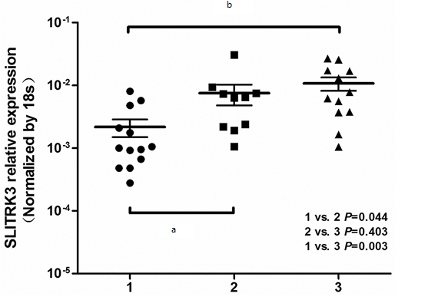

Figure 3 Overall survival (A) and Disease-free survival (B) of 398 GISTs according to SLITRK3 expression.

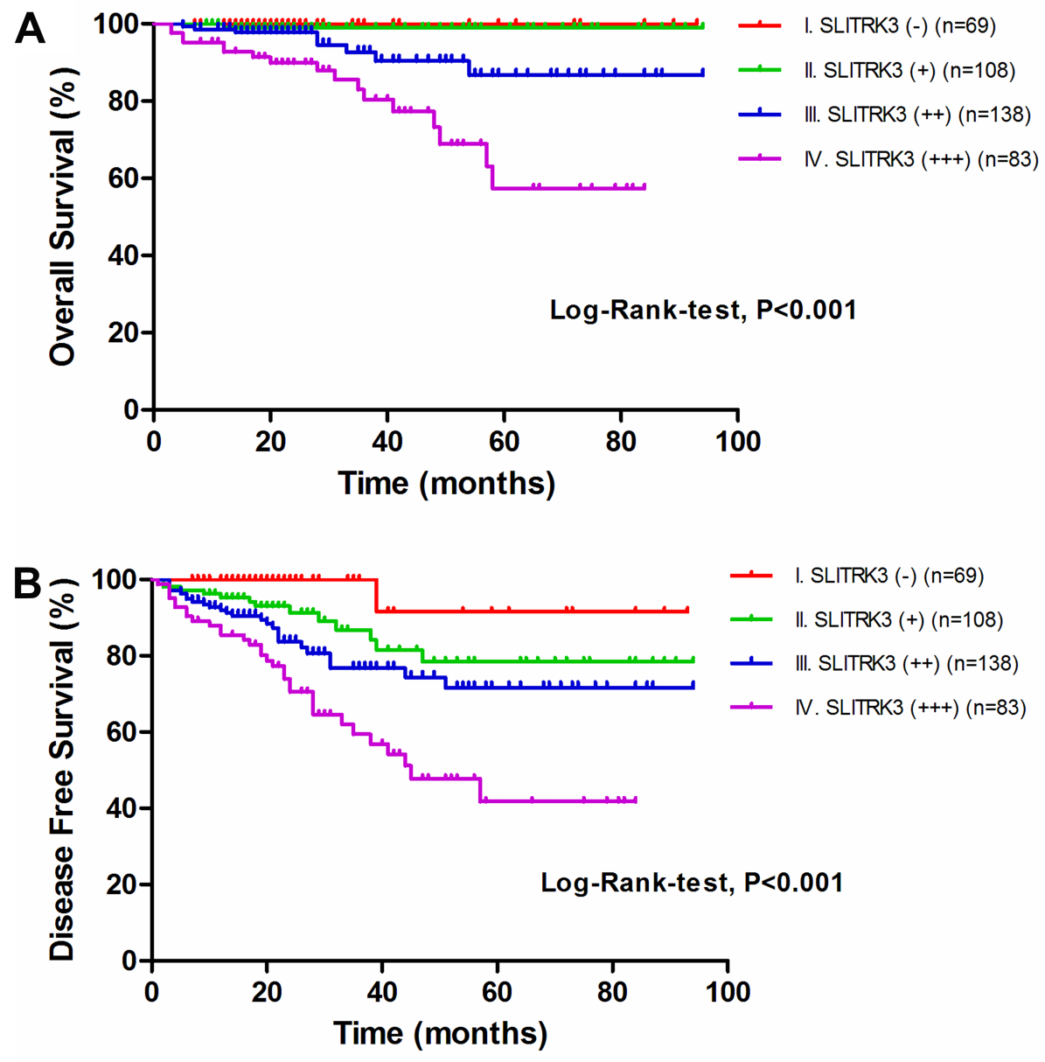

Figure 4 Disease-free survival analysis in a subgroup of 152 high risk cases.

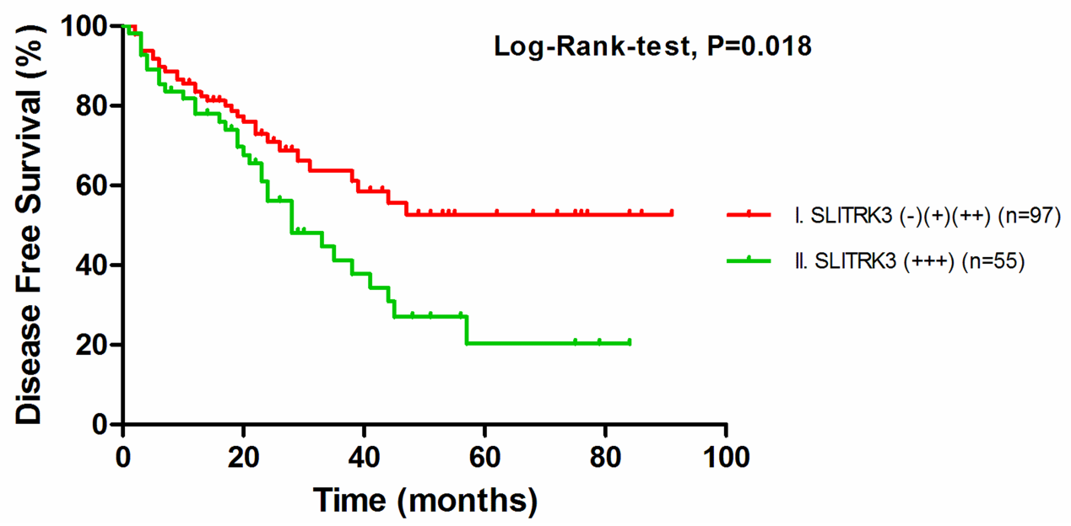

Figure 5 Overall survival analysis in 71 patients after recurrence.

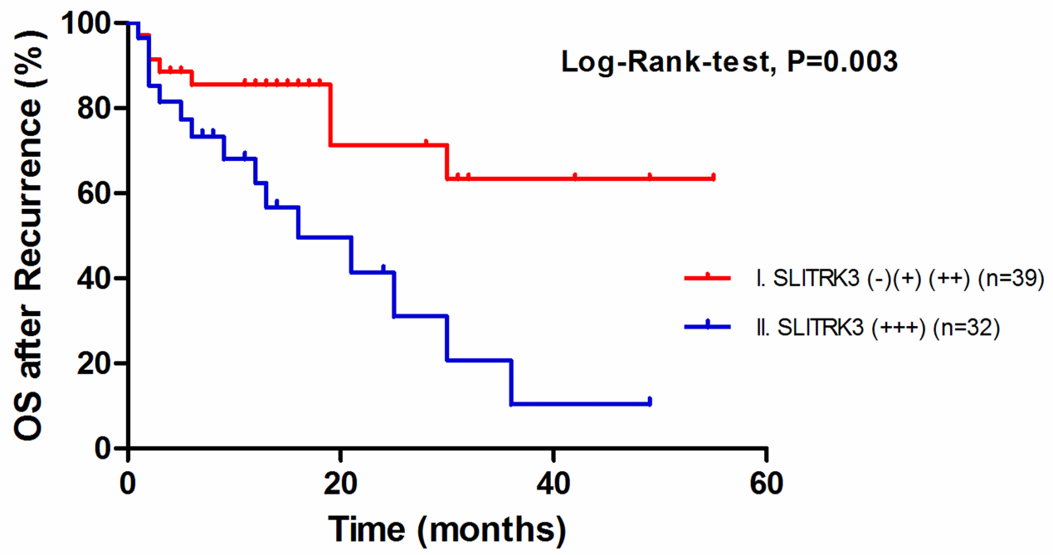
Table 1 Risk level access of gastrointestinal stromal tumor
Risk level | Tumor size (cm) | Mitotic count (50/HPF) | Primary tumor location
Very low | ≤ 2.0 | ≤ 5 | any
low | 2.1-5.0 | ≤ 5 | any
Medium | 2.1-5.0 | > 5 | stomach
 | < 5.0 | 6-10 | any
 | 5.1-10.0 | ≤ 5 | stomach
High | any | any | Tumor rupture
 | > 10.0 | any | any
 | any | > 10 | any
 | > 5.0 | > 5 | any
 | 2.1-5.0 | > 5 | Non stomach
 | 5.1-10.0 | ≤ 5 | Non stomach

Table 2 Quantitative real-time PCR primer for candidate genes and endogenous reference gene
Gene name | Primer | Sequence (5'-3') | Tm (℃) | Amplicon size (bp)
SLITRK3 | Forward | TTCCATAGCTGAGATGCTTCACA | 61.4 | 87
 | Reverse | GGAATCGGGGTAGTCCATCC | 61.2
18S | Forward | GTAACCCGTTGAACCCCATT | 60.4 | 151
 | Reverse | CCATCCAATCGGTAGTAGCG | 61.7

Table 3 Patient and tumor characteristics
Clinicopathological factors |  | n (%)
Gender | Male | 226 (54.2)
 | Female | 191 (45.8)
Age (yr) | ≤ 60 | 223 (53.5)
 | > 60 | 194 (46.5)
 | Median (yr) | 60
Gastrointestinal bleeding | No | 315 (75.5)
 | Yes | 102 (24.5)
Primary tumor site | Stomach | 229 (54.9)
 | Small bowel | 123 (29.5)
 | Colon | 21 (5.0)
 | Others | 44 (10.6)
Predominant cell type | Spindle | 271 (65.0)
 | Epithelioid | 54 (12.9)
 | Mixed | 92 (22.1)
Primary tumor size (cm) | 0-5 | 202 (48.4)
 | 5.1-10 | 138 (33.1)
 | >10 | 77 (18.5)
 | Median (cm) | 5.5
Mitotic index (per 50 HPFs) | 0-5 | 309 (74.1)
 | 6-10 | 60 (14.4)
 | > 10 | 48 (11.5)
NIH stage | Very low risk | 33 (7.9)
 | Low risk | 154 (36.5)
 | Intermediate risk | 67 (16.1)
 | High risk | 163 (39.1)
Recurrence | No | 331 (79.4)
 | Yes | 71 (17.0)
 | Insufficient data | 15 (3.6)
Death from illness | No | 376 (90.2)
 | Yes | 26 (6.2)
 | Insufficient data | 15 (3.6)

Table 4 Expression levels of SLITRK3 in gastrointestinal stromal tumor tumor and adjacent non-tumor tissues n (%)
Tissue | SLITRK3 level
 | - | + | ++ | +++
Tumor | 14 (11) | 37 (28) | 49 (37) | 31 (24)
Non-tumor tissue | 91 (69) | 33 (25) | 5 (4) | 2 (2)

Table5 Correlations between SLITRK3 expression and clinicopathological factors in 417 gastrointestinal stromal tumor patients
Clinicopathological factors¹ |  | SLITRK3 expression |  | Number of patients | χ² | P value²
 |  | Low | High
Gender | Male | 100 | 123 | 224 | 0.001 | 1.000
 | Female | 85 | 104 | 189
Age (years) | ≤ 60 | 99 | 121 | 220 | 0.000 | 1.000
 | > 60 | 87 | 106 | 193
Gastrointestinal bleeding | No | 153 | 160 | 313 | 7.722 | 0.006³
 | Yes | 33 | 67 | 100
Primary tumor site | Stomach | 120 | 106 | 226 | 24.730 | < 0.001 ³
 | Small bowel | 34 | 88 | 122
 | Colon | 14 | 7 | 21
 | Others | 18 | 26 | 44
Predominant cell type | Spindle | 126 | 144 | 270 | 2.552 | 0.279
 | Epithelioid | 26 | 27 | 53
 | Mixed | 34 | 56 | 90
Primary tumor size | ≤ 5cm | 116 | 83 | 199 | 27.260 | < 0.001 ³
 | > 5cm | 70 | 144 | 214
Mitotic index | ≤ 5/50HPF | 157 | 149 | 306 | 18.763 | < 0.001 ³
 | > 5/50 HPF | 29 | 78 | 107
NIH stage | Very low risk | 28 | 3 | 31 | 53.340 | < 0.001 ³
 | Low risk | 87 | 67 | 154
 | Intermediate risk | 25 | 41 | 66
 | High risk | 46 | 116 | 162
¹Cases with missing data were not included for analysis; ²P-value by χ² test; ³Statistically significant (P < 0.01).
Table 6 Univariate analysis of factors influencing overall survival in 402 patients with gastrointestinal stromal tumor
Factor |  | 5-year OS rate (%) | OS hazard ratio (95%CI) | P value
Gender | male: female | 81.3: 89.2 | 0.508 (0.221-1.169) | 0.111
Age | ≤ 60: > 60 | 88.9: 80.0 | 2.186 (0.989-4.832) | 0.053
Gastrointestinal bleeding | no: yes | 86.8: 81.2 | 1.259 (0.559-2.837) | 0.578
Primary tumor site | gastric: non-gastric | 83.0: 86.8 | 1.143 (0.529-2.470) | 0.733
Predominant cell type | spindle: epithelioid: mixed | 87.7: 82.4: 88.8 | 0.935 (0.586-1.491) | 0.778
Primary tumor size (cm) | ≤ 5: > 5 | 99.2: 74.0 | 22.726 (3.079-167.742) | 0.002¹
Mitotic index (HPFs) | ≤ 5/50: 6-10/50: > 10/50 | 96.5: 83.0: 39.7 | 4.727 (2.887-7.740) | < 0.001¹
NIH stage | very low: low: mid: high | 100.0: 100.0: 88.6: 70.3 | 8.005 (2.365-27.098) | 0.001¹
SLITRK3 expression | (-): (+): (++): (+++) | 100.0: 99.0: 86.7: 57.4 | 4.164 (2.227-7.786) | < 0.001¹
¹ Statistically significant (P < 0.01). Mid: Intermediate.
Table 7 Univariate analysis of factors influencing disease-free survival in 402 patients with gastrointestinal stromal tumor
Factor |  | 5-year DFS rate (%) | DFS hazard ratio (95%CI) | P value
Gender | Male: Female | 69.0: 69.7 | 0.643 (0.398-1.038) | 0.071
Age | ≤ 60: > 60 | 72.1: 65.6 | 1.285 (0.806-2.049) | 0.292
Gastrointestinal bleeding | No: Yes | 71.6: 65.7 | 1.425 (0.874-2.322) | 0.155
Primary tumor site | Gastric: Non-gastric | 81.5: 59.4 | 2.669 (1.623-4.388) | 0.001¹
Predominant cell type | Spindle: Epithelioid: mixed | 72.0: 67.1: 71.3 | 0.877 (0.661-1.164) | 0.365
Primary tumor size (cm) | ≤ 5: > 5 | 92.2: 50.8 | 8.183 (3.921-17.079) | < 0.001¹
Mitotic index (HPFs) | ≤ 5/50: 6-10/50: > 10/50 | 84.2: 50.7: 19.0 | 3.289 (2.545-4.253) | < 0.001¹
NIH stage | very low: low: mid: high | 100.0: 93.3: 87.1: 40.0 | 5.421 (3.249-9.045) | < 0.001¹
SLITRK3 expression | (-): (+): (++): (+++) | 91.7: 78.6: 71.6: 41.8 | 2.082 (1.575-2.753) | < 0.001¹
¹ Statistically significant (P < 0.01). Mid: Intermediate; DFS: Disease-free survival.

Table 8 Multivariate analysis of factors influencing disease-free survival in 402 patients with gastrointestinal stromal tumor
Factor |  | Model A |  | Model B |  | Model C
 |  | DFS hazard ratio (95%CI) | P value | DFS hazard ratio (95%CI) | P value | DFS hazard ratio (95%CI) | P value
Primary tumor site | gastric: non-gastric | 1.762 (1.036-2.999) | 0.037¹ | 2.046 (1.232-3.401) | 0.006 ² | 1.593 (0.928-2.733) | 0.091
Primary tumor size (cm) | ≤ 5: >5 | 1.388 (0.567-3.398) | 0.473 | 3.370 (1.545-7.351) | 0.002² | 1.183 (0.477-2.934) | 0.717
Mitotic index (HPFs) | ≤ 5/50: 6-10/50: > 10/50 | 2.027 (1.494-2.749) | < 0.001² | 2.549 (1.930-3.366) | < 0.001 ² | 2.032 (1.496-2.760) | < 0.001²
NIH stage | very low: low: mid: high | 2.753 (1.426-5.314) | 0.003 ² |  |  | 2.707 (1.387-5.283) | 0.004 ²
SLITRK3 expression | (-): (+): (++): (+++) |  |  | 1.508 (1.151-1.976) | 0.003 ² | 1.465 (1.114-1.928) | 0.006²
¹ Statistically significant (P < 0.05); ² Statistically significant (P < 0.01). Model A includes analysis of NIH stage without SLITRK3; model B includes SLITRK3 without NIH stage; model C includes both of them. Mid = intermediate.

