Name of journal: World Journal of Gastroenterology
ESPS Manuscript NO: 32386
Manuscript Type: ORIGINAL ARTICLE

Observational Study
Endoscopic ultrasound-guided cut holes and deep biopsy for diagnosis of gastric infiltrative and gastrointestinal submucosal tumours using a novel vertical diathermic loop

Liu YM et al. EUS-guided

Yu-Mei Liu, Xiu-Jiang Yang

Yu-Mei Liu, Xiu-Jiang Yang, Department of Endoscopy, Fudan University Shanghai Cancer Center, Shanghai 200032, China

Yu-Mei Liu, Xiu-Jiang Yang, Department of Oncology, Shanghai Medical College, Fudan University, Shanghai 200032, China

Author contributions: Liu YM drafted the manuscript, and assisted with data collection and analysis; Yang XJ participated in design and oversight of the study, and performed the major operation of experiments; all authors read and approved the final manuscript.

Institutional review board statement: The study was reviewed and approved by the institutional review boards and Ethics Committee of Fudan University Shanghai Cancer.

Informed consent statement: Informed consent was obtained from all participants , or their legal guardian.

Conflict-of-interest statement: The authors of this manuscript having no conflicts of interest to disclose.

Data sharing statement: There is no additional data available.

Open-Access: This article is an open-access article which was selected by an in-house editor and fully peer-reviewed by external reviewers. It is distributed in accordance with the Creative Commons Attribution Non Commercial (CC BY-NC 4.0) license, which permits others to distribute, remix, adapt, build upon this work non-commercially, and license their derivative works on different terms, provided the original work is properly cited and the use is non-commercial.See: http://creativecommons.org/licenses/by-nc/4.0/

Manuscript source: Unsolicited manuscript

Correspondence to: Xiu-Jiang Yang, MD, Professor, Department of Endoscopy, Fudan University Shanghai Cancer Center, 270 Dong’an Road, Shanghai 200032, China. yangxj1960@163.com
Telephone: +86-21-34610367

Received: January 5, 2017
Peer-review started: January 5, 2017
First decision: February 9, 2017
Revised: February 13, 2017
Accepted: March 15, 2017
Article in press:
Published online:

Abstract
AIM
To report on a more accurate diagnostic possibility offered by endoscopic ultrasound-guided cut holes and deep biopsy (EUS-CHDB) for pathologic diagnosis of gastric infiltrative tumours and gastrointestinal submucosal tumours.

METHODS
Ten consecutive patients who were suspected of gastric invasive tumours or submucosal tumours underwent EUS-CHDB with the novel vertical diathermic loop. We extracted their medical data and analysed the effectiveness and safety of this new method. The final diagnosis was based on the surgical pathology or a clinical/imaging follow-up.

RESULTS
EUS-CHDB was performed successfully in all 10 patients. Neither severe haemorrhage nor perforation occurred in any patient. Among the ten patients, there were 3 GLP (gastric linitis plastic) cases, 1 gastric lymphoma case, 5 GIST (gastrointestinal stromal tumor) cases, and only 1 case showing chronic non-atrophic gastritis. That is, 9 of the cases (90%) treated with EUS-CHDB showed positive findings.

CONCLUSION
EUS-CHDB may be a technically feasible and safe option for patients with gastric infiltrative or submucosal tumours. EUS-CHDB may be used as a remedial or even preferred biopsy method for submucosal lesions.

Key words: Endoscopic ultrasound; Cut holes; Deep biopsy; A vertical diathermic loop; Gastric linitis plastica; Gastrointestinal submucosal tumor

© The Author(s) 2017. Published by Baishideng Publishing Group Inc. All rights reserved.

Core tip: This was a prospective clinical diagnostic trial seeking to evaluate the efficacy of endoscopic ultrasound -guided cut holes and deep biopsy for diagnosis of gastric infiltrative and gastrointestinal submucosal tumours using a novel vertical diathermic loop. This new technique was proved to be a safe, technically feasible and more accurate option for patients with gastric infiltrative or submucosal tumours.

Liu YM, Yang XJ. Endoscopic ultrasound-guided cut holes and deep biopsy for diagnosis of gastric infiltrative and gastrointestinal submucosal tumours using a novel vertical diathermic loop. World J Gastroenterol 2017; In press

INTRODUCTION
Gastric infiltrative tumours, commonly referred to as gastric linitis plastica (GLP) and gastric lymphoma, along with gastrointestinal submucosal tumours often have more than one negative pathological finding on ordinary endoscopic biopsies. Such troublesome phenomena are associated with the biopsy technique itself and the deep location of the tumours. GLP, which is also known as Borrmann type IV or diffuse infiltrating-type gastric cancer or scirrhous carcinoma, is an invasive and diffuse carcinoma that is characterized by a thickened, tough and rigid gastric wall and a narrow cavity^{[1]}. In general, GLP infiltrates the submucosal layer without destroying the superficial structure of the gastric wall; thus, pathological findings in the mucosal layer are not available for making a diagnosis via common biopsy ^{[2]}. Therefore, making an early diagnosis is difficult, and peritoneal metastasis is common at the time of detection, which results in a poor prognosis^{[3,4]}. Primary gastric lymphomas, which are the major malignant tumours of the stomach secondary to gastric carcinoma, mostly originate in the submucosa, and their diagnosis via endoscopic forceps biopsy is often difficult, with a positive rate of only 29% in the initial detection^{[5,6]}. For patients with primary gastric lymphoma, in contrast to those with GLP, effective chemotherapy produces a good outcome, and unnecessary surgery is avoided. Therefore, the distinction between GLP and gastric lymphoma is also significant for treatment. Similarly, for GISTs, which generally originate from the muscularis propria, a common endoscopic biopsy cannot acquire the correct tumour tissue that is usually resected during surgery or endoscopic submucosa dissaction (ESD) for immunohistochemistry analysis.
Endoscopic ultrasound (EUS) is reliable in the diagnosis and staging of gastrointestinal malignancies and has become an indispensable evaluation in patients who are suspected of submucosal tumours of the upper gastrointestinal tract^{[7,8]}. Specimens obtained with a standard endoscopic biopsy rarely provide a confirmative diagnosis because lesions in the submucosa are difficult to reach directly with forceps. The excavating biopsy, snaring biopsy and endoscopic mucosal resection (EMR), derived from the traditional biopsy methods, are considered unsafe for frequent complications such as haemorrhaging and perforation^{[9-10]}. EUS enables the detection of the thickness of the wall and invasive depth of lesions, so it may reduce the operational risks and complications to finish a deep biopsy under the guidance of EUS in real time, which makes up for the deficiency of a routine endoscopy. In addition, given the deficiency of the currently available biopsy methods, such as a broad wound, an inadequate depth and a rigid gastric wall, we invented a novel assistant tool, a reform of the diathermic snare. It contains a control handle, an insulated sheath and an electric mental wire whose tail end wields a small loop vertically. This vertical diathermic loop connected with an electrosurgical unit can be used to cut holes by fulguration into the tumour through the biopsy channel first, and the biopsy forceps can be poked into the holes to acquire deep tissue samples. Here, we retrospectively investigated the safety and efficacy of this novel process, called EUS-guided cut holes and deep biopsy (EUS-CHDB), for diagnosing gastric infiltrative and submucosal tumours.

MATERIALS AND METHODS
Patients
From March 2014 to June 2016, 10 consecutive patients (5 men, average age 52.4 years, age range: 41-75 years) in our department who were suspected of having gastric invasive tumours (or GISTs) underwent EUS-CHDB with the novel electric ring. All patients had undergone ordinary endoscopic biopsies 1 to 4 times, and their pathology showed negative results. We extracted and analyzed their medical data. The study was approved by the institutional review board at Fudan University Shanghai Cancer Center, and informed consent for the procedure was obtained.

EUS equipment and biopsy instruments
EUS equipment in our endoscopy centre is composed of an ultrasound mainframe (Hitachi Preirus; Hitachi, Tokyo, Japan) and linear echoendoscopes (PANTAX EG-3870UTK and EG-3270UK; PANTAX, Tokyo, Japan). Biopsy instruments consisted of the following: a vertical diathermic loop, composed of a control handle, an insulated sheath and an electric mental wire whose end vertically wields a small loop with the diameter of 3-5 mm. The available length of this device was 155 cm. The small ring could be pushed out with the largest length at 1.5 cm or pulled into the sheath with the diameter of approximately 2 mm (Figure 1). An electrosurgical unit was connected to the handle of the loop, and energy delivery was controlled by a foot switch. A small conventional biopsy forceps with a diameter of 1.8 mm was attached.

Biopsy process
All patients experienced conventional EUS examination first to determine the targeted focus characterized by the obviously thick and rigid wall on the tumour. Subsequently, the vertical diathermic loop connected to an electrosurgical unit could be used to cut cylindrical holes under the guidance of EUS by fulguration into the targeted focus through the biopsy channel, and then a conventional biopsy forceps was poked into the holes to acquire the deep tissue samples. The diameters of the holes were approximately 3–5 mm, and the depth to the location was equivalent to the muscularis propria. Every tumour required cutting 2-3 holes to acquire more than 7 blocks of tissue specimens. When the biopsy was finished, if the incision was too broad or still bleeding after spraying thrombin locally, the endoclip was selectively used to close it (Figure 2).

RESULTS
EUS-CHDB was performed successfully in all 10 patients. The median age of the patients was 52.4 years (range 41-75 years), and the male to female ratio was 5:5. Characteristics of patient and tumour and the final diagnoses are shown in Table 1.
The average number of cutting holes and tissue specimens of the total patients was 2.29 (range 2–3) and 8.57 (range 7–12), respectively. There were 2 cases still haemorrhaging after spraying thrombin locally and 3 cases showing a broad wound, so endoclips were used to close the incision. Neither severe haemorrhage nor perforation occurred in any patient. According to the pathology results from the samples obtained by EUS-CHDB, among the 10 patients, there were 3 GLP cases, 1 gastric lymphoma case, 5 GIST cases and only 1 case showing chronic non-atrophic gastritis (Figure 3). Three of the 5 patients diagnosed with GIST underwent surgical treatment, and the surgical pathology findings were consistent with the EUS-CHDB findings. The patient showing chronic non-atrophic gastritis was diagnosed as GLP by surgery resection. According to the clinical/imaging follow-up, the diagnosis of patients without surgery resection was consistent with the EUS-CHDB findings. That is, 9 of the cases (90%) treated with EUS-CHDB had positive findings.

DISCUSSION
Primary gastric lymphoma (PGL) accounts for 2% to 8% of all malignant gastric tumours, which spread mainly in a longitudinal growth style. Sueknae et al^{[11]} divided the patients into four groups according to the endoscopic ultrasonography findings. The groups included the following: superficially spreading type, diffusely infiltrating type, mass-forming type, and mixed type. Among the four groups, the superficially spreading type had the highest frequency with the EUS imaging feature of diffused gastric wall thickening and the second and third layer were replaced with a hypoecho mass. Based on the morphological characteristics of the gastric tumour visualized with common endoscopy or EUS, differential diagnosis of GLP and gastric lymphoma is difficult in most cases. In our out-patient department of endoscopy, a female patient of 34 years old, clinically suspected of having gastric lymphoma for more than 3 years, who was always treated as chronic gastritis, subsequently suffered with a huge abdominal mass suspected of being the product of metastasis and left us with great regret. We suggest that the correct histopathologic findings were closely tied to the prognosis of GLP—The sooner the pathology, the better the treatment. However, the study showed that only 8 cases were diagnosed with preoperative biopsy among 45 cases of GPL^{[12]}. Thus, finding an effective biopsy method may be the key point.
A meta-analysis^{[4]}showed that compared with Borrmann type "others" , B-4 had a higher incidence of poorly differentiated carcinoma (P < 0.01), lymph node metastases (P < 0.01), peritoneal metastases (P < 0.01), and serosal invasion (P < 0.01). Sueknae et al^{[14]} showed that the false missed rate of ordinary biopsies in diagnosing Borrmann type IV gastric cancer was high, that is, up to 55.9%. Lesions showing thickening of the gastric mucosa generally originate from the submucosa, whose tissue samples obtained by large-capacity biopsy forceps can improve the diagnostic rate, but only to 17%^{[13]}. For patients of gastric infiltrative tumors whose initial biopsy is negative for malignancy, the following two to four biopsies enable an increase in the positive rate, but limited, and repeated endoscopy examinations and biopsies may bring more suffering, cost burdens and even delayed treatment.
Along with the advancement of endoscopic diagnostic and therapeutic technology, several novel technologies, such as EUS-guided fine needle aspiration (EUS-FNA), excavating biopsy, snaring biopsy and endoscopic mucosal resection (EMR), have emerged. EUS-FNA for gastric infiltrative tumours can be used to acquire cytology findings, but for large tissue specimens for histopathology analysis, with the disadvantage of difficult operations, long time and high expenses, the positive findings rate is still undesirable^{[15-17]}. Al-Haddad et al^{[18]} reported that the sensitivity, specificity and accuracy rate of EUS-FNA in the diagnosis of lymphoma were 80-87%, 92%-93%, and 83%-89%, respectively. Recently, Zhou et al^{[19]} confirmed that endoscopic ultrasound-guided deep and large biopsy technique provided a definitive and conclusive diagnosis in 29 (80.6%) of the 36 patients suspected of gastric infiltrating tumours. Excavating biopsy, snaring biopsy and endoscopic mucosal resection (EMR), which generally cannot obtain the correct deep tissue samples, are considered unsafe due to frequent complications such as haemorrhaging and perforation^{[19]}.
Gastrointestinal stromal tumours (GISTs), demonstrated to stem from gain-of-function mutations of the platelet-derived growth factor receptor alpha gene and/or C-KIT gene^{[20-21]}, account for 1% of primary GI tumours. Although surgical resection has been the main modality of treatment ^{[22]}, many cases are locally advanced and unresectable at present. In addition, as post curative resections, approximately 40% cases will develop recurrences in the form of local or distant metastasis^{[23-24]}. Imatinib mesylate (IM), the tyrosine kinase targeted therapy, is now the standard adjuvant therapy before or after surgical resection of non-metastatic GISTs with significant risk of recurrence^{[25-26]}. In locally advanced or unresectable GISTs, use of neoadjuvant IM helps decrease the extent of resection and surgical morbidity by diminishing the tumour and reducing the intraoperative spillage of tumour cells^{[27-29]}. Obtaining the gene mutation status from the biopsy specimens before neoadjuvant IM therapy makes the process more accurate, which is in accordance with the latest edition of the NCCN clinical practice guidelines (2016) for gastrointestinal stromal tumours. Decisions to improve the outcomes in the management of GISTs is based on the risk of progression, pathologic characteristics, and tumour locations^{[30]}. Limited by a fine needle, specimens obtained by EUS-FNA are often not sufficient to allow immunohistochemistry and genotype analysis, which could occur with EUS-CHDB with careful operations to reduce the intraoperative spillage of tumour cells.
Using the vertical diathermic loop, gastric infiltrative tumours were open to the biopsy forceps safely by electric coagulation, which resulted in a positive rate of 90% in this study. In particular, for a rigid and tough wall, the diathermic loop, similar to a knife, makes the tumour incised and revealed. The vertical angle makes cutting holes in tumours easier than with other electroexcision tools or biopsy forceps. Under the guidance of EUS, we can determine the most characterized targeted focus, guarantee electroexcision without risk, and avoid areas with abundant irregular branch blood flow signals. In this way, EUS-CHDB was preliminarily proved to be quite safe because neither severe haemorrhaging nor perforation occurred in any patient. In contrast to EUS-FNA, EUS-CHDB is less costly, easier to carry out and, most significantly, allows more histopathology findings. Meanwhile, EUS-CHDB can obtain a larger tissue specimen and may thus increase the rate of positive diagnostic findings compared with conventional biopsies. We spent some time reflecting on the only negative case, who was suspected of GLP but suffered a negative pathology, and the rational speculation was focused on an inadequate depth, insufficient biopsy samples or invalid biopsy on the tissue that received electrocoagulation. For negative cases, if necessary, EUS-FNA combined with EUS-CHDB may offer a satisfactory solution.
As a limitation, this study was performed at a single centre with a small number of patients and without a control group. Further large studies on this method are needed to clarify the indications and clinical outcomes.
In conclusion, under the guidance of high-definition longitudinal axis EUS, the vertical diathermic loop can safely and efficiently break up the shield of a thick and rigid wall of the gastric or mucous layer above the tumour. EUS-CHDB may be a technically feasible and safe option for patients with gastric infiltrative tumours or gastrointestinal submucosal tumours. EUS-CHDB could be recommended as a remedial or even preferred biopsy method for some submucosal lesions.

COMMENTS
Background
Gastric infiltrative tumours, such as gastric linitis plastica (GLP) and gastric lymphoma, and gastrointestinal submucosal tumours often have more than one negative pathological finding on ordinary endoscopic biopsies. They invented a novel vertical diathermic loop to perform EUS-guided cut holes and deep biopsies (EUS-CHDBs).

Research frontiers
For patients suspected with gastric infiltrative tumours or gastrointestinal submucosal tumours, diagnosis via endoscopic forceps biopsy is often difficult, with a low positive rate in the initial detection. several novel emerging technologies, such as EUS-guided fine needle aspiration, excavating biopsy, snaring biopsy and endoscopic mucosal resection, have emerged. However, the positive findings rate of the above techniques is still undesirable.

Innovations and breakthroughs
This study reported on a more accurate diagnostic possibility offered by EUS-CHDB for pathologic diagnosis of gastric infiltrative tumours and gastrointestinal submucosal tumours. This new technique was proved to be a safe, technically feasible and more accurate option for patients with gastric infiltrative or submucosal tumour.

Applications
This study serves as the evidence supporting a new technique about biopsy —EUS-CHDB, which may improve the diagnostic accuracy and even assist in the early diagnosis of gastric infiltrative tumours and gastrointestinal submucosal tumours.

Terminology
EUS: the endoscopy with an ultrasonic probe in the headend, can detect and scan lesions of gastrointestinal tract, pancrea, liver gallbladder and adjacent organs by virtue of ultrasound. GLP: a special type of diffuse infiltrative gastric carcinoma and tumor growth direction is to the submucosa so that the gastric cavity becomes small, gastric full layer is thickening and hardening.

Peer-review
Gastric infiltrative tumours, such as gastric linitis plastica and gastric lymphoma, and gastrointestinal submucosal tumours often have more than one negative pathological finding on ordinary endoscopic biopsies. The authors invented a novel vertical electrode loop to perform EUS-guided cut holes and deep biopsies.The authors report on a more accurate diagnostic possibility offered by EUS-CHDB for pathologic diagnosis of gastric infiltrative tumours and gastrointestinal submucosal tumours. The results are interesting.

REFERENCES
1 Yoon WJ, Brugge WR. Endoscopic ultrasound and pancreatic cystic lesions-diagnostic and therapeutic applications. Endosc Ultrasound 2012; 1: 75-79 [PMID: 24949341 DOI: 10.7178/eus.02.004]
2 Laffan TA, Horton KM, Klein AP, Berlanstein B, Siegelman SS, Kawamoto S, Johnson PT, Fishman EK, Hruban RH. Prevalence of unsuspected pancreatic cysts on MDCT. AJR Am J Roentgenol 2008; 191: 802-807 [PMID: 18716113 DOI: 10.2214/AJR.07.3340]
3 Lee KS, Sekhar A, Rofsky NM, Pedrosa I. Prevalence of incidental pancreatic cysts in the adult population on MR imaging. Am J Gastroenterol 2010; 105: 2079-2084 [PMID: 20354507 DOI: 10.1038/ajg.2010.122]
4 Zhang XM, Mitchell DG, Dohke M, Holland GA, Parker L. Pancreatic cysts: depiction on single-shot fast spin-echo MR images. Radiology 2002; 223: 547-553 [PMID: 11997566 DOI: 10.1148/radiol.2232010815]
5 Vege SS, Ziring B, Jain R, Moayyedi P. American gastroenterological association institute guideline on the diagnosis and management of asymptomatic neoplastic pancreatic cysts. Gastroenterology 2015; 148: 819-22; quize12-3 [PMID: 25805375 DOI: 10.1053/j.gastro.2015.01.015]
6 Soroida Y, Sato M, Hikita H, Hagiwara S, Sato M, Gotoh H, Kato S, Iwai T, Yamazaki T, Yatomi Y, Sasano T, Ikeda H. Pancreatic cysts in general population on ultrasonography: Prevalence and development of risk score. J Gastroenterol 2016; 51: 1133-1140 [PMID: 26988361 DOI: 10.1007/s00535-016-1196-y]
7 Kim JH, Eun HW, Park HJ, Hong SS, Kim YJ. Diagnostic performance of MRI and EUS in the differentiation of benign from malignant pancreatic cyst and cyst communication with the main duct. Eur J Radiol 2012; 81: 2927-2935 [PMID: 22227264 DOI: 10.1016/j.ejrad.2011.12.019]
8 Rastegar N, Matteoni-Athayde LG, Eng J, Takahashi N, Tamm EP, Mortele KJ, Syngal S, Margolis D, Lennon AM, Wolfgang CL, Fishman EK, Hruban RH, Goggins M, Canto MI, Kamel IR. Incremental value of secretin-enhanced magnetic resonance cholangiopancreatography in detecting ductal communication in a population with high prevalence of small pancreatic cysts. Eur J Radiol 2015; 84: 575-580 [PMID: 25619503 DOI: 10.1016/j.ejrad.2014.12.028]
9 Kauhanen S, Rinta-Kiikka I, Kemppainen J, Grönroos J, Kajander S, Seppänen M, Alanen K, Gullichsen R, Nuutila P, Ovaska J. Accuracy of 18F-FDG PET/CT, Multidetector CT, and MR Imaging in the Diagnosis of Pancreatic Cysts: A Prospective Single-Center Study. J Nucl Med 2015; 56: 1163-1168 [PMID: 26045314 DOI: 10.2967/jnumed.114.148940]
10 Yoshioka T, Shigekawa M, Yamai T, Suda T, Kegasawa T, Iwahashi K, Ikezawa K, Sakamori R, Yakushijin T, Hiramatsu N, Tatsumi T, Takehara T. The safety and benefit of pancreatic juice cytology under ERCP in IPMN patients. Pancreatology 2016; 16: 1020-1027 [PMID: 27567445 DOI: 10.1016/j.pan.2016.08.009]
11 Lee YS, Paik KH, Kim HW, Lee JC, Kim J, Hwang JH. Comparison of Endoscopic Ultrasonography, Computed Tomography, and Magnetic Resonance Imaging for Pancreas Cystic Lesions. Medicine (Baltimore) 2015; 94: e1666 [PMID: 26469901 DOI: 10.1097/MD.0000000000001666]
12 Jani N, Bani Hani M, Schulick RD, Hruban RH, Cunningham SC. Diagnosis and management of cystic lesions of the pancreas. Diagn Ther Endosc 2011; 2011: 478913 [PMID: 21904442 DOI: 10.1155/2011/478913]
13 Jones MJ, Buchanan AS, Neal CP, Dennison AR, Metcalfe MS, Garcea G. Imaging of indeterminate pancreatic cystic lesions: a systematic review. Pancreatology 2013; 13: 436-442 [PMID: 23890144 DOI: 10.1016/j.pan.2013.05.007]
14 Brugge WR. Diagnosis and management of cystic lesions of the pancreas. J Gastrointest Oncol 2015; 6: 375-388 [PMID: 26261724 DOI: 10.3978/j.issn.2078-6891.2015.057]
15 Tsujino T, Yan-Lin Huang J, Nakai Y, Samarasena JB, Lee JG, Chang KJ. In vivo identification of pancreatic cystic neoplasms with needle-based confocal laser endomicroscopy. Best Pract Res Clin Gastroenterol 2015; 29: 601-610 [PMID: 26381305 DOI: 10.1016/j.bpg.2015.06.006]
16 Bhutani MS. Role of endoscopic ultrasound for pancreatic cystic lesions: Past, present, and future! Endosc Ultrasound 2015; 4: 273-275 [PMID: 26643692 DOI: 10.4103/2303-9027.170400]
17 Falasca M, Kim M, Casari I. Pancreatic cancer: Current research and future directions. Biochim Biophys Acta 2016; 1865: 123-132 [PMID: 26794394 DOI: 10.1016/j.bbcan.2016.01.001]
18 Scheiman JM, Hwang JH, Moayyedi P. American gastroenterological association technical review on the diagnosis and management of asymptomatic neoplastic pancreatic cysts. Gastroenterology 2015; 148: 824-48.e22 [PMID: 25805376 DOI: 10.1053/j.gastro.2015.01.014]
19 Tanaka M, Fernández-del Castillo C, Adsay V, Chari S, Falconi M, Jang JY, Kimura W, Levy P, Pitman MB, Schmidt CM, Shimizu M, Wolfgang CL, Yamaguchi K, Yamao K. International consensus guidelines 2012 for the management of IPMN and MCN of the pancreas. Pancreatology 2012; 12: 183-197 [PMID: 22687371 DOI: 10.1016/j.pan.2012.04.004]
20 Farrell JJ, Fernández-del Castillo C. Pancreatic cystic neoplasms: management and unanswered questions. Gastroenterology 2013; 144: 1303-1315 [PMID: 23622140 DOI: 10.1053/j.gastro.2013.01.073]
21 Cho HW, Choi JY, Kim MJ, Park MS, Lim JS, Chung YE, Kim KW. Pancreatic tumors: emphasis on CT findings and pathologic classification. Korean J Radiol 2011; 12: 731-739 [PMID: 22043156 DOI: 10.3348/kjr.2011.12.6.731]
22 Nakai Y, Isayama H, Itoi T, Yamamoto N, Kogure H, Sasaki T, Hirano K, Tada M, Koike K. Role of endoscopic ultrasonography in pancreatic cystic neoplasms: where do we stand and where will we go? Dig Endosc 2014; 26: 135-143 [PMID: 24219338 DOI: 10.1111/den.12202]
23 Lu X, Zhang S, Ma C, Peng C, Lv Y, Zou X. The diagnostic value of EUS in pancreatic cystic neoplasms compared with CT and MRI. Endosc Ultrasound 2015; 4: 324-329 [PMID: 26643701 DOI: 10.4103/2303-9027.170425]
24 Wright GP, Morrow JB, Shaheen M, Goslin BJ, Baatenburg L, Chung MH. Accuracy of endoscopic ultrasound in the evaluation of cystic pancreatic neoplasms: a community hospital experience. Pancreas 2014; 43: 465-469 [PMID: 24622081 DOI: 10.1097/MPA.0000000000000057]
25 Arshad HM, Bharmal S, Duman DG, Liangpunsakul S, Turner BG. Advanced endoscopic ultrasound management techniques for preneoplastic pancreatic cystic lesions. J Investig Med 2017; 65: 7-14 [PMID: 27574295 DOI: 10.1136/jim-2016-000167]
26 Canto MI, Hruban RH, Fishman EK, Kamel IR, Schulick R, Zhang Z, Topazian M, Takahashi N, Fletcher J, Petersen G, Klein AP, Axilbund J, Griffin C, Syngal S, Saltzman JR, Mortele KJ, Lee J, Tamm E, Vikram R, Bhosale P, Margolis D, Farrell J, Goggins M. Frequent detection of pancreatic lesions in asymptomatic high-risk individuals. Gastroenterology 2012; 142: 796-804; quiz e14-5 [PMID: 22245846 DOI: 10.1053/j.gastro.2012.01.005]
27 Hijioka S, Hara K, Mizuno N, Imaoka H, Bhatia V, Yamao K. Morphological differentiation and follow-up of pancreatic cystic neoplasms using endoscopic ultrasound. Endosc Ultrasound 2012; 4: 312-318 [PMID: 26643699 DOI: 10.4103/2303-9027.170423]
28 Adimoolam V, Sanchez MJ, Siddiqui UD, Yu S, Dzuira JD, Padda MS, Aslanian HR. Endoscopic ultrasound identifies synchronous pancreas cystic lesions not seen on initial cross-sectional imaging. Pancreas 2011; 40: 1070-1072 [PMID: 21705942 DOI: 10.1097/MPA.0b013e31821f65e3]
29 Gerke H, Jaffe TA, Mitchell RM, Byrne MF, Stiffler HL, Branch MS, Baillie J, Jowell PS. Endoscopic ultrasound and computer tomography are inaccurate methods of classifying cystic pancreatic lesions. Dig Liver Dis 2006; 38: 39-44 [PMID: 16314152 DOI: 10.1016/j.dld.2005.09.023]
30 Brugge WR, Lewandrowski K, Lee-Lewandrowski E, Centeno BA, Szydlo T, Regan S, del Castillo CF, Warshaw AL. Diagnosis of pancreatic cystic neoplasms: a report of the cooperative pancreatic cyst study. Gastroenterology 2004; 126(5): 1330-1336 [DOI: 10.1053/j.gastro.2004.02.013]
31 Wamsteker EJ, Gauger PG, Thompson NW, Scheiman JM. EUS detection of pancreatic endocrine tumors in asymptomatic patients with type 1 multiple endocrine neoplasia. Gastrointest Endosc 2003; 58: 531-535 [PMID: 14520285]
32 Leeds JS, Nayar MN, Dawwas M, Scott J, Anderson K, Haugk B, Oppong KW. Comparison of endoscopic ultrasound and computed tomography in the assessment of pancreatic cyst size using pathology as the gold standard. Pancreatology 2013; 13: 263-266 [PMID: 23719598 DOI: 10.1016/j.pan.2013.02.009]
33 Maimone S, Agrawal D, Pollack MJ, Wong RCK, Willis J, Faulx AL, Isenberg GA, Chak A. Variability in measurements of pancreatic cyst size among EUS, CT, and magnetic resonance imaging modalities. Gastrointest Endosc 2010; 71: 945-950 [PMID: 20231021 DOI: 10.1016/j.gie.2009.11.046]
34 Duconseil P, Turrini O, Ewald J, Soussan J, Sarran A, Gasmi M, Moutardier V, Delpero JR. 'Peripheric' pancreatic cysts: performance of CT scan, MRI and endoscopy according to final pathological examination. HPB (Oxford) 2015; 17: 485-489 [PMID: 25691074 DOI: 10.1111/hpb.12388]
35 Kim SY, Lee JM, Kim SH, Shin KS, Kim YJ, An SK, Han CJ, Han JK, Choi BI. Macrocystic neoplasms of the pancreas: CT differentiation of serous oligocystic adenoma from mucinous cystadenoma and intraductal papillary mucinous tumor. AJR Am J Roentgenol 2006; 187: 1192-1198 [PMID: 17056905 DOI: 10.2214/AJR.05.0337]
36 Alkaade S, Chahla E, Levy M. Role of endoscopic ultrasound-guided fine-needle aspiration cytology, viscosity, and carcinoembryonic antigen in pancreatic cyst fluid. Endosc Ultrasound 2015; 4: 299-303 [PMID: 26643697 DOI: 10.4103/2303-9027.170417]
37 Yoon WJ, Brugge WR. The safety of endoscopic ultrasound-guided fine-needle aspiration of pancreatic cystic lesions. Endosc Ultrasound 2015; 4: 289-292 [PMID: 26643695 DOI: 10.4103/2303-9027.170408]
38 Tanaka SA, McKee JD, Conway WC. Intracystic Biopsy and Diagnosis of Intraductal Papillary Mucinous Neoplasm via SpyGlass Pancreatoscopy. Ochsner J 2015; 15: 452-454 [PMID: 26730233]
39 Pai M, Habib N, Senturk H, Lakhtakia S, Reddy N, Cicinnati VR, Kaba I, Beckebaum S, Drymousis P, Kahaleh M, Brugge W. Endoscopic ultrasound guided radiofrequency ablation, for pancreatic cystic neoplasms and neuroendocrine tumors. World J Gastrointest Surg 2015; 7: 52-59 [PMID: 25914783 DOI: 10.4240/wjgs.v7.i4.52]
40 Caillol F, Poincloux L, Bories E, Cruzille E, Pesenti C, Darcha C, Poizat F, Monges G, Raoul JL, Bommelaer G, Giovannini M. Ethanol lavage of 14 mucinous cysts of the pancreas: A retrospective study in two tertiary centers. Endosc Ultrasound 2012; 1: 48-52 [PMID: 24949335 DOI: 10.7178/eus.01.008]
41 Park JK, Song BJ, Ryu JK, Paik WH, Park JM, Kim J, Lee SH, Kim YT. Clinical Outcomes of Endoscopic Ultrasonography-Guided Pancreatic Cyst Ablation. Pancreas 2016; 45: 889-894 [PMID: 26765962 DOI: 10.1097/MPA.0000000000000567]
42 Oh HC, Seo DW, Song TJ, Moon SH, Park DH, Soo Lee S, Lee SK, Kim MH, Kim J. Endoscopic ultrasonography-guided ethanol lavage with paclitaxel injection treats patients with pancreatic cysts. Gastroenterology 2011; 140: 172-179 [PMID: 20950614 DOI: 10.1053/j.gastro.2010.10.001]
43 Gan SI, Thompson CC, Lauwers GY, Bounds BC, Brugge WR. Ethanol lavage of pancreatic cystic lesions: initial pilot study. Gastrointest Endosc 2005; 61: 746-752 [PMID: 15855986]
44 DeWitt J, McGreevy K, Schmidt CM, Brugge WR. EUS-guided ethanol versus saline solution lavage for pancreatic cysts: a randomized, double-blind study. Gastrointest Endosc 2009; 70: 710-723 [PMID: 19577745 DOI: 10.1016/j.gie.2009.03.1173]
45 DeWitt J, DiMaio CJ, Brugge WR. Long-term follow-up of pancreatic cysts that resolve radiologically after EUS-guided ethanol ablation. Gastrointest Endosc 2010; 72: 862-866 [PMID: 20883866 DOI: 10.1016/j.gie.2010.02.039]
46 Ahmad NA, Kochman ML, Brensinger C, Brugge WR, Faigel DO, Gress FG, Kimmey MB, Nickl NJ, Savides TJ, Wallace MB, Wiersema MJ, Ginsberg GG. Interobserver agreement among endosonographers for the diagnosis of neoplastic versus non-neoplastic pancreatic cystic lesions. Gastrointest Endosc 2003; 58: 59-64 [PMID: 12838222 DOI: 10.1067/mge.2003.298]

P-Reviewer: Fernandez JM, Sato H S-Editor: Qi Y L-Editor: E-Editor:
Specialty type: Gastroenterology and hepatology
Country of origin: China
Peer-review report classification
Grade A (Excellent): 0
Grade B (Very good): B, B
Grade C (Good): 0
Grade D (Fair): 0
Grade E (Poor): 0

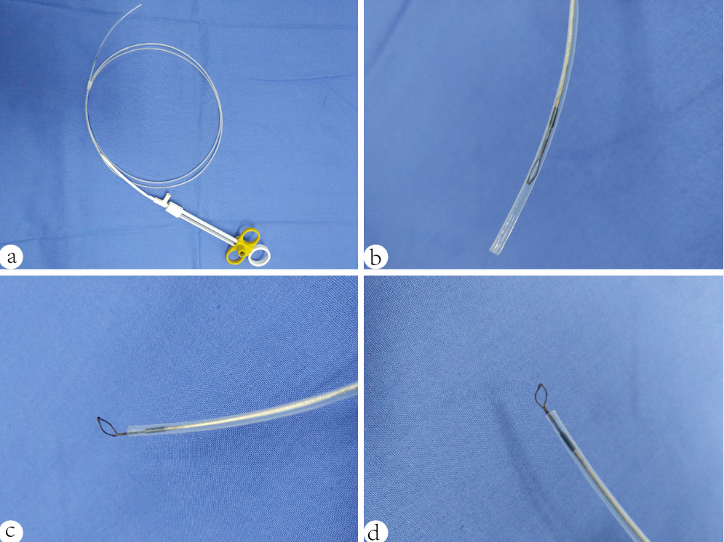Figure 1 Vertical electrode loop. A: The vertical electrode loop device; B: The loop is dragged into the sheath when not working; C, D: When working, the small loop that is vertically wielded to the end of the electric metal wire is pushed out of the sheath.

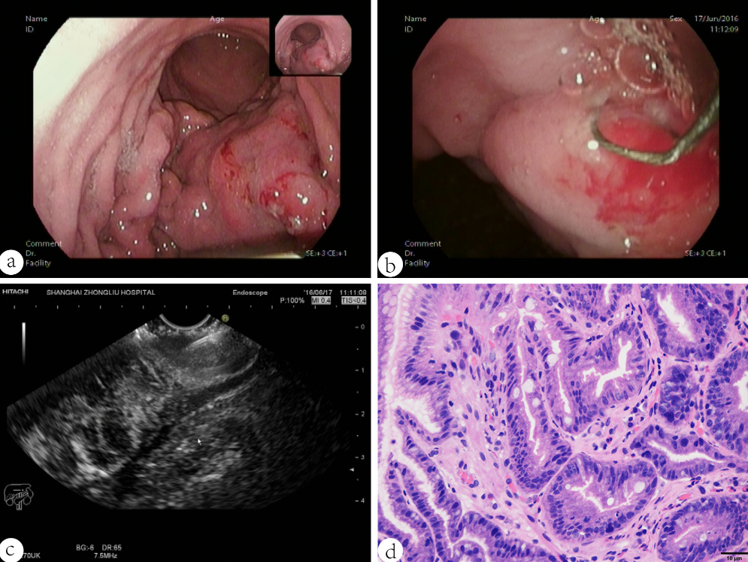
Figure 2 A case diagnosed with gastric linitis plastic. A: Endoscopic characteristics: thick and rigid gastric duplicature and a narrow cavity; B: The loop was placed on the targeted focus characterized by the obviously thick and rigid wall on the tumour, then the holes were cut; C: A biopsy forceps was poked into the holes to acquire the deep tissue samples under the guidance of EUS; D: The tissue specimen was then analysed histopathologically and shown to be gastric adenocarcinoma.

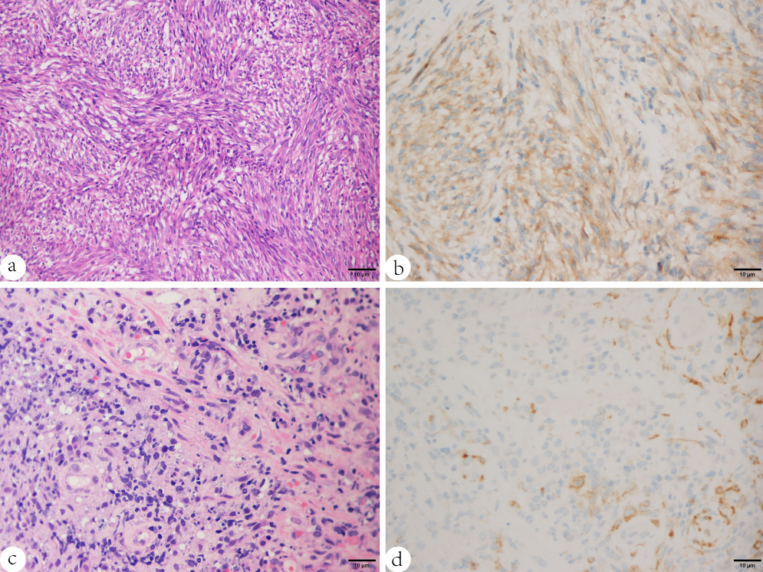
Figure 3 Results of pathology and immunohistochemistry of gastrointestinal stromal tumors and gastric lymphoma. A, B: The pathology characterized by spindle cells (HE × 200) and immunohistochemistry showing positive CD117 proved the diagnosis of gastrointestinal stromal tumors (GIST); C, D: Increased and dispersively distributed lymphocytes (HE × 400) with positive CD10 according to the immunohistochemistry results confirmed the diagnosis of gastric diffuse large B-cell lymphoma (DLBCL).

Table 1 Patient and tumour characteristics

Age, median (range), yr | 52.4 (41-75)
Male, n (%) | 5 (50)
Tumour thickness, median (range), mm | 25.34 (10.6-45.2)
Tumour location, n
gastric fundus | 2
gastric body | 5
gastric fundus and body | 1
gastric body and antrum | 1
descending duodenum | 1
Final diagnosis, n
Pathology obtained by EUS-CHDB | Surgery resection or clinical follow-up
histological type | gastric adenocarcinoma | GIST | gastric lymphoma
gastric adenocarcinoma | 3 | 0 | 0
GIST | 0 | 5 | 0
gastric lymphoma | 0 | 0 | 1
chronic non-atrophic gastritis | 1 | 0 | 0
The overall accuracy rate | 90%
GIST: Gastrointestinal stromal tumors.

