Name of Journal: World Journal of Radiology
ESPS Manuscript NO: 30491
Manuscript Type: Original Article

Observational Study

Computed tomography pulmonary angiography using a 20% reduction in contrast medium dose delivered in a multiphasic injection

Chen M et al. CTPA with a reduced contrast dose

Mitchell Chen, Gaith Mattar, Jamal A Abdulkarim

Mitchell Chen, Jamal A Abdulkarim, Department of Radiology, George Eliot Hospital NHS Trust, Nuneaton, Warwickshire, CV10 7DJ, United Kingdom

Gaith Mattar, Department of Radiology, University Hospitals Birmingham NHS Trust, Birmingham, B15 2TH, United Kingdom

Author contributions: Abdulkarim JA designed the experiment; Chen M and Abdulkarim JA conducted literature research; Abdulkarim JA and Mattar G performed the data collection; Chen M analysed the data; Chen M and Abdulkarim JA prepared the manuscript.

Institutional review board statement: The study was reviewed and approved by the George Eliot Hospital NHS Trust Directorate of Audit and Research.

Informed consent statement: Individual consent from patients was not obtained as this is retrospective observational study. All patient data were fully anonymised.

Conflict-of-interest statement: Chen M declares no conflict of interest. Mattar G declares no conflict of interest. Abdulkarim JA declares no conflict of interest.

Data sharing statement: Technical appendix, statistical code, and dataset available from the corresponding author at jamal.abdulkarim@geh.nhs.uk. Consent was not obtained for data sharing but the presented data are anonymised and risk of identification is low.

Open-Access: This article is an open-access article which was selected by an in-house editor and fully peer-reviewed by external reviewers. It is distributed in accordance with the Creative Commons Attribution Non Commercial (CC BY-NC 4.0) license, which permits others to distribute, remix, adapt, build upon this work non-commercially, and license their derivative works on different terms, provided the original work is properly cited and the use is non-commercial. See: http://creativecommons.org/licenses/by-nc/4.0/

Manuscript source: Invited manuscript

Correspondence to: Jamal A Abdulkarim, FRCR, Consultant Radiologist, Department of Radiology, George Eliot Hospital NHS Trust, College Street, Nuneaton, Warwickshire, CV10 7DJ, United Kingdom. jamal.abdulkarim@geh.nhs.uk
Telephone: +44-247-6351351
Fax: +44-247-6865175

Received: October 5, 2016
Peer-review started: October 9, 2016
First decision: November 29, 2016
Revised: December 30, 2016
Accepted: January 16, 2017
Article in press:
Published online:

Abstract
AIM
To evaluate the feasibility of reducing the dose of iodinated contrast agent in computed tomography pulmonary angiography (CTPA).

METHODS
One hundred and twenty-seven patients clinically suspected of having pulmonary embolism underwent spiral CTPA, out of whom fifty-seven received 75 mL and the remaining seventy a lower dose of 60 mL of contrast agent. Both doses were administered in a multiphasic injection. A minimum opacification threshold of 250 Hounsfield units (HU) in the main pulmonary artery is used for assessing the technical adequacy of the scans.

RESULTS
Mean opacification was found to be positively correlated to patient age (Pearson’s correlation 0.4255, P < 0.0001) and independent of gender (male:female, 425.6 vs 450.4, P = 0.34). When age is accounted for, the study and control groups did not differ significantly in their mean opacification in the main (436.8 vs 437.9, P = 0.48), left (416.6 vs 419.8, P = 0.45) or the right pulmonary arteries (417.3 vs 423.5, P = 0.40). The number of sub-optimally opacified scans (the mean opacification in the main pulmonary artery < 250 HU) did not differ significantly between the study and control groups (7 vs 10).

CONCLUSION
A lower dose of iodine contrast at 60ml can be feasibly used in CTPA without resulting in a higher number of sub-optimally opacified scans.

Key words: Computed tomography pulmonary angiography; Contrast dose; Contrast induced nephropathy; Acute kidney disease; Contrast safety; Contrast dose reduction; Multiphasic injection

© The Author(s) 2017. Published by Baishideng Publishing Group Inc. All rights reserved.

Core tip: Computed tomography pulmonary angiography scanning using a lower dose of contrast agent (60 mL) is proposed. Comparisons were made to patients in a control group who have received a standard dose of contrast medium (75 mL) at our Trust. There is no statistical difference in the degree of opacification in the main pulmonary artery between the two groups. The rate of rejection due to inadequate opacification is not affected by the reduction in contrast dose. The feasibility of using a reduced contrast dose at 60 mL is clearly demonstrated.

Chen M, Mattar G, Abdulkarim JA. Computed tomography pulmonary angiography using a 20% reduction in contrast medium dose delivered in a multiphasic injection. World J Radiol 2017; In press

INTRODUCTION
Computed tomography pulmonary angiography (CTPA) is the de facto gold standard investigation for detecting or ruling out the presence of pulmonary embolism (PE)^{[1]}. The degree of pulmonary arterial opacification defines the technical adequacy of a CTPA scan. It is proportional to the rate and dose of contrast medium administration^{[2]}. A good quality scan is essential for optimising its negative predictive value. However, using a high dose of contrast medium can lead to contrast induced-acute kidney injury (CI-AKI), formerly known as contrast-induced nephropathy, when there is a sudden rise in serum creatinine following the exposure to iodinated contrast media, that is not linked to another nephrotoxic event. The condition is normally self-limiting but can lead to increased morbidity and mortality^{[3]}. Certain patient groups are at an increased risk of developing CI-AKI; such as those affected by hypertension, chronic kidney disease (CKD), diabetes mellitus, congestive heart failure, reduced intravascular volume, advanced age and recent exposure to nephrotoxic drugs^{[4]}. For this reason, the dose of contrast should be kept to a minimum provided that it does not affect the overall quality of the image.
Recent advances in CT technology have enabled faster image acquisition times, thus reducing the time required during which the pulmonary vasculature must be opacified. This has made it possible to consider reducing the dose of contrast medium used in CTPA^{[5]}. At our Trust, the current protocol is to administer 75 mL of 350 mg/mL iodine/ioversol delivered via a multiphasic injection. In this study, we have tested the hypothesis that the scan is technically adequate using only a 60 mL dose of the contrast medium at the same concentration. The dose reduction is intended to enhance patient safety as well reducing the overall scanning cost.

MATERIALS AND METHODS
Patient selection

One hundred and twenty-seven patients clinically suspected of having PE underwent spiral CTPA between the months of January to April 2015; Of these subjects, seventy received a higher dose of 75 mL (control group) and the remaining fifty-seven, 60 mL (study group) of 350 mg/mL iodine/ioversol contrast agent (Omnipaque 350, GE Healthcare, USA). The dose reduction of 20% was chosen in conjunction with the CT scanner manufacturer (Siemens AG). In this observational study, both patient cohorts were studied retrospectively. Patient cohort allocation was not randomised due to the nature of this study.
In the control group, there were 32 male and 38 female patients, whose mean age was 65.7 years (range [34-93]). In the study group, there were 23 male and 34 female patients, with a mean age of 62.7 years (range [16-92]). Characteristics of the study population are given in Table 1. Patient data were fully anonymised.

CTPA protocol
Scans were performed on a 128-slice CT scanner (Somatom Definition AS+, Siemens AG, Berlin and Munich, Germany), and acquired with a radiation dose of 120 kV and a tube output of a minimum of 666 mAs/80 kW for 5 s, 0.3 s rotation time, pitch 0.6, 0.6 mm slice thickness with 38.4 mm collimation.
The contrast medium was given via an 18G cannula, placed in the ante-cubital fossa and delivered via a power injector (Ulrich Inject CT Motion, Ulrich Medical, Buchbrunnenweg, Germany) at a rate of 5 mL/s, with a saline chaser of 25 mL at the same injection rate. The overall injection time is 12 s for 60 mL of contrast and 15 s for 75 mL of contrast.
We used a bolus tracking method to control the scan initiation. We first acquired an initial low-dose monitoring image six seconds after contrast injection and repeated every 1.5 s thereafter. Upon reaching a threshold of 100 Hounsfield units (HU) in the main pulmonary artery, the scan was initiated. The scan table is then moved from the monitoring to the starting position; during which time patients were instructed to breath-hold for 4-6 s. CTPA scans were acquired in a cranio-caudal direction. The images were reconstructed using Siemens iterative reconstruction method, SAFIRE (Sinogram Affirmated Iterative Reconstruction, strength 3).
Patients’ age and gender were obtained retrospectively from their medical notes. Patient weight was not examined in this study.

Image data assessment
A radiology registrar with 3 year of experience performed the image data analysis retrospectively on an Insignia Picture Achieving and Communication System workstation (Basingstoke, UK). We measured image opacification in the main, left and right pulmonary arteries. An acceptance threshold of a 250 HU for main pulmonary artery opacification was adopted for our study, as it was the figure used widely in various literatures^{[6]}.

Statistical analysis
We used the χ² test to analyse categorical variables such as gender and number of rejected scans and Pearson’s coefficient for the correlation studies. We performed all statistical tests with a significance level of P < 0.05. Statistical calculations were performed using Microsoft Excel 2010 (Microsoft Corp, USA).

RESULTS
We found no significant difference between the two groups in either age (P value: 0.35) or gender (P value: 0.42).
Sample axial images from the 60 and 75 mL groups are given in Figure 1, showing the good opacification of the main pulmonary arteries.
The mean opacification values in the main, right and left pulmonary arteries are shown in Table 2. Even though the reported degree of opacification was higher with 75 mL of contrast medium, the difference did not affect the overall image quality, as shown in the discussion below.
We found the mean opacification to be positively correlated to patient age (Pearson’s correlation 0.426, P < 0.0001). When age is accounted for by introducing an age-dependent linear regression coefficient to the mean opacification measure, the two groups did not differ significantly in terms of their mean opacification in the main (437 vs 438, P = 0.48), left (417 vs 420, P = 0.45) or the right pulmonary arteries (417 vs 424, P = 0.40). Taking an acceptance threshold of 250 HU, the rate of rejected scans did not differ significantly between the two groups, as shown in Table 3.

DISCUSSION
Various past literature have reported on the use of a smaller dose of contrast media in CTPA^{[7-9]}. In a former study carried out at our centre^{[7]}, we have established the feasibility of using a 75 mL of contrast in a higher concentration (350 mg/mL Iodine/Ioversol), compared to 100 mL of a standard concentration (300 mg/mL Iodine/Ioversol). This finding was also reported in a Randomised Clinical Trial published in the same year^{[8]}, which further established the use of a lower energy tube (80 kVp vs 100 kVp) for a reduced dose of radiation. In a different single cohort study^{[9]}, the authors have evaluated the practicality of CTPA with 30 mL of contrast medium in patients with renal impairment. Although it was stated that only one out of 24 scans were non-diagnostic, the reported average opacification (247 HU) in the main pulmonary arteries is notably lower than that found in our study and is below the 250 HU threshold that we have used. Furthermore, their work was a single cohort study and reported no comparisons to a control group.
The risk of CI-AKI in the general population is low (less than 2%) but would greatly increase to up to 40% in patients with certain risk factors (diabetes mellitus, cardiac failure, CKD, older age and recent exposure to nephrotoxic drugs)^{[3]}. Since the risk of CI-AKI is known to be dose-dependent^{[3]}, the goal would be to keep the dose of contrast medium to a minimum. Additionally, a reduction in contrast medium dose can lower the cost by about 15% per scan, which is in line with figures cited in a related study^{[10]}.
Our study utilised a lower dose (60 mL) of contrast agent compared to the normal dose (75 mL) currently used in clinical practice at our Trust. The study results show that a further reduction in contrast agent dose in CTPA is possible, without impairing pulmonary arterial enhancement.
To highlight sub-optimally opacified scans, we used an acceptance threshold of 250 HU. It is important to note that there is no overall consensus on this cut-off figure and various other figures have been quoted in past literature^{[5][11]}. The threshold of 250 HU was chosen based on the authors’ own clinical experience: when reporting on CTPA scans, a single radiodensity measurement is made in the main pulmonary artery and as such, PE can not be confidently ruled out if the minimum opacification was less than 250 HU. With this figure, the experimental and control groups have yielded a scan acceptance rate of 89% and 86%, respectively. This is comparable to the 88.9% acceptance rate quoted in Nazaroglu et al^{[12]}. We note that the Hounsfield Unit is not the optimal quality measure for indeterminate scans, such as those affected by flow or streak artefacts. Given these artefacts are more prominent at a lower contrast dose, alternative quality measures such as a visual grading system or reporter confidence can be employed to potentially better assess our data.
Some patient factors are known to influence the degree of vascular opacification. Most notably, age has been demonstrated to have a positive correlation with the degree of opacification^{[11]}, which is reflected in our results. Body weight is yet another factor with a negative impact on image opacification^{[5]}, this was not assessed given the retrospective nature of our study.
Another limitation of our study is that the patients were not monitored for any change in their renal function, as this was not routinely done in our hospital but only reserved for those with a clinical suspicion of CI-AKI. Therefore, we were not able to assess the impact of using a lower dose of contrast medium on the incidence of CI-AKI. Moreover, given the small study size and the low incidence of CI-AKI in the general population, it might have been difficult to establish compelling evidence on this even had such test results been available. A potential improvement can be achieved by prospectively recruiting patients who are at a higher risk of developing CI-AKI and monitor for any incidence difference of CIN in the low contrast dose group. However, even without this result, knowing the dose-dependent nature of CI-AKI, it would still be sensible to strive for any contrast dose reduction when possible, especially for patients more prone to developing this condition^{[13]}.
Finally, we have focused our measurements on the central pulmonary vasculature whereas pulmonary emboli can also be found in the peripheries. It should be noted that the isolation and sampling of smaller peripheral vessel would be technically challenging and potentially inaccurate, and it is therefore impractical to incorporate peripheral vessel measurements at this stage.
In summary, our study demonstrated that using a reduced dose of contrast medium (60 mL vs 75 mL) is a clinically feasible without adversely affecting the image quality and diagnostic value of CTPA for PE. We propose the lower contrast dose of 60 mL should be used as standard practice in all patients undergoing CTPA.

ACKNOWLEDGMENTS
We would like to thank Mr Adam Ryder and the rest of the CT team at the George Eliot Hospital for their help during this study.

COMMENTS
Background
Computed tomography pulmonary angiography (CTPA) is the de facto gold standard for visualising the pulmonary arteries to detect the presence of pulmonary emboli (PE). However, the use of contrast agent in this modality can lead to contrast-induced acute kidney injury (CI-AKI). To enhance the safety of CTPA for patients prone to developing CI-AKI, such as the elderly and those with diabetes mellitus, cardiac failure or chronic kidney disease, a dose reduction is desirable and has been rendered feasible with recent technological advancements in CT image acquisition and multiphasic contrast injection.

Research frontiers
The focus in this research area has been on reducing the dose of contrast used in CTPA to achieve better patient safety, while still producing technically satisfactory imaging data for PE detection.

Innovations and breakthroughs
The authors have demonstrated the feasibility of using a lower dose (60ml) of contrast agent compared to the normal dose (75 mL) currently used at this Trust. The study results have shown that CTPA can be performed at this reduced contrast dose level without rendering pulmonary arterial enhancement inadequate.

Applications
The result can be applied to clinical radiology practice where a lower dose of contrast can be used to produce technically adequate imaging data. Future works include the inclusion of patient body weight, a large sample size and a study of the specific effect of contrast medium dose on patients’ kidney function. A further reduction in contrast dose can also be considered.

Peer-review
This study utilised a lower dose (60 mL) of contrast agent compared to the normal dose (75 mL) currently used in clinical practice. The experimental results have shown that a reduction in contrast agent dose can be achieved without adversely affecting pulmonary arterial enhancement in CTPA. They demonstrated that using a reduced dose of contrast medium (60 mL vs 75 mL) is a clinically feasible without adversely affecting the image quality and diagnostic value of CTPA for PE. They proposed the lower contrast dose of 60 mL should be used as standard practice in all patients undergoing CTPA. The dose reduction is intended to enhance patient safety as well reducing the overall scanning cost. The dose reduction is a hot issue at present. This is a useful paper for the patient’s health care.

REFERENCES
1 National Institute for Health and Care Excellence (2012) Venous thromboembolic diseases: the management of venous thromboembolic diseases and the role of thrombophilia testing, CG144. London: National Institute for Health and Care Excellence
2 Fleischmann D. How to design injection protocols for multiple detector-row CT angiography (MDCTA). Eur Radiol 2005; 15 Suppl 5: E60-E65 [PMID: 18637231]
3 Thomsen HS, Morcos SK, Barrett BJ. Contrast-induced nephropathy: the wheel has turned 360 degrees. Acta Radiol 2008; 49: 646-657 [PMID: 18568557 DOI: 10.1080/02841850801995413]
4 Lewington A, MacTier R, Hoefield R, Sutton A, Smith D, Downes M (2013) Prevention of contrast induced acute kidney injury (CI-AKI) in adult patients. Royal College of Radiologist Guidelines
5 Bae KT, Tao C, Gürel S, Hong C, Zhu F, Gebke TA, Milite M, Hildebolt CF. Effect of patient weight and scanning duration on contrast enhancement during pulmonary multidetector CT angiography. Radiology 2007; 242: 582-589 [PMID: 17255426 DOI: 10.1148/radiol.2422052132]
6 Ramadan SU, Kosar P, Sonmez I, Karahan S, Kosar U. Optimisation of contrast medium volume and injection-related factors in CT pulmonary angiography: 64-slice CT study. Eur Radiol 2010; 20: 2100-2107 [PMID: 20437179 DOI: 10.1007/s00330-010-1782-y]
7 Goble EW, Abdulkarim JA. CT pulmonary angiography using a reduced volume of high-concentration iodinated contrast medium and multiphasic injection to achieve dose reduction. Clin Radiol 2014; 69: 36-40 [PMID: 24070908 DOI: 10.1016/j.crad.2013.07.023]
8 Szucs-Farkas Z, Christe A, Megyeri B, Rohacek M, Vock P, Nagy EV, Heverhagen JT, Schindera ST. Diagnostic accuracy of computed tomography pulmonary angiography with reduced radiation and contrast material dose: a prospective randomized clinical trial. Invest Radiol 2014; 49: 201-208 [PMID: 24473367 DOI: 10.1097/RLI.0000000000000016]
9 Singh T, Lam KV, Murray C. Low volume contrast CTPA in patients with renal dysfunction. J Med Imaging Radiat Oncol 2011; 55: 143-148 [PMID: 21501402 DOI: 10.1111/j.1754-9485.2011.02243.x]
10 Tsuchiya K, Honya K, Yoshida M, Gomyo M, Nitatori T. Cerebral CT angiography using a reduced dose of contrast material at high iodine concentration in combination with a saline flush. Clin Radiol 2008; 63: 1332-1335 [PMID: 18996263 DOI: 10.1016/j.crad.2008.07.007]
11 Roggenland D, Peters SA, Lemburg SP, Holland-Letz T, Nicolas V, Heyer CM. CT angiography in suspected pulmonary embolism: impact of patient characteristics and different venous lines on vessel enhancement and image quality. AJR Am J Roentgenol 2008; 190: W351-W359 [PMID: 18492877 DOI: 10.2214/AJR.07.3402]

P- Reviewer: Chow J, Gao BL, Li YZ
S- Editor: Song XX L- Editor: E- Editor:

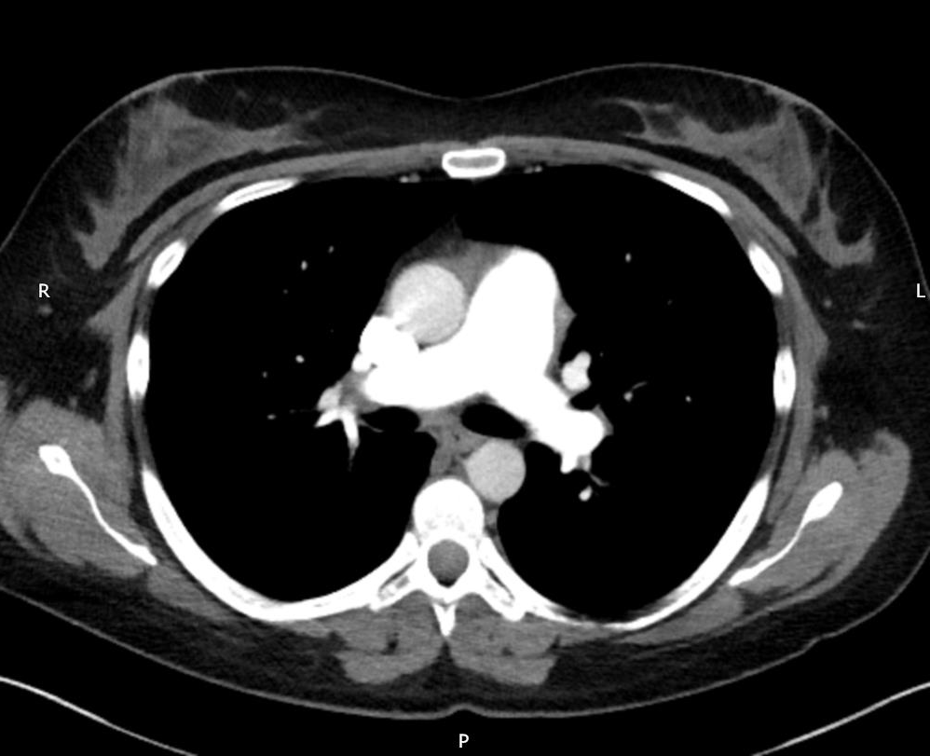
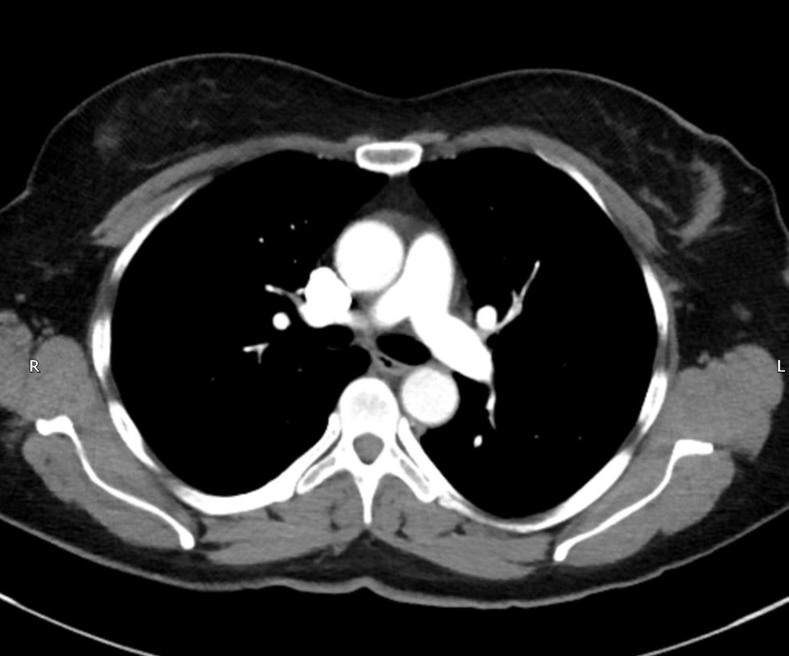
A 60 mL B 75 mL
Figure 1 Sample axial image slices showing the good opacification in the main pulmonary artery with intravenous contrast in the two groups (red arrows).

Table 1 Characteristics of the study population
 | 60 mL | 75 mL (control)
Size | 57 | 70
Gender (M:F) | 23:34 | 32:38
Mean age (yr) | 65.7 | 62.7
Age range (yr) | 34-93 | 16-92

M: Male; F: Female.

Table 2 A comparison of mean opacification values in the pulmonary arteries between the two groups
 | Mean opacification ± standard deviation
 | 60 mL of contrast agent | 75 mL of contrast agent | Mean difference (95%CI)
Main Pulmonary artery | 437 ± 121 | 438 ± 142 | 1 (-45 to 47)
Right Pulmonary artery | 417 ± 115 | 420 ± 130 | 3 (-41 to 47)
Left Pulmonary artery | 417 ± 110 | 424 ± 140 | 7 (-38 to 50)
All values are given in Hounsfield units.

Table 3 Number of sub-optimal studies in each group
Group | Number of sub-optimal studies
75 mL | 10
60 mL | 7
 | P = 0.96

