Name of Journal: World Journal of Hepatology
ESPS Manuscript NO: 27887
Manuscript Type: Case Report

Major hepatectomy using the glissonean approach in cases of right umbilical portion

Ome Y et al. Hepatectomy in cases of right umbilical portion

Yusuke Ome, Kazuyuki Kawamoto, Tae Bum Park, Tadashi Ito

Yusuke Ome, Kazuyuki Kawamoto, Tae Bum Park, Tadashi Ito, Department of Surgery, Kurashiki Central Hospital, Kurashiki, Okayama 710-8602, Japan

Author contributions: Ome Y clinically managed the patients, performed the operations, gathered the clinical data, designed the report, and wrote the paper; Kawamoto K, Park TB, and Ito T supervised the clinical practices and helped draft and revise the manuscript.

Institutional review board statement: The Kurashiki Central Hospital Institutional Review Board does not require approval for case reports. Ethics approval was not necessary for this case report.

Informed consent statement: Written informed consent was obtained from the patients.

Conflict-of-interest statement: None of the authors have conflicts of interest to declare.

Open-Access: This article is an open-access article which was selected by an in-house editor and fully peer-reviewed by external reviewers. It is distributed in accordance with the Creative Commons Attribution Non Commercial (CC BY-NC 4.0) license, which permits others to distribute, remix, adapt, build upon this work non-commercially, and license their derivative works on different terms, provided the original work is properly cited and the use is non-commercial. See: http://creativecommons.org/licenses/by-nc/4.0/

Manuscript source: Invited manuscript

Correspondence to: Yusuke Ome, MD, Department of Surgery, Kurashiki Central Hospital, 1-1-1 Miwa, Kurashiki City, 710-8602, Okayama, Japan. yo14408@kchnet.or.jp
Telephone: +81-86-4220210
Fax: +81-86-4213424

Received: June 21, 2016
Peer-review started: June 24, 2016
First decision: August 11, 2016
Revised: September 11, 2016
Accepted: October 25, 2016
Article in press:
Published online:

Abstract
Right umbilical portion (RUP) is a rare congenital anomaly associated with anomalous ramifications of the hepatic vessels and biliary system. As such, major hepatectomy requires a careful approach. We describe the usefulness of the Glissonean approach in two patients with vessel anomalies, such as RUP. The first patient underwent a right anterior sectionectomy for intrahepatic cholangiocarcinoma. We encircled several Glissonean pedicles that entered the right anterior section along the right side of the RUP. We temporarily clamped each pedicle, confirmed the demarcation area, and finally cut them. The operation was performed safely and was successful. The second patient underwent a left trisectionectomy for perihilar cholangiocarcinoma. We secured the right posterior Glissonean pedicle. The vessels in the pedicle were preserved, and the other vessels and contents were resected. Identifying the vessels for preservation facilitated the safe lymphadenectomy and dissection of the vessels to be resected. We successfully performed the operation.

Key words: Right umbilical portion; Glissonean approach; Glissonean pedicle; Right anterior sectionectomy; Left trisectionectomy; Cholangiocarcinoma; Hepatocellular carcinoma

© The Author(s) 2016. Published by Baishideng Publishing Group Inc. All rights reserved.

Core tip: Right umbilical portion (RUP) is a rare congenital anomaly, and its presence is associated with anomalous ramifications of the hepatic artery, portal vein, and biliary system. Major Hepatectomies for patients with this anomaly are complicated and require a careful approach. The Glissonean approach is acknowledged as a successful technique. The targeted Glissonean pedicle to be resected or preserved is easily identified by clamping; thus, the Glissonean approach can be used in various situations of hepatic resection. This report describes the usefulness of the Glissonean technique, especially in cases with an anomaly, such as RUP.

Ome Y, Kawamoto K, Park TB, Ito T. Major hepatectomy using the Glissonean approach in cases of right umbilical portion. World J Hepatol 2016; In press

INTRODUCTION
Right umbilical portion (RUP) is a rare congenital anomaly, and its reported incidence ranges from 0.2% to 1.2%^{[1-6]}. The presence of RUP is associated with anomalous ramifications of the hepatic artery, portal vein, and biliary system. During anatomical liver resection, only the vessels feeding the area intended for resection should be resected, whereas the other vessels should be preserved. Consequently, major hepatectomies for cases with RUP are complicated and require a careful approach and attention to the anomalous branching of those vessels. Only a few hepatectomy cases with RUP have been reported in the English literature. Here, we report two successful cases with RUP who safely underwent anatomical hepatectomy. We also describe the usefulness of the Glissonean approach.

CASE REPORT
Case 1
A 70-year-old man with hepatitis C presented with a liver tumour. He had a past medical history of distal gastrectomy for gastric ulcer, Graves’ disease, and diabetes mellitus. Laboratory tests showed normal levels of CEA, CA19-9, and AFP but elevated PIVKA-II at 808 mAU/mL. The indocyanine green retention rate at 15 min was 12.9%, and the Child-Pugh score was 5 points, Grade A. He was diagnosed with intrahepatic cholangiocarcinoma or combined hepatocellular and cholangiocarcinoma located in segment 8. A CT scan also revealed that his gallbladder was attached to the left side of the liver; RUP was noted (Figure 1).
The patient underwent right anterior sectionectomy (Figure 2). Laparotomy showed that the gallbladder was attached to the round ligament. After the mobilization of the right lobe, the gallbladder was resected. Then, the right anterior Glissonean pedicles, which ramified along the right side of the RUP, were extrahepatically separated and encircled with tape. We temporarily clamped each pedicle and confirmed the demarcation area and blood flow via ultrasonography. The demarcation area was the same as the three-dimensional image visualization via preoperative simulation. The liver parenchyma was transected along the demarcation line using the Pringle manoeuvre. We finally ligated and cut the encircled right anterior Glissonean pedicles. The operation succeeded without injuring any of the vessels intended for preservation. The operation required 244 min, and the estimated blood loss was 776 mL.
Macroscopic findings showed an irregular mass, 25 mm in size. A histological examination revealed that the tumour was a poorly differentiated intrahepatic cholangiocarcinoma that invaded the intrahepatic portal vein. The patient was diagnosed as stage II (T2N0M0). All of the surgical margins were negative. He recovered uneventfully and was discharged on postoperative day 6.

Case 2
A 70-year-old woman presented with general fatigue and intrahepatic bile duct dilatation. Tumour markers, such as AFP, PIVKA-II, and CEA, were normal, but CA19-9 was elevated at 843.6 U/mL. Other laboratory tests showed elevated ALP at 601 IU/L, elevated γ-GTP at 318 IU/L, and impaired serum albumin at 3.3 g/dl. Bilirubin was normal. The indocyanine green retention rate at 15 min was 4.6%, and the Child-Pugh score was 6 points, Grade A. She was diagnosed with perihilar cholangiocarcinoma and RUP via US, CT, and MRCP (Figure 3). The tumour involved the confluence of the left lateral, left medial, and right anterior hepatic ducts; the right posterior branch was intact.
The patient underwent left trisectionectomy with extrahepatic bile duct resection (Figure 4). First, Kocher’s manoeuvre and lymphadenectomy around the pancreas head were performed. The distal common bile duct was transected at the level of the pancreas. Then, we performed lymphadenectomy in the hepatoduodenal ligament. The gallbladder was dissected, and we secured and encircled the right lateral Glissonean pedicle with tape. The portal vein, the hepatic artery, and the hilar plate were separated from the other structures just proximal to the secured Glissonean pedicle. The vessels entering the pedicle were preserved, and the other vessels and contents were resected. In the preoperative simulation, only one right posterior branch of the hepatic artery was identified. During the operation, however, two arteries were found entering the right posterior section. We preserved the vessels that nourished the right posterior section and resected the root of the left hepatic artery, the right anterior hepatic artery, and the common trunk of the left lateral portal vein and RUP. Next, the demarcation area was confirmed. The left side of the liver was fully mobilized, and the liver parenchyma was transected along the demarcation line. Finally, we cut the right posterior hepatic duct, and the specimen was removed. Hepaticojejunostomy to the right posterior bile duct and jejunojejunostomy were conducted, and the operation was successfully completed. The operative time was 697 min, and the estimated blood loss was 716 mL.
A histological examination showed moderately differentiated cholangiocarcinoma, 30 mm in size that was invading the hepatic duct and the portal vein. Two lymph node metastases were revealed. The patient was diagnosed as stage IIB (T3N1M0). All of the surgical margins were negative. The postoperative course was uneventful, and this patient was discharged on postoperative day 13.

DISCUSSION
RUP, previously known as a left-sided gallbladder, is a rare congenital anomaly. However, we occasionally encounter it in our daily medical procedures (e.g., cholecystectomy). RUP is an anatomical anomaly in which the umbilical portion exists between the right anterior and left medial section. The right-sided round ligament adheres to the RUP. Other theories exist regarding liver segmentation with RUP. One is that segment 4 is absent^{[5]}. Another is that the right side of the RUP is comparable with the dorsal segment of the right anterior section and the left side of the RUP with the ventral segment of the right anterior section^{[7]}. In this report, we defined RUP as the umbilical portion that exists between the right anterior and left medial section. Nagai et al^{[1]} reviewed the literature concerning this anomaly and classified the type of portal branching according to bifurcation type and trifurcation type. Nineteen cases with RUP have undergone hepatectomy in the English-language literature^{[1,3,6,8-15]} (Table l). RUP is associated with anomalous ramifications of the hepatic artery, portal vein, and biliary system; thus, surgery for cases with RUP requires careful procedures, especially with regard to hepatic resection. Previous reports described the importance of the thorough preoperative and intraoperative recognition of the various anomalies associated with RUP to prevent operative accidents.
CT and three-dimensional imaging have been developed, and preoperative simulation is of great help. We must preoperatively evaluate and recognize the anatomy precisely in cases with this anomaly. However, some vessels go unrecognized during the preoperative survey but can be encountered during the procedure, as was observed in case 2. Thus, paying special attention during the operation is important.
The Glissonean approach is acknowledged as a potentially successful technique for liver surgery, and it is widely performed for liver resection. The ramification pattern of the hepatic artery, portal vein, and bile duct in the hepatoduodenal ligament often varies across patients. However, the Glissonean pedicle peripheral to the hilar plate, which is wrapped by connective tissue and contains the hepatic artery, portal vein, and bile duct, enters its proper area and never contains branches that nourish other areas. Consequently, the Glissonean pedicle transection peripheral to the extrahepatic hilar plate is a safe and sure method that enables the cutting of the intended vessels without damaging the vessels to be preserved. Secondary and tertiary branches of the Glissonian pedicle peripheral to the hilar plate can usually be approached and transected extrahepatically. When the targeted Glissonean pedicle is transiently and selectively clamped, we can recognize the area to be resected. Surgeons do not have to consider any variations in the hepatoduodenal ligament. The Glissonean approach is a successful method, especially in cases with anomalous ramifications of the hepatic artery, portal vein, and biliary system. The Glissonean pedicle to be resected was separated in case 1, whereas that to be preserved was encircled in case 2. The Glissonean approach can be used in various situations of hepatic resection, and it contributes to a safe and secure liver surgery.
In conclusion, we successfully performed two major hepatectomies using the Glissonean approach in cases with RUP. The Glissonean approach is a useful method and contributes to a safe procedure for cases with an anomalous anatomy such as RUP.

COMMENTS
Case characteristics
A 70-year-old man with hepatitis C presented with a liver tumour without any symptoms; a 70-year-old woman presented with general fatigue and intrahepatic bile duct dilatation.

Clinical diagnosis
Intrahepatic cholangiocarcinoma or combined hepatocellular and cholangiocarcinoma of the right umbilical portion (RUP); perihilar cholangiocarcinoma of the RUP.

Differential diagnosis
Metastatic liver tumour; intrahepatic cholangiocarcinoma and inflammatory biliary stenosis.

Laboratory diagnosis
The level of tumour marker PIVKA-II was elevated at 808 mAU/mL; other tumour markers were normal; the level of tumour marker CA19-9 was elevated at 843.6 U/mL; other tumour markers were normal.

Imaging diagnosis
A CT scan showed RUP and a 25-mm sized tumour peripherally enhanced in the arterial phase in segment 8; a CT scan showed RUP and a 25-mm sized tumour in the left side of the perihilar region, which caused dilatation of intrahepatic distal bile duct and almost occluded the RUP.

Pathological diagnosis
A pathological examination showed a poorly differentiated intrahepatic cholangiocarcinoma invading the intrahepatic portal vein; the pathological findings revealed a moderately differentiated cholangiocarcinoma invading RUP.

Treatment
The patient was treated with right anterior sectionectomy; the patient was treated with left trisectionectomy.

Related reports
Only nineteen cases of hepatectomy among patients with RUP have been reported in the English-language literature.

Term explanation
RUP is a congenital anomaly in which the umbilical portion exists between the right anterior section and left medial section.

Experiences and lessons
This report emphasizes that the Glissonean approach is useful, especially in cases with anomalous ramifications of the hepatic artery, portal vein, and biliary system such as RUP. This procedure contributes to a safe and secure liver surgery.

Peer-review
This paper is the first report about major hepatectomy using the Glissonean approach in cases with RUP, and demonstrates the safety and usefulness of the Glissonean approach for hepatectomy in cases with anomalies such as RUP, and this report is very important guidance for surgeons who perform major hepatectomy for cases with RUP.

REFERENCES
1 Nagai M, Kubota K, Kawasaki S, Takayama T, BandaiY M. Are left-sided gallbladders really located on the left side? Ann Surg 1997; 225: 274-280 [PMID: 9060583 DOI: 10.1097/00000658-199703000-00006]
2 Maetani Y, Itoh K, Kojima N, Tabuchi T, Shibata T, Asonuma K, Tanaka K, Konishi J. Portal vein anomaly associated with deviation of the ligamentum teres to the right and malposition of the gallbladder. Radiology 1998; 207: 723-728 [PMID: 9609896 DOI: 10.1148/radiology.207.3.9609896]
3 Asonuma K, Shapiro AM, Inomata Y, Uryuhara K, Uemoto S, Tanaka K. Living related liver transplantation from donors with the left-sided gallbladder/portal vein anomaly. Transplantation 1999; 68: 1610-1612 [PMID: 10589965 DOI: 10.1097/00007890-199911270-00031]
4 Baba Y, Hokotate H, Nishi H, Inoue H, Nakajo M. Intrahepatic portal venous variations: demonstration by helical CT during arterial portography. J Comput Assist Tomogr 2000; 24: 802-808 [PMID: 11045706 DOI: 10.1097/00004728-200009000-00024]
5 Savier E, Taboury J, Lucidarme O, Kitajima K, Cadi M, Vaillant JC, Hannoun L. Fusion of the planes of the liver: an anatomic entity merging the midplane and the left intersectional plane. J Am Coll Surg 2005; 200: 711-719 [PMID: 15848361 DOI: 10.1016/j.jamcollsurg.2004.12.017]
6 Hsu SL, Chen TY, Huang TL, Sun CK, Concejero AM, Tsang LL, Cheng YF. Left-sided gallbladder: its clinical significance and imaging presentations. World J Gastroenterol 2007; 13: 6404-6409 [PMID: 18081230]
7 Gupta R, Miyazaki A, Cho A, Ryu M. Portal vein branching pattern in anomalous right-sided round ligament. Abdom Imaging 2010; 35: 332-336 [PMID: 19396389 DOI: 10.1007/s00261-009-9520-0]
8 Uesaka K, Yasui K, Morimoto T, Torii A, Kodera Y, Hirai T, Yamamura Y, Kato T, Kito T. Left-sided gallbladder with intrahepatic portal venous anomalies. J Hep Bil Pancr Surg 1995; 2: 425-430 [DOI: 10.1007/BF02349262]
9 Idu M, Jakimowicz J, Iuppa A, Cuschieri A. Hepatobiliary anatomy in patients with transposition of the gallbladder: implications for safe laparoscopic cholecystectomy. Br J Surg 1996; 83: 1442-1443 [PMID: 8944467 DOI: 10.1002/bjs.1800831037]
10 Kaneoka Y, Yamaguchi A, Isogai M, Harada T. Hepatectomy for cholangiocarcinoma complicated with right umbilical portion: anomalous configuration of the intrahepatic biliary tree. J Hepatobiliary Pancreat Surg 2000; 7: 321-326 [PMID: 10982634 DOI: 10.1007/s005340000070321.534]
11 Tashiro H, Itamoto T, Nakahara H, Ohdan H, Kobayashi T, Asahara T. Resection of hepatocellular carcinoma in a patient with congenital anomaly of the portal system. Dig Surg 2003; 20: 163-165 [PMID: 12686785 DOI: 10.1159/000069385]
12 Hwang S, Lee SG, Park KM, Lee YJ, Ahn CS, Kim KH, Moon DB, Ha TY, Cho SH, Oh KB. Hepatectomy of living donors with a left-sided gallbladder and multiple combined anomalies for adult-to-adult living donor liver transplantation. Liver Transpl 2004; 10: 141-146 [PMID: 14755792 DOI: 10.1002/lt.20007]
13 Abe T, Kajiyama K, Harimoto N, Gion T, Shirabe K, Nagaie T. Resection of metastatic liver cancer in a patient with a left-sided gallbladder and intrahepatic portal vein and bile duct anomalies: A case report. Int J Surg Case Rep 2012; 3: 147-150 [PMID: 22365920 DOI: 10.1016/j.ijscr.2012.01.003]
14 Sakaguchi T, Suzuki S, Morita Y, Oishi K, Suzuki A, Fukumoto K, Inaba K, Takehara Y, Baba S, Nakamura S, Konno H. Hepatectomy for metastatic liver tumors complicated with right umbilical portion. Hepatogastroenterology 2011; 58: 984-987 [PMID: 21830428]
15 Almodhaiberi H, Hwang S, Cho YJ, Kwon Y, Jung BH, Kim MH. Customized left-sided hepatectomy and bile duct resection for perihilar cholangiocarcinoma in a patient with left-sided gallbladder and multiple combined anomalies. Korean J Hepatobiliary Pancreat Surg 2015; 19: 30-34 [PMID: 26155274 DOI: 10.14701/kjhbps.2015.19.1.30]

P-Reviewer: Bramhall S, Lau WYJ, Qin JM S-Editor: Qiu S L-Editor: E-Editor:

A
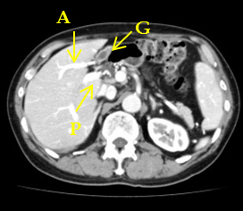
B
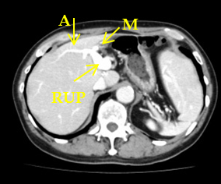
C
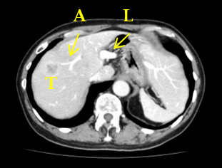
D
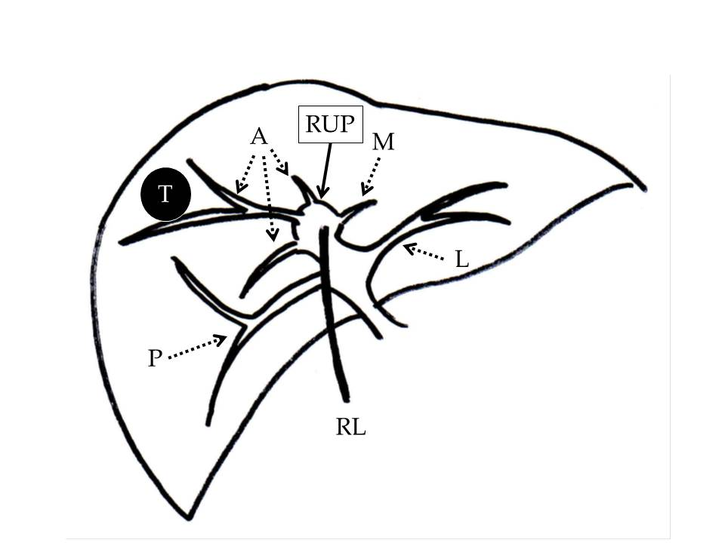
Figure 1 Case 1 enhanced computed tomography. A: CT shows the left-sided gallbladder and RUP; B: The right anterior and medial segmental portal branches ramify from the RUP after its trifurcation as well as the right posterior and left lateral branch; C: A 25-mm sized tumour peripherally enhanced in the arterial phase was detected in segment 8; D: Diagram of the intrahepatic portal vein branching and the location of the tumour. A: Right anterior portal vein; P: Right posterior portal vein; G: Gallbladder; M: Left medial portal vein; RUP: Right umbilical portion; L: Left lateral portal vein; T: Tumour; RL: Round ligament.

A
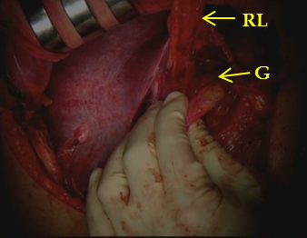
B
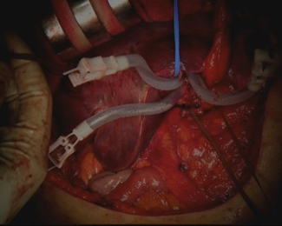
C
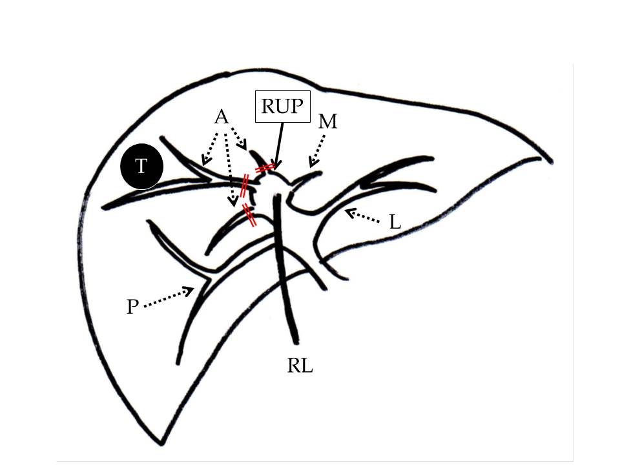
D
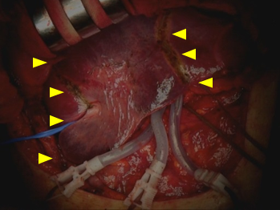
E
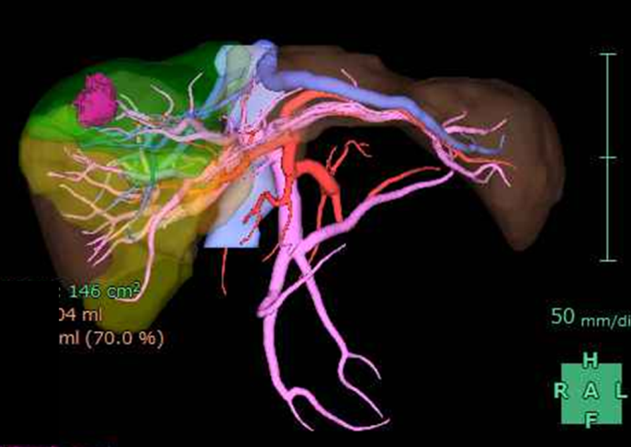
f.
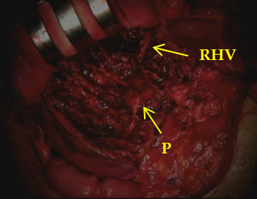
Figure 2 Case 1 operative findings. A: The gallbladder was attached to the round ligament; B: Three ramifications of the right anterior Glissonean pedicles were separated and clamped; C: Diagram of the clamped Glissonean pedicles (double line); D, E: The demarcation area (arrow head) was identified as in the preoperative simulation; F: The accomplishment of a right anterior sectionectomy. RL: Round ligament; G: Gallbladder; A: Right anterior branch of the Glissonean pedicle; P: Right posterior branch of the Glissonean pedicle; M: Left medial branch of the Glissonean pedicle; RUP: Right umbilical portion; L: Left lateral branch of the Glissonean pedicle; T: Tumour; RHV: Right hepatic vein.

A
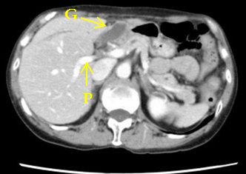
B
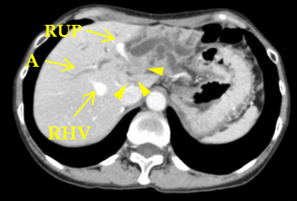
C
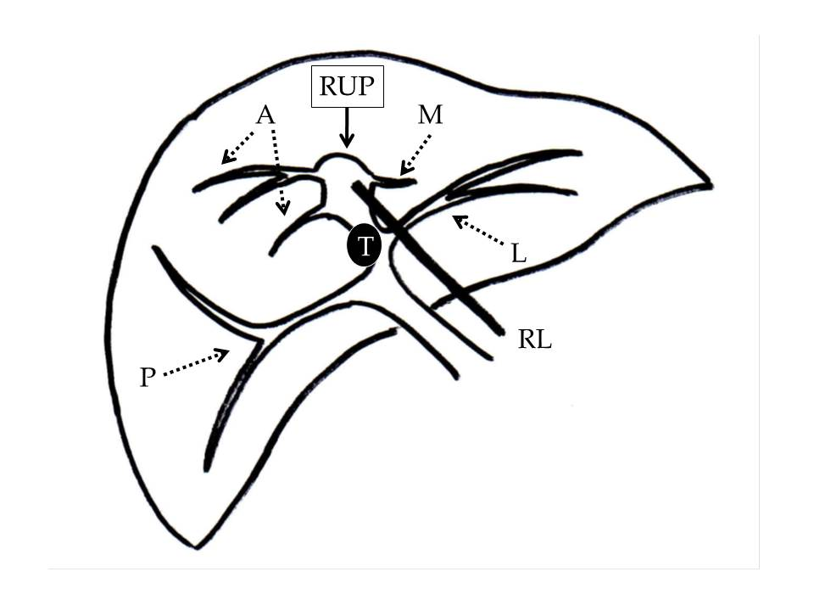
Figure 3 Case 2 enhanced computed tomography. A, B: CT shows the right posterior portal branch to be solely bifurcated, and the right anterior and medial segmental portal branches ramify from the RUP ; B: A 25-mm sized mass (arrow head) is adjacent to the RUP. The RUP is almost occluded, and the intrahepatic distal bile duct is dilated (b); C: Diagram of the intrahepatic portal vein branching and the location of the tumour. RL: Round ligament; G: Gallbladder; A: Right anterior branch of the Glissonean pedicle; P: Right posterior branch of the Glissonean pedicle; M: Left medial branch of the Glissonean pedicle; RUP: Right umbilical portion; L: Left lateral branch of the Glissonean pedicle; T: Tumour; RHV: Right hepatic vein.

A
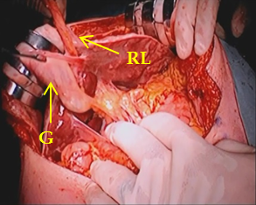
B
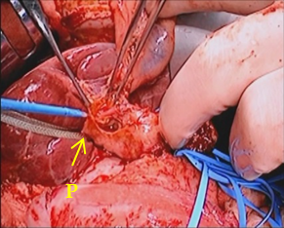
C
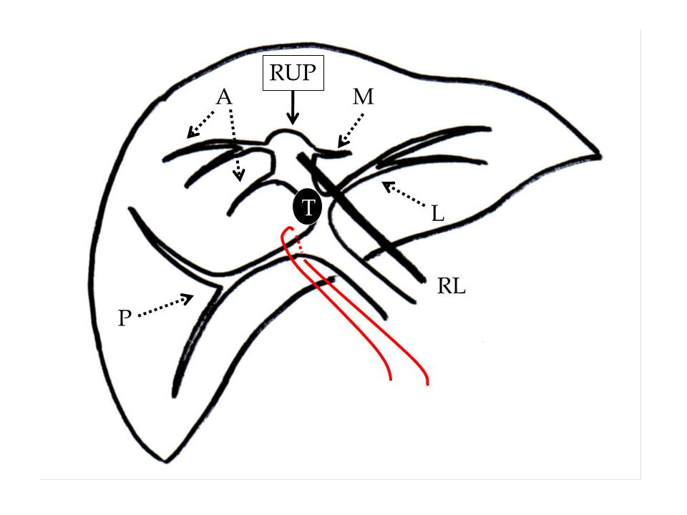
D
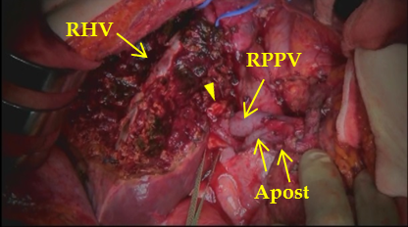
E
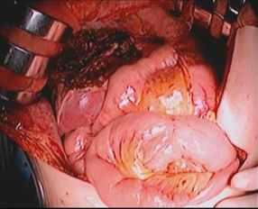
Figure 4 Case 2 operative findings. A: The gallbladder was attached to the round ligament; B: The right posterior Glissonean pedicle was encircled, and the vessels entering the right posterior Glissonean pedicle were identified; C: Diagram of securing the right posterior branch of the Glissonean pedicle; D: The accomplishment of left trisectionectomy; E: Hepaticojejunostomy was performed. RL: Round ligament; G: Gallbladder; A: Right anterior branch of the Glissonean pedicle; P: Right posterior branch of the Glissonean pedicle; M: Left medial branch of the Glissonean pedicle; RUP: Right umbilical portion; L: Left lateral branch of the Glissonean pedicle; T: Tumour; RHV: Right hepatic vein; RPPV: Right posterior portal vein; Apost: Right posterior hepatic artery; Arrow-head: Stump of the right posterior bile duct.

Table 1 The reported patients with right umbilical portion who underwent hepatectomy in the English-language literature

Ref | Age (yr) | Sex | Disease | Surgical procedure | Type of intrahepatic portal venous branching
Uesaka et al^{[8]} | 53 | Male | Liver metastasis of bile duct cancer | Right hepatectomy | Trifurcation type
Idu et al^{[9]} | Unknown | Male | Perihilar cholangiocarcinoma | Left hepatectomy | Unknown
Nagai et al^{[1]} | 67 | Male | Bile duct cancer | Right anterior sectionectomy, segmentectomy 1, | Trifurcation type
 |  |  |  | and pancreatoduodenectomy
Nagai et al^{[1]} | 67 | Male | Hepatocellular carcinoma | Segmentectomy 8, | Trifurcation type
 |  |  |  | and partial resection of segment 1
Asonuma et al^{[3]} | 48 | Male | Living donor | Left lateral sectionectomy | Unknown
Asonuma et al^{[3]} | 29 | Male | Living donor | Left lateral sectionectomy | Unknown
Asonuma et al^{[3]} | 35 | Female | Living donor | Left lateral sectionectomy | Bifurcation type
Kaneoka et al^{[10]} | 53 | Male | Perihilar cholangiocellular carcinoma | Left Hepatectomy and segmentectomy 1 | Trifurcation type
 |  |  |  | with extrahepatic bile duct resection
Kaneoka et al^{[10]} | 61 | Male | Extrahepatic bile duct cholangiocarcinoma | Left hepatectomy, segmentectomy 1, | Trifurcation type
 |  |  |  | and pylorous-preserving pancreaticduodenectomy
Tashiro et al^{[11]} | 53 | Male | Hepatocellular carcinoma | Partial hepatectomy | Trifurcation type
Hwang et al^{[12]} | 18 | Male | Living donor | Right hepatectomy | Bifurcation type
Hwang et al^{[12]} | 24 | Unknown | Living donor | Right posterior sectionectomy | Trifurcation type
Hwang et al^{[12]} | 39 | Unknown | Living donor | Left hepatectomy leaving S4a | Bifurcation type
Hsu et al^{[6]} | Unknown | Unknown | Hepatocellular carcinoma | Right hepatectomy | Trifurcation type
Hsu et al^{[6]} | Unknown | Unknown | Hepatocellular carcinoma | Partial resection of left lateral section | Trifurcation type
Hsu et al^{[6]} | Unknown | Unknown | Hepatocellular carcinoma | Left lateral sectionectomy | Bifurcation type
Abe et al^{[13]} | 70 | Female | Liver metastasis of uterine cervical cancer | Right hepatectomy with extrahepatic bile duct resection | Bifurcation type
Sakaguchi et al^{[14]} | 76 | Male | Liver metastasis of rectal cancer | Right posterior sectionectomy | Trifurcation type
 |  |  |  | and partial resection of segment 1 and right anterior section
Almodhaiberi et al^{[15]} | 67 | Male | Perihilar cholangiocarcinoma | Extended left lateral sectionectomy and segmentectomy 1 | Trifurcation type
 |  |  |  | with extrahepatic bile duct resection
Case 1 | 70 | Male | Intrahepatic cholangiocarcinoma | Right anterior sectionectomy | Trifurcation type
Case 2 | 70 | Female | Perihilar cholangiocarcinoma | Left trisectionectomy with extrahepatic bile duct resection | Trifurcation type

