Name of Journal: World Journal of Clinical Cases
Manuscript NO: 65427
Manuscript Type: ORIGINAL ARTICLE

Retrospective Study
Increased morbidity and mortality of hepatocellular carcinoma patients in lower cost of living areas

Sempokuya T et al. Regional disparity of hepatocellular carcinoma

Tomoki Sempokuya, Kishan P Patel, Muaataz Azawi, Jihyun Ma, Linda L Wong

Tomoki Sempokuya, Muaataz Azawi, Division of Gastroenterology and Hepatology, Department of Internal Medicine, University of Nebraska Medical Center, Omaha, NE 68198, United States

Kishan P Patel, Department of Internal Medicine, University of Nebraska Medical Center, Omaha, NE 68198, United States

Jihyun Ma, Department of Biostatistics, University of Nebraska Medical Center, Omaha, NE 68198, United States

Linda L Wong, Department of Surgery, John A Burns School of Medicine, University of Hawaii at Manoa, Honolulu, HI 96817, United States

Author contributions: Sempokuya T contributed to the study design, data collection, and statistical analysis; Sempokuya T, Patel KP, and Azawi M contributed to the literature review, manuscript drafting, and editing; Ma J contributed to the study design and statistical analysis; Wong LL contributed to study supervision, manuscript drafting and editing; and all of the authors have approved the final version of the manuscript.

Corresponding author: Tomoki Sempokuya, MD, Doctor, Division of Gastroenterology and Hepatology, Department of Internal Medicine, University of Nebraska Medical Center, 982000 Nebraska Medical Center, Omaha, NE 68198, United States. tsempoku@hawaii.edu

Received: March 15, 2021
Revised: April 11, 2021
Accepted: June 25, 2021
Published online:

Abstract
BACKGROUND
The incidence and mortality rates of hepatocellular carcinoma (HCC) are increasing in the United States. However, the increases in different racial and socioeconomic groups have not been homogeneous. Access to healthcare based on socioeconomic status and cost of living index (COLI), especially in HCC management, is under characterized.

AIM
The aim was to investigate the relationship between the COLI and tumor characteristics, treatment modalities, and survival of HCC patients in the United States.

METHODS
A retrospective study of the Surveillance, Epidemiology, and End Results (SEER) database was conducted to identify patients with HCC between 2007 and 2015 using site code C22.0 and the International Classification of Disease for Oncology, 3rd edition (ICD-O-3) codes 8170-8173, and 8175. Cases of fibrolamellar HCC were excluded. Variables collected included demographics, COLI, insurance status, marital status, stage, treatment, tumor size, and survival data. Interquartile ranges for COLI were obtained. Based on the COLI, the study population was separated into four groups: COLI ≤ 901, 902-1044, 1045-1169, ≥ 1070. The χ² test was used to compare categorical variables, and the Kruskal-Wallis test was used to compare continuous variables without normal distributions. Survival was estimated by the Kaplan-Meier method. We defined P < 0.05 as statistically significant.

RESULTS
We identified 47,894 patients with HCC. Patients from the highest COLI areas were older (63 vs 61 years of age), more likely to be married (52.8% vs 48.0%), female (23.7% vs 21.1%), and of Asian and Pacific Islander descent (32.7% vs 4.8%). The patients were more likely to have stage I disease (34.2% vs 32.6%), tumor size ≤ 30 mm (27.1% vs 23.1%), received locoregional therapy (11.5% vs 6.1%), and undergone surgical resection (10.7% vs 7.0%) when compared with the lowest quartile. The majority of patients with higher COLIs resided in California, Connecticut, Hawaii, and New Jersey. Patients with lower COLIs were more likely to be uninsured (5.7% vs 3.4%), have stage IV disease (15.2% vs 13%), and have received a liver transplant (6.6% vs 4.4%) compared with patients from with the highest COLI. Median survival increased with COLI from 8 (95%CI: 7-8), to 10 (10-11), 11 (11-12), and 14 (14-15) mo (p < 0.001) among patients with COLIs of ≤ 901, 902-1044, 1045-1169, ≥ 1070, respectively. After stratifying by year, a survival trend was present: 2007-2009, 2010-2012, and 2013-2015.

CONCLUSION
Our study suggested that there were racial and socioeconomic disparities in HCC. Patients from lower COLI groups presented with more advanced disease, and increasing COLI was associated with improved median survival. Future studies should examine this further and explore ways to mitigate the differences.

Key Words: Hepatocellular carcinoma; Disparity; Race; Socioeconomic status; Survival; Treatment

Sempokuya T, Patel KP, Azawi M, Ma J, Wong LL. Increased morbidity and mortality of hepatocellular carcinoma patients in lower cost of living areas. World J Clin Cases 2021; In press

Core Tip: This was a retrospective study to evaluate the relationship between the cost of living index (COLI) of patients with hepatocellular carcinoma (HCC) and treatment options, tumor characteristics, and median overall survival. Patients from lower COLIs were more likely to be uninsured (5.7% vs 3.4%), had more stage IV disease (15.2% vs 13%), and required more liver transplants (6.6% vs 4.4%) compared with those having the highest COLI. Median survival individuals with HCC from the highest COLI areas was significantly longer compared with the lowest COLI (14 mo vs 8 mo), suggesting that socioeconomic and racial disparities may contribute to survival for HCC.

INTRODUCTION
Hepatocellular carcinoma (HCC) is the sixth most common malignancy worldwide^{[1]}. In 2018, there were more than 841,000 new primary liver cancer cases and 782,000 deaths globally, most of which were HCC^{[2]}. Chronic hepatitis B (HBV) or hepatitis C (HCV) virus infection, heavy alcohol consumption, diabetes, and nonalcoholic fatty liver disease (NAFLD) are the most important risk factors for developing HCC^{[3]}. Notably, nonalcoholic steatohepatitis (NASH) has become the fastest growing cause of HCC-related liver transplants in the United States^{[3]}.
Nearly 80% of all HCC cases are attributable to HBV or HCV infections, and can develop subsequent to infection without any evidence of cirrhosis^{[4]}. Men of Asian and East African descent have historically experienced the highest age-adjusted incidence, of HCC attributed to active chronic HBV infection^{[2]}. With the reduction of aflatoxin exposure, increased in HBV vaccination coverage, and subsequent generations of United States-born Asians having lower HBV infection rates, the incidence of infection among the Asian demographic has improved^{[4]}. HCC age-adjusted incidence rates have recently shifted, with higher rates occurring in Hispanic individuals^{[5,6]}. Compared with foreign-born Hispanics, United States-born Hispanics were previously noted to have a higher incidence of HCC^{[3]}.
When considering socioeconomic status, Yu et al^{[7]} noted that black patients in their large tertiary transplant institution were much less likely (OR = 0.03, 95%CI: 0.00–0.37) than white patients to receive a liver transplant, which may be related to Blacks and Hispanics being more likely to be diagnosed with advanced-stage disease, having higher initial Child-Pugh scores and AFP levels, and coming from lower median-income households. In support, a study by Shah et al^{[8]} suggested that therapy for HCC had historically been underutilized; their no-treatment groups included more individuals with a lower socioeconomic status, of black heritage, and evaluated at small and medium-sized hospitals. Despite recent increases in the incidence and mortality rates of HCC, the rise is not homogenous across various racial and socioeconomic groups. Furthermore, it is unclear how socioeconomic status, access to medical care, and underlying racial disparities currently impact the outcome of HCC. Therefore, we aimed to characterize the relationship between the cost of living index (COLI), sociodemographic factors, tumor characteristics, treatment modalities, and overall survival in HCC patients using Surveillance, Epidemiology, and End Results (SEER) data from 2007 to 2015.

MATERIALS AND METHODS
Study design
Population data from the SEER database published by the National Cancer Institute was obtained through the Surveillance Research Program, National Cancer Institute SEER*Stat software (seer.cancer.gov/seerstat/) version <8.3.6>^{[9]}. SEER Registries include population-based data that report cancer incidence, characteristics, treatment and, mortality in selected states of the United States since 1973. Approximately 34.6% of all cancer cases in the United States population are included^{[10]}. The SEER data analyzed in this study was obtained in 18 states and regions available to conduct survival analysis, including the Alaska Native Tumor Registry, California (San Francisco-Oakland, San Jose-Monterey, Los Angeles, Greater California), Connecticut, Georgia (Atlanta, Greater Georgia, Rural Georgia), Hawaii, Iowa, Kentucky, Louisiana, Michigan (Detroit), New Jersey, New Mexico, Utah and Washington (Seattle-Puget Sound) More details are available at https://seer.cancer.gov/registries/terms.html. This study was conducted after complying with the SEER Research Data Use Agreement. As we utilized a publicly available, de-identified database, approval from an institutional review board was not required to conduct this study.

Patients
We collected data on patients diagnosed with HCC between 2007 and 2015 by using site code C22.0, the International Classification of Disease for Oncology, third edition (ICD-O-3) codes 8170-8173, and 8175. As fibrolamellar HCC has a distinct phenotype, it was excluded. Variables of interest that were collected included age at the time of diagnosis, year of diagnosis, sex, race (White, Blacks, Hispanic, Asian or Pacific Islander (API), or others/unknown), marital status, COLI, insurance status, stage of disease by the American Joint Committee on Cancer (AJCC) Staging Manual, sixth edition^{[11]}, modality and frequency of treatment, tumor size, and survival data. The SEER database calculates COLI using a family budget analysis done by the Economic Policy Institute (https://www.epi.org/resources/budget/). The COLI was based on a family of two parents and one child living in a county and with an essential family expenditures including housing, food, childcare, transportation, health care, and taxes (https://seer.cancer.gov/seerstat/variables/countyattribs/static.html#col). The United States population-weighted mean cost of living is valued at 1,000. The COLI is the ratio of the local cost of living and the mean cost. Values greater than 1,000 suggest higher than the mean cost of living in the area.

Statistical analysis
Statistical analysis was performed with R version 3.4.1 (The R Foundation for Statistical Computing, Vienna, Austria), EZR version 1.36 (Division of Hematology, Saitama Medical Center, Jichi Medical University, Japan)^{[12]}, and SAS version 9.4 (SAS Institute Inc., Cary, NC, United States). Interquartile ranges for COLI were calculated, and based on that number, we stratified the study population into four groups: COLI ≤ 901, 902-1044, 1045-1169, ≥ 1070. The χ² test was used to compare categorical variables, and the Kruskal-Wallis test was used to compare continuous variables without normal distributions. Survival was estimated by the Kaplan-Meier method. Univariate and multivariate Cox regression analysis was used to compare socioeconomic variables. P < 0.05 was considered significant. The statistical methods of this study were reviewed by Jihyun Ma from the Department of Biostatistics, College of Public Health, University of Nebraska Medical Center.

RESULTS
We identified 47,894 patients with a diagnosis of HCC. Table 1 shows the characteristics of the individuals included in this study. There were 13,515 patients in the COLI ≤ 901 group, 11,379 in the COLI 902-1044 group, 12,167 in the COLI 1045-1169 group, and 10,833 in the COLI ≥ 1070 group. The median age at the time of diagnosis was 63 years and was higher in areas with a higher COLI. All COLI groups had a male predominance. Patients living in the higher COLI areas were more often married, older, and insured when compared with the lowest COLI group. There was also a lower proportion of Black and Hispanic individuals and a higher proportion of API individuals living in higher COLI areas. The majority of the study patients with higher COLIs resided in California, Connecticut, Hawaii, and New Jersey.
Table 2 summarizes the characteristics of HCC in the study patients. Those with the highest COLI were found to more often have stage I disease (34.2% vs 32.6%), tumor size ≤ 30 mm (27.1% vs 23.1%), have received locoregional therapy (11.5% vs 6.1%), and have been treated by surgical resection (10.7% vs 7.0%) compared with the those with the lowest COLI. Patients from the lowest COLI group more often had stage IV disease (15.2% vs 13%) and had received liver transplants (6.6% vs 4.4%). The Kaplan-Meier survival analysis (Figure 1A) demonstrated that median survival increased with increasing COLI from 8 (95%CI: 7-8), to 10 (95%CI: 10-11), to 11 (95%CI: 11-12), and to 14 (95%CI: 14-15) mo (p < 0.001). The trend in median survival remained after stratification by year (2007-2009, 2010-2012, and 2013-2015), as shown in Table 3 and Figure 1B-D.
Table 4 summarizes the results of univariate and multivariate Cox regression analysis of various socioeconomic risk factors and patient backgrounds. The majority of factors (COLI, age, sex, race, insurance status, stage, tumor size, locoregional therapy (LRT), resection, transplant, and year) had a significant hazard ratios (HRs). Univariate analysis found no significant differences for COLI 1048-1169 vs 902-1044, Hispanic vs White, uninsured vs unknown, and stage III vs unknown. Multivariate analysis found no significant differences for API vs other/unknown, black vs white, married (including common law) vs unknown, separated/divorced vs widowed, and single/unmarried or domestic partner vs widowed. Notably, after multivariate analysis, the HR for COLI 1048-1169 vs 902-1044 became significant. Variables associated with marital factors were no longer significant after multivariate analysis. The highest HRs were for LRT, resection, and transplant.

DISCUSSION
In general, HCC has a poor prognosis, with an overall median survival of 6-16 mo, depending on the extent of disease^{[13]}. Our study found that median survival was significantly longer in individuals from the highest COLI than in those with the lowest COLI (14 mo vs 8 mo), suggesting that socioeconomic disparities contributed to survival in HCC. The differences may have resulted from disparities in accessing healthcare for early detection and treatment options available at different disease stages. Individuals from the highest COLI were more likely to receive locoregional (11.5% vs 6.1%) and surgical resection (10.7% vs 7.0%), whereas those from the lowest COLI more often required liver transplantation (6.6% vs 4.4%). The differences may have resulted from the stage or extent of the disease at the time of diagnosis. Compared with the highest COLI, individuals from the lowest COLI were more likely to present with stage IV disease (15.2% vs 13.0%) and less likely to have smaller tumors (23.1% vs 27.1%), suggesting that tumor characteristics, treatment modalities, and overall survival vary by sociodemographic group.
Chronic HBV and HCV infection are predominant risk factors for the development of HCC in various ethnic groups^{[3,14]}. Globally, the disease burden of HCC was the highest in sub-Saharan African and East Asia due to HBV^{[14]}. High rates of HCC have also been noted in APIs, but vaccination programs and healthcare access may have shifted the trend^{[15]}. Our study suggests that more APIs live in the highest COLI areas. A relatively higher HBV burden among API individuals may contribute to more readily available definitive treatments by hepatic resection or locoregional therapy, thus prolonging survival. In the United States, cases of HCC in Hispanics have now surpassed those in APIs, likely related to heavy alcohol consumption, obesity, diabetes, and NAFLD^{[3,6,14]}. Such NAFLD and NASH-related HCC cases may present at advanced stages because of a lack of universal surveillance strategies, particularly in this population. Rich et al^{[16]} suggested that Black and Hispanic patients were historically less likely to be diagnosed with early-stage HCC when compared with their white counterparts. Additionally, African American and Hispanic patients have previously been shown to undergo transplants at rates lower than Whites, and they were less likely than Whites and APIs to undergo ablation or hepatectomy despite disproportionately higher rates of HCC^{[17]}.
Our study demonstrated the challenges and ramifications of socioeconomic status on treatment and outcome in HCC, with individuals in the lowest COLI having a worse disease course and overall prognosis. Previous studies regarding the outcomes of non-metastatic HCC suggested a worse liver cancer-specific survival in patients treated with ablation or surgery with low socioeconomic backgrounds^{[18]}. In general, low-income individuals are more likely to be uninsured and have less access to medical care, including routine screening, diagnosis, and treatment^{[6,19]}. As reported by low-income families, the significant barriers to healthcare access have reinforced a growing concern of lack of insurance coverage, access to appropriate services, and ultimately facing unaffordable costs^{[20]}. Although patients in a lower COLI area have insurance, they may be subject to high copays and deductibles, which make it difficult to afford coverage. Given an increased financial burden of health care, these individuals may opt to forgo routine office visits and screening.
Our study supported a higher rate of uninsured individuals coming from the lower COLI area. While the expansion of Medicaid has improved healthcare access, it has had little effect on cancer screening^{[21]}. Shah et al^{[8]} reported that less than 30% of Medicare patients with HCC underwent therapy, with nearly half of those undergoing noncurative transarterial chemoembolization (TACE) as their treatment option. Furthermore, Medicaid recipients had higher Child-Pugh scores, HCC beyond Milan criteria, and higher AJCC staging^{[7]}. As such, minorities and various socioeconomic groups face serious barriers in disease surveillance and treatment for HCC based on their insurance status and the quality of insurance alone.
As mentioned, our findings suggest that there is improved survival in those living in the higher COLI areas. In contrast, those living in rural areas with lower COLI may be significantly disadvantaged by long travel distances and transportation obstacles to receive the same specialized care. Although one-fifth of the United States population resides in rural regions, only one-tenth of practicing physicians service those areas^{[22]}. As a result, those individuals likely face more socioeconomic obstacles because of the distance to specialists and complex treatments. Optimal treatment of HCC requires regular surveillance and prompt referral to a multidisciplinary team for management. Early tumor detection and evaluation by gastroenterology care were independently associated with receiving curative treatment, ultimately contributing to improved outcomes^{[23]}. Patients with lower socioeconomic status and without private insurance were historically less likely to receive any surgical options; additionally, the same issue occurred if patients were evaluated at public, rural, and nonteaching hospitals^{[17]}. Unfortunately, the lack of preventative care and surveillance will continue to contribute to the late presentation of disease and ultimately poor outcomes of HCC.
Despite demonstrating that individuals from lower COLIs have lower mean survival and more advanced stages of the disease, there are limitations to our study. The survival differences among individuals from various COLIs should be interpreted with caution, as lead-time bias may play a role. Also, cancer registries that participate in the SEER database capture data from 18 states across the United States. Although there is a large sample size, generalizability of the SEER database may be limited by geographical variation and missing data from the remaining 32 states. Assignment of COLI is based on living location, which may include homeless individuals or transient workers living in the area at the time of diagnosis, thus may not necessarily reflect their financial status. Besides, the SEER database has no information on underlying liver disease etiology, comorbidities, laboratory data, whether HCC surveillance was performed, type of locoregional therapy, disease recurrence, or subsequent therapies. Finally, the SEER database is an administrative database and is limited by missing data, variety on a coder-to-coder basis, and the tumor registry staff required to maintain the data.

CONCLUSION
In summary, our study suggested that there are racial and socioeconomic disparities associated with the diagnosis and treatment of HCC. Patients who live in areas with a high COLI are more likely to have earlier detection of malignancy and often experience better outcomes than those in lower COLI areas. As a COLI may not be the most accurate way to delineate differences in society, additional studies are needed to identify and address disparities in the care provided to all individuals with HCC.

ARTICLE HIGHLIGHTS
Research background
The incidence and mortality rates of hepatocellular carcinoma (HCC) are increasing in the United States. However, the increases in different racial and socioeconomic groups have not been homogeneous.

Research motivation
Access to healthcare based on socioeconomic status and cost of living index (COLI), especially in HCC management, is under characterized. Therefore, a study to characterize disparity in HCC care is needed.

Research objectives
To investigate the relationship between the COLI and tumor characteristics, treatment modalities, and survival of HCC patients in the United States.

Research methods
A retrospective study of the Surveillance, Epidemiology, and End Results (SEER) database was conducted to identify patients with HCC between 2007 and 2015. Interquartile ranges for COLI were obtained and were used to separate the study population into four groups: COLI ≤ 901, 902-1044, 1045-1169, ≥ 1070. The χ² test was used to compare categorical variables, and the Kruskal-Wallis test was utilized to compare continuous variables without normal distributions. Survival analysis was done by the Kaplan-Meier method.

Research results
We identified 47,894 patients with HCC. Patients from the highest COLI areas were more likely to have stage I disease (34.2% vs 32.6%), tumor size ≤ 30 mm (27.1% vs 23.1%), have received locoregional therapy (11.5% vs 6.1%), and undergone surgical resection (10.7% vs 7.0%) compared with the lowest quartile. Patients from lower COLI were more likely to be uninsured (5.7% vs 3.4%), have stage IV disease (15.2% vs 13%), and have received a liver transplant (6.6% vs 4.4%) compared with patients from the highest COLI. The median survival increased with increasing COLI; from 8 (95%CI: 7-8), to 10 (95%CI: 10-11), 11 (95%CI: 11-12), and 14 (95%CI: 14-15) mo (p < 0.001) in the COLI ≤ 901, 902-1044, 1045-1169, ≥ 1070 groups, respectively.

Research conclusions
Our study suggested that there were racial and socioeconomic disparities in HCC. Patients from lower COLIs presented with more advanced disease, and increasing COLI was associated with improved median survival.

Research perspectives
Future studies should examine this further and explore ways to mitigate the differences.

REFERENCES
1 Waller LP, Deshpande V, Pyrsopoulos N. Hepatocellular carcinoma: A comprehensive review. World J Hepatol 2015; 7: 2648-2663 [PMID: 26609342 DOI: 10.4254/wjh.v7.i26.2648]
2 Bray F, Ferlay J, Soerjomataram I, Siegel RL, Torre LA, Jemal A. Global cancer statistics 2018: GLOBOCAN estimates of incidence and mortality worldwide for 36 cancers in 185 countries. CA Cancer J Clin 2018; 68: 394-424 [PMID: 30207593 DOI: 10.3322/caac.21492]
3 Kulik L, El-Serag HB. Epidemiology and Management of Hepatocellular Carcinoma. Gastroenterology 2019; 156: 477-491.e1 [PMID: 30367835 DOI: 10.1053/j.gastro.2018.08.065]
4 El-Serag HB. Epidemiology of viral hepatitis and hepatocellular carcinoma. Gastroenterology 2012; 142: 1264-1273.e1 [PMID: 22537432 DOI: 10.1053/j.gastro.2011.12.061}]
5 Balogh J, Victor D 3rd, Asham EH, Burroughs SG, Boktour M, Saharia A, Li X, Ghobrial RM, Monsour HP Jr. Hepatocellular carcinoma: a review. J Hepatocell Carcinoma 2016; 3: 41-53 [PMID: 27785449 DOI: 10.2147/JHC.S61146]
6 White DL, Thrift AP, Kanwal F, Davila J, El-Serag HB. Incidence of Hepatocellular Carcinoma in All 50 United States, From 2000 Through 2012. Gastroenterology 2017; 152: 812-820.e5 [PMID: 27889576 DOI: 10.1053/j.gastro.2016.11.020]
7 Yu JC, Neugut AI, Wang S, Jacobson JS, Ferrante L, Khungar V, Lim E, Hershman DL, Brown RS Jr, Siegel AB. Racial and insurance disparities in the receipt of transplant among patients with hepatocellular carcinoma. Cancer 2010; 116: 1801-1809 [PMID: 20143441 DOI: 10.1002/cncr.24936]
8 Shah SA, Smith JK, Li Y, Ng SC, Carroll JE, Tseng JF. Underutilization of therapy for hepatocellular carcinoma in the medicare population. Cancer 2011; 117: 1019-1026 [PMID: 20945363 DOI: 10.1002/cncr.25683]
9 Surveillance, Epidemiology, and End Results (SEER) Program (www.seer.cancer.gov) SEER*Stat Database: Incidence – SEER Research Data, 18 Registries, Nov 2019 Sub (2000-2017) - Linked To County Attributes - Time Dependent (1990-2017) Income/Rurality, 1969-2018 Counties, National Cancer Institute, DCCPS, Surveillance Research Program, released April 2020, based on the November 2019 submission
10 National Cancer Institute. About the SEER Registries [Internet]. Surveillance, Epidemiol. End Results Program. Available from: https://seer.cancer.gov/registries/
11 American Joint Committee on Cancer, Greene FL, Page DL, Fleming ID, Fritz AG, Balch CM, Haller DG, Morrow M. AJCC Cancer Staging Manual. 6th ed. New York: Springer, 2002 [DOI: 10.1007/978-1-4757-3656-4]
12 Kanda Y. Investigation of the freely available easy-to-use software 'EZR' for medical statistics. Bone Marrow Transplant 2013; 48: 452-458 [PMID: 23208313 DOI: 10.1038/bmt.2012.244]
13 Greten TF, Papendorf F, Bleck JS, Kirchhoff T, Wohlberedt T, Kubicka S, Klempnauer J, Galanski M, Manns MP. Survival rate in patients with hepatocellular carcinoma: a retrospective analysis of 389 patients. Br J Cancer 2005; 92: 1862-1868 [PMID: 15870713 DOI: 10.1038/sj.bjc.6602590]
14 Mittal S, El-Serag HB. Epidemiology of hepatocellular carcinoma: consider the population. J Clin Gastroenterol 2013; 47 Suppl: S2-S6 [PMID: 23632345 DOI: 10.1097/MCG.0b013e3182872f29]
15 Zhu RX, Seto WK, Lai CL, Yuen MF. Epidemiology of Hepatocellular Carcinoma in the Asia-Pacific Region. Gut Liver 2016; 10: 332-339 [PMID: 27114433 DOI: 10.5009/gnl15257]
16 Rich NE, Hester C, Odewole M, Murphy CC, Parikh ND, Marrero JA, Yopp AC, Singal AG. Racial and Ethnic Differences in Presentation and Outcomes of Hepatocellular Carcinoma. Clin Gastroenterol Hepatol 2019; 17: 551-559.e1 [PMID: 29859983 DOI: 10.1016/j.cgh.2018.05.039]
17 Zak Y, Rhoads KF, Visser BC. Predictors of surgical intervention for hepatocellular carcinoma: race, socioeconomic status, and hospital type. Arch Surg 2011; 146: 778-784 [PMID: 21422327 DOI: 10.1001/archsurg.2011.37]
18 Abdel-Rahman O. Treatment choices and outcomes of non-metastatic hepatocellular carcinoma patients in relationship to neighborhood socioeconomic status: a population-based study. Int J Clin Oncol 2020; 25: 861-866 [PMID: 31953780 DOI: 10.1007/s10147-020-01616-x]
19 Dickman SL, Himmelstein DU, Woolhandler S. Inequality and the health-care system in the USA. Lancet 2017; 389: 1431-1441 [PMID: 28402825 DOI: 10.1016/S0140-6736(17)30398-7]
20 Devoe JE, Baez A, Angier H, Krois L, Edlund C, Carney PA. Insurance + access not equal to health care: typology of barriers to health care access for low-income families. Ann Fam Med 2007; 5: 511-518 [PMID: 18025488 DOI: 10.1370/afm.748]
21 Tummalapalli SL, Keyhani S. Changes in Preventative Health Care After Medicaid Expansion. Med Care 2020; 58: 549-556 [PMID: 32028524 DOI: 10.1097/MLR.0000000000001307]
22 Charlton M, Schlichting J, Chioreso C, Ward M, Vikas P. Challenges of Rural Cancer Care in the United States. Oncology (Williston Park) 2015; 29: 633-640 [PMID: 26384798]
23 Scaglione S, Adams W, Caines A, Devlin P, Mittal S, Singal AG, Parikh ND. Association Between Race/Ethnicity and Insurance Status with Outcomes in Patients with Hepatocellular Carcinoma. Dig Dis Sci 2020; 65: 1669-1678 [PMID: 31643036 DOI: 10.1007/s10620-019-05890-2]

Footnotes
Institutional review board statement: Due to utilization of a publicly available, de-identified database, review by our institutional review board was not required.

Informed consent statement: Informed consent was not required to conduct this study.

Conflict-of-interest statement: The authors declare that they have no conflicting interests.

Data sharing statement: All of the data used in this analysis is available from the SEER database.

Open-Access: This article is an open-access article that was selected by an in-house editor and fully peer-reviewed by external reviewers. It is distributed in accordance with the Creative Commons Attribution NonCommercial (CC BY-NC 4.0) license, which permits others to distribute, remix, adapt, build upon this work non-commercially, and license their derivative works on different terms, provided the original work is properly cited and the use is non-commercial. See: http://creativecommons.org/Licenses/by-nc/4.0/

Manuscript source: Invited manuscript

Corresponding Author's Membership in Professional Societies: American College of Gastroenterology; American Gastroenterological Association; American Society for Gastrointestinal Endoscopy; and American Association for the Study of Liver Diseases.

Peer-review started: March 15, 2021
First decision: April 6, 2021
Article in press:

Specialty type: Gastroenterology and hepatology
Country/Territory of origin: United States
Peer-review report’s scientific quality classification
Grade A (Excellent): 0
Grade B (Very good): 0
Grade C (Good): C
Grade D (Fair): D
Grade E (Poor): 0

P-Reviewer: Li CP S-Editor: Ma YJ L-Editor: Filipodia P-Editor:

Figure Legends
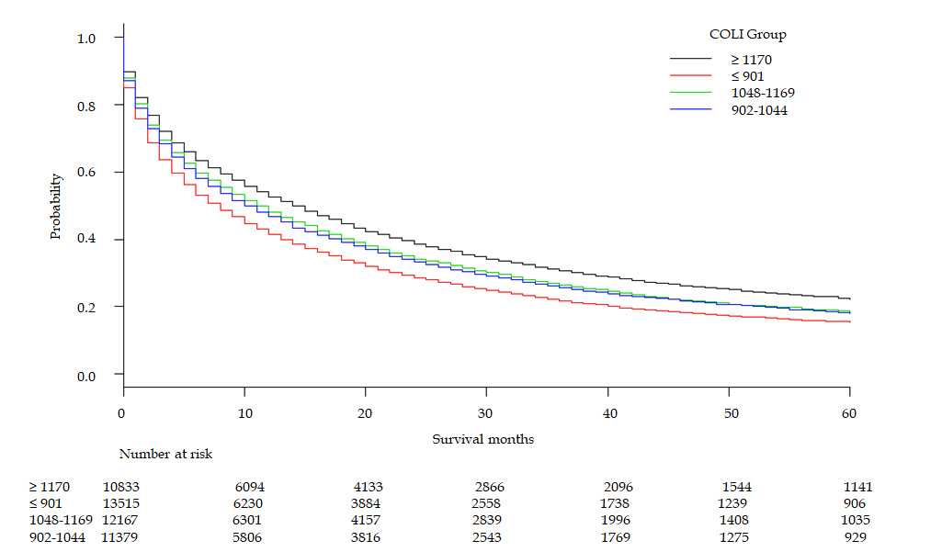
A
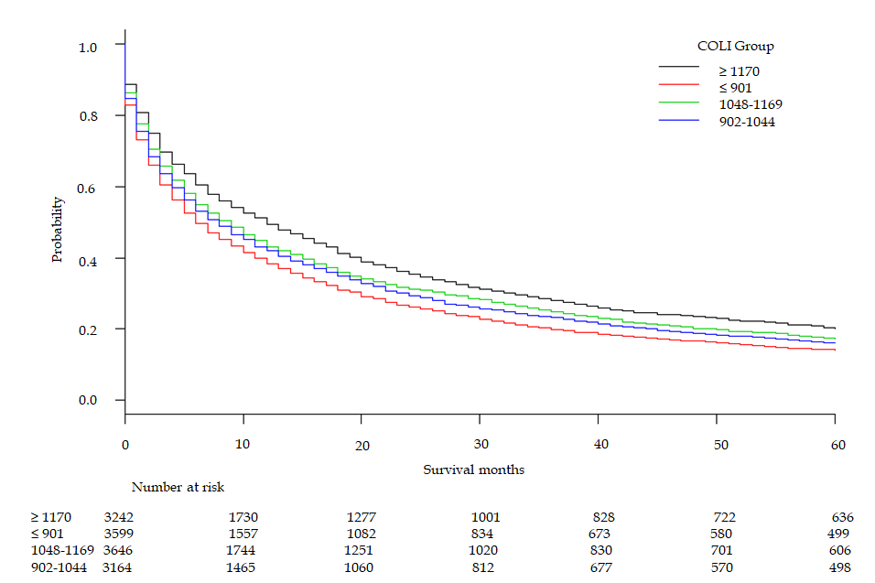
B
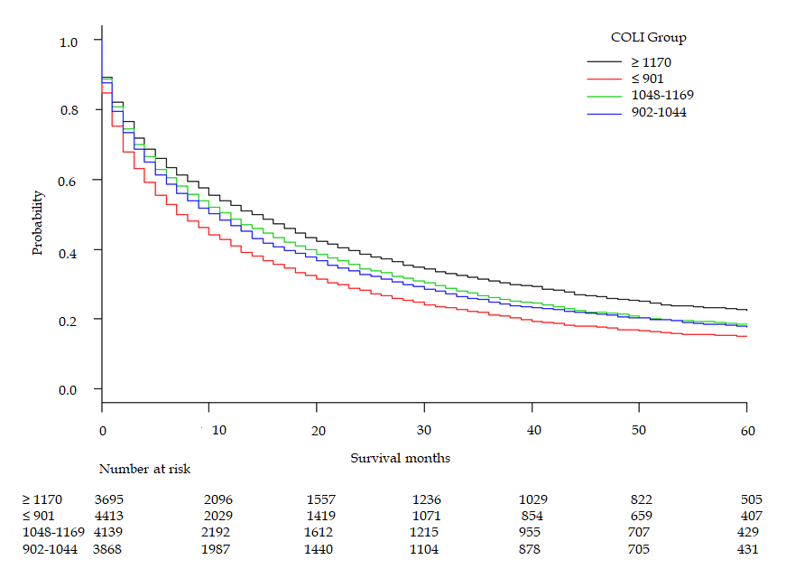
C
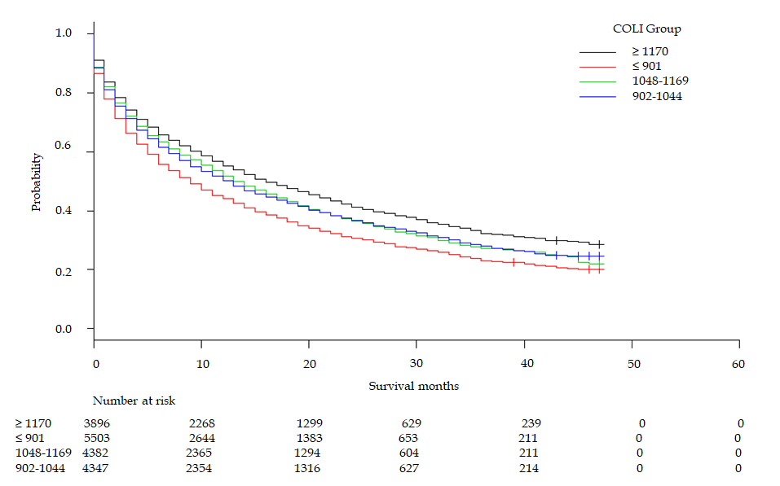
D
Figure 1 Kaplan-Meier survival by cost of living index. A: 2007-2015; B: 2007-2009; C: 2010-2012; D: 2013-2015. COLI: cost of living index.
Table 1 Baseline characteristics of hepatocellular carcinoma patients by cost of living index group between 2007 and 2015
COLI group |  | Total | < 901 | 902-1044 | 1048-1169 | 1170+ | P-value
Number |  | 47894 | 13515 | 11379 | 12167 | 10833
Median age [IQR] |  | 62.00  [56.00, 70.00] | 61.00  [55.00, 69.00] | 61.00 [56.00, 68.00] | 62.00  [56.00, 71.00] | 63.00  [57.00, 72.00] | < 0.001
Survival mo [IQR] |  | 10.00  [2.00, 27.00] | 8.00  [2.00, 23.00] | 10.00  [2.00, 27.00] | 10.00  [2.00, 28.00] | 13.00  [3.00, 31.00] | < 0.001
Male sex (%) |  | 37202 (77.7) | 10661 (78.9) | 8921 (78.4) | 9357 (76.9) | 8263 (76.3) | < 0.001
Race (%) | White | 23220 (48.5) | 8062 (59.7) | 6108 (53.7) | 4864 (40.0) | 4186 (38.6) | < 0.001
 | Black | 6537 (13.6) | 2094 (15.5) | 2231 (19.6) | 1197 (9.8) | 1015 (9.4)
 | Hispanic | 9695 (20.2) | 2497 (18.5) | 1504 (13.2) | 3708 (30.5) | 1986 (18.3)
 | API | 7723 (16.1) | 652 (4.8) | 1231 (10.8) | 2294 (18.9) | 3546 (32.7)
 | Other/Unkn | 719 (1.5) | 210 (1.6) | 305 (2.7) | 104 (0.9) | 100 (0.9)
Marital status (%) | Divorced | 6125 (12.8) | 1978 (14.6) | 1673 (14.7) | 1466 (12.0) | 1008 (9.3) | < 0.001
 | Married | 23338 (48.7) | 6490 (48.0) | 5237 (46.0) | 5888 (48.4) | 5723 (52.8)
 | Separated | 900 (1.9) | 241 (1.8) | 242 (2.1) | 248 (2.0) | 169 (1.6)
 | Single | 10474 (21.9) | 2938 (21.7) | 2477 (21.8) | 2778 (22.8) | 2281 (21.1)
 | Unknown | 2545 (5.3) | 585 (4.3) | 710 (6.2) | 611 (5.0) | 639 (5.9)
 | Unmarried | 120 (0.3) | 33 (0.2) | 37 (0.3) | 28 (0.2) | 22 (0.2)
 | Widowed | 4392 (9.2) | 1250 (9.2) | 1003 (8.8) | 1148 (9.4) | 991 (9.1)
Insurance status (%) | Any Medicaid | 11851 (24.7) | 3346 (24.8) | 2591 (22.8) | 3415 (28.1) | 2499 (23.1) | < 0.001
 | Unknown | 1864 (3.9) | 536 (4.0) | 450 (4.0) | 456 (3.7) | 422 (3.9)
 | Insured | 24225 (50.6) | 6531 (48.3) | 5811 (51.1) | 5970 (49.1) | 5913 (54.6)
 | Insured/Unspecified | 7796 (16.3) | 2337 (17.3) | 2053 (18.0) | 1776 (14.6) | 1630 (15.0)
 | Uninsured | 2158 (4.5) | 765 (5.7) | 474 (4.2) | 550 (4.5) | 369 (3.4)
State (%) | Alaska | 60 (0.1) | 0 | 60 (0.5) | 0 | 0 | < 0.001
 | California | 23501 (49.1) | 4266 (31.6) | 3005 (26.4) | 9219 (75.8) | 7011 (64.7)
 | Connecticut | 1880 (3.9) | 0 | 307 (2.7) | 1573 (12.9) | 0
 | Georgia | 4124 (8.6) | 1767 (13.1) | 2357 (20.7) | 0 | 0
 | Hawaii | 1054 (2.2) | 0 | 0 (0.0) | 293 (2.4) | 761 (7.0)
 | Iowa | 1103 (2.3) | 1003 (7.4) | 100 (0.9) | 0 (0.0) | 0
 | Kentucky | 2047 (4.3) | 2047 (15.1) | 0 | 0 | 0
 | Louisiana | 2740 (5.7) | 2740 (20.3) | 0 | 0 | 0
 | Michigan | 2129 (4.4) | 0 (0.0) | 2129 (18.7) | 0 | 0
 | New Jersey | 4131 (8.6) | 0 | 0 | 1082 (8.9) | 3049 (28.1)
 | New Mexico | 1335 (2.8) | 636 (4.7) | 687 (6.0) | 0 | 12 (0.1)
 | Utah | 772 (1.6) | 770 (5.7) | 2 (0.0) | 0 | 0
 | Washington | 3018 (6.3) | 286 (2.1) | 2732 (24.0) | 0 | 0
Year (%) | 2007-2009 |  | 3599 (26.6) | 3164 (27.8) | 3646 (30.0) | 3242 (29.9) | < 0.001
 |  | 13651 (28.5)
 | 2010-2012 | 16115 (33.6) | 4413 (32.7) | 3868 (34.0) | 4139 (34.0) | 3695 (34.1)
 | 2013-2015 | 18128 (37.9) | 5503 (40.7) | 4347 (38.2) | 4382 (36.0) | 3896 (36.0)
API: Asians and Pacific Islanders; COLI: Cost of living index; HCC: Hepatocellular carcinoma; IQR: Interquartile range..
Table 2 Characteristics of hepatocellular carcinoma by cost of living index group between 2007 and 2015
COLI group |  | ≤ 901 | 902-1044 | 1048-1169 | ≥ 1170 | P-value
Stage (%) | I | 4403 (32.6) | 3764 (33.1) | 3977 (32.7) | 3704 (34.2) | < 0.001
 | II | 2201 (16.3) | 2057 (18.1) | 2006 (16.5) | 1988 (18.4)
 | III | 2804 (20.7) | 2380 (20.9) | 2350 (19.3) | 2100 (19.4)
 | IV | 2055 (15.2) | 1582 (13.9) | 1674 (13.8) | 1410 (13.0)
 | UNK | 2052 (15.2) | 1596 (14.0) | 2160 (17.8) | 1631 (15.1)
Tumor size (%) | ≤ 20 | 1335 (9.9) | 1379 (12.1) | 1378 (11.3) | 1338 (12.4) | < 0.001
 | 21-30 | 1786 (13.2) | 1835 (16.1) | 1776 (14.6) | 1598 (14.8)
 | 31-50 | 2701 (20.0) | 2353 (20.7) | 2522 (20.7) | 2136 (19.7)
 | 51 | 4780 (35.4) | 3830 (33.7) | 4164 (34.2) | 3664 (33.8)
 | UNK | 2913 (21.6) | 1982 (17.4) | 2327 (19.1) | 2097 (19.4)
≤ 20 mm (%) |  | 1335 (9.9) | 1379 (12.1) | 1378 (11.3) | 1338 (12.4) | < 0.001
≤ 30.mm (%) |  | 3121 (23.1) | 3214 (28.2) | 3154 (25.9) | 2936 (27.1) | < 0.001
≤ 50.mm (%) |  | 5822 (43.1) | 5567 (48.9) | 5676 (46.7) | 5072 (46.8) | < 0.001
LRT (%) |  | 819 (6.1) | 1268 (11.1) | 1286 (10.6) | 1244 (11.5) | < 0.001
Resection (%) |  | 949 (7.0) | 695 (6.1) | 1000 (8.2) | 1154 (10.7) | < 0.001
Transplant (%) |  | 889 (6.6) | 637 (5.6) | 507 (4.2) | 481 (4.4) | < 0.001
COLI: Cost of living index; HCC: Hepatocellular carcinoma.

Table 3 Survival by year and cost of living index group
COLI group | Survival in mo (95%CI) |  |  |  | P-value
 | 2007-2015 | 2007-2009 | 2010-2012 | 2013-2015
≤ 901 | 8 (7-8) | 6 (6-7) | 7 (7-8) | 9 (8-10) | < 0.001
902-1044 | 10 (10-11) | 8 (7-9) | 11 (10-11) | 13 (12-13)
1048-1169 | 11 (11-12) | 9 (8-10) | 12 (11-13) | 13 (13-14)
≥ 1170 | 14 (14-15) | 12 (11-13) | 14 (13-16) | 16 (15-18)
CI: Confidence interval; COLI: Cost of living index.

Table 4 Univariate and multivariate Cox regression
 | Univariate |  | Multivariate
 | HR | 95%CI | HR | 95%CI
COLI ≤ 901- vs 1048-1169 | 1.162 | 1.131-1.195 | 1.141 | 1.109-1.174
COLI ≤ 901- vs 1170 ≤ | 1.300 | 1.263-1.338 | 1.218 | 1.181-1.255
COLI ≤ 901- vs 902-1044 | 1.130 | 1.099-1.163 | 1.067 | 1.037-1.097
COLI 1048-1169 vs 1170 ≤ | 1.118 | 1.085-1.001 | 1.067 | 1.035-1.100
COLI 1048-1169 vs 902-1044 | 0.972 | 0.944-1.001 | 0.934 | 0.907-0.963
COLI 1170 ≤ vs 902-1044 | 0.869 | 0.843-0.896 | 0.876 | 0.849-0.904
Age | 1.014 | 1.013-1.015 | 1.012 | 1.011-1.013
Sex female vs male | 0.903 | 0.881-0.926 | 0.925 | 0.901-0.950
API vs Black | 0.710 | 0.684-0.737 | 0.817 | 0.785-0.851
API vs Hispanic | 0.809 | 0.781-0.838 | 0.874 | 0.842-0.906
API vs Other/unknown | 0.895 | 0.818-0.980 | 1.000 | 0.913-1.096
API vs White | 0.813 | 0.788-0.838 | 0.839 | 0.813-0.867
Black vs Hispanic | 1.139 | 1.100-1.180 | 1.069 | 1.031-1.108
Black vs Other/unknown | 1.261 | 1.152-1.380 | 1.223 | 1.118-1.339
Black vs White | 1.145 | 1.110-1.180 | 1.027 | 0.996-1.060
Hispanic vs Other/unknown | 1.107 | 1.012-1.210 | 1.145 | 1.047-1.252
Hispanic vs White | 1.005 | 0.978-1.032 | 0.961 | 0.935-0.988
Other/unknown vs White | 0.908 | 0.832-0.991 | 0.839 | 0.769-0.916
Married (including common law) vs Separated/Divorced | 0.839 | 0.814-0.865 | 0.909 | 0.881-0.937
Married (including common law) vs Single/Unmarried or domestic partner | 0.799 | 0.779-0.820 | 0.876 | 0.852-0.901
Married (including common law) vs Unknown | 0.916 | 0.873-0.961 | 1.037 | 0.988-1.089
Married (including common law) vs Widowed | 0.708 | 0.683-0.733 | 0.881 | 0.847-0.915
Separated/divorced vs Single/unmarried or domestic partner | 0.953 | 0.921-0.985 | 0.964 | 0.932- 0.998
Separated/divorced vs Unknown | 1.092 | 1.036-1.150 | 1.142 | 1.083-1.204
Separated/divorced vs Widowed | 0.843 | 0.809-0.879 | 0.969 | 0.927-1.013
Single/unmarried or domestic partner vs Unknown | 1.146 | 1.090-1.205 | 1.184 | 1.125-1.247
Single/Unmarried or domestic partner vs Widowed | 0.885 | 0.852-0.920 | 1.005 | 0.963-1.049
Unknown vs Widowed | 0.773 | 0.731-0.817 | 0.849 | 0.801-0.899
Any Medicaid vs Insured | 1.211 | 1.182-1.240 | 1.141 | 1.113-1.170
Any Medicaid vs Uninsured | 0.705 | 0.670-0.741 | 0.830 | 0.789-0.874
Any Medicaid vs Unknown | 0.678 | 0.644-0.715 | 0.904 | 0.856-0.956
Insured vs Uninsured | 0.582 | 0.555-0.611 | 0.728 | 0.693-0.764
Insured vs Unknown | 0.560 | 0.533-0.589 | 0.792 | 0.751-0.836
Uninsured vs Unknown | 0.962 | 0.900-1.029 | 1.089 | 1.016-1.168
Stage I vs II | 0.938 | 0.907-0.970 | 0.833 | 0.805-0.862
Stage I vs III | 0.373 | 0.363-0.385 | 0.570 | 0.552-0.590
Stage I vs IV | 0.221 | 0.214-0.229 | 0.372 | 0.359-0.386
Stage vs Unknown | 0.370 | 0.359-0.382 | 0.656 | 0.632-0.681
Stage II vs III | 0.398 | 0.385-0.412 | 0.685 | 0.658-0.713
Stage II vs IV | 0.236 | 0.227-0.245 | 0.447 | 0.429-0.466
Stage II vs Unknown | 0.395 | 0.381-0.409 | 0.788 | 0.754-0.823
Stage III vs IV | 0.593 | 0.574-0.613 | 0.653 | 0.631-0.675
Stage III vs Unknown | 0.992 | 0.961-1.024 | 1.151 | 1.108-1.196
Stage IV vs Unknown | 1.673 | 1.6161.732 | 1.763 | 1.699-1.830
20 vs 21-30 | 0.796 | 0.758-0.835 | 0.835 | 0.796-0.876
20 vs 31-50 | 0.564 | 0.540-0.590 | 0.672 | 0.643-0.703
20 vs 50+ | 0.308 | 0.296-0.321 | 0.506 | 0.484-0.529
20 vs Unknown | 0.235 | 0.225-0245 | 0.454 | 0.432-0.476
21-30 vs 31-50 | 0.710 | 0.683-0.737 | 0.805 | 0.774-0.837
21-30 vs 50+ | 0.387 | 0.374-0.401 | 0.606 | 0.582-0.630
21-30 vs Unknown | 0.295 | 0.284-0.306 | 0.543 | 0.520-0.568
31-50 vs 50+ | 0.546 | 0.530-0.562 | 0.753 | 0.728- 0.778
31-50 vs Unknown | 0.416 | 0.403-0.430 | 0.675 | 0.650-0.701
50+ vs Unknown | 0.763 | 0.742-0.783 | 0.897 | 0.869-0.926
LRT | 2.184 | 2.099-2.273 | 1.931 | 1.852-2.012
Resection | 2.670 | 2.548-2.799 | 2.986 | 2.845-3.135
Transplant | 6.311 | 5.837-6.822 | 5.352 | 4.941-5.796
2007-2009 vs 2010-2012 | 1.071 | 1.044-1.098 | 1.074 | 1.048-1.102
2007-2009 vs 2013-2015 | 1.153 | 1.123-1.184 | 1.143 | 1.113-1.174
2010-2012 vs 2013-2015 | 1.077 | 1.050-1.104 | 1.064 | 1.037-1.091
Bold indicates nonsignificant confidence interval. API: Asians and Pacific Islanders; CI: Confidence interval; COLI: Cost of living index; HR: Hazard ratio; LRT: Locoregional therapy.

