Name of Journal: World Journal of Radiology
ESPS Manuscript NO: 22982
Manuscript Type: Minireviews

Biopsy of parotid masses: Review of current techniques

Haldar S et al. Biopsy parotid masses: Review of current techniques

Sananda Haldar, Joseph D Sinnott, Kemal M Tekeli, Samuel S Turner, David C Howlett

Sananda Haldar, David C Howlett, Department of Radiology, East Sussex Healthcare Trust, Eastbourne BN21 2UD, United Kingdom

Joseph D Sinnott, Department of ENT Surgery, East Sussex Healthcare Trust, Eastbourne BN21 2UD, United Kingdom

Kemal M Tekeli, Department of Maxillofacial Surgery, Royal Sussex County Brighton, Brighton BN2 5BE, United Kingdom

Samuel S Turner, Department of Surgery, Royal Free Hospital, London NW3 2QG, United Kingdom

Author contributions: All authors contributed equally to this work: Performing literature searching, data analysis, writing and editing roles.

Conflict-of-interest statement: The authors above have no affiliations with or involvement in any organization or entity with any financial interest or non-financial interest in the subject matter or materials discussed in this manuscript.

Open-Access: This article is an open-access article which was selected by an in-house editor and fully peer-reviewed by external reviewers. It is distributed in accordance with the Creative Commons Attribution Non Commercial (CC BY-NC 4.0) license, which permits others to distribute, remix, adapt, build upon this work non-commercially, and license their derivative works on different terms, provided the original work is properly cited and the use is non-commercial. See: http://creativecommons.org/licenses/by-nc/4.0/

Correspondence to: Dr. Joseph D Sinnott, Department of ENT Surgery, East Sussex Healthcare Trust, King's Dr, Eastbourne BN21 2UD, United Kingdom. j.d.sinnott@gmail.com
Telephone: +44-01323-417400

Received: October 10, 2015
Peer-review started: October 11, 2015
First decision: December 28, 2015
Revised: February 2, 2016
Accepted: February 23, 2016
Article in press:
Published online:

Abstract
Definitive diagnosis of parotid gland masses is required optimal management planning and for prognosis. There is controversy over whether fine needle aspiration cytology (FNAC) or ultrasound guided core biopsy (USCB) should be the standard for obtaining a biopsy. The aim of this review is to assess the current evidence available to assess the benefits of each technique and also to assess the use of intra-operative frozen section (IOFS). Literature searches were performed using pubmed and google scholar. The literature has been reviewed and the evidence is presented. FNAC is an accepted and widely used technique. It has been shown to have variable diagnostic capabilities depending on centres and experience of staff. USCB has a highly consistent diagnostic accuracy and can help with tumour grading and staging. However, the technique is more invasive and there is a question regarding potential for seeding. Furthermore, USCB is less likely to be offered as part of a one-stop clinic. IOFS has no role as a first line diagnostic technique but may be reserved as an adjunct or for lesions not amenable to percutaneous biopsy. On balance, USCB seems to be the method of choice. The current evidence suggests it has superior diagnostic potential and is safe. With time, USCB is likely to supplant FNAC as the biopsy technique of choice, replicating that which has occurred already in other areas of medicine such a breast practice.

Key words: Parotid; Biopsy; Mass; Fine needle aspiration cytology; Fine needle aspiration; Cytology; Core-biopsy; Ultrasound; Diagnosis

© The Author(s) 2016. Published by Baishideng Publishing Group Inc. All rights reserved.

Core tip: Definitive diagnosis of parotid gland masses is important for management and prognosis. There is a move toward a triple assessment but there remains some uncertainty about the best method for obtaining biopsy. We discuss the advantages and disadvantages of each technique and propose that ultrasound guided core biopsy should be the technique of choice. Fine needle aspiration cytology is an accepted and widely used technique although the diagnostic accuracy is low. Intra-operative frozen section does not have a role as a first line diagnostic technique but may be reserved as an adjunct or for lesions not amenable to percutaneous biopsy.

Haldar S, Sinnott JD, Tekeli KM, Turner SS, Howlett DC. Biopsy of parotid masses: Review of current techniques. World J Radiol 2016; In press

INTRODUCTION
Salivary gland tumours, despite being relatively uncommon, encompass a wide range of benign and malignant pathologies^{[1]}. There can be crossovers between the appearance of benign and malignant lesions, there are rare subtypes and multiple pathologies can co-existing within a specimen^{[1]}. The resulting unfamiliarity and diversity presents a diagnostic challenge to the general pathologist. Furthermore, the parotid gland presents additional challenges due to the contrasting treatments available, complex anatomy and relationship to the facial nerve.
As a rule, as the size of the salivary gland decreases, the chances of a lesion within that gland being malignant increases (roughly 25% parotid, 50% submandibular, 75% sublingual). Thus, around 75% of all parotid masses are benign^{[2]}. Of benign parotid tumours, over 50% are pleomorphic adenomas^{[2,3]}. Warthin’s tumour is the second most common benign tumour, usually found in older male patients and bilateral in 10%-15%^{[3]}. Of the malignant tumours, the commonest are muco-epidemoid carcinoma, adenoid cystic carcinomas and metastases from squamous cell carcinoma or melanoma^{[2,3]}.
Traditionally, following presentation to surgical outpatients with a parotid mass, open surgical excision biopsy (SEB) was used as a method of obtaining a histological diagnosis. This fell out of favour in the 1980s due to the risk of infection, tumour seeding, facial nerve injury, sialocoele and fistula formation^{[4]}. As a result, fine needle aspiration cytology (FNAC) gained popularity^{[5]} and is still commonly used today. It is increasingly recognised that pre-operative (or pre-non-operative management) diagnosis of parotid lesions is essential. As has occurred in breast practice, the investigative pathway has evolved into a form of triple assessment with clinical, imaging and histological examination.
Ultrasound (US) is the primary imaging investigation of choice^{[6]}, with magnetic resonance imaging (MRI) reserved for large, complex or possibly malignant tumours^{[7,8]}. CT can be of use where an inflammatory lesion such as an abscess is suspected or in malignant lesions where MRI is contraindicated. An accurate tissue diagnosis is required to inform decisions regarding management. Some benign lesions may be managed conservatively or non-operatively whereas others may require adjuvant therapies and in lesions where surgery is required, a tissue diagnosis would help with planning surgical technique. This could range from minimally invasive excision to an extensive dissection^{[2]}. Furthermore, pre-treatment diagnosis is essential for appropriate patient consent for the various treatment options and prognosis.
As described below, FNAC has limitations and more recently a combined approach has emerged to obtain imaging and histological diagnosis: ultrasound guided core biopsy (USCB). It is the purpose of this review to assess the evidence for the advantages and disadvantages of the techniques available.

FNAC
Since the 1980s the technique used most commonly for initial investigation has been FNAC^{[9]}. This classically involves blind insertion of a needle into the parotid mass and aspiration by the clinician. It is a quick and safe sampling technique that can be performed readily in the outpatient setting. In the hands of a small number of experienced clinicians, FNAC can achieve high specificity and diagnostic accuracy (89% and 85%^{[2]}). However, there are significant variations in the performance of FNAC within different practice settings as demonstrated in a recent meta-analysis^{[10]}; it is associated with high levels of inadequate diagnoses and missed malignancies especially outside specialist centres^{[2]}. Sensitivity for detecting malignancy has been reported between 70% and 80%^{[2,10]} and non-diagnostic rates average at 14%-18%^{[11-13]} but can be as high as 56%^{[2]}. This is increasingly considered unacceptable and may have adverse effects on diagnosis, treatment and prognosis.
The diagnostic performance and specificity of FNAC can be improved significantly when used in conjunction with a cytologist or cytology technician-led service where the sample can be assessed immediately and lesions can be re-aspirated if required^{[14]}. Image guidance also improves the yield of FNAC; US guidance increases diagnostic accuracy by enabling avoidance of necrotic or cystic regions and targeting of higher yield areas of the lesion for tissue extraction^{[12,14,15]}. US guidance also allows the operator to confirm that the needle tip is inserted within the lesion.
Even when FNAC is optimised, parotid cytology still presents challenges to the pathologist. Cellular aspirate cannot be used for grading, staging or immunofluorescence and cannot assess the interaction with surrounding tissue. Reactive hyperplasia with atypia in lymph nodes adjacent to the salivary gland is often indistinguishable from lymphoma or squamous cell carcinoma metastases^{[11]}. With Warthin’s tumour, cytological misinterpretation may occur due to a lack of characteristic features and overabundance of squamous metaplasia/atypia, mucoid/mucinous background, spindle-shaped cells and cystic/inflammatory debris^{[16]}. Similarly, the presence of either cystic degeneration or squamous and mucinous metaplasia in the context of pleomorphic adenoma can lead to a false positive diagnosis of malignancy^{[17]}. Ancillary cytology techniques including flow cytometry and in situ hybridisation can increase the diagnostic yield from FNAC but these are expensive and not widely available. There is also a shortage of trained cytology staff.

USCB
The perceived and real diagnostic limitations associated with FNAC have led operators to explore alternative biopsy techniques. USCB is a safe and successful technique for the diagnosis of parotid lesions where FNAC is non-diagnostic^{[18]} and is developing into an established technique. The technique^{[18,19]} requires an operator, usually a radiologist trained in head and neck US and biopsy techniques. The procedure requires local anaesthetic infiltration, a small skin incision and use of an automated spring-loaded biopsy device. The throw is deployed under US guidance. Figure 1 shows a parotid lesion on US scanning and Figure 2 shows the biopsy needle within the lesion. The core of tissue is then processed by paraffin section histology. Sections from the core can be used for grading, staging and immunohistochemical analysis, allowing planning of appropriate operative or non-operative management. Figures 3 and 4 show the results of a core biopsy macroscopically and microscopically respectively. Immunofluorescence analysis is particularly useful for haematological malignancies^{[18,19]}. This technique is already well established in other areas of image guided biopsy including breast and abdomen^{[20]} and is now widely accepted by histopathologists and oncologists as a sufficient technique to allow tumour grading and typing^{[21]}. There will be a requirement for a wider pool of trained operators in order to disseminate the technique.
A recent meta-analysis incorporates 12 studies and provides substantial evidence supporting the potentially superior diagnostic yield of USCB over FNAC^{[22]}. Although using a database of admittedly smaller studies when compared to FNAC, USCB showed a higher sensitivity (96%) and specificity (100%) compared to FNAC, a low complication rate (1.6% haematoma rate) and no variation in accuracy between locations^{[22]}. The low complication rate is attributed to the ability of US to visualise the vessels and allow the operator to infer the position of facial nerve branches. Although only including a small number of centres, the authors felt the results could be replicated on a wider scale, possibly because of the standardisation of the procedure^{[22]}. In agreement with this, a systematic observational clinico-pathological study demonstrated USCB of salivary gland lesions to have sensitivity 94%, specificity 100%, accuracy 96%, positive predictive value 100% and negative predictive value 90%^{[23]}. A study by Eom et al^{[24]} also showed that trainees had a significantly lower accuracy with fine needle aspiration than USCB when diagnosing malignant tumours when compared to USCB. Lymphomas diagnosed much more accurately using USCB as shown by Huang et al^{[25]}.
Despite generally favourable outcomes and diagnostic advantages, USCB is not yet considered the reference standard in parotid lesion biopsy and the optimum technique remains controversial. The potential problems with USCB include possible false negatives, complications of a slightly more invasive technique and tumour seeding. Haldar et al^{[2]} describe 2 cases which were malignant clinically, on imaging and in the resected specimen but benign on USCB, i.e., false negatives. Also, some cases of well-differentiated malignancy require direct histological assessment of the whole excised lesion capsule to demonstrate invasiveness; USCB will miss this. This emphasises that USCB should not be used alone but as part of a triple assessment.
USCB is a slightly more invasive technique and cannot be used as part of a one-stop diagnostic clinic service as FNAC can. Bleeding and pain are potential complications following the technique. However it is thought the bleeding risk should be minimised by US allowing the operator to avoid vessels. Eom et al^{[24]} as showed there were no complications requiring intervention or hospital admission. Tumour seeding and displaced epithelia are further potential complications. This is particularly relevant to pleomorphic adenoma which has recognised potential for tumour seeding^{[26]}. However, the most recent meta-analysis did not describe any such events^{[22]}. A comparative evaluation in 2013 which addressed tumour seeding post salivary gland biopsy^{[27]} found only two cases following a 14G core needle biopsy; no cases were reported with needles of 18G or smaller. Interestingly, the same study also reported two cases of seeding post FNAC biopsy. However, the interval between seeding and resultant disease is variable and may be up to 20 years so longer term follow up is needed for USCB. In a review of the literature on seeding of tumour cells Douville and Bradford ^{[28]} conclude that there is a small risk of seeding, that needle size should be limited while maintaining diagnostic accuracy and that more follow up is required to accurately assess the long term complications of core biopsy patients. One technique to potentially avoid seeding is to perform surgical excision of the biopsy tract but there is no evidence to support this routinely.

INTRA-OPERATIVE FROZEN SECTION
Another salivary gland biopsy technique is intra-operative frozen section (IOFS), which is used in a small number of specialist centres as an alternative to FNAC or where FNAC is not performing well. A surgical specimen is sent to the histopathology department prior to closure of the skin. It is frozen and examined immediately and results can then be telephoned to the surgeon within 20-30 min. This is useful where no pre-operative diagnosis is available, for example in deep parotid lesions not amenable to percutaneous biopsy or for lesions that are suspicious on clinical/imaging assessment but benign or considered non-representative on FNAC/USCB. IOFS can be employed to guide further surgical management while the patient is still on the operating table. A meta-analysis published in 2011 looking at data from 13 studies over a 25-year period describes 90% sensitivity, 99% specificity and good consistency of results across study centres^{[29]}.
IOFS mandates a full SEB and so cannot be recommended as a first-line diagnostic technique, particularly as patients cannot be consented appropriately. In addition, this service cannot be widely supported outside dedicated histopathology units, the histopathology unit may not be set up for it, there is a wide variety of complex lesions and most pathologists are reluctant to diagnose these on the table in the absence of further techniques including immunofluorescence. The pitfalls and failures outlined above for USCB also apply to IOFS. In general, IOFS can be used as an adjunct to the less invasive options described where diagnostic suspicion and uncertainty remain.

CONCLUSION
The wide spectrum of parotid gland pathology and complex gland anatomy with a variety of surgical options mean that accurate tissue diagnosis is an essential part of triple assessment to provide the appropriate care. There is no current referenced standard in the optimum method of biopsy assessment and the techniques described remain controversial. The continuing debate of cytology vs histology persists as the underlying issue. FNAC is an accepted and widely used technique under optimised circumstances. However, the diagnostic accuracy of a cellular aspirate is inherently lower, even under optimised circumstances, than the core of tissue which can be used for immunohistochemistry as is provided by USCB. USCB is also safe and well tolerated.
On balance and where available, USCB would seem the diagnostic biopsy technique of choice for parotid lesions. In institutions where FNAC has high rates of accuracy and is performing well, USCB should be considered as second line for non-diagnostic or equivocal samples. IOFS does not have a role as a first line diagnostic technique but may be reserved as an adjunct to equivocal FNAC/USCB or for lesions not amenable to percutaneous biopsy. With time and an increasing pool of trained operators, USCB is likely to supplant FNAC as the biopsy technique of choice, replicating that which has occurred already in breast practice. Continual evaluation of USCB outcome, clinical follow up data and standardised operator training will be required.

REFERENCES
1 Westra WH. Diagnostic difficulties in the classification and grading of salivary gland tumors. Int J Radiat Oncol Biol Phys 2007; 69: S49-S51 [PMID: 17848294 DOI: 10.1016/j.ijrobp.2007.04.084]
2 Haldar S, Mandalia U, Skelton E, Chow V, Turner SS, Ramesar K, Tighe D, Williams M, Howlett D. Diagnostic investigation of parotid neoplasms: a 16-year experience of freehand fine needle aspiration cytology and ultrasound-guided core needle biopsy. Int J Oral Maxillofac Surg 2015; 44: 151-157 [PMID: 25457828 DOI: 10.1016/j.ijom.2014.09.025]
3 Pinkston JA, Cole P. Incidence rates of salivary gland tumors: results from a population-based study. Otolaryngol Head Neck Surg 1999; 120: 834-840 [PMID: 10352436 DOI: 10.1016/S0194-5998(99)70323-2]
4 McGuirt WF, McCabe BF. Significance of node biopsy before definitive treatment of cervical metastatic carcinoma. Laryngoscope 1978; 88: 594-597 [PMID: 642657]
5 Frable WJ. Thin-needle aspiration biopsy. A personal experience with 469 cases. Am J Clin Pathol 1976; 65: 168-182 [PMID: 56129]
6 Sriskandan N, Hannah A, Howlett DC. A study to evaluate the accuracy of ultrasound in the diagnosis of parotid lumps and to review the sonographic features of parotid lesions - results in 220 patients. Clin Radiol 2010; 65: 366-372 [PMID: 20380934 DOI: 10.1016/j.crad.2010.01.009]
7 Brennan PA, Herd MK, Howlett DC, Gibson D, Oeppen RS. Is ultrasound alone sufficient for imaging superficial lobe benign parotid tumours before surgery? Br J Oral Maxillofac Surg 2012; 50: 333-337 [PMID: 21371794 DOI: 10.1016/j.bjoms.2011.01.018]
8 Lee YY, Wong KT, King AD, Ahuja AT. Imaging of salivary gland tumours. Eur J Radiol 2008; 66: 419-436 [PMID: 18337041 DOI: 10.1016/j.ejrad.2008.01.027]
9 Balakrishnan K, Castling B, McMahon J, Imrie J, Feeley KM, Parker AJ, Bull PD, Johnston A. Fine needle aspiration cytology in the management of a parotid mass: a two centre retrospective study. Surgeon 2005; 3: 67-72 [PMID: 15861939 DOI: 10.1016/S1479-666X(05)80064-2]
10 Schmidt RL, Hall BJ, Wilson AR, Layfield LJ. A systematic review and meta-analysis of the diagnostic accuracy of fine-needle aspiration cytology for parotid gland lesions. Am J Clin Pathol 2011; 136: 45-59 [PMID: 21685031 DOI: 10.1309/AJCPOIE0CZNAT6SQ]
11 Cajulis RS, Gokaslan ST, Yu GH, Frias-Hidvegi D. Fine needle aspiration biopsy of the salivary glands. A five-year experience with emphasis on diagnostic pitfalls. Acta Cytol 1997; 41: 1412-1420 [PMID: 9305378 DOI: 10.1159/000332852]
12 McIvor NP, Freeman JL, Salem S, Elden L, Noyek AM, Bedard YC. Ultrasonography and ultrasound-guided fine-needle aspiration biopsy of head and neck lesions: a surgical perspective. Laryngoscope 1994; 104: 669-674 [PMID: 8196441 DOI: 10.1288/00005537-199406000-00005]
13 Roland NJ, Caslin AW, Smith PA, Turnbull LS, Panarese A, Jones AS. Fine needle aspiration cytology of salivary gland lesions reported immediately in a head and neck clinic. J Laryngol Otol 1993; 107: 1025-1028 [PMID: 8288972 DOI: 10.1017/S0022215100125162]
14 Robinson IA, Cozens NJ. Does a joint ultrasound guided cytology clinic optimize the cytological evaluation of head and neck masses? Clin Radiol 1999; 54: 312-316 [PMID: 10362238 DOI: 10.1016/S0009-9260(99)90561-5]
15 Sharma G, Jung AS, Maceri DR, Rice DH, Martin SE, Grant EG. US-guided fine-needle aspiration of major salivary gland masses and adjacent lymph nodes: accuracy and impact on clinical decision making. Radiology 2011; 259: 471-478 [PMID: 21364082 DOI: 10.1148/radiol.11101087]
16 Parwani AV, Ali SZ. Diagnostic accuracy and pitfalls in fine-needle aspiration interpretation of Warthin tumor. Cancer 2003; 99: 166-171 [PMID: 12811857 DOI: 10.1002/cncr.11207]
17 Brachtel EF, Pilch BZ, Khettry U, Zembowicz A, Faquin WC. Fine-needle aspiration biopsy of a cystic pleomorphic adenoma with extensive adnexa-like differentiation: differential diagnostic pitfall with mucoepidermoid carcinoma. Diagn Cytopathol 2003; 28: 100-103 [PMID: 12561031 DOI: 10.1002/dc.10240]
18 Buckland JR, Manjaly G, Violaris N, Howlett DC. Ultrasound-guided cutting-needle biopsy of the parotid gland. J Laryngol Otol 1999; 113: 988-992 [PMID: 10696376 DOI: 10.1017/S0022215100145785]
19 Kesse KW, Manjaly G, Violaris N, Howlett DC. Ultrasound-guided biopsy in the evaluation of focal lesions and diffuse swelling of the parotid gland. Br J Oral Maxillofac Surg 2002; 40: 384-388 PMID: 12379183 DOI: 10.1016/S0266-4356(02)00189-4]
20 Zinzani PL, Colecchia A, Festi D, Magagnoli M, Larocca A, Ascani S, Bendandi M, Orcioni GF, Gherlinzoni F, Albertini P, Pileri SA, Roda E, Tura S. Ultrasound-guided core-needle biopsy is effective in the initial diagnosis of lymphoma patients. Haematologica 1998; 83: 989-992 [PMID: 9864918]
21 Burke C, Thomas R, Inglis C, Baldwin A, Ramesar K, Grace R, Howlett DC. Ultrasound-guided core biopsy in the diagnosis of lymphoma of the head and neck. A 9 year experience. Br J Radiol 2011; 84: 727-732 [PMID: 21427181 DOI: 10.1259/bjr/60580076]
22 Witt BL, Schmidt RL. Ultrasound-guided core needle biopsy of salivary gland lesions: a systematic review and meta-analysis. Laryngoscope 2014; 124: 695-700 [PMID: 23929672 DOI: 10.1002/lary.24339]
23 Pfeiffer J, Ridder GJ. Diagnostic value of ultrasound-guided core needle biopsy in patients with salivary gland masses. Int J Oral Maxillofac Surg 2012; 41: 437-443 [PMID: 22204925 DOI: 10.1016/j.ijom.2011.12.005]
24 Eom HJ, Lee JH, Ko MS, Choi YJ, Yoon RG, Cho KJ, Nam SY, Baek JH. Comparison of fine-needle aspiration and core needle biopsy under ultrasonographic guidance for detecting malignancy and for the tissue-specific diagnosis of salivary gland tumors. AJNR Am J Neuroradiol 2015; 36: 1188-1193 [PMID: 25678480 DOI: 10.3174/ajnr.A4247]
25 Huang YC, Wu CT, Lin G, Chuang WY, Yeow KM, Wan YL. Comparison of ultrasonographically guided fine-needle aspiration and core needle biopsy in the diagnosis of parotid masses. J Clin Ultrasound 2012; 40: 189-194 [PMID: 21953076 DOI: 10.1002/jcu.20873]
26 Roussel F, Dalion J, Benozio M. The risk of tumoral seeding in needle biopsies. Acta Cytol 1989; 33: 936-939 [PMID: 2686327]
27 Song IH, Song JS, Sung OC, Roh JL, Choi SH, Nam SY, Kim SY, Lee JH, Baek JH, Cho KJ. Accuracy of Core Needle Biopsy Versus Fine Needle Aspiration Cytology for Diagnosing Salivary Gland Tumors. J Pathol Transl Med 2015; 49: 136-143 [DOI: 10.4132/jptm.2015.01.03]
28 Douville NJ, Bradford CR. Comparison of ultrasound-guided core biopsy versus fine-needle aspiration biopsy in the evaluation of salivary gland lesions. Head Neck 2013; 35: 1657-1661 [PMID: 23109044 DOI: 10.1002/hed.23193]
29 Schmidt RL, Hunt JP, Hall BJ, Wilson AR, Layfield LJ. A systematic review and meta-analysis of the diagnostic accuracy of frozen section for parotid gland lesions. Am J Clin Pathol 2011; 136: 729-738 [PMID: 22031311 DOI: 10.1309/AJCP2SD8RFQEUZJW]

P- Reviewer: Chen F, Tang GH S- Editor: Song XX L- Editor: E- Editor:

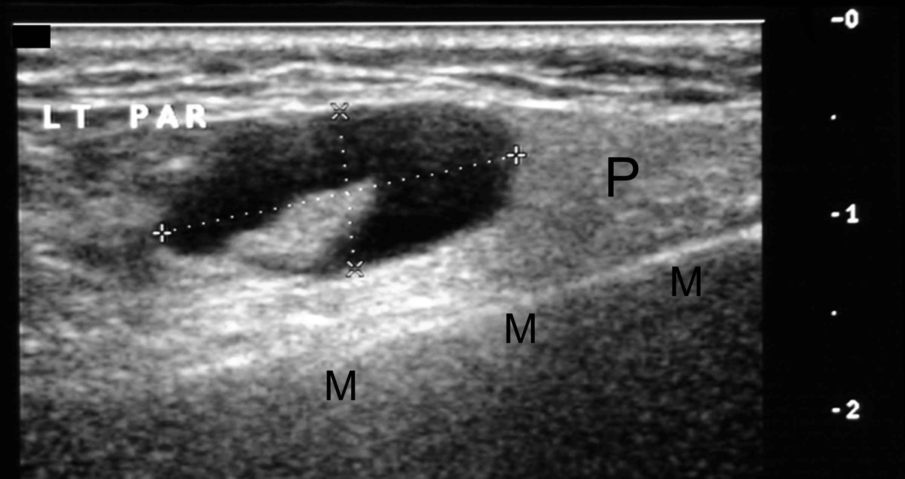
Figure 1 Longitudinal sonogram through left parotid gland (P) superficial lobe, mandible (M). Demonstrates an atypical node, callipers-eccentric hilum displaced and heterogeneous cortex.

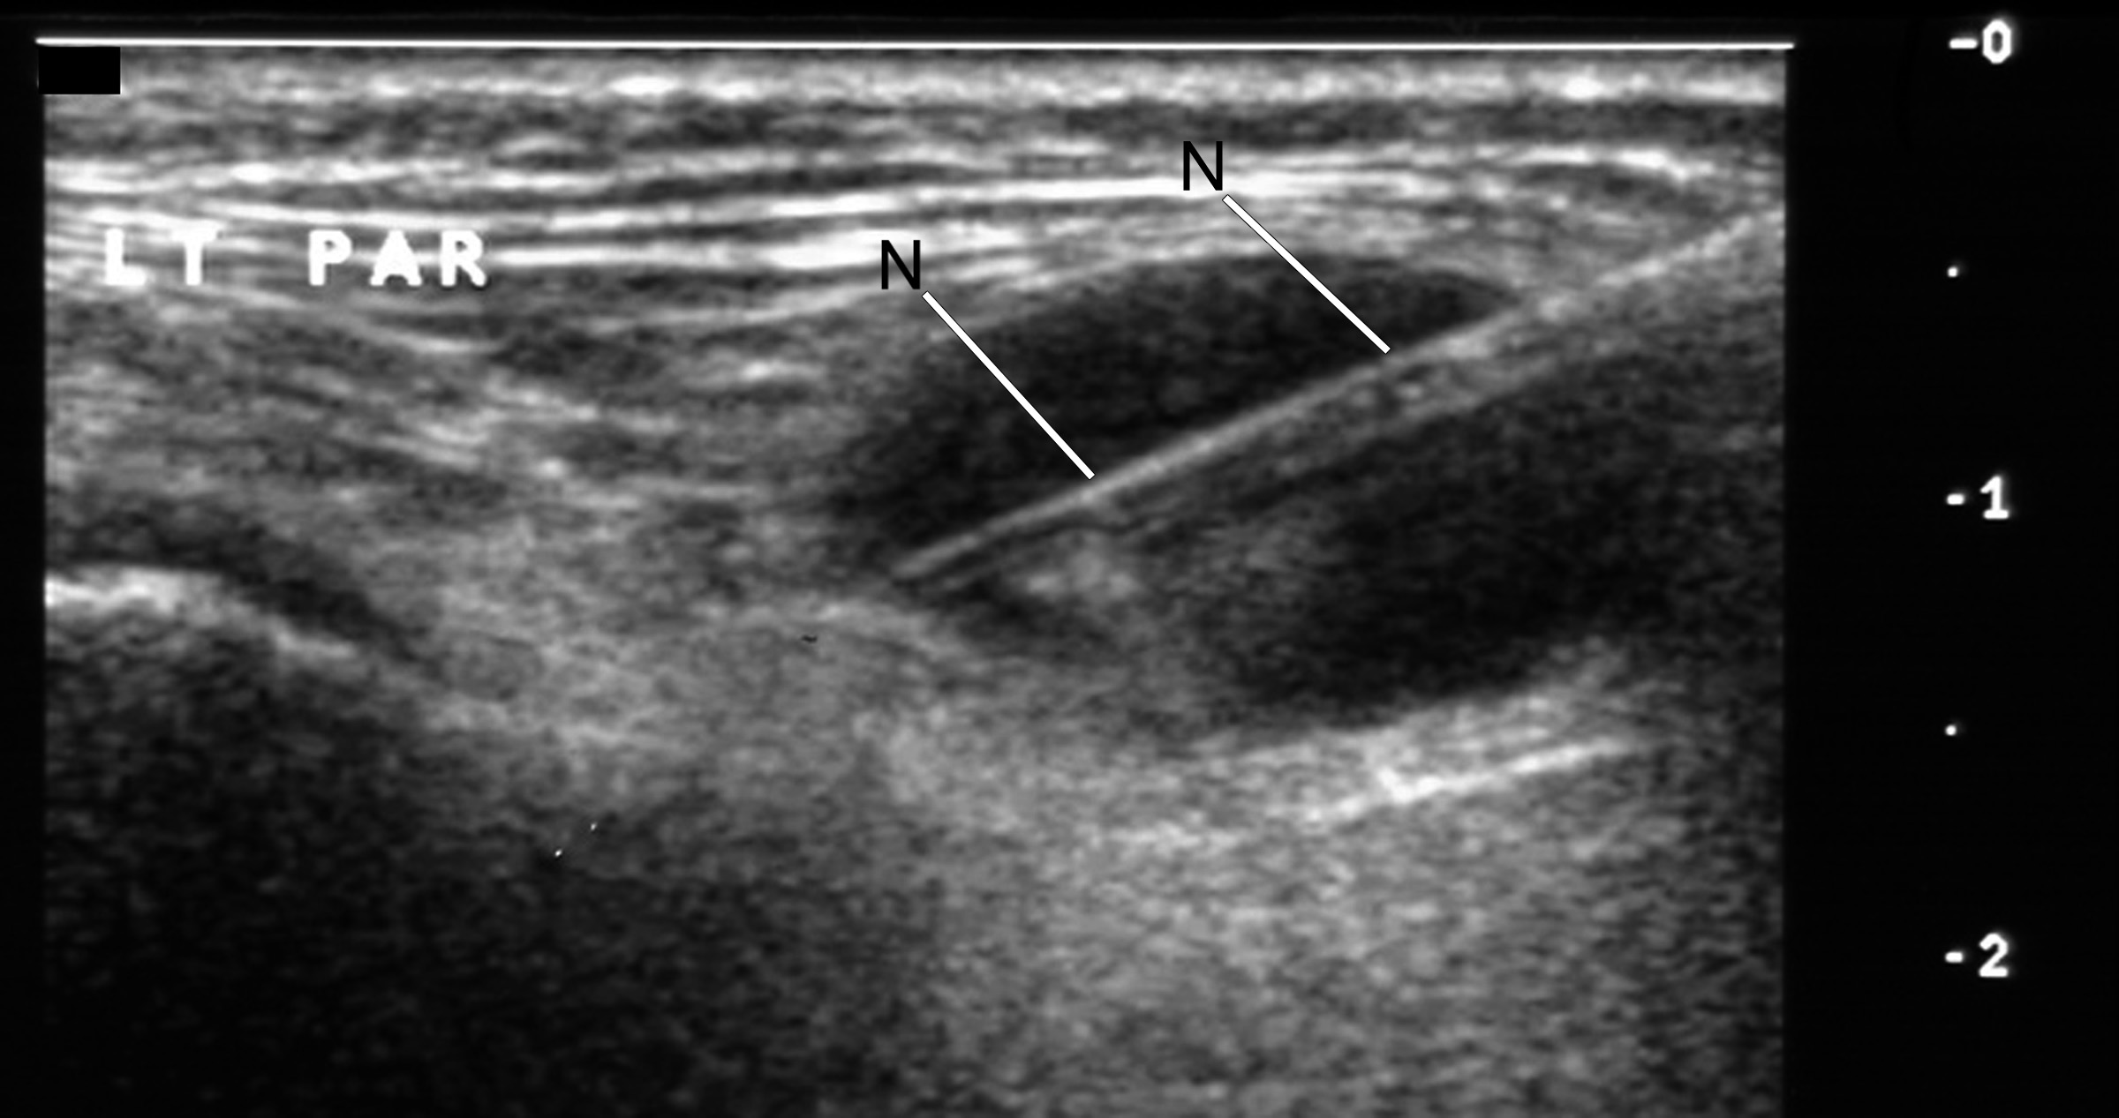
Figure 2 Biopsy undertaken with spring loaded biopsy automated device, 22 mm throw, 18G needle (N). Note needle deployed to traverse but not exit the lesion.

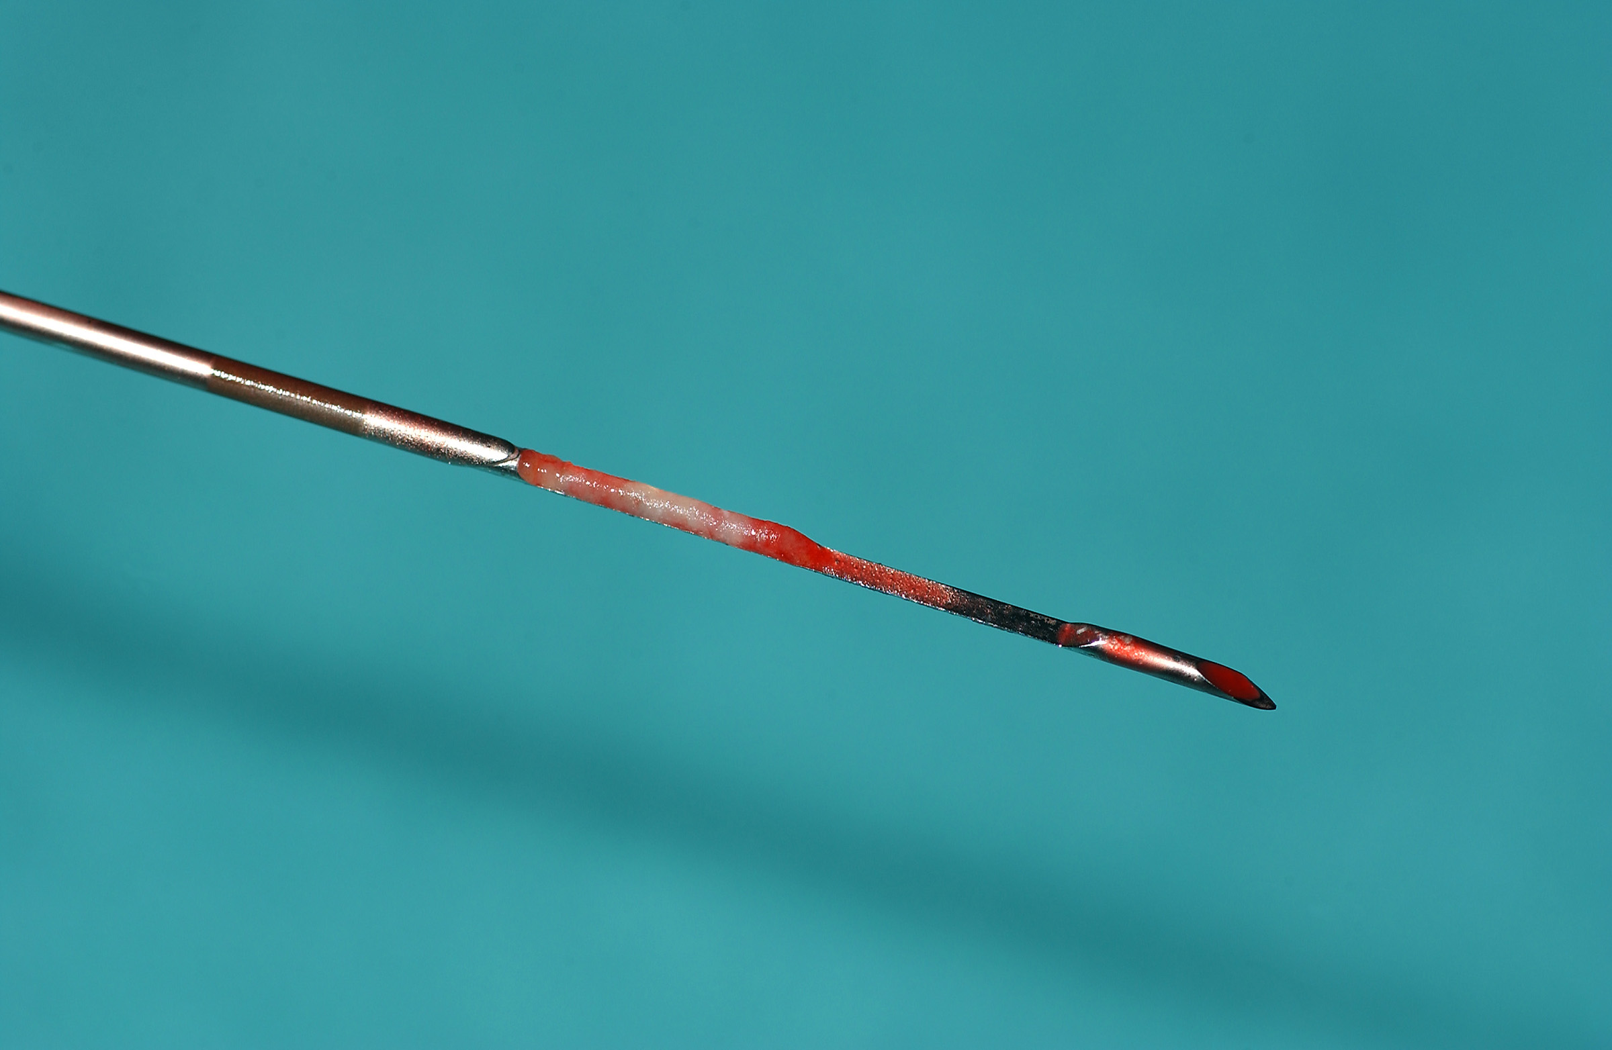
Figure 3 Image of biopsy specimen taken in figure 2. 18G-Needle in biopsy tray with overlying needle overlying sheath retracted.

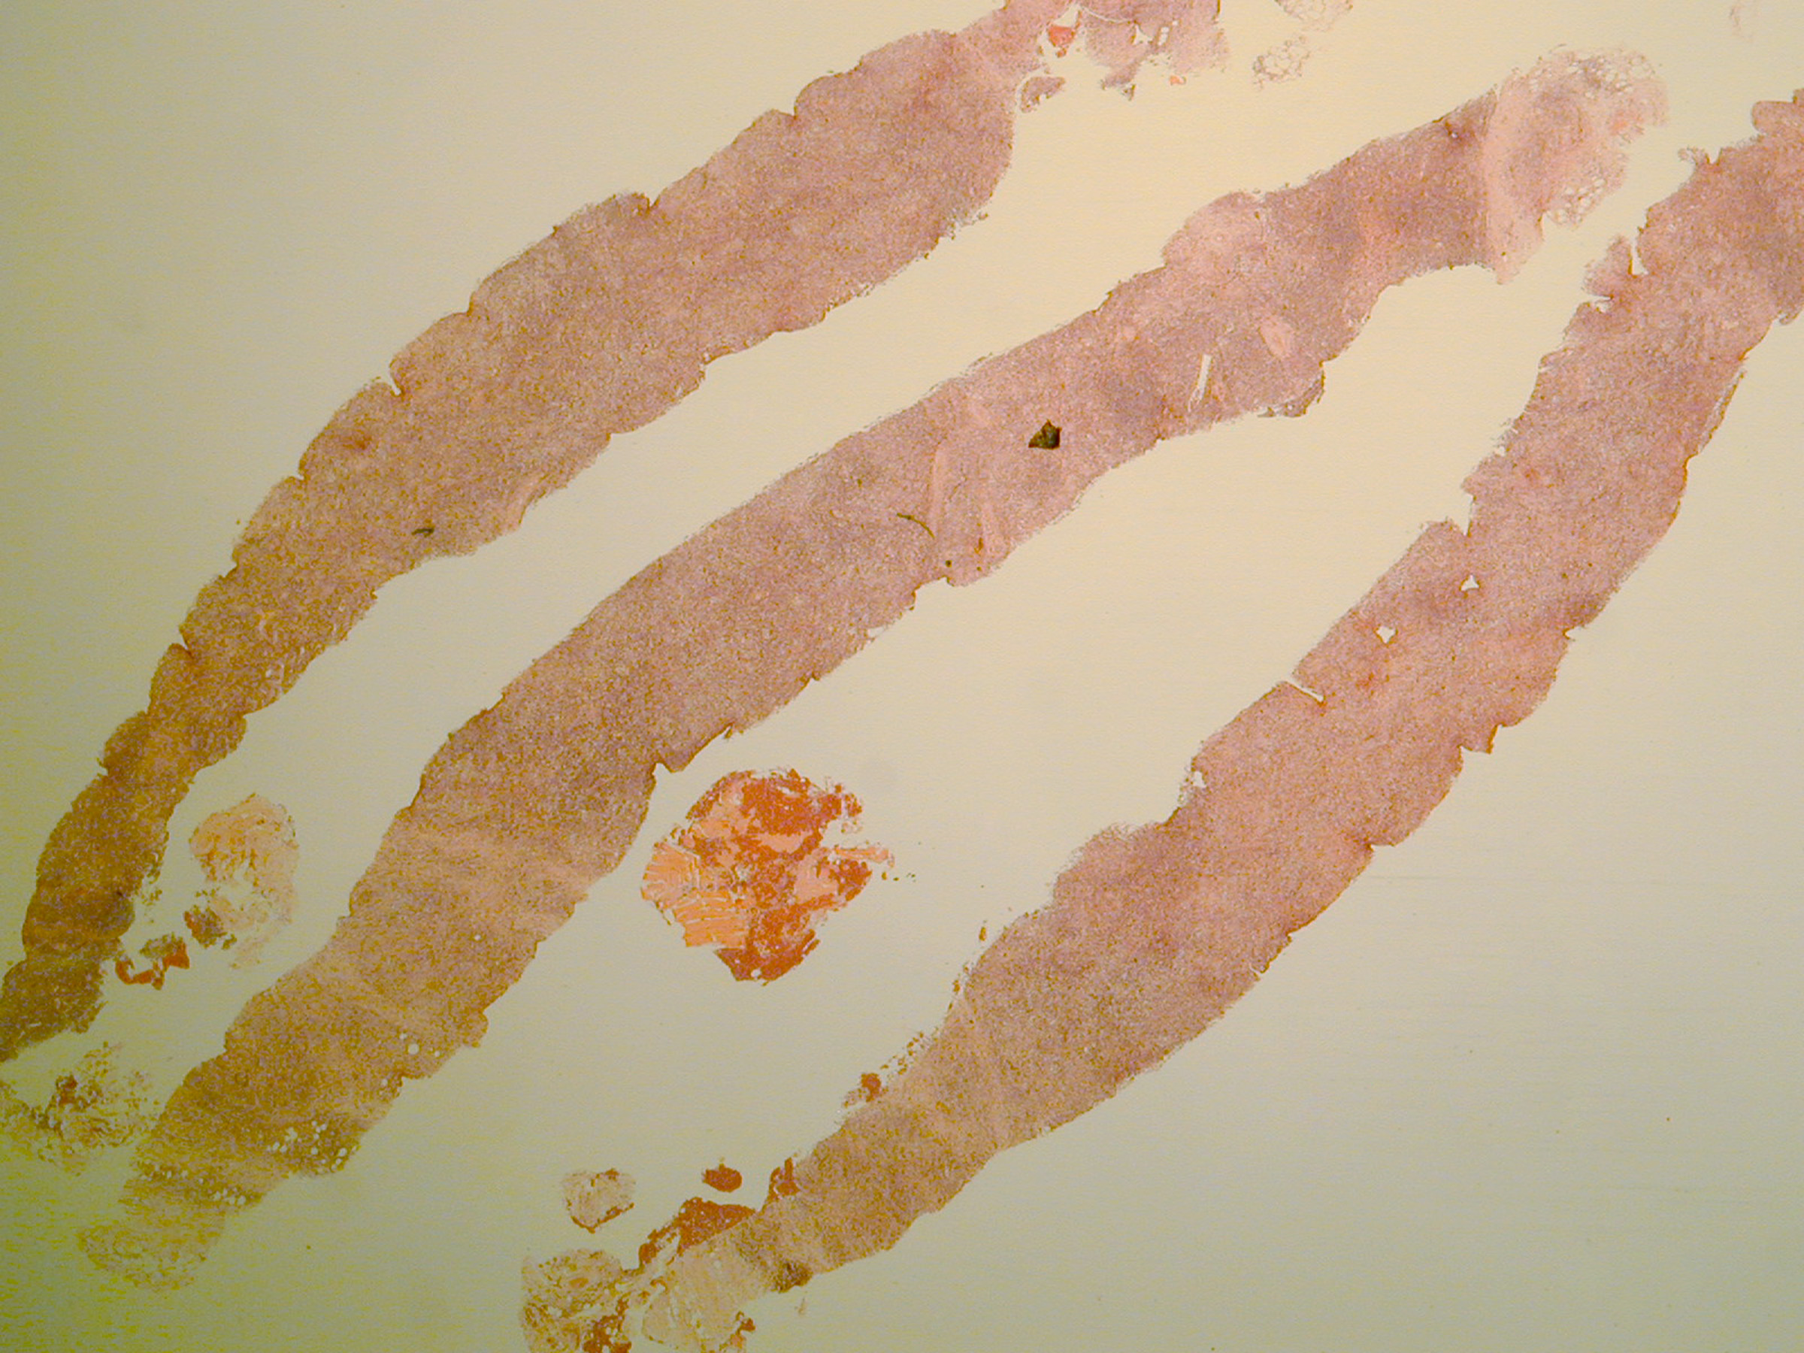
Figure 4 Low power image, H and E stain, of biopsy samples obtained in this case to give an idea of what material is available to the pathologist for reporting and immunohistochemistry- final diagnosis in this case was B cell NHL.

