Name of Journal: World Journal of Radiology
Manuscript NO: 84768
Manuscript Type: MINIREVIEWS

Acute pancreatitis: Structured report template of magnetic resonance imaging

Song LJ et al. Acute pancreatitis: MRI structured report template

Ling-Ji Song, Bo Xiao

Ling-Ji Song, Bo Xiao, Department of Radiology, Sichuan Key Laboratory of Medical Imaging, The Affiliated Hospital of North Sichuan Medical College, Nanchong 637000, Sichuan Province, China

Author contributions: Song LJ and Xiao B contributed equally to this work; Xiao B designed the research study; Song LJ performed the research; Song LJ and Xiao B analyzed the data and wrote the manuscript; All authors have read and approve the final manuscript.

Corresponding author: Bo Xiao, Doctor, MD, PhD, Associate Professor, Department of Radiology, Sichuan Key Laboratory of Medical Imaging, The Affiliated Hospital of North Sichuan Medical College, No. 1 Maoyuan South Street, Nanchong 637000, Sichuan Province, China. xiaoboimaging@163.com

Received: March 27, 2023
Revised: May 25, 2023
Accepted: June 16, 2023
Published online:

Abstract
Acute pancreatitis (AP) is a common acute abdomen disease of the digestive system. It has a potentially fatal risk because of its variable severity and various complications. With the widespread application of the Revised Atlanta Classification, new requirements for AP imaging reports are introduced. Experts in abdominal radiology and pancreatology in the United States published the first structured computed tomography reporting template for AP in 2020. However, there is no corresponding structured magnetic resonance imaging (MRI) reporting template globally. Therefore, this article focuses on the structured MRI report of AP images from our pancreatitis imaging center, which is intended to improve the systematic understanding of this disease and standardize the writing of MRI structured reports. In the meantime, we aim to promote the clinical diagnosis and assessment of MRI efficacy for AP and its multiple complications. It is further intended to facilitate academic exchanges and scientific research between different medical centers.

Key Words: Magnetic resonance imaging; Acute pancreatitis; Structured reporting; Computed tomography

Song LJ, Xiao B. Acute pancreatitis: Structured report template of magnetic resonance imaging. World J Radiol 2023; In press

Core Tip: Acute pancreatitis (AP) is a common digestive disease. Experts in abdominal radiology and pancreatology in the United States published the first structured computed tomography reporting template for AP in 2020, but there is no corresponding structured magnetic resonance imaging (MRI) reporting template internationally. For this reason, this article focuses on the structured MRI report of AP and its standardization, which is beneficial for clinicians to diagnose and evaluate the MRI efficacy of AP and its multiple complications. At the same time, it will promote academic exchanges between different medical centers as well as scientific research and teaching.

INTRODUCTION
Acute pancreatitis (AP) is one of the most common causes of hospitalization due to gastrointestinal disorders and it requires multidisciplinary treatment^{[1,2]}. AP inflammation can be confined to the pancreas itself, and can further involve other tissues and remote organs^{[3]}. Approximately 15%-20% of AP patients will progress to severe acute pancreatitis (SAP)^{[4]}, which is potentially lethal and remains one of the most challenging diseases to date. In China, the majority of AP patients are caused by cholelithiasis, alcoholism, and hyperlipidemia^{[5]}. With the in-depth study of pathophysiological mechanisms of AP, traditional terminologies of imaging reports related to AP have been updated in the Revised Atlanta Consensus^{[6]}. In fact, it is both an opportunity and a challenge for radiologists. In 2020, American experts in the field of abdominal radiology and pancreatology first released AP's computed tomography (CT) structured report template^{[7]}. It is designed based on contrast-enhanced CT. But to the best of our knowledge, magnetic resonance imaging (MRI) has additionally important values in the AP severity assessment at early-phase and differential diagnosis of AP-related collection complications^{[3,8,9]}. However, there is a lack of corresponding MRI structured report template in this field. In this article, therefore, we have combined our clinical practice and previous research data to introduce the structured MRI report template for AP. Our aim is to facilitate the standardization of MRI report writing and clinical multidisciplinary team communication for AP patients.

IMAGING INDICATIONS OF ACUTE PANCREATITIS
AP is a dynamically changing disease. In the clinical settings, most AP patients have a typical clinical course, symptoms and signs, and serum enzyme characteristics^{[10]}. Under normal circumstances, imaging examination is not the first or mandatory choice. However, AP patients with the following aspects need to be examined in time: (1) Difficulty in differential diagnosis of other acute abdomen disorders; (2) serum enzymatic levels do not reach the relevant threshold; (3) confirm the clinical prediction of SAP; and (4) suspected cholelithiasis and other neoplastic complications^{[11]}. In addition, the detection of various local complications in the late stage of AP and the evaluation of curative effect after treatment are also indications for AP repeated imaging examination^{[6,12]}.
For radiologists, the first step should be to identify the patient's general information (gender, age, inducement, previous history, concomitant diseases, etc.). It is essential for the diagnosis and treatment of pancreatic diseases. For instance, men are prone to alcoholic AP due to alcohol abuse, while women are prone to gallstone AP^{[13]}. The occurrence of AP in adolescents may be related to genetic factors and biliopancreatic duct anatomical variants. In contrast, AP in the elderly may be severe and complicated by advanced age factors and the coexistence of multiple underlying diseases. The medical history of pregnancy, trauma, and endoscopic retrograde cholangiopancreatography (ERCP) is also important in determining the etiology of AP. Additionally, Sadr-Azodi et al^{[14]} suggest that smoking may be an independent risk factor for AP. Another study further confirmed that smoking was positively associated with the development of pancreatitis^{[15]}. Last but most importantly, patients with underlying renal disease or renal insufficiency need to avoid CT-enhanced examinations^{[6,16]}. Accordingly, the emergence MRI can make up for the deficiency of CT.

IMAGING TECHNIQUES OF ACUTE PANCREATITIS
Early imaging of AP (within 72 h of onset) is frequently deceptive due to underestimate the true extent of parenchymal involvement and the inability to reliably assess early complications^{[17,18]}. However, revised Atlanta International Consensus still suggests enhanced CT is the primary imaging method for the initial diagnosis of AP patients. It can clearly diagnose AP and provide a better evaluation of pancreatic necrosis, local complications, and the severity of AP. Occasionally, the application of contrast agents has been reported to aggravate the condition of AP^{[19]}. Also, CT examinations have radiation. So accordingly, many studies at domestic and abroad have used conventional MRI sequences combined with diffusion-weighted imaging (DWI) to detect AP. Some scholars have confirmed that the diagnostic value of the DWI technique in AP is equivalent to that of enhanced CT and exceeds the capability of plain CT^{[20]}. They believe that DWI can be used as a powerful tool for evaluating and following up AP^{[20]}. In addition, MRI is feasible for patients with a medical history of iodine allergy or acute renal insufficiency. Moreover, for pregnant women, children, and patients requiring multiple reviews, MRI can be utilized to evaluate the pancreas and peripancreatic conditions.
Taking our unit as an example, we use the following MRI sequences and parameters for comprehensive evaluation of AP (Tables 1 and 2), covering T1-weighted imaging (T1WI) (anatomy, hemorrhage), T2-weighted imaging (T2WI) (effusion, necrosis), DWI (early diffusion restriction), magnetic resonance cholangiopancreatography (MRCP) (observation of the pancreaticobiliary system, effusion), and contrast-enhancement scans (blood supply). Since each medical center has different MRI manufacturers and different imaging protocols, we recommend the mentioned-above sequences for reference. On the basis of our clinical practice, most AP patients are able to complete MRI examinations. Compared to enhanced CT, MRI has the following advantages for AP: (1) MRI is a non-ionizing radiation-free diagnostic imaging that can be used for patients who require multiple follow-up scans; (2) The diagnostic ability of MRI plain scan for pancreatic necrosis is comparable to that of contrast-enhanced CT^{[20]}; (3) Fat-suppressed T1WI is more sensitive than CT for the diagnosis of pancreatic/peripancreatic hemorrhage^{[21]}; (4) Fat-suppressed T2WI is appropriate for the detection of peripancreatic fat necrosis; (5) Fat-suppressed T2WI is significantly better than CT in showing small amounts of "non-liquid" substances within acute necrotic collection (ANC) and walled-off necrosis (WON); (6) MRCP is superior to CT in demonstrating morphological changes of main pancreatic duct (MPD) and the connectivity between the MPD and pseudocyst/WON; and (7) MRI is a reliable modality for staging the severity of AP and has predictive value for disease prognosis. Indeed, MRI has some shortcomings. For example, it is not as good as CT for peripancreatic infection gas findings. MRI needs a long scanning time, and presents difficulty in completing the examination in some SAP patients, as well as a relatively high cost. It is worth mentioning that clinicians need to clarify the advantages and disadvantages of various imaging techniques in order to select the proper examination method for each individual with AP.

STRUCTURED REPORT TEMPLATE OF MRI FOR ACUTE PANCREATITIS
As for the initial CT examination of AP, the Revised Atlanta Consensus recommends that it is better to perform CT 3 d after AP onset^{[6,22]}. At this time, the evaluation of the degree of inflammation and the confirmation of pancreatic necrosis are more reliable, and they may help facilitate the differentiation between acute peripancreatic fluid collection (APFC) and ANC^{[17]}. Furthermore, some scholars have found that MRI performed within 3 d is also helpful in determining the severity of AP and evaluating the prognosis^{[21]}.
The MRI structured report for AP should include the description of the pancreas itself, peripancreatic conditions, related complications, and the severity score. Moreover, changes of the lesions before and after treatment need to be described, as shown in Table 3^{[21,23]}.

INTERPRETATION AND CLINICAL VALUE OF EVALUATION INDEXES OF STRUCTURED IMAGING REPORT
Pancreatic necrosis
Pancreatic necrosis refers to the pathological accumulation of inactivated pancreatic tissue, which is a relatively common local complication of AP^{[24]}. The extent of pancreatic necrosis can be subdivided according to the anatomical region of the organ and the percentage of unenhanced pancreatic parenchyma, such as < 30%, 31%-50%, and > 50% subcategories^{[25]}. These subcategories are clinically significant because the volume of glandular necrosis can predict serious complications such as infection and organ failure. When talking about necrotizing pancreatitis, we previously always thought of the severity of "pancreas itself" necrosis. This is because of the influence of the scoring system based on the degree of pancreatic parenchymal necrosis proposed by Balthazar. However, the Revised Atlanta Consensus reclassified pancreatic necrosis into three subtypes: (1) Pancreatic and peripancreatic necrosis (mixed type) (Figure 1A and B); (2) peripancreatic necrosis only (Figure 1C and D); and (3) pancreatic necrosis only (Figure 2). Although the mixed type is the most prevalent in clinical practice, the latter two subtypes also require attention. As proposed by Meyrignac et al^{[26]} and Çakar et al^{[27]} in recent years, the amount of peripancreatic necrosis was more suitable for AP severity determination and prognostic analysis than the pancreatic necrosis score proposed by Balthazar. And meanwhile, it could better predict organ failure and secondary infection. Cucuteanu et al^{[28]} found that extra-pancreatic necrotic volume was the best predictor for evaluating severe pancreatitis with an area under the curve of 0.993. MRI has good soft tissue resolution, so it is accurate to determine the nature of pancreatic necrosis and the measurement of extra-pancreatic necrotic volume.

Pancreatic divisum
Pancreatic divisum is an anatomical variation of the pancreatic duct system, with an incidence of approximately 10% in the general population. About 5% of these patients will present with symptoms^{[29]}. MRI combined with MRCP is the first choice for the diagnosis of pancreatic divisum. It has been estimated that approximately 20% of AP patients with unknown etiology suffer from pancreatic divisum^{[29]}. Therefore, MRI structured report template for AP should include the description of pancreatic divisum.

Peripancreatic changes
As we all known, the term “AP-related hemorrhage” is not mentioned in the Revised Atlanta Classification. Pathologically, AP is still divided into interstitial edematous pancreatitis and hemorrhagic necrotizing pancreatitis (necrotic lesions often accompanied by hemorrhagic foci)^{[30]}. Peripancreatic fatty tissue necrosis is a form of inflammatory extension involving the peripancreatic intra-abdominal fatty tissue and adipose tissue in the retroperitoneal spaces^{[31]}. MRI might show the intra-abdominal inflammatory involvement located in the omental or mesenteric fatty tissue regions. In our clinical practice, we found that peripancreatic fat necrosis combined with hemorrhage could be detected by MRI (patchy T1-hyperintense on fat suppression T1WI). Although early detection of this pathology condition may have no effect on patient management, necrosis combined with hemorrhage may be associated with the prognosis of AP patients. Scholars show that pancreatic/peripancreatic hemorrhage demonstrated on MR imaging (Figure 3A) has a good correlation with the severity of AP^{[21]}, which can be useful in prognostic determination.
In addition to the corresponding changes in retroperitoneal spaces in AP, changes in subperitoneal spaces should also be observed. Some scholars have conducted clinical studies on this issue. AP is prone to involve the transverse colonic mesentery (incidence of 61.9%)^{[32]} (Figure 3B). Moreover, AP also easily involved the small intestine mesentery (incidence of 67.9%)^{[33]}. Both the transverse-mesocolon involvement score and the mesenteric involvement score correlated well with the MRSI score^{[32,33]}. These signs of subperitoneal space invasion can contribute to the prognostic assessment of the disease.

Local complications
The Revised Atlanta Consensus renamed four local fluid collections following AP. Of note, the exact time from the onset of the patient's initial symptoms to the imaging examination needs to be clarified. For radiologists, it is important for the correct nomenclature of peripancreatic fluid collections^{[2]}. Typically, an imaging diagnosis of a pseudocyst or WON is reported equivalent to 4 wk after the onset of APFC (Figure 3C) or ANC (Figure 1). In particular, while characterizing the contents of a WON (Figure 3D), the percentage of solid debris within the overall fluid collection needs to be identified. That can be valuable in the choice of patient treatment decision-making. Rana et al^{[23]} performed endoscopic ultrasound-guided treatment in 43 patients with symptomatic WON. When the solid necrotic debris in WON is less than 10%, only one endoscopic drainage is required. Then, at least two endoscopic drainages are required to cure patients if the necrotic debris is between 10% and 40%. If the solid necrotic debris is more than 40%, either endoscopic removal of necrotic tissue under ultrasound or surgical removal of necrotic tissue is additionally required^{[23]}. In other words, with the increase of the amount of solid fragments, the number of transendoscopic operations will increase significantly^{[23]}.
DWI technology has a good ability to distinguish between aseptic, infected or necrotic components in WON^{[3,9,34]}. Therefore, MRI is also a powerful tool for the qualitative and quantitative analysis of solid necrotic debris in WON.

Complications of infection
If peripancreatic fluid collection is complicated with infection, the mortality of AP patients will be significantly increased^{[6,35]}. When gas-bubble or gas-fluid level signs appear in the APFC/ANC or pseudocyst/WON, radiologists need to describe in the MRI report and suggest infectious collections (Figure 3E). Besides, long-term fluid collections in the peripancreatic areas may erode the adjacent digestive tract and cause a secondary intestinal fistula^{[35]}. Therefore, we need to report the segment of the intestinal canal that may be complicated by intestinal fistula. Patients with combined intestinal fistulas are indications for surgical procedures^{[36]}.

Disconnected pancreatic duct syndrome
If an encapsulated fluid collection of the pancreas/peripancreatic zones involves the entire length of a pancreas (transmural necrosis), the collection lesion can often disrupt the MPD (Figure 3F and G). That is to say, it can lead to "disconnected pancreatic duct syndrome (DPDS)"^{[37]}, which is commonly seen in acute necrotizing pancreatitis. A recent prospective study shows that about 46.2% of patients with necrotizing pancreatitis will develop DPDS^{[38]}. In addition, Maatman et al^{[39]} have confirmed that an increased degree of pancreatic glandular necrosis is associated with the development of DPDS. Most importantly, the presence of such complications often requires surgical management. ERCP is the gold standard for diagnosing DPDS with 100% sensitivity, but it is invasive^{[40]}. Magnetic resonance cholangiopancreatography (MRCP) is a non-invasive magnetic resonance technique. A recent study reported 92% sensitivity of combined MRCP and secretin MRCP in diagnosing DPDS^{[40]}. That it can be seen that MRCP technology in MRI plays an irreplaceable role in the diagnosis of DPDS.

Vascular complications
Sinistral portal hypertension: Although chronic pancreatitis and pancreatic cancer are the main causes of sinistral portal hypertension (SPH), AP-related SPH also requires attention^{[41]}. One study^{[42]} found a 3.3% prevalence of SPH in 633 AP patients who underwent MRI. According to MRSI scores, the prevalence of SPH in mild, moderate, and severe AP increased progressively with 0.6%, 2.9%, and 47.8%, respectively^{[42]}. This complication may be associated with late-phase gastrointestinal bleeding in AP patients and is therefore described in the MR structured report.

Pseudoaneurysm: Pseudoaneurysm is a rare but potentially fatal complication of AP, which is caused by reactive local arteritis following pancreatic proteolytic enzyme erosion^{[43]}. The lesion most frequently involves the splenic, gastroduodenal, or pancreaticoduodenal arteries. If a pseudoaneurysm ruptures and bleeds, it may constitute a life-threatening emergency^{[24]}. MRI can directly show the pseudoaneurysm lumen connected to the adjacent artery and the mural thrombus in the pseudoaneurysm lumen. On the enhanced MRI, the enhancement of the pseudoaneurysm lumen corresponds to that of an adjacent artery, while the non-enhanced area shows mural thrombus formation.

Venous thrombosis: Venous thrombosis is the most common vascular complication of AP^{[24]}. The splenic vein is the most frequent vein invaded by inflammatory extension of the pancreas because of its proximity to the pancreas. Furthermore, the portal and superior mesenteric veins may also be involved. Dörffel et al^{[44]} assessed this issue by color Doppler ultrasonography and found the incidence of venous thrombosis was 30% in acute non-necrotizing pancreatitis and 57% in necrotizing pancreatitis, similar to the conclusion of Jeffrey et al^{[45]}. When there is venous thrombosis, MRI shows a loss of the normal vascular flow effect in the involved venous segment. After administration of contrast agent, intravenous filling defects can be seen on the enhanced venous phase images.

Organ complications/comorbidities
It is well known that three-quarters of the hepatic blood are supplied by the portal system. When AP occurs, many inflammatory factors and free fatty acids could be gathered in the liver during a short period of time, thereafter, MRI manifestations of fatty liver can be seen. Xiao et al^{[46]} found that 66% of AP patients could be detected with signs of fatty liver on MRI. And the liver signal difference quantified by in-phase and out-of-phase images was positively correlated with MRSI. With the reduction of plasma triglyceride levels, the performance of the fatty liver on MRI can gradually return to normal^{[46]}.
The diagnosis of biliary stones, especially common bile duct stones, is suggestive for the choice of clinical treatment modality^{[47]}. Thus, the MRI report description needs to be focused on gallstone pancreatitis (Figure 4). Furthermore, AP inflammatory exudate has a great impact on the gastrointestinal tract. It often causes damage to the intestinal barrier^{[48]}, followed by incomplete intestinal obstruction. This is associated with abdominal distention and increased intra-abdominal pressure in AP patients.
As far as chest CT is concerned, AP is mostly combined with pleural effusion and signs of compressive atelectasis^{[49]}. Some scholars have suggested that this may be related to the presence of respiratory insufficiency (such as acute respiratory distress syndrome) in AP patients^{[50]}.
AP can also cause subcutaneous edema and fluid collection changes in the abdominal walls (Figure 5). Yang et al^{[51]} found that 53.8% of AP patients showed abdominal wall edema on MRI. The abdominal wall edema score was positively correlated with the MRSI score^{[51]}. Also, the degree of abdominal wall edema could indirectly reflect the severity of AP.

Comparison before and after treatment
The radiological changes in pancreatic/peripancreatic fluid collections before and after treatment should be described emphatically (Figure 6) in order to guide the adjustment of clinical treatment. In the cases of surgical drainage or built-in metal stents^{[52]}, the relationship between the site of the placement and the surrounding tissues and organs should be observed.

CONCLUSION
In summary, AP is a systemic and complex disease. The radiologists need to assist the clinicians in selecting a reasonable imaging modality. Although enhanced CT is considered to be the main imaging method for the first diagnosis of AP patients, MRI has good soft tissue resolution and various sequence techniques. Thus, it can be better evaluated and follow up the condition of AP patients. In the writing of MR structured imaging report, we need to take into account the systematic description of the pancreas itself, peripancreatic changes, local complications, organ complications, and the dynamic changes after treatment. If the patient's condition is tolerated and the hospital equipment permits, we recommend that the patient be examined by MRI. The MRI structured report template of AP recommended in this paper could be used as a reference for different centers. Indeed, multi-center validation of MR structured report template at domestic and abroad is needed in order to constantly improve and update in the future clinical practice.

REFERENCES
1 Li F, Zhang F, Wan X, Wu K, Liu Q, Qiu C, Yin H, Lyu J. Infections in Acute Pancreatitis: Organisms, Resistance-Patterns and Effect on Mortality. Dig Dis Sci 2023; 68: 630-643 [PMID: 36562889 DOI: 10.1007/s10620-022-07793-1]
2 Ortiz Morales CM, Girela Baena EL, Olalla Muñoz JR, Parlorio de Andrés E, López Corbalán JA. Radiology of acute pancreatitis today: the Atlanta classification and the current role of imaging in its diagnosis and treatment. Radiologia (Engl Ed) 2019; 61: 453-466 [PMID: 31153603 DOI: 10.1016/j.rx.2019.04.001]
3 Sureka B, Rai B, Varshney V, Nag VL, Garg MK, Garg PK, Yadav T, Khera PS, Goel A. Quantitative diffusion-weighted magnetic resonance imaging for prediction of early infection in pancreatic collections: Results of a pilot study. Saudi J Gastroenterol 2020; 26: 20-25 [PMID: 31997778 DOI: 10.4103/sjg.SJG_411_19]
4 Pavlidis ET, Pavlidis TE. Management of infected acute necrotizing pancreatitis. World J Clin Cases 2023; 11: 482-486 [PMID: 36686342 DOI: 10.12998/wjcc.v11.i2.482]
5 Li YL, Zhang DD, Xiong YY, Wang RF, Gao XM, Gong H, Zheng SC, Wu D. Development and external validation of models to predict acute respiratory distress syndrome related to severe acute pancreatitis. World J Gastroenterol 2022; 28: 2123-2136 [PMID: 35664037 DOI: 10.3748/wjg.v28.i19.2123]
6 Banks PA, Bollen TL, Dervenis C, Gooszen HG, Johnson CD, Sarr MG, Tsiotos GG, Vege SS; Acute Pancreatitis Classification Working Group. Classification of acute pancreatitis--2012: revision of the Atlanta classification and definitions by international consensus. Gut 2013; 62: 102-111 [PMID: 23100216 DOI: 10.1136/gutjnl-2012-302779]
7 Khurana A, Nelson LW, Myers CB, Akisik F, Jeffrey BR, Miller FH, Mittal P, Morgan D, Mortele K, Poullos P, Sahani D, Sandrasegaran K, Tirkes T, Zaheer A, Patel BN. Reporting of acute pancreatitis by radiologists-time for a systematic change with structured reporting template. Abdom Radiol (NY) 2020; 45: 1277-1289 [PMID: 32189022 DOI: 10.1007/s00261-020-02468-9]
8 Türkvatan A, Erden A, Türkoğlu MA, Seçil M, Yener Ö. Imaging of acute pancreatitis and its complications. Part 1: acute pancreatitis. Diagn Interv Imaging 2015; 96: 151-160 [PMID: 24512896 DOI: 10.1016/j.diii.2013.12.017]
9 de Freitas Tertulino F, Schraibman V, Ardengh JC, do Espírito-Santo DC, Ajzen SA, Torrez FR, Lobo EJ, Szejnfeld J, Goldman SM. Diffusion-weighted magnetic resonance imaging indicates the severity of acute pancreatitis. Abdom Imaging 2015; 40: 265-271 [PMID: 25070771 DOI: 10.1007/s00261-014-0205-y]
10 Szatmary P, Grammatikopoulos T, Cai W, Huang W, Mukherjee R, Halloran C, Beyer G, Sutton R. Acute Pancreatitis: Diagnosis and Treatment. Drugs 2022; 82: 1251-1276 [PMID: 36074322 DOI: 10.1007/s40265-022-01766-4]
11 Aghdassi AA, Seidensticker M. [Imaging diagnostics in acute pancreatitis]. Internist (Berl) 2021; 62: 1044-1054 [PMID: 34524469 DOI: 10.1007/s00108-021-01153-3]
12 Brizi MG, Perillo F, Cannone F, Tuzza L, Manfredi R. The role of imaging in acute pancreatitis. Radiol Med 2021; 126: 1017-1029 [PMID: 33982269 DOI: 10.1007/s11547-021-01359-3]
13 Yadav D, Lowenfels AB. The epidemiology of pancreatitis and pancreatic cancer. Gastroenterology 2013; 144: 1252-1261 [PMID: 23622135 DOI: 10.1053/j.gastro.2013.01.068]
14 Sadr-Azodi O, Andrén-Sandberg Å, Orsini N, Wolk A. Cigarette smoking, smoking cessation and acute pancreatitis: a prospective population-based study. Gut 2012; 61: 262-267 [PMID: 21836026 DOI: 10.1136/gutjnl-2011-300566]
15 Ye X, Lu G, Huai J, Ding J. Impact of smoking on the risk of pancreatitis: a systematic review and meta-analysis. PLoS One 2015; 10: e0124075 [PMID: 25879541 DOI: 10.1371/journal.pone.0124075]
16 Obed M, Gabriel MM, Dumann E, Vollmer Barbosa C, Weißenborn K, Schmidt BMW. Risk of acute kidney injury after contrast-enhanced computerized tomography: a systematic review and meta-analysis of 21 propensity score-matched cohort studies. Eur Radiol 2022; 32: 8432-8442 [PMID: 35727320 DOI: 10.1007/s00330-022-08916-y]
17 Rocha APC, Schawkat K, Mortele KJ. Imaging guidelines for acute pancreatitis: when and when not to image. Abdom Radiol (NY) 2020; 45: 1338-1349 [PMID: 31712865 DOI: 10.1007/s00261-019-02319-2]
18 James TW, Crockett SD. Management of acute pancreatitis in the first 72 hours. Curr Opin Gastroenterol 2018; 34: 330-335 [PMID: 29957661 DOI: 10.1097/MOG.0000000000000456]
19 Shinya S, Sasaki T, Nakagawa Y, Guiquing Z, Yamamoto F, Yamashita Y. Acute pancreatitis successfully diagnosed by diffusion-weighted imaging: a case report. World J Gastroenterol 2008; 14: 5478-5480 [PMID: 18803364 DOI: 10.3748/wjg.14.5478]
20 Shinya S, Sasaki T, Nakagawa Y, Guiquing Z, Yamamoto F, Yamashita Y. The efficacy of diffusion-weighted imaging for the detection and evaluation of acute pancreatitis. Hepatogastroenterology 2009; 56: 1407-1410 [PMID: 19950800]
21 Tang MY, Chen TW, Bollen TL, Wang YX, Xue HD, Jin ZY, Huang XH, Xiao B, Li XH, Ji YF, Zhang XM. MR imaging of hemorrhage associated with acute pancreatitis. Pancreatology 2018; 18: 363-369 [PMID: 29615311 DOI: 10.1016/j.pan.2018.03.004]
22 Foster BR, Jensen KK, Bakis G, Shaaban AM, Coakley FV. Revised Atlanta Classification for Acute Pancreatitis: A Pictorial Essay. Radiographics 2016; 36: 675-687 [PMID: 27163588 DOI: 10.1148/rg.2016150097]
23 Rana SS, Bhasin DK, Sharma RK, Kathiresan J, Gupta R. Do the morphological features of walled off pancreatic necrosis on endoscopic ultrasound determine the outcome of endoscopic transmural drainage? Endosc Ultrasound 2014; 3: 118-122 [PMID: 24955341 DOI: 10.4103/2303-9027.131039]
24 Miller FH, Keppke AL, Dalal K, Ly JN, Kamler VA, Sica GT. MRI of pancreatitis and its complications: part 1, acute pancreatitis. AJR Am J Roentgenol 2004; 183: 1637-1644 [PMID: 15547203 DOI: 10.2214/ajr.183.6.01831637]
25 Liao Q, Ding L, Xu X, Yu C, Deng F, Xiong H, He W, Xia L, Zeng X, Lu N, Zhu Y. Pancreatic necrosis volume for predicting readmission and reintervention in acute necrotizing pancreatitis. Eur J Radiol 2022; 154: 110419 [PMID: 35878514 DOI: 10.1016/j.ejrad.2022.110419]
26 Meyrignac O, Lagarde S, Bournet B, Mokrane FZ, Buscail L, Rousseau H, Otal P. Acute Pancreatitis: Extrapancreatic Necrosis Volume as Early Predictor of Severity. Radiology 2015; 276: 119-128 [PMID: 25642743 DOI: 10.1148/radiol.15141494]
27 Çakar İ, Keven A, Eseroğlu E, Çubuk SM. Role of extrapancreatic necrosis volume in determining early prognosis in patients with acute pancreatitis. Abdom Radiol (NY) 2020; 45: 1507-1516 [PMID: 31428812 DOI: 10.1007/s00261-019-02188-9]
28 Cucuteanu B, Negru D, Gavrilescu O, Popa IV, Floria M, Mihai C, Cijevschi Prelipcean C, Dranga M. Extrapancreatic necrosis volume: A new tool in acute pancreatitis severity assessment? World J Clin Cases 2021; 9: 9395-9405 [PMID: 34877275 DOI: 10.12998/wjcc.v9.i31.9395]
29 Khristenko E, Tjaden C, Klauß M. [Pancreas divisum and pancreatitis]. Radiologe 2021; 61: 541-547 [PMID: 33942124 DOI: 10.1007/s00117-021-00848-w]
30 Wessling J, Peitz U, Hoffmann M, Schreyer AG, Grenacher L. [Acute pancreatitis : Typical findings in computed tomography and magnetic resonance imaging]. Radiologe 2021; 61: 532-540 [PMID: 34061214 DOI: 10.1007/s00117-021-00854-y]
31 Lenhart DK, Balthazar EJ. MDCT of acute mild (nonnecrotizing) pancreatitis: abdominal complications and fate of fluid collections. AJR Am J Roentgenol 2008; 190: 643-649 [PMID: 18287434 DOI: 10.2214/AJR.07.2761]
32 Chi XX, Zhang XM, Chen TW, Huang XH, Yang L, Tang W, Xiao B. The normal transverse mesocolon and involvement of the mesocolon in acute pancreatitis: an MRI study. PLoS One 2014; 9: e93687 [PMID: 24705446 DOI: 10.1371/journal.pone.0093687]
33 Chi XX, Zhang XM, Chen TW, Tang W, Xiao B, Ji YF, Huang XH. Magnetic resonance imaging for the normal mesostenium and involvement of the mesostenium in acute pancreatitis. Biomed Res Int 2014; 2014: 924845 [PMID: 25136639 DOI: 10.1155/2014/924845]
34 Islim F, Salik AE, Bayramoglu S, Guven K, Alis H, Turhan AN. Non-invasive detection of infection in acute pancreatic and acute necrotic collections with diffusion-weighted magnetic resonance imaging: preliminary findings. Abdom Imaging 2014; 39: 472-481 [PMID: 24441591 DOI: 10.1007/s00261-014-0076-2]
35 Umapathy C, Gajendran M, Mann R, Boregowda U, Theethira T, Elhanafi S, Perisetti A, Goyal H, Saligram S. Pancreatic fluid collections: Clinical manifestations, diagnostic evaluation and management. Dis Mon 2020; 66: 100986 [PMID: 32312558 DOI: 10.1016/j.disamonth.2020.100986]
36 Banter LR, Maatman TK, McGuire SP, Ceppa EP, House MG, Nakeeb A, Nguyen TK, Schmidt CM, Zyromski NJ. Duodenal complications in necrotizing pancreatitis: Challenges of an overlooked complication. Am J Surg 2021; 221: 589-593 [PMID: 33218676 DOI: 10.1016/j.amjsurg.2020.11.022]
37 Vanek P, Urban O, Trikudanathan G, Freeman ML. Disconnected pancreatic duct syndrome in patients with necrotizing pancreatitis. Surg Open Sci 2023; 11: 19-25 [PMID: 36438587 DOI: 10.1016/j.sopen.2022.10.009]
38 Maatman TK, Roch AM, Lewellen KA, Heimberger MA, Ceppa EP, House MG, Nakeeb A, Schmidt CM, Zyromski NJ. Disconnected Pancreatic Duct Syndrome: Spectrum of Operative Management. J Surg Res 2020; 247: 297-303 [PMID: 31685250 DOI: 10.1016/j.jss.2019.09.068]
39 Maatman TK, Roch AM, Ceppa EP, Easler JJ, Gromski MA, House MG, Nakeeb A, Schmidt CM, Sherman S, Zyromski NJ. The continuum of complications in survivors of necrotizing pancreatitis. Surgery 2020; 168: 1032-1040 [PMID: 32843212 DOI: 10.1016/j.surg.2020.07.004]
40 Timmerhuis HC, van Dijk SM, Verdonk RC, Bollen TL, Bruno MJ, Fockens P, van Hooft JE, Voermans RP, Besselink MG, van Santvoort HC; Dutch Pancreatitis Study Group. Various Modalities Accurate in Diagnosing a Disrupted or Disconnected Pancreatic Duct in Acute Pancreatitis: A Systematic Review. Dig Dis Sci 2021; 66: 1415-1424 [PMID: 32594462 DOI: 10.1007/s10620-020-06413-0]
41 Li H, Yang Z, Tian F. Clinical Characteristics and Risk Factors for Sinistral Portal Hypertension Associated with Moderate and Severe Acute Pancreatitis: A Seven-Year Single-Center Retrospective Study. Med Sci Monit 2019; 25: 5969-5976 [PMID: 31400275 DOI: 10.12659/MSM.916192]
42 Xie CL, Wu CQ, Chen Y, Chen TW, Xue HD, Jin ZY, Zhang XM. Sinistral Portal Hypertension in Acute Pancreatitis: A Magnetic Resonance Imaging Study. Pancreas 2019; 48: 187-192 [PMID: 30629031 DOI: 10.1097/MPA.0000000000001242]
43 Kalas MA, Leon M, Chavez LO, Canalizo E, Surani S. Vascular complications of pancreatitis. World J Clin Cases 2022; 10: 7665-7673 [PMID: 36158481 DOI: 10.12998/wjcc.v10.i22.7665]
44 Dörffel T, Wruck T, Rückert RI, Romaniuk P, Dörffel Q, Wermke W. Vascular complications in acute pancreatitis assessed by color duplex ultrasonography. Pancreas 2000; 21: 126-133 [PMID: 10975705 DOI: 10.1097/00006676-200008000-00004]
45 Easler J, Muddana V, Furlan A, Dasyam A, Vipperla K, Slivka A, Whitcomb DC, Papachristou GI, Yadav D. Portosplenomesenteric venous thrombosis in patients with acute pancreatitis is associated with pancreatic necrosis and usually has a benign course. Clin Gastroenterol Hepatol 2014; 12: 854-862 [PMID: 24161350 DOI: 10.1016/j.cgh.2013.09.068]
46 Xiao B, Zhang XM, Jiang ZQ, Tang W, Huang XH, Yang L, Feng ZS. Fatty liver in acute pancreatitis: characteristics in magnetic resonance imaging. J Comput Assist Tomogr 2012; 36: 400-405 [PMID: 22805667 DOI: 10.1097/RCT.0b013e31825977c2]
47 Ji YF, Zhang XM, Li XH, Jing ZL, Huang XH, Yang L, Zhai ZH. Gallbladder patterns in acute pancreatitis: an MRI study. Acad Radiol 2012; 19: 571-578 [PMID: 22366559 DOI: 10.1016/j.acra.2012.01.004]
48 Koh YY, Jeon WK, Cho YK, Kim HJ, Chung WG, Chon CU, Oh TY, Shin JH. The effect of intestinal permeability and endotoxemia on the prognosis of acute pancreatitis. Gut Liver 2012; 6: 505-511 [PMID: 23170158 DOI: 10.5009/gnl.2012.6.4.505]
49 Kumar P, Gupta P, Rana S. Thoracic complications of pancreatitis. JGH Open 2019; 3: 71-79 [PMID: 30834344 DOI: 10.1002/jgh3.12099]
50 Song LJ, Xiao B. Medical imaging for pancreatic diseases: Prediction of severe acute pancreatitis complicated with acute respiratory distress syndrome. World J Gastroenterol 2022; 28: 6206-6212 [PMID: 36504558 DOI: 10.3748/wjg.v28.i44.6206]
51 Yang R, Jing ZL, Zhang XM, Tang W, Xiao B, Huang XH, Yang L, Feng ZS. MR imaging of acute pancreatitis: correlation of abdominal wall edema with severity scores. Eur J Radiol 2012; 81: 3041-3047 [PMID: 22571930 DOI: 10.1016/j.ejrad.2012.04.005]
52 Heckler M, Hackert T, Hu K, Halloran CM, Büchler MW, Neoptolemos JP. Severe acute pancreatitis: surgical indications and treatment. Langenbecks Arch Surg 2021; 406: 521-535 [PMID: 32910276 DOI: 10.1007/s00423-020-01944-6]

Footnotes
Conflict-of-interest statement: All the authors declare that they have no conflict of interest.

Open-Access: This article is an open-access article that was selected by an in-house editor and fully peer-reviewed by external reviewers. It is distributed in accordance with the Creative Commons Attribution NonCommercial (CC BY-NC 4.0) license, which permits others to distribute, remix, adapt, build upon this work non-commercially, and license their derivative works on different terms, provided the original work is properly cited and the use is non-commercial. See: https://creativecommons.org/Licenses/by-nc/4.0/

Provenance and peer review: Invited article; Externally peer reviewed.
Peer-review model: Single blind

Peer-review started: March 27, 2023
First decision: May 13, 2023
Article in press:

Specialty type: Radiology, nuclear medicine and medical imaging
Country/Territory of origin: China
Peer-review report’s scientific quality classification
Grade A (Excellent): 0
Grade B (Very good): 0
Grade C (Good): B
Grade D (Fair): D
Grade E (Poor): 0

P-Reviewer: Mohey NM, Egypt; Nakano H, Japan S-Editor: Liu JH L-Editor: A P-Editor:
Figure Legends
A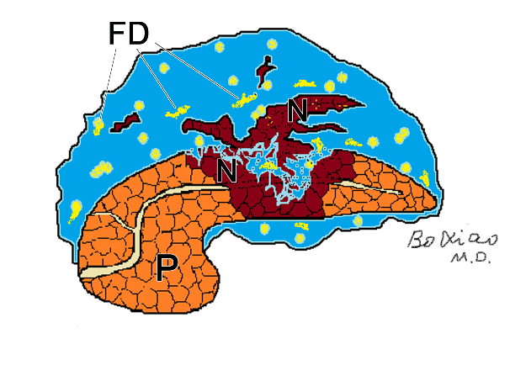B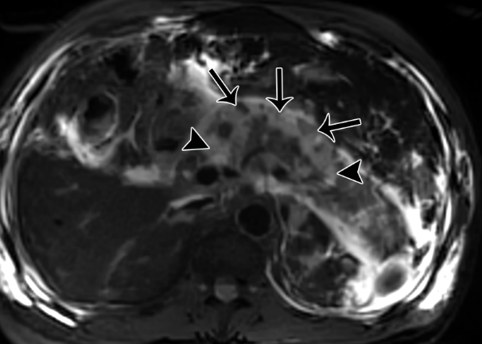

C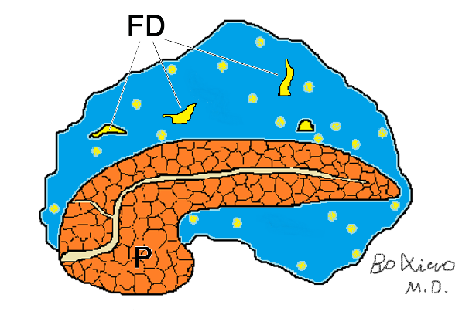D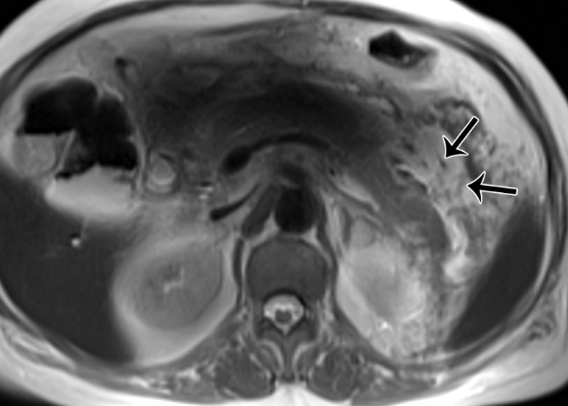
Figure 1 Pancreatic and peripancreatic necrosis. A: Schematic diagram of pancreatic and peripancreatic necrosis (mixed type): pancreatic body necrosis (N) accompanied by peripancreatic fatty tissue debris (FD); B: A 61-year-old male with acute necrotizing pancreatitis (both pancreatic and peripancreatic necrosis). Fat-suppressed axial T1-weighted imaging shows a wide range of necrosis of the head and body of the pancreas (arrowheads), as well as peripancreatic collections containing large amounts of fat necrotic debris (arrows); C: Schematic diagram of necrotizing pancreatitis (peripancreatic necrosis alone): FD and absence of necrosis of pancreatic parenchyma; D: A 65-year-old woman with acute necrotizing pancreatitis (peripancreatic necrosis alone). Magnetic resonance imaging T2WI shows multiple patchy fatty fragments (hypointensity areas) (arrows) surrounding the pancreas.

A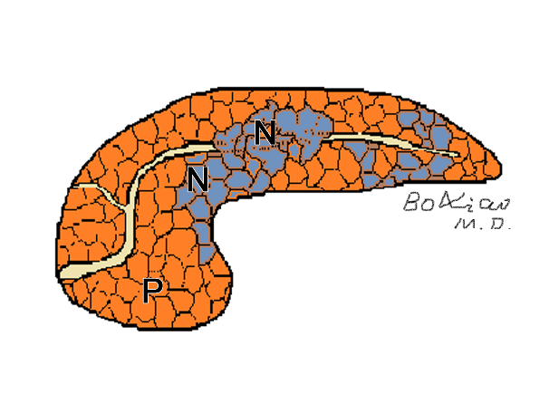B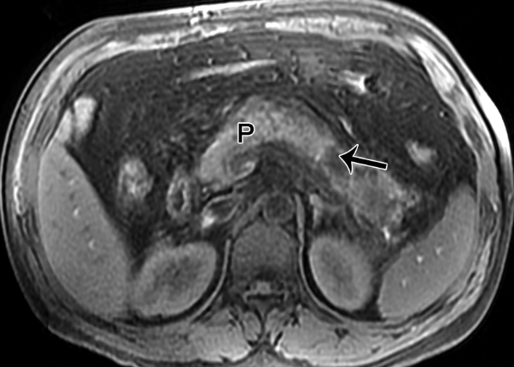
Figure 2 Peripancreatic necrosis only. A: Schematic diagram of necrotizing pancreatitis (pancreatic necrosis alone): Scattered necrotic lesions (N) within the pancreatic parenchyma; B: A 40-year-old man with necrotizing pancreatitis (pancreatic necrosis alone). Magnetic resonance imaging fat-suppressed T1-weighted imaging shows hypointensity area (arrow) in the pancreatic body, as well as absence of peripancreatic fat involvement.

A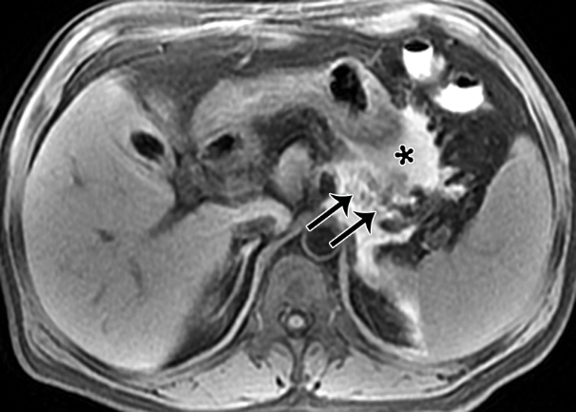 B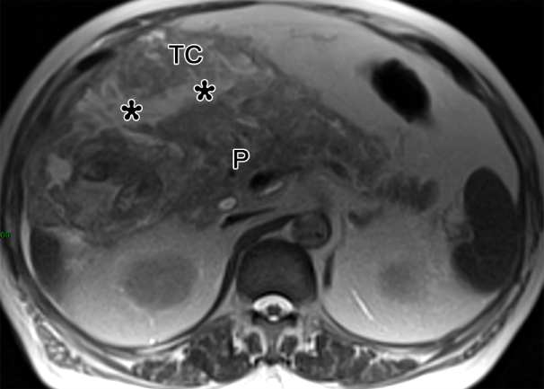
C 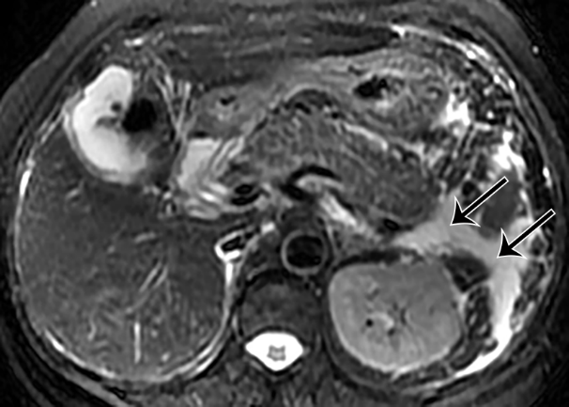 D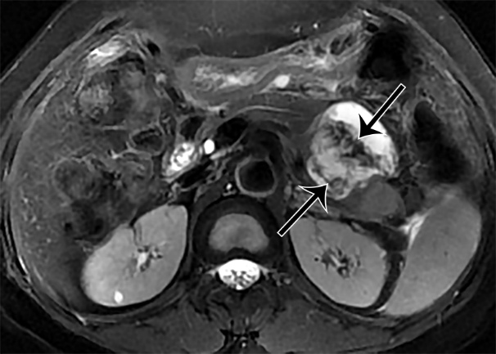
E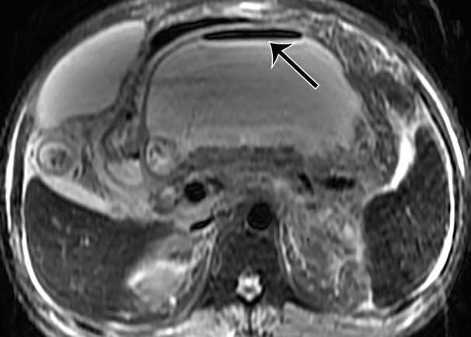 F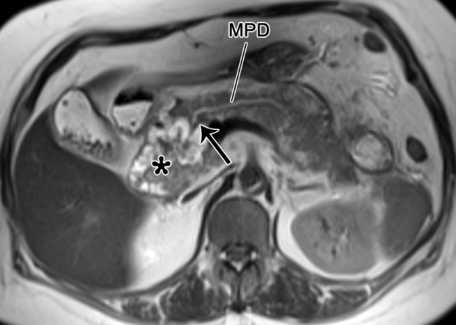
G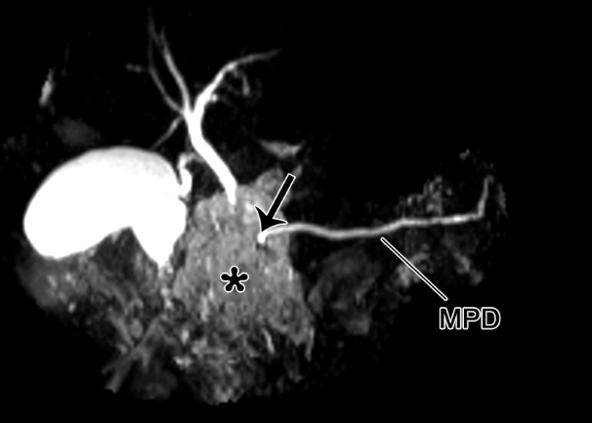
Figure 3 Pancreatic necrosis only. A: A 47-year-old male with acute necrotizing pancreatitis complicated by hemorrhage. MRI fat-suppressed T1WI depicts a large area of hyperintensity in the pancreatic body (arrow) and peripancreatic areas (*), indicating the presence of pancreatic and peripancreatic fat necrosis with hemorrhage; B: A 73-year-old man with acute necrotizing pancreatitis complicated with transverse mesenteric effusion. Magnetic resonance imaging (MRI) T1-weighted imaging (T1WI) demonstrates peripancreatic inflammation spreading from the root of mesentery to the transverse colon along the involved transverse mesentery (*). P: pancreas; C: A 63-year-old woman with acute interstitial pancreatitis with acute peripancreatic fluid collection. MRI fat-suppressed T2WI reveals the uniformly hyperintense fluid collections (arrows) around the pancreas; D: A 53-year-old woman with walled-off necrosis secondary to acute necrotizing pancreatitis (pancreatic and peripancreatic necrosis type). MRI fat-suppressed T2WI shows an enveloped necrotic collection involving the body and tail of the pancreas, with solid necrotic debris (arrows) accounting for more than 40%; E: A 45-year-old man with acute necrotizing pancreatitis accompanied by walled-off necrosis and secondary infection. MRI fat-suppressed T2WI shows extensive walled-off necrosis in the omental sac, as well as a gas-fluid level sign (arrow). Thereafter, the open surgery and drainage for infectious collections was performed; F: A 55-year-old woman with pancreatic duct disruption syndrome secondary to acute necrotizing pancreatitis with walled-off necrosis. MRI T2WI shows an enveloped necrosis lesion (*) in the pancreatic head, and a cut-off sign (arrow) of the main pancreatic duct (MPD) traveling into this lesion (*). G: MRCP reveals that the MPD of the pancreatic body and tail directly enters into the lesion (*) in a right-angle, concomitant with the interrupted MPD.

A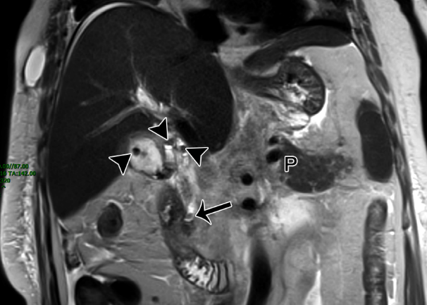B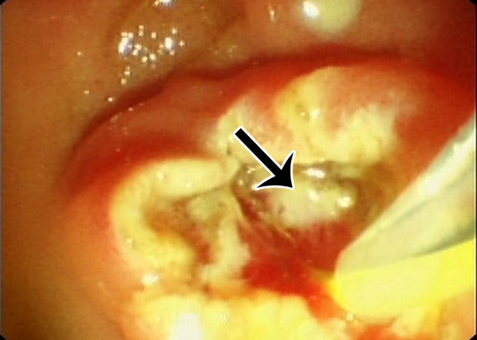
Figure 4 The magnetic resonance imaging report description needs to be focused on gallstone pancreatitis. A 56-year-old woman with acute gallstone pancreatitis. A: Magnetic resonance imaging T2WI coronal imaging shows multiple hypointensity stones (arrowheads) in the gallbladder and gallbladder duct, and another hypointensity stone (arrow) in the lower level of the common bile duct. The patient was underwent an endoscopic retrograde cholangiopancreatography (ERCP) procedure; B: ERCP shows a stone in the lower part of the common bile duct with suppurative conditions (arrow). P: Pancreas.
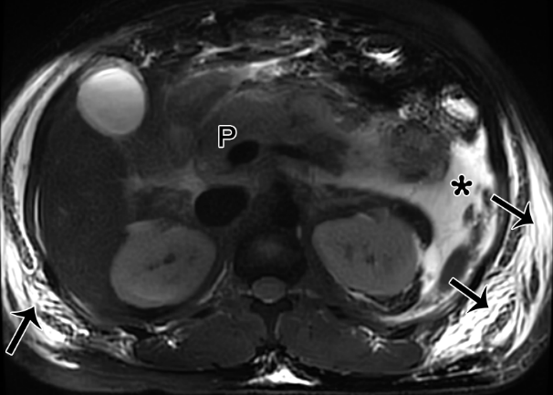
Figure 5 Acute pancreatitis can also cause subcutaneous edema and fluid collection changes in the abdominal walls. A 25-year-old man with acute necrotizing pancreatitis and acute necrotic collection accompanied by conspicuous subcutaneous edema. Magnetic resonance imaging fat-suppressed T1-weighted imaging shows a majority of hyperintense fluid collections (*) in the left pararenal anterior space, and large flaps of hyperintense changes (arrows) in subcutaneous tissues of bilateral flanks and abdominal walls. P: Pancreas.

A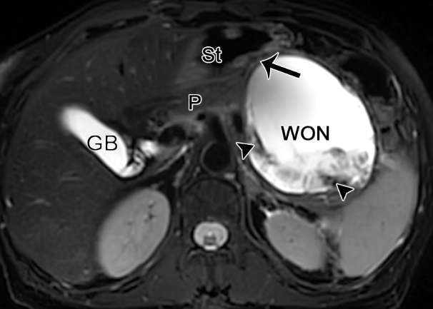 B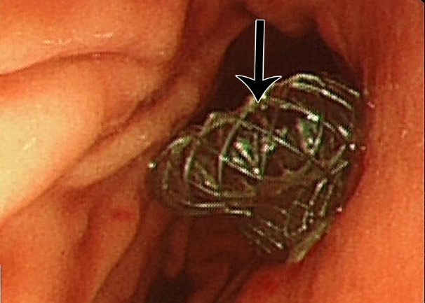
C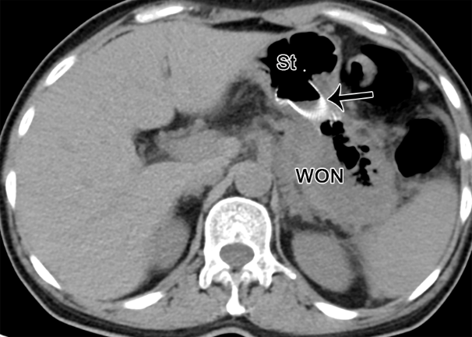
Figure 6 The radiological changes in pancreatic/peripancreatic fluid. A 49-year-old woman with acute necrotizing pancreatitis and pancreatic walled-off necrosis, performed by endoscopic ultrasound drainage. A: Magnetic resonance imaging fat-suppressed T1-weighted imaging shows a walled-off necrosis (WON) with a diameter of 10 cm × 9 cm in the omental sac and pancreatic body and tail, as well as numerous necrotic fragments (arrowheads) within the WON. The WON is adjacent to the gastric body; B: Thereafter, under the guidance of endoscopic ultrasonography, a fully coated mushroom metal stent (arrow) was placed through the stomach for internal drainage; C: Postoperative computed tomography image shows that the WON was apparently decreased, with a large amount of gas and a high-density stent (arrow) in place. St: Stomach, P: Pancreas, GB: Gallbladder.

Table 1 Magnetic resonance imaging sequences and parameters (1.5 Tesla) for acute pancreatitis
Sequence | Repetition time (ms) | Echo time (ms) | Slice thickness (mm) | Slice space (mm) | Matrix | Field of view (mm) | Flip angle
T1WI | 6.19 | 2.86 | 2.4 | 0 | 143 × 272 | 300 × 400 | 15°
IP/OP | 6.19 | 4.47 | 2.4 | 0 | 143 × 272 | 300 × 400 | 15°
T2WI | 2,000 | 78.26 | 5 | 1 | 256 × 152 | 300 × 380 | 150°
DWI | 3611 | 64 | 6 | 1.2 | 114 × 144 | 300 × 380 | 90°
MRCP | 6500 | 1004 | 60 | 60 | 336 × 336 | 340 × 340 | 160°
DCE MRI | 6.19 | 2.86 | 2.4 | 0 | 143 × 272 | 300 × 400 | 15°
IP/OP: In-phase/Out-of-phase; DWI: Diffusion-weighted imaging; MRCP: Magnetic resonance cholangiopancreatography; DCE: Dynamic contrast-enhancement.

Table 2 Magnetic resonance imaging sequences and parameters (3.0 Tesla) for acute pancreatitis
Sequence | Repetition time (ms) | Echo time (ms) | Slice thickness (mm) | Slice space (mm) | Matrix | Field of view (mm) | Flip angle
T1WI | 3.91 | 1.42 | 4.5 | 0 | 304 × 274 | 400 × 300 | 12°
T2WI | 8963 | 116.16 | 6 | 20 | 256 × 218 | 380 × 300 | 90°
DWI | 3555 | 63.8 | 6.0 | 20 | 128 × 101 | 380 × 300 | 90°
MRCP | 6000 | 753.6 | 60 | 0 | 368 × 276 | 300 × 300 | 180°
DCE MRI | 3.91 | 1.42 | 4.5 | 0 | 304 × 274 | 400 × 300 | 12°
DWI: Diffusion-weighted imaging; MRCP: Magnetic resonance cholangiopancreatography; DCE: Dynamic contrast-enhancement.

Table 3 Structured report template of magnetic resonance imaging for acute pancreatitis
Contents | Descriptions
Pancreas itself
Enlargement | Diffuse; Focal (head/neck/body/tail)
Edge | Clear; blur
Signal intensity | Variable owing to internal necrosis and/or hemorrhage
Enhancement | Homogeneous; Heterogeneous
Pancreatic duct | Normal; dilated (mm); stricture (mm); calculi (mm)
Pancreatic necrosis
Position | Head; neck; body; tail
Range¹ | < 30%; 30%-50%; > 50%
Peripancreatic changes
Renal fascia and peritoneum | Thickening (anterior renal fascia/posterior renal fascia/lateral cone fascia/lateral abdominal wall peritoneum); Enhanced or not?
Peripancreatic fat space | Clear; Blur
Peripancreatic fat necrosis | Site (retroperitoneal space/transverse colonic mesentery/small intestinal mesentery); amount (patchy/large flake); whether combined with hemorrhage (fat-suppressed T1-hyperintense)^{[21]}
Peripancreatic collection | Position²; volume (linear/patchy/large); encapsulated round/oval; contents (homogeneous fluid signal/heterogeneous mixed signal)
Local complication
I Pancreatic/peripancreatic collection (type) | Some of the features can be seen in the above peripancreatic collection
APFC | Yes or no?
ANC | Yes or no?
Pseudocyst | Yes or no? If yes, thickness of the cyst wall (mm, uniform?); Is adjacent to and pushing out adjacent organs (stomach/duodenum, etc.)?
WON | Yes or no? If yes, thickness of the lesion wall (mm); Whether the wall is enhanced and the pattern of enhancement? “Non-liquid substances” within WON (< 10%, 10%-40%, > 40%)^{[23]}; Is WON close to adjacent organs (stomach/duodenum/AC/DC)?
II Infection of collection | Suggestive signs [bubble sign, air-fluid level sign]
Complicated intestinal fistula | Relationship between collection and the intestinal fistula canal, and the intestinal segment of intestinal fistula (duodenum/AC/DC)
III Pancreatic duct disruption syndrome | Site (head/neck/body); Is MPD dilated on the upstream/caudal side of the interruption (mm)? Relationship with adjacent pseudocyst/WON?
IV Vascular complications
Venous thrombosis | SV; SMV; PV, etc.
Sinistral portal hypertension | Establishment of collateral vascular network³
Pseudoaneurysm | Size (mm) and involvement artery⁴
Organ complications
Liver | Fatty liver (Signal difference of liver in the in-phase and out-of-phase)
Gallbladder and bile duct | Gallbladder stones (sandy/granular/filled); Common bile duct stones (site, number, size) and maximum duct diameter (mm)
Lung | Extent of pneumonia, pleural effusion
Subcutaneous and intermuscular space | Edema/effusion
Severity image score (MRSI) | (0-10) score
Comparison with previous imaging findings | For AP review, describe the pancreatic/peripancreatic changes after treatment; for surgical treatment, describe the site of the external drainage tube and internal covered metal stent
¹The ratio of the area of pancreatic necrosis in the largest slice to the whole pancreatic area.
²Sites of effusion include: left/right pararenal anterior spaces, perirenal spaces, posterior pararenal spaces, omental sac, bilateral paracolic sulcus, transverse colonic mesentery, small intestinal mesentery, greater omentum, other abdominal spaces, pelvic extraperitoneal spaces, pelvis cavity, thoracic cavity, and mediastinum.
³Such as left/right gastric omental vein, gastrocolic trunk, short gastric vein, submucosal vein of gastric fundus and gastric coronary vein).
⁴Such as splenic artery, pancreaticoduodenal artery, gastroduodenal artery, superior mesenteric artery, and celiac trunk. APFC: Acute peripancreatic fluid collection; ANC: Acute necrotic collection; WON: Walled-off necrosis; AC: Ascending colon; DC: Descending colon; MPD: Main pancreatic duct; SV: Splenic vein; SMV: Superior mesenteric vein; PV: Portal vein; IEP: Interstitial edematous pancreatitis; ANP: Acute necrotizing pancreatitis.

