Name of Journal: World Journal of Clinical Cases
Manuscript NO: 69574
Manuscript Type: CASE REPORT

Crab lice infestation in unilateral eyelashes and adjacent eyelids: A case report

Tang W et al. Crab lice infestation of ocular surface

Wei Tang, Qian-Qian Li

Wei Tang, Department of Ophthalmology, The Affiliated Wuxi No. 2 People’s Hospital of Nanjing Medical University, Affiliated Wuxi Clinical College of Nantong University, Wuxi 214000, Jiangsu Province, China

Qian-Qian Li, Intensive Care Unit, The Affiliated Wuxi No. 2 People’s Hospital of Nanjing Medical University, Affiliated Wuxi Clinical College of Nantong University, Wuxi 214000, Jiangsu Province, China

Author contributions: Tang W designed and drafted the manuscript; Li QQ provided care for the patient, generated the figures, and revised the manuscript for important intellectual content; both authors read and approved the final version of the manuscript.

Supported by the Youth Program of Wuxi No. 2 People’s Hospital, No. YZQN16.

Corresponding author: Qian-Qian Li, MD, Chief Physician, Intensive Care Unit, The Affiliated Wuxi No. 2 People’s Hospital of Nanjing Medical University, Affiliated Wuxi Clinical College of Nantong University, No. 68 Zhongshan Road, Liangxi District, Wuxi 214000, Jiangsu Province, China. lqqeve@163.com

Received: July 6, 2021
Revised: August 1, 2021
Accepted: September 10, 2021
Published online: November 26, 2021

Abstract
BACKGROUND
Crab lice (Phthirus pubis) infestation can occur at any age, to either males or females, and across all regions of the world. However, cases involving the eyelashes and adjacent eyelids (phthiriasis palpebrarum) are rare. Usually occurring as a sexually transmitted disease, crab lice can be spread by poor hygiene or in a dirty environment through direct contact with contaminated skin (hands) or textiles (towels and clothing).

CASE SUMMARY
A 50-year-old woman presented to our hospital with a 2-wk history of chronic eyelid pain and itching in the right eye, which exacerbated in the evening hours and which had not resolved following a 1-wk course of antibiotics and corticosteroid ointments (for blepharitis diagnosis from another hospital). A careful ophthalmic slit-lamp and light microscope examination revealed multiple crab lice and nits on the right upper eyelashes; the right and left lower eyelashes were normal. Following the new diagnosis of phthiriasis palpebrarum, the patient was treated by removing the affected eyelashes, the crab lice, and their nits completely. Additionally, the eyelids were washed once with povidone-iodine. A follow-up examination at 2 wk later showed complete resolution of symptoms and no evidence of re-infection.

CONCLUSION
This case emphasizes the importance of correct diagnosis and complete removal of eyelashes, crab lice and nits to cure phthiriasis palpebrarum.

Key Words: Crab lice; Infestation; Unilateral eyelashes; Phthiriasis palpebrarum; Treatment; Case report

©The Author(s) 2021. Published by Baishideng Publishing Group Inc. All rights reserved.

Citation: Tang W, Li QQ. Crab lice infestation in unilateral eyelashes and adjacent eyelids: A case report. World J Clin Cases 2021; 9(33): 10323-10327
URL: https://www.wjgnet.com/2307-8960/full/v9/i33/10323.htm
DOI: https://dx.doi.org/10.12998/wjcc.v9.i33.10323

Core Tip: Crab lice (Phthirus pubis) infestation of the eyelids and lashes (phthiriasis palpebrarum), despite manifesting eyelid pain and itching, is easy to miss, even for ophthalmologists, as the lice and nits are translucent. For the case presented here, a light microscope revealed the features of crab lice and nits in unilateral eyelashes and adjacent eyelids. Complete removal of the affected eyelashes, by trimming or plucking, followed by a single povidone-iodine rinse appears to be a simple, safe and effective method of treatment.

INTRODUCTION
Crab lice (Phthirus pubis) is a hematophagous parasite of humans^{[1]}. Although the infection usually occurs as a sexually transmitted disease, it also can be spread by direct contact with contaminated skin (e.g., hands) or textiles (e.g., towels and clothing)^{[2]}. Crab lice infestation involving the unilateral eyelashes and adjacent eyelids is rare among the overall spectrum of ocular surface diseases^{[3]}. Many studies of such in the literature refer to the crab lice infection of the eyelid as phthiriasis palpebrarum^{[4-8]}. The condition can occur in any decade of life, with case reports describing afflicted individuals ranging in age from 21 d (infant) to 75 years (elderly)^{[9,10]}. Moreover, cases have originated from developing as well as developed countries. Here, we report a case of phthiriasis palpebrarum caused by poor hygiene or dirty environment.

CASE PRESENTATION
Chief complaints
A 50-year-old woman presented at our hospital’s ophthalmology department in October 2019, with a 2-wk history of intermittent right upper eyelid pain and itching (Figure 1), which exacerbated in the evening hours.

History of present illness
The patient reported having previously presented to another hospital with the same complaint of symptoms. There, she had been diagnosed with blepharitis and prescribed a 1-wk course of antibiotics and corticosteroid ointments. When the symptoms did not resolve with treatment, she sought assessment at our hospital.

History of past illness
No relevant information.

Personal and family history
Personal and family history-taking revealed no relevant information.

Physical examination
The patient’s best-corrected visual acuity was 20/20, in both eyes. A careful ophthalmic slit-lamp examination was conducted, and showed several parasites adherent to the right upper eyelashes of the right eye. A slight touch of the eyelashes stimulated the parasites to initiate a creeping movement in response (Video). In addition to the parasites, there were empty shells present on the eyelashes (Figure 2).

Imaging examinations
A few of the parasites and empty shells were collected and examined under a light microscope (Figure 3). The gross visual characteristics of both were consistent with crab lice and nits (eggs of the crab lice)^{[5]}.

FINAL DIAGNOSIS
Unilateral (right eye) crab lice infection of the eyelids and eyelashes: Phthiriasis palpebrarum.

TREATMENT
The right upper eyelashes were trimmed to the skin surface or plucked out, to ensure complete removal of the crab lice (Figure 4A) and nits. The eyelids were subsequently washed once with povidone-iodine.

OUTCOME AND FOLLOW-UP
A follow-up examination 2-wk later showed complete resolution of the patient’s eye symptoms and no evidence of re-infection (Figure 4B).

DISCUSSION
Parasitic eye infection is a rare ocular disease, without geographic, age or sex propensity. In our clinical work, we have come across eye diseases caused by infections with demodicosis (usually inhabiting hair follicles and largely involving those on the head), cysticercosis (primarily infecting brain and muscle), and crab lice (typically as a sexually transmitted disease). The various parasitic infections feature distinctive infection and symptomological profiles. When crab lice invade eyelid skin, their nits can be observed adhering to the eyelashes. Patients afflicted with phthiriasis palpebrarum always present with eyelid pain and itching, which are unfortunately the most common symptoms of all types of eye diseases. In addition, the adult crab lice are translucent, being easy to miss by an ophthalmologist and supporting the misdiagnosis of blepharitis. The parasitic nature of crab lice includes their derivation of nutrients from human blood, via an ex vivo sucking mechanism. The symptoms of itching and pain arise from the biting of the crab lice to penetrate the skin and obtain the blood meal.
There are three transmission mechanisms for crab lice, including sexual, direct and indirect contact. Vulva infestation of crab lice is most commonly transmitted by sexual contact. Eyelid infestation is mainly transmitted by direct or indirect contact with a contaminated source. In our case, the patient had worked as a hotel cleaner for 4 years, and declared no history of sexually transmitted diseases. She could have contracted the disease from contact with contaminated towels and clothing at her worksite. Good hygienic habits, including frequent bathing, hand washing and laundering of textiles (including personal clothing) are important ways to prevent this disease.
There are several topical drug-based treatments currently available for crab lice, namely ivermectin^{[11,12]}, pilocarpine drops^{[13]}, yellow mercuric oxide, and petrolatum ointment. However, manual removal of visible crab lice and nits remains the standard of care^{[14]}. For our case, with visible crab lice and nits clinging to the skin and eyelashes, the right upper eyelashes were removed by trimming or plucking to ensure complete mechanical removal of the crab lice from the skin. This approach also helped to avoid immediate-future reattachment of residual crab lice and nits. Ultimately, the patient achieved complete resolution of her symptoms and showed no evidence of re-infection.

CONCLUSION
This case emphasizes the importance of correct diagnosis for crab lice infestation. The mechanical removal of crab lice and nits, in addition to complete trimming or plucking of the affected eyelashes, appears to be a simple, safe and effective method of treatment for crab lice infestation of the eyelids and eyelashes.

ACKNOWLEDGEMENTS
The authors express their sincere gratitude to the patient for her cooperation in treatment and permission to share her case through publication.

REFERENCES
1 Slonka GF. Life cycle and biology of lice. J Sch Health 1977; 47: 349-351 [PMID: 586414 DOI: 10.1111/j.1746-1561.1977.tb01084.x]
2 Anderson AL, Chaney E. Pubic lice (Pthirus pubis): history, biology and treatment vs. knowledge and beliefs of US college students. Int J Environ Res Public Health 2009; 6: 592-600 [PMID: 19440402 DOI: 10.3390/ijerph6020592]
3 Baskan C, Duman R, Balci M, Ozdogan S. A rare cause of blepharoconjunctivitis: Phthiriasis palpebrarum. Niger J Clin Pract 2014; 17: 817-818 [PMID: 25385926 DOI: 10.4103/1119-3077.144419]
4 Ashkenazi I, Desatnik HR, Abraham FA. Yellow mercuric oxide: a treatment of choice for phthiriasis palpebrarum. Br J Ophthalmol 1991; 75: 356-358 [PMID: 2043580 DOI: 10.1136/bjo.75.6.356]
5 Droutsas К, Tzanetou К, Kafentzi M, Matemou-Lada E, Droutsas D. Phthiriasis palpebrarum-case report and photo essay. Int J Ophthalmol 2007; 7: 618-620
6 Wu N, Zhang H, Sun FY. Phthiriasis palpebrarum: A case of eyelash infestation with Pthirus pubis. Exp Ther Med 2017; 13: 2000-2002 [PMID: 28565799 DOI: 10.3892/etm.2017.4187]
7 Lv Y, Xing X, Ma W. A Case of Unilateral Phthiriasis Palpebrarum Infestation. JAMA Ophthalmol 2019; 137: e184503 [PMID: 30973587 DOI: 10.1001/jamaophthalmol.2018.4503]
8 Dredge JH, Winter TW, Alset AE. Phthiriasis Palpebrarum Treated with Oral Ivermectin. Ophthalmology 2019; 126: 791 [PMID: 31122358 DOI: 10.1016/j.ophtha.2019.02.024]
9 Ozer PA, Kabatas EU, Gurkan A, Kurtul BE. Treatment of Phthiriasis Palpebrarum Mimicking Conjunctivitis in a Newborn. Indian J Pediatr 2016; 83: 730-731 [PMID: 26676651 DOI: 10.1007/s12098-015-1983-0]
10 Lacarrubba F, Micali G. The not-so-naked eye: phthiriasis palpebrarum. Am J Med 2013; 126: 960-961 [PMID: 24050483 DOI: 10.1016/j.amjmed.2013.08.002]
11 Burkhart CN, Burkhart CG. Oral ivermectin therapy for phthiriasis palpebrum. Arch Ophthalmol 2000; 118: 134-135 [PMID: 10636433]
12 Fox LM. Ivermectin: uses and impact 20 years on. Curr Opin Infect Dis 2006; 19: 588-593 [PMID: 17075336 DOI: 10.1097/QCO.0b013e328010774c]
13 Turgut B, Kurt J, Catak O, Demir T. Phthriasis palpebrarum mimicking lid eczema and blepharitis. J Ophthalmol 2009; 2009: 803951 [PMID: 20339456 DOI: 10.1155/2009/803951]
14 Padhi TR, Das S, Sharma S, Rath S, Rath S, Tripathy D, Panda KG, Basu S, Besirli CG. Ocular parasitoses: A comprehensive review. Surv Ophthalmol 2017; 62: 161-189 [PMID: 27720858 DOI: 10.1016/j.survophthal.2016.09.005]

Footnotes
Informed consent statement: Consent was obtained from the patient for publication of this report and any accompanying images.

Conflict-of-interest statement: The authors declare having no conflicts of interest.

CARE Checklist (2016) statement: The authors have read the CARE Checklist (2016), and the manuscript was prepared and revised according to the CARE Checklist (2016).

Open-Access: This article is an open-access article that was selected by an in-house editor and fully peer-reviewed by external reviewers. It is distributed in accordance with the Creative Commons Attribution NonCommercial (CC BY-NC 4.0) license, which permits others to distribute, remix, adapt, build upon this work non-commercially, and license their derivative works on different terms, provided the original work is properly cited and the use is non-commercial. See: http://creativecommons.org/Licenses/by-nc/4.0/

Provenance and peer review: Unsolicited article; Externally peer reviewed.

Peer-review started: July 6, 2021
First decision: July 26, 2021
Article in press: September 10, 2021

Specialty type: Medicine, research and experimental
Country/Territory of origin: China
Peer-review report’s scientific quality classification
Grade A (Excellent): A
Grade B (Very good): 0
Grade C (Good): 0
Grade D (Fair): 0
Grade E (Poor): 0

P-Reviewer: Șurlin VM S-Editor: Fan JR L-Editor: A P-Editor: Wang LYT

Figure Legends
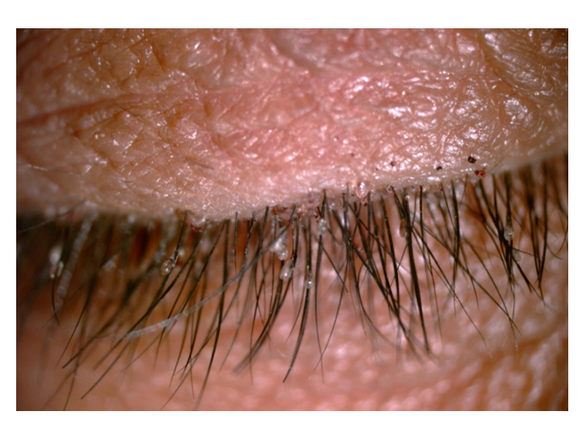
Figure 1 Slit-lamp examination of the patient’s right eyelashes and adjacent eyelids. Some macula and empty shells are seen on the eyelashes.
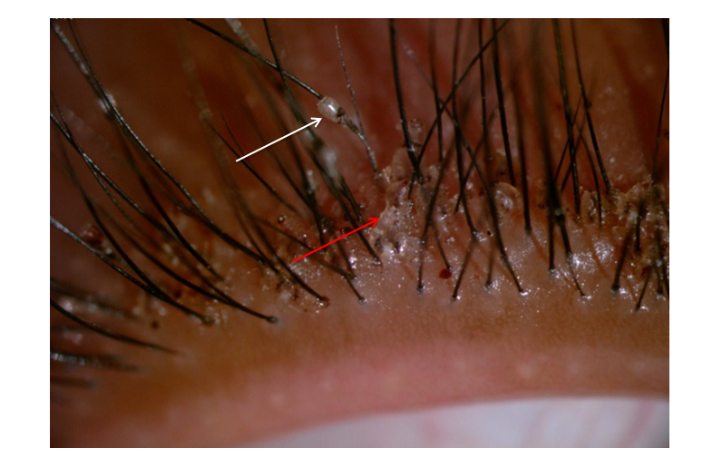
Figure 2 Photos of parasites and empty shells on the patient’s right eyelashes and adjacent eyelids. Empty shells are denoted by white arrow; Parasites are denoted by orange arrow.
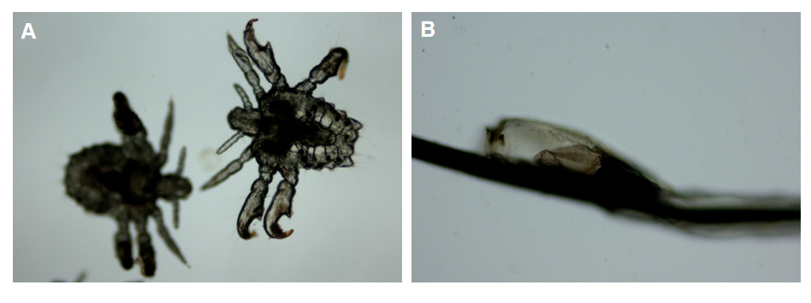
Figure 3 Photos of crab lice and nits taken from the patient’s right eyelashes and adjacent eyelids, as viewed under a light microscope. Magnification 100 ×. A: Crab lice; B: Nits.
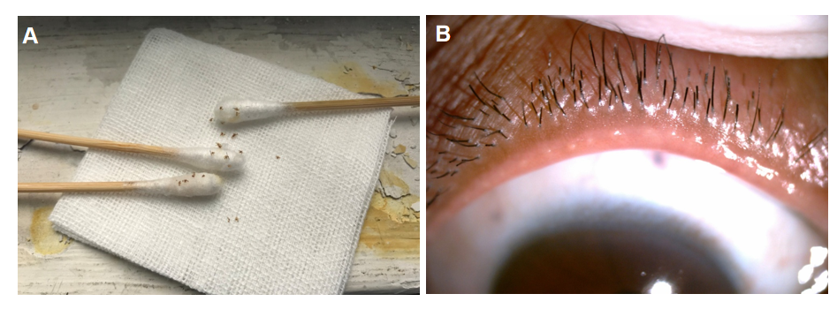
Figure 4 Some of crab lice taken from the patient and recovered eyelashes and eyelids. A: Twenty crab lice removed on cotton swabs and gauze and 6 were subjected to examination under a light microscope; B: Cleared eyelashes (regrowth) and adjacent eyelids at 2-wk after treatment.

Published by Baishideng Publishing Group Inc
7041 Koll Center Parkway, Suite 160, Pleasanton, CA 94566, USA
Telephone: +1-925-3991568
E-mail: bpgoffice@wjgnet.com
Help Desk: https://www.f6publishing.com/helpdesk
https://www.wjgnet.com

© 2021 Baishideng Publishing Group Inc. All rights reserved.

