Name of Journal: World Journal of Gastrointestinal Endoscopy
Manuscript NO: 87453
Manuscript Type: ORIGINAL ARTICLE

Observational Study
Effect of a disposable endoscope precleaning kit in the cleaning procedure of gastrointestinal endoscope: A multi-center observational study

Wang YF et al. Study on endoscopic precleaning methods

Yi-Fan Wang, Yu Wu, Xiao-Wei Liu, Jian-Guo Li, Yan-Qiong Zhan, Bin Liu, Wen-Ling Fan, Zi-Heng Peng, Jin-Tao Xiao, Bing-Bing Li, Jian He, Jun Yi, Zhao-Xia Lu

Yi-Fan Wang, Yu Wu, Xiao-Wei Liu, Zi-Heng Peng, Jin-Tao Xiao, Bing-Bing Li, Jian He, Jun Yi, Zhao-Xia Lu, Department of Gastroenterology, Xiangya Hospital, Central South University, Changsha 410008, Hunan Province, China

Yu Wu, Xiao-Wei Liu, Department of Gastroenterology, Hunan International Scientific and Technological Cooperation Base of Artificial Intelligence Computer Aided Diagnosis and Treatment for Digestive Disease, Changsha 410008, Hunan Province, China

Xiao-Wei Liu, Department of Gastroenterology, National Research Center of Geriatric Diseases, Xiangya Hospital, Central South University, Changsha 410008, Hunan Province, China

Jian-Guo Li, Department of Gastroenterology, The Fourth Hospital of Changsha, Changsha 410006, Hunan Province, China

Yan-Qiong Zhan, Department of Gastroenterology, Zhuzhou Hospital Affiliated to Xiangya School of Medicine, Central South University, Zhuzhou 412007, Hunan Province, China

Bin Liu, Department of Gastroenterology, Xiangtan Central Hospital, Xiangtan 411100, Hunan Province, China

Wen-Ling Fan, Department of Gastroenterology, The First Hospital of Changsha, Changsha 410005, Hunan Province, China

Author contributions: Wang YF, Wu Y, and Liu XW designed the study; Wang YF, Wu Y, Li JG, Zhan YQ, Liu B, Fan WL, Peng ZH, Xiao JT, Li BB, and He J performed the study and collected the data; Wang YF analyzed data and wrote the manuscript; Yi J, and Lu ZX revised the manuscript; Wu Y and Liu XW modified the manuscript critically; and all authors have read and approve the final manuscript.

Corresponding author: Yu Wu, RN, Nurse, Department of Gastroenterology, Xiangya Hospital, Central South University, No. 87 Xiangya Road, Changsha 410008, Hunan Province, China. wy22xy@163.com

Received: August 10, 2023
Revised: October 20, 2023
Accepted: November 8, 2023
Published online:

Abstract
BACKGROUND
Precleaning is a key step in endoscopic reprocessing.

AIM
To develop an effective and economic endoscope cleaning method by using a disposable endoscope bedside precleaning kit.

METHODS
Altogether, 228 used gastrointestinal endoscopes were selected from five high-volume endoscopy units and precleaned by a traditional precleaning bucket (group T) or a disposable endoscope bedside precleaning kit (group D). Each group was further subdivided based on the replacement frequency of the cleaning solution, which was replaced every time in subgroups T1 and D1 and every several times in subgroups Ts and Ds. The adenosine triphosphate (ATP) level and residual proteins were measured three times: Before and after precleaning and after manual cleaning.

RESULTS
After precleaning, the precleaning kit significantly reduced the ATP levels (P = 0.034) and has a more stable ATP clearance rate than the traditional precleaning bucket. The precleaning kit also saved a quarter of the cost of enzymatic detergent used during the precleaning process. After manual cleaning, the ATP levels were also significantly lower in the precleaning kit group than in the traditional precleaning bucket group (P < 0.05). Meanwhile, the number of uses of the cleaning solution (up to four times) has no significant impact on the cleaning effect (P > 0.05).

CONCLUSION
Considering its economic cost and cleaning effect, the use of a disposable endoscope bedside precleaning kit can be an optimal option in the precleaning stage with the cleaning solution being replaced several times in the manual cleaning stage.

Key Words: Cleaning effect; Economic cost; Endoscope; Multi-center study; Precleaning

Wang YF, Wu Y, Liu XW, Li JG, Zhan YQ, Liu B, Fan WL, Peng ZH, Xiao JT, Li BB, He J, Yi J, Lu ZX. Effect of a disposable endoscope precleaning kit in the cleaning procedure of gastrointestinal endoscope: A multi-center observational study. World J Gastrointest Endosc 2023; In press

Core Tip: Precleaning is a key step in endoscopic reprocessing, but related studies on the matter are few. In the present study, we evaluated the role of a self-developed disposable endoscope bedside precleaning kit for endoscopic cleaning. We compared the cleaning effects between the disposable precleaning kit and traditional precleaning buckets in five endoscopy units and found that the precleaning kit has advantages in the precleaning stage. Its better precleaning effect can improve the effectiveness of the subsequent reprocessing procedures. Meanwhile, the cleaning solution used in the precleaning and manual cleaning stages was reduced, suggesting a significant cost advantage in the clinical practice.

INTRODUCTION
With the development of gastrointestinal endoscopic techniques, endoscopy has become an essential part in the diagnosis and management of gastrointestinal diseases^{[1,2]}. Endoscopes are reusable devices that require reprocessing (cleaning, high-level disinfection or sterilization, and drying) to be safely used in other patients^{[3]}. As complex reusable instruments with narrowed lumens, gastrointestinal endoscopes are easily contaminated by blood, secretions, and microorganisms during its use^{[4]}. Besides, heat-sensitive materials are used in these devices; hence, gastrointestinal endoscopes must be sterilized by low-temperature chemical methods, such as liquid chemical germicide, rather than by steam sterilization, thus necessitating higher requirements for more standard cleaning and disinfection procedures^{[5]}. There may be a high risk of iatrogenic cross infection if the endoscope is not thoroughly cleaned and disinfected. In 1993, Spach et al^{[6]} summarized the most common infectious agents transmitted by endoscopy. Many studies have reported a gradual increase in the outbreaks of endoscopy-related infections. Epstein et al^{[7]} reported a carbapenem-resistant Escherichia coli infection in a hospital in the United States caused by exposure to duodenoscopes with bacterial contamination. Naas et al^{[8]} also described a multihospital outbreak of carbapenemase-producing Klebsiella pneumoniae associated with a contaminated duodenoscope. Moreover, Bajolet et al^{[9]} studied a gastroscope-associated outbreak in four patients with an extended spectrum β-lactamase-producing Pseudomonas aeruginosa (P. aeruginosa). Additionally, Birnie et al^{[10]} documented a case of hepatitis B virus transmission via gastrointestinal endoscopy. Although there is currently no evidence of transmission of the variant Creutzfeldt - Jakob disease infectivity by endoscopy (or any other medical or surgical device), laboratory tests have indicated that the standard disinfection and sterilization procedures may be insufficient to completely remove infectious proteins from contaminated instruments^{[11]}. In view of the aforementioned cases, improper or incorrect reprocessing may be responsible for the outbreak of these endoscopy-related infections. Concurrently, in recent years, concerns have been raised that many of these infectious risks to patients may be underestimated due to under-reporting or nonrecognition. Therefore, an improvement in endoscope cleaning and disinfection procedures is critical to prevent infection outbreaks in the future.
After an endoscopic procedure, transferring the contaminated endoscopes to the cleaning and disinfection center is time consuming. The remaining body fluids, blood, or debris on the outer surface and lumen of the contaminated endoscopes are prone to dry and solidify, which make it easier for bacteria to form biofilms in the endoscopic channel. Biofilms comprise multiple layers of bacterial or fungal cell clusters, embedded in an amorphous extracellular material composed of exopolysaccharide-derived bacteria^{[12]}. In clinical practice, biofilm formation may be associated with incomplete manual cleaning and drying^{[13]}. Biofilm formation protects microorganisms from biocides and disinfectants, which may result in the failure of cleaning and disinfection procedures^{[10]}. Precleaning is the first step in preventing the development of biofilms within endoscopes, highlighting the importance of diligent and consistent precleaning, first, in reprocessing^{[14]}. Proper precleaning (wiping and rinsing with air and water) immediately after use is necessary to prevent drying and curing of residual organic matters in the endoscope^{[3]}. The current precleaning procedure worldwide is conducted in accordance with the national endoscope cleaning and disinfection guidelines. The multi-society guideline for reprocessing flexible gastrointestinal (GI) endoscopes and accessories (2020) stipulated that endoscopes should be precleaned at the bedside by aspirating the detergent solution through all channels (including the air/water and biopsy channels) after use^{[14]}, but they have not specified the replacement frequency and holding device of the detergent solution. The manufacturer’s instructions for detergent solution only include requirements for the concentration, temperature, and effective time. Moreover, studies that explored the precleaning methods are few, suggesting the necessity for investigating the current situation of the precleaning practice and conducting relevant clinical research. According to the summarized data of the 2020 China Digestive Endoscopy Census in Hunan Province by our hospital, most hospitals only use a precleaning bucket with an effective concentration of detergent solution to save clinical costs, which is continuously used for the precleaning of all endoscopes in a clinic. In an endoscopy center in the United States, a P. aeruginosa infection after endoscopic retrograde cholangiopancreatography occurred due to the contamination of storage tanks of enzymatic solutions used in precleaning, and the outbreak was terminated after removing the refillable enzymatic bottles and replacing them with single-case enzymatic packs^{[15]}. All these cases suggest that this phenomenon is common worldwide and may lead to the development an infection. Therefore, there is a reason to believe that the traditional precleaning buckets may increase the risk of cross contamination and microbial residues. Accordingly, our research group previously designed a disposable endoscope bedside precleaning kit and attained the practical new patent (patent No.: ZL201920911448.7). In our previous small-scale single-center clinical study, this patented kit can improve the precleaning and manual cleaning effects^{[16]}. To further explore the role of this precleaning kit in improving endoscopic cleaning, we designed a multi-center study to further confirm its clinical effectiveness, safety and economic benefits.

MATERIALS AND METHODS
Study design and ethics
Altogether, 228 used gastroscopes and colonoscopes (Olympus, GIF-HQ290|GIF-XQ260, CF-HQ290I|CF-H260AI, Fukushima, Japan) were selected from five high-volume endoscopy units in Hunan Province, including Xiangya Hospital, the First Hospital of Changsha, the Fourth Hospital of Changsha, Xiangtan Central Hospital, and Zhuzhou Central Hospital. All units have > 200 daily patient volumes. The present investigation was an open study, with pseudo-randomization. In the pseudo-randomization procedure, the endoscopes were grouped according to the collection order. The first half of endoscopes tested at each unit comprised the group T, whereas the second half formed group D, with 114 pieces in each group. Repeated testing in an endoscope might result in an inaccurate representation, as the previous test could potentially remove or wipe away any bioburden. Therefore, 54 samples in each group were only tested by adenosine triphosphate (ATP) bioluminescence assay, and the remaining 60 samples were only subject to residual protein testing. In the precleaning stage, traditional precleaning buckets were used in group T, and the disposable endoscope bedside precleaning kit was used in group D. Altogether, three tests were performed on each endoscope. After the endoscopy procedure, the ATP assay or residual protein test was performed, first, before the precleaning procedure. The second test was performed after completing the precleaning process. Then, the endoscopes were subject to manual cleaning. In this stage, each group was randomly divided into two subgroups based on the replacement frequency of the cleaning solution, namely groups Ts, T1, Ds, and D1. Among them, the cleaning solution in groups Ts and Ds were replaced several times, including every two times, every three times, and every four times, specifically named T2, T3, and T4, respectively, and D2, D3, and D4, respectively, whereas groups T1 and D1 were replaced every time. The third test was conducted after manual cleaning. The specific flow chart is shown in Figure 1. The present study was reviewed and approved by the Medical Ethics Committee of Xiangya Hospital of Central South University and the committee considered that this research did not require ethical approval related to the use of a human body.

Precleaning and manual cleaning
All technical staff working in the five endoscopy units had undergone cleaning and reprocessing competency technical training of endoscopes in the Gastrointestinal Endoscopy Center of Xiangya Hospital, a unit of Hunan Provincial Gastrointestinal Endoscopy Medical Quality Control Center, and obtained the qualification certificate. The detergent solution used for precleaning and manual cleaning were high-concentration enzyme cleaning agents (CL-MA, 210611, Sakura, Tokyo, Japan) with a dilution concentration of 1:1000. After using the endoscope, the exterior of the endoscopes was immediately wiped with a detergent solution. In group T, the detergent was aspirated from the traditional precleaning bucket through biopsy channels until the aspirant became clear, whereas, in group D, the clean water was aspirated until the aspirant became clear; then, 100 mL of the detergent was aspirated from the disposable endoscope bedside precleaning kit. The precleaning process of the five units was performed by the same staff, and the equipment used was also consistent. The manual cleaning process was in strict conformity with the Regulation for Cleaning and Disinfection Technique of Flexible Endoscope (WS507-2016)^{[17]}.

ATP test
Following an endoscopic procedure, 40 mL of sterile phosphate buffered saline (BL302A, Biosharp, Beijing, China) was flushed through the endoscopic working channel and collected at the endoscope’s distal end in a sterile specimen container. The Hygiena AquaSnap™ Total ATP water test swab (AQ-100X, 16022, Hygiena, Camarillo, United States) was dipped into the sample for sampling and then placed into the ATP luminometer (BT-112D, Beijing Chuang Xin Shi Ji Biochemical Science & Technology Development Co., Ltd., Beijing, China) for measurement. The ATP levels are expressed in relative light units (RLU). The manufacturer specifies a cleaning failure at the threshold of the RLU of ≥ 20000.

Residual protein test
The residual protein test kit (NICE CHECK, Clean Chemical Co., Ltd., Osaka, Japan) contains the following three components: Staining, cleaning, and extraction solutions. By infusing 5 mL of staining solution into the endoscopic working channel, the dye was allowed to bind to any residual proteins in the channel. Next, the unbound excess dye was washed off with 5 mL of washing solution. Then, the sample of the dye bound to the residual protein was collected by infusion of 5 mL of the extraction solution. The residual protein was quantitated with bovine serum albumin as a standard.

Statistical analysis
All data are presented as mean ± SD, unless otherwise indicated. The Student’s t-test was used to assess the statistical significance of the differences between the two groups. One-way analysis of variance (ANOVA) was employed to analyze the significant differences among groups. Tukey’s test was used for pairwise comparison. A P value < 0.05 was considered statistically significant. Data were plotted and analyzed using Microsoft Excel and GraphPad Prism version 7.0.

RESULTS
Test results at all stages for all endoscopes
Both precleaning and manual cleaning can significantly reduce the ATP levels and residual proteins in the endoscopic channels. Before precleaning, the ATP level of the gastroscopes after use was significantly higher than that of the colonoscopes (P < 0.001). However, there was no significant difference in the residual protein (P > 0.05) between the gastroscopes and colonoscopes, despite the discovery of a relatively higher level in the colonoscopes. Nevertheless, the difference between the gastroscopes and colonoscopes disappeared after manual cleaning (P > 0.05). See the details in Table 1. To avoid any result error caused by this difference before manual cleaning, two subgroups of T and D groups were established separately for both the gastroscopes and colonoscopes.

Less amount of enzymatic detergent used with the precleaning kit in the precleaning stage
In addition to the normal experimental procedure, we did a small experiment to measure the amount of enzymatic detergent when using the traditional pretreatment bucket. Eighty endoscopes were divided into eight groups, with each group precleaned in the same traditional pretreatment bucket. Finally, the total amount of enzymatic detergent used in each group was measured, as shown in Supplementary Table 1. The average amount of enzymatic detergent used for one endoscope was approximately 136 mL, although the disposable precleaning kit limited the amount of detergent used each time to 100 mL, which greatly reduced the amount of enzymatic detergent used in precleaning stage.

Better precleaning effect of the precleaning kit based on the ATP result
In the post-use stage, the mean levels of ATP and residual proteins were not significantly different between groups T and D (both P > 0.05). After precleaning, the mean ATP level was lower in group D than in group T (P = 0.034). However, no significant difference was observed in the mean residual protein between the two groups (P > 0.05). See the details in Table 2. Moreover, by comparing the relationship between the precleaning sequence and ATP clearance rate, which was defined as the ATP difference value before and after precleaning/ATP value before precleaning × 100%, it was found that with the increase in the frequency of use, especially from the ninth use, the ATP clearance rate of the traditional bucket gradually decreased, whereas that of the disposable endoscope bedside precleaning kit was relatively stable (Figure 2).

Influence of different precleaning methods and cleaning solution replacement frequency on the manual cleaning effect
The ATP levels after manual cleaning were analyzed by pairwise comparison. Significant differences in the ATP levels were observed between groups Ts and Ds (q = 4.585, P = 0.0085), groups Ts and D1 (q = 5.104, P = 0.0026), groups T1 and Ds (q = 4.232, P = 0.0179), and groups T1 and D1 (q = 4.756, P = 0.0059) (Figure 3A). In other words, the mean ATP level after treatment using the traditional precleaning bucket was higher than that of the disposable endoscope bedside precleaning kit, although the difference between Ts and T1 or between Ds and D1 was not statistically significant (both P > 0.05). Additionally, in groups Ts and Ds, there was no significant difference in the ATP levels when the cleaning solution was replaced every two times, every three times, and every four times (all P > 0.05; Figure 3B).
Regarding the residual proteins after manual cleaning, there were no significant differences between any two groups (P > 0.05; Figure 3C). Moreover, in groups Ts and Ds, no significant difference in residual proteins among the groups with cleaning solution replaced every two times, every three times, and every four times (all P > 0.05; Figure 3D). See the details in Table 3.

DISCUSSION
Strict and appropriate endoscopic cleaning procedures are crucial for preventing future infection outbreaks. The present study demonstrated that our patented disposable endoscope bedside precleaning kit has obvious advantages over traditional precleaning buckets, in terms of better cleaning effect and cost advantage during precleaning procedure, and can enhance the effectiveness of subsequent reprocessing procedure.
In our study, the ATP levels were significantly lower after precleaning with the precleaning kit, and the precleaning effect of traditional precleaning buckets decreased due to the increase of pollutants and reduction of active ingredients with the increase in the frequency of use, whereas that of the disposable endoscope bedside precleaning kit was relatively stable. The ATP test is an effective method for detecting the cleaning effect of endoscopes. ATP is present in microorganisms and human cells, and the RLU value of ATP via bioluminescence assay in endoscopic working channels can reflect the residual situation of ATP-containing microorganisms or patients’ secretions^{[18,19]}. In a previous systematic review investigating the correlation between ATP test and bacterial culture based on the summary of the data reported in published studies, researchers have pointed out that the ATP test can be a useful tool for evaluating the adequacy of manual cleaning, although current studies did not support it as a substitute for bacterial culture^{[20]}. Another study found that gram-negative bacteria could be reliably eliminated by endoscopic cleaning under monitoring by using the ATP test^{[21]}. Our study found that, before precleaning, the ATP level of the gastroscopes after use was significantly higher than that of colonoscopes, consistent with other studies^{[22,23]}, which was possibly related to the presence of other nonmicrobial sources of ATP in the upper gastrointestinal tract, such as oral secretions, gastric acid, and bile.
The residues of patient tissue proteins in the endoscopic working channel may be associated with bacterial, viral, or prion infection^{[24]}. Residual proteins provide favorable conditions for microbial colonization and biofilm formation^{[12]}. Therefore, monitoring the residual proteins after cleaning is greatly important. Although no significant effect on residual proteins was observed when using the two methods, a significant decrease was noted after precleaning than that before precleaning (107.58 ± 61.40 vs 40.07 ± 19.31, P < 0.0001), which may be attributed to the components of the multi-enzyme cleaning solution, including protease, enzyme stabilizer, and surfactant that have a strong cleaning effect on the residual protein. Besides, the amount of residual proteins in the used endoscopes was not high, with an unqualified rate of only 17.5% according to the manufacturer’s instructions. Therefore, the two precleaning methods revealed no significant difference in the removal of residual proteins. It is interesting to note that another study also reached a similar conclusion; this study used a Coomassie protein assay reagent to measure the residual proteins of the used endoscopes and observed no significant change before and after cleaning^{[25]}.
Simultaneously, further comparison after manual cleaning revealed that the RLU values were higher when using traditional precleaning buckets than when using the patented precleaning kits. This result indicates that, in addition to its better precleaning effect, our patented precleaning kit also has a beneficial effect on the subsequent cleaning process, that is, a more effective precleaning will improve the effectiveness of the entire cleaning process.
Moreover, the precleaning kit has better economic benefits in terms of medical safety. When using the traditional precleaning bucket, the amount of enzymatic detergent was determined by whether the aspirant is clarified, which varied from 100 mL to 200 mL according to different operators, with an average of approximately 136 mL. The disposable precleaning kit limited the amount of detergent used each time to 100 mL, which reduced the amount of enzymatic detergent used for each endoscope in the precleaning process by approximately a quarter. Additionally, during manual cleaning in our research, no statistical difference was found among groups at different cleaning solution replacement frequencies of several times or every time, and the cleaning solution could still achieve a similar cleaning effect as the first time even after its fourth use. The multi-society guideline for reprocessing flexible GI endoscopes and accessories (2020) requires that the detergent solution should be replaced after each use and when the solution exceeds the specified dilution concentration or temperature range^{[14]}. However, it shows a low level of evidence, and there are no large-scale clinical trials to prove its necessity. Moreover, clinically, there is no additional charge for endoscope reprocessing in most areas in China. Due to the high cost and increased usage of enzymatic detergents, the cost of enzymatic detergents accounts 20% of the total cost of the reprocessing procedures (take our hospital as an example). Therefore, it will be of great significance if the cleaning solution can be used more than one time while ensuring the cleaning effect, which may greatly reduce the clinical cost. According to our results, the cleaning solution can be used up to four or more times in the manual cleaning stage, thereby greatly reducing the usage of the enzymatic detergents and saving costs. Considering medical safety, our study did not further evaluate the cleaning effect when the cleaning solution was used for more than four times, although the test results indicated that it may still qualify after five times of use in the pre experiment; our data may be supplemented in our future research. Overall, the disposable precleaning kit can save a quarter of the cost of the enzymatic detergent during the precleaning process, whereas, in manual cleaning, it can save three-quarters of the cost of the cleaning solution, as it allows the cleaning solution to be used four times before being replaced.
The present study has still some shortcomings. The enzymatic detergents work within a certain temperature range, whereas warm water is used in the manual cleaning stage. The cleaning effect of the enzymatic detergent will be weakened since there is no constant temperature device during precleaning. Additionally, a recent study found that cough evoked during endoscopy is a major source of elevated aerosol levels. Therefore, endoscopy should be regarded as a procedure with a high risk of producing respiratory aerosols, especially in patients with the coronavirus disease 2019 or infected by other respiratory pathogens^{[26-29]}. Our future research direction is to continue optimizing the design of the disposable endoscope bedside precleaning kit, with the primary plan of equipping the device with a thermostat to maintain the temperature of the enzyme detergent, and adding a lid to prevent aerosol pollution. In the future, we will conduct experiments to detect viruses and prions to perfect our research. Moreover, we will continue to promote the application of precleaning kits nationwide to obtain more clinical data.

CONCLUSION
The disposable endoscope bedside precleaning kit has advantages in the precleaning stage and can save cost in terms of the amount of detergent used in the precleaning stage. Moreover, its better and more stable precleaning effect can improve the effectiveness of the subsequent reprocessing procedures. Meanwhile, with this precleaning kit, the cleaning solution can be used up to four times without reducing the cleaning effect in the manual cleaning stage, suggesting a significant cost advantage in clinical practice.

ARTICLE HIGHLIGHTS
Research background
Precleaning is a key step in endoscopic reprocessing. There are some non-standard operations in the endoscopic precleaning stage in clinical practice, which increases the risk of endoscopic related infections. Therefore, it is important to improve the endoscopic precleaning method.

Research motivation
The research aims to develop an effective and economic endoscope cleaning method to reduce endoscopic related infections and reduce clinical costs.

Research objectives
The research aims to verify the clinical effectiveness, safety and economic benefits of our designed disposable endoscope bedside precleaning kit and it is expected to improve and supplement the endoscopic cleaning methods.

Research methods
Exploring the effectiveness of a disposable endoscope bedside precleaning kit through multi-center and observational research, and the precleaning kit is a patented product.

Research results
The disposable endoscope bedside precleaning kit can save cost in terms of the amount of detergent used in the precleaning stage and has better and more stable precleaning effect, which can improve the effectiveness of the subsequent reprocessing procedures. Meanwhile, the cleaning solution can be used up to four times without reducing the cleaning effect in the manual cleaning stage. The results provide a reference for the improvement of endoscopic precleaning methods. However, a larger sample size and more detection methods are still needed to verify this result.

Research conclusions
This study proposes a new endoscopic reprocessing method that uses a disposable endoscope bedside precleaning kit for precleaning and reuses the cleaning solution during the manual cleaning, which can improve cleaning effectiveness and reduce clinical costs.

Research perspectives
The future research direction is to continue optimizing the design of the disposable endoscope bedside precleaning kit and conduct experiments to detect viruses and prions to perfect the research. Moreover, it is particularly important to promote the application of precleaning kits nationwide to obtain more clinical data.

ACKNOWLEDGEMENTS
The authors would like to thank the members of the Endoscopic Unit of 5 hospitals, Hunan International Scientific and Technological Cooperation Base of Artificial Intelligence Computer Aided Diagnosis and Treatment for Digestive Disease and National Research Center of Geriatric Diseases for their technical support.

REFERENCES
1 Hocke M, Burmeister S, Braden B, Jenssen C, Arcidiacono PG, Iglesias-Garcia J, Ignee A, Larghi A, Möller K, Rimbas M, Siyu S, Vanella G, Dietrich CF. Controversies in EUS-guided treatment of walled-off necrosis. Endosc Ultrasound 2022; 11: 442-457 [PMID: 35313415 DOI: 10.4103/EUS-D-21-00189]
2 Ohno A, Kaku T, Fujimori N. Balloon guidewire technique during EUS-guided hepaticogastrostomy. Endosc Ultrasound 2022; 11: 330-331 [PMID: 34755704 DOI: 10.4103/EUS-D-21-00067]
3 Humphries RM, McDonnell G. Superbugs on Duodenoscopes: the Challenge of Cleaning and Disinfection of Reusable Devices. J Clin Microbiol 2015; 53: 3118-3125 [PMID: 26202125 DOI: 10.1128/JCM.01394-15]
4 Kovaleva J, Peters FT, van der Mei HC, Degener JE. Transmission of infection by flexible gastrointestinal endoscopy and bronchoscopy. Clin Microbiol Rev 2013; 26: 231-254 [PMID: 23554415 DOI: 10.1128/CMR.00085-12]
5 Chiu KW, Lu LS, Chiou SS. High-level disinfection of gastrointestinal endoscope reprocessing. World J Exp Med 2015; 5: 33-39 [PMID: 25699232 DOI: 10.5493/wjem.v5.i1.33]
6 Spach DH, Silverstein FE, Stamm WE. Transmission of infection by gastrointestinal endoscopy and bronchoscopy. Ann Intern Med 1993; 118: 117-128 [PMID: 8416308 DOI: 10.7326/0003-4819-118-2-199301150-00008]
7 Epstein L, Hunter JC, Arwady MA, Tsai V, Stein L, Gribogiannis M, Frias M, Guh AY, Laufer AS, Black S, Pacilli M, Moulton-Meissner H, Rasheed JK, Avillan JJ, Kitchel B, Limbago BM, MacCannell D, Lonsway D, Noble-Wang J, Conway J, Conover C, Vernon M, Kallen AJ. New Delhi metallo-β-lactamase-producing carbapenem-resistant Escherichia coli associated with exposure to duodenoscopes. JAMA 2014; 312: 1447-1455 [PMID: 25291580 DOI: 10.1001/jama.2014.12720]
8 Naas T, Cuzon G, Babics A, Fortineau N, Boytchev I, Gayral F, Nordmann P. Endoscopy-associated transmission of carbapenem-resistant Klebsiella pneumoniae producing KPC-2 beta-lactamase. J Antimicrob Chemother 2010; 65: 1305-1306 [PMID: 20382724 DOI: 10.1093/jac/dkq117]
9 Bajolet O, Ciocan D, Vallet C, de Champs C, Vernet-Garnier V, Guillard T, Brasme L, Thiefin G, Cadiot G, Bureau-Chalot F. Gastroscopy-associated transmission of extended-spectrum beta-lactamase-producing Pseudomonas aeruginosa. J Hosp Infect 2013; 83: 341-343 [PMID: 23337251 DOI: 10.1016/j.jhin.2012.10.016]
10 Birnie GG, Quigley EM, Clements GB, Follet EA, Watkinson G. Endoscopic transmission of hepatitis B virus. Gut 1983; 24: 171-174 [PMID: 6852628 DOI: 10.1136/gut.24.2.171]
11 Gruszecka J, Filip R. Handling of endoscopic equipment after use in the case of a patient with suspected prion disease. Ann Agric Environ Med 2020; 27: 319-325 [PMID: 32955209 DOI: 10.26444/aaem/111723]
12 Pajkos A, Vickery K, Cossart Y. Is biofilm accumulation on endoscope tubing a contributor to the failure of cleaning and decontamination? J Hosp Infect 2004; 58: 224-229 [PMID: 15501338 DOI: 10.1016/j.jhin.2004.06.023]
13 Ren-Pei W, Hui-Jun X, Ke Q, Dong W, Xing N, Zhao-Shen L. Correlation between the growth of bacterial biofilm in flexible endoscopes and endoscope reprocessing methods. Am J Infect Control 2014; 42: 1203-1206 [PMID: 25444266 DOI: 10.1016/j.ajic.2014.07.029]
14 Day LW, Muthusamy VR, Collins J, Kushnir VM, Sawhney MS, Thosani NC, Wani S. Multisociety guideline on reprocessing flexible GI endoscopes and accessories. Gastrointest Endosc 2021; 93: 11-33.e6 [PMID: 33353611 DOI: 10.1016/j.gie.2020.09.048]
15 Reiner S. Investigation of a cluster of genomically identical Pseudomonas aeruginosa blood isolates following endoscopic retrograde cholangio-pancreatography in a gastroenterology laboratory. Am J Infect Control 2008; 5: E198 [DOI: 10.1016/j.ajic.2008.04.232]
16 Wang Y, Wu Y, Li Y, Yi J, Lu Z, Liu X. [Evaluation of the application effect of disposable endoscope bedside pretreatment kit in the cleaning process of gastrointestinal endoscope: A single-center observational study]. Chin J Infect Control 2022; 21: 567-572 [DOI: 10.12138/j.issn.1671-9638.20222539]
17 Liu Y, Xing Y, Gong Y, Tian X, Li Z, Wang L, Zhang L, Li L, Fang Y, Liu F, Suo J, Kong J, Deng M, Zhang Y, Zhang J, Yang Y, Chen C, Ren X, Zhang H, Jiang P, Guo X. Regulation for cleaning and disinfection technique of flexible endoscope (WS 507-2016). Available from: https://www.ndeis.cn/userfiles/file/20200420/20200420164232_7519.pdf
18 Alfa MJ, Fatima I, Olson N. The adenosine triphosphate test is a rapid and reliable audit tool to assess manual cleaning adequacy of flexible endoscope channels. Am J Infect Control 2013; 41: 249-253 [PMID: 22975364 DOI: 10.1016/j.ajic.2012.03.015]
19 Alfa MJ, Fatima I, Olson N. Validation of adenosine triphosphate to audit manual cleaning of flexible endoscope channels. Am J Infect Control 2013; 41: 245-248 [PMID: 22980510 DOI: 10.1016/j.ajic.2012.03.018]
20 Olafsdottir LB, Whelan J, Snyder GM. A systematic review of adenosine triphosphate as a surrogate for bacterial contamination of duodenoscopes used for endoscopic retrograde cholangiopancreatography. Am J Infect Control 2018; 46: 697-705 [PMID: 29395506 DOI: 10.1016/j.ajic.2017.12.007]
21 Singh H, Duerksen DR, Schultz G, Reidy C, DeGagne P, Olson N, Nugent Z, Bernard KA, Alfa MJ. Impact of cleaning monitoring combined with channel purge storage on elimination of Escherichia coli and environmental bacteria from duodenoscopes. Gastrointest Endosc 2018; 88: 292-302 [PMID: 29476844 DOI: 10.1016/j.gie.2018.02.018]
22 McCafferty CE, Abi-Hanna D, Aghajani MJ, Micali GT, Lockart I, Vickery K, Gosbell IB, Jensen SO. The validity of adenosine triphosphate measurement in detecting endoscope contamination. J Hosp Infect 2018; 100: e142-e145 [PMID: 30092293 DOI: 10.1016/j.jhin.2018.08.004]
23 Ofstead CL, Wetzler HP, Heymann OL, Johnson EA, Eiland JE, Shaw MJ. Longitudinal assessment of reprocessing effectiveness for colonoscopes and gastroscopes: Results of visual inspections, biochemical markers, and microbial cultures. Am J Infect Control 2017; 45: e26-e33 [PMID: 28159069 DOI: 10.1016/j.ajic.2016.10.017]
24 Hervé RC, Keevil CW. Persistent residual contamination in endoscope channels; a fluorescence epimicroscopy study. Endoscopy 2016; 48: 609-616 [PMID: 27110695 DOI: 10.1055/s-0042-105744]
25 Fushimi R, Takashina M, Yoshikawa H, Kobayashi H, Okubo T, Nakata S, Kaku M. Comparison of adenosine triphosphate, microbiological load, and residual protein as indicators for assessing the cleanliness of flexible gastrointestinal endoscopes. Am J Infect Control 2013; 41: 161-164 [PMID: 22906873 DOI: 10.1016/j.ajic.2012.02.030]
26 Weissman S, Belyayeva A, Sharma S, Aziz M, Elias S, Tabibian JH. SARS-CoV-2 and Acute Diverticulitis: the Expanding Gastrointestinal Manifestations of COVID-19 Infection. J Transl Int Med 2021; 9: 59-60 [PMID: 33850804 DOI: 10.2478/jtim-2021-0019]
27 Gregson FKA, Shrimpton AJ, Hamilton F, Cook TM, Reid JP, Pickering AE, Pournaras DJ, Bzdek BR, Brown J; AERATOR group. Identification of the source events for aerosol generation during oesophago-gastro-duodenoscopy. Gut 2022; 71: 871-878 [PMID: 34187844 DOI: 10.1136/gutjnl-2021-324588]
28 Zhi X, Chen J, Xie F, Sun J, Herth FJF. Diagnostic value of endobronchial ultrasound image features: A specialized review. Endosc Ultrasound 2021; 10: 3-18 [PMID: 32719201 DOI: 10.4103/eus.eus_43_20]
29 Huang K, Zhao X, Chen X, Gao Y, Yu J, Wu L. Analysis of Digestive Endoscopic Results During COVID-19. J Transl Int Med 2021; 9: 38-42 [PMID: 33850800 DOI: 10.2478/jtim-2021-0006]

Footnotes
Institutional review board statement: The Medical Ethics Committee of Xiangya Hospital of Central South University determined that this project did not require ethics approval by an Human Research Ethics Committee.

Informed consent statement: This project has applied for exemption from informed consent forms.

Conflict-of-interest statement: All the authors report no relevant conflicts of interest for this article.

Data sharing statement: No additional data are available.

STROBE statement: The authors have read the STROBE Statement-checklist of items, and the manuscript was prepared and revised according to the STROBE Statement-checklist of items.

Open-Access: This article is an open-access article that was selected by an in-house editor and fully peer-reviewed by external reviewers. It is distributed in accordance with the Creative Commons Attribution NonCommercial (CC BY-NC 4.0) license, which permits others to distribute, remix, adapt, build upon this work non-commercially, and license their derivative works on different terms, provided the original work is properly cited and the use is non-commercial. See: https://creativecommons.org/Licenses/by-nc/4.0/

Provenance and peer review: Unsolicited article; Externally peer reviewed.
Peer-review model: Single blind

Peer-review started: August 10, 2023
First decision: October 9, 2023
Article in press:

Specialty type: Gastroenterology and hepatology
Country/Territory of origin: China
Peer-review report’s scientific quality classification
Grade A (Excellent): 0
Grade B (Very good): B
Grade C (Good): 0
Grade D (Fair): 0
Grade E (Poor): 0

P-Reviewer: Serban ED, Romania S-Editor: Wang JJ L-Editor: A P-Editor:

Figure Legends
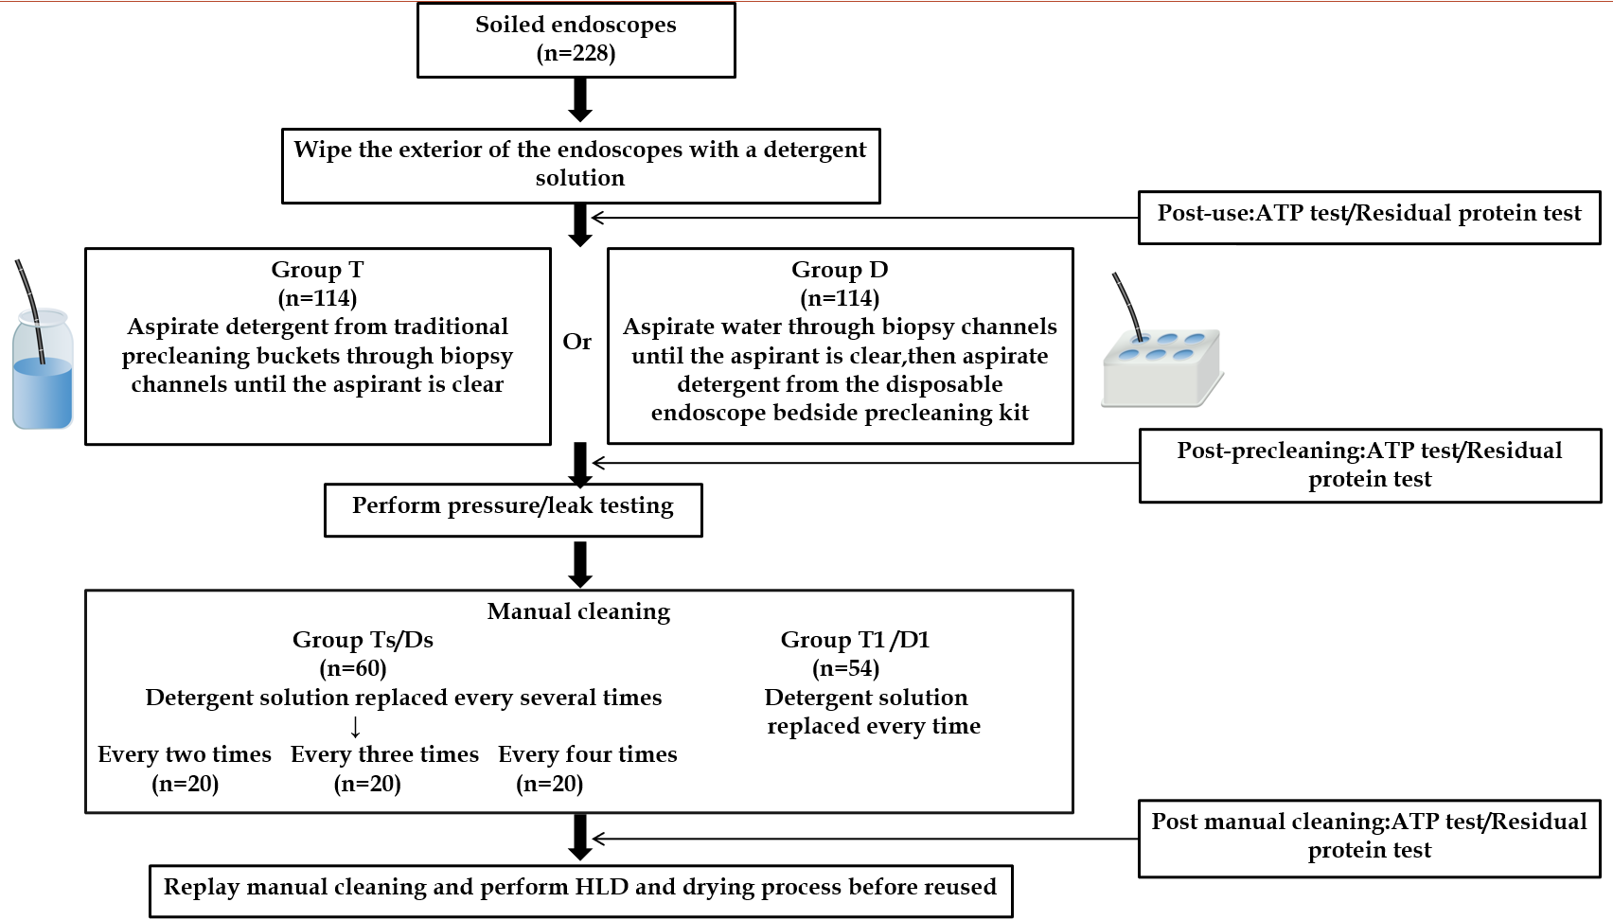
Figure 1 Experimental flow chart. ATP: Adenosine triphosphate; HLD: High-level disinfection.

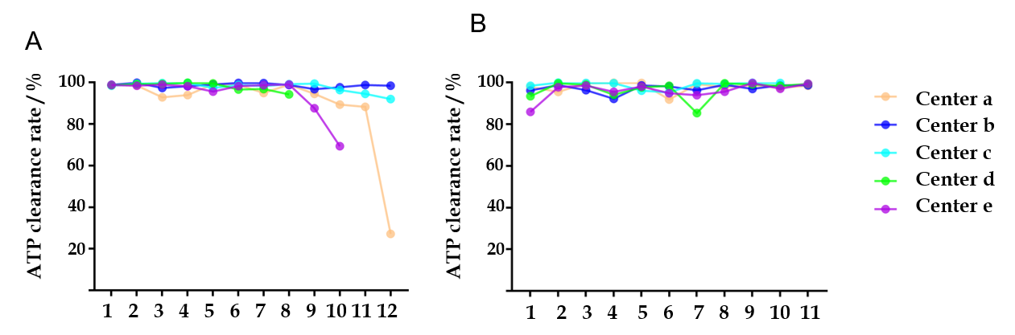
Figure 2 The relationship between the precleaning sequence and adenosine triphosphate clearance rate at different centers (a-e). A: The relationship between the precleaning sequence and adenosine triphosphate (ATP) clearance rate when using the traditional precleaning bucket; B: The relationship between the precleaning sequence and ATP clearance rate when using disposable endoscope bedside precleaning kit. ATP: Adenosine triphosphate.

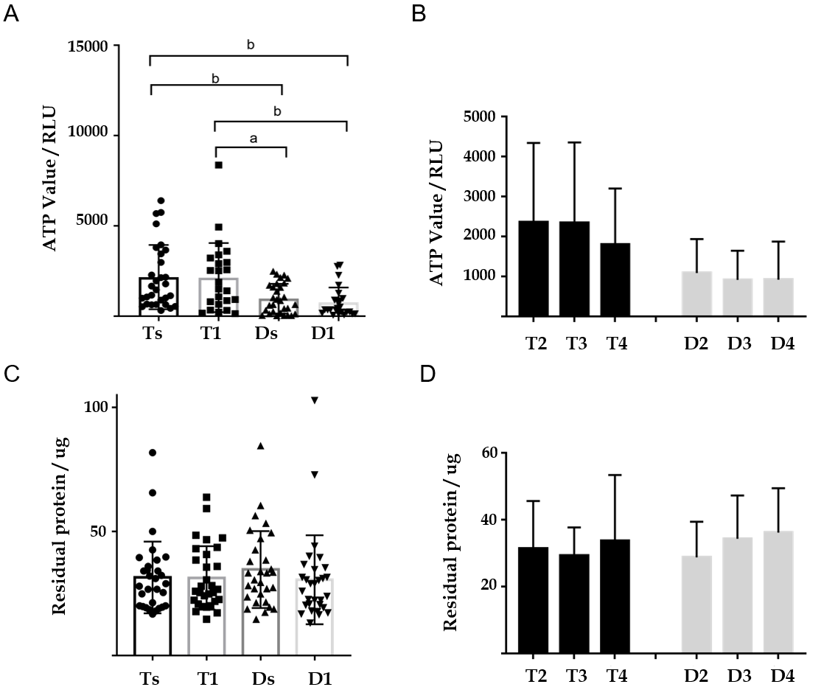
Figure 3 Comparison of the adenosine triphosphate and residual protein results after manual cleaning. A: The adenosine triphosphate (ATP) results after manual cleaning by using different precleaning methods; B: The ATP results after manual cleaning at different cleaning solution replacement frequencies; C: The residual protein results after manual cleaning by using different precleaning methods; D: The residual protein results after manual cleaning at different cleaning solution replacement frequency. ATP: Adenosine triphosphate; RLU: Relative light unit. ªP < 0.05, ^{b}P < 0.01.

Table 1 The test results at all stages for all endoscopes (mean ± SD)
Test method | Endoscopes | Postuse | Postprecleaning | Postmanual cleaning
ATP test (RLU) | Gastroscopes (n = 60) | 5313645 ± 3919731 | 120035 ± 214287ª | 1567 ± 1152^{b}
 | Colonoscopes (n = 48) | 1235303 ± 1182027 | 31293 ± 78392ª | 1450 ± 1945^{c}
Residual protein test (μg) | Gastroscopes (n = 88) | 102.39 ± 58.09 | 39.08 ± 19.60ª | 32.04 ± 15.63^{c}
 | Colonoscopes (n = 32) | 121.87 ± 68.66 | 42.80 ± 18.53ª | 30.34 ± 10.42^{c}
ªP < 0.0001 postuse vs postprecleaning.
^{b}P < 0.0001 postprecleaning vs postmanual cleaning.
^{c}P < 0.01 postprecleaning vs postmanual cleaning.
ATP: Adenosine triphosphate; RLU: Relative light unit.

Table 2 Comparison of the postuse and postprecleaning adenosine triphosphate and residual protein results (mean ± SD)
Test method | Postuse |  | Postprecleaning
 | Group T (n = 60)¹ | Group D (n = 54)² | Group T (n = 60)¹ | Group D (n = 54)²
ATP test (RLU) | 3536861 ± 3665062 | 3465218 ± 3643658 | 116120 ± 236664 | 45068 ± 44132ª
Residual protein test (μg) | 109.01 ± 60.30 | 106.16 ± 62.95 | 39.36 ± 17.70 | 40.78 ± 20.93
ªP < 0.05 group T vs D.
¹Of 30 samples for the adenosine triphosphate test and 30 samples for the residual protein test.
²Of 24 samples for the adenosine triphosphate test and 30 samples for the residual protein test.
ATP: Adenosine triphosphate; RLU: Relative light unit.

Table 3 The adenosine triphosphate and residual protein results after manual cleaning in the different groups (mean ± SD)
Groups |  | Samples | ATP test (RLU) | Samples | Residual protein test (μg)
T1 |  | 24 | 2141 ± 1913 | 30 | 31.27 ± 12.81
Ts | T2 | 10 | 2362 ± 1981 | 10 | 31.44 ± 14.19
 | T3 | 10 | 2340 ± 2017 | 10 | 29.28 ± 8.46
 | T4 | 10 | 1795 ± 1406 | 10 | 33.67 ± 19.75
 | Total | 30 | 2166 ± 1779 | 30 | 31.46 ± 14.46
D1 |  | 24 | 756 ± 834 | 30 | 30.51 ± 17.95
Ds | D2 | 10 | 1083 ± 854 | 10 | 28.80 ± 10.64
 | D3 | 10 | 913 ± 730 | 10 | 34.33 ± 12.96
 | D4 | 10 | 918 ± 956 | 10 | 36.18 ± 13.28
 | Total | 30 | 971 ± 826 | 30 | 34.66 ± 15.50
ATP: Adenosine triphosphate; RLU: Relative light unit.

