Name of journal: World Journal of Gastroenterology
ESPS Manuscript NO: 978
Columns: CASE REPORT

Case report and review of esophageal lichen planus treated with fluticasone

Ynson M et al. Esophageal lichen planus treated with fluticasone

Marie Lourdes Ynson, Faripour Forouhar, Haleh Vaziri

Marie Lourdes Ynson, Department of Medicine, University of Connecticut Health Center, Farmington, CT 06030, United States

Faripour Forouhar, Department of Pathology, University of Connecticut Health Center, Farmington, CT 06030, United States

Haleh Vaziri, Department of Gastroenterology, University of Connecticut Health Center, Farmington, CT 06030, United States

Author contributions: Ynson ML, Forouhar F and Vaziri H contributed to manuscript writing and revisions.

Correspondence to: Marie Lourdes Ynson, MD, Department of Medicine, University of Connecticut Health Center, 263 Farmington Avenue, Farmington, CT 06030, United States. mynson@resident.uchc.edu

Telephone: +1-860-6796524 Fax: +1-860-6793159
Received: October 31, 2012 Revised: January 21, 2013
Accepted: January 23, 2013

Published online

Abstract
Lichen planus is a fairly common chronic idiopathic disorder of the skin, nails and mucosal surfaces. Esophageal involvement of this disease on the other hand is rare and only about 50 cases have been reported in literature. Given its rarity, it can be difficult to diagnose and may be easily misdiagnosed as reflux esophagitis. Currently, there are no clear recommendations on the optimal management of this disease and little is known about the best treatment approach. Systemic steroids are usually the first line treatment and offer a favorable response. In this report, we would like to present a novel approach in the management of esophageal lichen planus in a middle-aged woman treated successfully with swallowed fluticasone propionate 220 mcg twice a day for 6 weeks, as evidenced by objective clinical findings. Based on our review of related literature and experience in this patient, we feel that a trial of swallowed fluticasone may be a prudent approach in the management of these patients since it has a more favorable side effect profile than systemic treatment.

© 2013 Baishideng. All rights reserved.

Key words: Lichen planus; Lichen rubra planus; Anti-inflammatory agents; Steroids; Dysphagia; Fluticasone

Ynson ML, Forouhar F, Vaziri H. Case report and review of esophageal lichen planus treated with fluticasone. World J Gastroenterol 2013; 19
Available from: URL:
DOI:

INTRODUCTION
Lichen planus is a well-recognized chronic idiopathic disorder involving the skin, nails and mucosal surfaces including the mouth, pharynx and perineum^{[1]}. It affects less than 1% of the general population^{[2]}. Mucosal surface involvement is found in about 30% to 70% of patients diagnosed with lichen planus^{[3]}. Esophageal involvement, on the other hand, is considered to be rare with its true prevalence unknown. The study by Dickens et al^{[4]} demonstrated esophageal lichen planus in 26% of patients with mucocutaneous lesions while a larger study by Eisen et al^{[5]} found esophageal lesions in only 1% of patients. Here we describe a case of esophageal lichen planus who was treated with swallowed fluticasone with good response and present a review of this topic.

CASE REPORT
A 63 year-old female with history of gastric bypass surgery, coronary artery disease, and hyperlipidemia reported having intermittent solid food dysphagia for the past 3 years. She also had symptoms of gastroesophageal reflux disease that was initially controlled with omeprazole 20 mg daily. Later on, she developed multiple episodes of breakthrough and nocturnal reflux symptoms accompanied by occasional difficulty in swallowing large pills that happened 2-3 times a week. She denied food regurgitation, odynophagia, nausea, vomiting or weight loss. For further evaluation of her dysphagia, a barium swallow was performed. During the procedure, the barium pill briefly got trapped in the upper esophagus at the level of C6-C7. This location correlated with the reported site of dysphagia (Figure 1). The rest of the exam was uneventful and no mass or stricture was noted except for a small sliding hiatal hernia. She subsequently underwent an upper endoscopy which showed areas of friable mucosa in the upper esophagus with denuded areas due to the peeled mucosa and dried blood as well as a mild stricture at the junction of upper and mid-esophagus (Figure 2). Esophageal biopsies were obtained which showed hyperkeratosis, parakeratosis and spongiosis of the lower third of the epithelium with focal dyskeratosis. Chronic inflammatory cell infiltration of the epithelium was also present and was mainly composed of lymphocytes (Figure 3). Submucosa was not present for evaluation of lichenoid inflammation. Nonetheless, in the presence of the clinical history, the findings were interpreted to be consistent with lichen planus. On further questioning, patient reported having an oral lesion diagnosed to be lichen planus in 2009. Due to her history of previous lichen planus and endoscopy findings, patient was diagnosed with esophageal lichen planus and was started on swallowed fluticasone propionate 220 mcg twice daily for 6 wk. At her 4th week follow-up she noted resolution of her symptoms. On follow-up endoscopy at 15 wk, only small light pink plaques were noted in the mid-esophagus while the rest of the esophagus showed normal looking mucosa (Figure 4). Pathology showed normal to atrophic squamous mucosa with mild non-specific inflammation including rare eosinophils and no evidence of interface band-like lymphocytic infiltrate which was compatible with lichen planus post-therapy.

DISCUSSION
Lichen planus is a common disorder of squamous epithelium^{[2]}. The exact cause of this disease is unknown; however infectious (viral), neurologic, genetic and immunologic causes have been proposed^{[6]}. Lichen planus appears to be mediated by cytotoxic CD8+ T cells that attack an antigen in the basal epithelium in a manner resembling graft-versus-host disease^{[2]}. There are no detailed studies published to specifically address the pathogenesis of esophageal lichen planus. Chandan et al^{[7]} suggests that the pathogenesis may be similar to oral lichen planus. It has been suggested that oral lichen planus is due to an immune response to an exogenous or endogenous antigen found in the basal keratinocytes. This activates the Langerhans cells which then present the antigen to the CD4+ T lymphocytes migrating to the oral mucosa lamina propria. Keratinocytes respond to the injury by producing cytokines that promote CD8+ T lymphocyte stimulation. These CD8+ cytotoxic cells will distribute near the epithelium and destroy it^{[8]}. Table 1 summarizes the differences between esophageal versus oral and cutaneous lichen planus.
Esophageal lichen planus is considered to be a rare disease with only about 50 cases reported in English literature. Retrospectively, Eisen^{[5]} suggests a prevalence of less than 1% among patients with oral lichen planus but because of subtle clinical findings and lack of characteristic histologic features, the true prevalence is hard to determine^{[9]}. All reported patients are usually middle-aged females except in the study by Chryssostalis et al^{[10]} that reported a case of a 22-year-old male with esophageal involvement. Esophageal lichen planus is often present in patients with extraesophageal involvement, but it may also be present in patients without dermal or oropharyngeal manifestations^{[11]}. In a case series of esophageal lichen planus, the initial site of involvement was esophagus in 48% of patients^{[12]}. Symptoms can range from asymptomatic to odynophagia and dysphagia^{[4]}. The proximal or mid-esophagus is the most common site of involvement^{[7]}, although the entire esophagus can also be affected with sparing of the gastroesophageal junction^{[13]}. Different types of lesions have been reported and can range from elevated lacy white papules, esophageal webs, pseudomembranes, desquamation, and superficial pinpoint erosions with and without stenosis. Most case reports mention the characteristic finding of peeling of the mucosa away from the esophagus leaving a friable, inflamed surface that bleeds on contact^{[11]}. Strictures are also common in these patients and may represent progression from inflammation to ulceration, fibrosis with subsequent stricture formation^{[14]}.
Esophageal lichen planus may be misdiagnosed as reflux esophagitis which further compounds the situation. In our patient, esophageal lichen planus was favored over reflux esophagitis due to the extensive degree of hyperkeratosis and focal parakeratosis with accumulation of keratohyalin granules which are unlikely in reflux related injury. The presence of spongiosis in the lower third of the epithelium was also more consistent with esophageal lichen planus. The spongiosis in reflux diseases tend to occur in the upper third of the epithelium where acid is in contact with the mucosa. The other factor that can help to differentiate these 2 entities is the site of involvement in the esophagus. While reflux disease is usually more severe in the distal esophagus, lichen planus affects the middle and upper esophagus in most cases.
The most characteristic histologic finding in esophageal lichen planus is a bandlike or lichenoid lymphocytic infiltrate involving the superficial lamina propria and basal epithelium^{[7]}. A predominance of mature T cells is present within this infiltrate. These are associated with basal keratinocyte degeneration which often include Civatte bodies (necrotic keratinocytes with anucleate remnants)^{[7]}. Lymphocytic infiltration of the mucosa is not pathognomonic of this disease and medications such as gold, thiazide, and anti-malarials can induce lichen planus-like lesions and need to be excluded clinically^{[15]}.
No clear guidelines are present for the treatment of esophageal lichen planus and there is no specific way to treat this entity. Historically, systemic corticosteroids have been used as first-line treatment with a response rate of up to 74% based on multiple reports. However, relapse rate can be as high as 85% with steroid withdrawal^{[11]}. Treatment response was also reported with adrenocorticotrophic hormone injection, etretinate, topical tacrolimus, intralesional corticosteroids and cyclosporine^{[2,16]}. Esophageal dilation is commonly used to treat strictures, although intralesional steroid injections and/or oral tacrolimus may decrease the frequency of required dilations. It is important to note that koebner phenomenon which is defined as development of new lesions along the lines of trauma, can occur with dilatation.
Although effective, systemic corticosteroid treatment can be associated with serious side effects and therefore there is a need for a safer alternative. In our review of literature, we have come upon case reports and a recent case series where treatment with swallowed fluticasone proprionate has resulted in symptomatic improvement as well as endoscopic improvement in 4 out 6 treated patients^{[14,17]}. Because of these promising results, we decided to try this novel approach for our patient which proved to be successful.
Oral lichen planus has a 1%-3% risk of malignant transformation to squamous cell carcinoma^{[3]}. It is unknown however if the same is true for esophageal lichen planus. To date, 3 case reports have described squamous cell carcinoma and 1 described a verrucous carcinoma arising from these lesions. ^{18,19,10} In these reports, squamous cell carcinoma developed more than 20 years after the diagnosis of esophageal lichen planus^{[18]}. Due to this risk, some advocated surveillance endoscopies in patients with esophageal lichen planus to detect early malignancy. In the study by Quispel et al^{[20]}, high magnification indigo carmine chromoendoscopy was used to establish the prevalence of endoscopic and histopathologic esophageal abnormalities consistent with lichen planus and dysplasia in a cohort of patients with lichen planus. It was found that up to 50% of patients with orocutaneous lichen planus had esophageal involvement but no dysplasia was found. The authors of this study proposed to set a low threshold for performing endoscopy in patients with lichen planus and symptoms suggestive of esophageal involvement but recommended against routine screening^{[20]}. Based on these data, we recommend that the frequency of screening by endoscopy be individualized, but the possibility of malignancy be kept in mind while evaluating these patients with a low threshold for further evaluation in patients with symptoms suggestive for esophageal cancer.
In conclusion, esophageal lichen planus should be suspected in middle-aged female patients who present with symptoms of dysphagia and odynophagia and found to have mucosal abnormalities involving the upper third of the esophagus. Once the diagnosis of esophageal lichen planus is made, these patients should be considered for treatment with swallowed fluticasone before other systemic and more toxic therapies. It is important to keep in mind that secondary to the risk for malignant transformation, these patients should be followed closely.

REFERENCES
1 Boyd AS, Neldner KH. Lichen planus. J Am Acad Dermatol 1991; 25: 593-619 [PMID: 1791218 DOI: 10.1016/0190-9622(91)70241-S]
2 Keate RF, Williams JW, Connolly SM. Lichen planus esophagitis: report of three patients treated with oral tacrolimus or intraesophageal corticosteroid injections or both. Dis Esophagus 2003; 16: 47-53 [PMID: 12581256 DOI: 10.1046/j.1442-2050.2003.00289.x]
3 Shenfine J, Preston SR. Lichen planus in the oesophagus: are we missing something? Eur J Gastroenterol Hepatol 2006; 18: 1043-1045 [PMID: 16957508 DOI: 10.1097/01.meg.0000236870.01151.c2]
4 Dickens CM, Heseltine D, Walton S, Bennett JR. The oesophagus in lichen planus: an endoscopic study. BMJ 1990; 300: 84 [PMID: 2105780 DOI: 10.1136/bmj.300.6717.84]
5 Eisen D. The evaluation of cutaneous, genital, scalp, nail, esophageal, and ocular involvement in patients with oral lichen planus. Oral Surg Oral Med Oral Pathol Oral Radiol Endod 1999; 88: 431-436 [PMID: 10519750 DOI: 10.1016/S1079-2104(99)70057-0]
6 Oliver GF, Winkelmann RK. Treatment of lichen planus. Drugs 1993; 45: 56-65 [PMID: 7680985 DOI: 10.2165/00003495-199345010-00006]
7 Chandan VS, Murray JA, Abraham SC. Esophageal lichen planus. Arch Pathol Lab Med 2008; 132: 1026-1029 [PMID: 18517264]
8 Villarroel Dorrego M, Correnti M, Delgado R, Tapia FJ. Oral lichen planus: immunohistology of mucosal lesions. J Oral Pathol Med 2002; 31: 410-414 [PMID: 12165059 DOI: 10.1034/j.1600-0714.2002.00097.x]
9 Bombeccari GP, Guzzi GP, Pallotti F, Marino R, Spadari F. Lichen planus esophagitis: diagnostic implications. Am J Dermatopathol 2009; 31: 509-510 [PMID: 19542934 DOI: 10.1097/DAD.0b013e31818c99e1]
10 Chryssostalis A, Gaudric M, Terris B, Coriat R, Prat F, Chaussade S. Esophageal lichen planus: a series of eight cases including a patient with esophageal verrucous carcinoma. A case series. Endoscopy 2008; 40: 764-768 [PMID: 18535938 DOI: 10.1055/s-2008-1077357]
11 Westbrook R, Riley S. Esophageal lichen planus: case report and literature review. Dysphagia 2008; 23: 331-334 [PMID: 18575934 DOI: 10.1007/s00455-007-9136-x]
12 Katzka DA, Smyrk TC, Bruce AJ, Romero Y, Alexander JA, Murray JA. Variations in presentations of esophageal involvement in lichen planus. Clin Gastroenterol Hepatol 2010; 8: 777-782 [PMID: 20471494 DOI: 10.1016/j.cgh.2010.04.024]
13 Ukleja A, DeVault KR, Stark ME, Achem SR. Lichen planus involving the esophagus. Dig Dis Sci 2001; 46: 2292-2297 [PMID: 11680610 DOI: 10.1023/A: 1011943805711]
14 Donnellan F, Swan MP, May GR, Kandel G, Marcon NE, Kortan PP. Fluticasone propionate for treatment of esophageal lichen planus. A case series. Dis Esophagus 2011; 24: 211-214 [PMID: 20946136 DOI: 10.1111/j.1442-2050.2010.01120.x.]
15 Lefer LG. Lichen planus of the esophagus. Am J Dermatopathol 1982; 4: 267-269 [PMID: 7114412 DOI: 10.1097/00000372-198206000-00017]
16 Chaklader M, Morris-Larkin C, Gulliver W, McGrath J. Cyclosporine in the management of esophageal lichen planus. Can J Gastroenterol 2009; 23: 686-688 [PMID: 19826643]
17 Hou JK, Qureshi W. Swallowed fluticasone for the treatment of esophageal lichen planus. Gastrointest Endosc 2011; 74: 708-709 [PMID: 21092955 DOI: 10.1016/j.gie.2010.09.032]
18 Schwartz MP, Sigurdsson V, Vreuls W, Lubbert PH, Smout AJ. Two siblings with lichen planus and squamous cell carcinoma of the oesophagus. Eur J Gastroenterol Hepatol 2006; 18: 1111-1115 [PMID: 16957518 DOI: 10.1097/01.meg.0000221854.25039.83]
19 Calabrese C, Fabbri A, Benni M, Areni A, Scialpi C, Miglioli M, Di Febo G. Squamous cell carcinoma arising in esophageal lichen planus. Gastrointest Endosc 2003; 57: 596-599 [PMID: 12665780 DOI: 10.1067/mge.2003.154]
20 Quispel R, van Boxel OS, Schipper ME, Sigurdsson V, Canninga-van Dijk MR, Kerckhoffs A, Smout AJ, Samsom M, Schwartz MP. High prevalence of esophageal involvement in lichen planus: a study using magnification chromoendoscopy. Endoscopy 2009; 41: 187-193 [PMID: 19280529 DOI: 10.1055/s-0028-1119590]
21 Abraham SC, Ravich WJ, Anhalt GJ, Yardley JH, Wu TT. Esophageal lichen planus: case report and review of the literature. Am J Surg Pathol 2000; 24: 1678-1682 [PMID: 11117791 DOI: 10.1097/00000478-200012000-00014]
22 Jobard-Drobacheff C, Blanc D, Quencez E, Zultak M, Paris B, Ottignon Y, Agache P. Lichen planus of the oesophagus. Clin Exp Dermatol 1988; 13: 38-41 [PMID: 3208440 DOI: 10.1111/j.1365-2230.1988.tb00648.x]
23 Holder PD, Wong WL, Pemberton J, Thompson RP, Parker SC. Diagnosis and treatment of an oesophageal stricture due to lichen planus. Br J Radiol 1992; 65: 451-452 [PMID: 1611430 DOI: 10.1259/0007-1285-65-773-451]
24 Sheehan-Dare RA, Cotterill JA, Simmons AV. Oesophageal lichen planus. Br J Dermatol 1986; 115: 729-730 [PMID: 3801311 DOI: 10.1111/j.1365-2133.1986.tb06655.x]
25 Kirsch M. Esophageal lichen planus: a forgotten diagnosis. J Clin Gastroenterol 1995; 20: 145-146 [PMID: 7769197 DOI: 10.1097/00004836-199503000-00016]

P-Reviewers Watabe K, Mullin JM
S-Editor Wen LL L-Editor E-Editor

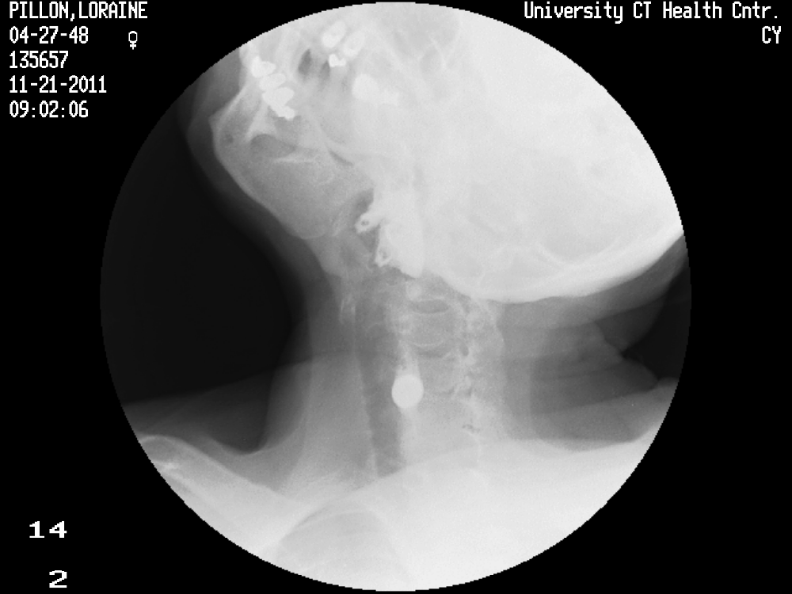
Figure 1 Barium swallow showing barium pill (red arrow) trapped in C6-C7.

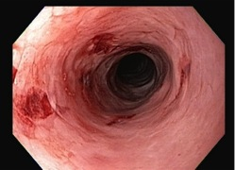
Figure 2 Endoscopy image showing friable mucosa and dried blood in upper esophagus with a mild to moderate stricture at upper and mid-esophageal junction.

A
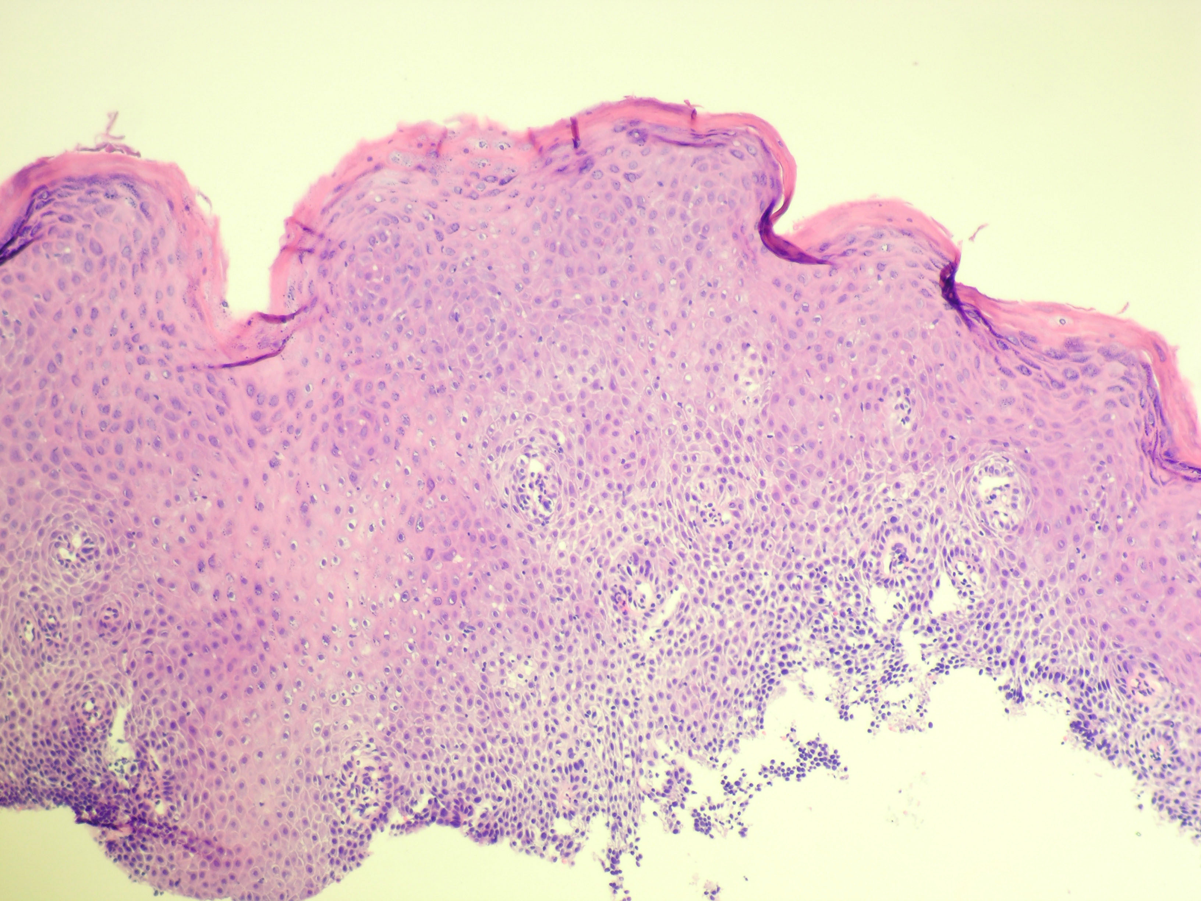
B
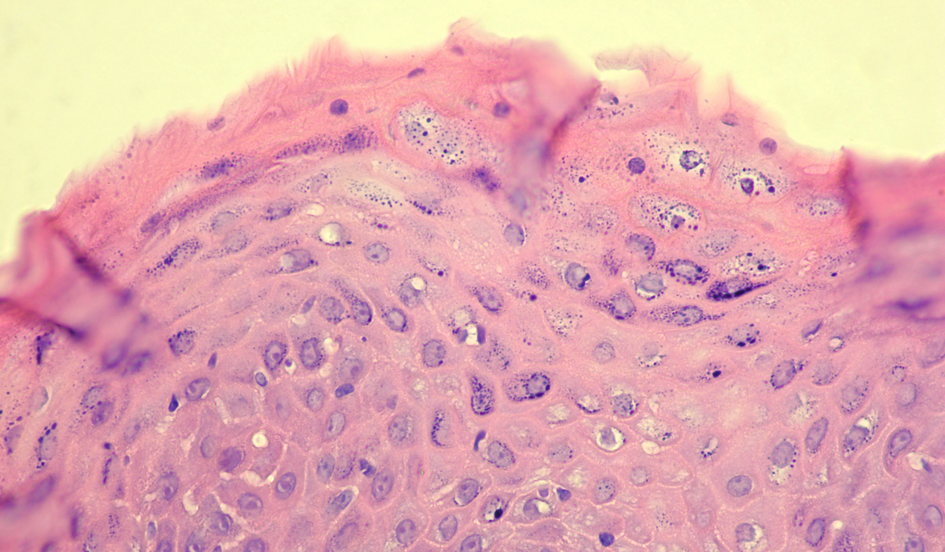
C
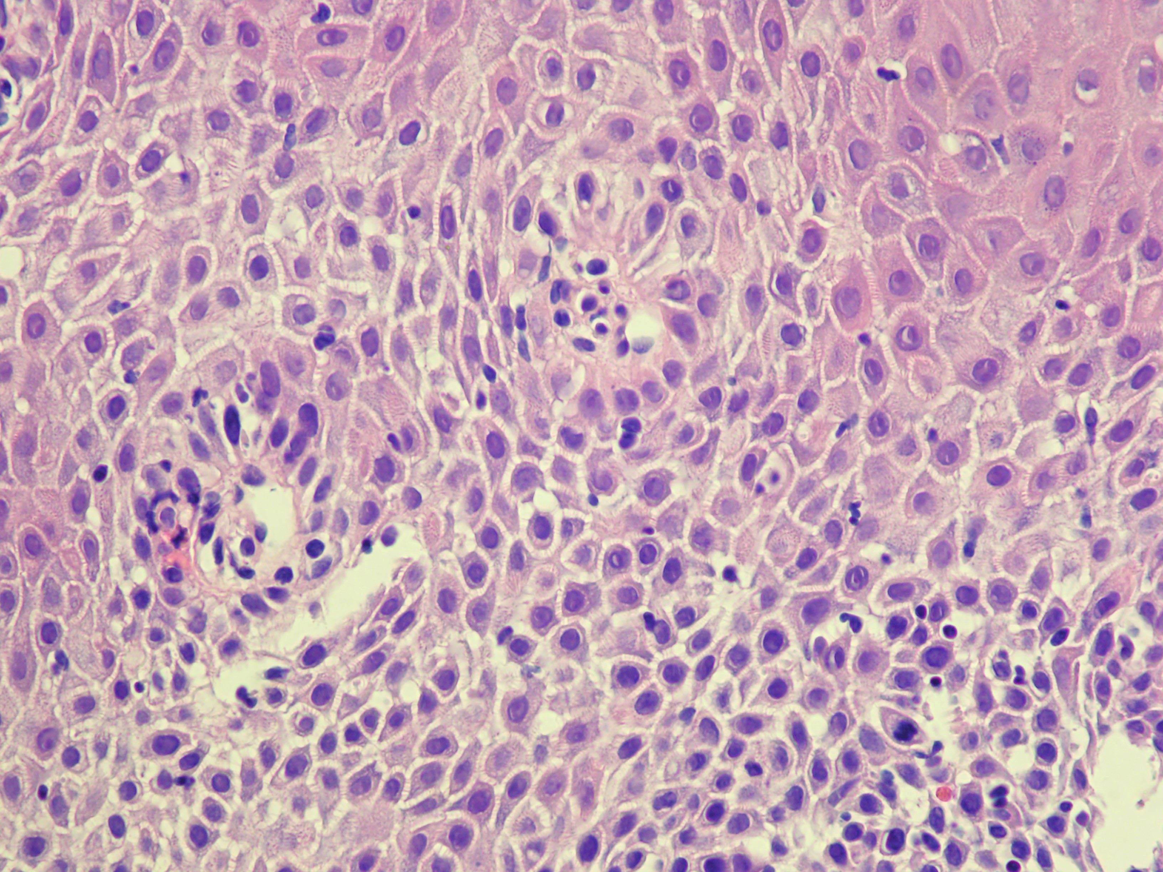
Figure 3 Chronic inflammatory cell infiltration of the epithelium was also present and was mainly composed of lymphocytes. A: Low power view of upper esophagus shows extensive severe keratinization, organizational disarray of cell arrangement and spongiosis of lower layer associated with inflammatory infiltration. (H and E, ×40); B: High power of parakeratotic cells and accumulation of kerato-hyline granules in the cytoplasm of the mature keratinocytes. In this zone keratinization is mild. (H and E, ×400); C: High power view of spongiosis of lower layers of squamous epithelium associated with sprinkling of lymphocytes typical of longstanding chronic inflammation. (H and E, ×400).

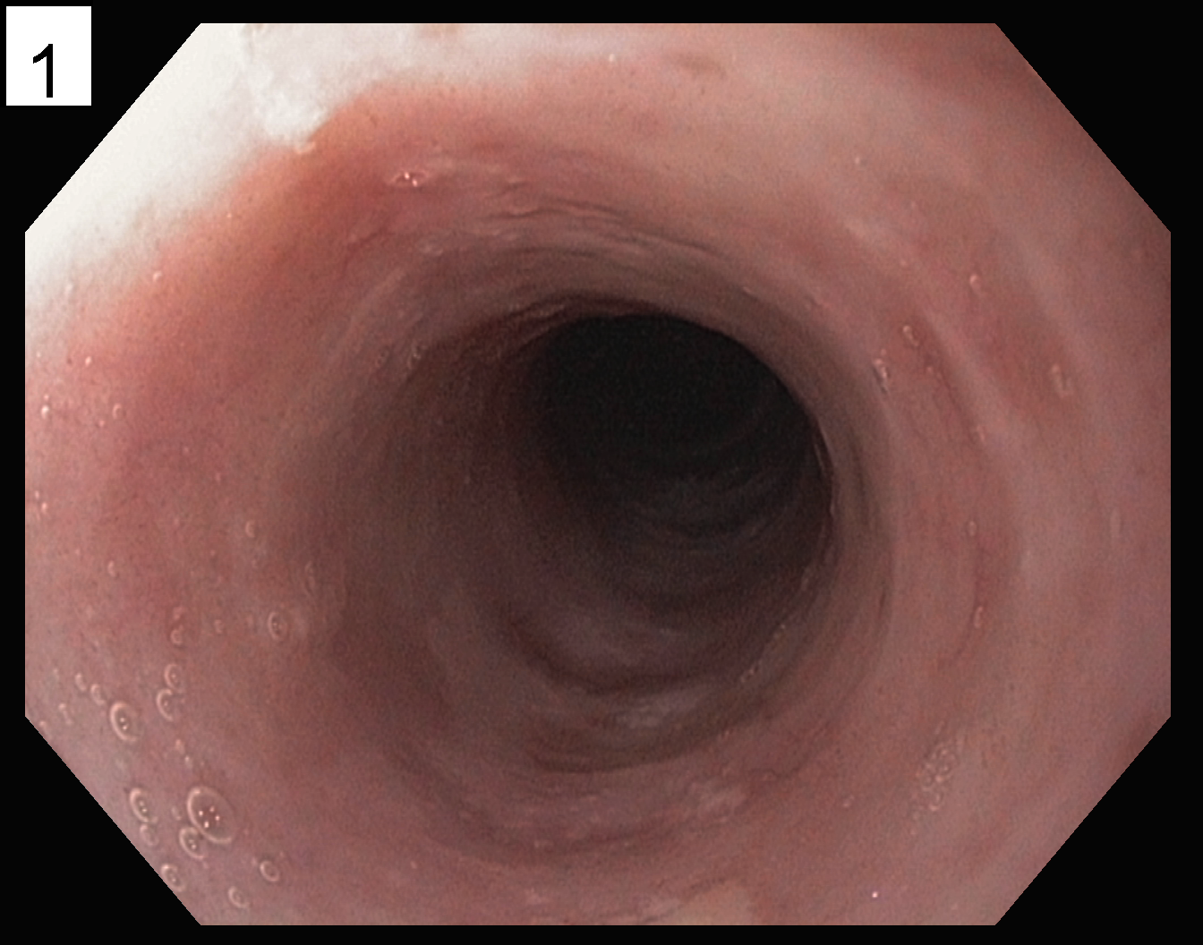
Figure 4 Endoscopy image showing resolution of lesions in the upper esophagus post treatment.

Table 1 Differentiation between types of Lichen Planus
 | Cutaneous | Oral |  | Esophageal
Age and Gender Distribution | No gender preference |  |  | Generally middle aged females¹
Clinical Findings | Eruptions of violaceous, scaling, pruritic plaques^{[7]} |  | Atrophic lesions, erosions, lace-like reticulated  Plaques^{[2]} | Elevated lacy white papules, esophageal webs, pseudomembranes, desquamation, and superficial pinpoint erosions with and without stenosis^{[4,5,15,22-25]}
Duration of illness | Self-limited with spontaneous regression in 1-2 yr^{[21]} |  | Propensity for chronicity^{[7]}
Histologic Findings | Hypergranulosis, hyperorthokeratosis, acanthosis and “saw-tooth” elongation of the rete pegs^{[21]} |  | Oral lesions closely resemble esophageal lesions | Parakeratosis, atrophic epithelium, lacks hypergranulosis, variable thinning or acanthosis^{[21]}
 | Typical band-like inflammatory infiltrate with a predominance of mature T cells and basal layer degeneration including characteristic Civatte bodies (i.e., apoptotic basal keratinocytes)^{[21]}.
Risk of Malignancy | No increased risk of malignant transformation |  | Increased risk of oral malignancy |  | Some case reports have shown malignancy associated with esophageal lichen planus
 |  |  | Associated with hepatitis C
¹One report by Chryssostalis showed esophageal lichen planus in a 22 year old male patient^{[10]}.

